The future of European militaries will be remotely piloted – and that should worry us all

Michael Mair, Alex Holder and Elizabeth Minor

There is nothing transparent about the use of armed drones. Although their number and use is increasing, our information concerning what they are doing, how and why, is not.

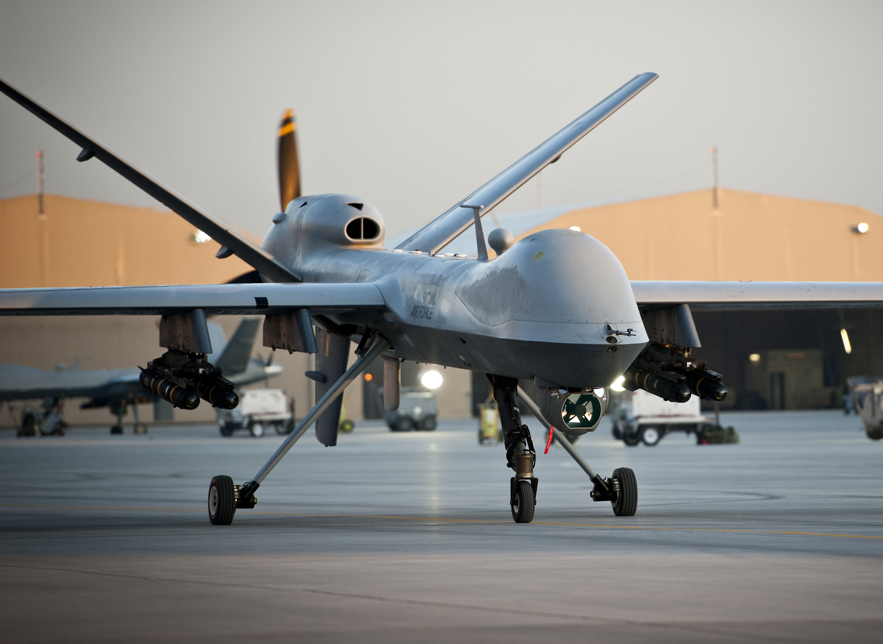
Photo: Sergeant Ross Tilly (RAF)/MOD, Open Government Licence v1.0

In an earlier post for Brave New Europe, we raised concerns about what we described as the Europeanisation of the armed drone; its diffusion outwards from the United States’ to European militaries. Despite those concerns, widely shared across civil society, that process continues apace with more and more European states rushing to build up their own drone programmes, often in close collaboration with the United States. What this accelerated investment means is that the future wars European states will enter into will be fought with remotely piloted vehicles. That should worry us all and for a variety of reasons. It should worry us because there is no transparency around the legal frameworks that guide the deployment of drones and drone strikes, there is no transparency around how remotely piloted drone operations are actually conducted in practice and there is no transparency around the unnecessary harms – the death, destruction and damage – caused by their use. Worse still, all the available evidence we have so far suggests the adoption of armed drone technology makes military operations more secretive, less publicly accountable and so less open to political oversight, something that ought to be of major concern in democratic societies. The problem is European publics have only been allowed a very partial view of what their governments are committing them to in developing these highly secretive programmes. Among other things, that secrecy may well be disguising a significant lack of sovereignty and independence in European uses of armed drones, due to their reliance upon American infrastructure and, potentially, personnel, in order to conduct them at all. For these and other reasons, public debate is urgently needed across Europe about these developments but European publics need access to much more information to arrive at a clearer picture of the future armed drones are remotely piloting us towards.

Drone warfare is the future for Europe

Drawing on work by the New America Foundation, in our first post we noted that the UK was the first European state to acquire armed drones, ten years ago in 2008. It was followed by Italy and Spain in 2015, France, Greece, Sweden and Switzerland in 2016 and Poland in 2017. Germany’s Bundeswehr also signalled its intent to acquire armed drones in 2017 but substantial political and civil society pushback means they have yet to actually do so. Although some European states like Germany will resist the allure of the armed drone, at least for a while, the picture as a whole is one of increasingly rapid and widespread proliferation. The European Union is itself pushing this process via a new €5.5 billion European Defence Fund approved in 2017. Despite calls by MEPs to ban the use of those funds for lethal autonomous weapons, armed drones fall out-with those restrictions. This is because drones do not fly themselves but are piloted, albeit remotely, and so not autonomous. The initial pilot projects funded by the European Defence Agency provide a good indication of where current European defence priorities lie and it appears drones are high among them.

Against this backdrop, national-level and European policymakers as well as arms manufacturers will argue, indeed are arguing, that the move towards drone-led forms of warfare is just a logical step. Drones are merely, so it is claimed, the next generation of weapons systems. Moreover they are just a vehicle, a package, one which can be militarised but need not be. As an increasingly stable, reliable and widespread technology, drones pose no particular issues. They are, in themselves, no big deal. We have several reasons not to be so sanguine.

One of the claims, never quite fully articulated, that is implicit in a great deal of what armed drone advocates have to say is that armed drones are equivalent to a like-for-like replacement for existing capabilities. Armed drones are the same just better; better suited to the contemporary era, more up-to-date, more networked, more useful for the kinds of conflicts European states are currently engaged in, whether wars or counter-insurgency operations linked to the ‘war on terror’, for instance in Afghanistan, Iraq, Syria, Yemen, Somalia, Libya, Nigeria and the Sahel/Mali. The public claim, in other words, is that armed drone patrols can be thought of as being fairly similar to, for example, a fighter jet patrol and that in developing the former, we are really getting the newest version of the latter. In fact, armed drone operations are very different indeed and it is important to understand what the differences are. This is because armed drones do not simply represent a transformation in the hardware European militaries have at their disposal, they represent a transformation in the kinds of operations they are gearing up to engage in and in how they will conduct them once these new capabilities are in place.

The drone way of warfare

Not only do armed drones need to be piloted, a huge number of people are needed to keep them in the sky and operationally functional. Drone patrols operate on a different order of complexity to traditional air missions, involving up to 200 people in a global division of labour as part of what are referred to in the United States where they were pioneered as ‘remote-split operations’. Incredible resources have to be committed to ensuring the video feeds, data from monitoring systems and sensor imagery drones generate in flight are available to a large number of those people simultaneously. As described in the Economist, “Today’s drones … collect and transmit so much data …that Western countries now practise warfare by committee”, allowing “government lawyers and [many] others” to be involved in deciding and clearing strikes against targets as they are encountered. The United States, which has invested most heavily in these systems, organises these operational warfare ‘committees’ through its Distributed Common Ground System (DCGS), a network of Signals Intelligence Processing Centres which costs $750 million per operational unit to service Air Force missions alone and which extends across the United States, Europe, Africa, the Middle East and Asia. These operational units are as critical to drone warfare as the actual drone itself. Given European states are not in a position to match that level of critical infrastructural investment, this raises difficult questions about how exactly their drone missions are being supported – an issue we pick up on in more detail below.

But why is Europe witnessing this rush to the drone? The answer lies in what drones enable military forces to do. Avoiding risk to personnel is only part of the rationale. If we look at the types of operations that involve the use of armed drones, we see that they make it possible to identify and target individuals, often in civilian contexts, by making use of the drone as a weaponised intelligence, surveillance and reconnaissance platform. Armed drones make it possible, in other words, to conduct ‘targeted killings’, a euphemism for extrajudicial killings or assassinations, and to do so ‘legally’. Rarely publicly acknowledged by any states before 2000, ‘targeted killings’ have become part of the stock-in-trade of Western militaries since and drones are the primary instrument for undertaking them. Drone warfare has thus made it possible to reverse accepted understandings of the international legal restrictions which outlaw such killings and to pursue courses of action, publicly and in ways that can be claimed to be legal, that could not have been pursued without them. At least that is the official position of armed drone using states. Although claims are made about their legality, the basis of those claims remains shrouded in secrecy. Simply put, we are not allowed to know the basis on which any given use of armed drones has been deemed legal. Because those operations are classified, and the legal justifications are worked out as strikes take place, they are thus not open to legal or indeed political challenge.

This much is clear from the experience in the United States. In 2011, as Megan Braun and Daniel Brunstetter report, United States’ District Judge Colleen McMahon ruled that her court had no authority to order the federal government to release documents relating to targeted killings due to the “thicket of laws and precedents that effectively allow the Executive Branch of our Government to proclaim as perfectly lawful certain actions that seem on their face incompatible with our Constitution and laws, while keeping reasons for their conclusion a secret.” This is not just about the United States, however, because European drone programmes are presently operating using infrastructures and technologies imported from the United States. Given that this is the case, European governments will be inheriting exactly these sorts of transparency issues too, importing secrecy along with the operational hardware and systems.

That is not all, however. In addition to the unknown costs, the unknown legal bases and unknown operational set ups involved, the precise nature and extent of the harms caused by using armed drones in the way they are being used is unknown too. We are told they are precision systems but all the available evidence points to large numbers of civilian casualties. Airwars, which has been monitoring the military campaign against ISIS, puts things as follows:

“By any measure, 2017 has been the worst year for civilians in the fight against ISIS, as battles moved deep into Iraqi and Syrian cities. Despite the Coalition’s insistence that it was waging “the most precise war in history”, Airwars estimates that at least 3,875 non-combatants have been killed by Coalition actions during 2017 to November. The complete toll in cities like Mosul and Raqqa still remains unknown.”

The scale of civilian deaths in a theatre where armed drones have been used extensively speaks to the ‘flexibility’ of the legal reasoning that justifies strikes as well as problems with how decisions are made to launch strikes against those picked out as targets. Once again, however, the evidence remains indirect because the restrictions in place mean we are not allowed to know more.

The not so European structure of European drone programmes

As we move further down the flightpath towards Europe’s remotely piloted military future, an issue that will become increasingly significant is the extent to which European states will have ‘sovereign control’ over their own armed drone programmes. If, as seems likely, European states are paying the United States for access to its infrastructure and the systems it houses in support of their armed drone programmes, we are entitled to ask at what costs, on what terms and conditions and with what legal and political ramifications. Based on the information that has been made public, the levels of ‘interoperability’ and interdependence involved suggest these are not best thought of as distinct programmes at all but as national nodes in a much wider drone warfare complex which is in large part staffed, led and overseen by the United States.

Drone Wars UK recently published a fascinating – and surprisingly revealing – interview with Air Marshall Greg Bagwell, in which the retired Royal Air Force (RAF) commander suggested that a sovereign drone programme means: “I make it, build it, control it, operate it, completely independently. Nobody controls my supply chain, nobody can turn a switch off”. On these criteria, there is no such thing as a sovereign European armed drone programme. Instead, the armed drone programmes of the United States and European states are deeply intertwined.

For instance, although the UK has developed its own base, RAF Waddington, for flying some missions, a large number of the UK’s armed Reapers, which are produced by the American firm General Atomics, are flown out of the United States’ Creech Air Force Base in Nevada. The structure of their joint operations and how they are conducted is troublingly unclear. The RAF’s description of how Reaper operations are conducted states that the drone is operated by the 39th Squadron of the RAF, and that a crew consists of “a pilot and a sensor operator, supported by a mission intelligence co-ordinator”. As we’ve noted above, it is well documented that a drone-strike requires as many as 200 personnel under the remote-split system. If this is so, an obvious question arises: who are the other 197 individuals involved in UK drone operations? The simple answer is, perhaps unsurprisingly, we don’t know who they are. We don’t know where they come from or who employs them. It is public knowledge that the Distributed Common Ground System is operated by private sector contractors, and it is a very real prospect that these contractors are also involved in the United Kingdom’s armed drone operations – and presumably, by extension, the drone operations of other European states too. The central point is that the public are denied access to this information, and as such there is a huge accountability gap in armed drone programmes which work with the United States.

The relationship between the United States’ and European drone programmes is further complicated by the inverse dependence of the United States’ military upon European states as sites for their international headquarters. In 2015, whistleblower Brandon Bryant stated that the United States’ operated Ramstein base in Germany was “absolutely essential to the US drone programme”. This revelation sparked protest in Germany, a state that, as noted above, has seen fierce opposition to the development of a proposed national armed drone programme. This where the issue of inheriting the American failure of transparency becomes an issue for European governments. As it stands, the German government claims it has “no hard evidence of Ramstein’s role in lethal strikes” but the credibility of that claim is, to put it mildly, questionable. It is a very real and pressing concern for the citizens of European nations that military bases within their borders – and similar bases are dotted around Europe – are being used by the United States’ military to support extrajudicial killing operations, irrespective of the policies of those countries, let alone international law.

Stopping the rush to the drone

Armed drones are not well understood, not by us, the European public, and not by the majority of our political representatives either. This is not a fault on our or their part but an inevitable and perhaps intended outcome of the secrecy which surrounds this new way of warfare. Given the financial, moral and human costs associated with the sprawling part public, part private complex that centres on armed drone operations, we have every reason to demand transparency around their use and the harms their use causes. Accountability and transparency are thus key, because it is only through greater openness that we can arrive at our own judgements about what is apparently being pursued on our behalf – the Europeanisation of the armed drone. When it comes to that process, we are currently being asked to take a great deal on trust. We have, however, moved quite far beyond the point, we would suggest, where trust should be extended.

Drone warfare is different, and that needs to be recognised – retired Air Marshall Bagwell acknowledged as much in his interview with Chris Cole of Drone Wars UK:

“CC: People often ask us why we [civil society] are so concerned about drones, but it’s because drones concretise a number of issues, ethical, moral, legal, about modern warfare and people talk about drones so they can talk about these issues.
GB: I have no problem with discussing the issues, but where I struggle is singling out drones. I think we have ended up pulling drones into a special place where they are singled out for commentary. When, actually, if it’s the idea of having a ‘kill list’ you want to talk about or the targeting of individuals, that’s a legal argument. It’s not about the tool you use, that’s just the method. You could just as easily – well not just as easily – but you can possibly do that with a number of tools.
CC: But that’s the nub of the argument isn’t it? When you say you can ‘just as easily do it with other tools’, can you?
GB: That’s why I corrected myself. You’re right it’s not just as easy.”

However, while drone warfare is different, our systems of legal and political accountability and transparency have not kept pace. The use of armed drones as a whole – their justification, their uses and the harms they bring about – has thus come to inhabit a legal, political and moral grey zone and that urgently needs to be revisited.

The work of civil society will be important in ensuring the use of armed drones is revisited. Over the past few years, alongside the U.N. General Assembly, civil society attending the Humanitarian Disarmament Forum have begun mapping out next steps for dealing with the problem of armed drones. Those discussions produced a clear position: international standards have to be agreed that address the harm caused by these systems and respect the rights of their victims, and define clearly what the limits to the acceptable use of these technologies are. Following that a range of bodies have sought to advance the debate furthers still. In Europe, that role has been played by the European Forum on Armed Drones (EFAD) which has provided an umbrella for civil society to organise a response to the proliferation of armed drone programmes in Europe.

We would echo EFAD’s call to action for European governments, which states that in order to achieve satisfactory policies on the use of drones governments must:

- Articulate Clear Policies: European states must clearly and publicly articulate their positions on the various ethical and practical challenges drones present as well as publishing their rules, laws and procedures in order to demonstrate their compliance with international law.

- Prevent Complicity: States must not be complicit in the operation of unlawful drone strikes by, for example, providing logistical support or data.

- Ensure Transparency: States should make public information that can contribute to the development of norms with regards to the use of drones as well as providing timely public information surrounding the individuals who have been targeted and why.

- Establish Accountability: States involved must conduct independent investigations into all allegations of unlawful death or civilian harm. States must also ensure that victims’ rights are upheld following drone strikes.

- Control Proliferation: States must enact stricter controls on the transfer of military and dual-use drone technologies alongside participating in debates in relevant international forums with regards to their understanding of, and position on the strict control of drones and drone-technologies.

As we have illustrated in this article, at present European governments are falling significantly short of the standards required of them when it comes to armed drones. With European governments working to ensure the future of their militaries is remotely piloted, it is incumbent on them to ensure the public knows exactly what the implications of that process are.

