Computed Tomography findings of Pigmented Villonodular Synovitis in a dog

L.M. Dempsey, T.W. Maddox, T. Meiring, M.J. Guilliard, B. Wustefeld-Janssens and E.J. Comerford

Abstract
Pigmented villonodular synovitis (PVNS) is a rare benign and usually monoarticular neoplastic lesion arising from the synovium, bursae and tendon sheaths in humans, horses and dogs. Categorisation for PVNS in humans includes localised and diffuse forms of PVNS and Tenosynovial giant cell tumour (TGCT), although histologically they are the same. The localised form is characterised by discrete nodular lesions, the diffuse form is often intra-articular, infiltrative, affecting the entire synovium with more aggressive behaviour and TGCT occurs along tendon sheaths.
Computed Tomography (CT) of PVNS is well described in humans but not documented in the veterinary literature. Pigmented Villonodular Synovitis is not a straightforward diagnosis and CT is useful to further characterise radiographic findings. A representative open surgical biopsy of the synovium is essential to obtaining the diagnosis and ruling out malignancy. Currently there are no guidelines for diagnosis of PVNS in dogs or long-term follow-up of these cases. This case report describes the presentation, diagnostic findings, treatment and long-term outcome of a four-year old male Labrador retriever with confirmed PVNS. Clinical outcome was considered fair with the dog’s lameness and symptoms remaining stable with medical management 3 years following the initial diagnosis.
Introduction
Pigmented villonodular synovitis (PVNS) is a rare, benign and usually monoarticular lesion arising from the synovium, bursae and tendon sheaths in humans, horses and dogs (1). In humans PVNS can be subdivided into a localised form, diffuse form and tenosynovial giant cell tumour. The localised form is characterised by discrete nodular lesions which are intra-articular and the more aggressive diffuse form, which is often intra-articular, infiltrative, affecting the entire synovium and may have extra-articular extension. Tenosynovial giant cell tumour occurs along tendon sheaths (1). The localized type most often affects the hand in humans, whereas diffuse PVNS affects larger joints with the knee accounting for two thirds of cases (2). Tenosynovial giant cell tumour affects the hands and feet. Histologically, the pigmented form of villonodular synovitis is characterized by haemosiderin deposition within macrophages (3).
The 2013 World Health Organisation Classification of Tumours classifies PVNS as a locally aggressive neoplasm (4). In this neoplastic condition the cells harbour a reciprocal somatic chromosomal translocation. As a result these tumour cells over express macrophage colony-stimulating factor that stimulates proliferation of macrophages (5). Previously Athanasou (6) noted that cytogenetic studies had examined the cells of this low grade proliferative condition and found consistent chromosomal abnormalities (trisomy 5 and trisomy 7) in this lesion.
In humans, diagnosis of PVNS is made by CT or magnetic resonance imaging (MRI), arthroscopy and histopathology of synovium. Computed tomography of PVNS is well described in humans but not documented in the veterinary literature. Pigmented Villonodular Synovitis is not a straightforward diagnosis and CT is useful to further characterise radiographic findings. Computed tomography findings in humans include synovial thickening in diffuse intraarticular PVNS and lesions may show high attenuation on CT resulting from haemosiderin deposition. Due to the hypervascular nature of PVNS, affected synovium enhances following administration of radiographic contrast (7). With improved tissue contrast, CT scanning is valuable in delineating bone cysts, erosions and extent of disease (8). Associated bone erosions with sclerotic margins may be present on both sides of affected joints, particularly joints with a tight capsule. The soft tissues masses seen in PVNS virtually never calcify which is in contrast to malignant synovial tumours (9). Preservation of bone mineralization and joint spaces until late in the disease is characteristic with PVNS (10).
Due to the small number of cases in the veterinary literature, information regarding diagnosis and treatment outcomes of PVNS are limited. Currently there are no guidelines for diagnosis of PVNS in dogs or long-term follow-up of these cases. Definitive diagnosis is challenging often requiring a synovial membrane biopsy via an open surgical approach or arthroscopy.
This case report describes the presentation, diagnostic findings, treatment and long- term outcome of a four-year old male Labrador retriever with confirmed PVNS. The report focuses on the initial and long-term CT findings in this case. To date, this is the first detailed report describing CT findings and longest follow-up (3 years) of PVNS in a dog.
Case History
A four-year-old 30kg male Labrador retriever was presented to the referring veterinary practice for right thoracic limb lameness. The dog was treated with omega-3 fatty acids, glucosamine HCl and chondroitin sulphate.ª Five months after commencement of the lameness, the dog was re-examined and the lameness localised to the right shoulder which was thickened with reduced extension.
Orthogonal radiographs of the right shoulder joint taken at the referring veterinary practice at initial presentation (Figure 1) showed osteophyte formation of the caudal humeral head and glenoid, joint space narrowing and subchondral sclerosis of the humeral head and glenoid. In the proximal humerus, multiple well-defined, coalescing regions of osteolysis were evident. The main differential diagnoses were neoplasia, infectious and non-infectious conditions, therefore biopsies were obtained. Biopsies of the right shoulder joint capsule were acquired via open lateral arthrotomy. Upon gross inspection, the joint appeared markedly thickened and fibrotic. Histopathology revealed hypertrophic synovial villi. Mitotic figures were not evident and a focal nodule of cartilage metaplasia was noted (Figure 2B). Lymphoplasmacytic inflammation was seen perivascularly and pigmented macrophages were visible (Figure 2 A-C). These findings were consistent with PVNS (11,12).
The dog was presented to the referral centre for a second opinion one month after the surgical biopsy. The dog had been conservatively managed with carprofen (2mg/kg PO every 12 hours) and 10-15 minutes on lead exercise twice daily. The dog was comfortable but still intermittently lame. Subjective gait analysis revealed mild right thoracic limb lameness 2/10 at a trotting gait. Orthopaedic examination found gross thickening of the right proximal humerus, mild discomfort on palpation and reduced range of motion in the right shoulder. Moderate shoulder muscle atrophy was present and the ipsilateral prescapular lymph node was prominent. Given the clinical findings and previous histopathological results, the differential diagnoses were neoplasia, infectious or non-infectious process with a high suspicion of PVNS and so CT was performed.
Computed tomography images^{b} were obtained of the thorax and both shoulders pre- and post-administration of contrast agent^{c} (2ml/kg IV). The thorax and left shoulder were within normal limits. The right shoulder joint showed severe osteophyte formation of the humeral head and glenoid, with new bone formation of the supraglenoid tubercle and along the intertubercular groove (Figure 3 A-C). There was increased attenuation of subchondral bone of the humeral head and glenoid. Multiple small osteolytic lesions were apparent in both articular surfaces extending into adjacent sclerotic areas of subchondral bone (Figure 3 G). Larger (non-articular) hypoattenuating (osteolytic), well-defined regions extended into the proximal humerus at the base of the greater and lesser tubercles, the intertubercular groove and in the distal scapula proximal to the caudal glenoid. There was narrowing of the joint space, severe thickening of the joint capsule and a moderate joint effusion, with slightly increased contrast enhancement of the joint capsule post contrast (Figure 3 H-I).
Arthrocentesis of the right shoulder joint was performed and fine needle aspirates (FNA) of the proximal humerus and soft tissue mass were taken. A tissue core biopsy of the mass and medial humeral metaphyseal area was obtained using a 14 gauge biopsy needle^{b} under ultrasound guidance. The synovial fluid was normal and culture was negative. The FNA of the proximal humerus was non-diagnostic due to a low cell harvest. Cytology of the soft tissue mass at the proximal aspect of the humerus showed aggregates of pink matrix suggestive of chondroid, occasional small mononuclear cells and no signs of malignancy. The core bone biopsy of this mass revealed normal bone and hyaline cartilage.
Given the clinical signs, imaging and histopathological findings, the diagnosis of diffuse PVNS of the right shoulder was supported. The dog was started on non-steroidal anti-inflammatory drugs (NSAID) firocoxib (5mg/kg PO every 24 hours) and a seven-day course of paracetamol/ codeine (10mg/kg PO every 8 hours). Controlled lead exercise for 6 weeks alongside bodyweight reduction was recommended.
Follow-up assessment at the referral centre 6 and 16 weeks after first presentation indicated an improvement in the dog’s mobility. Subjective gait analysis indicated mild 1-2/10 right thoracic limb lameness at a trotting gait. Findings of an orthopaedic examination were unchanged except that the range of motion was reduced to 20° in extension. Conservative management was continued with a gradual increase of off lead exercise. At follow-up by telephone, 24 weeks after the initial presentation, the degree of lameness remained the same. At this time, the patient was having 30 minutes twice daily of steady off lead exercise and the same dose of firocoxib.
Follow-up consultation was conducted 26 months after initial presentation to the referral centre. The dog’s lameness was slightly worse, the dog was notably stiffer but this did not impact quality of life. Subjective gait analysis revealed 1-2/10 right thoracic limb lameness at a walking gait and Liverpool Osteoarthritis in Dogs (LOAD) score of 12/52. Orthopaedic examination revealed moderate muscle atrophy of the right shoulder, marked periarticular thickening and a significant reduction in range of movement compared to the left shoulder joint. The dog was still medicated with firocoxib (5mg/kg PO every 12 hours) and receiving 30 minutes of steady off lead exercise twice a day.
Computed tomography images of the right shoulder joint showed bone changes similar to the previous CT, with mild progression in the size of the osteolytic regions and increased subchondral sclerosis (Figure 3 D-F). There was marked narrowing of the cranial and caudal aspects of the joint and a large volume of gas within it. A moderate joint effusion remained and there were multiple variably sized regions of well-defined mineralisation associated with the thickened joint capsule.
The dog was discharged with instructions to the owner to continue firocoxib on the present dose and current exercise regime. As the shoulder joint appeared to be ankylosing, shoulder arthrodesis was discussed with the owner if the dog’s mobility deteriorated markedly or the dog’s discomfort was non-responsive with medication. Three years after the initial diagnosis, the dog’s symptoms remain stable.
Discussion
The dog in this case report was typical of other cases described in the veterinary literature in terms of age, breed and clinical signs (13,14, 15,16,17).
Radiographic findings in other reports of dogs have included soft tissue swelling, osteolucent lesions, subchondral sclerosis, osteophytes, narrowing of the joint space and mineralization of surrounding soft tissues (13,14, 15,16,17), all of which were evident in this case.
Differential diagnoses for the radiographic findings in this case were neoplasia, infectious and non-infectious conditions, more specifically synovial chondromatosis, inflammatory synovitis, rheumatoid arthritis, chronic haemarthrosis and tumours such as synovial sarcoma, fibrosarcoma and histiocytic sarcoma. Hence additional diagnostic tests including advanced imaging were required to support the initial diagnosis from the rare histopathological findings. Computed tomography in this case allowed further characterisation of the bone and soft tissue components of PVNS and proved useful to rule out metastasis involving regional lymph nodes and the thorax.
Magnetic resonance imaging is the imaging modality of choice in humans, due to its ability to identify haemosiderin as a multifocal, low signal or extensive low signal area within the proliferative synovial masses on T₁ and T₂ weighted MRI images. Magnetic resonance imaging is preferred to CT due to better contrast resolution (18). However, CT is the optimal imaging modality in humans for demonstrating extrinsic erosion of bone on both sides of the joint and subchondral cyst formation (19) as in this case. In humans neoplastic, infectious and non-infectious conditions can give rise to osteolytic lesions, subchondral sclerosis, intra and extra-articular soft tissue masses, osteophytosis and changes in the joint space and therefore MRI, CT and radiographic documentation of these findings is not pathognomonic for PVNS. However mineralisation of soft tissues masses increases the suspicion of synovial malignancy or synovial osteochondromatosis in humans. Calcification of soft tissue masses is found in 30% and 70-75% of synovial sarcoma and synovial osteochondromatosis cases respectively in humans (9). Computed tomography findings in this case included features consistent with the diffuse form of PVNS. Mineralisation of the soft tissue mass was not seen in this case which may reduce the suspicion for synovial malignancy as is documented in the human literature (9).
Inflammatory causes of joint erosion were ruled out by normal synovial fluid analysis and negative culture in this case. In the five cases reported in the veterinary literature where arthrocentesis was performed, two cases had macroscopically orange or blood stained effusions, three cases had cell counts with 70-90% neutrophils and the other two were suggestive of degenerative joint disease (13, 14, 17). These findings correspond with synovial fluid analysis in humans with PVNS, which demonstrate an inflammatory effusion (20).
In this case, the open surgical biopsy proved to be the only diagnostic modality to obtain a definitive diagnosis. Arthroscopic examination of the right shoulder joint was not performed in this case, as it would not have contributed further information to the eventual diagnosis, however it would have been a lesser invasive method of obtaining a synovial biopsy initially.
Histopathology findings are similar to those previously reported (17), where haemosiderin was noted in macrophages alongside polymorphonuclear cells in the subsynovium with lymphoplasmacytic infiltrate and synoviocytic hyperplasia (14, 15, 16). These findings are also consistent with those reported in human PVNS (21). It would have been interesting to perform immunohistochemistry to confirm the histopathological diagnosis in this case as in human PVNS, the proliferating mononuclear cells and surface synovial cells stain positive for CD68, HAM56, vimentin and clusterin whilst multinucleated cells stain positive for CD68, common leucocyte antigen, vimentin, clusterin and desmin (22, 23).
The efficacy of treatment of PVNS in humans is limited, particularly in the diffuse form. Currently, surgical resection is the gold standard. The localised form in most instances is managed with excision of the tumour nodule. The management of diffuse PVNS is more complex and involves total synovectomy, joint replacement or in very rare cases amputation (24). Adjuvant treatments include radiosynovectomy, external beam radiotherapy or targeted treatments such as colony-stimulating factor 1 receptor inhibitors (1). The usefulness of these treatments remains to be confirmed, as existing data is often limited to small, single-institution series (2).
Treatments reported in the veterinary literature for diffuse PVNS include combinations of medical and surgical treatments including corticosteroids, indomethacin, intra-articular triamcinolonhexacetonide, non-steroidal anti-inflammatory drugs and radical synovectomy (14,15,16,17) with varying outcomes and limited follow-up. In our case report, the dog showed improvement with firocoxib although mild lameness (2/10) persisted 26 months after initial presentation. The dog’s clinical signs and quality of life remain stable with medical management three years after diagnosis. Radical synovectomy with or without radiation therapy, total synovectomy with shoulder arthrodesis as a salvage procedure or amputation would be options in this case if the dog’s signs markedly worsened. Follow-up CT imaging was useful to document that the bone changes were similar to previously, with only mild progression in the size of the osteolytic lesions and increased subchondral sclerosis, which correlated with the insidious nature of the disease.
In conclusion, diagnosis of PVNS, in dogs as in humans, is often delayed due to the nonspecific nature of clinical signs and imaging findings. A representative synovial biopsy and advanced imaging establishes a definitive diagnosis. An open biopsy was invaluable in this case and provided a definitive diagnosis over other sampling and diagnostic techniques. Computed tomography findings were not pathognomonic for PVNS which is also the case in humans, but helped to further classify and quantify the bone and soft tissue lesions. Computed tomography assisted in ruling out other conditions such as metastatic neoplasia with concurrent imaging of the thorax and locoregional lymph nodes.

ª Yumove®: Lintbells, Hertfordshie, England
^{b} Aquilion Prime 80: Toshiba Medical Systems Corporation, Tokyo, Japan
^{c} Iobitridol: Xenetix TM (300mgI/ml), Guerbet Laboratories, Roissy, France
References
1. Verspoor F, van der Geest I, Vegt E, et al. Pigmented villonodular synovitis: current concepts about diagnosis and management. Future Oncol 2013; 9: 1515-1531.
2. Brahmi M, Vinceneux A, Cassier P. Current systemic treatment options for Tenosynovial Giant Cell Tumour/Pigmented Villonodular Synovitis: Targeting the CSF1/CSF1R axis. Curr Treat Options in Oncol 2016; 17: 1-9.
3. Miller W. Villonodular synovitis: pigmented and nonpigmented variations. South Med J 1982; 75: 1084-1085.
4. WHO. Classification of tumours of soft tissue and bone. 4th ed. Lyon: World Health Organisation; 2013.
5. Horvai, A. Bones, joints and soft tissue tumours. In: Robbins and Cotran’s Pathologic basis of disease, 9th edition. Elsevier Saunders; 2015. pg. 1218-1219.
6. Athanasou, N. Pathological basis of orthopaedic and rheumatic disease. Arnold and Oxford University Press: Oxford and New York; 2001. Pg. 192-193
7. Murphey M, Rhee J, Lewis R, et al. Pigmented villonodular synovitis: radiologic-pathologic correlation. Radiographics 2008; 28:1493-1518.
8. Lin J, Jacobson J, Jamadar D, et al. Pigmented villonodular synovitis and related lesions: the spectrum of imaging findings. Am J Roentgenol 1999; 172: 191-197.
9. Dhanda S, Quek ST, Bathla G et al. Intra-articular and peri-articular tumours and tumour mimics – what a clinician and onco-imaging radiologist should know. Malays J Med Sci 2014; 21: 4-19
10. Llauger, J, Palmer, J, Roson, N et al. Pigmented villodular synovitis and giant cell tumours of the tendon sheath: Radiologic and pathologic features. Am J Roentgenol 1999; 172: 1087-1091
11. Campanacci M. Bone and soft tissue tumours, 2nd edition. New York: Springer Verlag; 1999. pg. 1289-1306.
12. Weiss S, Goldblum J. Benign tumours and tumour-like lesions of synovial tissue. In: Enzinger and Weiss’s soft tissue tumours, 4th edition. Mosby: St Louis; 2001. pg. 1037-1062.
13. Hanson J. Radiographic diagnosis – canine carpal villonodular synovitis. Vet Rad Ultrasound 1998; 39: 15-17.
14. Kusba J, Lipowitz A, Wise M, et al. Suspected villonodular synovitis in a dog. J Am Vet Med Assoc 1983; 182: 390-392.
15. Marti J. Bilateral pigmented villonodular synovitis in a dog. J Small Anim Pract 1997; 38: 256-260.
16. Somer T, Sittnikow K, Henriksson K, et al. Pigmented villonodular synovitis and plasmacytoid lymphoma in a dog. J Am Vet Med Assoc 1990; 197: 877-879.
17. Akerblom S, Sjostrom L. Villonodular synovitis in the dog: a report of four cases. Vet Comp Orthop Traumatol 2006; 19: 87-92.
18. Cheng X, You Y, Liu W, et al. MRI features of pigmented villonodular synvovitis (PVNS). Clin Rheumatol 2004; 23: 31-34.
19. Somerhausen N, Cin P. Giant cell tumour of tendon sheath and diffuse-type giant cell tumour. In: Pathology and genetics of tumours of soft tissue and bone. Lyon, France: IARC, 2002. pg. 110-114.
20. Zimmermann-Górska I, Puszczewicz M, Bialkowska-Puszczewicz G. Diagnostic value of synovial fluid analysis in pigmented villonodular synovitis (PVS) - a proposal of diagnostic criteria. Arthritis Res 2001; 3: 117
21. Berger I, Ehemann V, Helmchen B, et al. Comparative analysis of cell populations involved in the proliferative and inflammatory process in diffuse and localised pigmented villonodular synovitis. Histol Histopathol 2004; 19: 687-692
22. O’Connell J, Fanburg, J, Rosenberg A. Giant cell tumour of tendon sheath and pigmented villonodular synovitis: immunophenotyped suggests a synovial cell origin. Hum Pathol 1995; 26: 771-775
23. Tang, L, Zhou J, Jiang Z et al. Value of clusterin expression in pathologic diagnosis and histogenesis of giant cell tumour of tendon sheath. Zhonghua Bing Li Xue Za Zhi 2012; 41:161-167
24. Verspoor F, Hannink G, van der Geest I et al. Long-term follow-up results of primary and recurrent pigmented villonodular synovitis. Rheumatol Oxf Engl 2014; 53: 2063-2070

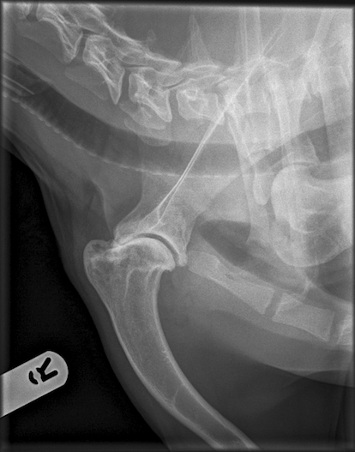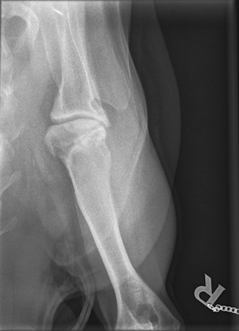
AYour text here
BYour text here
Figure 1: Mediolateral (A) and craniocaudal (B) radiographs of the right shoulder joint obtained at the first visit to the referral centre. There is moderate-severe osteophyte formation at the caudal humeral head and caudodistal aspect of the glenoid (block arrow). The joint space is narrowed cranially with irregular subchondral sclerosis of the humeral head and glenoid. There is a heterogeneous opacity of the proximal humerus in the region of the greater and lesser tubercles and intertubercular groove, with multiple well-defined, coalescing regions of radiolucency (osteolysis) throughout this region. In the proximal humerus, multiple well-defined, coalescing regions of osteolysis are seen (open arrow). There is no appreciable periosteal reaction or cortical destruction and no evident local soft tissue swelling.

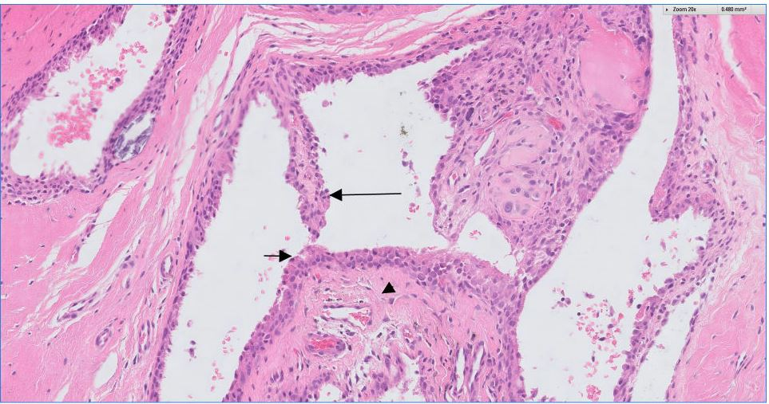
Figure 2A: Histological section of synovium obtained from the right shoulder joint with open surgical biopsy. Hypertrophic synovial villi (long arrow)are projecting haphazardly into a cystic lumen supported by a connective tissue stroma (arrow head). Synoviocytes are forming an ill-defined layer of 1 to 3 cell layers deep (short arrow).
20X magnification.

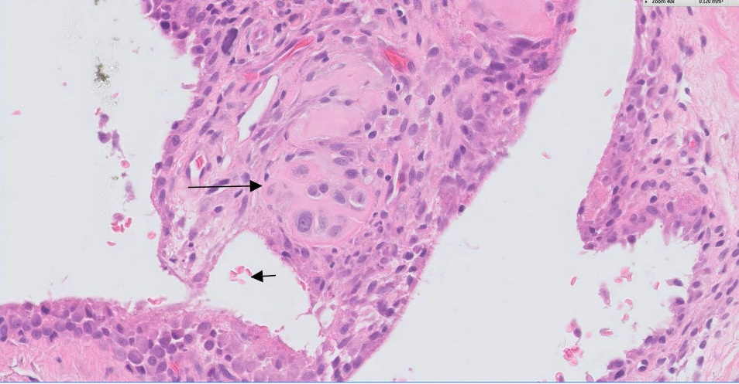
Figure 2B: This figure shows a focal nodule of cartilage metaplasia (long arrow). Scattered extravasated red blood cells are present in the lumen (short arrow).
40X magnification.

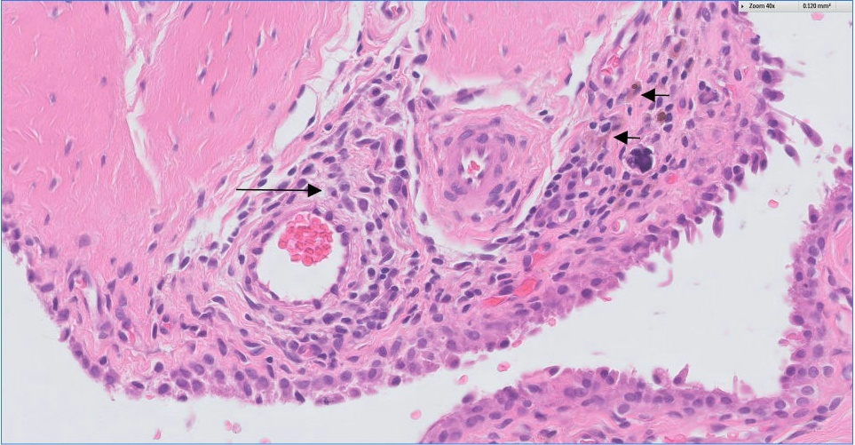
Figure 2C: In this histological section minimal lymphocytic and plasmacytic inflammation can be seen perivascularly (long arrow) as well as a few pigmented macrophages (containing haemosiderin) which are indicative of PVNS (short arrows).
40X magnification.

Figure 3 (A-F): Panels A, B and C: Transverse computed tomography (CT) images at the level of the distal scapula and glenoid (A), humeral head (B) and proximal humerus (C) obtained at the first visit to the referral centre. Severe osteophyte formation can be seen around the margins of the humeral head and caudal and medial aspect of the distal scapula and glenoid with further new bone formation at the margins of the supraglenoid tubercle and along the intertubercular groove. There is ill-defined heterogeneous increased attenuation of the subchondral bone of the humeral head and glenoid. Multiple small defects (osteolysis) are apparent in both articular surfaces extending a very short distance into the adjacent sclerotic areas of subchondral bone. Larger (non-articular) hypoattenuating well-defined regions extend into the bone of the proximal humerus at the base of the greater and lesser tubercles, the intertubercular groove and in the distal scapula proximal to the caudal glenoid. The proximal part of the biceps brachii tendon is thickened, with a small focus of mineralisation just distal to its origin. The joint space is narrowed, with small amount of gas is present within the joint consistent with vacuum phenomenon. There is moderately severe thickening of the joint capsule and a moderate joint effusion, with slightly increased contrast enhancement of the joint capsule evident on the post contrast images (I).

Panels D, E and F: These images were obtained 26 months following the first visit. The bone changes are similar to the previous CT, with only mild progression in the size of the hypoattenuating regions (osteolysis) and increased subchondral sclerosis. There is now marked narrowing of the cranial and caudal aspect of the joint and a large volume of gas within the central part of the joint with a smaller volume in the caudal joint recess. There remains a moderate joint effusion with now marked thickening of the joint capsule. There are multiple variably-sized regions of well-defined mineralisation associated with the joint capsule.

Panels G, H and I: Sagittal multiplanar reformatted image (G) showing one of several small defects extending from the articular surface into the subchondral bone of the humeral head (open arrow)
Pre-contrast (H) and post contrast (I) soft tissue algorithm images of the shoulder, showing minimal contrast enhancement of the soft tissue mass surrounding the joint.

