Determination of Thermal Expansion of KCaI₃ using In-Situ High Temperature Powder X-Ray Diffraction
Adam C. Lindsey^{a,b}, Matthew Loyd^{a,b}, Maulik K. Patel^{b,c}, Ryan Rawl^{d}, Haidong Zhou^{d}, Merry Koschanª , Charles L. Melcherª, Mariya Zhuravleva^{a,b}
ªScintillation Materials Research Center - The University of Tennessee - Knoxville TN, USA
^{b}Materials Science and Engineering Deparment – The University of Tennessee – Knoxville TN, USA
^{c}Department of Mechanical Materials and Aerospace, University of Liverpool, Harrison Hughes Building, Brownlow Hill, Liverpool L69 3GH. United Kingdom
^{d}Department of Physics – The University of Tennessee - Knoxville TN, USA
*Corresponding author E-mail: mloyd1@vols.utk.edu
Abstract
KCaI₃:Eu single crystals exhibit favorable scintillation properties and have potential for use in domestic security applications requiring radioisotope identification. The anisotropic thermal expansion of the orthorhombic unit cell of this perovskite-type scintillator has been investigated using in-situ high temperature X-ray diffraction on powdered samples. Samples from single crystals of both pure and Eu-doped KCaI₃ grown by the Bridgman method were used for comparison. Expansion with temperature along the b-axis is greatest with an average linear coefficient of thermal expansion of ≈ (41 – 46) x 10⁻⁶ K⁻¹ resulting from the weaker bonding between alternating layers of K and Ca parallel to the b-axis. Thermal expansion in each of the KCaI₃ samples has the highest degree of anisotropy with respect to the b and c axis with ratio ᾱ_{b}/ᾱ_{c} of 1.4 - 1.5. Additionally, we identify the predominant cleavage plane in KCaI₃ as (0 -3 -1) based upon Laue reflection imaging.

Keywords: A1. X-ray Diffraction; B2. Bridgman Technique; B1 Halides; B2 Scintillator Materials

Introduction
New radiation detection materials comprised of Eu²⁺ activated ternary halide based perovskites of the form ABX₃ where A=Group I, B=Group II, and X=halogens have shown significant promise as high performance scintillators ¹⁻⁴. These materials have intense scintillation response to ionizing radiation such as charged particles, X-rays, and gamma-rays. Single crystals of the cubic inch scale are used in spectroscopic detectors enabling the identification of radioactive materials and are most widely produced using growth from the melt techniques such as modifications of the Bridgman method. The requisite hermetic enclosure of the material with an optical window mated to a photosensor has been in practice for decades and enables use the hygroscopic crystals in a variety of environments. Other similarly hygroscopic metal halide based scintillators such as LaBr₃:Ce, and SrI₂:Eu belong to the current generation of scintillator development and exhibit unsurpassed energy resolution and light yield amongst all scintillators.
The single crystal forms of the alkali-alkaline earth metal halides are typically brittle and are prone to fracture if procedures are not followed to prevent thermal/mechanical shock during synthesis and handling. This material property is inarguably a significant obstacle to attaining high yields of usable crystals from melt-growth processes. Additionally, use of single crystals in spectroscopic detectors in the field must withstand a range of operating temperatures during night/day cycles, as well as during transport in extreme climate regions.
In particular there has been recent progress in development of Bridgman growth processes to fabricate larger diameter crystals (≈ Ø25 mm) of KCaI₃:Eu for use in handheld detectors ⁵. KCaI₃ crystallizes in an orthorhombic structure, space group Cmcm (Figure 1), and undergoes no phase transitions from room temperature to its melting point of 797 K, enabling single crystals of high optical quality to be grown from the melt. However, during experimental crystal growth of KCaI₃ in fused silica ampoules, cleaving and/or cracking occurs during the cooling process.
An example of the imperfect cleavage inclined to the growth direction in a randomly oriented self-seeded boule grown by the vertical Bridgman method is shown in Figure 2. The parallel fractures (cleaved surfaces) and their inclination to the growth direction suggest that it occurs along similar crystallographic planes and has a relationship with the orientation habit during growth from randomly oriented self-seeding.
The cleavage behavior and growth habit of KCaI₃ has not been investigated previously. This is because of the hygroscopic nature of KCaI₃ and other halide-based scintillation materials that introduces considerable difficulty to the investigation of their properties. As a result, the stress/strain behavior and fracture mechanisms in many newly developed single crystal materials are largely unknown and beyond the scope of this manuscript. Nevertheless, an understanding of the thermal stability and unit cell expansion with temperature is critical for overcoming obstacles to scale-up of growth processes required for commercialization. A large mismatch of thermal expansion between the grown crystal and the commonly used fused silica ampoule material is suspected to be a significant source of stress in the as-grown crystal. This may in turn cause fracture during growth. In a previous investigation, crystal growth in ampoules with a pyrolytic carbon coating on the inner surface has been shown to reduce ampoule adhesion resulting in a significant reduction in cracking ⁵. Since the thermal expansion behavior of fused silica is very well characterized with a coefficient of thermal expansion (CTE) of ≈ 0.5 x10⁻⁶ K⁻¹ ⁶, we set forth to determine the thermal expansion behavior of KCaI₃ using in-situ high temperature X-ray diffraction (HTXRD) in an effort to further understand the magnitude of the mismatch. We examine KCaI₃ crystals with and without Eu dopant atoms as previous work has shown KCaI₃ crystals are more prone to cracking as the europium concentration is increased ⁷. Furthermore, we have instituted the use of back reflection Laue measurements on the cleaved surface in KCaI₃ to determine its relationship with the crystallographic unit cell.
Extensive research on the thermal expansion of non-scintillating ternary halide compositions conducted by Meyer ⁸ illustrates the close relationship between thermal expansion and crystal structure. Crystals with layers or chains of connected polyhedra can be highly anisotropic in comparison with those with close-packed structures with primarily isotropic thermal expansion. Thermal expansion of scintillator materials like Ce-doped LaCl_{3,} LaBr₃, Lu₂SiO₅ (LSO), Eu-doped SrI_{2,} and CsCe₂Cl₇ have also been investigated ⁹⁻¹². For each material thermal expansion was determined to be highly anisotropic and, for LSO crystals, the expansion along the b and c axes is 5-10 times greater than along the a axis, which requires an optimal orientation for growth relative to a furnace’s thermal profile.
For the orthorhombic structure, since lattice parameters a ≠ b ≠ c, the deformation of the unit cell is described by 3 independent terms of a symmetrically polar tensor of the second rank (α_{ij}), namely α₁₁, α₂₂, and α₃₃ representing the linear coefficients of thermal expansion ¹³. If we choose the Cartesian coordinates as parallel to the a, b, and c axes of the unit cell, then α₁₁, α₂₂, and α₃₃ = α_{a}, α_{b}, and α_{c}. The volume expansion coefficient, α_{V}, is then:
$α_{V}=\frac{1}{V}\frac{∆V}{∆T}=α_{a}+α_{b}+α_{c}$= trace (α_{ij})
In this manuscript, the average volume expansion coefficient is denoted as ᾱ_{v}.
Figure 1. (a) Projection of the KCaI₃ structure with CaI₆ octahedra shaded in blue and KI₈ polyhedra shaded in purple. (b) Views along the c-axis and (c) the a-axis emphasize the wide spacing of the Ca/K layers and (d) the closer spacing of the Ca/K layers when viewed along the b-axis. The un-labeled sites are iodine atoms. Illustrations were created using VESTA ¹⁴.
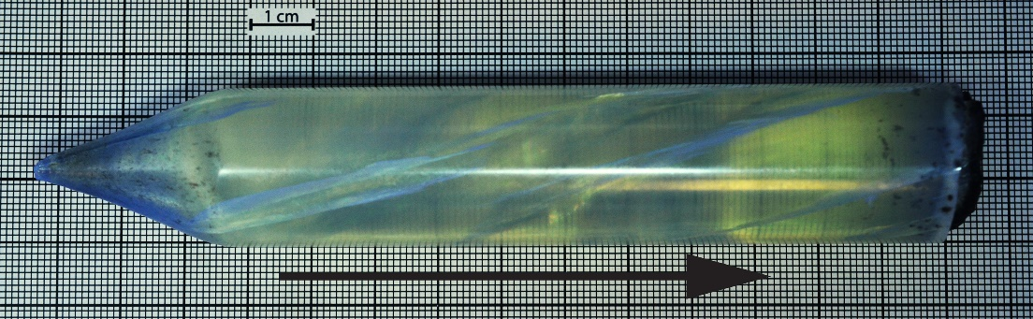
Figure 2. A Ø25 mm (1”) boule of KCaI₃:Eu with parallel cleavage inclined to the growth direction indicated by the arrow.

Experimental
HTXRD measurements were performed on two samples of KCaI₃. Sample 1 contained 1 at% divalent europium (substituting for Ca²⁺) and represented the doped matrix that was found to have desirable scintillation properties. Sample 2 contained no dopant. In this manner, the CTE of both the doped and undoped forms of KCaI₃ could be examined and compared to determine the effects of the europium dopant atoms in the KCaI₃ matrix.
Each sample was prepared from precursor materials KI, CaI₂ and EuI₂, all anhydrous in beaded form with 99.99% or better purity from a trace metals basis and were purchased from APL Engineered Materials Inc. A 1:0.99:0.01 molar ratio of KI, CaI₂, and EuI₂ was used for Sample 1 and stoichiometric mixtures of KI and CaI₂ in a 1:1 molar ratio were used for Sample 2. The mixtures comprising 30-60g total weight were loaded and sealed into fused silica ampoules after heating to 500 K under vacuum for several hours in order to remove any trace moisture or ambient oxygen. Once sealed, the mixtures were heated for 18 hours at 1073 K to melt and homogenize the composition and then directionally solidified into a single crystal using a two-zone vertical Bridgman furnace and a randomly oriented self-seed. A pulling rate of 0.5 mm/h, gradient of ≈25 K/cm in the solidification zone were used during growth and a cooling rate of 5 K/h was used. The resultant single crystals were crack and inclusion free, water clear and colorless for the undoped KCaI₃ sample, and slightly yellow-green tinted for the doped sample. More detailed information regarding the crystal growth apparatus can be found in ^{1,5}.
Due to the hygroscopic nature of KCaI₃, all handling of the material prior to measurement took place inside a nitrogen flushed glovebox maintaining an atmosphere of less than 1 ppm water vapor and oxygen. Powder samples were prepared by grinding a cleaved fragment in a synthetic sapphire mortar and pestle. Powder samples were loaded into a Ø15 mm x 0.4 mm alumina sample carrier and transferred to an Anton-Parr HTK 1200N high temperature oven chamber which was immediately evacuated to 10⁻⁴ Pa to prevent deliquescence of the powder. The non-ambient sample stage was used in the Bragg-Brentano geometry within a Panalytical Empyrean diffractometer. A Cu K_{α} X-ray source operated at 45 kV and 40mA was used. Incident beam optics included a 0.04 rad soller slit, a programmable divergence slit of 0.125°, a 0.25° fixed anti-scatter slit and beam mask of 10 mm. The diffracted beam optics included a PIXcel3D-Medipix3 1x1 area detector operated in 1D scanning mode with a 5mm fixed anti-scatter slit, 0.04 rad soller slits and a 0.020 mm thick nickel beta filter. Diffraction patterns were acquired at each temperature continuously over the 2θ range of 10-70° using a step size of 0.0131°/step. The scan duration was approximately 30 mins.
The sample was heated from room temperature to 723 K at a 5 K/min heating rate, taking a full diffraction pattern at 50 K increments after thermally stabilizing for 10 mins at each temperature. Thermal profile and pattern fitting information is contained in the appendix section. The maximum temperature was chosen to be close to the melting point of KCaI₃ (797 K) yet low enough to avoid the risk of inadvertently melting the sample. During heating, the sample height was automatically adjusted as a function of temperature to account for the thermal expansion of the alumina sample stage column and to reduce the measurement error in diffraction peak position due to sample surface displacement.
Laue imaging was taken using the back-reflection method, acquiring a cross section of the diffraction cone. Measurements were taken using a Cu K_{α} radiation from an X-ray tube operated at 40 mA and 20 kV. A ≈ 1 mm thick single crystal was cleaved from the boule using a razor blade by following the natural cleaved surface. The cleaved fragment was secured using double sided tape within an air tight housing covered by a 3 µm thick Mylar film to protect the surface from exposure to ambient moisture. Alignment was found by indexing the diffraction points using OrientExpress and a 1.5 degree angular tolerance.

Results and Discussion
Due to a brief 10-15 second exposure to ambient moisture during transfer to the non-ambient stage, a partial deliquescence of the powder top surface occurred and a hydrated phase appears in the X-ray data as an amorphous hump in the 25° 2θ region. With subsequent heating under vacuum, the hydrate phase is removed and no longer observed. This result indicates the top surface of the sample was subject to some deliquescence during the brief (10-15 seconds) of exposure during sample transfer to the vacuum chamber and as the sample was calcined, the remaining product then crystallized at high temperature into an unidentifiable phase.
A contour plot of a section of the diffraction pattern from 323 K to 723 K containing the most intense reflections in the 2θ range of ≈21-32° is shown in Figure 3. The peak position is shown to shift to lower 2θ values indicating the d-spacing is increasing with temperature. For each of the samples, a decomposition phase becomes observable starting with the patterns at 673 K. Diffraction peaks belonging to the KCaI₃ phase are shown to coexist alongside the decomposition phase with the former decreasing in intensity beyond 673 K and vice versa. Diffraction peaks from both the KCaI₃ phase and the decomposition phase are present for all the remaining data sets beyond 673 K. Nonetheless, the KCaI₃ phase could be well fitted up to 673 K. Figure 4 and Figure 5 shows lattice parameters a, b, and c, as well as unit cell volume as a function of temperature plotted for both the doped and pure KCaI₃ series of HTXRD measurements respectively. Reliable unit cell information from the highest temperature pattern for the doped sample could not be acquired due to very low intensity in the observed pattern. The same loss of intensity was less severe in the undoped KCaI₃ sample thus the two data sets represent comparable diffraction data up to 673K.
The KCaI₃ lattice has a single divalent site, and we assume that divalent Eu occupies this site exclusively in the absence of any evidence to the contrary. Our assumption is supported by the previously reported observation of a single narrow Eu²⁺ luminescence emission band that is the typical signature of a single site for Eu²⁺ (see ref. 1). The larger ionic radius of Eu²⁺ compared to Ca²⁺ will result in a distribution coefficient less than one, but the exact value has not been determined. The unit cell of the europium doped sample is slightly larger than the unit cell of the undoped sample most likely due to the presence of Eu²⁺ which has a larger 6-fold coordinated radius than Ca²⁺ (1.17 Å vs 1.00 Å respectively ¹⁵). However, since no effort was made to correct for instrumental error for line position, any discrepancy represented here on the basis of cell dimensions should be not be overly emphasized. In the determination of thermal expansion, only ΔL/ΔT factors into the calculation. As a result, an accurate measure of L₀ (the true unit cell) is not necessary.
From the data presented in Figure 4, the thermal expansion for each sample follows a nearly linear temperature dependence over the range of measurement, thus a linear fit of the data well represents the experimental observation. The mean CTE over the entire 323-673K temperature range along with comparisons of other halide scintillators are shown in Table I. The b axis is shown to have the largest magnitude of expansion with temperature which is in accordance with the weaker bonding between alternating layers of CaI₆ and KI₈ polyhedra parallel to the (010) plane. The europium doped sample clearly shows a larger magnitude CTE for each crystal axis in comparison with that of the pure KCaI₃ sample. The trend is due to lattice strain introduced by the relatively longer Eu-I bonds (3.37Å) in comparison to the Ca-I bonds (3.20Å). Thermal expansion in each of the KCaI₃ samples has the highest degree of anisotropy with respect to the b and c axis with ratio ᾱ_{b}/ᾱ_{c} of 1.5. Lower degrees of anisotropy are observed with respect to the a and b axes with ᾱ_{a}/ᾱ_{b} of 0.8-0.9 and with respect to the a and c axes with ᾱ_{a}/ᾱ_{c} of 1.1-1.2.
In comparison with other commercially produced halide scintillator materials, KCaI₃ possesses a larger magnitude CTE for each crystallographic axis and smaller degrees of CTE anisotropy than in SrI₂:Eu and LaCl₃:Ce. Compared with fused silica (CTE ≈ 0.05 x 10⁻⁵ K⁻¹), KCaI₃ thermally contracts at a rate nearly two orders of magnitude greater than the commonly used crystal growth ampoule material. Future research should include growth within flexible ampoules such as platinum foils sealed and supported by a rigid outer ampoule which may accommodate the large thermal expansion of KCaI₃, thereby further reducing stress and cracking during growth.
Figure 3. Partial contour plot for the 2θ range of 21°-32° obtained from HTXRD data collected from the KCaI₃ sample with peak indices labeled. Peaks belonging to the decomposition/impurity phase can be observed above 673 K (labeled at top of plot) and the hydrate peak disappears upon heating (shown at bottom of plot). The color scale on the left corresponds to the intensity of the measured diffractograms.
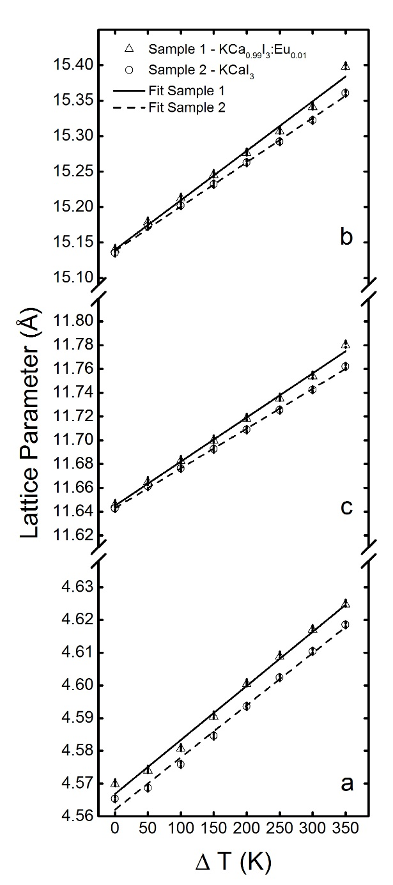
Figure 4. Lattice parameter vs ΔT obtained after refining the HTXRD data accompanied by a linear fit for each sample (europium doped and un-doped, respectively). Error bars indicate ±σ as calculated from the HTXRD data.
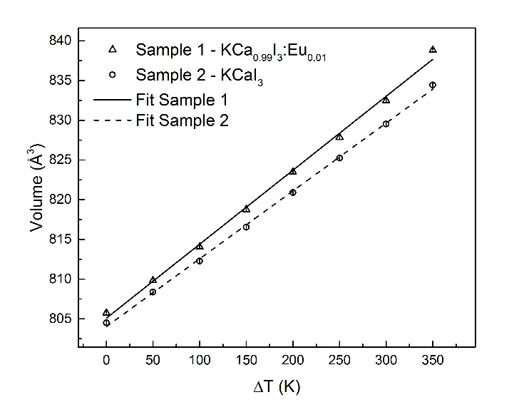

Figure 5. Unit cell volume vs ΔT obtained after refining the HTXRD data accompanied by a linear fit for each sample (europium doped and un-doped, respectively). Error bars indicate ±σ as calculated from the HTXRD data.

Table I. Mean linear CTE from 323 K-673 K and mean values of CTE anisotropy for each KCaI₃ sample compared with select commercial scintillators.
 | $${\overline{α}}_{a}$$  (10⁻⁵ K⁻¹) | $${\overline{α}}_{b}$$  (10⁻⁵ K⁻¹) | $${\overline{α}}_{c}$$  (10⁻⁵ K⁻¹) | $${\overline{α}}_{v}$$  (10⁻⁵ K⁻¹) | ${\overline{α}}_{a}$/${\overline{α}}_{b}$ | ${\overline{α}}_{a}$/${\overline{α}}_{c}$ | ${\overline{α}}_{b}$/${\overline{α}}_{c}$ | Reference
Sample 1 – KCa_{0.99}I₃Eu_{0.01} | 3.6(1) | 4.6(2) | 3.19(7) | 11.6(2) | 0.8 | 1.1 | 1.5 | This work
Sample 2 – KCaI₃ | 3.5(1) | 4.12(6) | 2.87(3) | 10.6(1) | 0.9 | 1.2 | 1.4 | This work
LaCl₃:Ce (Hexagonal) | 2.5 | - | 1.1 | 6.1 | - | 2.3 | - | 10
SrI₂:Eu (Orthorhombic) | 1.55 | 2.16 | 0.92 | 4.66 | 0.7 | 1.7 | 2.3 | 9
Uncertainties are shown in parentheses.

The calculated Laue pattern fitted to the observed pattern acquired from the cleaved surface of KCaI₃ is shown in Figure 6. Several reflections of the (0 k -1) family are observed suggesting the prismatic planes of this type are all similarly aligned, yet rotated about the a-axis to distribute them along a line in the detector film. The pattern indicates the irradiated sample area is a single crystal with the (0-3-1) plane normal closest to parallel with the incident X-ray beam and is proposed as the predominant cleavage plane of KCaI₃. Based upon the inclination of the cleavage plane to the growth direction of the boule shown in Figure 2, the growth habit may be approximated as along the [011] lattice vector. Several boules grown similarly using the randomly oriented self-seeded method also display a cleavage pattern inclined ≈ 45° to the growth direction as shown in Figure 7, thus it is reasonable to assign a growth habit along the [011] direction.
The cleavage behavior and anisotropy in CTE may make large-scale growth of single crystals difficult due to the temperature related stresses involved. Additionally, growth from seed crystals with attention to orientation of the cleavage plane to the growth direction, perhaps growth along [010], may be beneficial to improving cracking and cleaving behavior.
Figure 6. Calculated reflection Laue pattern (left) and observed pattern (right) obtained from the cleaved surface of a KCaI₃ single crystal.
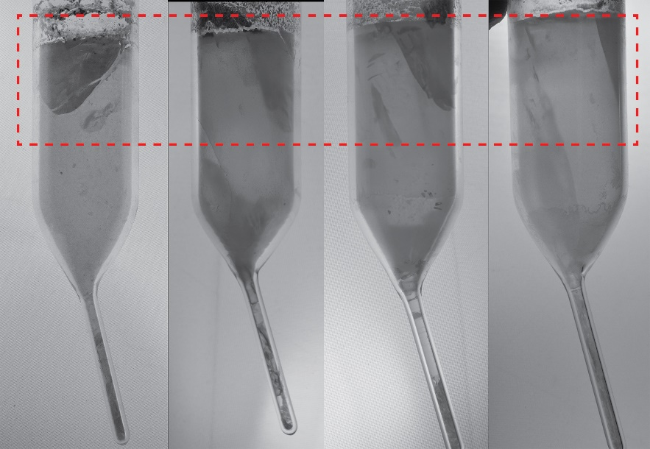
Figure 7. Photograph showing randomly oriented self-seeded boules of KCaI₃ at Ø22 mm with cleavage planes (highlighted with a rectangle) similarly inclined to the growth direction (towards the top in each photo).

Conclusions
The anisotropic thermal expansion behaviors of pure and 1 at% Eu doped KCaI₃ were investigated using HTXRD on powder samples from 323 K to 673 K. A slightly larger CTE for each lattice parameter was observed for the doped sample in comparison to the undoped sample which may be ascribed to additional lattice strain introduced by large mismatch in ionic radii for the substituting Eu²⁺ cation. The weaker bonding between layers of CaI₆ and KI₈ polyhedra produces a predominant imperfect cleavage along (0 -3 -1). The same layering results in the largest thermal expansion along the b-axis with 4.1-4.6 (10⁻⁵ K⁻¹) in comparison to the a and c axes, which have more moderate CTE’s of 3.5-3.6 and 2.9-3.2 (10⁻⁵ K⁻¹), respectively. Each sample exhibited the highest degree of thermal expansion anisotropy with respect to the b and c axes and lowest degree of anisotropy with respect to the remaining axes. Among commercially produced halide scintillator materials such as SrI₂:Eu and LaCl₃:Ce, KCaI₃ possesses a larger magnitude CTE for each crystallographic axis and smaller degrees of CTE anisotropy.
Acknowledgements
This work has been supported by the US Department of Homeland Security, Domestic Nuclear Detection Office, under competitively awarded grant #2012-DN-077-ARI067-05. This support does not constitute an express or implied endorsement on the part of the Government. Dr. Haidong Zhou thanks the support from award #NSF-DMR-1350002. The X-ray diffraction experiments were performed using the instruments procured through the general infrastructure grant of DOE-Nuclear Energy University Program #DE-NE0000693.
Appendix
A total of 9 data sets for each sample were used to track the unit cell expansion with temperature and the General Structure Analysis System –II (GSAS II) was used for performing Rietveld analysis ¹⁶. Single crystal diffraction data ¹⁷ of KCaI₃:Eu 3% acquired at 250 K with unit cell parameters of a=4.5630(11) Å, b=15.139(12) Å, and c=11.631(3) Å were used as a starting model to fit the lowest temperature data set at 323 K. A least squares refinement was used to derive the lattice parameter, pattern background, and sample displacement. SRM 660 (LaB₆) was measured using the same optics to characterize the instrumental broadening and peak shift. A sequential refinement of the change to the lattice parameters (D₁₁, D₂₂, D₃₃) and intensity scale factor was used for the remaining data sets up to 723 K. Pattern background and sample displacement were not refined beyond the first data set. A simulated pattern alongside the 323 K diffraction pattern for Sample 2 is shown in Figure A-1. The thermal profile used for the measurements is shown in Figure A-2.
Figure A-1. A simulated PXRD pattern from the structure model of KCaI₃ refined from single crystal diffraction data acquired at 250 K (bottom) with the observed PXRD pattern acquired at 323 K (top). Peak indices are shown below with some labels from low intensity or overlapping peaks omitted for clarity.
Figure A-2. Thermal profile used for the HTXRD measurements. The measured temperature profile is shown next to the programmed profile.

References

1. A. C. Lindsey, M. Zhuravleva, L. Stand, Y. Wu, and C. L. Melcher, "Crystal Growth and Characterization of Europium Doped KCaI₃, A High Light Yield Scintillator," Opt. Mater., 48 1-6 (2015).
2. A. Lindsey, W. McAlexander, L. Stand, Y. Wu, M. Zhuravleva, and C. L. Melcher, "Crystal Growth and Spectroscopic Performance of Large Crystalline Boules of CsCaI₃:Eu Scintillator," J. Cryst. Growth, 427 42-47 (2015).
3. V. L. Cherginets, N.V. Rebrova, A.Yu. Grippa, Yu.N. Datsko, T.V. Ponomarenko, V.Yu. Pedash, et al, "Scintillation Properties of CsSrX₃:Eu²⁺ (CsSr_{1−y}Eu_{y}X₃, X = Cl, Br; 0 ≤ y ≤ 0.05) Single Crystals Grown by the Bridgman Method," Mater. Chem. Phys., 143 [3] 1296-99 (2014).
4. K. Yang, M. Zhuravleva, and C. L. Melcher, "Crystal Growth and Characterization of CsSr_{1–x}Eu_{x}I₃ High Light Yield Scintillators," Phys. Status Solidi RRL, 5 [1] 43-45 (2011).
5. A. C. Lindsey, M. Zhuravleva, Y. Wu, L. Stand, M. Loyd, S. Gokhale, M. Koschan, and C. L. Melcher, "Effect of Increasing Size and Changing Europium Activator Concentration in KCaI₃ Scintillator Crystals," J. Cryst. Growth, 449 (2016) 96-103.
6. G. E. Merritt, "Thermal Expansion of Fused Quartz," J. Am. Ceram. Soc., 7 [11] 803-08 (1924).
7. Y. Wu, M. Zhuravleva, A. C. Lindsey, M. Koschan, and C. L. Melcher, "Eu 2+ concentration effects in KCa_{0.8}Sr_{0.2}I₃:Eu²⁺: A Novel High-Performance Scintillator," Nucl. Instrum. Methods Phys. Res., Sect. A, 820 132-40 (2016).
8. G. Meyer, "Thermal-Behavior Of Complex Halides," Eur. J. Solid State Inorg. Chem., 28 [6] 1209-43 (1991).
9. N. Cherepy, B.W. Sturm, O.B. Drury, T.A. Hurst, S.A. Sheets, L.E. Ahle, et al, "SrI₂ Scintillator for Gamma Ray Spectroscopy," pp. 74490F-90F-6 in SPIE Optical Engineering+ Applications (2009).
10. A. Iltis, M. R. Mayhugh, P. Menge, C. M. Rozsa, O. Selles, and V. Solovyev, "Lanthanum Halide Scintillators: Properties and Applications," Nucl. Instrum. Methods Phys. Res., Sect. A, 563 [2] 359-63 (2006).
11. S. A. Speakman, W. D. Porter, M. A. Spurrier, and C. L. Melcher, "Thermal Expansion and Stability of Cerium-doped Lu₂SiO₅," Mater. Res. Bull., 41 [2] 423-35 (2006).
12. M. Zhuravleva, A. Lindsey, B. C. Chakoumakos, R. Custelcean, F. Meilleur, R. W. Hughes, et al, "Crystal Structure and Thermal Expansion of a CsCe₂Cl₇ Scintillator," Journal of Solid State Chemistry, 227 142-49 (2015).
13. H. Küppers, "Thermal Expansion," pp. 99-104. in International Tables for Crystallography Volume D: Physical Properties of Crystals. Springer, 2006.
14. K. Momma and F. Izumi, "VESTA 3 for Three-dimensional Visualization of Crystal, Volumetric and Morphology Data," J. Appl. Crystallogr., 44 [6] 1272-76 (2011).
15. R. Shannon, "Revised Effective Ionic Radii and Systematic Studies of Interatomic Distances in Halides and Chalcogenides," Acta Crystallogr. Sect. A, 32 [5] 751-67 (1976).
16. B. H. Toby and R. B. Von Dreele, "GSAS-II: The Genesis of a Modern Open-Source All Purpose Crystallography Software Package," J. Appl. Crystallogr., 46 [2] 544-49 (2013).
17. Y. Wu, Q. Li, B. C. Chakoumakos, M. Zhuravleva, A. C. Lindsey, J. A. Johnson II, et al, "Quaternary Iodides K(Ca,Sr)I₃:Eu²⁺ Single Crystal Scintillators for Radiation Detection: Crystal Structure, Electronic Structure, Optical and Scintillation Properties " Adv. Opt. Mater. (2016).

