Measurement of blood-brain barrier permeability using

dynamic contrast-enhanced magnetic resonance imaging with

reduced scan time

Jonghyun Bae^{*,1,2,3}, Jin Zhang^{2,3}, Youssef Zaim Wadghiri^{2,3}, Atul Singh Minhas⁴,
Harish Poptani⁴, Yulin Ge^{2,3}, Sungheon Gene Kim^{2,3}

Affiliations
^{1.} Sackler Institute of Graduate Biomedical Science, New York University School of Medicine
^{2.} Bernard and Irene Schwartz Center for Biomedical Imaging, Radiology, New York University School of Medicine
^{3.} Center for Advanced Imaging Innovation and Research, Radiology, New York University School of Medicine
^{4.} Centre for Preclinical Imaging, Institute of Translational Medicine, University of Liverpool, UK

* Corresponding Author

Address all correspondence to:
Jonghyun Bae, Department of Radiology, NYU School of Medicine, 660 First Avenue, 4th Floor
New York, NY 10016, Email: Jonghyun.Bae@nyucm.org. Tel: +1-212-263-2717

Word Count: 4466

Running title: BBB permeability using DCE-MRI

Abstract

Purpose: To investigate the feasibility of measuring the subtle disruption of blood-brain barrier (BBB) using dynamic contrast-enhanced(DCE) MRI with a scan duration shorter than 10 min.
Methods: The extended Patlak-model(EPM) was introduced to include the effect of plasma flow (F_{p}) in the estimation of vascular permeability-surface area product (PS). Numerical simulation studies were carried out to investigate how the reduction in scan time affects the accuracy in estimating contrast kinetic parameters. DCE-MRI studies of the rat brain were conducted with Fisher rats to confirm the results from the simulation. Intracranial F98 glioblastoma models were used to assess areas with different levels of permeability. In the normal brain tissues, the Patlak-model(PM) and EPM were compared, while the two-compartment-exchange-model (TCM) and EPM were assessed in the peri-tumor and the tumor regions.
Results: The simulation study results demonstrated that scan time reduction could lead to larger bias in PS estimated by PM (> 2000%) than by EPM (< 47%), especially when F_{p} is low. When F_{p} was high as in the gray matter, the bias in PM-PS (>900%) were larger than that in EPM-PS (<42%). The animal study also showed similar results, where the PM parameters were more sensitive to the scan duration than the EPM parameters. It was also demonstrated that, in the peri-tumor region, the EPM parameters showed less change by scan duration than the TCM parameters.
Conclusion: The results of this study suggest that EPM can be used to measure PS with a scan duration of 10 min or less.

INTRODUCTION

Dynamic contrast enhanced (DCE)-MRI has been suggested as an effective tool for non-invasive measurement of blood-brain barrier (BBB) disruption in many brain disorders such as brain tumor (1), stroke (2), and multiple sclerosis (3). To date, there are only a handful of DCE-MRI studies on dementia or Alzheimer's disease (AD) (4,5) that showed the increased vascular permeability in the hippocampus of the patients including mild cognitive impairment (MCI). These studies demonstrated the feasibility that the small BBB leakage due to dementia can be measured with DCE-MRI. However, they suffer from a long acquisition time (e.g. >25 min). Holding steady for such a long scan can be a challenging task for many of elderly patients, which is a major limitation for applying this technique to routine practice or large-scale clinical trials. Although cerebrospinal fluid (CSF) markers such as Aβ peptide, T-tau and P-tau are more specific to brain pathophysiology and have been informative in BBB dysfunction and leakage (6), CSF examination is invasive and provides only indirect measures of BBB breakdown. Hence, there is clearly an unmet need for non-invasive and direct biomarkers which can be used in a clinical setting with a relatively shorter scan time for early detection of BBB disruption in AD and other neurological diseases with vascular permeability change.
Previous studies found that the permeability of gray matter BBB is 0.5-2.0x10⁻³ min⁻¹ (4,7) which is about two-to-three orders-of-magnitude smaller than the vascular permeability observed in tumor vessels. Because of such low permeability of the BBB, DCE-MRI studies are often conducted with a low temporal resolution (20s – 1 min/frame) and long scan duration (20-35 min) (8). Conventional DCE-MRI methods have an inherent trade-off between temporal resolution and spatial resolution, usually resulting in a low temporal resolution. Jelescu et al utilized a dual temporal resolution protocol to improve the accuracy of BBB permeability estimation (3). The dual temporal resolution protocol attempts to measure the uptake dynamics with a high temporal resolution of 5 s/frame, while using a low temporal resolution (32 s/frame) for the rest of the scan time. Their results demonstrated that the dual temporal resolution outperforms protocols using a fixed low temporal resolution in terms of the reduced uncertainty in contrast kinetic parameter estimation, suggesting that the temporal resolution is an important factor for contrast kinetic analysis. On the other hand, Wong et al (9) assessed the reproducibility of the permeability estimation using a similar dual temporal resolution protocol, and showed that the reduced scan time resulted in increased estimation error and low reproducibility. This study suggests that a high temporal resolution is not sufficient to shorten the scan time without compromising the accuracy of the kinetic parameter estimation. It is also in line with the results of recent studies by Barnes et al (10) and van de Haar et at (11) suggesting that it requires a scan time of longer than 15 min for accurate measurement of BBB permeability using the Patlak model.
In brain tissue with small leakage, the Patlak model (12) assumes that the reverse flow of the contrast agent from the interstitial space to the vascular space is negligible during the scan time. In addition, the Patlak model uses another important assumption regarding the arterial input function (AIF); the contrast agent concentration in the capillary bed is same as that of the artery. This assumption does not hold true when the flow is not high enough to guarantee that the AIF measured in a large artery represents the contrast concentration curve in the capillary bed. This assumption about the vascular concentration may become more important to consider when the scan time is reduced. While previous studies demonstrated the limited performance of the conventional Patlak with the reduced scan-time, there is paucity of studies on what type of contrast kinetic models should be used in order to reduce the scan time for measurement of low permeability and limited flow.
Hence, the purpose of this study is to assess the feasibility of reducing the scan time of DCE-MRI while maintaining the accurate detection of the BBB permeability change. We investigated the role of contrast kinetic model in measurement of low permeability values and what needs to be considered for data acquisition in a shorter scan time. This study was conducted using numerical simulations and DCE-MRI study of the rat brain.

METHODS

Contrast Kinetic Models for BBB Permeability
In DCE-MRI data analysis, one of widely used parameters is volume transfer rate constant, commonly known as K^{trans} (13). This parameter determines how fast contrast agents move from the vascular space to extravascular space depending on the vascular endothelial permeability-surface area product (PS) and plasma perfusion (F_{p}), i.e., K^{trans} = F_{p} (1-exp(-PS/F_{p})) (7,14). Tissue microcirculation environment including both PS and F_{p} is often modeled as a two-compartment exchange model (TCM) (Fig. 1a). Gadolinium-based contrast agent (GBCA) is introduced to the capillary compartment with the plasma volume fraction of v_{p} at the rate of F_{p}. Then the bidirectional exchange of the GBCA between the capillary compartment and extravascular extracellular space (EES) is determined by the rate constant PS and the difference between the blood plasma concentration and EES concentration of the GBCA. The concentration of GBCA of the tissue (C_{t}) is expressed as the following using the TCM(15):
$C_{t}\left(t\right)=v_{p}C_{p}\left(t\right)+v_{e}C_{e}\left(t\right)$ [1]
$v_{p}C_{p}^{'}\left(t\right)=F_{p}C_{a}\left(t\right)+PSC_{e}\left(t\right)-\left(F_{p}+PS\right)C_{p}\left(t\right)$ [2]
$v_{e}C_{e}^{'}\left(t\right)=PSC_{p}\left(t\right)-PSC_{e}\left(t\right)$ [3]
where v_{e} is the extravascular-extracellular volume fraction, C_{a} GBCA concentration in the artery, C_{e} GBCA concentration in extravascular-extracellular compartment and C_{p} GBCA concentration in the capillary compartment.
The brain tissue with low permeability has been modeled using a simplified model, known as the Patlak model (PM) (12), as depicted in Fig.1b. The PM assumes that the vascular compartment has infinite flow from the feeding artery and the extravasated GBCA does not return to the vascular compartment within the scan time. The PM can be expressed as:
$C_{t}\left(t\right)=v_{p}C_{a}\left(t\right)+C_{e}\left(t\right)$, [4]
$C_{e}^{'}\left(t\right)=PSC_{p}\left(t\right)$. [5]
The PM has been widely used as its linearity allows simple and fast analysis via a graphical method (12) where the linear regression can be used to estimate PS and v_{p}., which is often referred to as a graphical approach of the Patlak model (GPM). In this study, PM represents a non-linear fit of Eq.[4-5] to the entire time course of the data, whereas GPM is for a linearized approach of Eq.[4-5] using only the tail part (after 3-min post-injection) of the kinetic data. The effectiveness of the PM and GPM has been well established for the brain tissues. However, when the scan time is not long enough, it becomes problematic to apply PM or GPM as the contribution of the vascular compartment needs to be measured more accurately (9-11).
The PM can be extended to include a more accurate estimation of vascular effect and not to depend on the assumption that the plasma flow is high enough to ignore the transfer between the feeding artery and the capillary bed, thus referred to as Extended Patlak model (EPM). A similar concept was used for the Tissue Uptake Model in previous studies (16). The EPM, illustrated in Fig.1c, includes blood plasma flow F_{p} that determines how GBCA is transferred from the artery to the capillary compartment. Unlike TCM, the unidirectional exchange is assumed between the capillary and the EES at the rate determined by the PS. The EPM can be represented as:
$C_{t}\left(t\right)=v_{p}C_{p}\left(t\right)+C_{e}\left(t\right)$, [6]
$v_{p}C_{p}^{'}\left(t\right)=F_{p}C_{a}\left(t\right)-\left(F_{p}+PS\right)C_{p}\left(t\right)$, [7]
$C_{e}^{'}\left(t\right)=PSC_{p}\left(t\right)$. [8]
In this study, we investigated whether the EPM can be used to estimate the BBB permeability with a reduced scan time.

Numerical Simulation Study
To investigate how accurately the EPM can estimate BBB permeability compared to the PM, we performed a numerical simulation study. The TCM was used to generate realistic DCE-MRI data with specified model parameters in the ranges expected for the brain tissue. The population based AIF proposed by Parker at al (17) was used for the input function (Fig.2a). The concentration curve C_{t}(t) generated using the TCM was converted to the longitudinal relaxation rate $R_{1}$ which is defined, with the assumption of fast exchange limit(18), as:
$R_{1}\left(t\right)= C_{t}\left(t\right)* r_{10}+ \frac{1}{T_{10}}$ [9]
where $r_{10}$ is the relaxivity of the gadolinium chelate, and $T_{10}$ is the T₁ of the tissue before the contrast injection. $r_{10}$ and $T_{10}$ were fixed to 4.3 mM⁻¹s⁻¹ and 1.5 s, respectively, in this study. Then, the signal time-intensity curve S(t) was calculated using the signal equation of spoiled gradient echo sequence (19) :
$S\left(t\right)= S_{0}\frac{\left(1-e^{-TR*R_{1}\left(t\right)}\right)sin⁡(α)}{1-e^{-TR*R_{1}\left(t\right)}cos⁡(α)}$ [10]where, $S_{0}$ is the baseline signal intensity, $α$ is the flip angle in radians, and $TR$ is the repetition time.
To generate realistic MR data with Rician noise, the signal time-intensity curve S(t) from Eq.[10] was assumed to be the real part of the complex MRI data. Gaussian noise with the variance of 1.5% of base-line signal intensity ($S_{0})$ was added to both the real and imaginary parts of the signal, and the magnitude of the complex noisy data was used as the final noisy signal, which yielded the baseline signal-to-noise ratio (i.e., mean of the baseline signal / standard deviation of the baseline signal) of 0.8 and the enhancement-to-noise ratio (i.e., mean of the last 3 points / standard deviation of the baseline signal) of 0.5. A sample time-concentration curve with added noise is shown in Fig.2b. The simulated data with scan length of 30 min were down-sampled to have a temporal resolution of 5 s/frame.
A simulated DCE-MRI time-intensity curve was then converted back to the concentration time curve, using Eq.9 and Eq.10. For each scan-time, both PM and EPM were used to fit the simulated data. To avoid the local minima, each fitting process was repeated with 100 initial conditions ranging over the reasonable literature values to find the best result in terms of the sum of the squared differences. This process was repeated 100 times with different random noise to estimate the uncertainty in the parameter estimation for each set of ground truth. A total of 4 different sets of true values were simulated, high and low values for F_{p} and PS, respectively, which can represent the range of the values in the white and gray matters of the human brains as shown in Table 1. An additional simulation was conducted with a high F_{p} (20) of the rat brain to serve as the reference to our animal study.
A simulation study was also conducted to investigate the range of PS adequate for the PM and EPM. For this study, PS was varied from 10⁻⁴ to 10⁻² min⁻¹, while other parameters were kept constant. This simulation study was then repeated for the case when F_{p} is high as in the gray matter and low as in the white matter, respectively (Table 1).

Animal Model
We used the intracranial F98 glioblastoma model that can provide a wide range of vascular permeability ranging from that of the intact BBB and to highly leaky vessels of the tumor. Three syngeneic female Fisher rats (4-6 weeks old, 120-150 g) were used. A 5 uL suspension of 50,000 F98 cells in phosphate-buffered saline was injected into the cortex at a depth of 3 mm with a Hamilton syringe and a 30-gauge needle using stereotactic apparatus (3mm lateral and 3mm posterior to the bregma).
For the imaging study, the animal was mounted on a cradle after anesthesia had been induced with 3% isoflurane in oxygen. The rat head was secured in a nose cone and a restraining device with ear pins to minimize motion-artifacts. During the scan, anesthesia was maintained with 1.5 % isoflurane in oxygen. The animal body temperature was maintained at 37±1 ºC during the scan by directing a thermostatically controlled circulating water blanket over the animal. The animal imaging study was conducted at the University of Liverpool.

Data Acquisition
All MR studies were conducted on a 9.4 T scanner (Bruker BioSpin MRI, Ettlingen, Germany). A three-dimensional spoiled gradient echo sequence was employed for dynamic scans with dual echoes to correct for the T₂* effect (21). The scan parameters were TR=14ms, TE1/2 = 2.2 / 4.6ms, FA = 12$°$, FOV = 20mm x 25mm x 8mm, acquisition matrix= 64 x128 x 8, temporal resolution = 5.37s/frame, and the total scan time = 967.8 s. A bolus of gadopentetate in saline at the standard dose of 0.1 mmol/kg was injected through a tail vein catheter, starting 1 min after the acquisition of pre-contrast images.

Data Analysis
T₂* values of individual voxels at each time point were estimated from the double-echo data (21). Then the T₂* corrected time-intensity curves were converted to the concentration curves using Eq.9 and 10. T₁₀ of tissue was assumed to be 1.8 s (22). To investigate the feasibility of the proposed contrast kinetic model in the tissues with the different permeabilities, 3 different regions of interest (ROI) were selected for each rat: the normal brain region, the peri-tumor region and the tumor region. The ROI for the normal brain region was selected from the contralateral side of the tumor (Fig.3). To estimate the distribution of PS of the normal brain tissues with the intact BBB, a bootstrapping analysis was performed as the following. One half of the voxels in the ROI were selected randomly. The averaged time-intensity curve of the selected voxels was used for the contrast kinetic model analysis by fitting the model repeatedly with 100 initial conditions. This process was repeated 100 times to generate the statistics of each kinetic parameter in the selected ROI.
The brain hemisphere containing the tumor was subdivided to two groups based on the PS estimation from TCM with full 30-min data, which served as the reference standard, to distinguish between the regions with intermediate permeability and severe permeability caused by the tumor. The threshold for the separation was empirically decided with the visual confirmation to distinguish the peri-tumor regions from the tumor regions. A peri-tumor region was defined as the area with intermediate permeability between 0.005 and 0.02 min⁻¹. A tumor region was defined as the area with permeability higher than 0.02 (min⁻¹).
For the normal brain ROI, EPM, PM and GPM were used to analyze the data and EPM and TCM were used for the peri-tumor and the tumor ROI. The same population based AIF proposed by Parker at al (17) was used for the input function. The baseline of AIF was manually adjusted to align with the contrast agent injection time for each rat. The effect of scan time was investigated by using only the initial portion for the data for the scan time of interest, such as 5, 8, 13, and 16 min. A Mann-Whitney U test was used to compare contrast kinetic parameters estimated by different kinetic models with the Bonferroni multiple comparison correction. All statistical tests were conducted at the two-sided 5% significance level using Matlab (MathWorks, MA).

RESULTS

Effect of scan time on PS estimation
The results from the numerical simulation study are summarized in Figure 4. The PS values estimated from the PM and EPM are shown in Fig.4c. In all cases considered in the study, the PS values estimated using the PM are significantly different from the true values (p < 0.007). In contrast, the PS estimation using EPM is not significantly different from the true value for scan-time less than 13 min, when the flow is high or when the flow is low but the true PS value is high (p>0.007) (Figure 4c, column 1-3). Furthermore, the bias with PM-PS increases near-exponentially as the scan time decreases. When the flow is high and the scan-time of 5 min is used, PM-PS has more than 900% bias, while that from the EPM is around 42%. The bias with the PM-PS increases substantially more when the flow is low. The PM-PS had extremely large bias (up to 3270%) when the scan-time is 5 min. Even with the longest scan-time, the PM-PS has more than 200% bias. The EPM-PS maintains the bias < 47% for the scan times less than 10 min and the bias < 83% for the scan times longer than 10 min. The GPM-PS demonstrated better accuracy than the PM-PS (Supporting Figure S1). However, the GPM suffers from the lack of precision, especially when the scan time is reduced. The scan time dependency of PS is reduced when F_{p} is high, for instance F_{p}=0.9 min⁻¹ as in the rat brain (Supporting Figure S3d). However, the PM-PS still exhibits the overestimation as the scan time decreases, although noticeably smaller compared to the low flow case.

Estimation of high PS values
Fig.5 shows the estimated PS from the simulated data sets with different levels of PS between 10⁻⁴ and 10⁻² min⁻¹. When the scan time is 15 min long, both models produce relatively accurate estimation up to PS level of 0.003 min⁻¹, but they under-estimate the higher PS values. The bias with high PS (> 0.003 min⁻¹) becomes larger (up to 47%) as the scan-time increases to 30 min. When the scan time is 5 min, the EPM estimates PS with less than 8.5% bias in high PS values (>0.001 min⁻¹) and shows similar trends for both high and low flow. In contrast, PM-PS shows a larger degree of overestimation (bias up to 308 %) when the flow is low. GPM-PS showed underestimation up to 47% in high PS values (>0.001 min⁻¹) when the scan time is 5 min (Supporting Figure S2). GPM-PS has a larger deviation from the true value than PM-PS or EPM-PS when the scan time is 15 min or 30 min.

Effect of scan time on v_{p} estimation
Fig.4a shows the v_{p} values estimated by using the PM or EPM with different scan durations. Overall, the PM underestimates v_{p} compared to the estimation from the EPM estimates and the true values. When the flow is high (F_{p} = 0.58 mm⁻¹) and the scan time is longer than 10 min, the PM v_{p} is significantly lower (p<0.007) than the true value (bias ≤ 9%). The bias in the PM v_{p} estimates increased to about 12.3% when the scan-time under 10 min is used. When the flow is low (F_{p} = 0.12 mm⁻¹), for the same scan-time, the PM v_{p} is substantially lower (p < 0.007) than the true value. Even with the scan time of 30 min, the bias is larger than 30%. As the scan-time decreases, the bias increases to 47.5%. In contrast, for the scan time of less than 10 min, the EPM v_{p} has about 0.8% bias when the flow is low (F_{p} = 0.12 mm⁻¹), and bias less than 0.5% when the flow is high (F_{p} = 0.58 mm⁻¹). For the scan-time of 30 min, EPM v_{p} has slightly increased bias (<1.5%), but still substantially lower than that of PM v_{p}.

Effect of scan time on F_{p} estimation
Fig.4b shows the flow estimates from the EPM. Note that the PM does not provide an estimate of F_{p}. For both cases of low and high F_{p}, the estimation bias remained less than 1.4% over the range of scan times assessed in this study and the estimated F_{p} values did not significantly differ from the truth value (p>0.01).

Normal contralateral rat brain
The results of the animal study are summarized in Fig.6. Fig.6a shows the v_{p} estimated using both the PM and EPM for each rat. The PM-v_{p} estimates are lower than the EPM-v_{p} for all scan times. The PM-v_{p} are underestimated as the scan-time is reduced, which shares the similar trend as the simulation. The EPM-v_{p} estimates also exhibit the similar result as the simulation, and those are close to the literature value shown in Table 1. The flow estimated using the EPM is shown in Fig.6b. For all scan times, the estimated flow value does not change noticeably.
The estimated PS values from the two models are shown in Fig.6c. In all cases with three rats and scan times, the PM-PS estimates are significantly higher than the EPM-PS (p < 0.001). As the scan time decreases, the PM-PS is overestimated compared to the estimates using the full data, while the EPM-PS remains relatively constant regardless of the reduced scan time. These patterns are similar to the trend observed in the simulation result.

Tumor lesions in rat brain
Fig.7a shows the estimated PS values in the region with the intermediate permeability for different scan times. For all cases with three rats, EPM-PS estimates show a slight underestimation but relatively consistent estimation for the scan-time of 8min or longer, as opposed to TCM-PS estimates with the reduced scan-time overestimates the value as compared to the estimates using the full data.
The PS estimates in the regions with the high permeability are shown in Fig.7b. EPM-PS estimates, regardless of the scan times, were significantly underestimated as compared to TCM-PS estimates. The interquartile ranges of the TCM-PS estimates were substantially larger than those of the EPM-PS estimates.

DISCUSSION

In this study, we demonstrated that the EPM could be used to reduce scan time without compromising the accuracy and precision of PS and v_{p} estimation, in comparison with the PM, while providing accurate estimation of F_{p} that is not available from the PM. There are several studies that measured the vascular permeability in the brain using DCE-MRI. Most of studies adopted relatively long scan times (20-35 min) (4,5,7). These studies typically used the PM for the kinetic analysis, and there is lack of studies in which the accuracy of PM is investigated when scan time of 10 min or shorter is used. The results in the present study suggest that the integrity of BBB can be assessed using a DCE-MRI protocol with a clinically feasible scan time in the order of about 10 min when an appropriate contrast kinetic model, such as the EPM, is used for data analysis.
One of the key underlying assumptions of the PM is that the concentration of the capillary compartment is same as that in the artery where the AIF is measured (12). This assumption is valid if F_{p} is sufficiently high or the contrast agent concentration does not change fast as in the later portion of DCE-MRI data. In DCE-MRI data with a long scan time, the PM can be a valid contrast kinetic model since it is able to describe the later portion of the dynamic data where the contrast concentration in the capillary is close to that in the artery. However, it is not the case when the scan time becomes as short as 10 min or less. The actual contrast agent concentration in the capillary bed with low blood flow can be quite different from that is assumed by the PM (Supporting Figure S4). In this study, we found that the effect of scan time could be noticeable by the increased bias in the PM-estimated parameters when the flow was 0.58 min⁻¹, the level observed in the grey matter (23). When the flow was as low as 0.12 min⁻¹ as in the white matter (24), the biass in the PS and v_{p} from the PM were substantially higher than those with the higher flow and also increased near-exponentially. This observation suggests that the blood flow in the brain may not be high enough for the PM to provide accurate estimation of kinetic parameters from DCE-MRI data with a short scan duration.
It is also important to recognize that the EPM provides the estimation of perfusion flow F_{p} that is not available from the PM. Measuring CBF can be extremely valuable. Bangen et al. quantified CBF using arterial spin labeling, and correlated it with the vascular risk burden, age, and cognition (25). The study found that subjects with elevated vascular risk burden experienced the reduced CBF and aging was also significantly associated with the reduced cortical CBF. The association of aging with reduced CBF was also found in other studies (26). These studies suggest that CBF can serve as a promising biomarker for the pathologic stages of AD. Therefore, the PM may not be an adequate model to study AD, as it cannot provide any information about the CBF and also likely to have larger bias in the estimated kinetic parameters due to the reduced CBF in aging population. In contrast, the proposed EPM can measure F_{p} which aids the PS estimation, and could serve as a biomarker for the vascular change in AD and other neurological diseases.
The results in this study indicate that the proposed model EPM is not suitable for all range of PS values. As demonstrated by our simulation (Fig.5) and tumor analysis (Fig.7), when PS surpasses certain levels (around 0.003 min⁻¹), the contrast agent exchange between the compartments is no longer unidirectional; there is a non-negligible amount of reverse flow coming back from the EES within the scan time. This invalidates the underlying assumption of both EPM and PM, and clearly leads to underestimation of PS values. In case of peri-tumor data shown in Fig.7, the EPM-PS is smaller than the PS estimated by TCM, but it appears that both EPM-PS and TCM-PS have similar range of data distribution, suggesting that EPM-PS may capture the data variability estimated by TCM-PS. It is interesting to note that, when the scan time is reduced, the distribution of EPM-PS remains at a similar level while the distribution of TCM-PS is substantially shifted to a higher level with a noticeably wide range, suggesting that the uncertainty of TCM-PS increases when the scan time is not long enough. In case of tumor ROI, the distribution of EPM-PS is much narrower than that of TCM-PS, regardless of scan time, which indicates that EPM-PS cannot estimate high PS values.
The current study presents data to support that the EPM can be an appropriate model to measure the PS with a reduced scan time. However, there are some limitations of the study. It is noted that peri-tumoral regions were used as the brain regions with increased BBB leakiness where we did not have any control on the degree of permeability change. Future studies can be conducted with a means to open BBB, such as focused ultrasound of a region of the brain in conjunction with micro-bubbles (27). This method will be helpful to design a study with various degrees of permeability change in a local area. The proposed method also needs to be tested in subjects with normal aging versus neurological diseases.
In conclusion, our study demonstrated that the proposed EPM can provide accurate estimation of PS over the range where the permeability of tissue has changed from subtle to intermediate levels, approximately up to 0.007 min⁻¹, when a short scan time is used. Most importantly, our results substantiate that the EPM can be used with a reduced scan time of less than 10 min. Another advantage of the EPM is that it can measure blood flow and corrects for a possible effect of flow changes in PS estimation. Future studies are warranted to investigate the feasibility of using the proposed EPM in clinical settings to assess BBB integrity in cerebral small vessel diseases (26).

ACKNOWLEDGEMENTS
This work was supported in part by an NIH grant R01CA160620 and Alzheimer’s Association Research Grant AARG-17-533484. The Center for Advanced Imaging Innovation and Research (CAI²R, www.cai2r.net) at New York University School of Medicine is supported by NIH/NIBIB P41 EB017183. In vivo rat imaging data were obtained in the Centre for Preclinical Imaging (CPI) of the University of Liverpool, which has been funded by a Medical Research Council (MRC) grant (MR/L012707/1). We would like to acknowledge Dr. Authr Taylor, CPI, University of Liverpool for maintaining the F98 cell line and for the help with the in vivo tumor model.

TABLE and FIGURE LEGENDS

Table 1. Contrast kinetic parameter values used for simulation studies: volume fraction of extracellular-extravascular space(EES), v_{e}; volume fraction of the blood plasma compartment, v_{p}; the blood flow from the artery to the capillary bed, F_{p}; and the bidirectional endothelial permeability-surface-product, PS.

Figure 1. Contrast kinetic models considered in this study. (a) Two-compartment exchange model (TCM). (b) Patlak model (PM), (c) Extended Patlak model (EPM).

Figure 2. Examples of time-intensity curves used in the simulation study. (a) Population based arterial input function(AIF). (b) An example of tissue time-concentration curve with v_{e}=0.2, v_{p}=0.02, F_{p}=1.0 min⁻¹, and PS=0.001 min⁻¹.

Figure 3. Representative post-contrast images of a rat brain with tumor. (a) T1 weighted image. (b) An ROI (ref) selected for the normal appearing brain parenchyma in the contralateral side.

Figure 4. Summary of the numerical simulation study to assess the effect of scan time on contrast kinetic parameters. The simulation study was conducted with four different conditions of true F_{p} and PS as shown in Table 1. Each column of box-whisker plots presents the result for one of four conditions: H/H, High F_{p}/High PS; H/L, High F_{p} /Low PS; L/H, Low F_{p} /High PS; L/L, Low F_{p} /Low PS. Each row shows one of contrast kinetic parameters; (a) v_{p}, (b) F_{p}, (c) PS, (d) PS with a reduced range of y-axis.

Figure 5. Box-whisker plots of the PS values estimated using the PM (blue triangles) and EPM (red boxes) when the true PS values are between 10⁻⁴ and 10⁻² min⁻¹. This simulation study is conducted for two conditions: the true flow(F_{p}) being high and low. (a) Results with high true F_{p}, (b) Results with low true F_{p}

Figure 6. Contrast kinetic parameters, v_{p} (a), F_{p} (b), and PS (c), estimated from normal appearing brain parenchyma of three rat brains are shown using box-whisker plots.

Figure 7. Box- whisker plots of PS estimated from the peri-tumor region (a) and tumor region (b).

Supporting Figure S1. Summary of the numerical simulation study to assess the effect of scan time on contrast kinetic parameters estimated using the EPM and GPM (Graphical Patlak model) analyses. The simulation study was conducted with four different conditions of true F_{p} and PS as shown in Table 1. Each column of box-whisker plots presents the result for one of four conditions: H/H, High F_{p}/High PS; H/L, High F_{p} /Low PS; L/H, Low F_{p} /High PS; L/L, Low F_{p} /Low PS. Each row shows one of contrast kinetic parameters; (a) v_{p} and (b) PS (c) PS with a reduced range of y-axis..

Supporting Figure S2. Box-whisker plots of the PS values estimated using the GPM (magenta) and EPM (red) when the true PS values are between 10⁻⁴ and 10⁻² min⁻¹. This simulation study is conducted for two conditions: the true flow(F_{p}) being high and low. (a) Results with high true F_{p}, (b) Results with low true F_{p}

Supporting Figure S3. Summary of the numerical simulation study to assess the effect of scan time on contrast kinetic parameters. The simulation study was conducted with two different conditions of true PS as shown in Table 1 and the high F_{p} = 0.9 min⁻¹, simulating the blood flow of a rat brain. Each row shows one of contrast kinetic parameters; (a) v_{p}, (b) v_{p} with a reduced range of y-axis, (c) F_{p}, (d) PS

Supporting Figure S4. Simulated concentration-time curve in the plasma compartment (C_{p}). These curves are generated with the same v_{p} = 0.02, and PS = $1.25 × {10}^{-4}$ min⁻¹, but with different F_{p} = 0.58 and 0.121 min⁻¹ for EPM. The C_{p} from the PM is displayed in red, and the C_{p} from the EPM with two different blood flows are displayed in green and blue.

REFERENCES

1. Singh A, Haris M, Rathore D, Purwar A, Sarma M, Bayu G, Husain N, Rathore RK, Gupta RK. Quantification of physiological and hemodynamic indices using T(1) dynamic contrast-enhanced MRI in intracranial mass lesions. Journal of magnetic resonance imaging : JMRI 2007;26(4):871-880.
2. Kassner A, Roberts TP, Moran B, Silver FL, Mikulis DJ. Recombinant tissue plasminogen activator increases blood-brain barrier disruption in acute ischemic stroke: an MR imaging permeability study. AJNR American journal of neuroradiology 2009;30(10):1864-1869.
3. Jelescu IO, Leppert IR, Narayanan S, Araujo D, Arnold DL, Pike GB. Dual-temporal resolution dynamic contrast-enhanced MRI protocol for blood-brain barrier permeability measurement in enhancing multiple sclerosis lesions. Journal of magnetic resonance imaging : JMRI 2011;33(6):1291-1300.
4. Montagne A, Barnes SR, Sweeney MD, Halliday MR, Sagare AP, Zhao Z, Toga AW, Jacobs RE, Liu CY, Amezcua L, Harrington MG, Chui HC, Law M, Zlokovic BV. Blood-brain barrier breakdown in the aging human hippocampus. Neuron 2015;85(2):296-302.
5. van de Haar HJ, Burgmans S, Jansen JF, van Osch MJ, van Buchem MA, Muller M, Hofman PA, Verhey FR, Backes WH. Blood-Brain Barrier Leakage in Patients with Early Alzheimer Disease. Radiology 2016;281(2):527-535.
6. Blennow K, Dubois B, Fagan AM, Lewczuk P, de Leon MJ, Hampel H. Clinical utility of cerebrospinal fluid biomarkers in the diagnosis of early Alzheimer's disease. Alzheimer's & dementia : the journal of the Alzheimer's Association 2015;11(1):58-69.
7. Heye AK, Thrippleton MJ, Armitage PA, Valdes Hernandez Mdel C, Makin SD, Glatz A, Sakka E, Wardlaw JM. Tracer kinetic modelling for DCE-MRI quantification of subtle blood-brain barrier permeability. NeuroImage 2016;125:446-455.
8. Heye AK, Culling RD, Valdes Hernandez Mdel C, Thrippleton MJ, Wardlaw JM. Assessment of blood-brain barrier disruption using dynamic contrast-enhanced MRI. A systematic review. NeuroImage Clinical 2014;6:262-274.
9. Wong SM, Jansen JFA, Zhang CE, Staals J, Hofman PAM, van Oostenbrugge RJ, Jeukens C, Backes WH. Measuring subtle leakage of the blood-brain barrier in cerebrovascular disease with DCE-MRI: Test-retest reproducibility and its influencing factors. Journal of magnetic resonance imaging : JMRI 2017;46(1):159-166.
10. Barnes SR, Ng TS, Montagne A, Law M, Zlokovic BV, Jacobs RE. Optimal acquisition and modeling parameters for accurate assessment of low Ktrans blood-brain barrier permeability using dynamic contrast-enhanced MRI. Magnetic resonance in medicine 2016;75(5):1967-1977.
11. van de Haar HJ, Jansen JFA, Jeukens C, Burgmans S, van Buchem MA, Muller M, Hofman PAM, Verhey FRJ, van Osch MJP, Backes WH. Subtle blood-brain barrier leakage rate and spatial extent: Considerations for dynamic contrast-enhanced MRI. Med Phys 2017;44(8):4112-4125.
12. Patlak CS, Blasberg RG, Fenstermacher JD. Graphical evaluation of blood-to-brain transfer constants from multiple-time uptake data. J Cereb Blood Flow Metab 1983;3(1):1-7.
13. Tofts PS, Brix G, Buckley DL, Evelhoch JL, Henderson E, Knopp MV, Larsson HB, Lee TY, Mayr NA, Parker GJ, Port RE, Taylor J, Weisskoff RM. Estimating kinetic parameters from dynamic contrast-enhanced T(1)-weighted MRI of a diffusable tracer: standardized quantities and symbols. Journal of magnetic resonance imaging : JMRI 1999;10(3):223-232.
14. Buonaccorsi GA, O'Connor JP, Caunce A, Roberts C, Cheung S, Watson Y, Davies K, Hope L, Jackson A, Jayson GC, Parker GJ. Tracer kinetic model-driven registration for dynamic contrast-enhanced MRI time-series data. Magnetic resonance in medicine 2007;58(5):1010-1019.
15. Sourbron SP, Buckley DL. Tracer kinetic modelling in MRI: estimating perfusion and capillary permeability. Physics in medicine and biology 2012;57(2):R1-33.
16. Kallehauge JF, Sourbron S, Irving B, Tanderup K, Schnabel JA, Chappell MA. Comparison of linear and nonlinear implementation of the compartmental tissue uptake model for dynamic contrast-enhanced MRI. Magnetic resonance in medicine 2017;77(6):2414-2423.
17. Parker GJ, Roberts C, Macdonald A, Buonaccorsi GA, Cheung S, Buckley DL, Jackson A, Watson Y, Davies K, Jayson GC. Experimentally-derived functional form for a population-averaged high-temporal-resolution arterial input function for dynamic contrast-enhanced MRI. Magnetic resonance in medicine 2006;56(5):993-1000.
18. Kim S, Quon H, Loevner LA, Rosen MA, Dougherty L, Kilger AM, Glickson JD, Poptani H. Transcytolemmal water exchange in pharmacokinetic analysis of dynamic contrast-enhanced MRI data in squamous cell carcinoma of the head and neck. Journal of magnetic resonance imaging : JMRI 2007;26(6):1607-1617.
19. Tofts PS, Berkowitz B, Schnall MD. Quantitative analysis of dynamic Gd-DTPA enhancement in breast tumors using a permeability model. Magnetic resonance in medicine 1995;33(4):564-568.
20. Shen Q, Huang S, Duong TQ. Ultra-high spatial resolution basal and evoked cerebral blood flow MRI of the rat brain. Brain Res 2015;1599:126-136.
21. Zhang J, Freed M, Winters K, Kim SG. Effect of T2* correction on contrast kinetic model analysis using a reference tissue arterial input function at 7 T. Magma 2015;28(6):555-563.
22. van de Ven RC, Hogers B, van den Maagdenberg AM, de Groot HJ, Ferrari MD, Frants RR, Poelmann RE, van der Weerd L, Kiihne SR. T(1) relaxation in in vivo mouse brain at ultra-high field. Magnetic resonance in medicine 2007;58(2):390-395.
23. Barbier EL, Lamalle L, Decorps M. Methodology of brain perfusion imaging. Journal of magnetic resonance imaging : JMRI 2001;13(4):496-520.
24. Larsson HBW, Vestergaard MB, Lindberg U, Iversen HK, Cramer SP. Brain capillary transit time heterogeneity in healthy volunteers measured by dynamic contrast-enhanced T1 -weighted perfusion MRI. Journal of magnetic resonance imaging : JMRI 2017;45(6):1809-1820.
25. Bangen KJ, Nation DA, Clark LR, Harmell AL, Wierenga CE, Dev SI, Delano-Wood L, Zlatar ZZ, Salmon DP, Liu TT, Bondi MW. Interactive effects of vascular risk burden and advanced age on cerebral blood flow. Frontiers in aging neuroscience 2014;6:159.
26. Amin-Hanjani S, Du X, Pandey DK, Thulborn KR, Charbel FT. Effect of age and vascular anatomy on blood flow in major cerebral vessels. J Cereb Blood Flow Metab 2015;35(2):312-318.
27. Vlachos F, Tung YS, Konofagou E. Permeability dependence study of the focused ultrasound-induced blood-brain barrier opening at distinct pressures and microbubble diameters using DCE-MRI. Magnetic resonance in medicine 2011;66(3):821-830.

Table 1. Contrast kinetic parameter values used for simulation studies: volume fraction of extracellular-extravascular space(EES), v_{e}; volume fraction of the blood plasma compartment, v_{p}; the blood flow from the artery to the capillary bed, F_{p}; and the bidirectional endothelial permeability-surface-product, PS.

 | F_{p} (min⁻¹) | PS ($×{10}^{-4}$min⁻¹) | v_{e} | v_{p}
High | 0.58  (Grey matter₍₂₃₎ ) | 1.25  (Grey matter of patient with early Alzheimer’s Disease₍₅₎) | 0.2 | 0.02
Low | 0.121  (White matter ₍₂₄₎) | 0.84  (Normal grey matter₍₅₎)

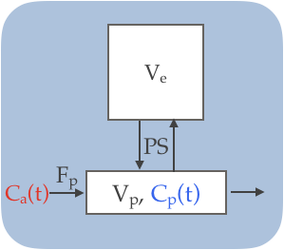 | 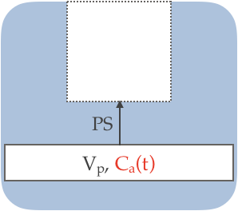 | 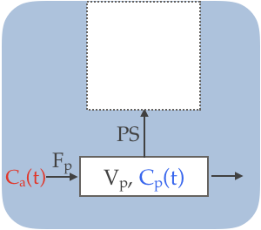
(a) | (b) | (c)
Figure 1. Contrast kinetic models considered in this study. (a) Two-compartment exchange model (TCM). (b) Patlak model (PM), (c) Extended Patlak model (EPM).

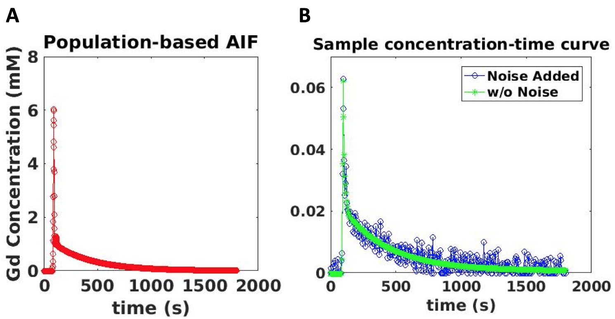

Figure 2. Examples of time-intensity curves used in the simulation study. (a) Population based arterial input function(AIF). (b) An example of tissue time-concentration curve with v_{e}=0.2, v_{p}=0.02, F_{p}=1.0 min⁻¹, and PS=0.001 min⁻¹.

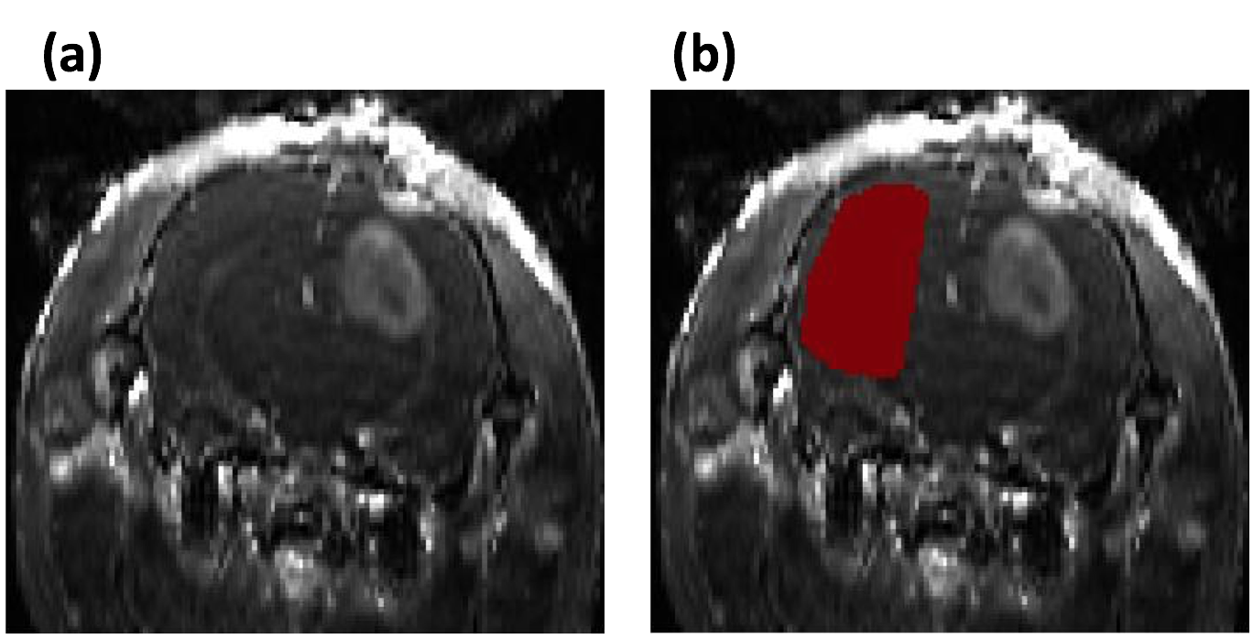
Figure 3. Representative post-contrast images of a rat brain with tumor. (a) T1 weighted image. (b) An ROI (ref) selected for the normal appearing brain parenchyma in the contralateral side.

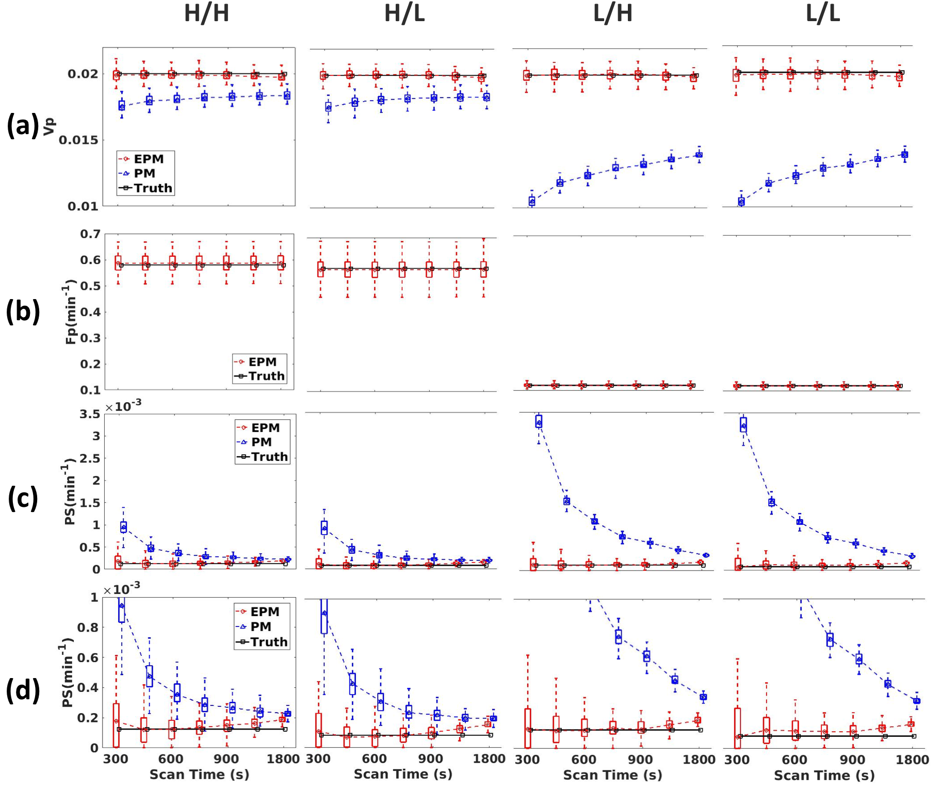

Figure 4. Summary of the numerical simulation study to assess the effect of scan time on contrast kinetic parameters. The simulation study was conducted with four different conditions of true F_{p} and PS as shown in Table 1. Each column of box-whisker plots presents the result for one of four conditions: H/H, High F_{p}/High PS; H/L, High F_{p} /Low PS; L/H, Low F_{p} /High PS; L/L, Low F_{p} /Low PS. Each row shows one of contrast kinetic parameters; (a) v_{p}, (b) F_{p}, (c) PS, (d) PS with a reduced range of y-axis.

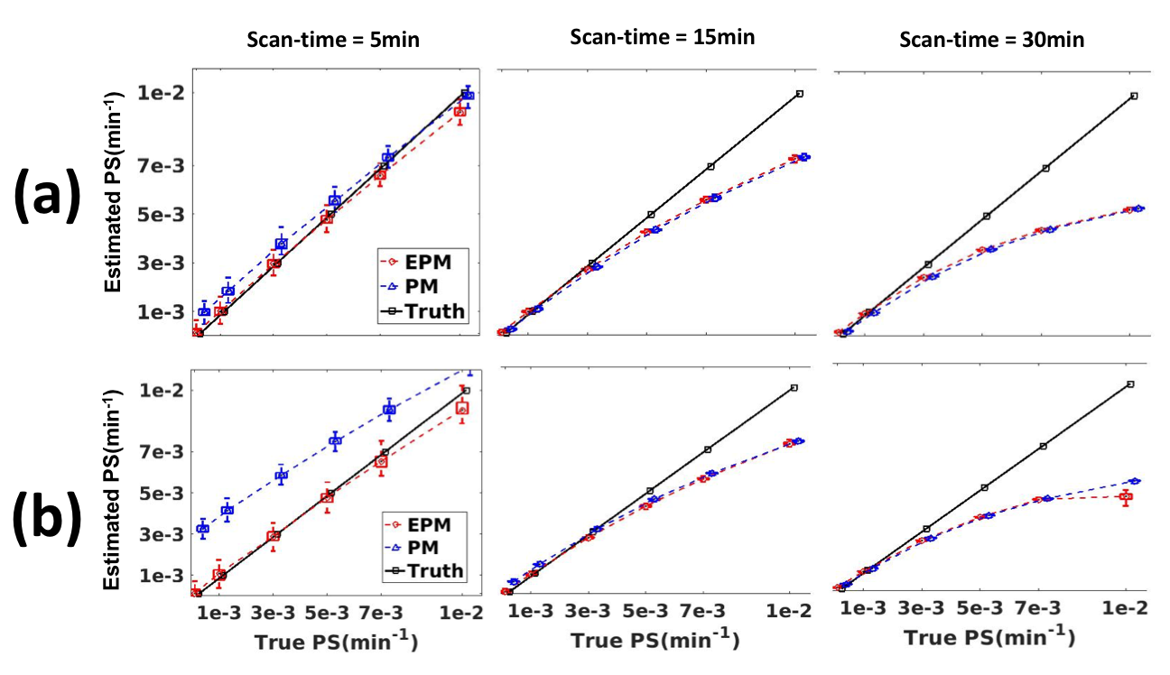

Figure 5. Box-whisker plots of the PS values estimated using the PM (blue triangles) and EPM (red boxes) when the true PS values are between 10⁻⁴ and 10⁻² min⁻¹. This simulation study is conducted for two conditions: the true flow(F_{p}) being high and low. (a) Results with high true F_{p}, (b) Results with low true F_{p}

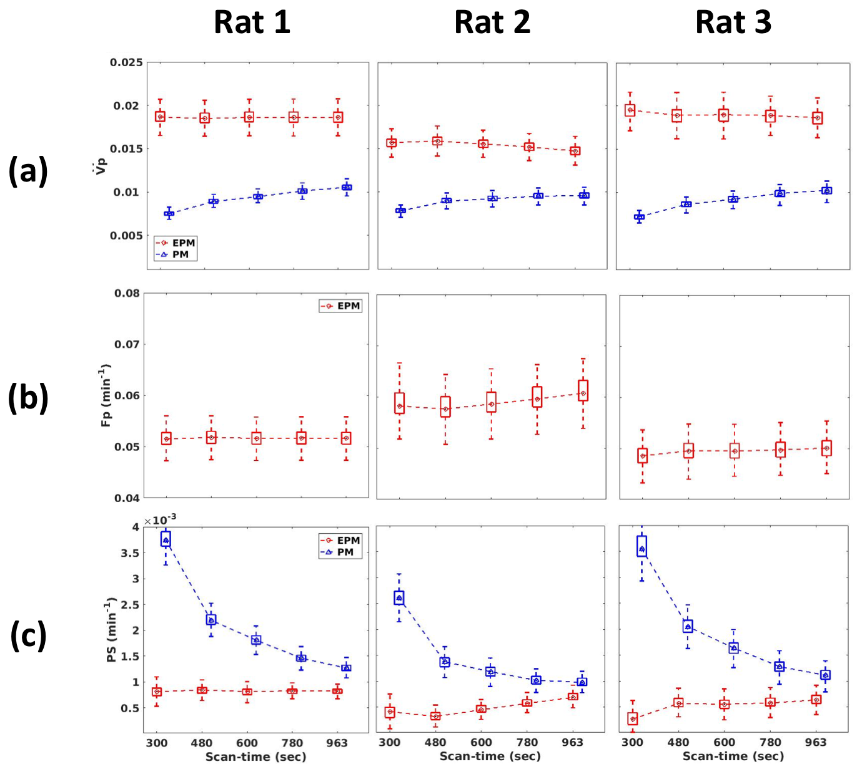

Figure 6. Contrast kinetic parameters, v_{p} (a), F_{p} (b), and PS (c), estimated from normal appearing brain parenchyma of three rat brains are shown using box-whisker plots.

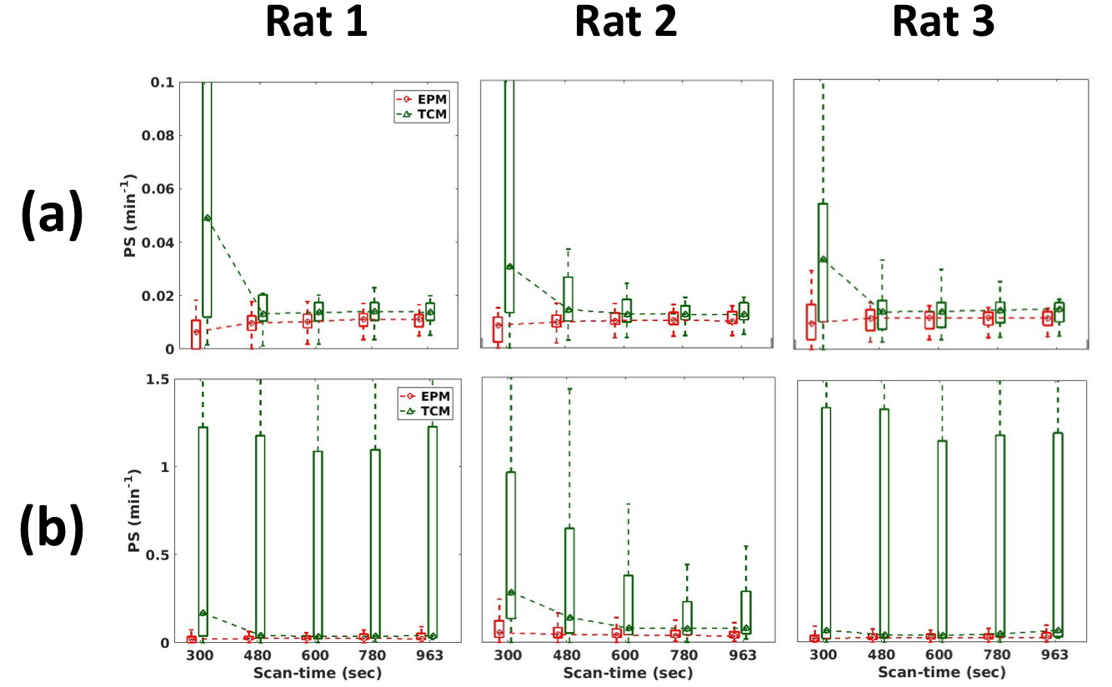
Figure 7. Box-whisker plots of PS estimated from the peri-tumor region (a) and tumor region (b).

