Supporting Information

Transcription factor scleraxis vitally contributes to progenitor lineage direction in wound healing of adult tendon in mice

Tomoya Sakabe, Keiko Sakai, Toru Maeda, Ataru Sunaga, Nao Furuta, Ronen Schweitzer, Takako Sasaki, and Takao Sakai

(Supplementary Figure 1 – Figure 10)

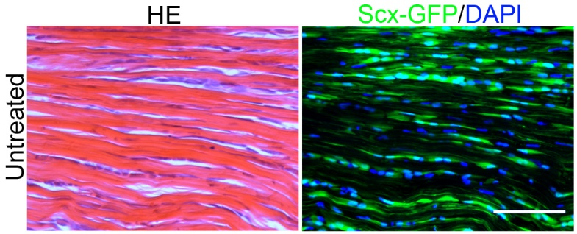

Supplementary Fig. 1. Normal morphology, and robust ScxGFP expression in Achilles tendon of adult 10-week-old ScxGFP mice. Scale bar = 100 μm.

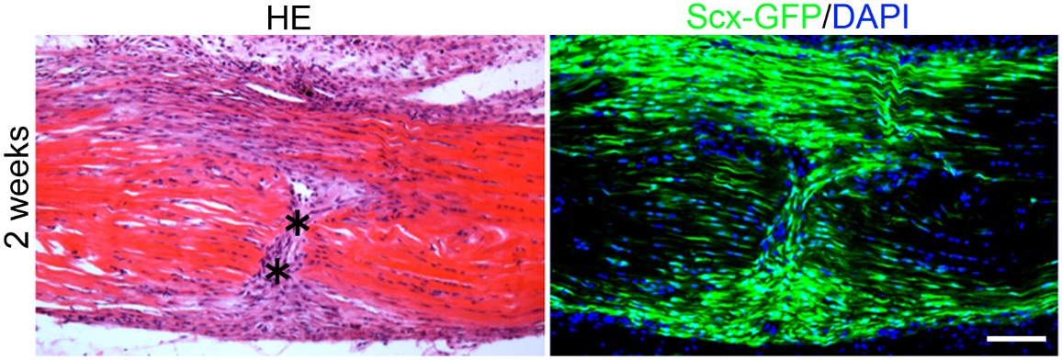

Supplementary Fig. 2. Histological analysis of Achilles tendon in the partial transection model at 2 weeks after tendon injury (at low magnification). HE staining (left panel) and the same area with GFP/UV filter (right panel; green, ScxGFP; blue, nuclear staining with DAPI). Asterisks in HE sections indicate wounds. Scale bar = 100 μm.

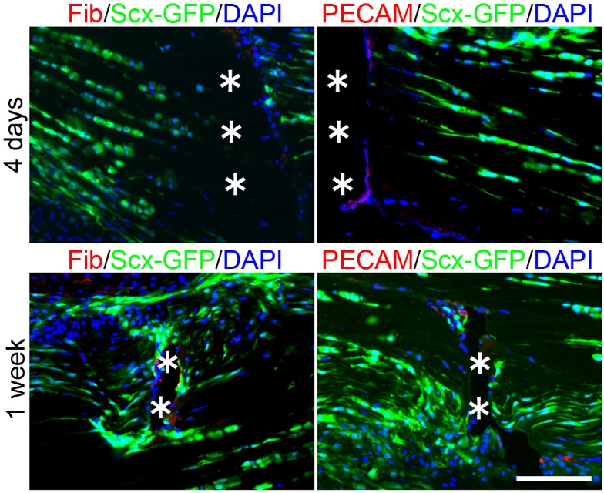

Supplementary Fig. 3. Tissue distribution of fibrinogen and PECAM at 4 days and 1 week after tendon injury. Triple immunofluorescence staining for fibrinogen (Fib) or PECAM (red)/ScxGFP (green)/ DAPI (blue). Asterisks indicate wounds. Scale bar = 100 μm.

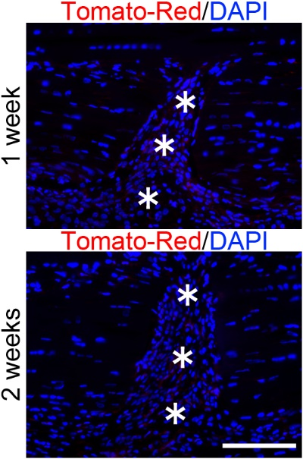

Supplementary Fig. 4. Tissue distribution of bone-marrow-derived cells at 1 and 2 weeks after tendon injury in mice treated with bone marrow transplantation. Double immunofluorescence staining for bone-marrow-derived cells (Tomato-Red)/DAPI (blue). Asterisks indicate wounds. Scale bar = 100 μm.

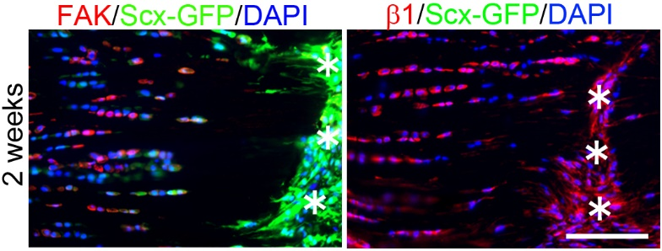

Supplementary Fig. 5. Tissue distribution of focal adhesion kinase (FAK) and β1 integrin positive cells at 2 weeks after injury. Triple immunofluorescence staining for tyrosine 397-phosphorylated FAK (pFAK-Tyr397) or ligand inducible active β1 integrin (red)/ScxGFP (green)/ DAPI (blue). Asterisks indicate wounds. Note that sections for activated β1 integrin staining were fixed in methanol, resulting in the loss of ScxGFP signals. Scale bar = 100 μm.

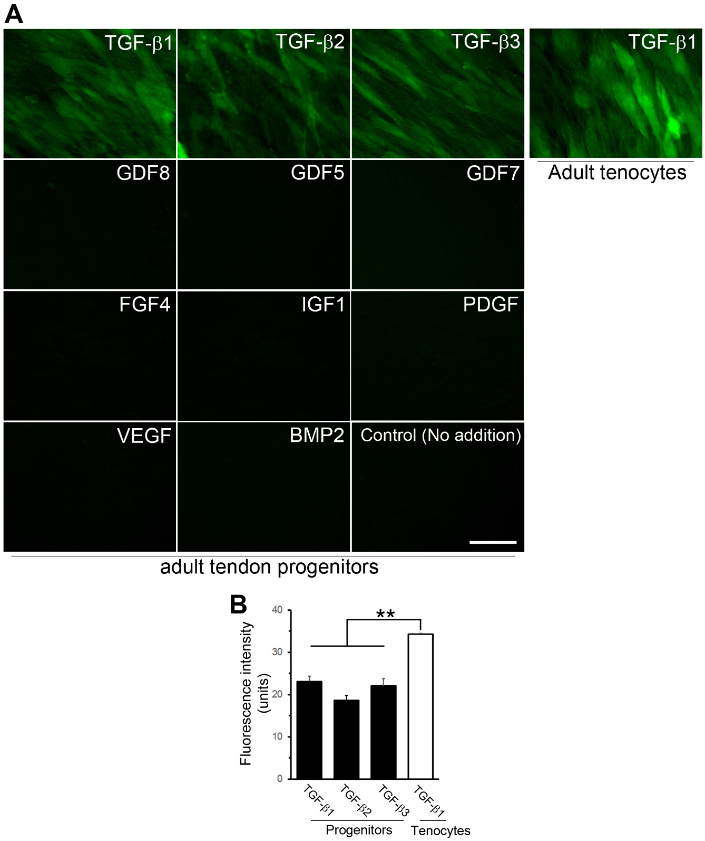

Supplementary Fig. 6. Effects of cytokines and growth factors on ScxGFP expression in adult progenitor cell lines in vitro.
(A) Tendon progenitor cells were cultured for 48 hr, then cytokines/growth factors (TGF-β1, -β2 and -β3, 2 ng/mL; GDF8, 500 ng/mL; GDF5, 2.0 μg/mL; GDF7, 1.0 μg/mL; FGF4, 20 ng/mL; IGF-1, 50 ng/mL; PDGF, 20 ng/mL; VEGF, 100 ng/mL; and BMP2, 200 ng/mL) were added for a further 7 days. The addition of TGF-β1, -β2 and -β3 resulted in the induction of ScxGFP expression. None of the other cytokines/growth factors had any effect on the regulation of ScxGFP expression. Control (no addition), DMEM containing 1% FBS. Scale bar = 100 μm.
(B) Analysis of ScxGFP intensity in progenitors and tenocytes treated with TGF-βs. The intensity is shown relative to the control value of 100 (treated with TGF-β1). Error bars represent the standard deviation (n = 6 for each group). The intensity of ScxGFP in progenitors is similar after treatment with any of the three TGF-βs. The intensity of ScxGFP in tenocytes treated with TGF-β1 is significantly higher than that in progenitors. **, P < 0.01.

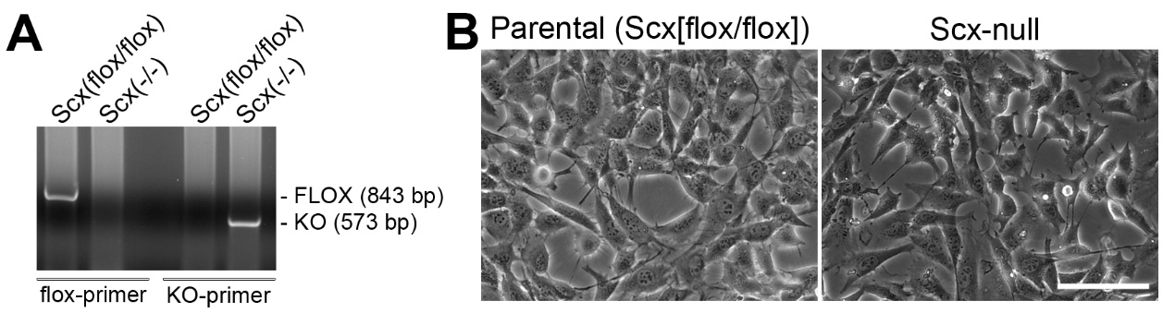

Supplementary Fig. 7. Generation of scx-null tendon progenitor cell lines from adult Achilles tendon.
(A) PCR analysis of adult tendon progenitor clones before and after treatment with a Cre-transducing adenovirus to delete the scx-floxed genes. PCR products for scx-floxed (843 bp) and scx-null (573 bp) are indicated.
(B) Cellular morphology of scx-null and its parental [scx(flox/flox)] progenitor cells under phase-contrast microscopy. Scale bar = 100 µm.

Supplementary Fig. 8. scx-null progenitor cells show a similar osteogenic activity to parental cells in response to BMP2.
(A) Western blot analysis of phospho-Smad1/5/8 (pSmad1/5/8) protein expression in scx-null and parental (control) progenitor cells at 2 and 24 hr after treatment with 200 ng/mL BMP-2 (osteogenesis medium). The band intensities were measured by densitometry and the intensity of the control sample band at 2 hr after BMP-2 treatment was set to 1. Each value is shown relative to this control value. The positions of molecular weight marker are indicated.
(B) Real-time PCR analysis of runx2 mRNA level at 72 hr after treatment with 200 ng/ml BMP-2 (osteogenesis medium). Relative mRNA expression level is shown relative to the control value of 1. Error bars represent the standard deviation (n = 3 for each group). n.s., not significant.

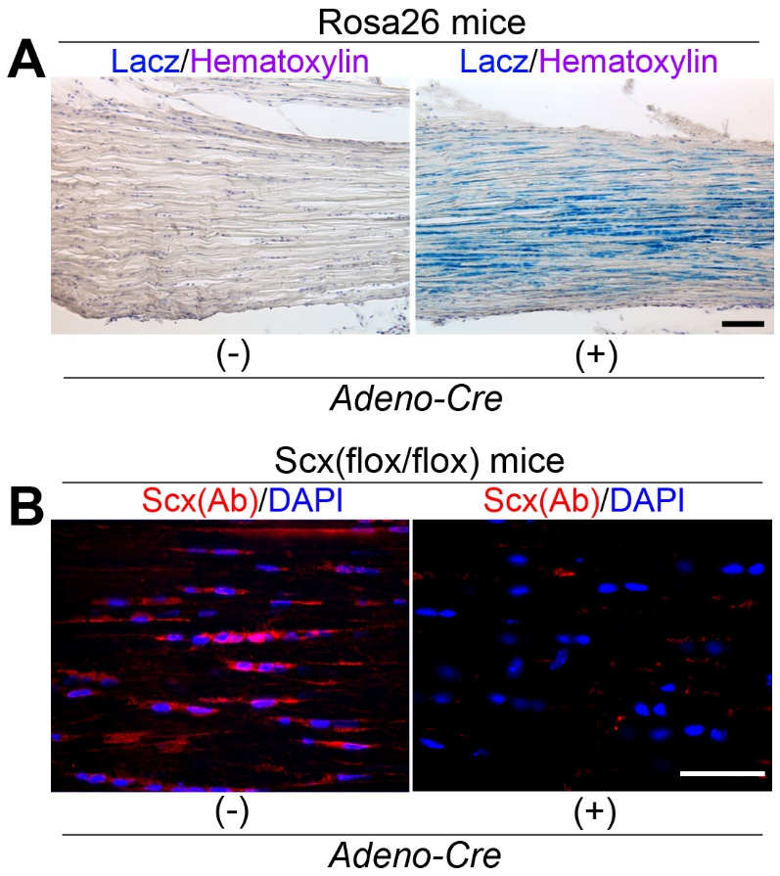

Supplementary Fig. 9. Inactivation of Scx from adult tenocytes by local injection of adenovirus-Cre.
(A) LacZ staining of the Achilles tendon in Rosa26 mice at 1 week after local injection of adenovirus-Cre or PBS into Achilles tendon. Double staining for LacZ and hematoxylin. Scale Bar = 100 μm.
(B) Immunostaining for Scx (Scx[Ab]) in the Achilles tendon of scx(flox/flox) mice at 1 week after local injection of adenovirus-Cre or PBS. The expression of Scx is markedly decreased in adenovirus-Cre-treated Achilles tendon. Scale bar = 100 μm.

Supplementary Fig. 10. Generation of tenocyte lines overexpressing mutated Scx.

(A) Diagram of full-length scx and mutated-scx molecules. Basic, basic DNA-binding domain; Flag, Flag-tag; HLH, helix-loop-helix protein interaction domain; P, proline rich domain.

(B) Western blot analysis of lysates from flag-tag/mutated Scx fusion protein transfected cells (ScxΔBasic, overexpressing the basic DNA-binding domain-deleted Scx and flag-tag fusion protein; ScxΔHLH, overexpressing the helix-loop-helix protein interaction domain-deleted Scx and flag-tag fusion protein). After protein transfer, the membrane was cut and performed immunoblot using anti-flag-tag and anti-Scx antibodies. The position of a molecular mass marker (kDa) is indicated. β-actin served as a loading control. The molecular size of the mutated ScxΔBasic and ScxΔHLH detected with anti-Scx antibody is completely identical to that detected with anti-flag antibody.

