Anti-loosening performance of coatings on fasteners subjected to dynamic shear load
Junbo Zhou ª, Jianhua Liu ª, Huajiang Ouyang ^{b}, Zhenbing Cai ª, Jinfang Peng ª, Minhao Zhu ^{a,}*
a Tribology Research Institute, Southwest Jiaotong University, Chengdu 610031, China
b School of Engineering, University of Liverpool, Liverpool L69 3GH, UK
Abstract:
Self-loosening issues of fasteners under dynamic shear load have been investigated in this paper. Three kinds of typical coatings, PTFE, MoS₂, and TiN, are applied to bolts and nuts tested in this investigation. This paper reveals the loosening mechanisms of fasteners and assesses the anti-loosening performance of three coatings by the tightening characteristics, loosening curves and the damage of thread surface, as well as comparison with the anti-loosening performance of three coatings under different load forms. The results indicate that PTFE coating and MoS₂ coating have a significant anti-loosening effect, whereas the anti-loosening performance of TiN coating is not so satisfactory. And an appropriate increase of initial tightening torque can significantly improve the anti-loosening effect. In addition, microscopic analyses of PTFE coating and MoS₂ coating demonstrate that a reduced initial tightening torque leads to fretting wear on the thread contact surfaces of fasteners, thereby aggravating the damage.

Key words: bolted fastener, loosening curve, fretting, coating, dynamic shear load

1 Introduction
Two kinds of the most common modes of threaded fasteners failure under dynamic loads are fatigue and self-loosening. Self-loosening is often encountered when threaded fasteners are subjected to transverse or shear load. Self-loosening can cause gradual loss or even complete loss of the clamping force in bolted connections. Ultimately, it is likely to lead to the occurrence of severe safety incidents. There has been much research on this topic. Self-loosening mechanisms [1-16] and various influencing factors [17-21] were studied through experiments, theoretical analysis and numerical simulation. A variety of measures were proposed to prevent self-loosening, such as chemical locking [21], Step Lock Bolt (SLB) [22], double-nut [8, 23] et al. However, loosening of threaded fasteners is still common. Therefore, the study of loosening mechanisms and improvement in anti-loosening performance are still an important issue which is worthy of in-depth research.
Over recent years, the loosening process of threaded fasteners had been extensively studied under different loading conditions. However, there has not been a universal acceptance of the mechanisms of the self-loosening process. Early works focused on loosening due to axial loading (dynamic loads acting along the fastener axis) [1-6]. Goodier et al. pointed out that radial sliding motions between the threads of the bolt and the nut or the interfaces of the clamped bearing surfaces were important factors for loosening of a threaded coupling structure under axial vibration [1]. Basava and Hess found that the clamping force could remain steady, decrease or increase when the assembly was subjected to axial vibration, which was related to the vibration frequency, amplitude and the frictional force between the contact surfaces [2]. However, Sakai pointed out that the clamping force might be reduced under the axial vibration [3]. Nassar and co-workers suggested that the loosening mechanism was the irreversible plastic deformation of bolts under axial vibration [4, 5]. Liu found that the loosening mechanism of bolted joints under axial excitation was the plastic deformation of the structure and fretting wear between contact surfaces [6].
On the other hand, experimental studies in 1960s by Junker demonstrated that loosening was more severe when a joint was subjected to shear loading [7]. A mass of researchers have focused on the responses under the dynamic transverse load or displacement. Sase found that the loosening of fasteners was mainly caused by two factors under a transverse displacement [8, 22]. One was the relative slip between threads of the bolt and the nut, the other was the relative slip between the bolt (or nut) surface and the surface of the fastened material. The loosening analysis of bolted joints subjected to dynamic shear load was done by Pai and Hess [9, 10]. They found that fasteners loosening occurred as a result of complete or localized slip at the thread and head contact surfaces. Fasteners can loosen under lower loads than that previously expected because of localized slip at the contact surfaces, which was confirmed by Dinger and Friedrich [11]. Shoji found that the relative slip between threads was recurrent, which led to a rotation of the nut large enough to cause the bolt to loosen [12]. Yang further noted that with the increasing number of load cycles, the relative slip gradually accumulated which reduced the preload continuously and eventually resulted in the failure of the connection of the fastening bolts [13]. Studies conducted by Jiang and co-workers revealed that the self-loosening process of bolted joints subjected to a transverse displacement could be divided into two distinguishable stages [14-16]. In the first stage there was no relative rotation between nut and bolt, and loosening was caused by material deformation. The second stage was characterized by obvious backing-off of the nut and rapid decrease of the clamping force.
Coating and lubrication are often used for reducing friction coefficients of threaded fasteners [24, 25]. However, the effect of friction coefficients on the loosening process is controversial. On one hand, increased friction coefficient means an increased friction torque for resisting the relative rotation or slip at the thread and head contact surfaces which plays a role on anti-loosening. Daadbin and Chow described a theoretical model for a threaded connection under impact loading [26]. They found that the increase of the friction coefficient decreased the preload loss. Houari [18] and Karamis [27] showed that the increase of the bearing friction reduced the loosening rate. Zaki and Nassar [19] found increase of the coating thickness decreased friction coefficients of the thread and the head bearing, therefore thick coated fasteners would loosen at a faster rate than thin coated fasteners [28]. Sanclemente discovered that friction coefficients decreased with the application of lubricant which promoted slippage and thereby loosening [20]. However, that paper also pointed out that when lubrication was applied in combination with higher preload, the resulting effect was beneficial for vibration resistance. On the other hand, the torque–tension relationship for threaded fasteners is highly sensitive to friction coefficient variation between the turning surfaces at the head/nut interface and threads [29]. The decrease of friction coefficients increases the preload under the same initial tightening torque which leads to a better anti-loosening performance. Liu pointed out that adding a lubricant of MoS₂ on bolted joints was a good method to prevent loosening when bolted joint was subjected to axial excitation [6]. Hence, the effect of coating on the self-loosening of threaded fasteners should be investigated.
Solid lubricating coatings are highly regarded in scientific and industrial communities due to their excellent friction reduction and wear resistance properties [30]. Coating used on fasteners can change friction coefficient and thus different coatings have a different anti-loosening performance. However, there is very little research on the anti-loosening performance of coatings. PTFE is one of the most commonly used solid lubricants, which exhibits an ultra-low coefficient of friction [31]. MoS₂ is a popular solid lubricant used widely in machinery equipment to reduce or eliminate various wear damage [32]. TiN coating is widely used to enhance the surface properties under wear and corrosion conditions due to its attractive properties such as high hardness, high adhesion strength [33, 34]. Research on the anti-loosening performance of these typical coatings will provide theoretical support and engineering guidance to prevent loosening for bolt-connected structures.
In this paper, two kinds of typical anti-friction coatings (PTFE and MoS₂) and anti-wear coating (TiN) are applied to fasteners and investigate their anti-loosening performance under dynamic shear load. The evolution curves of the clamping force of bolts are obtained and the damages of the thread surfaces in contact are analysed. This paper reveals the mechanism of loosening as fretting of surface coating and assesses the anti-loosening performance of these typical coatings. In addition, this paper also explores the differences of the anti-loosening performance of three coatings under different load forms.

2 Experimental details

2.1 Test device and parameters
Self-loosening experiments of fasteners are carried out by the electro-hydraulic servo fatigue testing machine with a custom designed testing fixture under cyclic shear load. The schematic of the test machine is shown in Fig. 1. The upper fixture is connected to the grip of the fatigue testing machine while the lower fixture is fixed to the test stand. The upper and the lower fixtures are made of 1045 steel with the thickness of 25mm. The upper fixture and the lower fixture are clamped by a bolt and a nut. The load cell is placed between the upper fixture and the lower fixture. It is connected to a data acquisition system in order to real-timely monitor the clamping force. In order to protect the load cell from fretting wear, two thin washers made of aluminium alloy are placed between the load cell and the bolt testing fixture.
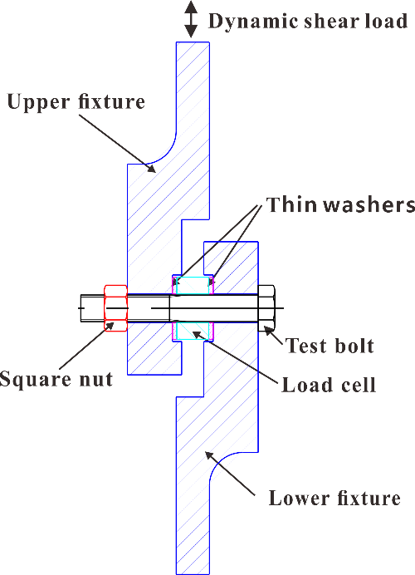
Fig. 1 Schematic of the test machine
Load-controlled experiments are conducted. Dynamic shear load is the controlling parameter which is applied by the fatigue testing machine and measured by high-precision mechanical sensors.
According to the related standard, an appropriate level of preload corresponds to 60–70% of the nominal yield strength of the bolt [35]. Accordingly for M12mm grade-8.8 bolts, the proper preload ranges from 18.2kN to 21.2kN. Therefore, the self-loosening experiments in the study are conducted with a preload of 20kN, a median value between 18.2kN and 21.2kN. However in practice, controlling-torque method is adopted to control preload. An initial tightening torque (M₀) is applied to achieve a specified torque through slowly tightening the bolt using a digital torque wrench. In order to assess the anti-loosening performance of different coatings more effectively, two groups of experimental parameters are selected: (a) applying the same initial tightening torque M₀ =72Nm; (b) applying the same preload P₀ =20kN.
Preliminary tests of uncoated fasteners for self-loosening experiment are performed to determine the test parameters. In the preliminary tests, four different dynamic shear load levels are applied in experiments, which respectively are ±4kN, ±6kN, ±7kN and ±8kN. It is found that when the shear load is ±4kN, the self-loosening curve is similar to the loosening curve under the shear load of ±6kN. When the shear load increases to ±7kN or ±8kN, the bolts become completely loosened in less than 5000 cycles. The reason may be that when the shear load is large enough to overcome the static friction between the two clamping plates, an excessive lateral slippage between them occurs and the clamping force decreases quickly. So the dynamic shear load is selected as ±6kN in experiments of coated fasteners. In the preliminary tests, two loading regimes of 200000 and 1000000 cycles are used and it is found that the self-loosening curve yields similar results. To save time, 200000 cycles of loading is used in experiments of coated fasteners.
The reason for choosing the frequency in the tests as 10Hz is as follows. First, the frequency of 10Hz is the frequency commonly used in the field of mechanical engineering. For example, fasteners on train bogies are subjected to an excitation of frequency of about 10Hz. Secondly, for the electro-hydraulic servo fatigue testing machine, the frequency of 10Hz is relatively easy to achieve. So all experiments are conducted at a frequency of 10Hz in air at room temperature.

2.2 Preparation and characterization of coatings
Bolts and nuts used in this study are M12×1.75 mm of grade 8.8. In order to reduce the dispersion of preload and loosening values, a number of high-quality bolts and nuts are machined using 1045 steel. Relevant parameters and thread profile of the testing bolts can be found in the reference [35]. The composition and main characteristics of 1045 steel are listed in Tables 1 and 2, respectively.
Table 1 The chemical composition of 1045 steel (wt. %)
Material | C | Si | Mn | Ni | Cr | P | S
1045 Steel | 0.45 | 0.27 | 0.65 | 0.25 | 0.25 | ≤0.04 | ≤0.04
Table 2 The main characteristics of 1045 steel
Material | Yield strength  /MPa | Tensile strength  /MPa | Elastic modulus  /GPa | Poisson's ratio
1045 Steel | 650 | 850 | 210 | 0.3
Three kinds of typical coatings, PTFE, MoS₂ and TiN, are applied to blots and nuts to study the effect of coatings on loosening. As previously mentioned, Nassar and Zaki [19] found that the increase of the coating thickness decreased the friction coefficient between threads and the friction coefficient between the bolt (or nut) and the bearing surface. Therefore, the coating thickness may affect the loosening behaviour and it is necessary to choose the appropriate coating thickness before coating preparation. On one hand, if the thickness of coating is too small, the coating may be worn out quickly during the pre-loading process. On the other hand, if the coating thickness is too large, the fit between the bolt and the nut would be affected, resulting in difficulty in applying tightening torque. Thus, the thickness of the coating is chosen to be a reasonable value of 15 micrometers for PTFE coating or MoS₂ coating. As to TiN coating, since TiN coating is a typical anti-wear coating, the thickness of TiN coating can be appropriately reduced. Thus, the thickness of TiN coating is chosen as 5 micrometers.
The preparation of the three coatings is as follows: (1) PTFE coating is prepared using spraying. The fine PTFE powders are uniformly dispersed in adhesive of epoxy. After descaling, rusting and sand blasting, the mixture is sprayed onto the surfaces of fasteners by a spray gun. Then the coating is solidified by heat curing at 200 °C for 1 hour. The thickness is 15±1μm. (2) MoS₂ coating is prepared in a similar way to PTFE coating. The thickness is also 15±1μm. (3) The PVD TiN coating, with thickness of 5±1μm, is deposited on the fasteners by an ion-plating equipment (MIP-800) at a bias voltage of -100 V to -150 V and a mixed gas (N₂ + He) pressure of 0.6Pa. The characteristic parameters of coatings are listed in Tables 3.
Table 3 The characteristic parameters of coatings
Coatings | Preparation | Thickness | Hardness
PTFE | spraying | 15±1μm | 23±2 HV
MoS₂ | spraying | 15±1μm | 60±5 HV
TiN | PVD | 5±1μm | 2500±200 HV
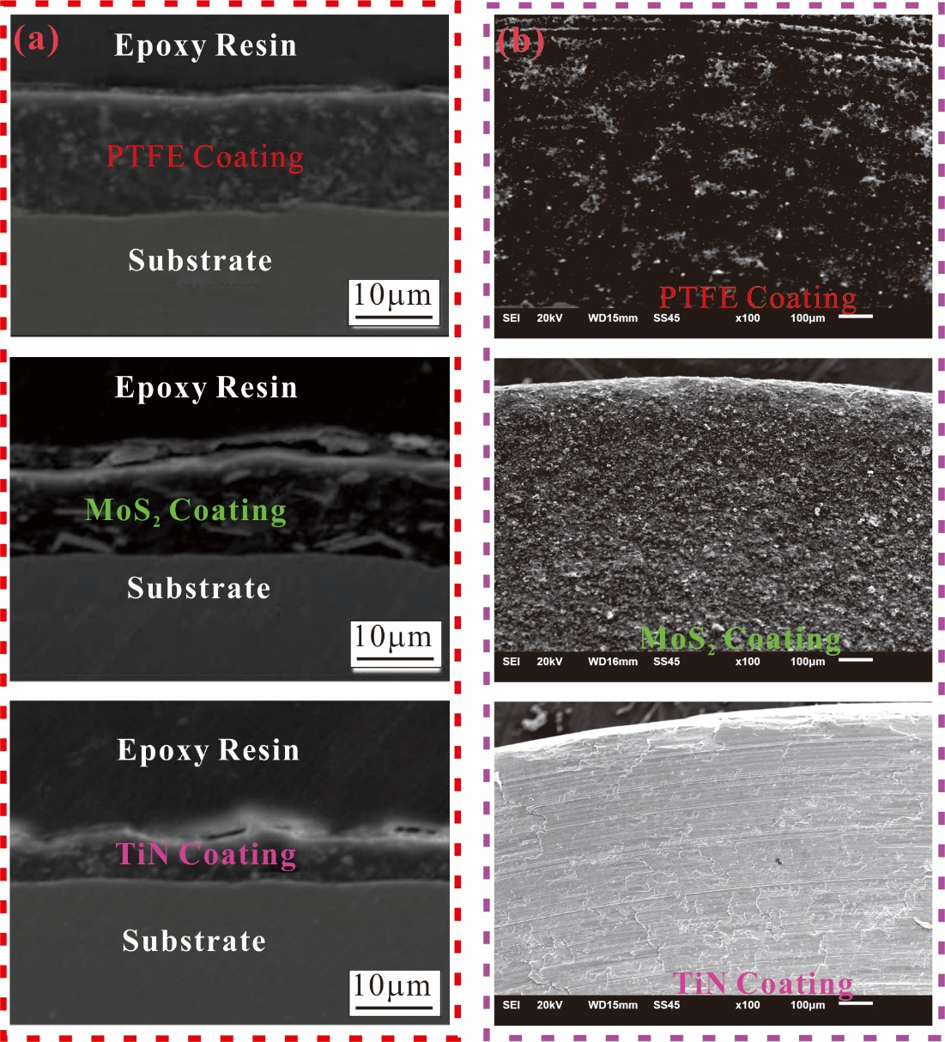
Fig.2 The morphology of the fastener after coating treatment
(a) the cross sectional morphology of coating/substrate, (b) the thread surface of coated fasteners
Fig. 2 shows the morphology of the fasteners after coating treatment. Fig. 2(a) shows a cross sectional morphology of coating/substrate. It can be seen from Fig. 2(a) that the thickness of coatings does not change significantly in the observation range. Fig. 2(b) shows the thread surface morphology of the three kinds of coated fasteners. It can be seen that there is no spalling in either coatings. Based on the above observations, we believe that the three coatings are sufficiently uniform.
All test specimens, screws, washers and fixtures are cleaned with acetone to remove surface contamination before self-loosening testing. As a comparison, some uncoated fasteners are also tested.
Each self-loosening experiment is repeated five times for coated fasteners and uncoated fasteners at identical test parameters. After self-loosening tests, the morphologies of wear scar are examined by a scanning electron microscope (SEM) and chemical compositions of damage zone are analysed by Energy Dispersive X-ray (EDX).

3 Results and discussion

3.1 The anti-loosening performance of three coatings
The loosening degree (ϕ) is defined as the ratio of the loss of preload and the initial preload [20].
(1)
Where P_{i} is the remaining preload after the test, P₀ is the initial preload.
The loosening degree is a dimensionless variable which is simply a measure or indication of preload loss. A low value of the loosening degree means a slight loosening of bolted fasteners and thus a better anti-loosening performance, and vice versa.
Fig. 3 shows the experimental results of self-loosening of three coated fasteners under the same initial tightening torque M₀ =72Nm. The median value of the repeated test data is taken as the experimental results. It is worth noting that the PTFE coated fastener begin slipping when the tightening torque is 60Nm. So the initial tightening torque is selected as 60Nm for PTFE coated fastener.
It is observed form Fig. 3 that different coatings result in quite different anti-loosening performances under the same initial tightening torque. As shown in Fig. 3(a), the clamping force of PTFE coated fasteners is virtually no change and the loosening degree of PTFE coated fasteners is close to zero (Fig. 3(b)). The clamping force of MoS₂ coated fasteners does not obviously decline and the average degree of loosening is only 8.08%, which decreases by 70% with uncoated fasteners as a comparison. More importantly, adding PTFE and MoS₂ coated fasteners can reduce the scatter of test data of the loosening degree thereby improving the reliability of bolted structures. The variance of loosening degree decreases by nearly 85% compared with uncoated fasteners. Therefore, PTFE coating and MoS₂ coating have a significant anti-loosening performance.
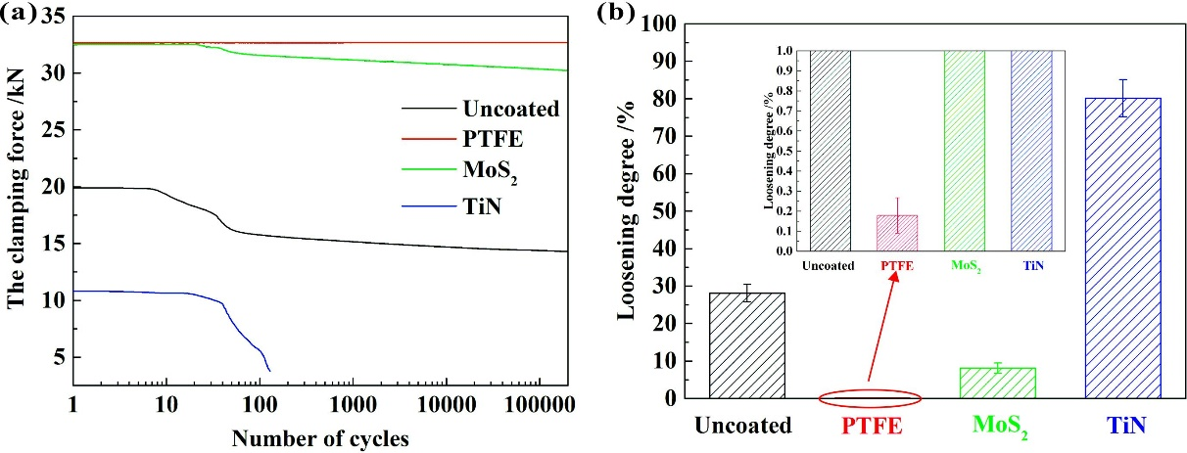
Fig. 3 Self-loosening experimental results of three coatings under the same initial tightening torque: (a) self-loosening curves, (b) loosening degree.
（f=10Hz, M₀=72Nm, N=2×10⁵）
TiN coating on fasteners achieves an opposite result. The preload is only approximately 12kN when the initial tightening torque is 72Nm. It should be pointed out that Fig. 3(b) shows the loosening degree of TiN coated fasteners is around 80%. However, the actual situation is likely to be more serious than 80%. What happened in the laboratory experiments was that, when the clamping force decreased to 4kN, the dynamic shear load can no longer be applied and loosening tests were aborted due to the excessive displacement between the upper fixture and lower fixture. It can be concluded that TiN coating allows complete loosening under the initial tightening torque (M₀=72Nm). Therefore, a fastener with TiN coating has an insignificant effect on anti-loosening performance under this initial tightening torque.
Under the same initial tightening torque, the anti-loosening performance between different coatings is very obvious, which is attributed to the difference in tightening characteristic of various coatings. It is assumed the threads friction coefficient μ_{t} equals to the friction coefficient between the bolt (or nut) and the bearing surface μ_{b} under various experimental parameters. The tightening characteristics of various coatings can be theoretically calculated using Eq. (2) and Eq. (3) [36-37].
(2)
(3)
where M₀ is the tightening torque applied to the bolt head/nut; P₀ is the preload; K is the nut factor; P is the thread pitch; β is half of the thread flank angle; d₂ is the basic pitch diameter of thread; d₀ is the hole diameter of the clamped body; μ_{t} is the friction coefficient between threads; μ_{b} is the friction coefficient between the bolt (or nut) and the bearing surface; r_{t} is the effective contact radius between threads; r_{b} is the effective bearing radius of the bearing contact area under the turning head or nut. The dimensions of the bolts used in this series of tests are given in Table 4.
Table 4. Bolt dimensional details.
Parameters | value
Thread diameter, d | 12 mm
Thread pitch, p | 1.75mm
the thread flank angle,α | 60°
The outer bearing diameter, D₀ | 18.0 mm
The hole diameter of the clamped body, d₀ | 13.0 mm
The effective thread radius , r_{t} | 5.43mm
the effective bearing radius, r_{b} | 7.82mm
Fig. 4 shows the tightening characteristics of various coatings. It is observed from Fig. 4 that coatings have a significant effect on the nut factor and friction coefficients in threaded fasteners. PTFE coating and MoS₂ coating can effectively reduce the nut factor and friction coefficients which decreases by nearly 50% compared with uncoated fasteners. So under the same initial tightening torque, as shown in Fig. 5, the initial preload of fasteners with PTFE coating or MoS₂ coating is approximately doubled of those of uncoated fasteners. Higher preload leads to reduce loosening or no loosening [8, 15, 20]. As to TiN coating, the initial preload is only half of those of uncoated fasteners. Under a lower preload, the friction force decreases and the shear force easily overcomes the friction force and the occurrence of slippage increases, causing the rapid decrease of the clamping force even complete looseness of fasteners (Fig. 3(a)).
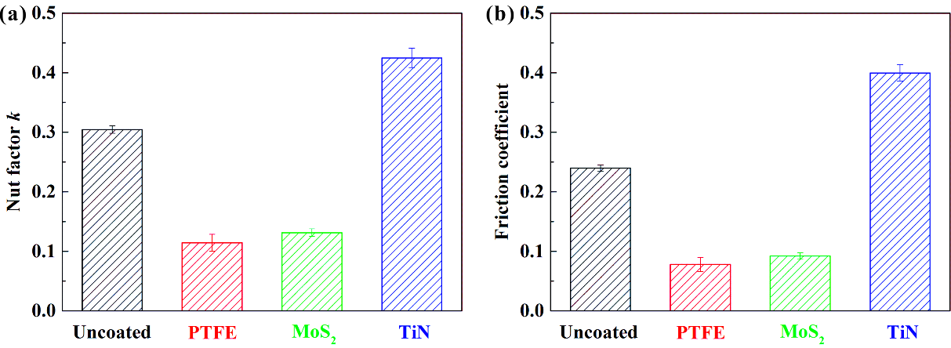
Fig. 4 The tightening characteristics of various coatings. (a) nut factor k (b) friction coefficients
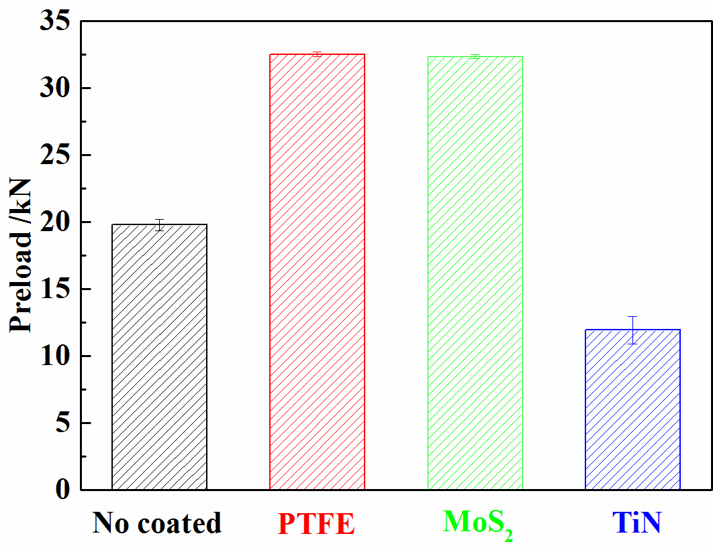
Fig. 5 The preload of coated fasteners under the same initial tightening torque
Fig. 6 shows the self-loosening experimental results of three coated fasteners under the same preload P₀=20kN. It should be noted that the nut factor of TiN coating is so high that fasteners are distorted before the preload reaches 20kN. In several experiments, the preload can only be applied to approximately 19kN. So the initial preload is selected 19kN for TiN coated fasteners.
Fig. 6(a) shows the clamping force reduction with the number of cycles. It is experimentally observed from Fig. 6(a) that a typical self-loosening process due to dynamic shear load can be divided into three distinct stages including a stable stage, a rapid declining stage and a slow declining stage.
(1) The first stage: at the beginning of around 50th cycles, the clamping force is nearly constant. The duration of this stage is not long, only about 5 seconds. This is probably because it takes a few seconds for the testing machine to achieve 6kN (the amplitude of the dynamic shear load). From the beginning of the experiment to obtaining the amplitude of shear load takes a small amount of times which corresponds to this stage.
(2) The second stage: from 50th cycles to about 2000th cycles, the clamping force decreases significantly. This stage corresponds to the second stage of the self-loosening process of bolted joints subjected to a transverse displacement researched by Jiang and co-workers [14-16]. Liu [6] and Yu [38] found that the self-loosening process of bolted joints under axial excitation also had this stage. Previous research showed that the obvious backing-off of the nut [14, 15] and the removal of asperities on contact surfaces in this stage led to reduction of the clamping force. In addition, dynamic shear load generates slippage between the two clamped plates which reduced the clamping force.
(3) The third stage: from 2000th cycles to 200,000 cycles, the clamping force slowly decreases. This may be because of the occurrence of localized slip, so-called partial slip in fretting, at the thread and head contact surfaces under dynamic shear load [10, 11]. Fretting leads to a stable friction coefficient and wear, thereby the clamping force declines slowly.
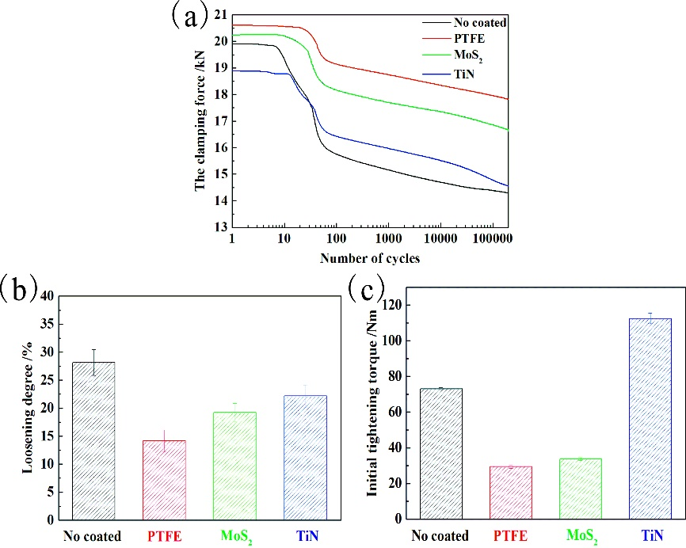
Fig. 6 The self-loosening experimental results of coated fasteners under the same preload: (a) self-loosening curves, (b) loosening degree, (c) initial tightening torque.
（f=10Hz, P₀=20kN, N=2×10⁵）
Fig. 6(b) and Fig. 6(c) show the average and variance of the loosening degree and the initial tightening torque. It can be noticed in Fig. 6(b) that different coatings result in very different anti-loosening performance under the same preload. In terms of loosening degree, PTFE has the best anti-loosening performance while TiN is the worst. The average of loosening degree of PTFE and MoS₂ coated fasteners is respectively 14.17% and 19.20%, which decreases by nearly 40% compared with uncoated fasteners. The average of loosening degree of TiN coated fasteners is only 22.16% which slightly decreases compared with uncoated fasteners. More importantly, adding PTFE coating and MoS₂ coating can reduce the scatter of test data of the loosening degree. The variance of loosening degree of PTFE and MoS₂ coated fasteners decreases nearly 30% compared with uncoated fasteners. Considering the difficulty of generating the same preload P₀=20kN, as shown in Fig. 6(c), the preload of the PTFE coated fasteners can be obtained at a low initial tightening torque level, whereas the TiN coated fasteners cannot obtain the same preload at such a low level of initial tightening torque.
Therefore, PTFE coating or MoS₂ coating not only reduces the loosening degree but also reduces the scatter of test data of the loosening degree thereby improving the reliability of bolted structures. This may be because adding PTFE coating or MoS₂ coating causes friction coefficients and asperity to decreases, thereby the contact area increases and the plastic deformation decreases under the same dynamic shear load. Thus the residual axial clamping force increases and the loosening degree decreases. Past studies have shown that a steel surface coated with a PVD TiN coating has a higher roughness [34]. So the contact areas of TiN coated fasteners are relatively small, thereby the plastic deformation increases under the same dynamic shear load. In addition, the nut factor of TiN coating is so high that it needs to be applied a relatively high initial tightening torque to generating the required preload, resulting in increasing plastic deformation of threaded surface. Thus the residual axial clamping force reduces and the loosening degree increases.
In addition, through comparison between Fig. 3(b) and Fig. 6(b), the anti-loosening performance is more significant under a higher initial tightening torque. When the initial tightening torque is 60Nm, as shown in Fig. 3(b), the loosening degree of PTFE coated fasteners is close to zero which indicates that the anti-loosening performance of PTFE coating is extremely significant. When the initial tightening torque reduces to 30Nm, as shown in Fig. 6(b), the loosening degree increases to 14.17% which indicates that the anti-loosening performance decreases under a lower initial tightening torque. When the initial tightening torque (M₀) is 72Nm, the degree of loosening of MoS₂ coated fasteners is only 8.08% (Fig. 3(b)). When the initial tightening torque reduces to 35Nm, the degree of loosening is 19.20%, more than doubled of that under a higher tightening torque. TiN coated fasteners exhibits complete loosening under the lower initial tightening torque (M₀=72Nm). When the initial tightening torque increases to 110Nm, the loosening degree of TiN coated fasteners is 22.16%, which indicates that adding TiN coating on fasteners has a certain anti-loosening performance under the higher initial tightening torque.

3.2 SEM investigation
It is reported that the distribution of axial load along a fastener is so uneven that the first three threads bear about 70% of the total axial load while the first thread carries more than 30% [39, 40]. Past research indicated that the degree of thread surface damage decreased with the increase of working thread ring [38, 41]. So the damage of the first thread is analyzed using SEM and EDX.
Fig. 7 shows the SEM morphologies and EDX patterns corresponding to wear scar of the first thread surface of uncoated fasteners. It can be seen from Fig. 7 that regions near the top of the thread show serious furrow while other regions show significant delamination. The EDX analyses of wear scars show that point B presents a higher O-element peak than that of point A. Therefore, the main wear mechanism of uncoated fasteners is abrasive wear, delamination and a slight oxidation wear which are typical characteristics of fretting [42].
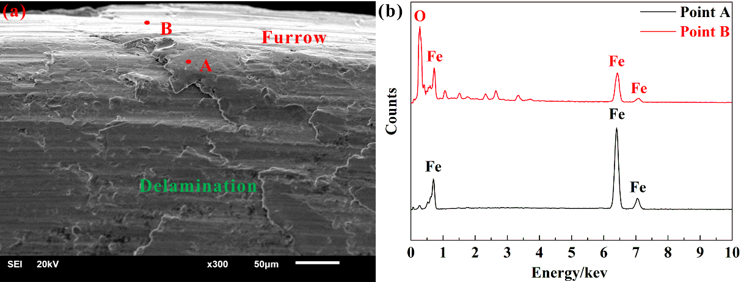
Fig. 7 Microscopic damage for uncoated fasteners: (a) SEM micrograph, (b) EDX spectrum corresponding to point A and point B.
Fig. 8 shows the SEM morphologies and EDX patterns corresponding to wear scars of the first thread surface of the PTFE coated fasteners under different initial tightening torques.
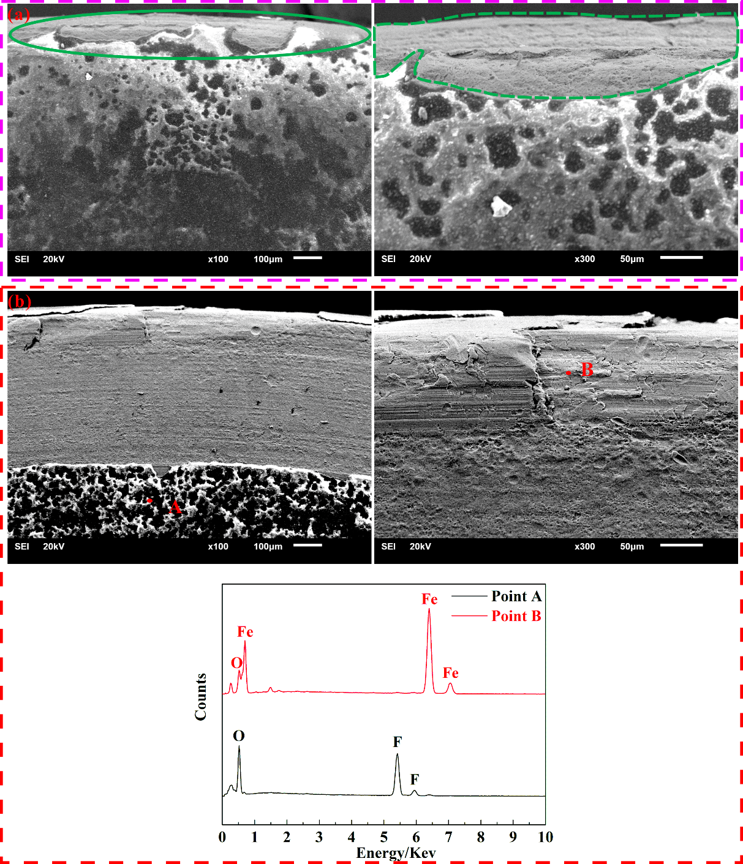
Fig. 8 Microscopic damage for PTFE coated fasteners under (a) initial tightening torque M₀=60Nm, (b) initial tightening torque M₀=30Nm.
It can be seen from Fig. 8 that with the decrease of initial tightening torque, the damage of PTFE coated fasteners exacerbates. Under a higher initial tightening torque, as shown in Fig. 8(a), the damage of PTFE coated fasteners is slight abrasion and exfoliation in the edge regions. When the initial tightening torque reduces to 30Nm, as shown in Fig. 8(b), the wear is more serious. Nearly half of the coating may be removed. Seriously damaged areas occur on the thread edge and it is found that these regions show serious furrow and significant delamination. The EDX analyses of wear scars show that a small amount of O-element is present at point A and point B. This may be because slight oxidation reaction occurs at the threaded surface before the application of coating. It also may be due to oxidation wear during experiments. Therefore, the main wear mechanism of PTFE coated fasteners is fatigue wear, abrasive wear and slight oxidation wear which are in accordance with the typical characteristics of fretting that means fretting wear occurs on the bolt contact surfaces.
Fretting exacerbates damage and leads to a higher loosening degree which indicates that loosening of bolts is closely related to fretting.
Fig. 9 shows the SEM morphologies and EDX patterns corresponding to wear scar of the first thread surface of the MoS₂ coated fasteners under different initial tightening torques. Similar to PTFE coated fasteners, with the decrease of initial tightening torque, the damage of MoS₂ coated fasteners also exacerbates. Under a higher initial tightening torque, as shown in Fig. 9(a), the damage of MoS₂ coated fasteners is slight abrasion and a small amount of areas exhibit exfoliation, mainly in the edge position. When the initial tightening torque reduces to 35Nm, as shown in Fig. 9(b), the damage of MoS₂ coated fasteners is discontinuous. In area I, the material components of point A are analyzed. It is found that the region contains only iron and carbon which suggests that coating of the bolt has been completely removed. The damaged surface in this area shows obvious plastic furrow and delamination phenomenon. In other regions, denoted as area II, the coating displays relatively minor abrasion. The EDX analyses of wear scars show that point B presents Mo-element and S-element which indicates that MoS₂ coating has a good self-lubricating effect. Meanwhile, a small amount of O-element is present at point B. This may be due to oxidation wear during experiments. Therefore, the main wear mechanism of MoS₂ coated fasteners is fatigue wear, abrasive wear, oxidation wear and delamination which are in accordance with the typical characteristics of fretting. Fretting exacerbates damage and leads to a higher loosening degree which indicates that loosening of bolts is closely related to fretting.
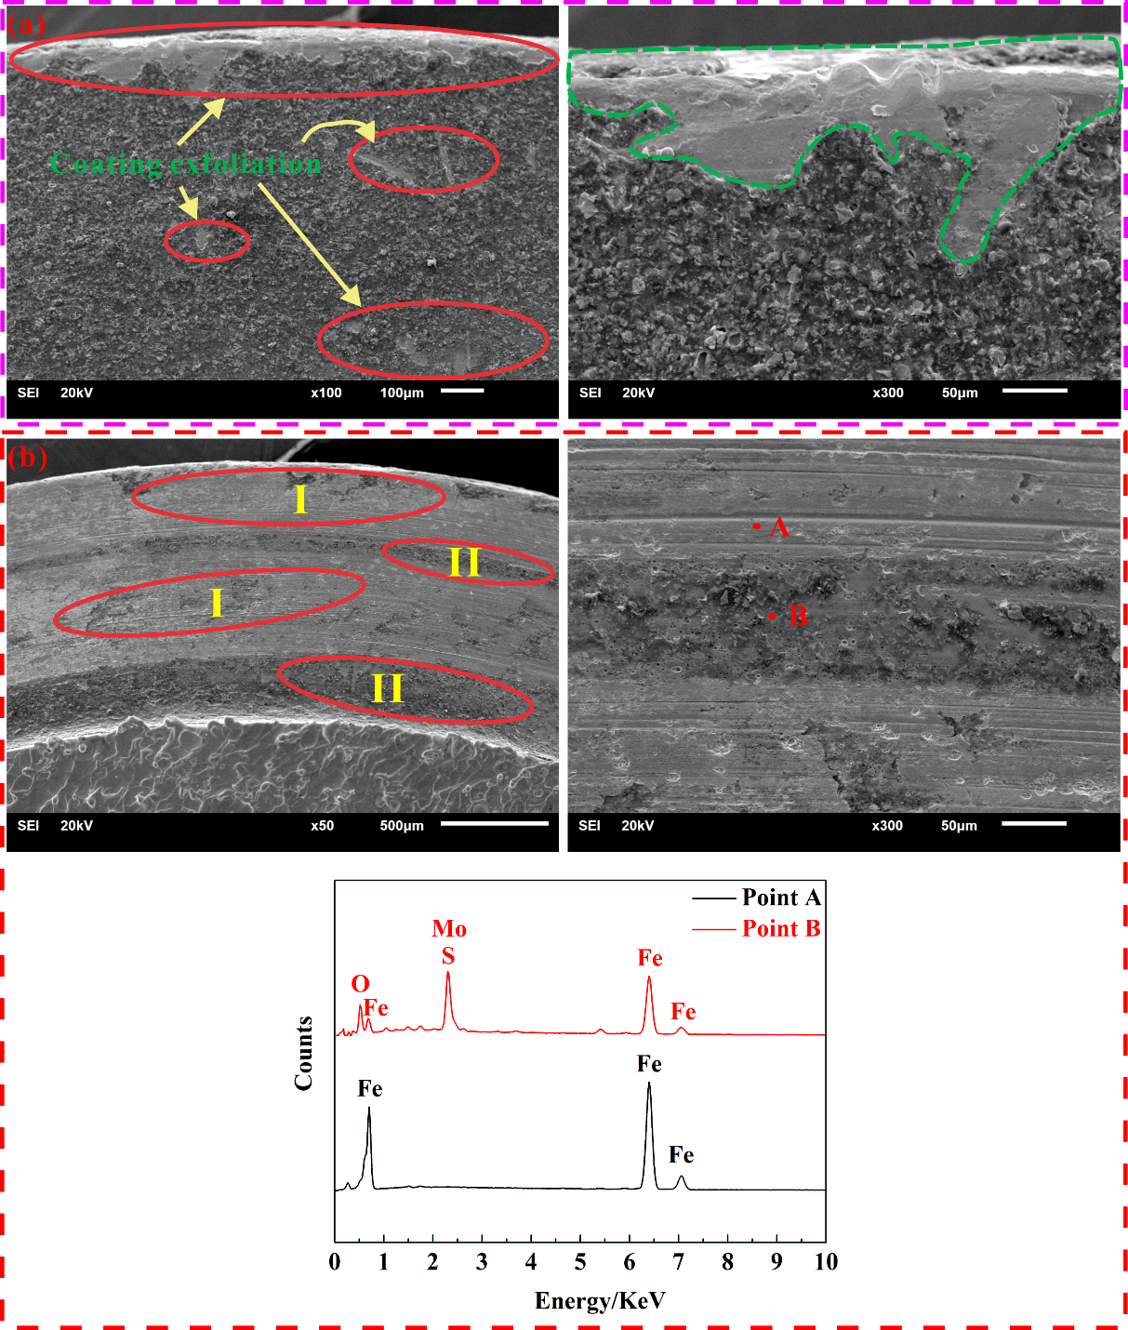
Fig. 9 Microscopic damage for MoS₂ coated fasteners under (a) initial tightening torque M₀=72Nm, (b) initial tightening torque M₀=35Nm.
（f=10Hz, N=2×10⁵）
As to TiN coatings, some TiN coated bolts are distorted during the test. The reason of distortion of TiN coated bolts is that the nut factor of TiN coated fasteners is so high that in order to achieve the same preload, the required tightening torque is larger than for uncoated fasteners. It can be seen from Fig. 6 that the preload of TiN coated fasteners can only be applied to approximately 19kN and the initial tightening torque is approximately 110Nm. Such a high tightening torque may result in a greater frictional stress between the thread contact surfaces. In fact, the bolts undergo serious plastic deformation under this loading condition or even fracture. After loosening testing, some TiN coated fasteners are difficult to unscrew because of distortion or fracture (Fig. 10).
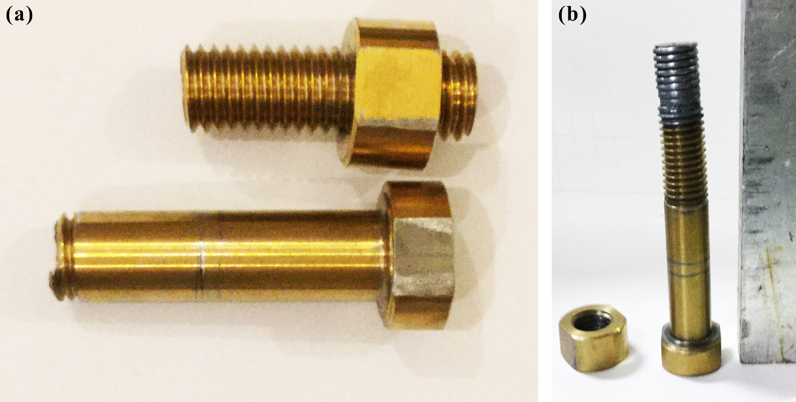
Fig. 10 TiN coated fasteners after loosening tests: (a) fracture (b) distortion.
Therefore, adding TiN coating on fasteners gains a certain anti-loosening performance under the same preload (Fig. 6), however it is not an ideal method to prevent loosening.

3.3 Effects of loading form
Many studies show that loosening was more severe when a joint is subjected to transverse alternating loading than axial alternating loading [7, 17]. However, anti-loosening performance of coating fasteners under the two alternating loading has not been reported in the open literature. The authors’ research team systematically studied the dynamic behaviour of coated fasteners under axial excitation using experimental and numerical methods [43]. The aim of this work is to explore the differences of the anti-loosening performances of three coated fasteners under dynamic shear load and axial load. Fig. 11 shows the loosening degrees of three coated fasteners under two different loading forms.
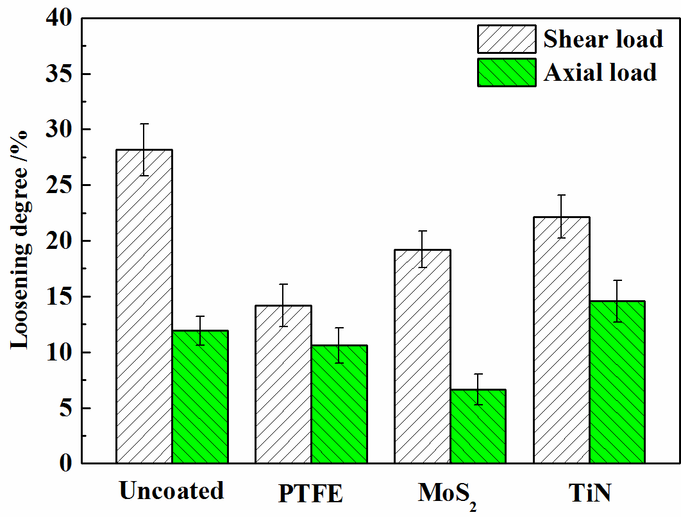
Fig. 11 The loosening degree under different loading forms
It is obvious in Fig. 11 that different load forms result in different anti-loosening performance of coatings. On one hand, when coated fasteners are subjected to shear load, three kinds of coatings demonstrate obvious anti-loosening performances. PTFE coating has the best anti-loosening performance while TiN coating ranks the worst. On the other hand, when coated fasteners are subjected to axial loading, the anti-loosening performance of MoS₂ coating is somewhat encouraging, while TiN coating still ranks the worst with loosening degree being even higher than those of uncoated fasteners. PTFE coating possesses relatively small anti-loosening ability compared with uncoated fasteners.
In addition, it can also be concluded from Fig. 11 that the loosening degree is more severe when the fasteners are subjected to shear load than axial load, especially for uncoated fasteners and MoS₂ coated fasteners. The possible reason is that the shear load is acting in the same direction as the relative slip and thus is more likely to cause relative slip, which may be more likely to lead to fretting damage.
In actual situation, fasteners are likely to withstand both axial and shear loads. To investigate the effect of the direction of the externally applied load, Zhang and Jiang [17] designed an experimental fixture which could change the angle between the directions of the applied force in relation to the contact surface of the two clamped plates. An angle of 0 deg represents the pure shear or transverse loading while an angle of 90 deg represents axial loading. An angle of 30 deg applies both axial and shear loads. The results suggest that an axial load component greatly enhances resistance of the bolted joints to self-loosening. However, their work shows that fatigue dominates failure under axial load component. So fatigue strength may become a great concern when there is a large axial load component.
In summary, compared to fasteners are subjected to shear load, when fasteners withstand both axial and shear loads at the same time, the risk of loosening may be reduced, but risk of fatigue is possible. Such a phenomenon is worth a further investigation in future.

4 Conclusions
According to the results obtained by a series of experiments on fasteners with three different kinds of coatings under different initial tightening torques and dynamic load forms, the following conclusions can be drawn.
(1) PTFE coating and MoS₂ coating have a significant anti-loosening capability and this capability is stronger under higher initial tightening torques. The anti-loosening performance of TiN coating is not very satisfactory.
(2) The loosening curve can be generally divided into three stages: a stable stage, a rapidly declining stage and a slowly declining stage.
(3) The loosening mechanism of coated fasteners is related to fretting under dynamic shear load. Fretting aggravates wear which can readily cause loosening.
(4) The anti-loosening performance of coatings exist obvious differences under shear load and axial load respectively. And the loosening degree is more severe when the fasteners are subjected to shear load than axial load, especially for uncoated fasteners and MoS₂ coated fasteners.

Acknowledgments
The authors gratefully acknowledge the financial support provided by China National Funds for Distinguished Young Scientists (No.51025519), the Changjiang Scholarships and Innovation Team Development Plan (No.IRT1178), and the Self-Topic Fund of Traction Power State Key Laboratory (No. 2016TPL-Z03).

Nomenclature
M₀ Tightening torque applied to the bolt head/nut
P₀ Preload
K Nut factor
P Thread pitch
β   Half of the thread flank angle
d₂ Basic pitch diameter of thread
d₀ Hole diameter of the clamped body
μ_{t} Friction coefficient between threads
μ_{b} Friction coefficient between the bolt (or nut) and the bearing surface
r_{t} Effective contact radius between threads
r_{b} Effective bearing radius of the bearing contact area under the turning
head or nut.

References
[1] Goodier J N, Sweeney R J. Loosening by vibration of threaded fastenings. Mechanical Engineering, 67: 794–800 (1945)
[2] Basava S, Hess D P. Bolted joint clamping force variation due to axial vibration. Sound and Vibration, 210 (2):255-265 (1998)
[3] Sakai T. Mechanism for a bolt and nut self-loosening under repeated bolt axial tensile load. Solid Mechanics and Materials Engineering, 5(11):627-639 (2011)
[4] Nassar S A, Yang X X, Gandham S V T, Wu Z J. Nonlinear deformation behavior of clamped bolted joints under a separating service load. Journal of Pressure Vessel Technology, 133(2):021001 (2011)
[5] Yang X X, Nassar S A, Wu Z J, Meng A D. Nonlinear behavior of preloaded bolted joints under a cyclic separating load. Journal of Pressure Vessel Technology, 134(1): 011206 (2012)
[6] Liu J H, Ouyang H J, Peng J F, Zhang C B, Zhou P Y , Ma L J, Zhu M H. Experimental and numerical studies of bolted joints subjected to axial excitation. Wear, 346–347: 66-77 (2016)
[7] Junker G H. New criteria for self-loosening fasteners under vibration. SAE, Transactions, 78: 314-335 (1969)
[8] Sase N, Nishioka K, Koga S, Fujii H. An anti-loosening screw-fastener innovation and its evaluation. Materials Processing Technology, 77:209–215 (1998)
[9] Pai N G, Hess D P. Three-dimensional ﬁnite element analysis of threaded fastener loosening due to dynamic shear load. Engineering Failure Analysis, 9:383–402 (2009)
[10] Pai N G, Hess D P. Experimental study of loosening of threaded fastener due to dynamic shear loads. Sound and vibration 253(3) 585-602 (2002)
[11] Dinger G, Friedrich C. Avoiding self-loosening failure of bolted joints with numerical assessment of local contact state. Engineering Failure Analysis, 18(8):
2188-2200 (2011)
[12] Shoji Y, Sawa T. Analytical research on mechanism of bolt loosening due to lateral loads. ASME Pressure Vessels and Piping Division Conference. Denver, Colorado, USA (2005)
[13] Yang G X, Xie J L, Xie Y Y. Study on mechanism of anti-loosening of a new type of nut based on fem. Engineering mechanics,12:224-243 (in Chinese) (2010)
[14] Jiang Y, Zhang M, Chu-Hwa Lee. A study of early stage self-loosening of bolted joints. Mechanical Design, 125(3): 518-526 (2003)
[15] Jiang, Y, Zhang M, Tae-Won Park, Chu-Hwa Lee. An experimental study of self-loosening of bolted joints. Mechanical Design, 126(5): 925-931 (2004)
[16] Zhang M, Jiang Y, Chu-Hwa Lee. Finite element modeling of self-loosening of bolted joints. Mechanical Design, 129(2): 218-266 (2007)
[17] Zhang M, Jiang Y, Lee C H. An experimental investigation of the effects of clamped length and loading direction on self-loosening of bolted joints.Journal of Pressure Vessel Technology, 128(3):129-136,(2004)
[18] Housari B A, Nassar S A. Effect of thread and bearing friction coefficients on the vibration-induced loosening of threaded fasteners. Journal of Vibration and Acoustics, 129(4): 484-494 (2007)
[19] Zaki A M, Nassar S A, Xianjie Y. Effect of thread and bearing friction coefficients on the self-loosening of preloaded countersunk-head bolts under periodic transverse excitation. Journal of Tribology, 132(3): 031601-1 (2010)
[20] Sanclemente J A, Hess D P. Parametric study of threaded fastener loosening due to cyclic transverse loads. Engineering Failure Analysis 14: 239–249 (2007)
[21] Anirban Bhattacharya, Avijit Sen, Santanu Das. An investigation on the anti-loosening characteristics of threaded fasteners under vibratory conditions.
Mechanism and Machine Theory 45:1215–1225 (2010)
[22] Sase N, Fujii H. Optimizing study of SLBs for higher anti-loosening performance. Materials Processing Technology, 119:174–179 (2001)
[23] Izumi S, Yokoyama T, Kimurab M, Sakaia S. Loosening-resistance evaluation of double-nut tightening method and spring washer by three-dimensional finite element analysis. Engineering Failure Analysis, 16(5): 1510–1519 (2009)
[24] Zou Q, Sun T S, Nassar S A, Barber G C, Gumul A K. Effect of lubrication on friction and torque-tension relationship in threaded fasteners. STLE/ASME International Joint Tribology Conference October 22-25, San Antonio, TX, USA (2006)
[25] Housari, B A, Nassar, S A. Effect of thread and bearing friction coefficients on the vibration-induced loosening of threaded fasteners. Vibration and Acoustics, 129:484-494 (2007)
[26] Daadbin A, Chow Y M. A theoretical model to study thread loosening. Mechanics and Machine Theory, 27: 69-74 (1992)
[27] Karamiş M B, Selçuk B. Analysis of the friction behavior of bolted joints. Wear 166(1): 73-83 (1993)
[28] Nassar S A, Zaki A M. Effect of coating thickness on the friction coefficients and torque-tension relationship in threaded fasteners. Journal of Tribology, 31:021301-1 (2009)
[29] Bickford J H. Introduction to the design and behavior of bolted joints [M] 4th ed. The Chemical Rubber Company Press, Florida, (2007)
[30] Fan X Q, Xue Q J, Wang L P. Carbon-based solid–liquid lubricating coatings for space applications–A review. Friction, 3(3): 191–207 (2015)
[31] Yuan X D, Yang X J. A study on friction and wear properties of PTFE coatings under vacuum conditions. Wear, 269:291–297 (2010)
[32] Luo J, Zhu M H, Wang Y D, Zheng J F, Mo J L. Study on rotational fretting wear of bonded MoS₂ solid lubricant coating prepared on medium carbon steel. Tribology International, 44: 1565-1570 (2011)
[33] Shan L, Wang Y X, Li J L, Li H. Wu X D, Chen J M. Tribological behaviours of PVD TiN and TiCN coatings in artificial seawater. Surface & Coatings Technology, 226:40-50 (2013)
[34] Paskvale S, Remškar M, Čekada M. Tribological performance of TiN, TiAlN and CrN hard coatings lubricated by MoS₂ nanotubes in Polyalphaolefin oil. Wear, 352-353:72–78 (2016)
[35] Cheng D X. Handbook of Mechanical Design [M]. Beijing: Chemical Industry Press, (in Chinese) (2016)
[36] Nassar S A, El-Khiamy H, Barber, G C, Zuo D J, Sun T S. An experimental study of bearing and thread friction in fasteners. Journal of Tribology, 127(2): 263-272 (2005)
[37] Nassar S A, Barber G C, Zuo D J. Bearing friction torque in bolted joints. Tribology Transactions, 48:69–75 (2005)
[38] Yu Z T, Liu J H, Zhang C Q, Zhou J B, Peng J F, Ma L J, et al. An experimental study on self-Loosening of bolted joints under axial vibration. Tribology, 35(6):732-736 (in Chinese) (2015)
[39] Yamamoto A. Theory and Calculation of thread connection [M]. Translated by Guo K Q, Gao S J, Wang X F et al. shanghai: shanghai scientific and technological literature press (in Chinese) (1982)
[40] Zhao H. Analysis of the load distribution in a bolt-nut connector. Computers and Structures, 53(6):1465-1472 (1994)
[41] Liu J H, Ouyang H J, Ma L J, Zhang C Q, Zhu M H. Numerical and theoretical studies of bolted joints under harmonic shear displacement. Latin American Journal of Solids and Structures, 12(1):115-132 (2015)
[42] Zhou Z R, Zhu M H. Dual-fretting wear [M]. Shanghai: Shanghai Jiaotong University Press, (in Chinese) (2004)
[43] Liu J H. Research on the self-loosening mechanism of bolted joints under axial excitation. Ph.D Thesis. Sichuan (China): Southwest Jiaotong University (2016)

* Corresponding author: Tel.: +86 28 87600715; fax: +86 28 87600723. E-mail address: zhuminhao@swjtu.cn (M. Zhu).

