SUPPLEMENTARY MATERIAL

A genome-wide association study of IgM antibody against phosphorylcholine: shared genetics and phenotypic relation to chronic lymphocytic leukemia

Xu Chen, Stefan Gustafsson, Thomas Whitington, Yan Borné, Erik Lorentzen, Jitong Sun, Peter Almgren, Jun Su, Robert Karlsson, Jie Song, Yi Lu, Yiqiang Zhan, Sara Hägg, Per Svensson, Karin E. Smedby, Susan L. Slager, Erik Ingelsson, Cecilia M. Lindgren, Andrew P. Morris, Olle Melander, Thomas Karlsson, Ulf de Faire, Kenneth Caidahl, Gunnar Engström, Lars Lind, Mikael C. I. Karlsson, Nancy L. Pedersen, Johan Frostegård, and Patrik K. E. Magnusson

Figure S1. Individual genome-wide association studies of IgM anti-PC in the discovery phase

Figure S2. Marks of regulation in the LD block of 11q24.1 from UCSC Genome Browser

Figure S3. Functional prediction of rs35923643 in leukemia- or immune- cells

Figure S4. Evidence for affecting binding from RegulomeDB

Figure S5. IgM anti-PC values before and after the first CLL diagnosis

Figure S6. Global allele frequency of SNP rs735665

Figure S7. Functional partners with RUNX3 predicted from STRING database

Figure S8. Potential functional pathways RUNX3 involved from STRING database

Table S1. Genome-wide significant SNPs in the discovery GWAS meta-analysis of IgM anti-PC

Table S2. Replication results for the eight genome-wide significant SNPs in PRACSIS

Table S3. Meta-analysis for the successfully replicated SNPs (sorted by association P-value)

Table S4. Levels of IgM anti-PC among genotypes of rs735665 and rs35923643

Table S5. Polygenic risk score analyses between immunoglobulins and CLL risk

Table S6. Signal for each transcription factor and matched sequence from FIMO
Figure S1. Individual genome-wide association studies of IgM anti-PC in the discovery phase

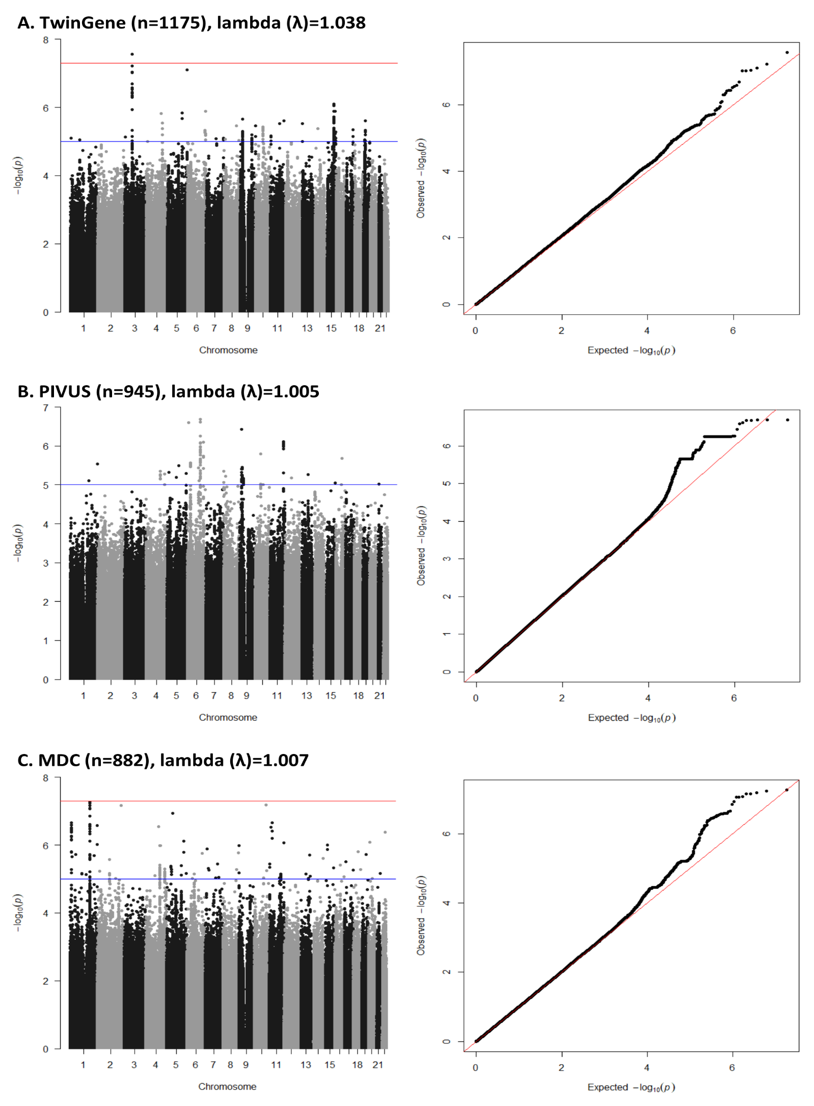

Figure S2. Marks of regulation in the LD block of 11q24.1 from UCSC Genome Browser

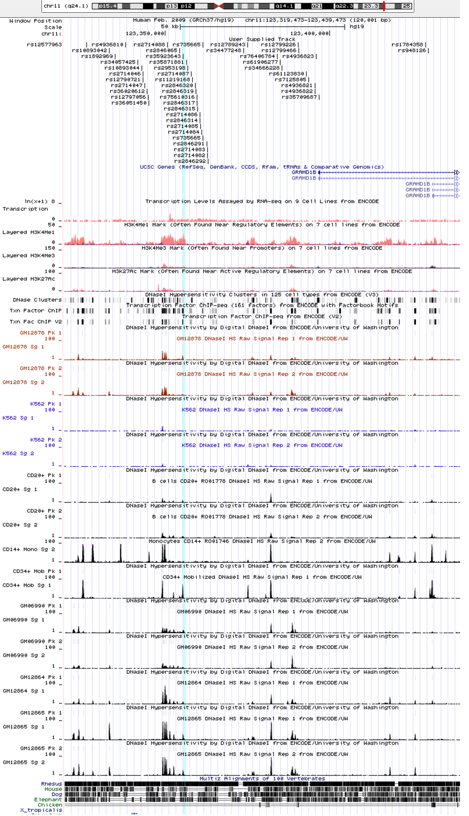

Figure S3. Functional prediction of rs35923643 in leukemia- or immune- cells

Figure S4. Evidence for affecting binding from RegulomeDB

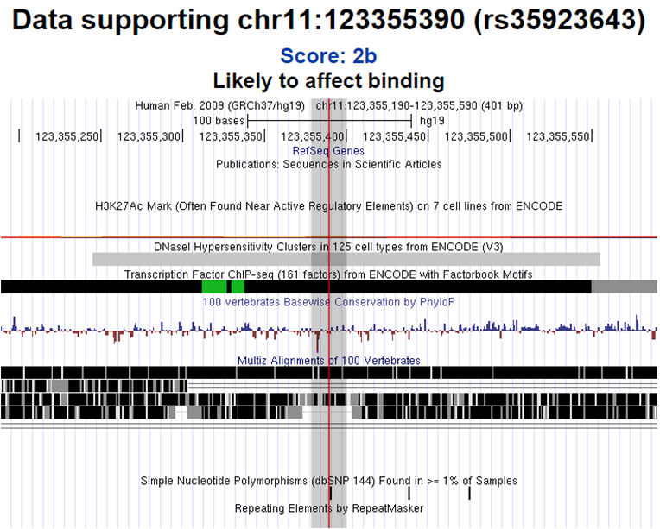

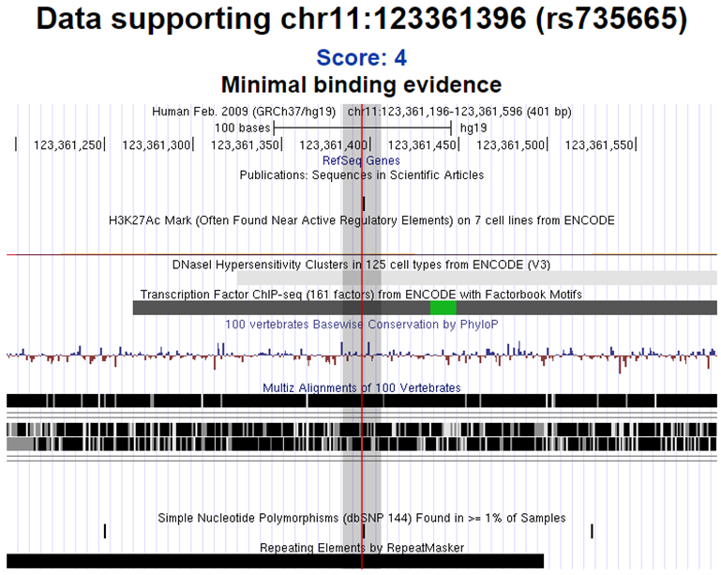

Figure S5. IgM anti-PC values before and after the first CLL diagnosis

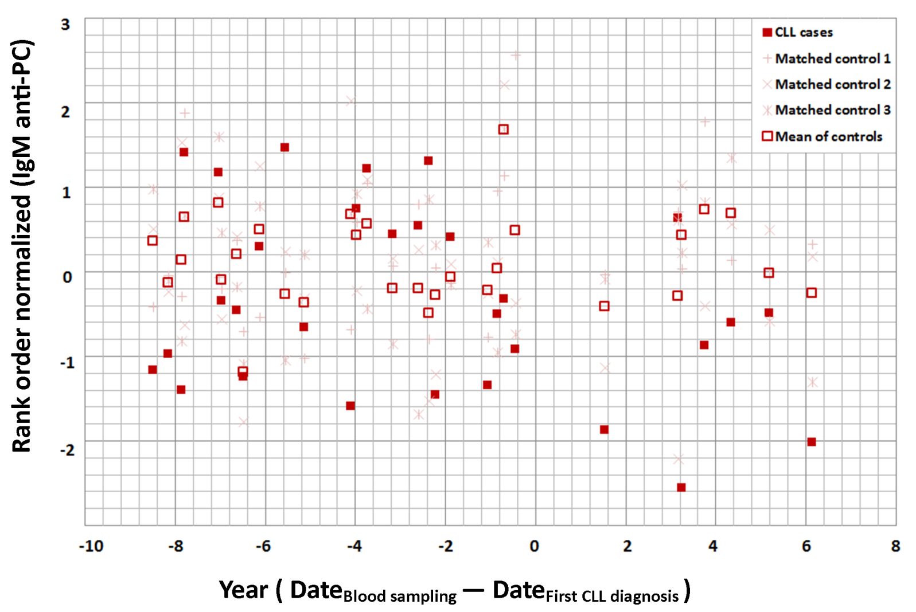

Figure S6. Global allele frequency of SNP rs735665 in the 1000 Genomes Project Phase 3 from Ensembl (GRCh37/hg19)

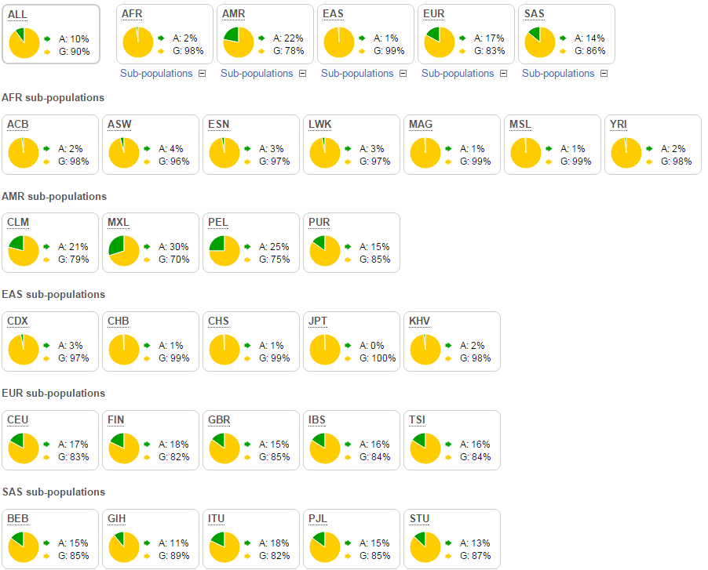

Figure S7. Functional partners with RUNX3 predicted from STRING database (version 10)

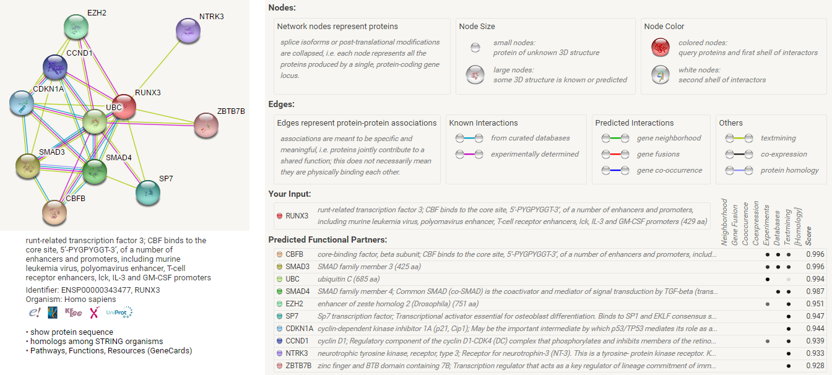

Figure S8. Potential functional pathways RUNX3 involved from STRING database

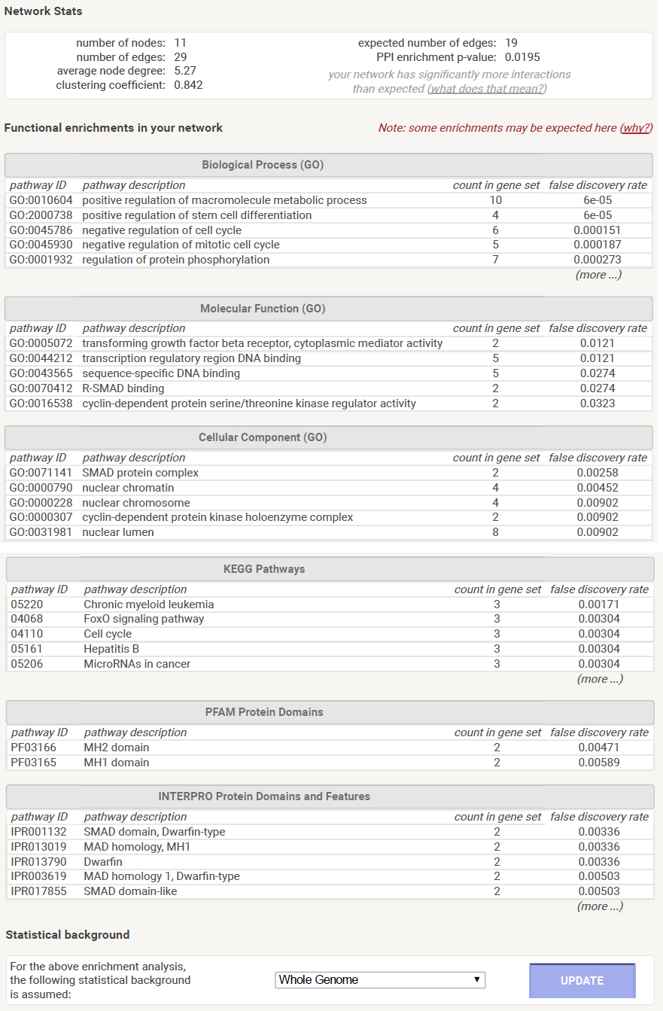

Table S1. Genome-wide significant SNPs in the discovery GWAS meta-analysis of IgM anti-PC
SNP |  | CHR | POS | A1 | A2 | FREQ_ A1 | INFO | Beta | SE | I²(%) | Phet | P-value
rs35871881 |  | 11 | 123356451 | G | A |  |  | 0.174 | 0.031 | 61.2 | 0.08 | 1.95e-08
 | TwinGene |  |  | G | A | 0.250 | 0.986 | 0.158 | 0.049 |  |  | 0.001
 | PIVUS |  |  | G | A | 0.241 | 0.970 | 0.263 | 0.053 |  |  | 7.72e-07
 | MDC |  |  | G | A | 0.215 | 0.969 | 0.086 | 0.059 |  |  | 0.145
rs12798553 |  | 11 | 123353693 | A | G |  |  | 0.174 | 0.031 | 61.0 | 0.08 | 1.98e-08
 | TwinGene |  |  | A | G | 0.248 | 0.980 | 0.160 | 0.049 |  |  | 0.001
 | PIVUS |  |  | A | G | 0.240 | 0.969 | 0.263 | 0.053 |  |  | 8.58e-07
 | MDC |  |  | A | G | 0.215 | 0.967 | 0.085 | 0.059 |  |  | 0.151
rs35923643 |  | 11 | 123355391 | G | A |  |  | 0.177 | 0.032 | 53.9 | 0.11 | 2.51e-08
 | TwinGene |  |  | G | A | 0.230 | 0.999 | 0.153 | 0.050 |  |  | 0.002
 | PIVUS |  |  | G | A | 0.225 | 0.980 | 0.263 | 0.054 |  |  | 1.18e-06
 | MDC |  |  | G | A | 0.188 | 0.987 | 0.101 | 0.061 |  |  | 0.097
rs141373354 |  | 1 | 68736970 | A | G |  |  | 0.578 | 0.104 | 0.0 | 0.71 | 2.60e-08
 | TwinGene |  |  | A | G | 0.980 | 0.910 | 0.625 | 0.159 |  |  | 9.22e-05
 | PIVUS |  |  | A | G | 0.986 | 0.901 | 0.658 | 0.203 |  |  | 0.001
 | MDC |  |  | A | G | 0.980 | 0.913 | 0.457 | 0.181 |  |  | 0.011
rs116361873 |  | 1 | 68728886 | G | A |  |  | 0.576 | 0.104 | 0.0 | 0.68 | 2.99e-08
 | TwinGene |  |  | G | A | 0.981 | 0.918 | 0.626 | 0.159 |  |  | 8.83e-05
 | PIVUS |  |  | G | A | 0.986 | 0.910 | 0.660 | 0.202 |  |  | 0.001
 | MDC |  |  | G | A | 0.981 | 0.935 | 0.446 | 0.181 |  |  | 0.014
rs735665 |  | 11 | 123361397 | A | G |  |  | 0.174 | 0.031 | 54.3 | 0.11 | 3.12e-08
 | TwinGene |  |  | A | G | 0.232 | NA | 0.145 | 0.050 |  |  | 0.004
 | PIVUS |  |  | A | G | 0.229 | NA | 0.261 | 0.053 |  |  | 1.05e-06
 | MDC |  |  | A | G | 0.188 | NA | 0.103 | 0.060 |  |  | 0.089
rs36020612 |  | 11 | 123344435 | T | C |  |  | 0.182 | 0.033 | 61.1 | 0.08 | 3.73e-08
 | TwinGene |  |  | T | C | 0.222 | 0.963 | 0.161 | 0.052 |  |  | 0.002
 | PIVUS |  |  | T | C | 0.218 | 0.909 | 0.279 | 0.057 |  |  | 9.47e-07
 | MDC |  |  | T | C | 0.186 | 0.900 | 0.090 | 0.064 |  |  | 0.156
rs36051450 |  | 11 | 123344959 | C | T |  |  | 0.179 | 0.033 | 60.6 | 0.08 | 4.26e-08
 | TwinGene |  |  | C | T | 0.224 | 0.962 | 0.158 | 0.052 |  |  | 0.002
 | PIVUS |  |  | C | T | 0.221 | 0.932 | 0.274 | 0.056 |  |  | 1.00e-06
 | MDC |  |  | C | T | 0.187 | 0.924 | 0.089 | 0.063 |  |  | 0.154
CHR: chromosome number; POS: position of the SNP in human genome (GRCh37/hg19); A1: effect allele; A2: non-effect allele; FREQ_A1: frequency of effect allele; INFO: imputation quality info; Beta: effect size per standard deviation of rank order normalized IgM anti-PC per allele; SE: standard error; I²: the percentage of variation across studies that is due to heterogeneity rather than chance; Phet: P-value for heterogeneity; NA: not available, because SNP was directly genotyped; PIVUS: Prospective Investigation of the Vasculature in Uppsala Seniors; MDC: Malmö Diet and Cancer study.

Table S2. Replication results for the eight genome-wide significant SNPs in PRACSIS
SNP | CHR | POS | A1 | A2 | FREQ_ A1 | INFO | Beta | SE | P-value
rs35871881 | 11 | 123356451 | G | A | 0.230 | 0.953 | 0.184 | 0.067 | 0.0064
rs12798553 | 11 | 123353693 | A | G | 0.229 | 0.946 | 0.185 | 0.068 | 0.0064
rs35923643 | 11 | 123355391 | G | A | 0.205 | 0.975 | 0.247 | 0.069 | 0.0004
rs141373354 | 1 | 68736970 | A | G | 0.982 | 0.883 | 0.305 | 0.219 | 0.1644
rs116361873 | 1 | 68728886 | G | A | 0.982 | 0.904 | 0.306 | 0.219 | 0.1640
rs735665 | 11 | 123361397 | A | G | 0.206 | 0.993 | 0.244 | 0.068 | 0.0004
rs36020612 | 11 | 123344435 | T | C | 0.199 | 0.933 | 0.250 | 0.072 | 0.0005
rs36051450 | 11 | 123344959 | C | T | 0.201 | 0.947 | 0.250 | 0.071 | 0.0004
CHR: chromosome number; POS: position of the SNP in human genome (GRCh37/hg19); A1: effect allele; A2: non-effect allele; FREQ_A1: frequency of effect allele; INFO: imputation quality info; Beta: effect size per standard deviation of rank order normalized IgM anti-PC per allele; SE: standard error.

Table S3. Meta-analysis for the successfully replicated SNPs (sorted by association P-value)
SNP (Position) | Study | Info | Beta | SE | P-value | Phet
rs35923643 G/A | Meta |  | 0.189 | 0.029 | 4.34×10⁻¹¹ | 0.159
(Chr11: 123355391) | TwinGene | 0.999 | 0.153 | 0.050 | 0.002
 | PIVUS | 0.980 | 0.263 | 0.054 | 1.18×10⁻⁶
 | MDC | 0.987 | 0.101 | 0.061 | 0.097
 | PRACSIS | 0.975 | 0.247 | 0.069 | 0.0004
rs735665 A/G | Meta |  | 0.186 | 0.028 | 5.03×10⁻¹¹ | 0.150
(Chr11: 123361397) | TwinGene | NA | 0.145 | 0.050 | 0.004
 | PIVUS | NA | 0.261 | 0.053 | 1.05×10⁻⁶
 | MDC | NA | 0.103 | 0.060 | 0.089
 | PRACSIS | 0.993 | 0.244 | 0.068 | 0.0004
rs36020612 T/C | Meta |  | 0.193 | 0.030 | 1.06×10⁻¹⁰ | 0.118
(Chr11: 123344435) | TwinGene | 0.963 | 0.161 | 0.052 | 0.002
 | PIVUS | 0.909 | 0.279 | 0.057 | 9.47×10⁻⁷
 | MDC | 0.900 | 0.090 | 0.064 | 0.156
 | PRACSIS | 0.933 | 0.250 | 0.072 | 0.0005
rs36051450 C/T | Meta |  | 0.191 | 0.030 | 1.09×10⁻¹⁰ | 0.116
(Chr11: 123344959) | TwinGene | 0.962 | 0.158 | 0.052 | 0.002
 | PIVUS | 0.932 | 0.274 | 0.056 | 1.00×10⁻⁶
 | MDC | 0.924 | 0.089 | 0.063 | 0.154
 | PRACSIS | 0.947 | 0.250 | 0.071 | 0.0004
rs12798553 A/G | Meta |  | 0.176 | 0.028 | 3.17×10⁻¹⁰ | 0.158
(Chr11: 123353693) | TwinGene | 0.980 | 0.160 | 0.049 | 0.001
 | PIVUS | 0.969 | 0.263 | 0.053 | 8.58×10⁻⁷
 | MDC | 0.967 | 0.085 | 0.059 | 0.151
 | PRACSIS | 0.946 | 0.185 | 0.068 | 0.0064
rs35871881 G/A | Meta |  | 0.176 | 0.028 | 3.25×10⁻¹⁰ | 0.160
(Chr11: 123356451) | TwinGene | 0.986 | 0.158 | 0.049 | 0.001
 | PIVUS | 0.970 | 0.263 | 0.053 | 7.72×10⁻⁷
 | MDC | 0.969 | 0.086 | 0.059 | 0.145
 | PRACSIS | 0.953 | 0.184 | 0.067 | 0.0064
SNP is presented with effect allele/alternative allele (chromosome number and position in human genome GRCh37/ hg19). Info: imputation quality; NA: not available, because SNP is directly genotyped; Beta: effect size per standard deviation of rank order normalized IgM anti-PC per allele; SE: standard error; Phet: P-value for heterogeneity; The two SNPs (rs141373354 and rs116361873) on chromosome 1 are not successfully replicated in PRACSIS, association P-values are 0.1644 and 0.1640, respectively.

Table S4. Levels of IgM anti-PC among genotypes of rs735665 and rs35923643
 |  |  |  | Discovery phase |  |  |  | Replication
 |  |  |  | TwinGene | PIVUS | MDC |  | PRACSIS
Genotypes of rs735665 |  | N_{GG} |  | 697 | 568 | 556 |  | 407
 |  | N_{GA} |  | 411 | 322 | 254 |  | 212
 |  | N_{AA} |  | 67 | 55 | 33 |  | 27
Raw values of  IgM anti-PC |  | GG |  | 40.3 (23.2-67.2) | 39.5 (24.8-68.1) | 46.0 (28.6-75.1) |  | 31.9 (19.7-56.3)
 |  | GA |  | 48.7 (23.8-83.2) | 45.8 (28.9-75.6) | 51.1 (32.8-75.5) |  | 39.7 (24.1-71.0)
 |  | AA |  | 40.6 (21.1-78.6) | 52.0 (34.6-110.9) | 58.6 (34.4-78.1) |  | 47.1 (28.9-59.7)
Normalized values of  IgM anti-PC in GWAS |  | GG |  | -0.07±0.99 | -0.11±0.98 | -0.05±0.99 |  | -0.11±1.01
 |  | GA |  | 0.14±1.03 | 0.13±0.99 | 0.05±1.00 |  | 0.18±0.98
 |  | AA |  | 0.01±1.08 | 0.43±1.09 | 0.22±0.86 |  | 0.23±0.69
Genotypes of rs35923643 |  | N_{AA} |  | 705 | 564 | 583 |  | 409
 |  | N_{AG} |  | 403 | 312 | 266 |  | 210
 |  | N_{GG} |  | 67 | 53 | 33 |  | 27
Raw values of  IgM anti-PC |  | AA |  | 40.0 (23.1-66.8) | 39.4 (24.8-68.1) | 47.2 (28.9-75.5) |  | 31.9 (19.6-56.2)
 |  | AG |  | 50.7 (24.0-83.9) | 46.8 (29.1-76.3) | 51.7 (32.8-77.4) |  | 39.7 (24.1-71.0)
 |  | GG |  | 40.6 (21.1-78.6) | 49.8 (34.6-107.9) | 58.6 (34.4-78.1) |  | 47.1 (28.9-59.7)
Normalized values of  IgM anti-PC in GWAS |  | AA |  | -0.08±0.99 | -0.11±0.98 | -0.04±1.00 |  | -0.11±1.01
 |  | AG |  | 0.16±1.03 | 0.14±0.99 | 0.05±1.01 |  | 0.18±0.98
 |  | GG |  | 0.01±1.08 | 0.41±1.10 | 0.22±0.86 |  | 0.23±0.69
PIVUS: Prospective Investigation of the Vasculature in Uppsala Seniors; MDC: Malmö Diet and Cancer study; PRACSIS: Prognosis and Risk in Acute Coronary Syndromes in Sweden.

Table S5. Polygenic risk score analyses between immunoglobulins and CLL risk
Base — Target | P_{T} | N_{SNPs} | OR | SE | r² | P-value
IgA — CLL | 5.0e-15 | 2 | 1.06 | 0.17 | 0.00% | 0.75
 | 5.0e-10 | 10 | 0.89 | 0.11 | 0.01% | 0.29
 | 5.0e-09 | 22 | 0.87 | 0.09 | 0.02% | 0.12
 | 5.0e-08* | 31 | 0.88 | 0.08 | 0.02% | 0.11
 | 5.0e-07 | 41 | 0.93 | 0.07 | 0.00% | 0.31
 | 1.0e-06 | 45 | 0.91 | 0.07 | 0.02% | 0.20
IgG — CLL | 5.0e-15 | 5 | 0.69 | 0.10 | 0.12% | 0.007
 | 5.0e-10 | 10 | 0.68 | 0.10 | 0.14% | 0.0003
 | 5.0e-09 | 12 | 0.67 | 0.10 | 0.15% | 0.0001
 | 5.0e-08 | 17 | 0.73 | 0.09 | 0.12% | 0.0004
 | 5.0e-07* | 20 | 0.68 | 0.09 | 0.18% | 3.9e-06
 | 1.0e-06 | 22 | 0.67 | 0.09 | 0.20% | 1.2e-05
IgM — CLL | 5.0e-15 | 5 | 0.84 | 0.16 | 0.01% | 0.27
 | 5.0e-10 | 18 | 0.70 | 0.09 | 0.14% | 0.0001
 | 5.0e-09 | 33 | 0.72 | 0.07 | 0.19% | 5.3e-06
 | 5.0e-08* | 43 | 0.69 | 0.07 | 0.28% | 4.2e-08
 | 5.0e-07 | 59 | 0.79 | 0.06 | 0.14% | 0.0001
 | 1.0e-06 | 66 | 0.75 | 0.06 | 0.23% | 8.4e-07
IgM anti-PC — CLL | 5.0e-08* | 1 | 17.55 | 0.36 | 0.59% | 1.2e-15
 | 5.0e-07* | 1 | 17.55 | 0.36 | 0.59% | 1.2e-15
 | 1.0e-06* | 1 | 17.55 | 0.36 | 0.59% | 1.2e-15
 | 5.0e-06 | 6 | 1.87 | 0.11 | 0.31% | 7.3e-09
 | 5.0e-05 | 39 | 1.11 | 0.04 | 0.05% | 0.02
 | 5.0e-04 | 386 | 1.00 | 0.02 | 0.00% | 0.87
 | 0.005 | 3237 | 1.00 | 0.01 | 0.00% | 0.90
 | 0.05 | 22405 | 1.02 | 0.003 | 0.24% | 3.1e-07
 | 0.5 | 137132 | 1.01 | 0.002 | 0.10% | 0.001
Standardized polygenic risk score (PRS) of the base phenotype was used to predict the target phenotype. P_{T}: P-value threshold of the association between single nucleotide polymorphisms (SNPs) and the base phenotype, * means the best P_{T} that defined as the threshold corresponding to the largest explained variance; N_{SNPs}: number of independent SNPs included in the best P_{T} quantile; OR: odds ratio per standard deviation; SE: standard error; r²: Nagelkerke r², the proportion of target variation explained by PRS of SNPs in the best P_{T} quantile.

Table S6. Signal for each transcription factor and matched sequence from FIMO
TF | Signal | Motif | Strand | Start | End | P-value | Q-value | Matched Sequence
ATF2 | 487 | M1 | - | 389 | 399 | 0.00986 | 1 | CTGAGGTTTTG
BCL11A | 426 | ×
BCL3 | 202 | ×
CEBPB | 264 | ×
FOXM1 | 549 | ×
IRF4 | 160 | M2 | + | 381 | 395 | 0.00665 | 1 | CCAACCCCCAAAACC
 |  | M3 | + | 384 | 398 | 0.00369 | 1 | ACCCCCAAAACCTCA
MEF2A | 144 | ×
MTA3 | 496 | ×
NFATC1 | 331 | ×
NFIC | 732 | M4 | - | 386 | 391 | 0.00862 | 0.528 | TTGGGG
PAX5 | 388 | M5 | - | 378 | 397 | 0.00555 | 0.499 | GAGGTTTTGGGGGTTGGAGG
PML | 319 | ×
POU2F2 | 327 | ×
RELA | 228 | ×
RUNX3 | 1000 | M6 | - | 391 | 397 | 0.000944 | 0.216 | GAGGTTT
 |  | M7 | + | 391 | 400 | 0.00029 | 0.208 | AAACCTCAGA
 |  | M7 | + | 382 | 391 | 0.00409 | 0.602 | CAACCCCCAA
 |  | M8 | + | 384 | 399 | 0.000894 | 0.301 | ACCCCCAAAACCTCAG
 |  | M8 | + | 383 | 398 | 0.00279 | 0.335 | AACCCCCAAAACCTCA
 |  | M8 | + | 376 | 391 | 0.00289 | 0.335 | CCCCTCCAACCCCCAA
 |  | M9 | + | 382 | 399 | 4.5e-05 | 0.0607 | CAACCCCCAGAACCTCAG
 |  | M9 | + | 382 | 399 | 1.86e-05 | 0.0251 | CAACCCCCAAAACCTCAG
 |  | M9 | + | 391 | 408 | 0.00673 | 0.479 | AAACCTCAGAAATTGGCT
 |  | M10 | + | 391 | 400 | 0.000414 | 0.229 | AAACCTCAGA
 |  | M10 | + | 383 | 392 | 0.000972 | 0.341 | AACCCCCAAA
 |  | M10 | + | 382 | 391 | 0.00156 | 0.369 | CAACCCCCAA
RXRA | 131 | M11 | - | 382 | 396 | 0.0012 | 0.423 | AGGTTTTGGGGGTTG
 |  | M11 | - | 381 | 395 | 0.00358 | 0.834 | GGTTTTGGGGGTTGG
 |  | M12 | - | 389 | 405 | 0.00907 | 0.699 | CAATTTCTGAGGTTTTG
SP1 | 156 | ×
SPI1 | 1000 | M13 | + | 314 | 328 | 8.52e-06 | 0.0117 | ATGAGGAACAGAGAG
 |  | M14 | + | 314 | 324 | 0.000166 | 0.226 | ATGAGGAACAG
STAT5A | 357 | M15 | - | 375 | 390 | 0.00373 | 0.367 | TGGGGGTTGGAGGGGG
 |  | M15 | - | 385 | 400 | 0.00495 | 0.367 | TCTGAGGTTTTGGGGG
 |  | M15 | - | 387 | 402 | 0.00503 | 0.367 | TTTCTGAGGTTTTGGG
 |  | M15 | - | 377 | 392 | 0.00982 | 0.431 | TTTGGGGGTTGGAGGG
TBL1XR1 | 220 | ×
TCF12 | 154 | ×
TCF3 | 131 | ×
The position of rs35923643 (at the 391bp of submitted sequence) is labeled in red. M1: Haib_ATF2_H1-hESC_ Motif1 _fw_ic0; M2: IRF4_full_TCAAGG20NCG_AD_NCGAAACCGAAACYN_fw_ic0; M3: Irf4_fw_ic0; M4: MA0161_NFIC_fw _ic0; M5: MA0014_Pax5_fw_ic0; M6: Haib_RUNX3_GM12878_Motif1_fw_ic0; M7: RUNX3_ DBD_TACGGA30NGGC_AI_NAACCGCAAN_fw_ic0; M8: RUNX3_DBD_TACGGA30NGGC_AI_NA ACCGC AAACCRCAN_fw_ic0; M9: RUNX3_DBD_TACGGA30NGGC_AI_WAACCRCAAWAACCRCAN_fw_ ic0; M10: RUNX3_full_TCTCCC20NGA_AE_NAACCRCAAN_fw_ic0; M11: MA0074_RXRA_VDR_fw_ic0; M12: MA0115_NR1H2_RXRA_fw_ic0; M13: Haib_SPI1_GM12878_Motif1_fw_ic0; M14: Haib_SPI1_K562_Motif1_ fw_ic0; M15: Haib_STAT5A _GM12878_Motif1_fw_ic0.

