The challenges posed by equine arboviruses

Authors:
Gail Elaine Chapman¹, Matthew Baylis¹, Debra Archer¹, Janet Mary Daly²
¹Epidemiology and Population Health, Institute of Infection and Global Health, University of Liverpool, Liverpool, UK.
²School of Veterinary Medicine and Science, University of Nottingham, Sutton Bonington, UK
Corresponding author: Janet Daly; janet.daly@nottingham.ac.uk

Keywords:
Arbovirus, horse, encephalitis, vector, diagnosis

Word count: c.5000 words excluding references

Declarations

Ethical Animal Research
N/A

Competing Interests
None.

Source of Funding
G.E. Chapman’s PhD research scholarship is funded by The Horse Trust.

Acknowledgements
N/A

Authorship
GAC and JMD drafted sections of the manuscript; MB and DA reviewed and contributed to the manuscript

Summary
Equine populations worldwide are at increasing risk of infection by viruses transmitted by biting arthropods including mosquitoes, biting midges (Culicoides), sandflies and ticks. These include the flaviviruses (Japanese encephalitis, West Nile and Murray Valley encephalitis), alphaviruses (eastern, western and Venezuelan encephalitis) and the orbiviruses (African horse sickness and equine encephalosis). This review provides an overview of the challenges faced in the surveillance, prevention and control of the major equine arboviruses, particularly in the context of these viruses emerging in new regions of the world.

Introduction
The rate of emergence of infectious diseases, in particular vector-borne viral diseases such as dengue, chikungunya, Zika, Rift Valley fever, West Nile, Schmallenberg and bluetongue, is increasing globally in human and animal species for a variety of reasons [1]. These include increased movement of animals and people worldwide, environmental and climate change, and human encroachment into natural habitats (taking domestic species with them). Equine arboviruses are no exception to this trend, and a number of authors have highlighted the potential for the introduction of various equine arboviruses to Europe [2-4].
Arboviruses are defined as viruses transmitted by biting arthropods, which include mosquitoes, biting midges (Culicoides), sandflies and ticks. Arboviruses replicate in the body of the insect and are, therefore, distinct from viruses with a mechanical mode of transmission (e.g. equine infectious anaemia virus is transmitted on or in the mouthparts of insects without replication). The equine arboviruses discussed in this review are listed, with their abbreviations, in Table 1. Although there are similarities in the transmission cycles of some of these viruses, the details are virus-specific and some are particularly complex. Similarities in clinical presentation and cross-reactivity of antibodies between related viruses can lead to initial misdiagnosis and delayed identification of an emerging arbovirus. For example, the first human cases of WNV infection in the USA were initially thought to be caused by SLEV infection [5]. In this review, the major challenges presented by equine arboviruses in relation to vector roles, surveillance, control and risk management are summarised.

Equine Arboviruses

Alphavirus and Flavivirus Disease
The main flavi- and alpha-viruses that affect horses share some similarities: they are transmitted by mosquitoes, and viruses of both genera cause encephalitic disease in both horses and humans. Major flaviviruses known to affect equids include Japanese encephalitis virus (JEV), WNV and Murray Valley encephalitis virus (MVEV) (Table 1). Major alphaviruses of horses include eastern, western and Venezuelan equine encephalitis viruses (EEEV, WEEV and VEEV, respectively), Ross River virus (RRV) and Getah virus (GETV).
Equine morbidity and mortality information for mosquito-borne viruses affecting horses is presented in Chapman et al. [6]. Inapparent infections with limited clinical signs (e.g. transient pyrexia) are common with the encephalitogenic viruses, as a result of which, the proportion of deaths per diagnosed cases (case-fatality rate) can be very high. For example, the average fatality rate reported for cases of West Nile encephalitis in the United States between 1999 and 2006 was 30–40% [7]. However, retrospective estimates suggest that less than 10% of infected horses develop encephalitis. This figure was confirmed in a prospective study involving 37 unvaccinated horses in which only 2 of 25 animals (8%) that seroconverted developed encephalopathy, which was fatal in one case [8]. Although around 80% of surviving horses recover in 3–4 weeks, a small proportion have residual neurological deficits [9]. In addition to inapparent infections, strain-dependent differences in virulence can lead to wide variation in morbidity and mortality or case fatality estimates. However, in contrast to WNV, JEV, EEEV and VEEV, morbidity rates of MVEV and RRV are low and they rarely cause fatal disease, and GETV is often subclinical with affected horses usually recovering completely [10].
Clinical signs in horses that are infected with the encephalitogenic viruses (WNV, JEV, MVEV, EEEV, WEEV, and VEEV) include a variety of neurological abnormalities. However, there is a significant degree of overlap between clinical presentation of these diseases (clinical signs of ataxia and paresis are common to all; Table 2), and it is this that can present a challenge in terms of clinical diagnosis, particularly where there is overlapping distribution.

Flavivirus epidemiology and ecology
The flaviviruses that affect horses share characteristics in their transmission cycles. In general, these viruses are maintained in an enzootic cycle (i.e. they are transmitted between wild animals, usually birds) and horses (and humans) are infected as “incidental” or “dead-end” hosts (Figure 1). Dead-end hosts usually do not produce sufficiently high viraemia to infect mosquitoes, and therefore are not involved in ongoing transmission. Although the reservoir hosts are avian, large outbreaks of JEV may be associated with efficient amplification of virus in pigs, which also produce high levels of viraemia [11].
West Nile virus has the most widespread geographical distribution (Figure 2a) and the largest known vector and host range of all mosquito-borne flaviviruses [12]. Its ability to occupy a wide geographical area is due to its broad host and vector range. In contrast, JEV and MVEV have more restricted ranges (Figure 2b, 2c). However, it is not clear whether host or vector range may be more important in restricting their distribution.

Alphavirus epidemiology and ecology
Although like the flaviviruses, alphaviruses are transmitted by mosquitoes, their life cycles tend to be more complex. The eastern, western and Venezuelan equine encephalitic viruses (EEVs) are all restricted to the Americas. Eastern EEV affects horses, swine and humans as dead-end hosts [13]. It was traditionally thought to be maintained in an enzootic cycle between passerine birds and mosquitoes. However rodents are now thought to be epidemiologically significant hosts in South America, and possibly in Florida [14; 15]. The ecology of South American EEEV is poorly understood [16]. Western EEV is maintained in an enzootic cycle between mosquitoes and birds, from Canada to Argentina [3], with horses and humans affected as dead-end hosts [17; 18]. Venezuelan EEV circulates in enzootic cycles between rodent hosts and mosquito vectors in Mexico, Central and South America [19]. The virus is antigenically complex with six antigenic subtypes within which there are antigenic variants. The E2 envelope glycoprotein determines equine viraemia and virulence, and mutations in the E2 gene can cause avirulent strains to be more efficiently amplified in horses. This results in an epizootic cycle during which virus amplification in the horse is sufficient to result in mosquito infection (i.e. the horse is no longer a dead-end host) and this is thought to significantly increase the risk of human infection [20]. Epizootics of VEEV have generally occurred in South America, although an epizootic occurred in Texas in 1971, affecting an estimated 10% of the equine population in the region and 1,500 equids died [21; 22]. Humans are typically considered dead-end hosts, but there is some recent evidence to suggest that humans may develop high enough virus titre to continue epidemic transmission in urban environments [23].
Ross River virus is active each year in most regions of Australia and has also caused epidemics in Papua New Guinea, the Solomon Islands, Fiji, New Caledonia and the Cook Islands. Epidemic polyarthritis due to RRV infection is the most common arboviral disease in humans in Australia [24]. The major enzootic cycle of RRV involves members of the macropod (i.e. kangaroo) family as the vertebrate host, although other mammals have been suggested as reservoir hosts [25]. There is evidence that both horses and humans are able to infect vectors and at least one outbreak thought to be due to human air travel has occurred [26-29].
Getah virus is found from Eurasia to Australasia (Figure 3e). The natural transmission cycle is not well described or studied, although swine are thought to play an important role in amplification [30]. Getah virus appears to have a wide host range, although the main enzootic cycle is thought to be between mammals (particularly rodents) and mosquitoes, as birds show lower seroprevalence rates [10; 30]. Horses produce a high enough viraemic titre during an epidemic to infect mosquitoes and direct horse-to-horse transmission has been demonstrated experimentally, although it is unlikely to be a common mechanism for natural infection [31].

Orbiviruses

African horse sickness virus
African horse sickness (AHS) is a disease almost exclusively of equids. It is endemic in sub-Saharan Africa, but outbreaks have occurred elsewhere including the Middle East and India, and the western Mediterranean (reviewed in [32]).
The virus infects capillary endothelial cells in the myocardium, lung, spleen and liver. A mild form (horse sickness fever) involves oedema of the supraorbital fossae and fever, and occurs in donkeys and zebra and horses that have some immunity or are infected with a less virulent strain [33]. The pulmonary form causes rapid respiratory failure and is associated with case fatality rates that can exceed 95% [34]. The cardiac form causes oedema of the head and neck, progressing to dyspnoea, cyanosis, abdominal pain and heart failure and case fatality rates are around 50%. A mixed form of AHS is common with a mortality rate of around 70% [33].
Transmission occurs via the bite of infected midges of the genus Culicoides. All recorded outbreaks of AHS have occurred within the geographic range of the primary vector, Culicoides imicola, although in recent years a second vector, C. bolitinos, has been identified in South Africa [35]. The transmission cycle of AHSV involves only equids as hosts; other infected mammals (dogs) appear to be dead-end hosts [36; 37]. Species that produce a prolonged viraemia and have low disease mortality, such as zebra and donkeys, act as reservoir hosts [38]. As there is no carrier state, persistence of AHSV is believed to rely on sufficient density and renewal of susceptible reservoir hosts [32; 39].

Equine encephalosis virus
Equine encephalosis virus (EEV) usually causes subclinical or mild disease in horses. Clinical signs include oedema of the back legs, eyelids and lips. As for AHSV, transmission is via C. imicola and the disease is endemic in temperate regions of Africa [40; 41], although there has been a recent outbreak in Israel [42]. Veterinarians and horse owners in at-risk regions should be aware that mild clinical signs including oedema of the eyelids and lips may be due to EEV rather than AHSV.

Others
Several other viruses belonging to the families described here and some belonging to other families may infect horses but their impact is more limited due to the sporadic nature of infection or geographic restriction (Table 1) [43-45]. Others are only just being recognised as potential causes of disease in horses. Since 2013, Bunyamwera virus, an Orthobunyavirus, has emerged as a cause of neurological disease and possibly abortion in horses in Argentina [46; 47]. Clinical signs include apparent disorientation, weakness, visual deficits, tongue protrusion, recumbency and death. Transmission cycles are poorly characterised, although mammals are considered to be amplifying hosts and most isolates have been recovered from mosquitoes. Seroprevalence among birds in Argentina indicate that they could be in involved as endemic hosts [48].

Meeting the challenges of diagnosis and control of equine arboviruses

Diagnosis and surveillance
The overlapping geographical ranges of the flavi- and alphaviruses and the overlap in clinical signs between these and other viruses can make clinical diagnosis challenging, particularly in some regions of the world. For example, differential diagnosis for infections causing non-suppurative encephalitis in horses in Australia include MVEV, RRV, WNV (Kunjin), a strain of WNV, and Hendra virus [49]. Similarly, various combinations of WNV, EEEV, WEEV and VEEV overlap in some regions of the Americas, particularly in Mexico and Central America. A recent serosurvey of 246 horses in Costa Rica revealed prevalence of 57% for WNV, 62% for EEEV, 43% for VEEV, and 17% for WEEV [50]. In many regions of the world, only outbreaks of WNV have been reported in horses, but an early and accurate diagnosis is important to rule out emergence of other flavi- or alpha-viruses.
Although challenging, clinical diagnosis remains the cheapest approach to surveillance for equine arbovirus outbreaks and can be enhanced by adopting a ‘multivariate syndromic surveillance’ system in which data are compiled from various sources. For example, taking weekly time series data on occurrence of nervous signs consistent with encephalitic disease in horses and mortality in both horses and wild birds has been used to identify outbreaks of WNV in France [51]. Laboratory confirmation is still required, and to be effective, this approach requires communication of data between various agencies including veterinary bodies and equine industry stakeholders.
Diagnostic tests for equine arboviruses have a number of disease-specific limitations. For many diseases, detection of virus nucleic acid is now favoured over traditional virus isolation. Some arboviruses are readily detected in blood using polymerase chain reaction (PCR)-based techniques, for example, for VEEV, viraemia occurs with the onset of pyrexia and lasts for 5–6 days. For AHSV, the World Organization for Animal Health (OIE) recommends that virus is isolated for serotyping so that a vaccine containing the relevant serotype can be implemented, although this could be achieved by direct sequencing [52]. However, as already described, the horse is a ‘dead-end’ host for some equine arboviruses such as the flaviviruses WNV and JEV. As a result of the limited and transient viraemia, even sensitive PCR-based diagnostic tests may yield false-negative results for these viruses. Therefore, although virus can be detected in post mortem tissues, particularly the brain and spinal cord [52], diagnosis frequently relies on serological tests.
Although diagnosis of equine and human flavivirus infections relies heavily on antibody detection, this is complicated by high levels of serological cross-reactivity among flaviviruses, particularly in rapid assays such as enzyme-linked immunosorbent assay (ELISA). Testing for IgM antibodies, which indicate the most recent infection, is preferable as IgG antibodies can remain in circulation long after the acute phase of infection. A positive diagnosis by ELISA usually requires confirmation by the more specific virus neutralisation test; this is time-consuming and costly due to the requirement for BSL-3 containment to handle infectious virus. To address these issues, new approaches are being developed, including rapid neutralisation tests based on pseudotyped viruses that do not require high levels of biosafety containment (reviewed in [53]). Multiplex serological assays (e.g. using micro-bead technology [54]) are desirable to speed up identification of pathogens and enable a syndromic approach to diagnosis to be undertaken (e.g. for neurological disease).

Vaccine challenges
Equine vaccines are available for most of the mosquito-borne equine arboviruses described in regions where they are endemic, with the notable exceptions of RRV and MVEV. In the USA, multivalent vaccines are available that include WNV, EEEV, WEEV and VEEV. Although effective vaccines against WNV are available, there may be a desire to prohibit vaccination of horses in some countries so that they can fulfil the role of a sentinel species [55; 56]. As vaccines become available, tests with differentiation of infected from vaccinated animals (DIVA) potential are desirable in order to determine whether an animal has seroconverted in response to natural infection or vaccination. This is particularly the case when attempting to control an outbreak of an emerging virus to prevent it from becoming established. For example, using a DIVA approach enables ring vaccination to be performed whilst still allowing any spread of the virus to be monitored. Three different vaccines for WNV are commercially available including the multivalent inactivated (killed virus) vaccine, a live canarypox virus vectored vaccine and a DNA vaccine. The latter two vaccines only contain a portion of the viral genome (expressing the prM/E proteins) and therefore have the potential to be used in a DIVA approach in combination with an assay that detects antibodies to other viral proteins (e.g. the NS1 non-structural protein [57]).
The existence of nine serotypes of AHSV presents a particular challenge for vaccination. The control of AHSV in South Africa depends on a live-attenuated AHSV vaccine produced by Onderstepoort Biological Products. This vaccine contains seven of the serotypes delivered as two separate injections, and it requires two or three doses to generate an adequate immune response to all of the serotypes in the vaccine. Reassortment (i.e. exchange of gene segments between vaccine and field strains) and reversion to virulence have been demonstrated [58]. Consequently, the live-attenuated vaccine is not licensed for use in countries where the virus is not endemic and alternative recombinant vaccines are being actively developed.

Arbovirus emergence: challenges in risk prediction
In order to understand the potential impacts of globalization and climate change on the global disease patterns of equine arboviral disease, knowledge of the complexities of transmission cycles, vector life cycle and the effects of climate change on the vector and vector infection dynamics are vital. In general, it is difficult to predict whether (or when) vector-borne diseases could become established in new areas. Due to the involvement of multiple different host types and vectors for some of the equine arboviruses, risk prediction for epidemic transmission and for virus establishment and endemicity is challenging. There is often a lack of information on the presence of vectors, their vectorial capacity, and the competence of potential reservoir hosts, which may not be present (and therefore studied) in endemic areas.

Virus introduction
Equine arboviruses cannot be controlled solely by animal trade policies as some can be introduced into new regions by movement of viraemic people, migratory birds, or incidental transport of infected vectors as well as by animal movements. It is important to remember that movement of infected individuals does not pose the same risk if they are a ‘dead-end’ host, as is the case for WNV. Therefore, disease introduction may occur without risk of onward transmission due to the absence or low titre of virus in the blood at the time of importation. For example, a horse imported into the UK from Europe had neurological signs and antibodies against WNV but no detectable viraemia at the time of testing [59]. If local vectors are infected, then clinical cases in horses or humans may occur. Occurrence of a small number of autochthonous (locally-acquired) infections could occur without local reservoir host involvement, where all vectors are infected from imported hosts. This type of locally-acquired infection may occur without being detected as many infections with equine arboviruses are subclinical. In certain cases, a small number of onward transmission events could occur without a vector contacting the importation host, for example by blood transfusion, as has been recorded in humans [60]. It has also been suggested that bird-to-bird transmission of WNV may occur in some species and contribute to overwintering of the virus [61]. A competent vector, however, is required for epizootic spread.
Ongoing transmission in the case of a VEEV epizootic strain or RRV would require only susceptible equids or humans and competent vectors, and in this case equids could represent a public health risk. In the case of other equine mosquito-borne pathogens, competent local reservoir hosts are required for ongoing transmission, as with the introduction of WNV into the USA.
Mathematical and epidemiological modelling can help to identify subpopulations, regions and periods when there is a higher risk of entry and spread of specific diseases, enabling the occurrence of outbreaks to be anticipated through targeted surveillance. For example, a study to identify hotspots for potential introduction of EEEV, WEEV, VEEV and JEV to Europe through live animal trade demonstrated that the risk was higher for EEEV than the other three viruses, which was mainly associated with trade in exotic pet species such as rodents, reptiles or caged birds [2]. The risk was greatest in Belgium, the Netherlands and northern Italy, highlighting that managing the risk of introduction of exotic arboviruses to Europe as a result of animal trade requires a transboundary approach.

Vector presence
The distribution of equine arboviruses is dependent on the presence of the relevant insect vector (Table 1). Many mosquito species act as vectors of WNV, hence the global distribution of this disease. For a number of the arboviruses, the distribution of outbreaks does not extend to all regions of vector occurrence. Therefore, these areas may be considered at risk of emergence.
The distribution of the main vector of AHSV (Culicoides imicola) extends from South Africa to Southern Europe and across the Middle East to South East Asia and Southern China [62]. African horse sickness virus was introduced into Spain in 1987 when a group of zebra were brought by ship from Namibia and were quarantined outdoors near Madrid. At the time, it was not known that C. imicola, was present across the southern half of Spain. The ensuing epizootic resulted in the death of at least 1000 equids over a 4-year period, and affected three countries (Spain, Portugal and Morocco) [63]. This emphasises the need for vector surveillance in order to accurately predict the risk of introduction of equine arboviruses into different regions. Some countries, such as Italy, also have AHSV vector populations but have not recorded outbreaks of disease. As C. imicola is also the main vector of EEV and the transmission cycle is similar, the same regions that are at risk of AHSV emergence may also be considered at risk of EEV emergence.
The presence of an alternative species to the main known vector species can have a profound impact on the epidemiology of incursion, but this is difficult to predict. For example, the main insect vector of JEV in Asia is Culex tritaeniorhynchus, which can be infected when there are very low levels of viraemia in the host. However, when there was an incursion of JEV in northern Australia, the main vector was Culex annulirostris [64; 65], which is thought to require higher titres to become infected. It is not clear whether JEV failed to become endemic in northern Australia for this reason or due to the presence of other flaviviruses conferring cross-protection to hosts, or because Cx. annulirostris preferentially feeds on marsupials and not wading birds or pigs, the reservoir and amplifying hosts, respectively, of JEV [66].
For some other viruses, such as EEEV, it is not clear whether virus introduction into new regions (e.g. Europe) would find adequate populations of competent vectors for ongoing transmission. Of the major vectors of EEEV in the Americas, only Cs. morsitans is present in Europe [67]. There are many other species of mosquito implicated as possible vectors of EEEV. However, without further information such as vector competence and ecological information on vector populations and host–vector interaction, it is not possible to accurately predict whether mosquito populations present in Europe would be capable of facilitating epidemic or endemic transmission. Similarly, the major vector of WEEV (Cx. tarsalis) and the major vectors of enzootic VEEV belonging to the genus Cx. melanoconion are only found in the Americas [19; 68; 69]. For the epidemic form of VEEV, many other mosquito species in the genera Psorophora, Aedes (Ochlerotatus) and Culex act as vectors [3], and species of these genera are found worldwide.
The major vector of MVEV (Cx. annulirostris) is confined to Oceania [68; 70] (not including New Zealand), and the distribution of outbreaks reflects this. RRV is active each year in most regions of Australia. Important vectors include Aedes camptorhyncus, Ochlerotatus vigilax and Cx. annulirostris [24]. The distributions of Cx. annulirostris and Oc. vigilax extend to South East Asia; for Oc. vigilax, this includes Japan and Taiwan [68].
For BUNV and GETV, transmission is not well studied, but Culex spp. are implicated in GETV transmission and the virus has been isolated from Aedes spp. in Siberia [71].

Vector introduction
The risk of arbovirus vector introduction is important in both endemic and non-endemic regions. Invasive vectors, i.e. introduced species that have increased in number and regional range [72], include vectors of equine arboviruses such as Aedes albopictus, Culex pipiens, Culex quinquefasciatus and Culicoides imicola [72; 73]. The introduction of an invasive vector with high vector competence could have significant ecological impact, even in endemic areas of virus transmission, and in disease-free regions increase the risks posed by virus introduction. Surveillance for invasive mosquito species is therefore carried out by governmental organisations, for example by Public Health England in the UK.
Introduction may occur through human activity such as the movement of people, livestock or goods. The used tyre trade has been implicated in long distance sea transport of mosquito eggs of Aedes mosquitoes [74] and desiccation-resistant eggs are associated with increased probability of species introduction [72]. Mathematical modelling applied to assess the risk of WNV-infected mosquitoes being introduced to the UK from America led to the conclusion that each summer there is a high risk of at least one WNV-infected mosquito arriving at Heathrow airport, which has a moderate density of susceptible vector and bird species that could allow local dissemination of the virus [75]. The airport is also in a region with a high density of horses [76].
Some barriers to expansion of vector range by natural dispersal include non-vegetated corridors, mountain ranges and large bodies of water [77]. However, Culicoides, being extremely small and light, can be transported long distances by the wind, and it is thought that plumes of wind prevailing from continental Europe were responsible for the introduction of both Schmallenberg and bluetongue viruses into the UK [78]. Interestingly, an outbreak of African horse sickness in 1966 occurred just across the Strait of Gibraltar, which separates southern Spain from North Africa [79].

Vector–host interaction
The details of vector–host interaction are complex and vary depending on the ecosystem. For some of the equine arboviral diseases, such as GETV, Bunyamwera and to an extent EEEV in South America, they have not been well studied. This lack of knowledge creates major challenges in predicting potential outcomes of an arboviral disease outbreak in a non-endemic region.
Apart from AHSV and epidemic VEEV, in which the amplification host is the equid, multiple hosts are necessary for completion of the transmission cycle of the arboviral diseases described in this review. Therefore, vectors must necessarily feed from more than one host species in order to infect susceptible hosts. Many of the equine encephalitis viruses have avian reservoir hosts. Vectors that blood-feed from both birds and mammals are therefore required for equine infection to occur. Vectors that bite multiple host types are commonly referred to as ‘bridge vectors’. Some of these bridge vectors are indiscriminate feeders whereas others mainly feed on avian species, and occasionally feed on large mammals. This can therefore lead to infection in these species, for example in the case of Culex pipiens and WNV [80] or Culiseta melanura and EEEV [81], both of which cause infections in horses and humans.

Vector life cycle and climate dependence
In order to appreciate how climate change might alter the ability of equine arboviruses to become established in temperate regions, it is necessary to consider how it may affect vectorial capacity, which is a measure of the efficiency of vector-borne disease transmission by a vector population.
Vectorial capacity is usually expressed as the number of infective bites received daily by a single host. It is comprised of the average daily vector biting rate (the daily probability of a vector feeding on a susceptible host), vector competence (the proportion of vectors capable of being infected; this may be determined genetically), the extrinsic incubation period, and vector lifespan [82; 83], all of which depend on temperature to a greater or less extent.
Adult female mosquitoes and Culicoides feed on blood to enable egg production. They become infected when they feed on a viraemic host and, following virus replication in the vector and spread to the salivary glands, transmit the virus when they subsequently feed on a susceptible host. Therefore, the vector biting rate depends on the time between laying egg batches (the gonotrophic cycle length). As the ambient temperature increases, the gonotrophic cycle decreases, leading to more frequent feeding, and creating more opportunities for onward transmission of virus.
The extrinsic incubation period (EIP) is defined as the time between a vector obtaining an infective blood meal and being able to infect a susceptible host [84]. The EIP for arboviruses has been shown to be temperature dependent; EIP shortens with increasing environmental temperature up to a maximum transmission efficiency, though some studies detect a subsequent decrease as the temperature rises further [85; 86]. There may also be strain differences in the relationship between temperature and EIP. For example, WNV is thought to have expanded rapidly across the US because of genome changes in the strain that became established resulting in a shorter EIP in Culex mosquitoes than the strain that was originally introduced [87; 88]. This advantage is also greater with increased temperatures [89].
Increases in temperature generally accelerate mosquito development [90], thereby reducing longevity. The impact of raising temperature is greater on some species than others, but the reduction in longevity will act to reduce vectorial capacity [91].
The vector biting rate also depends on the density of vectors in relation to the density of the host. Increases in vector populations may result from other consequences of climate change, for example decreased rainfall has been associated with a higher incidence of WNV infection in horses [92].

Overwintering
A characteristic of equine arboviruses in temperate regions is that transmission tends to stop, or at least not be observed, during the cold season when the vectors are not active, but they then reappear the following year. Potential mechanisms by which an arbovirus is able to ‘overwinter’ are virus–vector specific and are unknown or poorly understood in many cases. In mosquitoes, transovarial (vertical) transmission has been proposed as an over-wintering mechanism for several viruses, for example RRV [93]. Alternatively, some mosquito species hibernate as adults and may harbour virus over winter; for example, WNV has been demonstrated in overwintering adult Culex pipiens [94; 95]. In contrast, EEEV has not been found in hibernating mosquitoes in endemic areas [96]. Culicoides species do not hibernate, but overwinter in the larval stage. However, vectors of AHSV may be active in some temperate regions throughout the year and therefore low level virus transmission is proposed as a potential overwintering mechanism [97]. Laboratory studies suggest that at 10°C, low levels of AHSV may persist in Culicoides, and these vectors can develop transmissible infections when the temperature rises to 25°C [98]. The zebra also represents an overwintering opportunity for AHSV, as virus has been isolated from zebra up to 7 weeks post infection [38; 99]. Other vertebrate hosts that maintain a prolonged viraemia, such as bats and reptiles, have been suggested as potential overwintering hosts for JEV [100; 101], WNV [102], WEEV [103; 104] and EEEV [105]. Whilst it is apparent that many arboviruses overwinter in temperate regions, uncertainty about the underlying mechanisms presents a challenge when trying to determine whether a virus with expanding range will become endemic in a new region. For example, detection of persistent viral RNA in a vector or host species does not necessarily imply that there is sufficient infectious virus to subsequently re-establish an active transmission cycle.

Conclusion
Equine populations worldwide are at increasing risk of arboviral disease. Better understanding of factors that alter the likelihood of emergence and transmission of these viruses are important for accurate surveillance and control, enabling timely evidence-based information about disease risk and control to be conveyed to appropriate veterinary and equine industry stakeholders. In addition, it is important that equine veterinary surgeons are aware of the clinical signs of arboviral diseases and that different equine arboviral diseases may present with similar clinical signs. There is also the potential for emergence of new arboviruses in the future. Further advances in the development of diagnostic tests for rapid and accurate confirmation of disease and development of effective vaccines against some equine arboviruses are also required.

References
[1] Cohen, M.L. (2000) Changing patterns of infectious disease. Nature 406, 762-767.
[2] Durand, B., Lecollinet, S., Beck, C., Martínez-López, B., Balenghien, T. and Chevalier, V. (2013) Identification of hotspots in the European Union for the introduction of four zoonotic arboviruses by live animal trade. PLoS ONE 8, e70000.
[3] Pages, N., Huber, K., Cipriani, M., Chevalier, V., Conraths, F.J., Goffredo, M. and Balenghien, T. (2009) Scientific review on mosquitoes and mosquito-borne diseases: Scientific report submitted to EFSA. URL. http://agritrop.cirad.fr/550551/ [Accessed on 4 February 2017].
[4] Pfeffer, M. and Dobler, G. (2010) Emergence of zoonotic arboviruses by animal trade and migration. Parasit Vectors 3, 35.
[5] Roehrig, J.T. (2013) West Nile virus in the United States — a historical perspective. Viruses 5, 3088-3108.
[6] Chapman, G.E., Archer, D., Torr, S., Solomon, T. and Baylis, M. (2017) Potential vectors of equine arboviruses in the UK. Veterinary Rec 180, 19.
[7] Delcambre, G.H. and Long, M.T. (2014) Flavivirus Encephalitides. In: Equine Infectious Diseases, 2 edn., W.B. Saunders, St. Louis. pp 217-226.
[8] Gardner, I.A., Wong, S.J., Ferraro, G.L., Balasuriya, U.B., Hullinger, P.J., Wilson, W.D., Shi, P.Y. and MacLachlan, N.J. (2007) Incidence and effects of West Nile virus infection in vaccinated and unvaccinated horses in California. Vet Res 38, 109-116.
[9] Ward, M.P., Ramsay, B.H. and Gallo, K. (2005) Rural cases of equine West Nile virus encephalomyelitis and the normalized difference vegetation index. Vector Borne Zoonotic Dis 5, 181-188.
[10] Fukunaga, Y., Kumanomido, T. and Kamada, M. (2000) Getah virus as an equine pathogen. Vet Clin North Am Equine Pract 16, 605–617.
[11] Scherer, W.F., Moyer, J.T., Izumi, T., Gresser, I. and McCown, J. (1959) Ecologic studies of Japanese encephalitis virus in Japan VI. Swine infection. Am J Trop Med Hyg 8, 698–706.
[12] Pradier, S., Lecollinet, S. and Leblond, A. (2012) West Nile virus epidemiology and factors triggering change in its distribution in Europe. Rev Sci Tech OIE 31, 829-844.
[13] Weaver, S.C. (2005) Host range, amplification and arboviral disease emergence. In: Infectious Diseases from Nature: Mechanisms of Viral Emergence and Persistence, Eds: C.J. Peters and C.H. Calisher, Springer Vienna. pp 33-44.
[14] Arrigo, N.C., Adams, A.P., Watts, D.M., Newman, P.C. and Weaver, S.C. (2010) Cotton rats and house sparrows as hosts for North and South American strains of eastern equine encephalitis virus. Emerg Infect Dis 16, 1373-1380.
[15] Day, J.F., Stark, L.M., Zhang, J.-t., Ramsey, A.M. and Scott, T.W. (1996) Antibodies to arthropod-borne encephalitis viruses in small mammals from southern florida. J Wildl Dis 32, 431-436.
[16] Weaver, S.C., Winegar, R., Manger, I.D. and Forrester, N.L. (2012) Alphaviruses: Population genetics and determinants of emergence. Antiviral Res 94, 242-257.
[17] Long, M.T. and Gibbs, E.P.J. (2007) Chapter 20 - Equine Alphaviruses. In: Equine Infectious Diseases, 1st edn., Eds: D.C. Sellon and M.T. Long, Saunders, Elsevier, St. Louis. pp 191-197.
[18] Reed, D.S., Larsen, T., Sullivan, L.J., Lind, C.M., Lackemeyer, M.G., Pratt, W.D. and Parker, M.D. (2005) Aerosol exposure to western equine encephalitis virus causes fever and encephalitis in cynomolgus macaques. J Infect Dis 192, 1173-1182.
[19] Carrara, A.-S., Gonzales, M., Ferro, C., Tamayo, M., Aronson, J., Paessler, S., Anishchenko, M., Boshell, J. and Weaver, S.C. (2005) Venezuelan equine encephalitis virus infection of spiny rats. Emerg Infect Dis 11, 663-669.
[20] Greene, I.P., Paessler, S., Austgen, L., Anishchenko, M., Brault, A.C., Bowen, R.A. and Weaver, S.C. (2005) Envelope glycoprotein mutations mediate equine amplification and virulence of epizootic Venezuelan equine encephalitis virus. J Virol 79, 9128-9133.
[21] Sudia, W.D., McLean, R.G., Newhouse, R.G., Johnston, J.G., Miller, D.L., Trevino, H., Bowen, G.S. and Sather, G. (1975) Epidemic Venezuelan equine encephalitis in North America in 1971: vertebrate field studies. Am J Epidemiol 101, 36-50.
[22] Zehmer, R.B., Dean, P.B., Sudia, W.D., Calisher, C.H., Sather, G.E. and Parker, R.L. (1974) Venezuelan equine encephalitis epidemic in Texas, 1971. Health Serv Rep 89, 278.
[23] Morrison, A.C., Forshey, B.M., Notyce, D., Astete, H., Lopez, V., Rocha, C., Carrion, R., Carey, C., Eza, D., Montgomery, J.M. and Kochel, T.J. (2008) Venezuelan equine encephalitis virus in Iquitos, Peru: urban transmission of a sylvatic strain. PLoS Negl Trop Dis 2, e349.
[24] Russell, R.C. (2002) Ross River virus: ecology and distribution. Ann Rev Entomol 47, 1–31.
[25] Jacups, S.P., Whelan, P.I. and Currie, B.J. (2008) Ross River virus and Barmah Forest virus infections: a review of history, ecology, and predictive models, with implications for tropical northern Australia. Vector Born Zoonotic Dis 8, 283–298.
[26] Harley, D., Sleigh, A. and Ritchie, S. (2001) Ross River virus transmission, infection, and disease: a cross-disciplinary review. Clin Microbiol Rev 14, 909-932.
[27] Mackenzie, J.S., Lindsay, M.D., Coelen, R.J., Broom, A.K., Hall, R.A. and Smith, D.W. (1994) Arboviruses causing human disease in the Australasian zoogeographic region. Arch Virol 136, 447-466.
[28] Kay, B.H., Pollitt, C.C., Fanning, I.D. and Hall, R.A. (1987) The experimental infection of horses with Murray Valley encephalitis and Ross River viruses. Australian Vet J 64, 52-55.
[29] Rosen, L., Gubler, D.J. and Bennett, P.H. (1981) Epidemic polyarthritis (Ross River) virus infection in the Cook Islands. Am J Trop Med Hyg 30, 1294-1302.
[30] Kumanomido, T., Wada, R., Kanemaru, T., Kamada, M., Hirasawa, K. and Akiyama, Y. (1988) Clinical and virological observations on swine experimentally infected with Getah virus. Vet Microbiol 16, 295–301.
[31] Sentsui, H. and Kono, Y. (1980) An epidemic of Getah virus infection among racehorses: isolation of the virus. Res Vet Sci 29, 157–161.
[32] Robin, M., Page, P., Archer, D. and Baylis, M. (2016) African horse sickness: The potential for an outbreak in disease-free regions and current disease control and elimination techniques. Equine Vet J 48, 659-669.
[33] Mellor, P.S. and Hamblin, C. (2004) African horse sickness. Vet Res 35, 445-466.

[34] Long, M.T. and Guthrie, A.J. (2014) African Horse Sickness. In: Equine Infectious Diseases, 2 edn., W.B. Saunders, St. Louis. pp 181-188.
[35] Venter, G.J., Graham, S.D. and Hamblin, C. (2000) African horse sickness epidemiology: vector competence of south african Culicoides species for virus serotypes 3, 5 and 8. Med Vet Entomol 14, 245-250.
[36] Salama, S.A., Dardiri, A.H., Awad, F.I., Soliman, A.M. and Amin, M.M. (1981) Isolation and identification of African horsesickness virus from naturally infected dogs in Upper Egypt. Can J Comp Med 45, 392-396.
[37] Van Sittert, S.J., Drew, T.M., Kotze, J.L., Strydom, T., Weyer, C.T. and Guthrie, A.J. (2013) Occurrence of African horse sickness in a domestic dog without apparent ingestion of horse meat. J S Afr Vet Assoc 84, e1-5.
[38] Barnard, B.J.H., Bengis, R.G., Keet, D.F. and Dekker, E.H. (1994) Epidemiology of African horsesickness: duration of viraemia in zebra (Equus burchelli). Onderstepoort J Vet Res 61, 391-393.
[39] Mellor, P.S. (1993) African horse sickness: transmission and epidemiology. Vet Res 24, 199–212.
[40] MacLachlan, N.J. and Guthrie, A.J. (2010) Re-emergence of bluetongue, African horse sickness, and other Orbivirus diseases. Vet Res 41, 35.
[41] Venter, G.J., Groenewald, D., Venter, E., Hermanides, K.G. and Howell, P.G. (2002) A comparison of the vector competence of the biting midges, Culicoides (Avaritia) bolitinos and C. (A.) imicola, for the Bryanston serotype of equine encephalosis virus. Med Vet Entomol 16, 372-377.
[42] Mildenberg, Z., Westcott, D., Bellaiche, M., Dastjerdi, A., Steinbach, F. and Drew, T. (2009) Equine encephalosis virus in Israel. Transbound Emerg Dis 56, 291-291.
[43] Attoui, H., Mendez-lopez, M.R., Rao, S., Hurtado-Alendes, A., Lizaraso-Caparo, F., Jaafar, F.M., Samuel, A.R., Belhouchet, M., Pritchard, L.I., Melville, L., Weir, R.P., Hyatt, A.D., Davis, S.S., Lunt, R., Calisher, C.H., Tesh, R.B., Fujita, R. and Mertens, P.P.C. (2009) Peruvian horse sickness virus and Yunnan orbivirus, isolated from vertebrates and mosquitoes in Peru and Australia. Virology 394, 298-310.
[44] Bertone, J.J., Reed, S.M., Bayly, W.M. and Sellon, D.C. (2004) Togaviral encephalitis. In: Equine Internal Medicine, 2nd edn., Elsevier, St. Louis. pp 631-639.
[45] Hubálek, Z., Rudolf, I. and Nowotny, N. (2014) Arboviruses Pathogenic for Domestic and Wild Animals. In: Advances in Virus Research, Elsevier. pp 201-275.
[46] Tauro, L.B., Rivarola, M.E., Lucca, E., Mariño, B., Mazzini, R., Cardoso, J.F., Barrandeguy, M.E., Teixeira Nunes, M.R. and Contigiani, M.S. (2015) First isolation of Bunyamwera virus (Bunyaviridae family) from horses with neurological disease and an abortion in Argentina. Vet J 206, 111-114.
[47] Tauro, L.B., Rivarola, M.E., Lucca, E., Mariño, B., Nunes, M.R.T. and Contigiani, M.S. (2016) Bunyamwera virus, an emerging pathogen of veterinary importance in Argentina. J Equine Vet Sci 39, S27-S28.
[48] Tauro, L.B., Diaz, L.A., Almirón, W.R. and Contigiani, M.S. (2009) Infection by Bunyamwera virus (Orthobunyavirus) in free ranging birds of Cordoba city (Argentina). Vet Microbiol 139, 153-155.
[49] Holmes, J., Gilkerson, J., El Hage, C., Slocombe, R. and Muurlink, M. (2012) Murray Valley encephalomyelitis in a horse. Australian VetJ 90, 252-254.
[50] Jiménez, C., Romero, M., Baldi, M., Piche, M., Alfaro, A., Chaves, A., Morales, J., León, B., Hutter, S. and Corrales, E. (2016) Arboviral Infections (Eastern Equine Encephalitis, Western Equine Encephalitis, Venezuelan Equine Encephalitis and West Nile Encephalitis) in horses of Costa Rica. J Equine Vet Sci 39, Supplement, S31.
[51] Faverjon, C., Andersson, M.G., Decors, A., Tapprest, J., Tritz, P., Sandoz, A., Kutasi, O., Sala, C. and Leblond, A. (2016) Evaluation of a multivariate syndromic surveillance system for West Nile virus. Vector Borne Zoonotic Dis 16, 382-390.
[52] OIE (2017) Manual of Diagnostic Tests and Vaccines for Terrestrial Animals 2017. URL. http://www.oie.int/en/international-standard-setting/terrestrial-manual/access-online/ [Accessed on 27 December 2017].
[53] Mather, S., Scott, S., Temperton, N., Wright, E., King, B. and Daly, J. (2013) Current progress with serological assays for exotic emerging/re-emerging viruses. Future Virol 8, 745-755.
[54] Cleton, N.B., van Maanen, K., Bergervoet, S.A., Bon, N., Beck, C., Godeke, G.J., Lecollinet, S., Bowen, R., Lelli, D., Nowotny, N., Koopmans, M.P.G. and Reusken, C.B.E.M. (2016) A serological protein microarray for detection of multiple cross-reactive flavivirus infections in horses for veterinary and public health surveillance. Transbound Emerg Dis, 64, 1801-1812.
[55] Barbić, L., Stevanović, V., Kovač, S., Maltar, L., Lohman Janković, I., Vilibić-Čavlek, T. and Madić, J. (2013) West Nile virus serosurveillance in horses in croatia during the 2012 transmission season. Medicinske znanosti 39, 95-103.
[56] Sanchez-Matamoros, A., Beck, C., Kukielka, D., Lecollinet, S., Blaise-Boisseau, S., Garnier, A., Rueda, P., Zientara, S. and Sanchez-Vizcaino, J.M. (2016) Development of a microsphere-based immunoassay for serological detection of African horse sickness virus and comparison with other diagnostic techniques. Transbound Emerg Dis 63, e270-e277.
[57] Durand, B., Haskouri, H., Lowenski, S., Vachiery, N., Beck, C. and Lecollinet, S. (2016) Seroprevalence of West Nile and Usutu viruses in military working horses and dogs, Morocco, 2012: dog as an alternative WNV sentinel species? Epidemiol Infect 144, 1857-1864.
[58] Camilla, T.W., John, D.G., Phillippa, B., Esthea, R., Carina, L., Christopher, J., Misha le, G., Peter, C., Estelle, H.V., Darren, P.M., MacLachlan, N.J. and Alan, J.G. (2016) African horse sickness caused by genome reassortment and reversion to virulence of live, attenuated vaccine viruses, South Africa, 2004–2014. Emerg Infect Dis 22, 2087.
[59] Fooks, A.R., Horton, D.L., Phipps, L.P., Mansfield, K.L., McCracken, F., Jeffries, C.L., Johnson, N., Wrigley, S., Deuchande, R., Toth, B. and Alzola, R. (2014) Suspect West Nile encephalitis in a horse imported into the UK from Europe. Vet Rec Case Rep 2, e000104.
[60] Harvala, H., Bremner, J., Kealey, S., Weller, B., McLellan, S., Lloyd, G., Staples, E., Faggian, F. and Solomon, T. (2009) Case report: Eastern equine encephalitis virus imported to the UK. J Med Virol 81, 305-308.

[61] Ip, H.S., Van Wettere, A.J., McFarlane, L., Shearn-Bochsler, V., Dickson, S.L., Baker, J., Hatch, G., Cavender, K., Long, R. and Bodenstein, B. (2014) West Nile virus transmission in winter: the 2013 Great Salt Lake bald eagle and eared grebes mortality event. PLoS Currents 6.
[62] Guichard, S., Guis, H., Tran, A., Garros, C., Balenghien, T. and Kriticos, D.J. (2014) Worldwide niche and future potential distribution of Culicoides imicola, a major vector of bluetongue and African horse sickness viruses. PLoS One 9, e112491.
[63] Baylis, M., el Hasnaoui, H., Bouayoune, H., Touti, J. and Mellor, P.S. (1997) The spatial and seasonal distribution of African horse sickness and its potential Culicoides vectors in Morocco. Med Vet Entomol 11, 203-212.
[64] Hanna, J.H., Ritchie, S.A., Phillip, D.A., Shield, J., Mackenzie, J.S., Poidinger, M., McCall, B.J. and Mills, P.J. (1996) An outbreak of Japanese encephalitis in the Torres Strait, Australia, 1995. Med J Australia 165, 256.
[65] van den Hurk, A.F., Hall-Mendelin, S., Johansen, C.A., Warrilow, D. and Ritchie, S.A. (2012) Evolution of mosquito-based arbovirus surveillance systems in Australia. J Biomed Biotechnol 2012, 325659.
[66] van den Hurk, A.F., Craig, S.B., Tulsiani, S.M. and Jansen, C.C. (2010) Emerging tropical diseases in Australia. Part 4. Mosquitoborne diseases. Ann Trop Med Parasitol 104, 623-640.
[67] Gaffigan, T.V., Wilkerson, R.C., Pecor, J., Stoffer, J.A. and Anderson, T. (2017) Systematic Catalog of Culicidae, Walter Reed Biosystematics Unit. http://www.mosquitocatalog.org/ [accessed on 2 February 2017]
[68] Reisen, W.K., Lundstrom, J.O., Scott, T.W., Eldridge, B.F., Chiles, R.E., Cusack, R., Martinez, V.M., Lothrop, H.D., Gutierrez, D., Wright, S.E., Boyce, K. and Hill, B.R. (2000) Patterns of avian seroprevalence to western equine encephalomyelitis and Saint Louis encephalitis viruses in California, USA. J Med Entomol 37, 507-527.
[69] Adams, A.P., Navarro-Lopez, R., Ramirez-Aguilar, F.J., Lopez-Gonzalez, I., Leal, G., Flores-Mayorga, J.M., Travassos da Rosa, A.P.A., Saxton-Shaw, K.D., Singh, A.J., Borland, E.M., Powers, A.M., Tesh, R.B., Weaver, S.C. and Estrada-Franco, J.G. (2012) Venezuelan equine encephalitis virus activity in the Gulf Coast region of Mexico, 2003–2010. PLoS Negl Trop Dis 6, e1875.
[70] Boyle, D.B., Dickerman, R.W. and Marshall, I.D. (1983) Primary viraemia responses of herons to experimental infection with Murray Valley encephalitis, Kunjin and Japanese encephalitis viruses. Aust J Exp Biol Med Sci 61, 655–664.
[71] Mitchell, C.J., Lvov, S.D., Savage, H.M., Calisher, C.H., Smith, G.C., Lvov, D.K. and Gubler, D.J. (1993) Vector and host relationships of California serogroup viruses in western Siberia. The Am J Trop Med Hyg 49, 53–62.
[72] Juliano, S.A. and Lounibos, L.P. (2005) Ecology of invasive mosquitoes: effects on resident species and on human health. Ecology letters 8, 558-574.
[73] Jacquet, S., Garros, C., Lombaert, E., Walton, C., Restrepo, J., Allene, X., Baldet, T., Cetre-Sossah, C., Chaskopoulou, A., Delecolle, J.-C., Desvars, A., Djerbal, M., Fall, M., Gardes, L., De Garine-Wichatitsky, M., Goffredo, M., Gottlieb, Y., Fall, A.G., Kasina, M. and Labuschagne, K. (2015) Colonization of the Mediterranean basin by the vector biting midge species Culicoides imicola: an old story. Mol Ecol 24, 5707-5725.
[74] Reiter, P. and Sprenger, D. (1987) The used tire trade: a mechanism for the worldwide dispersal of container breeding mosquitoes. J Am Mos Control Assoc 3, 494-501.
[75] Brown, E.B., Adkin, A., Fooks, A.R., Stephenson, B., Medlock, J.M. and Snary, E.L. (2012) Assessing the risks of west Nile virus–infected mosquitoes from transatlantic aircraft: implications for disease emergence in the United Kingdom. Vector Borne Zoonotic Dis 12, 310–320.
[76] Boden, L.A., Parkin, T.D., Yates, J., Mellor, D. and Kao, R.R. (2012) Summary of current knowledge of the size and spatial distribution of the horse population within Great Britain. BMC Vet Res 8, 43.
[77] Baylis, D.M. and Rawlings, P. (1998) Modelling the distribution and abundance of Culicoides imicola in Morocco and Iberia using climatic data and satellite imagery. In: African Horse Sickness, Eds: D.P.S. Mellor, D.M. Baylis, D.C. Hamblin, D.P.P.C. Mertens and P.D.C.H. Calisher, Springer Vienna. pp 137-153.
[78] Sedda, L. and Rogers, D.J. (2013) The influence of the wind in the Schmallenberg virus outbreak in Europe. Sci Rep 3, 3361.
[79] Diaz Montilla, R. and P, P.M. (1967) Epizootiologiz de la peste equina en Espana. Bul OIE 68, 705-714.
[80] Hamer, G.L., Kitron, U.D., Goldberg, T.L., Brawn, J.D., Loss, S.R., Ruiz, M.O., Hayes, D.B. and Walker, E.D. (2009) Host selection by Culex pipiens mosquitoes and West Nile virus amplification. Am J Trop Med Hyg 80, 268-278.
[81] Armstrong, P.M. and Andreadis, T.G. (2010) Eastern equine encephalitis virus in mosquitoes and their role as bridge vectors. Emerg Infect Dis 16, 1869-1874.
[82] Engler, O., Savini, G., Papa, A., Figuerola, J., Groschup, M.H., Kampen, H., Medlock, J., Vaux, A., Wilson, A.J., Werner, D. and others (2013) European surveillance for West Nile virus in mosquito populations. Int J Environ Res Publ Health 10, 4869–4895.
[83] MacDonald, G. (1952) The analysis of the sporozoite rate. Trop Dis Bull 49, 569-568.
[84] Tjaden, N.B., Thomas, S.M., Fischer, D. and Beierkuhnlein, C. (2013) Extrinsic incubation period of dengue: knowledge, backlog, and applications of temperature dependence. PLoS Negl Trop Dis 7, e2207.

[85] Xiao, F.-Z., Zhang, Y., Deng, Y.-Q., He, S., Xie, H.-G., Zhou, X.-N. and Yan, Y.-S. (2014) The effect of temperature on the extrinsic incubation period and infection rate of dengue virus serotype 2 infection in Aedes albopictus. Arch Virol 159, 3053-3057.
[86] Hurlbut, H.S. (1973) The effect of environmental temperature upon the transmission of St. Louis encephalitis virus by Culex Pipiens Quinquefasciatus. J Med Entomol 10, 1-12.
[87] Ebel, G.D., Carricaburu, J., Young, D., Bernard, K.A. and Kramer, L.D. (2004) Genetic and phenotypic variation of West Nile virus in New York, 2000-2003. Am J Trop Med Hyg 71, 493-500.
[88] Moudy, R.M., Meola, M.A., Morin, L.-L.L., Ebel, G.D. and Kramer, L.D. (2007) A newly emergent genotype of West Nile virus is transmitted earlier and more efficiently by Culex mosquitoes. Am J Trop Med Hyg 77, 365–370.
[89] Kilpatrick, A.M., Meola, M.A., Moudy, R.M. and Kramer, L.D. (2008) Temperature, viral genetics, and the transmission of West Nile vrus by Culex pipiens mosquitoes. PLoS Path 4, e1000092.
[90] Rueda, L.M., Patel, K.J., Axtell, R.C. and Stinner, R.E. (1990) Temperature-dependent development and survival rates of Culex quinquefasciatus and Aedes aegypti (Diptera: Culicidae). J Med Entomol 27, 892-898.
[91] Ciota, A.T., Matacchiero, A.C., Kilpatrick, A.M. and Kramer, L.D. (2014) The effect of temperature on life history traits of Culex mosquitoes. J Med Entomol 51, 55-62.
[92] Crowder, D.W., Dykstra, E.A., Brauner, J.M., Duffy, A., Reed, C., Martin, E., Peterson, W., Carriere, Y., Dutilleul, P. and Owen, J.P. (2013) West Nile virus prevalence across landscapes is mediated by local effects of agriculture on vector and host communities. PLoS One 8, e55006.
[93] Dhileepan, K., Azuolas, J.K. and Gibson, C.A. (1996) Evidence of vertical transmission of Ross River and Sindbis viruses (Togaviridae: Alphavirus) by mosquitoes (Diptera: Culicidae) in southeastern Australia. J Med Entomol 33, 180-182.
[94] Nasci, R.S., Savage, H.M., White, D.J., Miller, J.R., Cropp, B.C., Godsey, M.S., Kerst, A.J., Bennett, P., Gottfried, K. and Lanciotti, R.S. (2001) West Nile virus in overwintering Culex mosquitoes, New York City, 2000. Emerg Infect Dis 7, 742-744.
[95] Petersen, L.R. (2015) West Nile virus: from Africa to Europe, America, and beyond. In: Zoonoses-Infections Affecting Humans and Animals, Springer. pp 937–975.
[96] Burkett-Cadena, N.D., McClure, C.J.W., Estep, L.K. and Eubanks, M.D. (2013) Hosts or habitats: What drives the spatial distribution of mosquitoes? Ecosphere 4, art30.
[97] Venter, G.J., Labuschagne, K., Majatladi, D., Boikanyo, S.N.B., Lourens, C., Ebersohn, K. and Venter, E.H. (2014) Species abundance and potential over-wintering of African horse sickness virus in the Onderstepoort area, Gauteng, South Africa. J S African Vet Assoc 85, 1102.
[98] Mellor, P.S., Rawlings, P., Baylis, M. and Wellby, M.P. (1998) Effect of temperature on African horse sickness virus infection in Culicoides. In: African Horse Sickness, Eds: P.S. Mellor, M. Baylis, C. Hamblin, P.P.C. Mertens and C.H. Calisher, Springer Vienna. pp 155-163.
[99] Erasmus, B.J., Young, E., Pieterse, L.M. and Boshoff, S.T. (1978) The susceptibility of zebra and elephants to African horsesickness virus. Proceedings of the 4th International Conference on Equine Infectious Diseases, 409-413.
[100] Shortridge, K.F., Oya, A., Kobayashi, M. and Duggan, R. (1977) Japanese encephalitis virus antibody in cold-blooded animals. Trans Royal Soc Trop Med Hyg 71, 261-262.
[101] Wang, J.-L., Pan, X.-L., Zhang, H.-L., Fu, S.-H., Wang, H.-Y., Tang, Q., Wang, L.-F. and Liang, G.-D. (2009) Japanese encephalitis viruses from bats in Yunnan, China. Emerg Infect Dis 15, 939-942.
[102] Dahlin, C.R., Hughes, D.F., Meshaka, W.E., Jr., Coleman, C. and Henning, J.D. (2016) Wild snakes harbor West Nile virus. One Health 2, 136-138.
[103] Gebhardt, L.P., Stanton, G.J., Hill, D.W. and Collett, G.C. (1964) Natural overwintering hosts of the virus of western equine encephalitis. New Engl J Med 271, 172-177.
[104] Gebhardt, L.P. and Hill, D.W. (1960) Overwintering of Western equine encephalitis virus. Exp Biol Med 104, 695-698.
[105] Bingham, A.M., Graham, S.P., Burkett-Cadena, N.D., White, G.S., Hassan, H.K. and Unnasch, T.R. (2012) Detection of eastern equine encephalomyelitis virus RNA in North American snakes. Am J Trop Med Hyg 87, 1140-1144.
[106] Chancey, C., Grinev, A., Volkova, E. and Rios, M. (2015) The global ecology and epidemiology of West Nile virus. BioMed Res Int 2015, e376230.
[107] Vieira, M.A.C.e.S., Aguiar, A.d.A.X., Borba, A.d.S., Guimarães, H.C.L., Eulálio, K.D., de Albuquerque-Neto, L.L., Salmito, M.d.A. and Lima, O.B. (2015) West Nile Fever in Brazil: Sporadic case, silent endemic disease or epidemic in its initial stages? Rev Inst Med Trop Sao Paulo 57, 276.
[108] Zeller, H.G. and Schuffenecker, I. (2004) West Nile virus: an overview of its spread in Europe and the Mediterranean basin in contrast to its spread in the Americas. Eur J Clin Microbiol Infect Dis 23, 147-156.
[109] OIE (2017) World Animal Health Information System. URL. https://www.oie.int/wahis_2/public/wahid.php/Diseaseinformation/WI [accessed 2 February 2017].
[110] Impoinvil, D.E., Baylis, M. and Solomon, T. (2013) Japanese encephalitis: on the one health agenda. In: One Health: The Human-Animal-Environment Interfaces in Emerging Infectious Diseases, Springer. pp 205–247.
[111] Mackenzie, J.S., Gubler, D.J. and Petersen, L.R. (2004) Emerging flaviviruses: the spread and resurgence of Japanese encephalitis, West Nile and dengue viruses. Nature Med 10, S98-S109.
[112] Selvey, L.A., Dailey, L., Lindsay, M., Armstrong, P., Tobin, S., Koehler, A.P., Markey, P.G. and Smith, D.W. (2014) The changing epidemiology of Murray Valley encephalitis in Australia: the 2011 outbreak and a review of the literature. PLoS Negl Trop Dis 8, e2656-e2656.
[113] VectorMap (2017). Global mosquito vectors of arboviruses to humans with an emphasis on the mosquito genus Aedes. URL. http://ku.maps.arcgis.com/apps/View/index.html?appid=7d05fc41939d440d9b3a0b4d94ade7d2 [Accessed on 2 February 2017]
[114] Kumanomido, T., Fukunaga, Y., Kamada, M. and Wada, R. (1982) Experimental transmission studies of Getah virus in Aedes vexans. Jap J Eq Sci 19, 93-96.
[115] Borland, E.M., Ledermann, J.P. and Powers, A.M. (2016) Culex tarsalis mosquitoes as vectors of Highlands J virus. Vector Borne Zoonotic Dis 16, 558-565.
[116] Adouchief, S., Smura, T., Sane, J., Vapalahti, O. and Kurkela, S. (2016) Sindbis virus as a human pathogen-epidemiology, clinical picture and pathogenesis. Rev Med Virol 26, 221-241.
[117] Gresser, I., Hardy, J.L., Hu, S.M.K. and Scherer, W.F. (1958) Factors influencing transmission of Japanese B encephalitis virus by a colonized strain of Culex tritaeniorhynchus Giles, from infected pigs and chicks to susceptible pigs and birds. Am J Trop Med Hyg 7, 365–373.
[118] Impoinvil, D.E., Baylis, M. and Solomon, T. (2013) Japanese encephalitis: on the one health agenda. In: One Health: The Human-Animal-Environment Interfaces in Emerging Infectious Diseases, Springer. pp 205–247.
[119] Chancey, C., Grinev, A., Volkova, E. and Rios, M. (2015) The Global Ecology and Epidemiology of West Nile Virus. BioMed Res Int 2015, 20.
[120] Hubálek, Z. and Halouzka, J. (1999) West Nile fever--a reemerging mosquito-borne viral disease in Europe. Emerg Infect Dis 5, 643-650.
[121] Medlock, J.M., Hansford, K.M., Schaffner, F., Versteirt, V., Hendrickx, G., Zeller, H. and Bortel, W.v. (2012) A review of the invasive mosquitoes in Europe: ecology, public health risks, and control options. Vector Borne Zoonotic Dis 12, 435-447.
[122] Nikolay, B. (2015) A review of West Nile and Usutu virus co-circulation in Europe: how much do transmission cycles overlap? Trans R Soc Trop Med Hyg 109, 609-618.
[123] Carpenter, S., Mellor, P.S., Fall, A.G., Garros, C. and Venter, G.J. (2017) African Horse Sickness Virus: History, Transmission, and Current Status. Annu Rev Entomol 62, 343-358.
[124] van Eeden, C., Williams, J.H., Gerdes, T.G.H., van Wilpe, E., Viljoen, A., Swanepoel, R. and Venter, M. (2012) Shuni Virus as Cause of Neurologic Disease in Horses. Emerg Infect Dis 18, 318-321.
[125] Mellor, P.S., Boorman, J. and Loke, R. (1974) The multiplication of main drain virus in two species of Culicoides (Diptera, Ceratopogonidae). Arch Gesamte Virusforsch 46, 105-110.
[126] Hardy, J.L. (1970) Arboviruses known to occur in California and their relationship to different vectors and vertebrate hosts. Proc Pap Annu Conf Calif Mosq Control Assoc 38, 31-34.
[127] Beaty, B.J. and Bishop, D.H. (1988) Bunyavirus-vector interactions. Virus Res 10, 289-301.
[128] Newhouse, V.F., Burgdorfer, W. and Corwin, D. (1971) Field and laboratory studies on the hosts and vectors of the Snowshoe hare strain of California virus. Mosquito News 31, 401-408.
[129] Long, M.T. (2007) Chapter 21 - Flavivirus Infections. In: Equine Infectious Diseases, 1st edn., Eds: D.C. Sellon and M.T. Long, Saunders Elsevier, St. Louis. pp 198-206.
[130] Burns, K.F. and Matumoto, M. (1949) Japanese equine encephalomyelitis - review of the literature. J Am Vet Med Assoc 115, 112–115.

[131] Ellis, P.M., Daniels, P.W. and Banks, D.J. (2000) Japanese encephalitis. Vet Clin North Am Equine Pract 16, 565–578.
[132] Onmaz, A.C., Beutel, R.G., Schneeberg, K., Pavaloiu, A.N., Komarek, A. and Hoven, R.v.d. (2013) Vectors and vector-borne diseases of horses. Vet Res Comm 37, 65-81.
[133] Taylor, K.G. and Paessler, S. (2013) Pathogenesis of Venezuelan equine encephalitis. Vet Microbiol 167, 145-150.
[134] Henderson, B.E., Chappell, W.A., Johnston, J.G. and Sudia, W.D. (1971) Experimental infection of horses with three strains of Venezuelan equine encephalomyelitis virus I. Clinical and virological studies. Am J Epidemiol 93, 194-205.
[135] El-Hage, C.M., McCluskey, M.J. and Azuolas, J.K. (2008) Disease suspected to be caused by Ross River virus infection of horses. Australian Vet J 86, 367-370.

Table 1. The main equine arboviruses
Family / genus | Virus | Abbr. | Major vectors | Zoonotic | Major hosts involved in transmission
Toga~/Alpha~ | Eastern equine encephalitis | EEEV | Culiseta melanura, Aedes taeniorhynchus [113] | Y | Passerine birds, rodents
 | Getah | GETV | Aedes vexans niponii, Culex spp. [10; 24;114] | N | Swine
 | Ross River | RRV | Aedes camptorhyncus, Culex annulirostris [24] | Y | Marsupials
 | Western equine encephalitis | WEEV | Culex tarsalis, Culiseta melanura [113] | Y | Passerine birds
 | Venezuelan equine encephalitis | VEEV | Enzootic form, Culex melanoconion spp.  Epizootic form – wide vector range including Psorophora and Ochlerotatus spp. [3] | Y | Rodents
 | Highlands J | HJV | Culiseta melanura [115] | Y | Passerine birds
 | Sindbis | SINV | Culex spp. Culiseta spp. [116] | Y | Birds
Flavi~/ Flavi~ | Japanese encephalitis | JEV | Culex tritaeniorhynchus,  vishnu complex spp., gelidus [117; 118] | Y | Waterbirds, swine
 | Murray Valley encephalitis | MVEV | Cx. annulirostris [70] | Y | Waterbirds
 | West Nile virus | WNV | Many Culex spp. some of the most important include Culex pipiens, tarsalis, modestus, quinquefasciatus [95; 119; 120] | N | Birds (rodents & reptiles)
 | Usutu | USUV | Culex pipiens [121] | (Y) | Birds
 | Powassan | POWV |  | (Y) | Small mammals
 | Louping ill | LIV | Ixodes ricinus [122] | (Y) | Sheep, red grouse
Reo~/Orbi~ | African horse sickness | AHSV | Culicoides imicola, bolitinos [123] | N | Equids
 | Equine encephalosis | EEV | Culicoides imicola [41] | N | Equids
Bunya~/Orthobunya~ | Bunyamwera virus | BUNV |  |  | Small mammals
 | Shuni | SHUV | Culicoides, Culex theilieri? [124] | (Y) | ?
 | Main Drain | MDV | Culicoides variipennis, other culicoides spp.? [125; 126] | (Y) | Small mammals
 | Snowshoe hare | SSHV | Aedes spp., Culiseta spp. [127; 128] | Y | Small mammals

Table 2. Common and important clinical signs of mosquito-borne arboviral diseases in horses
Clinical sign | Virus
 | WNV¹ | JEV² | MVEV³ | EEV⁴ | WEEV⁴ | VEEV⁵ | RRV⁶ | Getah⁷
Pyrexia
Gait abnormalities / ataxia
Paresis
Paralysis
Hyperexcitability
Impaired vision / blindness
Seizures
Dromomania / circling
Muscle fasciculations
Inability to swallow
Head pressing
Colic-like signs
Stiffness
Oedema
Lymphadenopathy
Flaccid lips / tongue protrusion
Urticaria / skin eruptions
Hypersensitivity
Cataplexy / narcolepsy
Cranial nerve deficits
Neck rigidity
Radial paralysis
Profuse sweating
Teeth grinding
Low head carriage
Drooping ears
Swollen eyelids
¹Reference [129]; ²References [129-132]; ³Reference [49]; ⁴Reference [17]; ⁵References [17; 133; 134]; ⁶Reference [135]; ⁷Reference [110].

Figure legends
Figure 1. Example transmission cycles of equine arboviruses: (a) Murray Valley encephalitis virus, which has a simple transmission cycle in which the horse is a ‘dead-end’ host similar to other arboviruses such as West Nile virus; (b) Venezuelan encephalitis virus, which has enzootic and epizootic cycles; and (c) African horse sickness virus.
Figure 2. Global distribution, by country, of equine flaviviruses: (a) West Nile virus [95; 106-109]; (b) Japanese encephalitis virus [110; 111]; (c) Murray Valley encephalitis virus [112].

Fig 1a
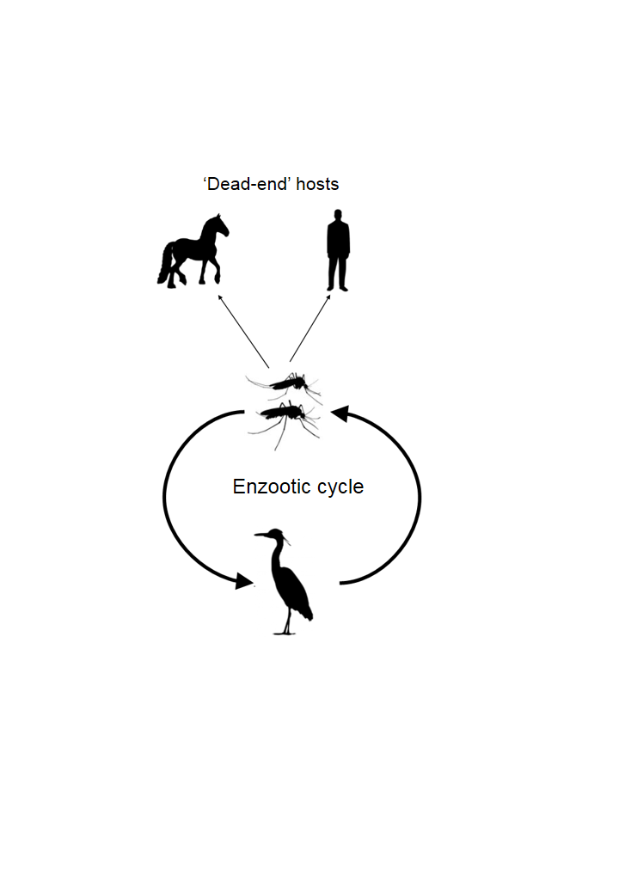
Fig 1b
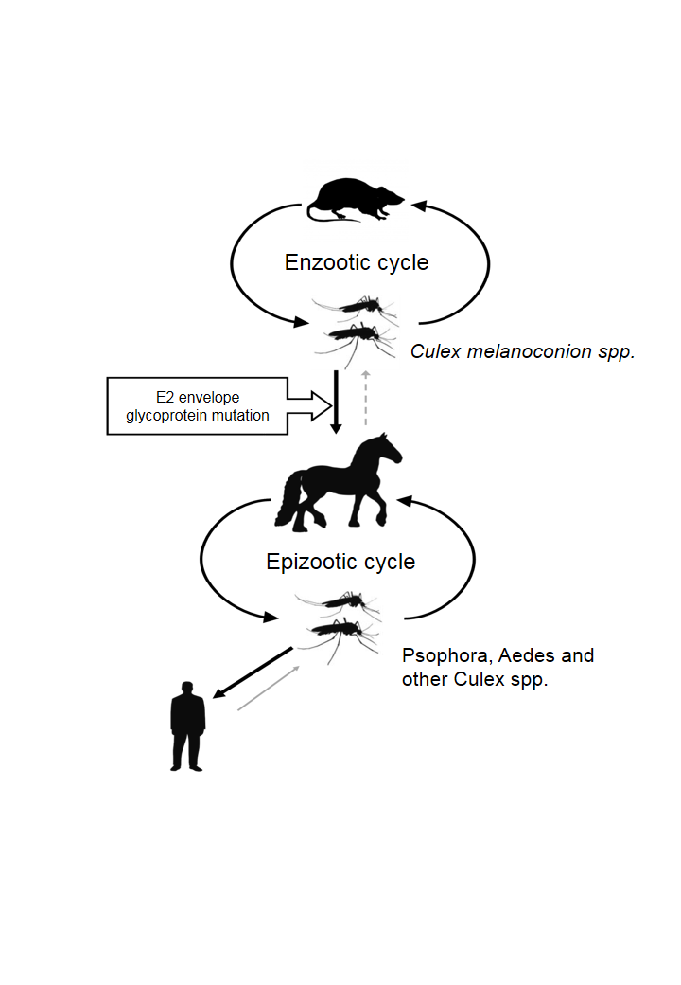
Fig 1c
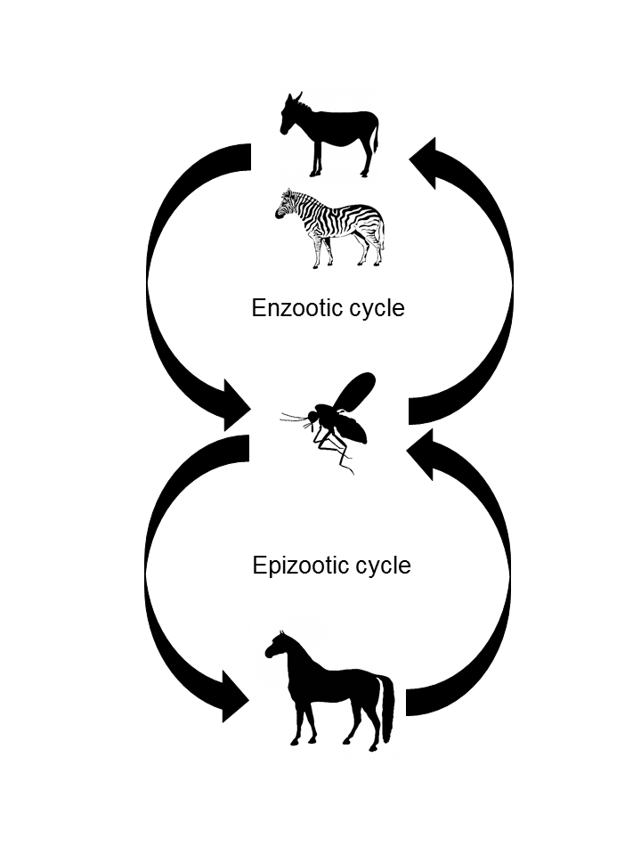

Fig 2a
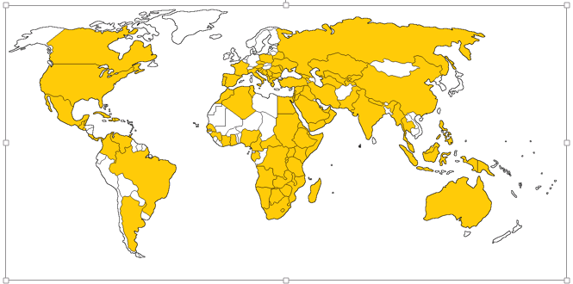

Fig 2b
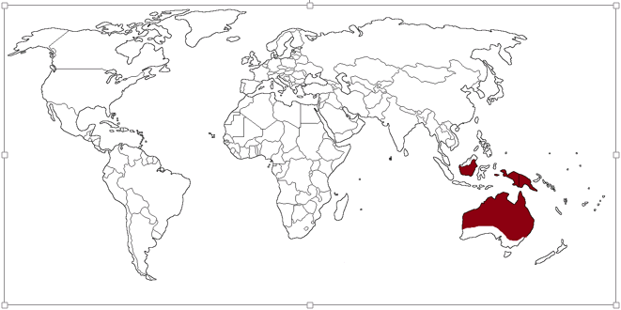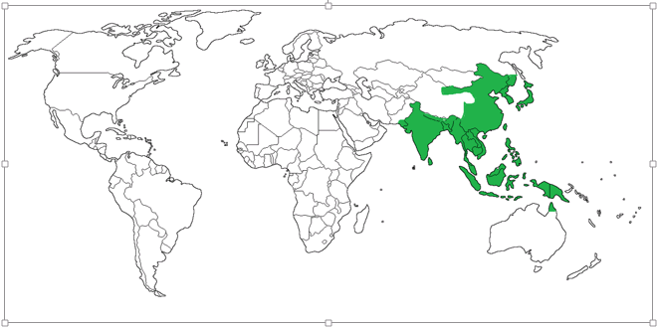

Fig 2c

