Original article

Quantification of equine sacral and iliac motion during application of manual forces and comparison between motion capture with skin-mounted and bone-fixated sensors

L.M Goff ^{a*}; C.M McGowan ^{b}; P. Condie ^{c}; J. Jasiewicz ^{d}; P.R vanWeeren ^{e}

ª School of Agriculture and Food Science, University of Queensland, Gatton Campus, Gatton, 4343, Queensland, Australia
^{b}Faculty of Health and Life Sciences,University of Liverpool, Leahurst, CH64 7TE, United Kingdom.
^{c} Consultant Engineer
^{d} James A. Haley Veterans Administration Hospital, Tampa, Florida
^{e}University of Utrecht, Utrecht, Netherlands

Corresponding author. Tel: +61 402 910 561; mail P.O Box 277, Highfields, Qld, 4352 Australia
Email address. l.goff@uq.edu.au

Abstract
Diagnosis of sacroiliac dysfunction in horses includes manual motion palpation of the equine ilium and sacrum. Motion of the ilium and sacrum during manual force application to the equine pelvis has been measured previously in vitro. The aim of this study was to measure the amount and direction of motion in vivo, including comparison of bone fixated and skin mounted inertial sensors. Sensors were skin-mounted over tuber sacrale (TS) and 3rd sacral spinous process (SP) of six Thoroughbred horses, and later attached via Steinman pins inserted into the same bony landmarks. Orientations of each TS and sacrum were recorded by one investigator during six trials of manual force applied to the pelvis, inducing cranial, caudal and oblique rotations. Mean values were reported in Euler angles for the three orthogonal planes lateral bend (LB), flexion-extension (FE) and axial rotation (AR). Differences between skin and bone fixated markers were determined with significance set at P<0.05.
The largest mean values recorded during rotations applied to the pelvises were for FE, (2.08±0.35º) with bone fixated sensors. Axial rotation gave the largest values recorded with skin-mountings (1.70±0.48º). There was poor correlation between skin-mounted and bone fixated markers. Bony kinematics during external movement applied to the pelvis cannot be predicted from skin-mounted sensors, due to differences between skin- and bone-mounted sensors. Manipulation of the equine pelvis can be expected to produce motion in the plane of FE, but axial movement should be interpreted with caution due to the potential effects of skin motion.

Keywords: sacroiliac, equine, inertial sensors, manual motion palpation

- Introduction
In human physiotherapy, composites of motion palpation and provocation tests of the sacroiliac joint (SIJ) together have reliability sufficiently high for use in clinical assessment of sacroiliac dysfunction (SID) [1, 2]. In horses, manual motion tests and provocation tests have been extrapolated from the human model. Establishing the nature and extent of equine SIJ motion is important to assist clinicians in determining if such tests are valid for the diagnosis of SID in horses.

Measurement of three-dimensional (3-D) movement at the SIJ presents a challenge in horses due to the location of the joint within the pelvis. Despite this, successful recording of movements at both the sacral vertebral segment and the pelvis have been performed. Measurements of these two articulating segments of the SIJ allow an indication of motion that may occur at the SIJ. In vivo studies during treadmill locomotion have been performed in sound horses [3-10]. In vitro measurements limited to the sagittal plane revealed that less than 1º of movement existed at the SIJ where the sacrum was moved against a fixed ilium [11]. Subsequent in vitro research using cadaveric equine specimens measured the amount of 3-D rotation occurring at the ilium with respect to a fixed sacrum. This was recorded with inertial sensors, during the application of movements based on manual motion tests that were applied to cadaveric pelvis [10]. Movement recorded in the sagittal rotation plane was only slightly greater than that recorded by Degueurce and colleagues (2004), [11] but the range of motion of the ilium was greatest in the transverse or coronal plane, when lateral (2.56 ± 0.29º) and oblique (2.25 ± 0.29º) rotations were applied to the pelvis [10].

Relative movement between the ilium and the sacrum has also been noted as a change in cross sectional area of the dorsal sacroiliac ligament (running from the tuber sacrale of the pelvis to the sacrum) occurring during application of manual forces to the pelvis in standing horses [10]. There has not, however, been a kinematic evaluation of the rotations that may occur during application of manual motion tests used in musculoskeletal examination of the SIJ in the horse to the pelvis in vivo.

The aim of this study was to measure the amount and direction of movement of the ilium relative to the sacrum in vivo, during the application of manual forces that are consistent with those utilised during a clinical physiotherapy examination of the equine pelvis. A further aim was to compare bone fixated and skin mounted inertial sensors. We hypothesised that there would be a relationship between the data gathered from the two types of inertial sensor mounting.

- Materials and Methods
Ethical approval for animal use was obtained by the institutional animal ethics committee (University of Queensland AEC number SAS/898/06/APA).

  - Animals
Six thoroughbred horses were recruited, two geldings and four mares, mean age 7.6 years (range 4 – 14 years); mean weight 519.6 kg (range 480 – 553kg), mean height 159 cm (SD 3.2). The history of the horses was unavailable as horses were acquired from a sale yard. The horses were assessed by a veterinarian and a physiotherapist and judged to be sound.

  - Measurement and sensors
Segment angles of both the sacral vertebral segment (S3) and the ilium (TS), were recorded using three wireless inertial sensors numbered 1, 2 and 3 (Inertia Cube 3, InterSense, Bedford, MA, USA www.intersense.com/InertiaCube_Sensors.aspx). The Inertia Cube 3 (IC3) sensors measure absolute orientation of any object relative to gravity and magnetic north. The collection frequency for the sensors was 100Hz. Previous work has shown that the sensors have a static accuracy of better than 0.05º when appropriately configured [13].

The IC3 sensors contain an accelerometer, a magnetometer and gyroscope in each orthogonal plane. The orthogonal planes referred to are those denoted by the standard right-handed orthogonal Cartesian coordinate system. Flexion-extension (FE) is described as rotation around the x-axis; lateral bending (LB) is described as rotation around the z-axis; axial rotation (AR) is described as rotation around the y-axis. Orientation in this study was reported as Euler angles. All data were collected and analysed using Labview 7.1 (National Instruments, Austin TX, USA).

  - Skin-mounted sensors

Xylazine 150mg was administered intravenously to each horse, prior to the horse being clipped over the regions of the tubera sacrale (TS), sacral dorsal spinous processes (SP) and caudal lumbar spinous processes, to ensure an adequate area for adhesion of sensors and their batteries. Adhesive stretch tape (FixomullTM) was applied over the bony prominences of both TS and the SP of S3, and an ink marker denoted the mid-point of each bony prominence (in the horse standing squarely). IC3 sensors were placed over the ink mark on the bony prominences, fastened with double sided tape and further fastened down with adhesive stretch tape.

Sensor 1 was attached onto the left TS; sensor 2 was attached onto the right TS and sensor 3 was attached onto the sacral vertebral segment, for each horse. Horses were placed in stocks, and were encouraged to stand squarely at all times during the testing. For applications of manual forces to the left side of the pelvis, only data from sensors 1 and 3 was recorded. Orientations of the left ilium and the sacrum were simultaneously recorded by the two sensors in three orthogonal planes, LB, FE and AR, during rotational manual forces applied to the left pelvis by physiotherapist (LG). The movements were assessed to the end of available passive range, reported as firm resistance to the induced motion [14, 15]. The manual forces were applied in the following directions:
- Cranial pelvic rotation (sagittal plane)
- Caudal pelvic rotation (sagittal plane)
- Oblique rotation (transverse-frontal plane)

Prior to data collection, at least one test application of each rotation was applied to the pelvis, on each side. During manual force application, if the horse moved from the square standing position, or there was muscle contraction, the application of rotation to the pelvis was repeated. There were three trials recorded for each application. Orientations of the right ilium and the sacrum were thus simultaneously recorded by the two sensors, in three orthogonal planes.

Data were sampled at 20 samples per second. Data was collected using a custom analysis program (Labview 7.1, National Instruments, Austin TX, USA), where they were represented as graphs. The difference between maximum and minimum values on the graph was calculated for each sensor and recorded as the Euler angle for each orthogonal plane.

  - Bone implanted sensors

Bone implantation was carried out following the testing of the horses with skin-mounted inertial sensors without randomisation of order due the possibility of bone implantation affecting the overlying skin. Horses were sedated with xylazine 200 mg and butorphanol 20mg IV. Prior to pin insertion gentamicin (6.6.mg/kg) and 2g phenylbutazone were administered IV. A 4 – 8 cm long, 3.0 mm thick Steinman pin was placed into the SPs (last lumbar and S2 or 3) and TS without pre-drilling, and cut so that each pin protruded approximately 1 cm above the skin. A custom-built light-weight bracket weighing 9 grams and measuring 34 x 25 x 20mm (Fig. 1) with an IC3 sensor screwed to the same, was fixed, via two tightening nuts, to the protruding end of each Steinman pin on the left TS, the sacral dorsal SP and the lumbar dorsal SP. Sensor 1 was pinned into the left TS; sensor 2 was pinned into the right TS and sensor 3 was pinned into the SP of the sacral segment.

The procedure of testing was identical to that of the skin-mounted inertial sensors. Orientation of the left and right ilium and the sacrum were simultaneously recorded by the sensors in three orthogonal planes. Data was collected and recorded in the same manner as for the skin-mounted sensors.

  - Statistical analysis

For each direction of applied rotation the degree of motion of LB, FE and AR was recorded at each sensor. The results were averaged over the six horses, and presented as mean angle ± SEM. Data was tested for normality and paired t-tests were used (STATA Version 10) to ascertain if there were significant differences between results obtained from bone-fixated sensors, from those obtained with skin fixated sensors, for each direction of movement. Data were then analysed using general linear model processing in SAS fitting terms for subject, movement (rotation applied) and sensor. Least squares mean was estimated for the above effects and compared using post-hoc t-tests. Pearson’s correlation coefficient was calculated to determine if there was any predictable relationship between skin-mounted and pin-mounted values.

- Results

3.1 Skin versus Bone Markers
Table 1 displays the means ± SD for all horses, recorded in Euler angles, for each orthogonal plane, during each application of rotation.

Skin-mounted data
Across all measured angles, the largest range of motion was recorded for AR during application of right oblique rotation to the pelvis, measured on the right TS (1.70±0.2º) (Fig. 4). The smallest movement was 0.51±0.11 º recorded at the left TS during application of left oblique rotation for FE (Fig. 3). The general range of sagittal plane motion (FE) during induced movement was 0.5-1.5º; the range of LB was 0.7-1.3 º and the general range of AR was 0.6 to 1.7 º.

Bone-fixated pin mounted data
Across all measured angles, the largest movement recorded was FE, during application of left oblique rotation, measured on the right TS (2.08±0.15º) (Fig. 3). AR gave the smallest range of motion during application of right caudal rotation, at the right TS, (0.42±0.08 º), the sacral segment (0.46±0.07 º) and the left TS (0.46±0.08 º) (Fig. 4). The general range of sagittal plane motion (FE) during induced movement was 1.1-2 º; the range of LB was 0.5-1.2 º and the general range of AR was 0.4 to 1.4 º.

During left caudal rotation, LB was significantly different between skin (1.19±0.08º) and pin-mounted (0.57±0.11º) sensors when measured at the left TS (P< 0.01) (Fig. 2). For application of left cranial rotation, FE was significantly different between skin-mounted (0.59±0.27º) and pin-mounted (1.59±0.10º) sensors on left TS (P< 0.05), and between skin (0.61±0.12 º) and pin-mounted sensors (1.67±0.14 º) on right TS (P< 0.01) during application of right cranial rotation (Fig. 3). During left oblique rotation FE was significantly different between skin-mounted (0.51±0.11) and pin-mounted sensors (1.96±0.11) on the left TS (P< 0.01), and for right oblique rotation at right TS (skin-mounted 0.86±0.17; pin-mounted 2.07±0.18) (P< 0.01), and a trend for difference on the sacrum (skin-mounted 1.08±0.23; pin-mounted 1.68±0.19) (P= 0.068) (Fig. 3). There were thus no consistent left-right differences in induced motion across all sites and angles. Sometimes the amplitude of motion was greater on the contralateral side to where the movement was induced (Fig, 2,3,4). This could occur as the two halves of the pelvis are connected by the pelvic symphysis.

There was poor correlation between skin and pin-mounted values, using Spearman’s Correlation coefficient (Table 2).

3.2 Effect of induced manual motion
Skin-mounted data
Post-hoc analysis showed that for LB and AR there was an effect of the induced manual motion applied. Values for LB during application of caudal rotation were significantly greater than when cranial and oblique rotation were applied (P<0.05), and values for AR were significantly less during caudal rotation than when cranial or oblique rotation were applied (P<0.05) (Tables 3 a, b).

Bone-fixated pin mounted data
Post-hoc analysis showed that values for FE during application of oblique rotation were greater than both cranial and oblique rotation (P<0.01) (Table 4a). Values for AR during application of oblique and cranial rotation were significantly larger than caudal rotation (P< 0.01) (Table 4b).

- Discussion

The objective of this study was to measure the amount and direction of motion of ilium and sacrum during induced motion applied to the horse’s pelvis. The hypothesis that the relative motion of the ilium on the sacrum would be able to be recorded by inertial sensors mounted to the pelvis was fulfilled. The hypothesis that there would be a relationship between the movements recorded with bone-fixated sensors and those recorded with skin-mounted sensors was not fulfilled.

For both skin and pin-mounted data, the induced movement to the pelvis that created the greatest motion at the inertial sensors was oblique rotation. This could be a reflection of the motion allowed at the lumbo-sacral junction by the relatively obliquely orientated facet joints, and the motion allowed by the orientation of the synovial part of the sacroiliac articulation. The joints are articulated approximately 30 degrees to the horizontal, which may foster an oblique rotation of the ilium around the sacrum. .

The orthogonal plane FE had the largest component of movements when recorded from the bone fixated sensors during all rotations applied to the pelvis. This suggests that during all movements applied to the pelvis externally, such as in physiotherapy manual assessment, there can be up to around 2º rotation of the pelvis within the sagittal plane. There was movement also occurring in other planes recorded from pin-mounted sensors, but less than 1.5º in the AR plane, and less than 1.2º in the LB plane.

For the majority of the induced rotations applied to the pelvis, the mean values recorded in the orthogonal planes of LB and AR were greater for skin-mounted inertial sensors than mean values derived from inertial sensors fixated into bone. It is well established that the skin overlying a given bony prominence impedes direct observation and quantification of movement of that bony prominence [16, 17] during gait. It is suggested that the discrepancy is due to both movement of the skin, and pre-loading of the soft tissue under the sensor fixator [17]. Earlier human research on sacroiliac kinematics used implanted tantalum balls and apparatus similar to Steinman pins in an attempt to overcome the skin motion artefact when recording intrapelvic motion [18].

In addition to this skin motion that may occur over pelvic bony prominences during induced rotations, horses also have a vast musculature and fascia that covers the same. The potential motion artefact provided by musculature and fascia during gait may not be as much as an issue for the recording of induced motions to the pelvis. As the induced motions are applied to the horse in square standing, there would be very minimal muscle contraction during the recording of the motion.

Despite the differences, some authors have concluded that skin-mounted markers could be used to evaluate the motion of the vertebral column in walking and trotting horses in a comparative way, where errors attributable to variability between strides and days are taken into account and correction for discrepancies occurs [16, 8]. Likewise, Licka and colleagues (2001) [3] noted in a kinematic gait study of horses without back pain, that movement of the markers on the skin didn’t resemble motion of underlying bony segments. However, they still concluded that skin-mounted markers could provide a method of comparison of horses with different gaits or movement patterns due to lameness [3].

If this effect occurs during gait, it could be also expected that when movements are applied externally to the ilium, the motion recorded by the inertial sensors would also be different for skin-mounted sensors compared to bone-fixated sensors. The current study showed poor correlation between skin and bone-fixated pin mounted sensors, with no repeatable pattern of difference. This suggests that motion recorded at inertial sensors attached via Steinman pins to the bones of the pelvis and sacrum cannot be predicted from skin-mounted inertial sensors during application of rotations to the pelvis. The poor correlation parallels the results of Goff and colleagues (2010) [10] whereby results from skin-mounted sensors did not predict those from bone fixated sensors during measurement of pelvic and sacral motion during walk and trot on a treadmill.

The poor prediction of skin-mounted data from pin-mounted data in this type of kinematic study has implications for future testing of kinematics of horses that are currently in work. Owners of working or performance horses may not wish to have Steinman pins fixated into the pelvis of their horse, whereas the idea of a non-invasive sensor attached to the skin may be less of a concern. However, we may be able to compare values for rotations of bony segments of horses within groups, recorded from the skin overlying the bony segment, such as carried out by Pfau and colleagues (2007) [19] in a comparison of lame versus sound horses with skin-mounted inertial sensors. This would be to ascertain if there were differences in patterns of motion between horses with SID and those that were sound, when orientation of bony segments of the pelvis were recorded from skin-mounted sensors during application of manual forces. We would be required to correct for error if trying to predict the kinematics of the underlying bony segment from skin-mounted sensors only. Motion sensors mounted to the skin could be used in evidence based practice, to measure the result of a given manual therapy, training, or physiotherapeutic intervention. In this way they are not measuring absolute motion of a segment, but simply given an objective measure before and after intervention

Another error source that is unique to application of movement to the pelvis is therapist error. An in vitro study of the application of similar rotations to the equine pelvis suggested there were therapist-based inconsistencies, which could be due to error in judgment of end of range of motion, or handedness of therapist [12]. The use of a pressure mat between the therapist’s hand and the bony prominences of the pelvis may have helped to standardise the forces required to produce the rotations [12, 15]. The increased FE (skin mounted) and LB (bone-fixated pin mounted) angles when movements were applied to the right versus the left pelvis imply there was an effect of handedness measured in this study, although repeatability was good. The data recorded from skin-mounted sensors revealed there was a significant effect of the movement applied to the pelvis by the therapist on the amount of rotation occurring in the orthogonal planes of LB and AR. LB was more likely to be larger during application of caudal rotation than when cranial or oblique rotations were applied, and AR was more likely to be smaller during application of caudal rotation than when cranial or oblique rotations were applied.

Likewise, the data recorded from the bone-fixated sensors also showed an effect of the movement that was applied. Application of oblique rotation resulted in significantly greater motion in the FE plane than when the sagitally directed cranial or caudal rotations were applied. The same rotation also resulted in significantly greater movement in the AR plane than during application of cranial or caudal rotation. This suggests that the applied movement that had the largest motion recorded by the inertial sensors (oblique rotation), consisted of a combination of movement in the sagittal and axial planes. This supports the suggestion that coupling of motion occurs in joints of the human vertebral column [20].

- Conclusion
For both skin-mounted and bone-fixated inertial sensors, the motion applied to the equine pelvic that created the greatest motion at the inertial sensors, was oblique rotation. This may suggest that it would be pertinent to assess this motion during manual physical assessment of the equine pelvis, as discrepancies between left and right oblique rotation may be more readily picked up than perhaps the other direction so motion.

During most of the movements applied to the pelvis, LB and AR were greater for skin-mounted inertial sensors than for sensors fixated into bone. Bone-fixated measurements of all movement applied to the pelvis resulted in greater movement in the FE plane. There was poor correlation here between degrees of rotation measured by bone-fixated inertial sensors and degrees of rotation measured by skin-mounted sensors, and it was recognised that there were a number of error factors that need to be considered with use of skin-mounted sensors. Skin-mounted sensors cannot be used to estimate kinematics of underlying bony segments movement in the horse, but they may potentially be used as a comparative method of analysing patterns of motion, or as a type of outcome measure when looking at manual therapy interventions to the equine pelvis.

Conflict of interest statement
No competing interests have been declared

Acknowledgements
This study was supported by the Australian Government Rural Industries Research and Development Corporation RIRDC Publication No 09/(added by RIRDC) RIRDC Project No PRJ-000683

References
[1] Arab, A., Abdollahi, I., Joghataei, M., Golafshani, Z, Kazemnejad, A., 2009. Inter-and intra- examiner reliability of selected motion palpation and pain provocation tests for the sacroiliac joint. Manual Therapy 14, 213-221

[2] Szadek K.M., van der Wurff P., van Tulder M.W., Zuurmond W.W., Perez R.S., 2009. Diagnostic validity of criteria for sacroiliac joint pain: a systematic review. Journal of Pain. 10(4), 354-368.

[3] Licka, T., Peham, C., Zohmann, E., 2001. Range of movement at trot in horses without back pain. Equine Veterinary Journal Supplement, 33, 150-153

[4] Haussler, K., Bertram, J., Gellman, K., Hermanson, J., 2001. Segmental in vivo vertebral kinematics at the walk, trot and canter: a preliminary study. Equine Veterinary Journal Supplement, 33, 160-164

[5] Faber, M., Schamhardt, H., van Weeren, R., Johnston, C., Roepstorff, L. Barneveld, A., 2000. Basic three-dimensional kinematics of the vertebral column of horses walking on a treadmill. American Journal of Veterinary Research, 61, 399-406

[6] Faber, M., Johnston, C., Schamhardt, H., van Weeren, R., Roepstorff, L. Barneveld, A., 2001a. Basic three-dimensional kinematics of the vertebral column of horses trotting on a treadmill. American Journal of Veterinary Research, 62 (5) 757-764

[7] Faber, M., Johnston, C., Schamhardt, H., van Weeren, R., Roepstorff, L. Barneveld, A., 2001b. Three-dimensional kinematics of the equine spine during canter. Equine Veterinary Journal Supplement, 33, 145-149

[8] Faber, M., Schamhardt, H., van Weeren, R., Barneveld, A., 2001c. Methodology and validity of assessing kinematics of the thoracolumbar vertebral column in horses on the basis of skin-fixated markers. American Journal of Veterinary Research, 62 (3) 301-306

[9] Gomez-Alvarez, C., Rhodin, M., Bobbert M., Meyer, H., Weishaupt, M., Johnston, C., van Weeren, P., 2006. The effect of head and neck position on the thoracolumbar kinematics in the unridden horse. Equine Veterinary Journal Supplement (36) 445-51

[10] Goff, L., van Weeren, P., Jeffcott, L., Condie, P., & McGowan, C. (2010) Quantification of equine sacral and iliac motion during gait: a comparison between motion capture with skin-mounted and bone-fixated sensors. Equine Veterinary Journal Supplement

[11] Degueurce, C., Chateau, H. and Denoix, J-M, 2004. In vitro assessment of
movements of the sacroiliac joint in the horse Equine Veterinary Journal 36 (8) 694-698.

[12] Goff, L., Jasiewicz, J., Jeffcott, LB., Condie, P., McGowan, TM., McGowan, CM., 2006. Movement between the equine ilium and sacrum: in vivo and in vitro studies. Equine Veterinary Journal Supplement, 37, 457-461

[13] Foxlin, E., Harrington, M. and Altschuler, Y., 1998. Helmet and head-mounted
displays III. SPIE v. 3362; AeroSense 98, Orlando, Florida, 13-14.

[14] Maitland, G. D. (1986) Vertebral Manipulation, 5th Edition. Elsevier Ltd., 144-170

[15] Haussler, K., Hill, A., Puttlitz, C., McIlwraith, C., 2007. Effects of vertebral manipulation on kinematics of the thoracolumbar region. American Journal of Veterinary Research, 68 (5) 508-516

[16] Van den Bogert, A., van Weeren, P., Schamhardt, H., 1990. Correction for skin displacement errors in movement analysis of the horse. Journal of Biomechanics, 23 (1) 97-101

[17] Taylor, W., Ehrig, R., Duda, G., Schell, H., Seebeck, P., Heller, M., 2005. On the influence of soft tissue coverage in the determination of bone kinematics using skin markers. Journal of Orthopaedic Research, 23, 726-734

[18] Sturesson, B., Uden, A., Vleeming, A., 2000. A radiostereometric analysis of movements of the sacroiliac joint during the standing hip flexion test. Spine (25) 364-368.

[19] Pfau, T., Robilliard, J., Weller, R., Jespers, K., Eliashar, E., Wilson, A., 2007. Assessment of mild hindlimb lameness during over ground locomotion using linear discriminant analysis of inertial sensor data. Equine Veterinary Journal, 39 (5) 407-413

[20] Kozanek, M., Wang, S., Passias, PG, Xia, Q., Li, G., Bono, C., Wood, K., Li, G., 2009. Range of motion and orientation of the lumbar facet joints in vivo. Spine 1 (34) E689-96

Table 1: Range of motion at each of three sensors (means ± SEM, n=6 horses), recorded in Euler angles, for each orthogonal plane, during the application of manual rotational forces (caudal, cranial and oblique) on either the left or right side of pelvis. Asterisks denote significant differences between skin and pin mountings. Note: There were only two sensors recording at a time for skin-mounted data, the side of the application of rotation and the sacral segment.

 |  |  | Left pelvic movement |  |  | Right pelvic movement
Rotation | Mount | Plane | 1 | 2 | 3 | 1 | 2 | 3
Caudal | Skin | LB | 1.19±0.08 |  | 1.34±0.30 |  | 1.05±0.24 | 1.13±0.19
 |  | FE | 0.95±0.13 |  | 0.97±0.09 |  | 0.96±0.12 | 1.00±0.08
 |  | AR | 1.19±0.53 |  | 1.12±0.53 |  | 0.82±0.24 | 0.67±0.28
 | Pin | LB | 0.57±0.11* | 0.62±0.11 | 0.75±0.10 | 0.88±0.07 | 0.92±0.14 | 1.02±0.12
 |  | FE | 1.18±0.14 | 1.15±0.26 | 1.16±0.15 | 1.60±0.46 | 1.55±0.46 | 1.47±0.41
 |  | AR | 0.90±0.22 | 0.78±0.20 | 0.89±0.28 | 0.46±0.08 | 0.42±0.08 | 0.46±0.07
Cranial | Skin | LB | 0.73±0.23 |  | 0.78±0.16 |  | 0.87±0.15 | 1.04±0.24
 |  | FE | 0.59±0.27 |  | 1.23±0.21 |  | 0.61±0.12 | 1.08±0.27
 |  | AR | 1.20±0.28 |  | 0.84±0.16 |  | 1.29±0..30 | 1.03±0.27
 | Pin | LB | 0.86±0.11 | 0.80±0.15 | 0.99±0.13 | 0.96±0.14 | 0.73±0.10 | 0.85±0.15
 |  | FE | 1.59±0.10* | 1.80±0.14 | 1.27±0.04 | 1.53±0.19 | 1.67±0.14* | 1.33±0.18
 |  | AR | 0.79±0.09 | 1.21±0.20 | 0.76±0.12 | 1.31±0.19 | 1.23±0.16 | 0.78±0.10
Oblique | Skin | LB | 0.73±0.09 |  | 0.94±0.20 |  | 0.95±0.25 | 0.91±0.17
 |  | FE | 0.51±0.11 |  | 1.33±0.21 |  | 0.86±0.17 | 1.08±0.23
 |  | AR | 1.16±0.29 |  | 0.72±0.20 |  | 1.70±0.20 | 1.32±0.31
 | Pin | LB | 0.66±0.10 | 0.83±0.07 | 0.78±0.12 | 0.97±0.19 | 0.95±0.17 | 0.88±0.17
 |  | FE | 1.96±0.11* | 2.08±0.15 | 1.73±0.16 | 2.07±0.15 | 2.07±0.18* | 1.66±0.19
 |  | AR | 1.17±0.28 | 1.41±0.27 | 1.00±0.27 | 1.42±0.25 | 1.32±0.22 | 0.85±0.20

Abbreviations: LB = lateral bend; FE = flexion extension; AR = axial rotation
Sensor 1=left tuber sacrale; Sensor 2=right tuber sacrale; Sensor 3=sacral segment

Table 2: Spearman’s correlation coefficient between skin and pin-mounted data, during the application of manual rotational forces (caudal, cranial and oblique) on either the left or right side of the pelvis in 6 horses.

Movement | Spearman’s correlation coefficient
 | LB | FE | AR
Left caudal rotation | 0.49 | 0.05 | 0.81
Right caudal rotation | 0.60 | 0.95 | 0.12
Left cranial rotation | 0.53 | 0.12 | 0.57
Right cranial rotation | 0.40 | 0.15 | 0.36
Left oblique rotation | 0.59 | 0.12 | 0.78
Right oblique rotation | 0.16 | 0.43 | 0.70

Table 3: Least squares mean angles for lateral bend (LB) and axial rotation (AR) during the application of manual rotational forces (caudal, cranial and oblique) on either the left or right side of pelvis from skin mounted sensors in 6 horses. Significantly greater value denoted by ª

Orthogonal Plane | Movement | Mean Euler Angle(º) | SEM
LB | Cranial | 0.81 | 0.08
 | Caudal | 1.06ª | 0.08
 | Oblique | 0.85 | 0.08
AR | Cranial | 1.15 | 0.09
 | Caudal | 0.71ª | 0.09
 | Oblique | 1.07 | 0.09

Table 4: Least squares mean angles for flexion-extension (FE) and axial rotation (AR) during the application of manual rotational forces (caudal, cranial and oblique) on either the left or right side of pelvis using bone fixated sensors in 6 horses. Significantly greater value denoted by ª

Orthogonal Plane | Movement | Mean Euler Angle(º) | SEM
FE | Cranial | 1.53 | 0.07
 | Caudal | 1.35 | 0.07
 | Oblique | 1.92ª | 0.07
AR | Cranial | 1.01 | 0.05
 | Caudal | 0.65ª | 0.05
 | Oblique | 1.19 | 0.05

Figure legends
Figure 1: The custom built light-weight aluminium bracket for mounting of inertial sensor

Figure 2: Means of pin-mounted movements and skin-mounted movements for lateral bend (LB). Error bars represent confidence interval of 95%. Asterisks represent signifcant differences between skin- and pin-mounted values. The relative movement is measured as Euler angles (y-axis). The induced movements are represented along the x-axis.

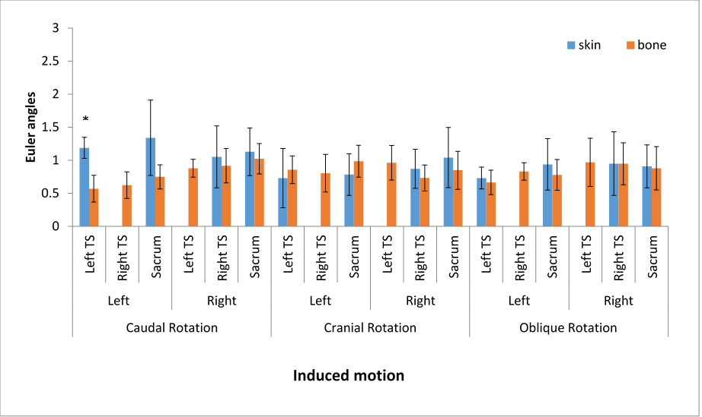
Figure 3: Means of pin-mounted movements and skin-mounted movements for flexion-extension (FE). Error bars represent confidence interval of 95%. Asterisks repesent significant differences between skin- and pin-mounted value. The relative movement is measured as Euler angles (y-axis). The induced movements are represented along the x-axis.
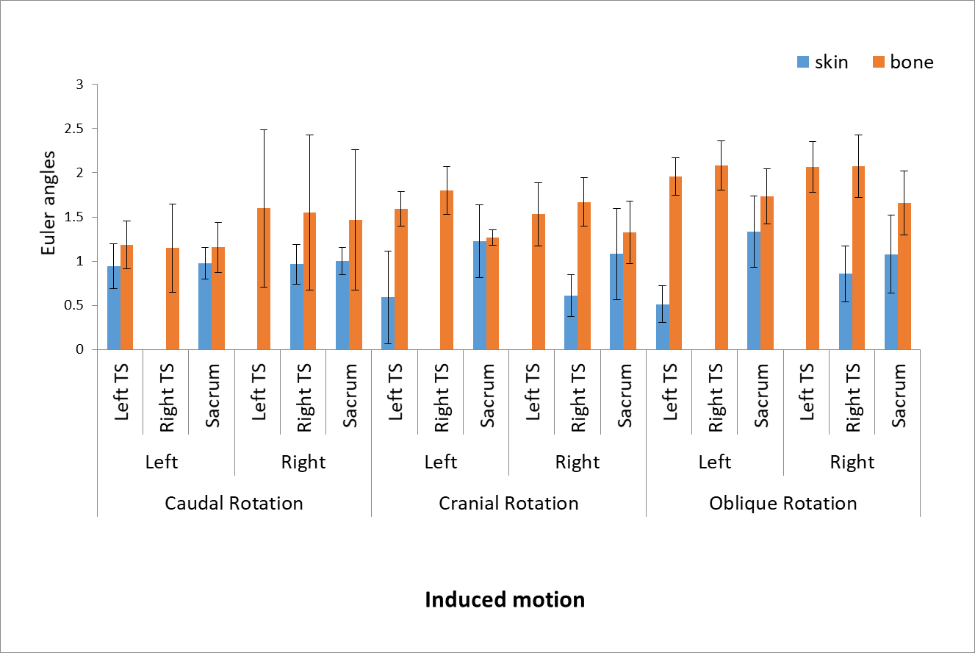
Figure 4: Means of pin-mounted movements and skin-mounted movements for axial rotation (AR). Error bars represent confidence interval of 95%. Asterisks represent significant differences between skin- and pin-mounted value. The relative movement is measured as Euler angles (y-axis). The induced movements are represented along the x-axis.
