Rates of myocardial infarction and stroke in patients initiated on SGLT2-inhibitors versus other glucose-lowering agents in real-world clinical practice: results from the CVD-REAL study
Mikhail Kosiborod MD¹, Kåre I. Birkeland MD², Matthew A. Cavender MD, MPH³, Alex Z. Fu PhD⁴, John P. Wilding MD⁵, Kamlesh Khunti MD⁶, Reinhard W. Holl MD⁷, Anna Norhammar MD^{8,9}, Marit Eika Jørgensen MD^{10,11}, Eric T. Wittbrodt PharmD, MPH¹², Marcus Thuresson PhD¹³, Johan Bodegård MD¹⁴, Niklas Hammar PhD^{8,15}, Peter Fenici MD¹⁶ on behalf of the CVD-REAL Investigators and Study Group*

¹Saint Luke's Mid America Heart Institute and University of Missouri-Kansas City, Kansas City, MO, United States; ²University of Oslo and Oslo University Hospital, Oslo, Norway; ³University of North Carolina, Chapel Hill, NC, United States; ⁴Georgetown University Medical Center, Washington DC, United States; ⁵University of Liverpool, Liverpool, United Kingdom; ⁶University of Leicester, Leicester, United Kingdom; ⁷University of Ulm, Ulm, Germany; ⁸Karolinska Institutet, Stockholm, Sweden; ⁹Capio S:t Görans hospital, Stockholm, Sweden; ¹⁰Steno Diabetes Center, Copenhagen, Gentofte, Denmark; ¹¹National Institute of Public Health, Southern Denmark University, Denmark; ¹²AstraZeneca, Wilmington, DE, United States; ¹³Statisticon AB, Uppsala, Sweden; ¹⁴AstraZeneca, Oslo, Norway; ¹⁵AstraZeneca Gothenburg, Sweden; ¹⁶AstraZeneca, Cambridge, United Kingdom
* See Supplementary Materials for full list
Short title: CVD-REAL: Myocardial infarction and stroke events

Corresponding author: Mikhail Kosiborod, MD
Saint Luke’s Mid America Heart Institute
4401 Wornall Road
Kansas City
MO, 64111, USA
Tel: +1 8169323445; Fax: +1 8169325798; E-mail: mkosiborod@saint-lukes.org

Word count: 893

Abstract (179/180 words)
The multinational, observational CVD-REAL study recently showed that initiation of sodium-glucose co-transporter-2 inhibitors (SGLT-2i) was associated with significantly lower rates of death and heart failure vs. other glucose-lowering drugs (oGLDs). This sub-analysis of CVD-REAL sought to determine the association between initiation of SGLT-2i vs. oGLDs and the rates of myocardial infarction (MI) and stroke. Medical records, claims and national registers collected from the US, Sweden, Norway and Denmark were used to identify patients with T2D who were newly initiated on SGLT-2i (canagliflozin, dapagliflozin or empagliflozin) or oGLDs. A non-parsimonious propensity score was developed within each country to predict initiation of SGLT-2i, and patients were matched 1:1 in the two treatment groups. Pooled hazard ratios (HR) and 95% confidence intervals (CI) were generated using Cox regression models. Overall, 205,160 patients were included. In the intent-to treat analysis, over 188,551 and 188,678 person-years follow-up (MI and stroke, respectively), there were 1077 MIs and 968 stroke events. Initiation of SGLT-2i vs. oGLD was associated with a modestly lower risk of MI and stroke (MI: HR 0.85, 95% CI 0.72–1.00; P=0.05; Stroke: HR 0.83, 95%CI 0.71–0.97; P=0.02). These findings complement the results of the cardiovascular outcomes trials, and offer additional reassurance in regards to the cardiovascular effects of SGLT-2i, specifically as it relates to ischaemic events.

Keywords (max 6, selected from a list): Cardiovascular disease; SGLT2 inhibitor; Type 2 diabetes; Observational study
Introduction
Despite advances in prevention, cardiovascular disease remains the leading cause of mortality and morbidity in patients with type 2 diabetes (T2D). Two large randomised controlled trials (RCTs) of sodium-glucose co-transporter-2 inhibitors (SGLT-2i; empagliflozin and canagliflozin) have shown significant reductions in major adverse cardiac events, as well as hospitalisations for heart failure.[1, 2] The rates of non-fatal myocardial infarction (MI) were numerically lower with both empagliflozin and canagliflozin vs. placebo; the point estimates for non-fatal stroke numerically favoured placebo vs. empagliflozin in EMPA-REG OUTCOME trial, and canagliflozin vs. placebo in the CANVAS Program, although none of these differences were statistically significant.[1, 2]
Recently, the CVD-REAL study, a multinational, observational study of over 300,000 patients, found that initiation of SGLT-2i was associated with a significant reduction in death and heart failure when compared to other glucose-lowering drugs (oGLDs).[3] Observational data from Nordic countries (CVD-REAL Nordic) has shown non-significant point estimates in favour of SGLT-2i for MI and stroke using somewhat different statistical methods, and with dapagliflozin dominating the SGLT-2i group.[4, 5] However, the effects of SGLT-2i on atherothrombotic events in the larger CVD-REAL cohort, including patients from the US, with a broader representation of SGLT-2i compounds, have not been previously explored. Accordingly, in this analysis of the global CVD-REAL data, we sought to determine the association between initiation of SGLT-2i vs. oGLD and MI and stroke events.

Methods
The CVD-REAL study design has been previously described.[3] For this analysis, adult patients with T2D who were newly initiated on SGLT-2i (canagliflozin, dapagliflozin or empagliflozin) or oGLD were identified from medical records, claims and national registers collected from four countries (US, Sweden, Norway and Denmark). Due to small numbers of patients and events in Germany and United Kingdom we elected not to include data from these countries in this analysis. A non-parsimonious propensity score was developed separately within each country to predict the likelihood of being prescribed an SGLT-2i, and patients were matched 1:1 in the two treatment groups. In the main, on-treatment analysis, patients were followed from the index date (initiation of the SGLT-2i or oGLD) until completion of treatment, occurrence of an outcome event, death or censoring. The endpoints of interest were time to MI and stroke. Pooled hazard ratios (HR) and 95% confidence interval (CI) for each endpoint were generated using Cox regression models, with inverse variance weighting for each country. In a sensitivity analysis, an intent-to-treat (ITT) approach was used, in which patients were followed after discontinuation of index treatment. Analyses of de-identified data were conducted in accordance with local laws and regulations, and received approvals from respective Scientific/Ethics/Data Protection Committees.

Results
After propensity-score matching, 205,160 patients were included in the analysis (102,580 in each group), and baseline characteristics were well balanced between the two groups. Mean age was 57 years, 43% were female, 14% had documented cardiovascular disease. In the SGLT-2i group, of the total exposure time, 49% of patients received dapagliflozin, 44% canagliflozin and 7% empagliflozin. There was significant geographical variation with regards to the specific SGLT-2i used, with canagliflozin used predominately (75%) in the US, and dapagliflozin used predominately (90%) in Europe. In patients initiating oGLDs, the most commonly used classes were insulin (34%), dipeptidyl peptidase-4 inhibitors (18%), sulfonylureas (17%), glucagon-like peptide-1 receptor agonists (14%) and metformin (12%).
For the on-treatment analysis, the mean follow up time was 254 days in SGLT-2i and 232 days in oGLD groups. Over 136,524 and 136,626 person-years follow-up (MI and stroke, respectively), there were 779 MIs and 674 strokes (event rate [ER] 0.57 and 0.49/100 person-years, respectively). Initiation of SGLT-2i vs. oGLD was associated with a lower risk of MI and stroke (MI: ER 0.49/100 person-years for SGLT-2i vs. 0.66/100 person-years for oGLD; HR 0.78, 95% CI 0.65–0.95; P=0.01; Figure 1A; Stroke: ER 0.42/100 person-years for SGLT-2i vs. 0.58/100 person-years for oGLD; HR 0.80, 95%CI 0.66–0.97; P=0.02; Figure 1B); with no evidence of heterogeneity by country.
In the ITT analysis, the mean follow-up time was 339 days in SGLT-2i and 332 days in oGLD groups. Over 188,551 and 188,678 person-years follow-up (MI and stroke, respectively), there were 1077 MIs and 968 strokes (ER 0.57 and 0.51/100 person-years, respectively). Initiation of SGLT-2i vs. oGLD was associated with a lower risk of MI and stroke (MI: ER 0.52/100 person-years for SGLT-2i vs. 0.62/100 person-years for oGLD; HR 0.85, 95% CI 0.72–1.00; P=0.05; Figure 1C; Stroke: ER 0.45/100 person-years for SGLT-2i vs. 0.57/100 person-years for oGLD; HR 0.83, 95%CI 0.71–0.97; P=0.02; Figure 1D); with no evidence of heterogeneity by country.

Conclusions
In summary, in this multinational study of over 200,000 patients seen in real-world clinical practice, with a very large number of ischaemic events, initiation of SGLT-2i vs. oGLD was associated with modestly lower rates of MI and stroke. Although our patient population differed from the EMPA-REG OUTCOME trial and CANVAS Program (with lower prevalence of cardiovascular disease, and thus lower event rates), for MI our results were directionally and numerically consistent with both studies;[1, 2] with difference in width of the confidence intervals likely related to greater absolute number of events in our study. For stroke, our data were also directionally and numerically consistent with the CANVAS Program.[1]
Our study offers important incremental information in regards to the association between SGLT-2i use and atherothrombotic events, including myocardial infarction and stroke, in a broad population of patients with Type 2 diabetes from routine clinical practice. Although prior observational data from Nordic countries (CVD-REAL Nordic) examined these relationships previously, and showed numerically lower, non-significant point estimates for MI and stroke favouring SGLT-2i versus other glucose lowering agents (as well as versus DPP4 inhibitors), those investigations evaluated smaller patient samples and numbers of events, used somewhat different statistical approaches, and dapagliflozin dominated the SGLT-2i group.[4, 5] Our report substantially expands these findings in the much larger CVD-REAL cohort, with greater number of events, included patients from the US, and had a broader representation of SGLT-2i compounds. Collectively, our findings complement the results of the completed cardiovascular outcomes trials of SGLT-2i, and prior observational analyses, and offer additional reassurance in regards to the cardiovascular effects of SGLT-2i, specifically as it relates to ischaemic events (and especially stroke, for which some concerns had previously been raised based on a small numerical excess of stroke events with empagliflozin vs. placebo, which was not statistically significant).
The results of our study should be considered in the context of several potential limitations. First, given the observational nature of the analyses, and despite robust statistical techniques, including 1:1 propensity matching, a possibility of residual, unmeasured confounding cannot be definitively excluded. Second, despite a large number of accrued patient-years of follow up, the average duration of follow up was relatively limited, as SGLT-2i use in real-world practice is still recent; longer-term follow up will be needed to evaluate if effects are sustained over time. Finally, given that CVD-REAL is a large, multinational pharmaco-epidemiologic comparative effectiveness study, it was not designed to examine the potential mechanisms linking the use of SGLT-2i and associated cardiovascular benefits. However, it is highly unlikely that glucose lowering per se is behind the lower risk of CV events. As an example, prior analyses from the EMPA-REG OUTCOME Trial have demonstrated that it is unlikely that reductions in HbA1c mediate the CV benefits of empagliflozin. Potential mechanisms may involve reductions in oxidative stress, improvement in endothelial function, neurohormonal modulation and anti-inflammatory effects, among others. A metabolic hypothesis suggesting that a shift in myocardial metabolism from glucose and free fatty acids to ketones may contribute to CV benefits of SGLT-2i has also been proposed. Importantly, this knowledge gap is being examined by mechanistic investigations across the SGLT-2i class, with more information forthcoming in the near future.
Author contributions
MK, NH and PF were involved in the study design, the protocol was finalized with contributions from all authors. NH, MT, XXX were involved in the data collection, all authors were involved in the analysis and interpretation of the data. MK wrote the manuscript and all authors reviewed and critically revised the draft. All authors provided final approval for submission.

Acknowledgements
Editorial support was provided by Nicola Truss PhD of inScience Communications, Springer Healthcare, and funded by AstraZeneca.

Sources of Funding
This work was supported by AstraZeneca.

Disclosures
MK, research grants from AstraZeneca and Boehringer Ingelheim, advisory boards for AstraZeneca, Boehringer Ingelheim, Sanofi, Glytec, Novo Nordisk, ZS Pharma, Janssen, Merck (Diabetes) and Novartis; consultant for AstraZeneca, Boehringer Ingelheim, Sanofi, GSK, Janssen, Intarcia, Merck (Diabetes), Novo Nordisk, Glytec and ZS Pharma. KIB, grants to his institution from AstraZeneca for this study and for lectures and consulting from Novo Nordisk, Sanofi, Lilly, Boehringer Ingelheim and Merck Sharp & Dohme. MAC, personal fees from AstraZeneca, Merck, Sanofi-Aventis, Chiesi and research support (non-salary) from Abbott Laboratories, AstraZeneca, GlaxoSmithKline, The Medicines Company, Merck, and Takeda. AZF, grants from AstraZeneca and Merck; personal fees from Asclepius Analytics and Complete HEOR Solutions. MT, employee of Statisticon who were under contract to AstraZeneca for this study. JPW, lecture fees from Astellas, AstraZeneca, Boehringer Ingelheim, Janssen, Lilly, Novo Nordisk, Orexigen, Sanofi; and consultancy (Institutional) from AstraZeneca, Boehringer Ingelheim, Janssen, Lilly, and Orexigen; grants to institution from Takeda, Novo Nordisk and AstraZeneca. KK, consultant and speaker for Astra Zeneca, Novartis, Novo Nordisk, Sanofi-Aventis, Lilly, Merck Sharp & Dohme, Janssen and Boehringer Ingelheim; grants in support of investigator and investigator initiated trials from Astra Zeneca, Novartis, Novo Nordisk, Sanofi-Aventis, Lilly, Boehringer Ingelheim, Merck Sharp & Dohme and Roche; advisory boards for Astra Zeneca, Novartis, Novo Nordisk, Sanofi-Aventis, Lilly, Merck Sharp & Dohme, Janssen and Boehringer Ingelheim. KK is supported by the NIHR Collaboration for Leadership in Applied Health Research and Care East Midlands (CLAHRC EM). RWH, grants from AstraZeneca. AN, personal fees from AstraZeneca for this study; honorarium for lectures and advisory board meetings for Novo Nordisk, Boehringer Ingelheim, and Lilly. MEJ, shareholder of Novo Nordisk, was employed by Steno Diabetes Center A/S until December 31 2016, a research hospital working in the Danish National Health Service and owned by Novo Nordisk A/S; grants from AstraZeneca. MT, employee of Statisticon who were under contract to AstraZeneca for this study. JB, ETW, NH and PF, employees of AstraZeneca.

References
[1] Neal B, Perkovic V, Mahaffey KW, et al. Canagliflozin and Cardiovascular and Renal Events in Type 2 Diabetes. New England Journal of Medicine. 2017; 377: 644-657
[2] Zinman B, Wanner C, Lachin JM, et al. Empagliflozin, Cardiovascular Outcomes, and Mortality in Type 2 Diabetes. New England Journal of Medicine. 2015; 373: 2117-2128
[3] Kosiborod M, Cavender MA, Fu AZ, et al. Lower Risk of Heart Failure and Death in Patients Initiated on SGLT-2 Inhibitors Versus Other Glucose-Lowering Drugs: The CVD-REAL Study. Circulation. 2017; 136: 249-259
[4] Persson F, Nystrom T, Jorgensen ME, et al. Dapagliflozin is associated with lower risk of cardiovascular events and all-cause mortality in people with type 2 diabetes (CVD-REAL Nordic) when compared with dipeptidyl peptidase-4 inhibitor therapy: A multinational observational study. Diabetes Obes Metab. 2017:
[5] Birkeland KI, Jørgensen ME, Carstensen B, et al. Cardiovascular mortality and morbidity in patients with type 2 diabetes following initiation of sodium-glucose co-transporter-2 inhibitors versus other glucose-lowering drugs (CVD-REAL Nordic): a multinational observational analysis. The Lancet Diabetes & Endocrinology. 5: 709-717

Figure 1. Event rates, unadjusted hazard ratios and 95% CI for acute myocardial infarction (A) and stroke (B) in the on-treatment population, and acute myocardial infarction (C) and stroke (D) in the ITT population
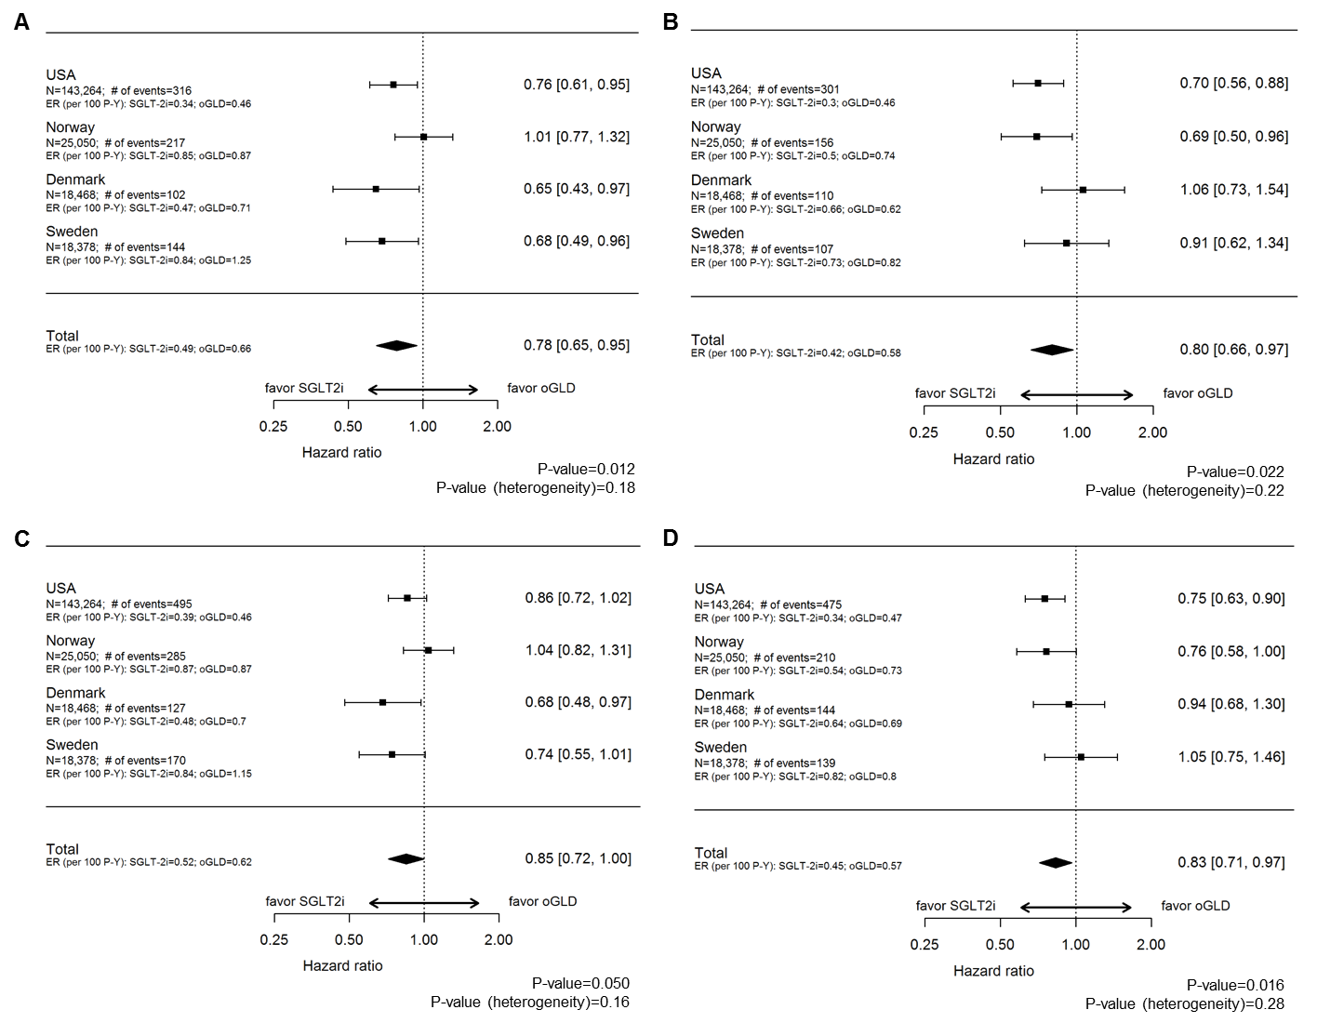
ER, event rate; oGLD, other glucose-lowering drug; P-Y, person-years; SGLT-2i, sodium-glucose transporter-2 inhibitors
Supplementary Materials
CVD-REAL Investigator and Study Group

Executive Scientific Committee (Academic Members and Investigators):
Mikhail Kosiborod, MD, Saint Luke's Mid America Heart Institute and University of Missouri-Kansas City, Kansas City, MO, United States; Matthew A. Cavender, MD MPH, University of North Carolina, Chapel Hill, NC, United States; Alex Z. Fu, PhD, Georgetown University Medical Center, Washington DC, United States; John P. Wilding MD, PhD, University of Liverpool, Liverpool, United; Kingdom; Kamlesh Khunti, MD PhD, University of Leicester, Leicester, United Kingdom; Anna Norhammar, MD, Cardiology Unit, Department of Medicine, Karolinska Institutet, Stockhom, Sweden; Kåre I Birkeland, MD PhD, Department of Endocrinology, University of Oslo, Norway; Marit Eika Jørgensen, MD PhD, cand.med, Steno Diabetes Center, Gentofte, Denmark; Reinhard W. Holl MD PhD, Institute of Epidemiology, University of Ulm, Ulm, Germany.

Executive Scientific Committee and Core Study Team (AstraZeneca Members):
Niklas Hammar, PhD, Senior Director Epidemiology, AZ Gothenburg, Sweden and Institute of Environmental Medicine, Karolinska Institutet, Stockholm, Sweden (Study Principal Investigator); Peter Fenici, MD, PhD, Global Medical Affairs Senior Leader, AZ, Academy House, Cambridge, United Kingdom (Study Leader); Hungta Chen, PhD, Principal Statistician, Biometrics and Information Sciences, AZ Gaithersburg, MD, United States (Study Statistician); Johan Bodegård, MD, PhD, Medical Evidence Scientific Lead Nordics/Baltic, AZ Oslo, Norway; Betina T. Blak, MSc, PhD, RWE Scientific Leader, AZ Luton, United Kingdom; Eric T. Wittbrodt, PharmD, MPH, HEOR Director, AZ Wilmington, DE, United States; Markus F Scheerer, MSc, PhD, Medical Affairs, AZ Wedel, Germany; Filip Surmont, MD, Medical Director, AZ Luton, United Kingdom; Kyle Nahrebne, MSc, Global Publication Leader, AZ Gaithersburg, MD, United (Study Publication Leader).
All Members of the Executive Steering Committee have contributed to data interpretation and approved this manuscripts analyses and conclusions. Executive Scientific Committee Academic Members MK, MAC, AZF, JPW, KK, AN have also reviewed and input the study protocol and amendment, together with the Executive Scientific Committee AZ Members NH, PF, KN, JB, ETW, BTB, and MFS. All Study Core Team Members have contributed to country level analyses and local coordination with databases analysts in their respective country. All pooled statistical analyses conducted by Marcus Thuresson (Statisticon), and validated by an independent statistical group at Saint Luke’s Mid America Heart Institute

External Investigators and Analysts:
Hanne Løvdal Gulseth, MD, PhD, Department of Endocrinology, Oslo University Hospital, Aker, Norway; Bendix Carstensen, PhD, Diabetes Center, Gentofte, Denmark; Marcus Thuresson, PhD Statistician (Study Statistician), Statisticon AB, Uppsala, Sweden; Esther Bollow, Institute of Epidemiology, University of Ulm, Ulm, Germany; Luis Alberto García Rodríguez, MD, CEIFE - Centro Español de Investigación Farmacoepidemiológica, Madrid, Spain; Lucia Cea Soriano, PharmD, PhD, CEIFE – Centro Español de Investigación Farmacoepidemiológica and Department of Preventive Medicine and Public Health, Faculty of Medicine, Complutense University of Madrid, Spain; Oscar Fernándex Cantero, CEIFE – Centro Español de Investigación Farmacoepidemiológica; Ellen Thiel, MPH, Senior Research Analyst, Truven Health Analytics, an IBM Company, Ann Arbor, MI; Brian Murphy, MS, Senior Data Analyst, Evidera, Waltham, MA.
All other External Investigators and Analysts Members have contributed to country level data analyses, quality check and validation and results interpretation in their respective country.

