What’s the probability that a simulation agrees with your experiment?
K. Dvurecenska, E. Patelli, E. A. Patterson
School of Engineering, University of Liverpool, Liverpool, L69 3GH, UK
Abstract — In modern engineering, one of the primary uses of data obtained from photomechanics experiments is to validate or confirm computational mechanics models. This paper concentrates on developing a validation metric that allows one to quantify the quality of a model’s predictions by incorporating orthogonal decomposition, uncertainty quantification and probabilistic statistics. These approaches together enable effective use of the whole set of full-field data obtained from the experiments, instead of traditional hot-spot data, and lead to a more informed validation process. The outcome of the proposed metric can be presented in a statement about the probability that the predictions agree with measurements, i.e. a probabilistic validation statement. Alternatively, it could be reversed to attempt to answer the question in the title: what’s the probability that a simulation agrees with your experiment.
Key Words — validation metric, orthogonal decomposition, probability.

Introduction
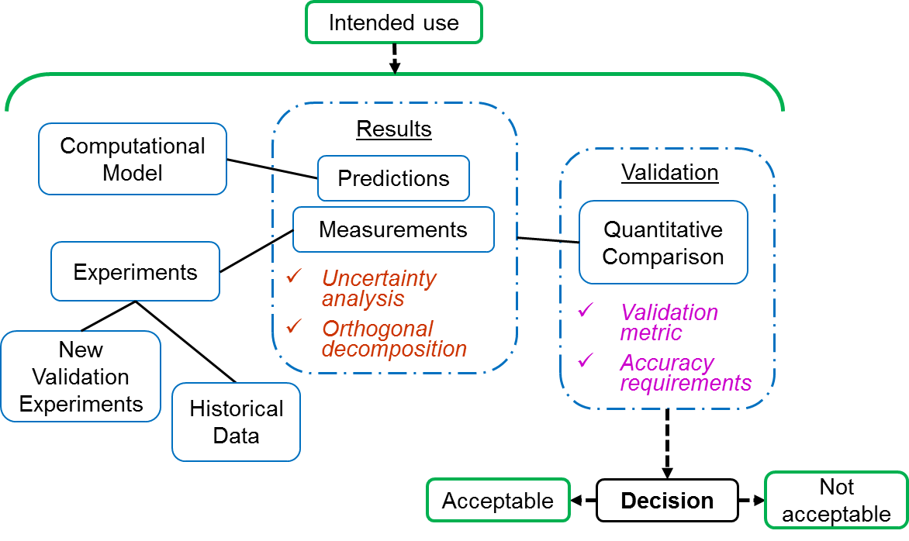
Simulations are routinely integrated with physical testing to complement studies on the characterization and identification of the mechanical behaviour of materials and structures across a wide range of engineering applications. In order to build confidence in findings from simulations, the quality of their predictions has to be quantified. This can be achieved through validation, i.e. establishing the extent to which results from the model are an accurate and reliable representation of the reality of interest [1], and the process can be illustrated by the diagram in figure 1. Current research has concentrated on the two dashed boxes in the diagram, which encompass analysis and the quantitative comparison of the predicted and measured results to provide sufficient information for subsequent decision making. The ultimate purpose of the validation process is to enable a decision on whether predictions are acceptable or not for the specific application of interest defined by the intended use of the computational model; however, this is outside the scope of this paper.
Figure 1: A schematic of the validation procedure that provides quantitative evidence to decision makers. The dashed boxes show the focus of the reported work, namely Results: evaluation of predicted and measured results, and associated uncertainties; and Validation: quantitative comparison of results through the application of the validation metric, taking into consideration all outcomes from ‘Results’ box.

Methods
Digital sensors permit information-rich data fields to be acquired from photomechanics experiments, and orthogonal decomposition, sometimes called image decomposition, can be used to reduce the dimensionality of these data fields to feature vectors [2]. The use of feature vectors allows more straightforward comparisons between measured and predicted results than is usually possible with data fields. Equivalent results can be achieved using principal components analysis in some circumstances [3].
Previous work has established a Boolean approach [4] for assessing the validity of predictions from computational mechanics models, based on a comparison of the feature vectors representing the predicted and measured strain fields together with the measurement uncertainty. Other work has established validation metrics that can be used to assess the extent to which predictions, in the form of data strings or signals, correspond to reality represented by equivalent measurements [5]. In this work, these two approaches have been combined to produce a validation metric based on the relative error between the two feature vectors, which can be expressed as:
$$Relative error= \left|\frac{x_{p}-x_{m}}{x_{m_max}}\right|×100\%$$ | (1)
where $x_{p}$ refers to predicted data and $x_{m}$ refers to measured data. The outcome of this metric is a probability of model’s predictions being an accurate and reliable representation of experimental results, given a minimum measurement uncertainty. This metric is robust for data sets with high variance and values close to zero; it considers the accuracy of the measured data and its outcome can be summarised in a probabilistic validation statement. Such a statement includes the quality of the predictions, the measurement uncertainty and the intended use of the model, thus summarising the key information for subsequent decision making, as schematically shown in figure 1.

Conclusion
This paper is focussed on the effective application of full-field data obtained from photomechanics experiments to validate computational mechanics models. A probabilistic validation metric was presented, which incorporated orthogonal decomposition and uncertainty analysis to aid quantitative comparison between predicted and measured results. This metric leads to a probabilistic statement on the quality of predictions, i.e. probability of predictions being representative of reality. In addition to quantifying the quality of the model, such a metric should help to communicate validation results and thus could potentially lead to a more informed decision making when relying on simulations.

Acknowledgements
The MOTIVATE project is funded by the EU Framework Programme for Research and Innovation Horizon 2020, Clean Sky 2, project number 754660 for which the topic manager is Eszter Szigeti (Airbus Operations Ltd).

References
- ASME V&V 10-2006, Guid for verification and validation in computational solid mechanics, Am. Soc. Mech. Eng., 2006.
- A. S. Patki and E. A. Patterson, Decomposing Strain Maps Using Fourier-Zernike Shape Descriptors, Exp. Mech., 52(8):1137–1149, 2012.
- W. Wang and J. E. Mottershead, Adaptive moment descriptors for full-field strain and displacement measurements, J. Strain Anal. Eng. Des., 48(1):16–35, 2012.
- European Committee for Standardisation (CEN), Validation of solid mechanics models, CEN Workshop Agreement, CWA16799:2014 E.
- W. L. Oberkampf and M. F. Barone, Measures of agreement between computation and experiment: Validation metrics, J. Computational Physics, 217(1):5-36, 2006.

