**Inverse structural modifications of a geared rotor-bearing system for frequency assignment using measured receptances**

Sung-Han Tsai1,2, Huajiang Ouyang1*, Jen-Yuan Chang2

1School of Engineering, University of Liverpool, Liverpool L69 3GH, UK

2Department of Power Mechanical Engineering, National Tsinghua University, Taiwan

# **Abstract**:

Inverse structural modifications have been studied in theory but have rarely been implemented in practice. In this paper, the inverse structural modification theory based on receptances is further developed. The receptances of a modified structure are expressed in terms of the receptances of the original structure and the modifications to be made, which allows measured receptances to be used instead of system matrices or a modal model (and thus a theoretical model of the structure is not needed). The method proposed in this paper can be applied to assignments of several different kinds of dynamical properties such as natural frequencies, antiresonant frequencies and receptances, and pole-zero cancellation.

To address the lack of experimental validation to inverse structural modification problems in published papers, a geared rotor-bearing system is designed and manufactured to validate the method and provide experimental insights. Experimental results show that more than one natural frequency or antiresonant frequency can be assigned within acceptable accuracy and the sensitivity of modifications is crucial for the solutions of modifications cast as an optimization problem. An additional application for determining the optimal locations for given modifications to achieve the highest first natural frequency is also presented. The experimental results obtained prove the effectiveness and the ease of use of this proposed method. This work should help make inverse structural modification a popular means of passive vibration control to improve the dynamical behaviour of real structures.

# Introduction

Nowadays, the energy density of a machine has significantly increased because such a machine tends to transfer a great amount of power or operate more efficiently than before. From a structural dynamics point of view, optimizing its design is a useful and fundamental way to achieve better dynamic performance. For an existing structure, it is often more useful to modify its structural properties (such as mass and stiffness, occasionally damping) to obtain certain desirable dynamic properties, which is usually referred to as structural modification. There are two complementary approaches to address structural modification problems: one is direct/forward structural modification approach and the other is inverse structural modification approach. The forward structural modification aims to predict the exact change to the structure’s dynamic properties when known modifications are made at a given location while the inverse structural modification determines what modifications should be made so that the modified structure can have the prescribed dynamic characteristics [1].

Early studies of forward structural modification, which is also known as re-analysis, were reviewed and summarized by Baldwin and Hutton [2]. They classified the techniques into three groups based on the assumptions of the form of modifications: techniques based on small modifications, techniques based on localized modifications, and techniques based on modal approximation. Several approaches such as Rayleigh quotient [3], sensitivity analysis [4], and perturbation approach [5] were used to address forward modification problems without a complete reanalysis of the whole structure. However, compared with direct structural modification, inverse structural modification is more intuitive and time-efficient, which later on has been a more active area of research in the last decades. Part of the relevant literature is summarized as follows.

The solution for an inverse structural modification problem can be exactly obtained if a complete set of modal data is available. However, it is extremely difficult to identify most of a modal data set from an experimental point of view, which would later result in a truncation error problem. Many early studies [6-8] were focused on minimizing/ circumventing the effect to achieve sufficiently accurate solutions. Other than modal information, system matrices, i.e. mass/damping/stiffness matrices, can also be used for the purpose of inverse structural modifications. Methods related to the usage of system matrices and sensitivity analysis were proposed in [9, 10]. Among many techniques for solving the problem, receptance method recently has received considerable attention since it does not require a theoretical model to find the solution. That is to say, one can deal with a complex structure even though a realistic finite element model is very difficult to construct. Modal truncation error that can occur when using a spatial model or modal model can be avoided by the receptance method within a frequency range. The receptance method can be further divided into two groups based on the implementation: one is structural modification by passive elements (such as masses, springs, or beams), and the other is active vibration control using sensors and actuators.

Passive structural modification offers several advantages over active control. For example, the modified system is guaranteed to be stable, it does not require additional sensors, actuators or power suppliers, and it is able to deliver large modification to the system [11]. Among early studies, Tsuei and Yee [12] proposed a method for inverse structural modification based on the FRFs of an undamped vibrating system. The method could determine the required mass or stiffness modification value to give a system an assigned natural frequency with only a few computations. Later on, the same idea was extended to assign a damped natural frequency of a damped structure [13] by the same authors. Both studies considered changing only the mass matrix or stiffness matrix separately. A method of simultaneous mass and stiffness modification on lumped systems was presented in a book by Maia [14] in which a coefficient matrix and predetermined mass/stiffness ratios were introduced in the modification matrices instead of their absolute values. Methods for assigning an antiresonant frequency for spring-mass system were also covered in the book.

The most basic form of modification, rank-one modification, for pole or zero assignment has been well studied and summarized in a review paper by Mottershead [15]. Exact numerical solutions are available for rank-one modifications, which include point mass modification, grounded spring modification, or springs connected between two coordinates, if a solution exists. Cakar [16] extended the rank-one modifications to the case when some natural frequencies were kept the same after one or more mass modifications and addition of a grounded spring. For a rank-one modification, it is also possible to fix antiresonant frequencies while shifting natural frequencies since the zeros of a cross-receptance or a point receptance are not affected by the modification made at one of the coordinates of the receptance concerned. Mottershead and Lallement [17] studied pole-zero cancellation in which the assigned pole possessed the same frequency as the antiresonant frequency, and a vibration node could be created. A similar approach for assigning nodes was presented by Mottershead *at el.* [18].

Kyprianou *et al.* [19] showed that up to two natural frequencies could be assigned through an addition of a single degree-of-freedom (DoF) spring-mass oscillator. It was also shown that the effect of attaching an oscillator can be included in the system dynamic stiffness matrix without expanding the total number of DoFs. Zhu *et al.* [20] proposed a similar procedure to assign receptances at particular frequencies by using one or more simple spring-mass oscillators. This provided an alternative way to reduce vibration response of a system. Kyprianou *et al.* [11] managed to assign the natural frequencies and antiresonant frequencies of a continuous frame structure. The modification involved a 3×3 receptance matrix that covers two translational DoFs and more importantly one rotational DoF at the modification location. This study showed that the methodology based on receptance method still works even if the assigned frequency and mode shape are much different from the original ones.

A different approach was made by Richiedei *et al.* [21] and Ouyang *et al.* [22] in which the inverse problem was transformed into a multi-variable optimization problem. Both eigenvalues and corresponding eigenvectors could be assigned through minimizing an objective function, and the required mass and stiffness modifications could be computed simultaneously; additionally, for the specific case in which the function is proved to be convex, the solution is guaranteed to be a global minimum and is not affected by initial guess. This study and that in [6] motivated the work of Liu *et al.* [23] about eigenstructure assignment through placing multiple spring-mass oscillators.

Although inverse structural modification has been studied for many years, it is worthwhile mentioning that there are still several problems to be addressed. One of the problems which is usually referred to as partial eigenvalue or partial eigenstructure assignment problem recently has received much attention. Partial eigenvalue assignment aims to overcome the frequency spill-over, a phenomenon in which unassigned natural frequencies are also shifted after the assignment of a subset of natural frequencies. This phenomenon could result in an unfavorable situation in which an unassigned frequency is relocated to an unwanted value. On the other hand, partial eigenstructure assignment aims at assigning certain eigenpairs while keeping all the other eigenpairs unchanged [24].

From the literature these problems can be dealt with through passive structural modification (Ouyang and Zhang [25], Belotti *et al.* [26], Gurgoze and Inceoglu [27]), active feedback control (Ghandchi *et al*. [28], Bai *et al*. [29], Datta *et al.* [24]), or an active-passive hybrid approach [30]. Compared with active control approach, passive approach for partial assignment is reliable and cost-effective, but theoretically more demanding due to the limited effects of the mass and stiffness modification in preventing spill-over [31]. On this topic it has been shown that including receptances could improve the computation efficiency. For example, Ram *et al.* [32] presented a hybrid method that combined system matrices and receptances for partial pole assignment. The inevitable time delay between measurements and actuation was also taken into account. Bai and Wan [33] demonstrated the effectiveness of integrating receptances through several numerical examples, which required solving only a small linear system and a few undesired eigenpairs. Singh and Brown [34] implemented an active control method based on receptances to achieve partial pole assignment on an aerofoil wing model.

Most of the studies so far focused on theoretical development and validation with numerical models while few investigations have reported practical implementations of the methods. In addition to [1] and [8], Zarraga *et al*. [35] demonstrated the successful shift of the natural frequency of a doublet mode of a simplified brake-clutch structure so as to suppress squeal noise due to friction. Mottershead *et al.* [36] studied the modification of a helicopter tail cone the form of a heavy block mass, using the receptances measured with the aid of an additional X-shaped attachment and its (small) finite element model. Caracciolo *et al*. [37] improved the dynamic behaviour of vibratory linear feeders based on a systematic approach through inverse structural modifications. A laboratory vibratory linear feeder was manufactured according to the optimization of the simplified spring-mass model to verify the design method.

This paper focuses on the theoretical development of inverse structural modification and its practical implementations to design certain dynamic properties of a laboratory test rig based on only measured receptances. Experimental insights into the dynamic characteristics of the laboratory structure from various implementation schemes are provided. The paper is organized as follows: in Section 2 the receptance-based inverse structural modification theory is extended. The test rig, a geared rotor-bearing system built on aluminium profiles, is described in Section 3 along with the experimental details. Section 4 presents the implementation and validation of the method by modifying the geared rotor-bearing system. Three different modification schemes are provided including natural frequency assignment, antiresonant frequency assignment, and determination of the highest first natural frequency. Conclusions are drawn in Section 5.

# Theoretical development

The Laplace transform of the equation of motion of a linear vibrating viscously damped multi-degree-of-freedom system can be expressed as

|  |  |  |
| --- | --- | --- |
|  | $$(Ms^{2}+Cs+K)x\left(s\right)=f\left(s\right)$$ | () |

if the initial conditions are zeros. **M**, **C**, **K** are $n ×n$ mass, damping, and stiffness matrices respectively and $n$ is the total number of degrees of freedom of the system. $f\left(s\right)$ is the vector of any type of excitation applied to the system. Assuming that the original structure is modified in terms of mass $∆M$, damping $∆C$, and stiffness $∆K$ simultaneously, the equation of motion of the modified system can be given as

|  |  |  |
| --- | --- | --- |
|  | $$\left[(s^{2}M+sC+K)+(s^{2}∆M+s∆C+∆K)\right]x\left(s\right)=f\left(s\right)$$ | () |

Premultiplying both sides by receptance matrix **H**(*s*) of the original structure and inverting the resulting matrix on the left side of the equation lead to

|  |  |  |
| --- | --- | --- |
|  | $$x(s)={\left[I+H\left(s\right)∆B\left(s\right)\right]}^{-1}H\left(s\right)f=\hat{H}\left(s\right)f$$ | () |

where $∆B\left(s\right)=(s^{2}∆M+s∆C+∆K)$ is called dynamic stiffness modification matrix which has real physical meaning of the modifications made, i.e. magnitudes and coordinates. Clearly, this equation shows that the modified receptance matrix only involves the receptance matrix of the original structure and the dynamic stiffness modification matrix. The modified receptance matrix can be further defined as

|  |  |  |
| --- | --- | --- |
|  | $$\hat{H}\left(s\right)=\frac{adj(\left[I+H(s) ∆B(s)\right])H(s)}{det⁡(\left[I+H(s) ∆B(s)\right])}$$ | () |

which reveals a new relationship between responses and excitations of the system. Based on the definition of the adjugate matrix, a certain $(p^{th}, q^{th})$ element of $\hat{H}\left(s\right)$ in which *p* is the response coordinate and *q* is the excitation coordinate of the modified receptance matrix can be given by the following

|  |  |  |
| --- | --- | --- |
|  | $${{\hat{h}\left(s\right)}_{p,q}=(-1)}^{p+q}\frac{det\left({\left(s^{2}M+sC+K\right)}_{(qp)}+{∆B(s)}_{(qp)}\right)}{det\left(\left(s^{2}M+sC+K\right)+∆B(s)\right)⁡}$$ | () |

where subscripts (*qp*) indicate the matrix formed after deleting the $q^{th}$ row and $p^{th}$ column of the original matrix. This equation can be rewritten by extracting $det\left({\left(s^{2}M+sC+K\right)}_{qp}\right)$ and $det\left(s^{2}M+sC+K\right)$ from the numerator and the denominator, respectively, leading to

|  |  |
| --- | --- |
| $${\hat{h}\left(s\right)}_{p,q}={(-1)}^{p+q}\frac{det\left({\left(s^{2}M+sC+K\right)}_{(qp)}\right)det\left(I+{\left({\left(s^{2}M+sC+K\right)}_{(qp)}\right)}^{-1}{∆B(s)}_{(qp)}\right)}{det\left(s^{2}M+sC+K\right)det\left(I+H(s)∆B(s)\right)⁡}$$ | () |

The identity matrix in the numerator is now a $(n-1)×(n-1)$ matrix. Since $(s^{2}M+sC+K)$ is symmetric and invertible, the relation shown below holds.

|  |  |  |
| --- | --- | --- |
|  | $${(-1)}^{p+q}\frac{det\left({\left(s^{2}M+sC+K\right)}_{(qp)}\right)}{det\left(s^{2}M+sC+K\right)}=h_{p,q}(s)$$ | () |

Finally, the $(p^{th}, q^{th})$ receptance of the modified receptance matrix can be given by

|  |  |  |
| --- | --- | --- |
|  | $${\hat{h}\left(s\right)}_{p,q}=\frac{h_{p,q}(s)det\left(I+{\left({\left(s^{2}M+sC+K\right)}_{(qp)}\right)}^{-1}{∆B(s)}_{(qp)}\right)}{det\left(I+H(s)∆B(s)\right)}$$ | () |

Matrix ${\left({\left(s^{2}M+sC+K\right)}_{(qp)}\right)}^{-1}={\tilde{H}}_{pq}(s)$, which is called subsidiary receptance matrix, is the inverse of a dynamic stiffness matrix whose *q*th row and *p*th column are deleted. The matrix might be obscure in physical meaning, but it has been shown by Mottershead [38] that each element of the matrix can actually be obtained from receptances of the original system. Any element ${\tilde{h}}_{t_{1},t_{2}}$ in ${\tilde{H}}_{pq}(s)$ can be given by

|  |  |  |
| --- | --- | --- |
|  | ${\tilde{h}}_{t_{1},t_{2}}=h_{t_{1},t_{2}}-{\left(h_{q,t_{1}}h_{p,t_{2}}\right)}/{h_{q,p}}$ | () |

which shows that one subsidiary frequency response function requires four receptances of the original system at most. It should be noted that $t_{1}, t_{2}=1,2,…,n$, but $t_{1}≠p$ and $t_{2}≠q$. Now it is clear that it is possible to obtain the exact modified receptance function solely based on receptances of the original system; that is to say, apart from using numerical model the modified receptance function can also be derived from modal testing data as long as the measurement is accurate enough.

In the case of an inverse structural modification problem, the desired frequency is prescribed whilst the dynamic stiffness modification matrixshould be sought. From equation (8), it is clear that the functions in the numerator or denominator could approach zero near a desired frequency; therefore, they can be treated as the basic equations for natural frequency or antiresonant frequency assignments. In addition to that, the ratio between modified receptances and the corresponding original receptances could also be readily assigned through equation (8). If the form of the modification is simple, such as a rank-one modification, it is possible to find the required modification by solving the corresponding equations directly. However, directly solving the equation could be challenging especially when the number of modification is large or there are multiple desired frequencies. In fact, an approximate solution might be sufficient in some cases in which the exact solution does not exist or is hard to compute. Besides, there might be multiple solutions to an assignment problem. Casting the assignment problem as an optimization problem provides a relatively flexible way to find a solution, which can also be seen from several published papers [21-23, 37, 39].

Therefore, it is reasonable to construct the basic objective function as

|  |  |  |
| --- | --- | --- |
|  | $$\min_{x}\left\{\sum_{i=1}^{n}{α_{i}{\left(det\left(I+H(s_{i})∆B(s_{i},x)\right)\right)}^{2}}\right\}$$ | () |

and

|  |  |  |
| --- | --- | --- |
|  | $$\min_{x}\left\{\sum_{i=1}^{n}{{α_{i}\left(det\left(I+{\tilde{H}}_{pq}\left(s_{i}\right){∆B\left(s_{i},x\right)}_{qp}\right)\right)}^{2}}\right\}$$ | () |

for natural frequency and antiresonant frequency assignment, respectively. In the objective functions $α_{i}$ are the weighting coefficients and the modification matrix is now a function of eigenvalues and design variables **x**. Since a determinant is used, the value of the objective function might vary enormously in the design space especially when the desired frequency is high. In order to avoid very steep gradients in the feasible domain, which can reduce the step size in the optimization process, scaling the functions to some extent is often necessary. However, there is no definitive criterion indicating which form of scaling is the most suitable. This might be a problem that is determined on a case-by-case basis. Thus scaling is not yet implemented in either equation above.

There are several algorithms nowadays for solving nonlinear programming problems. In this paper an interior-point algorithm “fmincon” provided by MathWorks is adopted. It has been supported and shown by many published papers that barrier methods are the foundation of modern interior method. A comprehensive paper including the history, developments, and important features of the interior-point method and its relationship with barrier method was presented by Forsgren *et al.* [40]. Alternatively, genetic algorithm can also be used to avoid guessing initial points and prevent the solution from converging to local minimums around the initial points. Since the optimization algorithm is not the objective of this research, relevant details will not be included here.

# Experimental setup

The laboratory test rig is essentially a geared rotor-bearing system shown in Figs. 1 and 3. A short shaft is coupled to a one-meter-long shaft of the same diameter (17 mm) through a pair of spur gears, and there are two identical discs which can be moved freely on the long shaft or easily removed from the rig. In fact, the discs (and the additional masses of nut sets bolted to them) will be considered to be the mass modification for the test rig. Each disc which weighs 658 g has several tapped holes uniformly distributed around its circumferential direction for possible additional mass modifications as shown in Fig. 2. The additional mass modification is achieved by bolting or removing nuts on the disc. In Fig. 2 the M20-nut set and M16-nut set weigh 61g and 38g, respectively. The material of the shafts and discs is medium carbon steel while the material of the bearing holders is aluminium. The whole structure is bolted onto two aluminium profiles that are also bolted together as the base. The total mass of the system without discs is 16.35 kg. It is worth mentioning that the base should not be considered to be rigid in this case, which will definitely bring complexity to the system and in constructing the finite element model.

Impact testing is utilized for the receptance measurements in this study, and there are totally 16 equally spaced measurement points with interval of 4.5 cm, denoted as p1 to p16, along the long shaft; however, not all of the measurement points may be available in practice and thus it is assumed that only five locations are available; they are p4, p5, p7, p11, and p13. Five Kistler miniature accelerometers-8728A500 that weighs 8 grams in total are used so as to minimize the mass loading effect, and the impact force is imparted through PCB Model 086C04 impact hammer with the plastic hammer tip. Signals are sampled by LMS SCADAS III signal conditioning and data acquisition system which passes experimental data to a PC. The LMS software Test.Lab in the PC is adopted for signal processing, modal parameter estimation, and data management purposes. The experimental modal testing data can be stored and exported to the Universal File Format, which makes processing the experimental results more efficient.

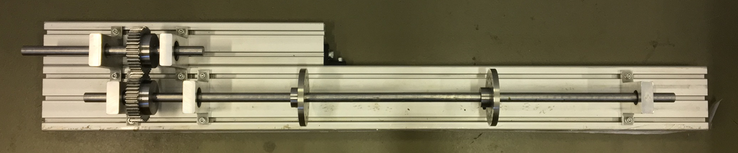

Fig. 1. Experimental setup.

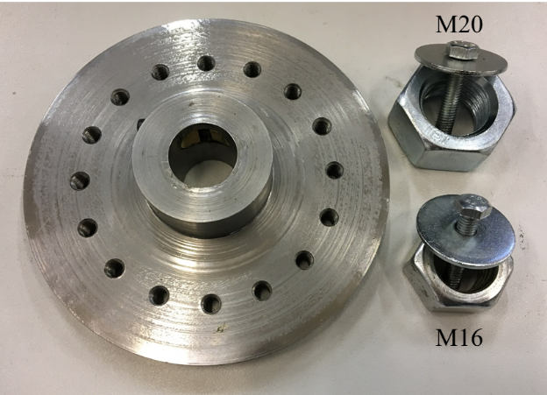

Fig. 2 Disc and nuts.

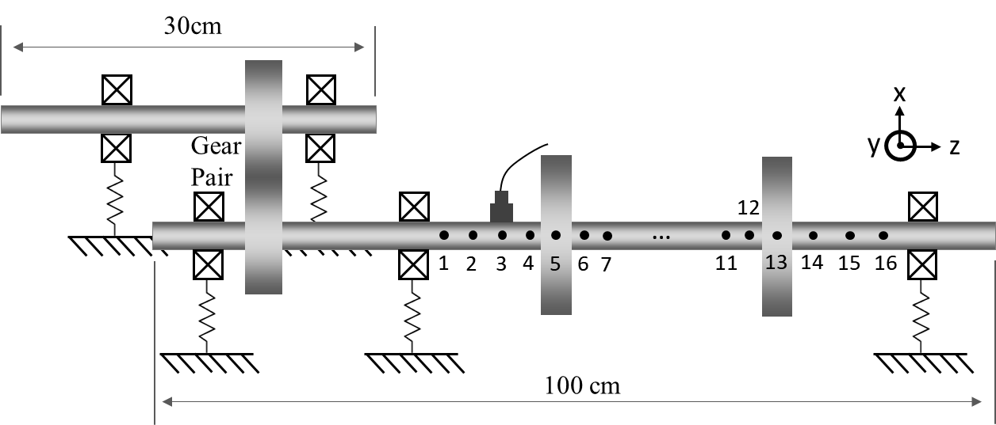

Fig. 3. Schematic of the geared rotor-bearing system.

The objective is to verify the proposed method through the current experimental setup. For a geared rotor-bearing system, it is always more practical and easier to conduct mass modification instead of stiffness modification or damping modification; therefore, the two discs (with a few nuts bolted to it) are considered to be the only modifications for this goal. The point and cross receptances of the five accessible locations are measured before the modification. Then, two discs are placed at certain locations and the corresponding modified frequencies are measured and taken as desired frequencies. Through equations (10) and (11), the mass that is required to achieve the desired frequencies can be obtained if a global/local minimum exist in the feasible domain. Since the modification is known, the difference between the predicted mass for the modification and the actual value can be used as one of the two benchmarks to reveal the effectiveness of the method. The other benchmark is the difference between the desired frequency and the frequency of the structure modified using the determined mass modification.

# Determination of structural modifications for desirable dynamic properties

As can be seen from the objective function, the degrees of freedom of the modification matrix have to be defined first, and the corresponding receptances then have to be measured. In this case only the vibration in the lateral direction, which is the out of plane direction *y* in Fig. 3, is considered since the bending vibration is dominant in the dynamic behaviour of the structure. Furthermore, the influence of the mass modification on the rotational degrees of freedom in the *y-z* plane are assumed to be negligible; that is to say, the discs act as point masses and the dynamic stiffness modification matrix is now a 2 by 2 matrix with the masses whose diagonal elements are the design variables. On the other hand, the receptance matrix required is also a 2 by 2 matrix which contains information of both point and cross receptances of the locations where the modifications are made.

## Natural frequency assignment

Fig. 4 shows the cross FRFs of p7 to p4 in the *y* direction before and after the modification in which the two discs with additional masses of 780 g each (disc plus two M20-nut sets, i.e. 658 g + 121 g) are placed at p5 and p13. The force spectrum of the impact must be inspected first to determine the usable frequency range before any modifications, and additional care must be paid to energy distribution of the impact over the frequency range so that the noise in the FRF measurement can be minimized. The frequency range of interests is then limited to frequency below 600 Hz which covers the first four modes of the rig.



Fig. 4. The cross-FRF of p7-p4 before and after the modification

The frequencies are estimated through peak picking and recorded in Table 1. The frequencies of the modified structure are targeted as the desired frequencies in the optimization problem. Apart from implementing equation (10) at each of the four frequencies, the objective function is subject to a linear equality constraint to ensure that two design variables have the same value. The predicted modifications are also given in Table 1.

First, it is clear that all of the frequencies are decreased since only mass modification is made. Second, it shows that some of the frequencies are not assignable, more precisely, the optimization finds close solutions to the first and third targeted frequencies, but fails to find the right solutions to the second and fourth targeted frequencies (the optimization procedure converges to boundary of the feasible domain); therefore, the Predicted Modification for the second and fourth cases are denoted as N/A in table 1. For the first and the third frequencies, additional modifications are made in order to reflect the actual error between the desired frequency and the actually assigned frequency. Since it can be expensive or sometimes infeasible to exactly implement the determined mass modifications, some nuts are removed/added to roughly make up the difference (the fourth column of table 1). A M16-nut set of 38 g is added to both discs to reflect the first case (each disc weighs 780 + 38 g), which leads to a first frequency that is close to the desired frequency value, and the error between them is less than 0.5 Hz. On the other hand, a M20-nut set of 61 g, which was originally bolted to the disc, is removed from both discs for the third case (each disc weighs 780 – 61 g), which results in a third frequency at 158 Hz, a frequency difference of less than 3.5 Hz. The FRFs of the structure with the additional modifications are compared with those of modified structure in Fig. 5.

Table 1 Results of natural frequency assignment

|  |  |  |  |  |  |  |
| --- | --- | --- | --- | --- | --- | --- |
| Original Frequency | Modified Frequency | Predicted Modification | Difference | Remove 61g | Add 38g | Error |
| 80.5 Hz | 53 Hz | 814.6 g | +34.6 g |  | 52.5 Hz | < 0.5 Hz (0.9%) |
| 97.5 Hz | 84 Hz | N/A | N/A |  |  |  |
| 268.5 Hz | 154.5 Hz | 735.2 g | -44.8 g | 158 Hz |  | < 3.5 Hz (2.3%) |
| 542 HZ | 422 Hz | N/A | N/A |  |  |  |

A further investigation through an FE model (see Appendix) has found that 422 Hz is the third bending frequency of the modified system, and the both discs happen to be close to the nodes of the modified mode. The corresponding mode shape of the long shaft is shown in Fig. 6. In addition, the second frequency in Table 1 (97 Hz/ 84 Hz) is found to be the main frequency of the foundation, i.e. the stators and the aluminium profiles. These both imply that the sensitivity of the natural frequency is low to the current modifications; therefore, a local minimum might not exist in the feasible domain. Making modification on the shaft has a small effect on these frequencies, which might lead to inaccurate results. It is reasonable to expect that performing the sensitivity analysis prior to structural modifications can improve the effectiveness of the method. However, sensitivity analysis often requires a fairly accurate theoretical model (system matrices), which would take away a main advantage of the receptance method, and thus is not carried out in this paper. Although experimental modal analysis itself is not sufficient to produce a complete and accurate sensitivity analysis, it can still reveal some useful insights.

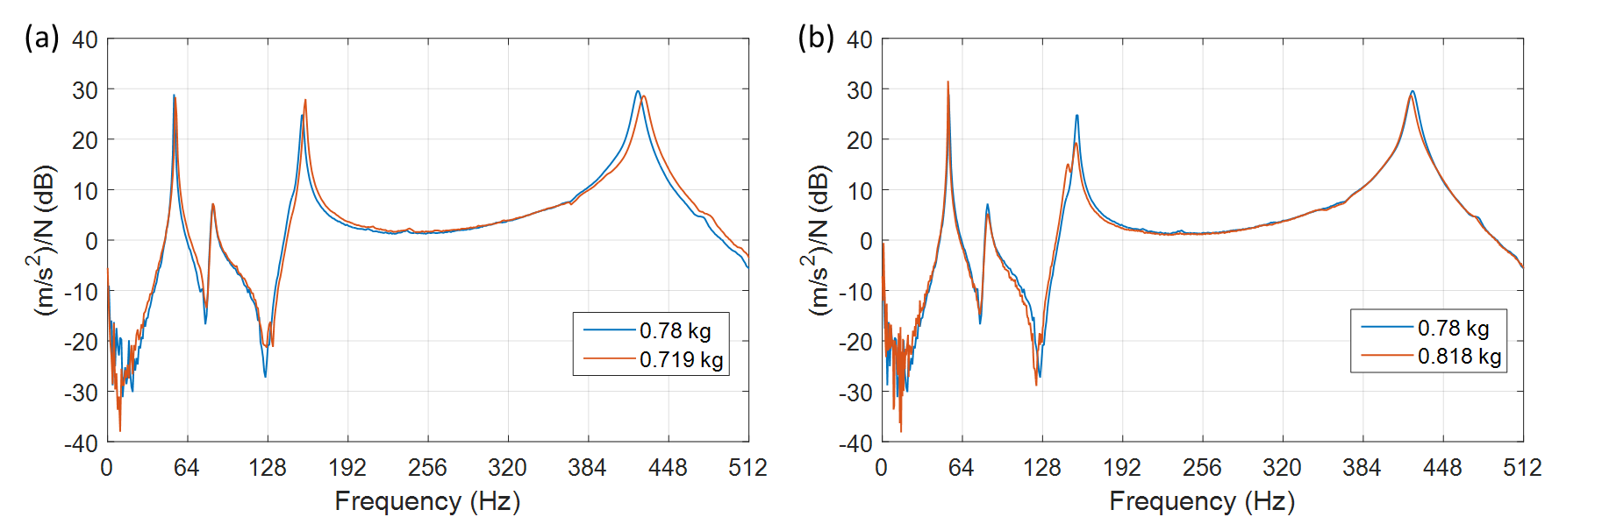

Fig. 5. Cross-FRFs of p7 to p4 in different modifications. (a) and (b) reflect the additional modification for the third case and the first case in Table 1.

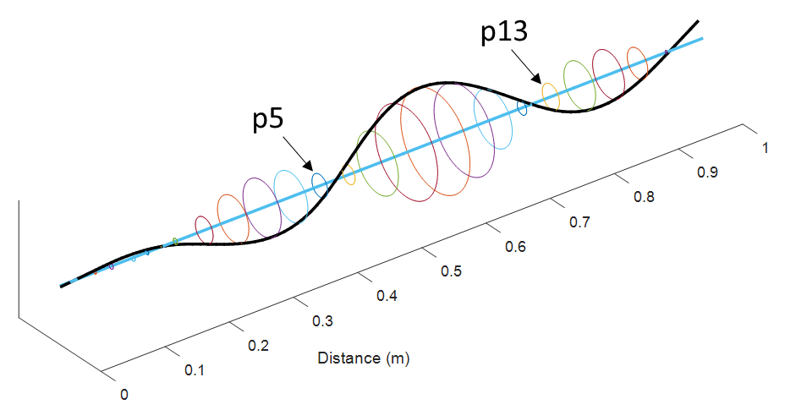

Fig. 6. The mode shape of the 422 Hz obtained from a simulated FE model.

Besides single natural frequency assignment, it is possible to assign multiple frequencies simultaneously through equation (10). For the sake of convenience, the first and the third modified frequencies in Table 1 are taken as desired frequencies, thereby resulting in $n=2$ in equation (10). The weighting coefficients are both set to be 1. Results are shown in Table 2 below. It is clear that the predicted modification lies between those modifications of the two individual cases in Table1, which represents the trade-offs between the two objective functions. By examining Fig. 5 (a), the differences between the desired and assigned frequencies can be roughly estimated which are definitely less than 1 and 3.5 Hz, respectively.

Table 2 Assignment of two natural frequencies.

|  |  |  |  |  |  |
| --- | --- | --- | --- | --- | --- |
| Original Frequency | Modified Frequency | Predicted Modification | Difference | Remove 61g | Error |
| 80.5 Hz  268.5 Hz | 53 Hz  154.5 Hz | 0.7421 kg | -37.9 g | 54 Hz  158 Hz | < 1 Hz (1.9%)  < 3.5 Hz (2.3%) |

## Antiresonant frequency assignment

The first two pronounced antiresonant frequencies from the cross-FRF in Fig. 4 are studied. Equation (11) was used and the results are shown in Table 3. From the table, the difference in mass for the second antiresonant frequency is fairly small while the predicted mass for the first antiresonant frequency is only 20 g heavier. After the additional modifications, it can be shown that the difference in antiresonant frequency for the first case should be less than 0.5 Hz. The corresponding FRF is given in Fig. 5 (b). In the case in which two antiresonant frequencies are assigned simultaneously, the prediction is almost the same as the actual value with only 6.6 g difference.

Table 3 Results of antiresonant frequency assignment.

|  |  |  |  |  |  |
| --- | --- | --- | --- | --- | --- |
| Original Frequency | Modified Frequency | Predicted Modification | Difference | Add 38g | Error |
| 94.5 Hz | 78 Hz | 0.8 kg | +20 g | 78 Hz | < 0.5 Hz (0.6%) |
| 189 Hz | 126 Hz | 0.7742 kg | -5.8 g |  |  |
| 94.5 Hz & 189 Hz | 78 & 126 Hz | 0.7866 kg | +6.6 g |  |  |

Another example of antiresonant frequency assignment under the same modification scenario is given below. In this case the assignment of the first pronounced antiresonant frequency of the cross-FRF of p11 to p4 is studied. As can be seen from Fig. 7, both antiresonant frequencies are not clear enough to be identified because of noise present in the measurement. A noise elimination technique for FRFs based on singular value decomposition (SVD) was applied to the measurements [41], in which the measured FRFs were first transformed to impulse response functions (IRF), and then Hankel matrices could be formed from the time domain data. SVD was utilized to estimate the rank of the Hankel matrices, and the rank could be used to separate uncontaminated data from noise matrices. Therefore, the rank has to be chosen appropriately. The same method to determine the rank in [41] is also adopted in this study. Once the rank is determined, the filtered data is then transformed back to FRFs to produce less noisy data. Fig. 8 shows the result and compares the measured FRF with the filtered FRF.



Fig. 7. The cross-FRF of p11-p4 before and after the modification

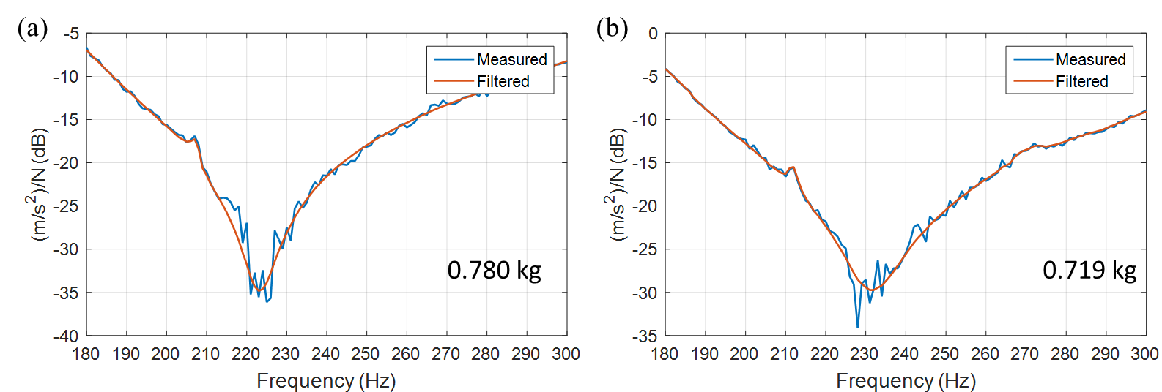

Fig. 8. Comparison of the measured FRFs and the filtered FRFs.

Valley picking, which is similar to peak picking, now can be used to estimate the antiresonant frequencies. The results of this assignment are given in Table 4. The predicted mass is 27.6 g lighter than the actual mass. Due to the constraints of the modification available, a M20-nut set of 61g is removed from both discs and an interpolation is applied to estimate the difference in antiresonant frequencies. This finds the difference in frequency to be smaller than 4 Hz, which is less than 1.8% of the desired antiresonant frequency.

Table 4 Antiresonant frequency assignment for cross FRF of p11 to p4

|  |  |  |  |  |  |
| --- | --- | --- | --- | --- | --- |
| Original Frequency | Modified Frequency | Predicted Modification | Difference | Remove 61g | Error (interpolated) |
| 440.5 Hz | 223 Hz | 752.4 g | -27.6 g | 231 Hz | < 4 Hz (1.8%) |

## Determination of the highest first bending natural frequency

In section 4.1, the required modification for assigning a frequency is determined as an inverse dynamic problem. In this section, the goal is to search for the optimal location for the given modifications among all the possible locations that results in the highest first bending natural frequency. This method is essentially a forward structural modification application, but it is included in this study since the operating speeds of some rotating machines are below the first critical speed; therefore, increasing the first natural frequency can increase the range of operating speed or possibly avoid/reduce response at resonance. In addition, the computational load to determine the optimal location would not be an issue because the number of measurements in practice is usually not large, and this application does not require an FE model of the structure.

The application can be described as follows:

|  |  |  |
| --- | --- | --- |
| 1. | Quantify the modifications made to the system and list the accessible locations for the modifications. Arrange the possible combinations of the modification locations into vector **v** and create a vector $f={\left\{f_{1}, f_{2},⋯,f_{n_{f}}\right\} }^{T}$ of $n_{f}$ evenly spaced points in an estimated frequency range for first natural frequency. $f_{1}$ is the upper bound while $f_{n_{f}}$ is the lower bound. | |
| 2. | Measure the point and cross receptances at the accessible DoFs before any modifications are applied. Some DoFs of lower sensitivity to the frequency of interest could be left out. This should be carefully determined. | |
| 3. | Specify a threshold ζ which should be a sufficiently small number. Set $i=0$. | |
| 4. | **While $i≤n_{f}$** **do** | |
| 5. |  | Set $i=i+1$ |
| 6. |  | Calculate the denominator of equation (8), which is repeated here for convenience, for all possible combinations in **v** at frequency:   |  |  |  | | --- | --- | --- | |  |  | () | |
| 7. |  | Keep records of the combination that has the smallest value in **z** and check if $z≤ζ$. If yes, exit the **While** loop. If not, then move to the next loop until the criterion is satisfied. |

In this study, the two identical discs of 780 g each can be placed at any two of the five accessible locations: p4, p5, p7, p11, p13, that is to say, there are 10 possible combinations of modification in total. It is assumed that $f$ ranges from 50 Hz to 70 Hz with resolution of 1 Hz and ζ is set to 0.01. Since rotational degrees of freedom are neglected and acceleration are measured at the accessible locations, only five impact tests are required to produce the receptance matrix. In this case the process is carried out throughout $f$ to provide more insights into the dynamic characteristics of the structure.

The outcomes are summarized as follows: Table 5 lists some of the cases in which the determinant values satisfy the criterion while Table 6 lists those that do not; Table 7 shows the experimental results of the modifications on all the possible locations in descending order of the first natural frequency. It can first be seen from Table 6 that the smallest determinant value is decreasing as $f_{i}$ drops, and the corresponding combination of modification locations is either (p4, p5) or (p4, p13). This implies that these two combinations bring the objective function close to its global or a local minimum as $f_{i}$ decreases. Therefore, it is reasonable to assume that one or both of the combinations might lead to the highest first natural frequency. The assumption can be quickly verified by Table 5 which indicates that the (p4, p5) combination is the first one satisfying the criterion at 58 Hz while (p4, p13) results in the lowest determinant values for the next two frequencies at 57 Hz and 56 Hz. The observation above suggests that (p4, p5) and (p4, p13) could result in similar first natural frequencies, but the one produced by (p4, p5) combination is slightly higher.

The above findings can be confirmed by experimental results given in Table 7. It shows that (p4, p5) combination does lead to the highest natural frequency at 57 Hz while (p4, p13) results in the second highest natural frequency at 56 Hz. It should be noted that the difference in frequency between (p4, p5) and (p4, p13) combinations in Table 5 and Table 7 could be accounted for by not only the noise present in the experimental results but also the resolution in the spectrum of modal testing and in estimated frequency range **f**. Lastly, the order of the objective function values from the other combinations in Table 5, i.e. (p5, p13), (p4, p7), (p4, p11), and (p5, p7), also match their order in Table 7 (from 53 Hz to 50 Hz).

Table 5 Optimal locations for each frequency.

|  |  |  |
| --- | --- | --- |
| $f_{i}$ (Hz) | Combination | Determinant Value |
| 58 | (p4, p5) | 2.03E-3 |
| 57 | (p4, p13) | 2.12E-4 |
| 56 | (p4, p13) | 5.53E-4 |
| 55 | (p5, p13) | 3.76E-3 |
| 54 | (p5, p13) | 5.71E-4 |
| 53 | (p5, p13) | 1.29E-3 |
| 52 | (p4, p7) | 5.83E-6 |
| 51 | (p4, p11) | 2.77E-4 |
| 50 | (p5, p7) | 2.43E-4 |

Table 6 Results that do not satisfy the criterion.

|  |  |  |
| --- | --- | --- |
| $f_{i}$ (Hz) | Combination | Determinant Value |
| 67 | (p4, p13) | 1.14 |
| 66 | (p4, p13) | 0.823 |
| 65 | (p4, p5) | 0.553 |
| 64 | (p4, p5) | 0.317 |
| 63 | (p4, p5) | 0.256 |
| 62 | (p4, p13) | 0.157 |
| 61 | (p4, p5) | 0.0656 |
| 60 | (p4, p5) | 0.410 |
| 59 | (p4, p5) | 0.0152 |

Table 7 Experimental results.

|  |  |
| --- | --- |
| Combination | First natural frequency (Hz) |
| (p4, p5) | 57 |
| (p4, p13) | 56 |
| (p5, p13) | 53 |
| (p4, p7) | 52 |
| (p4, p11) | 51 |
| (p5, p7) | 50 |
| (p5, p11) | 50 |
| (p7, p13) | 49 |
| (p11, p13) | 47 |
| (p7, p11) | 46 |

# Conclusions

In this work the theory of inverse structural modification based on the receptance method is further extended. The receptance of a modified linear structure is expressed in terms of the receptances of the original structure and the modifications to be made. The method proposed can be applied to assignments of several different kinds of dynamical properties such as natural frequencies, antiresonant frequencies, receptances, and pole-zero cancellation. Only a small number of measured receptances are needed for the assignments; therefore, a theoretical model is not required. The resulting equation also covers several forms of modifications previously reported in the literature, for instance, unit-rank modifications or single-DoF spring-mass absorbers (as reduced cases).

A geared rotor-bearing system is used to implement and validate the inverse method. The experimental results clearly show that the method can produce a fairly accurate prediction even if the structure is complicated and more than one frequency can be assigned simultaneously. Sensitivity of frequency of concern to the modifications is found to affect convergence in the optimisation process of searching for the solution of the modification, and thus conducting sensitivity analysis prior to structural modification is recommended when a fairly accurate theoretical model is available. Finally, the optimal locations of given modifications to achieve the highest first natural frequency are determined, which are found to be correctly predicted through validation with experimental results. This approach can also predict the order of the first natural frequency as a result of making given modifications at other locations.

**Acknowledgements**

The first author is grateful for the support of the UoL-NTHU Dual PhD Programme.

# References

1. D.J. Ewins, *Modal testing : theory, practice, and application, 2nd ed.* Mechanical engineering research studies: Engineering dynamics series 10. 2000: Baldock : Research Studies Press, 2000.

2. J.F. Baldwin and S.G. Hutton, *Natural modes of modified structures.* AIAA Journal, 1985. **23**(11): p. 1737-1743.

3. B.P. Wang and W.D. Pilkey, *Eigenvalue reanalysis of locally modified structures using a generalized Rayleigh’s method.* AIAA Journal, 1986. **24**(6): p. 983-990.

4. W.M. To and D.J. Ewins, *Structural modification analysis using Rayleigh quotient iteration.* International Journal of Mechanical Sciences, 1990. **32**(3): p. 169-179.

5. S.H. Chen, X.W. Yang, and H.D. Lian, *Comparison of several eigenvalue reanalysis methods for modified structures.* Structural and Multidisciplinary Optimization, 2000. **20**(4): p. 253-259.

6. Y.M. Ram and S.G. Braun, *An inverse problem associated with modification of incomplete dynamic systems.* Journal of Applied Mechanics, Transactions ASME, 1991. **58**(1): p. 233-237.

7. I. Bucher and S. Braun, *The structural modification inverse problem: An exact solution.* Mechanical Systems and Signal Processing, 1993. **7**(3): p. 217-238.

8. S.G. Braun and Y.M. Ram, *Modal modification of vibrating systems: some problems and their solutions.* Mechanical Systems and Signal Processing, 2001. **15**(1): p. 101-119.

9. K. Farahani and H. Bahai, *An inverse strategy for relocation of eigenfrequencies in structural design. Part I: First order approximate solutions.* Journal of Sound and Vibration, 2004. **274**(3–5): p. 481–505.

10. H. Bahai and F. Aryana, *Design optimisation of structures vibration behaviour using first order approximation and local modification.* Computers and Structures, 2002. **80**(26): p. 1955-1964.

11. A. Kyprianou, J.E. Mottershead, and H. Ouyang, *Structural modification. Part 2: Assignment of natural frequencies and antiresonances by an added beam.* Journal of Sound and Vibration, 2005. **284**(1-2): p. 267–281.

12. Y.G. Tsuei and E.K.L. Yee, *A Method for Modifying Dynamic Properties of Undamped Mechanical Systems.* Journal of Dynamic Systems, Measurement, and Control, 1989. **111**(3): p. 403-408.

13. E.K.L. Yee and Y.G. Tsuei, *Method for shifting natural frequencies of damped mechanical systems.* AIAA Journal, 1991. **29**(11): p. 1973-1977.

14. N.M.M. Maia and J.M. Montalvão e Silva, *Theoretical and experimental modal analysis*. Mechanical engineering research studies: Engineering dynamics series 9. 1997: Taunton, Somerset : Research Studies Press, 1997.

15. J.E. Mottershead and Y.M. Ram, *Inverse eigenvalue problems in vibration absorption: Passive modification and active control.* Mechanical Systems and Signal Processing, 2006. **20**(1): p. 5-44.

16. O. Çakar, *Mass and stiffness modifications without changing any specified natural frequency of a structure.* JVC/Journal of Vibration and Control, 2011. **17**(5): p. 769-776.

17. J.E. Mottershead and G. Lallement, *Vibration nodes, and the cancellation of poles and zeros by unit-rank modifications to structures.* Journal of Sound and Vibration, 1999. **222**(5): p. 833-851.

18. J.E. Mottershead, C. Mares, and M.I. Friswell, *An inverse method for the assignment of vibration nodes.* Mechanical Systems and Signal Processing, 2001. **15**(1): p. 100-87.

19. A. Kyprianou, J.E. Mottershead, and H. Ouyang, *Assignment of natural frequencies by an added mass and one or more springs.* Mechanical Systems and Signal Processing, 2004. **18**(2): p. 263–289.

20. J. Zhu, J.E. Mottershead, and A. Kyprianou, *An inverse method to assign receptances by using classical vibration absorbers.* JVC/Journal of Vibration and Control, 2009. **15**(1): p. 53-84.

21. D. Richiedei, A. Trevisani, and G. Zanardo, *A Constrained Convex Approach to Modal Design Optimization of Vibrating Systems.* Journal of Mechanical Design, 2011. **133**(6): p. 061011-061011.

22. H. Ouyang, D. Richiedei, A. Trevisani, and G. Zanardo, *Eigenstructure assignment in undamped vibrating systems: A convex-constrained modification method based on receptances.* Mechanical Systems and Signal Processing, 2012. **27**: p. 397–409.

23. Z. Liu, W. Li, H. Ouyang, and D. Wang, *Eigenstructure assignment in vibrating systems based on receptances.* Archive of Applied Mechanics, 2015. **85**(6): p. 713-724.

24. B.N. Datta, S. Elhay, Y.M. Ram, and D.R. Sarkissian, *Partial eigenstructure assignment for the quadratic pencil.* Journal of Sound and Vibration, 2000. **230**(1): p. 101-110.

25. H. Ouyang and J. Zhang, *Passive modifications for partial assignment of natural frequencies of mass–spring systems.* Mechanical Systems and Signal Processing, 2015. **50–51**: p. 214-226.

26. R. Belotti, H. Ouyang, and D. Richiedei, *A new method of passive modifications for partial frequency assignment of general structures.* Mechanical Systems and Signal Processing, 2018. **99**(Supplement C): p. 586-599.

27. M. Gurgoze and S. Inceoglu, *Preserving the fundamental frequencies of beams despite mass attachments.* Journal of Sound and Vibration, 2000. **235**(2): p. 345-359.

28. M. Ghandchi Tehrani, R.N.R. Elliott, and J.E. Mottershead, *Partial pole placement in structures by the method of receptances: Theory and experiments.* Journal of Sound and Vibration, 2010. **329**(24): p. 5017-5035.

29. Z.J. Bai, M.X. Chen, and B.N. Datta, *Minimum norm partial quadratic eigenvalue assignment with time delay in vibrating structures using the receptance and the system matrices.* Journal of Sound and Vibration, 2013. **332**(4): p. 780-794.

30. D. Richiedei and A. Trevisani, *Simultaneous active and passive control for eigenstructure assignment in lightly damped systems.* Mechanical Systems and Signal Processing, 2017. **85**(Supplement C): p. 556-566.

31. J. Zhang, H. Ouyang, and J. Yang, *Partial eigenstructure assignment for undamped vibration systems using acceleration and displacement feedback.* Journal of Sound and Vibration, 2014. **333**(1): p. 1-12.

32. Y.M. Ram, J.E. Mottershead, and M.G. Tehrani, *Partial pole placement with time delay in structures using the receptance and the system matrices.* Linear Algebra and Its Applications, 2011. **434**(7): p. 1689-1696.

33. Z.J. Bai and Q.Y. Wan, *Partial quadratic eigenvalue assignment in vibrating structures using receptances and system matrices.* Mechanical Systems and Signal Processing, 2017. **88**: p. 290-301.

34. K.V. Singh, R.N. Brown, and R. Kolonay, *Receptance-based active aeroelastic control with embedded control surfaces having actuator dynamics.* Journal of Aircraft, 2016. **53**(3): p. 830-845.

35. O. Zarraga, I. Ulacia, J.M. Abete, and H. Ouyang, *Receptance based structural modification in a simple brake-clutch model for squeal noise suppression.* Mechanical Systems and Signal Processing, 2017. **90**: p. 222-233.

36. J.E. Mottershead, M. Ghandchi Tehrani, D. Stancioiu, S. James, and H. Shahverdi, *Structural modification of a helicopter tailcone.* Journal of Sound and Vibration, 2006. **298**(1–2): p. 366-384.

37. R. Caracciolo, D. Richiedei, A. Trevisani, and G. Zanardo, *Designing vibratory linear feeders through an inverse dynamic structural modification approach.* International Journal of Advanced Manufacturing Technology, 2015. **80**(9-12): p. 1587-1599.

38. J.E. Mottershead, *Structural modification for the assignment of zeros using measured Receptances.* Journal of Applied Mechanics, 2001. **68**(5): p. 791-798.

39. D. Richiedei and A. Trevisani, *Simultaneous active and passive control for eigenstructure assignment in lightly damped systems.* Mechanical Systems and Signal Processing, 2017. **85**: p. 556-566.

40. A. Forsgren, P.E. Gill, and M.H. Wright, *Interior methods for nonlinear optimization.* SIAM Review, 2002. **44**(4): p. 525-597.

41. K.Y. Sanliturk and O. Cakar, *Noise elimination from measured frequency response functions.* Mechanical Systems and Signal Processing, 2005. **19**(3): p. 615-631.

42. J.S. Rao, T.N. Shiau, and J.R. Chang, *Theoretical analysis of lateral response due to torsional excitation of geared rotors.* Mechanism and Machine Theory, 1998. **33**(6): p. 761-783.

# APPENDIX

The Finite Element Analysis (FEA) of the test rig is summarized here. It should be noted that in this paper the purpose of conducting FEA is not to verify or predict structural modifications but to give more insights of the current structure, for example, natural frequencies, mode shapes, and the complexity of the structure. The FE model is built using Matlab, and Model Updating is then applied to improve the model. In the following paragraphs the FE model is described first and then the natural frequencies and the mode shapes are analysed.

The FE model consists of four principal components, namely two shafts, five sets of bearings, two discs, and two gears (please see Fig. 3). They are briefly introduced in sequence below.

Shaft

The two shafts in the rig are build using Timoshenko beam elements which has five degrees of freedom at each node (the axial displacement is excluded). In this case the element displacement vector is defined as ${\left[u_{1},v_{1},θ_{1},φ_{1},∅_{1},u_{2},v_{2},θ_{2},φ_{2},∅_{2}\right]}^{T}$ as shown in Fig. A.1. The short shaft is modelled with 6 elements while the long one has 24 elements, and thus the total number of degrees of freedom of the system is 160.

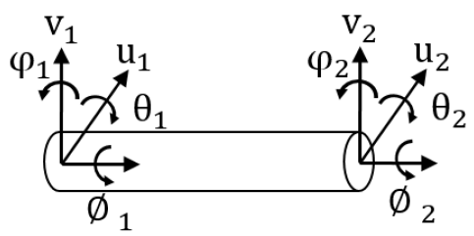

Fig. A. 1. The coordinate system for the Timoshenko beam element.

Bearing

The mechanical design and working principle vary for different types of bearing, and therefore the dynamic characteristics and the interactions within rotor/stator can be very different. Although in practice a bearing acts as a mechanical component connecting two other structures, i.e. rotor and ground or rotor and flexible foundation, it is conventionally not modelled as an additional degree of freedom in an FE model. In this paper, the bearings are assumed to be isotropic and treated as grounded springs in the FE model, and each bearing consists of two translational stiffness for ${ u}_{1}$ and ${ v}_{1}$, and two rotational stiffness for ${ θ}_{1}$ and $φ_{1}$.

Disc

In this paper it is assumed that the discs are rigid and axisymmetric, i.e. they mainly contribute kinetic energy to the vibrating system instead of strain energy, and rotate about a fixed point (the centre of the disc). The mass matrix of a rigid disc can be derived through calculating the total kinetic energy in the frame that fixes in the disc first, then applying transformation of coordinates to local coordinates, and then applying Lagrange’s equation. It has the form:

|  |  |  |
| --- | --- | --- |
|  | $$M = diag([m,m,I_{d},I_{d},I_{p}])$$ | (A.1) |

Gears

The modelling of the gears in the FE model is based on the work by Rao et al. [42]. They are treated as rigid discs with an equivalent stiffness k along the pressure line, as shown in Fig. A.2. It’s clear that the pressure angle (𝛼) is included so that the lateral vibration is now coupled with the torsional vibration.

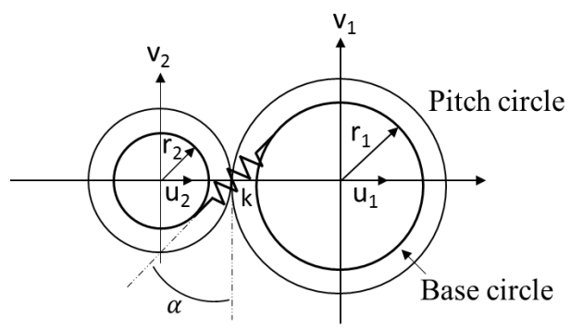

Fig. A. 2. Arrangement of the gear model.

The stiffness matrix of the gear meshing can be represented as

|  |  |  |
| --- | --- | --- |
|  | $$K_{g}=k\left[\begin{matrix}S^{2} & SC & 0 & 0 & -Sr_{1} & -S^{2} & -SC & 0 & 0 & -Sr_{2} \\ SC & C^{2} & 0 & 0 & -Cr_{1} & -SC & -C^{2} & 0 & 0 & -Cr_{2} \\ 0 & 0 & 0 & 0 & 0 & 0 & 0 & 0 & 0 & 0 \\ 0 & 0 & 0 & 0 & 0 & 0 & 0 & 0 & 0 & 0 \\ -Sr_{1} & -Cr_{1} & 0 & 0 & {r_{1}}^{2} & Sr_{1} & Cr_{1} & 0 & 0 & r_{1}r_{2} \\ -S^{2} & -SC & 0 & 0 & Sr_{1} & S^{2} & SC & 0 & 0 & Sr_{2} \\ -SC & -C^{2} & 0 & 0 & Cr_{1} & SC & C^{2} & 0 & 0 & Cr_{2} \\ 0 & 0 & 0 & 0 & 0 & 0 & 0 & 0 & 0 & 0 \\ 0 & 0 & 0 & 0 & 0 & 0 & 0 & 0 & 0 & 0 \\ -Sr_{2} & -Cr_{2} & 0 & 0 & r_{1}r_{2} & Sr_{2} & Cr_{2} & 0 & 0 & {r_{2}}^{2}\end{matrix}\right]$$ | (A.2) |

where $S=\sin\left(α\right), C=\cos\left(α\right).$

To determine some of the system parameters and improve the model, the inverse eigensensitivity method is implemented to update the FE model without the discs. In the process of updating the FE model the material properties (Young’s modulus & Poisson ratio) of the short shaft is updated first on the component level, which are taken as the same material properties of the long shaft as the two shafts are nominally identical. Then, stiffness of the bearings (translational and bending stiffness) are updated on the assembly level. In Table A.1 the frequencies of the updated model are compared with the experimental results which are identified through modal identification technique PolyMAX using LMS.Testlab. Among the four frequencies the maximum difference is the first frequency with 1.34 % error, and the updated parameters are given in Table A.2. It should be pointed out that in this model updating exercise the discs are excluded in these cases, and the gear contact stiffness is not updated since torsional natural frequency is not measured.

Table A. 1 Comparison of experimentally and numerically determined natural frequencies

|  |  |  |  |
| --- | --- | --- | --- |
|  | Experiment | Updated model | Difference |
| Bending natural frequencies (Hz) | 80.586 | 81.6687 | 1.3436 % |
| 266.678 | 265.558 | 1.17 % |
| 541.218 | 540.476 | 0.1371 % |
| 920.512 | 919.7091 | 0.0872 % |

Table A. 2 Updated system parameters

|  |  |  |  |
| --- | --- | --- | --- |
| Translational bearing stiffness | 2.1596e7 N/m | Young’s modulus | 203.23 GPa |
| Bending bearing stiffness | 26.3656 N/m | Poisson ratio | 0.3179 |

For the case in which discs of 780 g each are placed at p5 and p13, the natural frequencies and the corresponding mode shapes are shown in Fig. A.3.

It is worth noting that these frequencies, which are obtained from the FE model, are different from the modified ones listed in Table 1 (second column). This suggests that even if the FE model has been updated and shows good agreement with the measured frequencies of the original structure, it might not perform well when the modifications are included. This inadequacy of the theoretical model also partly strengthens the merit of the receptance-based method presented in this paper. Several factors can be accounted for the error. For example,

1. The aluminium profiles are not included in the FE model and therefore the assumption of a bearing behaving like a grounded spring might not be sufficiently accurate.
2. The stiffness of each bearing might be different; thus, the stiffness of each bearing possibly has to be updated separately.
3. The cross section of the rotors is not constant throughout their length. There are key seats and several grooves for circlips on the rotors.

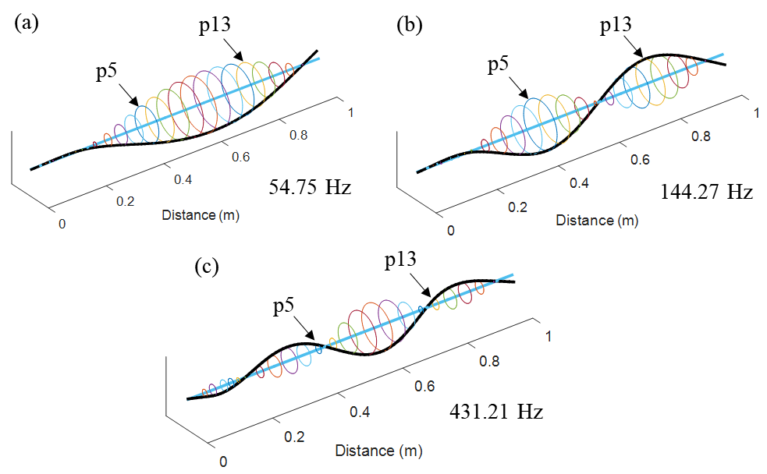

Fig. A. 3. Numerically determined natural frequencies and corresponding mode shapes