DNA binding and phosphorylation regulate the core structure of the NF-κB p50 transcription factor
Matthias Vonderach,ª Dominic P. Byrne,^{b} Perdita E. Barran,^{c} Patrick A. Eyers,^{b} and Claire E. Eyersª

- Centre for Proteome Research, Department of Biochemistry, Institute of Integrative Biology, University of Liverpool, Crown Street, Liverpool, L69 7ZB, UK
- Department of Biochemistry, Institute of Integrative Biology, University of Liverpool, Crown Street, Liverpool, L69 7ZB, UK
- Michael Barber Centre for Collaborative Mass Spectrometry, Manchester Institute of Biotechnology, The University of Manchester, 131 Princess Street, Manchester M1 7DN, UK.

Running title: DNA binding stabilises NF-κB dimers
Address reprint requests to: Professor Claire E. Eyers, Centre for Proteome Research, Department of Biochemistry, Institute of Integrative Biology, University of Liverpool, Crown Street, Liverpool, L69 7ZB, Liverpool, UK.

Email: CEyers@liverpool.ac.uk

Phone number: +44 151 795 4424
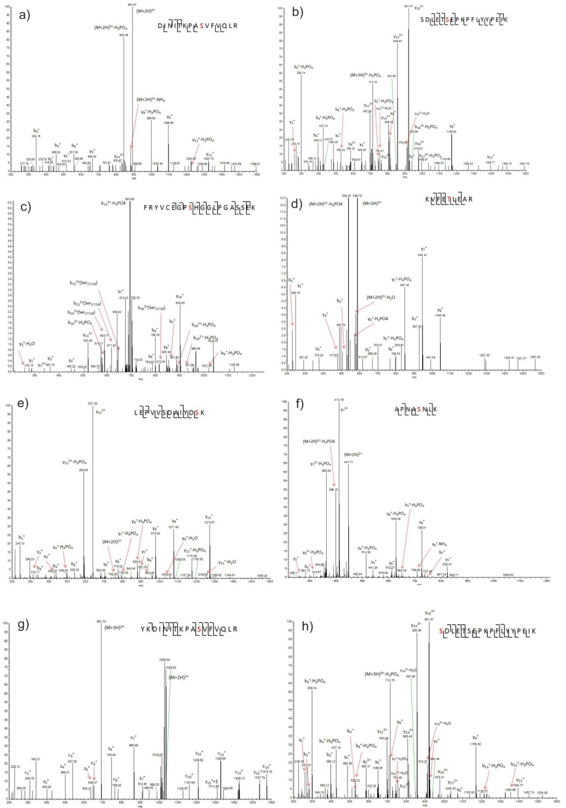
Supplementary Figure 1: Tandem mass spectra of p50 tryptic phosphopeptides. Doubly charged peptide ions derived from the PKAc treated sample: (a) m/z 890.97 indicating phosphorylation of Ser328 and (b) m/z 746.36 indicating phosphorylation of Ser337. Chk1-treated p50 also yielded phosphorylated tryptic peptide ions at (c) m/z 719.98 indicating phosphorylation of Ser65, (d) m/z 586.79 representing pThr152, (e) m/z 758.35 representing pSer242, (f) m/z 447.71 representing pSer248, (g) m/z 691.70 representing pSer328, and (h) m/z 746.35 representing pSer337. Sites of phosphorylation are in red on the annotated peptide sequence (insets).

Q66IP9|Xenopus_NFKB1 MAQNM-Y-----DIDDAHLETFLRINPLFQEPMYMPSEPHLRNAEGPYIEITEQPKQRGF
Q04861|Chicken_NFKB1 MAGEDPYIMGVSDPQMFAMDQLMGMSTIFNNTGYITSDLPLRTADGPYLQIIEQPKQRGF
P25799|Mouse_NFKB1 MADDDPY--G--TGQMFHLNTAL-THSIFNAELYSP-EIPLST-DGPYLQILEQPKQRGF
F1MKW9|Cow_NFKB1 MAEDDPYLGG--HEQMFHLDP-L-NHTMFSPELFQP-EMPLPTADGPYLQILEQPKQRGF
Q6F3J0|Dog_NFKB1 MAEDDTYLGA--HEQMFHLDP-L-THTIFNPELFQP-EMPLPTADGPYLQILEQPKQRGF
A7XNS1|Pig_NFKB1 MAEDDPYLGG--HDQMFHLDP-L-NHTIFNPELFQP-EMPLPTADGPYLQILEQPKQRGF
F6Z5H5|Marmoset_NFKB1 MAEDDPYLGR--PEQMFHLDPSL-THTIFNPEVFQP-QMALPT-DGPYLQILEQPKQRGF
F7HKH9|Rhesus_macaque MAEDDPYLGR--PEQMFHLDPSL-THTIFNPEVFQP-QMALPT-DGPYLQILEQPKQRGF
H2QPY8|Chimpanzee_NFKB1 MAEDDPYLGR--PEQMFHLDPSL-THTIFNPEVFQP-QMALPTADGPYLQILEQPKQRGF
P19838|Human_p50 1 MAEDDPYLGR--PEQMFHLDPSL-THTIFNPEVFQP-QMALPT-DGPYLQILEQPKQRGF 55
** : * : :: : .:*. : . : * . :***::* ********

Q66IP9|Xenopus_NFKB1 RFRYVCEGPSHGGLPGASSEKNRKSYPQIKIHNYVGQVKVVVQLITNSKDIRLHAHSLVG
Q04861|Chicken_NFKB1 RFRYVCEGPSHGGLPGASSEKNKKSYPQVKICNYVGPAKVIVQLVTNGKYVHLHAHSLVG
P25799|Mouse_NFKB1 RFRYVCEGPSHGGLPGASSEKNKKSYPQVKICNYVGPAKVIVQLVTNGKNIHLHAHSLVG
F1MKW9|Cow_NFKB1 RFRYVCEGPSHGGLPGASSEKNKKSYPQVKICNYVGPAKVIVQLVTNGKNIHLHAHSLVG
Q6F3J0|Dog_NFKB1 RFRYVCEGPSHGGLPGASSEKNKKSYPQVKICNYVGPAKVIVQLVTNGKNIHLHAHSLVG
A7XNS1|Pig_NFKB1 RFRYVCEGPSHGGLPGASSEKNKKSYPQVKICNYVGPAKVIVQLVTNGKNIHLHAHSLVG
F6Z5H5|Marmoset_NFKB1 RFRYVCEGPSHGGLPGASSEKNKKSYPQVKICNYVGPAKVIVQLVTNGKNTHLHAHSLVG
F7HKH9|Rhesus_macaque RFRYVCEGPSHGGLPGASSEKNKKSYPQVKICNYVGPAKVIVQLVTNGKNIHLHAHSLVG
H2QPY8|Chimpanzee_NFKB1 RFRYVCEGPSHGGLPGASSEKNKKSYPQVKICNYVGPAKVIVQLVTNGKNIHLHAHSLVG
P19838|Human_p50 56 RFRYVCEGPSHGGLPGASSEKNKKSYPQVKICNYVGPAKVIVQLVTNGKNIHLHAHSLVG 115
**********************.*****:** **** .**:***:**.* .********

Q66IP9|Xenopus_NFKB1 KNCEDGICSLTVGPKDTIVGFPNLGILHVTKKKVIEILEARMTDAFKKGHNAALLVHPEL
Q04861|Chicken_NFKB1 KFCEDGVCTVNAGPKDMVVGFANLGILHVTKKKVFETLETRMIDACKKGYNPGLLVHPEL
P25799|Mouse_NFKB1 KHCEDGVCTVTAGPKDMVVGFANLGILHVTKKKVFETLEARMTEACIRGYNPGLLVHSDL
F1MKW9|Cow_NFKB1 KHCEDGVCTVTAGPKDMVVGFANLGILHVTKKKVFETLEARMTDACIRGYNPGLLVHPDL
Q6F3J0|Dog_NFKB1 KHCEDGICTVTAGPKDMVVGFANLGILHVTKKKVFETLEARMTEACTKGYNPGLLVHPDL
A7XNS1|Pig_NFKB1 KHCEDGICTVTAGPKDMVVGFANLGILHVTKKKVFETLEARMTEACIRGYNPGLLVHPDL
F6Z5H5|Marmoset_NFKB1 KHCEDGICTVTAGPKDMVVGFANLGILHVTKKKVFETLEARMTEACIRGYNPGLLVHPDL
F7HKH9|Rhesus_macaque KHCEDGICTVTAGPKDMVVGFANLGILHVTKKKVFETLEARMTEACIRGYNPGLLVHPDL
H2QPY8|Chimpanzee_NFKB1 KHCEDGICTVTAGPKDMVVGFANLGILHVTKKKVFETLEARMTEACIRGYNPGLLVHPDL
P19838|Human_p50 116 KHCEDGICTVTAGPKDMVVGFANLGILHVTKKKVFETLEARMTEACIRGYNPGLLVHPDL 175
* ****:*::..**** :***.************:* **:** :* .*:*..****.:*

Q66IP9|Xenopus_NFKB1 NYTNSE---DRPLNEREKEIIRQAATQQSKDIDLSVVRLMFTAFLLDSEGRFTRSLEPVL
Q04861|Chicken_NFKB1 GYLQAEGCGDRQLTEREREIIRQAAVQQTKEMDLSVVRLMFTAFLPDSNGGFTRRLDPVI
P25799|Mouse_NFKB1 AYLQAEGGGDRQLTDREKEIIRQAAVQQTKEMDLSVVRLMFTAFLPDSTGSFTRRLEPVV
F1MKW9|Cow_NFKB1 AYLQAEGGGDRQLTDREKEIIRQAALQQTKEMDLSVVRLMFTAFLPDSTGSFTRRLEPVV
Q6F3J0|Dog_NFKB1 AYLQAEGGGDRQLTDREKEIIRQAALQQTKEMDLSVVRLMFTAFLPDSTGSFTRRLEPVV
A7XNS1|Pig_NFKB1 AYLQAEGGGDRQLTDREKEIIRQAALQQTKEMDLSVVRLMFTAFLPDSTGSFTRRLEPVV
F6Z5H5|Marmoset_NFKB1 AYLQAEGGGDRQLGDREKELIRQAALQQTKEMDLSVVRLMFTAFLPDSTGSFTRRLEPVV
F7HKH9|Rhesus_macaque AYLQAEGGGDRQLGDREKELIRQAALQQTKEMDLSVVRLMFTAFLPDSTGSFTRRLEPVV
H2QPY8|Chimpanzee_NFKB1 AYLQAEGGGDRQLGDREKELIRQAALQQTKEMDLSVVRLMFTAFLPDSTGSFTRRLEPVV
P19838|Human_p50 176 AYLQAEGGGDRQLGDREKELIRQAALQQTKEMDLSVVRLMFTAFLPDSTGSFTRRLEPVV 235
* ::* ** * :**.*:***** **:*::************* ** * *** *:**:

Q66IP9|Xenopus_NFKB1 SVPIFDSKAPNASNLKIVRMDRTAGCVTGGEEVYLLCDKVQKDDIQVRFYEEDENGGYWE
Q04861|Chicken_NFKB1 SDAIYDSKAPNASNLKIVRMDRTAGCVTGGEEIYLLCDKVQKDDIQIRFYEEDENGGMWE
P25799|Mouse_NFKB1 SDAIYDSKAPNASNLKIVRMDRTAGCVTGGEEIYLLCDKVQKDDIQIRFYEEEENGGVWE
F1MKW9|Cow_NFKB1 SDAIYDSKAPNASNLKIVRMDRTAGCVTGGEEIYLLCDKVQKDDIQIRFYEEEENGGIWE
Q6F3J0|Dog_NFKB1 SDAIYDSKAPNASNLKIVRMDRTAGCVTGGEEIYLLCDKVQKDDIQIRFYEEEENGGIWE
A7XNS1|Pig_NFKB1 SDAIYDSKAPNASNLKIVRMDRTAGCVTGGEEIYLLCDKVQKDDIQIRFYEEEENGGIWE
F6Z5H5|Marmoset_NFKB1 SDAIYDSKAPNASNLKIVRMDRTAGCVTGGEEIYLLCDKVQKDDIQIRFYEEEENGGVWE
F7HKH9|Rhesus_macaque SDAIYDSKAPNASNLKIVRMDRTAGCVTGGEEIYLLCDKVQKDDIQIRFYEEEENGGVWE
H2QPY8|Chimpanzee_NFKB1 SDAIYDSKAPNASNLKIVRMDRTAGCVTGGEEIYLLCDKVQKDDIQIRFYEEEENGGVWE
P19838|Human_p50 236 SDAIYDSKAPNASNLKIVRMDRTAGCVTGGEEIYLLCDKVQKDDIQIRFYEEEENGGVWE 295
* .*:***************************:*************:*****:**** **

Q66IP9|Xenopus_NFKB1 GFGDFSPTDVHRQFAIVFKTPKYKDVNITKAASVFVQLRRKSDYETSEPKPFLYYPEIKD
Q04861|Chicken_NFKB1 GFGDFSPTDVHRQFAIVFKTPKYRDVNITKPASVFVQLRRKSDLETSEPKPFLYYPEIKD
P25799|Mouse_NFKB1 GFGDFSPTDVHRQFAIVFKTPKYKDVNITKPASVFVQLRRKSDLETSEPKPFLYYPEIKD
F1MKW9|Cow_NFKB1 GFGDFSPTDVHRQFAIVFKTPKYKDVNITKPASVFVQLRRKSDLETSEPKPFLYYPEIKD
Q6F3J0|Dog_NFKB1 GFGDFSPTDVHRQFAIVFKTPKYKDVNITKPASVFVQLRRKSDLETSEPKPFLYYPEIKD
A7XNS1|Pig_NFKB1 GFGDFSPTDVHRQFAIVFKTPKYKDVNITKPASVFVQLRRKSDLETSEPKPFLYYPEIKD
F6Z5H5|Marmoset_NFKB1 GFGDFSPTDVHRQFAIVFKTPKYKDVNITKPASVFVQLRRKSDLETSEPKPFLYYPEIKD
F7HKH9|Rhesus_macaque GFGDFSPTDVHRQFAIVFKTPKYKDVNITKPASVFVQLRRKSDLETSEPKPFLYYPEIKD
H2QPY8|Chimpanzee_NFKB1 GFGDFSPTDVHRQFAIVFKTPKYKDINITKPASVFVQLRRKSDLETSEPKPFLYYPEIKD
P19838|Human_p50 296 GFGDFSPTDVHRQFAIVFKTPKYKDINITKPASVFVQLRRKSDLETSEPKPFLYYPEIKD 355
***********************.*:****.************ ****************

Q66IP9|Xenopus_NFKB1 KEEVQRKRQKLMPNFSDGYGGSGAGSGGGVGGGLY--GGGGGAGGSAGGGYGFSSFSYNN
Q04861|Chicken_NFKB1 KEEVQRKRQKLMPNFSDGYGG-GS--GAG-GGGMF--GGGGGGAGS---GFSYPSYGYSA
P25799|Mouse_NFKB1 KEEVQRKRQKLMPNFSDSFGG-GSGAGAG-GGGMFGSGGGGGSTGSPGPGYGYSNYGFPP
F1MKW9|Cow_NFKB1 KEEVQRKRQKLMPNFSDSFGG-GSGAGAG-GGGMFGSGGGGGGAGSTGPGYGFPHYGFPT
Q6F3J0|Dog_NFKB1 KEEVQRKRQKLMPNFSDSFGG-GSGAGAG-GGGMFGSGGGGGGAGSTGPGYGFPHYGFPT
A7XNS1|Pig_NFKB1 KEEVQRKRQKLMPNFSDSFGG-GSGAGAG-GGGMFGSGGGGGGAGSTGPGYGFPHYGFPT
F6Z5H5|Marmoset_NFKB1 KEEVQRKRQKLMPNFSDSFGG-GSGAGAG-GGGMFGSGSGGGGTGSTGPGYSFPHYGFPT
F7HKH9|Rhesus_macaque KEEVQRKRQKLMPNFSDSFGG-GSGAGAG-GGGMFGSGGGGGGTGSTGPGYSFPHYGFPT
H2QPY8|Chimpanzee_NFKB1 KEEVQRKRQKLMPNFSDSFGG-GSGAGAG-GGGMFGSGGGGGGTGSTGPGYSFPHYGFPT
P19838|Human_p50 356 KEEVQRKRQKLMPNFSDSFGG-GSGAGAG-GGGMFGSGGGGGGTGSTGPGYSFPHYGFPT 413
*****************.:** *: *.* ***:: *.***. ** *:.:. :.:

Q66IP9|Xenopus_NFKB1 YGGLNFHGGPMNSGPCMKHE
Q04861|Chicken_NFKB1 FGGMHFHPGTTKSNAGMKHE
P25799|Mouse_NFKB1 YGGITFHPGVTKSNAGVTHG
F1MKW9|Cow_NFKB1 YGGITFHTGTTKSNAGMKHG
A7XNS1|Pig_NFKB1 YGGITFHAGTTKSNAGMKHG
Q6F3J0|Dog_NFKB1 YGGITFHPGTTKSNAGMKHG
F6Z5H5|Marmoset_NFKB1 YGGISFHPGTTKSNAGMKHG
F7HKH9|Rhesus_macaque YGGITFHPGTTKSNAGMKHG
H2QPY8|Chimpanzee_NFKB1 YGGITFHPGTTKSNAGMKHG
P19838|Human_p50 414 YGGITFHPGTTKSNAGMKHG 433
:**: ** * :*.. :.*

Supplementary Figure 2. Cross-species sequence alignment of p50.
Thirteen higher eukaryote p50 protein sequences: Human (P19838); Pan troglodytes (Chimpanzee, H2QPY8); Macaca mulatta (Rhesus macaque, F7HKH9); Marmoset F6Z5H5; Pig A7XNS1; Cow, F1MKW9; Dog, Q6F3J0; Mouse, P25799; Chicken, Q04861-3; Xenopus Laevis Q66IP9, were aligned with MUSCLE (3.8). Sites of phosphorylation are highlighted red (serine) or yellow (threonine). Non-conservative substitutions are highlighted cyan.

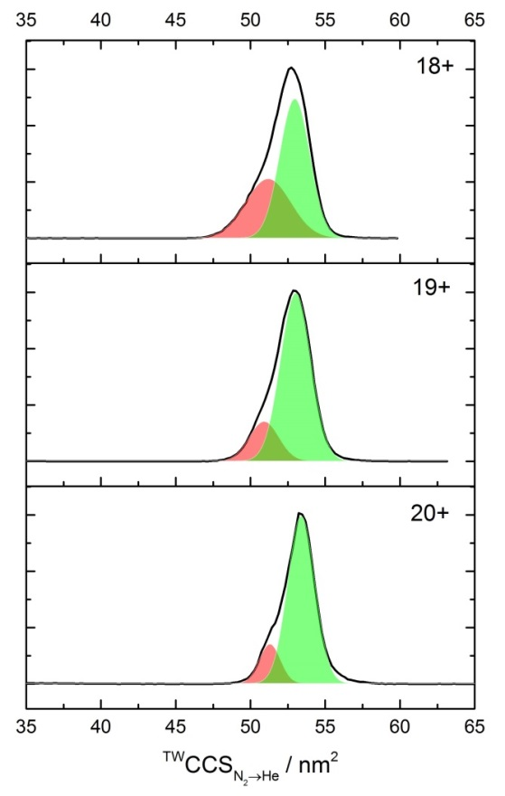
Supplementary Figure 3: CCS distributions of p50 dimer (35-381) before (black line) and after in vitro phosphorylation with either PKA_{c} (red) or Chk1 (blue), in the absence (top left) or presence (top right) of κB DNA. (Bottom) Gaussian fitting of the DNA bound dimer indicates two predominant conformers.

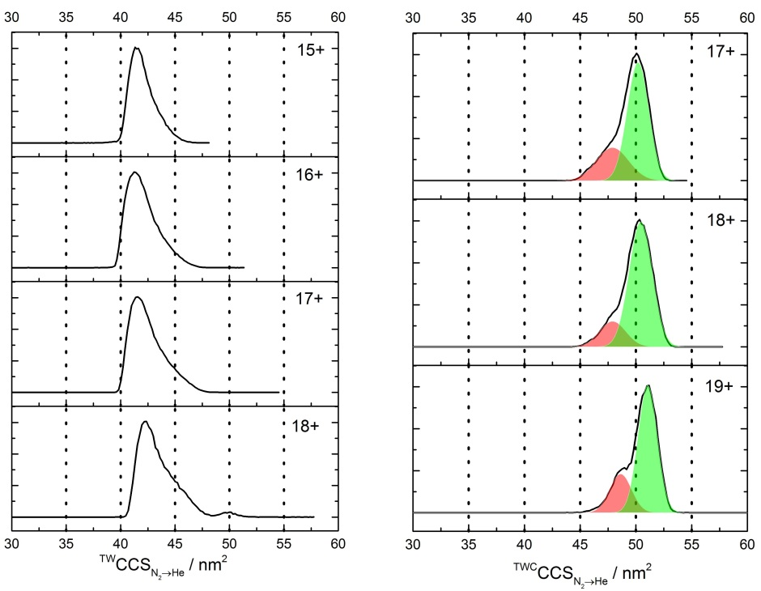 Supplementary Figure 4: CCS distributions of p50 (39-365) dimer in the absence (left) and presence (right) of κB DNA oligomer. Gaussian fitting of the DNA bound dimer indicates two predominant conformers.

Supplementary Figure 5: S337D p50 phosphomimetic has decreased preference for dimer formation. WT or S337D p50 (39-364) were proteolytically separated from the MBP affinity tag using 3C protease, and dimer:monomer ratio evaluated in solution using SEC on a Superdex 200 16/600 column. The position of dimeric p50 (centred at 70 ml column elution volume) and monomeric p50 (centred at 87 ml column elution volume) was confirmed by SDS-PAGE (top). The minor MBP contaminant present in the S337D preparation, which migrates more slowly than p50, is indicated by an asterisk on the gel.

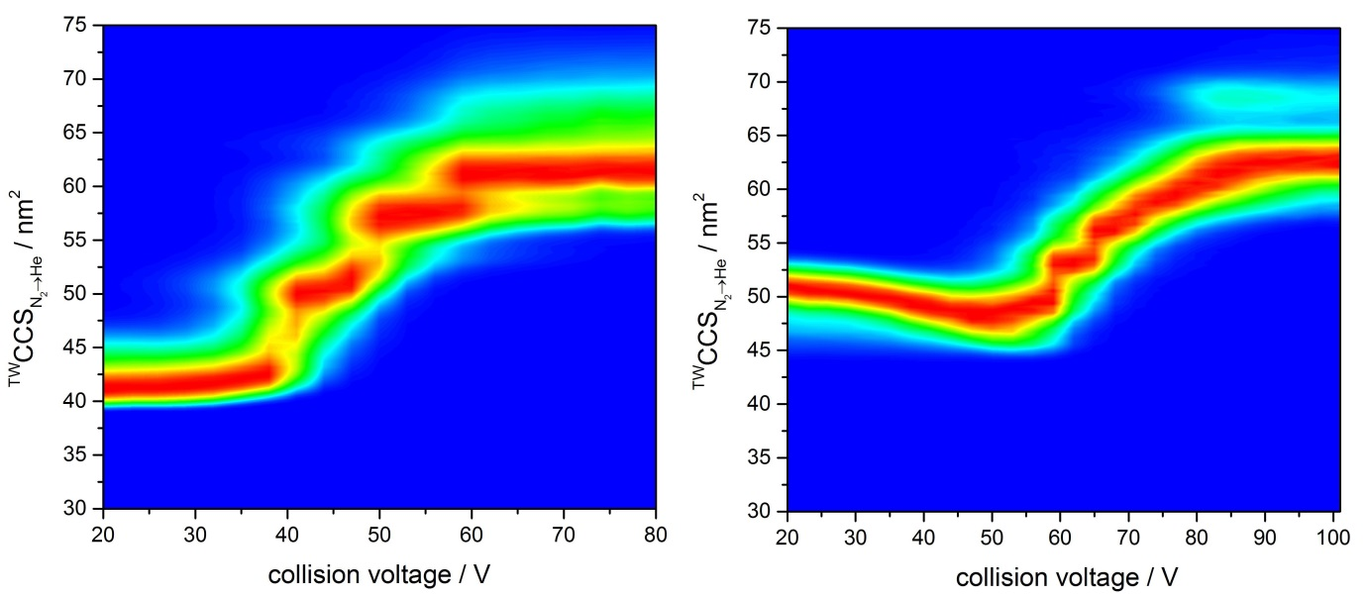
Supplementary Figure 6: DNA binding increases the stability of the p50 dimer. Collision-induced unfolding profiles of the 17+ charge state of WT p50 (39-364) dimer in the absence (left) and presence (right) of DNA indicate markedly different stabilities.

