Zebrafish as a model to study bone maturation: nanoscale structural and mechanical characterization of age-related changes in the zebrafish vertebral column

Zhuo Chang¹, Po-Yu Chen², Yung-Jen Chuang³, Riaz Akhtar¹

¹Department of Mechanical, Materials and Aerospace Engineering, School of Engineering, University of Liverpool, The Quadrangle, Brownlow Hill, Liverpool, L69 3GH, UK;
²Department of Materials Science and Engineering, National Tsing Hua University, Hsinchu 30013, Taiwan
³Department of Medical Science and Institute of Bioinformatics and Structural Biology, National Tsing Hua University, Hsinchu 30013, Taiwan

*Corresponding author email: r.akhtar@liverpool.ac.uk
Running Title: Zebrafish vertebral column structure-mechanical properties
Keywords: zebrafish, bone, vertebral column, age, mechanical property, AFM

ABSTRACT
Zebrafish (Danio rerio) is a useful model for understanding biomedical properties of bone and are widely employed in developmental and genetics studies. Here, we have studied the development of zebrafish vertebral bone at the nanoscale from adolescence (6 months), early adulthood (10 months) to mid-life (14 months). Characterization of the bone was conducted using energy-dispersive X-ray spectroscopy (EDX), scanning electron microscopy (SEM) and Peakforce QNM Atomic force microscopy (AFM) techniques. SEM and AFM revealed a lamellar structure with mineralized collagen fibrils. There was a significant increase in the wall thickness from 6 to 10 months (76%) and 10 months to 14 months (26 %), which is positively correlated with nanomechanical behavior. An increase in the Ca/P ratio was found which was also positively correlated with nanomechanical properties. The change in mechanical properties and Ca/P are similar to those expected in humans when transitioning from adolescence to mid-life. We suggest that zebrafish serve as a suitable model for further studies on age-related changes in bone ultrastructure.

KEYWORDS: Bone; zebrafish; vertebral column; nanomechanics; EDX; AFM; PF-QNM

- Introduction

Zebrafish (Danio rerio) has emerged as an excellent model organism for studies of vertebrate biology and for modelling human diseases (Bournele and Beis, 2016; Tu and Chi, 2012), because of their transparent embryos, suitability for genetic manipulation and high similarity to the human genome (Gerhard, 2007). Zebrafish possess a complex ossified skeleton that is comprised of cartilage and bone, which show key similarities to humans (Lieschke and Currie, 2007). Although zebrafish have ‘compact bone’ but not ‘cortical bone’ i.e. compact bone that surrounds a bone marrow cavity (Geurtzen et al., 2017), and trabecular bone is only found in the skull (Weigele and Franz‐Odendaal, 2016) zebrafish share many key features of bone structure and remodeling with humans (Asharani et al., 2012; Brittijn et al., 2009; Shin and Fishman, 2002; Spoorendonk et al., 2010), which suggests they are a suitable model to understand age-related development of human bone, as well as human bone diseases. For example, a study has shown that zebrafish bone has a lamellar structure and a biomineralized microstructure with hierarchical organization which is similar to human Haversian bone (Ge et al., 2006). In recent years, changes in skeletogenesis and osteogenesis (Weigele and Franz-Odendaal, 2016), osteogenesis imperfecta (OI) (Asharani et al., 2012) and bone regeneration (Knopf et al., 2011) have been modelled and assessed in the zebrafish system. Thus, these studies imply that zebrafish has the potential to complement or even replace mammalian models in studies on skeletal disorders on mammals. Until now, to our best knowledge, there have been no studies that explore age-related development and changes in zebrafish bone.

Age-related development and changes with advanced aging in the skeleton system are known to associate with increased bone fragility and fracture (Ensrud, 2013). Although the mechanical properties and age-related bone development have been studied in humans, there are still gaps in our understanding in relation to the structural and mechanical changes that occur in the bone matrix and microarchitecture during the aging process (Akkus et al., 2003; Legrand et al., 2000). Furthermore, there is an urgent need to develop suitable alternatives to mammalian animal models for studying bone development, skeletal maturation and aging to comply with the ‘3Rs’ (reduce, refine and replace) approach of animal use for scientific studies. Zebrafish align with the 3Rs which covers replacement of higher-order animals such as rodents with lower-order zebrafish (Vliegenthart et al., 2014). Zebrafish models can also overcome limitations associated with human biopsy samples including concerns in relation to ethics, suitability of samples and costs (Barut and Zon, 2000; Grizzle et al., 2011).

To determine how zebrafish bone develops with age in terms of ultrastructure and biomechanical properties, we studied the vertebral column of adolescence, early adulthood and mid-life fish. We employed a number of high spatial resolution techniques to characterize the micro- and nano-scale structural features and mechanical properties of the zebrafish vertebral column. Specifically, scanning electron microscopy (SEM) was utilized to observe bone microstructure. Calcium (Ca) and phosphate (P) levels were determined with scanning electron microscope (SEM) integrated energy-dispersive X-ray spectroscopy (EDX). Atomic force microscopy (AFM) based PeakForce Quantitative Nanomechanical Mapping (PFQNM) was used to co-localize ultrastructural and nanomechanical properties in the bone. Our study is the first to report how the ultrastructure and nanomechanical properties change as zebrafish bone ages.

2. Materials and Methods

2.1 Sample information
All wild-type AB strain zebrafish (Danio rerio) were raised at The Taiwan Zebrafish Core Facility (TZCF) at National Tsing Hua University (NTHU). The fish were maintained under standard conditions (Westerfield, 1995), following the strict animal usage guidelines and complying with the humane endpoints that are stipulated at TZCF where zebrafish are maintained up to around 18 months on average (You et al., 2016).

In this study, zebrafish were euthanized in an ice bath and dissected to collect the front-end of the fish body at the following ages; 6 months, 10 months and 14 months. Three fish were collected for each age group. The three age groups were selected to represent ‘adolescence’ (6 months), ‘early adulthood’ (10 months) and ‘mid-life’ (14 months), loosely based on the classification of Gilbert et al. (Gilbert et al., 2014) and Armstrong (Armstrong, 2007). The average lifespan of zebrafish is approximately 36 months (Gerhard et al., 2002) hence these three age groups correspond to 17 %, 28 % and 39 % of the maximum zebrafish lifespan. Given that the average life expectancy is 79.2 for males and 82.9 for women (Office for National Statistics, UK: 2014-2016), the equivalent age groups for humans would be 14 years, 23 years and 32 years. Therefore, these are relevant for studying bone development because bone mass peaks at around 30 years of age (O'Flaherty, 2000).

Zebrafish use was approved by the Experimental Animal Care and Use Committee of NTHU (Approval number: 10048). The precaudal vertebrae were used for all experiments as detailed below.

2.2 Sample preparation
The zebrafish were collected immediately after sacrifice and subsequently embedded in optimum cutting temperature (OCT) compound (Tissue-Tek Sakura Finetek, Torrance, USA) along with a transverse plane of the fish trunk. They were immediately immersed into the pre-frozen isopentane (2-Methylbutane) (Sigma-Aldrich, Saint Louis, USA) with a liquid nitrogen bath for 2 minutes until the sample was totally frozen. The unfixed, frozen fish samples, which included the vertebral column from the precaudal regions of the zebrafish, were then cryo-sectioned to a nominal thickness of 10 µm along a transverse plane of the skeletal bone using a Leica CM1850 cryostat (Leica Microsystems, Heidelberger, Germany) and adhered onto glass coverslip for further experimentation (Figure 1). At least 10 sections were cut from each fish vertebral column. Due to the small size of the vertebral bodies, it was not possible to determine whether the sections were from the same or adjacent vertebral bodies. All the cryo-sections were stored in a -80 ℃ freezer until testing.

2.3 Hematoxylin and Eosin Staining
For histological characterization, the sample sections were stained with Hematoxylin and Eosin (H&E). Cryo-sections were de-thawed at room temperature for 10 minutes and washed with distilled water for 10 minutes to remove any excess OCT compound. Following drying in air for 10 minutes, the H&E stained tissue section was characterized following standard histological procedures (Cardiff et al., 2014) and optical images were captured using an optical microscope (Olympus, Tokyo, Japan). 15 measurements of the wall thickness of the vertebral column were made in each group to assess its development with age.

2.4 Scanning Electron Microscopy (SEM)
For SEM observation, the sample sections were fixed on the coverslip with Karnovsky’s fixative (2.5% glutaraldehyde (GA) in 0.2M phosphate) for 2 hours and then were dipped in buffer solution (0.2M monobasic sodium phosphate and 0.2M dibasic sodium phosphate) for 15 hours. The sodium phosphate buffers used in the SEM sample preparation allow a constant pH to be maintained at a physiological level along with physiological osmolality and ion concentrations, thus preventing acidification during fixation (Schiff and Gennaro, 1979). Following this, the samples were dehydrated in graded ethanol concentrations (from 50%, 70%, 95% to 100%) for 15 minutes each. Finally, the samples were critical-point-dried (CPD) (Samdri-795 Critical Point Dryer, Tousimis®, MD, USA) and stored in a desiccator for the SEM study. Prior to SEM characterization, the sections were sputter-coated with gold and then imaged with a SEM (Hitachi SU8010, Chiyoda, Japan) at 15 kV.

2.5 Energy-dispersive X-ray spectroscopy (EDX) analysis
The SEM instrument (Hitachi SU8010, Chiyoda, Japan) was equipped with an energy dispersive X-ray spectroscopy (EDX). EDX was employed to determine the elemental compositions of the zebrafish vertebral column for the different ages. EDX measurements were performed with an electron beam of accelerating voltage 15 kV. The weight proportion of each assessed element was obtained, involving carbon (C), nitrogen (N), oxygen (O), sulfur (S), phosphorous (P) and calcium (Ca). The Ca/P ratio was subsequently determined for each measurement. One measurement was made on the outer half of the vertebral column in each fish with a fixed size of 7×7 µm².
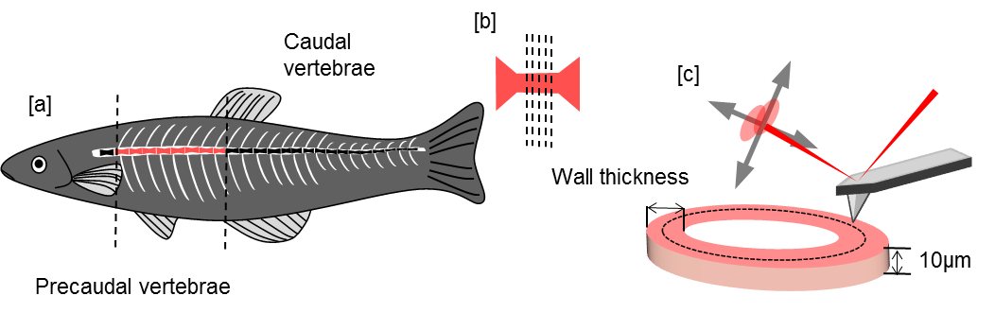
Figure 1. Schematic diagram of the experimental approach for PFQNM and EDX measurements of the zebrafish vertebral column. (a) The front-end with precaudal vertebra of the fish body was collected. (b) The vertebrae were sectioned to a nominal thickness of 10 μm. (c) The outer half of the vertebral column (posterior) was probed using PFQNM AFM to assess the localized nanomechanical properties, and EDX was solely conducted on another corresponding section to investigate chemical compositions.

2.6 PeakForce Quantitative Nanomechanical Mapping (PFQNM) Atomic Force Microscopy (AFM)
All experiments were conducted using PeakForce Quantitative Nanomechanical Mapping (PFQNM) on a Bruker AFM (Bruker, ICON Dimension, MA, USA). Prior to AFM measurements, the tissue was de-thawed at room temperature for 15 minutes and washed with distilled water for 10 minutes to remove any excess OCT compound. Subsequently, the sample was dried at room temperature (21°C) for 30 minutes and the outer half layer of the vertebral column was imaged with AFM. An RTESPA-150A probe (Bruker, California, USA) was used for all of the experiments. The probe had a nominal spring constant of 5 N/m, tip radius of 8 nm and a resonant cantilever frequency of 150 kHz. To assess the nanoscale mechanical properties of the sample, the deflection sensitivity was calibrated, following which the spring constant of the cantilever was calibrated using the thermal tune method. A polystyrene reference sample (a polystyrene film spin-cast on silicon) was used to calibrate the elastic modulus (Bruker, California, USA). The reference sample had a nominal elastic modulus of 2.7 GPa.

The AFM setup was integrated with an optical microscope which enabled the vertebral column to be identified and the probe was placed over it before testing. All testing was conducted with a scan rate of 0.9 Hz, a resolution of 256 pixels/line and a fixed scan size (2 × 2 μm). For each of the age groups (3 samples per group), 14 representative images were collected from the outer half region per sample. There were 65,536 (256 × 256 independent force curves) measurements for each image. The force curves were fitted using the Derjaguin-Muller-Toporov (DMT) analytical model as outlined by Young et al. (Young et al., 2011). All AFM raw data files were analyzed to yield the mean elastic modulus for each image with NanoScope Analysis version 1.5 (Bruker, Santa Barbara, CA, USA).

2.7 Statistical analysis
All statistical analysis was conducted in OriginPro version 9 (OriginLab, Northampton, MA, USA). All of the data are presented as mean ± standard deviation (SD). Firstly, as a quality control step, intra-group homogeneity was studied via the Kruskal-Wallis ANOVA test to determine if there were significant variations between measurements of wall thickness and also nanomechanical properties within each age group. Following this, group differences were assessed via suitable 2-sample independent tests selected after appraisal of data normality and homoscedasticity. Differences in vertebral column wall thickness, Ca/P ratio and nanomechanical properties were tested with the Kruskal-Wallis ANONA with Mann-Whitney post-hoc test. The adjusted p values in our results were calculated by applying the Benjamini and Hochberg false discovery rate correction to all raw p values (Benjamini and Hochberg, 1995). To assess for statistical significance between distributions of nanomechanical properties, Kolmogorov-Smirnov (K-S) tests were applied to the data. The elastic modulus-Ca/P ratio and elastic modulus-wall thickness relationships were obtained through Spearman's Rank Order Correlation and a correlation test was used to test the significance. A multivariate transformation called principal component analysis (PCA) was used for integrating the chemical and histological data with nanomechanical results in this study.

- Results
  - Histological analysis
Histology of the zebrafish was conducted on the fish trunk to identify the presence and structure of vertebral column (Figure 2). The locations of key structures are labelled in Figure 2a including the spinal cord, muscular tissue, dorsal aorta and vertebral column. As shown in Figure 2, the vertebral column was visible in all samples as a dense, ring-like structure.

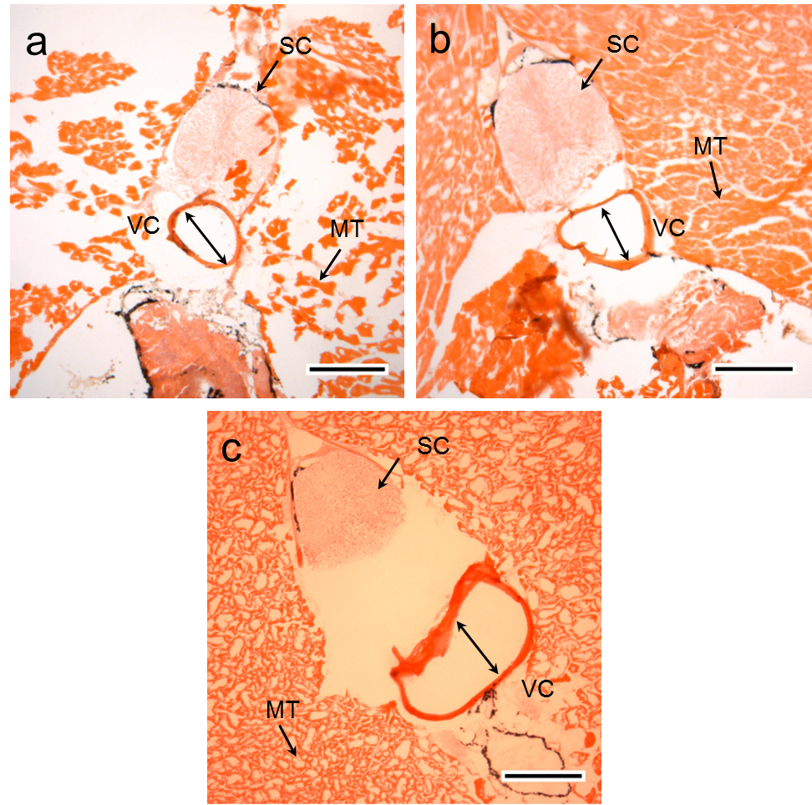
Figure 2. H&E stained histological sections for the zebrafish trunk at (a) 6 months (b) 10 months (c) 14 months. The circular structure above the vertebral column is the spinal cord (SC). The majority of the trunk section was loosely organized muscular tissue (MT) surrounding the spinal cord and vertebral column (VC). The scale bar represents 200 µm.
To assess the development of the vertebral column from adolescence (6 months) through to early adulthood (10 months) and mid-life (14 months), we measured the thickness of vertebral column wall in the histological images, as shown in Figure 3. Kruskal-Wallis test was performed for each group to test that no measurement within an age group was skewing the data. The test confirmed that there were non-significant differences between samples of the same group (Kruskal-Wallis ANOVA, p>0.05). Overall, the wall thickness was significantly increased as the zebrafish age increased through appositional growth (6 months = 8.4 ± 2.0 µm, 10 months = 14.8 ± 3.7 µm and 14 months = 18.6 ± 1.9 µm, Kruskal-Wallis ANOVA with Mann-Whitney post-hoc test, p<0.0001, adjusted p<0.0001).
Figure 3. Zebrafish vertebral column wall thickness at 6 months, 10 month and 14 months. Bar graph shows the mean ± SD. There were 15 measurements in each group (n=3 fish/age group with 5 locations for each age group).

  - Bone ultrastructure
The ultrastructure of zebrafish vertebral column was characterized by SEM and AFM. As shown in Figure 4, a defined lamellar structure was visible in the bone with it being most pronounced at 14 months (Figure 4e and 4f).

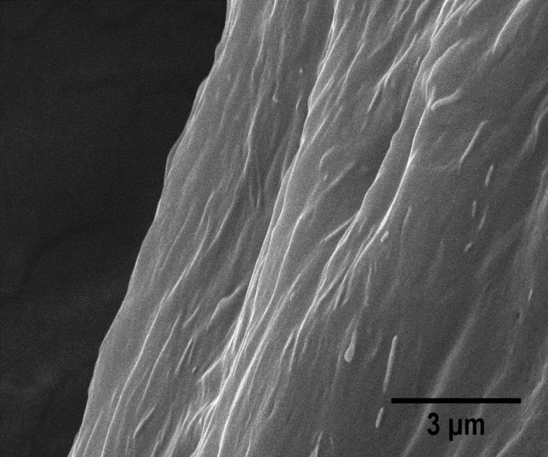
c
d
e
f
a
b
Figure 4. SEM micrographs of the cross-section of the vertebral column in zebrafish at (a)&(b) 6 months, (c)&(d) 10 months and (e)&(f) 14 months. (a), (c) and (e) lamella structure in all age groups. (d)&(f) high magnification of lamellar structure in 10 months and 14 months sample. (e) Mineralized collagen fibrils in 6 month sample. Images (a), (c) and (e) are at x5000 magnification, (d) at x10000 magnification and (b)&(f) at x25000 magnification.

We subsequently probed the ultrastructure of the vertebral column sections using AFM and identified major bone components: mineral crystals and collagen fibrils (Figure 5). As shown in Figure 5a, 5c & 5e, the bone ultrastructure was highly mineralized in all of the groups. Furthermore, collagen fibrils were also observed in all of the samples (Figure 5b, 5d and 5f). These mineralized collagen fibrils appeared to be more randomly distributed in the samples at 6 months, while fibrils were highly organized and tightly packed along one direction in sample at 10 months and 14 months. In some of the images, the 67 nm collagen D-Period could be identified in the fibrils, which had typical diameters of around 100 nm to 150 nm (Figures 5g and 5h).
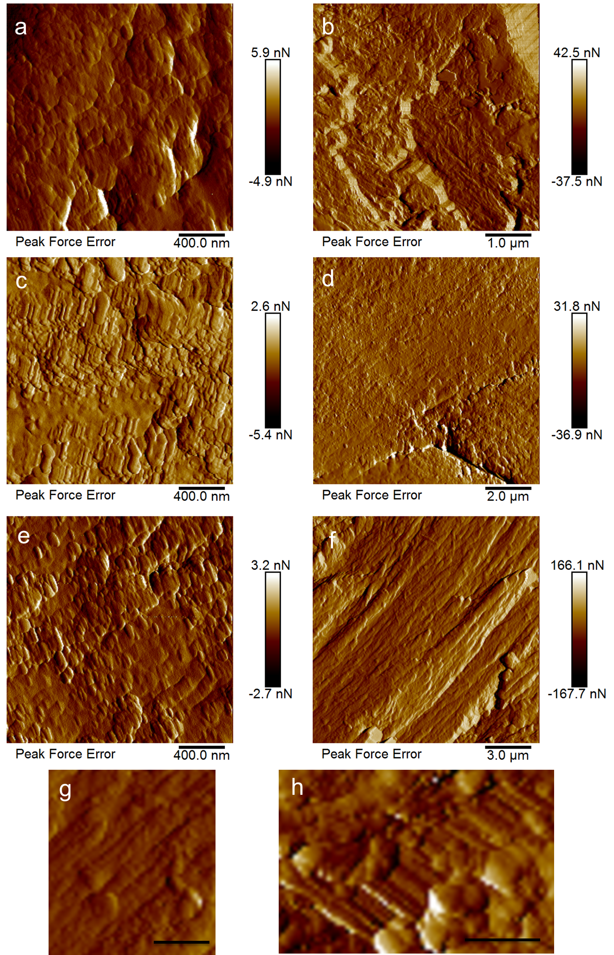
Figure 5. Peak Force Error and amplitude AFM images showing the ultrastructure of the zebrafish vertebral column at (a&b) 6 months, (c&d) 10 months and (e-h) 14 months (a), (c) and (e) are highly mineralized ultrastructure of zebrafish vertebral column at 6 months, 10 months and 14 months respectively. (b), (d) and (f) are mineralized collagen fibrils of zebrafish vertebral column at (b) 6 months, (d) 10 months and (f) 14 months respectively. (g) and (h) are zoomed in images of collagen fibrils with distinct D-Period. Scare bar represents (g) 1 µm and (h) 500 nm.

  - Chemical compositions in the bone
EDX analysis was performed to determine the bone chemical composition at different ages. We found that the vertebral column mostly comprised of C, N, O, P and Ca elements. S appeared to be a minimal element, which was less than 1% in all groups (Table I). Calcium and phosphorus were two of the most abundant elements in all samples, which were also the key elements in bone tissue. We evaluated the Ca/P ratio for all the three groups as shown in Figure 6. Although no statistically significant difference was detected in the Ca/P ratio between the three age groups (Kruskal-Wallis ANOVA, p = 0.4), we found the Ca/P ratio in the 10 months and 14 months groups was slightly higher than that in the 6 months group; 6 months = 1.74, 10 months = 1.97 and 14 months = 1.90). These data were related to nanomechanical properties (Section 3.4).

Table I EDX results (mean±SD) for the 6 months, 10 month and 14 months zebrafish vertebral column.
Element | 6 months (weight %) | 10 month (weight %) | 14 months (weight %)
Ca | 41.06 ± 2.51 | 42.61 ± 11.25 | 42.91 ± 1.72
P | 23.63 ± 0.37 | 21.40 ± 2.02 | 22.54 ± 0.76
O | 14.32 ± 0.48 | 8.04 ± 4.48 | 17.38 ± 1.67
C | 14.02 ± 2.42 | 20.59 ± 6.36 | 11.76 ± 0.11
N | 6.27± 0.69 | 6.54 ± 3.36 | 5.09 ± 0.91
S | 0.69 ± 0.18 | 0.81 ± 0.08 | 0.32 ± 0.06

Figure 6. Ca/P ratio of zebrafish vertebral column at 6 months, 10 months and 14 months. Data are shown as mean±SD. There were 3 measurements in each age group (i.e one EDX measurement/fish).

  - Nanoscale mechanical properties
PFQNM was used to probe nanomechanical properties along with ultrastructural topography in the zebrafish vertebral column. Kruskal-Wallis ANOVA testing confirmed that there were no differences within each group (Kruskal-Wallis ANOVA, p>0.05). As shown in Figure 7a, the mean elastic modulus was significantly higher in the 10 months and 14 months group as compared to the 6 months group; 6 months = 1703.6 ± 846.5 MPa, 10 months = 2056.1 ± 454.9 MPa and 14 months = 2301.5 ± 736.6 MPa (Kruskal-Wallis ANONA with Mann-Whitney post-hoc test, p<0.001, adjusted p<0.001). Furthermore, significant differences in the elastic modulus distribution were observed between the 6 months and 10 months groups (Kolmogorov–Smirnov test, p<0.0001), as well as the 6 months and 14 months groups (Kolmogorov–Smirnov test, p<0.0001) (Figure 7b). Subsequently, the 14 measurements of elastic modulus and the 5 measurements of wall thickness obtained for each fish were averaged and compared with the mean Ca/P ratio. A significant and positive correlation with Ca/P ratio and nanomechanical properties was found (Figure 7c). The relationship between the elastic modulus and wall thickness was also found to be positively correlated in all samples (Figure 7d).
Figure 7. Nanomechanical properties of the zebrafish vertebral column for 6 months, 10 months and 14 months and its relationships with other parameters. (a) Elastic modulus of the vertebral column for each group (Kruskal-Wallis ANONA with Mann-Whitney post-hoc test, p<0.001. There are 42 measurements per age group (n=3 fish x 14 regions per group) (b) Frequency distribution of the elastic modulus (Kolmogorov–Smirnov test, p<0.0001). (c) Ca/P ratio-elastic modulus and (d) vertebral column wall thickness-elastic modulus relationship were found to be positively correlated (Spearman's Rank Order Correlation, Ca/P-elastic modulus: r_{S} = 0.74, p=0.022; Wall thickness-elastic modulus: r_{S} = 0.67, p = 0.049). Plots (c) and (d) are based on the mean values for each fish.

Principal Component Analysis (PCA) was utilized to study the relations between all of the variables measured in this study. The measurements of elastic modulus and wall thickness in each fish were averaged before this (n=3 fish per age group) for the PCA. The projections that showed the best separation between the three ages studied corresponded to PC2 and PC3 (Figure 8a and 8b). The loading plot (Figure 8b) shows that whilst elastic modulus (E), wall thickness and S contribute the most to the separation of 14 months from 6 and 10 months, the variables Ca, P, C and O are the variables most responsible for the differences between 6 and 10 months from 14 months. Note that plots for PC1 and PC2 are provided in the Supplementary Material.

Figure 8. Principal component analysis (PCA) for the variables measured in this study (a) Score plots of PC2 and PC3 indicated a distinct separation in all of the three age groups. (b) Loading plot showed the relationships of the original variables with respect to each principal component. Elastic modulus and wall thickness appear closely correlated and relatively anticorrelated to P. Similarly Ca, C, N and Ca/P are closely correlated and anticorrrelated to O. Overall this multivariate approach is suitable to assess the age-related differences at the three time points selected.

4. Discussion
In this study, we used zebrafish as a model vertebrate to investigate age-related structural, chemical and biomechanical changes during skeletal maturation. Under laboratory conditions, zebrafish typically reach sexual maturity at 3 months and their optimal reproduction age ranges from 6 months to 12 months (Kishi et al., 2003; Nasiadka and Clark, 2012). The average lifespan of zebrafish is approximately 36 months with a maximum lifespan of up to 66 months (Gerhard et al., 2002; Kishi et al., 2003). Here, we used wild-type zebrafish at 6 months, 10 months and 14 months to explore age-dependent skeletal maturation and aging process. The rationale for selecting these age groups was explained in Section 2.1, which we estimate correspond to adolescence, early adulthood and mid-life of the average human lifespan. This is particularly relevant because human bone density peaks at about 30 years of age (early adulthood) and hence in this zebrafish model we can explore the properties of bone with advancing age, and its relevance to humans.

Given the small sample size and high spatial resolution demands, we developed an approach combining different techniques at the micro- and nano-scales to study the zebrafish vertebral column, where SEM and AFM were employed for observation of the bone matrix and ultrastructural features, whilst EDX and PFQNM were applied to characterize the chemical and nanomechanical changes, respectively.

  - Zebrafish as a bone aging model
Zebrafish have several advantages as a model system for aging research. This is because they experience senescence, have a genome which has been evolutionarily conserved and can also be manipulated genetically (Gerhard, 2003; Gilbert et al., 2014; Lieschke and Currie, 2007). They have been found to be a suitable model for studying aging and exercise (Gilbert et al., 2014), and also for bone research because their skeleton and mineralized tissues share many similarities with humans (Mackay et al., 2013). It is for this reason, we hypothesized that zebrafish bone may be a suitable model for understanding changes in human bone with advancing age.

Most of the research on bone to date has focused on bone disorders such as osteogenesis imperfecta because, as highlighted by Mackay et al., in such conditions there are genomic and phenotypic similarities between the zebrafish and human cases. Our study addresses the gap in the literature with regard to normal aging and bone development in wildtype zebrafish. The limitations of using zebrafish for such bone aging studies are addressed in Section 4.5.

4.2 Wall thickness
The wall thickness measurements are a useful way of assessing the development of the fish skeleton with age. The ring-like structure in fish vertebrae serves as a way of determining age (Das, 1994). In our case, we assessed wall thickness because it provides a good indication of development of the skeleton with age. Wall thickness measurements allow us to relate growth in the skeleton with mechanical properties and chemical composition. Although the relevance to the human skeleton may not be directly obvious, there may be some equivalence with cortical shell thickness, which plays an important role in the mechanical properties of the vertebral body (Eswaran et al., 2006). The PCA analysis (Figure 8) demonstrated that the wall thickness was most related to the elastic modulus.

4.3 Ultrastructural properties of zebrafish bone
A number of previous studies have used the zebrafish as a model vertebrate to explore the microstructure and mechanical properties of mineralized tissues. For example, zebrafish fin bony rays have been used as a model for studying mineral formation process in skeletal bone (Mahamid et al., 2008). Ge et al. (Ge et al., 2006) first demonstrated the utility of zebrafish skeletal bone as a simple model to study bone mineralization and human diseases using AFM and TEM. The same group have also used gene-mutated zebrafish models to explore changes in nanomechanical properties (Wang et al., 2002) and bone ultrastructure (Wang et al., 2003; Wang et al., 2004). In our study, we have linked age-related structural and biomechanical changes during skeletal maturation in the zebrafish using the vertebral column as the target bone.

Similar to previous studies (Wang et al., 2004; Zhang et al., 2002), we found that a lamellar structure was visible in the SEM images. The lamellar structure was more discernible in the 14 months specimens. However, the plywood-like structure reported by Wang et al. (2004) was not clearly identifiable in our study. This is most likely because we only examined cryosections and not fracture surfaces. Our AFM images showed mineralized collagen fibrils with plate-like crystals evident. It should be noted that these tests were conducted without any chemical surface treatment, e.g. demineralization, however, we were still able to detect some collagen fibrils with the distinct banding evident (Figure 5g & 4h).

4.4 Ca/P Ratio
Energy dispersive x-ray (EDX) analysis has been extensively documented as a useful quantitative method for the analysis of bone mineral status (Lochmüller et al., 2001), as well as the evaluation of mineralization by determining the Ca/P ratio (Mahamid et al., 2008) and assessing bone mineral changes (Åkesson et al., 1994). Although absolute measurements of Ca and P with EDX vary greatly, the Ca/P ratio exhibits good accuracy (Åkesson et al., 1994; Zaichick and Tzaphlidou, 2002). In bone, the relative content of Ca and P is essential for maintaining mineral balance and bone remodeling. Their co-dependence with the appropriate Ca/P ratio is also critical for bone mineralization and development (Shapiro and Heaney, 2003). Bone Ca/P ratio is a good index of bone quality and can be used for diagnosing bone disorders. For example, reduced Ca/P ratio has been associated with osteogenesis imperfecta (OI) (Sarathchandra et al., 1999) and osteoporosis (Kourkoumelis et al., 2012). In OI bone, the Ca/P ratio is lower than healthy bone (Cassella et al., 1995). In a rabbit model of osteoporosis, a relationship was found between induced bone loss and lowered Ca/P ratio (Kourkoumelis et al., 2012). Ca/P ratio for bone has also been reported for healthy rats (Kourkoumelis and Tzaphlidou, 2010) and rabbits (Kourkoumelis et al., 2012) with ranges from 1.8 to 2.0 and 1.9 to 2.2, respectively, which is relatively consistent with our data. In the human skeleton, although Ca/P ratio is not significantly different with age, it appears to increase slightly from 15 to 40 years in males (Tzaphlidou and Zaichick, 2003) and 15 to 35 years in females (Zaichick and Tzaphlidou, 2002) during skeletal maturation. This is also in good agreement with our findings in zebrafish bone.

Interestingly, the chemical composition measurements via the EDX analysis were the most useful to separate 6 and 10 months, as seen by PCA.

4.5 Elastic Properties
Due to the small size of the zebrafish vertebral column, AFM and nanoindentation are suitable techniques for characterizing the biomechanical properties of the bone. Previous studies have shown that for 3 months old wild-type zebrafish, the elastic modulus of the vertebral column varies across the bone cross-section, with a decrease in elastic modulus from the inner to the outer layers of the bone (Zhang et al., 2002). A similar trend has also been reported for 6 months zebrafish (Ge et al., 2006). This variation in mechanical properties matches their ultrastructural characterization of the bone in terms of the degree of mineralization from the outer to the inner layer in the bone. In our study, we used PFQNM to characterize the mechanical properties of the outer half region of bone for the three age groups. The mean values were 1.7 ± 0.8 GPa in the 6 months group, 2.1 ± 0.4 GPa in the 10 months group and 2.3 ± 0.7 GPa in the 14 months group. The modulus values ranged from 0.7 - 4.3 GPa in the 6 months group, 1.2 - 3.4 GPa in the 10 months group and 1.2 - 4.5 GPa in the 14 months group. These values were lower than the range reported by Ge et al. (6.4 - 9.8 GPa) and Zhang et al. (1.1 - 8.4 GPa). However, the differences in values are likely to be related to the different spatial resolution, location, testing methods (nanoindentation vs AFM) and due to the embedding/preparation method. With regard to the latter point, both Ge et al. and Zhang et al. utilized PMMA-embedded samples which may have elevated the elastic modulus values (Bushby et al., 2004).

The trends that we found in the mechanical properties from adolescence to mid-life in the zebrafish (an increase of 35 %) follow the expected trends for human bone, based on apparent-level mechanical tests. In human femoral cortical bone, the ultimate tensile strength of bone peaks at approximately 35 years and increases by 33% from adolescence (10 to 19 years) to mid-life (30 to 39 years) (Wall et al., 1979). It should be noted that our measurements with AFM are at the tissue-level and hence we cannot compare our trends directly with apparent-level modulus measurements. However, to the best of our knowledge, there have been no studies at the tissue-level on human bone which cover these age ranges. Rho et al. (Rho et al., 2002) used nanoindentation to show that there was no differences in the tissue modulus of human femoral bone with age, however their age range was from 35-95 years old. Similarly, Mirzaali et al. (Mirzaali et al., 2016) found that bone composition and the tissue-level modulus of human femoral bone (determined with microindentation) was independent of age, covering the age range 46 to 99. Given the scarcity of mechanical property data for younger human bones, the relevance of our zebrafish model is clear. Although there is a gap in the literature regarding bone maturation and tissue-level modulus, other studies on mammals are consistent with our trends. Chittenden et al. (Chittenden et al., 2015) examined the elastic modulus and hardness of porcine cortical bone, with nanoindentation. They found an increase with age, from 1 to 48 months, as the bone develops. They found that mineral content also increased with age. In a study on murine cortical bone, Raghavan et al. (Raghavan et al., 2012) used linear regression analysis to show that there are patterns in the relationships between mechanical and compositional properties at the tissue scale when comparing skeletally mature young (4 or 5 months) and old (19 months) animals.

Further studies on zebrafish could be extended to include structural and biomechanical changes associated with old age. The combination with genomic editing and chemical screen study with techniques and findings enlisted in this study holds great potential to advance orthopedic medicine in the future.

4.6 Limitations
In the present study, we demonstrated that the zebrafish vertebral column has potential for studies on bone maturation and aging studies. However, although there are numerous advantages of using zebrafish for bone research, a number of limitations must be considered, as summarized by Geurtzen et al. (Geurtzen et al., 2017). Strictly speaking (as stated in the Introduction), zebrafish have ‘compact bone’ but not ‘cortical bone’ and trabecular bone is only found in the skull (Weigele and Franz‐Odendaal, 2016). Furthermore, it has been reported that zebrafish bone is devoid of obvious Haversian systems (Cui et al., 2007; Wang et al., 2004). However, in a detailed histological study, Weigele and Franz-Odendaal (2016) have clearly identified osteons in zebrafish bone with central Haversian canals, although they reported that osteons were rarely detected. This finding leads on to one major difference between zebrafish and mammalian bone; in zebrafish acellular bone (devoid of osteocytes) is found as well as mononucleated osteoclasts. In contrast, mammalian bone is exclusively cellular with multinucleated osteoclasts (Laizé et al., 2014). These acellular regions may explain why Cui et al. have not found complete Haversian systems. Despite these differences, the zebrafish skeleton does have a lamellar structure and exhibits a hierarchical organization which is a characteristic of human long bones (Cui et al., 2007). Overall, the biomineralization process and microstructure of zebrafish bone has also been found to be similar to that of human Haversian bone (Ge et al., 2006). In terms of cellular activity and remodeling, there are a number of similarities between zebrafish and human mammalian bone including endochondral bone formation and ossification, bone formation by osteoblasts and bone resorption by osteoclasts (Laizé et al., 2014). Zebrafish osteoblast differentiation is also similar to that in mammals (Weigele and Franz‐Odendaal, 2016; Witten et al., 2001). Differences arise in remodeling due to the presence of both mono- and multinucleated osteoclasts in the zebrafish. Nonlacunar bone resorption by mononucleated cells is an important remodeling process in zebrafish (Witten et al., 2001). Overall, zebrafish share many important features in terms of bone formation and remodeling with vertebrates including mammals (Geurtzen et al., 2017).

Similar to mammals, teleost skeletal tissue adaptively remodels to their loading environment (Fiaz et al., 2012), and have even been used as a model for human exercise and aging (Gilbert et al., 2014). However, one limitation that should also be considered is that the loading environment on the zebrafish skeletal system is different to that of mammals.

There are some limitations with the experimental approach that should also be addressed. Firstly, our study just focused on the outer half layer (posterior) of precaudal vertebral column. In future, it may be useful to examine the entire vertebral column to assess age-related, regional variations in the bone especially given the variation across the vertebral column that has been reported by Ge et al (Ge et al., 2006). Secondly, future work could be conducted to determine apparent-level mechanical properties through tension and compression rather than focusing only on localized, tissue-level mechanical properties. PFQNM-AFM provides topographical and elastic modulus information at the nano-scale. However, to fully understand the biomechanical properties of zebrafish bone it would be useful to determine its fracture resistance, strength and toughness. Finally, use of demineralization methods would help better understand the interaction between the organic and inorganic phases. Demineralized bone may have allowed individual collagen fibrils to be identified more clearly, for example with transmission electron microscopy (TEM).

5. Conclusions
Zebrafish serve as a readily accessible model for studying bone development. Here, we have shown how the ultrastructure, composition of zebrafish bone changes from adolescence to early adulthood and mid-life. Wall thickness in the vertebral column increased by 122 % from 6 to 14 months. This was associated with a 12 % increase in Ca/P and a 35 % increase in elastic modulus. Ca/P and elastic modulus were found to be closely correlated. These changes in bone properties with skeletal development are consistent with trends reported for mammals. Our approach has the potential to be extended for other aging studies and for bone pathology investigations in zebrafish.

Supplementary Material
Additional PCA plots are presented in the Supplementary Material.

Acknowledgments
Z.C is funded by the University of Liverpool/National Tsing Hua University Dual PhD scheme. RA is grateful to the Royal Academy of Engineering/Leverhulme Trust for a Senior Research Fellowship (LTSRF1617/13/76). The authors (ZC and PYC) sincerely thank the financial support from the Ministry of Science and Technology, Taiwan (MOST103-2221-E-007-034-MY3 and MOST105-2221-E-007-012-MY4) and High Entropy Materials Center. The authors gratefully acknowledge Shin Yang-Rong (National Tsing Hua University) for SEM imaging and Eva Caamano Gutierrez (Institute of Integrative Biology, University of Liverpool) for advice and assistance with the statistical analysis.

References
Åkesson, K., Grynpas, M., Hancock, R., Odselius, R., Obrant, K., 1994. Energy-dispersive X-ray microanalysis of the bone mineral content in human trabecular bone: a comparison with ICPES and neutron activation analysis. Calcified tissue international 55, 236-239.
Akkus, O., Polyakova‐Akkus, A., Adar, F., Schaffler, M.B., 2003. Aging of microstructural compartments in human compact bone. Journal of Bone and Mineral Research 18, 1012-1019.
Armstrong, T., 2007. The human odyssey: Navigating the twelve stages of life. Sterling Publishing Company.
Asharani, P., Keupp, K., Semler, O., Wang, W., Li, Y., Thiele, H., Yigit, G., Pohl, E., Becker, J., Frommolt, P., 2012. Attenuated BMP1 function compromises osteogenesis, leading to bone fragility in humans and zebrafish. The American Journal of Human Genetics 90, 661-674.
Barut, B.A., Zon, L.I., 2000. Realizing the potential of zebrafish as a model for human disease. Physiological genomics 2, 49-51.
Benjamini, Y., Hochberg, Y., 1995. Controlling the false discovery rate: a practical and powerful approach to multiple testing. Journal of the royal statistical society. Series B (Methodological), 289-300.
Bournele, D., Beis, D., 2016. Zebrafish models of cardiovascular disease. Heart failure reviews 21, 803-813.
Brittijn, S.A., Duivesteijn, S.J., Belmamoune, M., Bertens, L.F., Bitter, W., Debruijn, J.D., Champagne, D.L., Cuppen, E., Flik, G., Vandenbroucke-Grauls, C.M., 2009. Zebrafish development and regeneration: new tools for biomedical research. International Journal of Developmental Biology 53, 835-850.
Bushby, A., Ferguson, V., Boyde, A., 2004. Nanoindentation of bone: Comparison of specimens tested in liquid and embedded in polymethylmethacrylate. Journal of Materials Research 19, 249-259.
Cardiff, R.D., Miller, C.H., Munn, R.J., 2014. Manual hematoxylin and eosin staining of mouse tissue sections. Cold Spring Harbor protocols 2014, pdb. prot073411.
Cassella, J., Garrington, N., Stamp, T., Ali, S., 1995. An electron probe X-ray microanalytical study of bone mineral in osteogenesis imperfecta. Calcified tissue international 56, 118-122.
Chittenden, M., Najafi, A.R., Li, J., Jasiuk, I., 2015. Nanoindentation and ash content study of age dependent changes in porcine cortical bone. Journal of Mechanics in Medicine and Biology 15, 1550074.
Cui, F.-Z., Li, Y., Ge, J., 2007. Self-assembly of mineralized collagen composites. Materials Science and Engineering: R: Reports 57, 1-27.
Das, M., 1994. Age determination and longevity in fishes. Gerontology 40, 70-96.
Ensrud, K.E., 2013. Epidemiology of fracture risk with advancing age. Journals of Gerontology Series A: Biomedical Sciences and Medical Sciences 68, 1236-1242.
Eswaran, S.K., Gupta, A., Adams, M.F., Keaveny, T.M., 2006. Cortical and trabecular load sharing in the human vertebral body. Journal of Bone and Mineral Research 21, 307-314.
Fiaz, A.W., Léon-Kloosterziel, K.M., Gort, G., Schulte-Merker, S., van Leeuwen, J.L., Kranenbarg, S., 2012. Swim-training changes the spatio-temporal dynamics of skeletogenesis in zebrafish larvae (Danio rerio). PloS one 7, e34072.
Ge, J., Wang, X., Cui, F., 2006. Microstructural characteristics and nanomechanical properties across the thickness of the wild-type zebrafish skeletal bone. Materials Science and Engineering: C 26, 710-715.
Gerhard, G.S., 2003. Comparative aspects of zebrafish (Danio rerio) as a model for aging research. Experimental gerontology 38, 1333-1341.
Gerhard, G.S., 2007. Small laboratory fish as models for aging research. Ageing research reviews 6, 64-72.
Gerhard, G.S., Kauffman, E.J., Wang, X., Stewart, R., Moore, J.L., Kasales, C.J., Demidenko, E., Cheng, K.C., 2002. Life spans and senescent phenotypes in two strains of Zebrafish (Danio rerio). Experimental gerontology 37, 1055-1068.
Geurtzen, K., Vernet, A., Freidin, A., Rauner, M., Hofbauer, L.C., Schneider, J.E., Brand, M., Knopf, F., 2017. Immune suppressive and bone inhibitory effects of prednisolone in growing and regenerating zebrafish tissues. Journal of Bone and Mineral Research.
Gilbert, M.J., Zerulla, T.C., Tierney, K.B., 2014. Zebrafish (Danio rerio) as a model for the study of aging and exercise: physical ability and trainability decrease with age. Experimental gerontology 50, 106-113.
Grizzle, W.E., Bell, W.C., Sexton, K.C., 2011. Issues in collecting, processing and storing human tissues and associated information to support biomedical research. Cancer Biomarkers 9, 531-549.
Kishi, S., Uchiyama, J., Baughman, A.M., Goto, T., Lin, M.C., Tsai, S.B., 2003. The zebrafish as a vertebrate model of functional aging and very gradual senescence. Experimental gerontology 38, 777-786.
Knopf, F., Hammond, C., Chekuru, A., Kurth, T., Hans, S., Weber, C.W., Mahatma, G., Fisher, S., Brand, M., Schulte-Merker, S., 2011. Bone regenerates via dedifferentiation of osteoblasts in the zebrafish fin. Developmental cell 20, 713-724.
Kourkoumelis, N., Balatsoukas, I., Tzaphlidou, M., 2012. Ca/P concentration ratio at different sites of normal and osteoporotic rabbit bones evaluated by Auger and energy dispersive X-ray spectroscopy. Journal of biological physics 38, 279-291.
Kourkoumelis, N., Tzaphlidou, M., 2010. Spectroscopic assessment of normal cortical bone: differences in relation to bone site and sex. The Scientific World Journal 10, 402-412.
Laizé, V., Gavaia, P.J., Cancela, M.L., 2014. Fish: a suitable system to model human bone disorders and discover drugs with osteogenic or osteotoxic activities. Drug Discovery Today: Disease Models 13, 29-37.
Legrand, E., Chappard, D., Pascaretti, C., Duquenne, M., Krebs, S., Rohmer, V., Basle, M.F., Audran, M., 2000. Trabecular bone microarchitecture, bone mineral density, and vertebral fractures in male osteoporosis. Journal of Bone and Mineral Research 15, 13-19.
Lieschke, G.J., Currie, P.D., 2007. Animal models of human disease: zebrafish swim into view. Nature Reviews Genetics 8, 353.
Lochmüller, E.-M., Krefting, N., Bürklein, D., Eckstein, F., 2001. Effect of fixation, soft-tissues, and scan projection on bone mineral measurements with dual energy X-ray absorptiometry (DXA). Calcified tissue international 68, 140-145.
Mackay, E.W., Apschner, A., Schulte-Merker, S., 2013. A bone to pick with zebrafish. BoneKEy reports 2.
Mahamid, J., Sharir, A., Addadi, L., Weiner, S., 2008. Amorphous calcium phosphate is a major component of the forming fin bones of zebrafish: Indications for an amorphous precursor phase. Proceedings of the National Academy of Sciences 105, 12748-12753.
Mirzaali, M.J., Schwiedrzik, J.J., Thaiwichai, S., Best, J.P., Michler, J., Zysset, P.K., Wolfram, U., 2016. Mechanical properties of cortical bone and their relationships with age, gender, composition and microindentation properties in the elderly. Bone 93, 196-211.
Nasiadka, A., Clark, M.D., 2012. Zebrafish breeding in the laboratory environment. ILAR journal 53, 161-168.
O'Flaherty, E.J., 2000. Modeling normal aging bone loss, with consideration of bone loss in osteoporosis. Toxicological Sciences 55, 171-188.
Raghavan, M., Sahar, N.D., Kohn, D.H., Morris, M.D., 2012. Age-specific profiles of tissue-level composition and mechanical properties in murine cortical bone. Bone 50, 942-953.
Rho, J.Y., Zioupos, P., Currey, J.D., Pharr, G.M., 2002. Microstructural elasticity and regional heterogeneity in human femoral bone of various ages examined by nano-indentation. Journal of biomechanics 35, 189-198.
Sarathchandra, P., Kayser, M., Ali, S., 1999. Abnormal mineral composition of osteogenesis imperfecta bone as determined by electron probe X-ray microanalysis on conventional and cryosections. Calcified tissue international 65, 11-15.
Schiff, R., Gennaro, J., 1979. The role of the buffer in the fixation of biological specimens for transmission and scanning electron microscopy. Scanning 2, 135-148.
Shapiro, R., Heaney, R., 2003. Co-dependence of calcium and phosphorus for growth and bone development under conditions of varying deficiency. Bone 32, 532-540.
Shin, J.T., Fishman, M.C., 2002. From zebrafish to human: modular medical models. Annual Review of Genomics and Human Genetics 3, 311-340.
Spoorendonk, K.M., Hammond, C.L., Huitema, L.F., Vanoevelen, J., Schulte‐Merker, S., 2010. Zebrafish as a unique model system in bone research: the power of genetics and in vivo imaging. Journal of Applied Ichthyology 26, 219-224.
Tu, S., Chi, N.C., 2012. Zebrafish models in cardiac development and congenital heart birth defects. Differentiation 84, 4-16.
Tzaphlidou, M., Zaichick, V., 2003. Calcium, phosphorus, calcium-phosphorus ratio in rib bone of healthy humans. Biological trace element research 93, 63-74.
Vliegenthart, A., Tucker, C.S., Del Pozo, J., Dear, J.W., 2014. Zebrafish as model organisms for studying drug‐induced liver injury. British journal of clinical pharmacology 78, 1217-1227.
Wall, J., Chatterji, S., Jeffery, J., 1979. Age-related changes in the density and tensile strength of human femoral cortical bone. Calcified tissue international 27, 105-108.
Wang, X.-M., Cui, F.-Z., Ge, J., Ma, C., 2003. Alterations in mineral properties of zebrafish skeletal bone induced by liliput dtc232 gene mutation. Journal of crystal growth 258, 394-401.
Wang, X., Cui, F., Ge, J., Wang, Y., 2004. Hierarchical structural comparisons of bones from wild-type and liliput dtc232 gene-mutated Zebrafish. Journal of structural biology 145, 236-245.
Wang, X., Cui, F., Ge, J., Zhang, Y., Ma, C., 2002. Variation of nanomechanical properties of bone by gene mutation in the zebrafish. Biomaterials 23, 4557-4563.
Weigele, J., Franz-Odendaal, T.A., 2016. Functional bone histology of zebrafish reveals two types of endochondral ossification, different types of osteoblast clusters and a new bone type. Journal of anatomy 229, 92-103.
Weigele, J., Franz‐Odendaal, T.A., 2016. Functional bone histology of zebrafish reveals two types of endochondral ossification, different types of osteoblast clusters and a new bone type. Journal of anatomy 229, 92-103.
Westerfield, M., 1995. The zebrafish book: a guide for the laboratory use of zebrafish (Brachydanio rerio). University of Oregon Press.
Witten, P.E., Hansen, A., Hall, B.K., 2001. Features of mono‐and multinucleated bone resorbing cells of the zebrafish Danio rerio and their contribution to skeletal development, remodeling, and growth. Journal of Morphology 250, 197-207.
You, M.-S., Jiang, Y.-J., Yuh, C.-H., Wang, C.-M., Tang, C.-H., Chuang, Y.-J., Lin, B.-H., Wu, J.-L., Hwang, S.-P.L., 2016. A Sketch of the Taiwan Zebrafish Core Facility. Zebrafish 13, S-24-S-29.
Young, T., Monclus, M., Burnett, T., Broughton, W., Ogin, S., Smith, P., 2011. The use of the PeakForceTM quantitative nanomechanical mapping AFM-based method for high-resolution Young's modulus measurement of polymers. Measurement Science and Technology 22, 125703.
Zaichick, V., Tzaphlidou, M., 2002. Determination of calcium, phosphorus, and the calcium/phosphorus ratio in cortical bone from the human femoral neck by neutron activation analysis. Applied Radiation and Isotopes 56, 781-786.
Zhang, Y., Cui, F., Wang, X., Feng, Q., Zhu, X., 2002. Mechanical properties of skeletal bone in gene-mutated stöpsel dtl28d and wild-type zebrafish (Danio rerio) measured by atomic force microscopy-based nanoindentation. Bone 30, 541-546.

