BIM FM: An international call for action

Ricardo Codinhoto

The University of Bath, UK

Vincenzo Donato

Politecnico de Torino, Italy

Julie Comlay

The University of Bath, UK

Kemi Adeyeye

The University of Bath, UK

Arto Kiviniemi.

University of Liverpool, UK

# Abstract

Despite significant progress for the adoption of BIM in AEC, currently, its adoption for FM has been sparse, scarce and extraneous. There are few cases in the world where robust adoption has taken place; which are able to demonstrate success and are willing to disseminate the positive impact of BIM FM on sustainability, operational efficiency and cost reduction. To date, there is no approach, motivation or support in place to enable the extensive adoption of BIM for FM worldwide. In the UK for instance, the UK BIM initiative, mandate and the Digital Built Britain, cannot count on the participation of FM stakeholders, the government has only started promoting initiatives that could trigger an extensive BIM approach, generating benefits for organisations and more importantly, society as a whole. In this article, data from authors’ various research projects has been put together to generate an agenda for BIM FM implementation. The findings reveal that unless an intervention, such as a mandate for FM services suppliers is put in place, very little will happen with regards to BIM FM.

Keywords: Building Information Modelling, Facilities Management, Soft Landings, Mandate

# A slightly different viewpoint

The year is 2018 and much of what is proclaimed in the academic press, popular media and all other means of communications is that humanity has disturbed the balance of life in our planet to an extent that might be irreversible. Global warming and climate change constantly make headlines as the explanation for floods, landslides, draughts, storms, the melting of the polar caps and rising sea levels, as well as irregular weather patterns. Amongst the causes of these is the continuous accumulation of pollutant gases, such as CO2 and methane, in our atmosphere. Many of these gases come from the collective impact of the way we live our lives individually, and that has to change.

Building use is at the core of the problem. The study by Kleips et al. (2001) revealed that, on average, American and Canadian adults spend approximately 87% of their time in enclosed buildings. Give or take, a person dying at the age of 83 (UK life expectancy) would have spent 72 years of their life inside a building. While individually that might not be significant, collectively it is a critical problem that requires attention as buildings consume approximately 40% of all energy production and generate circa 36% of global CO2 and other greenhouse gases (European Commission, 2017).

Building occupancy is the subject explored within this article, with a focus on the use of Building Information Modelling (BIM) to support facilities management (FM). BIM for FM had its first significant application at the Sydney Opera House (Ballesty et al., 2006; Schevers et al., 2007) and has seen a number of applications worldwide since. This paper will not significantly address the matter of applications as discussed by Becerik-Gerber et al., (2012), Arayici et al., (2012) or the compilation of case applications presented by Teicholz (2013) and Volk et al., (2014). Instead, it will refer to the authors own earlier publications about various cases (e.g. Codinhoto et al., 2013a; Kiviniemi and Codinhoto, 2014; Comlay 2015 and Comlay and Codinhoto, 2017), to form the argument as to why the extensive adoption of BIM for facilities management has not happened, and as such is failing to deliver critical environmental and economic benefits.

The authors have drawn evidence from various independent pieces of research related to BIM FM carried out by them since 2011. Whilst evidence from systematic data collection forms the basis of the arguments presented in this article, anecdotal evidence from the participation of the authors in various activities related to the advancement of BIM FM and experience from conducting research in this field is also used. The aim of this article is not to contribute to the scientific advancement of BIM FM, rather it aims to present state-of-the-art of BIM FM and contribute to expanding its practical adoption.

# Sources of evidence, knowledge and beliefs

The sources of evidence, knowledge and belief that underpin the discussions presented in this article were derived from various longitudinal research projects undertaken at different organisations. A synopsis of the aims and methods for these projects is presented in the following paragraphs and links to additional information are provided. In addition, the authors are referring to their experience and participation in research and educational programmes and professional groups such as Sennatti Properties, BuildingSmart, BIM TaskGroup and UK BIM Alliance.

## Manchester Town Hall Complex Project (MTHCP)

This project started in 2010, was completed in 2014 and is used as a case study. The project consisted of a major construction redevelopment (12500sqm) of a public library and the town hall built in the 1870s, with further work in the 1930s, in Manchester UK. In this £40m project, the client established that BIM had to be used in the design, construction and operational phases. Data from this project was gathered within three different stages.

* **Stage 1 – design and construction (2011):** the aim of this research was to explore issues related to BIM implementation in design and construction and handover. In this project, BIM was implemented in a bottom-up approach and as such the research team were able to identify implementation issues as they emerged and discuss them with the project team at the point of occurrence. Several techniques were used for data collection including non-participant observations of design development; interviews with 11 members of the multidisciplinary team; archival documental analysis and BIM capability and maturity assessment using the NBIMS CMM. Data analysis focused on assessing the capability maturity level of the design and construction team; mapping formal and informal contractual relationships amongst stakeholders; listing the contracted and completed scope of works; listing BIM deliverables for design and construction; identifying the Information Exchange Standards utilised; registering the BIM implementation process utilised and eliciting expected BIM FM benefits.The team comprised of five researchers collecting data over six months. Details related to data collection and results are presented in Codinhoto et al. (2011).
* **Stage 2 – FM implementation and handover stage (2013):** Based on the same project, the focus of the analysis was on the identification of the FM processes in place and those offering potential to be supported by BIM; the BIM capabilities used to support FM and its maturity level; and the identification of facilitators and barriers to the use of BIM FM. In addition, the level of BIM maturity of the design and construction team was reassessed 2 years after project inception and the NBIMS CMM was used for FM purposes. The tools and techniques used for data collection included 18 semi-structured interviews with facilities managers; a 2-hour validation workshop; modelling of FM services using the swimming lanes process model technique; archival analysis of the Facilities Management Output Specification for Statutory Servicing and Reactive Maintenance. Details related to data collection and results are presented in Codinhoto et al. (2013b).
* **Stage 3 Post Occupancy Evaluation (2016):** a post occupancy evaluation was carried out two years after project completion in 2014. The focus of the research was to identify the existence of performance gaps (if any) and the level of satisfaction of building users. Data was collected through survey questionnaire (n=120 respondents including visitors and staff); 40 hours of building use observation; 10 in-depth interviews with staff and visitors; on-site Environmental Performance Measurement using 12 Raspberry PI sensors (temperature, humidity, lighting and motion, and CO2 concentration and 30 thermal spot check measurements with additional thermal comfort questionnaire survey. The team also accessed the energy model produced in 2010 using IES VE software. Details related to data collection and results are presented in Shen and Codinhoto (2017).

## Salford Royal Foundation Trust (SRFT)

The case for investigation was a major hospital in the North of the UK. The research started in 2008 investigating a £200 million project for the redevelopment of a large hospital complex in Salford. The project was 80% funded through Private Finance Initiative (PFI) and 20% through public capital and included the redevelopment of various buildings with four different age profiles (1850-1899; 1900-1949; 1950-1975 and 1976-1999). The project involved the redesign of services and existing facilities (refurbishment) as well as the design of new facilities. Data from this project was gathered within two different stages.

* **Stage 1 – Service and building design integration:** the focus of the research was to identify the impact of service design on building design and building design on service delivery. Data was collected through archival analysis of the (re)design of the services and facilities. In addition, seven in depth semi-structured interviews were carried out with project directors and service and building design coordinators to map the process of designing services and facilities and identify, according to interviewee’s perspectives, facilitators and barriers to the integration of service and building design. Additional evidence was gathered through documents such as service descriptions and building plans. Research findings were validated through a workshop. Details related to data collection and results are presented in Codinhoto et al. (2008).
* **Stage 2 - Enablers, barriers, maturity and challenges for BIM FM adoption:** The research took place in 2014, two years after project completion and the results were presented as a dissertation for the award of master in Building Information Modelling (Comlay, 2015). The method involved work shadowing to support the observation of FM practices, working processes and procedures and its evaluation with regard to: types of tasks undertaken, time line for resolution, management of current processes, allocation of work, use of facilities, impact on service delivery i.e. time, availability of space, space utilisation, workflows and task interdependencies. Supporting evidence included, FM documentation, archival records, interviews, and direct observation. A total of 38 hours of digitally recorded data was compiled, transcribed and a qualitative analysis undertaken. In addition, two interviews with 'Thought Leaders' were undertaken for validation purposes. Details related to data collection and results are presented in Comlay (2015).

## The University of Bath Campus (UoB)

This research project was ongoing at the time this article was written and based on waste management modelling for the University of Bath campus. With 18,000 students and staff, the campus can be considered as a small scale town composed of buildings of different sizes and uses (education, accommodation, catering, banking, healthcare, etc.) and its own infrastructure systems such as water provision, transport hubs, energy. The aim of the research was to investigate how information modelling can support the reduction of operational costs, environmental impacts and generation of waste. This research consisted of two interrelated projects.

* **Data requirements for BIM FM:** This research was conducted with the aim of investigating the design and construction bias within Employers Information Requirements protocols. The research method included an extensive literature review of EIR’s, BEP’s, BIM for facilities management, information management, standards, guidelines, processes, Big Data and data analytics. EIR and BEP exemplars were sourced from large owner/client organisations based in the UK. Each organisational EIR was compared to the BIMSmart [2013] exemplar EIR template and BEP’s were compared to the Cpix BEP [2013] template to determine a range of adaptations. Elements of comparative analysis were used to identify emerging trends within categories, identifying variables and emphasis of use (Cragun et al., 2015). Investigating EIR’s against the BIMSmart template and the efficacy of BEP’s to respond to EIR’s to determine the use profile of the BIMSmart template. This was done by using the BIMSmart template as a baseline and identifying the total number of clauses within each EIR and how many clauses have been added comparatively. Details related to data collection and results are presented in Comlay and Codinhoto (2017).
* **OPEX waste management modelling:** The Department of Estates and Facilities granted access to existing building documentation (in paper or digital – CAD format) to support LOD200 information modelling that consisted of: A ‘topographical model’ using REVIT and AutoCAD created to capture physical environment properties in question; A ‘bin zone model’ with the approximate catchment area of each waste collection point (bins) using Voroni diagrams; A ‘directional space model’ using the Dijkstra algorithm to indicate the optimum path with respect to distance and waste volume, during waste collection; a depth max model was used to describe the visibility of each waste collection point and its relationship with waste generation; finally, Smart Move was used to model the flow of people (or 'crowding') within the space. The outputs of the model included the optimum path for bin collection and a relationship between bin arrangement with respect to people and waste generation. The final information model also supports the generation of campaigns for waste generation reduction and service efficiency.

The plethora of research projects presented here is not exhaustive, but it reflects the level of expertise of the authors in relation to longitudinal research across design, construction and operation phases of building projects. It is this experience(built on evidence) that underpins the statements and claims presented in this article.

# BIM is yet to contribute to organisations and cities

Much work still remains to be done with regards to the full adoption of BIM for FM purposes. Worldwide, the adoption of BIM for design and construction progressed rapidly between 2011 and 2017, but while a huge amount of information generated in design and construction is handed over to facilities managers, very little is utilised (RIBA, 2017). Here, Lillrank’s (1995) theory of transfer of complex systems is used to speculate why that is. As represented in Figure 1, what is happening is that the new ideas and practice of information modelling as applied to design and construction have been abstracted and ‘packaged’ in various levels to be useful. At the FM end, application requires the ideas to be ‘unpacked’ and tailored to FM processes. To some extent, the abstraction can be at a very low level for CAPEX (which has many similarities with design and construction processes). This is a possible explanation for the larger number of reported cases of the use of BIM for refurbishment/maintenance of existing buildings (Volk et al., 2014). However, for OPEX (where arguably the most relevant benefits of information modelling can be obtained) higher levels of abstraction are required, thus modelling has to be done afresh without previous knowledge as it is dissimilar to design and construction, thus creating a knowledge gap. Because FM teams are experiencing huge budget reductions (Naylor, 2017), the capacity for carrying out BIM FM implementation (modelling) is simply non-existent. In addition, while BIM knowledge evolved within the building sector (and more recently infrastructure), there is an acknowledged lack of BIM expertise within FM preventing its extensive adoption (Cracknell, 2012).

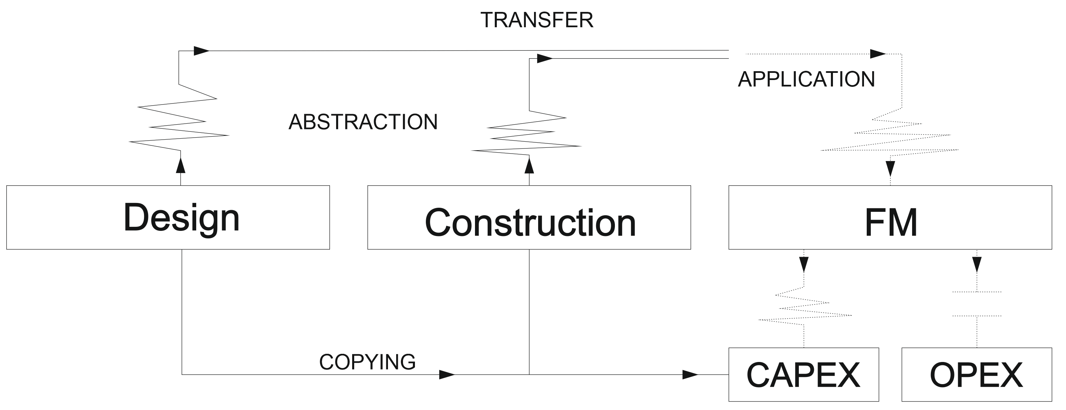

Figure – Transfer of Complex Information through abstraction and application (adapted from Lillrank, 1995).

Indeed, multidisciplinary literacy is a reason why BIM has not been used more in FM and in particular OPEX. The difficulties of transferring BIM from design and construction to FM are, to some extent, related to a general lack of understanding regarding what FM entails. In part, this is caused by the lack of general knowledge relating to the impact that service and building have on each other (Codinhoto et al., 2008; Tzortzopoulos et al, 2009) but also from a lack of general guidance for how FM representatives can contribute during the development of design and construction projects (Codinhoto et al., 2013a).

Academically, the confusion arises from (several) definitions of FM with contrasting meanings (e.g. British Standards Institute (BSI), 2007; Atkin and Brooks, 2009; Bungar, 2012 and Alexander, 2013). Thus the literacy issue is on both sides, i.e. FM teams lacking BIM expertise and design and construction teams lacking specific FM knowledge. Part of the problem is related to the fact that FM definitions do not have a clear scope. In this respect, early discussions by Thomson (1990) and Tay and Ooi (2001) have emphasised how FM definitions place particular emphasis on maintenance and cleaning, sometimes extending the definition to incorporate the provision of support services such as porterage and reception. In a more inclusive manner, Alexander (2013) states that FM concerns the management of quality, value and risk associated with the occupancy of buildings and the delivery of customer services which links asset management and the provision of support services. This view is also shared by Atkin and Brooks (2009) and the British Institute of Facilities Management (BIFM) which sees FM as a “*critical professional and strategic business discipline*”. For Atkin and Brooks (2009) the current view of FM covers a wider range of activities such as financial management, change management, health and safety, contract management and ICT and therefore its processes are related to the strategic, tactical and operational levels of an organisation. Similarly the BSI (2007) defines FM as “*the integration of processes within an organisation to maintain and develop the agreed services which support and improve the effectiveness of its primary activities*” (BSI, 2007). Also part of the spectrum of definitions is the idea of asset management. The BSI (2014) defines asset management as “*involves the balancing of costs, opportunities and risks against the desired performance of assets, to achieve the organizational objectives. The balancing might need to be considered over different timeframes*.” In other words, the asset is not the building but the artefacts within buildings. It is worth mentioning that in certain countries such as the USA, the term Asset Management refers to FM. For clarification purposes, in this article FM refers to the support services and operations that are essential for the successful delivery of core services and operations of a business. As shown in Figure 2, that involves services for maintaining facilities (buildings and surrounding areas) and assets (e.g. furniture and equipment) in an appropriate offering condition (i.e. quantity, quality and location) as well as providing support services (e.g. porterage, security) and operations (e.g. waste collection) that are essential for the core business to succeed.

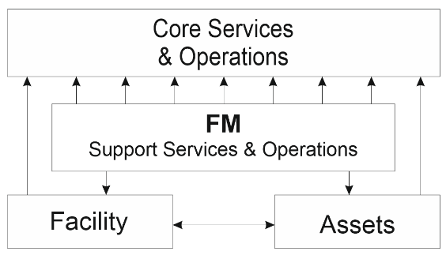

Figure – Conceptual scope of Facilities management

Supporting services refers to the several FM services (Table 1) that are, in general, organised in key priority areas, each having its specific subdivision to facilitate the monitoring of performance indicators and compliance to regulatory standards. In the table below, IT is considered a unit of its own and even though related to FM, it is separated from it and delivered by a specialist team with its own budget and own service level agreements (which in general is a cause of intra-departmental conflict within the organisation – Codinhoto et al., 2013b).

Table : Facilities management services (source: Codinhoto et al., 2013b)



Another issue causing conflict is the fact that FM is often not seen as directly contributing to the core business. As argued by Thomson (1990), facilities management is more than construction, real estate, building operations, maintenance, cleaning and reception. For Thompson, FM is related to business planning - where building design is linked to service design according to business objectives and together they influence organisational strategy development. Planning is at the core of FM (Thomson, 1990; Barrett and Baldry, 2009; Alexander, 2013) and it is its integration into company management strategy that determines whether FM is or is not perceived as adding value to the core business. However, planning and value management are quite often neglected by CEO’s as key FM functions. In general, what is seen is the adoption of piecemeal approaches that are not process orientated but focused instead on small short-term gains rather than long-term rewards. Consequently, facilities managers have difficulties in systematically identifying areas where value can be added. There is little or no integration between FM and corporate thinking (Cairns, 2003; Alexander, 2013).

To date, only piecemeal small data is used but there is substantial unexplored potential for generating Big Data that can support core business activities. As argued by Comlay and Codinhoto (2017) BIM can generate opportunities for organisations to leverage information for service delivery, improving productivity, reliability and the multiple use of profile information. This transformational aspect of digital information modelling implementation for FM operates at department and organisational level, it also has the capacity to be disruptive (Reinhardt & Gurtner, 2015). As digital expertise and the sophistication of data capture and management develops within an organisation, what also develops is the feasibility for the integration of data at various levels within and beyond the organisation. From an organisation’s perspective, that means that they can better identify and manage inefficiencies. That information can also be used for city and regional planning purposes, as well as for supporting the achievement of country and global targets. However, frameworks for the holistic integration of information still do not exist. Standards for Smart Cities are in development (i.e. PAS 180 series) and its adoption is very limited. Even though much progress has been achieved, the limited use of small data settings locally with some exchange across areas is what prevails as depicted in Figure 3. Big Data, where individual information is integrated to form a whole, is to date only a concept.

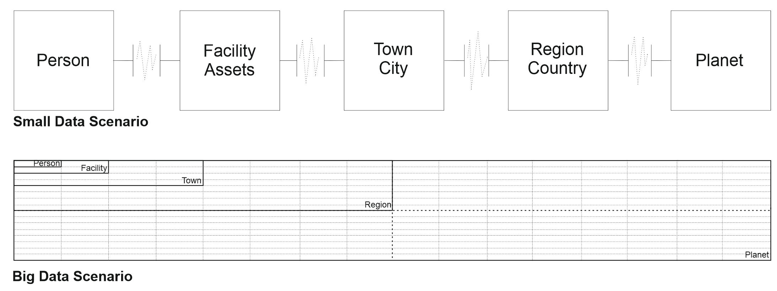

Figure – Fragmented Small Data usage

Indeed, as argued by Codinhoto and Kiviniemi (2014) and Volk et al., (2014) the literature shows that there is very little that has been implemented extensively in FM and even less has been measured in terms of improvements made due to BIM. In addition, for those who have sought to adopted BIM for FM, the level of maturity is low, even though it is higher when compared with those with no BIM FM programme (Figure 4). BIM FM related articles reporting on case studies shows that the application of BIM for FM has been focused on Hard FM (CAPEX) to a great extent and in particular on the accuracy of 3D as-built models (LOD 500) and the link to digital statutory/maintenance/supplier information available through online services. In an inverted fashion, the emphasis is placed on BIM (a solution) rather than on the organisational problems (that BIM can resolve). In other words, it’s a solution looking for a problem, rather than the other way round. Still, there are cases where the correct approach have been taken. One of the best publicly documented examples of successful implementation of BIM in FM is Sydney Opera House (CRC 2007, Linning 2015). BIM did not come from the design and construction process, which regarding the age of the building would of course have been impossible, however the building has subsequently been modelled specifically for FM purposes. This project demonstrates excellently the possibilities of BIM in FM and basically similar data delivery could be implemented in real construction process, although it would require significant changes in the current work processes. Some more recent examples of successful implementation of BIM for FM are presented in Teicholz's book BIM for Facility Managers (2013). Among those are Texas A&M Health Science Center and the School of Cinematic Arts in the University of Southern California. In this respect, several indicators of BIM for FM successful implementation exist. For instance, financial indicators related to estimating costs associated with: operations and maintenance, energy, building functions, real estate, plant, etc; indicators associated with the need for preventive maintenance of fabric, systems, and components; functional indicators related schedule maintenance of building space for operational use (e.g. cleaning schedule), etc.. To a large extent, most of the indicators reported in the literature were obtained through the testimony of managers rather than from an information model (Codinhoto and Kiviniemi, 2014). Among the many projects where the owner and project team have developed the design and construction processes considering the content and value of the FM information, most were clustered in silos focused on CAPEX (Volk et al., 2014).

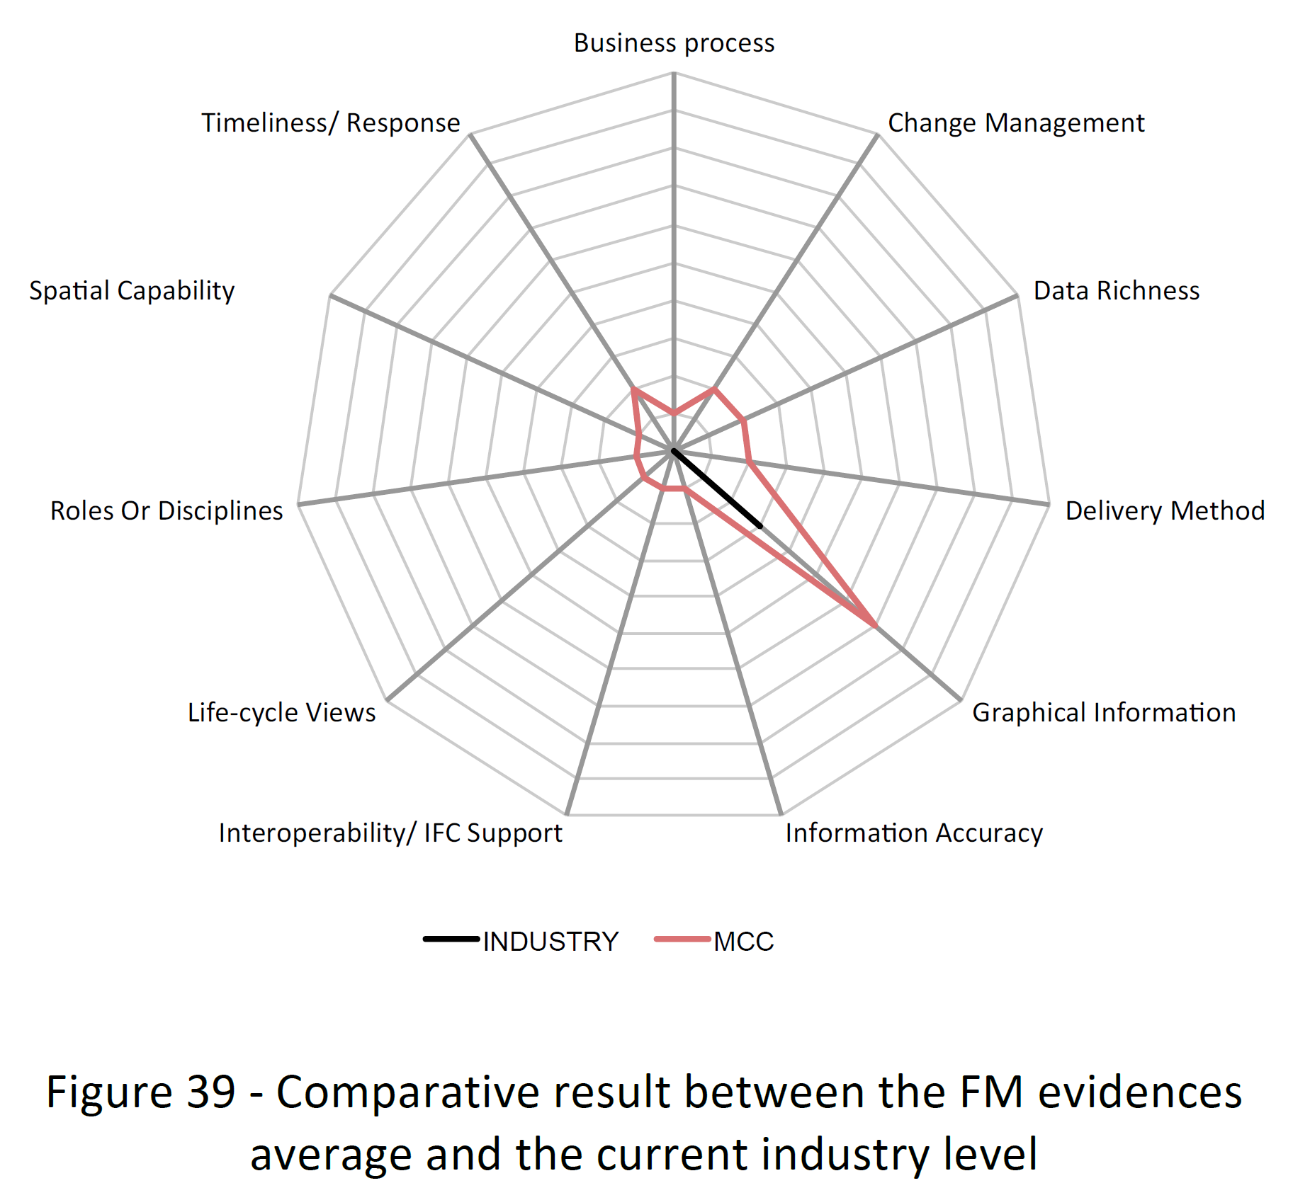

Figure 4 – BIM FM capability maturity level at the Manchester Central Library. Comparative view with the wider sector (Source: Codinhoto et al., 2013a)

With regards to information silos in FM, little movement has been seen towards FM integrated data. Currently, a significant proportion of data used by FM teams is contained in information silos which limits the use profile of data for FM service delivery through a lack of integrated data (Codinhoto & Kiviniemi, 2014; Bilal et al., 2016). For instance, in Table 2 details the data silos both digital and paper that were identified in SRFT. Digital data for the CSD is stored on a dedicated server in an organised file structure. Alchemy is the e-document management system which is not a networked licence and is problematic in terms of installation, reliability and accessibility. These underlying issues affect the use of the digital data available to the team members within the different departments within SRFT. As discussed in Comlay and Codinhoto (2017), more recent approaches that deliver a sustainable model continue to value data that is delivered through the multiple reuse of data for different purposes, regardless of the primary motivation for the collection of the data (Batra, 2014). The search for more integration suggests organisations will become increasingly agile and responsive to market trends that are relevant to the organisation. For instance, debates around circular economy (e.g. Cruz et al., 2015; ARUP, 2016) indicate that information requirements for physical assets are becoming even more significant and increasing in volume due to organisations endeavouring to demonstrate they have met global strategies for carbon reduction, budget constraints, economic turmoil and instability. In addition, governmental bodies and taxpayers are more likely to require organisational accountability for environmental performance of OPEX activities (Crown, 2013). Despite BIM standards and demonstration studies being available, change is slow for BIM FM implementation and while there is engagement in the debate by FM teams, the status quo continues with isolated pots of data (Bilal et al., 2016). In the UK, the 2011 BIM Mandate did not count with the participation of FM providers and while Government Soft Landings (GSL) and COBie addressed the issues of data exchange between BIM for design and construction and an asset information model (AIM), there is no government (client) push. The improvement of FM service delivery through the integration of data silos and a platform for integrated digital data is currently expected to only be delivered if a business need is identified.

Table 2 – Information assets and silos (Source: Comlay, 2015).

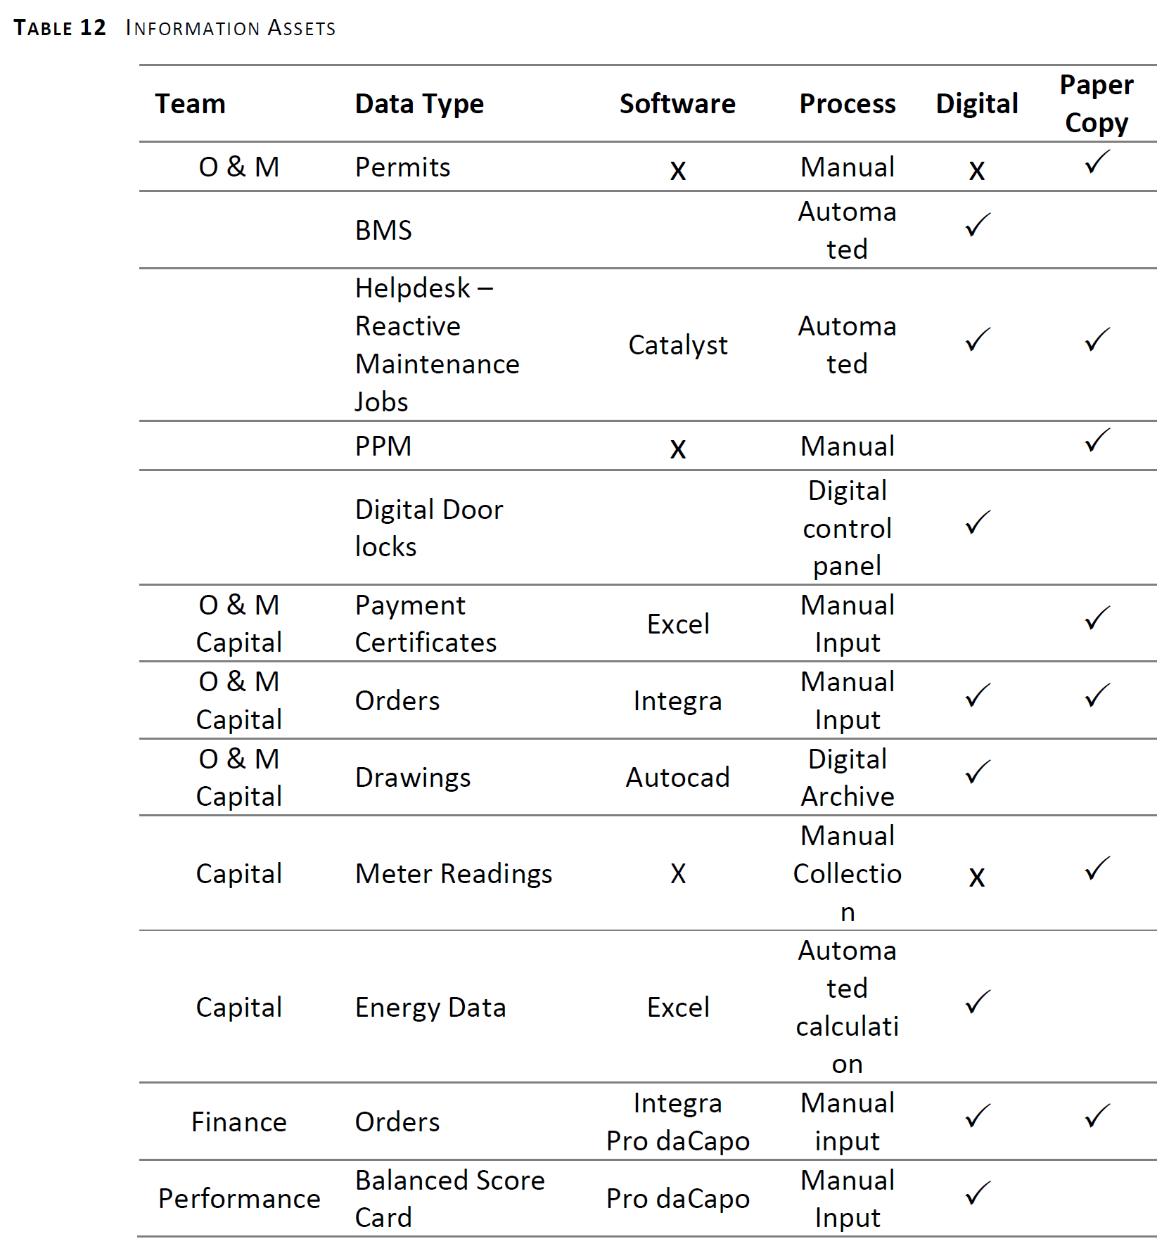

Although BIM promises to generate benefits and overcome problems in the management of buildings that can affect the core business (Becerik-Gerber et al., 2012; Arayici et al., (2012); Liu & Issa, 2015; Nicał & Wodyński, 2016), the obstacles to its adoption are significant and challenging (BIS, 2011). Authors such as Bernstein and Pittman (2004), Kiviniemi et al. (2008), Forns-Samso et al. (2011) and Wang et al., (2013) have discussed a series of key obstacles to BIM implementation that require further attention. These include legal issues, business-related issues, people and technical issues, and developments to resolve these issues have not evolved since early publications.

For Kiviniemi et al. (2008), the legal issues of using data, including the lack of adoption of e-procurement routes (Grilo and Jardim-Goncalves, 2011) and undefined responsibilities of data content in the models and the legal status of these models compared to other documents, has yet to be addressed in FM contexts. Very little exists for design and construction, but even less is available for FM that would give facilities managers confidence when implementing BIM. This issue is reflected when considering the lack of FM information needs that are generally available at early stages of design of new buildings (Liu & Issa, 2013) where stakeholder engagement would unlock significant potential for reduced lifecycle costs (Wang et al., 2013). Moreover, the use of BIM for FM is not sufficiently integrated within existing FM IT systems. According to Ammari & Hammad (2014), Yalcinkaya & Singh, (2014) and Motamedi, Hammad, & Asen (2014) this is related to the current focus of existing FM information systems on work orders and asset inventory. Data entry necessary for FM purposes is presently undertaken manually, rather than through sensors or other automated data collection methods.

With regard to business, decisions that resolve business challenges such as the allocation of roles, responsibilities and rewards that apply to the different stakeholders are still a barrier. The great majority of FM providers have not experienced using BIM and there is a lack of clarity regarding the impact BIM would have on current roles and responsibilities. Thus, there is a need for well-defined transactional business process models to ease the flow of information and connect processes. Changes in business processes and business relationships are necessary for benefiting from BIM (Bernstein and Pittman, 2004; Konukcu, & Koseoglu, 2012; Liu et al., 2013; Deshpande, Azhar, & Amireddy, 2014, Zou, Jones, & Kiviniemi, 2015). These changes are effected within an organisation, but also beyond that, achieved through the integration of information from the supply chain as exemplified by Jalaei & Jrade (2014). The benefits of using data analytics, as demonstrated by Barton and Court (2012) and Liu (2015) can deliver productivity gains of approximately 5% and budget savings of 6%.

Additionally, there are issues relating to how people work in the BIM implementation environment. For instance, issues related to people’s fear and resistance to change and to potential changes to roles within the organisation. In the context of increasingly constrained budgets, change is perceived as “more work to do”, even though BIM may create opportunities for doing the same work in a more efficient manner, i.e. “to do less work”, but that is not seen by facilities managers. Yan and Damian (2008), Forns-Samso et al. (2011) and Kassem, et al., (2015) found that an unwillingness to change processes; and the allocation of time and human resources to the training process, are major obstacles to the adoption of BIM.

Finally, there are technical problems that relate to software, particularly in terms of data exchange and interoperability; which are still problematic (Bernstein and Pittman, 2004; Yan and Damian, 2008). Technical issues are, by far, the most explored subject in BIM literature and a common theme in design, construction and FM. Authors such as Steel, Drogemuller and Toth (2012) and Stapleton et al., (2014) agree that interoperability issues must be addressed prior to digitalisation. Robust solutions to the problem of data exchange do not exist, Hallberg & Tarandi, (2011) and many others suggest that the standardisation of IFC will aid the adoption of a maintenance strategy within FM process by controlling the build-up of information, making it more efficient than a traditional database. In this respect, some progress has been made and reported through the use of cloud solutions (Forns-Samso et al., 2011; Redmond, Hore, Alshawi, & West, 2012; Juan & Zheng, 2014). Similarly, in the UK, the government recommendation has been the use of COBie (Cabinet Office, 2012).[1].

The implementation of BIM is a complex process that can end in financial losses if not managed properly. The change from traditional non-intelligent data to BIM-based intelligent information systems impacts in many areas within an organisation. Early works such as Jung and Gibson (1999) and Jung and Joo (2011) are still relevant in discussing key areas impacted by this change. For these authors, there are 3 main areas of concern: BIM technology (property, relation, standards and utilisation), BIM perspective (project, organisation and industry) and Construction Business Function (e.g. planning, design, estimating, scheduling, etc.). Knowledge management, thus, becomes essential for managing corporate knowledge, and failing to capture knowledge from BIM models results in significant costs and risks, therefore more focus must be placed on knowledge modelling (Konukcu, & Koseoglu, 2012; Motawa & Almarshad, 2013; Liu et al., 2013; Deshpande, Azhar, & Amireddy, 2014, Zou, Jones, & Kiviniemi, 2015 and Mignard & Nicolle, 2015; Donato, 2017).

In this respect, as in any business organisation, the clear identification of the need and the resulting impact of every implementation process should be measured to promote learning. Thus, the first step in the implementation of BIM is the identification of the current problems that the organisation that may be improved with the use of BIM and how much improvement can be achieved (e.g. reduction of maintenance delays, reduced time to assess information, etc.) through the implementation (Codinhoto et al., 2011). The decision to implement should not be based simply on a short-term cost-benefit analysis as, from a business perspective, investments made by an organisation can result in improvements that are necessary for maintaining the organisation’s competitiveness. However, as argued by Comlay and Codinhoto (2017) data digitalisation can only be justified if the benefits from it are robust (Bilal et al., 2016). Isolated digitalisation is not the solution, but an integrated approach to improve process and workflows, increasing transparency in the data, and accessibility to the data, deliver a platform to use analytics as a predictor of the future (Bilal et al., 2016). Data analytics can support the development of strategies to future-proof organisations (Wamba et al., 2017). However, Giel et al. (2015) argues that owners are overwhelmed by the change management required.

Adding to the problem is the fact that clients’ information needs are not known by contractors who often ask in the preparation of EIRs “what information do you need?”, but also by clients who respond “What information can you give me?” The lack of definition by clients of the information, documentation and deliverables required throughout design and construction and handover are problematic (Beck, 2012; Cotts, Roper, & Payant, 2010). This is as a result of the multiplicity of choices, the complexity of processes, BIM guides and BIM standards together with the data use profiles of multiple users (Giel, et al., 2015), and the lack of specificity for FM within all these resources. Giel et al. (2015) outline a pragmatic model for transitioning to a digital landscape through the connection of digital information, not necessarily requiring highly developed geometric modelling expertise from the outset. An additional constraint concerns construction supply chain, which are not very experienced in delivering digital information modelling for FM but are regarded as the primary change agents to develop the expertise of clients accessing the construction market (CIC, 2014). Giel et al. (2015) with a limited survey indicates that 47% of client respondents do not have their BIM information requirements in place for FM. There are good examples of developing FM practice, in Manchester Town Hall the BIM FM implementation was driven by the client. The FM team as client at the Manchester Library Project, sought BIM education and experienced the difficulties of changing the status quo at a time when the benefits of BIM for FM were unknown and unproven. This demonstrates the importance of internal BIM champions able to drive change and validate the benefits of implementation (Comlay and Codinhoto, 2017).

Performance of information management within FM can be enhanced by taking a ‘lean’ perspective. For instance, Jylhä and Suvanto (2015) identified that improvements to the quality of information for FM service delivery minimises the additional time required for data validation and reliability checks. Missing data as a result of data atrophy and omitted data, is reduced while productivity is increased. Problem solving is achieved in a shorter timescale because data is transparent, visible and easily available, as demonstrated in ‘Lessons-learned’ within the BIM task group website. Ventilation motor replacement was reduced from 4 weeks and 14 work hours to 1 day and 3 work hours, in turn reducing costs by £286 and disruption by 27 days. This gains observed in the MTHCP can be achieved even in a situation where the level of BIM maturity of the FM team is not high. Figure 5 shows the level of capability maturity of the FM team whose achieved the presented financial gains above and it is evidence that implementation of digital information modelling and geometric modelling within an FM environment will lead to value creation, as also stated by Jylhä & Suvanto, (2015).

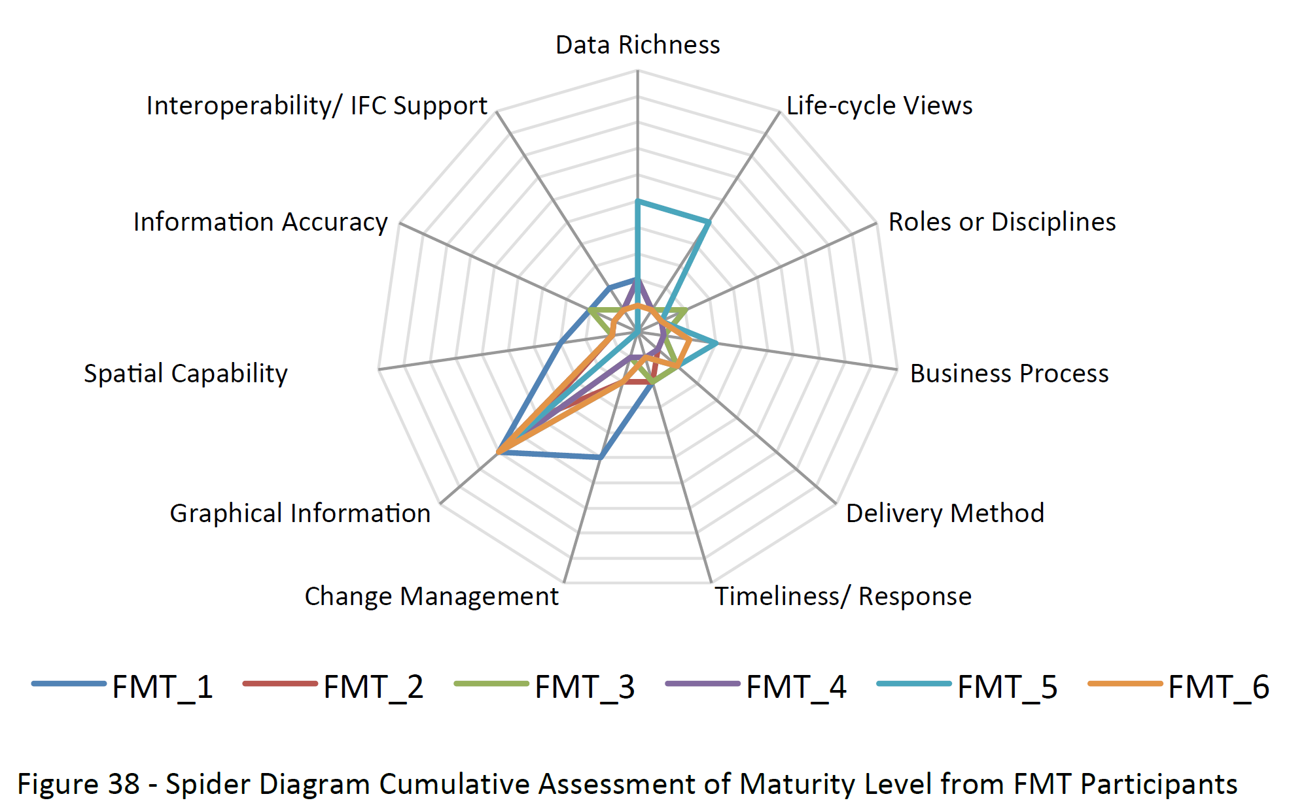

Figure 5 – Capability maturity assessment of facilities managers at MTHCP (Source: Codinhoto et al., 2013a)

Yes, there are benefits, there are gains, but where do we draw a line for what information should and shouldn’t be modelled? As argued by Lucas (1999), initiatives such as Cloud technology and Internet of things (IoT) have unlocked a colossal unprecedented potential for data connectivity, thus making the data stream in FM extremely large and complex. Figure 6 shows an example from MTHCP where all documentation from facility and assets where stored in a cloud repository and linked to the 3D model through a standardised nomenclature. Consequently, the transition to digitised data for FM adds to the intricacy of the working environment and the potential for data overload (Irizarry, Gheisari, Williams, & Walker, 2013). Considering that the digitalisation of building complexes is happening in stages as building stocks are renovated, that means that FM teams are managing two information platforms in parallel, a set of historic text and 2D drawings together with a digital based information platform received from recent CAPEX BIM projects. In general, this is an inefficient process (Irizarry et al., 2013) as isolated database queries and spreadsheets are challenging tools to use for delivering insight and identifying patterns in collected data (Berinato, 2016).

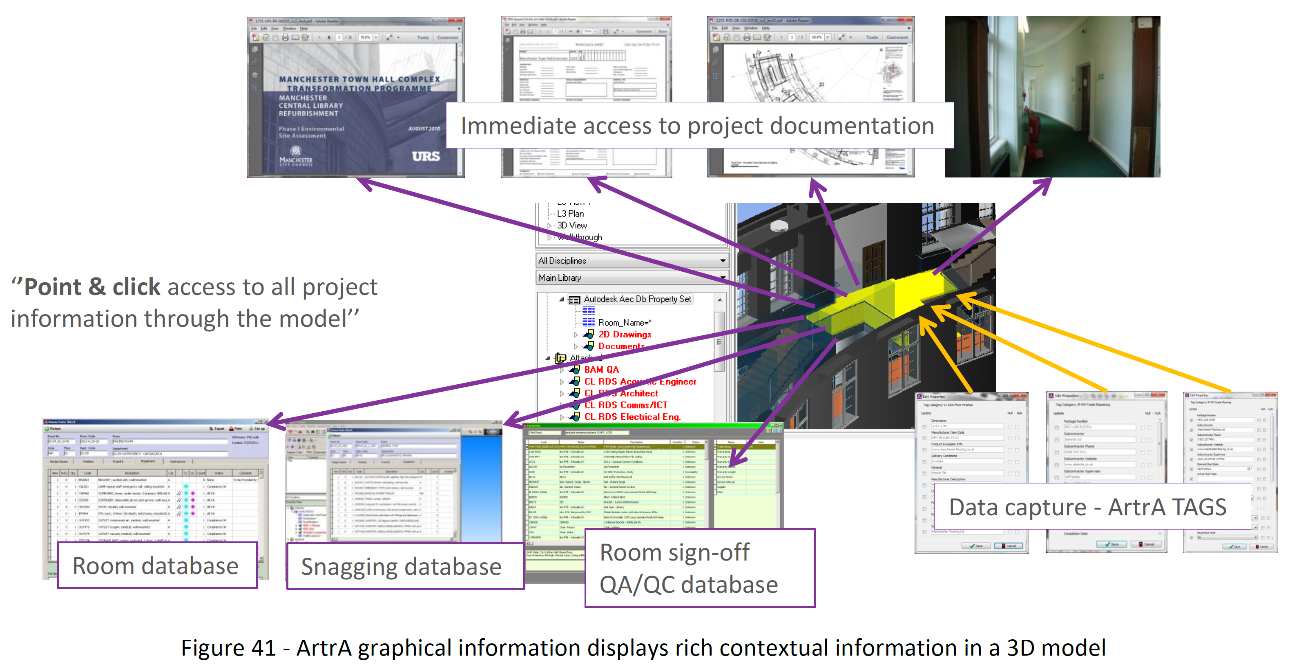

Figure – Graphical information display linking 3D model and relevant building documentation store in cloud (Source: Codinhoto et al., 2011)

While the problem is understood, the solution for integration of legacy estate FM information within a digital information modelling platform is under developed worldwide, despite the application of digital information modelling processes, work flows, information sharing and technology for existing built assets, having the potential to create added value for organisations (Crown, 2013). In Figure 7, for instance, a model of waste movement was created for the UoB to support waste management. The model was built from a 3D model but uses a different approach (graph theory) to map flows. As suggested by Giel et al. (2015), the key benefits of digitalised information are in the potential for: asset management, building systems analysis, ease of transfer of data to computerized maintenance management system [CMMS], space management and control, scheduling of maintenance, GPS/GIS integration, disaster planning etc. This view is confirmed by the Ministry of Justice (UK) and Sydney Opera House which continue to develop and publicise strategies to transition and operate digitally modelled information for FM with reported gains of accessibility to information, resource utilisation and increased productivity (Linning, 2015).

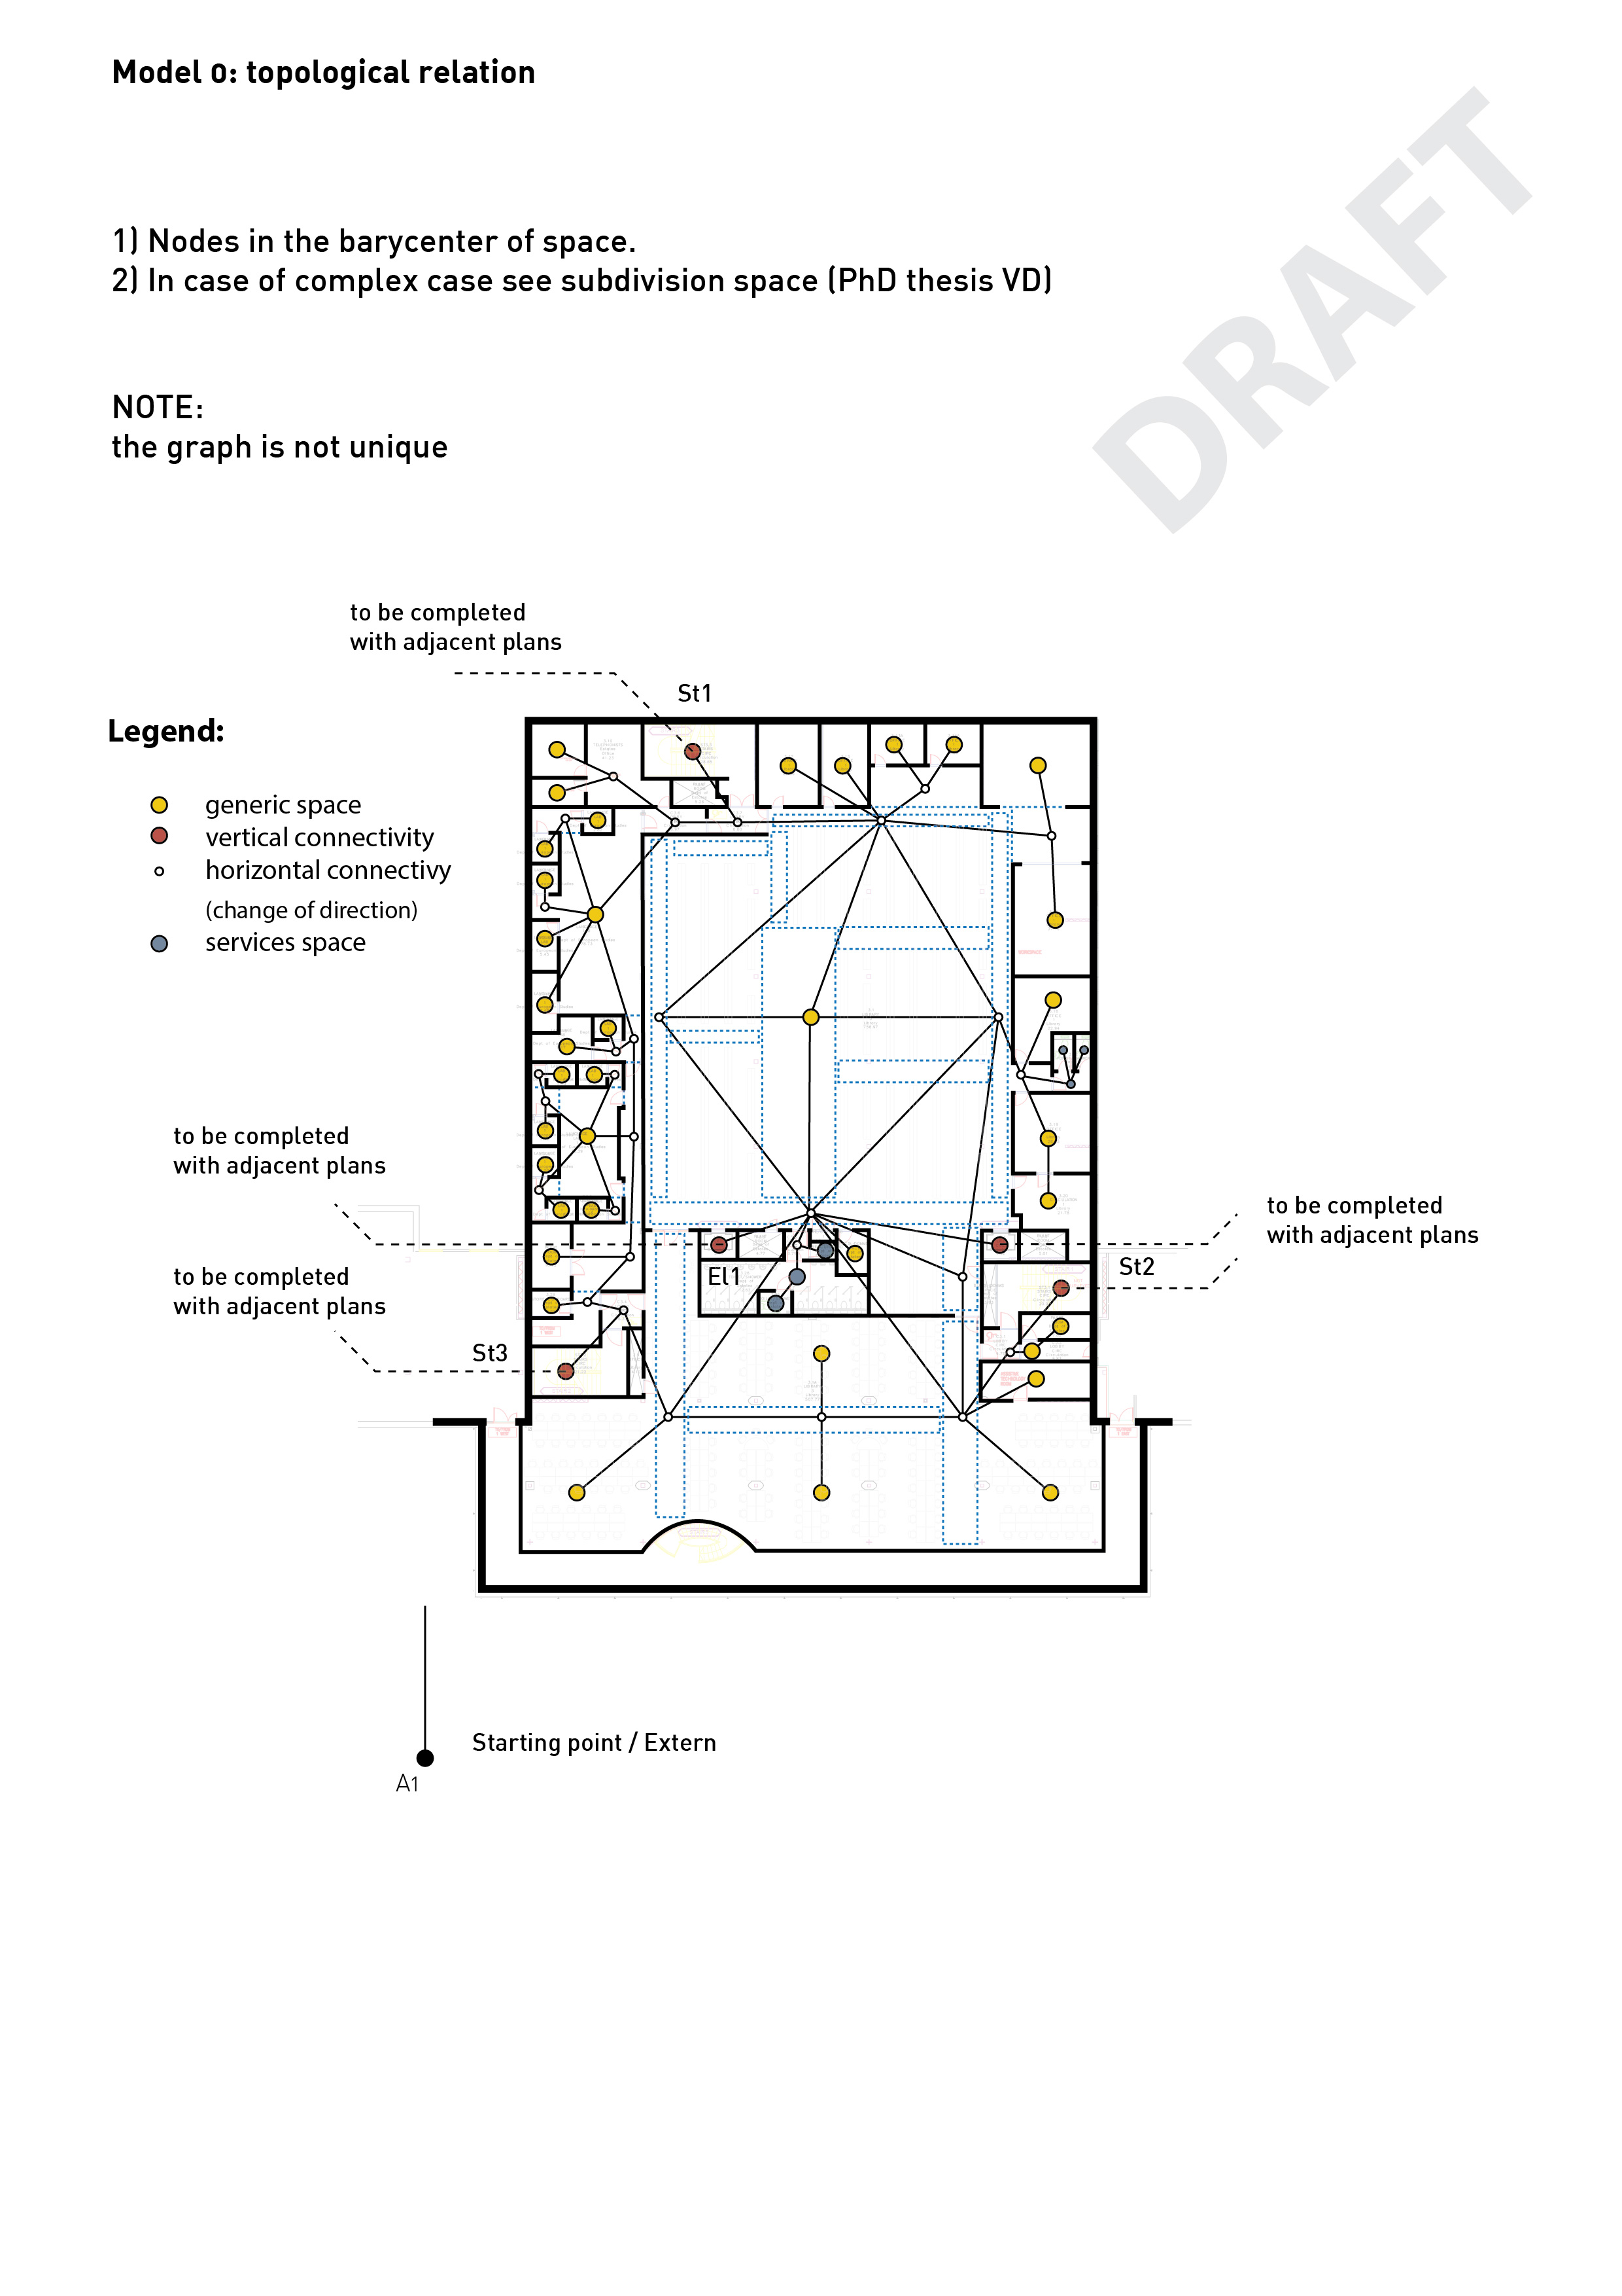

Figure – UoB library: graph theory model for waste movement

Paradoxically, the management of information requirements and their data demands, adds a layer of complexity to O&M service delivery that is generally unquantifiable. However, it is known that successful implementation which is focussed on how to capture and use data; and is appropriate to the organisation, assists with improved decision-making and achieves an increasingly flexible team, able to respond to changing organisational requirements (Barton & Court, 2012). Refining the resolution of the granularity of information required, to map data requirements for digitalised information requirements of organisations, necessitates a data audit of the existing situation to understand the inefficiencies and identify the development needs.

The data collection needs identified should be sufficient to deliver FM, not just a catchall of JIC [just in case] information, also known as ‘data bloat’. High information granularity is as bad as low granularity. In instances of lack of knowledge around digital data there is a tendency to request everything, a ‘low granularity’ of data, which presents significant storage issues and incurred costs and does not address the issues facing FM (Bilal et al., 2016). Individually designed professional BIM models represent on average 100Mb of data, a single construction project with the potential range in models, visualisations, analytical models, AIM model and data, has significant data storage and maintenance needs. The granularity of data, resolved as the quantification of how much fine data is required (low granularity) and strategic level data (high granularity) presents significant cost implications (Comlay and Codinhoto, 2017).

Furthermore, to be effective, exchangeable and useful, data formats have to be standardised. Worldwide, various classification systems exist that respond to the need for a structured way to organise information so it can be seamlessly exchanged. For instance, local standardisation initiatives have developed in the United Kingdom (e.g. COBie and Uniclass 2015), the United States (e.g. Masterformat and Omniclass), Finland (e.g. Talo 2000), Denmark (e.g. Cuneco), Japan (JCCS), Brazil (e.g. NBR 15965-1), Australia (e.g. Natspec), Portugal (e.g. ProNIC – Salvado et al., 2016), etc.. In fact, many of these relatively successful approaches have only achieved limited adoption (Biscaya, 2013; RIBA, 2017) and as IT systems become more sophisticated and complex, the need to find more robust and effective ways of exchanging information is constant.

Several ‘new’ improved systems have been developed within the European context (such as the ISO 12006-3:2007; ISO 16739:2013 and ISO 29481-2:2012). Amongst prominent solutions already implemented or in early stages of its implementation are OmniClass (Ominiclass, 2011), Uniclass 2015 (RIBA, 2017) and ISO 12006-2: 2015 which maps into other classification systems. These systems comprehensively identify classes for the organization of information, indicate their relationship and enable cross-referencing with other systems. Information types include: geometrical, functional, technical and cost data as well as maintenance data. These systems have contributed considerably to the improvement of information structuring and exchange in recent past (Mêda et a., 2017) and the challenge is to keep them effective in the face of increased complexity.

As dicussed by Comlay and Codinhoto (2017) BIM Standards such as ISO/TS 12911:2012, ISO 29481-1:2010, BSi PAS1192:3, etc., aim to achieve the quality, validity and reliability of data and information; this approach to standardisation reduces variability, atrophy, replication and redundancy in the data (Corrocher, 2013). Standards reduce technical uncertainty and complexity and result from innovation and knowledge sharing between an extensive range of experts and specialists (Corrocher, 2013). Compliance with BIM standards has seen the commensurate development of the IFC standard to deliver interoperability for BIM tools. However, the IFC standard is under constant revision to meet the needs of the industry, which has affected the information requirements of clients where all file types are required, due, in part to a lack of confidence in IFC data (Giel et al., 2015). The use of standards in the digital construction platform ensures consistent information is issued and released in appropriate formats, achieving good levels of efficiency for information exchange and compatibility (Giel et al., 2015). Roles and responsibilities require clear definition together with key deliverables and processes for managing the quality and timing of data exchanges (Biddle et al., 2012).

BIM standards and guidelines currently available apply in the main to new build CAPEX projects. PAS 1192-3: 2016 and BS 8536-1-2015 are specifically for facilities management, however, legacy estate is not explicit within these standards. BS EN 19650-2 and BS EN 19650- 2, are international standards under development, due Spring 2018 that will also be relevant to facilities management (BSI, 2017). These proposed ISO standards engage with BIM for the whole life cycle of a built asset and may be applied irrespective of procurement strategy, organisation typology and size, however, the standards are aimed at CAPEX projects i.e. refurbishment and do not address digital data for an existing built environment. Currently the standards are acting as an enabler and as an ‘… engine of innovation’, primarily for design, construction and refurbishment. The current standards are unbalanced at present, as they do not engage with legacy estate (Corrocher, 2013). Unfortunately there remains no framework for ‘how’ large client/owners can migrate their legacy estate to a BIM platform.

In addition, a series of standards for smart cities (PAS 180, PAS 181, PAS 182, PAS 183, PAS 184, PAS 185, PD 8100:2015 and PD 8101:2014) is emerging in parallel. In this respect, it is expected that smart cities will have a certain amount of data that is the result of a compilation of data from individuals and buildings. In other words, there are overlaps between building and city data sets and the current lack of adoption of standards at building level will create difficulties for the creation of smart cities platforms.

For clients to achieve the level of information required by the FM team to operate and maintain their buildings, the information requirements of the client should be sufficiently detailed to receive useful information from the supply chain that meets the current state and the projected future state and meet BS 8536:2015 - FM briefing for design & construction. Overall, FM teams are engaging with the highly complex paradigm of digital information modelling, with all its intricacies without the support of fully developed guidance, standards and templates that will assist in an easier transition to a digitalised landscape.

Information structuring and exchange in construction has been a constant challenge. Despite much progress being made, a unified classification system still does not exist, due several reasons including inherent cultural differences informing the generation of (unrelated) taxonomies. While an agreed classification does not exist, software providers use their own approaches for the classification of information, thus causing problems of integration (Laakso and Kiviniemi, 2012; Monteiro et al., 2014). This means that client organisations face the paradox of receiving information from best of breed solutions used by designers and contractors when standardised solutions are better for data use. Best of breed software performs specialized functions better than an integrated system, however each is limited by its specialty area, with cross connectivity and integration challenges and unique data structures.

# Key issues to be addressed for expanding BIM FM adoption

In light of the discussion presented here, various issues are highlighted below that require addressing if BIM FM is to be adopted at a level where it makes a significant environmental and economic contribution to organisations, cities and society.

Firstly, the issue of literacy must be addressed. There is evidence of FM literacy issues by designers and contractors. In this respect, the early involvement of FM representatives in the design process helps minimise issues, however, FM services design is never clear throughout the design process as focus is placed on core services offered by the client. In addition, the analysis of EIRs and BEPs shows that the templates for capturing data requirements have been developed by designers and contractors, so while useful during the design and construction phases they do not capture the necessary information for hard and soft FM purposes. What aggravates the problem of communication between parties is the fact that there are also BIM literacy issues amongst facilities managers. In this respect, to say that there are BIM literacy issues amongst facilities managers is not to say that Facilities Management has not been digitalised. The adoption of BIM FM has been increasing since 2011, but the pace is too slow and with limited emphasis to CAPEX. While literacy remains an issue, facilities managers will still be requesting COBie from a ‘just in case’ perspective without benefiting from using the information given through it.

Secondly, there is an assumption amongst FM providers that their current level of BIM FM capability and maturity is very low. In all assessments of maturity carried out by the authors, the self-evaluation done by facilities managers proved worse than that carried out by the independent research team. Partially this problem is related to the strong association that FM providers make between BIM and 3D models. To some extent, that association is pertinent as CAPEX in particular can be facilitated by information that is built in digital 3D objects. However, that is not the only source of information, as data for FM purposes can come from various sources such as spreadsheets, documents and databases. Thus, even though much of the effort related to BIM implementation has been placed on hard FM (maintenance of building fabric, statutory, planned and reactive maintenance alongside environmental control) and much less has been done for soft FM services such as waste management, security, building resilience, etc. The potential for its full adoption is latent and depends on skills for information modelling, i.e. connecting disconnected pieces of information sets using the native format they are generated in.

Thirdly, because the potential for BIM FM has not been exploited, the utilisation of meaningful POE for organisations’ benefit is patchy, at best. The mentality that POEs are a burden still remains. Managers perceive that conducting POEs can create expectations amongst building users that existing problems will be resolved. In general that is never the case, as interventions require funding that is usually not available. In addition, it also reveals that POEs are perceived as a one-off event rather than a continuous monitoring activity. As a consequence, opportunities for capturing detailed service design processes are missed and consequent communication with designers and contractors in the advent of new CAPEX projects suffers. In addition, while BIM FM of new or refurbishment projects have experienced some level of BIM implementation, there has been no push for modelling the existing building stock. There is a lack of strategy for how digital information from new buildings will be managed with existing analogue information of existing buildings in multi-site complexes such as hospitals, universities, industrial complexes, etc.

Fourth, is the issue of guidance, which has been developed through the creation of standards. However, these have been created with a focus on different levels of data analysis and further integration is needed. As an example from the UK, PAS 1192:2 and PAS 1192:3 the level of data analysis is “building” whereas the PAS 180 series focus on cities. Studies looking at Big Data are, in general, embryonic and the lack of an agreed framework and strategic thinking for content and data format means that more work should be expected. For that reason, some may be put off and prefer to wait until a data structure is more definitive, hindering the adoption of standards.

Fifth, is the lack of BIM FM research buy-in. BIM FM research, to a great extent, falls within applied research. As such, it requires the participation of organisations through the provision of access to data. However, there is an inertia in the sector to buy into the idea of BIM FM research. Huge financial pressures placed on FM means that teams have been reduced to bare minimums and the operation of facilities is done at full capacity, on a fire-fighting approach. FM teams are reactive to managing their service delivery model and are managing significant levels of backlog maintenance that requires additional funding outside of the FM budget. In addition, 3rd party FM contractors are in high demand due to limited availability of FM speciality firms and are choosing to ignore implementing BIM for FM. The large demand from clients and shortage of contractors empowers 3rd parties. Because demand is high, many prefer to release the contract rather than upskill their own organisation. This therefore, makes it difficult for clients to specify BIM for FM as FM contractors are refusing to comply.

Finally, and more importantly, there is a need for a BIM FM mandate. Mirroring the UK 2011 mandate, a general mobilisation of BIM FM efforts has to happen. Governments must act as client and regulator as no links or umbrella organisations exists for FM and there are no means by which buildings with different functions such as health, education, retail, leisure, housing, etc., from public or private organisations can be reached, if not by means of contracts and tax incentives and penalties. Some may feel discouraged at the enormity of the task before them. It will demand a strategy for upskilling the FM task force. It will require coordination so that a framework for data generation at various levels is agreed. It will require collaboration amongst researchers, practitioners and users so that change can take place and standards are fully adopted. It will take time for adaptation and adjustment but the environment and society cannot continue to pay for avoidable built in inefficiencies in the way we utilise buildings.

# References

Alexander, K. (Ed.). (2013). Facilities management: theory and practice. Routledge.

Ammari, K. E., & Hammad, A. (2014). Collaborative BIM-based markerless mixed reality framework for facilities maintenance. In Computing in Civil and Building Engineering - Proceedings of the 2014 International Conference on Computing in Civil and Building Engineering (pp. 657–664). https://doi.org/10.1061/9780784413616.082

Arayici, Y., Onyenobi, T. C., & Egbu, C. O. (2012). Building information modelling (BIM) for facilities management (FM): The MediaCity case study approach. International Journal of 3D Information Modelling , 1 (1), 55-73.

ARUP. (2016). The Circular Economy in the Built Environment. Retrieved from <http://publications.arup.com/publications/c/circular_economy_in_the_built_environment>

Atkin, B. and Brooks, A. (2009), Total Facilities Management, Facilities, Oxford: Wiley-Blackwell, 3rd ed., Vol. 12.

Ballesty S., Morris J., Ding L., Drogemuller R., Mitchell J., Schevers H., Leifer D., Schwede D., Wu J., Henriksen J., Akhurst A. and Spink G. (2006). An Integrated Collaborative Approach for FM – Sydney Opera House FM Exemplar, Clients Driving Innovation: Moving Ideas into Practice, Gold Coast, Australia;

Barrett, P., & Baldry, D. (2009). Facilities management: Towards best practice. John Wiley & Sons.

Barton, D., & Court, D. (2012). Making Advanced Analytics Work For You. Harvard Business Review, 90(10), 78-83.

Batra, S. (2014). Big data analytics and its reflections on DIKW hierarchy. Review of Management, 4(1), 5-17.

Becerik-Gerber, B., Jazizadeh, F., Li, N., & Calis, G. (2012). Application Areas and Data Requirements for BIM-Enabled Facilities Management. Journal of Construction Engineering and Management, 138(May), 431–442. <https://doi.org/10.1061/(ASCE)CO.1943-7862.0000433>

Beck, K. (2012). The state of Wisconsin: BIM – digital FM handover pilot projects. Journal of Building Information Modeling(Spring 2012), 22-23.

Berinato, S. (2016). Visualizations that really work. Harvard Business Review, 2016(June), <xocs:firstpage xmlns:xocs=""/>.

Bernstein, P. G., & Pittman, J. H. (2004). Barriers to the adoption of building information modeling in the building industry. Autodesk building solutions.

Biddle, B., Curci, F. X., Haslach, T. F., Marchant, G. E., Askland, A., & Gaudet, L. (2012). The expanding role and importance of standards in the information and communications technology industry. Jurimetrics, 177-208.

Bilal, M., Oyedele, L. O., Qadir, J., Munir, K., Ajayi, S. O., Akinade, O. O., . Pasha, M. (2016). Big Data in the construction industry: A review of present status, opportunities, and future trends. Advanced Engineering Informatics, 30(3), 500-521. doi:10.1016/j.aei.2016.07.001

Biscaya, S.,(2013). Coordination and Management of Information for Construction Design Projects – A Framework for Portugal, Doctoral Thesis, at http://usir.salford.ac.uk/29281/, University of Salford, Manchester, UK

BSI (2007), Facility Management - Part 1: Terms and definitions: BS EN 15221-1:2006, London: BSI Standards Publication, 19pp, Vol. 44.

BIS (2011) A report for the Government Con- struction Client Group Building Information Modelling (BIM) Working Party Strategy Paper (Retrieved from: http://www.bimtaskgroup.org/wp-content/uploads/2012/03/BIS-BIM-strategy-Report.pdf)

BSI (2014). Asset management. Overview, principles and terminology: BS ISO 55000:2014.

Bungar, S. (2012), Facilities Management-UK Overview, Facilities Management, London, pp. 1–7.

Cabinet Office. (2012). The Government Soft Landings Policy. Retrieved from BIM task group website: http://www.bimtaskgroup.org/gsl-policy-2

Cairns, G. (2003), “Seeking a facilities management philosophy for the changing workplace,” Facilities, Vol. 21 No. 5/6, pp. 95–105. doi:10.1108/02632770310476705

CIC - Construction Industry Council (2014) Built Environment 2050: A Report on our Digital Future. BIM 2050. Available at: <https://www.google.co.uk/url?sa=t&rct=j&q=&esrc=s&source=web&cd=1&cad=rja&uact=8&ved=0ahUKEwjbyszd8pDYAhWpLcAKHckiBJgQFggpMAA&url=http%3A%2F%2Fcic.org.uk%2Fdownload.php%3Ff%3Dbe2050-cic-bim2050-2014-1.pdf&usg=AOvVaw3FocdkM1OqsWG9LLuznY2M> , Accessed: December 2017).

Codinhoto, R., Kiviniemi, A., Kemmer, S., & da Rocha, C. G. (2013a). BIM-FM implementation: an exploratory invesigation. International Journal of 3-D Information Modeling (IJ3DIM), 2(2), 1-15.

Codinhoto, R., Tzortzopoulos, P., Rooke, J., Kagioglou, M., & Koskela, L. (2008). Facilitators and barriers to the integration of healthcare service and building design.

Codinhoto, R; Kiviniemi, A; Kemmer, S. and Da Rocha, C.G. (2011) BIM Implementation: Manchester Town Hall Complex. SCRI Report Series 6. Available at: http://live.scri.salford.ac.uk/wp-content/uploads/2011/12/MCC_Final_Research_Report.pdf.

Codinhoto, R; Kiviniemi, A; Kemmer, S; Martin, E; Donato, V; and Tonso, L. (2013b) BIM FM at the Manchester Town Hall Complex: A Case Study Investigation. Research Report. The University of Salford.

Comlay, J. (2015) Facilities Management (FM) Organisational Transformation: Building Information Modelling (BIM) is the Proposition. MSc dissertation. The University of Salford.

Comlay, J., and Codinhoto, R. (2017) Facilities Management: Granularity of Information for a Digital Information Platform. In proceedings of the International Conference on Sustainable Futures (ICSF) Bahrain 2017.

Corrocher, N. (2013). The Development of Short Message Services: Standard Organizations as Engines of Innovations. Revue Economique, 64(1), 149-163.

Cotts, D., Roper, K., & Payant, R. (2010). The facility management handbook. (3rd ed.). New York, N.Y.: American Management Association.

Cracknell, D. (2012) Sector BIM strategy: Improving BIM education & training. The Higher Education Academy. Available at <http://www.heacademy.ac.uk/assets/documents/disciplines/built_environment/BIM/BIM_Skills_CIC_David_Cracknell.pdf> (Accessed December 2017)

Cragun, D., Pal, T., Vadaparampil, S. T., Baldwin, J., Hampel, H., & DeBate, R. D. (2015). Qualitative Comparative Analysis. Journal of Mixed Methods Research, 10(3), 251-272. doi:10.1177/1558689815572023

CRC Construction Innovation (2007) Adopting BIM for Facilities Management: Solutions for Managing the Sydney Opera House, Cooperative Research Center for Construction Innovation, Brisbane, Australia

Crown. (2013). Construction 2025. (URN BIS/13/955). London: HMSO.

Cruz, F., Chong, W. K., & Grau, D. (2015). Design for Disassembly and Deconstruction - Challenges and Opportunities. Procedia Engineering, 118, 1296–1304. <https://doi.org/10.1016/j.proeng.2015.08.485>

Deshpande, A., Azhar, S., & Amireddy, S. (2014). A framework for a BIM-based knowledge management system. Procedia Engineering, 85, 113–122. <https://doi.org/10.1016/j.proeng.2014.10.535>

Donato, V. (2017). Towards design process validation integrating graph theory into BIM. Architectural Engineering and Design Management, 13(1), 22-38.

European Commission (2017) Energy Efficiency: Buildings [online] available at <https://ec.europa.eu/energy/en/topics/energy-efficiency/buildings>

Forns-Samso, F., Bogus, S. M., & Migliaccio, G. C. (2011). Use of Building Information Modeling (BIM) in Facilities Management. Paper presented at the 3rd International/9th Construction Speciality Conference, Ottawa, Ontario, Canada.

Giel, B. K., Mayo, G., & Issa, R. R. A. (2015). BIM Use and Requirements Among Building Owners. In R. R. A. Issa & S. Olbina (Eds.), Building Information Modeling - Applications and Practices. USA: American Society of Civil Engineers (ASCE).

Grilo, A., & Jardim-Goncalves, R. (2011). Challenging electronic procurement in the AEC sector: A BIM-based integrated perspective. Automation in Construction, 20(2), 107–114. <https://doi.org/10.1016/j.autcon.2010.09.008>

Hallberg, D., & Tarandi, V. (2011). On the use of open bim and 4d visualisation in a predictive life cycle management system for construction works. Journal of Information Technology in Construction (ITcon), 16, 445–466. Retrieved from <http://www.diva-portal.org/smash/record.jsf?pid=diva2%3A478341&dswid=-8750>

Irizarry, J., Gheisari, M., Williams, G., & Walker, B. N. (2013). InfoSPOT: A mobile Augmented Reality method for accessing building information through a situation awareness approach. Automation in Construction, 33, 11-23. doi:10.1016/j.autcon.2012.09.002

Jalaei, F., & Jrade, A. (2014). Developing a spatial data framework for facility management supply chain. In Construction Research Congress 2014 (pp. 140–149). <https://doi.org/10.1061/9780784413517.176>

Juan, D., & Zheng, Q. (2014). Cloud and Open BIM-Based Building Information Interoperability Research. Journal of Service Science and Management, (April), 47–56. <https://doi.org/10.4236/jssm.2014.72005>

Jung, Y., & Gibson, G. E. (1999), "Planning for computer integrated construction", Journal of Computing in Civil Engineering, Vol. 13, No. 4,pp. 217-225.

Jung, Y. and Joo, M. (2011), Building Information Modeling (BIM): Framework for Practical Implementation, Automation in Construction, Vol. 20, No. 2, pp. 126-133.

Jylhä, T., & Suvanto, M. E. (2015). Impacts of poor quality of information in the facility management field. Facilities, 33(5/6), 302-319. doi:10.1108/f-07-2013-0057

Kassem, M., Kelly, G., Dawood, N., Serginson, M., & Lockley, S. (2015). BIM in facilities management applications: a case study of a large university complex. Built Environment Project and Asset Management, 5(3), 261–277. https://doi.org/10.1108/BEPAM-02-2014-0011

Kiviniemi, A., & Codinhoto, R. (2014). Challenges in the Implementation of BIM for FM—Case Manchester Town Hall Complex. Computing in Civil and Building Engineering, 665–672. Retrieved from <http://ascelibrary.org/doi/abs/10.1061/9780784413616.083>

Kiviniemi, A., Tarandi, V., Karlshøj, J., Bell, H., & Karud, O. J. (2008). Review of the development and implementation of IFC compatible BIM. Erabuild Funding Organizations, Europe.

Klepeis, N. E., Nelson, W. C., Ott, W. R., Robinson, J. P., Tsang, A. M., Switzer, P., ... & Engelmann, W. H. (2001). The National Human Activity Pattern Survey (NHAPS): a resource for assessing exposure to environmental pollutants. Journal of Exposure Science and Environmental Epidemiology, 11(3), 231.

Konukcu, S., & Koseoglu, O. (2012). Knowledge Management Through Bim in Construction Supply Chains. In CIB W78 2012: 29th International Conference. (pp. 17–19). Beirut.

Laakso, M., & Kiviniemi, A. O. (2012). The IFC standard: A review of history, development, and standardization, information technology. ITcon, 17(9), 134-161.

Lillrank, P. (1995). The transfer of management innovations from Japan. Organization studies, 16(6), 971-989.

Linning, C. (Producer). (2015). BIM for Facility Management. [PowerPoint slides] Retrieved from <https://bips.dk/files/article_files/keynote_bim_i_fm_paa_sydney_opera_house.pdf>

Liu, Y. (2015). Big data and predictive business analytics. The Journal of Business Forecasting, 33(4), 40-42.

Liu, R., & Issa, R. R. A. (2013). Issues in BIM for Facility Management from Industry Practitioners’ Perspectives. Computing in Civil Engineering, 411–418.

Lucas, P. (1999). The trillion-node network. MAYA Technical Report,# MTR-00001.

Mêda, P., Hjelseth, E., & Sousa, H. (2017). Construction information framework—the role of classification systems. In eWork and eBusiness in Architecture, Engineering and Construction: ECPPM 2016: Proceedings of the 11th European Conference on Product and Process Modelling (ECPPM 2016), Limassol, Cyprus, 7-9 September 2016 (p. 447). CRC Press.

Mignard, C., & Nicolle, C. (2015). A Building Information Management (BIM) Framework and Supporting Case Study for Existing Building Operations, Maintenance and Sustainability. Procedia Engineering , 118, 1104-1111.

Monteiro, A., Mêda, P., & Martins, J. P. (2014). Framework for the coordinated application of two different integrated project delivery platforms. Automation in Construction, 38, 87-99.

Motamedi, A., Hammad, A., & Asen, Y. (2014). Knowledge-assisted BIM-based visual analytics for failure root cause detection in facilities management. Automation in construction, 43, 73-83.

Motawa, I., & Almarshad, A. (2013). A knowledge-based BIM system for building maintenance. Automation in Construction, 29, 173–182. <https://doi.org/10.1016/j.autcon.2012.09.008>

Naylor, S. R. (2017). NHS Property and Estates: Why the estate matters for patients. London, UK: Crown.

Nicał, A. K., & Wodyński, W. A. (2016). Enhancing Facility Management through BIM 6D. In Creative Construction Conference (pp. 656–661). Budapest.

Redmond, A., Hore, A., Alshawi, M., & West, R. (2012). Exploring how information exchanges can be enhanced through Cloud BIM. Automation in Construction, 24, 175–183. <https://doi.org/10.1016/j.autcon.2012.02.003>

Reinhardt, R., & Gurtner, S. (2015). Differences between early adopters of disruptive and sustaining innovations. Journal of Business Research, 68(1), 137-145. doi:10.1016/j.jbusres.2014.04.007

RIBA (2017) NBS National BIM Report 2017. London, RIBA Enterprises Ltd.

Schevers, H., Mitchell, J., Akhurst, P., Marchant, D., Bull, S., McDonald, K., ... & Linning, C. (2007). Towards digital facility modelling for Sydney opera house using IFC and semantic web technology. Journal of Information Technology in Construction (ITcon), 12(24), 347-362.

Shen, S. and Codinhoto, R. (2017) Post-Occupancy Evaluation Report: Manchester Central Library Case Study. Master Dissertation. The University of Bath.

Stapleton, K. A. J., Gledson, B. J., & Alwan, Z. (2014). Understanding technological interoperability through observations of data leakage in Building Information Modelling (BIM) based transactions. Proceedings of the 32nd eCAADe Conference, 2, 515–524. <https://doi.org/10.13140/RG.2.1.3882.5849>

Steel, J., Drogemuller, R., & Toth, B. (2012). Model interoperability in building information modelling. Software and Systems Modeling, 11(1), 99–109. https://doi.org/10.1007/s10270-010-0178-4

Teicholz, P. (Ed.). (2013). BIM for facility managers. John Wiley & Sons.

Tay, L. and Ooi, J.T.L. (2001), “Facilities management: a ‘Jack of all trades’?,” Facilities, Vol. 19, No. 10, pp. 357–363. doi:10.1108/EUM0000000005534

Thomson, T. (1990), “The essence of facilities management,” Facilities, Vol. 8, No. 8, pp. 8–12. doi:10.1108/EUM0000000002119

Tzortzopoulos, P., Codinhoto, R., Kagioglou, M., Rooke, J. A., & Koskela, L. J. (2009). The gaps between healthcare service and building design: a state of the art review. Ambiente construido, 9(2), 47-55.

Volk, R., Stengel, J., & Schultmann, F. (2014). Building Information Modeling ( BIM) for existing buildings — Literature review and future needs. Automation in Construction, 38, 109-127. doi:10.1016/j.autcon.2013.10.023

Wamba, S. F., Gunasekaran, A., Akter, S., Ren, S. j., Dubey, R., & Childe, S. J. (2017). Big data analytics and firm performance: Effects of dynamic capabilities. Journal of Business Research, 70, 356- 365. doi:http://dx.doi.org/10.1016/j.jbusres.2016.08.009

Wang, Y., Wang, X., Wang, J., Yung, P., & Jun, G. (2013). Engagement of facilities management in design stage through BIM: Framework and a case study. Advances in Civil Engineering, 2013(30836). <https://doi.org/10.1155/2013/189105>

Yan, H., & Demian, P. (2008). Benefits and barriers of building information modelling.

Yalcinkaya, M., & Singh, V. (2014, July). Building information modeling (BIM) for facilities management–literature review and future needs. In IFIP International Conference on Product Lifecycle Management (pp. 1-10). Springer, Berlin, Heidelberg.

Zou, Y., Jones, S. W., & Kiviniemi, A. (2015). BIM and Knowledge Based Risk Management System A Conceptual Model. Proceedings of CitA BIM Gathering 2015, 63–68.

1. Although COBie is often seen as an Excel file, it is actually a subset (and partly extension) of IFC and can also be delivered in IFC format.