The conceptual Distances between ideas in combinational creativity
J. Han, F. Shi, D. Park, L. Chen and P. R. N. Childs
Abstract
Combinational creativity plays a significant role in design for supporting designers in producing creative ideas at early phases of design. This study provides insights into conceptual distances for forming combinational ideas. The results from a case study indicate that far-related ideas are used more often than closely-related ones to produce creative combinational designs and that far-related ideas could lead to more creative outcomes. The study provides new insights to aid designers in understanding the value of combinational creativity, and support in the production of creative designs
Keywords: design creativity, conceptual design, idea generation, combinational creativity, conceptual distanceIntroduction
Idea generation plays a significant role in product design and development, which determines the type of product produced (Howard et al., 2011; Childs, 2018). Although design relies on the generation of various ideas, producing ideas, especially creative ones, is challenging. In addition, creative ideas are significantly related to commercial values (Howard et al., 2008). Creativity, which is described as "the production of novel and useful product" (Mumford, 2003), has been considered as an integral part of design used for exploring creative ideas for solving problems as well as developing innovative products (Hsiao and Chou, 2004; Sarkar and Chakrabarti, 2011).
A wide variety of methods and tools have been introduced to assist designers in creative idea generation. For instance, conventional tools such as six thinking hats (De Bono, 1985) and TRIZ (Altshuller, 1984), and advanced ones such as bio-inspired design (Goel et al., 2014), design-by-analogy (Linsey et al., 2012), and the 77 design heuristics (Yilmaz et al., 2016). In recent years, a growing number of computational methods and tools have been developed for supporting designers. For example, the Concept Generator (Bryant et al., 2006), the Analogy Retriever (Han et al., 2017b), the Idea Inspire 3.0 (Chakrabarti et al., 2017), and B-Link (Shi et al., 2017a; 2017b). In order to provide operational insights, it is important to investigate the crucial factors behind design creativity, such as motivations and driving forces of creativity, as well as conceptual distances between inspirational sources.
Combinational creativity involves generating associations between ideas that were previously not related or indirectly related (Boden, 2004; 2009) and has been indicated as the easiest method for humans to achieve creativity, as it is a natural feature of human associative memory. Han et al. (2017a) have reported insights on the driving forces of producing combinational creativity in product design, which are design problems, similar representations, and inspirational sources. Recently, several computer-based design tools have been developed through using the concept of combinational creativity, for example, the Combinator by Han et al. (2016) and the computational method of combining scenes by Georgiev et al. (2017). In order to understand combinational creativity in design and to improve the performance of these combination-based tools, there is a need to explore the relations of the ideas used for producing combinational creative ideas in practical designs.
This paper aims to provide insights on conceptual distances between ideas in combinational creativity in a context of practical product design. This will provide a better comprehension of combinational creativity as well as design creativity. Understanding conceptual distances between ideas could deliver positive effects to designers for improving creativity during idea generation at early design phases. Here, we hypothesise that a larger proportion of practical combinational creative products are produced from the combinations of conceptually far-related ideas rather than conceptually closely-related ideas. Also, combinational designs produced by combining conceptually far-related ideas are more creative than the ones generated by closely-related ideas. The hypotheses are proposed according to studying and reviewing research projects on combinational creativity and conceptual distances. In the following two sections, aspects of combinational creativity and conceptual distance are reviewed. A case study involving hundreds of practical products is conducted to explore distances between ideas in combinational creativity through expert evaluations. Discussion and conclusion are provided in the last section.
- Combinational Creativity
Boden (2004; 2009) has proposed three methods to achieve creativity, exploratory creativity, transformational creativity, and combinational creativity. Exploratory creativity involves producing ideas via exploring the conceptual space, such as the different flavours of crisps. Transformational creativity includes generating ideas through transforming the conceptual space, for example, Picasso's masterpieces "Head of a Woman". Combinational creativity involves coming up with ideas by exploring unfamiliar combinations of familiar ideas, for instance "Apple Watch" which could be regarded as a combination of a "watch" and an "iPhone". Combinational creativity has been suggested as the easiest method to produce creativity. However, Ward (1994) revealed that combinational creativity could lead to considerable difficulties, and Simonton (2017) indicated that idea combinations would cause "combinational explosion" consuming years for idea generation and evaluation. The concept of combinational creativity has been used by a number of researchers to describe creativity. Frigotto and Riccaboni (2011) suggested combine is the nature of creativity; Henriksen et al. (2014) described creativity as a process of generating new combinations and alterations with existing ideas; Childs (2018) indicated that creativity originates from combining mental capabilities.
Combinational creativity has been studied extensively for decades, especially the cognitive aspects. Conceptual combination is a basic creative cognition, which involves emerging previously separate concepts to present new thoughts and provoke new ideas (Ward, 2001; Wilkenfeld and Ward, 2001). It can produce emergent properties which are not from parent concepts. Additionally, conceptual combination is positively related to creative problem solving (Kohn et al., 2011). Scott et al. (2005) have indicated two approaches, which are the analogical approach and the case-based approach, to produce conceptual combinations.
Studies exploring combinational creativity in design have included Nagai et al. (2009) who suggested three methods to interpret combined concepts, which are property mapping, concept blending, and concept integration. Han et al. (2017a) indicated three approaches to produce combinational creativity: problem-, similarity-, and inspiration-driven approach. The problem-driven approach involves producing a combinational idea through combining a basic idea and a problem-solving idea. The similarity-driven approach suggests combinational ideas are generated by combining basic ideas and similar-representation ideas. The inspiration-driven approach includes producing combinational ideas by combining basic ideas and inspirational ideas. Chen et al. (2017) applied bisociation theory, which is a form of combinational creativity associating separate and often conflicting ideas in new ways (Koestler, 1964), to discover creative knowledge for design. In addition, a number of computational tools employing combinational creativity have been developed to support designers in creative idea generation at early phases of design. Bacciotti et al. (2016) developed a tool combining concepts from two different dimensions for identifying scenarios to provoke creativity. Han et al. (2016) have developed a software, named the Combinator, to assist creative ideation by producing combinational stimulus in both text forms and image forms. Georgiev et al. (2017) have proposed a computational method to create new scenes by combining existing ones for developing new products.
Combinational ideas are often produced by combining elements such as ideas, concepts, words, and images (Ward and Kolomyts, 2010). Noun-noun combination is the conventional form of combinational creativity, and it is used in this study. However, nouns are not restricted to single noun words (such as "card" and "cup"), they can be noun phrases (such as "bank card" and "coffee cup"). Thus, nouns in this study can also be considered as concepts. Costello and Keane (2000) and Ward et al. (2002) have explored noun-noun combinations, and how people interpret them. Moreover, Nagai et al. (2009) have investigated the interpretations of noun-noun combinations in design.
Combinational creativity plays a significant role in design for supporting designers in generating creative ideas at early stages of design. It is also used extensively as the core to develop computational tools for assisting designers in creative ideation. Therefore, it is significant to study conceptual distances between ideas in combinational creativity. Comprehending the distance between ideas could help designers identify appropriate ideas for producing combinational creative ideas. This could also benefit combination-related computational tools by enhancing idea selection algorithms to improve effectiveness and efficiency.
- Conceptual Distance of Combinational Creativity
In linguistics, semantic distance is a measure of how close two words are, while conceptual distance is a measure of how close two concepts are. In design, conceptual distance is described as a function of the degree of structural similarity and surface similarity (Ozkan and Dogan, 2013). Structural similarity refers to relational similarity which is about the resemblance in the underlying systems of relations between the elements of two concepts, while surface similarity is attributional which refers to the resemblance of the objects and properties of two concepts (Vosniadou and Ortony, 1989; Blanchette and Dunbar, 2000; Gentner and Smith, 2012). Structural similarity shows a far relation between the two concepts, while surface similarity represents a close relation. Ward (1998) has suggested a tripartite classification according to the semantic similarity, alternatively the conceptual distance, between the concepts, which are "same conceptual domain", "related, though non-identical domains", and "wildly discrepant domains". In this study, two ideas or concepts are considered as closely-related if the ideas or concepts are from the same conceptual domain. Two ideas are considered as far-related when the ideas are from non-identical domains or discrepant domains. For example, a "cup" and a "mug" is conceptually closely-related for belonging to the same conceptual domain, while a "cup" and a "car" is far-related for belonging to different domains.
Several research projects in design have investigated conceptual distances, especially in design-by-analogy. Lopez et al. (2011) have suggested analogies from distant domains have a greater potential to produce more creative designs by more abstraction. Chan et al. (2011) have presented positive effects of far-field analogy on novelty and variability of solution concepts. Ozkan and Dogan (2013) have shown that experts select close domain while novices prefer far domain, as experts considered it is easier and more efficient to retrieve close domain sources. They also indicated experts are more likely to establish structural similarity which often produces creativity, while novices are more likely to establish surface similarity. Fu et al. (2013) have indicated "close" and "far" are relative terms depending on the characteristics of the potential ideas. Although far analogues could lead to creative solutions, it could be harmful to the design process and the effectiveness of the process if the analogues are too far. However, Chan et al. (2015) have shown that design ideas cited conceptually closer sources are more creative than the ideas cited further sources.
Combinational creativity is produced by combining ideas, and conventionally it is achieved by combining two nouns or concepts. Han et al. (2017a) have shown how designers are motivated or driven to produce combinational creativity. The research has indicated a combinational idea is produced by combining a base idea, which is the basic idea of the combination, and an additive idea, which is the additional idea for forming the combination. The terms base and additive are also used in this study to describe the two ideas or concepts that produce combinational ideas. Based on the illustrations above, combinational ideas or designs, which are produced by conceptually closely-related base and additive ideas, are called as closely-related combinational designs. Similarly, far-related combinational designs are the ones generated by combining conceptually far-related base and additive ideas. It is significant to explore the distance between the base idea and the additive idea in practical product design, and how the distance affects the degree of creativity of the combinational ideas. Creativity is a crucial factor of product design and development (Sarkar and Chakrabarti, 2011), which is also a natural element of the design process (Demirkan and Afacan, 2012). Besides, designers from all areas are required to be creative for producing new and useful solutions (Crilly and Cardoso, 2017). This implies that good practical designs are creativity-oriented. Therefore, as illustrated previously, this study proposes that far-related ideas are used more commonly than closely-related ones to produce creative combinational ideas in practical designs, and far-related ideas could lead to more creative outcomes than closely-related ones. The next section presents a case study to investigate conceptual distances of combinational creativity in practical designs. The results of the study could potentially support designers to select better additive ideas for producing creative combinational ideas.
- Case Study
A case study has been conducted to explore the conceptual distance hypotheses of combinational creativity in practical product design by employing expert evaluation. Two-hundred combinational creativity originated designs were selected from the winners of top international design competitions, such as the Red Dot Design Award and the iF Award, as the samples for evaluations by means of purposive sampling. International design competitions encourage creative designs (Wang and Chan, 2010), and use novelty and usefulness as the top assessment criteria. In addition, winners of design competitions have been used for developing ideation methods, for example, winning formulas for metaphor design (Wang, 2016) and the 77 design heuristics (Yilmaz et al., 2016). Thus, the designs selected in this case study can be considered as creative (combinational) ideas which are useful and valuable.
Expert evaluation was employed in this case study to identify conceptual distances and assess creativity of the combinational designs. Evaluating a design is often considered as a multi-criteria decision-making process, which is usually directed by experts based on qualitative descriptions and subjective judgements (Zhai et al., 2009). Besides, identifying evaluation criteria as well as creativity rely on experts (Geng et al., 2010). Thereby, expert evaluation is a preferable method to analyse practical designs and to assess products' creativity. However, the evaluation results could potentially be altered based on the different experience and background of evaluators.
  - Conceptual Distance in Practical Designs
An evaluation has been performed to assess whether designers prefer to use far-related ideas or closely-related ideas for producing combinational creativity. Three experts, two design engineers and one designer with years of experience, participated in this evaluation voluntarily to identify whether a combinational design is produced by combining conceptually far-related ideas or closely-related ideas. The two design engineers were identified as Evaluator 1 and 2, while the designer was called as Evaluator 3. Although the number of experts seems low, there is not a standard of the number of experts for an assessment (Lai et al., 2006). It is also indicated that the number of expert evaluators is far less required than general evaluators (Achiche et al., 2013). For instance, two experts participated the study conducted by Charyton and Merrill (2009) to evaluate creativity and creative engineering designs. A decision table including the two-hundred combinational design samples was constructed for evaluating the distances of the designs, as shown in Figure 1. The table involves base ideas and additive ideas, which were decomposed based on specific information of the designs previously, of the select design samples. It also includes names and images of the designs, which were used as extra information for helping the evaluators understand the base and additive ideas. Based mainly on the base and additive ideas of the designs, the three evaluators assessed respectively whether the base ideas and additive ideas of each design are conceptually far-related or closely-related, according to the evaluators' knowledge and experience. For example, an evaluator suggested that a "pen" and a "ruler" are closely-related, as "pen" and "ruler" are both from the same conceptual domain "stationery"; while the evaluator considered a "parasol" and a "LED" are far-related, as "parasol" and "LED" are from different domains. In addition, the experts were required to indicate if a base idea and an additive idea is neither closely-related nor far-related.
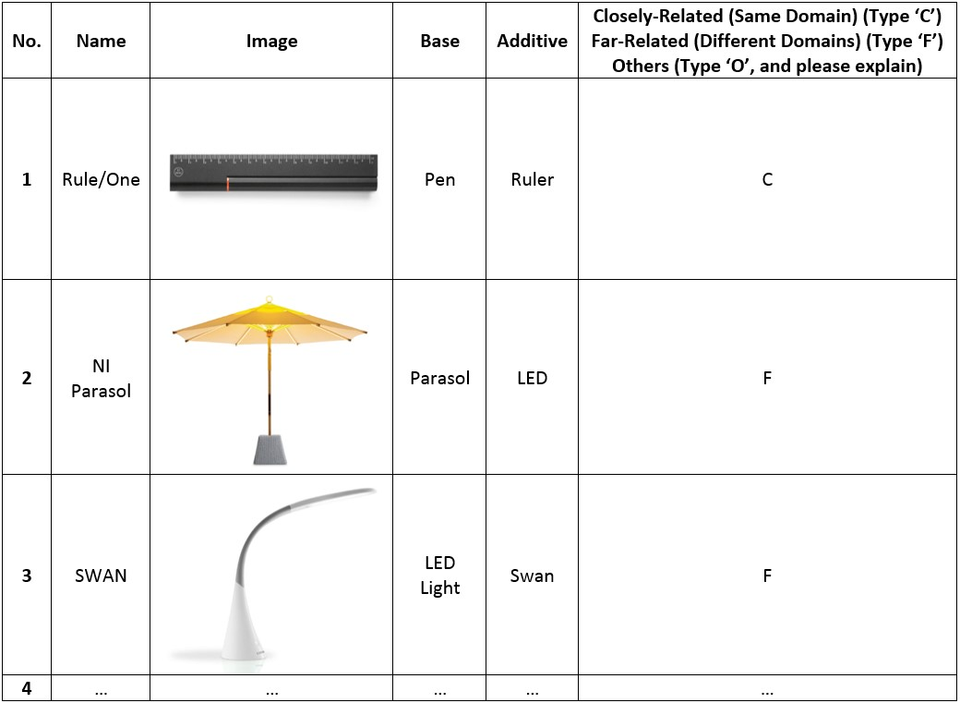
- An example of a decision table used in this case study

The evaluation results of the case study are presented in Table 2. Evaluator 1 indicated 148 products out of 200 were far-related combinational designs, and 52 were closely-related designs. Evaluator 2 suggested 66 closely-related combinational designs and 134 far-related designs. Evaluator 3 identified 49 and 151 products were closely-related designs and far-related designs, respectively.

- Evaluation results – Number of closely-related and far-related combinational designs
 | Evaluator 1 | Evaluator 2 | Evaluator 3
Closely-related Designs | 52 | 66 | 49
Far-related Designs | 148 | 134 | 151
Others | 0 | 0 | 0

A Kappa test was conducted to assess the overall inter-rater agreement of the evaluation in this case study to explore the reliability of the results. Cohen's Kappa coefficient usually measures the agreement between two judges. For more than two judges, the mean Kappa coefficient value of all rater pairs is used to measure the overall inter-rater agreement of a category (Light, 1971). As shown in Table 2, the mean Kappa coefficient is 0.695 which has suggested a good agreement among the evaluators. This has indicated the robustness and reliability of the evaluation results.

- Kappa test results
(Kappa values and strength of agreements: 0.00-0.20: Poor, 0.21-0.40: Fair, 0.41-0.60: Moderate, 0.61-0.80: Good, 0.81-1.00: Very Good)
Rater Pairs |  | Kappa Value
Evaluator 1 | Evaluator 2 | 0.689
Evaluator 1 | Evaluator 3 | 0.748
Evaluator 2 | Evaluator 3 | 0.649
Mean Kappa Coefficient |  | 0.695
Strength of Agreement |  | Good

According to the evaluation results and the Kappa test, far-related ideas are used more commonly and frequently than closely-related ideas to produce creative combinational ideas or products, for the case study concerned. Although far-related combinational designs are more common than closely-related ones in design competitions, the creativity level of far-related combinational designs could be lower than closely-related ones. Therefore, the creativity levels of far-related and closely-related designs need to be assessed to further explore the conceptual distances in combinational creativity.
  - Creativity of Far-related and Closely-related Combinational Designs
In addition to the evaluation above, we have conducted another evaluation to assess the creativity levels of products from far-related and closely-related combinational designs. Metrics are often used to evaluate creativity of designs as well as concepts. For instance, Shah et al. (2003) proposed to use quantity, novelty, quality, and variety to measure creativity as well as the effectiveness of an ideation method. Plucker and Makel (2010) used fluency, originality, flexibility, and elaboration as the measurement metric. Sarkar and Chakrabarti (2011) employed novelty and usefulness to evaluate creativity by using the Function-Behaviour-Structure model and the SAPPhIRE model, respectively. O'Quin and Besemer (1989) have proposed a revision of the Creative Product Semantic Scale (CPSS) to assess creativity by using the terms novelty and resolution (also known as utility or usefulness).
The Creative Product Semantic Scale (CPSS) metric was employed in this case study to assess the selected designs. This metric, which uses novelty and utility to describe creativity, has been validated for several times (Chulvi et al., 2012). In this case study, we used the questionnaire based on CPSS, which was created by Chulvi et al. (2012), for the creativity evaluation. The questionnaire is a seven-point scale table involving eighteen bipolar pairs of items referring novelty and utility, as shown in Figure 2. In the questionnaire, novelty items and utility items are mixed and some are reversed to avoid evaluators' inertia.
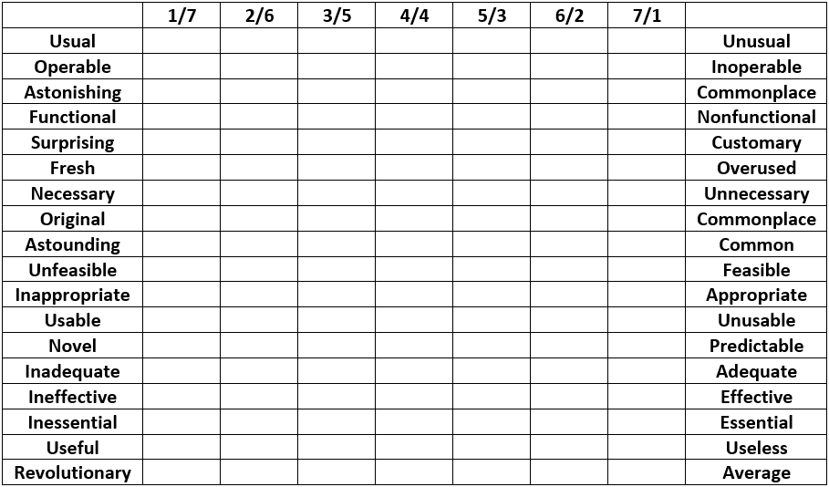
- The questionnaire based on CPSS for evaluating the creativity of selected designs (adapted from (Chulvi et al., 2012))
Five designs from each, far-related and closely-related combinational designs, were randomly selected to investigate which distance of combination could lead to more creative results. The ten designs selected have achieved consensuses among the three evaluators, which were agreed as either far-related combinational design or closely-related combinational design. Two design experts having more than four years of experience participated in this creativity evaluation voluntarily, which were identified as Expert 1 and 2 to distinguish from the previous conceptual distance evaluation. The two evaluators were provided with the ten designs in a random order printed on paper including the designs' names, images, and text descriptions. The two evaluators were not provided with other information, and conducted the evaluation respectively to verify the robustness of the scores. The evaluators employed the CPSS questionnaire for the creativity evaluation by choosing between the bipolar pairs of the items in a seven-point scale. The creativity score of a design was the sum of the scores of all the individual items.
The creativity evaluation results by the two design experts are shown in Table 3. Expert 1 has indicated that the creativity scores of all the five far-related combinational designs are higher than the five closely-related ones. Expert 2 has indicated all the five far-related designs are more creative than the closely-related ones, but except Design 9. Mean creativity scores of closely-related and far-related combinational designs were calculated respectively to provide an overall comparison, as shown in Table 4. In the table, SD is the abbreviation of standard deviation. In addition, the effect sizes, also known as Cohen's d, were also calculated to measure the strength of the difference between the mean scores of closely-related and far-related combinational designs. According to Expert 1, the five far-related combinational designs have achieved a mean creativity score of 95.8 which is 22.2 higher than that of the five closely-related ones (73.6). This has suggested a Cohen's d value of 2.87 which has shown a large difference between the two mean scores. In terms of Expert 2, the five closely-related designs have scored 80.0, while the five far-related designs have achieved 98.6 which is 18.6 higher. The Cohen's d value of the two mean creativity scores assessed by Expert 2 was 1.22 which has also indicated a large effect size or a large difference. Therefore, the creativity evaluation results have shown that combinational designs produced by combining conceptually far-related ideas are generally more creative than the ones generated by using conceptually closely-related ideas, concerning the selected combinational designs in this case study.
- Creativity evaluation results by using the CPSS questionnaire
Design Number | Closely- or Far-related | Expert 1 – Creativity Score | Expert 2 – Creativity Score
1 | Close | 84 | 90
2 | Far | 100 | 119
3 | Close | 68 | 91
4 | Close | 60 | 77
5 | Far | 89 | 93
6 | Close | 81 | 74
7 | Far | 99 | 108
8 | Close | 75 | 68
9 | Far | 92 | 69
10 | Far | 99 | 104
- Mean creativity values of closely-related and far-related combinational designs and effect sizes (Cohen's d)
(Cohen's d value and strength: 0.20: Small, 0.50: Moderate, 0.80: Large)
 | Expert 1 (SD) | Expert 2 (SD)
Closely-related Designs | 73.6 (8.73) | 80.0 (10.12)
Far-related Designs | 95.8 (4.45) | 98.6 (18.98)
Effect Size (Cohen's d) | 2.87 - Large | 1.22 - Large

- Discussion and Conclusion
A case study including two separate evaluations was conducted to investigate closely and far-related ideas in terms of producing combinational designs. The first evaluation assesses which distance, closely- or far-related, between the base and additive ideas is generally used in producing practical combinational designs. The results have shown that the majority of the selected combinational designs are produced by combining far-related ideas rather than closely-related ideas, albeit with a limited number of combinational design samples. Although the number of evaluators is limited, the Kappa test has shown a good inter-rater agreement among the evaluators indicating the evaluation results are robust and reliable. The second evaluation assesses the degree of creativity of far-related and closely-related combinational designs by using a CPSS questionnaire. The results indicate that far-related ideas could lead to more creative outcomes concerning the randomly selected designs, which is in line with the study by Lopez et al. (2011) in design-by-analogy. The effect sizes, or Cohen's d values, suggest there are large differences in the degree of creativity between closely-related and far-related combinational designs with regards to the two experts. This indicates far-related combinational designs are "largely" more creative than closely-related designs, for the designs concerned. Therefore, the case study conducted has justified the two hypotheses proposed in this study. However, using international design award-winning products or designs as samples might have limitations, as award winners are arguably more creative than conventional designs on the market. The samples in the case study, which are relatively more creative than conventional ones, cannot represent general product design. Therefore, the case study shows how conceptually closely-related and far-related ideas are employed in practical combinational designs, as well as how the conceptual distance affects the degree of combinational creativity in a relatively more creative context.
In conclusion, this study has explored conceptual distances between base ideas and additive ideas for generating combinational creativity, especially in the domain of product design. The study indicates far-related ideas are used more often in practical combinational designs, as well as could lead to more creative outcomes comparing with closely-related ideas, for the case study concerned. The study has provided better comprehension of how combinational creativity is achieved in design. Understanding conceptual distances between base and additive ideas could support designers identifying appropriate ideas for generating creative combinational concepts at early phases of design. The outcomes of the study could benefit computational tools that employ the concept of "combination", such as the Combinator (Han et al., 2016) and the combination of scenes (Georgiev et al., 2017). A further study involving more evaluators and more samples is planned to provide additional insights. Additionally, several computational tools will be used to measure the conceptual distances between base ideas and additive ideas, as well as to provide a comparison with the results assessed by experts.

References:
Achiche, S., Appio, F. P., McAloone, T. C. and Di Minin, A. (2013), "Fuzzy decision support for tools selection in the core front end activities of new product development", Research in Engineering Design, Vol. 24 No. 1, pp. 1-18. doi: 10.1007/s00163-012-0130-4.
Altshuller, G. S. (1984), Creativity as an Exact Science: The Theory of the Solution of Inventive Problems. Gordon and Breach Publishers, Amsterdam, Netherlands.
Bacciotti, D., Borgianni, Y. and Rotini, F. (2016), "An original design approach for stimulating the ideation of new product features", Computers in Industry, Vol. 75, pp. 80-100.
Blanchette, I. and Dunbar, K. (2000), "How analogies are generated: The roles of structural and superficial similarity", Memory and Cognition, Vol. 28 No. 1, pp. 108-124. doi: 10.3758/bf03211580.
Boden, M. A. (2004), The Creative Mind: Myths and Mechanisms, 2nd, Routledge, London, UK.
Boden, M. A. (2009), "Computer models of creativity", AI Magazine, Vol. 30 No. 3, pp. 23-34. doi: 10.1609/aimag.v30i3.2254.
Bryant, C. R., McAdams, D. A., Stone, R. B., Kurtoglu, T. and Campbell, M. I. (2006), "A validation study of an automated concept generator design tool", Proceedings of ASME 2006 IDETC/CIE, Philadelphia, USA.
Chakrabarti, A., Siddharth, L., Dinakar, M., Panda, M., Palegar, N. and Keshwani, S. (2017), "Idea Inspire 3.0-A tool for analogical design", In: Chakrabarti, A. and Chakrabarti, D. (Eds.), Research into Design for Communities, Springer, Singapore, pp. 475-485.
Chan, J., Dow, S. P. and Schunn, C. D. (2015), "Do the best design ideas (really) come from conceptually distant sources of inspiration?", Design Studies, Vol. 36, pp. 31-58. doi: 10.1016/j.destud.2014.08.001.
Chan, J., Fu, K., Schunn, C., Cagan, J., Wood, K. and Kotovsky, K. (2011), "On the benefits and pitfalls of analogies for innovative design: ideation performance based on analogical distance, commonness, and modality of examples", Journal of Mechanical Design, Vol. 133 No. 8. doi: 10.1115/1.4004396.
Charyton, C. and Merrill, J. A. (2009), "Assessing general creativity and creative engineering design in first year engineering students", Journal of Engineering Education, Vol. 98 No. 2, pp. 145-156. doi: 10.1002/j.2168-9830.2009.tb01013.x.
Chen, L., Shi, F., Han, J. and Childs, P.R.N. (2017), "A network-based computational model for creative knowledge discovery bridging human-computer interaction and data mining", Proceedings of ASME 2017 IDETC/CIE, Cleveland, USA. doi: 10.1115/DETC2017-67228.
Childs, P.R.N. (2018), Mechanical design engineering handbook. 2nd, Butterworth-Heinemann, Oxford, UK.
Chulvi, V., Sonseca, A., Mulet, E. and Chakrabarti, A. (2012), "Assessment of the relationships among design methods, design activities, and creativity", Journal of Mechanical Design, Vol. 134 No. 11, pp. 111004-111004-11. doi: 10.1115/1.4007362.
Costello, F. J. and Keane, M. T. (2000), "Efficient creativity: Constraint-guided conceptual combination", Cognitive Science, Vol. 24 No. 2, pp. 299-349. doi: 10.1207/s15516709cog2402_4.
Crilly, N. and Cardoso, C. (2017), "Where next for research on fixation, inspiration and creativity in design?", Design Studies, Vol. 50 No. pp. 1-38. doi: 10.1016/j.destud.2017.02.001.
De Bono, E. (1985), Six Thinking Hats, Little Brown and Company, USA.
Demirkan, H. and Afacan, Y. (2012), "Assessing creativity in design education: Analysis of creativity factors in the first-year design studio", Design Studies, Vol. 33 No. 3, pp. 262-278. doi: 10.1016/j.destud.2011.11.005.
Frigotto, M. L. and Riccaboni, M. (2011), "A few special cases: Scientific creativity and network dynamics in the field of rare diseases", Scientometrics, Vol. 89 No. 1, pp. 397-420. doi: 10.1007/s11192-011-0431-9.
Fu, K., Chan, J., Cagan, J., Kotovsky, K., Schunn, C. and Wood, K. (2013), "The meaning of "near" and "far": The impact of structuring design databases and the effect of distance of analogy on design output", Journal of Mechanical Design, Vol. 135 No. 2, pp. 021007-021007-12. doi: 10.1115/1.4023158.
Geng, X., Chu, X. and Zhang, Z. (2010), "A new integrated design concept evaluation approach based on vague sets", Expert Systems with Applications, Vol. 37 No. 9, pp. 6629-6638. doi: 10.1016/j.eswa.2010.03.058.
Gentner, D. and Smith, L. A. (2012), "Analogical reasoning", In: Ramachandran, V.S. (Ed.), Encyclopedia of Human Behavior, Elsevier, Oxford, pp. 130-136.
Georgiev, G. V., Sumitani, N. and Taura, T. (2017), "Methodology for creating new scenes through the use of thematic relations for innovative designs", International Journal of Design Creativity and Innovation, Vol. 5 No. 1-2, pp. 78-94. doi: 10.1080/21650349.2015.1119658.
Goel, A. K., Vattam, S., Wiltgen, B. and Helms, M. (2014), "Information-processing theories of biologically inspired design", In: Goel, A. K., McAdams, D. A. and Stone, R. B. (Eds.), Biologically Inspired Design: Computational Methods and Tools, Springer London, London, pp. 127-152.
Han, J., Park, D., Shi, F., Chen, L., Hua, M. and Childs, P.R.N. (2017a), "Three driven approaches to combinational creativity: Problem-, similarity- and inspiration-driven". Proceedings of the Institution of Mechanical Engineers, Part C: Journal of Mechanical Engineering Science. doi: 10.1177/0954406217750189.
Han, J., Shi, F., Chen, L. and Childs, P.R.N. (2017b), "The Analogy Retriever-an idea generation tool". DS 87-4 Proceedings of the 21st International Conference on Engineering Design (ICED 17), Vancouver, Canada.
Han, J., Shi, F. and Childs, P.R.N. (2016). "The Combinator: A computer-based tool for idea generation". Proceedings of the Design 2016 14th International Design Conference, Dubrovnik, Croatia.
Henriksen, D., Mishra, P. and the Deep-Play Research, G. (2014), "Twisting knobs and connecting things: Rethinking technology and creativity in the 21st century", TechTrends, Vol. 58 No. 1, pp. 15-19.
Howard, T. J., Culley, S. and Dekoninck, E.A. (2011), "Reuse of ideas and concepts for creative stimuli in engineering design", Journal of Engineering Design, Vol. 22, pp. 565-581. doi: 10.1080/09544821003598573.
Howard, T. J., Culley, S. J. and Dekoninck, E.A. (2008), "Describing the creative design process by the integration of engineering design and cognitive psychology literature", Design Studies, Vol. 29 No. 2, pp. 160-180.
Hsiao, S.-W. and Chou, J.-R. (2004), "A creativity-based design process for innovative product design", International Journal of Industrial Ergonomics, Vol. 34 No. 5, pp. 421-443. doi: 10.1016/j.ergon.2004.05.005.
Koestler, A. (1964), The Act of Creation, Hutchinson, London, UK.
Kohn, N. W., Paulus, P. B. and Korde, R. M. (2011), "Conceptual combinations and subsequent creativity", Creativity Research Journal, Vol. 23 No. 3, pp. 203-210. doi: 10.1080/10400419.2011.595659.
Lai, H.-H., Lin, Y.-C., Yeh, C.-H. and Wei, C.-H. (2006), "User-oriented design for the optimal combination on product design", International Journal of Production Economics, Vol. 100 No. 2, pp. 253-267.
Light, R. J. (1971), "Measures of response agreement for qualitative data: Some generalizations and alternatives", Psychological Bulletin, Vol. 76 No. 5, pp. 365-377. doi: 10.1037/h0031643.
Linsey, J. S., Markman, A. B. and Wood, K. L. (2012), "Design by analogy: A study of the WordTree method for problem re-representation", Journal of Mechanical Design, Vol. 134 No. 4, pp. doi: 10.1115/1.4006145.
Lopez, R., Linsey, J. S. and Smith, S. M. (2011), "Characterizing the effect of domain distance in design-by-analogy", Proceedings of ASME 2011 IDETC/CIE. doi: 10.1115/DETC2011-48428.
Mumford, M. D. (2003), "Taking stock in taking stock", Creativity Research Journal, Vol. 15, pp. 147-151.
Nagai, Y., Taura, T. and Mukai, F. (2009), "Concept blending and dissimilarity: Factors for creative concept generation process", Design Studies, Vol. 30 No. 6, pp. 648-675. doi: 10.1016/j.destud.2009.05.004.
O'Quin, K. and Besemer, S. P. (1989), "The development, reliability, and validity of the revised creative product semantic scale", Creativity Research Journal, Vol. 2 No. 4, pp. 267-278. doi: 10.1080/10400418909534323.
Ozkan, O. and Dogan, F. (2013), "Cognitive strategies of analogical reasoning in design: Differences between expert and novice designers", Design Studies, Vol. 34 No. 2, pp. 161-192. doi: 10.1016/j.destud.2012.11.006.
Plucker, J. A. and Makel, M. C. (2010), "Assessment of creativity", In: Kaufman, J. C. and Sternberg, R. J. (eds.), The Cambridge Handbook of Creativity, The Cambridge University Press, Cambridge, UK, pp. 48-73.
Sarkar, P. and Chakrabarti, A. (2011), "Assessing design creativity", Design Studies, Vol. 32 No. 4, pp. 348-383. doi: 10.1016/j.destud.2011.01.002.
Scott, G. M., Lonergan, D. C. and Mumford, M. D. (2005), "Conceptual combination: Alternative knowledge structures, alternative heuristics", Creativity Research Journal, Vol. 17 No. 1, pp. 79-98.
Shah, J. J., Smith, S. M. and Vargas-Hernandez, N. (2003), "Metrics for measuring ideation effectiveness", Design Studies, Vol. 24 No. 2, pp. 111-134. doi: 10.1016/s0142-694x(02)00034-0.
Shi, F., Chen, L., Han, J. and Childs, P. (2017a), "A data-driven text mining and semantic network analysis for design information retrieval", Journal of Mechanical Design, Vol. 139 No. 11. doi: 10.1115/1.4037649.
Shi, F., Chen, L., Han, J. and Childs, P. (2017b), "Implicit knowledge discovery in design semantic network by applying Pythagorean means on shortest path searching", Proceedings of ASME 2017 IDECT/CIE, Cleveland USA. doi:10.1115/DETC2017-67230
Simonton, D. K. (2017), "Domain-general creativity: On generating original, useful, and surprising combinations", In: Kaufman J.C., Glaveanu V.P. and J., B. (Eds.), The Cambridge Handbook of Creativity across Domains, The Cambridge University Press., Cambridge, UK, pp. 18-40.
Vosniadou, S. and Ortony, A. (1989), "Similarity and analogical reasoning: a synthesis", In: Ortony, A. and Vosniadou, S.(Eds.), Similarity and Analogical Reasoning, Cambridge University Press, Cambridge, pp. 1-18.
Wang, H.-H. (2016), " Winning formulas for metaphor design: A case study of design competitions ". DS 84: Proceedings of the DESIGN 2016 14th International Design Conference, Dubrovnik, Croatia.
Wang, H.-H. and Chan, J.-H. (2010), "An Approach to Measuring Metaphoricity of Creative Design", In: Taura, T. and Nagai, Y. (Eds.), Design Creativity 2010, Springer London, London, pp. 89-96.
Ward, T. B. (1994), "Structured imagination: The tole of category structure in exemplar generation", Cognitive Psychology, Vol. 27 No. 1, pp. 1-40. doi: 10.1006/cogp.1994.1010.
Ward, T. B. (1998), "Analogical distance and purpose in creative thought: mental leaps versus mental hops", In: Holyoak, K. J., Gentner, D. and Kokinov, B. N. (Eds.), Advances in Analogy Research: Integration of Theory and Data from the Cognitive, Computational, and Neural Sciences, New Bulgarian University Press, Sofia, Bulgaria, pp. 221-230.
Ward, T. B. (2001), "Creative cognition, conceptual combination, and the creative writing of Stephen R. Donaldson", American Psychologist, Vol. 56 No. 4, pp. 350-354. doi: 10.1037/0003-066X.56.4.350.
Ward, T. B., Finke, R. A. and Smith, S. M. (2002), Creativity and the Mind: Discovering the Genius within, Perseus Books, Cambridge, MA, USA.
Ward, T. B. and Kolomyts, Y. (2010), "Cognition and creativity", In: Kaufman, J. C. and Sternberg, R. J. (Eds.), The Cambridge Handbook of Creativity, The Cambridge University Press, Cambridge, UK, pp. 93-112.
Wilkenfeld, M. J. and Ward, T. B. (2001), "Similarity and emergence in conceptual combination", Journal of Memory and Language, Vol. 45 No. 1, pp. 21-38. doi: 10.1006/jmla.2000.2772.
Yilmaz, S., Daly, S. R., Seifert, C. M. and Gonzalez, R. (2016), "Evidence-based design heuristics for idea generation", Design Studies, Vol. 46, pp. 95-124. doi: 10.1016/j.destud.2016.05.001.
Zhai, L.-Y., Khoo, L.-P. and Zhong, Z.-W. (2009), "Design concept evaluation in product development using rough sets and grey relation analysis", Expert Systems with Applications, Vol. 36 No. 3, pp. 7072-7079.

