INTERNATIONAL DESIGN CONFERENCE - DESIGN 2016
Dubrovnik - Croatia, May 16 - 19, 2016.
The Combinator: A Computer-based tool for idea generation
J. Han, F. Shi and P. R. N. Childs

Keywords: design, creativity, idea generation, combinational creativity, creativity tools

1. Introduction
Design tends to benefit from the generation of alternative ideas. However, coming up with new ideas is often challenging. Design engineering suggests a process in which engineering approaches are applied in the activities that began with a design concept or proposal [Childs 2014]. Ideation is where a design concept begins, and it fundamentally determines the type of design produced and the value of business performed. Ideation or idea generation is the process of generating ideas in design activities. It is considered as a vital role to novel design concept development and the key to success in business competition [Jaruzelski et al. 2014]. Enterprises like Dyson and Apple have achieved great success due to their creative products, whereas firms like Nokia and Motorola have been acquired as they could not sustain their creative and business edge.
The UK's most innovative companies historically generate over 75% of their profits from products that did not exist 5 years before [Cox 2005]. This indicates that generating creative ideas is necessary to novel concept development and ultimately innovation [Howard et al. 2011]. Therefore, more robust creative ideas are required to be developed for the needs of producing creative products, and thereby promoting commerce. However, generating creative ideas is difficult, due to problems such as lack of creative people, time pressure, numerous existing ideas, and limited core information. According to [Childs 2014], an enormous amount of information, the willingness and endeavour of producing ideas, and the capability of discarding irrelevant ideas are the essential elements of generating creative ideas. Nevertheless, creativity is a notoriously elusive phenomenon, often associated with human genius or serendipitous discovery. As a result, there has been increasing interest in recent years in understanding the factors that encourage creativity and exploring how it can be fostered.
A number of creativity tools have been developed to help designers invent new ideas. These tools do not actually produce ideas [Childs 2014], but stimulate the user's creative mind by removing mental blocks and expanding searching space [Cross 2001]. Some, like brainstorming and mind mapping, are fairly easy to grasp but rely heavily on the user's experience and knowledge. Others, like TRIZ and SCAMPER, are rather complex and difficult to master. Some, like lateral thinking, are even inconsistent with normal human thought processes. Besides, different creativity tools possess diverse characteristics and are suitable for different personality attributes and different applications [Yan & Childs 2015].
This research project aims at developing a simple-to-learn and easy-to-use computer-based tool named the Combinator, which is based on combinational creativity theory, through a novel approach. The new tool is intended to assist designers to generate new ideas through combining familiar ideas. It is suitable for a variety of people as it matches with normal human thought mode and can provide users with relevant knowledge databases. The new tool is expected to help both novice designers as well as experienced designers come up with high valuable ideas easily and effectively, thereby tackling the challenges of nowadays fast-moving business market.
2. Combinational Creativity
Creativity can be defined as "the ability to come up with ideas or artefacts that are new, surprising, and valuable" [Boden 2004], or "the ability to imagine or invent something new of value" [Childs et al. 2006]. The output of creativity, which arises from the combination of some essential mental capabilities, is the result of long periods of work with a series of mini breakthroughs [Childs 2014]. The output of creativity can be an object, an action, or an idea, and these outputs are conceived to be novel, high in quality, and useful [Carruthers 2011]. The new tool proposed in this study aims at enhancing the generation of creative ideas during design engineering problem solving.
Most creative ideas can be characterised by the diverse thoughts from previous experience stored in the memory elements [Childs 2014, Benedek et al. 2014, Liikkanen & Perttula 2010]. Boden [2004] has proposed three methods of achieving creative ideas in our human mind: combinational creativity, exploratory creativity, and transformational creativity. Exploratory creativity involves generating creative ideas through exploring structured conceptual space (structured styles of thought). Transformational creativity includes transforming the conceptual space to produce transformative ideas in new structures. Combinational creativity, also known as conceptual combination, involves the generation of new ideas through exploring unfamiliar combinations of familiar ideas [Boden 2004, Ward & Kolomyts 2010]. It works by making associations between ideas that were previously only indirectly linked [Boden 2004]. The "ideas" to be combined can be concepts, words, images, sounds, and other simple elements, or more abstract ones like music styles, artistic genres, and so forth [Ward & Kolomyts 2010]. Combinational creativity is the easiest type of creativity for human beings to achieve, as it is a natural feature of human associative memory system [Boden 2009]. Moreover, many people used the term "combinational creativity" to describe what creativity is, for instance, Steve Jobs described that "creativity is just connecting things", Frigotto and Riccaboni [2011] indicated the nature of creativity is to combine, and Henriksen et al. [2014] defined creativity as "the process of making alterations to, and new combinations with, pre-existing ideas and artifacts, to create something new".
The theory of combinational creativity has been used widely in creating various products. For example, the influential chocolate bar "Kit-Kat" is just a simple combination of chocolate and wafers; the creative toy "LEGO" is a series of combinations of numerous different bricks; the "Apple Watch" is a combination of watch and mobile phone, albeit with a very sophisticated operating system.
Boden [2004] points out that combinational creativity requires a very rich store of knowledge, and the ability to form links of many different types. This indicates that combinational creativity also requires the ability and the knowledge database to evaluate the links. These are also some of the main reasons why acclaimed designers are usually rich in knowledge and experience.
LEGO is often used as a metaphor of describing combinational creativity. Similarly to the LEGO toy, our storage of knowledge is a bit like a bag of bricks, and the different sizes, colours, and shapes of bricks in the bag are like the different types of knowledge stored in our knowledge database. How different bricks are connected to each other is like how different types of knowledge are combined together. If we only have a few bricks of one size, shape, and colour, what we are able to build is very limited. However, if we equip ourselves with numerous bricks in different kinds, we are capable to constructing a skyscraper or even an entire city. Similarly, we would have difficulties in appreciating and understanding other "architectures", unless we know what kinds of bricks have been used and how the bricks are connected.
Although combinational creativity is the easiest type of creativity for humans in both achieving and understanding, combinational creativity is the most elusive for computers. It is not difficult for computers to form combinations or even novel combinations of stored familiar ideas, but it is extremely difficult for computers to generate valuable or interesting combinations and to recognize their values [Boden 2009]. Compared with the human brain, it is difficult for computers to achieve the cornucopia of human associative memory [Boden 2009]. Moreover, computers cannot naturally form links between ideas and evaluate them, while human could naturally associate ideas of many different kinds during everyday thinking. Therefore, modelling combinational creativity on computational systems requires a rich knowledge database and methods of link making comparable to a human. However, there still exist a few successful computer programs that involve combinational creativity theory, for example, Gastronut [Butnariu & Veale 2006] and Portrait Robot [Augello et al. 2014].
3. Methodology of the Combinator
The Combinator is a piece of software that has been developed for assisting users in idea generation. The Combinator is based on the simulation of human combinational creativity, and it can combine familiar ideas together and then generate new combinational ones. The generated combinational ideas are not just limited to text forms but also visual forms. The following sections illustrate the novel approach of developing the Combinator. This approach or this type of approach can be regarded as a new method for developing design support tools, especially idea generation tools.
In this study, the Combinator aims at ideation in the product design field. However, it is believed that the Combinator can be used in various fields, such as engineering, fashion, music, and art. Before starting to simulate combinational creativity on computers, it is necessary to understand how the human mind and memory work, as they are the crucial foundation of combinational creativity theory and the Combinator. Memory is the place where knowledge and information are stored, and the mind is the place where links between ideas are formed. Therefore, in order to simulate combinational creativity, modelling a rich knowledge database and an idea linking system are necessary.
The word "memory" is defined as "the ability to store, retain, and subsequently access information" [Childs 2014], or "a network of meanings" [Boden 2004]. The idea generation process involves controlled retrieval of existing information from the memory [Benedek et al. 2014, Liikkanen & Perttula 2010]. The multi-store memory model proposed by Atkinson & Shriffin [1968] comprising long-term memory and short-term memory is often cited. Long-term memory is a system that underpins the capacity to store information over long-periods of time, while short-term memory retains small amounts of material over periods of a few second [Baddeley et al. 2010]. Information from the outside world can flow into short-term memory through sensory perceptions (such as visual and auditory), and then the information can flow into long-term memory through encoding. The information maintained in long-term memory can be passed back into short-term memory by retrieval. Through refreshing [Vergauwe & Cowan 2015], the information in short-term memory can be retained for a relatively long time. Figure 1 is a brief information flow chart of human memory system.
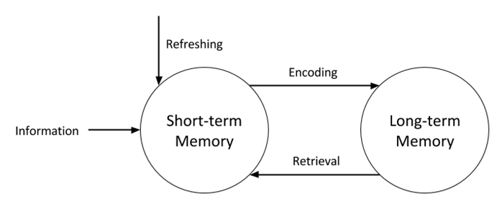
Figure 1. Information Flow Chart of Human Memory System
Although human memory could be theoretically unlimited in both capacity and duration, the performance on tasks involving long-term memory declines steadily through the adult years. Baddeley et al. [2010] pointed out that human memory seems to be less reliable than augmented memory (non-single human mental memory, such as books and Internet). Therefore, many computer-based augmented memory have been developed in recent years.
The human mind is widely considered as the product of natural selection and evolution, even though there is no direct evidence that can prove it [Bolhuis & Wynne 2009]. Therefore, intuition is often used for solving all kinds of problems [Pinker 1999]. Recent studies show that activity in the human mind is triggered by external stimuli, especially the input gathered from eyes [Luis-Ferreira & Jardim-Goncalves 2013]. Many psychologists [e.g., Pinker 1999] agree that the mind is similar to a digital computer and thinking is like a kind of computation. This is known as the computational theory of mind, which explains where human and computer intelligence come from and underlies artificial intelligence (AI), perception, decision making, and linguistics. It also explains how ideas are linked in the human mind. It is the computational theory of mind that has enabled us to model the human mind, especially combinational creativity, on computational systems.
3.1 Modelling Human Memory and Mind
The model of human memory on computational systems can be regarded as a rich store of knowledge database (long-term memory) and an input/output of the Combinator (short-term memory). The input of the combinator can be a desire or a design keyword, and the output is a text combination and an image combination. The knowledge database can be simply generated through manual input, but this is time consuming and capacity limited. Therefore, this study takes the advantage of nowadays robust Internet and information retrieval technology to produce the database.
A web crawler is a program that browses and retrieves specific resources and information from Web sites [Patil et al. 2014]. This technology has been used for data mining, information searching, web monitoring, web archiving, and so on. Moreover, it has been demonstrated that web crawlers can be used to mine design-related information for idea generation [Wang 2013].
Scrapy, which is an open-source web crawler licensed under the BSD License, is used in this study to produce a text-based knowledge database. Scrapy is an extensible and high efficiency application framework written in Python, which allows users to program which domain or group of domains to be explored, what kind of data to be extracted, which format the data will be stored in, and so forth. This study aims at producing ideas for product design, and therefore a database that focuses on the design area needs to be developed. Data elements need to be narrowed down and irrelevant elements are required to be discarded in order to produce creative ideas [Childs 2014]. Therefore, Scrapy is programed by the authors to obtain only main body texts which describe design products or ideas in a design website covering the best in product design. Simultaneously with the crawling, the crawled texts are processed by the Natural Language Toolkit (NLTK) [Bird et al. 2009], which is a computational linguistic platform distributed under the open source terms of Apache License 2.0, to extract requisite words. After that, the words are stored into corresponding databases in the Combinator according to their part-of-speech.
The text database is used to generate compound phrase ideas, such as noun-noun, adjective-noun, and verb-adjective-noun, but sometimes it might be difficult for users to capture the combinational meaning of the phrase. This might be due to the limitation of user's vocabulary or the lack of corresponding images in the user's long-term memory. Thus, combinational images are required to enhance the understanding and interpretation of compound phrases, as the human brain activities are mainly triggered by the input gathered from the eyes [Luis-Ferreira & Jardim-Goncalves 2013]. Moreover, according to Ward & Kolomyts [2010], it has been revealed that combinational images are beneficial in idea generation. Images are needed to be gathered from the internet in order to produce combinational images. Scrapy can crawl images according to the existing text database and store them into an image database, but creating this image database can take weeks and even months as it is usually enormous. Therefore, we have developed a live feed image crawler using python to avoid the problems. The live feed image crawler can scrape correspondence images in real-time from the Internet according to the generated combinational phrases.
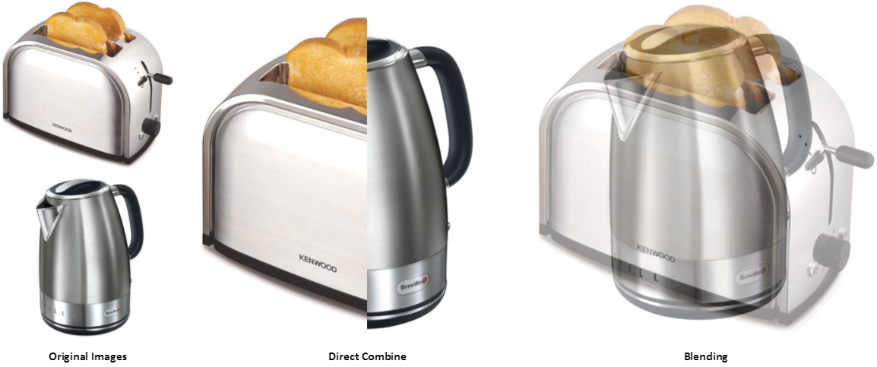
Figure 2. An Example of Image Combination
The Combinator overlays images for producing image-based combinational ideas by using the OpenCV Python module (an open source BSD-licensed vision algorithm library). According to Ward & Kolomyts [2010], researchers have showed that superimposed or merged images can lead to more creative outcomes, and the combined images can be stimuli to creativity. Two main image combination methods are used in the current Combinator, direct combine and blending. In direct combine, images are cropped first and then merged next to one another. In blending, images are superimposed on one another. For instance, Figure 2 shows the original images of a "Kenwood" toaster and a "Breville" kettle, and their direct combination image and blending combination image. The alternative image combination methods are adopted in the Combinator to avoid einstellung effect that might block people's mind of sticking to just one type of idea combination.
Simulating aspects of the human mind on computers can be considered as forming a linking system among the database elements. In the current version of Combinator, the combinational ideas are produced in a random manner, as the links between ideas are formed randomly. In other words, text-based ideas are retrieved randomly from the database to combine with the input keyword to create combinational ideas, and combinational images are generated simultaneously according to the combinational ideas. Random stimulus has been proved to be beneficial in idea generation [Howard et al. 2011], and randomness is regarded as a crucial element of creativity [Carruthers 2011].
3.2 The Combinator Algorithm
A brief representation of the algorithm of the current version of the Combinator, which is based on an imitation of the way the human brain achieves combinational creativity, is shown in Figure 3. It starts with crawling relevant user-defined information from the Internet using web crawlers, which is similar to a human in gaining knowledge from augmented memory. The information is then stored into corresponding databases in the Combinator after being analysed and processed by the NLTK integrated in the tool, and this simulates the process of encoding knowledge and storing them into long-term memory. Focusing on the user input, the Combinator retrieves information used for producing combinational ideas from the corresponding Combinator part-of-speech databases, which is similar to the process of retrieving knowledge from human long-term memory and transferring to short-term memory. The user input and the retrieved information are considered to be a simulation of memory elements maintained in human short-term memory. Then, similar to the human mind, the combination links between the chosen ideas are formed, including both texts and images via text combinator and image combinator respectively. Lastly, a combinational creative text-based idea and its correlated combinational creative image-based idea are generated and shown to the user. The output combinational idea is regarded as an imitation of a memory element retained in human short-term memory.
According to Ward & Kolomyts [2010], it has been proved that mentally combined visual-based ideas are essential for developing inventions and exploring discoveries. Therefore, the combinational ideas produced by the Combinator algorithm, especially the imaged-based combinational ideas, can be beneficial for designers in idea generation. Users of the Combinator can be further stimulated by the generated combinational ideas, and thereby generating or deriving more ideas.
As illustrated above, the algorithm of the Combinator conforms to the natural feature of the human mind and memory system in generating combinational creative ideas. Thereby, the natural feature of the algorithm of the Combinator has provided a method accommodating a human's natural thinking pattern, with the characteristics of being simple-to-learn and easy-to-use. The Combinator algorithm has provided a novel approach for developing design support tools, and moreover, this algorithm can be also applied for creating knowledge databases.
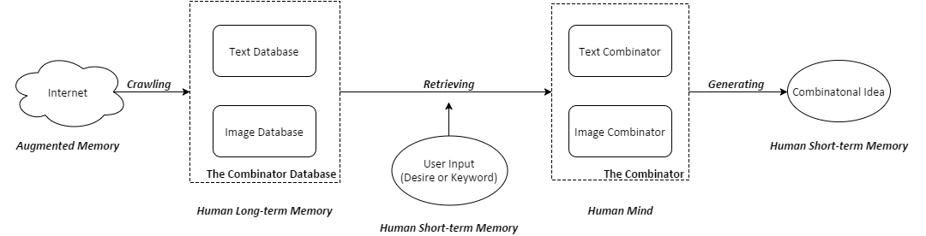
Figure 3. Algorithm of the Current Version of the Combinator

3.3 Using the Combinator
This section describes the instructions for using the Combinator software to assist designers in idea generation. The Combinator software provides a user interface, as shown in Figure 4. On the left, Figure 4(a) shows the user input and text-based combinational idea output interface. In this interface, users can enter their design keyword(s) and select the combinational output type (e.g., "two nouns", "three nouns", "verb+adjective+2 nouns", "verb+adjective+3 nouns"). Users can also define the combinational image style, such as "direct combine", "blending", and "random combine" (randomly selecting direct combine and blending). After entering all these inputs, the combinational idea is generated through simply clicking the "Generate" button. The combinational image pops out if the "Show Image/Change Direction" button is selected. As shown in Figure 4(b), the combinational image is given in a window with a text description, and it can be saved to computers. By selecting the "Show Image/Change Direction" button again, the combination direction is changed to gain more stimulus, for example, left and right image merging can transform into up and down merging. Clicking the "Generate" button again produces a new combinational idea associated with the same design keyword, if the already generated idea does not meet the requirement or more ideas are needed. The "Play" button allows users to play a slideshow focusing on the input keyword. Different words from the database are retrieved to combine with the design keyword to generate new combinational ideas. At the same time, different combinational images are produced and shown to the user according to the corresponding new combinational ideas. The slideshow can provide users a series of new combinational ideas including combinational images for a period of time in order to improve divergent thinking and avoid design or cognitive fixation. The following example provides a demonstration of how the Combinator can be used for exploring a design task.
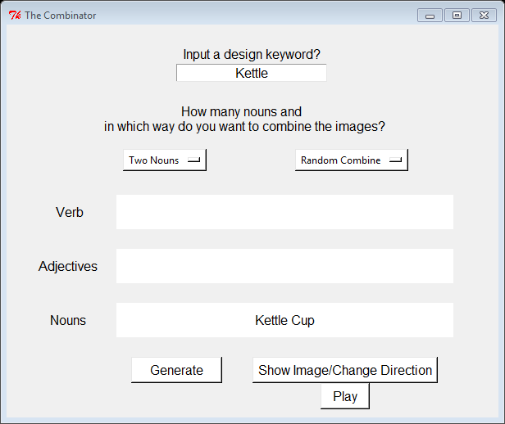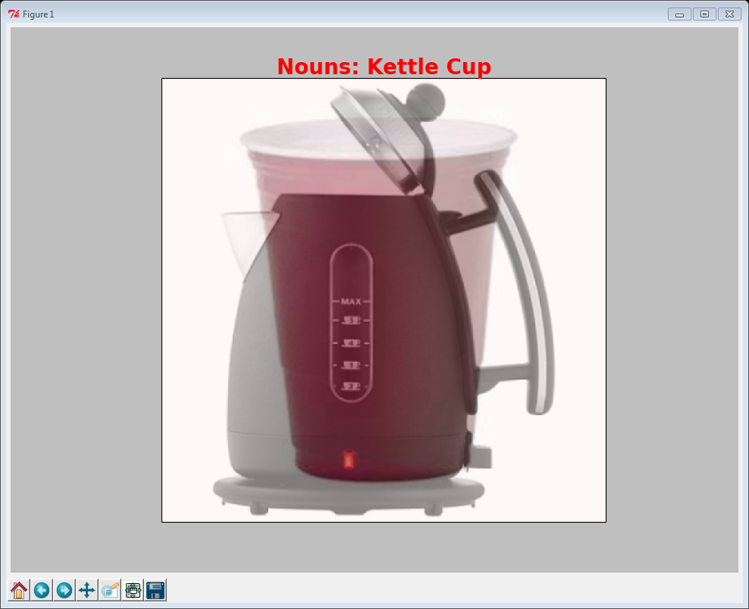
(a). User Input and Combinational Output (b). Combinational Image
Figure 4. User Interface of the Combinator
A design task asks designers to come up with new design concepts about "kettle". Using the Combinator, the design keyword "Kettle" is considered and entered. "Two Nouns" combination and "Random Combine" method are selected to generate simple random combinational text-based ideas and images. The combinational phrase "Kettle Cup" is then generated after clicking the "Generate" button, and the combinational image of "Kettle Cup" is produced after clicking the "Show Image" button, as shown in Figure 4. Then, many new ideas are derived or interpreted from the generated combinational phrase and image, such as, a kettle that looks like a cup, a cup that can heat water similarly as kettles do, a cup that looks similar to a kettle, a kettle-cup that can be used as a kettle and a cup, a kettle that placed a cup inside and is able to heat the ingredients (such as butter and chocolate) in the cup with boiling water. As a result, several creative combinational ideas focusing on "kettle" is derived with only one combinational output, and thereby it is expected that numerous ideas around "kettle" can be generated by the Combinator. This simple example gives an idea of how the Combinator works, and shows its capability of assisting users in generating creative ideas.
4. Evaluation of the Combinato
In order to evaluate the usefulness and effectiveness of the Combinator, we performed a controlled experiment of individual designers tackling a novel problem. The controlled experiment compared the Combinator to having participants generate ideas without using the tool.
Evaluation of idea generation methods or tools can be grouped into process based and outcome based approaches [Shah et al. 2003]. Process based evaluation is not geared to analyse outcomes, but rather used to analyse how and why the ideation method produces those outcomes. However, Shah et al. indicate that process based evaluation is time consuming and difficult. Besides, there are no generally agreed protocol studies can be used to collect data for idea generation process evaluation.
Outcome based evaluation is the most common method of evaluation, for example [Istre et al. 2014]. The outcome approach is easier than the process approach, especially for engineers, as there are no difficulties for experts to evaluate a set of ideas in their domains for a given problem [Shah et al. 2003]. In outcome based evaluation of creativity, psychometric measurements have been used extensively for decades. A good measure of the outcomes can objectively reflect the ideation method. The evaluation of outcomes can be related to the idea generation method through assessing creativity psychometrics.
Researchers use different set of psychometrics to evaluate creativity of ideation methods, for example, Plucker and Makel [2010] indicated a set of psychometric that is composed of fluency, flexibility, originality, and elaboration of ideas to measure creativity; Diedrich et al. [2015] used novelty and usefulness; Dean et al. [2006] indicated the four metrics of creativity are novelty, workability, relevance, and thoroughness; Shah et al. [2003] proposed the four creativity measures are quantity, quality, novelty, and variety.
Shah's psychometric evaluation method [2003] is applied in this study to evaluate the Combinator, as it is focused on measuring creativity of solving design problems and the effectiveness. In Shah's method, quantity is the total number of ideas generated. It is commonly believed that the more ideas generated, the higher chance of occurring better ideas. Quality shows the feasibility of an idea and how close it comes to meet the design specifications. Novelty is the unusualness or unexpectedness of an idea comparing to the others. Variety reflects the exploration of solution space during the idea generation process. Generating similar ideas indicates low variety, and thereby less probability of exploring better ideas in other areas of the solution space.
4.1 Procedures and Measures of the Evaluation
A controlled experiment of individual designers conducting an idea generation case study "design a new milk bottle for supermarkets to increase the sale" was performed. Ten participants, who have similar engineering backgrounds and are familiar with "milk bottles", conducted the case study voluntarily. The participants are first year and second year PhD students who are considered as novice designers in this study, as none of them have sufficient experience in either engineering design or industry design. They were highly interested and intrinsically motivated to participate this ideation case study. The participants were divided into two groups with 5 people in each group, and both groups were familiar with "milk bottles". The controlled experiment is aimed to identify the usefulness and effectiveness of the Combinator through comparing the utilisation of the tool with generating ideas without the tool. Group A participants generated ideas based on their intuition and experience, while participants in Group B came up with ideas under the assistance of using the Combinator. Members in both groups were given the same time to generate as many ideas as they can according to the given task. The generated ideas from each group were collected and mixed together before the evaluation in order to eliminate bias. Moreover, two experts with similar backgrounds evaluated the ideas respectively under the same guidance with an inter-rater agreement of scoring 10 for excellent, 8 for good, 5 for fair, 3 for poor, and 1 for bad, in order to avoid subjective judgement.
Based on Shah et al. [2003], the four metrics of each group are calculated respectively as follows. Quantity is measured through counting the total number of ideas generated by each group. The Average quantity of ideas generated by a single individual of Group A and B are calculated to provide a contrast of individual idea quantity output. Novelty is calculated for each idea through scoring 1 to 10 from least novelty to most novelty, while considering attributes such as shape, function, and material, comparing with the existing products in the market. Quality is assessed for each idea through scoring 1 to 10 from worst quality to best quality considering its feasibility and to what extent it meets the design specification. Average scores of novelty and quality of the ideas generated by each group are then calculated for comparing, as it is more objective to compare the average scores then the total novelty and quality scores of Group A and Group B due to the different quantity of ideas generated. The Variety rating is applied to an entire group of ideas. The ideas from Group A and B are classified into groups based on the different design thinking principles considered in generating the ideas, for instance, considering shapes of the product, thinking about user experience, focusing on storage problems, considering useful extra functions, concentrating on recycle problems, thinking about specific utilisations, and considering different target customers. The variety score is measured through counting the number of the groups classified according to the different design thinking principles.
The evaluation results of the metrics of Group A and Group B are shown in Table 1. As shown, Group B generated 45 ideas with using the Combinator, which is higher than the 29 ideas produced by Group A without using the program. On average, each user in Group A generated 5.8 ideas while Group B user produced 9 ideas. In terms of novelty, the average score of each idea generated by Group A is 5.7, and the average score of each idea generated by Group B is 6.6. Through using the Combinator, the average quality score of Group B is 7.3 which is 1.4 higher than that of Group A. Group B demonstrated 10 design thinking varieties, but Group A only showed 8 design thinking varieties. Among Group A's ideas, most of them were focused on the shape or exterior of the milk bottle, while only several ideas from Group B were focused on this aspect.
The Standard deviation of novelty and quality scores were calculated to quantify the dispersion of the data values. As shown in the table below, all the standard deviation values are around 1, which shows that the data values are all close to the mean of the data sets respectively. This indicates that the data are consistent and stable, and therefore a larger sample size test should not needed to be conducted.
Table 1. Evaluation Result of Group A and Group B
Metrics\Groups | Group A - Without Using the Combinator | Group B - Using the Combinator | Improvement
Quantity - Total / Average | 29 / 5.8 | 45 / 9 | 55%
Novelty - Average (Standard Deviation) | 5.7 (1.04) | 6.6 (1.02) | 16%
Quality - Average (Standard Deviation) | 5.9 (1.65) | 7.3 (1.02) | 24%
Variety | 8 | 10 | 25%

Interviews were conducted with the members in Group B to investigate their experience and opinions of using the Combinator. All the 5 users provided very positive feedbacks considering the Combinator as a very useful tool, and indicated that the Combinator had provided many useful combinational ideas effectively when they were generating new designs. The users also pointed out that the Combinator have enhanced their creative thinking during the ideation process. However, some users considered that some irrelevant combinational ideas produced by the Combinator were interrupting their thinking. Through the interviews and results, it seems the effect of using the Combinator varies from person to person. This could be caused by the different interpretation skills and understanding of the combinational ideas.
4.2 Evaluation Results and Discussion
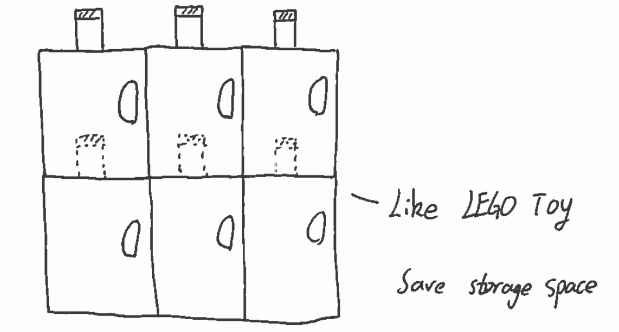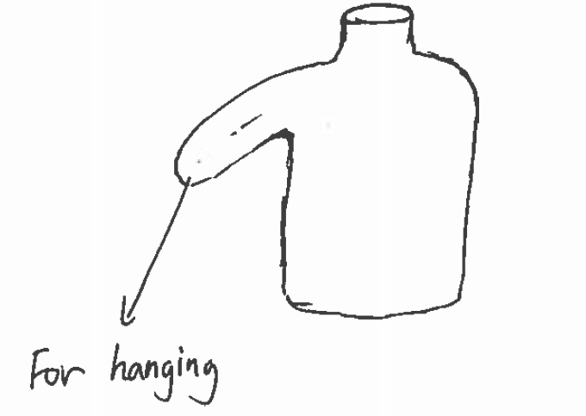
(a). LEGO Milk Bottle (b). Hanging Milk Bottle
Figure 5. Examples of Ideas Generated by Using the Combinator
Two examples of ideas generated by using the Combinator, as shown in Figure 5, are illustrated briefly as follows before analysing the evaluation result. On the left, as shown in Figure 5(a), is the combinational creative idea "LEGO milk bottle". The milk bottles can be connected to one another similar to how LEGO bricks do, which is able to save storage space. The originator of this idea noted that the LEGO milk bottle was inspired from the combinational idea "milk bottle - LEGO brick" generated by the Combinator. The "hanging milk bottle", as shown in Figure 5(b), was generated based on the combinational output "milk bottle - clothes hanger". The hanging design allows the milk bottle to be hanged on the edge of a table or a cupboard, which enables customers to place their milk bottles easier when they have a messy desk or cupboard. The examples suggested that the Combinator is able to assist novice designers in generating creative ideas that are both novel and useful.
Table 1 compares the evaluation results of the ideas generated by 5 novice designers using their intuition and experience with the ideas produced by other 5 novice designers using the Combinator. From the figures illustrated in Table 1, it is proved that the Combinator can increase idea quantity by about 55% from 5.8 to 9 on average, and enhance design thinking variety by about 25% from 8 varieties to 10 varieties. Moreover, it is shown that the average idea novelty and average idea quality have been improved by around 16% (from 5.7 to 6.6) and 24% (from 5.9 to 7.3), respectively.
Comparing with the ideas generated by novice designers using intuition and experience, the ideas generated by novice designers using the Combinator are better in quantity, novelty, quality, and variety. As a consequence, the Combinator is considered to be beneficial, albeit based on a limited data sample, in increasing better ideas occurrence, expanding design space, improving design success rate, and enhancing design space exploration. The improvement of the metrics also reflects the high effectiveness and creativity of using the Combinator on solving design problems. In conclusion, the results suggest that the Combinator is capable to help designers generate useful and novel creative ideas, and improve the quantity, novelty, quality, and variety attributes of the ideas, for the group concerned.
5. Conclusion
Idea generation is important in design, but coming up with new ideas is difficult. Existing creative tools have limitations and might not be suitable for every person. This research was undertaken with the aim of developing a simple-to-learn and easy-to-use new tool that can help novice designers as well as experienced designers produce useful and novel creative ideas easily and effectively. The investigation of the human mind and memory has provided the methods to solve the difficulties of simulating combinational creativity on computers. The Combinator program is capable to generate new combinational ideas through combining existing familiar ideas automatically. This new tool is an imitation of human in achieving combinational creativity, and thereby matching with normal human thought mode.
The Combinator has been indicated to be useful and effective in assisting designers in idea generation through performing a case study. The Combinator can improve the quantity, novelty, quality, and variety of ideas for solving design problems. The limited case study undertaken indicates that the Combinator can increase better ideas occurrence, expand design space, improve design success rate, and enhance design space exploration. Moreover, the creative approach of the Combinator has proposed a new method for developing design support tools. However, further research is planned in order to improve the efficiency and effectiveness of the Combinator, as well as enable the Combinator functions similarly to the human brain in generating combinational creative ideas.
References
Atkinson, R.C., Shiffrin, R.M., "Human memory: A proposed system and its control process", Psychology of Learning and Motivation, Vol.2, 1968, pp 89-195.
Augello, A., Infantino, I., Pilato, G., Rizzo, R., Vella, F., "Robotic creativity driven by motivation and semantic analysis", ICSC, Newport Beach, USA, 2014, pp 285-289.
Baddeley, A., Eysenck, M.W., Anderson, M.C., "Memory", Psychology Press East Sussex, UK, 2010.
Benedek, M., Jauk, E., Fink, A., Koschuting, K., Reishofer, G., Ebner, F., Neubauer, A.C., "To create or recall? Neural mechanism underlying the generation of creative new ideas", NeuroImage, Vol.88, 2014, pp 125-133.
Bird, S., Klein, E., Loper, E., " Natural language processing with python", O’Reilly Media Sebastopol, USA, 2009.
Boden, M.A., "Computer models of creativity", AI Magazine, Vol.30, No.3, 2009, pp 23-34.
Boden, M.A., "The creative mind", 2nd ed., Routledge London, UK, 2004.
Bolhuis, J.J., Wynne, C.D.L., " Can evolution explain how minds work?", Nature, Vol.458, 2009, pp 832-833.
Butnariu, C., Veale, T., "Lexical combinatorial creativity with “gastronaut”", The Third Joint Workshop on computational Creativity, Trento, Italy, 2006.
Carruthers, P., "Creative action in mind", Philosophical Psychology, Vol.24, No.4, 2011, pp 437-461.
Childs, P.R.N., "Mechanical Design Engineering Handbook", Butterworth-Heinemann, Oxford, 2014.
Childs, P.R.N., Hamilton, T., Morris, R.D., Johnston, G., "Centre for technology enabled creativity", 4th Engineering and Product Design Education International Conference, Salzburg, Austria, 2006, pp 367-372.
Cross, N., "Engineering design methods: strategies for product design", 4th ed., John Wiley & Sons, UK, 2008.
Dean, D.L., Hender, J.M., Rodgers, T.L., Santanen, E.L., "Identifying quality, novel, and creative ideas: Constructs and scales for idea evaluation", Journal of the Association for Information Systems, Vol.7, No.10, 2006, pp 646-699.
Cox, G., "Cox review of creativity in business: building onthe UK’s strengths" [online]. Available from: http:// www.hm-treasury.gov.uk/independent_reviews/cox_ review/coxreview_index.cfm. 2005 [Accessed Oct 2015]
Diedrich, J., Benedek, M., Jauk, E., Neubauer, A.C., "Are creative ideas novel and useful?", Psychology of Aesthetics, Creativity, and the Arts, Vol.9, No.1, 2015, pp 35-40.
Frigotto, M.L., Riccaboni, M., " A few special cases: scientific creativity and network dynamics in the field of rare diseases", Scientometrics, Vol.89, No.1, 2011, pp 397-420.
Henriksen, D., Mishra, P., the Deep-Play Research Group, "Twisting knobs and connecting things: Rethinking technology & creativity in the 21st century", Tech Trends, Vol.58, No.1, 2014, pp 15-19.
Howard, T.J., Culley, S.J., Dekoninck, E., "Reuse of ideas and concepts for creative stimuli in engineering design", Journal of Engineering Design, Vol.22, No.8, 2011, pp 565-581.
Istre, G.R., McCoy, M.A., Moore, B.J., Roper, C., Stephens-Stidham, S., Barnard, J.J., Carlin, D.K., Stowe, M., Anderson, R.J., "Preventing deaths and injuries from house fires: An outcome evaluation of a community-based smoke alarm installation programme", Injury Prevention, Vol.20, No.2, 2014, pp 97-102.
Jaruzelski, B., Staack, V., Goehle, B., "Global innovation: Proven paths to innovation success", Strategy + Business, Vol.77, 2014, pp 1-16.
Liikkanen, L.A., Perttula, M., "Inspiring design idea generation: Insights from a memory-search perspective", Journal of Engineering Design, Vol.21, No.5, 2010, pp 545-560.
Luis-Ferreira, F., Jardim-Goncalves, R., "Internet of persons and things inspired on brain models and neurophysiology", Computational Methods in Social Sciences, Vol.1, No.1, 2013, pp 52-64.
Patil, S., Bhattacharjee, S., Ghosh, S.K., "A spatial web crawler for discovering geo-servers and semantic referencing with spatial features", Distributed Computing and Internet Technology, Vol.8337, 2014, pp 68-78.
Pinker, S., "How the mind works", Penguin Books London, UK, 1999.
Plucker, J.A., Makel, M.C., "Assessment of creativity", The Cambridge handbook of creativity, Kaufman, J.C., Sternberg, R.J. [Eds.], The Cambridge University Press New York, USA, 2010, pp 48-73.
Shah, J.J., Vargas-Hernandez, N., Smith, S.M., "Metrics for measuring ideation effectiveness", Design Studies, Vol.24, 2003, pp 111-134.
Vergauwe, E., Cowan, N., "Attending to items in working memory: evidence that refreshing and memory search are closely related", Psychonomic Bulletin & Review, 2015.
Wang, Z., Childs, P.R.N., Jiang, P., "Using web crawler technology to support design-related web information collection in idea generation", 19th international Conference on Engineering Design, Seoul, Korea, 2013.
Ward, T.B., Kolomyts, Y., "Cognition and creativity", The Cambridge handbook of creativity, Kaufman, J.C., Sternberg, R.J. [Eds.], The Cambridge University Press New York, USA, 2010, pp 93-112.
Yan, Y., Childs, P.R.N., "Creativity tools selection for design engineers in idea generation", Proceedings of the 20th International Conference on Engineering Design, Milan, Italy, 2015.

