A chemical alphabet for macromolecular communications.
Stamatios Giannoukos,ª Daniel Tunç McGuiness,ª Alan Marshall,ª Jeremy Smith,ª and Stephen Taylor^{a,}*
ªDepartment of Electrical Engineering and Electronics, University of Liverpool, Brownlow Hill, Liverpool, L69 3GJ, United Kingdom

*Corresponding author: e-mail: S.Taylor@liv.ac.uk.

ABSTRACT
Molecular communications in macroscale environments is an emerging field of study driven by the intriguing prospect of sending coded information over olfactory networks. For the first time, this article reports two signal modulation techniques (on-off keying - OOK and concentration shift keying - CSK) which have been used to encode and transmit digital information using odors over distances of 1 to 4m. Molecular transmission of digital data was experimentally investigated for the letter ‘‘ r ’’ with a binary value of 0 1 1 1 0 0 1 0 (ASCII) for a gas stream network channel (up to 4 m) using mass spectrometry (MS) as the main detection-decoding system. The generation and modulation of the chemical signals was achieved using an automated odor emitter (OE) which is based on the controlled evaporation of a chemical analyte and its diffusion into a carrier gas stream. The chemical signals produced propagate within a confined channel to reach the demodulator - MS. Experiments were undertaken for a range of volatile organic compounds (VOCs) with different diffusion coefficient values in air at ambient conditions. Representative compounds investigated include: acetone, cyclopentane and n-hexane. For the first time, the binary code ASCII is combined with chemical signalling to generate a molecular representation of the English alphabet. Transmission experiments of fixed-width molecular signals corresponding to letters of the alphabet over varying distances are shown. A binary message corresponding to the word ‘‘ion’’ was synthesized using chemical signals and transmitted within a physical channel over a distance of 2 m.

- INTRODUCTION
Effective communication and mutual exchange of information are essential features of human society. Secure information exchange is key for economic sustainability and prosperity. Communication networks typically utilise electromagnetic and /or acoustic waves to carry information over short or long distances.¹⁻³ However, there are cases where traditional communications may be inefficient or met with physical limitations e.g. in underground or underwater environments and hazardous industrial or military situations. In some circumstances, conventional communication via electromagnetic waves is not possible due to their harmful interaction with the human body and/or interference with processes, pieces of equipment or materials. The requirement for highly secure communication networks (e.g. for exchanging-sharing classified information) is an important feature of national and international government and financial institutions.^{4, 5} These are current areas of intense research activity. It is clear that future communication networks need to be designed to facilitate information exchange with tighter security than hitherto. Olfactory information (or generally molecular information) adds a new dimension to conventional communication schemes and offers advantages in secure data transmission. ^{4–8}
A molecular communication system uses a transmitter to generate, modulate and encode messages onto chemical particles (atoms and/or molecules). The message travels within a communication medium or channel (confined space or not) to reach a receiver which decodes, analyse, interprets and displays the transmitted information. Molecular communications are very common in micro-scale and macro-scale environments in the natural world (e.g. exchange of pheromones, hormones, allomones, kairomones among species from the same or different families, etc.).⁹⁻²⁷ When the generated chemical message is composed of odor particles, then the molecular communication system can be characterized as a scent communication system.^{17, 25} Odors are mainly associated with volatile organic compounds (VOCs) or semi-VOCs which act in a synergic or additive way to compose a unique sensory olfactory experience. According to the US Environmental Protection Agency (EPA), VOCs are organic chemicals with vapour pressure above 0.1 Torr at 25ºC and 760 mmHg. This allows them to transmit to the gaseous phase under normal atmospheric and pressure conditions.^{28, 29}
In macromolecular communication, information can be encoded, linked or locked onto the physical or chemical characteristics of molecules (e.g. molecular weight, molecular structure (shape, bonds), 3D orientation, etc.), and onto their macroscale physical and chemical properties (e.g. vapor pressure, diffusion coefficient, etc.), and the concentration of chemical substance (e.g. at the initial generation point and/or at the detection point and/or at the release time or detection time.^{4, 12, 30} In the natural world molecular communications have been observed to reliably and accurately transmit information at different levels with multiple approaches for reproductive interactions, agonistic behaviours, courtship, early warning, conflict etc. However, in modelling molecular communication the characteristics of the communication medium/channel may affect the propagation of the generated signal (e.g. memory and/or carry-over effects, delayed perception, distortion of the original signal, etc.) and should be considered. Molecular communication can also be affected by the ambient thermodynamic state of the transmission medium (temperature, humidity and volume (e.g. whether an open or confined space)) as well as the presence of other propagating molecules (‘noise’) transmitted or present at the same time, in similar, opposite or more complex directions.³⁰⁻³⁵
In conventional telecommunications, computing systems and generally in the digital world, many communication protocols utilise binary symbols patterns (usually 0 and 1) to encode data. Nowadays, the American Standard Code for Information Interchange (ASCII) and the extended ASCII utilise seven-bit and eight-bit respectively to encode lowercase and uppercase characters of the English alphabet, numbers 0 to 9, punctuation symbols, space and control characters.³⁶⁻³⁸ The ASCII code is an extension of Morse code or other telegraph codes which use electric dots and dashes to represent letters and digits. By combining ASCII code with chemical species, molecular pulses can be generated containing encoded information. For example, a traditional binary representation of a letter or a symbol (combination of 0s and 1s) can be directly mapped onto a molecular representation by the absence of presence of a particular chemical or species.
The work described in this paper was developed in the framework of the UK EPSRC funded research project ‘Creating a Stink: - Investigating Olfactory Transport Streams’ which investigates novel communication approaches based on olfactory signals in macroscale environments. A previous report³⁰ documented the development and testing of an array of odor emitters for the controllable generation of gaseous standard mixtures for communication purposes and raised the intriguing prospect of an ‘‘odor-net’’. Transmission experiments of gas pulses were investigated for different sizes and lengths of straight tubular containers and it was demonstrated that a vapor pulse transmitted into a confined space can securely transmit information. Thus, any chemical information emitted from a molecular transmitter to a molecular demodulator can be used to potentially encrypt messages. We now describe combine and test, for the first time, two communication signal modulation techniques On-Off Keying (OOK) and Concentration Shift Keying (CSK) with molecular flows or plumes to encode and decode digital information onto chemical particles in macroscale environments using mass spectrometry as the main sensory-decoding approach.^{4, 12} In the OOK modulation technique, an information package or a message is coded in such a way that the demodulator can discriminate among the symbols 0 and 1 when the detected concentration of the generated and transmitted chemical is absent or present respectively. Similarly, in the CSK technique the information is encoded in the number of the released information particles or simply in their amplitude or concentration level. The propagation of simple olfactory messages (fixed-width molecular signals – chemical representations of the letters and the words) over predetermined (fixed dimensions and length) gas stream networks is also investigated.

- EXPERIMENTAL PROCEDURE

Concept
The concept behind this work is to experimentally investigate two signal modulation schemes (OOK and CSK) used in molecular communications for the transmission of olfactory information over gas stream networks. This research examines methods of encoding digital information onto odor molecules for macroscale communications using mass spectrometry as the main demodulation sensor. The methods employ signal modulation techniques to generate transmit information in the form of ASCII text as a coded sequence of molecular signals. The work described here could be considered as an extension of the Morse code to the molecular (chemical) world. The transmission of textual information is through as a series of chemical pulses at programmed concentration levels so that the dots and pulses of conventional Morse code are replaced with the timed release or suppression of odors at specific or pre-determined signal intensity levels.
An odor emitter (OE)³⁰ was used that can generate and modulate pulses of molecular standards in the gaseous phase in a precise and repeatable way. Encoding of digital information onto odor particles and transmission took place over a gas stream within a semi-open tubular environment. The compounds investigated are presented in Table 1 for a range of diffusivities in air. Signal demodulation was performed with portable mass spectrometry. Figure 1 shows a graphical representation of our concept and experimental set-up.

Table 1. Summary of the compounds used in the testing process of the OOK and CSK modulation approaches.
Compound | CAS Number | Molecular weight | Vapor pressure (mmHg) at 20ºC | Diffusion coefficient in air (cm²/s)
Acetone (m/z 43) | 67-64-1 | 58.0791 | 181.72 | 0.124
n-Hexane (m/z 86) | 110-54-3 | 86.1754 | 120.96 | 0.2
Cyclopentane (m/z 42) | 287-92-3 | 70.135 | 317.8 at (25ºC) | 0.078

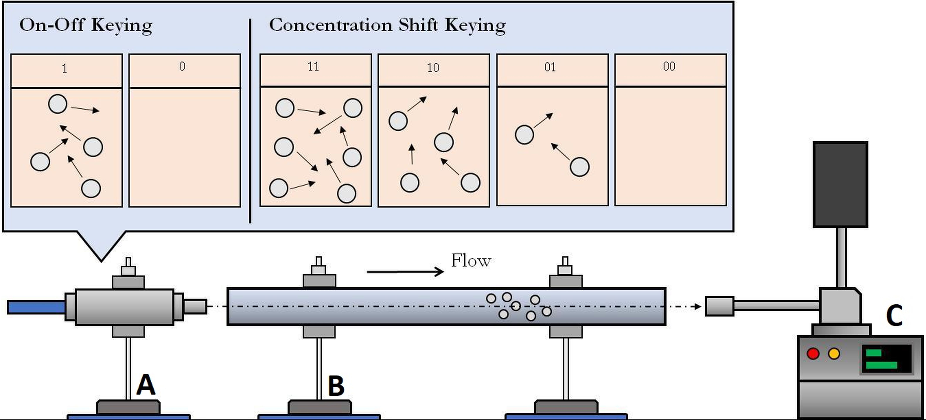
Figure 1. Schematic representation of the macroscale odor molecular communication system. Graphical representation of a) the OE, b) the communication channel and c) the demodulator – MS.

Chemicals
Acetone (HPLC grade, 99.8 % of purity), cyclopentane (reagent grade, 98 %), and methanol (HPLC grade, purity >99.9 %) were provided by Sigma-Aldrich Company, UK. n-Hexane (99.0 %) was purchased from Fisher Scientific. All chemicals were obtained in the liquid phase and were stored at room temperatures prior to their use. Methanolic liquid stock solutions of acetone, cyclopentane and n-hexane were prepared at 1%, 5%, 10% and 25% concentration and stored at ambient conditions.

Odor Modulation
The generation of the chemical signals was achieved using an odor emitter (OE) is described extensively elsewhere.^{29, 30} However, for clarity a brief description of the OE technology is as follows. The OE operating principle is the controlled evaporation of a liquid chemical analyte and its diffusion in a carrier gas stream such as N₂ or zero grade air. The main components of the OE are: a) a mixing chamber (MC), b) an evaporation chamber (EC), c) two high accuracy programmable mass flow controllers (MFCs) for the accurate control of the flow rates within the MC and the EC, d) an automation platform for the simultaneous digital control of the MFCs e) a laptop PC and f) a digital controlled heating mantle for maintaining stable temperatures within the EC. The OE was built-in house from stainless steel (SS) and standard Swagelok fitting unions. The MFCs (type GE50A) and the automation platform were purchased from MKS Instruments UK Ltd. and were digitally calibrated for N₂ gas flow by the manufacturer. The MFC which controls the carrier gas flow passing through the MC had a flow range up to 10 L/min with 1 mL/min increments, whereas the MFC controlling the flow within the EC had a flow range between 0.1 mL/min and 10 mL/min with 0.1 mL/min increments. The automation platform was controlled via custom software in LabView 2015 32 bit for the synchronised operation of the two MFCs. The heating mantle (DM-Series, model number DM-602) was purchased from the Medline Scientific Ltd., with a volume capacity of 250 mL, providing controllably accurate and stable temperatures up to 400ºC continuously be monitored using a high accuracy thermocouple. The original design of the OE comprised of 3 ECs and the associated number of MFCs and heating mantles. The MC has three side inlets for connecting with the ECs. However, during our experimental work, only one EC was used, and the other two side inlets of the MC were sealed with 3.175 mm Swagelok SS plugs. The number of the ECs added on the OE can increase accordingly to the number of the different introduced chemical analytes or groups of analytes. This would enable the controlled generation of more complex vapour pulses at standard concentrations of mixtures of compounds with different physical and chemical properties. The OE was placed on a mobile platform at the same level height with the reference detector allowing convenient transportation at different test distances.

Communication medium
An olfactory test chamber (OTC) was used as a physical communication channel to transmit olfactory signals with encoded digital data from the OE to the demodulator - MS. The OTC was consisting of different size straight clear acrylic tubes with inner diameters 20 mm and lengths 1, 2, 3 and 4 meters. The containers were purchased from the Clear Plastic Shop, Chesterfield, UK at standard dimensions of 1 m and 2 m. During tests, the OTC tubing was supported with multiple laboratory retort stands purchased from Rapid Electronics Ltd., UK to ensure alignment of the OE with the MS inlet. For the 3 and 4-meter experiments, the tubular containers were connected and sealed with several layers of Parafilm M wrapping film.

Odor Demodulation
Two different types of mass spectrometers were used to detect and monitor the produced chemical signals. Most of the experiments were performed using a portable membrane inlet mass spectrometer (MIMS) provided by Q-Technologies Ltd. UK³⁹ as the main demodulation sensor. The technical characteristics of every individual component of the MIMS system have been described in detail previously elsewhere. A second portable MS based system (VapourSense-500, Q-Technologies Ltd. UK) equipped with a short length (2 m) heated at 110ºC GC fused silica capillary column and a sinter leak was also used.
The main parts of the portable MIMS are: a) a non-heated membrane sampling probe that allows the selective gas sample introduction into the MS vacuum, b) a triple filter quadrupole mass spectrometer - QMS (consisting of an EI ion source, mass analyzer and detector) and c) the vacuum system. Sample introduction into the MS was done though a flat polydimethylsiloxane (PDMS) based membrane sampling probe. The description of the membrane probe can be found in detail elsewhere.^{40–44} Data acquisition and interpretation was done by a laptop computer using the NIST mass spectral library.⁴⁵ The multiple ion monitoring mode was selected to screen continuously characteristic mass fragments for the following chemical analytes of interest: acetone (m/z 43, 58), cyclopentane (m/z 42, 55, 70), n-hexane (m/z 56, 57, 86). To evaluate the analytical performance characteristics of our MIMS system as well as to provide quantitative interpretation of the acquired data, the MIMS system was calibrated using static dilution bottles. Gas standards of the compounds of Table 1 were generated in 1.3 L and 2.8 L narrow-neck glass flasks purchased from Sigma Aldrich Company Ltd., U.K. at the following concentrations: blank, 100 ppb, 250 ppb, 500 ppb, 750 ppb, 1 ppm, 5 ppm, 10 ppm and 100 ppm. The gas standards were prepared from liquid stock solutions corresponding at 1000 ppm in methanol each. Information for the preparation of the gas standards can be found in literature.^{41-43, 46-51} The calibration measurements were repeated three times to ensure reproducibility of the results obtained and to allow statistical processing. The experiments showed repeatable measurements with an average relative standard deviation (%RSD) of 4.8 % for the compounds examined. The R² values obtained for acetone (m/z 43), n-hexane (m/z 86) and cyclopentane (m/z 42) correspond to 0.9899, 0.9992 and 0.9981 respectively. This shows that there is a linear relationship between the concentrations investigated and the output signal current values.
Selective experiments using the VapourSense-500 with acetone molecules and for distances up to 2 m followed, to examine the effects of a direct sample inlet (capillary column) onto the received signals. The VapourSense-500 was recently introduced into the MS market and is a portable dual filter quadrupole mass spectrometer equipped with two sample inlets (a membrane probe and a 2 m long heated GC capillary). It has mass range up to 500 Da with a unit resolution and sensitivity in the low-ppb concentration area. It integrates an automated tuning and it does not require sample preparation prior to chemical analysis.

Experimental Setup and Design
During our experiments, a high purity N₂ carrier gas stream set at 1000 mL/min was passing through the MC to carry the controllably modulated vapor plume flows of the analytes of interest generated within the EC. All flows were controlled digitally using high precision MFCs. The simultaneous sequences of both flows (within the MC and the EC) were controlled through an automation platform. Appropriate chemical signalling modulation protocols were developed and described below to allow the investigation of the CSK and the OOK modulation schemes. The outlet of the OE was coupled with the OTC using several layers of parafilm M wrapping film purchased from Sigma Aldrich Ltd. UK. The distance between the odor emitter and the reference detector or between the OTC and the reference detector was maintained at 10 mm. Experiments were performed at ambient environment temperatures (18 - 20 ºC).

- RESULTS AND DISCUSSION
  - Signal modulation experiments
This section shows that digital information can be encoded onto molecular flows allowing chemical signals to carry of information within confined or open spaces. For the experiments below, the experimental set-up described in Figure 1 was used.
For the OOK experiments (Figure 2a) we chose to generate and transmit within our communication channel the single letter ‘‘ r ’’ which has a binary value of 0 1 1 1 0 0 1 0 (ASCII). As such, different flow rate combinations within the MC and the EC corresponding to the digit 0: 1000 mL/min carrier) and 0 mL/min (analyte) respectively) and to the digit 1:1000 mL/min (carrier) and 5 mL/min (analyte) respectively were selected as shown in Table 2. For the experiments, we investigated the transmission of the letter ‘’‘r’’ using three chemical analytes with different volatilities (Table 1) as the carrier media of the binary information over 5 different distances: 0, 1, 2, 3 and 4 m. The N₂ flow rate through the mixing chamber was constantly kept stable at 1000 mL/min throughout the measurements, whereas the N₂ flows through the EC (filled with the test analyte) followed the general step profile of 0 mL/min (for 90 sec), 5 mL/min (for 90 sec), 5 mL/min (for 90 sec), 5 mL/min (for 90 sec), 0 mL/min (for 90 sec), 0 mL/min (for 90 sec), 5 mL/min (for 90 sec), 0 mL/min (for 90 sec). Experiments were triplicated to ensure reproducibility of our results and to allow us to perform statistical analysis.
For the CSK experiments (Figure 2b) and again for the letter ‘‘ r ’’, we followed flow rate combinations corresponding to the binary values: 00, 01, 10 and 11 (Table 3). For the letter ‘‘r’’, the N₂ flow rate through the mixing chamber was again constantly kept stable at 1000 mL/min, whereas the N₂ flows through the EC (filled with the test analyte) followed the general step profile of 1 mL/min (for 90 sec), 3 mL/min (for 90 sec), 0 mL/min (for 90 sec), 2 mL/min (for 90 sec).
Both OOK and CSK techniques concluded with a 120 sec. step of pure N₂ flow at 1000 mL/min through the MC and 0 mL/min through the EC for purging (flush) purposes for the communication medium. The total transmission time for a single ASCII character using the OOK technique is 720 sec., whereas using the CSK, it is 360 sec. For longer message transmission therefore, the CSK approach was selected for time-saving purposes. The information transmission rate is something considered later in this paper.

Table 2. Flow chart for the concentration modulation of target molecules during the OOK experiments.
Binary Value | Nitrogen Flow (mL/min) | Acetone Flow (mL/min)
0 | 1000 | 0
1 | 1000 | 5

Table 3. Flow chart for the concentration modulation of the selected molecules during the CSK experiments.
Binary Value | Nitrogen Flow (mL/min) | Acetone Flow (mL/min)
00 | 1000 | 0
01 | 1000 | 1
10 | 1000 | 2
11 | 1000 | 3

In all the experiments, the flow rate passing through the MC was constantly stable at 1000 mL/min. The digital information was encoded on the chemical flows passing through the EC (flows carrying molecular vapors) in the carrier gas stream of the MC. The differences between the theoretical chemical profiles (Figure 2) and the experimental (Figure 3 and 4) are due to the membrane interface of the reference detector. The theoretical OOK and CSK profiles of Figure 2 are ideal graphical representations of the expected responses and correspond to real-time detected and monitored signals when the OE is at close proximity to the reference detector (10 mm) and there is no membrane interface mediating among them. The membrane inlet used during the measurements offers near-real time monitoring of the chemical pulses and causes delayed detection of the signals before they reach a steady state condition. The membrane interface also deforms slightly the shape of the detected signals (e.g. Figure 3a or 4a) compared to the expected rectangular-shaped pulses. This can be explained by the interaction of the membrane material with chemical compounds with different physical and chemical properties. The nature of the target analyte within the EC also affects the shape of the detected signal e.g. the experimental responses of the MIMS system for cyclopentane show a rectangular-shaped profile compared to the acetone profile. Figure 3a and 3b correspond to 10% methanolic solutions, whereas Figure 4a and 4b correspond to 5% methanolic solutions of acetone and cyclopentane.

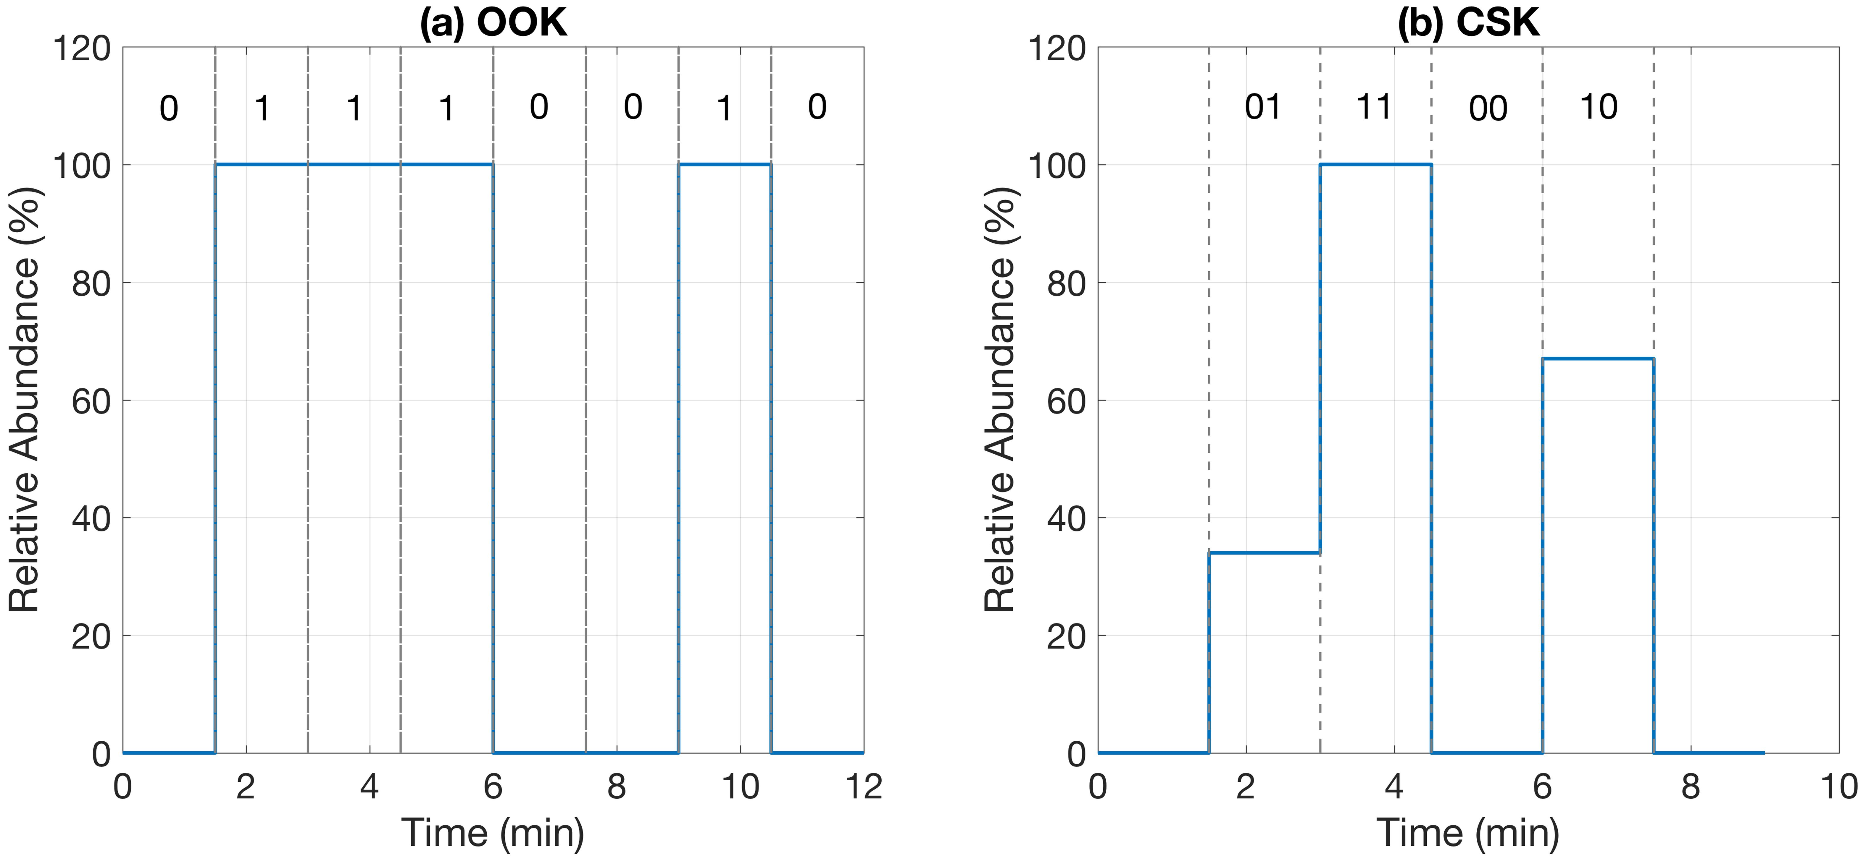
Figure 2. Theoretical chemical signalling representation for the binary letter ‘‘ r ’’ using a) the OOK and b) the CSK modulation approach.

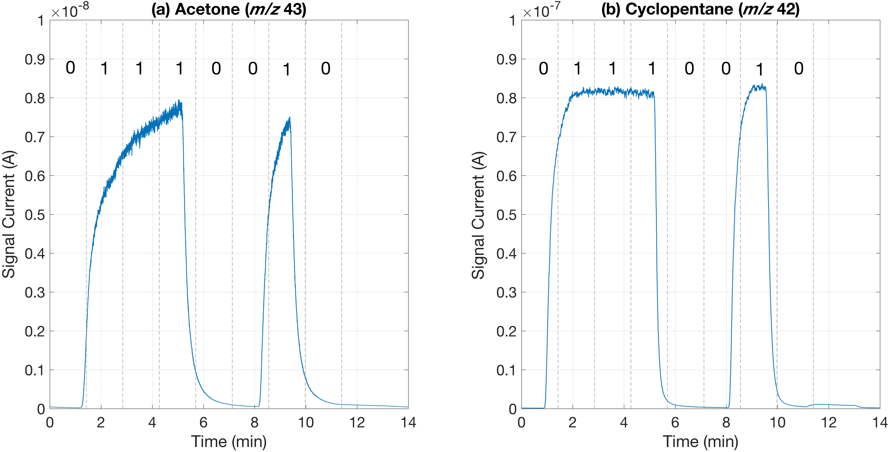
Figure 3. Experimental chemical signalling representation for the binary letter ‘‘ r ’’ using the OOK modulation technique for a) acetone and b) cyclopentane. Data demodulation was done using a portable MIMS system.
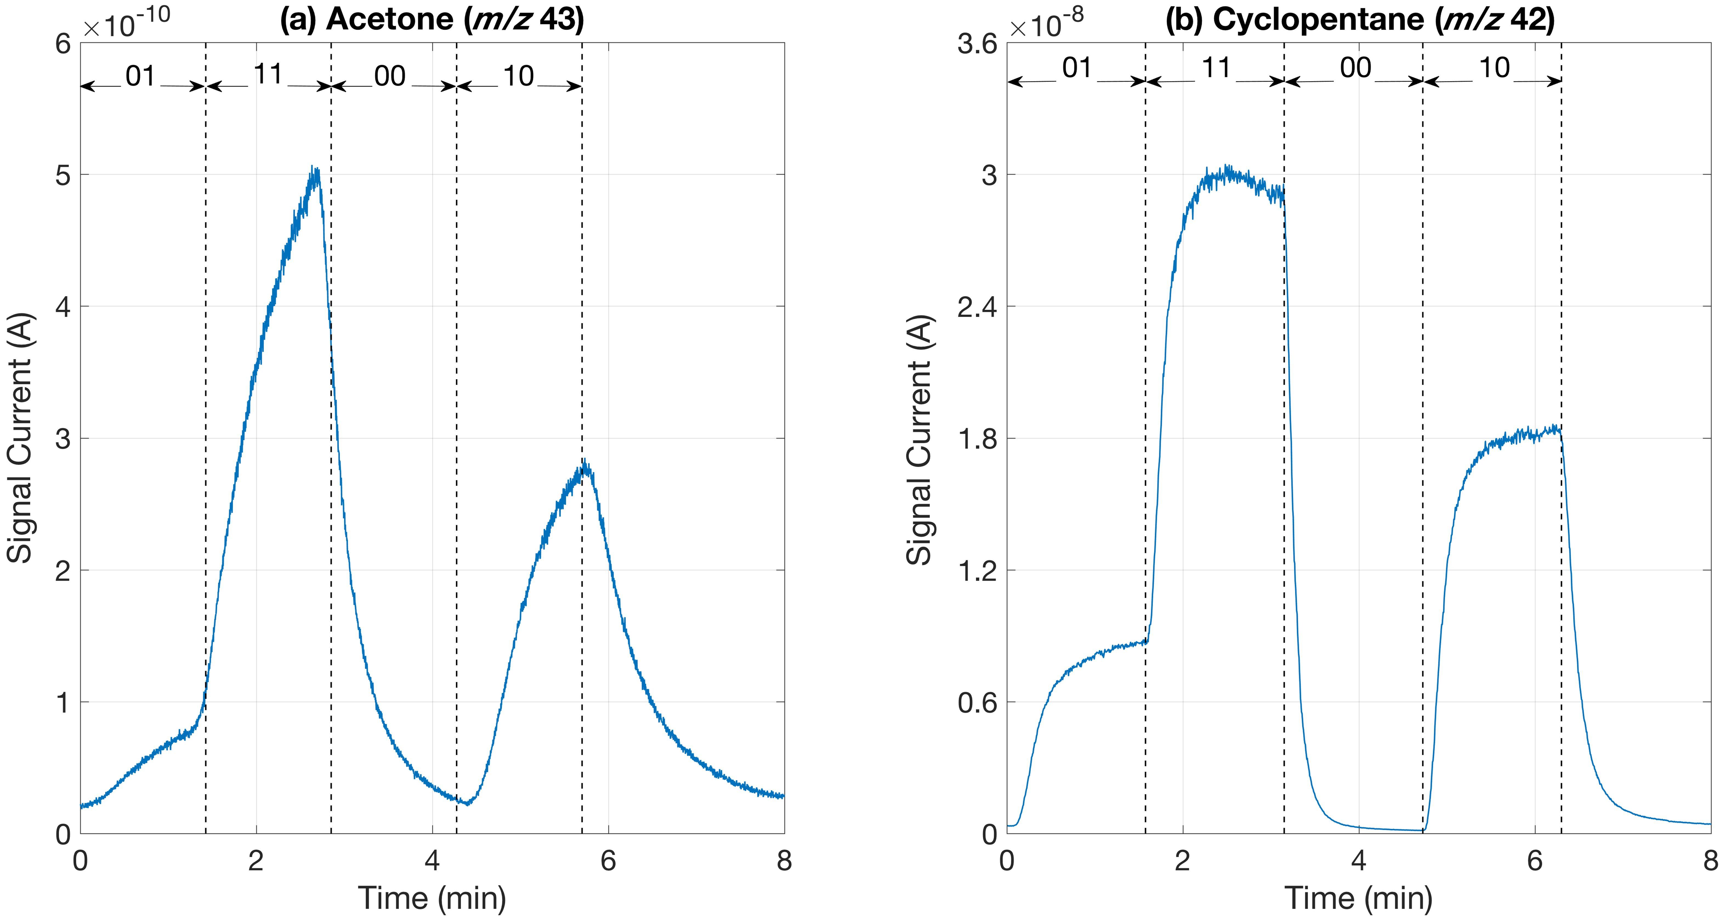
Figure 4. Experimental chemical signalling representation for the binary letter ‘‘r ’’ using the CSK modulation technique for a) acetone and b) cyclopentane. Detection was done using a portable MIMS system. The distance between the OE and the demodulator (MS) was 10 mm.

  - Molecular transmission experiments
In molecular communications, when a chemical signal is transmitted through a medium, attenuation of its intensity may occur due to various reasons e.g. loss of energy of the signal molecules, channel disturbance, channel geometry, etc. As the distance between the signal emitter and the receiver increases, considerable signal attenuation was observed. This section examines molecular transfer phenomena within a semi-open tubular container with 20 mm inner diameter and for distances: 0, 1, 2, 3 and 4 meters for the chemical compounds of the Table 1. Representative experimental data from our transmission system are shown in Figure 5. This presents results for acetone mass fragment m/z 43 for the a) OOK and b) CSK modulation technique. Testing was done with a 10% acetone solution in methanol during the OOK approach, whereas during the CSK method a 5% methanolic solution of acetone was used. The signals of acetone generated by the OE when it is directly connected with the inlet of the MS system were considered to be the reference signals. For the distances examined the generated signals experienced dispersion and signal attenuation at the receiver side. The tests were triplicated to ensure their repeatability.
3.2.1. Modelling of the transmission experiments
Any communication system that utilizes chemicals for transmission purposes can be explained using a simplified expression of the convection - diffusion partial differential equation:
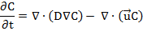 | (1)
The solution for the partial differential equation expressed above is given as:
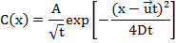 | (2)
where x is the transmission distance (m), u is the velocity vector (m/s), D is the diffusivity constant (m²/s) and the t is the duration of the experiment (s). A is a constant of the equation described by the following expression:
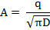 | (3)
where q is the amount of chemical introduced into the system (kg or mol). The equation (2) can be simplified into a Gaussian function defined as:
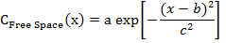 | (4)
where a, b and c are the parameters of the equation. In Ref. 30 experimental results show that the concentration of a transmitted chemical in a bounded medium experiences a linear loss in the signal current that the detector detects. By including a linear loss term in to the overall transmission equation, the following expression can be obtained:
(5)
where d and e are the parameters. The overall transmission equation is given as:
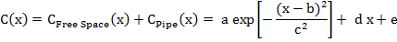 | (6)
Experimentally obtained results along with the comparison of the mathematical model described above can be found in Figure 5. As it can be seen, the signal experiences free space amplitude loss in short distances. This is because as the transmission evolves, the gas stream expands in 3D space (x, y, and z) due to the diffusion of the chemicals and until the expanded gas stream will collide with the boundary of the medium, the amplitude loss of the signal will experience free space amplitude loss. When the gas stream hits the boundary of the medium, the gas stream becomes governed by the medium part of the equation, and experiences linear losses.
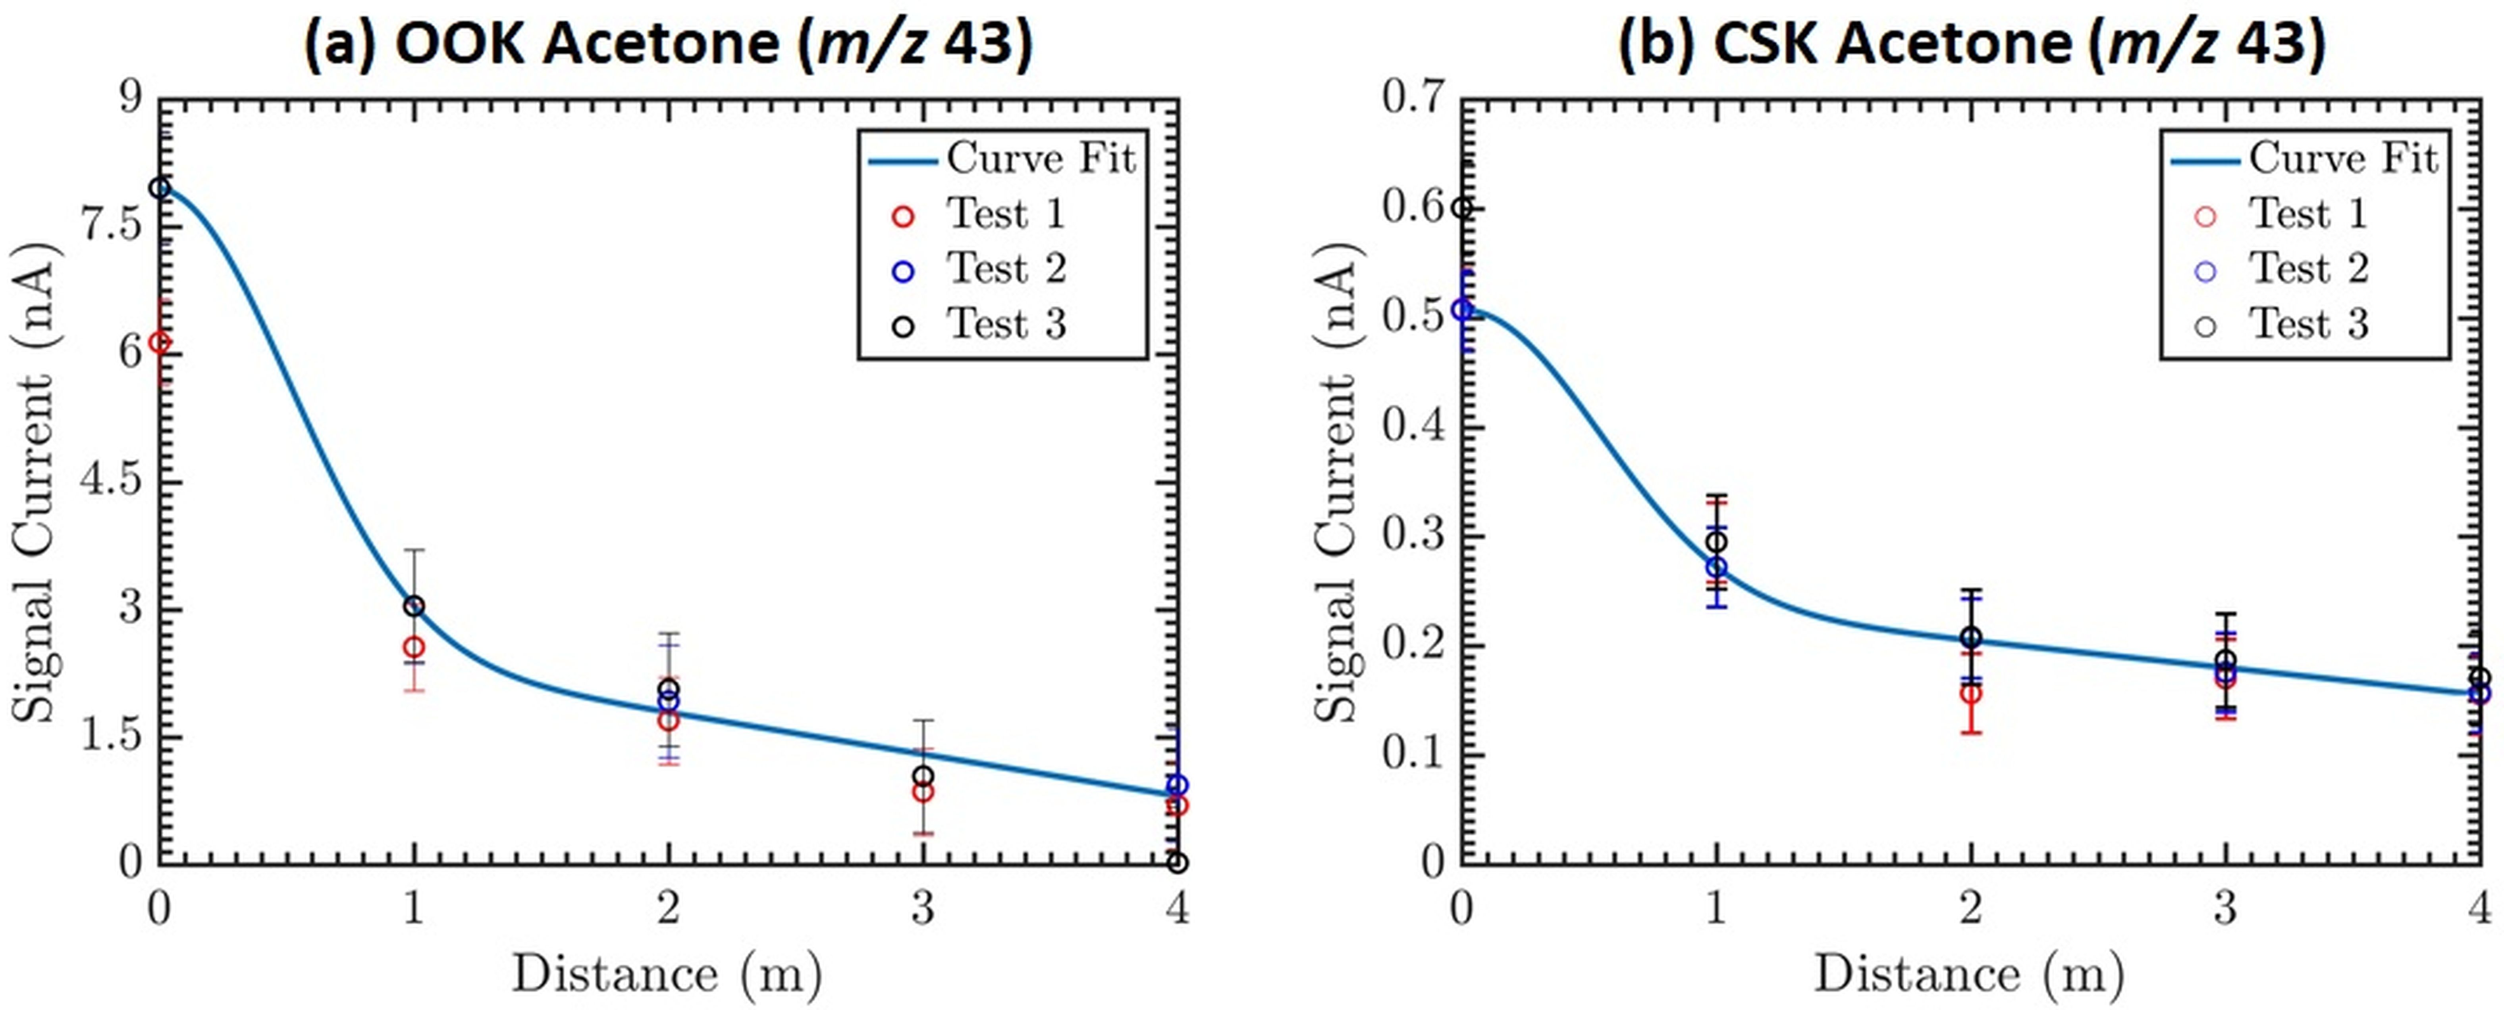
Figure 5. Experimental data obtained from the transmission of acetone (m/z 43) molecules within a tubular container (communication channel) with ID of 20 mm over distances of 0, 1, 2, 3 and 4 m using the a) OOK (R² = 0.99) (a = 5.183,b= 3.529e-12 ,c = 0.7219, d = -0.491, e = 2.77) and the b) CSK (R² = 0.99) (a = 0.2532, b = 0.02719, c = 0.7286, d = -0.02475, e = 0.2543) signal modulation approach.

  - Chemical messaging in macroscale environments
This section describes the transmission of a chemical message over a distance of 2 m. For this purpose, the word ‘‘ion’’ was selected for transmission. In binary (ASCII) form the word ‘‘ion’’ was converted to 01101001, 01101111, 01101110 for the letters ‘‘i’’, ‘‘o’’ and ‘‘n’’ respectively. The CSK modulation approach was selected for signal transmission. The molecular flows presented in Table 3 were used to translate the above binary message in chemical signals. Among each letter a chemical gap of 120 sec was introduced (flow rate through the MC and the EC was 1000 mL/min and 0 mL/min respectively. This was done for discrimination of signals interfering among them. Each binary step had a fixed duration of 90 sec. The signal current axis was split in four clearly discriminated areas corresponding to the binary value combinations 00, 01, 10 and 11. The total duration for the transmission of the message was 22 min. This time can be shortened if the signal transmission is done in a vacuum due to the increased speed of the information molecules.

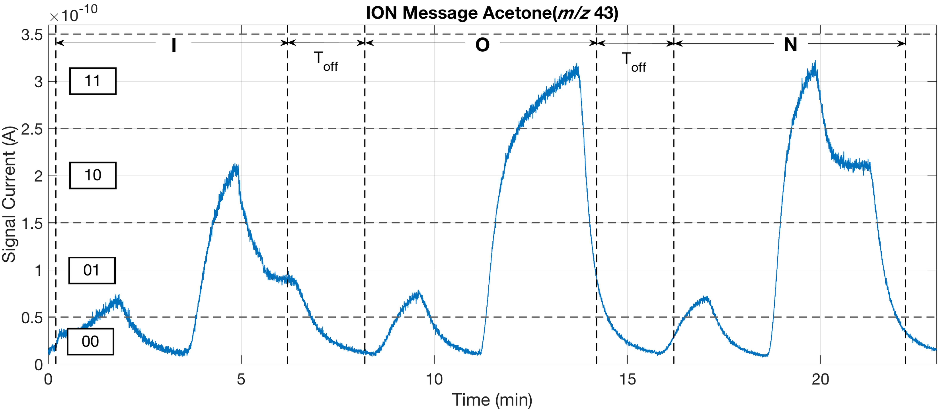
Figure 6. Experimental data showing the transmission of a molecular message corresponding to the word ‘‘ion’’ using particles of acetone within a tubular container with ID of 20 mm over a distance of 2 m. The whole binary message was encoded onto molecular flows using the CSK modulation technique whereas demodulation of the message was done using a portable MIMS system.
To improve the shape of the transmitted signals for communication purposes, the above CSK, OOK and message transmission experiments were repeated with a MS system equipped with a short length capillary inlet with near real-time detection times. Results are presented in Figure 7. The results obtained showed square-shaped molecular pulses. The gradually falling baseline could be effect of the N₂ flow in the mass analyser. Except from the above issue, the signals of all pulses show excellent stability in intensities, whereas the signals detection times are faster compared to the MIMS system.

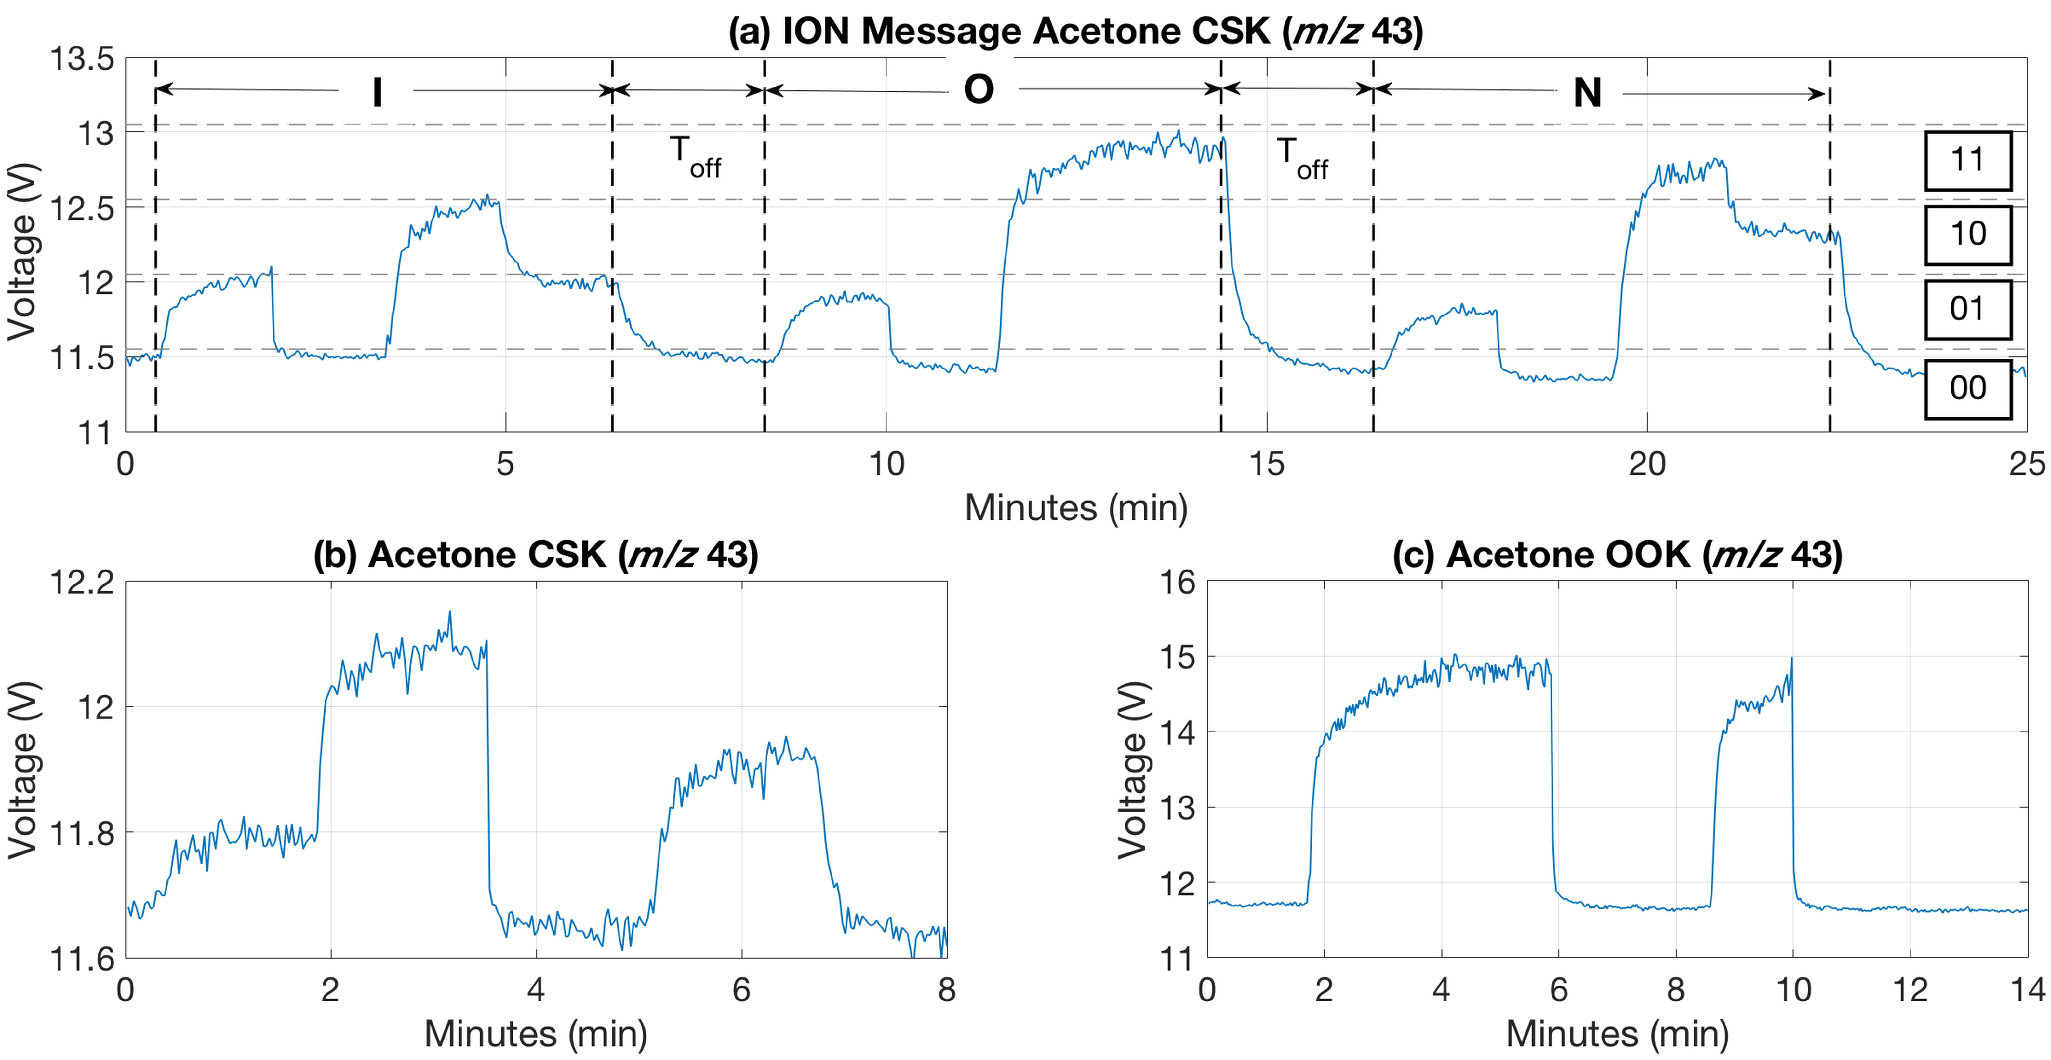
Figure 7. a) Experimental data obtained from the transmission of the word ‘‘ion’’ using acetone molecules (50% in methanol) within a tubular container (communication channel) with ID of 20 mm over a distance of 2 m. Sample quantity was 250 uL, b) experimental molecular representation for the binary letter ‘‘ r ’’ using the CSK modulation technique for acetone and c) chemical representation for the binary letter ‘‘ r ’’ using the OOK signal modulation technique for acetone molecules. For a), b) and c) detection of the binary signals was done using VapourSense- 500. Sample introduction was done with a 2 m heated at 110ºC GC fused silica capillary column.

- CONCLUSIONS
This manuscript describes for the first-time transmission of a chemical alphabet based on molecular flows for molecular communication purposes. The chemical alphabet in this case is a chemical illustration-representation of traditional extended ASCII code realized using VOCs in a nitrogen carrier gas flow. Two signal modulation techniques (OOK and CSK) were used encode digital information onto odors with a view to possible communication applications in macroscale environments. Molecular transmission experiments were performed for the letter ‘‘r’’ with the OOK and CSK approach for various distances up to 4 m. Signal modulation was done using a novel built-in-house OE, whereas detection/demodulation was achieved using portable mass spectrometry (2 systems – a MIMS system and the VapourSense 500). Successful transmission of a chemical message (of the word ‘‘ion’’) was also achieved within a semi-open physical tubular channel over a distance of 2 m. The physical and chemical properties of the modulated particles showed that they affect the propagation of a transmitted signal.
Chemical signalling using the above molecular alphabet showed great potential for alternative secure future communications. The results obtained showed that information can be successfully transmitted using odors. Possible applications include the finance and/or security sectors for secure transmission of encoded digital information. Our future work includes modelling and mathematical explanation of the molecular transmission through different gaseous and aqueous environments. Future work will investigate new modulation schemes using molecular signalling and to compare them with those described and tested in this paper including validation experiments in real case scenarios.

ACKNOWLEDGEMENTS
The research leading to these results has received funding from the Engineering and Physical Sciences Research Council (EPSRC) under grant agreement: EP/M029425/1 ‘Creating a Stink - Investigating Olfactory Transport Streams’. The authors gratefully acknowledge Professor Graham Cooks from Purdue University, Dr Boris Brkic from BioSense Institute and Dr. Neil France and Mr. Barry Smith from Q-Technologies Ltd., UK for their assistance and support. Special thanks are due to Mr. Gareth Blacoe from the Department of Electrical Engineering and Electronics, University of Liverpool for the technical support of this work.

REFERENCES
- Nakamoto, T. Essentials of Machine Olfaction and Taste. John Wiley & Sons Singapore Pre Ltd., 2016.
- Gosain, D.; Sajwan, M. Int. J. Curr. Eng. Tech. 2014, 4, 2804-2812.
- Walrand, J.; Shyam, P. Communication networks: a concise introduction. Morgan & Claypool Publishers, 2010.
- Farsad, N.; Guo, W.; Eckfold, A.W. PLOS ONE 2013, 8, 1-13.
- Mahfuz, M. U.; Makrakis, D.; Mouftah, H. T. Nano. Commun. Netw. 2010, 1, 289–300.
- Nakano, T.; Moore, M. J.; Wei, F.; Vasilakos, A. V.; Shuai, J. IEEE Trans. NanoBiosci. 2012, 11, 135–148.
- Pierobon, M.; Akyildiz, I. IEEE Transactions on Inform. Theor. 2013, 59, 942–954.
- Bush, S. F. Nanoscale Communication Networks. Artech House: Norwood, MA, 2010.
- Parcerisa Gine L.; Akyildiz, I. F. Comput. Netw. 2009, 53, 2753–2766.
- Akyildiz, I. F.; Brunetti, F.; Blazquez, C. Comput. Netw. 2008, 52, 2260–2279.
- Darchini, K.; Alfa, A. S. Nano Commun. Netw. 2013, 4, 73–85.
- Farsad, N.; Eckford, A. W.; Hiyama, S.; Moritani, Y. IEEE Trans. NanoBiosci. 2012, 11, 304–314.
- Cobo, L. C.; Akyildiz, I. F. Nano Commun. Netw. 2010, 1, 244–256.
- Srinivas, K. V.; Eckford, A. W.; Adve, R. S. IEEE Trans. Inf. Theory 2012, 58, 4678–4692.
- Chen, M. -T.; Weiss, R. Nat. Biotechnol. 2005, 23, 1551–1555.
- Pelosi, P.; Zhou, J. J.; Ban, L. P.; Calvello, M. Cell. Mol. Life Sci. 2006, 63, 1658–1676.
- Buck, L.; Axel, R. Cell, 1991, 65, 175-187.
- Ueda, H.; Kikuta, Y.; Matsuda, K. Plant Signal Behav. 2012, 1, 222-226.
- Hansson, B. S.; Van der Pers, J. N. C.; Löfqvist, J. Physiol. Entomol. 1989, 14, 147-55.
- Galizia, C. G.; Sachse, S.; Mustaparta, H. J. Comp. Physiol. A. 2000, 186, 1049–63.
- Durand, K.; Baudouin, J. -Y.; Lewkowicz, D. J.; Goubet, N.; Schaal, B. PLOS ONE 2013, 8, 1-8.
- Justus, K. A.; Cardé, R. T. Physiol. Entomol. 2002, 27, 67–75.
- Agosta, W. C. Chemical Communication: The Language of Pheromones. 1st ed.; Scientific American Library, 1992.
- Reddy, G. V. P., Guerrero, A. Trends Plant Sci. 2004, 9, 253 – 261.
- Tristram, D. W. Pheromones and animal behaviour: communication by smell and taste, Cambridge University Press: Cambridge, 2003; pp 1-36.
- Wyatt, T. D. Nature, 2009, 457, 262-263.
- Brown, Jr. W. L.; Eisner, T.; Whittaker, R. H. BioScience 1970, 20, 21-22.
- United States Environmental Protection Agency – US EPA, https://www.epa.gov/.
- Statheropoulos, M.; Pallis, G. C.; Mikedi, K.; Giannoukos, S.; Agapiou, A.; Pappa, A.; Cole, A.; Vautz, W.; Thomas, C. L. P. Anal. Chem. 2014, 86, 3887–3894.
- Giannoukos, S.; Marshall, A.; Taylor, S.; Smith, J. J. Am. Soc. Mass Spectrom. 2017, DOI: 10.1007/s13361-017-1752-6
- Mukai, M.; Maruo, K.; Kikuchi, J.-I.; Sasaki, Y.; Hiyama, S.; Moritani, Y.; Suda, T. Supramol. Chem. 2009, 21, 284–291.
- Ma, M. Critical Reviews in Biochem. and Mol. Biol. 2007, 42, 463-480.
- Cole, M.; Racz, Z.; Gardner, J. W.; Pearce, T. C. Proc. IEEE Sensors 2012, 1–4.
- Matsukura, H.; Yoneda T.; Ishida, H. IEEE Trans. Visualiz. and Comput. Graph. 2013, 19, 606-615.
- Russell, R. A.: Odour detection by mobile robots, World Scientific: Singapore, 1999.
- Bruen A. A.; Forcinito M. A. Cryptography, Information Theory, and Error-Correction: A Handbook for the 21st Century, John Wiley & Sons, Inc., 2005.
- American National Standards Institute – ANSI, https://www.ansi.org/.
- Mackenzie, C. E. Coded Character Sets, History and Development, Addison-Wesley Publishing Company, Inc., 1980.
- Q-Technologies Ltd., Liverpool, UK, http://q-technologies.co.uk/.
- Giannoukos, S.; Brkić, B.; Taylor, S.; France, N. Anal. Chem. 2014, 86, 1106−1114.
- Giannoukos, S.; Brkić, B.; Taylor S.; France, N. J. Am. Soc. Mass Spectrom. 2015, 26, 231-239.
- Giannoukos, S.; Brkić, B.; Taylor S. Anal. Methods 2016, 8, 6607-6615.
- Giannoukos, S.; Antony Joseph, M. J.; Taylor, S. Anal. Methods 2017, 9, 910-920.
- Giannoukos, S.; Brkić, B.; Taylor, S.; Marshall A.; Verbeck, G. F. Chem. Reviews 2016, 116, 8146-8172.
- National Institute of Standards and Technology – NIST, https://www.nist.gov/.
- McClennen, W. H.; Vaughn, C. L.; Cole, P. A.; Sheya, S. N.; Wager, D. J.; Mott, T. J.; Dworzanski, J. P.; Arnold, N. S.; Meuzelaar H. L. C. Field Anal. Chem. Technol. 1996, 1, 109−116.
- Naganowska-Nowak, A.; Konieczka, P.; Przyjazny A.; Namiesnik, J. Crit. Rev. Anal. Chem. 2005, 35, 31-55.
- Namiesnik, J. J. of Chromatogr. 1984, 300, 79-108.
- Slominska, M.; Konieczka, P.; Namiesnik, J. Trends in Anal. Chem. 2010, 29, 419-429.
- Jardine, K. J.; Henderson, W. H.; Huxman, T. E.; Abrell, L. Atmos. Meas. Tech. 2010, 3, 1569–1576.
- Ballesta, P. P.; Baldan, A.; Cancelinha, J. Anal. Chem. 1999, 71, 2241–2245.

For TOC only



