Acute phase response signalling is altered following cartilage harvest in non-responders to Autologous Chondrocyte Implantation
Charlotte H Hulme^{1,2}, Emma Wilson^{2,3}, Heidi R Fuller¹, Sally Roberts^{1,2}, James B. Richardson^{1,2}, Pete Gallacher^{1,2}, Mandy J. Peffers⁴, Sally L Shirran⁵, Catherine H. Blotting⁵, Karina T Wright^{1,2}
1. Institute of Science and Technology in Medicine, Keele University, Keele, Staffordshire, UK; 2. Robert Jones and Agnes Hunt Orthopaedic Hospital, Oswestry, Shropshire, UK; 3. Chester Medical School, Chester University, Chester, UK; 4. Institute of Ageing and Chronic Disease, University of Liverpool, Liverpool, UK; 5. BSRC Mass Spectrometry and Proteomics Facility, University of St Andrews, North Haugh, Fife, KY16 9ST, UK
Purpose (the aim of the study)
Autologous Chondrocyte Implantation (ACI) has recently been recommended by the National Institute for Health and Care Excellence (NICE) for the UK National Health Service but only for use in knee chondral/osteochondral defects of a specific subset of patients. For this cell therapy to be recommended on a wider scale, a better understanding of the biological mechanisms underlying ACI success/failure is needed, so as to identify potential therapeutic targets for tailored ACI treatments.
ACI is a two stage procedure. During initial surgery (Stage I) healthy cartilage is harvested from the joint. Chondrocytes are then extracted and culture expanded for 3-4 weeks in a GMP laboratory before being implanted into the defect site under a periosteal patch in a second surgery (Stage II). We have previously highlighted that there is a marked response to the cartilage harvest procedure in individuals who do not respond well post-operatively. We therefore aimed to identify biological pathways that are altered in response to cartilage harvest in non-responders to ACI.
Methods
Isobaric tag for relative and absolute quantitation (iTRAQ) nano-liquid chromatography tandem mass-spectrometry (nLC-MS/MS) was used to assess the proteome of high abundance proteins in pooled synovial fluid (SF) samples from the knees of 14 ACI responders and 13 ACI non-responders collected immediately prior to Stages I and II. ACI response was determined by change in Lysholm score at 12 months (the Lysholm is a scale of 0-100; 100 represents a ‘perfect’ functioning knee); mean improvement was 33 points (range 17-54) and mean worsening was 14 points (range -4- 46). This dataset was then combined with our published label-free quantitation (LF) proteomic dataset (1), in which the same SF samples were dynamically compressed to measure low abundance proteins. The combined proteomic profile was assessed using IngenuityTM Pathway Analysis (IPA) software (Qiagen).
Results
Assessment of the differential proteome shift identified in response to cartilage harvest in non-responders using IPA highlighted altered acute phase response signalling when the iTRAQ (p=2.93 x10⁻¹; Fisher’s Exact test) and LF (p= 1.69× 10^{–6}; Fisher’s Exact test) datasets were considered independently and when combined (p=1.10x10⁻⁹; Fisher’s Exact test), indicating this pathway may contribute to the non-responder phenotype. Twenty-two of the 39 proteins that are bioinformatically predicted to be increased in the plasma during the acute phase response were more abundant (≥+1.2 fold change (FC)) in the SF at Stage II compared to Stage I (Figure 1). Further, two of the ten proteins that are predicted to be downregulated demonstrated decreased abundance in the SF at Stage II compared to Stage I. Interestingly, only three of these proteins (fibrinogen alpha chain; fibrinogen beta chain and fibrinogen gamma chain) were identified by both proteomic techniques, with iTRAQ and LF proteomics highlighting a total of 18 and six differentially abundant proteins within the acute phase response signalling pathway, respectively.
Conclusions
Acute phase response signalling has been highlighted as a functional pathway which is associated with the marked proteome shift that exists in response to cartilage harvest in non-responders to ACI. Using two independent proteomic techniques has provided a more comprehensive assessment of the proteins within this pathway. The acute phase response is the body’s first systemic response to trauma and surgery indicating that clinical non-responders may have a greater innate response to initial surgery. Alternatively, this pathway has been associated with the SF proteome in patients with OA (2), perhaps suggesting that ACI non-responders have already developed a more ‘OA-like’ phenotype meaning a therapy to repair cartilage injury may be insufficient to treat this whole joint disease.
References
1. Hulme CH, Wilson EL, et al. Arthritis Res Ther. 2017;19:150. 2. Ritter SY, et al. Arthritis Rheum. 2013;65(4):981–92.

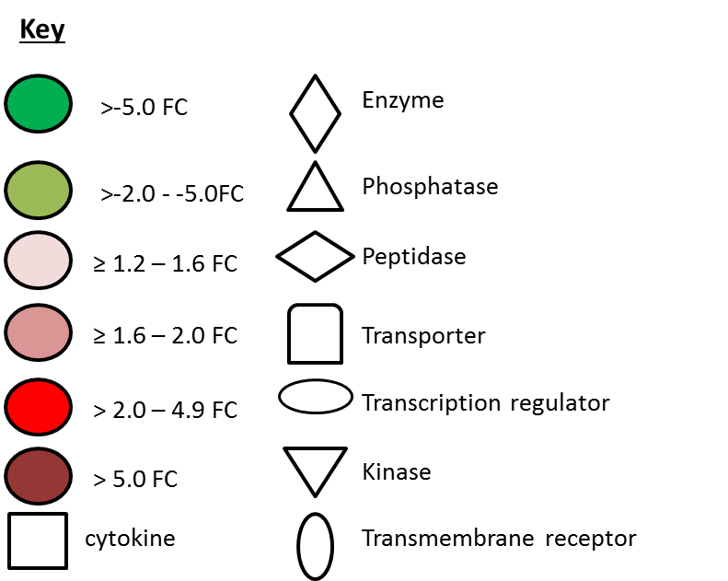
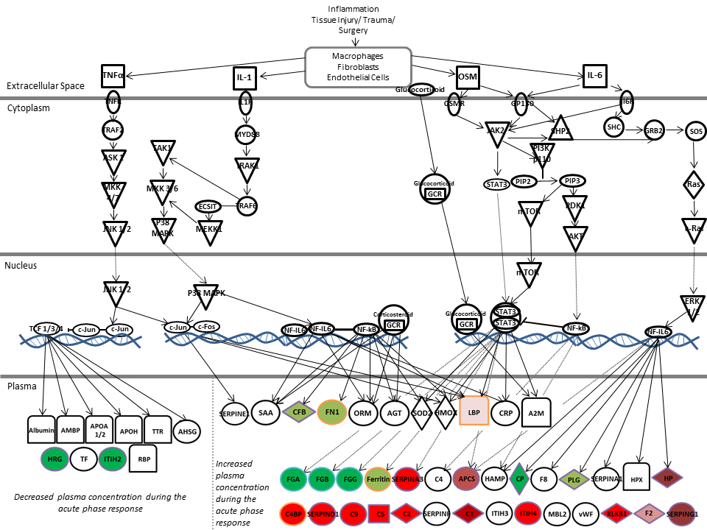

Figure 1: Proteins of Acute Phase Signalling at Stage II compared to Stage I in non-responders to Autologous Chondrocyte Implantation (ACI). Several synovial fluid proteins that are downstream of acute phase response signalling were differentially abundant between Stages I and II of ACI. Proteins edged in purple, orange and blue were identified using iTRAQ nLC-MS/MS, LF LC-MS/MS or by both techniques, respectively. (Adapted from Ingenuity).

