British Journal of Clinical Pharmacology
DRUG INTERACTIONS
Br J Clin Pharmacol (2018) •• ••–•• 1

Clinical impact of pharmacokinetic interactions between the HCV protease inhibitor simeprevir and frequently used concomitant medications

Correspondence Fiona Marra, MPharm, University of Liverpool, 70 Pembroke Place, L69 3GL Liverpool, UK. Tel.: +44 151 794 5553; Fax: +44 151 794 5656; E-mail: ﬁona.marra@liverpool.ac.uk

Received 30 August 2017; Revised 3 January 2018; Accepted 14 January 2018

Fiona Marra¹, Christoph Höner zu Siederdissen², Saye Khoo¹, David Back¹, Michael Schlag³, Sivi Ouwerkerk- Mahadevan⁴, Ceyhun Bicer⁵, Isabelle Lonjon-Domanec⁶, Wolfgang Jessner⁴, Maria Beumont-Mauviel⁶, Ronald Kalmeijer⁷ and Markus Cornberg²
1Department of Molecular and Clinical Pharmacology, University of Liverpool, Crown Street, Liverpool L69 3BX, UK, ²Department of Gastroenterology, Hepatology and Endocrinology, Hannover Medical School, Carl-Neuberg-Str. 130625 Hannover, Germany, ³Janssen Cilag Pharma GmbH, EMEA Medical Affairs, Vorgartenstraße 206B1020 Vienna, Austria, ⁴Janssen Pharmaceutica, Turnhoutseweg 302340 Beerse, Belgium,
5BICER Consulting & Research, Oosterveldlaan 12 A2610 Antwerp, Belgium, ⁶Janssen-Cilag, 1 Rue Camille Desmoulins92130 Issy-les-Moulineaux,
France, and ⁷Janssen Global Services LLC, 1125 Trenton-Harbourton Road, Titusville, NJ, 08560, USA

Keywords DDI, drug–drug interaction, HCV, hepatitis C virus, simeprevir, SMV

AIMS
Direct-acting antiviral agents (DAAs) for the treatment of hepatitis C (HCV) can be associated with drug–drug interactions (DDIs) with concomitant medications. The practical clinical implications of such DDIs are poorly understood. We assessed the clinical impact of possible pharmacokinetic (PK) interactions between simeprevir and frequently prescribed concomitant medications.
METHODS
This post hoc analysis pooled data from nine studies which evaluated simeprevir (SMV)-based interferon-free HCV treatment. Three classes of frequently used concomitant medications of interest (CMOIs) were analysed [antihypertensive drugs (AHDs), anxiolytic drugs (AXDs) and lipid-lowering drugs (LLDs)] and categorized as amber or green according to their DDI potential with SMV (green: no DDIs; amber: potential/known PK interactions). Concomitant medications not recommended to be coadministered with SMV were not included. The composite primary endpoint was deﬁned as the frequency of either discon- tinuation, interruption or dose modiﬁcation of the CMOI during 12 weeks of SMV treatment.
RESULTS
Few patients met the composite endpoint in the various subgroups. Patients on amber CMOIs tended to experience CMOI modiﬁcation more often (13.4–19.4%) than those on green CMOIs (3.1–10.8%). There was no difference in the frequency of adverse events between patients taking green and those taking amber CMOIs.
CONCLUSIONS
In this large pooled analysis, coadministration of the evaluated commonly prescribed medications with known or potential PK interactions with SMV was manageable and resulted in few adjustments of concomitant medications. Our method could serve as a blueprint for the evaluation of the impact of DDIs.

© 2018 The Authors. British Journal of Clinical Pharmacology
published by John Wiley & Sons Ltd on behalf of British Pharmacological Society.
DOI:10.1111/bcp.13519

This is an open access article under the terms of the Creative Commons Attribution-NonCommercial License, which permits use, distribution and reproduction in any medium, provided the original work is properly cited and is not used for commercial purposes.

WHAT IS ALREADY KNOWN ABOUT THIS SUBJECT
- Direct-acting antiviral agents for the treatment of hepatitis C (HCV) can be associated with drug–drug interactions (DDIs) with concomitant medications.
- The practical implications of such DDIs in patients is poorly understood.
- We assessed the clinical impact of possible pharmacokinetic (PK) interactions between simeprevir and frequently pre- scribed concomitant medications.
WHAT THIS STUDY ADDS
- The impact on patient safety and on physicians’ clinical management of coadministration of a HCV protease inhibitor and commonly prescribed comedication with PK interactions is described in detail for the ﬁrst time.
- Our method could serve as a blueprint for evaluating of the impact of DDIs.

Introduction
With the introduction of interferon-free hepatitis C (HCV) therapy consisting of two or more direct-acting antiviral agents (DAAs), the treatment of HCV infection has become less complex, more tolerable and more effective compared with prior interferon-based therapy. However, all DAAs may potentially be associated with drug–drug interactions (DDIs) with concomitant medications due to shared transporter pro- teins or metabolic enzymes. The widespread deployment of DAAs makes optimal management of these DDIs a priority for successful therapeutic outcomes, as many of these con- comitant treatments cannot be avoided [1].
HCV protease inhibitors (PIs) are metabolized via the cytochrome P450 (CYP) system; therefore, a broad range of interactions involving enzyme inhibition and/or induc- tion can be expected, but may vary between PIs [2].
Simeprevir (SMV) is a PI with established clinical efﬁ- cacy in HCV genotypes 1 and 4, and antiviral activity against HCV genotypes 2, 5, and 6 [3]. Hepatic uptake of SMV is me- diated by the organic anion-transporting polypeptide (OATP) 1B1/3 [4]. SMV is primarily metabolized by CYP3A4. Drugs that moderately or strongly inhibit or induce CYP3A4, or in- hibit the hepatic transporter OATP1B1/3, may inﬂuence SMV plasma concentrations. On the other hand, SMV inhibits OATP1B1/3, P-glycoprotein 1 (P-gp), intestinal CYP3A4 and breast cancer resistance protein (BCRP) transporter. Coadministration of SMV with drugs that are substrates for any of these molecules may result in increased plasma concentrations of these drugs [4, 5].
Consequently, coadministration of SMV with drugs that moderately or strongly inhibit or induce CYP3A4 is not rec- ommended [4]. Other medications have known or potential pharmacokinetic (PK) interactions with SMV but can still be coprescribed with caution or may need dose modiﬁcation (e.g. calcium channel blockers and most statins).
HCV infection is associated with an increased risk of extrahepatic disease, including cardiovascular and renal dis- ease, insulin resistance, diabetes mellitus type 2 and neuro- psychiatric disorders [6–9]. Therefore, HCV patients often suffer from a higher total burden of disease, with an increased need for pharmacotherapy compared with HCV-uninfected individuals of a similar age. Polypharmacy has been found to be associated with an increased risk of adverse events (AEs) due to DDIs [10].
Previous research has focused mainly on the descriptive analyses of the prevalence of concomitant medications with
the potential for interactions with DAAs, highlighting the risk of DDIs in subjects receiving a high number of contrain- dicated medications and the need for evaluation of potential DDIs to prevent AEs or the unnecessary risk of treatment failure [11, 12]. A recent analysis of over 400 HIV/HCV coinfected patients receiving DAAs together with their HIV treatment indicated that physicians are aware of potential DDIs between comedication and DAAs, in particular poten- tial DDIs with antiretroviral therapy [13]. To date, the impact on patients and clinical management needs of potential PK interactions between DAAs and concomitant medication has not been assessed systematically. Understanding these practical implications may increase the level of conﬁdence of healthcare providers in handling such DDIs and thus fur- ther improve HCV treatment outcomes.
The primary objective of the present analysis was to inves- tigate the clinical management and treatment outcomes of coadministration of SMV with frequently prescribed con- comitant medications of interest (CMOIs) with known or po- tential PK interactions with SMV.

Methods

Study design
In a post hoc analysis we pooled data from eight prospective interventional studies and one observational study of SMV- based interferon-free HCV therapy.
Studies selected for this analysis were Janssen-sponsored clinical trials evaluating interferon-free combinations of SMV in combination with sofosbuvir (SOF) and/or daclatasvir (DCV) with or without ribavirin (RBV) (Table 1) [14–22]. All studies were conducted in accordance with the 1975 Declaration of Helsinki, approved by independent ethics committees and registered with www.clinicaltrials. gov. Written informed consent was obtained from all pa- tients prior to study initiation. The observational study was conducted at 33 US sites selected to reﬂect a diverse care setting; monitoring and source data veriﬁcation were performed.
For the current analysis, the observation period was de- ﬁned as the screening period (except for the observational study, which did not have a screening period) and the initial 12 weeks of SMV-based HCV treatment.
Three classes of CMOIs were selected for the analysis, ow- ing to their broad use in this population and the potential for

Table 1
Studies included in this post-hoc analysis

Study identiﬁer at ClinicalTrials.gov (Study name) | Type of study | Number of patients included in the analysis, n (%)  N = 876 (100%) | Patient population | Reference | No.
NCT02103699 (SONET) | Prospective observational | 308 (35.2%) | Naïve or experienced, treated with SMV at various practice settings | 19
NCT02114177 (OPTIMIST-1) | Interventional | 155 (17.7%) | Naïve, no cirrhosis, treated with SMV + SOF | 14
NCT02268864 (COMMIT) | Interventional | 106 (12.1%) | Naïve, treated with SMV + DCV in GT 1b | 18
NCT02114151 (OPTIMIST-2) | Interventional | 103 (11.8%) | DAA-naïve, with cirrhosis, treated with SMV + SOF | 15
NCT02165189 (GALAXY) | Interventional | 46 (5.3%) | Liver transplant, treated with SMV + SOF ± RBV | 20
NCT02278419 (OSIRIS) | Interventional | 43 (4.9%) | Naïve or experienced Egyptians, GT 4, treated with SMV + SOF | 16
NCT02262728 (IMPACT) | Interventional | 40 (4.6%) | Cirrhosis, decompensated liver disease, GT 1 and 4, treated with SMV + SOF  + DCV | 22
NCT02250807 (PLUTO) | Interventional | 40 (4.6%) | Naïve or experienced, GT 4, treated with SMV + SOF | 17
NCT01938625 (SATURN) | Interventional | 35 (4.0%) | Liver transplant, GT 1b, treated with SMV + DCV + RBV | 21
DAA, direct-acting antiviral agents; DCV, daclatasvir; GT, HCV genotype; RBV, ribavirin; SMV, simeprevir; SOF, sofosbuvir

DDIs: antihypertensive drugs (AHDs), anxiolytic drugs (AXDs) and lipid-lowering drugs (LLDs). Some of these drugs have known or potential DDIs with SMV, either as victims (SMV affects the concentration of other drugs, particularly with a narrow therapeutic window – e.g. calcium channel blockers, statins, anxiolytics) or as perpetrators (SMV concen- tration is affected by the other drug – e.g. some calcium channel blockers) [4, 5].
Treatment outcomes in patients taking drugs from more than one CMOI class were analysed in each class.
The CMOIs with known or potential DDIs with SMV were labelled ‘amber’, and CMOIs with no known or potential DDIs with SMV were labelled ‘green’. The grouping into green and amber CMOIs was carried out according to the prescribing information for SMV [4] and the Liverpool DDI database (www.hep-druginteractions.org); in the absence of information from either source, expert advice was sought. Medications that are not recommended to be coadministered (‘red’) were disallowed in all clinical studies with SMV at study entry, and thus this category was not considered in the present analysis.

Study population
The overall population was deﬁned as all study patients who had received SMV in combination with other DAAs (±RBV) and were observed for at least 12 weeks. To be included in the DDI analysis, patients also had to be receiving at least one drug from a class of CMOI; patients were required to have started this CMOI before study start or screening, and/or
during the screening period. Patients who had not been on a CMOI during screening or at study start but had started a CMOI after initiation of SMV therapy were excluded from the analysis. Two analysis sets were deﬁned: the outcomes co- hort, which included data from the screening period and the initial 12 weeks of SMV treatment, and patients receiving both green and amber CMOIs were evaluated twice, sepa- rately in each group; and the safety cohort, which included only patient data from the initial 12 weeks of SMV treatment. For both cohorts, patients taking CMOIs from several classes were counted in each CMOI class separately. In the safety cohort, patients had to be still on the CMOI at the start of SMV therapy, resulting in a slightly lower number of subjects. Additionally, in this cohort patients receiving both green and amber CMOIs were only counted in the amber group based on the assumption that safety outcomes would be driven mainly by amber drugs.

Outcome measures
The composite primary endpoint described dosing changes of the CMOI as an indicator for DDI management and was deﬁned as either discontinuation (permanent discontinua- tion or interruption for ≥14 days), interruption (interrup- tion of medication for 2–13 days) or dose modiﬁcation (any increase or decrease from ﬁrst recorded total daily dose or subsequent change, including interruptions up to 1 day of SMV treatment). Clinical information on the reasons for discontinuation, interruption or dose modiﬁcation were not captured in the database, and thus not analysed

retrospectively. No direct analyses of DDIs on a PK level were performed. The primary endpoint was analysed in the outcomes cohort.
Secondary endpoints included the occurrence of AEs and AEs of interest (AEOIs), and discontinuation of SMV, regard- less of causality. Adverse events of interest were deﬁned as AEs that are either associated with the treated comorbidity, are signature AEs for the CMOI and would indicate either underdosing or overdosing. Secondary endpoints were analysed in the safety cohort.

Statistical analyses
Statistical comparisons of baseline demographics and disease parameters in green and amber groups were carried out in the safety cohort. Continuous parameters were tested using the Wilcoxon–Mann–Whitney test, and categorical parameters were tested using the chi-square test. Statistical analysis was conducted using the SAS statistical analysis software (SAS Institute Inc., Cary, N.C., USA). Representation of patients in both the green and amber groups precluded statistical comparison in the outcomes cohort.

Nomenclature of targets and ligands
Key protein targets and ligands in this article are hyperlinked to corresponding entries in http://www. guidetopharmacology.org, the common portal for data from the IUPHAR/BPS Guide to PHARMACOLOGY [23], and are permanently archived in the Concise Guide to PHARMACOLOGY 2017/18 [24, 25].

Results

Baseline characteristics
In total, 876 patients receiving SMV from the nine studies listed in Table 1 comprised the overall population, of which 47% (409/876) of the patients received AHDs, 17% (153/ 876) received AXDs and 11% (96/876) received LLDs. The ob- servational study (SONET) contributed 35% (308/876) of the overall population, and 40% (162/409) of the patients receiv- ing AHDs, 44% (67/153) of those receiving AXDs, and 50% (48/96) of those receiving LLDs. Table S1 presents the propor- tions of patients analysed from the different studies.

Demographics and disease parameters. Patients from the outcomes cohort represented a diverse population, with 31–41% women and 9–34% black/African American in any green or amber CMOI group. Information on the cirrhosis status was available for a large majority (91–100%), with cirrhosis prevalence ranging from 34% to 51% (Table S2). Some numerical (outcomes cohort) and statistically signiﬁcant (safety cohort, Table S3) differences in demographic and disease parameters were detected between the green and amber groups.

Frequency of CMOIs. The prevalence of green vs. amber drugs differed by class of CMOI (Figure 1, Table 2). In the outcomes cohort, the majority of patients on AHDs received only green
AHDs (252/409, 61%), while the opposite was seen in patients on AXDs and LLDs (amber AXDs: 121/153, 79%; amber LLDs: 54/96, 56%) (Figure 1A–C). Patients receiving both green and amber CMOIs of the same drug class were most common in the AHD group (AHDs: 105/409, 26%; LLDs: 13/96, 14%; AXDs: 6/153, 4%). Table S3 lists the CMOIs administered.
The frequency of polypharmacy was high in the study population. In the outcomes cohort, most patients [67% on AHDs (272/409), 64% on AXDs (98/153), and 83% on LLDs
(80/96)] were taking ﬁve or more of any type of concomitant medications. A relevant proportion of patients were taking more than one CMOI (Figure 2A–C).
In the safety cohort, more patients in the amber groups were receiving >1 CMOI (AHD, AXD, LLD) than patients in the green groups [AHDs: 69% vs. 36% (P ≤ 0.001); AXDs: 18.7% vs. 4% (P = 0.061); LLDs: 20% vs. 11% (P = 0.29)].

DDI management (composite primary endpoint in the outcomes cohort)
Most patients remained on their original CMOI without any modiﬁcation during SMV treatment. Between 3.1% (green AXD) to 19.4% (amber LLD) of patients met the composite endpoint (Figure 3A–D).

Outcomes in patients on AHDs. Among patients on AHDs, the overall rate of CMOI treatment changes was similar for green and amber drugs [10.6% (38/357) in the green group, 14.0% (22/157) in the amber group; Figure 3A]. Most CMOI changes were either discontinuations or dose changes, with similar rates for amber and green drugs (Figure 3B). Most dose modiﬁcations of amber drugs were single dose changes (6/10, 60%, with four dose increases), with a subsequent discontinuation in a single patient. Half of all discontinuations of amber AHDs occurred during the screening period or on day 1 of SMV therapy (7/14).

Outcomes in patients on AXDs. Among patients on AXDs, the overall rate of CMOI treatment changes was lower in the green group [3.1% (1/32)] than in the amber group [13.4% (17/127)] (Figure 3A). A single patient stopped a green AXD, while 14/127 patients (11%) discontinued their amber AXD concomitant medication (Figure 3C), 5/14 (36%) during screening or on day 1 of SMV therapy. There was no clear pattern in patients stopping amber AXDs regarding their cirrhosis status, age, type of AXD or timing of discontinuation in relation to SMV treatment.

Outcomes in patients on LLDs. More patients (19.4%, 13/67) receiving LLDs classiﬁed as amber changed their CMOI treatment compared with 3/42 (7.1%) patients on green LLDs (Figure 3A,D). This difference was driven by statin dose reductions at a single timepoint (n = 7), mostly before SMV treatment was initiated (5/7) and in accordance with the US product information and EU Summary of Product Characteristics (SmPC) [4]. Four of these seven patients received a DCV-containing HCV regimen. One patient discontinued the statin following a dose change.
No major differences in the incidence of DDI manage- ment endpoints between clinical studies and the

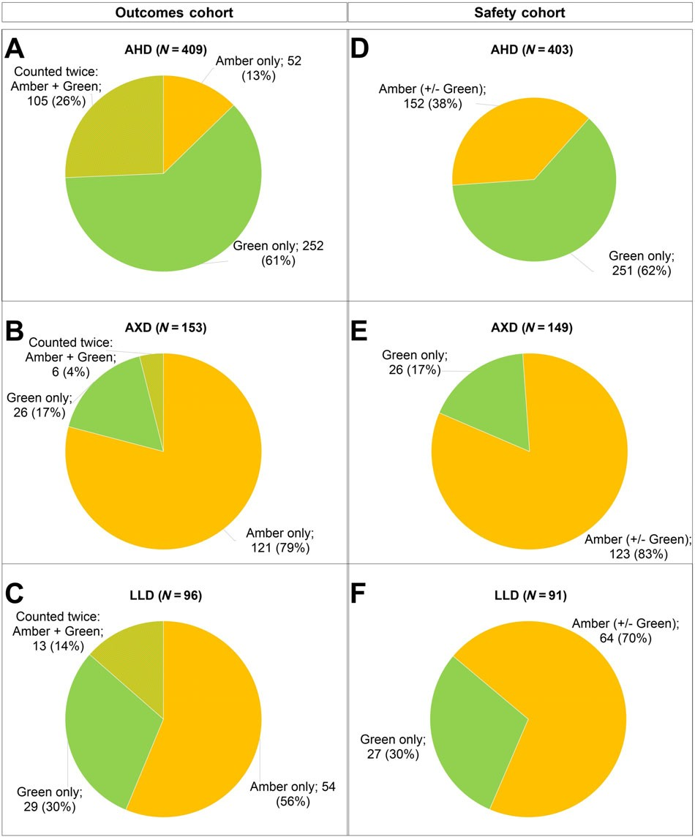

Figure 1
Proportion of green and amber CMOIs. Proportion of patients taking CMOIs classiﬁed as amber, green or both in the outcomes cohort and safety cohort. In both cohorts, most patients on AHDs were taking green AHDs only (A,D). The majority of patients on AXDs (B,E) and LLDs (C,F) were taking amber drugs only. There were slightly fewer patients in the safety cohort. AHD, antihypertensive drug; AXD, anxiolytic drug; CMOI, con- comitant medication of interest; LLD: lipid-lowering drug

observational cohort during the treatment period were ob- served (data not shown). When treatment and screening pe- riods were analysed separately, similar trends to the overall analysis were observed (data not shown). For patients on am- ber LLDs, CMOI changes were mainly carried out during the screening period, and mostly related to statins.

Safety and tolerability (safety cohort)
SMV in combination with green and amber CMOIs was well tolerated, with low rates of serious AEs (SAEs) and grade 3/4 events (Table 3). Similar rates were seen across all groups, ex- cept in patients taking green AXDs, where no such events oc- curred. Two patients discontinued SMV owing to AEs (grade 2–3 rash and sepsis) during the observation period. One pa- tient on a green AHD discontinued SMV owing to death (road
trafﬁc accident, not related to SMV). Another patient discontinued SMV after the observation period, but was in- cluded in the analysis as the AE started during the observa- tion period.

AEs at least possibly related to SMV. AEs (all grades) at least possibly related to SMV were similar across CMOI groups, with no major differences between green and amber drugs (AHDs: green 37.1%, amber 44.1%; AXDs: green 34.6%,
amber 39.8%; LLDs: green 40.7%, amber 32.8%; Table 3). Most of these related AEs were grade 1 or 2, with only seven patients experiencing grade 3 or 4 AEs. Serious AEs at least possibly related to SMV were reported in two patients: one patient on a green AHD (1/251, 0.4%) and one patient on an amber LLD (1/64, 1.6%).

Table 2
List of administered concomitant medication of interest (outcomes cohort)

AHDs started before study/screening and/or during screening  Green (used in more than 3% of patients) (N = 357) |  | Amber (all) (N | = | 157)
Lisinopril | 99 (27.7%) | Amlodipine | 102 (65.0%)
Furosemide | 57 (16.0%) | Carvedilol | 25 (15.9%)
Metoprolol | 57 (16.0%) | Bisoprolol | 20 (12.7%)
Hydrochlorothiazide | 53 (14.8%) | Diltiazem | 10 (6.4%)
Losartan | 43 (12.0%) | Verapamil | 4 (2.5%)
Spironolactone | 39 (10.9%) | Felodipine | 3 (1.9%)
Atenolol | 26 (7.3%) | Indapamide | 2 (1.3%)
Propranolol | 26 (7.3%)
Nadolol | 25 (7.0%)
Enalapril | 20 (5.6%)
Valsartan | 17 (4.8%)
Clonidine | 11 (3.1%)
AXDs started before study/screening and/or during screening  Green (N = 32) |  | Amber (N = 127)
Lorazepam | 22 (68.8%) | Alprazolam | 46 (36.2%)
Temazepam | 6 (18.8%) | Zolpidem | 43 (33.9%)
Oxazepam | 3 (9.4%) | Clonazepam | 26 (20.5%)
Bromazepam | 1 (3.1%) | Diazepam | 14 (11.0%)
Lormetazepam | 1 (3.1%) | Buspirone | 7 (5.5%)
 |  | Clorazepate | 2 (1.6%)
 |  | Eszopiclone | 2 (1.6%)
 |  | Triazolam | 2 (1.6%)
 |  | Zaleplon | 2 (1.6%)
 |  | Zopiclone | 2 (1.6%)
 |  | Prazepam | 1 (0.8%)
LLDs started before study/screening and/or during screening  Green (N = 42) |  | Amber (N = 67)
Omega 3 ﬁsh oil | 31 (73.8%) | Simvastatin | 22 (32.8%)
Ezetimibe | 7 (16.7%) | Atorvastatin | 19 (28.4%)
Fenoﬁbrate | 6 (14.3%) | Pravastatin | 14 (20.9%)
Bezaﬁbrate | 1 (2.4%) | Lovastatin | 5 (7.5%)
Fluvastatin | 1 (2.4%) | Rosuvastatin | 4 (6.0%)
 |  | Gemﬁbrozil | 3 (4.5%)
AHD, antihypertensive drug; AXD, anxiolytic drug; LLD, lipid-lowering drug

Safety of patients who discontinued their CMOI before or on day 1 of SMV initiation. Twelve patients (12/403, 3%) discontinued their AHD before or on day 1 of SMV treatment, six stopped an amber AHD (6/152, 4%) and six stopped a green AHD (6/251, 2%). Six patients started another AHD (two green, four amber) and two of them restarted their original AHD after 2 weeks to 5 months of
discontinuation (one green, one amber). Eleven of these 12 patients experienced AEs, mostly of mild severity (grade 1–2). One grade 4 event (increased lipase) was reported, which resolved during SMV therapy and was considered not to be related to SMV.
Transient cardiovascular AEs of mild to moderate severity (grades 1–2) were reported in four of the 12 patients (two

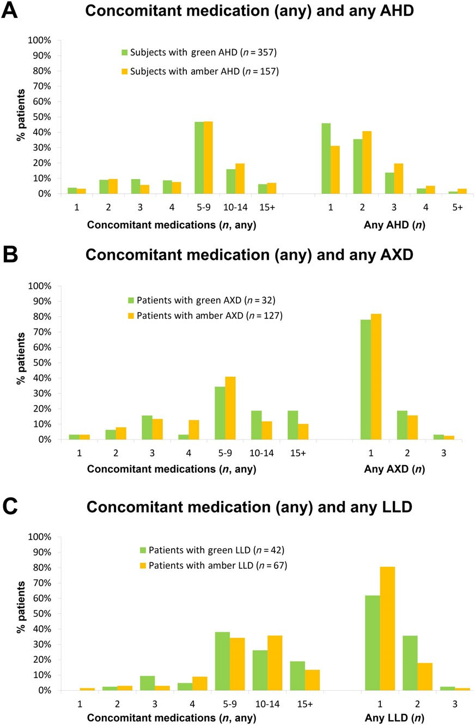

Figure 2
Frequency of CMOI (outcomes cohort). The number of concomitant drugs (any or additional CMOI) given in addition to SMV-based therapy are described. In all patient groups, rates of polypharmacy were similar for amber and green drugs. (A) Among patients on AHDs, the level of polypharmacy was high, with almost half of the patients taking any ﬁve to nine concomitant medications in addition to HCV therapy. It was com- mon to take one or two AHDs. (B) Polypharmacy was high, with most patients on AXDs taking any ﬁve to nine concomitant medications. It was very common to take only one AXD, and less common to take two or three AXDs. (C) Among patients on LLDs, the frequency of any concomitant medications was higher compared with AHDs and AXDs, especially for patients taking 10 or more concomitant medications. It was very common to take only one LLD, and less common to take two or three LLDs. AHD, antihypertensive drug; AXD, anxiolytic drug; CMOI, concomitant med- ication of interest; HCV, hepatitis C virus; SMV, simeprevir; LLD, lipid-lowering drug

green AHDs, two amber AHDs) and not considered by the in- vestigator to be related to SMV.
Among patients on AXDs, ﬁve patients discontinued their AXD before or on day 1 of SMV treatment (0 green AXDs, ﬁve amber AXDs). No patients switched to another AXD. One patient restarted the original AXD
after 2 months of discontinuation. AEs during SMV treatment in these ﬁve patients were mostly mild (grades 1–2). No grade 3/4 AEs were reported. None of these ﬁve patients experienced AEs that indicated a withdrawal syndrome or experienced new or worsening psychiatric symptoms.

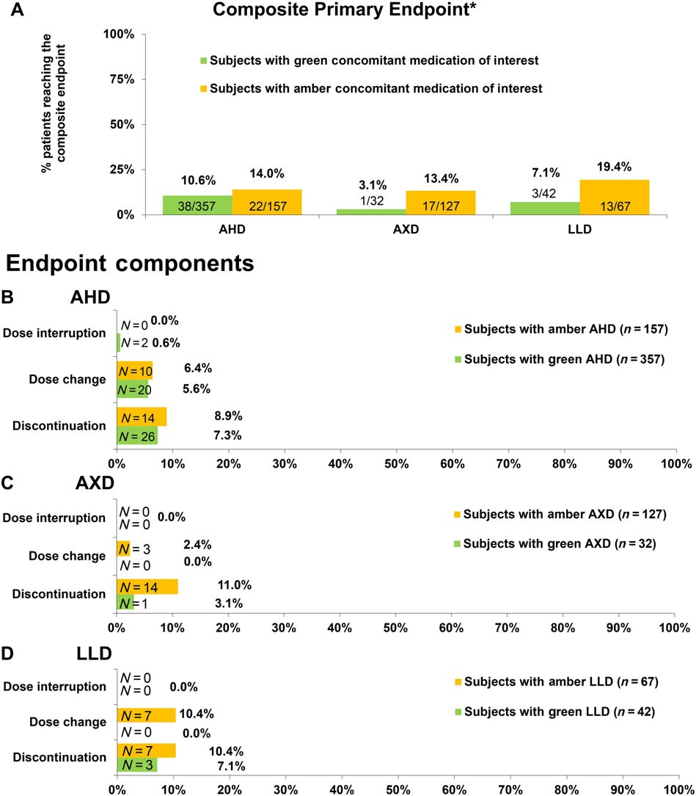

Figure 3
Primary outcome: treatment management of CMOI (outcomes cohort). Composite primary endpoint (A) and endpoint components (B, C, D). AHD, antihypertensive drug; AXD, anxiolytic drug; CMOI, concomitant medication of interest; LLD, lipid-lowering drug*Composite endpoint of either discontinuation, interruption or dose modiﬁcation of the concomitant medication of interest

Five patients discontinued an LLD before or on day 1 of SMV treatment (two green LLDs, three amber LLDs). All am- ber LLDs were statins. None of the patients started another LLD or restarted the original LLD. AEs during SMV therapy (12 weeks) were mostly mild (grades 1–2); no grade 3/4 events were seen. One patient reported two SAEs (vomiting and ab- dominal pain), which resolved and were not considered to be related to SMV treatment. No AEs were linked to the with- drawal of LLDs, including two patients with ongoing hyper- lipidaemia in their medical history.

AEOIs. Overall, AEIOs were rare. No differences among patients on green vs. amber CMOIs for AHDs and LLDs could be detected (Table S4). Among patients taking AXDs, patients on amber CMOIs showed higher frequencies of agitation (8.9% vs. 0.0%) and dizziness (4.1% vs. 0.0%) in comparison with patients on green CMOIs.

Discussion
We have presented a method to characterize the impact on patient safety and clinical management burden of the coad- ministration of DAAs with comedications with potential in- teractions. This is, to our knowledge, the ﬁrst report of such an in-depth analysis in a diverse HCV-infected population with a high prevalence of advanced compensated liver dis- ease and polypharmacy.
One of the strengths of the present analysis was the size- able proportion of safety and outcomes data from carefully executed clinical trials, with strict capturing and follow-up of AEs and clinical outcomes. In addition, complete docu- mentation of concomitant medication intake was available. As the clinical study protocols with SMV generally did not re- quire changes in the dosage of the CMOIs analysed in the present study (e.g. for statins, only general guidance similar to the SmPC was included), the management of concomitant

Table 3
Safety summary and tolerability of simeprevir (SMV) in combination with green and amber concomitant medication of interest (safety cohort)

Drug class of interest AHD (N = 403) |  | AXD (N = 149) |  | LLD (N = 91)
(Patients on both green and
amber drugs were counted Green | Amber | Green | Amber | Green | Amber
only in the amber group) n = 251 (62%) | n = 152 (38%) | n = 26 (17%) | n = 123 (83%) | n = 27 (30%) | n = 64 (70%)
≥1 AE (all grades), n (%) 159 (63.3%) | 98 (64.5%) | 17 (65.4%) | 79 (64.2%) | 19 (70.4%) | 35 (54.7%)
≥1 SAE, n (%) 18 (7.2%) | 9 (5.9%) | 0 | 9 (7.3%) | 2 (7.4%) | 2 (3.1%)
≥1 Grade 3/4 AE, n (%) 22 (8.8%) | 11 (7.2%) | 0 | 7 (5.7%) | 2 (7.4%) | 5 (7.8%)
Discontinuation of SMV 3^{a,b}(1.2%)  (any AE), n (%) | 1^{c}(0.7%) | 0 | 0 | 1^{b}(3.7%) | 0
AEs at least possibly related to SMV
≥1 AE (all grades), n (%) 93 (37.1%) | 67 (44.1%) | 9 (34.6%) | 49 (39.8%) | 11 (40.7%) | 21 (32.8%)
≥1 Grade 3/4 AE, n (%) 4 (1.6%) | 2 (1.3%) | 0 | 1 (0.8%) | 0 | 0
≥1 SAE, n (%) 1^{d}(0.4%) | 0 | 0 | 0 | 0 | 1e(1.6%)
AE, adverse event; AHD, antihypertensive drug; AXD, anxiolytic drug; LLD, lipid-lowering drug; n, number of patients; SAE, serious adverse event aReasons for discontinuation: hyperbilirubinaemia Grade 4 (possibly related; recovered), sepsis (not related; recovered), road trafﬁc accident (not related; death)
bReason for discontinuation: sepsis (not related; recovered) – same patient as in green AHD group
cReason for discontinuation: rash Grade 2/3 (probably related; recovered)
dAnaemia Grade 3 and hyperbilirubinaemia Grade 4 (possibly related to SMV therapy; recovered/resolved)
ePhotosensitivity reaction Grade 1 (possibly related to SMV therapy; recovered/resolved)

medication in these studies resembles routine clinical prac- tice. In addition, the observational study contributed a sub- stantial proportion of the study population, reﬂecting common clinical practice. Investigators in the observational study were obliged to record changes in a participant’s con- comitant medications. Moreover, monitoring and source data veriﬁcation took place in the observational study, and dose changes possibly related to DDI management were most likely reported. This was conﬁrmed by an additional analysis separating the data from the clinical trials, and the observational study revealing similar low rates of DDI management incidence during the treatment period in both settings.
Most patients remained on their original CMOI without dose change or interruption during SMV treatment. In addi- tion, only small differences in CMOI management between green and amber drugs were observed. As green CMOIs are not known to interact with SMV, this indicates that SMV treatment in the presence of amber CMOIs with known or po- tential PK interactions is manageable with few adaptations. If dose changes or discontinuations were considered necessary, they were to similar degrees implemented during screening and during SMV treatment, except for changes of amber LLDs. Most of these LLDs were statins, which may have been pre-emptively adjusted for potential DDIs with SMV. This fur- ther indicates that patients on some statins may – in accor- dance with the label – require DDI management prior to SMV treatment. In the studies analysed, healthcare profes- sionals were aware of potential DDIs and the recommended coadministration, and followed clinical recommendations. However, as the number of patients in the various subgroups decreases, especially for AXDs and LLDs, interpretations should be made with caution.
In this group of well-managed patients, 12 weeks of SMV- based treatment were generally well tolerated, despite a high level of polypharmacy and a large proportion of patients with advanced disease, with most AEs being of mild or moderate severity.
No major differences in the safety outcomes were ob- served between green and amber CMOIs for AHDs and LLDs, despite some differences existing in baseline parame- ters among patients on AHDs, and patients on amber drugs tending to have a higher frequency of polypharmacy. Patients on amber AXDs had a higher rate of AEOIs, such as agitation; however, we could not determine whether these AEs were due to DDIs. Moreover, signiﬁcant differ- ences in baseline parameters existed between the green and amber groups.
In patients who discontinued their CMOIs before starting SMV therapy, few AEs were reported. These AEs were not likely to be associated with the discontinuation of the respec- tive CMOI. For discontinuations of LLDs, the observation pe- riod may have been too short for the development of any AE linked to hyperlipidaemia.

Limitations
The present study was a post hoc analysis. Patients on green and amber AHDs and AXDs differed slightly in key disease and demographic parameters and in polypharmacy rates, limiting comparisons between groups. Outcomes were not differentiated for patients taking drugs from several drug clas- ses of interest. In the database, there was no information available on whether dose changes or dose interruptions of CMOIs were due to DDIs with HCV treatment. In cases where DDIs may have been the reason for reaching the primary or

secondary endpoint, the data did not allow us to identify the interacting drugs (SMV, DCV, SOF or RBV).
We did not analyse the potential for DDIs in patients receiving multiple concomitant medications, as the main objective was to elucidate the impact of the short-term anti-HCV treatment. However, some of the CMOI changes could have been due to interactions with drugs other than the DAAs.
Clinicians may already have taken the ongoing concomi- tant medication into account prior to screening, potentially resulting in recruitment of patients with easy to manage con- comitant medications. On the other hand, clinical trials doc- ument and grade safety events in a much more complete, consistent and reproducible manner compared with real- world cohorts, providing a robust picture of the real safety issues. Further, in the present analysis a high degree of polypharmacy was still seen, so we do not consider exclusion of certain comedications to be a relevant confounder of our analysis. In an unselected sample of 261 DAA-naive HCV- mono-infected patients, only 0.4% received a concomitant medication that was strictly contraindicated for SMV–SOF, while drugs with potential DDIs (category amber) were found in 31% of the sample [11]. Our dataset thus was a good reﬂec- tion of the distribution of comedications used by mono- infected patients in routine clinical practice.

Conclusions
In the present post hoc analysis of pooled data from eight clin- ical trials and one observational study with interferon-free SMV combinations, coadministration of the evaluated medications with known or potential PK interactions with SMV was manageable. This observation is encouraging and should increase the level of conﬁdence of healthcare pro- viders in handling such DDIs, thereby improving the man- agement of HCV patients. However, healthcare providers should remain vigilant of potential DDIs when administering HCV medication.
Our method could serve as a blueprint for the evaluation of the impact of DDIs in other areas – e.g. with other DAAs, to elucidate the clinical consequences of administering DAAs in a setting with a high rate of comorbidities and concomi- tant medication. With this method, it would be possible to utilize clinical study outcomes data in retrospect, in the ab- sence of prospectively collected PK data.

Competing Interests
F.M. reports personal fees and nonﬁnancial support from Abbvie, Gilead, MSD, BMS and Janssen outside the submitted work. C.H.S. reports grants from the German Federal Ministry of Education and Research, and personal fees from Gilead during the conduct of the study, as well as personal fees from Roche, Gilead and MSD outside the submitted work. S.K. re- ports grants from Merck, Abbvie, Gilead, Janssen and ViiV outside the submitted work. D.B. reports grants from Janssen during the conduct of the study, and grants and personal fees from Janssen, Abbvie, Gilead and Merck outside the submit- ted work. M.S. is an employee and shareholder of Janssen
Cilag Pharma. S.O.M. reports personal fees from Johnson & Johnson outside the submitted work. C.B. reports personal fees from Bicer Consulting & Research BVBA during the con- duct of the study and outside of the submitted work. I.L.D. is an employee of Janssen. W.J. is an employee of Janssen Pharmaceutica NV and a shareholder of Johnson & Johnson.
M.B.M. is an employee of Janssen. R.K. is an employee of Janssen Pharmaceutica. M.C. reports grants and personal fees from Abbvie, Bristol-Myers Squibb, Gilead, Janssen-Cilag, Roche, Merck, MSD, Biogen, Falk Foundation, Boehringer- Ingelheim and Siemens outside the submitted work. The data have been previously presented, in part, as a poster at the fol- lowing conferences: EASL Special Conference 2016 (Poster 251), International Liver Congress 2017 (Poster THU-281) and International Workshop on Clinical Pharmacology of Antiviral Therapy 2017 (Poster 35).
The authors thank Sandy van Hemelryck for reviewing part of the data and T.O.M. Life Science Consulting for editorial assistance. The study and editorial assistance was supported financially by Janssen Cilag Pharma.

Contributors
F.M., C.H.S., S.K., D.B., M.C., R.K., M.B., W.J., M.S. and I.L.D.
were responsible for the study concept and design. F.M., C.H.S., S.K., D.B., M.C., S.O.M., C.B., W.J. and M.S. carried
out analysis and interpretation of the data. F.M., C.H.S., S.K., D.B., M.C., C.B. and M.S. drafted the manuscript, with editorial support from T.O.M. Life Science Consulting. All authors critically revised and approved the manuscript.

References
- Back D, Else L. The importance of drug-drug interactions in the DAA era. Dig Liver Dis 2013; 45 (Suppl. 5): S343–8.
- Soriano V, Labarga P, Barreiro P, Fernandez-Montero JV, de Mendoza C, Esposito I, et al. Drug interactions with new hepatitis C oral drugs. Expert Opin Drug Metab Toxicol 2015; 11: 333–41.
- Moreno C, Berg T, Tanwandee T, Thongsawat S, Van Vlierberghe H, Zeuzem S, et al. Antiviral activity of TMC435 monotherapy in patients infected with HCV genotypes 2-6: TMC435-C202, a phase IIa, open-label study. J Hepatol 2012; 56: 1247–53.
- Janssen-Cilag International NV. Olysio – Summary of Product Characteristics. Eur Med Agency 2017. Available at http://www. ema.europa.eu/docs/en_GB/document_library/EPAR_-_Product_ Information/human/002777/WC500167867.pdf (last accessed February 2018).
- Ouwerkerk-Mahadevan S, Snoeys J, Peeters M, Beumont-Mauviel M, Simion A. Drug-drug interactions with the NS3/4A protease inhibitor simeprevir. Clin Pharmacokinet 2016; 55: 197–208.
- Fukui M, Kitagawa Y, Nakamura N, Yoshikawa T. Hepatitis C virus and atherosclerosis in patients with type 2 diabetes. JAMA 2003; 289: 1245–6.
- Jacobson IM, Cacoub P, Dal Maso L, Harrison SA, Younossi ZM. Manifestations of chronic hepatitis C virus infection beyond the liver. Clin Gastroenterol Hepatol 2010; 8: 1017–29.

- Adinolﬁ LE, Zampino R, Restivo L, Lonardo A, Guerrera B, Marrone A, et al. Chronic hepatitis C virus infection and atherosclerosis: clinical impact and mechanisms. World J Gastroenterol 2014; 20: 3410–7.
- Adinolﬁ LE, Nevola R, Lus G, Restivo L, Guerrera B, Romano C, et al. Chronic hepatitis C virus infection and neurological and psychiatric disorders: an overview. World J Gastroenterol 2015; 21: 2269–80.
- Gleason LJ, Luque AE, Shah K. Polypharmacy in the HIV-infected older adult population. Clin Interv Aging 2013; 8: 749–63.
- Höner Zu Siederdissen C, Maasoumy B, Marra F, Deterding K, Port K, Manns MP, et al. Drug-drug interactions with novel all oral interferon-free antiviral agents in a large real-world cohort. Clin Infect Dis 2016; 62: 561–7.
- Patel N, Nasiri M, Koroglu A, Bliss S, Davis M, McNutt L-A, et al.A cross-sectional study comparing the frequency of drug interactions after adding simeprevir- or sofosbuvir-containing therapy to medication proﬁles of hepatitis C monoinfected patients. Infect Dis Ther 2015; 4: 67–78.
- Smolders EJ, Smit C, de Kanter C, Dofferhoff A, Arends JE, Brinkman K, et al. Management of drug interactions with direct- acting antivirals in Dutch HIV/hepatitis C virus-coinfected patients: adequate but not perfect. HIV Med 2017. https://doi. org/10.1111/hiv.12570.
- Kwo P, Gitlin N, Nahass R, Bernstein D, Etzkorn K, Rojter S, et al. Simeprevir plus sofosbuvir (12 and 8 weeks) in hepatitis C virus genotype 1-infected patients without cirrhosis: OPTIMIST-1, a phase 3, randomized study. Hepatology 2016; 64: 370–80.
- Lawitz E, Matusow G, DeJesus E, Yoshida EM, Felizarta F, Ghalib R, et al. Simeprevir plus sofosbuvir in patients with chronic hepatitis C virus genotype 1 infection and cirrhosis: a phase 3 study (OPTIMIST-2). Hepatology 2016; 64: 360–9.
- El Raziky M, Gamil M, Ashour MK, Sameea EA, Doss W, Hamada Y, et al. Simeprevir plus sofosbuvir for eight or 12 weeks in treatment-naïve and treatment-experienced hepatitis C virus genotype 4 patients with or without cirrhosis. J Viral Hepat 2016; 24: 102–10.
- Buti M, Calleja JL, Lens S, Diago M, Ortega E, Crespo J, et al. Simeprevir in combination with sofosbuvir in treatment-naïve and -experienced patients with hepatitis C virus genotype 4 infection: a phase III, open-label, single-arm study (PLUTO). Aliment Pharmacol Ther 2017; 45: 468–75.
- Hezode C, Almasio P, Bourgeois S, Buggisch P, Brown A, Diago M, et al. Efﬁcacy and tolerability of simeprevir and daclatasvir for 12 or 24 weeks in HCV genotype 1b-infected treatment-naive patients with advanced ﬁbrosis or compensated cirrhosis. J Hepatol 2016; 64 (Suppl): S754.
- Alam I, Brown K, Donovan C, Forlenza J, Lauwers K, Mah’moud MA, et al. Real-world effectiveness of simeprevir-containing
regimens among patients with chronic hepatitis C virus: the SONET study. Open Forum Infect Dis 2017; 4: ofw258.
- O’Leary JG, Fontana RJ, Brown K, Burton JR, Firpi-Morell R, Muir A, et al. Efﬁcacy and safety of simeprevir and sofosbuvir with and without ribavirin in subjects with recurrent genotype 1 hepatitis C postorthotopic liver transplant: the randomized GALAXY study. Transpl Int 2017; 30: 196–208.
- Forns X, Berenguer M, Herzer K, Sterneck M, Donato MF, Andreone P, et al. Efﬁcacy, safety, and pharmacokinetics of simeprevir, daclatasvir, and ribavirin in patients with recurrent hepatitis C virus genotype 1b infection after orthotopic liver transplantation: the phase II SATURN study. Transpl Infect Dis 2017; 19: e12696. https://doi.org/10.1111/tid.12696.
- Lawitz E, Poordad F, Gutierrez JA, Kakuda TN, Picchio G, Beets G, et al. 39-SVR12 results from the phase II, open-label IMPACT study of simeprevir (SMV) in combination with daclatasvir (DCV) and sofosbuvir (SOF) in treatment-naïve and -experienced patients with chronic HCV genotype 1/4 infection and decompensated liver disease. Hepatology 2015; 1: 227A.
- Harding SD, Sharman JL, Faccenda E, Southan C, Pawson AJ, Ireland S, et al. The IUPHAR/BPS guide to PHARMACOLOGY in 2018: updates and expansion to encompass the new guide to IMMUNOPHARMACOLOGY. Nucl Acids Res 2018; 46: D1091–106.
- Alexander SPH, Fabbro D, Kelly E, Marrion NV, Peters JA, Faccenda E, et al. The Concise Guide to PHARMACOLOGY 2017/18: enzymes. Br J Pharmacol 2017; 174: S272–359.
- Alexander SPH, Kelly E, Marrion NV, Peters JA, Faccenda E, Harding SD, et al. The Concise Guide to PHARMACOLOGY 2017/18: Transporters. 2017; 174: S360–446.

Supporting Information
Additional Supporting Information may be found online in the supporting information tab for this article.

http://onlinelibrary.wiley.com/doi/10.1111/bcp.13519/suppinfo

Table S1 Patients taking green vs. amber concomitant med- ication of interest by trial (outcomes cohort)
Table S2 Key baseline demographic and disease parameters (outcomes cohort)
Table S3 Key baseline demographic and disease parameters (safety cohort)
Table S4 Frequency of adverse events of interest (safety cohort)

