Please cite the paper as:
Han J, Shi F, Chen L, Childs PRN (2018). A computational tool for creative idea generation based on analogical reasoning and ontology. Artificial Intelligence for Engineering Design, Analysis and Manufacturing 1–16. https://doi.org/10.1017/ S0890060418000082

A computational tool for creative idea generation based on analogical reasoning and ontology

Ji HAN, Feng SHI, Liuqing CHEN, Peter R.N. CHILDS
Dyson School of Design Engineering, Imperial College London

Corresponding Author: Ji Han, Dyson School of Design Engineering, South Kensington, London, SW7 2AZ, UK, +44 (0) 7754358855, j.han14@imperial.ac.uk.

Short Title: The Retriever

Tables: 6
Figures: 7

A computational tool for creative idea generation based on analogical reasoning and ontology

Abstract
Analogy is a core cognition process used to produce inferences as well as new ideas using previous knowledge and experience. Ontology is a formal representation of a set of domain concepts and their relationships. The use of analogy and ontology in design activities to support design creativity have previously been explored. This paper explores an approach to construct ontologies with sufficient richness and coverage to support reasoning over real-world datasets for prompting creative idea generation. This approach has been implemented into a computational tool for assisting designers in generating creative ideas during the early stages of design. The tool, called ‘the Retriever’, has been developed based on ontology by embracing aspects of analogical reasoning. A case study has indicated that the tool can be effective and useful for idea generation. The results have indicated that the tool, in its current formulation, can significantly improve the fluency and flexibility of idea generation and the usefulness of ideas, as well as slightly increase the originality of ideas, for the case study concerned.

Keywords: Design creativity, Creativity, Ideation, Analogy, Ontology

- Introduction
Design can be described as a specific end to the deployment of creativity, which couples creativity to innovation. Product design and development often starts from problem definition and is followed by idea generation. Idea generation or ideation can be described as the process of creating, developing and communicating ideas, where an ‘idea’ is considered as a basic element of thought in either visual, concrete or abstract forms (Jonson, 2005). It is deemed to be the foundation of innovation (Sarkar and Chakrabarti, 2011, Cash and Štorga, 2015). Ideation essentially determines the type of designs produced, and is regarded as having a significant role in novel concept development and business success (Howard et al., 2011). Creativity is defined as ‘the process by which something so judged (to be creative) is produced’ (Amabile, 1983), ‘the ability to produce work that is both novel (i.e. original, unexpected) and appropriate (i.e. useful, adaptive concerning task constraints)’ (Sternberg and Lubart, 1998), ‘the production of novel, useful products’ (Mumford, 2003) and ‘the ability to come up with ideas or artefacts that are new, surprising, and valuable’ (Boden, 2004). It is an integral part of design, which supports problem solving, initiates innovation, and closely relates to business commercial performance (Sarkar and Chakrabarti, 2011, Childs and Fountain, 2011). This indicates that creativity is connected with economic benefit via design, and thereby suggests the significance of generating creative ideas. Good ideas are regarded as the source from which creativity springs (Goldschmidt and Tatsa, 2005). However, coming up with ideas, especially creative ones, is challenging, due to issues such as numerous existing ideas, limited relevant information, and lack of creative minds (Childs, 2018).
Design creativity, alternatively creativity in design, is a notoriously elusive phenomenon which has conventionally been associated with human thinking. A number of methods or tools have been developed to assist creative idea generation in design, for example conventional creativity tools such as brainstorming (Osborn, 1979) and TRIZ (Altshuller, 1984), advanced design methods such as bio-inspired design (Helms et al., 2009, Chakrabarti and Shu, 2010, Fu et al., 2014) and design-by-analogy (Goldschmidt, 2001, Linsey et al., 2007, Linsey et al., 2012). Recently, McCaffrey (2016) has shown how the BrainSwarming graph, a visual representation for insight problems, could lead to a detailed exploration of an individual’s creative weakness. Yilmaz et al. (2016) have identified 77 design heuristics to help designers produce varied concepts in early design phases. Georgiev et al. (2017) have proposed a methodology for creating new scenes to support the development of creative products through combining existing scenes. Most of the tools or methods do not actually produce creative ideas, but provide a means to augment innate generative activity (Childs, 2018). However, some of the tools are complex and not intuitive, some are difficult to master, and some rely heavily on users’ knowledge and experience. Different creativity tools have been shown to be beneficial to different applications and suitable for different personality traits (Yan and Childs, 2015). There is an increasing interest in developing computational tools to support creative idea generation for enhancing design creativity, such as the virtual concept generation process (Taura et al., 2012) and the Combinator (Han et al., 2016, Han et al., 2018).
Analogy is described as the ability to perceive and use relational similarity across different contexts, which is widely regarded as a fundamental component of creativity in science and art (Goel, 1997, Boden, 2004, Ward, 2011, Ozkan and Dogan, 2013, Licato et al., 2015, Gentner and Smith, 2013). It is regarded as a fundamental cognitive process that underlies most other cognitive processes (Ozkan and Dogan, 2013), such as learning (Richland and Simms, 2015), predicting and reasoning (Bar, 2007, Ward, 2011), problem solving (Ozkan and Dogan, 2013), scientific discovery (Gentner and Smith, 2013), and creativity (Boden, 2009, Goel, 1997, Ward and Kolomyts, 2010). In recent years, a number of studies have explored the use of analogy to support design activities. For example, Blanchette and Dunbar (2001), Ball et al. (2004) and Christensen and Schunn (2007) showed that professional designers often use analogies. Goel and Bhatta (2004) used IDeAL to instantiate and evaluate a model-based analogy which transfers design patterns from source cases to target problems. Ball and Christensen (2009) indicated that analogy is a strategy deployed to resolve uncertainties in design. Wilson et al. (2010) investigated the impact of biology inspired examples, which are considered as surface dissimilar analogies, in ideation during the early phases of design. Linsey et al. (2012) proposed the WordTree design-by-analogy method for identifying far domain analogies to support idea generation. Verhaegen et al. (2011) explored the use of automatically distilled product characteristics for identifying candidate products for analogical design. Moreno et al. (2014) explored using analogy in idea generation for transactional problems.
Transferring information from a source domain to a target domain is a vital process in analogical reasoning. The conceptual distance between the source and target domain is closely related to the outcome of analogy. Chan et al. (2011) showed that far-field and less common examples could lead to more novel results in analogical design. Similarly, Christensen and Schunn (2007) and Goldschmidt (2011) indicated far-domain sources could lead to better results than near-domain sources. However, Chan et al. (2015) have found that conceptually closer sources of inspiration rather than further ones lead to more creative ideas. Fu et al. (2013b) indicated that ‘near’ and ‘far’ are relative terms in analogy depending on the features of the stimuli. They also illustrated that although ‘far’ analogical stimuli could lead to novel results, the stimuli, which are too distant, have negative effects on idea generation.
Developing computational methods or tools for supporting analogical design has been a popular topic for years. Qian and Gero (1992) proposed a computational knowledge-based model to support design using between-domain analogy. Bhatta and Goel (1996a, 1996b) described a computational method, called IDeAL (DEsign by Analogy and Learning), for supporting analogical design by employing structure-behaviour-function models of designs. Goel et al. (1997) developed a design system, named Kritik, employing case-based and model-based reasoning for producing conceptual designs, and using structure-behaviour-function models for guiding design adaptions. The use of databases to support analogical design has also been explored. Chakrabarti et al. (1998) showed that hierarchically organised text databases could aid better searching, browsing, and filtering. Fu et al. (2013a) presented a methodology for discovering structural forms in design repository databases, which is based on latent semantic analysis processing as well as Kemp and Tenenbaum’s Bayesian model. This methodology has proven to generate diverse structures of data in terms of functional and surface relations, ultimately leading to the potential production of useful stimuli in design-by-analogy. In recent years, several sophisticated computational analogical design support tools have been developed. For instance, DANE (Design by Analogy to Nature Engine) developed by Vattam et al. (2011) and Goel et al. (2012), provides a library containing structure-behaviour-function models of biological and engineering systems. Idea Inspire 3.0, developed by Chakrabarti et al. (2017), could retrieve systems from biological domains for solving a given problem to support ideation with the support of the SAPPhIRE model (Chakrabarti et al., 2005). McCaffrey and Spector (2017) have demonstrated that a software program called the Analogy Finder can perform searches to explore analogous solutions to a problem, which are beyond a person’s areas of expertise. The software rephrases the goal by using synonyms and verbs, leading to diverse areas for exploration. Possible patents from other fields are then retrieved by the Analogy Finder for solving the original problem.
An ontology is defined as an explicit formal specification of a shared conceptualisation (Gruber, 1993). It can be constructed around an individual taxonomy or several taxonomies and their relationships (Gilchrist, 2003). The aim of ontologies is to capture consensual data, knowledge, and information in a formal approach for reusing and sharing among different people and applications (Štorga et al., 2010). Ontologies have been widely applied in various areas, such as knowledge and information management, semantic webs, and natural language processing. Ontologies are often used to support design activities, for example design knowledge representation (Gero and Kannengiesser, 2007, 2014, Cross and Bathija, 2009), design activity description (Sim and Duffy, 2003), functional knowledge systematisation (Kitamura and Mizoguchi, 2004), product family development (Nanda et al., 2005), and design information extraction and retrieval (Li and Ramani, 2007). There is potential for enhancing design, especially design creativity, by combining aspects of analogy and ontology.
This study is an exploration and extension of that conducted by Han et al. (2017b). The aim is to investigate the construction of ontologies for supporting reasoning to assist creative idea generation, as well as to develop a computational tool, called the Retriever, based on ontology by embracing aspects of analogical reasoning to support novice designers and experienced designers in creative idea generation and potentially in idea elaboration. A case study has been conducted to evaluate the usefulness and effectiveness of the tool.
The following section reviews related work in design creativity, ontology, and analogy. Section 3 demonstrates the basic concept of the tool and how the tool was developed. Section 4 evaluates the tool through analysing a case study and discusses the results. The last section provides conclusions.
- Related work
  - Design creativity
Creativity is a fundamental attribute of human intelligence (Boden, 2004, Cross, 2011). The outputs of creativity are usually the results of long periods of work with a set of mini-breakthroughs, which arise from combinations of some essential mental capabilities (Childs, 2018). The outputs are conceived to be novel and useful, but in various forms such as ideas, objects, and actions (Carruthers, 2011). Diverse thoughts from previous experience stored in memory elements are the main sources for originating creative outputs (Childs, 2018, Benedek et al., 2014, Liikkanen and Perttula, 2010). Kaufman and Beghetto (2009) introduced the four C model of creativity, which involves mini-c, little-c, Pro-c and Big-C, for classifying different levels of creativity. Boden (2004) identified three approaches to producing creativity: exploratory, transformational, and combinational creativity. Exploratory creativity involves exploring the structured conceptual space, while transformational creativity involves modifying the structured conceptual space by breaking the boundaries. Combinational creativity is achieved through unusual combinations of familiar ideas.
In design, creativity is a significant element that indicates design effectiveness, but customers may not explicitly state creativity as a requirement while seeking creative designs (Chiu and Shu, 2012). It has been identified that the early stages of design have a vital impact on the final design (Keller et al., 2009), moreover, creative ideas or concepts generally lead to creative and successful designs (Chiu and Shu, 2012). This indicates that creative idea generation is an essential part of the innovation process, which is highly relevant to the performance of new products and services, and thereby determines the later innovation success (Howard et al., 2011, Sarkar and Chakrabarti, 2011).
Design creativity, or creativity in design, is significantly influenced by the early stages of design. A number of studies have focused on investigating how to promote creativity during the early stages of design, especially during the idea generation phase. Nagai et al. (2009) analysed different linguistic interpretation processes in the idea generation stage within the framework of concept-synthesizing. They indicated that concept blending, which produces a new idea that is not involved in the two base concepts but inherits certain characteristics is the most creative idea generation process. Howard et al. (2011) explored the use of creative stimuli in brainstorming sessions for creative idea generation. Chiu and Shu (2012) showed that oppositely related word stimuli can encourage creative idea generation and ultimately facilitate more creative and successful designs. Viswanathan et al. (2014) demonstrated that the use of physical models during idea generation can mitigate design fixation. Han et al. (2017a)2018) proposed three approaches, which are problem-, similarity- and inspiration-driven, to generating creative combinational ideas.

  - Analogy
Analogy, also known as analogical reasoning, is a core process of human cognition frequently used to produce inferences and generate new ideas (Gentner and Smith, 2013). It can be described as retrieving an idea sharing a noted subset of constituent aspects of another decomposed idea (Liu and Singh, 2004), a form of combinational creativity exploring shared conceptual space (Boden, 2009), and applying or projecting structured knowledge from a familiar domain to a less familiar one (Ward and Kolomyts, 2010). Gentner and Smith (2012) suggested that analogy is the cognitive mechanism that most distinguishes humans from other species. Studying and producing analogies can improve the abilities of reasoning and critical thinking, as well as develop the comprehension of vocabulary and concept (Nessel and Graham, 2007).
Analogical reasoning generates inferences and learning about new domains by using previous knowledge and experience (Daugherty and Mentzer, 2008). To be more precise, analogy applies the knowledge from a well-known domain (the source domain) to another less-known domain (the target domain) (Blanchette and Dunbar, 2000, Ward, 2011). In other words, it transfers knowledge from a familiar situation to a less-familiar situation that requires explanation (Casakin and Goldschmidt, 1999). Analogical reasoning could also process from unfamiliar to familiar. For example, exploring a new (unfamiliar) problem through identifying or recognising similarities from a known (familiar) problem (Kim and Choi, 2003).
Analogy can be considered as using a known subject to understand or draw inferences about an unknown one, that is, comprehending Y by noting that Y is similar to Z in some aspects (Ward, 2011, Gentner and Smith, 2012). The conventional form of analogy is generally described in a likeness relation of A:B::C:D, which indicates that C is related to D in the target domain as how A is related to B in the source domain (Casakin and Goldschmidt, 1999, Ward, 2011). This form of analogy is known as proportional analogy (Gust et al., 2008). It transforms into A:B::C:X when solving problems, in which terms A, B, and C are generally known and the term X is unknown requiring to be established. For instance, ‘Lungs : Humans :: Gills : X’ can be interpreted as ‘Gills’ are related to the unknown term X similar to how ‘Lungs’ are related to ‘Humans’. The unknown term X can be inferred according to the provided information.
In analogy, especially proportional analogy, the specific relation between the terms in the source domain plays a vital role (Ward, 2011). Analogy relations are abstracted from A:Bs to instruct the retrieval of an unknown analogue X based on a given term C in the target domain, as shown in Figure 1. In the previous example, ‘Lungs : Humans’ in the source domain indicates the analogy relationship is ‘used for’ breathing, as ‘Lungs’ are used for breathing by ‘Humans’. Thus, based on the analogy relation and the known term ‘Gills’ in the target domain, term X can be inferred as ‘Fish’. That is ‘Gills’ are used for breathing by ‘Fish’ similar to ‘Lungs’ are used for breathing by ‘Humans’. This example of analogy is used to understand the function of ‘Gills’. Other examples of proportional analogy involves ‘Defending Soldiers : Invading Army :: White Blood Cells : Germs’ and ‘Planets : Sun :: Electrons : Nucleus’, which are often used in medical science to explain the purpose of ‘White Blood Cells’ and in chemistry to describe the structure of an ‘Atom’, respectively.

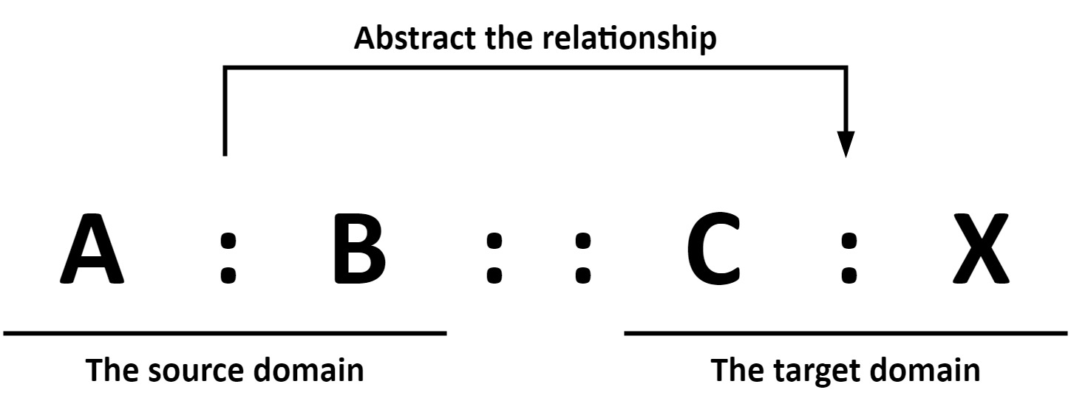
Figure 1. Proportional analogy in problem-solving

Analogy relations are significant for producing inferences for generating ideas and understanding less familiar domains while using proportional analogy. In human cognition, analogy relations, which are generally abstracted from source domains, are stored as rules or principles for solving future problems without the requirement of source analogues (Gentner and Forbus, 2011, Lopez et al., 2011, Linsey et al., 2012). In design, identifying an analogy relationship from previous knowledge can produce inferences about the design context. It is beneficial for creative idea space exploration and the design space expansion, which enhances context comprehension and idea elaboration.
A series of research projects have been conducted by psychologists and researchers studying analogy to explore the cognitive process of analogy. According to the processes proposed by Kokinov and French (2003), Casakin (2004), Gust et al. (2008), Gentner and Forbus (2011), Lopez et al. (2011), Linsey et al. (2012), Gentner and Smith (2012, 2013), analogy generally includes three core processes, which are retrieval, mapping and knowledge transfer, and abstraction. However, human analogy processes depend on how a problem is presented (Moreno et al., 2014). Retrieval involves exploring potential analogues according to the known term and analogy relation. Mapping and knowledge transfer includes aligning the ideas of the source domain and the target domain, and transferring knowledge from the source to the target domain. Abstraction generates schema or rules, also known as analogy relations, from results to apply in future situations without requiring source analogues. Generally, the analogy relations are abstracted from A:Bs in the source domain. In addition, concept re-representation is also a vital cognitive process in analogy, as well as in learning and scientific discovery (Yan et al., 2003). It increases the number of cues for analogue retrieval in analogy problem-solving, which enhances the exploration of the design space (Moreno et al., 2016). Thus, re-representing an idea with a similar idea before the retrieval process is indispensable for improving creativity. The cognitive process of analogy proposed in this study is illustrated schematically in Figure 2.
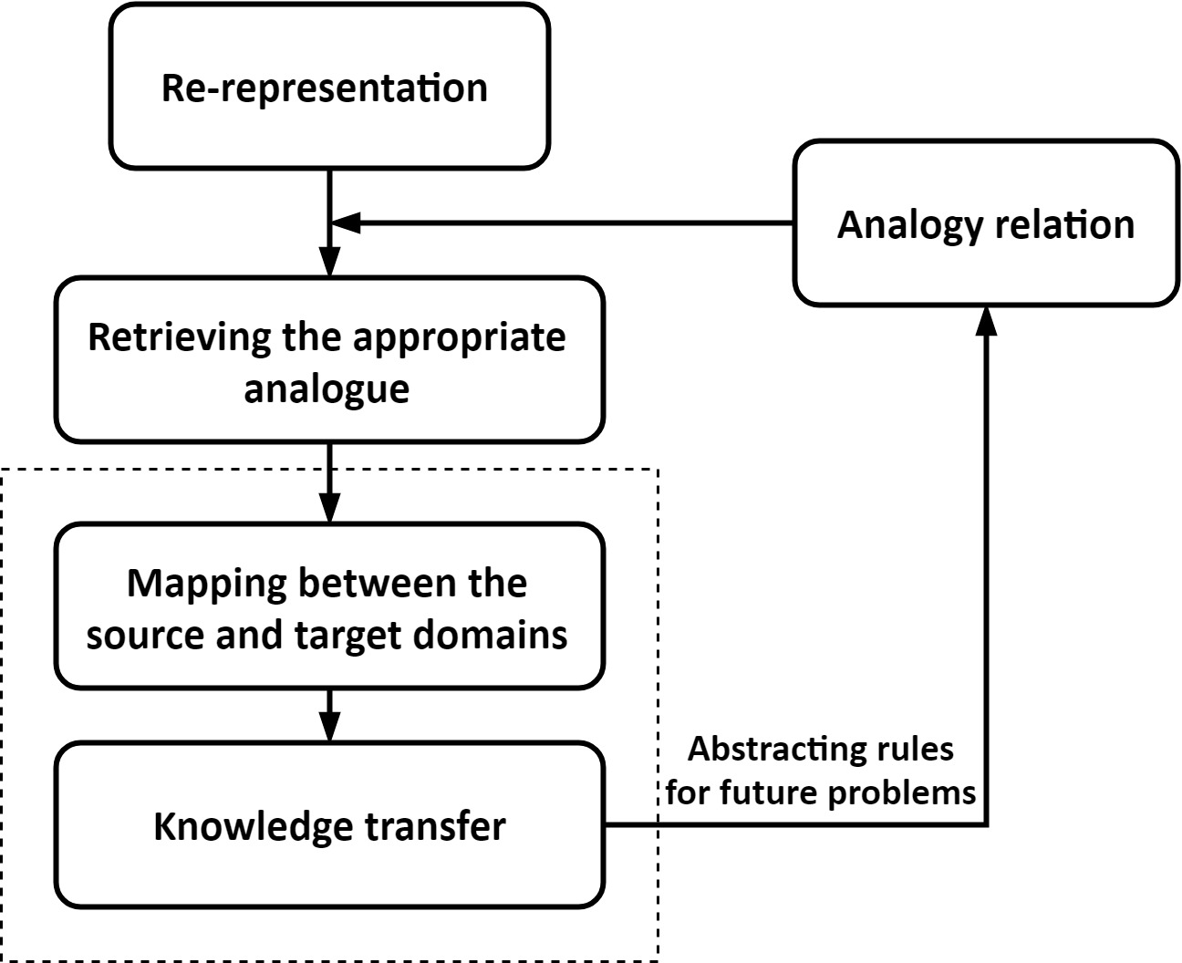
Figure 2. Cognitive process of analogy

In design, analogy has been considered as a beneficial method for idea generation (Wilson et al., 2010, Linsey et al., 2012, Moreno et al., 2014), as it can enhance design space exploration and expansion by transferring knowledge from a source domain containing the analogue phenomena to a target domain involving the problem. It is significant in terms of delivering creative ideas and understanding ideas. Analogy has been applied in numerous designs, for instance, the cyclone technology used by Dyson vacuum cleaners can be regarded as an analogical reasoning of an industrial cyclone for removing particulates in factory production processes.

  - Ontology
An ontology is described as a taxonomically or axiomatically based explicit formal specification of a shared conceptualisation (Gruber, 1993); a structured conceptualisation of a domain involving a set of entities and their relationships in that domain (Lin et al., 1996, Gero and Kannengiesser, 2007, Raad and Evermann, 2015); a metadata schema providing a controlled vocabulary of concepts with explicitly defined and machine-understandable semantics (Maedche and Staab, 2001); a highly structured system of concepts involving the objects, processes, attributes of a particular domain as well as their corresponding relationships (Li et al., 2008). It provides uniform frameworks to identify differences and similarities among obscured concepts (Gero and Kannengiesser, 2007). Ontologies are necessary for representing knowledge as well as exchanging knowledge (Obitko et al., 2004).
An ontology captures the structure of a domain and describes the domain. It is not only determined by the nature of each relevant kind in the domain, but rather by the semantic roles it plays (Štorga et al., 2010). Ontologies are usually captured in some form of semantic net (Chandrasegaran et al., 2013). A semantic net is an artificial graph-structured associative network with nodes representing concepts or knowledge and arcs describing relationships among the concepts (Sowa, 1992, Chandrasegaran et al., 2013). The nodes and arcs in semantic nets are used to create an ontology of a domain and express the relations in the domain. By this, an ontology is useful for human as well as processable for computational machines.
An ontology can be used as a tool for explaining the semantics of a terminology system in a well-defined situation, due to its shared vocabularies for describing the concepts and relations (Guarino, 1998, Lee et al., 2009). Ontology relations provide logical associations or dependencies between concepts in an ontology (Gulla and Brasethvik, 2008). Gulla et al. (2009) indicated that the concepts in an ontology may be taxonomically related by transitive relations such as ‘is a’ as well as non-taxonomically associated by a user named relation for instance ‘has part’. Chang-Shing et al. (2005) claimed that there are three kinds of ontology relationships, which are generalisation such as ‘is kind of’, aggregation such as ‘is part of’, and association such as ‘class’. Product ontologies are commonly used for semantic interoperability of product information in the design chain (Lee et al., 2009). The relationships involved in a product ontology, such as ‘parts’ and ‘features’, play an essential role in the ontology construction (Lin et al., 1996, Lee et al., 2009).
In the design domain, ontologies are used to formalise domain knowledge in a way which makes it accessible, sharable and reusable (Darlington and Culley, 2008). Ontologies allow designers to construct and present a particular domain with regard to taxonomic structures and axiomatic definitions (Chandrasegaran et al., 2013). Li and Ramani (2007) proposed a method for design information retrieval by using natural language processing and design ontology. Darlington and Culley (2008) showed how ontologies support the capture of the engineering design requirement. Nanda et al. (2005) and Liu et al. (2013) used ontology for product family design. Chandrasegaran et al. (2013) indicated that ontologies are required for encoding design knowledge as well as facilitating semantic interoperability. Shi and Setchi (2013) indicated that ontologies can benefit query expansion by improving the query representation on conceptual. In addition, a number of ontologies have been developed or applied for supporting design, for instance, Gero and Kannengiesser (2007, 2014) developed a Function-Behaviour-Structure (FBS) ontology to represent objects and processes in engineering design. Štorga et al. (2010) introduced a Design Ontology for improving product development. Ahmed and Štorga (2009) proposed an ontology for specific applications in engineering design through merging engineering design integrated taxonomies (EDIT) (Ahmed, 2005) and the Design Ontology (DO) (Štorga et al., 2010). Cross and Bathija (2009) created design ontologies through employing an automatic approach by adaption. Hatchuel et al. (2013) derived an ‘ontology of design’ from C-K theory and Forcing.
  - Analogy and ontology
A limited number of research projects have investigated the use of analogy in ontologies. For instance, Forbus et al. (2002) have proposed an analogy ontology, which is based on Gentner’s structure-mapping theory of analogy (Gentner, 1983), for creating a human-like flexible reasoning system by representing key entities and relationships in analogical processing. Raad and Evermann (2015) illustrated that analogical reasoning can assist in solving the problem of ontology alignment, which is used for establishing correspondences between concepts of different ontologies, by providing a good source of algorithms and heuristics.
Analogy and ontology are both used in design activities to support design creativity, but they are different in several aspects. Analogical reasoning applies knowledge from a familiar domain to a less-familiar domain that requires explanation, while ontologies are explicit formal representations of concepts and corresponding relations of a particular knowledge domain. That is, analogy is a reasoning process, while ontology is a structured system for representing knowledge. An analogical stimulus helps apply the knowledge from a well-known domain to a less-known domain. For instance, ‘velcro’ was inspired from the analogical stimulus ‘burrs’. An ontological stimulus assists the understanding of knowledge in a particular domain. For example, an ontological stimulus of ‘burrs’, which involves relevant knowledge in the domain, could facilitate the comprehension the properties, functions, characteristics of ‘burrs’. However, relationship performs the function of a common bridge between analogy and ontology. In analogy, especially proportional analogy, relations are significant for generating inferences about a less-familiar domain. In ontologies, relations are used for constructing an ontology and providing logical associations or dependencies between concepts.
Therefore, there is potential for improving design creativity by applying aspects of analogy in ontology. Designers often use ontologies to demonstrate a particular product to help their understanding. However, it is challenging to construct a well-defined ontology, especially confronting those less-familiar ones. This is due to problems such as an unfamiliar subject and lack of relevant knowledge. Mechanisms for reasoning, particularly from ontologies, are significant to idea generation, for instance the foundational work on structure mapping conducted by Gentner, Forbus, and Falkenhainer (1983, 1989, 2011). This study indicates the construction of ontologies with sufficient richness and coverage to support reasoning over real-world datasets. This leverages human reasoning from ontologies, and thereby provokes creative idea generation. For example, as shown in Figure 3, an ontology of ‘Future Vehicle’ is constructed through reasoning from an ontology of ‘Spacecraft’, which could stimulate the generation of creative ideas about new means of transportation. However, it is necessary to have a knowledge database containing relations and concepts to achieve this type of analogical reasoning for ontologies.
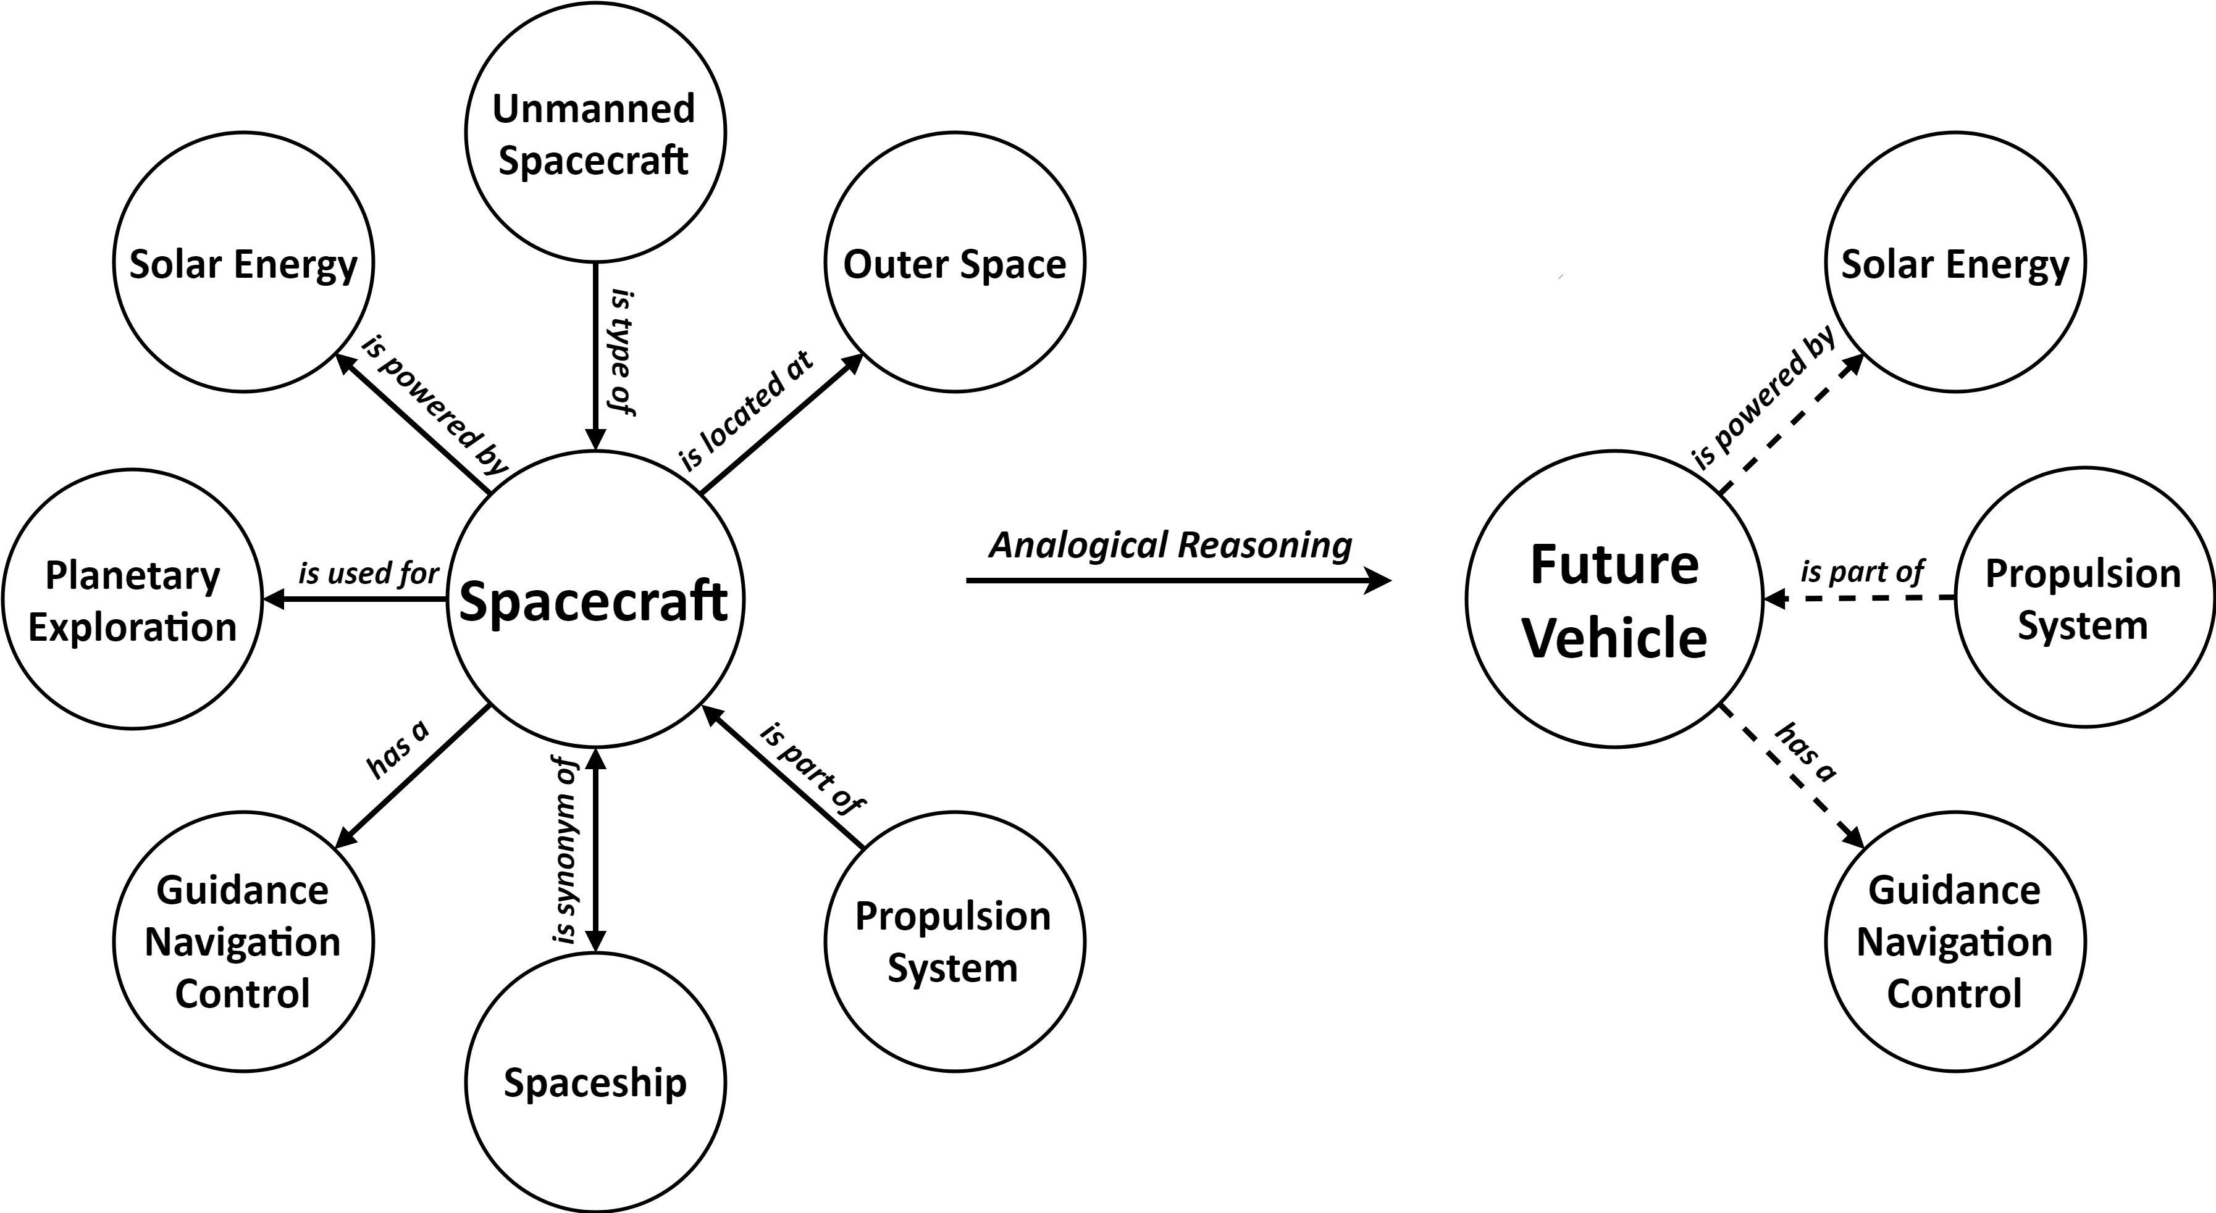
Figure 3. An example of using analogical reasoning to construct a new ontology
- The Retriever
  - The essential concept of the Retriever
The Retriever is a computational tool for assisting novice designers as well as experienced designers in idea generation. The tool is based on aspects of the cognitive process of analogical reasoning by employing ontologies. It is designed to help designers construct ontologies to support reasoning for creative idea generation through solving proportional analogy problems in the form of A:B::C:X. To be more specific, the tool constructs an ontology or part of an ontology by retrieving an unknown X or Xs based on a known term C in a less-familiar ontology (target ontology) and an ontology relation abstracted from A:B from a familiar ontology (base ontology). It can retrieve concepts or ideas in both text and visual forms according to the input, and thereby provoke the user in creative idea generation. The following sections demonstrate the essential concept of the Retriever as well as an example of using the tool.
ConceptNet is a knowledge base providing a large semantic net that represents general human knowledge associated by common-sense relations (Liu and Singh, 2004, Speer and Havasi, 2012), which is used as the knowledge database for concept retrieval and ontology construction in this study. The use of ConceptNet to construct ontologies has been previously explored by, for example, Agarwal and Mittal (2016), Mukherjee and Joshi (2013), Keshavarz and Lee (2012), and Sureka et al. (2010). ConceptNet has a closed class of over twenty relations used for connecting various concepts. Among them, sixteen relations, which are commonly used in design ontologies to express products, were summarised and selected, as shown in Table 1. Although the ConceptNet database is limited in size, coverage, and diversity compared with humans, it is sufficient for constructing an ontology for representing a design.
[Table 1]
The essential concept, which is a simulation of aspects of the cognitive process of analogical reasoning, used for developing the Retriever is shown in Figure 4. This type of cognition simulation approach has been applied in developing design support tools and has achieved a positive result, such as the Combinator (Han et al., 2016, Han et al., 2018). Human short-term memory, also known as working memory, is used for manipulating and processing information (Baddeley et al., 2009, Cowan, 2008). Miller (1956) summarised the evidence that human short-term memory is able to store 7±2 items, while Cowan (2008) indicated short-term memory could only store four items. This implies that humans could only process about four to nine items at one time. Therefore, we have selected a median number ‘six’ as the number of outputs of the Retriever, in order to help the tool users receive and process ideas effectively. The six outputs of the Retriever consist of a known term C provided by the user, as well as two re-representations and three unknown Xs retrieved by the tool. The known term C is considered as an output of the tool as well as a user input.

Figure 4. The essential concept of the Retriever
As shown in Figure 4, the essential concept starts with delivering the user inputs, involving a known term C and an ontology relation, to the Retriever. The tool then retrieves two related re-representations from the knowledge database (ConceptNet) according to the known term C for increasing retrieval cues, and thereby expanding the design space exploration (Moreno et al., 2016). The two re-representations are retrieved from the ConcepNet database through using the ‘association’ or ‘related to’ functions which provide the most similar concepts to the known term C. After that, on a one-to-one basis, three unknown terms Xs are retrieved from the knowledge database according to the known term C and the two re-representations through employing the selected ontology relation. To be more specific, through using the same ontology relation, one unknown term X is retrieved according to the known term C, while the other two Xs are retrieved respectively according to the two re-representations. This process is conducted by using the ‘search’ function of the ConceptNet, which retrieves corresponding concepts according to a given concept and a given relation.
The Retriever provides seventeen relationship selections, such as ‘Random’ (selecting an ontology relation randomly), ‘Association’, ‘Location’, and ‘Function (Purpose)’. The Retriever does not simply identify related functional terms, but retrieves related entities or concepts through using particular relations. It is an enrichment of the structures and components space in an ontology as well as functions and behaviours, which support design exploration and expand the design space. The unknown term Xs with a higher degree of relation to the input or the re-representations are retrieved prior to lower degree ones. The degrees here are known as the edge weights in ConceptNet, which were programmed into the module representing a rough heuristic of which statements are more reliable than the others. The known term C, re-representations and unknown term Xs are considered as the outputs of the Retriever in text forms.
Goldschmidt and Sever (2011) indicated that textual stimuli are useful in the design process, especially for improving idea originality. However, generating results in only text forms might have limitations, as sometimes it is difficult for a user to retrieve corresponding images from long-term memory. It has been identified that the human brain is mainly triggered by visual perceptions, such as images and videos (Luis-Ferreira and Jardim-Goncalves, 2013). Images are the most preferred inspiration sources for novice designers as well as professional designers (Gonçalves et al., 2014). Moreover, designers prefer to explore inspirations from images (Eckert and Stacey, 2000). Malaga (2000) demonstrated that using images as stimuli could produce more creative ideas than using texts as stimuli. Laing and Masoodian (2016) reported positive benefits of using images during the idea generation stage of the design process. We have therefore developed a live feed image crawler and implemented it into the Retriever module. Corresponding images of the known term C, retrieved re-representations and unknown term Xs are crawled simultaneously according to the text forms. The crawled images are presented in a mood board style as the output, as shown in the bottom image of Figure 5. A mood board is a collection of images used in the early phases of design for improving creativity and aiding communications (McDonagh and Storer, 2004, Setchi and Bouchard, 2010).

  - Example of using the Retriever
As shown in Figure 5, the Retriever provides a simple and friendly user interface. The tool allows users to input a design keyword or idea which is considered as the known term C, and select an ontology relationship which is regarded as a abstracted relation from A:Bs in familiar ontologies. The tool produces two re-representations of the known term C, as well as three unknown terms Xs in text forms at each retrieval. It should be noted that the known term C is also considered as an output of the tool. The three Xs, which are considered as the unknown terms in less-familiar ontologies, are retrieved according to the known term C and the two re-representations on a one-to-one basis. The six outputs of the Retriever (the known term C, two re-representations and three Xs could support constructing new ontologies and expanding the design space exploration, and thereby provoke users’ creative minds effectively. In addition, the tool can generate an image mood board correlating to its text-form outputs in real time.
As a hypothetical example, suppose new ideas for a chair design are required. The design keyword ‘Chair’, which is regarded as the known term C, is considered as the input. The ontology relation ‘Function (Purpose)’ abstracted from A:Bs in familiar ontologies is selected to explore what chairs are commonly used for. By using the Retriever, two re-representations, ‘Bench’ and ‘Sofa’, are retrieved. According to the input and re-representations, three ideas, ‘Leading A Meeting’, ‘Growing Plants’, and ‘Reading A Book’, are produced respectively according to the selected relation. The retrieved outputs are presented in text forms as shown in the top image of Figure 5, accompanying with a mood board containing corresponding images as shown in the bottom image of Figure 5. The example here shows a distant retrieval, of which ideas with lower relational degrees are retrieved, for avoiding design fixation and prompting creative ideation. As illustrated previously, ideas (unknown Xs) that are strongly related (higher relational degrees) to the term C or re-representations via the selected ontology relationship are retrieved prior to lower correlated ones in the Retriever. Using the input ‘Chair’ and ‘Function (Purpose)’ as example, ideas such as ‘Resting’ are retrieved prior to ‘Leading A Meeting’.
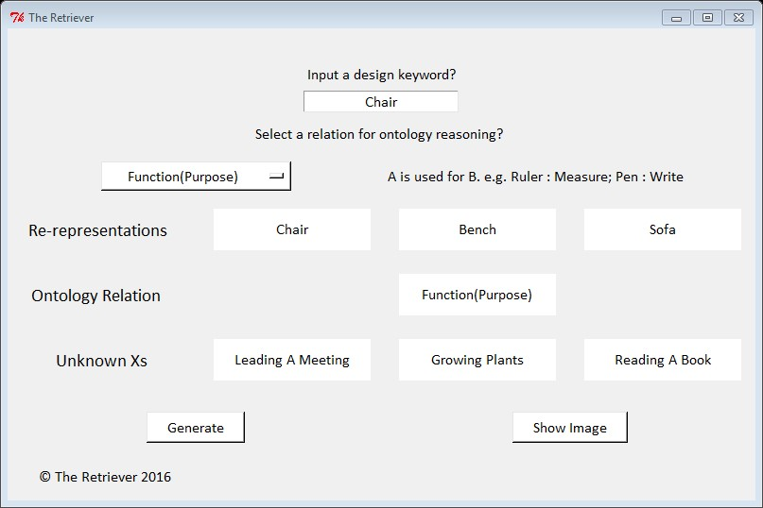
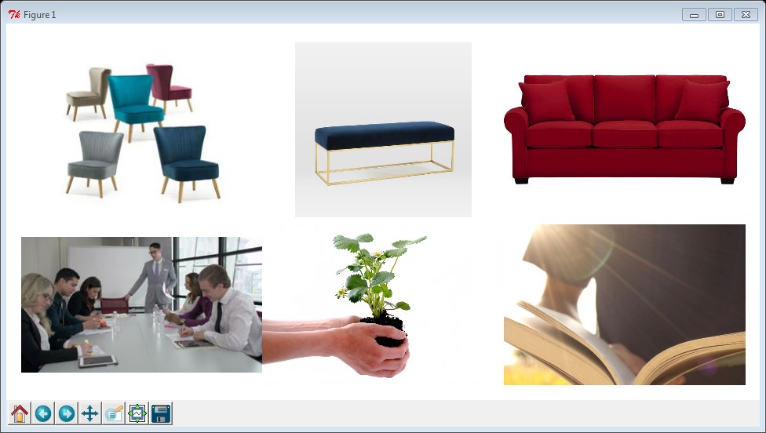
Figure 5. The Retriever interface

- Evaluation of the Retriever
  - Design challenge and participants
A case study has been conducted to evaluate the creativity of the ideas generated by using the Retriever as well as the usefulness and effectiveness of the tool. The case study was a controlled experiment involving twenty participants to produce ideas for solving a design challenge. The controlled experiment compares participants producing ideas with and without using the Retriever. The participants generating ideas without using the Retriever were granted use of Google Image for constructing a fairer comparison, as both of the tools provide images. The design challenge was to design a ‘bicycle’ to help kids fight obesity, as childhood obesity has been widely considered as a serious public health threat. The design specifications of the new ‘bicycle’ design ideas are feasible, easy to learn, attractive to children, and safe to ride.
Twenty participants, with high levels of interests and intrinsic motivations, participated in the design challenge voluntarily via a case study advertising. Each of the participant could receive a piece of high-quality stationery as a reward after accomplishing the case study. The basic information of the participants is shown in Table 2. The participants involve fifteen PhD students, one Masters student, one undergraduate student, and three employees. All of the participants were recruited from a university in UK. Sixteen were from a Design Engineering department, while the other four were from other departments, such as Computer Science and Mechanical Engineering, to increase the variety of the participants. The average age of the participants was 28 years. Two of the participants have more than three years’ experience in design, and were considered as experienced designers in this case study. The other eighteen participants were considered as novice designers, as none of them had extensive design experience. All of the participants had signed up with standard case study protocols giving permission to use the data. The twenty participants were divided into two categories having similar capabilities based on their experience and backgrounds, constituting two categories with ten participants in each. Ten of the participants conducted the case study by using the Retriever, which are regarded as the Retriever participants or the Retriever users. The other ten participants produced ideas without using the tool but could use Google Image as an assistant, and are named as the non-Retriever participants. Both the Retriever participants and the non-Retriever participants were recommended to use ‘bike’ or ‘bicycle’ to start the retrieving or searching process. The participants were also allowed to use other keywords during the design challenge. Each of the participants from either category performed the design challenge separately, as a participant’s idea generation performance may be influenced by actions or ideas of others (Perttula and Sipilä, 2007), within the same amount of time. The ideas produced by an individual were recorded on a piece of A3 paper in text and images. The papers with ideas produced by the Retriever users as well as non-Retriever users were then collected and mixed together for evaluation to enhance reliability.
[Table 2]

  - Evaluation methods and processes
The evaluation of an idea generation method can be grouped into outcome-based and process-based, of which process-based approaches are rarely used (Shah et al., 2003). Psychometric measurement is an outcome-based approach for assessing creativity. Measuring outcomes can objectively demonstrate the effectiveness of an idea generation method, as specific metrics are used to reflect the creativity of ideas to the performance of the idea generation method. Shah et al. (2003) have proposed a psychometric approach for measuring effectiveness and creativity. It involves four metrics: quantity, novelty, quality, and variety, which were used in this case study to evaluate the Retriever. These four metrics are also known as fluency, originality, usefulness, and flexibility, respectively (Ward and Kolomyts, 2010). The measurement of the four metrics in this research is illustrated in the following paragraphs.
Fluency (quantity) was measured by counting the total number of ideas produced by an individual, which shows the fluency of idea generation of the individual. It is commonly considered that generating more ideas increases the chance of better ideas occurring.
Originality (novelty) indicates the unexpectedness and unusual nature of an idea compared with non-original ones. In this case study, existing conventional children’s bikes on the market are considered as non-original ideas. An original idea is usually the result of the design space expansion. The originality of an idea was measured by scoring 1 to 5 from ‘poor’ originality to ‘excellent’ originality. The overall originality score of an individual participant was the mean originality score of all the ideas produced.
Usefulness (quality) of an idea shows the feasibility of the idea and to what extent the idea meets the design specifications. An idea with high usefulness indicates a higher design success rate. The usefulness of an idea was assessed by scoring each key attribute 1 to 5 from ‘poor’ usefulness to ‘excellent’ usefulness in terms of the idea’s feasibility and how close each attribute meets the design specifications. A total weight of 1 was assigned to four key attributes according to their significance as follows, feasibility (0.25), easy to learn (0.25), attraction (0.25), and safety (0.25). This was assuming that feasibility, easy to learn, attraction, and safety are regarded as equally important in the initial design stage. The overall usefulness score of an idea was computed by Equation (1) adapted from Shah et al. (2003). In (1), M is the overall usefulness score of an idea with n attributes, while f_{i} is the weight assigned to attribute i and S_{i} is the score of attribute i. The overall usefulness score of an individual participant was the mean usefulness score of all the ideas generated.

$$M=\sum_{i=1}^{n}{f_{i}S_{i}} (1)$$

Flexibility (variety) demonstrates the exploration of the design space, which was measured by counting the total number of categorises of the ideas produced by an individual. Categorising the ideas generated was based on assessing how different each idea is from another. In this case study, the assessment was based on the different working principles as well as physical principles, for instance the number of wheels, the variety of the wheels, the structure of the bike, and the drive mode of the bike. The assessment was focused on general aspects instead of very detailed characteristics, as the idea generation case study only produced initial design ideas rather than sophisticated ones. Producing similar ideas shows a low idea variety and a poor idea generation flexibility, and thereby a low probability of exploring better ideas in the design space.
The individual level mean scores of fluency (quantity), originality (novelty), usefulness (quality), and flexibility (variety) were calculated for a fair and effective comparison. The mean scores of different metrics at the individual level were used instead of total scores, due to the different amount of ideas generated by different participants.
Two professional design engineers having over three years of experience evaluated the ideas respectively in order to verify the robustness of the metric scores. The two raters, who were researchers in the Design Engineering department, participated in the evaluation voluntarily with intrinsic motivations. The ideas were assessed under the same guidance and inter-rater agreement of scoring 1≤ poor < 2, 2 ≤ moderate < 3, 3 ≤ good < 4, and 4 ≤ excellent ≤ 5 for idea originality and usefulness. In addition, the two raters were blind to the idea generation conditions. Moreover, idea fluency and flexibility were measured with relative objectivity by counting the number of ideas produced and the number of idea categories, respectively. The final metric scores were the mean scores marked by the two raters.

  - Results
A kappa test was conducted to assess the rating agreement between the two raters. The test results showed that the kappa coefficients of the agreements of fluency, originality, usefulness, and flexibility were 1, 0.353, 0.310, and 1, respectively. This indicated that the two raters had close agreement on fluency and flexibility, and fair agreement on originality and usefulness. This is because fluency and flexibility are objective metrics, while originality and usefulness are subjective metrics in this case study. To estimate the reliability of the consensus between the two raters in terms of originality and usefulness, a popular modification of the percent of adjacent agreements were calculated. Ratings for each idea were regarded as consensus if the two scores did not differ by more than one point (Stemler, 2004). This consensus estimate of reliability method was also used in the idea generation study conducted by Daly et al. (2016). For the originality and usefulness ratings, the percentage of adjacent agreements between the two raters were 92% and 94% respectively. The results of the Kappa test and the consensus test have shown the robustness of the evaluated scores.
The evaluation results of the Retriever and non-Retriever participants, which are the mean scores of fluency, originality, usefulness, and flexibility at the individual level, are shown in Figure 6. At the individual level, the Retriever participants generated 4.30 ideas with a standard deviation of 2.67, while the non-Retriever participants came up with 1.90 ideas with a standard deviation of 1.45. In terms of idea originality and usefulness, the Retriever participants achieved 3.47 and 3.69 while the Non-Retriever participants scored 3.05 and 3.26, respectively. The standard deviation of which were 0.49 and 0.35, 0.37 and 0.30, respectively. The Retriever participants’ idea generation flexibility was 3.60 with a standard deviation of 1.84, which is 2.10 higher than that of the non-Retriever participants with a standard deviation of 0.97.
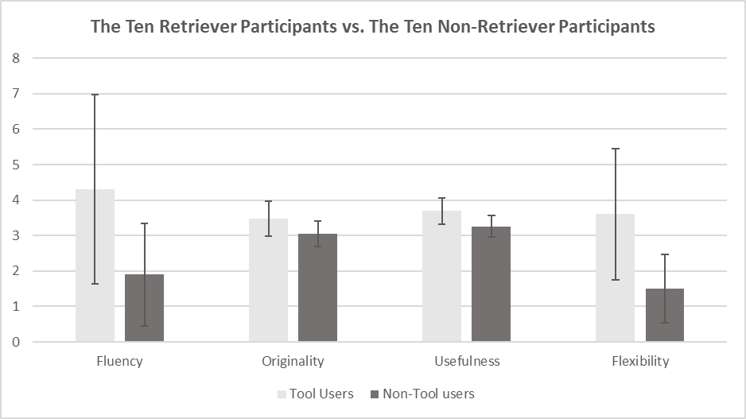
Figure 6. The evaluation results: The ten Retriever participants vs. The ten non-Retriever participants (Note: The error bars indicate standard deviations)
Although the mean metric scores of the Retriever participants are higher the non-Retriever participants, this might occur by chance. The standard deviations of fluency and flexibility are relatively larger than the others, which indicate the values are more dispersed. Thus, a Mann-Whitney U test was conducted in order to measure whether there are statistically significant differences between the means of the metric scores. The significant level of the Mann-Whitney U test was set as 5% (α=0.05). This suggests that there is a statistically significant difference between the means of two conditions if a p-value is less than or equal to 0.05. The Mann-Whitney U test was performed by using SPSS and the results are illustrated in Table 3. Comparing the Retriever participants with the non-Retriever participants, the p-values between the mean scores of fluency, usefulness, and flexibility are all less than the defined 0.05, while the p-value of originality is slightly greater than 0.05. This demonstrates that there are statistically significant differences between the Retriever users and the non-Retriever users in terms of fluency (U=23.0, p=.033), usefulness (U=19.5, p=.021), and flexibility (U=17.5, p=.010), while there is no statistically significant difference in terms of originality (U=28.0, p=.081), with medium and large effect sizes.
[Table 3]
We have also calculated the Cohen’s d values to measure the differences between the means to support the statistical analysis. As shown in table 4, the Cohen’s d values of the four metrics indicate that there are large differences. The large differences have suggested high practical significant differences between the mean metric scores of the two types of participants.
[Table 4]
However, in a case study limited by a small sample size, there is an increasing probability of chance to estimate effects that have incorrect directions (Type S error) or to over-estimate effect sizes (Type M error) (Gelman and Carlin, 2014). To investigate these problems of the conducted case study, Type S errors and Type M errors were calculated based on the standard errors between means with estimated true effect sizes 0.1, 0.2, and 0.3, respectively. As shown in Table 5, there are slightly higher probabilities that Type S errors and Type M errors might occur in fluency and flexibility rather than originality and usefulness. This indicates that there exist probabilities that the effects of fluency and flexibility are in the wrong directions or the effect sizes of which are too high. However, these figures only present a hypothetical indication, as it is difficult to hypothesise true effect sizes for this case.
[Table 5]
Due to a small sample size, we have conducted a Bayesian analysis, which is a Bayes factor independent sample test by using SPSS, to produce more informative statements about the values of the case study data. In the test, H₀ is the null hypothesis indicating there is no difference between the Retriever participants and the non-Retriever participants, while H₁ is the alternative hypothesis indicating there are statistically significant differences between the two types of participants. The Bayesian analysis result is presented in Table 6, and the Bayes factors were interpreted according to Jarosz and Wiley (2014). As shown in the table, all the p-values are smaller than 0.05, which indicate that there could be significant differences between the Retriever users and the non-Retriever users in all four aspects. The Bayes factors have shown that there is anecdotal support for the alternative hypothesis (H₁) in terms of fluency (BF=.345, t=-2.49, p=.022) and originality (BF=.555, t=-2.19, p=.042), as well as substantial supports for the alternative hypothesis (H₁) in terms of usefulness (BF=.175, t=-2.91, p=.009) and flexibility (BF=.108, t=-3.19, p=.005). The Bayes factors suggest that these data are 2.9, 1.8, 5.7, and 9.3 times more likely to be observed under the alternative hypothesis (H₁) with regards to fluency, originality, usefulness, and flexibility, respectively. Therefore, the Bayesian analysis indicates there are higher probabilities that the Retriever participants could performance better than the non-Retriever participants, especially in flexibility, usefulness, and fluency.
[Table 6]
Therefore, comparing the ten participants using the Retriever with the ten participants without using the tool in this case study, we can conclude that there are significant improvements in ideation fluency and flexibility as well as the idea’s usefulness, according to the statistical analysis above. The Mann-Whitney U test has indicated an insignificant difference in originality and the Bayes analysis has shown a poor support for the alternative hypothesis (H₁) in originality, while the Cohen’s d value has indicated a large difference. Thereby, we could consider there is a slight improvement in terms of the originality of the ideas produced.
Interviews were conducted after the design challenge. All the Retriever participants provided positive feedback indicating the tool is simple, useful, and effective for assisting idea generation. All the tool users indicated that the outputs were closely related to their input, which were useful for the design space exploration and expansion. Moreover, nine out of ten users agreed that the mood boards produced had provided a better comprehension of the outputs and enhanced their creative thinking during the idea generation. However, two participants pointed out that some of the outputs were common knowledge which they already knew. This is due to the limitation of the common-sense knowledge database used in the Retriever. In terms of the non-Retriever participants, although all of them indicated Google Image is a simple tool, eight and nine out of ten considered Google Image is not useful nor effective respectively for supporting idea generation. They suggested that the images provided by Google Image were monotonous, which might had led them into design fixation. Six of the non-Retriever participants considered the design challenge was difficult and it was therefore challenging to generate creative ideas, despite having access to Google Image. Eight out of ten of the non-Retriever participants considered that it would be useful to have a number of good quality stimuli or source of inspirations, which are relevant to the specific domain, in visual forms during the idea generation.

  - Discussion
Comparing with the non-Retriever participants, creative ideas were commonly produced by the participants who were using the Retriever. Several creative ideas, ‘Scooter bike’, ‘Treadmill bike’, and ‘Connectable bike’, produced by using the tool have been selected and re-sketched, as shown in Figure 7. The ‘Scooter bike’ uses gliding rather riding, which is safer, easier, and more fun than a conventional bike. The ‘Treadmill bike’ provides a new method of operating a bike, as well as offers the energy consumption benefit of conventional treadmills. The ‘Connectable bike’ allows users to connect two bikes together converting them to a single bike, which provides children with the enjoyment of playing together and subconsciously encourages them to ride bikes. However, these types of creative ideas were less common among the ideas generated by the non-Retriever participants. A significant proportion of the non-Retriever participants’ ideas were focused on the appearance of bikes.

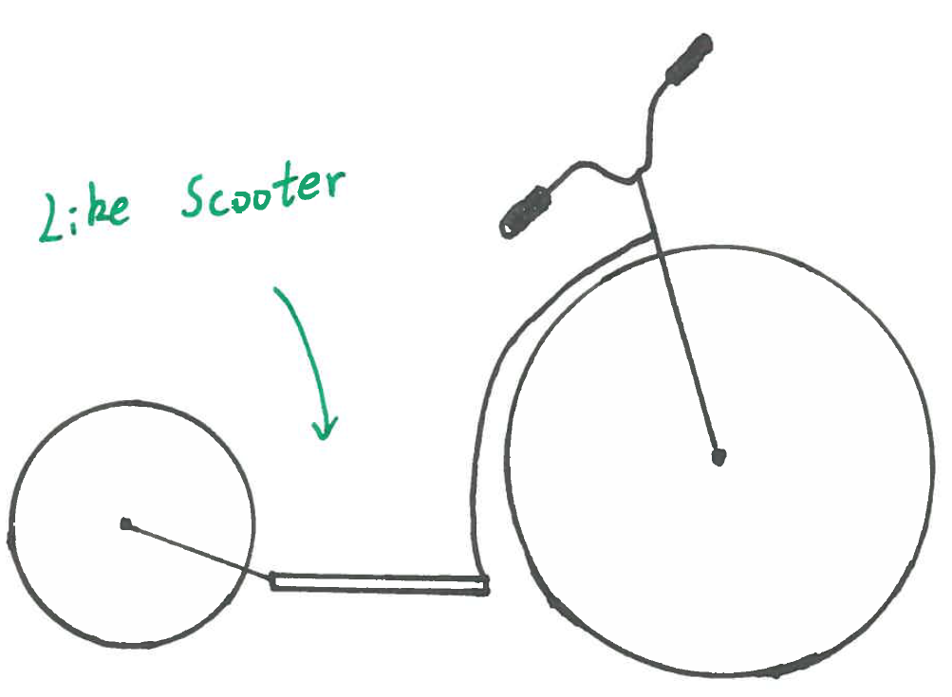 | 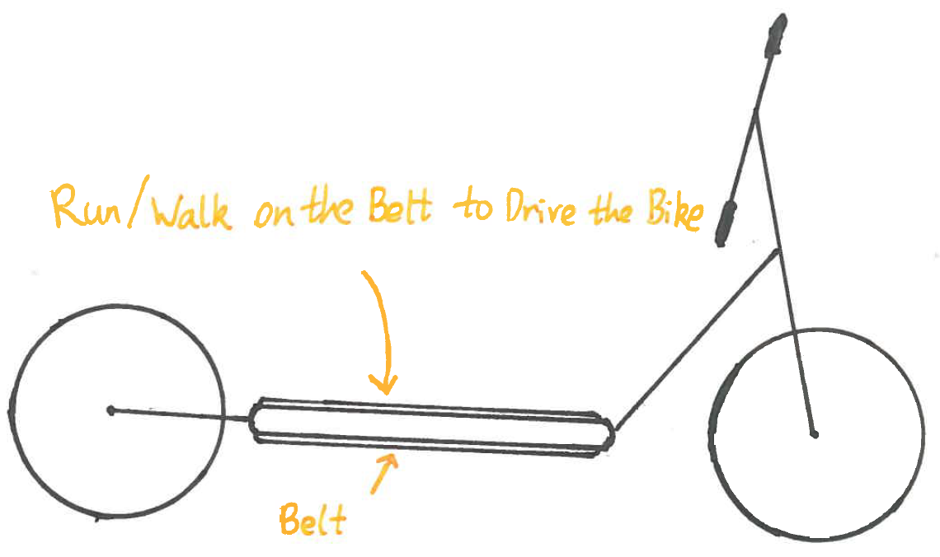
Scooter Bike | Treadmill Bike
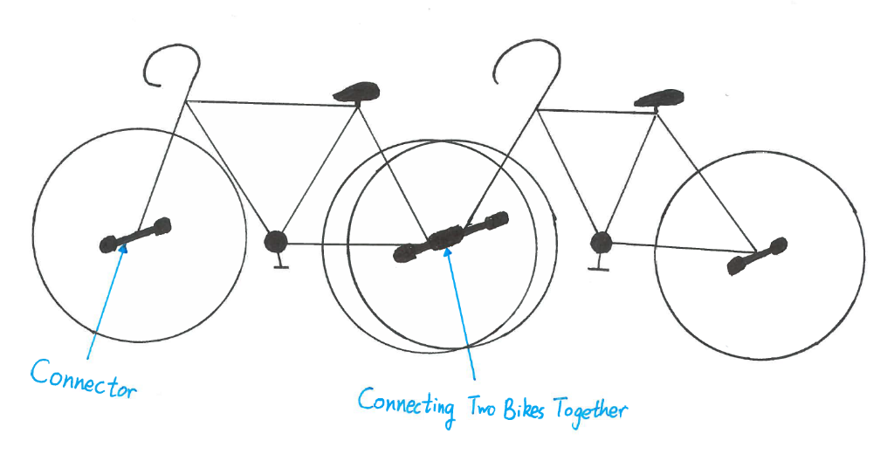
Connectable Bike
Figure 7. Examples of the ideas produced by the Retriever participants

The evaluation results show that the usefulness of the ideas as well as the fluency and flexibility of idea generation were significantly improved by using the Retriever, while the originality of the ideas was slightly improved. This is in line with the research conducted by Linsey et al. (2011), of which there are no differences in novelty across different ideation conditions. This evaluation results indicate that the Retriever had increased the success rate of design, improved the occurrence of better ideas, and enhanced the exploration of the design space, and promoted the expansion of the design space. Moreover, all the ten Retriever participants provided positive feedback on the tool, highlighting its effectiveness, usefulness, and simplicity. Without using the Retriever, the other ten participants were confronting difficulties in producing ideas, especially creative ones, to solve the design challenge, despite with the assistant of Google Image. As a result, the Retriever is considered as an effective tool for assisting the designers concerned in producing creative ideas, albeit based on a limited sample. However, the capability of the Retriever can potentially be increased by adding an ontology database containing technical concepts and relations.
Using the Retriever is considered to have significant benefits in long idea generation sessions, which exceed 30 minutes, compared with individuals not using any creativity tools. A human’s idea generation rate generally decreases in 30 minutes, while the idea quality declines in 20 minutes (Howard et al., 2011). Theoretically, the tool can continuously generate useful stimuli to assist a designer in idea generation, which can maintain the designer’s ideation rate and idea quality (Howard et al., 2011).
In comparison with other computational analogy tools, such as the WordTree method (Linsey et al., 2012) and Analogy Finder (McCaffrey and Spector, 2017), the Retriever can provide image-based stimuli or outcomes in addition to text-based outcomes. Image-based ideas or entities in mood board styles could support the comprehension of text-based outcomes, as well as improve creativity and enhance design communication. The WordTree method and Analogy Finder simply retrieve associated functional terms through abstractions, for instance, Analogy Finder rephrases the goal through using synonyms from WordNet and verbs, and then searches patents that match the rephrased goal from a database. The Retriever uses particular relations for retrieving related ideas or entities, which enriches the space of structures and components in an ontology as well as functions and behaviours. These novel properties of the Retriever could support design exploration and expand the design space.

- Conclusion
Design creativity is a significant element in design, which assists problem solving, initiates innovation, and determines a product’s performance. However, it is challenging to come up with creative ideas. This study has indicated a method of constructing ontologies with sufficient richness and coverage to support reasoning over real-world datasets for stimulating creative idea generation. The method has been developed into a computational tool, which is based on analogical reasoning and ontology, for supporting novice designers as well as experienced designers in idea generation and prospectively in idea elaboration. The tool is designed for solving proportional analogy problems (A:B::C:X) by retrieving the unknown term X from a knowledge database to help designers construct an ontology. Thereby, it can help designers produce creative ideas through design space expansion and exploration.
The tool has been considered as useful and effective for helping the designers concerned generate creative ideas through a case study. The statistical analysis results have indicated that the tool can significantly improve the designer’s ideation fluency, ideation flexibility, and the idea’s usefulness, as well as slightly increase the idea’s originality, concerning the conducted case study. It has been revealed that the Retriever can improve better ideas occurrence and design success rates, and enhance design space exploration and expansion, albeit based on a limited sample. The cognition simulation approach used in the case study conducted has achieved a positive outcome, which provided a novel and robust method of developing design support tools. However, the current database employed in this study is a common-Csense knowledge base, which is considered as a non-technical database. The performance of the tool can be potentially improved by adding a technical ontology database, for example the one developed by Shi et al. (2017) which involves technical terms and relations such as desalination is related to reverse osmosis, electrodialysis, and solar energy. Further research is planned to enhance the tool’s performance in idea generation, as well as measure the tool’s capability in idea elaboration.

Acknowledgement
This work includes data from ConceptNet 5, which was compiled by the Commonsense Computing Initiative. ConceptNet 5 is freely available under the Creative Commons Attribution-ShareAlike license (CC BY SA 3.0) from http://conceptnet5.media.mit.edu. The included data was created by contributors to Commonsense Computing projects, contributors to Wikimedia projects, Games with a Purpose, Princeton University's WordNet, DBPedia, OpenCyc, and Umbel.

References
Agarwal, B. & Mittal, N. 2016. Sentiment Analysis Using ConceptNet Ontology and Context Information. Prominent Feature Extraction for Sentiment Analysis. Cham: Springer International Publishing.
Ahmed, S. 2005. Encouraging reuse of design knowledge: a method to index knowledge. Design Studies, 26, 565-592. doi: https://doi.org/10.1016/j.destud.2005.02.005.
Ahmed, S. & Štorga, M. 2009. Merged ontology for engineering design: Contrasting empirical and theoretical approaches to develop engineering ontologies. Artificial Intelligence for Engineering Design, Analysis and Manufacturing, 23, 391-407. doi: 10.1017/S0890060409000146.
Altshuller, G. S. 1984. Creativity as an exact science: The theory of the solution of inventive problems. Amsterdam, Netherlands, Gordon and Breach Publishers.
Amabile, T. M. 1983. The social psychology of creativity. New York, USA, Springer-Verlag.
Baddeley, A. D., Eysenck, M. W. & Anderson, M. C. 2009. Memory. East Sussex, UK, Psychology Press.
Ball, L. J. & Christensen, B. T. 2009. Analogical reasoning and mental simulation in design: two strategies linked to uncertainty resolution. Design Studies, 30, 169-186. doi: https://doi.org/10.1016/j.destud.2008.12.005.
Ball, L. J., Ormerod, T. C. & Morley, N. J. 2004. Spontaneous analogising in engineering design: a comparative analysis of experts and novices. Design Studies, 25, 495-508. doi: https://doi.org/10.1016/j.destud.2004.05.004.
Bar, M. 2007. The proactive brain: Using analogies and associations to generate predictions. Trends in Cognitive Sciences, 11, 280-289. doi: 10.1016/j.tics.2007.05.005.
Benedek, M., Jauk, E., Fink, A., Koschutnig, K., Reishofer, G., Ebner, F. & Neubauer, A. C. 2014. To create or to recall? Neural mechanisms underlying the generation of creative new ideas. NeuroImage, 88, 125-133. doi: 10.1016/j.neuroimage.2013.11.021.
Bhatta, S. R. & Goel, A. K. 1996a. From design experiences to generic mechanisms: Model-based learning in analogical design. Artificial Intelligence for Engineering Design, Analysis and Manufacturing, 10, 131-136. doi: 10.1017/S0890060400001372.
Bhatta, S. R. & Goel, A. K. 1996b. Model-based design indexing and index learning in engineering design. Engineering Applications of Artificial Intelligence, 9, 601-609. doi: https://doi.org/10.1016/S0952-1976(96)00055-3.
Blanchette, I. & Dunbar, K. 2000. How analogies are generated: The roles of structural and superficial similarity. Memory & Cognition, 28, 108-124. doi: 10.3758/bf03211580.
Blanchette, I. & Dunbar, K. 2001. Analogy use in naturalistic settings: The influence of audience, emotion, and goals. Memory & Cognition, 29, 730-735. doi: 10.3758/bf03200475.
Boden, M. A. 2004. The creative mind: Myths and mechanisms. 2. London, UK, Routledge.
Boden, M. A. 2009. Computer models of creativity. AI Magazine, 30, 23-34. doi: http://dx.doi.org/10.1609/aimag.v30i3.2254.
Carruthers, P. 2011. Creative action in mind. Philosophical Psychology, 24, 437-461. doi: 10.1080/09515089.2011.556609.
Casakin, H. 2004. Visual analogy as a cognitive strategy in the design process. Expert versus novice performance. Journal of Design Research, 4, 197-217. doi: 10.1504/jdr.2004.009846.
Casakin, H. & Goldschmidt, G. 1999. Expertise and the use of visual analogy: Implications for design education. Design Studies, 20, 153-175. doi: 10.1016/s0142-694x(98)00032-5.
Cash, P. & Štorga, M. 2015. Multifaceted assessment of ideation: using networks to link ideation and design activity. Journal of Engineering Design, 26, 391-415. doi: 10.1080/09544828.2015.1070813.
Chakrabarti, A., Sarkar, P., Leelavathamma, B. & Nataraju, B. S. 2005. A functional representation for aiding biomimetic and artificial inspiration of new ideas. Artificial Intelligence for Engineering Design, Analysis and Manufacturing, 19, 113-132. doi: 10.1017/S0890060405050109.
Chakrabarti, A. & Shu, L. H. 2010. Biologically inspired design. Artificial Intelligence for Engineering Design, Analysis and Manufacturing, 24, 453-454. doi: 10.1017/S0890060410000326.
Chakrabarti, A., Siddharth, L., Dinakar, M., Panda, M., Palegar, N. & Keshwani, S. 2017. Idea Inspire 3.0—A Tool for Analogical Design. In: Chakrabarti, A. & Chakrabarti, D. (eds.) Research into Design for Communities, Volume 2: Proceedings of ICoRD 2017. Singapore: Springer Singapore.
Chakrabarti, S., Dom, B., Agrawal, R. & Raghavan , P. 1998. Scalable feature selection, classification and signature generation for organizing large text databases into hierarchical topic taxonomies. The VLDB Journal, 7, 163-178. doi: 10.1007/s007780050061.
Chan, J., Fu, K., Schunn, C., Cagan, J., Wood, K. & Kotovsky, K. 2011. On the Benefits and Pitfalls of Analogies for Innovative Design: Ideation Performance Based on Analogical Distance, Commonness, and Modality of Examples. Journal of Mechanical Design, 133, 081004-081004-11. doi: 10.1115/1.4004396.
Chandrasegaran, S. K., Ramani, K., Sriram, R. D., Horváth, I., Bernard, A., Harik, R. F. & Gao, W. 2013. The evolution, challenges, and future of knowledge representation in product design systems. Computer-Aided Design, 45, 204-228. doi: 10.1016/j.cad.2012.08.006.
Chang-Shing, L., Zhi-Wei, J. & Lin-Kai, H. 2005. A fuzzy ontology and its application to news summarization. IEEE Transactions on Systems, Man, and Cybernetics, Part B (Cybernetics), 35, 859-880. doi: 10.1109/TSMCB.2005.845032.
Childs, P. & Fountain, R. 2011. Commercivity. DS 69: Proceedings of E&PDE 2011, the 13th International Conference on Engineering and Product Design Education, London, UK, 08.-09.09.2011.
Childs, P. R. N. 2018. Mechanical design engineering handbook. 2nd. Oxford, UK, Butterworth-Heinemann.
Chiu, I. & Shu, L. H. 2012. Investigating effects of oppositely related semantic stimuli on design concept creativity. Journal of Engineering Design, 23, 271-296. doi: 10.1080/09544828.2011.603298.
Christensen, B. T. & Schunn, C. D. 2007. The relationship of analogical distance to analogical function and preinventive structure: the case of engineering design. Memory & Cognition, 35, 29-38. doi: 10.3758/bf03195939.
Cowan, N. 2008. What are the differences between long-term, short-term, and working memory? Progress in brain research, 169, 323-338. doi: 10.1016/S0079-6123(07)00020-9.
Cross, N. 2011. Design thinking: Understanding how designers think and work. New York, USA, Berg Publishers.
Cross, V. & Bathija, V. 2009. Automatic ontology creation using adaptation. Artificial Intelligence for Engineering Design, Analysis and Manufacturing, 24, 127-141. doi: 10.1017/S0890060409000183.
Daly, S. R., Seifert, C. M., Yilmaz, S. & Gonzalez, R. 2016. Comparing Ideation Techniques for Beginning Designers. Journal of Mechanical Design, 138, 101108-101108-12. doi: 10.1115/1.4034087.
Darlington, M. J. & Culley, S. J. 2008. Investigating ontology development for engineering design support. Advanced Engineering Informatics, 22, 112-134. doi: https://doi.org/10.1016/j.aei.2007.04.001.
Daugherty, J. & Mentzer, N. 2008. Analogical reasoning in the engineering design process and technology education applications. Journal of Technology Education, 19, 7-21. doi:
Eckert, C. & Stacey, M. 2000. Sources of inspiration: a language of design. Design Studies, 21, 523-538. doi: https://doi.org/10.1016/S0142-694X(00)00022-3.
Falkenhainer, B., Forbus, K. D. & Gentner, D. 1989. The structure-mapping engine: Algorithm and examples. Artificial Intelligence, 41, 1-63. doi: https://doi.org/10.1016/0004-3702(89)90077-5.
Forbus, K. D., Mostek, T. & Ferguson, R. 2002. An analogy ontology for integrating analogical processing and first-principles reasoning. AAAI/IAAI, 2002, 878-885. doi:
Fu, K., Cagan, J., Kotovsky, K. & Wood, K. 2013a. Discovering Structure in Design Databases Through Functional and Surface Based Mapping. Journal of Mechanical Design, 135, 031006-031006-13. doi: 10.1115/1.4023484.
Fu, K., Chan, J., Cagan, J., Kotovsky, K., Schunn, C. & Wood, K. 2013b. The Meaning of “Near” and “Far”: The Impact of Structuring Design Databases and the Effect of Distance of Analogy on Design Output. Journal of Mechanical Design, 135, 021007-021007-12. doi: 10.1115/1.4023158.
Fu, K., Moreno, D., Yang, M. & Wood, K. L. 2014. Bio-Inspired Design: An Overview Investigating Open Questions From the Broader Field of Design-by-Analogy. Journal of Mechanical Design, 136, 111102-111102-18. doi: 10.1115/1.4028289.
Gelman, A. & Carlin, J. 2014. Beyond Power Calculations:Assessing Type S (Sign) and Type M (Magnitude) Errors. Perspectives on Psychological Science, 9, 641-651. doi: 10.1177/1745691614551642.
Gentner, D. 1983. Structure‐mapping: A theoretical framework for analogy. Cognitive science, 7, 155-170. doi:
Gentner, D. & Forbus, K. D. 2011. Computational models of analogy. Wiley Interdisciplinary Reviews: Cognitive Science, 2, 266-276. doi: 10.1002/wcs.105.
Gentner, D. & Smith, L. A. 2012. Analogical reasoning. In: Ramachandran, V. S. (ed.) Encyclopedia of human behavior. 2 ed. Oxford: Elsevier.
Gentner, D. & Smith, L. A. 2013. Analogical learning and reasoning. In: Reisberg, D. (ed.) The Oxford handbook of cognitive psychology. Oxford: Oxford University Press.
Georgiev, G. V., Sumitani, N. & Taura, T. 2017. Methodology for creating new scenes through the use of thematic relations for innovative designs. International Journal of Design Creativity and Innovation, 5, 78-94. doi: 10.1080/21650349.2015.1119658.
Gero, J. S. & Kannengiesser, U. 2007. A function–behavior–structure ontology of processes. Artificial Intelligence for Engineering Design, Analysis and Manufacturing, 21, 379-391. doi: 10.1017/S0890060407000340.
Gero, J. S. & Kannengiesser, U. 2014. The Function-Behaviour-Structure Ontology of Design. In: Chakrabarti, A. & Blessing, L. T. M. (eds.) An Anthology of Theories and Models of Design: Philosophy, Approaches and Empirical Explorations. London: Springer London.
Gilchrist, A. 2003. Thesauri, taxonomies and ontologies–an etymological note. Journal of documentation, 59, 7-18. doi:
Goel, A., Bhatta, S. & Stroulia, E. 1997. Kritik: An early case-based design system. Issues and applications of case-based reasoning in design, 1997, 87-132. doi:
Goel, A. K. 1997. Design, analogy, and creativity. IEEE Expert: Intelligent Systems and Their Applications, 12, 62-70. doi: 10.1109/64.590078.
Goel, A. K. & Bhatta, S. R. 2004. Use of design patterns in analogy-based design. Advanced Engineering Informatics, 18, 85-94. doi: https://doi.org/10.1016/j.aei.2004.09.003.
Goel, A. K., Vattam, S., Wiltgen, B. & Helms, M. 2012. Cognitive, collaborative, conceptual and creative — Four characteristics of the next generation of knowledge-based CAD systems: A study in biologically inspired design. Computer-Aided Design, 44, 879-900. doi: https://doi.org/10.1016/j.cad.2011.03.010.
Goldschmidt, G. 2001. Visual Analogy - a Strategy for Design Reasoning and Learning. Design Knowing and Learning: Cognition in Design Education. Oxford: Elsevier Science.
Goldschmidt, G. 2011. Avoiding Design Fixation: Transformation and Abstraction in Mapping from Source to Target. The Journal of Creative Behavior, 45, 92-100. doi: 10.1002/j.2162-6057.2011.tb01088.x.
Goldschmidt, G. & Sever, A. L. 2011. Inspiring design ideas with texts. Design Studies, 32, 139-155. doi: https://doi.org/10.1016/j.destud.2010.09.006.
Goldschmidt, G. & Tatsa, D. 2005. How good are good ideas? Correlates of design creativity. Design Studies, 26, 593-611. doi: https://doi.org/10.1016/j.destud.2005.02.004.
Gonçalves, M., Cardoso, C. & Badke-Schaub, P. 2014. What inspires designers? Preferences on inspirational approaches during idea generation. Design studies, 35, 29-53. doi:
Gruber, T. R. 1993. A translation approach to portable ontology specifications. Knowledge acquisition, 5, 199-220. doi:
Guarino, N. 1998. Formal ontology and information systems. Proceedings of FOIS. 81-97.
Gulla, J. A. & Brasethvik, T. 2008. A Hybrid Approach to Ontology Relationship Learning. International Conference on Application of Natural Language to Information Systems. Springer, 79-90.
Gulla, J. A., Brasethvik, T. & Kvarv, G. S. 2009. Association Rules and Cosine Similarities in Ontology Relationship Learning. In: Filipe, J. & Cordeiro, J. (eds.) Enterprise Information Systems: 10th International Conference, ICEIS 2008, Barcelona, Spain, June 12-16, 2008, Revised Selected Papers. Berlin, Heidelberg: Springer Berlin Heidelberg.
Gust, H., Krumnack, U., Kühnberger, K. U. & Schwering, A. 2008. Analogical reasoning: A core of cognition. KI - Zeitschrift Künstliche Intelligenz, 1, 8-12. doi:
Han, J., Park, D., Shi, F., Chen, L., Hua, M. & Childs, P. R. 2017a. Three driven approaches to combinational creativity: Problem-, similarity- and inspiration-driven. Proceedings of the Institution of Mechanical Engineers, Part C: Journal of Mechanical Engineering Science. doi: 10.1177/0954406217750189.
Han, J., Shi, F., Chen, L. & Childs, P. R. N. 2017b. The Analogy Retriever–an idea generation tool. DS 87-4 Proceedings of the 21st International Conference on Engineering Design (ICED 17) Vol 4: Design Methods and Tools, Vancouver, Canada.
Han, J., Shi, F., Chen, L. & Childs, P. R. N. 2018. The Combinator - A computer-based tool for creative idea generation based on a simulation approach. Design Science. doi: 10.1017/dsj.2017.31.
Han, J., Shi, F. & Childs, P. R. N. 2016. The Combinator: A computer-based tool for idea generation. Proceedings of the Design 2016 14th International Design Conference. Dubrovnik, Croatia.
Hatchuel, A., Weil, B. & Le Masson, P. 2013. Towards an ontology of design: lessons from C–K design theory and Forcing. Research in engineering design, 24, 147-163. doi:
Helms, M., Vattam, S. S. & Goel, A. K. 2009. Biologically inspired design: process and products. Design Studies, 30, 606-622. doi: https://doi.org/10.1016/j.destud.2009.04.003.
Howard, T. J., Culley, S. & Dekoninck, E. A. 2011. Reuse of ideas and concepts for creative stimuli in engineering design. Journal of Engineering Design, 22, 565-581. doi: 10.1080/09544821003598573.
Jarosz, A. F. & Wiley, J. 2014. What are the odds? A practical guide to computing and reporting Bayes factors. The Journal of Problem Solving, 7, 2. doi:
Jonson, B. 2005. Design ideation: the conceptual sketch in the digital age. Design Studies, 26, 613-624. doi: https://doi.org/10.1016/j.destud.2005.03.001.
Kaufman, J. C. & Beghetto, R. A. 2009. Beyond big and little: The four c model of creativity. Review of General Psychology, 13, 1-12. doi: 10.1037/a0013688.
Keller, R., Eckert, C. M. & Clarkson, P. J. 2009. Using an engineering change methodology to support conceptual design. Journal of Engineering Design, 20, 571-587. doi: 10.1080/09544820802086988.
Keshavarz, M. & Lee, Y. 2012. Ontology matching by using ConceptNet. the Asia Pacific Industrial Engineering & Management Systems, 1917-1925. doi:
Kim, M. & Choi, K.-S. 2003. Access to Structural Similarity in the Analogical Problem Solving of Children. School Psychology International, 24, 218-231. doi: 10.1177/0143034303024002006.
Kitamura, Y. & Mizoguchi, R. 2004. Ontology-based systematization of functional knowledge. Journal of Engineering Design, 15, 327-351. doi: 10.1080/09544820410001697163.
Kokinov, B. & French, R. M. 2003. Computational Models of Analogy-making. In: Nadel, L. (ed.) Encyclopedia of Cognitive Science. London: Nature Publishing Group.
Laing, S. & Masoodian, M. 2016. A study of the influence of visual imagery on graphic design ideation. Design Studies, 45, 187-209. doi: https://doi.org/10.1016/j.destud.2016.04.002.
Lee, J., Chae, H., Kim, C.-H. & Kim, K. 2009. Design of product ontology architecture for collaborative enterprises. Expert Systems with Applications, 36, 2300-2309. doi: http://dx.doi.org/10.1016/j.eswa.2007.12.042.
Li, Z. & Ramani, K. 2007. Ontology-based design information extraction and retrieval. Artificial Intelligence for Engineering Design, Analysis and Manufacturing, 21, 137-154. doi: 10.1017/S0890060407070199.
Li, Z., Raskin, V. & Ramani, K. 2008. Developing Engineering Ontology for Information Retrieval. Journal of Computing and Information Science in Engineering, 8, 011003-011003-13. doi: 10.1115/1.2830851.
Licato, J., Bringsjord, S. & Govindarajulu, N. S. 2015. How models of creativity and analogy need to answer the tailorability concern. In: Besold, T. R., Schorlemmer, M. & Smaill, A. (eds.) Computational creativity research: Towards creative machines. Amsterdam: Atlantis Press.
Liikkanen, L. A. & Perttula, M. 2010. Inspiring design idea generation: Insights from a memory-search perspective. Journal of Engineering Design, 21, 545-560. doi: 10.1080/09544820802353297.
Lin, J., Fox, M. S. & Bilgic, T. 1996. A requirement Ontology for engineering design. Concurrent Engineering, 4, 279-291. doi: 10.1177/1063293x9600400307.
Linsey, J. S., Clauss, E. F., Kurtoglu, T., Murphy, J. T., Wood, K. L. & Markman, A. B. 2011. An Experimental Study of Group Idea Generation Techniques: Understanding the Roles of Idea Representation and Viewing Methods. Journal of Mechanical Design, 133, 031008-031008-15. doi: 10.1115/1.4003498.
Linsey, J. S., Laux, J. P., Clauss, E., Wood, K. L. & Markman, A. B. 2007. Increasing Innovation: A Trilogy of Experiments Towards a Design-by-Analogy Method. 145-159. doi: 10.1115/DETC2007-34948.
Linsey, J. S., Markman, A. B. & Wood, K. L. 2012. Design by analogy: A study of the WordTree method for problem re-representation. Journal of Mechanical Design, 134. doi: 10.1115/1.4006145.
Liu, H. & Singh, P. 2004. ConceptNet — A practical Commonsense reasoning tool-kit. BT Technology Journal, 22, 211-226. doi: 10.1023/b:bttj.0000047600.45421.6d.
Liu, Y., Lim, S. C. J. & Lee, W. B. 2013. Product Family Design Through Ontology-Based Faceted Component Analysis, Selection, and Optimization. Journal of Mechanical Design, 135, 081007. doi: Artn 081007 10.1115/1.4023632.
Lopez, R., Linsey, J. S. & Smith, S. M. 2011. Characterizing the effect of domain distance in design-by-analogy. Volume 9: 23rd International Conference on Design Theory and Methodology; 16th Design for Manufacturing and the Life Cycle Conference. ASME International.
Luis-Ferreira, F. & Jardim-Goncalves, R. 2013. Internet of persons and things inspired on brain models and neurophysiology. Computational Methods in Social Sciences, 1, 52-64. doi:
Maedche, A. & Staab, S. 2001. Ontology learning for the semantic web. IEEE Intelligent systems, 16, 72-79. doi:
Malaga, R. A. 2000. The effect of stimulus modes and associative distance in individual creativity support systems. Decision Support Systems, 29, 125-141. doi: https://doi.org/10.1016/S0167-9236(00)00067-1.
McCaffrey, T. 2016. A Visual Representation to Quantitate, Diagnose, and Improve Creativity in Insight Problem Solving. The Journal of Creative Behavior. doi: 10.1002/jocb.132.
McCaffrey, T. & Spector, L. 2017. An approach to human–machine collaboration in innovation. Artificial Intelligence for Engineering Design, Analysis and Manufacturing, 1-15. doi: 10.1017/S0890060416000524.
McDonagh, D. & Storer, I. 2004. Mood boards as a design catalyst and resource: Researching an under-researched area. The Design Journal, 7, 16-31. doi: 10.2752/146069204789338424.
Miller, G. A. 1956. The magical number seven, plus or minus two: some limits on our capacity for processing information. Psychological Review, 63, 81-97. doi: 10.1037/h0043158.
Moreno, D. P., Blessing, L. T., Yang, M. C., Hernández, A. A. & Wood, K. L. 2016. Overcoming design fixation: Design by analogy studies and nonintuitive findings. Artificial Intelligence for Engineering Design, Analysis and Manufacturing, 30, 185-199. doi: 10.1017/s0890060416000068.
Moreno, D. P., Hernández, A. A., Yang, M. C., Otto, K. N., Hölttä-Otto, K., Linsey, J. S., Wood, K. L. & Linden, A. 2014. Fundamental studies in Design-by-Analogy: A focus on domain-knowledge experts and applications to transactional design problems. Design Studies, 35, 232-272. doi: https://doi.org/10.1016/j.destud.2013.11.002.
Mukherjee, S. & Joshi, S. 2013. Sentiment Aggregation using ConceptNet Ontology. IJCNLP. 570-578.
Mumford, M. D. 2003. Taking stock in taking stock. Creativity Research Journal, 15, 147-151. doi:
Nagai, Y., Taura, T. & Mukai, F. 2009. Concept blending and dissimilarity: Factors for creative concept generation process. Design Studies, 30, 648-675. doi: 10.1016/j.destud.2009.05.004.
Nanda, J., Simpson, T. W., Kumara, S. R. & Shooter, S. B. 2005. A Methodology for Product Family Ontology Development Using Formal Concept Analysis and Web Ontology Language. Journal of Computing and Information Science in Engineering, 6, 103-113. doi: 10.1115/1.2190237.
Nessel, D. D. & Graham, J. M. 2007. Thinking strategies for student achievement: Improving learning across the curriculum, K-12. 2. California, Corwin Press.
Obitko, M., Snasel, V., Smid, J. & Snasel, V. 2004. Ontology Design with Formal Concept Analysis. CLA. 1377-1390.
Osborn, A. F. 1979. Applied imagination: Principles and procedures of creative problem-solving. 3. New York, USA, Charles Scribener's Sons.
Ozkan, O. & Dogan, F. 2013. Cognitive strategies of analogical reasoning in design: Differences between expert and novice designers. Design Studies, 34, 161-192. doi: https://doi.org/10.1016/j.destud.2012.11.006.
Perttula, M. & Sipilä, P. 2007. The idea exposure paradigm in design idea generation. Journal of Engineering Design, 18, 93-102. doi: 10.1080/09544820600679679.
Qian, L. & Gero, J. S. 1992. A Design Support System Using Analogy. In: Gero, J. S. & Sudweeks, F. (eds.) Artificial Intelligence in Design ’92. Dordrecht: Springer Netherlands.
Raad, E. & Evermann, J. 2015. The role of analogy in ontology alignment: A study on LISA. Cognitive Systems Research, 33, 1-16. doi: 10.1016/j.cogsys.2014.09.001.
Richland, L. E. & Simms, N. 2015. Analogy, higher order thinking, and education. Wiley Interdisciplinary Reviews: Cognitive Science, 6, 177-192. doi: 10.1002/wcs.1336.
Sarkar, P. & Chakrabarti, A. 2011. Assessing design creativity. Design Studies, 32, 348-383. doi: https://doi.org/10.1016/j.destud.2011.01.002.
Setchi, R. & Bouchard, C. 2010. In search of design inspiration: A semantic-based approach. ASME Journal of Computing and Information Science in Engineering, 10. doi: 10.1115/1.3482061.
Shah, J. J., Smith, S. M. & Vargas-Hernandez, N. 2003. Metrics for measuring ideation effectiveness. Design Studies, 24, 111-134. doi: 10.1016/s0142-694x(02)00034-0.
Shi, F., Chen, L., Han, J. & Childs, P. 2017. A Data-Driven Text Mining and Semantic Network Analysis for Design Information Retrieval. Journal of Mechanical Design, 139, 111402-111402-14. doi: 10.1115/1.4037649.
Shi, L. & Setchi, R. 2013. Ontology-based personalised retrieval in support of reminiscence. Knowledge-Based Systems, 45, 47-61. doi:
Sim, S. K. & Duffy, A. H. B. 2003. Towards an ontology of generic engineering design activities. Research in Engineering Design, 14, 200-223. doi: 10.1007/s00163-003-0037-1.
Sowa, J. F. 1992. Semantic networks. In: Shapiro, S. C. (ed.) Encyclopaedia of artificial intelligence. 2 ed. New York: John Wiley & Sons.
Speer, R. & Havasi, C. 2012. Representing general relational knowledge in ConceptNet 5. Proceedings of the Eight International Conference on Language Resources and Evaluation.
Stemler, S. E. 2004. A comparison of consensus, consistency, and measurement approaches to estimating interrater reliability. Practical Assessment, Research & Evaluation, 9, 1-19. doi:
Sternberg, R. J. & Lubart, T. I. 1998. The Concept of Creativity: Prospects and Paradigms. In: Sternberg, R. J. (ed.) Handbook of Creativity. Cambridge: Cambridge University Press.
Štorga, M., Andreasen, M. M. & Marjanović, D. 2010. The design ontology: foundation for the design knowledge exchange and management. Journal of Engineering Design, 21, 427-454. doi: 10.1080/09544820802322557.
Sureka, A., Goyal, V., Correa, D. & Mondal, A. 2010. Generating domain-specific ontology from common-sense semantic network for target specific sentiment analysis. Proceedings of the fifth international conference of the Global WordNet Association. Mumbai, India. 1-8.
Taura, T., Yamamoto, E., Fasiha, M. Y. N., Goka, M., Mukai, F., Nagai, Y. & Nakashima, H. 2012. Constructive simulation of creative concept generation process in design: A research method for difficult-to-observe design-thinking processes. Journal of Engineering Design, 23, 297-321. doi: 10.1080/09544828.2011.637191.
Vattam, S., Wiltgen, B., Helms, M., Goel, A. K. & Yen, J. 2011. DANE: Fostering Creativity in and through Biologically Inspired Design. London. Springer London, 115-122.
Verhaegen, P.-A., D’hondt, J., Vandevenne, D., Dewulf, S. & Duflou, J. R. 2011. Identifying candidates for design-by-analogy. Computers in Industry, 62, 446-459. doi: https://doi.org/10.1016/j.compind.2010.12.007.
Viswanathan, V., Atilola, O., Esposito, N. & Linsey, J. 2014. A study on the role of physical models in the mitigation of design fixation. Journal of Engineering Design, 25, 25-43. doi:
Ward, T. B. 2011. Analogies. In: Runco, M. A. & Pritzker, S. R. (eds.) Encyclopedia of creativity. 2 ed. London: Academic Press.
Ward, T. B. & Kolomyts, Y. 2010. Cognition and creativity. In: Kaufman, J. C. & Sternberg, R. J. (eds.) The Cambridge handbook of creativity. Cambridge, UK: The Cambridge University Press.
Wilson, J. O., Rosen, D., Nelson, B. A. & Yen, J. 2010. The effects of biological examples in idea generation. Design Studies, 31, 169-186. doi: 10.1016/j.destud.2009.10.003.
Yan, J., Forbus, K. & Gentner, D. 2003. A theory of rerepresentation in analogical matching.
Yan, Y. & Childs, P. R. N. 2015. Creativity tools selection for design engineers in idea generation. DS 80-8 Proceedings of the 20th International Conference on Engineering Design (ICED 15) Vol 8: Innovation and Creativity, Milan, Italy, 27-30.07.15.
Yilmaz, S., Daly, S. R., Seifert, C. M. & Gonzalez, R. 2016. Evidence-based design heuristics for idea generation. Design Studies, 46, 95-124. doi: https://doi.org/10.1016/j.destud.2016.05.001.

Table 1. The sixteen ontology relations
Ontology Relation | Description | Example
Synonym | B is a synonym of A | Cheerful : Happy
Anatomy | B is an anatomy of A | Black : White
Association | A is related to B | Cow : Milk
Part-to-Whole | A is a part of B | Trunk : Tree
Whole-to-Part | B is a part of A | Bird : Wing
Category (Instance) | A is a type of B | Persian : Cat
Function (Purpose) | A is used for B | Ruler : Measure
Object and Action | A can typically do B | Chef : Cook
Location | A is located at B | Car : Garage
Cause and Effect | A is a cause of B | Earthquake : Tsunami
Event and Subevent | B is a subevent of A | Swim : Dive
Characteristic | B is a property of A | Cookie : Sweet
Object and Creator | A is created by B | Book : Writer
Similarity | A is similar to B | Hot : Fiery
Dependence | A is depended on B | Cook : Ingredient
Symbol | A is a symbol of B | Dove : Peace

Table 2. Basic participant information
 | Gender |  | Average Age | Background |  |  |  | Professional Design Experience
 | Male | Female |  | Design | Engineering | Design+Eng | Others | ≥3 Years
The Retriever Participants | 7 | 3 | 28 | 1 | 6 | 1 | 2 | 1
The Non-Retriever Participants | 7 | 3 | 27.5 | 1 | 6 | 1 | 2 | 1

Table 3. The Mann-Whitney U test result: The ten Retriever participants vs. The ten non-Retriever participants
 | Mann-Whitney U | Z | Significant Difference  - p Value | Effect Size
Fluency | 23.0 | -2.13 | p=.033 | r=-.48
Originality | 28.0 | -1.75 | p=.081 | r=-.39
Usefulness | 19.5 | -2.31 | p=.021 | r=-.52
Flexibility | 17.5 | -2.59 | p=.010 | r=-.58
r effect size: .10=small, .30=medium, .50=large

Table 4. Cohen’s d: The ten Retriever participants vs. The ten non-Retriever participants
 | The Retriever Participants (N=10) |  | The Non-Retriever Participants (N=10) |  | Cohen’s d
 | M | SD | M | SD
Fluency | 4.30 | 2.67 | 1.90 | 1.45 | d=1.12 (Large)
Originality | 3.47 | .49 | 3.05 | .37 | d=.96 (Large)
Usefulness | 3.69 | .35 | 3.26 | .30 | d=1.32 (Large)
Flexibility | 3.60 | 1.84 | 1.50 | .97 | d=1.43 (Large)
Cohen’s d value: .20=small, .50=medium, .80=large

Table 5. Type S errors and Type M errors: The ten Retriever participants vs. The ten non-Retriever participants
 | Standard Error | True Effect Size | Type S Error | Type M Error
Fluency | .43 | .1 | .25 | 10.16
 |  | .2 | .10 | 5.17
 |  | .3 | .04 | 3.51
Originality | .09 | .1 | 5.4∙10⁻³ | 2.25
 |  | .2 | 2.4∙10⁻⁵ | 1.29
 |  | .3 | 6.6∙10⁻⁸ | 1.05
Usefulness | .07 | .1 | 1.1∙10⁻³ | 1.81
 |  | .2 | 8.9∙10⁻⁷ | 1.11
 |  | .3 | 2.1∙10⁻¹⁰ | 1.01
Flexibility | .29 | .1 | .17 | 6.89
 |  | .2 | .04 | 3.53
 |  | .3 | .01 | 2.43

Table 6. Bayes factor independent sample test: The ten Retriever participants vs. The ten non-Retriever participants
(H₀ null hypothesis: there is no difference between the two types of participants,
H₁ alternative hypothesis: there is a statistically significant difference between the two types of participants)
 | Significant Difference  p Value | Bayes Factor | Interpretation
Fluency | t=-2.49, p=.022 | BF=.345 | There is an anecdotal support for H₁
Originality | t=-2.19, p=.042 | BF=.555 | There is an anecdotal support for H₁
Usefulness | t=-2.91, p=.009 | BF=.175 | There is a substantial support for H₁
Flexibility | t=-3.19, p=.005 | BF=.108 | There is a substantial support for H₁
BF Bayes factor: 1-.33 = anecdotal, .33-.10=substantial, .10-.03=strong

