Influence of Annealing on the electrical characteristics of GaSbBi Schottky diodes
Zhongming Cao¹, Tim Veal², Mark Ashwin³ and Ian Sandall¹
- Department of Electrical Engineering and Electronics, University of Liverpool, Brownlow Hill, Liverpool, L69 3GJ.
- Department of Physics, University of Liverpool, Oliver Lodge, Oxford Street, Liverpool, L69 7ZE
- Department of Chemistry, University of Warwick, Gibbet Hill, Coventry, CV4 7AL
Email: zmc506@liverpool.ac.uk; Ian.Sandall@Liverpool.ac.uk
Bismuth containing semiconductors have attracted increasing interest in recent years due to the large band gap reduction possible with small concentration of Bi. While significant work has been undertaken on developing GaAsBi based alloys for operation at telecommunication wavelengths, comparatively little work has been undertaken on other dilute Bi alloys for operation at longer wavelengths.
GaSbBi offers the possibility to extend the operation of GaSb emitters and detectors to around 3µm and as such is of interest for a range of applications such as gas and chemical sensing. However successful incorporation of Bi into the GaSb matrix requires non-standard growth parameters such as very low growth temperatures, potentially reducing the quality of the material. To investigate the potential of these layers for use in optoelectronic devices we have fabricated and characterized a range of Schottky diodes from thin films of GaSbBi. We have investigated the influence of post growth annealing to improve the quality of the material.
Nominally undoped GaSbBi layers with a thickness of approximately 500 nm and Bi compositions in the range of 1.5 – 3% have been grown and subsequently annealed. XRD and optical absorption measurements have used to confirm that the Bi composition is unaffected by the annealing before Schottky diodes were fabricated by depositing appropriate metal layers. Current Voltage (IV) and Capacitance Voltage (CV) measurements were performed to investigate the influence of annealing on the electrical performance. The un-annealed samples show extremely poor diode rectification and high ideality factors, however upon annealing at 500ºC for 30 minutes (fig 1) high rectification (>10³) and good ideality factors (~1.5) are obtained. These results indicate that annealing can be used to achieve high quality GaSbBi layers which can be used to realize optoelectronic devices operating in the mid infrared.
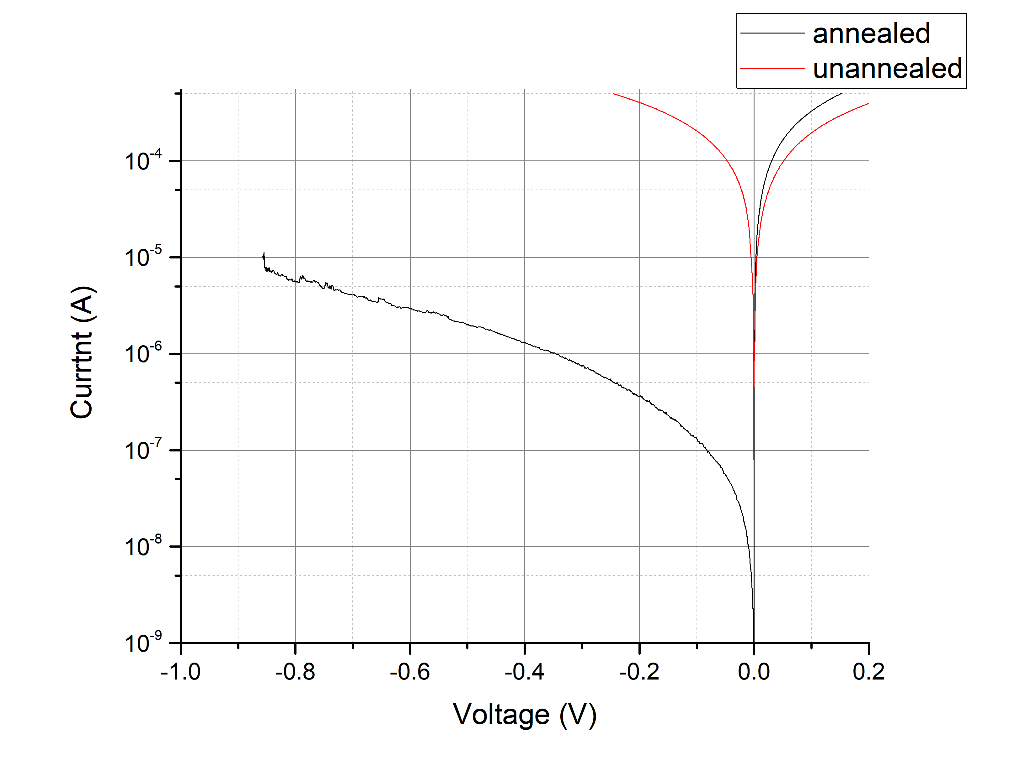
Figure 1: - Room Temperature IV measurement of annealed and un-annealed GaSbBi Schotkky Diode

