**The 13th International Probabilistic Workshop (IPW2015)**University of Liverpool, UK, 4 – 6 November 2015

IPW 2015 THE POSSIBILITIES OF COAL POWER PLANTS REPLACEMENT WITH SMALL MODULAR REACTORS – A UK CASE STUDY

PETRA MLEJNKOVA1 and EDOARDO PATELLI1

## *1Institute for Risk and Uncertainty/ University of Liverpool/ Brownlow Hill Liverpool L69 3GH, United Kingdom. E-mail: petra.mlejnkova@liverpool.ac.uk;*

*E-mail: edoardo.patelli@liverpool.ac.uk.*

ABSTRACT

This study aims to analyze the possibilities of Small Modular Reactors (SMRs) as a potential replacement of coal power plants. As deriving from current UK energy policy to increase the share of low carbon energy sources, SMRs offers more timely viable option compare to large nuclear power plants. As shown in a case study, several units of currently leading designs of SMRs could be built in the UK if all coal power plants will be shut due to carbon price increase and CO2 emission restrictions. The case study shows the time scheme of potential coal power plants shut down to comply with Carbon Budget emission limits. A time scheme and number of units of construction commencement of six leading SMR designs is made to show the feasibility of replacement shut down coal plants. For comparison, a time scheme and number of rectors of conventional nuclear power plant to be built to replace potentially closed coal plants is done in the end of the study.

Keywords: Small Modular Reactors; UK carbon reduction policy; coal power elimination.

# Introduction

There are several advantages that deployment of SMRs can bring to future generations. Building smaller units closer to point of use can reduce transmission losses or provide district heating. People’s natural fear of nuclear power can be moderated by increased passive safety measures united with all SMR designs. Many recent studies have focused foremost on technological and economic aspects of SMRs. Liu and Fan (2013) reviewed several representative SMR designs and their technology readiness. Namely they have focused on mPower by Babcock&Wilcox, the Westinghouse SMR and NuScale PWR. A study by Carelli et al. (2010) pointed out that the preliminary evaluation of the capital and Operations and Maintenance (O&M) costs shows that the negative effects of the economies of scale can be balanced by the integral and modular design strategy of SMRs. A paper by Locatelli et al (2013) is focused on assessment of Light Water Reactors (LWRs) life cycle, along with a comparison of their relative merits with other base-load technologies. Technology readiness and feasibility study for SMRs have been also published by International Atomic Energy Agency.

However, this study aims to show the possible replacement of coal power plants in the UK by SMRs as coal plants may begin to be shut down according to new Government requirements. The case study reveals a possible prediction model for the carbon emissions limit from power plants and predicts the time scheme in which UK coal power plants may start to be shutting down. Based on the capacity of each coal plant being shut down another time scheme, this time for commencement of construction for the six leading SMR designs to replace coal plants capacity is presented and number units that would need to build is shown. A comparison with number of rectors and commencement of construction for conventional nuclear power plant is made.

## UK carbon dioxidereduction plan

The UK signed (1998) and ratified (2002) the Kyoto Protocol[1] which entered into force in February 2005 and it is therefore obliged to lower its CO2 emissions. The provisions to meet the Kyoto Protocol requirements are stated in the UK Climate Change Act of 2008. Besides others, the Act added carbon reduction target into law and UK is therefore committed to reduce CO2 emissions between 26% and 32% by 2020 and by 80% in 2050 from 1990 levels (HM Government, 2011). The emissions reduction needs to be targeted in the all of the three main sectors – electricity, residential and transport, with electricity being produced by low-carbon sources (renewables, nuclear and Carbon Capture and Storage – CCS), houses being more efficient to save energy and vehicles with internal combustion engines to be hybridized with electric motors, replaced by all-electric battery vehicles, or fuel cell vehicles, probably fuelled by hydrogen (Ekins et al., 2013).

The future of nuclear power in the UK is secured by the provisions of the Energy Act 2013 (HM Government, 2013a) which commits to deliver secure, affordable and low carbon energy and establishes an independent nuclear regulator – Office for Nuclear Regulation (ONR). This Act puts in place measures to attract the £110 billion investment which is needed to replace current generating capacity with low-carbon capacity and upgrade the grid by 2020, and to cope with a rising demand for electricity.

## *Power Stations to be shut down*

Due to one of the proposals of the 2011 government Electricity Market Reform (EMR) white paper, the carbon floor price went up from £9.54 to £18.08 per tonne of CO2, raising the cost of a tonne of carbon for British power plants to £23, when allowances on the EU’s emissions trading system (ETS) are factored in (The Guardian, 2015). Nowadays 31% of UK electricity comes from 11 coal stations across the country. Increase of carbon price led to a shutdown of 3 coal power stations in the last three years, namely:

* Cockenzie Power Station (1152 MW)
* Kingsnorth Power Station (1940 MW);
* Tilbury Power Station (1131 MW) (Smeed, 2015, Processengineering.theengineer.co.uk, 2015).

About 20% of UK electricity in 2014 came from nuclear power. To sustain this contribution of nuclear power to the future energy mix, new nuclear power plants (NPP) must begin to be built within few years as most of the currently operating power plants will be shut down by 2023 (World-nuclear.org, 2015a).

**Table 1. Expected shutdown of nuclear power stations operating in the UK.**

|  |  |  |  |
| --- | --- | --- | --- |
| **Plant** | **Type** | **Capacity (MWe net)** | **Expected Shutdown** |
| **Wylfa 1** | Magnox | 490 | Dec 2015 |
| **Dungeness B 1&2** | AGR | 2x520 | 2028 |
| **Hartlepool 1&2** | AGR | 595, 585 | 2024 |
| **Heysham I 1&2** | AGR | 580, 575 | 2019 |
| **Heysham II 1&2** | AGR | 2x 610 | 2023 |
| **Hinkley Point B 1&2** | AGR | 475, 470 | 2023 |
| **Hunterston B 1&2** | AGR | 475, 485 | 2023 |
| **Torness 1&2** | AGR | 590, 595 | 2023 |
| **Sizewell B** | PWR | 1198 | 2035 |
| **Total: 16 units** |  | **9373 MWe** |  |

(World-nuclear.org, 2015a).

The planned start of Hinkley Point C (two EPR reactors - 3.2GW in total) operation in 2023 seems to be delayed and new nuclear power plant at Wylfa Newydd will not commence operating before 2025 (BBC, 2015, Daily Post, 2015).

New replacement gas plants have not yet been built, in part because Britain’s drive for more intermittent wind farms. Ministers are planning a new subsidy scheme to encourage new gas plants, but those built under this scheme will not be up and running until 2018 at the earliest. One gas plant, Carrington, is currently under construction and scheduled to open in 2016 (Telegraph, 2015).

Carbon capture and storage technology offers a potential means of reducing the impact of CO2 emissions from coal-fired power stations. Although still in development, the UK Government is encouraging investment in CCS to help reduce emissions[2] and the timely deployment of this technology. But this still does not offer a solution for a near future.

SMRs can be built in a relatively short time compare to large NPP (World-nuclear.org, 2015b). The issue with SMRs that can raise now is public rejection and similarly to large NPP SMRs need to undergo licensing process which can be as time-expensive as for large power plants. With a four year licensing process and an average three year construction time, SMRs can still help substitute some of the nuclear plants to be shut in 2023.

The Government’s Long Term Nuclear Energy Strategy, part of the Nuclear Industrial Strategy, sets out the need to keep an advanced and diverse range of options (including SMRs) open in terms of nuclear technology (HM Government, 2013b).

SMRs, particularly those based on known nuclear technologies, are a viable proposition for future deployment in the UK in the next decade. They could potentially have a key role to play in delivering low carbon energy at lower upfront capital cost compared to large conventional nuclear reactors. The planned shutdown of both coal and nuclear power plants can jeopardize energy supply in the UK (World-nuclear.org, 2015a). The potential distribution of UK energy mix up to 2050 was modeled[3] by the UK Energy Research Centre (UKERC). The prediction model was built on known and by the time implemented energy legislation (cut-off date December 2012). In Fig. 1 we can see the combination of four modeled scenarios considering different evolution in UK energy policy.

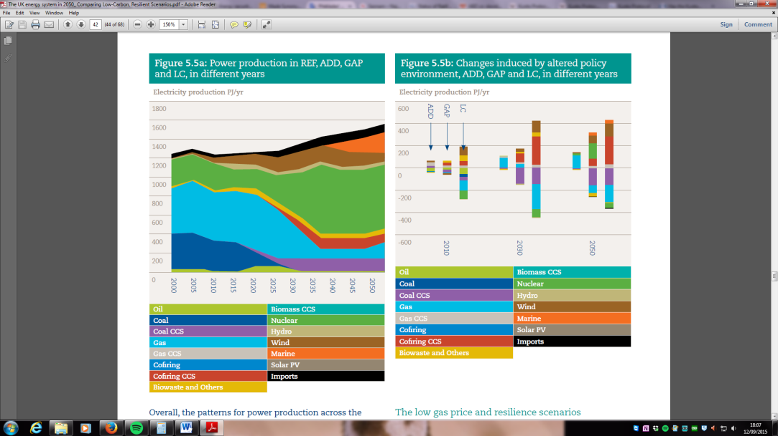

**Fig. 1.** Predicted UK energy mix up to 2050 by UKERC (Ekins et al., 2013).

The level of changes needed in the energy sector to produce enough low-carbon energy was by this model discovered to be very costly and politically demanding. From Fig.1. we can also see that nuclear power plays important part in future energy mix scenario. The increase of nuclear energy contribution in the energy mix is evident between years 2025 to 2035. With the fact that most of the currently producing NPP are going to be shut down by 2023, more than the two currently planned NPP should start to be built soon (World-nuclear.org, 2015a). This gives an opportunity for SMRs to contribute to the energy demanded from nuclear source.

**Case Study – replacement of all UK coal plants with SMR**

Focus of this case study is to show how many SMRs would need to be built to replace the current capacity of all UK operating coal power plants. The SMRs considered are either in their near-term deployment stage or already under construction in some country according to International Atomic Energy Agency (IAEA) (International Atomic Energy Agency, 2014a,b).

**Table 2. Currently operating coal power stations and their maximal electric power output.**

|  |  |
| --- | --- |
| **Plant** | **Capacity (MWe) (MWe)(MWE(MWe net)** |
| **Longanet** | 1490 |
| **Kilroot** | 520 |
| **Fiddler’s Ferry** | 1980 |
| **Ferrybridge C** | 920 |
| **Eggborough** | 1960 |
| **Drax** | 3870 |
| **Cottam** | 2008 |
| **West Burton** | 2012 |
| **Rugeley** | 1006 |
| **Ratcliffe** | 2000 |
| **Aberthaw** | 1586 |
| **Total 11 coal plants** | **19 352 MWe** |

**Table 3. Characteristics of the most developed SMR designs.**

|  |  |  |  |  |
| --- | --- | --- | --- | --- |
| **SMR design** | **Design Organization** | **Country** | **Output (MWe)** | **Design Status/Commercial Start** |
| **SMART** | Korea Atomic Energy  Research Institute | Republic of Korea | 100 | Standard Design Approval Received 4 July 2012 |
| **mPower** | B&W Generation mPower | USA | 180 | Design Certification Application 2015 |
| **NuScale** | NuScale Power Inc. | USA | 50 | Design Certification Application mid 2016 |
| **ACP100** | CNNC/NPIC | China | 100 | Detailed Design, Construction Starts in 2016 |
| **CAREM-25** | CNEA | Argentina | 27 | Commercial start: 2017 ~ 2018 |
| **HTR-PM** | Tsinghua Univ./Harbin | China | 250 | Commercial start: 2017 ~ 2018 |
| **PFBR-500** | IGCAR | India | 500[4] | Commercial start: 2015 ~ 2018 |

(International Atomic Energy Agency, 2014a,b).

**Table 4. The overall number of units per reactor design needed to replace current operating capacity of coal power plants.**

|  |  |  |
| --- | --- | --- |
| **SMR design** | **Output (MWe)** | **Number of modules needed to replace capacity of coal plants** |
| **SMART** | 100 | 194 |
| **mPower** | 180 | 108 |
| **NuScale** | 50 | 387 |
| **ACP100** | 100 | 194 |
| **CAREM-25** | 27 | 717 |
| **HTR-PM** | 250 | 77 |
| **PFBR-500** | 500 | 39 |

As we can see from Tab. 4 the number of units that would have to be built to replace the capacity of coal power plants is very high. This raises a question whether this amount of units could be built from not only financial point of view but also from public acceptance or ecological point of view.

Sitting issues for SMRs have not been solved yet, but due to their modular character and smaller radioactive material inventory, they can be built closer to densely populated places which may not be accepted by affected public. This issue needs to be addressed and will be focused on in future work. More units may also require denser grid in particular places, which can raise some ecological opposition by disrupting landscapes etc.

Financial issues have been excluded from this study because of their complexity and will also be of interest in one of future studies.

*Estimation of coal plants time scheme shut down to comply with Carbon Budget emission limits*

Based on Carbon Budget CO2 emission limits a time scheme for coal plants shut down was estimated. The emission limit for power plants was estimated at 32% of the overall Carbon Budget emission limits. The 32% estimate was based on historical data - is it an average share of power plants CO2 emissions on overall UK CO2 emissions between years 1970 and 2013 (Department of Energy & Climate Change, 2015). The option of reduction of CO2 emission from a different source was excluded from this study.

The scenario of Carbon Budget emission limits development is a linear prediction model based on the last value of the Carbon Budget power plant share emission limit (in 2027) and the targeted value for 2050 (80% of the 1990 CO2 levels).

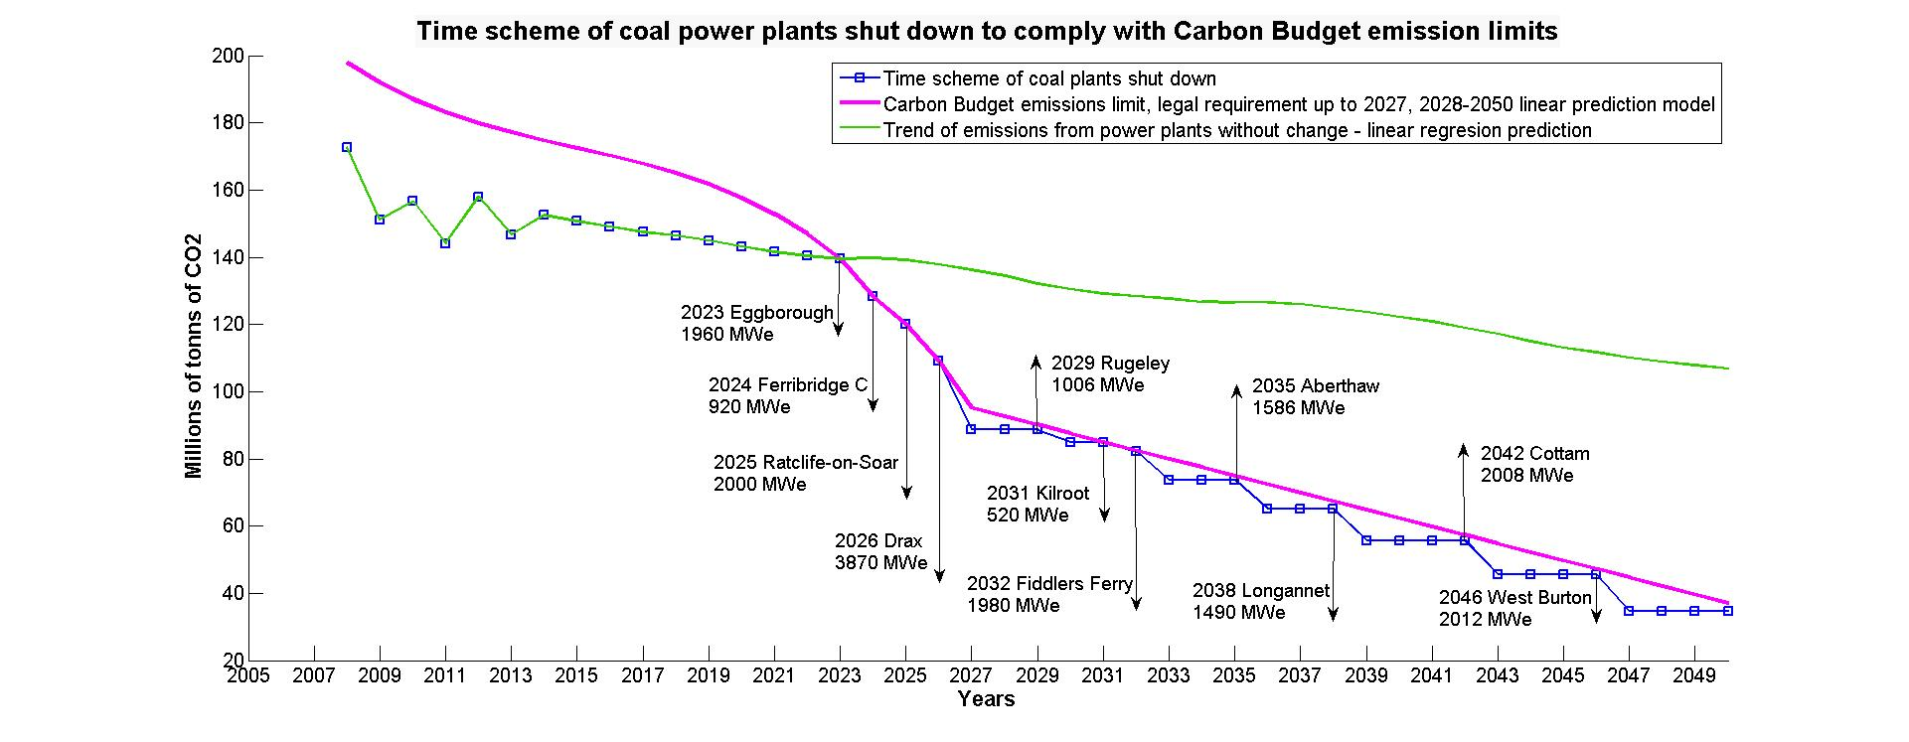

**Fig. 2.** Time scheme of coal power plants shut down to comply with Carbon Budget emission limits.

In Fig. 2we can see the estimated time frame of coal power plants shut down according to emission limits of chosen model. In this graph we can see gradual scheme of coal plants shut down due to the linear properties of the model. We can see from the figure that shutting down all currently operating coal power plants would be enough to comply with the strict Carbon Budget target for 2050 which for the power plants share is estimated to be 37.1 MtCO2/year.

Uncertainty in the prediction scenario has to be taken into account as the Carbon Budget share for power plants emissions was estimated to be 32% as the mean of historical share of power plants emissions on overall UK emissions. The historical share varies between 26% and 35% with a standard deviation of these values of 2.4.

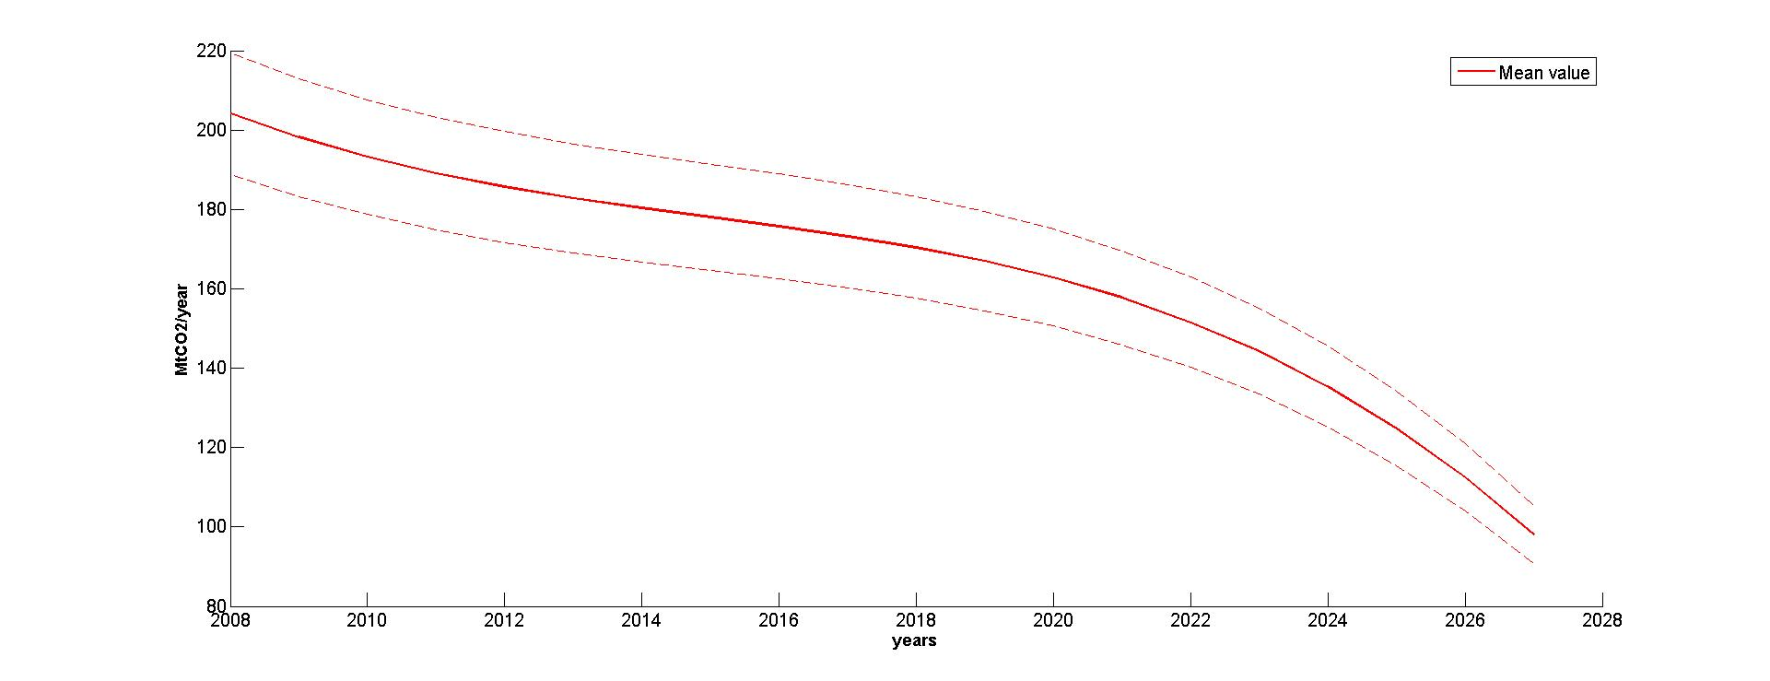

**Fig. 3.** Uncertainty in the share of power plants CO2 Carbon Budget emissions on overall CO2 Carbon Budget emissions.

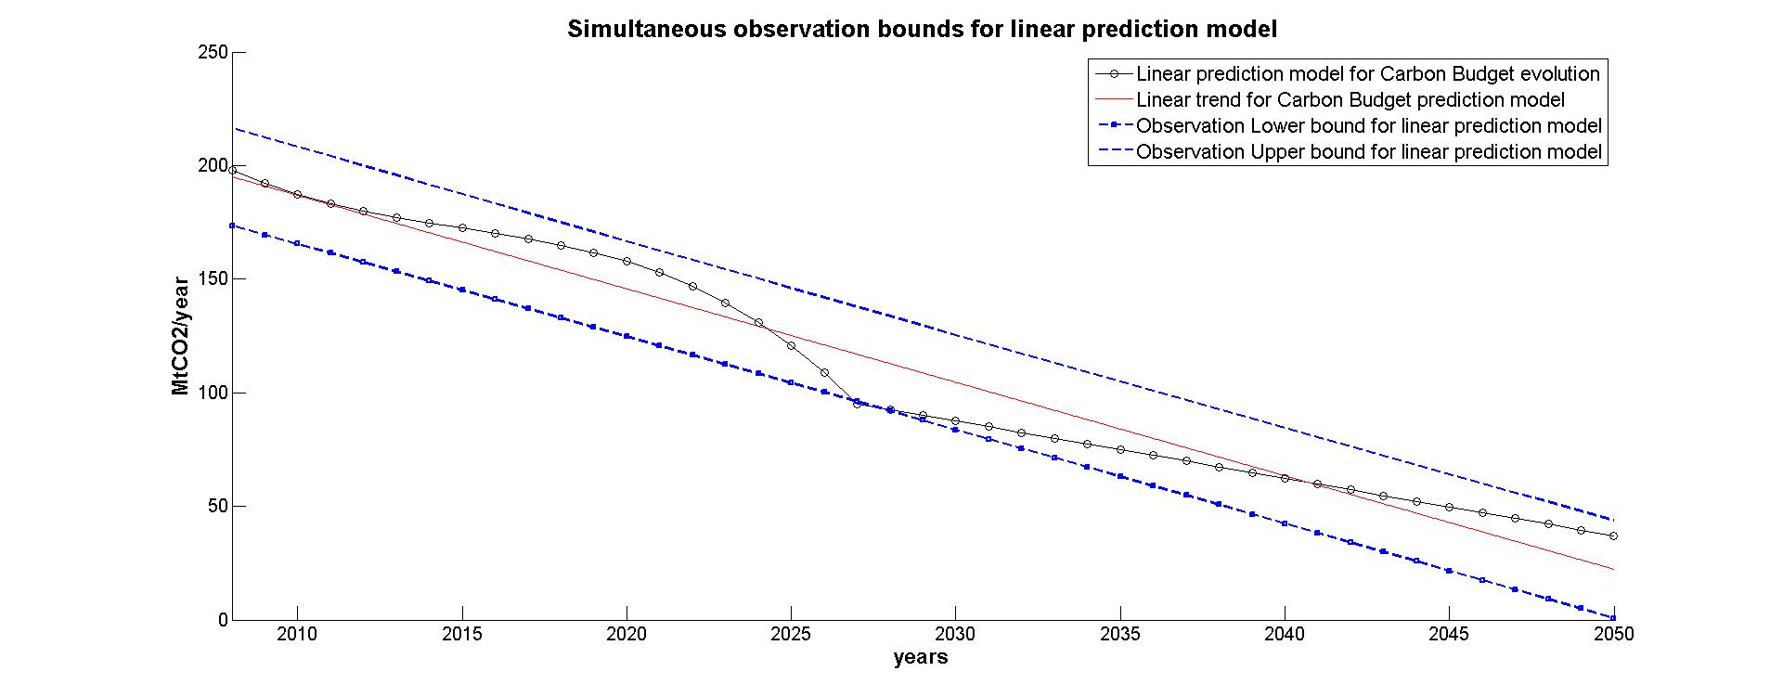

**Fig. 4.** Uncertainty and observation bounds in linear prediction model.

Fig. 4 shows the observation bounds for linear curve fitted to linear prediction model scenario. Observation simultaneous bounds were chosen for this model as they measure the uncertainty of predicting the fitted curve plus the random variation in the new observation and are for all elements of x.

**Small Modular reactors**

The next part of the study aims to show the time frame and a number of SMR units (considering only designs in near-term deployment or designs already under construction stated in Tab. 3.) should be built in order to replace the capacity of potentially shut down coal plants to comply with Carbon Budget emissions.

The graphs shows the time frame of construction commencement as stated by Rothwell and Ganda (2014), with an estimated construction lead mean time (for water-cooled designs) of 2.9 years with 95% confidence interval between 4 years and 2.2 years fitted to lognormal density.

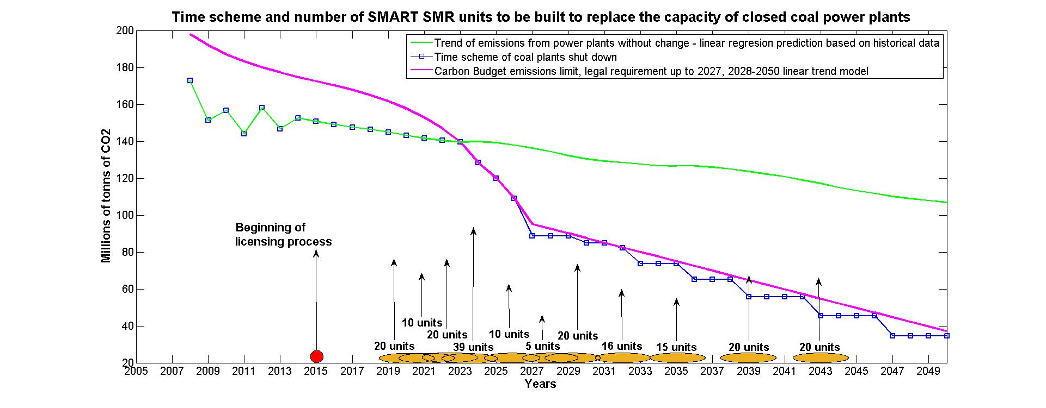

**Fig. 5.** Time scheme and number of units of SMART SMRs units to be built to replace the capacity of shut down coal plants.

From Fig. 5 we can see that the time frame to start building first 20 units of SMART SMR is between the end of 2018 (11/2018) and the end of 2020 (10/2020) to replace the 1960 MWe of the first coal plant being shut down in 2023. If we also consider that no SMR has been yet licensed in the UK we have to add 4 years for a licensing process (Halper, 2014).

Time scheme and number of units for the remaining 5 types of SMR and comparison with a conventional NPP are summarized in Tab. 5. The construction time for mPower and NuScale SMRs is assumed to be the same as for SMART SMR as all three are water-cooled designs and more accurate construction time estimate is not available. The expected construction time for ACP100 is 36-40 months (World-nuclear.org, 2015b) for HTR-PM is expected to be 50 months (Zhang et al., 2009) and a 5 year construction time for PFBR-500 (Dae.nic.in, 2015).

**Table 5 . The time scheme and number of units of the remaining 5 designs of SMRs and conventional NPP.**



**Conventional Nuclear Power Plant**

For comparison a time scheme and number of reactors of a conventional nuclear power plant was estimated. In the model a nuclear power plant with electrical output of 1040 MWe was considered. This number is an average of electrical outputs of currently operating NPP in the UK. The time frame for construction of one reactor was taken from a report by Schneider et al., (2013), which considered conventional reactor construction times between years 2003 and 2013 worldwide and estimated total average mean time of 9.4 years with a minimum construction time 3.8 years and maximum construction time of 26.8 years. Fig. 6 shows the average construction mean time for a conventional reactor.

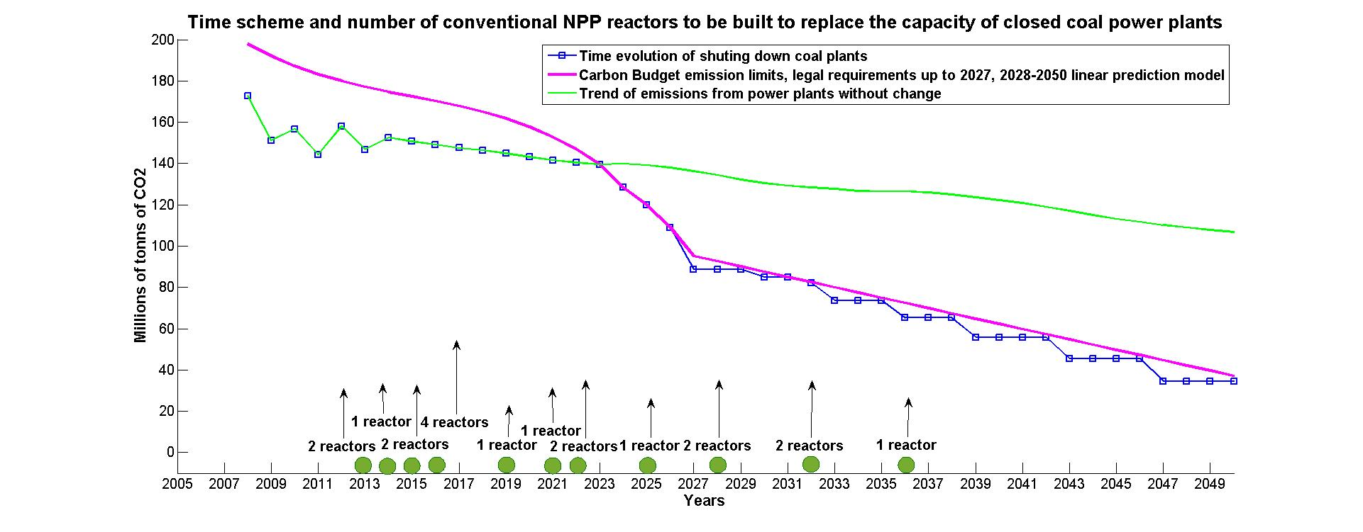

**Fig. 6.** Time scheme and number of reactors of an average conventional NPP to be built to replace the capacity of shut down coal plants.

# Discussion

Based on the Carbon Budget CO2 emission limits it is very likely that UK coal power plants will soon need to be shut down, if no other technology for carbon emission reduction like Carbon Capture and Storage will not soon become available. As the overall capacity of UK coal power plants is high we can see from the results of the case study that quite high number of Small modular reactors would need to be built to replace them. This can raise a question whether this amount of nuclear reactors even though significantly smaller than conventional NPP would be accepted by public. Time – wise we can see that the option is still feasible, but only in case licensing process would begin this year. There can be also questions about financing such a significant investment in a new technology. Also price per MWh of electricity produced by SMR is not very clear and issues some questions about competitiveness. Undoubtedly, the financial feasibility of coal replacement with SMRs requires further investigation. From the comparison with an average conventional nuclear power plant we can see that way fewer reactors would need to be built but with way higher uncertainty in construction times and with some of the first reactors being already few years behind commencement of construction.

There is also uncertainty in the Carbon Budget emission prediction trends as we are looking at quite distant future and the prediction model represents only a trend and do not reveal exact values of the power plants CO2 emission share. Future work will be focused on comparison of prediction model presented in this case study with different scenarios in emission limit development. This should offer a comprehensive overview on application of SMRs as a coal power plants replacement. There is also a gap in SMR public acceptance investigation which offers many interesting topics that can be look at. From a point of view of new technology acceptance, preferences in electric energy providers or popularity comparison with other representatives of small energy generation.

**Conclusion**

This study looked at one of the many possible applications of SMRs and its feasibility. From the current UK CO2 emissions legal limits became obvious that coal power plants cannot remain a dominant energy provider and their part of future energy mix cannot be very significant if any. Based on current Carbon Budget emission limits an emission limit prediction model for power plants was estimated and a time scheme of coal power plants shut down to comply with this limit was established. According to this scheme the first coal power would need to be shut down in 2023 (emitting 11.5 Mt of CO2/year) and the last one to be shut down in 2046 (emitting 10.9 Mt of CO2/year). Based on electric capacity of each coal plant and a construction time of each chosen SMR design a time scheme for construction commencement of each SMR to replace the missing electric energy capacity was made. It was found out that SMRs can still be built on time to replace the missing capacity from coal plants if these will be shut down. The mean time of commencement of most designs was estimated to year 2020. Because of uncertainty in construction times and likely delays in first-of-a-kind engineering construction of first units should be taken to be around the upper bound of estimated construction time which is 4 years for most of the chosen designs. Time for licensing process has to be added on top the construction time as no SMR design has been yet licensed in the UK. Therefore the estimated year for licensing process start gives us year 2015. A time scheme for construction commencement of a conventional NPP was made as a comparison. If a conventional NPP should serve as a replacement for coal plants being shut down, first reactor would have to be under construction since 2013.

**References**

BBC, (2015). *Hinkley Point nuclear plant delayed, says EDF*. [online] Available at: http://www.bbc.co.uk/news/business-34149392 [Accessed 11 Sep. 2015].

Change, U. (2015). *Kyoto Protocol*. [online] Unfccc.int. Available at: http://unfccc.int/kyoto_protocol/items/2830.php [Accessed 10 Sep. 2015].

Daily Post, (2015). *Wylfa Newydd developers still aiming for 2025 despite EDF's Hinkley Point delays*. [online] Available at: http://www.dailypost.co.uk/business/business-news/wylfa-newydd-developers-still-aiming-9993883 [Accessed 11 Sep. 2015].

Dae.nic.in, (2015). *Fast Breeder Programme | Department of Atomic Energy*. [online] Available at: http://dae.nic.in/?q=node/208 [Accessed 14 Oct. 2015].

Department of Energy and Climate Change, (2011a). *Electricity Generation Cost Model - 2011 Update Revision 1*. Parsons Brinckerhoff.

Department of Energy & Climate Change, (2015). *2013 UK greenhouse gas emissions: final figures - statistical release*. Department of Energy & Climate Change.

Eia.gov, (2015). *Environment - U.S. Energy Information Administration (EIA) - U.S. Energy Information Administration (EIA)*. [online] Available at: http://www.eia.gov/environment/emissions/co2_vol_mass.cfm [Accessed 19 Oct. 2015].

Ekins, P., Strachan, N., Keppo, I., Usher, W., Skea, J. and Anandarajah, G. (2013). *The UK energy system in 2050: Comparing Low-Carbon, Resilient Scenarios*. [online] London: UK Energy Research Centre. Available at: http://www.ukerc.ac.uk/publications/the-uk-energy-system-in-2050-comparing-low-carbon-resilient-scenarios.html [Accessed 11 Sep. 2015].

Engineeringtoolbox.com, (2015). *Combustion Fuels - Carbon Dioxide Emission*. [online] Available at: http://www.engineeringtoolbox.com/co2-emission-fuels-d_1085.html [Accessed 26 Oct. 2015].

Halper, M. (2014). UK prepared to regulate small modular reactors. *Energy 2.0*.

HM Government, (2011). *The Carbon Plan: Delivering our low carbon future*. London: Department of Energy & Climate Change.

HM Government, (2013a). *Energy Act 2013*. London: HM Government.

HM Government, (2013b). *Long-term Nuclear Energy Strategy*. London: Department of Energy and Climate Change.

International Atomic Energy Agency, (2014a). *SMRs Under Construction for Immediate Deployment*. Vienna: International Atomic Energy Agency.

International Atomic Energy Agency, (2014b). *SMRs under development for Near - term Deployment*. Vienna: International Atomic Energy Agency.

Liu, Z. and Fan, J. (2014). Technology readiness assessment of Small Modular Reactor (SMR) designs. *Progress in Nuclear Energy*, 70, pp.20-28.

Processengineering.theengineer.co.uk, (2015). *Ferrybridge power station to close | Business news | Process Engineering*. [online] Available at: http://processengineering.theengineer.co.uk/power-and-water/ferrybridge-power-station-to-close/1020393.article [Accessed 10 Sep. 2015].

Ramana, M., Hopkins, L. and Glaser, A. (2013). Licensing small modular reactors. *Energy*, 61, pp.555-564.

Rothwell, G. and Ganda, F. (2014). *Electricity Generating Portfolio s with Small Modular Reactors*. Argonne: Nuclear Engineering Division.

Schneider, M., Froggatt, A., Hosokawa, K., Thomas, S., Yamaguchi, Y. and Hazemann, J. (2013). *The World Nuclear Industry Status Report 2013*. Paris, London: Mycle Schneider Consulting.

Smeed, M. (2015). *Coal generation | Energy UK*. [online] Energy-uk.org.uk. Available at: http://www.energy-uk.org.uk/energy-industry/coal-generation.html [Accessed 5 Sep. 2015].

Telegraph, (2015). *Why Britain's power plants have closed - and more will be closing*. [online] Available at: http://www.telegraph.co.uk/finance/newsbysector/energy/11175700/Didcot-fire-Why-Britains-power-plants-have-closed-and-more-will-be-closing.html [Accessed 8 Sep. 2015].

The Guardian, (2009). *Carbon capture plans threaten shutdown of all UK coal-fired power stations*. [online] Available at: http://www.theguardian.com/business/2009/jun/17/coal-power-stations-face-shutdown [Accessed 7 Sep. 2015].

The Guardian, (2015). *Carbon floor price hike will trigger UK coal slowdown, say analysts*. [online] Available at: http://www.theguardian.com/environment/2015/apr/02/carbon-floor-price-hike-will-trigger-uk-coal-slowdown-say-analysts [Accessed 11 Sep. 2015].

World-nuclear.org, (2015a). *Nuclear Power in the United Kingdom |UK Nuclear Energy*. [online] Available at: http://www.world-nuclear.org/info/Country-Profiles/Countries-T-Z/United-Kingdom/#SSA [Accessed 15 Sep. 2015].

World-nuclear.org, (2015b). *Small Nuclear Power Reactors*. [online] Available at: http://www.world-nuclear.org/info/Nuclear-Fuel-Cycle/Power-Reactors/Small-Nuclear-Power-Reactors/ [Accessed 6 Sep. 2015].

Zhang, Z., Wu, Z., Wang, D., Xu, Y., Sun, Y., Li, F. and Dong, Y. (2009). Current status and technical description of Chinese 2×250MWth HTR-PM demonstration plant. *Nuclear Engineering and Design*, 239(7), pp.1212-1219.

1. The Kyoto Protocol is an international agreement linked to the United Nations Framework Convention on Climate Change, which commits its Parties by setting internationally binding emission reduction targets (Change, 2015).
2. For example: In 2006 Drax Power Limited, in response to a government consultation, stated they were sponsoring development studies into carbon capture and storage (CCS), but noted that it was not then commercially viable, with costs comparable with nuclear or offshore wind power (The Guardian, 2009).
3. The model was built in MARKAL software. MARKAL is a well-established linear optimization, energy system model, developed by the Energy Technology Systems Analysis Programme (ETSAP) of the International Energy Agency (IEA) (Ekins et al., 2013).
4. According to electric output of the PFBR-500 it falls more into a category of medium sized modular reactors. For greater diversity in chosen designs and comparison, we will consider PFBR-500 to be an SMR for purposes of this study and the nomenclature between medium and small reactors will not be distinguished from now on in this this study.PFBR-500 will be taken as SMR as it still meet the conditions of being modular.