Abstract
Nuclear power systems capable of outputting low powers (<100 MWth) are increasingly receiving interest internationally for deployment not only as electricity production systems, capable of operating off-grid, but also as systems able to provide industrial process heat. These ‘micro-reactor’ concepts must demonstrate economic competitiveness with other potential solutions capable of providing similar power outputs. With this in mind, reactor technologies that offer inherent advantages associated with improved power density and simplified operation, both of which are important attributes that determine economic competitiveness, are reviewed in the context of the fundamental safety functions provided by the IAEA.
The reactor technology chosen based on the results of the review were: low vapour pressure coolants like molten salt or liquid metal; solid moderator material; and conventional solid UO₂ fuel. Initial infinite lattice neutronic studies indicated a series of positive reactivity coefficients. A finite system was also modelled using a molten salt as the coolant. When modelling the finite system the coolant temperature reactivity coefficient became negative, the void coefficient strongly negative and moderator temperature coefficient negative to weakly positive. Given that a number of reactivity coefficients were negative to strongly negative in the finite system, the weakly positive moderator temperature coefficient is not thought to be prohibitive. Thus the design should exhibit acceptable safety performance.
Whilst the importance of leakage in fast reactor cores is well known, a key outcome from this study is the strong influence of leakage on all safety related parameters for the thermal reactor designs considered here with solid moderator material. Thus it seems that safety studies for such small cores should be based on full core calculations instead of the traditional infinite lattice studies for fuel assemblies.

Introduction
There is an increasing interest, globally, in small reactors (<300 MWe) that are designed to be assembled, as far as is practical, in a factory setting. These so-called Small Modular Reactors (SMRs) have been discussed extensively elsewhere [1, 2, 3]. Briefly, apart from being ideally suited to customers with smaller power requirements, the benefits SMRs may offer are: increased flexibility with respect to siting; improved safety performance; reduced construction times; and reduced upfront investment requirements. The challenges facing SMRs relate to development costs; uncertainty surrounding licensing (especially for innovative technologies that regulators are less familiar with); and uncertainties surrounding economic competitiveness, in terms of cost per kWe.
Many of the SMRs have power outputs ~100 MWe, with the intention of placing multiple units together to allow for electricity production around 500 MWe and sharing of facilities (such as turbo-generator units) to reduce costs. Therefore, the primary purpose of these systems is to provide electricity to the grid. It should be noted that as power plants are grouped together, this limits siting flexibility. However, to operate systems with a small combined power output (<200 MWe), bespoke turbo-generators would be required.
There has also been recent interest in mobile floating nuclear power plants. Two recent noteworthy examples are: the ACPR50S, which is a 60 MWe reactor, being developed for the supply of electricity, heat and desalination; and the Russian Akademik Lomonosov plant which uses two 35 MWe reactors [4]. Besides the Akademik Lomonosov plant several new designs are investigated for autonomous power supply in Russia [5].
Some SMRs are focused on producing even lower power outputs and are targeted at industrial power facilities or remote locations where there is no grid available. Furthermore, these low powered systems intend to take the safety performance benefits of many SMRs further by achieving indefinite decay heat removal. These smaller variants of SMRs are sometimes termed micro-reactors [6].
Micro-reactors, being a subset of SMRs, share the same challenges listed above but the most profound will be the issue relating to cost per kWe since micro-reactors will lose almost entirely the benefits attributable to scaling of power to improve economic performance and, if not appropriately designed, the operation and maintenance (O&M) costs could make these low power nuclear reactors formidably expensive. However, it must be remembered that for micro-reactors, the comparison should not be with large nuclear reactors but with the technologies that are often used to provide such small amounts of power, e.g. diesel generators or small gas turbines.
Unlike in the case for SMRs, where there is a broad agreement in the literature regarding power output (<300 MWe), there is no comparable definition for micro-reactors. Given that many micro-reactors are focused around industrial power requirements and process heat applications, micro-reactors are thus defined here as having thermal powers <100 MWth. This definition is based solely on the fact that industrial power generation units typically have outputs of up to 50 MWe [7, 8] and some advanced micro-reactors claim thermal efficiencies ~40% [9].
The purpose of this investigation was to consider what technologies are capable of taking advantage of the inherent benefits attributable to micro-reactors (easier decay heat removal) whilst also meeting the requirements related to improved economic performance (reducing capital and O&M costs).

Choice of technologies
For any nuclear reactor system it is vital that the system is able to demonstrate that: the fuel is adequately cooled; reactivity can be controlled; and radioactive material is confined [10], see Figure 1. Meeting these multiple requirements defined in the fundamental safety functions provided by the IAEA always adds complexity, and therefore cost, of the system.

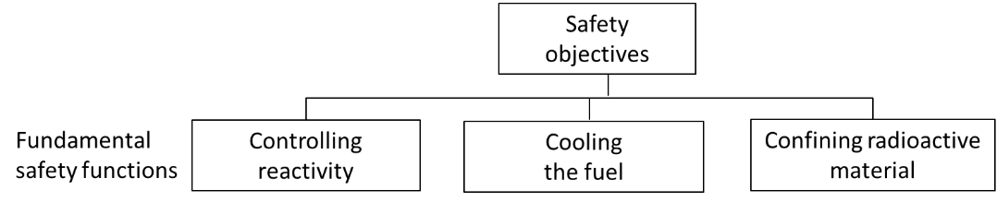
Figure 1: General view on reactor safety as expressed by the IAEA [10]

Controlling reactivity
The neutron spectrum ultimately governs the overall difficulty in achieving adequate reactivity control and the required fissile concentrations in the fuel (with the cycle lifetime being of secondary importance). With fast spectrum systems, high fissile concentrations are required due to the low fission cross-section of fissile material at high neutron energies (~1/100th compared to thermal neutron energies).
Energy production per unit volume (E) is given by:
$$E=ϕ∙κ∙Σ_{\text{fiss}}$$
where $ϕ$ is the neutron flux (cm⁻²s⁻¹), $κ$ is the average energy released per fission event (J/fission) and $Σ_{\text{fiss}}$ is the macroscopic fission cross-section (cm⁻¹). Therefore, to achieve high energy production within a small core the choices are:
- to increase the flux level, which results in degradation/neutron damage of core materials; and/or
- to increase the fissile content, which has negative implications regarding cost of enrichment, proliferation and safety. Moreover, in the case of high concentration plutonium fuel, there is limited information regarding the suitability of manufacturing such fuel using current processes and, for uranium fuel, the 20 wt.% enrichment limit must be obeyed [11]; and/or
- to adopt a neutron energy spectrum that favours the thermal end of the spectrum such that the integrated value of $Σ_{\text{fiss}}$ is maximised.

A further difficulty in fast reactor systems is the inherent difficulty associated with reduced negative feedback effects, compared to LWRs, and the reactor kinetics associated with the comparably short neutron generation time. Furthermore, since high fissile concentrations are required in a fast spectrum, which almost inevitably forces designers to employ MOX fuel, with significant ²³⁹Pu content, the delayed neutron fraction is reduced. Therefore, a thermal spectrum system was selected.
By operating a liquid metal, or molten salt cooled system with a thermal spectrum, some of the inherent challenges with fast spectrum systems, such as core compaction, (whereby, in a fast spectrum system, fuel densification increases system reactivity, whereas in a thermal spectrum system reactivity reduces) and sufficient shutdown margin, would be removed. Furthermore, there exists the possibility of utilising a liquid injection system to act as a diverse shutdown mechanism, which is not normally possible in fast systems due to the weak fast neutron absorption properties of almost all absorber materials in a fast neutron spectrum.

Cooling the fuel
The most important design choice that impacts heat removal aspects is the selected coolant medium. A coolant should preferably exhibit a high volumetric heat capacity (product of density and specific heat capacity) and no phase change during normal and accident conditions. Furthermore, for economic reasons, the coolant should: exhibit low neutron absorption; possess a low pressure at operational temperatures; exhibit limited activation in the presence of neutrons (thereby reduce shielding requirements); be chemically compatible with core and structural materials; and have good thermal conductivity (the latter enabling high power density operation). The coolant options most reactors utilise fall into the following groups:
- Water, with light water being the preferred coolant option due to its low cost and the ready availability of the required enriched level of uranium on the open market. The main drawbacks associated with water as a coolant is the inevitable need to operate at high pressure (due to the steep vapour pressure curve) to achieve sufficiently high temperatures for electricity production, the need to use a large volume of water to achieve indefinite decay heat removal and a containment with considerably high volume due to the high pressure system [12]. All of these drawbacks result in significant economic penalties.
- Light liquid metals, with most experience associated with sodium. The main benefits of sodium are its excellent heat transfer capabilities at atmospheric pressure and its compatibility with a variety of materials that have been well-tested in nuclear reactors, along with the extensive operational experience gained with this coolant medium (> 400 reactor-years of operation) [13]. The drawbacks related to sodium are mainly associated with its chemical reactivity with air and water, the difficulty in achieving a negative void coefficient, and its opacity making in-service inspection and repair (ISI&R) challenging relative to transparent coolants [14].
- Heavy liquid metals, with historic experience heavily focused on lead-bismuth eutectics (LBE). Lead-based coolants are not strongly exothermic with air or water and have very high boiling points. However, their drawbacks relate to their ability to corrode and erode materials in a nuclear reactor and their high density making ISI&R even more difficult than sodium [15]. LBE has a much lower melting point than other lead-based coolants but it has a significant drawback associated with the production of highly active polonium aerosols. Therefore, there is an increasing interest to move away from LBE to pure lead coolants.
- Gas coolants, with two gases being extensively used or tested as a primary circuit coolant: He and CO₂. CO₂’s main advantage over helium relates to its relative abundance and therefore low cost but its main drawback is its chemical reactivity at high temperatures in the presence of an irradiation field [16]. Hence, almost all modern gas-cooled reactor concepts favour helium as the coolant choice. Helium’s main advantage over other coolants is its chemical inertness at very high temperatures [17]. A significant drawback associated with all gas coolants is the inherent difficulty in achieving passive decay heat removal with high power density systems.
- Molten salts, with the majority of experience being based on fluoride salts, in particular LiF-BeF₂ [18, 19]. Fluoride salts are particularly attractive when the fuel is dissolved into the coolant due to solubility behaviour. In a solid fuel design other options may be attractive. Molten salt coolants have advantages associated with optical transparency, high boiling points and no strongly exothermic reaction with air or water. However, their high melting points, chemical corrosiveness and, in the case of salts containing lithium, tritium production are all significant drawbacks.
Further, in aiming to achieve reduced operation and maintenance costs, and improving the overall economic performance of the reactor design, two options were considered that would impact on coolant selection:
- Increasing the power density of the reactor system, thereby requiring a coolant that exhibits a high heat capacity and efficient heat transfer; and
- Reducing the number of moving parts, such as mechanical pumps, which requires coolant properties amenable for natural convection or the use of electromagnetic (EM) pumps.
Note that EM pumps are not well suited to heavy liquid metal coolants since: the electrical conductivity of lead is relatively low; the volumetric heat capacity is relatively low, thereby requiring relatively high volumetric flow rates; and the formation of oxide layers within the primary circuit (which is a necessity to inhibit corrosion), all reduce EM pump efficiency. Molten Salts’ low electrical conductivity compared with metal coolants also limits the application of EM pumps in molten salt cooled systems.
Gas-cooled reactor systems are not amenable to natural circulation or high power density due to the limitations of the coolant (minimal density differences as a function of temperature and the fact that all gases exhibit poor heat transfer characteristics). Moreover, water coolants were not considered due to the economic penalties associated with high pressure systems and the fact that large volumes of water are necessary to achieve indefinite decay heat removal. For these reasons, only liquid metals and molten salts were considered further.
Note that the total elimination of pumps in systems using natural convection cooling will likely be challenging since situations may arise whereby natural convection is difficult to establish. This is especially true during reactor startup from cold conditions (such as after a fuel reload or a prolonged shutdown period), whereby the limited temperature differences and strong neutronic/thermal-hydraulic interaction could hinder setting up natural convection. To overcome these challenges, it is envisaged pumps would have to be available purely to aid in the establishment of natural convection, which whilst having an economic penalty (namely a set of pumps that are hardly ever used), they would be much simpler than conventional safety related reactor pump technology and their limited use would reduce their need for maintenance.

Confining radioactive material
The design of engineering barriers to confine radioactive material is made easier when: the source term is low; the system pressure during normal operation and fault sequences are low; and the likelihood of chemical reactions taking place that could degrade barriers is reduced. All else being equal, a system with these properties will exhibit economic advantages relative to a system with none of these barriers since the engineering requirements on systems to confine radioactive material will be lower.
When including molten salts as a possible coolant medium, the possibility of dissolving the fuel into the salt medium arises. The benefits associated with dissolving fuel into coolant are due to: the strong negative temperature coefficient; the high burn-up and high conversion ratio if continuous fuel clean-up is performed; and the ability to achieve a redundant shutdown mechanism related to removal of fuel into subcritical tanks [18]. However, the drawback associated with such a proposal relate to the relatively low technology readiness [19] (most experience with liquid fuelled reactors comes from operating a single research reactor for a few years compared with the thousands of reactor-years worth of experience gained from operating solid fuelled systems) and the reduced defence in depth (loss of coolant automatically results in a loss of highly active fuel). In addition, these systems will require a considerable initial investment for development and construction of an integrated system with chemical salt clean-up which is essential to access the mentioned advantages. For these reasons, only solid fuel was considered further for a micro-reactor application; cooled by either molten salt or liquid metal.

Summary of technology choice
A moderated system, using solid fuel, employing either a molten salt, heavy liquid metal or light liquid metal coolant capable of supporting a high power density core without the need for high pressure operation was selected on the basis of:
- Thermal spectrum systems exhibit fewer technical challenges associated with reactivity control than fast spectrum systems, due to thermal spectrum systems possessing stronger negative feedback effects and the reactor kinetics associated with longer neutron generation time.
- Molten salts, heavy liquid metals and light liquid metals all confer considerable advantages regarding increased power density, without necessitating high pressure operation, and also permitting the use of simplified heat removal systems (natural convection cooling). All three of these coolant options, especially in the case of light liquid metals (e.g. sodium), have historical precedents for reactor operation.
- The many decades of successful international operation of solid fuelled reactors and improved radioactive material confinement (loss of coolant does not automatically result in loss of highly active fuel).

Scoping calculations performed for natural circulation cooling and determining neutronic characteristics
Given the preference for a system utilising either natural circulation cooling or EM pumps, and the fact that for EM pumps it is relatively easy to determine appropriate coolant choices (see Section 2.2), scoping calculations were performed to assess the suitability of coolants for natural circulation operation. Furthermore, the novel attributes of the combined technology choices: a small thermal spectrum system using coolants that have typically been associated with fast reactors, warranted scoping calculations to establish neutronic characteristics.

Suitability of chosen coolants for natural circulation cooling
The system considered here is a simple natural convection loop with a hot leg containing the reactor core near its base and a cold leg containing the main heat exchanger at its top. The height difference (L) between the core and the main heat exchanger is a design parameter which needs to be large enough to generate the required flow of coolant, but small enough to make the plant compact. The following calculations impose a balance between the driving pressure differential generated by buoyancy and the pressure losses within the system for three different choices of coolant, namely molten salt, heavy liquid metal and light liquid metal.
The pressure difference associated with the buoyancy force is
ΔP_{B} = ρβgΔTL (1)
Where ρ is the coolant density, β is coolant expansion coefficient, g is the gravitational acceleration, ΔT is the temperature difference across core region and L is the distance between the mid-point of the core and the mid-point of the heat exchangers.
The pressure drop across the core is
ΔP_{D} = (½)K[(m’)/A]²/ρ (2)
Where K is the loss coefficient and m’ is the mass flow rate and A is the flow area. Note that K is highly dependent on the lower reactor structural geometry that directs the coolant into the core coolant channels, which is especially important in natural circulation cooling configurations.
Equating the two pressure differences equations and replacing m’ with the equation relating heat transfer, Q’, with specific heat capacity, C_{p}, (Q’=m’C_{p}ΔT) gives:
ΔP_{B} / ΔP_{D} = 1 = [2ρ²βg(ΔT)³L(A)²C_{p}²]/[K(Q’)²] (3)
ρ and β are properties of the coolant and g is a constant. Q’ is set by the functional requirements placed on the power system. K, A and L are free parameters, hence the following coolant metric (M) has been defined as:
M = K/[L(ΔT)³A²] = 2 ρ²βg C_{p}²/(Q’)². (4)
In the case natural circulation, the low coolant velocities will limit the importance of the pressure loss coefficient (K).
Table 1: Coolant properties for LiF-BeF₂, Pb and Na
Coolant | T_{in}/T_{out}  (K) | T_{mean}  (K) | ρC_{p}  (J/m³/K) | β  (K⁻¹) | ΔT  (K) | λ  (W/m/K) | Reference(s)
LiF-BeF₂ | 798/923 | 861 | 4.9E6 | 2.0E-4 | 125 | 1.0 | [18]
Pb | 673/773 | 723 | 1.5E6 | 1.2E-4 | 100 | 17 | [22]
Na | 673/823 | 748 | 1.1E6 | 2.8E-4 | 150 | 69 | [23]

Table 1 highlights key coolant properties that ultimately determine the suitability of coolants for natural circulation cooling. Coolant inlet and outlet temperatures for Na and Pb are based on historical operation and reactor designs, respectively. For LiF-BeF₂, the coolant inlet temperature is based on the melting point of LiF-BeF₂ (~723 K), with a 75 K margin (comparable to the margin used for Pb coolants) to ensure the likelihood of solidification is sufficiently low. The outlet temperature for LiF-BeF₂ was inferred on the basis that the sparse data available on lithium fluoride indicates that candidate cladding and vessel materials may be able to operate up to temperatures ~973 K [20]; however, the poor thermal conductivity and low turbulence of the coolant [21] imply that heat transfer from the clad surface to the bulk coolant will be poor. Thus, the outlet temperature for LiF-BeF₂ was set to 923 K to limit clad surface temperatures.
From Equation (4) it is clear that when comparing two coolants, for a given Q’, the volumetric heat capacity, flow area and temperature difference (ΔT) are of greatest importance. Molten salt and lead coolants allow the designer an extra degree of flexibility with respect to increasing flow areas, which is more difficult with sodium coolants due to the relatively high neutron absorption cross-section of sodium. Hence, based on the very high volumetric heat capacity associated with molten salts, their reasonably high ΔT and the ability to increase flow areas, molten salts are very good candidates for natural circulation cooling.

Neutronic calculations
In this study, the HELIOS 2.1 licensing-grade code system is used, with the internal 177 group library based on ENDF/B-VII [24]. The HELIOS code is a 2D spectral/lattice code with wide unstructured mesh capabilities and a transport solver, based on the Current Coupling Collision Probability method [25] developed by Studsvik Scandpower. The HELIOS code is an industrial standard software tool for neutron transport and burn up calculations, and, if requested, cross section preparation in defined calculation areas for further application in nodal core simulators. Originally, the HELIOS code was written for the simulation of LWR fuel assemblies, thus it seemed to be a good choice for the investigation of the proposed thermal system with non-standard geometries.
The neutronic calculations were performed as follows:
- A conventional sodium fast reactor lattice was modified to incorporate varying amounts of moderator material in the form of yttrium hydride (YH_{x}) based on infinite lattice calculations, with sodium and lead-based coolant investigated since they have very different neutronic characteristics, namely lead-based coolants are weakly interact with neutrons in comparison to sodium.
- An alternative unit cell configuration, with improved manufacturability, was investigated that had fuel pins located in the centre a moderator medium, with the yttrium hydride in the form of YH_{1.5} chosen and coolant lithium fluoride (LiF) employed, with a ⁶Li impurity level set to 50 ppm [27].
- Finally, a series of infinite and finite (reflected and unreflected) cores were considered based on the unit cell configuration from step 2, with the coolant set to LiF.
Starting with a conventional fast reactor lattice, the material constituents have been altered to introduce sufficient moderator, namely: the coolant region replaced with the solid moderator material yttrium hydride (YH_{x}), which was chosen on its comparable high thermal stability, excellent moderation capabilities and existing reactor experience; and some fuel channels now containing sodium as low pressure coolant (see Figure 2, where green indicates moderator, pink indicates fuel and blue indicates coolant). It should be noted that whilst YH_{x} exhibits favourable material properties, extensive material performance data under reactor operating conditions (thermal gradients, appropriate chemistry regimes and irradiation fields) would need to be gathered to determine adequate behaviour over the desired cycle length. It may be necessary to incorporate a cladding material around the moderator to ensure survivability of the moderating medium.
To achieve ideal moderation, whereby the addition of moderating material no longer increases k-inf, it was found that unrealistically large additions of hydrogen into the moderator were necessary. This implies that if YH_{x} were used as the moderating medium, then a significantly larger volume of moderator would be required. Note that whilst there is no specific thermal scattering data for YH_{x} in HELIOS 2.1, HELIOS does contain data for bound hydrogen in zirconium hydride (ZrH), with the data for bound hydrogen in ZrH used in this study. Thus, the effect of hydrogen in a metallic compound is considered, for the purposes of this study, to be sufficient.

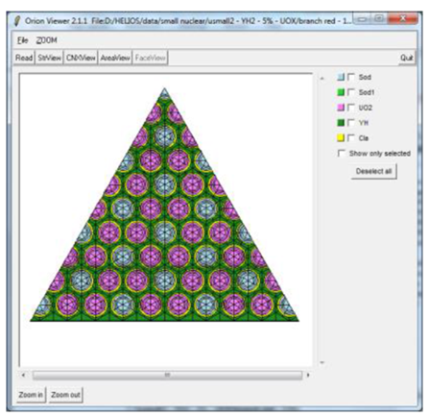
Figure 2: Adapted fuel assembly with 5% enriched UO₂ fuel
Based on the above scoping calculations, modifications to the fuel assembly were made which involved removing the shroud to maximise the amount of fuel, moderator and coolant in the design (see Figure 2) and adjusting the pin pitch over diameter (PoD) in the HELIOS model to vary the moderator to fuel ratio. Furthermore, only fuel containing UO₂, rather than MOX, was studied since it was assumed that for small cores, where leakage is dominant, the eventual concentration of fissile material in the core would need to be high. A high fissile concentration creates issues when plutonium is employed since it raises proliferation and manufacturability concerns. The moderator was set to YH₂, i.e. no changes were made to the hydrogen concentration within the moderator.
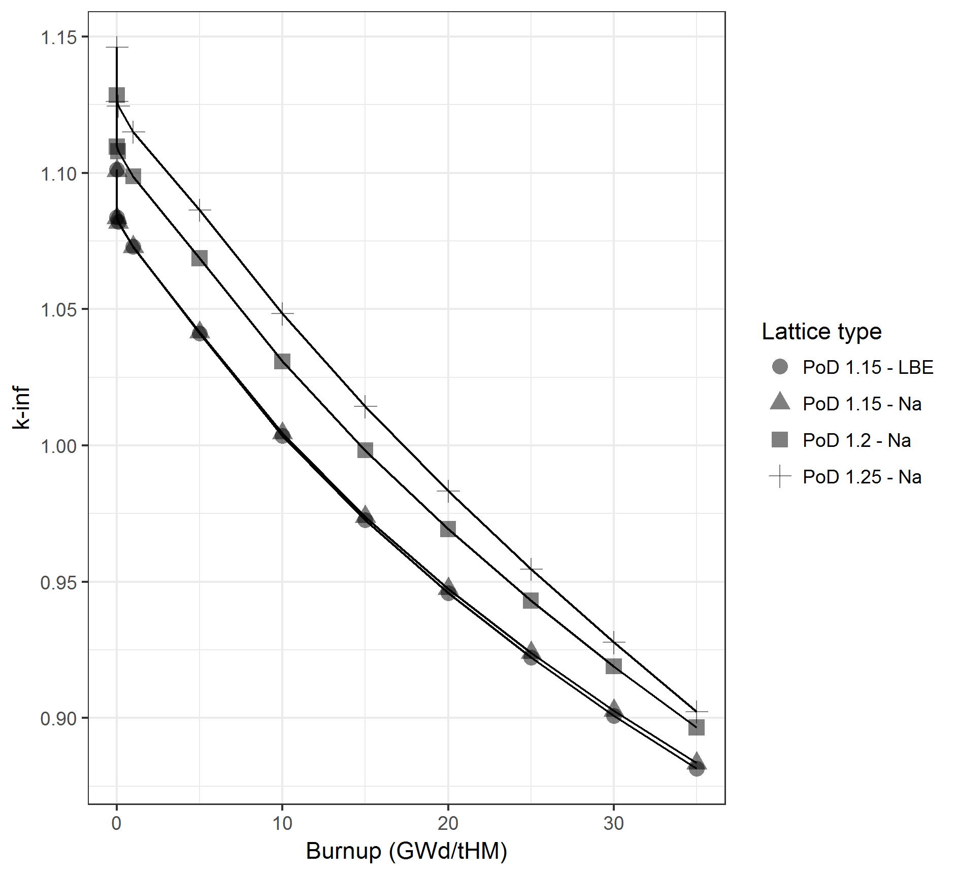
Figure 3: k-inf as a function of burnup and Pitch over Diameter, with classification by coolant type
It was found that changing the volume of moderator (i.e. reducing PoD) strongly influenced the feedback characteristics. However, reducing the moderator content away from the ideal moderation ratio leads to a significant reduction in criticality through the whole observed burnup period (see Figure 3). The reduction of PoD from 1.25 to 1.15 reduces the beginning-of-life (BOL) criticality by more than 4500 pcm. Moreover, the reduction of the moderator content increases the absolute value of the negative fuel temperature effect by ~15% over the whole observed burnup period. The positive moderator effect is significantly reduced, by a factor of more than 2.5 at end-of-life (EOL) where the maximum value appears. The coolant temperature effect is not influenced by PoD. To reduce this effect a change of the coolant, from the currently investigated sodium to, for example, lead or molten salt, would be advisable. However, the positive coolant temperature effect is around a factor of 10 smaller than the moderator temperature effect. Thus it will not play an important role in the transient behaviour of the system.
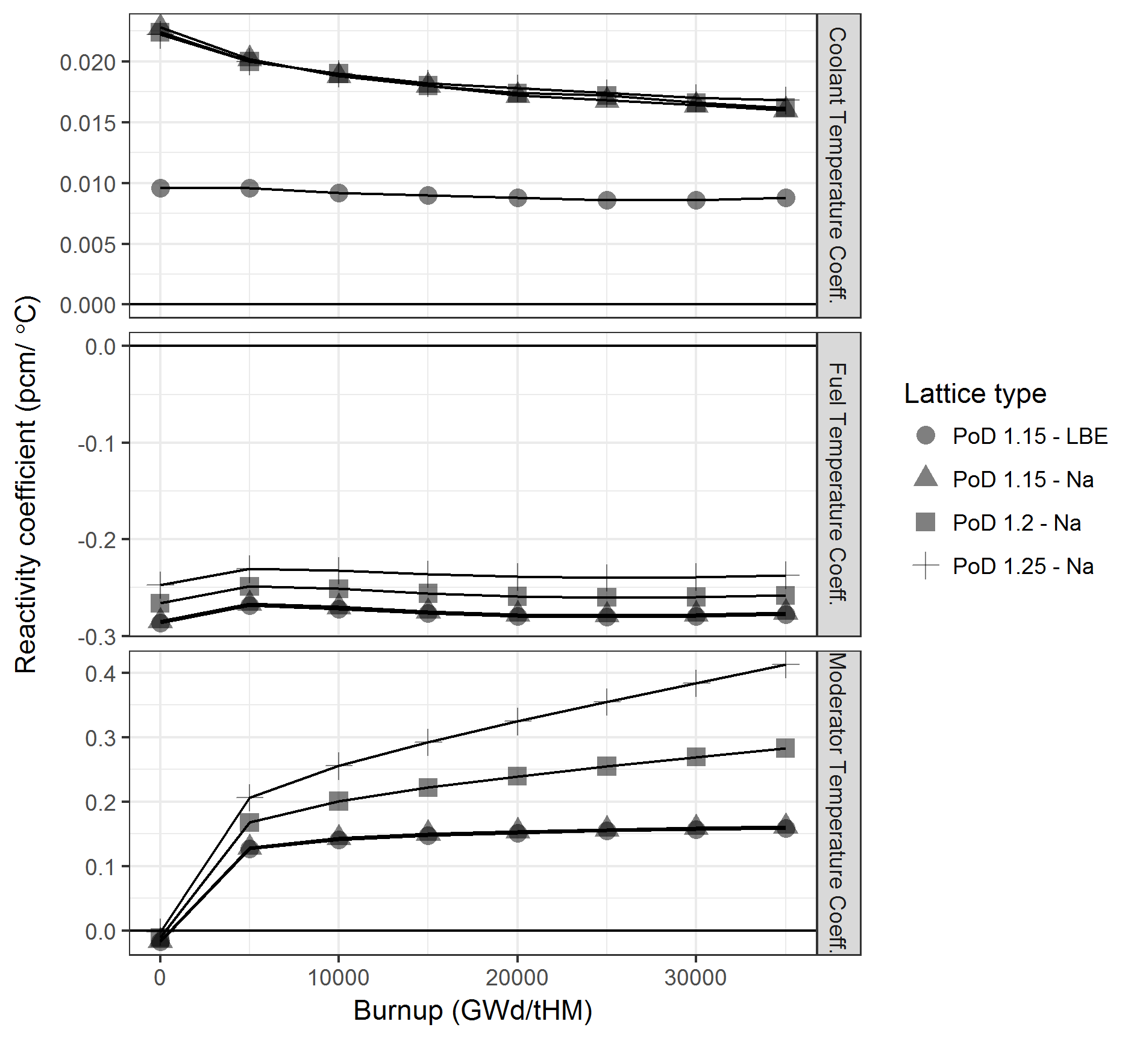
Figure 4: Comparison of coolant, moderator and fuel temperature coefficients as a function of Pitch over Diameter and coolant type
Replacing sodium coolant channels with a lead-based coolant was found to have minimal impact on reactivity as a function of burnup. However, there was the expected very noticeable change in coolant temperature effect as a function of burnup with sodium spanning ~0.23 to 0.015 pcm/°C, whereas the lead-based coolant stayed fairly constant at around 0.01 pcm/°C thanks to lead’s transparency to neutrons (see Figure 4).
In general, a system with a PoD of 1.15 seems to be acceptable from safety and operational point of view based on the lattice code calculations with an infinite medium approximation. The negative fuel temperature effect is in this case ~60% higher than the positive moderator temperature effect. Moreover, the negative fuel temperature coefficient is prompt whereas the positive moderator temperature is delayed. Thus the negative stabilizing effect overrules the positive effects and should lead to an acceptable stability of the system.
The lattice arrangement in Figure 2 is relatively complex from a manufacturing standpoint since it contains multiple fuel channels, which are individually embedded in the moderating medium. Furthermore, heat removal is impaired as coolant is not in direct contact with the fuel channels. To address these issues an improved unit cell configuration was developed and investigated, which is shown in Figure 5. The coolant employed in the new unit cell models was LiF.
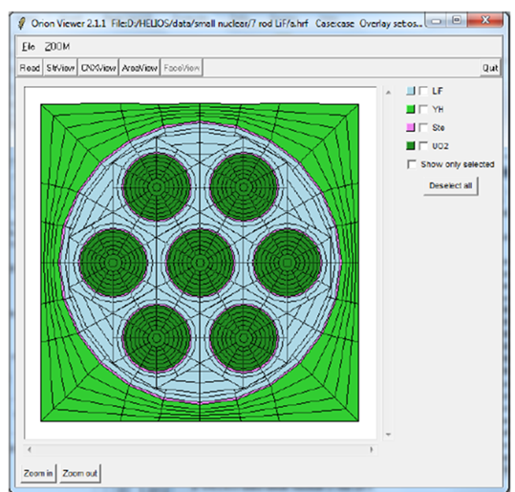
Figure 5: Improved unit cell configuration
The fuel rods, for which seven have been considered, are arranged in a concentric ring and are in direct contact with the LiF coolant medium. The moderating material (which was set to YH_{1.5} to assure sufficient thermal stability [26] up to high temperatures) surrounds the fuel channels. Hence, fewer fuel channel locations need to be incorporated into the solid moderator medium. Furthermore, the unit cell in Figure 5 is considered far simpler to manufacture than a design with moderator pins and the nature of the new unit cell makes it amenable to produce via manufacturing methods such as extrusion. Table 2 details a number of key parameters for the fuel, coolant and moderator used in the HELIOS model for the unit cell shown in Figure 5.
Table 2: Fuel, coolant and moderator parameters for the improved unit cell configuration
Parameter | Value | Reference/Comments
UO₂ fuel porosity | 6% | Typically UO₂ porosity is between 4 and 6%
YH_{1.5} density | 4.3 g/cm³ | [31]
Cladding material | Stainless Steel (SS) 304 | Nominally employed SS; however, an experimental programme would need to be performed to identify suitable candidate materials
Clad thickness | 0.2 cm | -
LiF density | 4.1 g/cm³ | [27]

The dimension of the unit cell was determined based on achieving optimal moderator to fuel ratios, whilst simultaneously achieving satisfactory reactivity effects. This neutronic optimisation resulted in a cell size of ~3.1 × 3.1 cm and pellet diameters of 0.66 cm. The power density of the lattice in Figure 5 was set to 20 kW/kgHM, which is approximately half the power density of the fuel in a conventional Light Water Reactor (LWR). The low power density results in a longer fuel residence time for a given targeted burnup than with conventional LWRs

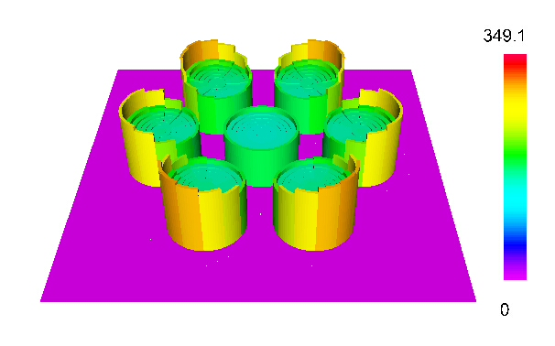
Max
Max
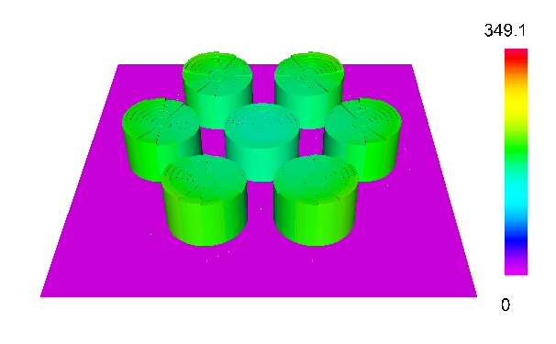
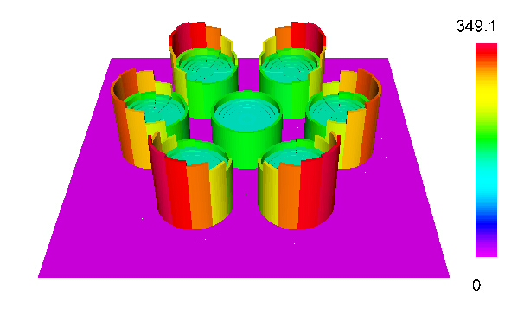
Max
Figure 6: Power distribution within the new unit cell configuration at 0, 20 and 40 GWd/tHM (left to right and top to bottom)
The evolution of the power distribution over the burnup is characterized by the expected build up of plutonium on the periphery of the pin (known as the rim effect), which is typical for fuel pins in thermal systems as shown in Figure 6. The effect of the moderator arrangement surrounding the seven pin ‘assembly’ is clearly visible and leads to the increased burnup of the pin sectors located closer to the moderator. Figure 7 shows the Beginning of Life (BOL) and End of Life (EOL) power distribution for a rod in the outer ring of fuel rods along circumferential region that exhibits the highest power peaking at EOL.
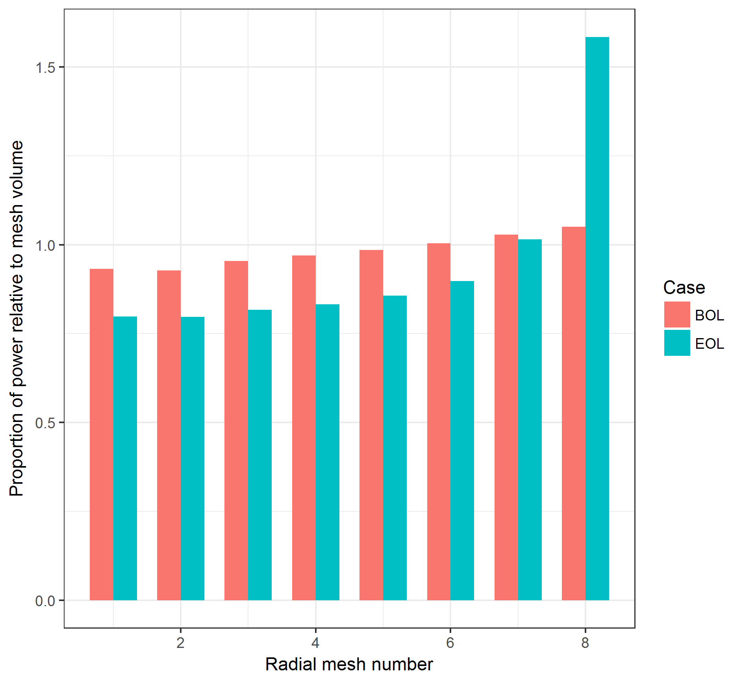
Figure 7: Proportion of power relative to mesh volume for the unit cell shown in Figure 5.
A simplified version of the fuel temperature model from the fuel performance code ENIGMA [30], that assumed pellet-clad gap closure had occurred was used to determine indicative fuel temperatures across the UO₂ pellet using the power distribution in Figure 7. ENIGMA calculations indicated typical centreline temperatures of around 1100 K, with thermal-hydraulic boundary conditions set to 911 K for the fuel moderated by YH_{1.5}. For comparison, in PWR fuel rods, which operate at power densities of around 40 kW/kgHM and have pellet diameters around 0.82 cm, have peak centreline temperatures, once gap closure has occurred, of are around 1250 to 1350 K. Note that ENIGMA’s internal thermal-hydraulic model is only suitable for water-cooled fuel and therefore thermal-hydraulic boundary conditions had to be manually set for the YH_{1.5} moderated case.
Given the characteristics of the core studied here, namely: the relatively low power density; small diameter of the pellets; and the fact that end-of-life core burnup is ~40 GWd/tHM, UO₂ is considered a viable fuel form. Furthermore, the arrangement with seven pins seems to be very promising from the point of an evenly distributed power production. Taking the optimised concentric unit cell as the fuel assembly, a series of 2D full cores (symmetric quarters) were modelled in HELIOS. All cores had a power output of 25 MWth (again with a power density of 20 kW/kgHM); therefore, assuming an electrical efficiency of about 40%, results in an electrical output of around 10 MWe.
An active rod length of 2 m was chosen, which resulted in the full core consisting of 360 fuel assemblies. Four cores were modelled (see Figure 8): an infinite array of fuel assemblies (zero leakage arrangement); an unreflected finite core with a diameter of ~0.60 m, which had vacuum boundary conditions (high leakage core); a core with one reflector ring, which had a diameter of ~0.66 m; and a core with two reflector rings, which had a diameter of ~0.72 m (low leakage core).
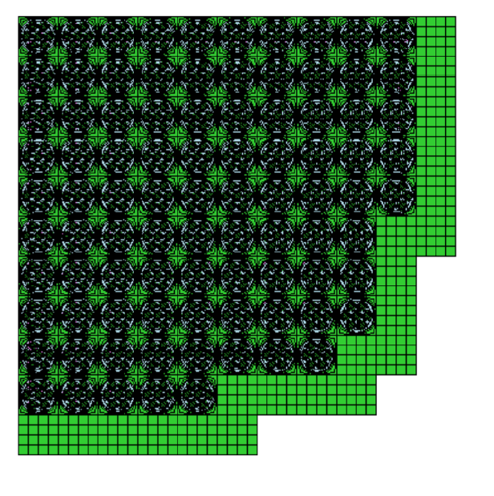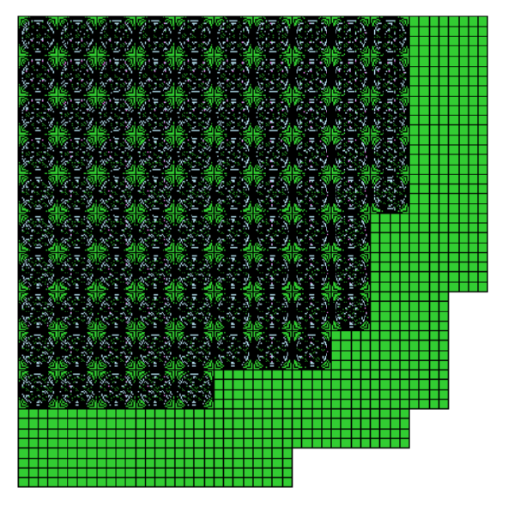

Figure 8: From left to right: unreflected core (infinite and finite); reflected core with one reflector ring; and reflected core with two reflector rings.

Table 3: Fuel enrichments for the four core configurations
Core configuration | Fuel enrichment
Infinite | 5 wt.%
Unreflected | 12 wt.%
One reflector ring | 10.5 wt.%
Two reflector rings | 10.0 wt.%

The enrichment of the fuel for these four configurations is shown in Table 3. The enrichment penalty for such a small core is clearly very large (5 wt.% for the infinite core configuration versus 10.0 wt.% for the core with two reflector rings). Note that in this preliminary model no enrichment zoning has been performed, that is to say no variation in enrichment across the core or within the unit cells (Figure 5) has taken place, which would become attractive in the case of a bigger fuel assembly design with more fuel rods. In reality, enrichment zoning would ameliorate power peaking within unit cells. For reactivity control the burnable poison Gd₂O₃ is well-established for use with UO₂ fuel, and has the ability to minimise the residual poison penalty whilst also being capable of supressing excess reactivity over long cycle lengths [28, 29].
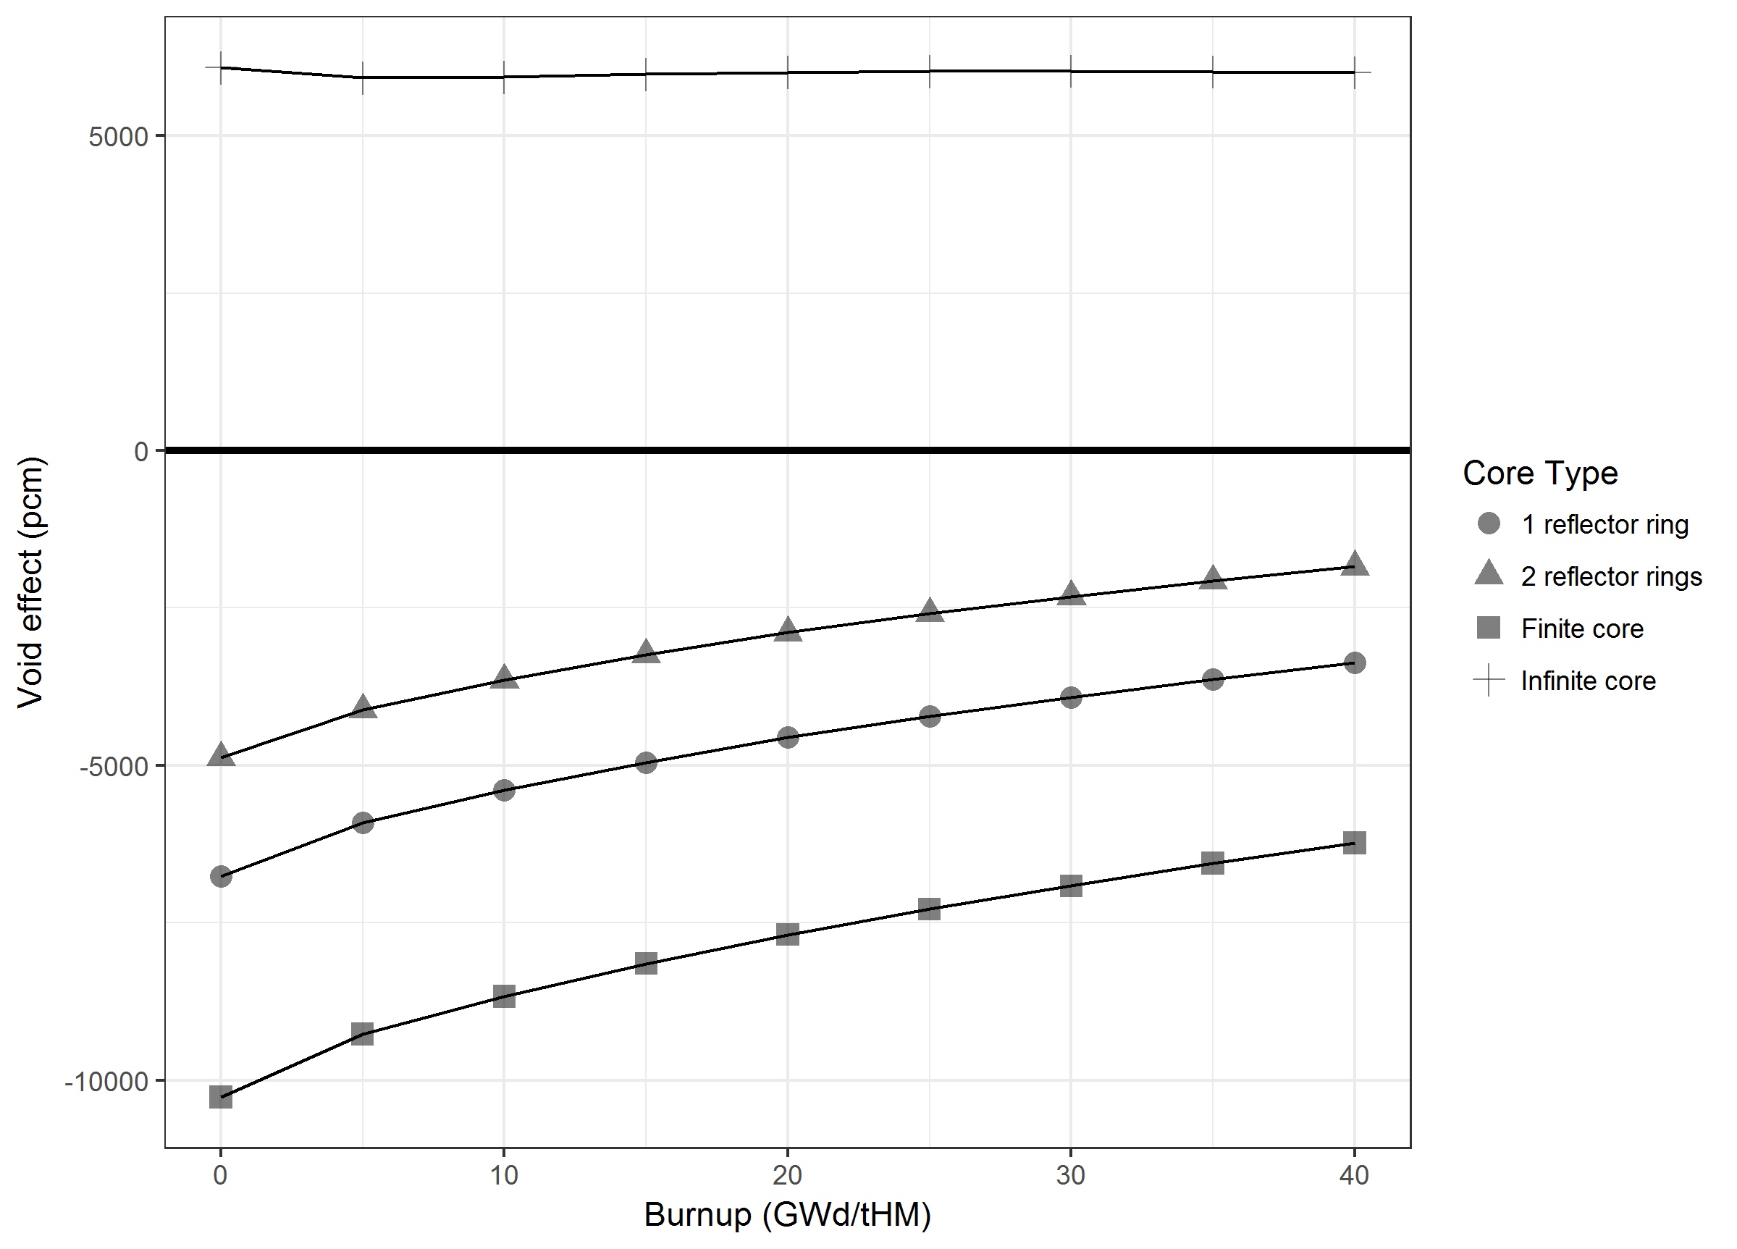
Figure 9: Void effect by core type as a function of burnup
The coolant void effect was modelled for the four cores, as shown in Figure 9, which resulted in a fairly constant positive coolant void effect (~6000 pcm), throughout core life for the infinite core, and a large negative void coefficient ranging from -10300 to -6200 pcm for the finite core with no reflector. The core with one reflector ring exhibited a void effect around 60% smaller than the finite core, and the two ring core had a void effect around 40% smaller than the finite core.
A discussion of the void effect in a molten salt may appear to be insignificant due to the high boiling point of the molten salt; however, due to the unusual configuration that separates out the fuel and the molten salt coolant, this effect could be very important in the case of a loss of coolant accident. Furthermore, for a finite core it is expected that the reactivity effect associated with a sodium-cooled system will become negative since the void and coolant effect do not play a major role in the finite core configuration. Therefore, even a sodium-cooled configuration, that retains beneficial reactivity characteristics, may also be of interest as a thermal spectrum micro-reactor concept.

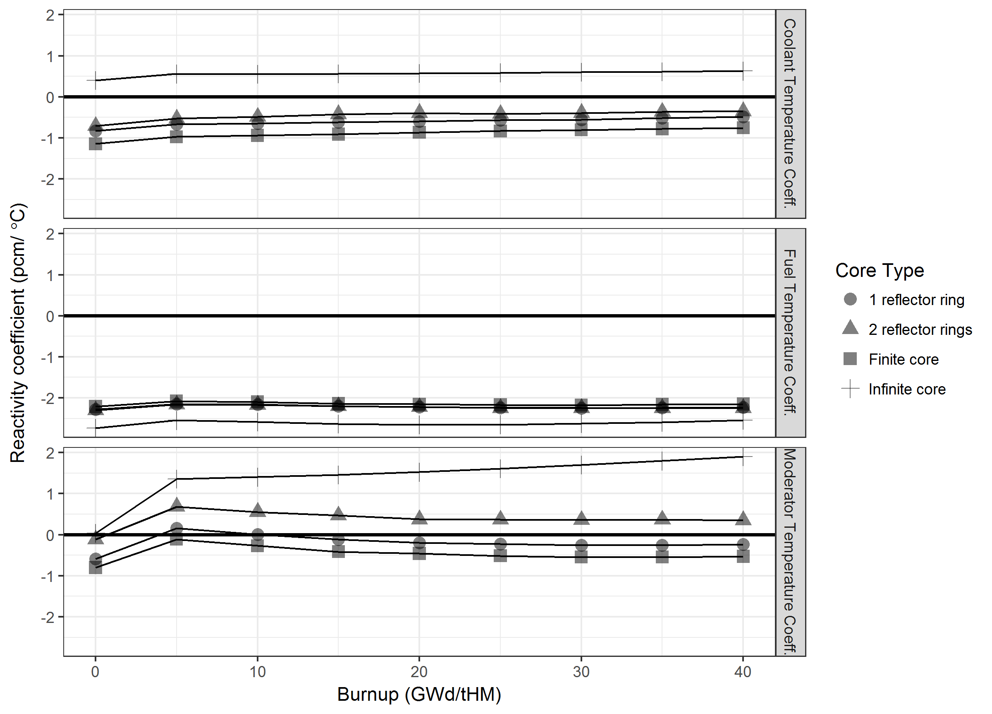

Figure 10: Comparison of coolant, moderator and fuel temperature coefficients for the four core models of the micro-reactor
Figure 10 shows the fuel, moderator and coolant temperature coefficients for the four cores, and together with the coolant void effects, highlight the importance of going from the infinite medium approximation to a finite, real core arrangement. This is due to the beneficial safety effects that such small reactor cores exhibit owing to their very strong leakage characteristics, even for the thermal reactors considered in this study.
The fuel temperature coefficient is relatively insensitive to the change from an infinite to finite core configuration. All cases lead to a clear negative fuel temperature effect which is a prerequisite for the safe and stable operation of any kind of reactor system.
The moderator temperature coefficient in the infinite system is strongly positive; however, moving to the finite systems significantly reduces the moderator temperature coefficients, with the two ring core having a weakly positive coefficient and the one ring core having a generally negative coefficient apart from near BOL where it is weakly positive. Therefore, on balance it is better to accept higher leakage (and therefore a higher initial enrichment) to improve safety behaviour. For a more detailed investigation the core power distribution would have to be studied in order to improve the economic performance.
The observations on the coolant temperature coefficients are comparable to the moderator temperature coefficient; however, the finite cores all exhibit negative coolant temperature coefficients over the whole observed burnup period.
It is important to remember that the overall reactivity coefficient will be a combination of the many individual reactivity coefficients but will be dominated by the fuel, coolant and moderator coefficients. Given that the fuel temperature and coolant temperature coefficients are negative and the void coefficient is strongly negative for the finite reactor systems, then the weakly positive moderator temperature coefficient is not thought to be prohibitive. Thus the design should exhibit acceptable safety performance.
The results on the safety effects, especially, demonstrate that the behaviour of such a small core is almost completely leakage dominated. The safety effects of the full core are much more promising than for the infinite lattice.

Conclusions
Given the need to reduce greenhouse gas emissions in many areas of the economy besides electricity production and the fact that there is currently demand for energy production systems capable of achieving outputs up to 100 MWth, micro-reactors are receiving increasing interest. The very low power output of micro-reactors results in considerable economic challenges. To overcome these challenges it is important that design choices are selected that reduce complexity and O&M costs. Hence, a thermal spectrum, high power density system that uses solid fuel was chosen. Furthermore, coolant methods relying on natural convection cooling and/or EM pumps are preferred.
Three coolants suitable for high power density operation cores, whilst maintaining favourable safety characteristics (high heat capacity, no phase change and low pressure, passive decay heat removal) up to high temperatures, are: molten salts, sodium and lead-based coolants.
Molten salts are a good coolant choice for natural convection cooling given their potential to achieve a reasonably high ΔT and their large volumetric heat capacities. However, material challenges associated with corrosion behaviour, in addition to the high melting point, are significant challenges.
Sodium exhibits many positive features given its technical maturity, low melting point, proven ability to achieve a high ΔT and the possibility of using EM pumps or natural circulation cooling in normal operation to further reduce reactor volume. However, when sodium coolant is employed there is limited scope to adjust flow area to enhance natural circulation and its chemical reactivity with water/air complicates plant design.
Lead-based coolants also exhibit reasonable natural convection cooling properties, especially given its neutron transparency (at both high and low neutron energies), thereby permitting increased flow areas. Furthermore, lead-based coolants possess other advantages relating to its high thermal inertia due predominantly to its high boiling point but also a fairly high volumetric heat capacity. However, similar to molten salts coolants, lead-based coolants have disadvantages associated with their high melting point and corrosive nature. Moreover, in the case of LBE coolants, the production of highly active polonium aerosols is a major drawback.
Lattice neutronic calculations showed that adequate thermalisation can be achieved using solid moderators whilst maintaining a reasonably high power density. However, the chemical compatibility between the solid moderator and liquid coolants needs further investigation, which may necessitate a cladding material applied to the solid moderator.
Initial infinite lattice neutronic studies indicated a series of positive reactivity coefficients; therefore a finite system using molten salt as the coolant was also studied. When modelling the finite system the coolant temperature reactivity coefficient became negative, the void coefficient strongly negative and moderator temperature coefficient negative to weakly positive. Given that a number of reactivity coefficients were negative to strongly negative in the finite system, then the weakly positive moderator temperature coefficient is not thought to be prohibitive. Thus the design, when taking into account leakage, should exhibit acceptable safety performance, which highlights the importance of taking into account leakage when modelling very small cores with a solid moderator material. This is due to the high degree of leakage overcoming the potentially positive reactivity effects associated with sodium, lead and molten salts coolants for the systems modelled here.

Future work
The current work has focused on the feasibility from a core design perspective of using, in conjunction with a moderator, coolants that have typically been considered for fast-reactors applications (sodium, molten salts and lead-based coolants), with a particular emphasis on molten salts. Future work should focus on optimisation of the core design and performing coupled 3D calculations (thermal-hydraulics, fuel performance and neutronics) to establish in detail the behaviour and operating conditions of core materials as a function of burnup. The scoping calculations performed so far have indicated that, once leakage is taken into account, transient behaviour should be acceptable; however, ultimately plant analyses will also need to be performed to determine core and plant system dynamics, to confirm whether the core design has viable transient behaviour.

Acknowledgements
The Micro-reactor project was funded through National Nuclear Laboratory’s Innovation Research and Development programme. We also gratefully acknowledge Richard Stainsby’s contribution to the suitability of different coolants for natural circulation cooling.

References
[1] OECD-NEA, “Small Modular Reactors: Nuclear Energy Market Potential for Near-term Deployment”, OECD-NEA (2016)
[2] J. Vujić et al, “Small modular reactors: Simpler, safer, cheaper?”, Energy, Volume 45, Issue 1, Pages 288–295, September 2012,
[3] IAEA, “Advances in Small Modular Reactor Technology Developments”, IAEA Advanced Reactors Information System (2016)
[4] WNN, “CGN to build floating reactor”, http://www.world-nuclear-news.org/NN-CGN-to-build-floating-reactor-1301164.html, last accessed 27/01/2017
[5] N. Ye. Goltsov et al, “Nuclear Small Power Plants for Autonomous Power Supply”, Fourth International Scientific and Technical Conference “Innovative Designs and Technologies of Nuclear Power” (ISTC NIKIET-2016), Moscow, September 27-30, 2016
[6] NNL, “Small Modular Reactors (SMR) Feasibility Study”, NNL (2014)
[7] The Committee on Climate Change, “The Fourth Carbon Budget – reducing emissions through the 2020s”, CCC, (2010)
[8] Viessmann, “Solutions for generating energy in industry and commerce”, https://www.viessmann.com/com/content/dam/vi-corporate/COM/Download/Solutions_for_generating_energy_in_industry_and_commerce.pdf/_jcr_content/renditions/original.media_file.download_attachment.file/Solutions_for_generating_energy_in_industry_and_commerce.pdf, last accessed 27/01/2017
[9] C. F. Smith et al, “SSTAR: The US lead-cooled fast reactor (LFR)”, Journal of Nuclear Materials, Vol. 376, pp 255-259 (2008)
[10] International Nuclear Safety Advisory Group, “Basic Safety Principles for Nuclear Power Plants 75-INSAG-3 Rev. 1”, INSAG-12, IAEA (1999)
[11] A. Glaser, “On the Proliferation Potential of Uranium Fuel for Research Reactors at Various Enrichment Levels”, Science and Global Security, pp 1 – 24 (2006)
[12] A. Morozov and A. Soshkina, “Passive Core Cooling Systems for Next Generation NPPs: Characteristics and State of the Art”, IYNC, Interlaken, Switzerland 20-26 September 2008
[13] B. Merk et al, “Progress in reliability of fast reactor operation and new trends to increased inherent safety”, Applied Energy, Vol. 147, Pages 1-626 (2015)
[14] F. Baque et al, “ASTRID In Service Inspection and Repair: review of R&D program and associated results”, International Conference on Fast Reactors and Related Fuel Cycles: Safe Technologies and Sustainable Scenarios, Paris (2013)
[15] IRSN, “Review of Generation IV Nuclear Energy Systems”, IRSN (2015)
[16] J. W. Dawson, “Gas-cooled Nuclear Reactor Designs”, in Nuclear Fuel Cycle Science and Engineering (I. Crossland, ed.), Chapter 12, Pages 300 – 332, Cambridge: Woodhead Publishing (2012)
[17] R. Baumer et al, “Construction and Operating Experience with the 300-MW THTR Nuclear Power Plant”, Nuclear Engineering and Design, Vol. 121, Pages 155-166 (1990)
[18] O. Beneš and R. J. M. Konings, “Molten Salt Reactor Fuel and Coolant”, in Comprehenisve Nuclear Materials, Elsevier Ltd., Vol. 3, pp 359-389 (2012)
[19] “Program on Technology Innovation: Technology Assessment of a Molten Salt Reactor Design: The Liquid-Fluoride Thorium Reactor (LFTR)”, EPRI, Palo Alto, CA: 2015. 3002005460
[20] V. Ignatiev and A. Surenkov, “Material performance in molten salts”, in Comprehenisve Nuclear Materials, Elsevier Ltd., Vol. 3, pp 221-250 (2012)
[21] S. J. de Zwaan et al, “Conceptual Design of a Natural Circulation Cooled Nuclear Battery for Process Heat Applications”, International conference on non-electric applications of nuclear power: Seawater desalination, hydrogen production and other industrial applications, Oarai (Japan), 16-19 Apr 2007
[22] OECD-NEA, “Handbook on lead-bismuth eutectic alloy and lead properties, materials compatibility, thermal-hydraulics and technologies”, OECD/NEA report 7268 (2015)
[23] V. Sobolev, “Database of Thermophysical properties of liquid metal coolants for GEN-IV”, SCK-CEN-BLG-1069, December 2011
[24] HELIOS-2 Methods (Version 2.1), SSP-11/452 Rev 1, December 16, 2011
[25] E. A. Villarino, R. J. J. Stammler, A. Ferri and J. J. J. Casal, “HELIOS: angularly dependent collision probabilities”, Vol. 112, Nuclear Science and Engineering (1992)
[26] B. Merk, “Fine Distributed Moderating Material with Improved Thermal Stability Applied to Enhance the Feedback Effects in SFR Cores”, Science and Technology of Nuclear Installations, Article ID 217548, Vol. 2013, 11 pages (2013)
[27] EVOL (Project no. 249696) FINAL REPORT, cordis.europa.eu/docs/results/249/249696/final1-final-report-f.pdf, last accessed 23/06/2017
[28] D. Carpenter, D. Feng, P. Hejzlar, M. S. Kazimi, W.-J. Lee, and P. Morra, “High Performance Fuel Design for Next Generation PWRs", tech. rep., MIT (2006)
[29] M. Hirai and S. Ishimoto, “Thermal Diffusivities and Thermal Conductivities of UO₂-Gd₂O₃", Journal of Nuclear Science and Technology, vol. 28, pp. 995-1000, Nov. 1991
[30] G. Rossiter, “Development of the ENIGMA Fuel Performance Code for Whole Core Analysis and Dry Storage", Nuclear Engineering and Technology, vol. 43, pp. 489-498 (2011)
[31] E. S. Funston, “Physical properties of yttrium hydride,” in Nuclear Metallurgy, A Symposium on Metallic Moderators and Cladding Materials, American Institute of Mining and Metallurgical Engineers, New York, NY, USA (1960)

A phase change associated with a coolant that exhibits a strong negative void effect can be an important safety-related feature associated with reactors that struggle to maintain negative reactivity coefficients under normal and accident conditions. However, this advantage needs to be considered against the disadvantages associated with impaired heat transfer once the phase change has occurred and stresses imposed on structural materials associated with the increase in system pressure.

