Two- and Three-dimensional Geometry in Tierceron Vaults: A Case Study of Exeter Cathedral
Alexandrina C. Buchanan
University of Liverpool, Liverpool, United Kingdom
Nicholas J. Webb
University of Liverpool, Liverpool, United Kingdom
ABSTRACT: This paper presents recent findings from the ‘Tracing the Past’ project, which uses digital methods to investigate English thirteenth and fourteenth-century vaults. Our paper presents initial analysis of the vaults of Exeter Cathedral, based on a laser scan survey undertaken in April 2016. We suggest that all the high vaults were laid out in two dimensions using a geometrical figure called the ‘starcut’, allowing the same proportions to be maintained throughout, despite different bay dimensions. The three-dimensional geometry of the vaults, however, presents significant variation between bays. These appear to correspond with the construction sequences proposed by previous scholarship. Nevertheless, the nature of the variations does not correspond fully with previous interpretations. We propose that two-centred arcs were found at Exeter earlier than generally recognised and in a different pattern of distribution than previously suggested.

- Introduction
Our research project ‘Tracing the Past’ (www.tracingthepast.org.uk) aims to use experimental methods of digital analysis to investigate the design and construction of English thirteenth and fourteenth-century vaults. This period saw the development of tierceron, lierne and fan vaulting, experiments which have been identified as fundamental to the origins of European Late Gothic. This paper will share the first findings from a new survey of Exeter Cathedral, justly celebrated for its sequence of tierceron vaults which extend the full length of the nave, choir and Lady Chapel. Erected between c.1275 and c.1369, they are longest run of such vaults in the world, show the fullest development in terms of numbers of additional ribs and also benefit from a complete series of fabric rolls documenting their construction.
The aesthetic effect of Exeter’s vaults derives from their apparent consistency - a dramatic avenue of branching, palm-like conoids. However, previous study has suggested that the three-dimensional geometry of the vaults shows significant variation between separate building campaigns, in particular, the apparent use of more than one arc in each rib. Our research therefore set out to test the validity of previous observations, based on digital laser-scanning and new techniques of digital analysis.
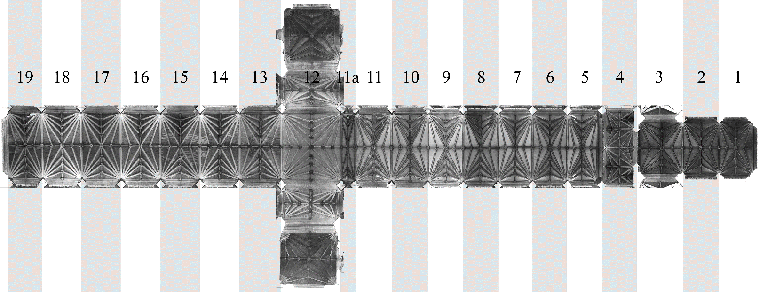
The use of four-centred arches is well-recognised in non-vault contexts and has been identified in later vaults but, if present at Exeter, could be the earliest example so far documented in a surviving and dated vault. Robert Willis, whose nineteenth-century research on vaults has inspired our project, had identified ‘semi-three-centred’ arches in the lower chapel of St Stephen’s, Westminster (Willis 1842, 19-21), a project commenced in 1292. However the dating of the original vaults is uncertain and they have since been rebuilt. Our research aims to contribute to the future research outlined by Willis, who stated that ‘it would be very valuable to measure accurately a good number of examples [of vaults with two-centred ribs], to ascertain whether the curvature of the upper circles is often the same in all the ribs as well as the lower’ (Willis 1842, 17).
Figure 1. Orthophoto of the high vaults at Exeter cathedral derived from a point cloud model, with numbered bays.
2 LITERATURE REVIEW
The basic chronology of the cathedral was first established W. R. Lethaby (1903), supported by the evidence of the fabric rolls which had been known to antiquaries since the eighteenth century (Smiles 2002) but had been misinterpreted by Freeman (1873). Lethaby’s datings were supported by Bishop and Prideaux (1922), backed up by close stylistic analysis of the boss sculpture (Prideaux and Holt Shafto 1910). Through this work it was recognised that there was a break in construction between bays 8 and 9 in the eastern arm, marking the liturgical division between choir and presbytery and also the eastern termination of the Norman cathedral (Fig. 1). The crossing, transepts and first nave bay were identified as a new campaign, followed by remodelling of the west front. The intervening nave bays were the last part of the cathedral to be built.
The publication of the fabric rolls (Erskine 1981-83), dendrochronological analysis of the roofs (Mills 1988) and extensive archaeological recording and analysis carried out under Cathedral Archaeologist, John Allen (Brown and Matthews 1999 and 2003) has supported the previous sequencing suggestions.
Freeman was the first to try to attribute individual campaigns to specific architects, a project continued by Lethaby and John Harvey. Harvey was the first to note the possibility that the Exeter vaults included what he called ‘adjustments’ to the true curve of the nave vault ribs by means of ‘hand-drawn curves’, a feature he first described in 1950, when he attributed it tentatively to William Joy, to whom he also ascribed the retrochoir and choir of Wells Cathedral (Harvey 1950a 93). However, in The English Cathedrals he suggested a straightforward division of design contribution between Master Roger (1299-1310), responsible for vaulting the Lady Chapel and presbytery; William Luve (1310-16), responsible for the crossing and first bay of the nave; Thomas of Witney (1316-42) who designed the choir fittings, nave elevation and cloister north walk; William Joy (1329-46), responsible for the west front screen and Richard Farleigh (1333-63), who designed and built the nave vault (Harvey 1950b 81). By the first publication of his Dictionary, Harvey’s views had changed and the nave was instead attributed to Thomas of Witney, whom he had also by then connected to the easternmost work at Wells (Harvey 1954, 298). By 1972, Harvey had undertaken more research on Witney, whose entry in the 1984 edition of the Dictionary is considerably extended and to whose ‘highly individual style’ he attributed the innovatory approach to the rib curvatures in the Exeter nave (Harvey 1972, 127-8 and 135; Harvey 1987). Identifying the nave vault as the design of Witney was accepted by Hope and Lloyd (1988, 40).
Harvey’s work having introduced the possibility of two-centred arcs at Exeter, Christopher Wilson’s PhD thesis put forward that these existed in the Exeter eastern arm (Wilson 1980, 262-3). He suggested that they were introduced to create a regular conoid and associated the innovation with experiments leading to the development of fan vaulting in the next century.
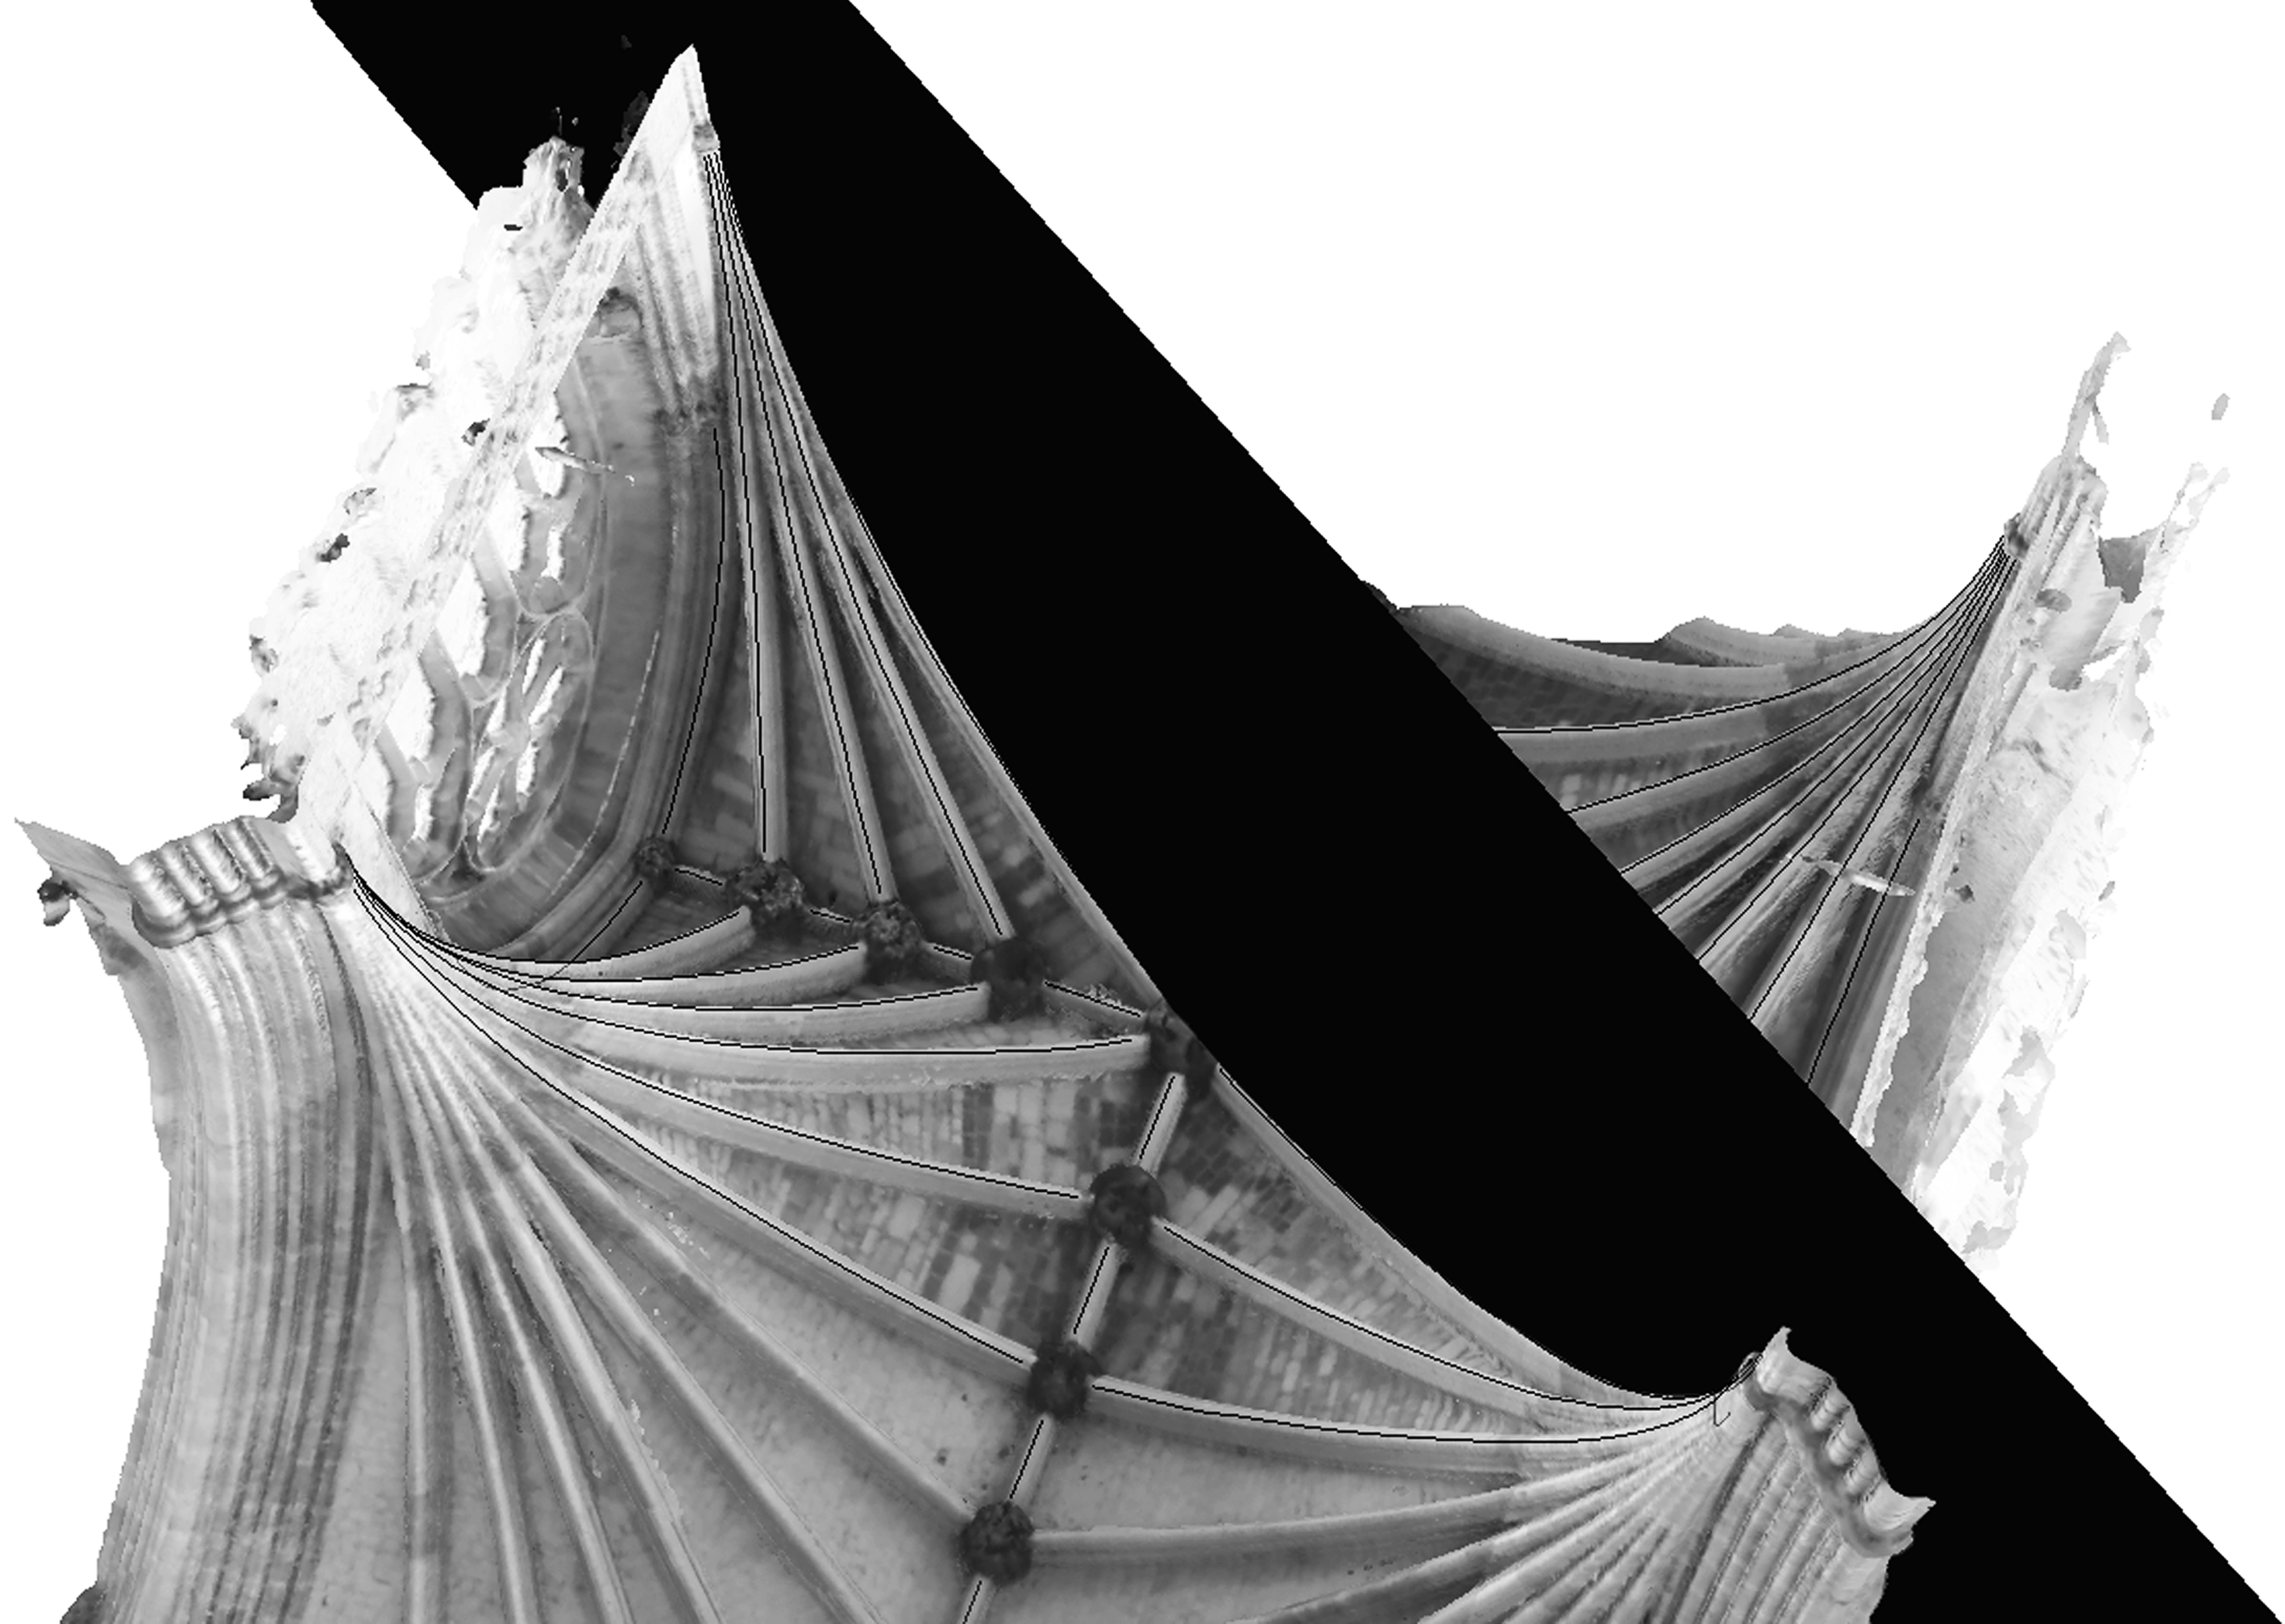
Figure 2. In Rhinoceros 5, planar surfaces were placed along vault ribs to assist in tracing intrados lines right up to their springing points.
3 METHODOLOGY
Digital laser scanning has transformed our ability to accurately document historic artefacts, in this case medieval vaults, which is particularly advantageous as they are generally hard to reach, being located high up in church and cathedral interiors. Individual laser scans capture the distance between the scanner and the solid surfaces surrounding it hundreds of thousands of times over, creating detailed point cloud models. In our survey of Exeter undertaken in April 2016, these were combined with further scans, taken at strategic points in the cathedral, to capture as much detail of the vaults as possible. The point cloud models were then used to create mesh models, which are surface-based and therefore easier to view and analyse. Using mesh models of each vault bay, we digitally traced the intrados line, or innermost edge, of all vault ribs. The intrados line is crucial for analysis, as it forms the curve that would have been the outermost edge of the timber centering, and consequently is the innermost edge of the stonework that would have rested on it prior to removal of the centering during the construction process.
Rhinoceros 5, an advanced 3D modelling programme, was used to trace the intrados lines of the mesh models, specifically the ‘control point curve’ tool. Using this, points at regular intervals were selected along the intrados line of each rib, forming a curve of undefined geometry. At Exeter, the intrados lines proved difficult to locate close to the springing point, and therefore planar surfaces were placed along each rib directionally in plan to assist with completing the tracings (Fig. 2). Once we had these tracings, we then used the ‘circle: fit points’ tool in Rhinoceros 5, which finds the best fit though these points to create a precise arc. Here we first noticed the inclusion of two-centred arcs, as the ‘circle: fit points’ tool was unable to create a single arc aligned satisfactorily enough to the original traced lines in some instances. To establish the break between the lower and upper arcs, we initially used a process of trial and error, however, it soon became apparent that the break was located in section at half the height of the bay from abacus level to arch apex height. This is defined it as the ‘middle plan’ as suggested by Willis (1842 12, 15-16 and 43-44). This halfway level also aligns with the higher abacus level of the longitudinal wall arches forming part of the interior elevations, suggesting that it was a level recognised by the original masons. It is also observed, where possible in the nave, that this break is slightly below the upper edge of the tas-de-charge stone. This can be seen in the break between bay 13 and 14, indicated by a change of tone (Fig. 3).
Using this process, we had three sets of data for each rib: the original ‘control point curve’ traced lines, a best fit one-centred arc, and a best fit two-centred arc. We could visually compare the best fit one- and two-centred arcs to see which aligned most closely with the original tracings (Fig. 4).
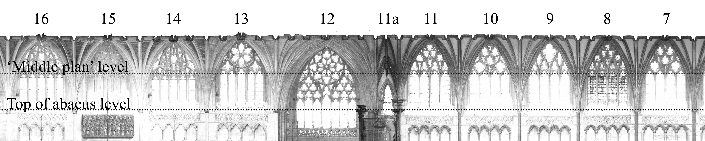
In some instances, the difference between the best fit one and two-centred arcs was minimal, and in the supporting diagrams to locate them, dotted lines 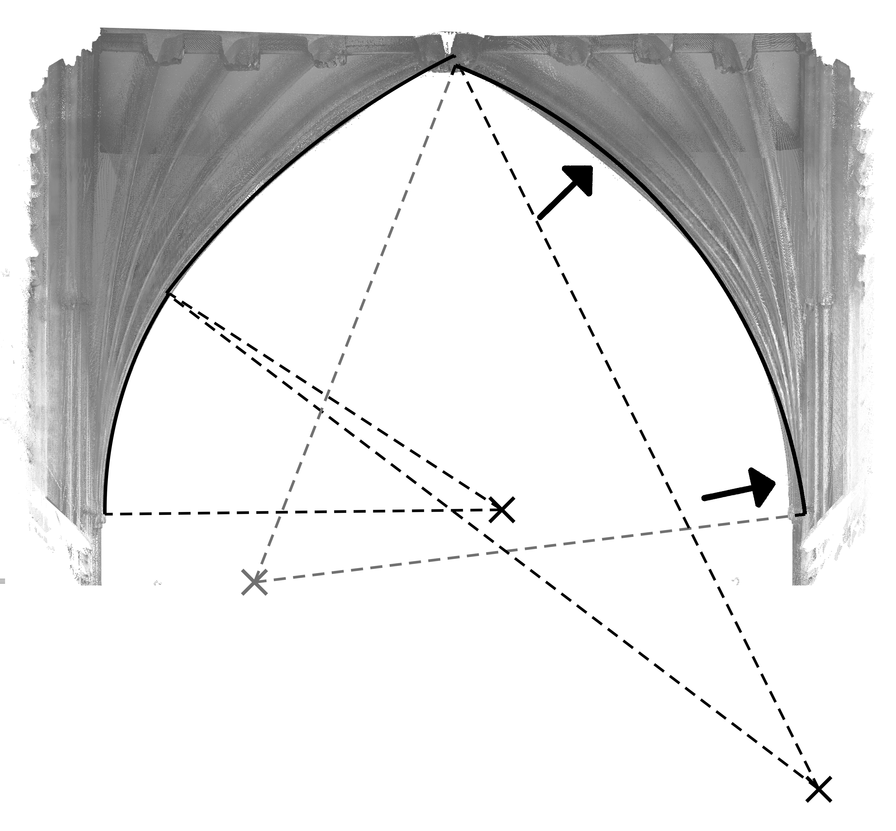
Figure 3. Section taken through the point cloud model along the ridge rib, indicating the top of abacus and ‘middle plan’ levels.
Figure 4. The right hand one-centred arc has a poor fit to the original arc (see arrows indicating areas of creeping) whereas the left hand two-centred arc has a superior fit.
have been used instead of solid lines to indicate less confidence in the result.
In addition to locating arcs of one- or two-centres visually, we could document the geometries of these for additional clarification and analysis. We recorded their radii, centre points in relation to the impost level, as well as the arch apex height above the impost level. We also had very accurate two- and three-dimensional digital models of each vault rib and their relationship with each other.
4 TWO-DIMENSIONAL PROCESS
We have argued elsewhere that an essential starting point for complex vault design was the creation of a full-size tracing floor on which the plan was established and from which the arcs of the ribs could be projected (Buchanan and Webb 2017a). Throughout the central vessel (excluding the crossing), the Exeter vaults have exactly the same plan in terms of geometrical process. This process is based on what has been termed the ‘starcut’ (Stewart 2009) and may be described as follows and understood in conjunction with Figure 5:
- Draw diagonals across the bay AD and BC. These are the diagonal ribs.
- Establish the mid-points of the sides of the bay and join these at right angles. This locates the ridge ribs EH and FG.
- Take one corner of a bay and connect it to the opposite mid-point, and back again to the adjacent corner to form a chevron. For example, AGC.
- Repeat this for all four sides of the bay.
- The lines drawn across the width of the bay form the lateral tiercerons, for example AJB.
- The four crossing points K, L, M and N divide the length and width of the bay into thirds.
- The longitudinal tiercerons nearest to the diagonal meet the lateral ridge rib at one third and two thirds along and form part of a subsidiary starcut within the outer thirds of the bay, such as BfD.
- Complete this subsidiary starcut.
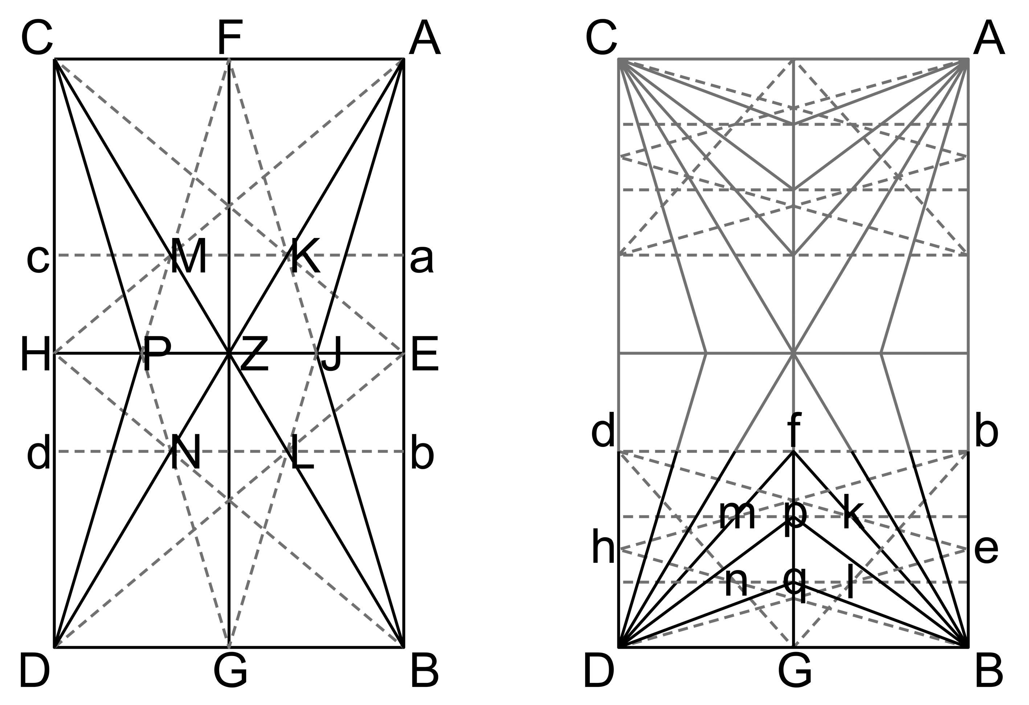
Figure 5. Starcut used to create the tracing floor for most major ribs (left) and a subsidiary starcut used for the longitudinal tiercerons (right).
The other longitudinal tiercerons, for example BpD and BqD meet the lateral ridge rib at one ninth and two ninths along from the side wall (in other words, one and two thirds across the third of the bay as indicated by k, l, m and n). By this process, all the ribs are located, based on geometry rather than measurement, with the bosses along the transverse ridge rib at regular, but not identical, distances. Although from the junction between bays 9 and 10 onwards, the conoid has a relatively smoothly curved middle plan (as observed by Wilson 1980, 262), this was not achieved by setting the ribs at equal angles as he anticipated (Fig. 6).
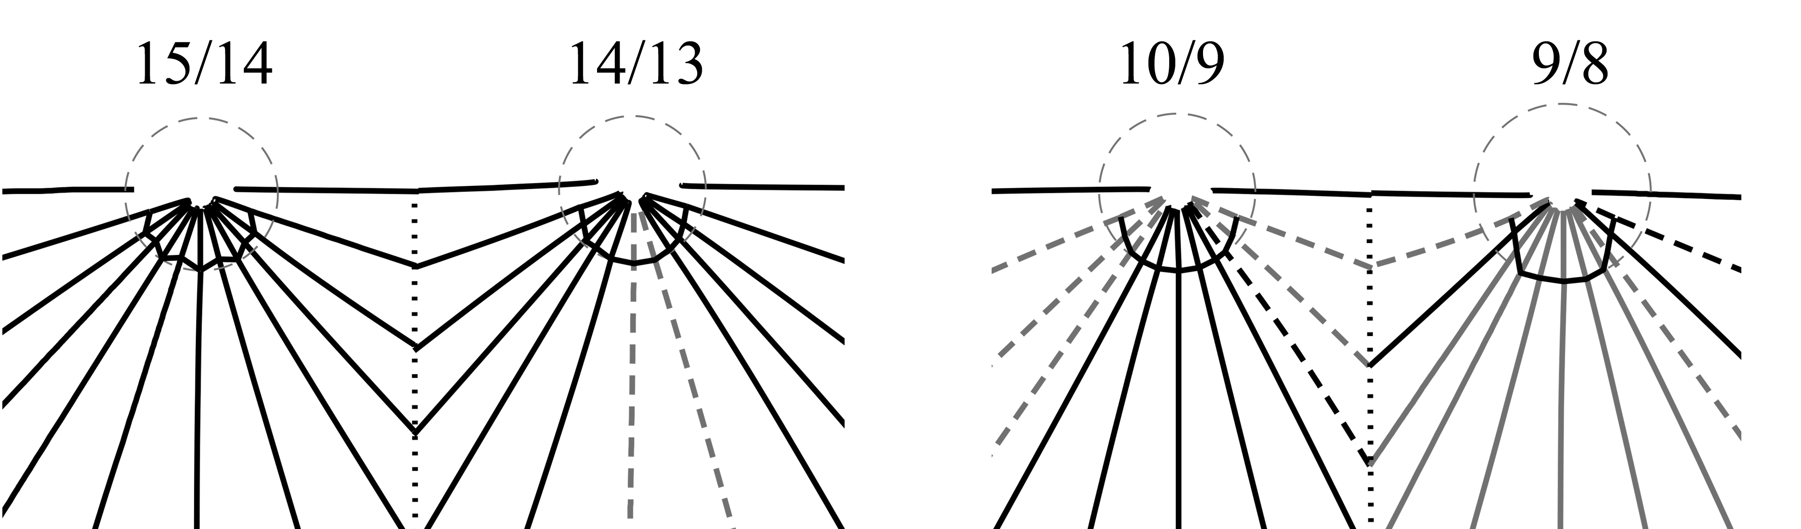
The value of the starcut as a design tool is that it can create the same proportional relationships regardless of the relative dimensions of the bay. This was important at Exeter, because although the geometrical process used to lay out the tracing floor was the same throughout, the bay proportions are different across the length of the cathedral and would have required different tracing floors for stone-cutting purposes and different centering. The easternmost bay of the presbytery (bay 5) is narrower at 10.33m, being inset slightly on the south side. After this, all the bays have very similar widths (on average 10.51 m) and in terms of length there are two ‘sets’ which might have shared a tracing floor: bays 6-8 are the same - between 5.38 and 5.39 m long; whilst bays 10 and 11 are approximately the same, 5.60 and 5.63 m long. The first bay of the choir (bay 9) seems to form a transition, being 5.47 m long. It should also be noted that in bay 5 the longitudinal ridge rib is central to the bay as constructed, therefore in bay 6 this rib is not central to the width of the bay. In order to address this, in bay 7 it is shifted southwards, so that from bay 8 it returns to a central position.
Figure 6. The middle plan between bays 15-14 is fluted, between bays 14-13 and 10-9 is smoother in its curvature and between bays 9-8 is angular.
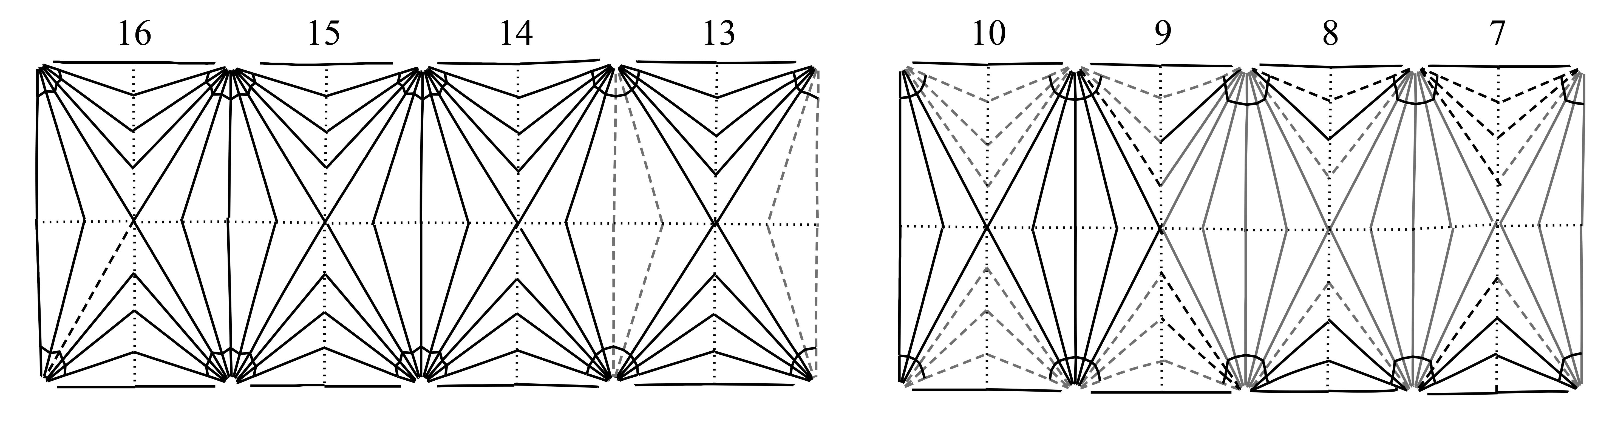
The bays in the nave are again different in length. Bay 13 (the first from the crossing) is 6.49m long. The next bays westwards are all of the same length - between 6.11-6.15 m long, until bay 19, the westernmost bay, which is 5.23 m long, presumably to meet the pre-existing position of the west front. The west front is also not square to the crossing and east end, making the north side of the nave longer than the south. This means that as the nave progresses westwards the bay plans start to shift from an alignment with those in the eastern arm, but probably not to such an extent that it would have necessitated a different tracing floor plan.
Figure 7. Traced intrados lines shown in plan, with single centred arcs shown in black and two centred arcs shown in grey. Where less confident, these lines are dashed. Ridge ribs are dotted, and Willis’s middle plan is indicated around each springing stone and joined together to show its change across bays.
5 THREE-DIMENSIONAL PROCESS
The literature review having suggested that there was a break in construction between bays 8 and 9, these were the first to be analysed. Figure 7 shows the distribution between arches which seem clearly four-centred, arches which are potentially four-centred (two-centred arcs) and arches which seem two-centred (single-centred arcs). This suggests that the break already identified between bays 8 and 9 involved minor changes to the vaulting, in that all the longitudinal tiercerons became two-centred arcs, whilst the transverse ribs became single-centred arcs. The changes made were not wholesale and immediate, as in bay 9, the pattern of rib curvatures in the eastern half of the bay is closer to that of bay 8 and those in the western half of the bay are closer to bay 10. This suggests that the tas-de-charge between bay 8 and bay 9 on each side was cut as part of the earlier campaign and the ribs above it had to spring from this as a pre-existing fixed point. A sample of radii comparing the hypothetical one- and two -centred arcs is presented in Table 1. Here we can establish that where the difference between upper ribs (2.1) and lower ribs (2.2) is significant in hypothetical two-centred arcs, thus providing further evidence of their existence. On the other hand one-centred arcs (1.1) display a relatively insignificant difference in radii when hypothesised as two-centred arcs; under 1 m in most cases.
Table 1. Sample of best fit one- and two-centred arcs
Bay reference | Radius 1.1 | Radius 2.1 | Radius 2.2 | Diff. 2.1-2.2
8_CH_Transverse | 8.17 | 11.37* | 5.75* | 5.62
8_DH_Transverse | 8.00 | 12.76* | 5.67* | 7.09
8_CZ_Diagonal | 8.00 | 11.08* | 5.73* | 5.35
8_DH_Diagonal | 7.71 | 10.18* | 5.77* | 4.41
9_CH_Transverse | 7.37* | 7.68 | 6.93 | 0.75
9_DH_Transverse | 7.34* | 7.48 | 6.56 | 0.92
9_CZ_Diagonal | 6.93* | 7.32 | 6.82 | 0.50
9_DH_Diagonal | 6.96* | 7.58 | 6.50 | 1.08
13_CH_Transverse | 7.52 | 8.59* | 6.58* | 2.01
13_DH_Transverse | 7.80 | 8.15* | 6.49* | 1.66
13_CZ_Diagonal | 6.77* | 7.13 | 6.46 | 0.67
13_DH_Diagonal | 6.91* | 7.30 | 6.97 | 0.33
14_CH_Transverse | 7.21* | 7.00 | 6.21 | 0.79
14_DH_Transverse | 7.53* | 7.19 | 6.25 | 0.94
14_CZ_Diagonal | 6.75* | 6.49 | 6.31 | 0.18
14_DH_Diagonal | 7.01* | 7.02 | 6.59 | 0.43
*Indicates whether analysis suggests one- or two-centred arcs.
Checking eastwards, it is clear that two-centred arcs are also found in bay 7 (Fig. 7) and therefore potentially throughout the eastern arm, confirming the observation made by Wilson. Checking westwards, in bay 10 only the longitudinal tiercerons appear to have two-centred arcs, the other ribs having single-centred arcs. We therefore suggest that four-centred arches were introduced at Exeter from the time of Master Roger at the latest and should not be identified as an innovation either in the nave or associated with Thomas of Witney.
In terms of the radii of the arcs, writing of the nave, Harvey had suggested that the ribs were ‘fudged’ at the springing ‘in order to present a more suave appearance at the springing’ (Harvey 1972, 128). Wilson, on the other hand, had suggested that the lower section of every rib was given a similar curvature, the ‘fudging’ being associated with the upper arc, in order that it should reach the fixed height of the ridge rib (Wilson 1980, 263). This results in the radii of the upper sections varying very widely. This hypothesis seems confirmed by the data: in every case in bays 7, 8 and 9, the lower arc has a radius of between 5.436 m and 5.909 m and its centre is on the impost, whereas the upper arc radii vary between 8.350 m and 13.607 m and their centres are generally around 3.1 m below the impost. Elsewhere, we have argued that arcs with their centre on the impost are normative (Buchanan and Webb 2017a and 2017b).
Finally, Wilson had suggested that the radius chosen for the lower arcs was that of the diagonal rib (Wilson 1980, 263). Whilst his argument seems to suggest that the diagonals alone had single-centred arcs, which our data does not confirm, his identification of the diagonal as the most significant rib seems apposite. If a diagonal rib were constructed across bays 7-9 as a single-centred (circular) arch, its radius would be between 5.4 m and 5.7 m (bearing in mind the different dimensions of the bays), at the centre of the range of radii of the traced lower arcs of the transverse ribs, diagonals and transverse tiercerons (in other words, the ribs forming the longitudinal ‘tunnel’). It is therefore possible that in these bays, the form of these ribs was determined by a decision to employ this curvature at the springing which, when combined with a decision to have a flat, horizontal ridge rib, required the upper parts of the ribs to rise more steeply. Their centres were not generally at impost level and the process for determining their upper radius requires more space than is available here.
A horizontal section cut through the lower part of the conoids (which we anticipate will mark the top of the tas-de-charge) both confirms the change in construction already identified and complicates Wilson’s hypothesis that experiments at Exeter prefigured the development of fan-vaulting. Between bays 6-7, 7-8 and 8-9, the middle plan is angular, whereas between bays 9-10 and 10-11, it is relatively smoothly curved as Wilson had predicted (Wilson 1980, 262) (Fig. 6 and 7). Laying a circle over the middle plan shows coincidence with the diagonal, transverse tierceron and transverse ribs, whereas the longitudinal tiercerons are skewed back, possibly to give greater visibility to the windows. This supports Willis’s identification of a ‘middle plan’ of intentional form; however, although the result between bays 9-10 looks similar to the middle plan of a fan vault (as suggested by Wilson 1980, 263), the means by which it is achieved is different. In these conoids, the transverse, transverse tierceron and diagonal ribs have single arcs with varying radii (whereas in fan vaulting, the radii are expected to be the same).
When we turn to the nave, the results are very different from what the literature review had led us to expect. There is a clear difference between bays 13 and 14, in that the former includes two-arc ribs and the latter does not. The visual difference that Harvey identified between the two bays derives from the use of four arcs for CKD and CHD of bay 13, and two arcs in AJB in bay 14, rather than the reverse as he claimed (Harvey 1950, 93 and 1972, 128 and 135). Although the break in construction is evident from the introduction of Beer stone in bay 14, the different rib curvatures between the two bays seems as likely to be the result of the different bay dimensions as the input of a new designer. Nevertheless, between bays 14-15 the conoid does take on a new form, being fluted. This continues at least as far as bay 17 (which is as far as we have traced to date) and could be evidence of a change in design.
6 CONCLUSION
Analysis of the Exeter vaults confirms previous statements as to the consistency of its design (Cherry and Pevsner 1989, 372) and demonstrates how this was achieved in terms of two-dimensional planning. The use of the starcut to lay out the vaults enables every bay to have a similar geometry even when measured dimensions differ. Our research has also largely supported existing conclusions as to building sequence, but has complicated previous suggestions as to design intentions and the input of individual designers.
In order to investigate the possible existence of more than one centre being used in each arc, we have modified our previous method of identifying rib curvatures. When exploring the use of two-centred arcs, Willis’s concept of the ‘middle plan’ has proved helpful. Using this approach, we have confirmed that the cathedral’s architects employed two-centred arcs in the vaulting at an earlier date than has generally been recognised. That this innovation cannot be attributed to Thomas of Witney in no way devalues his contribution to fourteenth-century architecture but demonstrates the extent of constructive creativity operating in England in the late thirteenth and early fourteenth centuries.
Although on initial analysis Exeter’s vaults appear consistent, we have found significant variation between bays. We therefore need to trace the rest of the vaults in order to attempt to identify further patterns in order to hypothesise the design process by which the (consistent) two-dimensional plan was projected into three dimensions. This will form the next stage of our research.
7 ACKNOWLEDGEMENTS
We would like to thank John Allen, Cathedral Archaeologist of Exeter Cathedral and the Dean and Chapter for facilitating access; the University of Liverpool for funding our fieldwork, and J. R. Peterson for his technical support.
8 REFERENCES
Bishop, H. E. and E. K. Prideaux. 1922. The Building of the Cathedral Church of St Peter in Exeter. Exeter: James G. Commin.
Brown, Stewart and Aidan Matthews. 1999. “Exeter Cathedral Roof: An Archaeological Survey of the North Side from the East End to the Crossing, 1999.” Unpublished archaeological report by Stewart Brown Associates.
Brown, Stewart and Aidan Matthews. 2003. “Exeter Cathedral High Roof: An Archaeological Survey of the North Side from the Crossing to the West End of the Nave, 2003”. Unpublished archaeological report by Stewart Brown Associates.
Buchanan, Alexandrina and Nicholas Webb. 2017a. “Creativity in Three Dimensions: An Investigation of the Presbytery Aisles of Wells Cathedral.” British Art Studies 6.
Buchanan, Alexandrina and Nicholas Webb. 2017b. “Tracing Tiercerons: An Evaluation of the Significant Properties of Thirteenth and Fourteenth-century Tierceron Vaults in England.” In Building Histories: The Proceedings of the Fourth Annual Conference of the Construction History Society. Edited by James W. P. Campbell et al., 145-57. Cambridge: Construction History Society.
Cherry, Bridget and Nicholas Pevsner. 1989. Devon. The Buildings of England. London: Penguin.
Erskine, Audrey Mary. 1981-1983. The accounts of the fabric of Exeter Cathedral, 1279-1353. Publications of the Devon & Cornwall Record Society. New series, vols. 24, 26.
Freeman, Philip. 1873. The Architectural History of Exeter Cathedral. Exeter and London: Henry S. Eland and Bell and Sons.
Harvey, John Hooper. 1950. The Gothic World 1100-1600. A Survey of Architecture and Art London, New York, Toronto and Sydney: Batsford.
Harvey, John Hooper, The English Cathedrals. London: Batsford.
Harvey, John Hooper. 1954. English Medieval Architects. A Biographical Dictionary Down to 1550. London: Batsford.
Harvey, John Hooper. 1972. The Medieval Architect. London: Wayland.
Harvey, John Hooper. 1987. English Medieval Architects. A Biographical Dictionary Down to 1550. 2nd edn. Stroud: Alan Sutton.
Hope, V. and J. Lloyd. 1988. Exeter Cathedral. A Short History and Description. Revised by A. Erskine. Exeter: Exeter Cathedral.
Jansen, Virginia. 1991. “The Design and Building Sequence of the Eastern Area of Exeter Cathedral, c.1270-1310: A Qualified Study.” In Medieval Art and Architecture at Exeter Cathedral. The British Archaeological Association Conference Transactions for 1985. Edited by Frances Kelly, 35-56. Leeds: Maney.
Lethaby, William Richard. 1903. “How Exeter Cathedral was Built.” Architectural Review XIII: 109-30 and 166-76.
Mills, Coralie. 1988. “Dendrochronology in Exeter and its Application.” PhD, University of Sheffield.
Morris, Richard K. 1991. “Thomas of Witney at Exeter, Winchester and Wells.” In Medieval Art and Architecture at Exeter Cathedral. The British Archaeological Association Conference Transactions for 1985. Edited by Frances Kelly, 57-84. Leeds: Maney.
Prideaux, Edith K. and George Reginald Holt Shafto. 1910. Bosses & Corbels of Exeter Cathedral. Exeter and London: James G. Common and Chatto & Windus.
Smiles, Sam. 2002. “Data, Documentation and Display in Eighteenth–Century Investigations of Exeter Cathedral.” Art History 25 (4): 500-519.
Stewart, Malcom. 2009. Patterns of Eternity: Sacred Geometry and the Starcut Diagram. Edinburgh: Floris Books.
Willis, Robert. 1842. “On the Construction of the Vaults of the Middle Ages.” Transactions of the Royal Institute of British Architects 1 (2): 1-69.
Wilson, Christopher. 1980. “The origins of the Perpendicular Style and its Development to circa 1360.” PhD, Courtauld Institute of Art, University of London.

