Experimental determination of transient structure-borne sound power from heavy impact sources on heavyweight floors with floating floors using an inverse form of Transient Statistical Energy Analysis

Susumu Hirakawa and Carl Hopkins*
Acoustics Research Unit, School of Architecture, University of Liverpool, Liverpool, L69 7ZN, UK

*Corresponding author
Tel: +44 1517944938
E-mail: carl.hopkins@liverpool.ac.uk

Keywords: impact sound insulation; rubber ball; bang machine; transient statistical energy analysis

Abstract
For heavy impacts on floors in heavyweight buildings, prediction models are needed at the design stage to estimate the spatial-average Fast time-weighted maximum sound pressure level in the receiving room. This paper extends previous work using Transient Statistical Energy Analysis (TSEA) in heavyweight buildings by introducing an inverse form of TSEA (ITSEA) to determine the transient structure-borne sound power input from heavy impact sources into a heavyweight base floor with a floating floor. The difference in the power input with and without a floating floor gives a correction factor that can be used to modify the power input into the base floor. This allows the effect of the floating floor to be incorporated in a TSEA model of a heavyweight building. ITSEA is initially validated with heavy impacts from a rubber ball directly onto a concrete base floor and with small, locally reacting, mass-spring systems. Laboratory experiments are then used to quantify the transient structure-borne sound power input into a full-size concrete base floor when a heavy impact is applied to the base floor, and to the base floor with a full-size Ondol floating floor. The resulting TSEA model shows close agreement with the predicted change in the Fast time-weighted maximum sound pressure level due to the floating floor.

1. Introduction
The measurement of impact sound insulation in buildings due to heavy impacts on floors is described in International, Japanese and Korean standards [,,,] which use standardized excitation sources such as a rubber ball or bang machine. These standards require measurement of the Fast time-weighted maximum sound pressure level, L_{p,Fmax} in the room underneath the floor that is excited by the heavy impact.

Experimental work (e.g. see [,]) has previously quantified the time-dependent force from the rubber ball and/or bang machine. However, there are very few models available to predict Fast time-weighted maximum sound pressure levels due to these heavy impact sources. Kimura and Inoue [] developed an approach to predict the impact sound insulation in heavyweight buildings due to excitation with the bang machine. This used an impedance model to predict direct sound radiation from the floor to the receiving room by using an empirical correction factor to estimate the Fast time-weighted maximum level from the predicted steady-state level. Koga et al [] subsequently proposed that the terms relating to the effective radiating area of the floor and the absorption area in the room were not needed, although later work has quantified the effect of the reverberation time in the receiving room on the impact sound pressure level that is measured with heavy impact sources []. Koga [] further developed the model to include decay constants of the floor vibration, sound field and the Fast time-weighting. Koga also incorporated impedance values that were predicted from finite element models to model different floor shapes and boundary conditions. Okano and Koyanagi [] noted that when using the impedance model for the bang machine on a concrete floor there were often errors of 5 to 10dB in the 63Hz octave band. The accuracy of the prediction was improved by accounting for the rapid change in the force spectrum between the lower and upper band edge frequencies of the 63Hz band, and by using transfer impedances for the floor that were determined using finite element methods. However, the impedance model does not account for flanking transmission and is limited to direct transmission. To allow prediction of L_{p,Fmax} from any form of transient excitation in heavyweight buildings, Robinson and Hopkins [,] showed that Transient Statistical Energy Analysis (TSEA) can be used to predict this parameter from the combination of direct and flanking paths. They subsequently showed that TSEA can be used to predict L_{p,Fmax} due to excitation of a concrete base floor that is directly excited by the rubber ball or human footsteps []. However, there will usually be a floating floor on top of this base floor to provide insulation against light impacts such as footsteps from walkers in shoes, as well as heavy impacts such as from children running or jumping. For this reason it is necessary to identify and experimentally validate a new approach to incorporate floating floors in TSEA models of heavyweight buildings, and this is the focus of this paper.

TSEA models require a transient power input from the excitation source. This can be calculated by using a force plate to measure the blocked force from the rubber ball, bang machine or human footsteps along with knowledge of the driving-point mobility of the receiver structure (e.g. base floor) [7]. However, the size of the force plate means that this experimental approach is not feasible for a large floating floor with a rigid walking surface that is undergoing wave motion due to the excitation. Assuming the surface of the floating floor has a low mobility relative to the mobility of the heavy impact source, one possibility could be to predict the dynamic behaviour of the floating floor to predict the improvement in impact sound insulation. While models exist for a floating floor comprising a rigid walking surface and resilient layer, they do not accurately predict the decrease in the impact sound insulation near the mass-spring resonance frequency of the floating floor and would not account for any non-linear response caused by heavy impacts []. Modern buildings incorporate floating floors with multiple rigid or resilient layers (as well as heating pipe systems) and the walking surface often has a similar or higher mobility than the impact source; hence, it is not feasible to rely on current prediction models for the range of floating floors that are built in practice. To facilitate the inclusion of floating floors in TSEA models, this paper proposes an inverse form of TSEA (ITSEA) to experimentally determine the transient power input for the combination of the heavy impact source and floor, and the combination of the heavy impact source, floating floor and floor.

In this paper, the validation of ITSEA is initially carried out with heavy impacts from a rubber ball onto small, locally reacting, mass-spring systems on a full-size concrete base floor. These represent highly idealised versions of floating floor systems which are sufficiently small that they fit on top of a force plate in order to measure the blocked force. Laboratory experiments are then used to quantify the transient structure-borne sound power input into a full-size concrete base floor when a heavy impact is applied to the base floor, and to the same base floor with a full-size floating floor. The difference between these values gives a correction factor for a specific floating floor that can be applied to the predicted transient power input for the base floor when using TSEA to predict the impact sound insulation; this approach is also validated with a full-size floating floor on a base floor.

2. Theory

2.1 Transient Statistical Energy Analysis
Transient Statistical Energy Analysis can be used to predict time-varying, spatial average, mean-square energy in frequency bands from a given power input and loss factors. The approach is essentially a time domain version of Statistical Energy Analysis (SEA) which solves the power balance equations in short time intervals as described by Powell and Quartararo [] and Lyon and DeJong []. The forward difference approach is used to determine energy at a specific time step by using the energy calculated at the previous time step. For any subsystem i, the time-dependent power balance is given in Eq. (1) by the difference between the power lost and the power gained,
$$\frac{{dE}_{i}\left(t\right)}{dt}=\left({W'}_{in,i}^{}(t)+\sum_{j\left(j≠i\right)}{{ωη}_{ji}E_{j}\left(t\right)}\right)-\left(ωη_{ii}E_{i}\left(t\right)+\sum_{i\left(i≠j\right)}{{ωη}_{ij}E_{i}\left(t\right)}\right)$$ | ( 1 )
where η_{ij} is the coupling loss factor from subsystem i to subsystem j, η_{ii} is the internal loss factor of subsystem i, E_{i} is the energy in subsystem i, and W'_{in,i} is the normalised transient power input into subsystem i which is applied over the duration of the transient input force [5].

Power input from the transient excitation is injected to the source subsystem over one or more time intervals such that the time period over which the injection occurs is approximately equal to the actual duration of the transient. For numerical implementation, Eq. (1) can be rewritten to calculate the energy in time step t_{n+1} from the energy in time step t_{n} using
$$E_{i}\left(t_{n+1}\right)=E_{i}\left(t_{n}\right)+∆t\left[\left({W'}_{in,i}^{}\left(t_{n}\right)+\sum_{j\left(j≠i\right)}{{ωη}_{ji}E_{j}\left(t_{n}\right)}\right)-\left(ωη_{ii}E_{i}\left(t\right)+\sum_{i\left(i≠j\right)}{{ωη}_{ij}E_{i}\left(t_{n}\right)}\right)\right]$$ | ( 2 )
where Δt is the time interval.

The power loss term can be simplified by making it a function of the total loss factor, η_{i}, for subsystem i as
$$E_{i}\left(t_{n+1}\right)=E_{i}\left(t_{n}\right)+∆t\left({W'}_{in,i}^{}(t_{n})+\sum_{j(j≠i)}{{ωη}_{ji}E_{j}\left(t_{n}\right)-ωη_{i}E_{i}\left(t_{n}\right)}\right)$$ | ( 3 )
where η_{i} is the total loss factor of subsystem i.

The accuracy of the solution depends on the size of Δt for which the lower and upper limits can be estimated using the subsystem properties in the TSEA model as given by [5,10]
$$\frac{d_{mfp}}{2c_{g}}≤∆t≤\frac{1}{bωη}$$ | ( 4 )
where b is an integer constant for which the optimum value for the prediction of maximum time-weighted levels will typically fall in the range 3≤ b ≤43 [5], η is the total loss factor, d_{mfp} is the mean free path and c_{g} is the group velocity of bending waves into which the power is injected.

2.1.1 Proposal to incorporate floating floors in TSEA
Laboratory measurements with ITSEA are used to experimentally determine the normalised transient power input into the base floor for the heavy impact source on the base floor (W'_{in,ITSEA,Base}) and on the combination of the floating floor and base floor (W'in,ITSEA,Base_with_floating_floor) indicated in Fig. 1. The applicability of these laboratory measurements to the field requires that the thickness and material properties of the concrete base floor in the laboratory are the same, or similar to the thickness of the base floor in the field that is being modelled with TSEA.

The laboratory measurements will allow calculation of the change in normalised transient power due to the floating floor, $ΔL_{{W^{'}}_{in,ITSEA}^{}}$ as given by
$$ΔL_{{W^{'}}_{in,ITSEA}^{}}=10\log_{10}\left(\frac{{W'}_{in,ITSEA,Base}^{}}{{W'}_{in,ITSEA,Base_with_floating_floor}^{}}\right)$$ | ( 5 )
where W'_{in,ITSEA,Base} is the normalised transient power input for the heavy impact source directly exciting the base floor and W'in,ITSEA,Base_with_floating_floor is the normalised transient power input for the heavy impact source exciting the floating floor.

There are two steps in creating a TSEA model for a heavyweight base floor with a floating floor. The first step is to calculate the normalised transient power, $L_{{W^{'}}_{in,∞Base}^{}}$referenced to 10⁻¹²W, for a heavy impact source exciting the base floor when represented as an infinite plate according to
$$L_{{W^{'}}_{in,∞Base}^{}}= 10\log_{10}\left(\frac{F_{rms}^{2}Y_{∞}}{{10}^{-12}}\right)$$ | ( 6 )
where $Y_{∞}$ is the driving-point mobility of the base floor when assumed to act as an infinite plate. The second step is to modify the power input to the base floor using $ΔL_{{W^{'}}_{in,ITSEA}^{}}$ to account for the floating floor using
$$L_{{W^{'}}_{in,Base_with_floating_floor}^{}}= L_{{W^{'}}_{in,∞Base}^{}}-ΔL_{{W^{'}}_{in,ITSEA}^{}}$$ | ( 7 )

2.2 Inverse TSEA (ITSEA)
The aim with ITSEA is to determine the normalised transient power input from the time-varying, mean-square energy in each frequency band on a heavyweight base floor that is excited by a transient from a single heavy impact. A potential issue is that in heavyweight buildings there is usually vibrational energy flowing back from other subsystems to the excited subsystem. Hence, numerical experiments are used here to assess whether the errors in ITSEA are likely to be significant when energy returns to an excited subsystem. Input data is taken from TSEA models of a 140mm concrete base floor. Firstly, the base floor is isolated so that there is a one subsystem TSEA model. Secondly the base floor is connected to masonry walls on all four sides in a test facility (corresponding to test facility A in Section 3.1) which is represented using a previously validated 14 subsystem TSEA model [6,7]. The time-varying, mean-square energy in the 50, 250 and 500Hz one-third octave bands for these two TSEA models is shown in Fig. 2 where the transient excitation corresponds to an 18.8ms duration pulse applied by a rubber ball dropped from a height of 1m [7]. During the exponential growth in energy the two TSEA models are nominally identical (i.e. the values are within 2.3% which corresponds to a 0.1dB difference) up to 18.8ms for 50Hz, up to 8.8ms for 250Hz and up to 6.3ms for 500Hz. The peak occurs at 18.8ms for both TSEA models and this corresponds to the transient power duration. The peak value is higher with the 14 subsystem model than the one subsystem model by a factor of 1.025 at 50Hz (corresponding to a 0.1dB difference), a factor of 1.1049 (corresponding to a 0.4dB difference) at 250Hz and a factor of 1.173 (corresponding to a 0.7dB difference) at 500Hz. This is because energy returns to the source subsystem from the other 13 subsystems that make up the 14 subsystem model. The subsequent decays from the two TSEA models also differ because energy returns to the source subsystem with the 14 subsystem model. This assessment leads to the conclusion that if it is possible to identify the time, t_{peak}, at which the highest peak occurs in the time-varying, mean-square energy, then it should be feasible to sum the mean-square energy between 0s and t_{peak} to estimate the transient power. However, when the base concrete floor is coupled to other walls and floors there will be (relatively small) errors in the peak value. Note that the effect of energy returning from the room(s) to the excited floor can affect the decays in structural reverberation time measurements but the peak tends to be unaffected [].

Following from Eq. (3), ITSEA determines the transient power input into source subsystem, i, in a system comprising of X subsystems using
$$W_{in,ITSEA,i}=\frac{1}{N}\sum_{n=1}^{N}{\frac{\left(E_{i}\left(t_{n+1}\right)-E_{i}\left(t_{n}\right)\right)}{∆t}-\left(\sum_{j≠i}^{X}{ωη_{ji}E_{j}\left(t_{n}\right)-ωη_{i}E_{i}\left(t_{n}\right)}\right)}$$ | ( 8 )
where N is the integer number of time steps between 0ms and t_{peak}.

Use of Eq. (8) requires (a) the time-varying, mean-square energy on the source subsystem and all subsystems directly connected to the source subsystem, (b) all the CLFs that directly transfer energy from other subsystems to the source subsystem, and (c) the TLF of the source subsystem. In practice, it is possible to measure the CLFs and the TLF [8] but their inclusion in Eq. (8) is likely to increase the uncertainty. In addition, it is experimentally demanding to measure time-varying, mean-square energy on the source subsystem and all of the subsystems that are directly connected to it. Therefore, for practical purposes it is simpler if ITSEA only considers the source subsystem. This allows Eq. (8) to be simplified to
$$W_{in,ITSEA,i}\frac{1}{N}\sum_{n=1}^{N}{\left[\frac{\left(E_{i}\left(t_{n+1}\right)-E_{i}\left(t_{n}\right)\right)}{∆t}+ωη_{i}E_{i}\left(t_{n}\right)\right]}$$ | ( 9 )

To quantify the transient power input which is to be injected into a TSEA model during the period of applied force, the values obtained from Eq. (9) needs to be modified to give the normalised transient power input using
$${W'}_{in,ITSEA,i}^{}=\frac{t_{peak}}{t_{input_duration}}W_{in,ITSEA,i}$$ | ( 10 )
where t_{input_duration} is the actual duration of the force pulse. For a heavy impact directly onto the base floor, t_{input_duration} can be determined from force plate measurements but it is not possible to use the force plate to determine t_{input_duration} for a heavy impact on a full-size floating floor. However, floating floors with a concrete or cement-based walking surface (as investigated in this paper) typically have a minimum thickness of 50mm, and t_{input_duration} will be similar to the value for the base floor. Future work could investigate values of t_{input_duration} for floating floors with a lightweight walking surface.

To assess the errors involved in using Eq. (9) the two TSEA models considered earlier in this section are used to determine the difference between the actual transient power input used in TSEA and the transient power input determined using ITSEA with Eq. (10); see Fig. 3. These shows that the error is 0dB for a one subsystem model and <0.7dB for the 14 subsystem model. This indicates that if it was possible to have a laboratory with a suspended concrete floor base, or one that rested upon resilient materials that isolated it from the rest of the structure, then that would effectively represent the one subsystem model where errors should be negligible. In practice, concrete floors are usually rigidly connected to walls in order to provide structural stability and to provide TLFs that are representative of the field situation. Fortunately, below 500Hz the 14 subsystem model indicates that the error is <0.5dB and whilst this can be considered to be negligible, it will be assessed as the first part of the experimental validation.

2.3 Signal processing required to implement ITSEA
As with SEA and TSEA, ITSEA considers the spatial-average response of each subsystem and therefore individual values of Wˈ_{in,ITSEA} can be determined with Eq. (8) from the time-varying, mean-square energy derived from a single accelerometer. Multiple accelerometer positions are then averaged to give the final estimate of Wˈ_{in,ITSEA}. Experimental implementation of ITSEA also requires that the one-third octave or octave band filters used to measure the time-varying mean-square energy do not significantly affect the exponential growth and the peak value. This will be assessed with the experimental work in the remainder of the paper.

Analysis of the impact sound insulation from heavy impacts is usually limited to frequency bands below 1kHz; hence a first-order Butterworth low-pass filter is applied to remove frequency components above 1kHz. The measured instantaneous acceleration is then integrated to give instantaneous velocity using a first-order Butterworth high-pass filter; this is equivalent to an analogue integrator found in a charge amplifier []. The signal is passed though one-third octave band filters, then squared and divided by two to convert it to instantaneous mean-square velocity.

Unlike the smooth time-varying curve of energy from TSEA that was shown in Fig. 2, the instantaneous mean-square velocity from an impact has many fluctuations with zero-value points; for example see Fig. 4 for the response in the 50Hz one-third octave band at a single accelerometer position. These fluctuations are problematic with Eq. (9) because the energy gradient with time needs to be positive. For this reason, the local maxima of the instantaneous mean-square velocity are identified and linear interpolation is carried out between them to give an envelope curve as shown in Fig. 4. This approach is reasonable because the real floor has a spatially-varying vibration field for which the response is specific to the floor geometry, excitation position and accelerometer position. However, the aim is to determine the spatial-average response of a plate subsystem with arbitrary geometry and arbitrary excitation position. The zero values in the instantaneous mean-square velocity differ for different excitation and accelerometer positions. Therefore, if the boundaries of the floor were to be altered (but the floor area remained the same) then the peaks and troughs would shift. Hence, it is reasonable to use Eq. (9) on the envelope so that the results are applicable to a subsystem of arbitrary geometry but similar area. The normalised transient power input is calculated using Eq. (10) and outliers that are more than three standard deviations from the mean are removed before recalculating the mean normalised transient power input. The instantaneous mean-square velocity is converted to mean-square energy through multiplication by the mass of the base floor.

3. Experimental set-up
3.1 Test facilities
Two different test facilities, A and B, were used in the experimental work; A was used to test the mass-spring systems with the rubber ball, and B was used to test a full-size floating floor with both the rubber ball and the bang machine.

Test facility A (see Fig. 5a) is a vertical transmission suite (BRE, UK) with suppressed flanking transmission that was used for previous validations of TSEA and is described in detail in [6]. This has a 140mm solid concrete base floor (345kg/m²) as prescribed in ISO 10140-5 [2] for the measurement of the improvement of impact sound insulation from floor coverings. The base floor dimensions are 4.19m × 3.61m, and the lower and upper rooms each have a volume of ≈50m³. The lower room is the receiving room which is formed by four 215mm solid masonry walls (430kg/m²) that are built off a 300mm solid concrete ground floor (660kg/m²). Flanking transmission is suppressed inside this lower room with independent plasterboard linings on the walls and a floating screed floor. The upper room is formed by lightweight plasterboard stud walls and a plasterboard ceiling.

Test facility B (see Fig. 5b) is a stand-alone test room (LH, South Korea) with a 210mm solid concrete base floor (462kg/m²) that is commonly used in Korean dwellings. The base floor dimensions are 4.76m ×4.08m, and the receiving room has a volume of ≈50m³. The facility has one glazed façade, three 200mm concrete walls without any wall linings, and a 300mm ground floor without a floating floor.

3.2 Mass-spring systems used in test facility A
3.2.1 Description of the mass-spring systems
Mass-spring systems are used to represent locally reacting systems as a simplified, idealised form of floating floor. Four mass-spring systems are used which comprise a 20mm thick steel plate (200mm x 200mm) on top of different resilient materials. The dynamic stiffness of these resilient materials is determined using the general approach described in ISO 29052-1 [] but using a force hammer to apply a peak force of 1500N±50N that is similar to the peak force applied by the rubber ball. The internal loss factor of the resilient material is determined from the 3dB down points of the magnitude of the driving-point mobility measured to determine the dynamic stiffness. The measured properties of the resilient materials are given in Table 1.

3.2.2 Force plate measurements
A force plate was used to measure the mean-square force with (a) a rubber ball impact from a drop height of 1m and (b) the same rubber ball impact on top of each mass-spring system. The force plate is constructed from a lower plate of 35mm thick circular steel with a 175mm radius (26.4kg) and an upper plate of 15.2mm thick circular aluminium with a 110mm radius (1.5kg) – see Fig 6. The force is measured by summing the output from three Kistler 9041A force transducers that are bolted between the two plates. The force-time spectrum was measured using the B&K PULSE Labshop system with a time resolution of 61.04µs and a frequency resolution of 1Hz.

From Robinson and Hopkins [5], the rms force, F_{rms}, from the force plate and the real part of the driving-point mobility of the source subsystem, Re{Y_{dp}} are used to calculate the normalised transient power input, ${W'}_{in,Force_Plate}^{}$, using
$${W'}_{in,Force_Plate}^{}=\frac{t_{w}}{t_{F}}F_{rms}^{2}Re\left\{Y_{dp}\right\}$$ | (11)
where t_{w} is the FFT window length, and t_{F} is the duration of the transient force [5]. In this paper, Re{Y_{dp}} corresponds to the spatial-average driving-point mobility that was measured on the base floor.

The transient power input was calculated with Eq. (8) for each excitation position using the measured driving-point mobility of the concrete floor at that position. The transient power inputs from all excitation positions were averaged to give a spatial-average value for comparison with ITSEA.

3.3 Floating floor system used in test facility B
In test facility B, the floating floor is the Ondol system that is commonly used in South Korea. The rigid walking surface is 40mm lightweight concrete (27.6kg/m²) bonded directly to 40mm mortar (72kg/m²) on a resilient material of 30mm EPS – see properties in Table 2.

3.4 Sound and vibration measurements
3.4.1 Test facility A
Two measurements with rubber ball excitation were carried out in test facility A with and without four different mass-spring systems on the base floor. For (a) and (b) a B&K Time Data Recorder was used with a time resolution of 61.04µs and a frequency resolution of 1Hz.

Five different excitation positions were used on the base floor with three accelerometers (B&K Type 4371) fixed to the floor at random positions for each excitation position. Two microphones (B&K Type 4165) were used in the receiving room to measure the sound pressure at random positions for each excitation position.

3.4.2 Test facility B
Two measurements on the floating floor were carried out in test facility B with excitation using (a) the rubber ball and (b) the bang machine. Four different excitation positions were used on the floating floor with three accelerometers (B&K Type 4371) fixed to the base floor at random positions for each excitation position and with two microphones (B&K Type 4165) in the receiving room to measure the sound pressure at random positions for each excitation position.

4. Results
In all figures, the upper frequency that is shown in the plot depends on the effectiveness of each mass-spring system or floating floor such that the frequency range shown has measurable signal above background noise.

4.1 Normalised transient power input from rubber ball excitation in test facility A
4.1.1 Concrete base floor
From the force plate measurements, t_{input_duration} for the rubber ball is 18.8ms and for ITSEA this value is used to determine the normalised transient power input from Eq. (10). Results for the rubber ball directly exciting the concrete floor are shown on Figure 7. Note that the numerical experiments with TSEA models in Section 2.2 indicated that ITSEA was likely to overestimate the transient power input due to energy returning from the heavyweight walls by <0.5dB below 500Hz. In fact, the average difference in terms of $L_{{W^{'}}_{in,ITSEA}^{}}$– $L_{{W^{'}}_{in,Force_Plate}^{}}$ is –1.1dB over the frequency range from 50 to 500Hz which is considered to be acceptable, particularly because of the negligible differences in the frequency range between 50 and 125Hz.

4.1.2 Mass-spring systems on the concrete base floor
From the force plate measurements, t_{input_duration} is 20.3, 19.3, 18.9 and 18.8ms for mass-spring systems A, B, C and D respectively and these values are used to determine the normalised transient power input from Eq. (10). It is noteworthy that these t_{input_duration} values are similar to the 18.8ms for the rubber ball directly impacting the force plate; hence these particular mass-spring systems do not significantly change t_{input_duration}.

Figure 8 allows comparison of the normalised transient power input from ITSEA and the force plate. The average differences, in terms of$L_{{W^{'}}_{in,ITSEA}^{}}$– $L_{{W^{'}}_{in,Force_Plate}^{}}$, are 0.3, 1.3, –2.2 and 0.06dB for mass-spring systems A, B, C and D respectively. This provides more evidence that ITSEA is valid.

4.2 Change due to mass-spring systems
Figure 9 allows comparison of measured and predicted $Δ$L_{p,Fmax} for which there is close agreement. This confirms that the values of Wˈ_{in,ITSEA} used in the TSEA model are correct. It is noteworthy that $ΔL_{{W^{'}}_{in,ITSEA}^{}}$ is similar to both the measured and predicted $Δ$L_{p,Fmax}; hence the change in the transient power input can be used as an estimate of the change in the impact sound insulation.

4.3 Change due to the floating floor
Figure 10 allows comparison of the change in $L_{{W^{'}}_{in,ITSEA}^{}}$ and L_{p,Fmax} due to the Ondol floating floor for excitation with the rubber ball and bang machine. Comparing $ΔL_{{W^{'}}_{in,ITSEA}^{}}$ and the measured $Δ$L_{p,Fmax} there is agreement within 2.5dB except at 160Hz for excitation with the rubber ball, and within 4.3dB for excitation with the bang machine. This indicates that ITSEA is appropriate when used on a floating floor with a walking surface that has a relatively high mass per unit area. Although the average values for $ΔL_{{W^{'}}_{in,ITSEA}^{}}$ are slightly different for the rubber ball and the bang machine this is unlikely to be significant due to the relatively large confidence intervals. However, it is possible that the performance of a floating floor could sometimes be specific to the heavy impact source. When the individual values of $ΔL_{{W^{'}}_{in,ITSEA}^{}}$ are incorporated in a TSEA model there is also close agreement (within 4dB) between the measured and predicted $Δ$L_{p,Fmax} (except at 250Hz). The differences between measured and predicted $Δ$L_{p,Fmax} are sufficiently low to indicate that the assumption of t_{input_duration}=18.8ms in Eq. (10) for excitation of the floating floor is reasonable when using ITSEA to determine $ΔL_{{W^{'}}_{in,ITSEA}^{}}$.

When the change in impact sound insulation due to a floating floor is measured using a tapping machine, it is common to observe a reduction near the mass-spring resonance frequency followed by a clear improvement in the impact sound insulation at higher frequencies [8]. For the Ondol system there is a peak in the normalised transient power input of ≈10dB in the 100Hz one-third octave band which is likely to be caused by the mass-spring resonance (although it is actually estimated to occur at 71Hz). This peak could potentially be reduced by using a double floating floor design [].

5. Conclusions
In this paper, ITSEA has been used to quantify the transient structure-borne sound power input from a heavy impact source into a heavyweight base floor with and without a floating floor. Using the rubber ball as a heavy impact source directly on a concrete base floor, there was close agreement between the transient power input determined from force plate measurements and ITSEA; this provided an initial validation of the ITSEA approach. Small, locally reacting, mass-spring systems were then used to compare the normalised transient power input from force plate measurements with ITSEA on the same base floor. The close agreement provided further evidence for the validity of the ITSEA approach. It also indicated that the change in the transient power input provides a reasonable estimate of the change in the impact sound insulation with these idealised versions of floating floors. Results from ITSEA on a full-size floating floor showed that it can be used to calculate a difference in transient power input due to the floating floor that can be incorporated in a TSEA model. The resulting TSEA model showed close agreement with the predicted change in the Fast time-weighted maximum sound pressure level.

This paper demonstrates that the transient structure-borne sound power input from heavy impact sources into a heavyweight base floor with and without a floating floor can be determined using ITSEA. Hence, the difference in the power input with and without floating floors can give a correction factor for a specific floating floor. This extends the applicability of TSEA to more realistic heavyweight building constructions because this difference can be applied to the estimated normalised transient power input for the base floor in the field situation to incorporate the effect of the floating floor.

Acknowledgement
This research was supported by a grant (18RERP-B082204-05) from Residential Environment Research Program funded by Ministry of Land, Infrastructure and Transport of Korean government. For assistance with the measurements the authors are grateful to Dr Gary Seiffert, Dr Pyoung-Jik Lee, Dr Byung Kwon Lee for providing access to the LH laboratory in Korea, and to Gary Timmins for providing access to the BRE laboratory in the UK.

References

Table 1. Resilient materials used with the mass-spring systems and their mass-spring resonance frequencies.
Resilient Material | Resilient Material |  |  | Mass-spring system
 | Sample  thickness (mm) | Dynamic stiffness per unit area (MN/m³) | Internal Loss Factor (-) | Mass-spring resonance frequency (Hz)
A (Yellow Sylomer) | 15 | 23.52 | 0.37 | 62
B (Green Sylomer) | 15 | 32.61 | 0.32 | 73
C (EVA) | 20 | 41.15 | 0.62 | 82
D (EVA) | 25 | 100.26 | 0.41 | 128

Table 2. Resilient materials used with the Ondol floating floor and its mass-spring resonance frequency.
Resilient Material | Resilient Material |  |  | Floating floor
 | Sample  thickness (mm) | Dynamic stiffness per unit area (MN/m³) | Internal Loss Factor (-) | Mass-spring resonance frequency (Hz)
EPS | 30 | 20 | - | 71

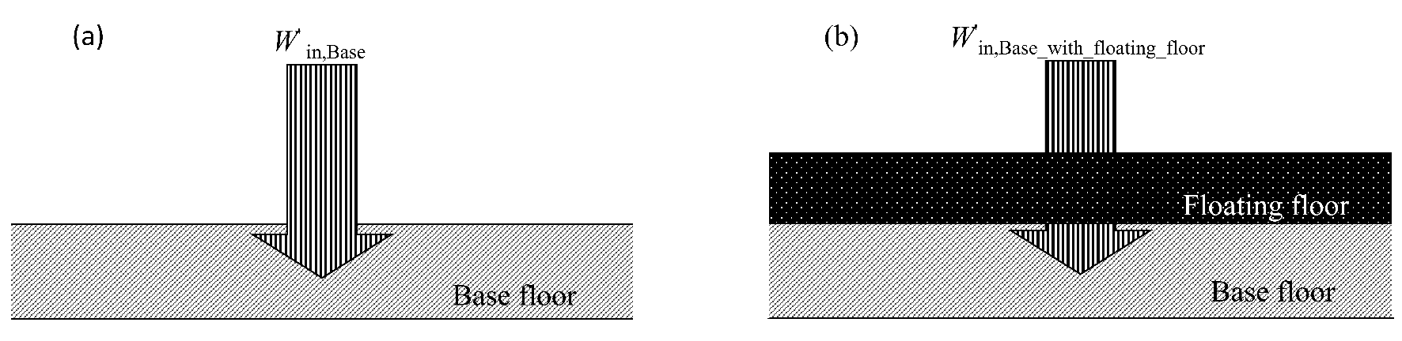

Figure 1. Power injection into (a) the base floor and (b) the base floor when there is a floating floor.

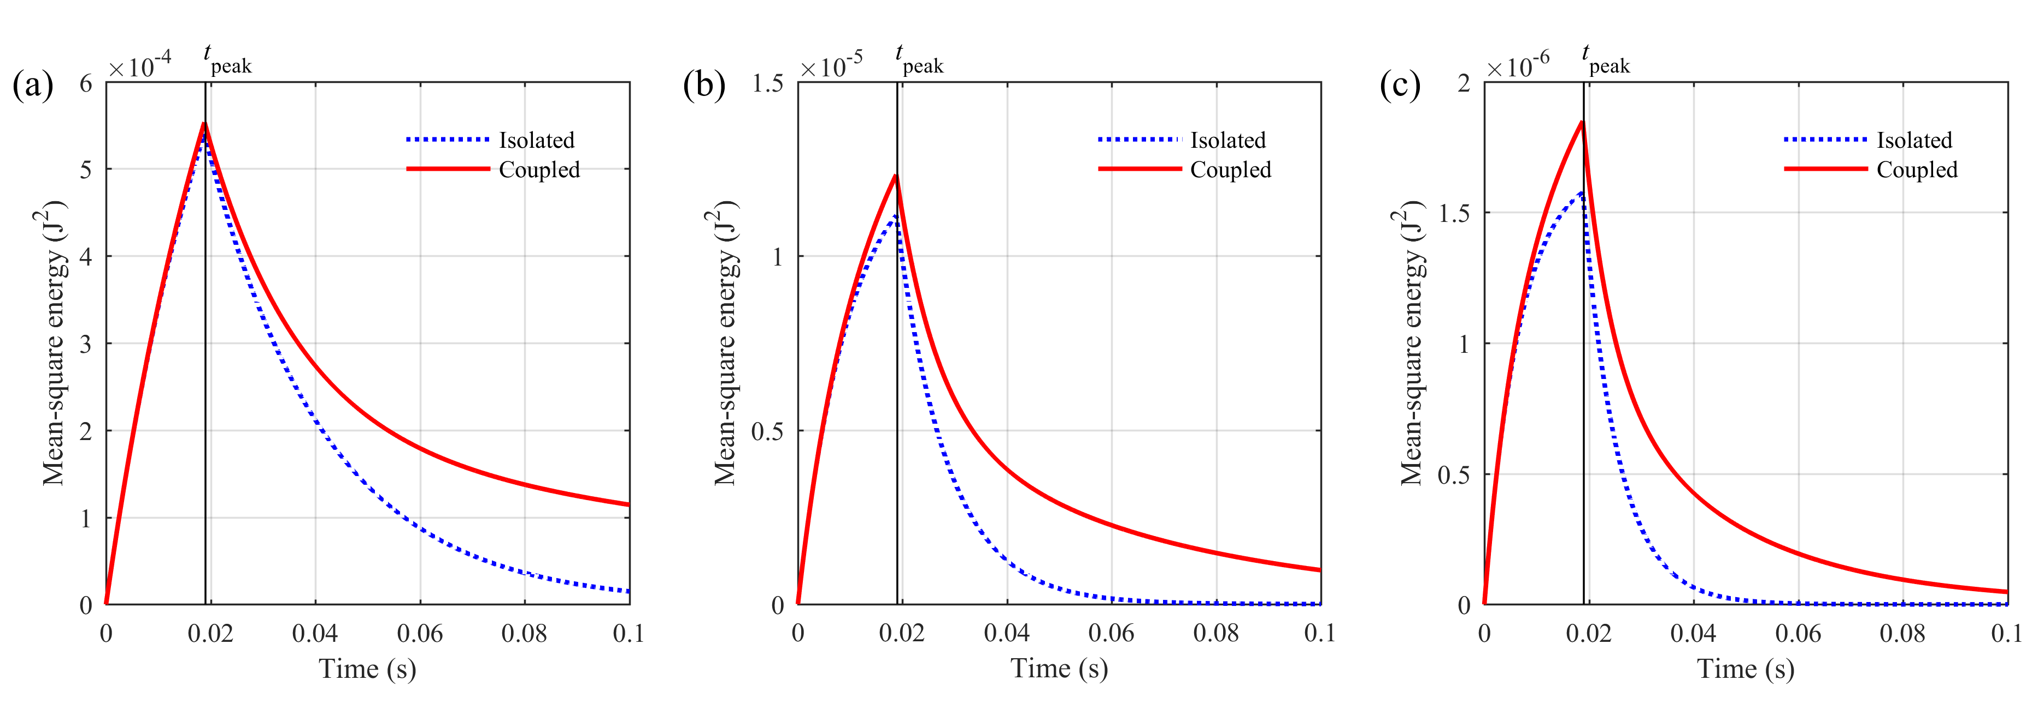
Figure 2. TSEA prediction of the time-varying, mean-square energy in the (a) 50Hz, (b) 250Hz and (c) 500Hz one-third octave bands for an isolated concrete base floor (one subsystem model) and a coupled concrete base floor (14 subsystem model).

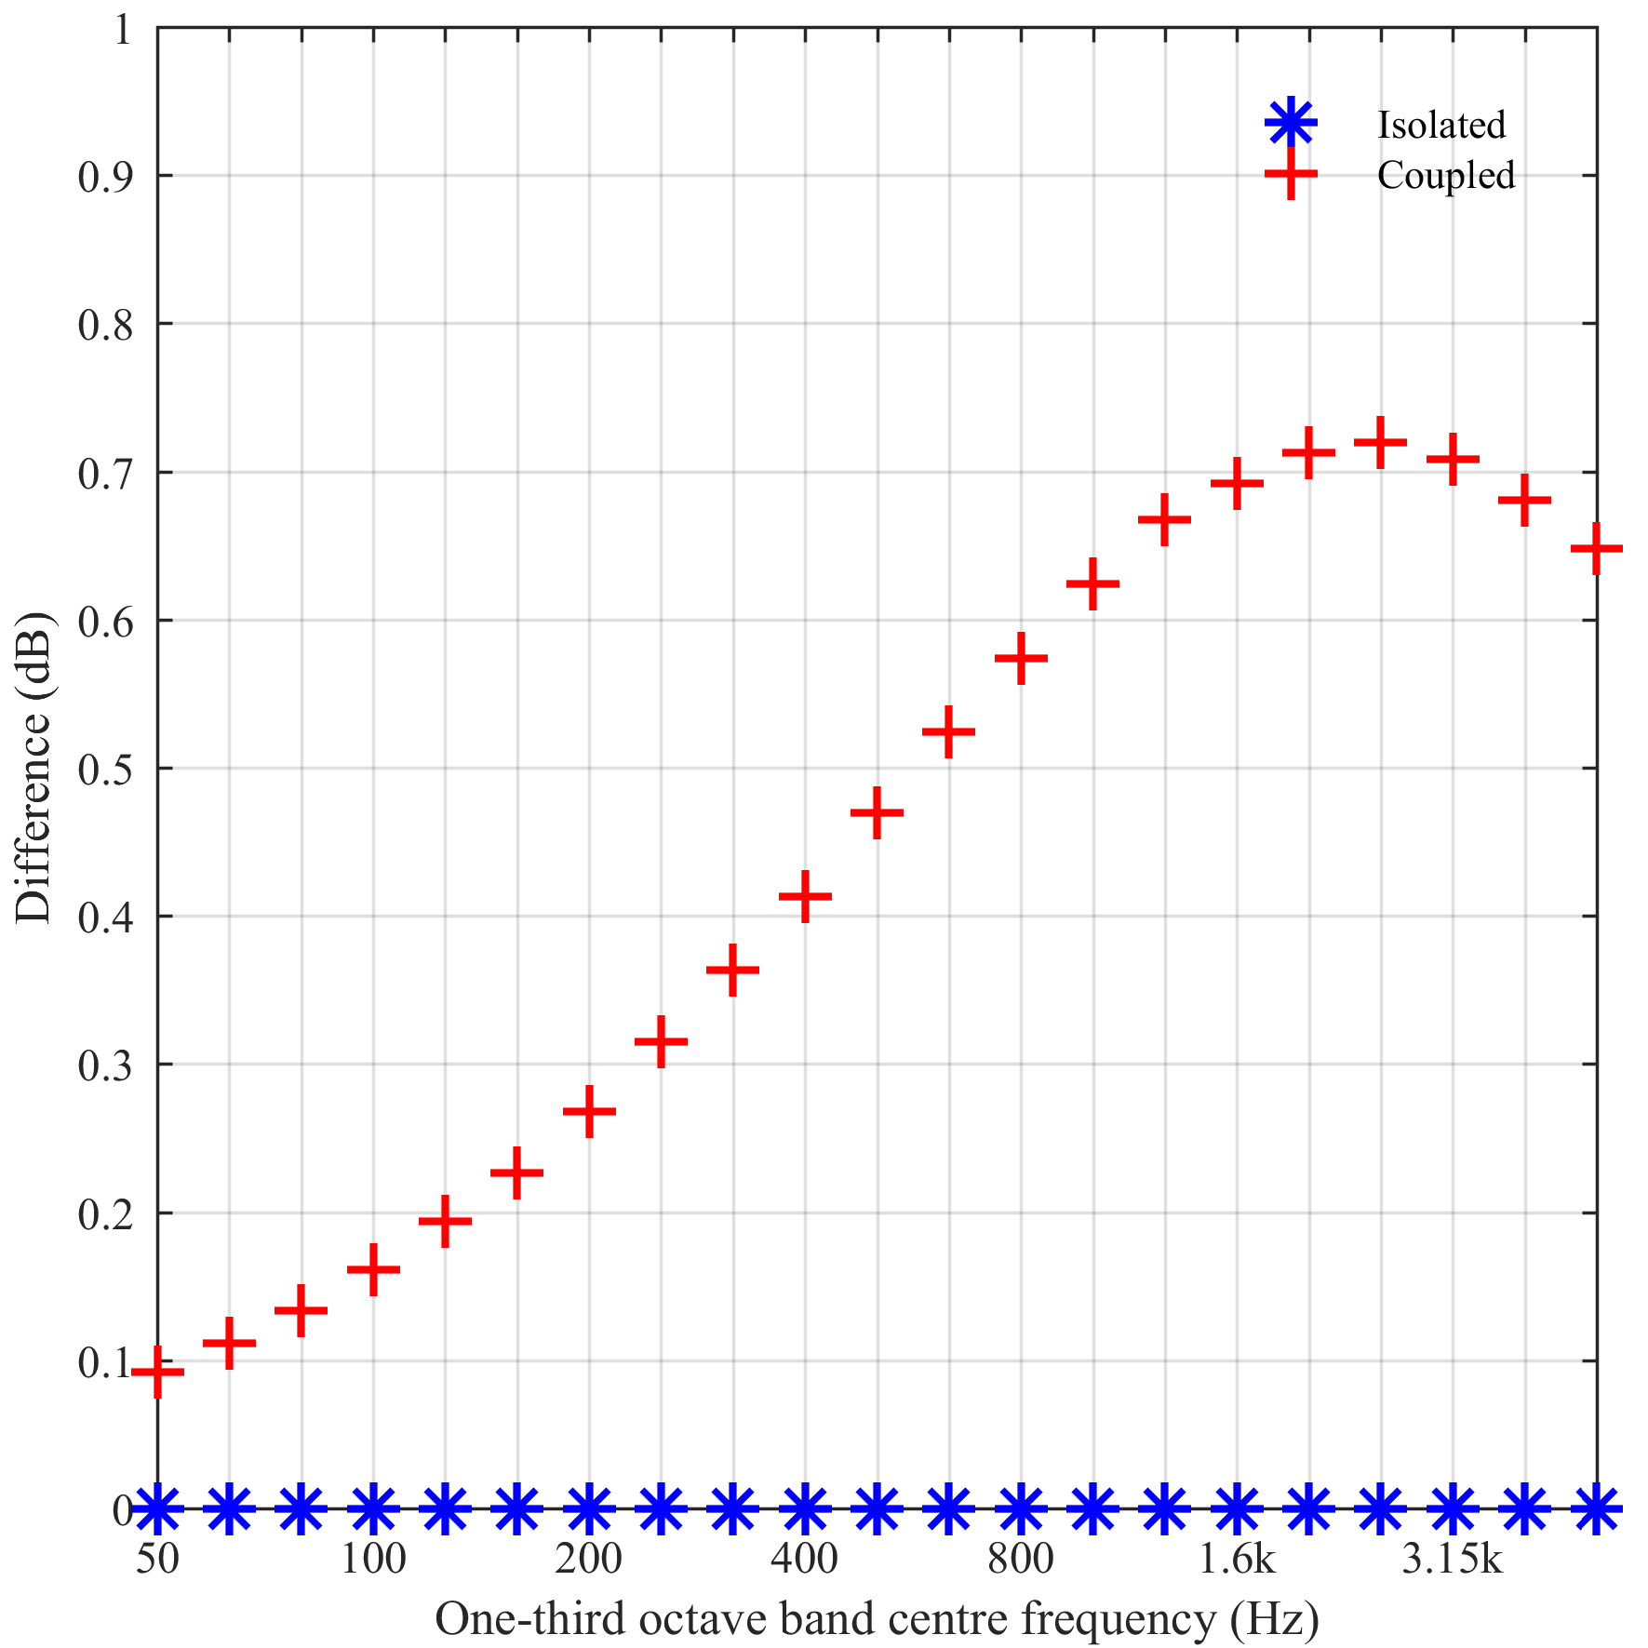
Figure 3. Difference between the normalised transient power input used in TSEA and the values calculated with ITSEA using the results from a TSEA model of the isolated and coupled concrete base floor as input data.

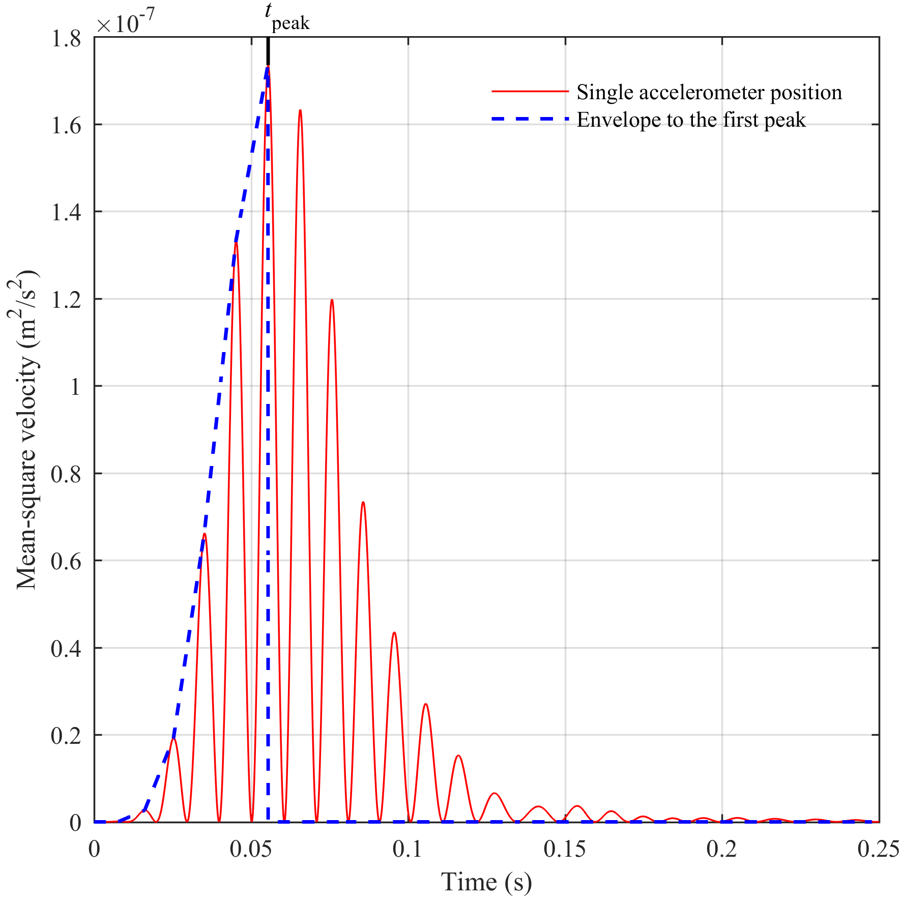
Figure 4. Instantaneous mean-square velocity due to a rubber ball impact from a single accelerometer position on a concrete floor (this example shows the 50Hz one-third octave band) and the corresponding envelope curve from linear interpolation up to the highest peak in the envelope.

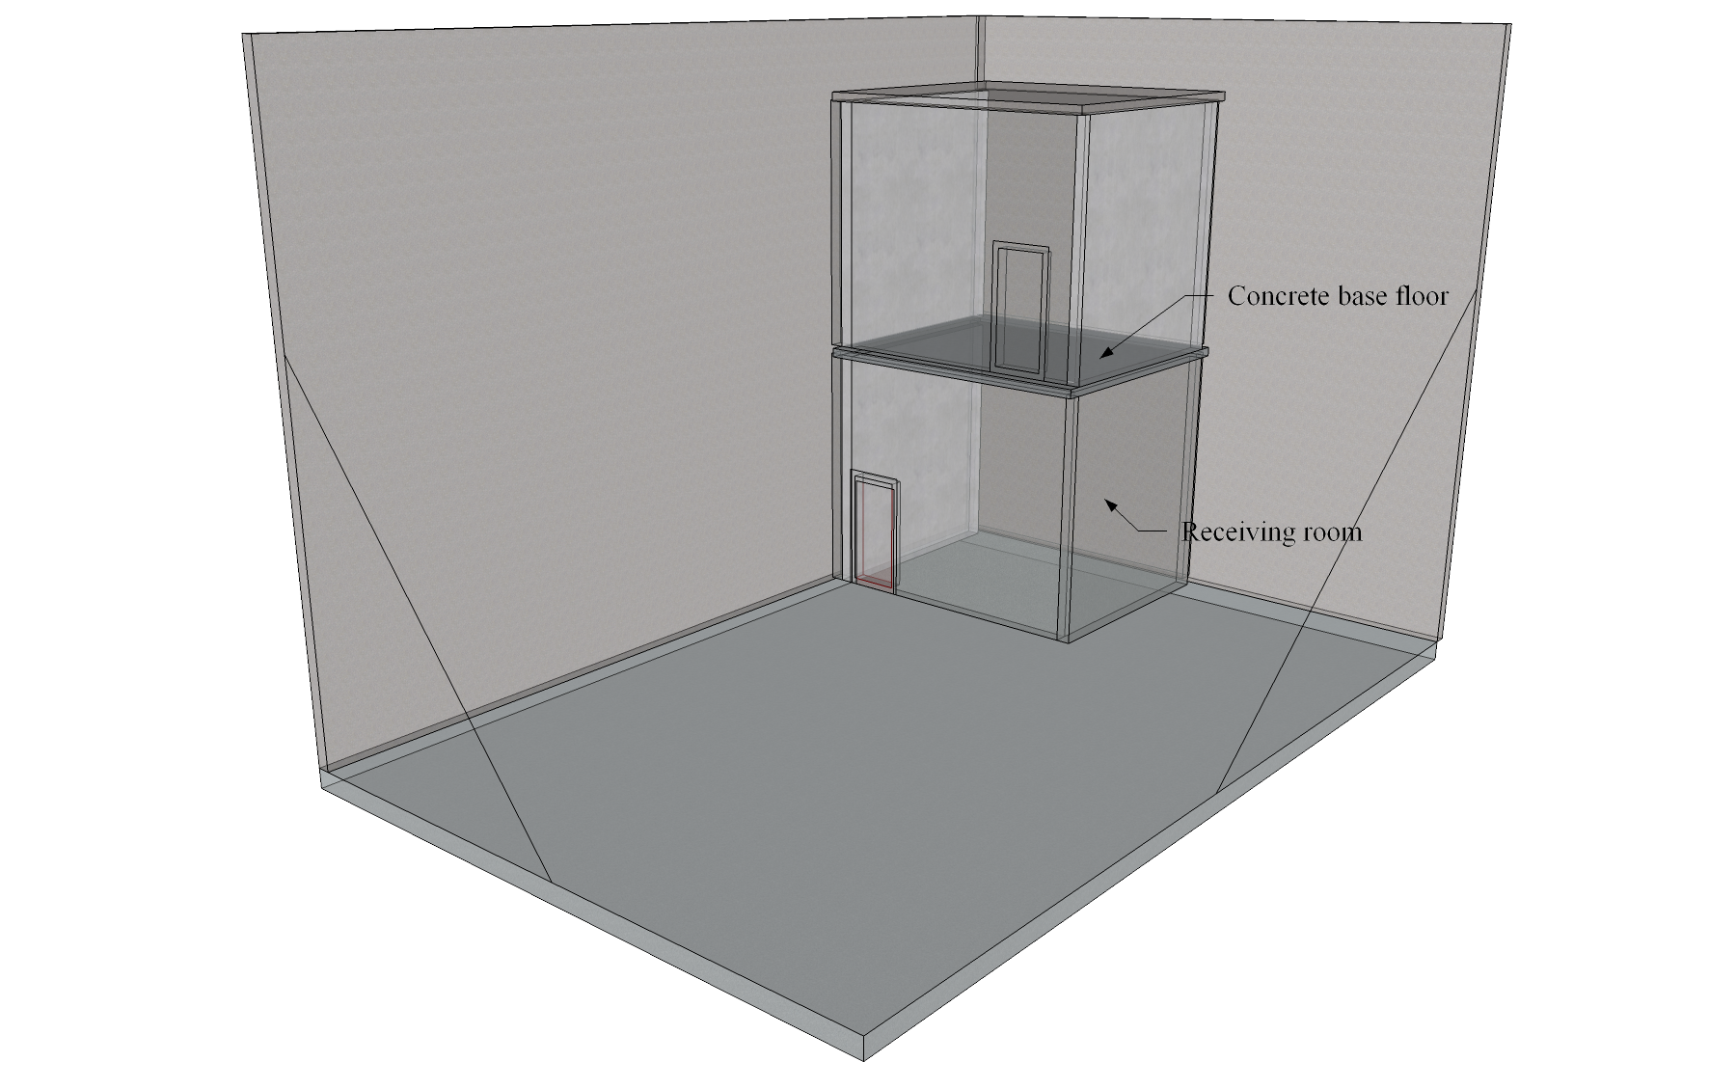
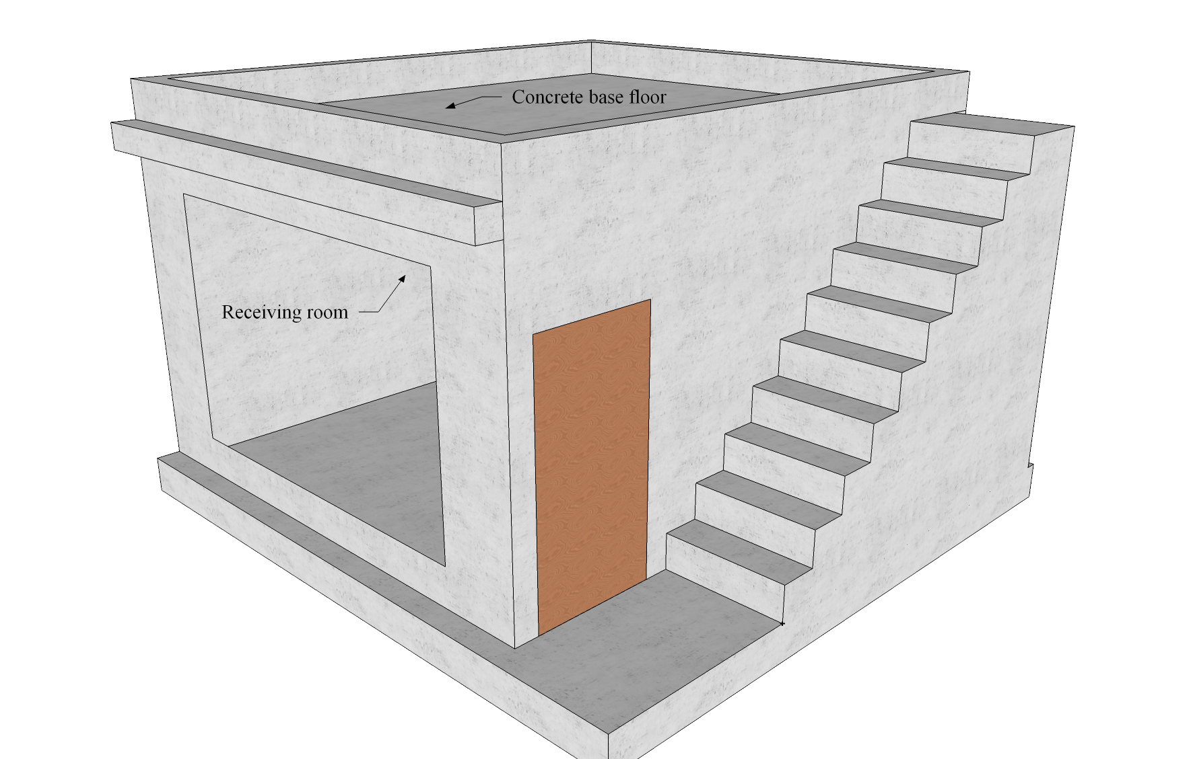
Figure 5. (a) Test facility A and (b) Test facility B.
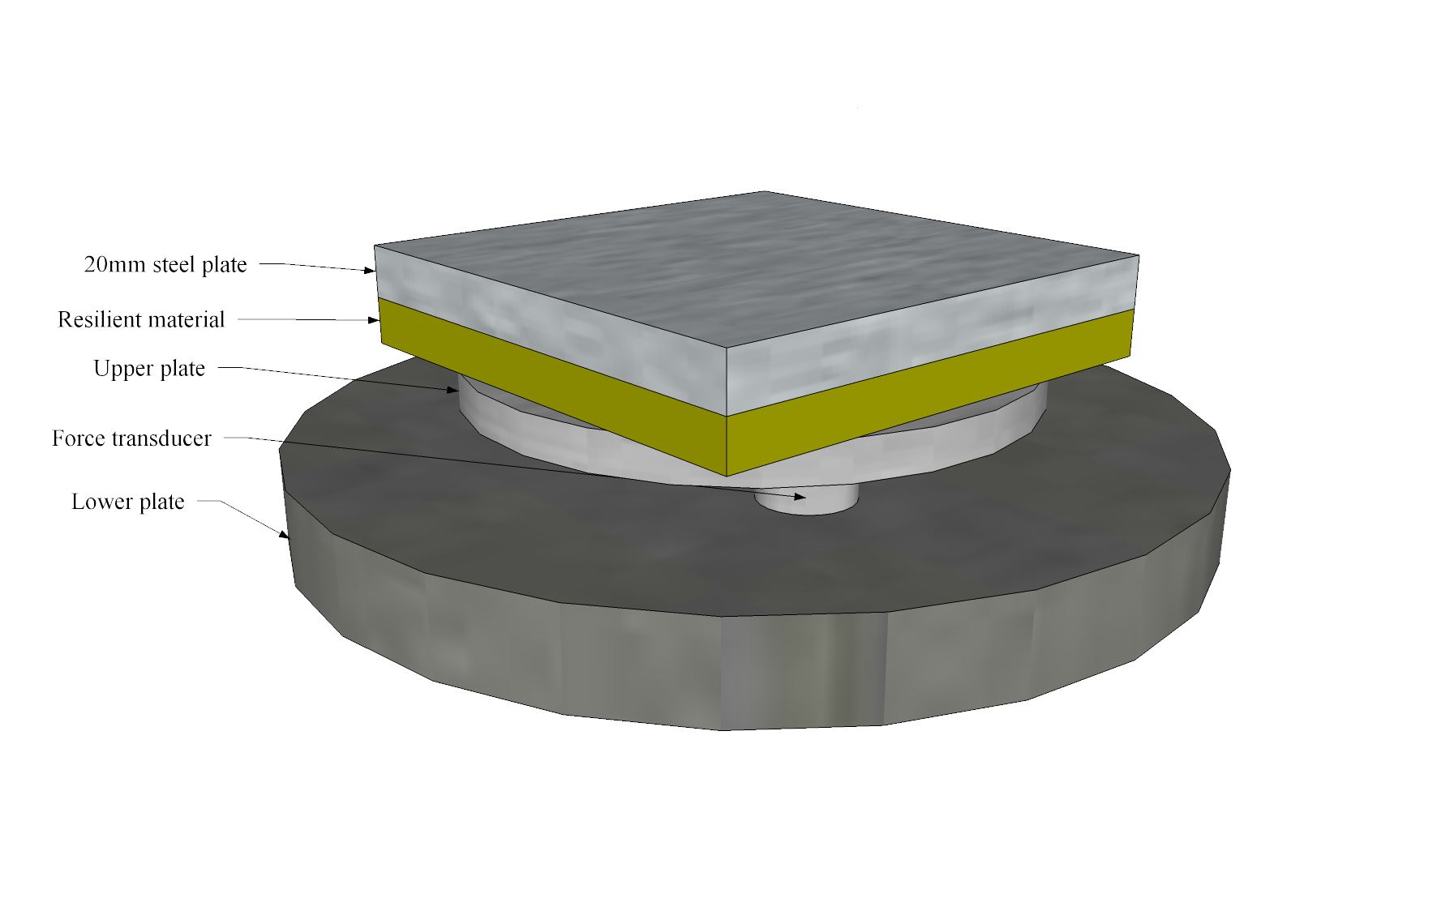
Figure 6. Force plate with mass-spring system.

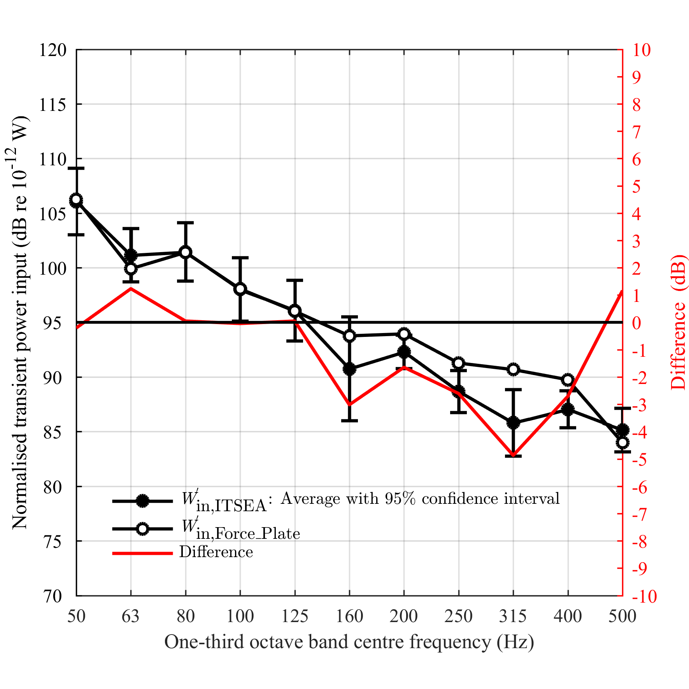
Figure 7. Comparison of the normalised transient power input for the rubber ball exciting a 140mm concrete base floor determined using ITSEA and the force plate.

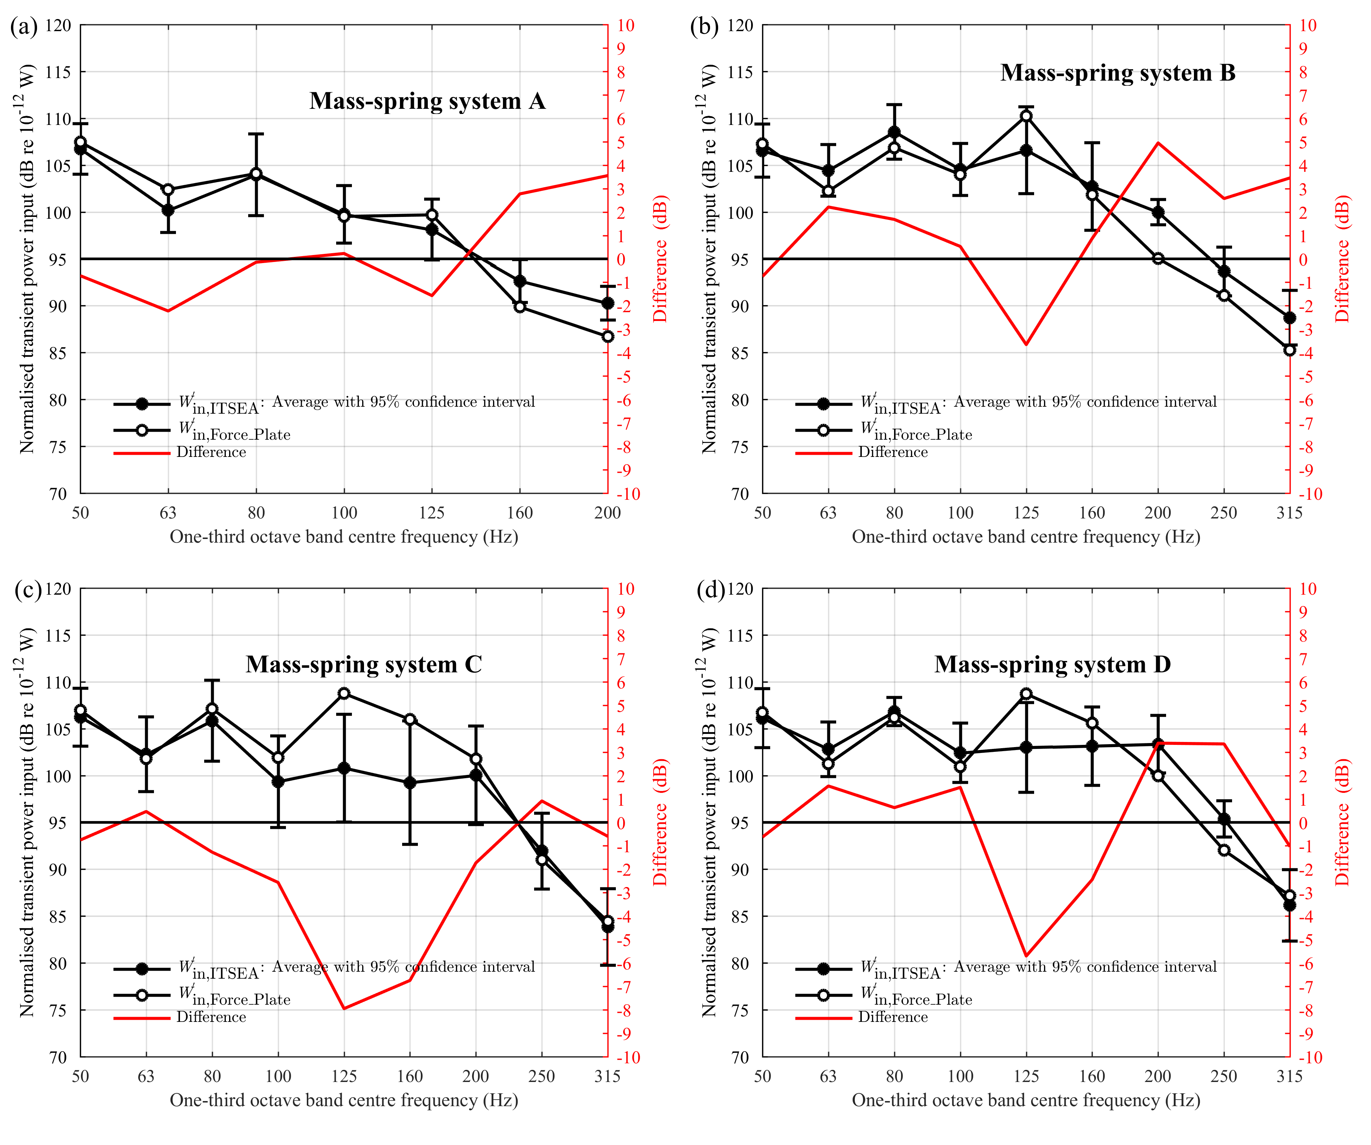
Figure 8. Comparison of the normalised transient power input for the rubber ball exciting locally reacting mass-spring systems A, B, C and D.

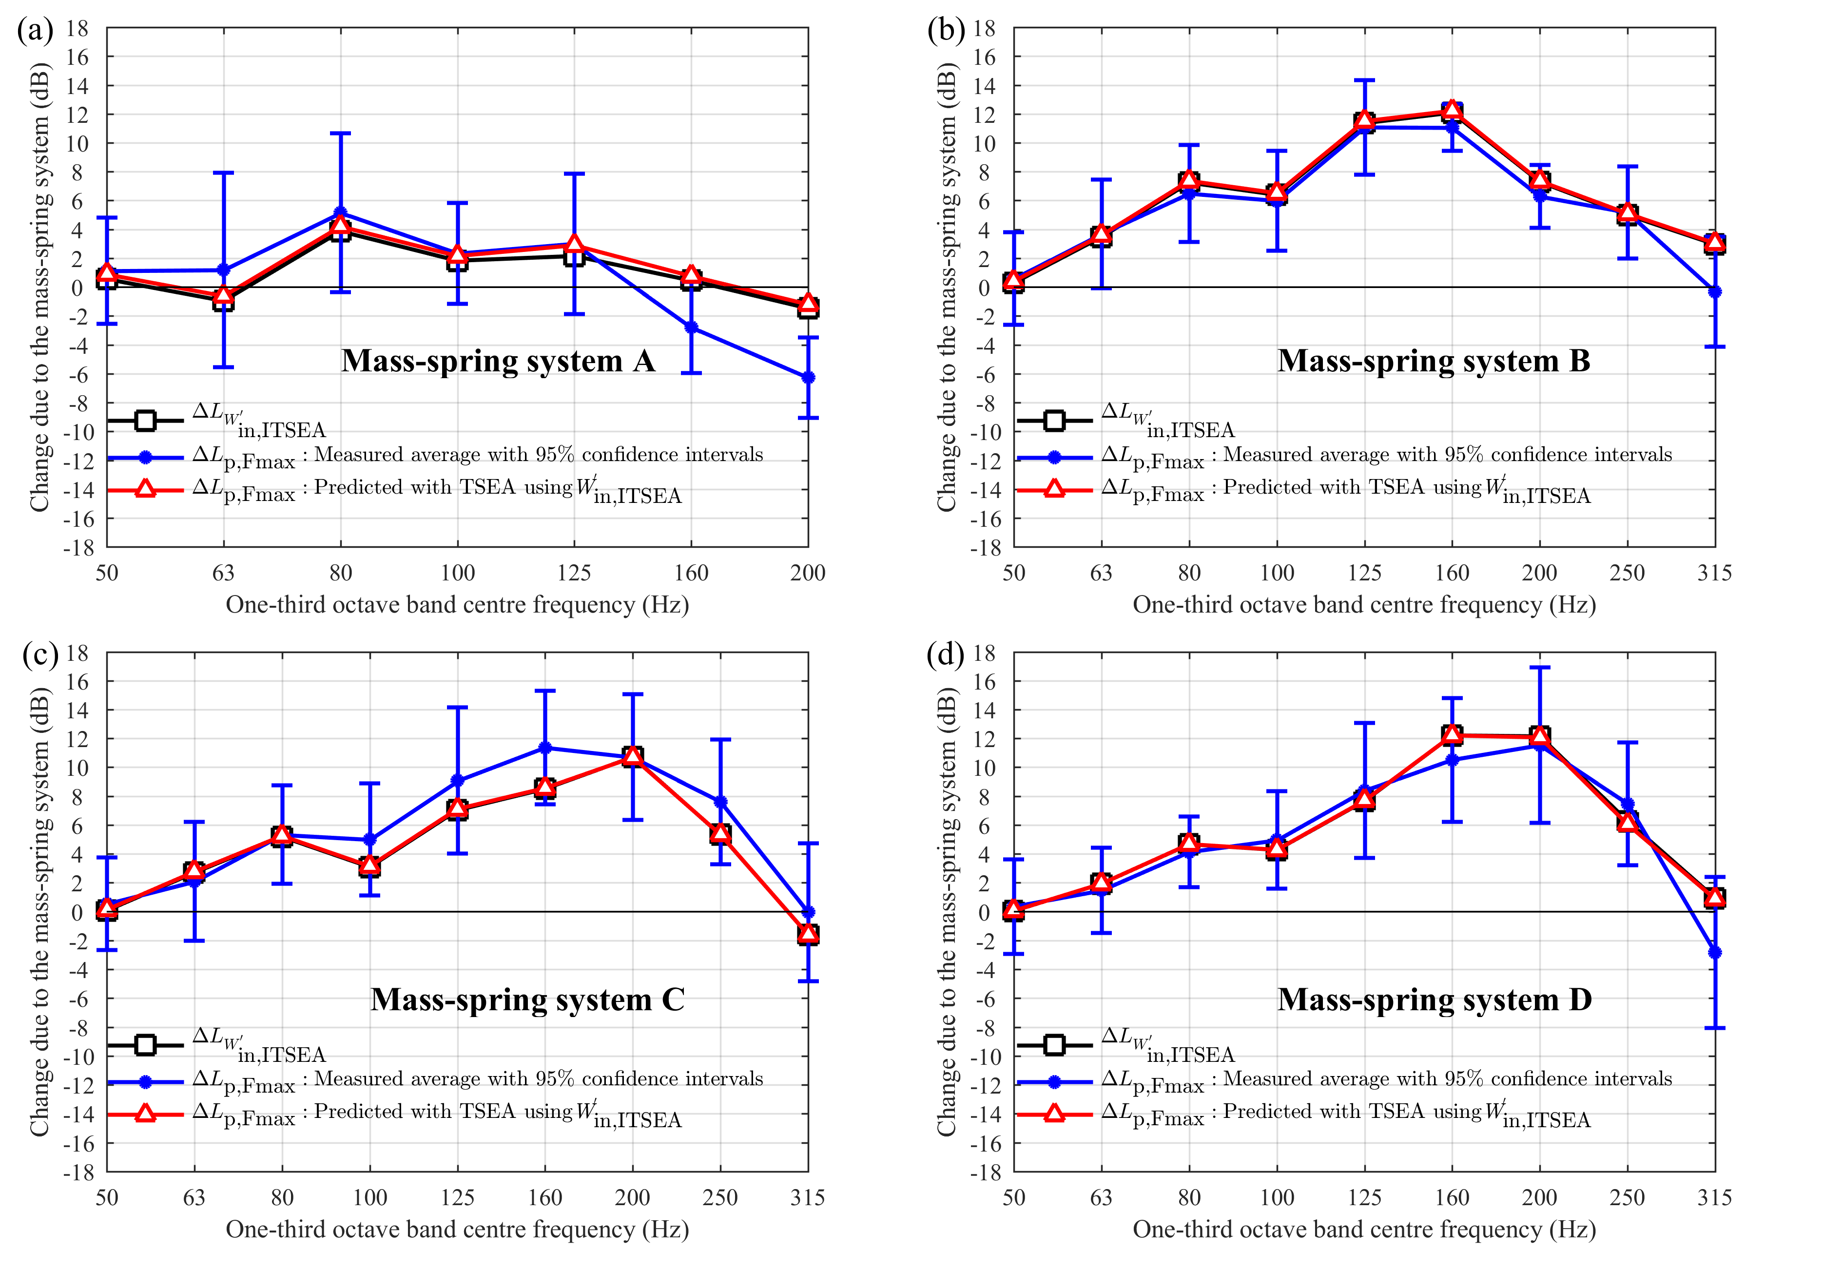
Figure 9. Change in L_{pF,max} and W'_{in,ITSEA} due to mass-spring systems A, B, C and D.

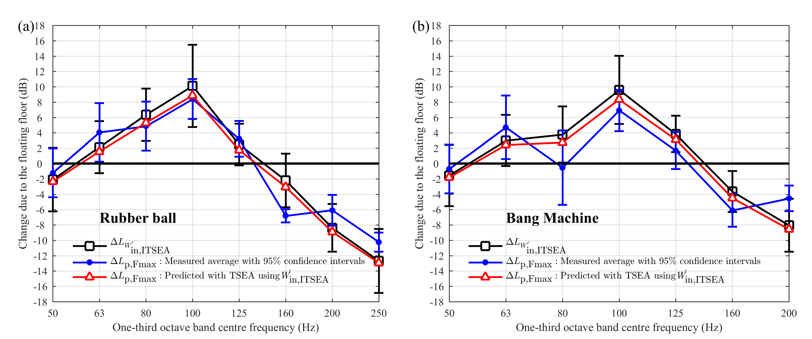
Figure 10. Change in W'_{in,ITSEA} and L_{pF,max} due to the full-size Ondol floating floor with excitation from (a) rubber ball and (b) bang machine.

[] EN ISO 10140-3:2010+A1:2015. Acoustics – Laboratory measurement of sound insulation of building elements – Part 3: Measurement of impact sound insulation. International Organization for Standardization.
[] EN ISO 10140-5:2010+A1:2014. Acoustics – Laboratory measurement of sound insulation of building elements – Part 5: Requirements for test facilities and equipment. International Organization for Standardization.
[] JIS A 1418-2: 2000. Acoustics – Measurement of floor impact sound insulation of buildings – Part 2: Method using standard heavy impact source, Japanese Industrial Standards Committee, 2000.
[] KS F 2810-2:2001. Method for field measurement of floor impact sound insulation. Part 2: Method using standard heavy impact sources. Korean Standard Committee, South Korea, 2001.
[] Tachibana H, Tanaka H, Yasuoka, M, Kimura S. Development of new heavy and soft impact source for the assessment of floor impact sound insulation of buildings. Proceedings of Internoise 98 (1998).
[] Park B, Jeon JY, Park J. Force generation characteristics of standard heavyweight impact sources used in the sound generation of building floors. J Acoust Soc Am 2010;128(6):3507-3512.
[] Kimura S and Inoue K. Practical calculation of floor impact sound by impedance method. Applied Acoustics 26 (1989) 263-292.
[] Koga T, Tano M, Andow K. A modified calculation method and its accuracy for floor impact sounds on large-span slabs from soft and heavy impact sources. Internoise 2000, 27-30 August 2000, Nice, France.
[] Schoenwald S, Zeitler B, Nightingale TRT. Influence of receive room properties on impact sound pressure level measured with heavy impact sources. Proceedings of EuroRegio 2010.
[] Koga T. Practical calculation of floor impact sound excited by heavy impact source. Proceedings of Internoise 2013. Innsbruck, Austria (2013).
[] Okano T and Koyanagi S. A quest for error factors in predicting heavy weight floor impact sound levels using measured data in existing residential buildings. Applied Acoustics 76 (2014) 329-336.
[] Robinson M and Hopkins C. Prediction of maximum time-weighted sound and vibration levels using transient statistical energy analysis. Part 1: Theory and numerical implementation. Acta Acust united Ac 2014;100(1):46–56.
[] Robinson M and Hopkins C. Prediction of maximum time-weighted sound and vibration levels using transient statistical energy analysis. Part 2: Experimental validation. Acta Acust united Ac 2014;100(1):57–66.
[] Robinson M and Hopkins C. Prediction of maximum fast time-weighted sound pressure levels due to transient excitation from the rubber ball and human footsteps. Build Environ 2015;94:810–20.
[] Hopkins C. Sound insulation. Routledge, 2012. ISBN: 978-0-7506-6526-1.
[] Powell, RE and Quartararo LR. Statistical energy analysis of transient vibration. Proceedings of the American Society of Mechanical Engineers (Winter meeting), Boston, United States, 3–8 (1987).
[] Lyon RH and DeJong RG. Theory and Application of Statistical Energy analysis, Second ed., Butterworth-Heinemann, Boston, United States, (1995).
[] Hopkins C and Robinson M. On the evaluation of decay curves to determine structural reverberation times for building elements, Acta Acust united Ac 2013;99(2):226–244.
[] Brandt A. Noise and vibration analysis: signal analysis and experimental procedures. John Wiley & Sons (2011).
[] ISO 9052-1:1989 Acoustics – Method for the determination of dynamic stiffness – Part 1: Materials used under floating floors in dwellings. International Organization for Standardization.
[] Hopkins C and Hall R. Impact sound insulation using timber platform floating floors on a concrete floor base. Build Acoust 2006;13(4):273-284.

