New Price, New Hope? An examination of the effects of doubling
the ticket price in UK Lotto*

Abstract

The UK Lotto game was introduced in November 1994 with a standard 6/49 format and an entry fee of £1 per ticket. After several years, revenue began to fall despite extensive publicity and a variety of inducements. By 2013, nominal weekly revenue was less than half the 1995 level. In October 2013, the operator doubled the price of a ticket to £2 and made a number of changes to the pay-out structure of smaller prizes. The intent of the changes was to reverse the long downward trend in game revenue by encouraging higher jackpots and offering more pay-out opportunities for each ticket. We use draw by draw revenue and other data to evaluate how players responded to these changes and find that, while ticket sales fell dramatically, total revenue rose following the changes. Primarily this appears to have been the consequence of increased frequency of rollovers (and therefore of more frequent high jackpot draws) rather than ticket price inelasticity. However, although there was a short-term gain in revenue, the changes did not arrest, and indeed seem to have accentuated, the long-run trend decrease in the revenue generated by the game.

New price, new hope? An examination of the effects of doubling the ticket price in UK Lotto

I. INTRODUCTION

The UK Lotto game was launched on November 19, 1994 with a once-per-week drawing on Saturdays. It was a standard 6/49 game, which is to say that the jackpot was won when a ticket matched all six numbers drawn from a pool of forty-nine. Smaller prizes were awarded for matching from three to five numbers (in any order). Average weekly revenue for the initial weekly draw was nearly £64 million. On February 5, 1997 a second weekly drawing began, on Wednesdays. Average weekly revenue increased to around £90 million in the following year. Subsequently, however, there was a sustained downward trend in sales, very evident in Figure 1, which shows the evolution of drawing-by-drawing revenue over the life of the game up to October 7, 2015.

After well over a decade of falling sales, average weekly revenue had fallen to around £41 million by 2013. Such a decline in revenue is typical of experience in many jurisdictions worldwide as the market matures. The operator, Camelot, reacted similarly as lottery agencies elsewhere: over the years, various promotions, inducements and new games were introduced in an attempt to maintain revenue. For example, some draws, usually on a Wednesday, are “superdraws” which feature topped-up jackpots; and there have been special promotions, with a bigger jackpot than usual, around special events such as the Queen’s Golden Jubilee and the Olympics. More fundamentally, the portfolio of games was widened to include such as a daily numbers game and, most importantly, participation from 2004 in a new multi-state game, Euromillions. There was also an increasing emphasis on instant win games (scratchcards). Nevertheless, despite the success of Euromillions and scratchcards, the original twice-a-week UK Lotto game remains even now the largest source of revenue and its long-run decline is the greatest threat to the generation of funds for the ‘Good Causes’ (such as investment in the arts and in the British Olympic team) which are entitled to (currently) 28% of gross revenue (the Government takes another 12% for the Treasury).

In 2013, Camelot made its most radical change to UK Lotto in an attempt to arrest declining sales when it did something rare in the history of lotto games: it increased the entry fee, in fact doubling it from £1 to £2 (from the drawing on October 5). Concomitant with this substantial price increase, it made additional changes to game parameters (as summarized in Table 1). First, lower-tier prize pay-outs for matching three or four numbers out of six were increased while the middle-tier pay-outs (for matching five numbers plus the bonus ball or five of the main numbers) were correspondingly decreased. The odds of winning each prize level remained unchanged. Second, the proportion of gross revenue returned to players was increased by two percentage points by decreasing the share going to Good Causes by a like amount. Finally, each ticket purchased was automatically entered into a raffle type draw whereby a minimum of fifty prizes of £20,000 each are paid out at each draw. A strong advertising campaign emphasised these other changes, intended to make the game more attractive, and also promised higher jackpots. But public and press attention appears to have remained focused on the doubling of the entry fee: social media posts were numerous and hostile and opinion polls indicated that most players claimed that they would give up the game.

The aim of this paper is to examine how and why the October 5, 2013 changes to UK Lotto affected revenue from the game. These questions are of interest for a number of reasons. First, lotto-style games do not change ticket prices and/or prize structure very often, making study of such changes difficult. Second, the UK game is one of the largest in the world and parameter changes here can be influential on other lottery agencies. Third, revenue of the game has been on a downward trend for many years despite a variety of attempts to reverse it, as noted above. Arresting this trend is critical for sustaining the Lottery’s contribution to Good Causes and Government revenue.
We find that the October 5, 2013 changes increased revenue from the main lotto game (relative to no changes being made) and that the primary reason for this finding is not that the demand for tickets is relatively inelastic with respect to the ticket price, but rather that. the changes to the game generated an increased number of high rollover, high jackpot games. We also find that the overall downward trend in revenue is not reversed, implying that lottery operators cannot simply increase ticket prices to deal with declining revenues.

II. LITERATURE REVIEW
Two strands of literature on lotteries are relevant to this study. First, there are the lotto demand studies. Economists have long been intrigued by why people choose to gamble when the expected return is almost invariably negative (especially in the case of state lotteries, which offer lower pay-back rates than alternative modes of gaming). Friedman and Savage (1948) famously provided one rationale. They demonstrated that individuals who are risk-averse at current levels of wealth might still buy tickets if their utility of wealth function took on a convex shape over some higher range of wealth. This explanation can be interpreted as gamblers playing because they are offered a financial asset where the probability distribution of payoffs offers sufficient positive skewness to compensate for their acceptance of an expected value lower than the ticket price. In some studies of lotto demand (for example Walker and Young, 2001, Forrest et al., 2010) the idea is applied by specifying revenue in a draw as depending on the mean, variance and skewness of returns. These studies are explicitly modelling demand as if the motivation of players were based on regarding the lottery as an investment.

Earlier lotto demand studies (for example, Gulley and Scott, 1993 and Mason et al., 1997 for the US and Farrell et al., 1999 and Forrest et al., 2000 for the UK) had employed a simpler specification with only the first moment of the probability distribution of payoffs included (together with assorted control variables). As the value of the first moment is less than the ticket price in nearly all drawings, the models could not easily be related to the idea of lottery as investment. They were therefore generally interpreted (Walker, 1998) as representing a market where players are buying entertainment rather than a financial asset: the expected loss exploited a willingness to pay for fun and players varied their purchases as the ‘effective price’ of (expected loss from) a ticket changed from draw to draw with incidence of rollovers. A problem with this interpretation is that the exclusion of variance and skewness from the specification implies that players must be indifferent to prize structure, which varies from draw to draw because rollover money (usually) augments only the top prize in the following draw. As in the attempt by Conlisk (1993) to introduce utility from the process of gambling itself, there is implausibility here in the implicit assumption that the entertainment from gambling is fixed rather than related to the range of prizes available.

Forrest et al. (2002) proposed that the entertainment value of lotto tickets was in fact intimately related to the range of prizes, and specifically to the largest possible prize that could be won in a given draw. Similar to Clotfelter and Cook (1989), who had characterized lottery players as buying ‘hope’, Forrest et al. saw them as buying a ‘dream’, or an entitlement to fantasize how they would spend the jackpot if they won. Therefore Forrest et al. modelled revenue in a draw as a function of the absolute size of the jackpot and found weak evidence that this tracked revenue better than when expected value was the regressor. Stronger evidence for the proposition is reported for the Spanish football pools by Garcia and Rodriguez (2007). And Papachristou (2006) reported that using the jackpot model estimated for an old game in Greece proved efficacious in predicting sales of a newly launched game. Garrett and Sobel (2004) found evidence from comparing sales of 135 lottery games across America that sales were significantly affected by the size of (and odds against winning) the jackpot but not by the expected value of lower-tier prizes. With all these findings in mind, we present modelling where sales are a function of jackpot though in fact results proved qualitatively similar when we replaced jackpot size with effective price per pound of entry fee.

The second strand of literature comprises studies which examine the impact of ticket price changes on lotto revenue. The papers cited above exploit drawing-by-drawing changes in expected value or jackpot to estimate elasticities. However, it is quite possible that such elasticities are not informative as to the effect of ticket price changes, which are relatively rare, making extensive study of them difficult. Perez and Forrest (2011) examined La Primitiva, the oldest and still most popular game in the Spanish operator’s portfolio. Like UK Lotto, it has a 6/49 format and is offered twice weekly. In September 2002, the nominal entry fee was raised from 60 eurocents to 90 eurocents (with no change to the pay-out rate). Comparing the number of tickets sold in the twelve months before and after the change, there was a fall of only 10%, yielding a substantial increase in revenue. A further rise to €1 per ticket in September, 2004 was followed by only a marginal decline in the number of tickets sold. In short, the demand appeared to be highly inelastic with respect to ticket price. Beenstock and Haitovsky (2001) examined the Israeli lotto market, which was characterized by multiple ticket price increases with the goal to keep the real price relatively stable over time. They estimated the long-run elasticity of the number of tickets sold with respect to ticket price as in the range -0.4 to -0.65, depending on model specification, implying that higher ticket prices increased overall revenue. They also found that higher announced jackpots were associated with an increase in ticket revenue.

In general, it is important to understand how bettors react to changes in game parameters so that lottery agencies can set these parameters to maximize revenue to the state, which is usually the objective function of a lottery agency.

III. THE DATA AND VISUAL INSPECTION
The first step is a simple visual inspection of UK Lotto ticket sales, revenue, and jackpots before and after the October 5, 2013 game changes. Figure 2 shows that the number of tickets sold fell dramatically beginning October 5, 2013. Figure 3 shows the corresponding revenue data from each draw. Particularly strong revenue figures from immediately following the changes may be associated with the heavy promotion from Camelot and the ‘special offers’ around the re-launch of the game. But, even ignoring these opening draws, it is clear from the raw data that, since ticket sales did not fall by quite as much as a half when the entry fee was doubled, revenue for both Wednesday and Saturday drawings rose.

From the graph, revenue appears to fall away again after the initial impact. Nevertheless, even into 2015, revenue remained higher than before the price increase. For example, average Saturday sales revenue in the first quarter of 2015 was 20.6% higher than in 2013, Q3 (before Camelot changed the game conditions) and Wednesday sales were 18.9% higher. These raw data suggest an elasticity of about -0.4 measured between the two periods, eighteen months apart, which is similar to that reported by Beenstock and Haitovsky (2001) for Israel. However, it must be cautioned that this is not a true elasticity since it is based on raw data rather than ceteris paribus conditions: the size of jackpot is not held constant.

Jackpot size has indeed tended to increase as a result of the changes Camelot made. The overall decline in the number of tickets sold has worked, as no doubt intended, to increase the number of rollovers and therefore the mean jackpot size. Figure 4 shows the number of rollovers per year. As the number of ticket sold fell, rollover frequency increased. Figure 5 shows the jackpots before and after the changes to the game. Again, the graphical representation illustrates a clear tendency for jackpots to be higher after October, 2013.

The infrequency with which lottery agencies increase ticket price suggests that they regard it as a risky strategy. Certainly Camelot can be perceived as having taken a risk here. The price increase was greater than any studied in the academic literature, so that previous estimates of ticket price elasticity might have proven a poor guide to results. One particular risk was that the price change for UK Lotto took it to the same price point as the multi-state Euromillions game, which features jackpots which dwarf those of the UK game. For example, this might not just have provoked player substitution between games but could have resulted in the permanent loss of some customers, those who thought that the dream of a big win was worth the expenditure of as inconsequential a sum as £1 but who did not regard the dream as an affordable luxury at £2.

Although it is clear from Figure 2 that the number of tickets sold fell dramatically these draw-by-draw data cannot show whether the decline was driven by players reducing ticket purchases and/or players becoming former players. However, the Gambling Commission publishes “participation in the last four weeks” in each of the whole range of gambling activities available in Great Britain, estimated from a telephone survey which samples about 4,000 adults per year, spread out across the year. The participation-rate in National Lottery draw games fell from 46% in 2012 to 43% in 2013 and 37% in 2014. The ticket price increase on the UK Lotto game occurred three quarters into 2013. It is clearly possible that the sharp decline between figures for 2013 and 2014 was related to the increase in ticket price.

Another material risk is that more frequent high jackpots will soon fail to elicit the same response from players as when such events were relatively rare. Large jackpots can produce a lot of excitement along with the attendant publicity but, if they become more commonplace, the allure may fade, as suggested by the “jackpot fatigue” identified by Matheson and Grote (2004). Players no longer respond as before and it takes an ever larger jackpot to generate a given level of sales. Familiarity breeds contempt. It is also possible that a lottery operator may inadvertently train bettors to wait for large jackpots. In lotto games where the jackpot is routinely not won, bettors may learn to wait to reserve their expenditure until a large jackpot has accumulated. Roger (2011), for example, finds that UK bettors are more responsive than bettors in other countries to changes in the Euromillions jackpot. The Euromillions game regularly features multiple consecutive rollovers of the jackpot. More frequent rollovers in the UK lotto game have moved it a step closer to the Euromillions game.

IV. ESTIMATION
We report modelling of draw-by-draw UK Lotto sales revenue over the period between February, 2004 and October, 2015 (two years after the change in ticket price). We decided to estimate over a shorter period rather than include data going as far back as 1997, when UK Lotto became twice-a-week, because the gaming environment was very different in the 1990s. Then there was no other high jackpot game available (the multi-state game had not yet started). Further, online entry into games was not yet possible and our intuition was that this innovation might have introduced greater inertia into sales given that online play would allow the buyer to purchase a standing order for a ticket, valid across every draw for up to eight weeks.

We therefore employ a data set which corresponds to the period over which Euromillions was available. We have separate models for Wednesday and Saturday draws as typical sales levels are much lower for the midweek round of the game. This will clarify the presentation of our results. The cost of this approach is of course less efficient estimates.

As noted above, we report estimates for the jackpot model of lotto sales, consistent with the proposition in Forrest et al. (2002) that sales are driven by the maximum prize that could be won by purchasing a ticket. We are therefore thinking of a positively sloped demand curve in jackpot-sales revenue space. Naturally the position of such a demand curve will depend on other factors, such as the pay-back rate and the structure of prizes. The pay-back rate was increased slightly at the time of the ticket price increase. This made the tickets (modestly) better value for money. For example, the expected value of holding a £1 ticket for the non-rollover Saturday draw on January 26, 2013 was £0.411. On the corresponding Saturday one year later, January 25, 2014, the expected value per pound of holding a ticket was £0.447.

Our basic demand model (ignoring interaction terms for the moment) is:

REVENUE= f(REVENUE₋₁, REVENUE_{-2,} , JACKPOT, TREND, OCT2013 VARIABLES) (1)

JACKPOT is the value of the jackpot pool (£) for a particular draw. Given we adopt the framework of lottery-as-a-consumer-good, we take this as a proxy for the utility of playing. We expect a demand curve in REVENUE-JACKPOT space to be positively sloped because the ‘dream’ is more thrilling the higher the value available to the luckiest of winners (the one who wins the jackpot outright rather than shared with holders of other tickets).

JACKPOT is endogenous because a fixed fraction of sales revenue from a draw is paid into the jackpot pool for that draw. Thus we follow the standard procedure in the lotto literature of estimating by two-stage least squares where the instruments for jackpot are rollover (the amount of extra money paid into the jackpot pool because it had not been won at the previous draw) and its square.

Among the explanatory variable are two lagged values of sales. The subscripts here refer to draw numbers such that -1 refers to the immediately preceding draw (for example, for a Wednesday draw, the value will be for sales on the preceding Saturday) whereas -2 refers to the draw on the same day the previous week (thus in the Wednesday equation, the value relates to sales on the Wednesday of the week before).

The October, 2013 variables include our key focus variable, NEWREGIME, which is a dummy variable set equal to one for the period from October 5, 2013 when the ticket price and other changes were in effect (and set to zero otherwise). For the first two Saturday draws, special bonus features were offered (as noted above) and there are therefore also dummies for OCTOBER5 and OCTOBER12. When we proceeded to estimation, we also added interaction terms to the basic model represented by (1), in order to test for changes in slope coefficients following the introduction of the new regime. The interaction terms were also introduced to the stage 1 equation in our two-stage least squares model.

Before proceeding to our results, it is important to give their discussion some context by considering the sources of any impact on revenue that may be associated with the increase in ticket price imposed in October, 2013. Suppose the elasticity of demand of the number of tickets sold with respect to the entry fee to the game were -1. In this case, the elasticity of sales revenue with respect to ticket price would be zero: the demand curve in jackpot-revenue space would remain in the same position following the doubling of ticket price. Any given jackpot would generate the same revenue. However, there would still be a gain in revenue for the operator over time because, with fewer entries into the game, it would be more likely than before that a draw with a given jackpot would yield no winners. With more frequent rollovers, there would be more observations at the high jackpot end of the demand curve and consequently, over a period, greater revenue on average for the operator.

But it was to be expected, from earlier studies of ticket price elasticity, that the number of tickets sold would not in fact fall to as low as half its previous level for a given jackpot. In this case, there would be a new demand curve in jackpot-sales revenue space and it would lie to the right of the old one. Now a given jackpot would deliver more revenue than before and this is the second source of additional revenue for the operator. But note that the two potential sources of revenue gain are not independent of each other. If players’ resistance to the price increase is weak, there will be greater direct revenue gain from inelasticity but the gain from generating more rollovers will be less (since not so many long sequences of rollovers will occur if there has been only a relatively modest fall in the number of entries).

V. RESULTS
Table 2 presents our results from estimation of equation (1) above with additional (interaction) terms to allow for any possible impact of the October, 2013 changes on the slope of the relationship between revenue in a draw and jackpot in a draw and between revenue in a draw and lagged revenue from preceding draws. All variables denominated in pounds were logged.

Principal findings were as follows.

(i) Sales for both Wednesday and Saturday draws are shown to be affected by ‘habit’ to the extent that coefficient estimates on sales at preceding draws are statistically and economically significant. However, in the case of Saturday draws, inspection of the size of the coefficient estimate on the interaction term with NEWREGIME reveals that the linkage with sales at the (Wednesday) draw three days before was broken. By contrast the link with sales on the previous Saturday was strengthened.

(ii) There is evidence of a slight weakening of the sensitivity of sales to jackpot size. This may be an effect from
‘lotto fatigue’ (Matheson and Grote, 2004).

(iii) From the coefficient estimates on the dummy variable NEWREGIME, there was no statistically significant direct effect on revenue from the regime change either on Wednesdays or on Saturdays. Therefore it is not possible to reject the hypothesis that, for a given jackpot size, players were willing to spend the same amount as before on entries to the game. This appears to suggest that the elasticity of the number of tickets sold with respect to ticket price was something close to -1 (since the elasticity of revenue with respect to ticket price was something close to zero). The qualification implied by the words “something close” is necessary because, while the doubling of ticket price was the most dramatic component in the package of changes, there was also a modest increase in the payback rate and a rebalancing of prizes between the middle- and bottom-tier prize levels. The response of sales (which happens to be insignificantly different from zero) is therefore a joint response to the doubling of ticket price, the increase of two percentage points in the proportion of revenue repaid to players as prizes, and the restructuring of non-jackpot prizes. But, whatever the individual impact of these different elements in the package of changes, we were not able to discern a statistically significant shift in the jackpot-sales revenue demand curve. However, we noted above that, from the raw data, mean sales revenue figures for both Wednesday and Saturday were in fact higher in the two years after compared with the two years before the changes. Our interpretation is that, from the regression results, this boost in sales was not to a significant degree the result of inelasticity in the number of tickets sold with respect to ticket price. Rather, the mechanism that made the changes an apparent success was that, with fewer entries into the game, there were more rollovers and therefore more draws in the high jackpot range of the jackpot-sales revenue demand curve.

This can be seen in Figure 6, which plots sales revenue against jackpot size, before and after the October 2013 price increase, for Wednesday and Saturday drawings separately. The before and after data points for the Wednesday drawings clearly illustrate an increased number of higher jackpot opportunities after the price change relative to before the change, and so there are more points along an upward sloping line in jackpot/revenue space. If the revenue increase was mainly driven by demand for tickets being price inelastic, we would expect a shift to the right in the loci of jackpot/revenue data points. The before and after data points for the Saturday drawings do not show as clear a pattern as do the Wednesday data points. It is not so clear that Saturday sales are higher in response to larger jackpots on offer. There may be several reasons for the lack of clarity. First, the two triangles on the far right of the chart on the £10 million jackpot line are the Saturday drawings on October 5 and 12, 2013. These drawings each featured one thousand £20,000 raffle prizes, rather than the usual fifty raffle prizes. These drawings were also heavily promoted. Note that we added dummy variables in our regressions to account for these circumstances. Second, the higher sales and jackpot levels on Saturday are associated with higher variances relative their Wednesday counterparts, and so any jackpot/sales relationship is going to be naturally more diffuse. Still, it is possible that some of the reason for higher revenue on Saturday is due to an inelastic demand (the point estimate on NEWREGIME was positive in the Saturday equation though it was not significant even at 10%). Demand for Saturday tickets has always been higher than for Wednesday tickets and thus more likely to be inelastic relative to Wednesday.

(iv) In addition to these one-off effects from the doubling of the ticket price, it is possible that there will have been longer-run effects on underlying interest in the game, which had long been waning, as the significant coefficient estimates on TREND illustrate. On the one hand, Camelot may have hoped that this trend away from playing the game might be mitigated because the excitement around big jackpots would be felt more often, maintaining player interest. On the other hand, players could be more likely to become disillusioned over time when they were spending much more per ticket (if they bought half as many tickets as before they would, on average, win the smallest prize much less often: for many wavering players, winning something over a period may be necessary to tip the balance towards staying in the game). Inspection of the coefficient estimates on the interaction term between NEWREGIME and TREND shows that there was no change in the downward trend in Wednesday sales and the downward trend on Saturday sales was in fact strongly accentuated. It cannot be known (a general problem with event studies) whether this deterioration in Saturday sales would have occurred anyway; but the results are suggestive that the immediate boost to sales from the reforms was to be offset in time by their driving down interest in playing the game. This is consistent with the steep fall in participation rates observed in Gambling Commission surveys (footnote 8 above).

VI. CONCLUSIONS
The main UK Lotto game dates from 1994 and the entry fee was set, as in most American jurisdictions, at a single unit of local currency. This price proved sticky as it was nineteen years before the operator decided to gamble on adjusting the price. The adjustment ended up being a dramatic one: the price doubled.

It was a gamble for the operator because there had been diminishing interest in the lottery for a long time. Evidently disillusion with the game was in the air and a sudden and large price change had the potential to drive many players to quit the game. On the other hand, operators in Israel and Spain had been found to have boosted revenue by increasing the entry fee on games with a similar format as UK Lotto and this gave hope that ticket price inelasticity would also prevail in UK.

To an extent, the operator’s gamble was successful. By the second year after the change to the ticket price, average revenue per draw was still about one-fifth higher than it had been immediately before. From our results, this was not primarily because of ticket price inelasticity of demand because, at given jackpot size, players appeared to be willing to spend only a similar amount on tickets as before (unit-elastic demand). The effect was therefore in large part because the fall in the number of tickets yielded more frequent rollovers and therefore a higher average jackpot size. Over a period, more revenue was generated because more draws featured a high jackpot.

Where the gamble was unsuccessful was in the longer-term. The operator bought more time in that the long slide in revenue was brought successfully to a halt and in fact revenue increased in the immediate term. But there was no break in the downward trend which resumed straightaway and indeed became more pronounced in the key Saturday version of the game. By the end of our data period, the long-run outlook looked bleak again even if the policy looked to have had a favourable effect to date.

Could an operator then put off long-run disaster by implementing multiple price increases over time, each time restoring revenue to its old level? Trying the same again might be yet more risky for this particular operator. Another doubling of price might drive away a high proportion of players because it would take price to a level where one might lose the selling point of lotto, that everyone can afford to buy the entitlement to the dream. Further, the less divisible investment in the lottery is, the greater the number of customers constrained by having to purchase an integer number of tickets. For example, an individual might optimise in a perfectly divisible environment by investing £1.60 in a draw. In the constrained environment, this would round to £2 both before and after a price increase from £1 to £2. Thus the revenue from the customer would be kept. However, this customer would likely be lost if there is no level of investment available between 0 and £4 because £1.60 would round to nothing.

On the other hand, any gain from doubling the price in 2013 appears to have come primarily from the operator being able to offer more frequent high jackpot draws. Instead of engineering this effect by increasing the ticket price, the operator could achieve the same thing by changing the format to make a longer-odds game. Faced with the unrelenting downward trend in revenue, it is in fact in this direction that the thoughts of the UK operator have more recently turned. The risks of lengthening odds represent a topic for future research.

References

Beenstock, Michael, and Yoel Haitovsky. “Lottomania and Other Anomalies in the Market for Lotto.” Journal of Economic Psychology 22 (6), 2001, 721-744.

Conlisk, J., “The Utility of Gambling.” Journal of Risk and Uncertainty 6:3, 1993, 255-75.

Clotfelter, C. T., and P. J Cook, Selling Hope: State Lotteries in America, 1989, Harvard University Press, Cambridge, MA.

Farrell, L., R. Hartley, G. Lanot, and I. Walker. "The Demand for Lotto: The Role of Conscious Selection." Journal of Business & Economic Statistics, 18(2), 2000, 228-41.

Forrest, D., O. D. Gulley, and R. Simmons, “Elasticity of Demand for U.K. National Lottery Tickets.” National Tax Journal 53(4), Part 1, 2000, 853-63.

Forrest, D., L. Perez, and R.D. Baker, “Evaluating the Effects of Game Design on Lotto Sales: A Case Study from Spain.” Journal of Gambling Business and Economics 4(2), 2010, 1-20.

Forrest, D., R.Simmons, and N. Chesters, “Buying a Dream: Alternative Models of demand for Lotto.” Economic Inquiry 40(3), 2002, 485-496.

Friedman, M., and L. J. Savage, “The Utility Analysis of Choices Involving Risk.” Journal of Political Economy, 48(4), 1948, 279-304.

Garcia, J., and P. Rodriguez, “The Demand for Football Pools in Spain: the Role of Price, Prizes, and the Composition of the Coupon.” Journal of Sports Economics 8, 2007, 335-54.

Garrett, T. A., and R. S. Sobel, “Gamblers Favor Skewness Not Risk: Further Evidence form United States’ Lottery Games.” Economic Letters, 63(1), 1999, 85-90.

Garrett, T. A. and R. S. Sobel, “State Lottery Revenue: The Importance of Game Characteristics.” Public Finance Review, 32(3), 2004, 313-340.

Gulley, O. D., and F. A. Scott, “The Demand for Wagering on State-Operated Lotto Games.” National Tax Journal 46(1), 1993, 13-22.

Mason, P. M., J. W. Steagall and M. M. Fabilus, “The Elasticity of Demand for Lotto Tickets and the Corresponding Welfare Effects.” Public Finance Review 25(5), 1997, 474-90.

Matheson, V. and K. Grote, “Lotto Fever: Do Lottery Players Act Rationally Around Large Jackpots? Economics Letters 83, 2004, 233-37.

Papachristou, G. A., “Is Lottery Demand Elasticity a Reliable Marketing Tool? Evidence from a Game Innovation in Greece.” International Review of Economics, 2006, 627-640.

Perez, L. and D. Forrest, “Own- and Cross-Price Elasticities for Games within a State Lottery Portfolio.” Contemporary Economic Policy, 29(4), 20062011, 29, Issue 4, 536–549.

Roger, P., “La demande de grilles d’Euromillions: une comparison internationale” (The demand of Euromillions lottery tickets: An international comparison with English Summary). Revue Économique, 62, 2011, 29–55.

Walker, I., “The Economic Analysis of Lotteries.” Economic Policy 13(27), 1998, 359-92.

Walker, I. and J. Young, “An Economist’s Guide to Lottery Design.” Economic Journal 111(475), 2001, F700-722.
Table 1: October 2013 Changes to the UK National Lottery game

 | November 1994-October 2 2013 | from October 5, 2013 | odds of winning
Nominal Price | £1 | £2
Match 3 of 6 numbers prize | £10 | £25 | 1:57
Match 4 of 6 numbers prize | £60 | £100 | 1:1,033
Match 5 of 6 numbers prize | £1,500 | £1,000 | 1:55,492
Match 5 numbers and bonus ball prize | £100,000 | £50,000 | 1:2,230,636
Match 6 out of 6 numbers prize (jackpot) | £4,369,961* | £4,789,885* | 1: 13,983,816
Raffle Prizes | NA | £20,000 | 1:170,000 Wednesday;  1:330,000 Saturday**

The odds are based on a standard 6/49 lotto game. The estimated prize values for all but the jackpot are from https://www.national-lottery.co.uk/games/lotto/game-procedures.

* The jackpot prizes are the average values in the 209 drawings prior to October 5, 2013, and the 209 drawings on and after October 5. Median jackpots, while lower, portray a similar numerical change.

** The odds of winning a raffle prize vary with the number of raffles prizes offered (usually 50 per drawing) and the number of tickets sold. The reported odds are from the UK National Lottery.
(https://www.national-lottery.co.uk/games/lotto/game-procedures)

Table 2: Revenue regression estimates

Independent Variable | Wednesday | Saturday
constant | 9.041**  (8.81) | 10.169**  (16.13)
trend | -0.00019**  (-8.70) | -0.0002**  (-14.93)
lagged revenue(-1) | 0.132*  (2.34) | 0.171**  (5.17)
lagged revenue(-2) | 0.166**  (3.60) | 0.112**  (3.13)
new regime*lagged revenue (-1) | 0.168  (1.24) | -0.180**  (-4.85)
new regime*lagged revenue(-2) | 0.007*  (2.10) | 0.136  (1.71)
new regime | -2.53  (-0.93) | 1.715  (1.27)
new regime*trend | -0.000  (-0.21) | -0.0003**  (-4.77)
jackpot | 0.193**  (23.84) | 0.169**  (14.86)
new regime*jackpot | -0.029  (-1.73) | -0.028*  (1.95)
October 5 |  | -0.35  (-0.23)
October 12 |  | 0.021**  (3.80)
sample size | 608 | 608
adjusted Rsq | 0.814 | 0.888
SEE | 0.065 | 0.040
Breucsh-Godfrey LM | 2.67 | 18.38**
Ljung- Box Q | 6.01 | 18.61**

t-statistics are in parentheses. ** and * indicate significance at 1% and 5% respectively. The revenue and jackpot variables are in natural logs. The new regime variables are non-zero beginning October 5, 2013. The equations are estimated with heteroskedastic and autocorrelation (Newey-West) consistent errors where appropriate.
Figure 1: Draw-by-draw UK Lotto revenue (£), November 1994-October 7, 2015

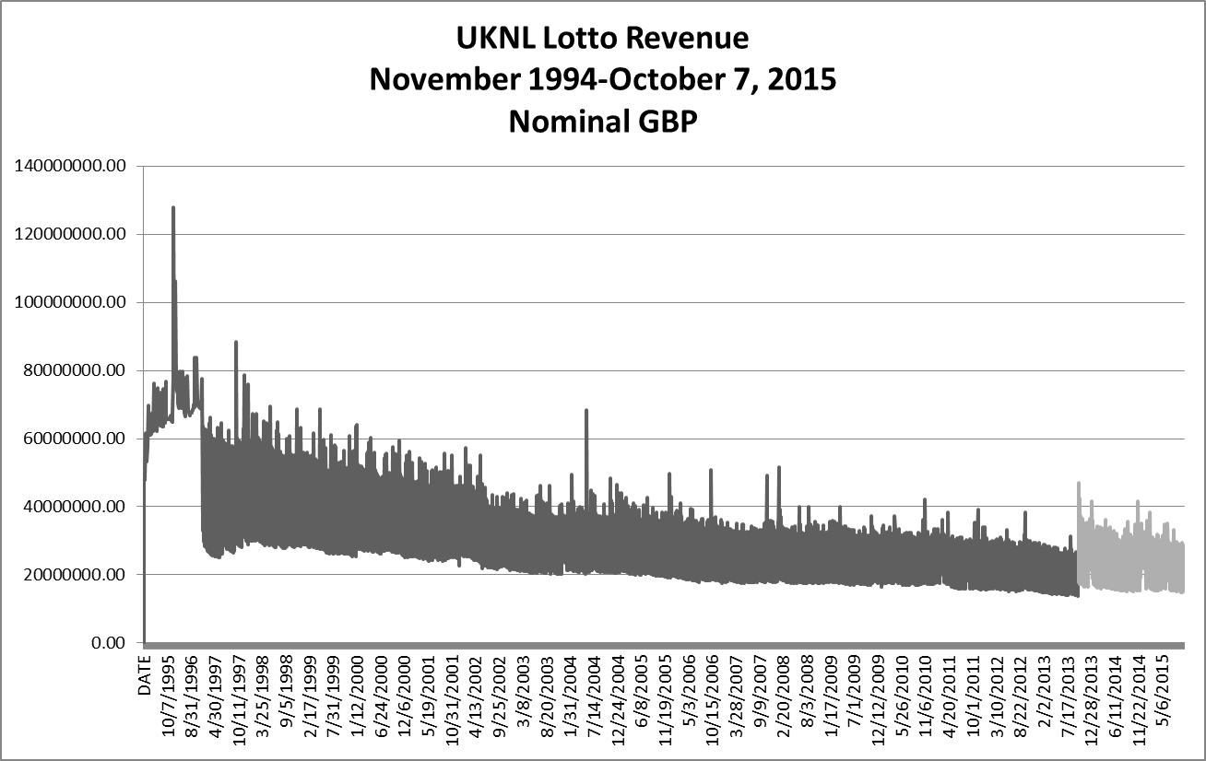
Source: merseyworld.com. The light-shaded line indicates the post October 5, 2013 period.

Figure 2: Number of tickets sold at each draw, October 2011-October 7, 2015

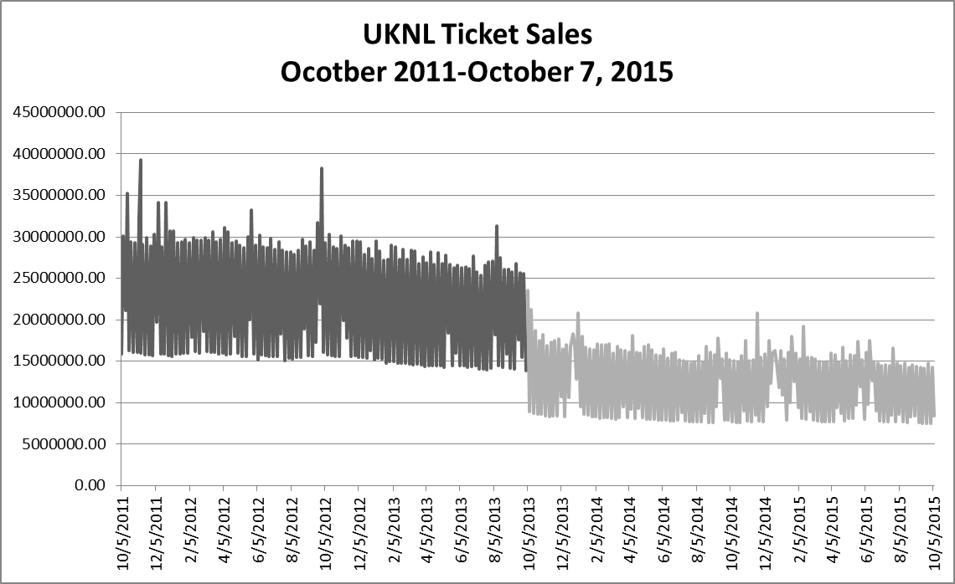

Source: merseyworld.com. The light-shaded line indicates the post October 5, 2013 period.

Figure 3: Sales revenue per draw (£), October 2011-October 7, 2015

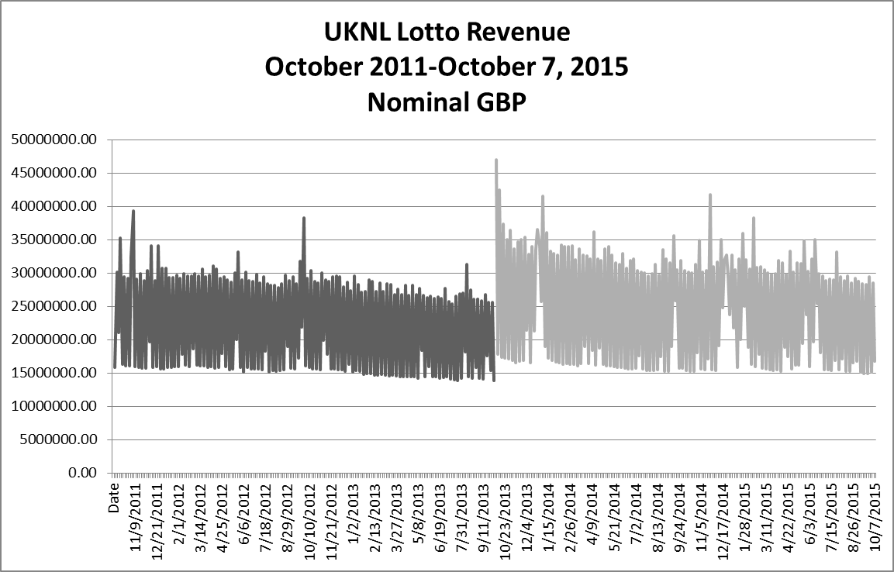

Source: merseyworld.com

Figure 4: Rollover frequency (number of rollovers) in each year

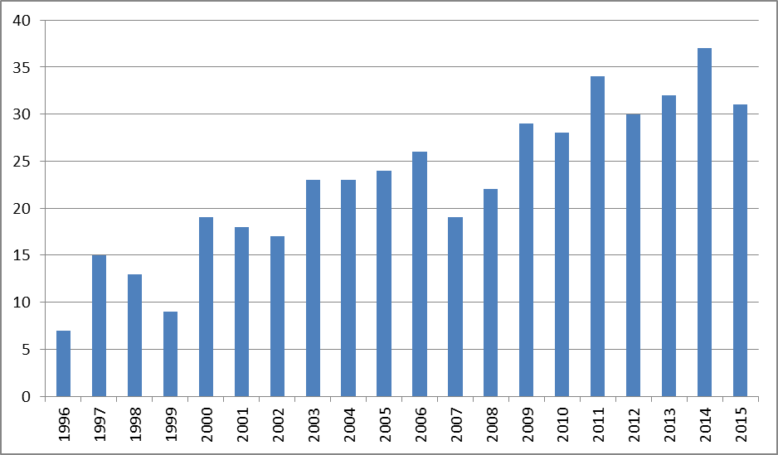

Note: year 2015 includes draws only up to October 7.
Source: merseyworld.com

Figure 5: Jackpot size (£), October 2011-October 7, 2015

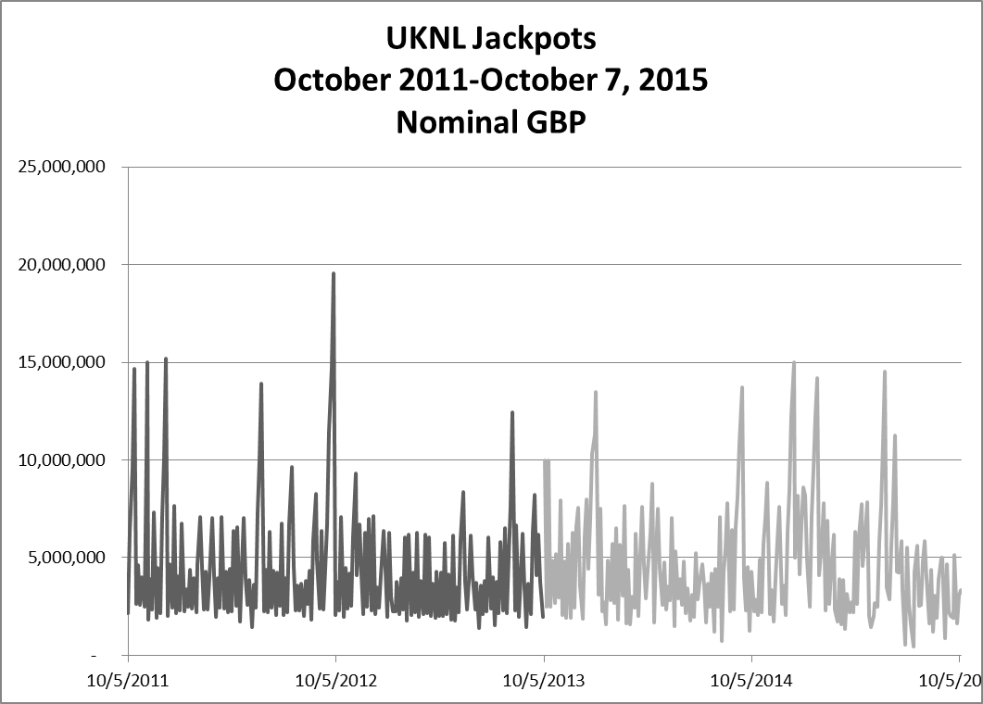

Source: merseyworld.com. The light-shaded line indicates the post October 5, 2013 period.

Figure 6: Jackpot vs Sales: October 2011-October 7, 2015

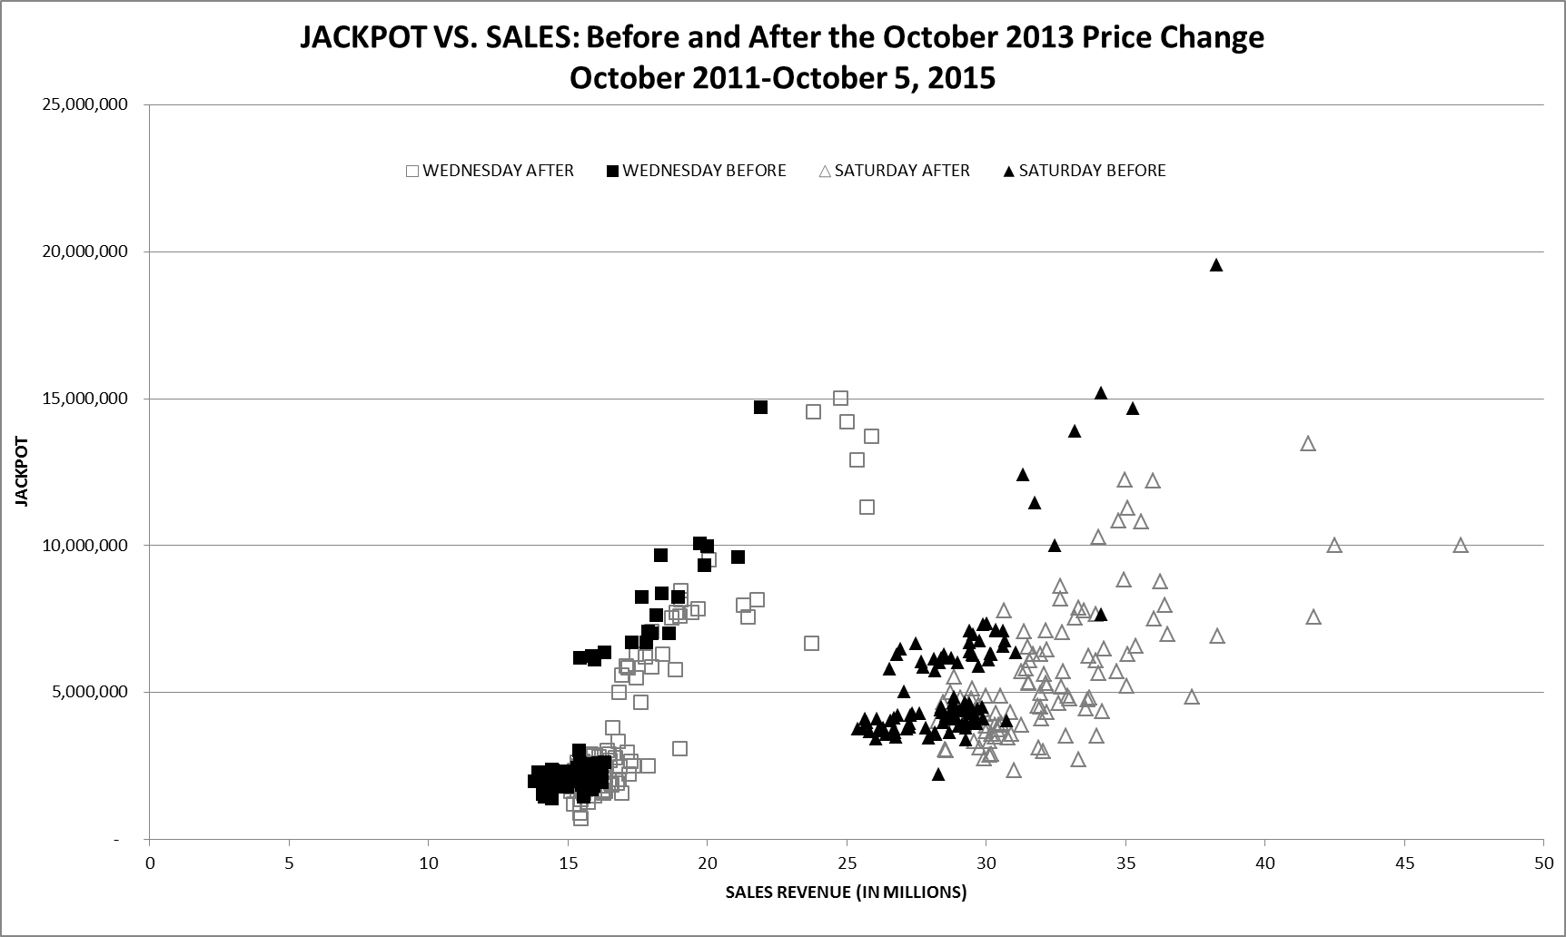
Source: merseyworld.com.

In the case of UK Lotto, there is also a bonus number drawn from a separate pool of numbers. Matching this number and five of the six regular numbers also wins a prize.
Proceeds from the each Lotto draw are now employed as follows: 45% paid out in prizes, 28% paid to the Good Causes, 12% to the Government, 5% in retailer commission, 5% for operating costs and profit to the operator; the remaining 5% is reserved for use to fund extra or enhanced prizes in future special promotional draws or scratchcards (http://lottery.merseyworld.com/Sales_index.html). The Good Causes: arts, charities, heritage, sports, health, education, and environment. Lottery revenues also partially funded the 2012 London Olympics. (http://www.lotterygoodcauses.org.uk/sites/default/files/Fact%20Sheet%20Oct%202014.pdf)
See http://www.marketingweek.co.uk/news/camelot-prepares-biggest-ever-marketing-campaign/4008018.article for a discussion of the marketing campaign associated with the lottery changes.
Camelot would presumably have felt safe in promising higher jackpots. So long as players still purchased more than half the number of tickets as before, revenue and therefore the amount allocated to the jackpot would increase. Further, the price increase would reduce the absolute number of entries to some extent and so players collectively would cover fewer number combinations in each draw. Consequently, with the jackpot won less often, there would be expected to be longer sequences of draws where the jackpot prize was successively carried over (‘rolled over’ in lottery parlance), allowing large prize pots to build up.
See for example https://uk.finance.yahoo.com/news/is-the-new-2-pound-national-lottery-ticket-a-worse-bet-171015787.html
Jackpots are often above £50m and occasionally above £100m. The odds are much longer than the UK game, though, at 1:116,531,800 for winning the main prize.
http://www.gamblingcommission.gov.uk/Gambling-data-analysis/Gambling-participation/Gambling-participation-data/Gambling-participation-survey-data.aspx
Subsequently we checked whether this made a material difference to our results. In fact, findings would have been broadly similar had we analysed data on all draws since 1997.
The specification of stage 1 is therefore: JACKPOT= f(TREND, OCT2013 VARIABLES, ROLLOVER, ROLLOVERSQ)
We also experimented with variables representing jackpot size in adjacent Euromillions draws but these were not significant and so are not included in our final specification. We also included a number of dummy variables to account for a number of one-off events that may impact lotto sales, including England’s participation in soccer World Cups, the 2012 Olympics, among others. Inclusion of these variables had no effect on our results.
And indeed gain from greater revenue at an initial non-rollover draw delivering a higher jackpot for the draw: the observed point on the new demand curve will lie upwards and to the right compared with that at the same jackpot size.
As reported in Table 2, we found evidence of higher-order serial correlation in the Saturday regression results. Reported t-statistics have been corrected using the Newey-West method.
It is possible only to speculate about the reason. Any effect of Wednesday sales on sales of the draw three days later may be a habit effect but it may also reflect reinvestment of bottom-tier prizes won on Wednesday. After the product changes, the bottom prize, for matching three numbers, was £25 instead of £10. Individuals may be inclined to treat £10 as ‘house money’ to be thrown back into the game but view £25 as substantial enough to be worth cashing in, i.e keeping for themselves.
This finding is reinforced by the significant negative sign on the interaction term with jackpot size in Saturday results. The corresponding Wednesday value is also negative, but not quite significant.
In addition to the attractiveness of larger jackpots, sales may also be boosted due to the fact that, post-price change, there are now fewer winners to share a jackpot. In the 210 drawing prior to the October 2013 price change, there were an average of 2.16 winners when the jackpot was won by at least one ticket. The figure for the 210 drawings after the price change is 1.78. This difference is significant at the 5% level.
Citing a lack of viewers, the BBC in January 2017 ended the live broadcast of the Saturday evening Lotto drawing. Instead, the drawing is now live-streamed on its website. Televised Wednesday drawings ended in 2012. At its peak in the mid-1990s, the televised drawings drew millions of viewers and often featured celebrities pushing the button to begin the number drawing process.

