**A** **multi-sensor fusion framework for detecting small amplitude hunting of high-speed trains**

Jing Ning*1, Qi Liu1, Huajiang Ouyang2, Chunjun Chen1, Bing Zhang3

*1 School of Mechanical Engineering, Southwest Jiaotong University, Chengdu 610031, Sichuan Province, China*

*2 Center for Engineering Dynamics, School of Engineering, University of Liverpool, Liverpool L69 3GH, UK*

*3 National Traction Power Laboratory, Southwest Jiaotong University, Chengdu 610031, Sichuan Province, China*

*\* E-mail: ningjing@swjtu.cn, Tel.: +86 28 87634693 and Fax: +86 28 87600690*

**Abstract:** Hunting monitoring is very important for high-speed trains to achieve safe operation. But all the monitoring systems are designed to detect hunting only after hunting has developed sufficiently. Under these circumstances, some damage may be caused to railway track and train wheels. The work reported in this paper aims to solve the detection problem of small amplitude hunting before the lateral instability of high-speed trains occurs. But the information from a single sensor can only reflect the local operation state of a train. So to improve the accuracy and robustness of the monitoring system, a multi-sensor fusion framework for detecting small amplitude hunting of high-speed trains based on an improved Dempster-Shafer (DS) theory is proposed. The framework consists of a series of steps below. Firstly, the method of combining Empirical Mode Decomposition (EMD) and Sample Entropy (SampEn) is used to extract features of each operation condition. Secondly, the Posteriori Probability Support Vector Machine (PPSVM) is used to get the Basic Probability Assignment (BPA). Finally, the DS theory improved by the authors is proposed to get a more accurate detection result. This framework developed by the authors is used on high-speed trains with success and experimental findings are provided. This multi-sensor fusion framework can also be used in other [condition](javascript:void(0);) [monitoring](javascript:void(0);) system on high-speed trains, such as the gearbox monitoring system, from which non-stationary signals are acquired too.

Keywords: high-speed train; small amplitude hunting; EMD; improved Dempster-Shafer theory; multi-sensor fusion

1. **Introduction**

Hunting stability is an important factor for high-speed train to achieve safe operation (Stephenson, 1821; De Pater, 1961). It is found that hunting is stable at low speed. But when the train is running above a high enough speed, which is called the critical speed, hunting may cause high-speed trains to derailment if the magnitude of the lateral vibration is large enough.

In the analysis of the measured lateral acceleration signals from the bogie of a certain type of high-speed trains, the authors find that before full development of hunting, there is small amplitude hunting at the pre-hunting state (shown in fig.1.). So the goal of this paper is to detect this pre-hunting state for the safety of high-speed trains, so that if these signals are detected beforehand, the train driver can take effective measures such as lowering the speed in good time to prevent the train from getting into hunting. The benefits include avoidance of derailment and maintenance of passenger comfort.

0

2

4

6

8

10

12

14

16

18

-1

-0.8

-0.6

-0.4

-0.2

0

0.2

0.4

0.6

0.8

1

X: 0

Y: 0.82

*t*/s

*a*/g

**small amplitude**

**hunting**

Fig.1.Three lateral acceleration signals in abnormal hunting state

(The bold blue line is the critical magnitude of the lateral acceleration for recognizing hunting in China (TB10761, 2013).Because a unit used to describe acceleration of gravity in engineering is g, so 8 m/s2 equals 0.82 g.)

There are different evaluation parameters for the lateral stability about railway passenger trains in different countries. Lateral force on the rail, lateral force on the wheel axis, lateral acceleration of the bogie frame and lateral acceleration of the vehicle body can all be the evaluation parameters respectively (UIC Code 518, 2003; BS EN 14363, 2005; 2008/232/EC, 2008; 75 FR 25927, 2013). In Chinese test standard, when the amplitude of lateral acceleration signals from the bogie frame reaches or exceeds 8~10 m/s2 for more than 6 times (including 6 times) [continuously](javascript:void(0);), the indicator will go from a normal state to an alarm state (TB/T3188, 2007; TB10761, 2013). Some past studies about small amplitude hunting are worth talking about. Polach indicated that the small limit cycle usually occurred in certain situation (Polach, 2010). In Dong's analysis, small amplitude hunting already existed before a train runs up to the critical speed, though it seemed that there was no limit cycle (TB10761, 2013). Cai defined a new test criterion of hunting (Cai, 2012). Yao proposed a method to monitor the small amplitude hunting signals of the root-mean-square (Yao et al., 2012). But in all the standard and investigations mentioned above, an alarm can be given only after the hunting state has reached, which means that some damage potential damage has been inflicted to some parts of high-speed train, for example, the anti-hunting damper.

Besides, in practice in China, two accelerometers are installed in the diagonal direction (positions 1 and 4 or positions 2 and 3) on the H-shaped bogie frame, as shown in fig. 2. And any one of the two accelerometers is selected to detect the hunting state of high-speed trains. This sensor setup is very simple and easy to implement. But signals from a single sensor have a limited amount of information and include the disturbances from random oscillation and the environment.



Fig.2. Installation locations of the accelerometers

Here is an example. Fig. 3 is shown to illustrate the conflict between the signals from the two accelerometers from a field test on a running train (8 coaches in all). In fig. 3, the red line and the blue line are about the data from the lateral accelerometer located at position 1 in coach 2 (sensor 1) and position 4 in coach 2 (sensor 2) respectively. Clearly, the measured acceleration magnitude from sensor 1 exceeds the limit of 8 m/s2 for more than 6 times [continuously](javascript:void(0);), which means the indicator will change from a normal state to an alarm state (TB10761, 2013) according to the China's Railway Passenger Traffic Safety Monitoring Standard. But based on signals from sensor 2, whose magnitude is very close to but never exceeds the limit of 8 m/s2, one would conclude that the train is running normally. Obviously, the conclusion is highly influenced by the installation location and some random environment factors.



1. Part of the lateral acceleration signals from sensor 1 () and sensor 2 ()



(b) Details of (a)

Fig. 3. The conflict between the two accelerometers from a field test on a running train

(The bold horizontal line is the critical magnitude of the lateral acceleration for recognizing hunting in China (TB10761, 2013). Because a unit used to describe acceleration of gravity in engineering is g, so 8 m/s2 equals 0.82 g.)

Now, with the development of high-speed trains, a safety monitoring system for key components of high speed trains is widely used in China. In this system, a network of multiple information sources formed by some accelerators is installed to monitor the vibration states of high-speed trains. So a monitoring system framework based on an improved multi-sensor fusion method (shown in Fig. 4) is developed in this paper based on the above-mentioned online monitoring system. The framework consists of a series of steps below. Firstly, the method of combining Empirical Mode Decomposition (EMD) and Sample Entropy (SampEn) is used to extract features of each operation condition. Secondly, the Posteriori Probability Support Vector Machine (PPSVM) is used to get the Basic Probability Assignment (BPA). Finally, the DS theory based on the BPA improved by the author is proposed to get a more accurate detection result. The framework developed by the authors is used on high-speed trains with success and the result obtained from the improved data fusion theory is much more accurate than that of the traditional DS theory or Murphy's theory. This multi-sensor fusion framework can also be used in other [condition](javascript:void(0);) [monitoring](javascript:void(0);) systems on high-speed trains, such as the gearbox monitoring system, from which non-stationary signals are acquired too.

1. **Background theory**

2.1 EMD

EMD is a method for analyzing non-linear and non-stationary data (Huang NE et al., 2003). Given a signal, the time domain signal is separated into multiple intrinsic mode functions (IMFs) using EMD:

 (1)

In formula (1), is the single signal component which satisfies the IMF condition, *n* is the number of the IMFs which is obtained finally, and  is the residue of the mean trend of the signal. An IMF is a function that satisfies two conditions: (1) In the whole data set, the number of the extreme points and the number of the zero points crossing the coordinate must either equal or differ at most by one; (2) At any point, the mean value of the envelope defined by the local maxima and minima is zero.

2.2 Sample Entropy

|  |  |  |  |
| --- | --- | --- | --- |
| Sample Entropy is used as a method of complexity measure for time series. Given a time series of length N as, the Sample Entropy can be calculated in the following steps:  (1) Firstly, the m-dimensions vector is defined, in which *m* is the embedding dimension $X(i)$ and.  (2) The distance between the vector and  is defined as $d[X_{m}(i),X_{m}(j)]$, in which and . The distance function can be any type of definition, from the Chebyshev distance to Euclidean distance.  (3) Given a threshold value ， the sample entropy ofcan be defined as   |  |  | | --- | --- | |  | (2) |   where *p*=the number of template vector pairs satisfying and *q*=number of template vector pairs satisfying.  2.3 Posteriori Probability Support Vector Machine (PPSVM)  Given training examples,, a decision function is computed by the binary Support Vector Machine (SVM), so that  can predict the label of training examples . is labeled by . The Probabilistic Outputs for Support Vector Machines was proposed by Platt J (1999) as  (3)  From the following formula, the best parameter setting can be obtained:  (4)  where  , and .  denotes the number of  which is positive, and  the number of  which is negative. |  |

1. **An improved DS theory**

3.1 The Dempster-Shafer theory

The Dempster-Shafer theory (DS theory) is an effective method to fuse the results of classifiers (Dempster, 1967).is denoted as the universe, which represents all possible states of a system under consideration. The power set is the set of all subsets of . is a subset of . Any element of in  is consisted a collectively exhaustive and mutually exclusive element. And in this data set, there must be one and only one element which is true.

**Definition 1:** → [0, 1] is defined as a Mass Function , if it satisfies the following two equations:

  (5)

 (6)

Mass function of, is the Basic Probability Assignment (BPA) of the subsetin and it stands for the degree of the belief thatis true.

In the DS theory, the support degree of evidential information is assigned base on the primitives, which are given by the form of the Mass Function. The Dempster's rule of combination is described as formula (7) and (8) if there are only two set of masses  and :

 (7)

 (8)

in which , and. is regarded as the amount of conflict between the subsets.

3.2 The proposed DS theory

Fault diagnosis based on multi-sensor information fusion technology is widely used in various machines (Hang et al., 2014; Banerjee et al.; 2012, Safizadeh et al., 2014). But in some real applications, the data from different sensors may include some conflicting information, which can lead to inconsistent fusion results (Zadeh, 1986). For example, when we select the data in the small amplitude hunting state, a few hunting or normal data might be included.

Considering a complicated non-linear relationship between the wheel and track, an optimize evidence theory based on the similarity function and the bias function is proposed. Firstly, the similarity degree of the individual partial classifier is calculated. Then the Support Degree Function is calculated as the first weight value to correct the BPA. Next the improved Bias Function is calculated as the second weight value to correct the BPA. At last, the two weight values are multiplied together with the BPA after normalization.

**Definition 2:** The Similarity Function between the two sensors (sensor *i* and sensor *j*) is defined as:

 (9)

where are the number of the sensors, and. And is the number of the subsets. From formula (9), we can conclude that the closer the value of the Similarity Function is to 1, the greater the similarity degree of the sensor *i* and sensor *j* will be. On the other hand, the closer the value of the degree of the Similarity Function is to 0, the smaller the similarity degree of the two evidences will be.

**Definition 3:** The Support Degree Function of  based on the sensor *i* is defined as

 (10)

**Definition 4:** The Bias Function ofbased on the sensor *i* is defined as:

|  |  |
| --- | --- |
|  | (11) |

in which,. From equation (11), we can deduce that the more  is far from the mean value, the smaller the Bias Function will be. On the other hand, the more  is close to the mean value, the greater the Bias Function will be. To better distinguish the evidences of high confidence and low confidence, is redefined as (lettingin the [denominator](javascript:void(0);) of equation (11)):

 (12)

which will make the weight value bigger (or equal) compared with that from equation (11).

**Definition 5:** The improved  is reckoned as the new confidence of evidence, which is defined as:

|  |  |
| --- | --- |
|  | (13) |

in which, the variables of and  are normalized by the transform of  and . In the proposed method, and are used as the weight values of the improved ， which can improve the problem of producing counter-intuitive results in case of low conflict.  is the weight value showing the degree of closeness of the belief that  is true between sensor *i* and the other sensors. And  is the weight value showing the closeness degree of the belief that  is true between sensor *i* and the mean value of the all sensors.

Then the improved  is normalizes as:

|  |  |
| --- | --- |
|  | (14) |

where  is regarded as the new improved Mass function of .

According to the process proposed above, its output is regarded as the weight value of optimization evidence.

* 1. Simulation

To verify the validity of this method, a simulation is studied below. First, there is a data set called, in which  are the subsets. Assume that the BPA can be calculated by the probabilistic output for SVM (2.3), in which the data are obtained from the sensors  (shown in Tab.1).

Tab.1 BPA from the different sensors

|  |  |  |  |  |
| --- | --- | --- | --- | --- |
| sensor |  |  |  |  |
|  | =0.3050 | =0.2560 | =0.3280 | =0.1110 |
|  | =0.3380 | =0.2160 | =0.1590 | =0.2870 |
|  | =0.3650 | =0.1920 | =0.2130 | =0.2300 |

From Tab.1, 0.3280 stands for the degree of the belief that  is true from sensor, which is the biggest possibility in the four subsets. But from sensors  and , 0.3380 and 0.3650 stand for the degree of the belief that  is true, which are the biggest possibility in the four subsetsrespectively. Obviously, there are conflicts from the three sensors. So the fusion method proposed above is used. And the results are compared with the results by the DS theory and the Murphy method (Murphy, 2000) (shown in Tab.2).

Tab.2 Results from the different theories

|  |  |  |  |  |
| --- | --- | --- | --- | --- |
| method |  |  |  |  |
| DS theory | =0.4837 | =0.2316 | =0.2606 | =0.0240 |
| Murphy's theory | =0.5405 | =0.2091 | =0.2405 | =0.0100 |
| Improved DS theory | =0.9251 | =0.0607 | =0.0140 | =0.0002 |

According to Tab.2, we can see that all the results give the biggest value of the BPA in subset  by three different methods. But by the improved DS theory, the probabilistic output is the biggest, 0.9251, which will be very helpful for improving the accuracy of the recognition at the next step.

1. **The monitoring framework**

The procedure of the proposed framework is shown in Fig.4 and the specific details are described as follows:



Fig.4.Diagram of the proposed multi-sensor fusion monitoring framework based on the improved Dempster-Shafer theory

**Step 1**The signals from more than two sensors are acquired and preprocessed.

**Step 2** The method of Empirical Mode Decomposition (EMD) and Sample Entropy are used to extract features from each sensor.

**Step 3**The Posteriori Probability Support Vector Machine (PPSVM) is used as the the Basic Probability Assignment after normalization.

**Step 4**According to the Basic Probability Assignment of evidence, the improved DS theory proposed above is used by weighted processing to obtain high confidence results.

**Step 5**The state of hunting is identified.

1. **Detection of the small amplitude hunting in high-speed trains** 
   1. Data acquisition and preprocessing

The acceleration signals from the bogie frame and the axle box were acquired in a field test on a train running between two big cities in China. The GPS module was fixed on the top of the train car-body in order to provide synchronization collection commands for all testing systems. The whole acquisition module included collecting, storing, transmitting, receiving and analysis modules. The power supply module was divided into two parts, one for acquisition and the other for the GPS module. All the data were transmitted to the monitoring system via a wireless LAN. The locations of sensors fixed on the bogie frame and the axle box are shown in Fig.5. The tri-axial accelerations LC0709A-18 and LC0706A-100 were fixed on the bogie frames and the axle boxes respectively. The speed of the high-speed trains under study is 320-350 km/h. Because of the high cost of the test, the sampling frequency is set as 2500 Hz. So the data can be used in other research about high-speed trains. The sampling time is 1228 s. All the data is acquired [in](javascript:void(0);) [strict](javascript:void(0);) [accordance](javascript:void(0);) [with](javascript:void(0);) the China's Railway Passenger Traffic Safety Monitoring Standard (TB10761, 2013).A low-pass filter of 250 Hz is used at first. Then a band-pass filter of 2-12.07 Hz is applied to resample the signals.

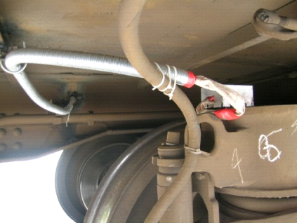

**Accelerometer**

**(lateral)**

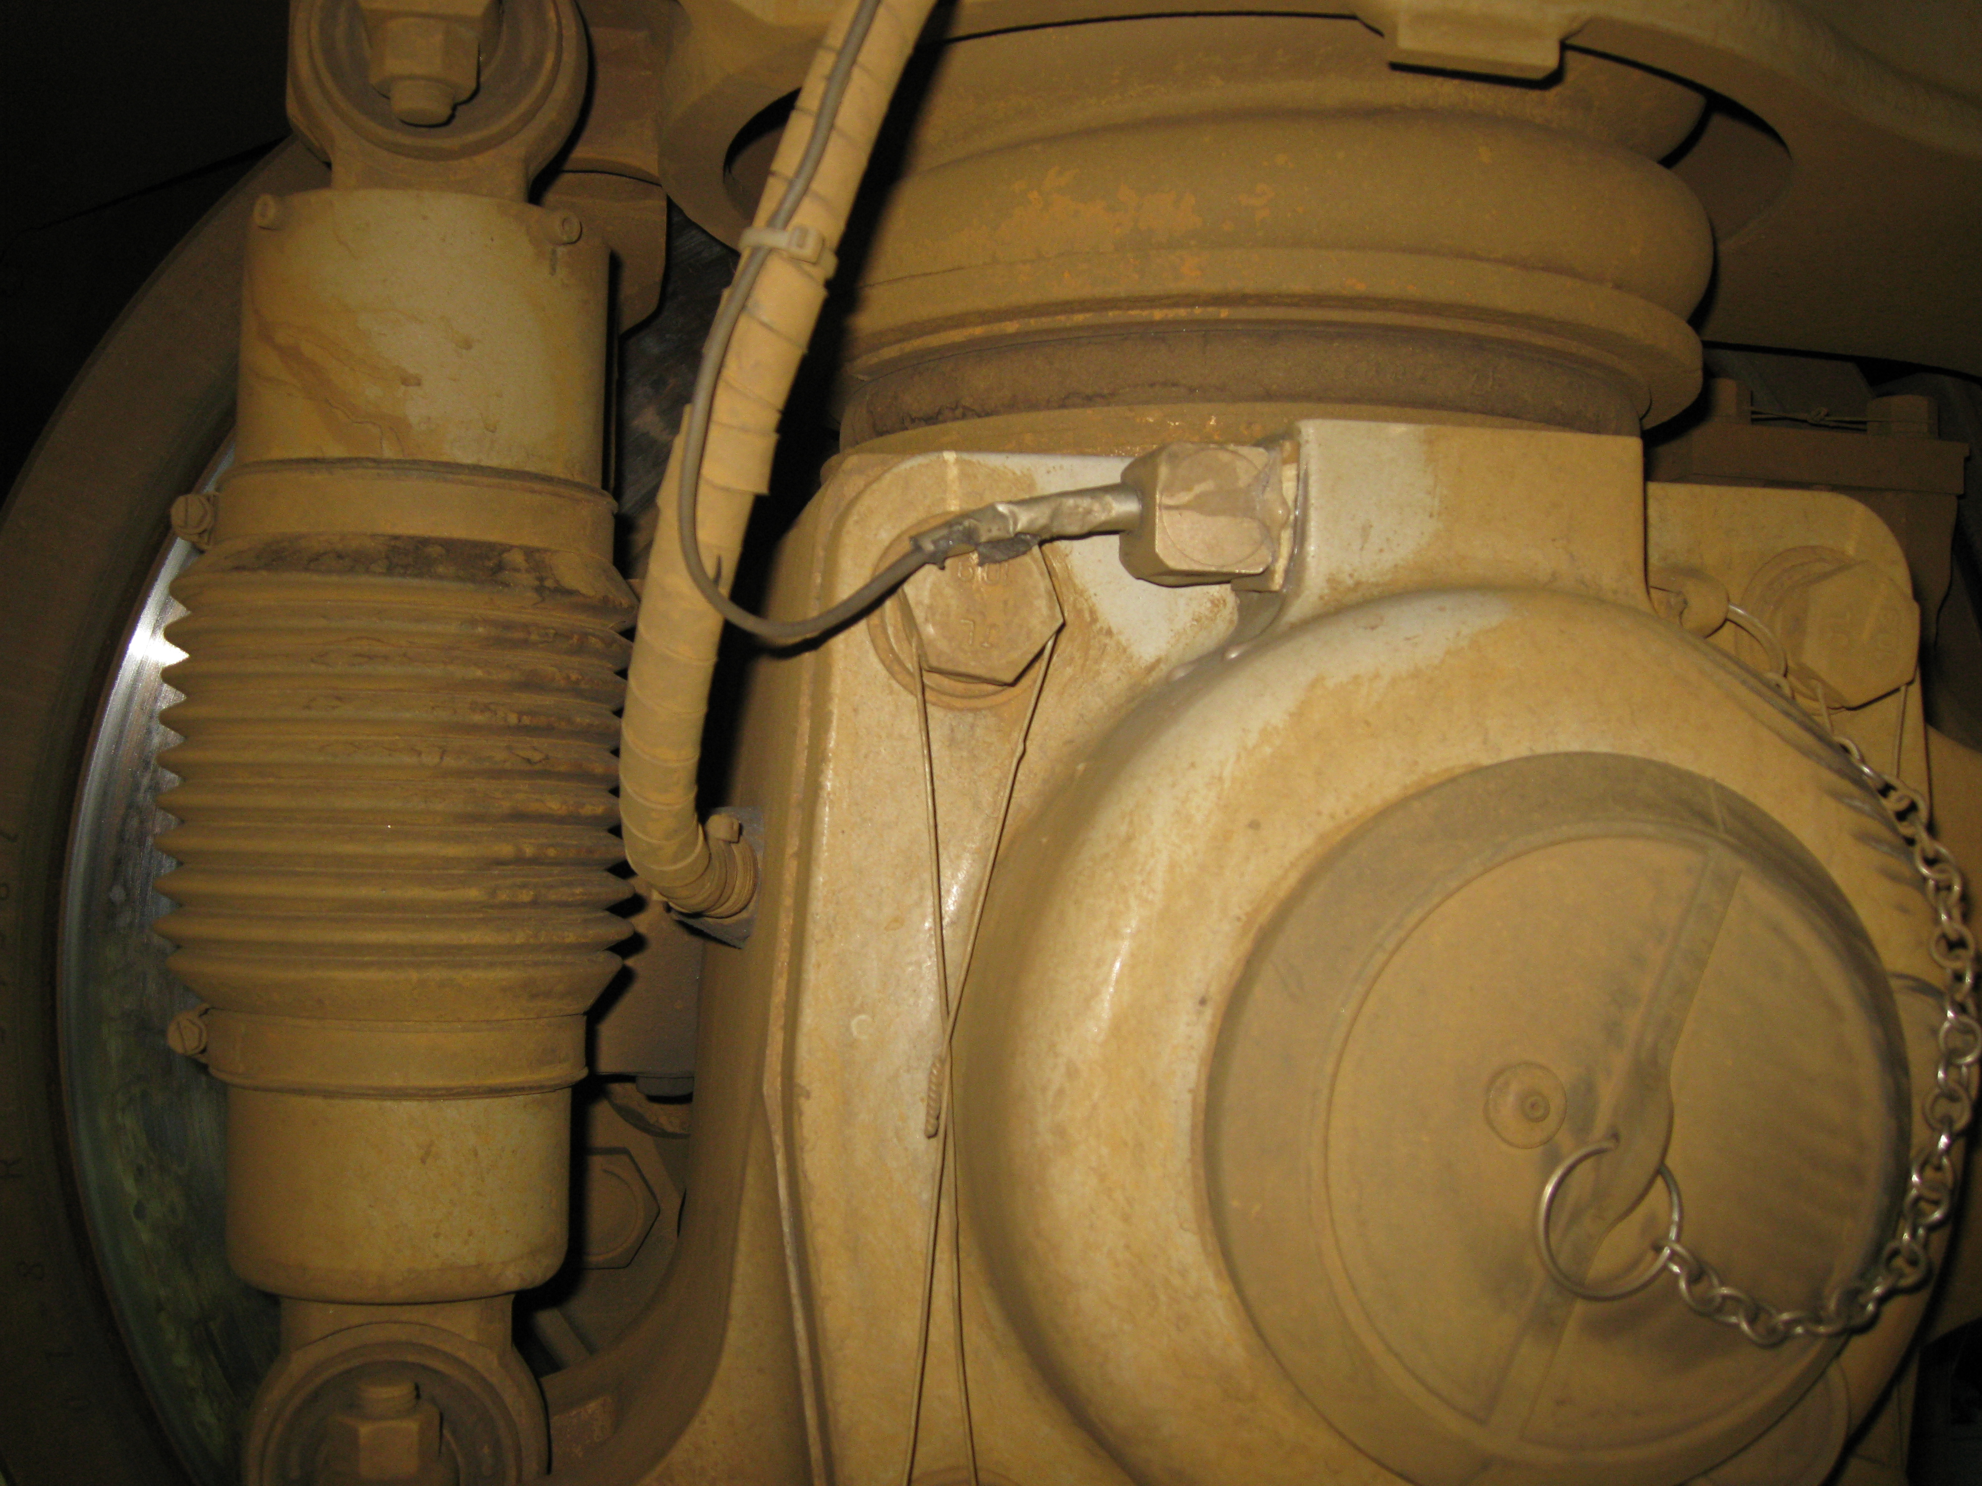

**Accelerometer**

**(vertical)**

(a) Bogie frame (b) Axle box

Fig.5. Locations of sensors.

The lateral accelerometers from bogie frame located at positions 1 and 4 (Fig. 2) in coach 2 are selected to test the hunting instability of high-speed trains, which is respectively represented as S1 and S2. Considering that track irregularities are important factors of hunting (Ning et al., 2016), a vertical accelerometer located on an axle box which is sensitive to track irregularity is also used. So the third sensor is located in the axle box of coach 1, which is represented as S3.

The filtered lateral acceleration signals are classified into 3 motion states by the authors based on the following criteria. The normal state is classified as when the lateral acceleration is not more than 2 m/s2; the small amplitude hunting is classified as when this acceleration does not exceed 8 m/s2 6 times continuously according to the small amplitude hunting theory proposed by Polach; and the hunting is classified as when this acceleration reaches or exceeds 8~10 m/s2 for more than 6 times (including 6 times) [continuously](javascript:void(0);) according to the China's Railway Passenger Traffic Safety Monitoring Standard. One typical set of time-domain signals corresponding to these three states are shown in Fig.1.

In this paper, there are 60 groups of sample signals in the 3 states totally for each sensor to study. 20 groups of data samples are respectively in three states: normal, the small amplitude hunting, and hunting. And each 20 groups of data samples are divided into two sets randomly: training set (12 samples for determining the parameters of the classifier: and in PPSVM method) and testing set (8 samples), which means that there are 108 training sets and 72 testing sets in all. Through examination of a large amount of test data, it is found that 4 s seem a suitable length. With this length of 4 s, the main information of the transient behaviour would be included, and the data is very easy to process.

5.2 Feature extraction

Considering the nonlinear factors like wheel/rail geometric contact, wheel/rail contact creep, and son on, the non-stationary signals processing method like EMD is used to extract the nonlinear features of the signals. So the signal of three states from each sensor is decomposed into many Intrinsic Mode Functions (IMFs) by the EMD method. Then the first 8 IMFs are passed to the next processing stage, in which the key information about the hunting is involved. At last, the corresponding Sample Entropy is calculated, in which the complexity of the [time-series](https://en.wikipedia.org/wiki/Time-series) signals can be assessed. The decomposed results and the Sample entropy of a sample of small amplitude hunting are shown in Fig.6 and Fig.7 respectively.

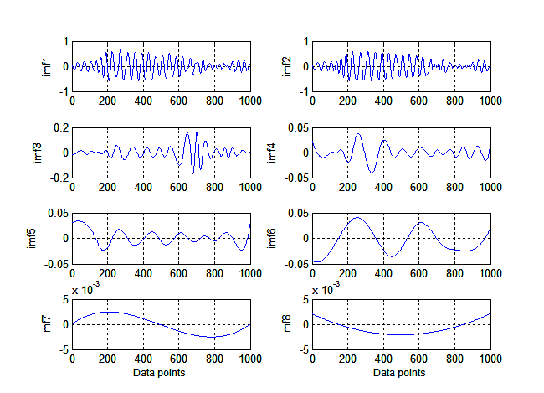

Fig.6. EMD for a sample of small amplitude hunting.

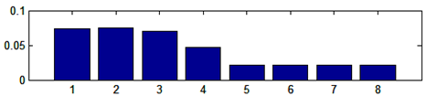

Sample Entropy

Numbers of IMFs

(a) Normal

Sample Entropy

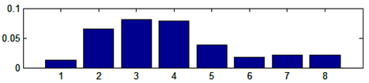

Numbers of IMFs

(b)The small amplitude hunting

Sample Entropy

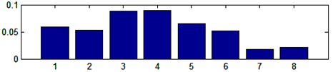

Numbers of IMFs

(c) Hunting

Fig.7. Sample Entropy of three states

5.3 Classifiers

The feature vectors calculated in section 5.2 will be used as inputs to the classifiers to get the Basic Probability Assignments (BPA) of each state. Firstly, PPSVM is used to get the parametersandby the Maximum Likelihood (ML) estimation algorithm with the training sets for each state. In this case, after training =-12.96 and =-2.68 are the optimized results for SVM1 (Fig.4.), which is used to identify the normal state.=-9.79 and=-1.26 are the optimized results for SVM2, which is used to identify the pre-hunting (the small amplitude hunting) state.=-3.41 and =-0.56 are optimized results for the SVM3, which is used to identify the hunting state. Then the Basic Probability Assignment is obtained by normalizing the probability assignments from the PPSVM.

5.4 Discussion

To compare the results of the different theories, the Mass functions by traditional DS theory and Murphy's theory are also calculated.

The new Mass functions for the normal, small amplitude hunting and hunting states by different fusion theories are shown in Tab.3, Tab.4 and Tab.5 respectively, in which,

.

Tab.3. The new Mass functionfor the normal state by different fusion theory

|  |  |  |  |  |
| --- | --- | --- | --- | --- |
| **Sensor** | **Basic Probability Assignment** | **Traditional DS theory** | **Murphy's theory** | **DS theory improved by the author** |
|  | m(*A1*)=0.6019 m(*A2*)=0.1786  m(*A3*)=0.2195  m(*A1*)=0.7064 m(*A2*)=0.0825  m(*A3*)=0.2111  m(*A1*)=0.6979 m(*A2*)=0.1129  m(*A3*)=0.1892 | m(*A1*)=0.9492  m(*A2*)=0.0382  m(*A3*)=0.0126 | m(*A1*)=0.9803  m(*A2*)=0.0166  m(*A3*)=0.0030 | m(*A1*)= 0.9803  m(*A2*)=0.0152  m(*A3*)=0.0030 |

In Tab. 3, the maximum output value of Basic Probability Assignment is 0.6019, 0.7064 and 0.6979 from,and respectively. From all the highlighted numbers in green, it is obvious that if only one sensor is used, subset  play a dominant role in the three states. But after the fusion theories are used, the Probability Assignments of  highlighted in yellow (0.9492 by traditional DS theory, 0.9803 by Murphy's theory, 0.9803 improved DS theory) become much bigger than that of the highlighted in green. It means that the bigger confidence will be assigned by the multi-sensor fusion theory. Besides, in the case of normal state, the degree of the belief that  (0.9818) is true by the improved DS theory is higher than those given by traditional DS theory (0.9492) and Murphy's theory (0.9803) respectively.

Tab.4. The new Mass function for the small amplitude hunting state by different fusion theory

|  |  |  |  |  |
| --- | --- | --- | --- | --- |
| **Sensor** | **Basic Probability Assignment** | **Traditional DS theory** | **Murphy's theory** | **DS theory improved by the author** |
|  | m(*A1*)=0.2395 m(*A2*)=0.6119  m(*A3*)=0.1486  m(*A1*)=0.0411 m(*A2*)=0.7264  m(*A3*)=0.2325  m(*A1*)=0.1092 m(*A2*)=0.6979  m(*A3*)=0.1929 | m(*A1*)=0.0376  m(*A2*)=0.9525  m(*A3*)=0.0099 | m(*A1*)=0.157  m(*A2*)=0.9821  m(*A3*)=0.0022 | m(*A1*)=0.0072  m(*A2*)=0.9927  m(*A3*)=0.0001 |

In Tab. 4, the maximum output value of Basic Probability Assignment is =0.6119, =0.7264 and =0.6979 from,and respectively. From all the highlighted numbers in green, it is obvious that if only one sensor is used, subset  play a dominate role in the three states. But after the fusion theories are used, the Probability Assignments of  highlighted in yellow (0.9525 by traditional DS theory, 0.9821 by Murphy's theory, 0.9927 improved DS theory) become much bigger than those highlighted in green. It means that a bigger confidence will be assigned by the multi-sensor fusion theory. Besides, in the case of the small amplitude hunting state, the degree of the belief that  (0.9927) is true by the improved DS theory is higher than those given by traditional DS theory (0.9525) and Murphy's theory (0.9821) respectively.

Tab.5. The new Mass function for hunting state by different fusion theory

|  |  |  |  |  |
| --- | --- | --- | --- | --- |
| **Sensor** | **Basic Probability Assignment** | **Traditional DS theory** | **Murphy's theory** | **DS theory improved by the author** |
|  | m(*A1*)=0.0825 m(*A2*)=0.2288  m(*A3*)=0.6887  m(*A1*)=0.1248 m(*A2*)=0.1323  m(*A3*)=0.7429  m(*A1*)=0.1161 m(*A2*)=0.1479  m(*A3*)=0.7360 | m(*A1*)=0.0031  m(*A2*)=0.0117  m(*A3*)=0.9852 | m(*A1*)=0.0005  m(*A2*)=0.0128  m(*A3*)=0.9867 | m(*A1*)=0.0073  m(*A2*)=0.0116  m(*A3*)=0.9911 |

In Tab. 5, the maximum output value of Basic Probability Assignment is =0.6887, =0.7429 and =0.7360 from,andrespectively. From all the highlighted numbers in green, it is obvious that if only one sensor is used, subset  play a dominate role in the three states. But after the fusion theory is used, the Probability Assignments of  highlighted in yellow (0.9852 by traditional DS theory, 0.9867 by Murphy's theory and 0.9911 by the improved DS theory) become much bigger than those highlighted in green. It means that a bigger confidence will be assigned by the multi-sensor fusion theory. Besides, in the case of hunting state, the degree of the belief that  (0.9911) is true by the improved DS theory is higher than those given by traditional DS theory (0.9852) and Murphy's theory (0.9867) respectively.

From the framework proposed above, the accuracy of detecting the three different motion states for hunting in high-speed trains is demonstrated by the remaining group of testing sets (shown in Tab.6). From Tab.6, a higher accuracy can be seen by any method of the multi-sensor fusion than from a single sensor, which means that multi-sensor fusion is an efficient method to detect the three different states of hunting in high-speed trains. Besides, the accuracy（97.7%，91.5%，94.6%）of the proposed improved DS theory is higher than those the by traditional DS theory (90.5%，78.7%，82.8%) and Murphy's theory respectively (93.5%，86.3%，89.3%). It shows that the state of small amplitude hunting in high-speed train can be identified effectively by this proposed method. In fact, if the onset of small-amplitude hunting can be detected rapidly, the train driver can lower the speed immediately to prevent the train from getting into hunting, and the information collected at this moment can be used to identify the cause of the fault. By comparing the diagnostic results between the improved DS theory and traditional DS theory, it can be found that the existing evidences are weighted and optimized by the improved DS theory proposed in this paper, which achieves better detection results from signals whether they contain conflicting or non-conflicting information.

Tab.6. The accuracy of recognizing the three different states of hunting instability in high-speed trains（%）.

|  |  |  |  |
| --- | --- | --- | --- |
| **Method** | **Normal** | **Small amplitude hunting** | **Hunting** |
| Only Sensor S1 | 82.7 | 67.7 | 76.3 |
| Only Sensor S2 | 85.6 | 70.8 | 82.7 |
| Only Sensor S3 | 83.7 | 67.5 | 80.2 |
| DS theory(Sensor fusion) | 90.5 | 78.7 | 82.8 |
| Murphy's theory(Sensor fusion) | 93.5 | 86.3 | 89.3 |
| DS theory improved by the author (Sensor fusion) | 97.7 | 91.5 | 94.6 |

6. Conclusions

The work reported in this paper aims to solve the detection problem of the small amplitude hunting before lateral instability of high-speed trains occurs. A multi-sensor fusion framework and an improved DS theory have been proposed in this paper. The following conclusions can be made.

(1) To the authors' best knowledge, multi-sensor fusion has not been studied in high-speed trains. In this paper, a multi-sensor fusion framework for detecting small amplitude hunting in high-speed trains based on an improved DS theory has been proposed.

(2) Vibration instrument technology has been widely used in China to monitor the working states of high-speed trains of the key components such as a train running gear system, a basic braking system and a vehicle electric application system. The idea of this multi-sensor fusion framework can also been used in the different system above.

(3) Multi-sensor fusion is applied in high-speed trains for the first time in this paper. For simplification, three sensors are used. How many sensors should be used in this fusion method for optimal detection remains a big question which should be investigated in near future.

(4) Because lacking of abnormal (hunting and small amplitude hunting) data, there are only 20 groups of data samples for each state, which might influence the results of the probability assignment. It is a problem of imbalanced fault classification of high-speed train. So what we should do in the future is to deal with the imbalanced fault classification questions to improve the accuracy of the probability assignment.

ACKNOWLEDGMENTS

The authors are grateful for the financial support from the National Natural Science Foundation of China (Grant no. 51475387) and the National Key Technology R&D Program of China (2009BAG12A01- E03). The first author gratefully acknowledges the financial support for the visit to the University of Liverpool from China Scholarship Council.

REFERENCES

2008/232/EC (2008) Concerning a technical specification for interoperability relating to 'rolling stock' sub-system of the trans- European high-speed rail system

75 FR 25927 (2013) Vehicle/track interaction safety standards; high-speed and high cant deficiency operations.

Banerjee TP, and Das S (2012) Multi-sensor data fusion using support vector machine for motor fault detection. *Information Sciences*, *217*, 96-107.

BS EN 14363 (2005) Railway applications-testing for the acceptance of running characteristics of railway vehicles-Testing of running behavior and stationary tests.

Cai LJ (2012) A real-time monitoring system of high speed train bogie hunting instability base on FPGA. Master Thesis, Southwest Jiaotong University, China.

De Pater AD (1961) The approximate determination of the hunting movement of a railway vehicle by aid of the method of Krylov and Bogoljubov. *Applied Scientific Research*, *10*(1), 205.

Dempster AP (1967) Upper and lower probabilities induced by a multivalued mapping. *The annals of mathematical statistics*, 325-339.

Dong H and Zeng J(2014) Normal form method for large/small amplitude instability criterion with application to wheelset lateral stability. *Int. J. Str. Stab. Dyn* ,1350073-1350088.

Hang J, Zhang J, and Cheng M (2014) Fault diagnosis of wind turbine based on multi-sensors information fusion technology. *IET renewable power generation*, *8*(3), 289-298.

Huang NE, Wu ML, Qu W, Long SR, and Shen SS (2003) Applications of Hilbert–Huang transform to non‐stationary financial time series analysis. *Applied stochastic models in business and industry*, *19*(3), 245-268.

Murphy CK (2000) Combining belief functions when evidence conflicts. *Decision support systems*, *29*(1), 1-9.

Ning J, Lin J, and Zhang B (2016) Time–frequency processing of track irregularities in high-speed train. *Mechanical Systems and Signal Processing*, *66*, 339-348.

Platt J (1999) Probabilistic outputs for support vector machines and comparisons to regularized likelihood methods. *Advances in large margin classifiers*, *10*(3), 61-74.

Polach, O (2010) Characteristic parameters of nonlinear wheel/rail contact geometry. *Vehicle System Dynamics*, *48*(S1), 19-36.

Safizadeh MS, and Latifi SK (2014) Using multi-sensor data fusion for vibration fault diagnosis of rolling element bearings by accelerometer and load cell. *Information Fusion*, *18*, 1-8.

Shafer G (1976) *A mathematical theory of evidence* (Vol. 1, pp. xiii+-297) Princeton: Princeton university press.

Stephenson G (1821) Observation on edge and tram railways. London Press.

TB/T3188(2007) Technical specification for rail- way car safety monitor and diagnosis system.

TB10761(2013). High-speed railway engineering dynamic acceptance technical criterion.

UIC Code 518 (2003) Testing and approval of railway vehicles from the point of view of their dynamic behaviour-safety-track fatigue-ride quality.

Yao JW, Sun LX and Hou FG (2012) Study on evaluation methods for lateral stability of high-speed trains. *China Railw Sci*. 33: 132-139.

Zadeh LA (1986) A simple view of the Dempster-Shafer theory of evidence and its implication for the rule of combination. *AI magazine*, *7*(2), 85.