DOI: 10.1002/adhm.201600258
Article type: Communication

A Novel Peptide Hydrogel for an Antimicrobial Bandage Contact Lens

By A.G. Gallagher, J.A. Alorabi, D.A. Wellings, R. Lace, M.J. Horsburgh and R.L.Williams*

[*] Prof. R. L. Williams, A.G. Gallagher, Dr. R. Lace
Institute of Ageing and Chronic Diseases
Department of Eye and Vision Science
University of Liverpool
Apex Building, West Derby Street L7 8TX (England)
E-mail: rlw@liverpool.ac.uk

Dr. M.J Horsburgh, J.A. Alorabi
Institute of Integrative Biology
University of Liverpool
Biosciences Building, Crown Street L69 7ZB (England)

D.A. Wellings, A.G. Gallagher
SpheriTech Ltd.
The Heath Business and Technical Park
Runcorn, Cheshire WA7 4QX (England)

Keywords: Hydrogel, Drug Delivery, Antimicrobial, Bandage Lens, Cornea.

Corneal ulcers are one of the most common conditions to affect the cornea, accounting for approximately 5% of total cases of blindness worldwide.^{[1-4]} The causes of corneal ulcers range from non-infectious autoimmune disorders and chemical burns to infectious causes such as the herpes simplex virus and fungal or bacterial keratitis.^{[5,6]} Of the infectious cases there is a global divide with fungal keratitis most prevalent in the developing world due to manual laborers working in optimal environments for fungal pathogens. In the developed world bacterial keratitis is the most common cause of corneal ulcers and is most often contracted by improper use of contact lenses.^{[7]} Current treatment focuses on the administration of broad spectrum antibiotic drops sometimes followed by the application of a bandage lens to protect the wound.^{[8]} However, less than 7% of the drug actually reaches the point of injury due to the method of administration. This results in a requirement for multiple administrations sometimes at 3-4 intervals per hour over a 24 h period often with an initial dose every 5 min for the first 30-60 min.^{[9,10]} There could be major advantages in the design and use of slow release antimicrobials from a bandage contact lens material as a more efficient delivery method.^{[11,12]} Corneal bandage materials include collagen, amniotic membrane derived materials and advanced hydrogel polymers. A synthetic corneal bandage has many advantages over biologically derived products in terms of reproducibility of its properties and overcoming the need to use animal derived materials or an allogenic graft.^{[13-15]} An ideal bandage contact lens should be transparent, have a high water content, have sufficient mechanical properties for handling and be antimicrobial. This study developed poly-ε-lysine (pεK) based hydrogels as bandage contact lenses with optimized mechanical and antimicrobial properties.
The peptide based polymer in this study has previously been developed in macroporous form as a wound dressing and as 3-D scaffolds for tissue engineering applications. The polymer is based on pεK cross-linked with bis-carboxy fatty acids. A feature which makes this hydrogel unique is the incorporation of two naturally occurring components; pεK is an edible, non-toxic material currently used as an emulsifier and preservative in foodstuffs and classified as “generally regarded as safe” (GRAS) by the U.S. food and drug administration since 2004.^{[16-18]} Short chain bis-carboxy fatty acids are found in both plants and animals. In the latter they are products of the oxidative degradation of longer chain fatty acids.^{[19,20]} The hydrogels produced have a high water content, excellent transparency and their mechanical properties can be tailored by altering the density of the polymer, the molecular length of the cross-linker and the cross-linking density. Further advantages of these hydrogels are that pεK is naturally antimicrobial and the surface chemistry may be used to attach a variety of biomolecules.
PεK (Zhengzhou Bainafo Bioengineering Ltd, China) was cross-linked with bis-carboxy fatty acids ranging from C6 to C10 (Sigma-Aldrich, St. Louis, MO, USA) (Figure 1a) using an N-hydroxysuccinimide (NHS)/1-ethyl-3-(3-dimethylaminopropyl) carbodiimide (EDCI) mediated cross-linking technique.^{[21]} This cross-linking reaction occurs randomly and it is noted that it may also include amide bonds between the bis-carboxy acid and a single pεK molecule. The density of the polymer ranged from 0.066 - 0.1 g cm⁻³ and the cross-linking density was varied between 60 mol% and 80 mol%. (Table S1, Supporting information). The optimum gelation time was shown to be 5 h (Figure S2, Supporting Information). Appropriate lens shaped structures can be cast from these materials (Figure 1b). Post polymerization penicillin G was attached via ionic interactions and free pεK was covalently attached to remaining free surface amine functional groups (Figure S1 and Table S2, Supporting information). Details of the hydrogels synthesis and surface molecule attachment are available in Supporting Information S1. The ultimate tensile strength (Linkam TST350 tensile tester, Linkam, Surrey, UK; 20 N load cell, strain rate of 100 μm s⁻¹) increased as the molecular length of the bis-carboxy fatty acid increased from C6 to C9 before a statistically significant decrease for C10 (Figure 1c). The cross-link density increase from 60 mol% to 80 mol% generally caused an increase in strength again except for C10 where a significant decrease was observed. The factor that had the greatest effect on the ultimate tensile strength was the density of the polymer. In each case the increase in density from 0.066 - 0.1 g cm⁻³ more than doubled the ultimate tensile strength. The transparency of these gels assessed qualitatively (Figure S3, Supporting Information) demonstrated a reduction as the chain length of the fatty acid increased. The reduction in transparency and tensile strength for C10 bis-carboxy fatty acid could be due to the hydrophobicity of the longer alkyl chain disrupting the structure of the hydrogel or the influence of intramolecular bonding or a combination of both.
Following these initial results, further tailoring of the hydrogel properties was investigated using octanedioic acid as the cross-linker. As expected the ultimate tensile strength increased with an increase in polymer density from 0.067 - 0.077 g cm⁻³ (Figure 1d). The elastic modulus (Figure 1e) for hydrogel Su 60 13 (octanedioic acid cross-linker with a density of 0.077 g cm⁻³ and 60 mol% cross-linked) was significantly greater than the other hydrogels tested. However, optical clarity of this hydrogel was compromised significantly due to the increased polymer density, resulting in a refractive index (Figure 1f) of 1.395 (AR200 digital refractometer (Reichert, New York, USA)). The hydrogel with the next greatest elastic modulus was hydrogel Su 60 14 (octanedioic acid cross-linker with a density of 0.071 g cm⁻³ and 60 mol% cross-linked) which, despite no significant difference in ultimate tensile strength compared to Su 60 13, was superior to both Su 60 15 (octanedioic acid cross-linker with a density of 0.066 g cm⁻³ and 60 mol% cross-linked) and Su 65 15 (octanedioic acid cross-linker with a density of 0.066 g cm⁻³ and 65 mol% cross-linked). Hydrogel Su 60 14 possessed a refractive index of 1.390 making it closely associated with the 1.380 of the human cornea.^{[22]} All of the hydrogels tested had a significantly lower refractive index than the commercial contact lens Etafilcon A at 1.412. Consequently, Su 60 14 was chosen as the hydrogel with superior mechanical properties whilst maintaining an acceptable optical clarity. The elastic moduli for all the hydrogels were in the range of 0.31 - 0.73 MPa, similar to commercial lens materials whilst maintaining a relatively high water content, measured gravimetrically, of between 67-73 w/w% regardless of the polymer composition (Table S3, Supporting Information). This may be extremely beneficial in that the mechanical properties may be optimized without significantly reducing the water content of the lens. This characteristic is important for both oxygen permeability and comfort of the lens to the wearer.^{[23]} The addition of penicillin G and free pεK to Su 60 14 did not influence the ultimate tensile strength (Figure 1d) of the gels, but the addition of free pεK did significantly increase the elastic modulus (Figure 1e) and resulted in a greater water content and lower refractive index than the penicillin G modified hydrogel (Figure 1f). The added pεK to hydrogel Su PεK results in an increase of hydrophilic amino groups and is directly associated with the increased water absorption capacity of the hydrogel.^{[24]}
An indirect cytotoxicity assay (CCK-8 assay kit (Dojindo Laboratories, Kumamoto, Japan)) was carried out to determine if any leachables from the hydrogel material had an effect on a human corneal epithelial cell line (HCE-T cells donated by Kaoru Araki-Sasaki, Japan.^{[25]}) in vitro. Over the period of an 8-day culture (Supporting Information) no significant effects upon cell viability were observed when compared with the control (Figure 2a). This suggests that leachables from the hydrogel were non-cytotoxic to the HCE-T cell line and provided the initiative to investigate how direct contact of the gel influenced the HCE-T cell behavior. A scratch assay was used to determine the rate of re-epithelialization of a HCE-T cell monolayer when in direct contact with the hydrogel material. The majority of scratch wounds with the hydrogel present closed by 23 h. This was also true of the control and no significant difference was observed in scratch wound closure rates when quantified with TScratch software.^{[26]} This suggests the Su 60 14 hydrogel does not inhibit HCE-T cell re-epithelialization when in direct contact (Figure 2b). The rate of wound healing is of great importance when considering a bandage contact lens material ensuring a faster healing process and less discomfort for the patient.^{[27]} Specific investigation of the closed cell monolayers was undertaken by staining for zonal occludens-1 (ZO-1). The ZO-1 protein functions in the formation of tight junctions which are expressed around the cell membrane when a cell monolayer is intact and the epithelial barrier functioning. Microbial infection may result in a compromised corneal epithelial barrier and repair of this is essential. Specifically, staining for ZO-1 (Primary antibody ZO-1 (Invitrogen 402200, California, USA) 1:100; Secondary antibody Alexa Fluor 594 Goat anti-Rabbit (Invitrogen A11008, California, USA) in 1% BSA 1:500) identifies whether the epithelial barrier function of the reformed monolayers is compromised in any way.^{[28]} A strong ZO-1 fluorescence signal was obtained for each of the different samples of closed scratch wounds (Figure 2c). This suggested that the presence of the hydrogel had no adverse effect on the reformation of a functioning HCE-T cell monolayer. These data coupled with data for scratch wound closure and cytotoxicity suggest that the hydrogel has no adverse effects on HCE-T cells in vitro, indicating it is cytocompatible with this cell type. To be a commercially viable alternative to conventional bandage lens materials, however, a drug delivery capability is beneficial. A repeat of the above cytocompatibility tests on the antimicrobial hydrogels highlighted several novel insights. Minor toxicity arising from the antimicrobial hydrogels was observed after 24 h in culture possibly due to pH changes in the media from biomolecule elution or insufficient neutralization of salts associated with the hydrogels (Figure 2a). To highlight this, hydrogel Su PεK PO₄ with its associated phosphate salt showed the most toxicity which was evident after only 2 h. This toxicity was due to the phosphate salt leaching from the hydrogel into cell culture media and highlights the need to consider the effect of hydrogel-associated molecules prior to cell culture. A repeat of the HCE-T scratch assay and ZO-1 staining found no difference in re-epithelialization with the antimicrobial hydrogels present when compared with the Su 60 14 hydrogel and control (Figure 2b). ZO-1 staining was evident for all the hydrogels, except with Su PεK PO₄ where no monolayer was present and almost all cells were dead after 23 h (Figure 2c). The toxicity observed at 24 h resulting from the antimicrobial hydrogels may not have a negative impact in vivo as the natural flushing mechanism associated with blinking would maintain the tear film turnover surrounding the cornea epithelium.^{[29]}
The natural antimicrobial activity of the pεK hydrogel towards S. aureus and E. coli was investigated by measuring cell metabolism using a resazurin assay adapted from Pettit et al. 2009.^{[30-32]} The cross-link density of the hydrogels was reduced to leave a greater number of free surface amine functional groups to contribute towards antimicrobial activity. There was approximately 40% less resazurin reduction for all hydrogels after 4 h and 18 h when compared with the growth medium control (Figure S4, Supporting Information). However, there was no significant difference in resazurin reduction when comparing hydrogels of different cross-link densities. This outcome may correlate with the 100 fold decrease in antimicrobial activity that pεK, with <9 lysine residues, has when compared with longer chain residues.^{[33,34]} There may not be enough of a difference in the number of free amino groups side-by-side within the polymer backbone to make a significant difference to antimicrobial activity between the three cross-link densities. To test this hypothesis, pεK was added post-polymerization to the hydrogel as longer chains. A similar trend was identified with both bacteria revealing little reduction of resazurin in the presence of the Su PεK hydrogel at the 2 h and 4 h time points and only a minor resazurin reduction at the 18 h time point for both S. aureus (3%) and E. coli (5%) (Figure S5, Supporting information). The unmodified hydrogel performed marginally better than the growth medium control at the 2 h and 4 h time points with both bacteria. After 18 h the resazurin reduction was approximately half of that of the growth medium control. A more detailed investigation into improving the antimicrobial activity of the hydrogel by either the ionic attachment of penicillin G or the covalent attachment of pεK was undertaken with focus on S. aureus as the microbial model. A significant improvement of antimicrobial activity was observed against both planktonic and attached S. aureus on the hydrogel. The assay of planktonic S. aureus revealed the greatest log reduction of 2.8 was observed from Su Pen G which may be explained from the fact that penicillin G was attached ionically and therefore becomes more bioavailable in the culture media when it releases from the hydrogel and has a greater effect than Su PεK on planktonic bacteria (Figure 3a). Activity towards S. aureus attached to hydrogel Su PεK revealed the greatest log reduction of 2.3 (Figure 3b). This could be due to the covalent attachment of cationic pεK to the hydrogel promoting interaction with the net negative charge of S. aureus at the hydrogel surface. Propidium iodide staining of S. aureus attached to the surface of the hydrogels revealed that the bacteria were arranged as singular cocci where they were attached to Su PεK as opposed to the other hydrogel surfaces where their eponymous clustered growth conformation was observed (Figure 3c I-III). The expected electrostatic interaction between the negatively-charged S. aureus surface and the highly cationic Su PεK hydrogel may be strong enough with this species to disrupt growth compared with other microbes.^{[35]} This interaction disrupts aggregation and biofilm formation leaving the microbes more susceptible to antimicrobial agents.^{[36]} Further staining with LIVE/DEAD® BacLight™ of S. aureus retrieved from the hydrogel supports the conformational differences previously observed with the propidium iodide staining (Figure 3c IV-VI). There was also confirmation of significantly greater S. aureus death when in contact with both the Su PεK and Su Pen G hydrogels compared with the unmodified Su 60 14 hydrogel, underpinning an increased antimicrobial activity after biomolecule attachment. This study demonstrates the effectiveness of antimicrobials that can either be attached via covalent bonding or electrostatic attachment to the amine groups and thus should work for other more clinically relevant antimicrobials with these properties. Other agents may be incorporated and released via dissolution in the aqueous phase of the hydrogel. One such example being the attachment of antifungals to the hydrogel for the treatment of fungal keratitis.
In summary, pεK hydrogel materials have been designed and characterized to show that they can be manufactured with properties similar to those of commercial contact lens materials. Their water content was determined to be high, which is a critical property for comfort to the wearer and oxygen permeability. Optimal monomer composition was established resulting in a highly reproducible final polymer material, hydrogel Su 60 14. This hydrogel was demonstrated to be non-cytotoxic to HCE-T cells in culture and does not inhibit re-epithelialization or indeed the re-formation of a fully functioning cell monolayer. The natural antimicrobial activity of the hydrogel was improved with biomolecule attachment without inhibiting re-epithelialization or the integrity of the HCE-T cell monolayer. Interference with S. aureus biofilm formation was demonstrated by the pεK hydrogel modified with either a model antibiotic or the attachment of free pεK both for planktonic bacteria and those attached to the hydrogel. This study has demonstrated that pεK hydrogels are potential candidates for antimicrobial bandage contact lenses.

Experimental
The methods detailing hydrogel design, mechanical analysis, cytotoxic evaluation and the investigation of antimicrobial activity are included in the supporting information.

Supporting Information
Supporting Information is available from the Wiley Online Library or from the author.

Acknowledgements
The authors thank SpheriTech Ltd. for funding a PhD studentship for AG and are grateful to the EPSRC for grant EP/M002209/1 which contributed to this study.
Received: ((will be filled in by the editorial staff))
Revised: ((will be filled in by the editorial staff))
Published online: ((will be filled in by the editorial staff))

_[1] S. Sengupta, K. Thiruvengadakrishnan, R.D. Ravindran, M.C. Vaitilingam, Opthal. Epidemiol. 2012, 19, 297.
_[2] J.P. Whitcher, M. Srinivasan, M.P. Upadhyay, Bulletin of the World Health Organization. 2001, 79, 214.
_[3] D.R. Franzco, S.W. Franzco, Clin. Experiment. Ophthalmol. 2014, 42, 213.
_[4] H. Wang, Y. Zhang, Z. Li, T. Wang, P. Liu, Clin. Experiment. Ophthalmol. 2014, 42, 249.
_[5] G. Weiner, EyeNet. 2012, Web. 28 Sept. 2015.
_[6] R.L. Williams, D. Wong, In Biomedical Materials (Ed: R. Narayan), Springer, USA 2009, Ch. 12.
_[7] M.P. Upadhyay, M. Srinivasan, J. Whitcher, Int. Ophthalmol. Clin. 2007, 47, 17.
_[8] P. Garg, S. Sharma, G.N. Rao, Opthalmology. 1999, 106, 1319.
_[9] J.B. Ciolino, T.R. Hoare, N.G. Iwata, I. Behlau, C.H. Dohlman, R Langer, D.S. Kohane, Invest. Ophthalmol. Vis. Sci. 2009, 50, 3346.
_[10] T.P. O’Brien, Eye. 2003, 17, 957.
_[11] A.S. Carreira, P. Ferreira, M.P. Ribiero, T.R. Correia, P., Coutinho, I.J. Correia, M.H. Gil, Int. J. Pharm. 2014, 477, 218.
_[12] J.B. Ciolino, C.F. Stefanescu, A.E. Ross, B. Salvador-Culla, P. Cortez, E.M. Ford, K.A. Wymbs, S.L. Sprague, D.R. Mascoop, S.S. Rudina, S.A. Trauger, F. Cade, D.S. Kohane, Biomaterials. 2014, 35, 432.
_[13] C.E. Willoughby, M. Batterbury, S.B. Kaye, Surv. Ophthamol. 2002, 47, 174.
_[14] V.P.J. Saw, D. Minassian, J.K.G. Dart, A. Ramsay, H. Henderson, S. Poniotowski, R.M. Warwick, S. Cabral, Br. J. Ophthalmol. 2007, 91, 1042.
_[15] S.J. Dell, J.A. Hovanesian, M.B. Raizman, A.S. Crandall, J. Doane, M. Snyder, S. Masket, S. Lane, N. Fram, J. Cataract. Refract. Surg. 2011, 37, 113.
_[16] M. Hyldgaard, T. Mygind, B.S. Vad, M. Stenvang, D.E. Otzen, R.L. Meyer, Appl. Environ. Microbiol. 2014, 80, 7758.
_[17] M. Nishikawa, K. Ogawa, Appl. Environ. Microb. 2006, 72, 2306.
_[18] I.L. Shih, M.H. Shen, Y.T. Van, Bioresour. Technol. 2006, 97, 1148.
_[19] J.K. Volkman, In The Handbook of Environmental Chemistry (Ed: J.K. Volkman), Springer, USA 2006, Ch. 2.
_[20] S. Passi, M. Nazarro-Porro, M. Picardo, G. Mingrone, P. Fasella, J. Lipid. Res. 1983, 24, 1140.
_[21] Z. Grabarek, J. Gergely, Anal. Biochem. 1990, 185, 131.
_[22] Y.L. Kim, J.T. Walsh Jnr, T.K. Goldstick, M.R. Glucksberg, Phys. Med. Biol. 2004, 49, 859.
_[23] A. Guzman-Aranguez, B. Colligris, J. Pintor, J. Ocul. Pharmacol. Ther. 2013, 29, 189.
_[24] J.D. Leeder, I.C. Watt, J. Phys. Chem. 1965, 69, 3280.
_[25] K. Araki-Sasaki, Y. Ohashi, T. Sasabe, K. Hayashi, H. Watanabe, Y. Tano, H. Handa, Invest. Ophthalmol. Vis. Sci.1995, 36, 614.
_[26] T. Gebäck, M.M.P. Schulz, P. Koumoutsakos, M. Detmar, BioTechniques. 2008, 46, 265.
_[27] M.A. Grentzelos, S. Plainis, N.I. Astyrakakas, V.F. Diakonis, G.D. Kymionis, P. Kallinikos, I.G. Pallikaris, J. Cataract. Refract. Surg. 2009, 35, 2103.
_[28] W. Chen, J. Hu, Z. Zhang, L. Chen, H. Xie, N. Dong, Y. Chen, Z. Liu, PLoS ONE. 2012, 7, e40893.
_[29] K.K.W. Wong, W.Y. Wan, S.B. Kaye, Br. J. Ophthalmol. 2001, 86, 479.
_[30] R.K. Pettit, C.A. Weber, G.R. Pettit, Ann. Clin. Microbiol. Antimicrob. 2009, 8, 28.
_[31] E.S. Duthie, L.L. Lorenz, J. Gen. Microbiol. 1952, 6, 95.
_[32] M.J. Casadaban, S.N. Cohen, J. Mol. Biol. 1980, 138, 179.
_[33] S. Shima, H. Matsuoka, T. Iwamoto, H. Sakai, J. Antibiot. 1984, 37, 1449.
_[34] T. Yoshida, T. Nagasawa, Appl. Environ. Microb. 2003, 62, 21.
_[35] J. Haaber, M.T. Cohn, D. Frees, T.J. Andersen, H. Ingmer, PLoS ONE. 2012, 7, e41075.
_[36] L. Hall-Stoodley, J.W. Costerton, P. Stoodley, Nat. Rev. Microbiol. 2004, 2, 95.
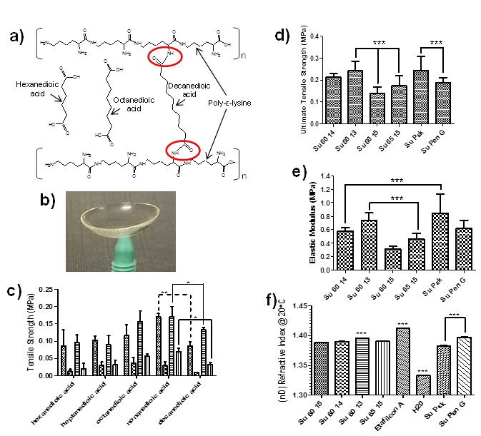

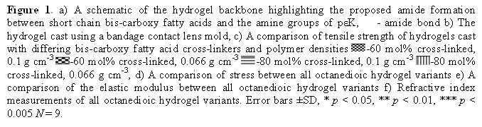
Figure 1. a) A schematic of the hydrogel backbone highlighting the proposed amide formation between short chain bis-carboxy fatty acids and the amine groups of pεK, - amide bond b) The hydrogel cast using a bandage contact lens mold, c) A comparison of tensile strength of hydrogels cast with differing bis-carboxy fatty acid cross-linkers and polymer densities 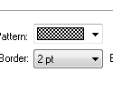-60 mol% cross-linked, 0.1 g cm⁻³ 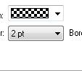-60 mol% cross-linked, 0.066 g cm⁻³ -80 mol% cross-linked, 0.1 g cm⁻³ -80 mol% cross-linked, 0.066 g cm⁻³, d) A comparison of stress between all octanedioic hydrogel variants e) A comparison of the elastic modulus between all octanedioic hydrogel variants f) Refractive index measurements of all octanedioic hydrogel variants. Error bars ±SD, * p < 0.05, ** p < 0.01, *** p < 0.005 N = 9.
Figure 1. a) A schematic of the hydrogel backbone highlighting the proposed amide formation between short chain bis-carboxy fatty acids and the amine groups of pεK, - amide bond b) The hydrogel cast using a bandage contact lens mold, c) A comparison of tensile strength of hydrogels cast with differing bis-carboxy fatty acid cross-linkers and polymer densities -60 mol% cross-linked, 0.1 g cm⁻³ -60 mol% cross-linked, 0.066 g cm⁻³ -80 mol% cross-linked, 0.1 g cm⁻³ -80 mol% cross-linked, 0.066 g cm⁻³, d) A comparison of stress between all octanedioic hydrogel variants e) A comparison of the elastic modulus between all octanedioic hydrogel variants f) Refractive index measurements of all octanedioic hydrogel variants. Error bars ±SD, * p < 0.05, ** p < 0.01, *** p < 0.005 N = 9.
Figure 1. a) A schematic of the hydrogel backbone highlighting the proposed amide formation between short chain bis-carboxy fatty acids and the amine groups of pεK, - amide bond b) The hydrogel cast using a bandage contact lens mold, c) A comparison of tensile strength of hydrogels cast with differing bis-carboxy fatty acid cross-linkers and polymer densities -60 mol% cross-linked, 0.1 g cm⁻³ -60 mol% cross-linked, 0.066 g cm⁻³ -80 mol% cross-linked, 0.1 g cm⁻³ -80 mol% cross-linked, 0.066 g cm⁻³, d) A comparison of stress between all octanedioic hydrogel variants e) A comparison of the elastic modulus between all octanedioic hydrogel variants f) Refractive index measurements of all octanedioic hydrogel variants. Error bars ±SD, * p < 0.05, ** p < 0.01, *** p < 0.005 N = 9.
Figure 1. a) A schematic of the hydrogel backbone highlighting the proposed amide formation between short chain bis-carboxy fatty acids and the amine groups of pεK, - amide bond b) The hydrogel cast using a bandage contact lens mold, c) A comparison of tensile strength of hydrogels cast with differing bis-carboxy fatty acid cross-linkers and polymer densities -60 mol% cross-linked, 0.1 g cm⁻³ -60 mol% cross-linked, 0.066 g cm⁻³ -80 mol% cross-linked, 0.1 g cm⁻³ -80 mol% cross-linked, 0.066 g cm⁻³, d) A comparison of stress between all octanedioic hydrogel variants e) A comparison of the elastic modulus between all octanedioic hydrogel variants f) Refractive index measurements of all octanedioic hydrogel variants. Error bars ±SD, * p < 0.05, ** p < 0.01, *** p < 0.005 N = 9.
Figure 1. a) A schematic of the hydrogel backbone highlighting the proposed amide formation between short chain bis-carboxy fatty acids and the amine groups of pεK, - amide bond b) The hydrogel cast using a bandage contact lens mold, c) A comparison of tensile strength of hydrogels cast with differing bis-carboxy fatty acid cross-linkers and polymer densities -60 mol% cross-linked, 0.1 g cm⁻³ -60 mol% cross-linked, 0.066 g cm⁻³ -80 mol% cross-linked, 0.1 g cm⁻³ -80 mol% cross-linked, 0.066 g cm⁻³, d) A comparison of stress between all octanedioic hydrogel variants e) A comparison of the elastic modulus between all octanedioic hydrogel variants f) Refractive index measurements of all octanedioic hydrogel variants. Error bars ±SD, * p < 0.05, ** p < 0.01, *** p < 0.005 N = 9.

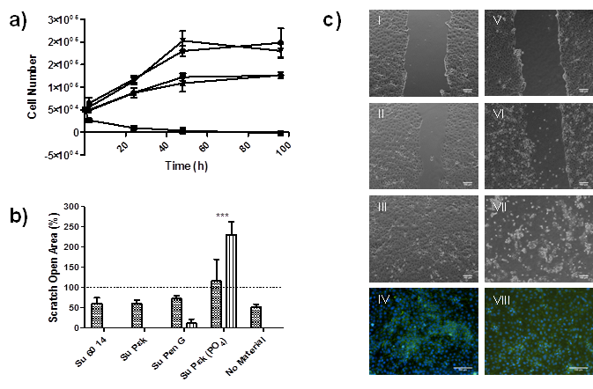

Figure 2. a) Cytotoxicity of leachables from the hydrogel variants towards the HCE-T cell line -Su 60 14 - Su PεK - Su Pen G - Su PεK PO₄ - No material b) Percentage scratch closure with/without hydrogels present at 5 h - and 23 h - after initial scratch at 0 h ----. Error bars ±SD, * p < 0.05, ** p < 0.01, *** p < 0.005 N = 9 c) I-III Scratch closure of a HCE-T monolayer after 0 h, 5 h and 23 h with Su PεK present, V-VII Scratch closure of a HCE-T monolayer after 0 h, 5 h and 23 h with Su PεK PO₄ present, IV ZO-1 and DAPI staining of reformed monolayer from scratch assay with no material present and VIII ZO-1 and DAPI staining of reformed monolayer from scratch assay with Su PεK present. Scale bar is 100 μm.

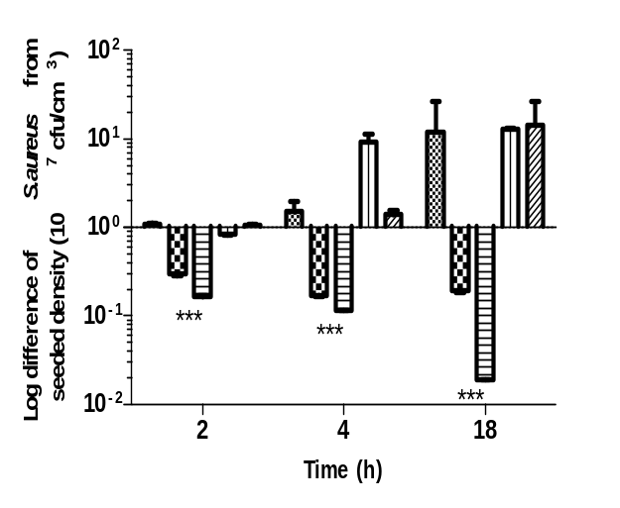
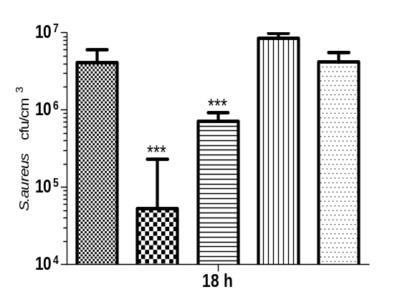
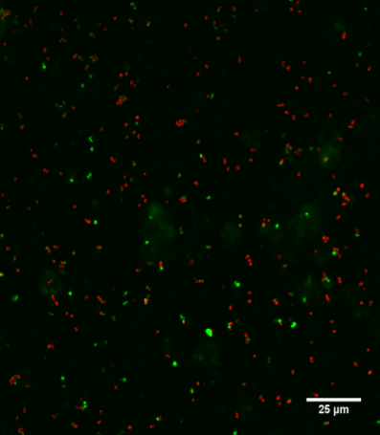
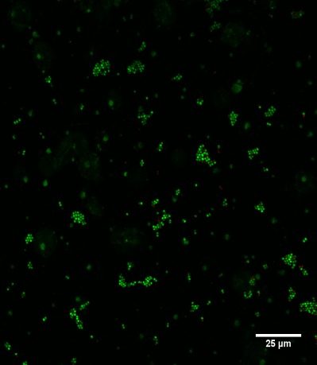
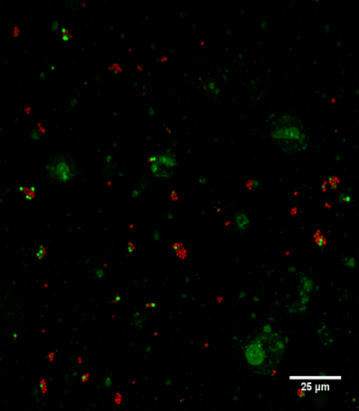
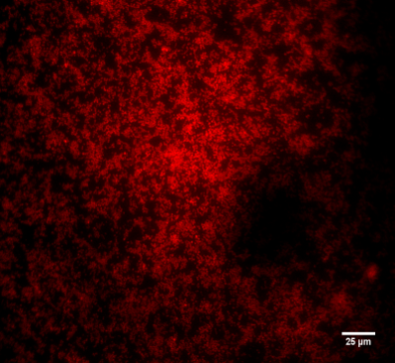
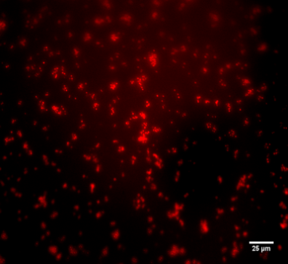
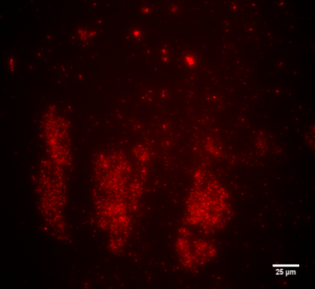
a)
b)
I
II
III
IV
V
VI
Su 60 14
Su Pen G
Su Pεk
c)

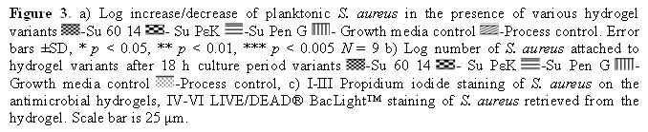
A peptide hydrogel with an antimicrobial activity is developed as a bandage contact lens. The antimicrobial activity is enhanced with the addition of the biomolecules penicillin G or poly-ε-lysine and is positive against S. aureus and E. coli. The lens is also non-cytotoxic towards a human corneal epithelial cell line and as a consequence is of great potential as a drug-eluting bandage lens replacing conventional corneal ulcer treatment.

Bandage Contact Lens

A.G. Gallagher, J.A. Alorabi, D.A. Wellings, R. Lace, M.J. Horsburgh and R.L.Williams*

A Novel Peptide Hydrogel for an Antimicrobial Bandage Contact Lens
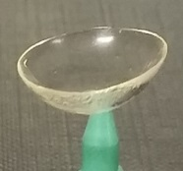
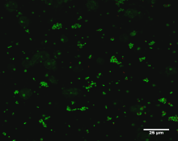
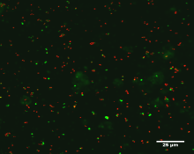
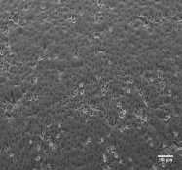
Hydrogel, no modification
Hydrogel, poly-ε-lysine modification
corneal epithelial monolayer
Hydrogel bandage lens
S. aureus: -live, -dead

Copyright WILEY-VCH Verlag GmbH & Co. KGaA, 69469 Weinheim, Germany, 2013.

Supporting Information

A Novel Peptide Hydrogel for an Antimicrobial Bandage Contact Lens

By A.G. Gallagher, J.A. Alorabi, D.A. Wellings, R. Lace, M.J. Horsburgh and R.L.Williams*

Supporting Information

Hydrogel design: The hydrogel material used in this study was composed of pεK cross-linked with a bis-carboxy fatty acid using an N-hydroxysuccinimide (NHS)/1-ethyl-3-(3-dimethylaminopropyl) carbodiimide (EDCI) mediated cross-linking technique which involves the formation of an intermediate stable NHS/bis-carboxy fatty acid ester to increase cross-linking efficiency [S1]. Alterations in the level of cross-linking and the density of the polymer produced the different variants of the hydrogel. These alterations were achieved by varying the molar concentrations of either pεK itself or the bis-carboxy fatty acid cross-linker. C, H and N elemental analysis (Butterworths Laboratories Ltd, Teddington, UK) was carried out to determine the amine content (mmol g⁻¹) of pεK for the purpose of this study. The quantity of bis-carboxy fatty acid added to the polymer mix directly correlated to the percentage of amine groups to be cross-linked. Polymer density was determined gravimetrically using the following formula and correlated with the theoretical value:
Polymer dry weight (g)
Volume of polymer solution (cm³) = Polymer density (g cm⁻³) (1)

The level of cross-linking was determined using the anionic dye methyl orange as an indicator of the unreacted amino groups on the hydrogel. The technique was modified from Itzhaki, 1972 and explained below [S2].
For a 20 cm³ final polymer solution (Table S1) pεK was dissolved in water (5 cm³). The bis-carboxy fatty acid pre-dissolved with a 2:1 molar ratio of N-methylmorpholine (NMM) in water (3 cm³), was added to the pεK solution with 5% Tween 80 (200 mm³) and topped up to a final volume (10 cm³) with water. NHS and EDCI were weighed into a separate tube and topped up with water to a final volume (10 cm³) and allowed to mix for 5 min. The two solutions were then mixed together to a total volume (20 cm³) and inverted 5 times before aliquots (10 cm³) were poured into polystyrene trays (10 cm² Elkay Laboratory Products Ltd, Basingstoke, UK). After polymerization (5 h minimum) the hydrogel was washed (x 5) in water at 30 min per wash before being stored in phosphate buffered saline (PBS).
To cast the gel in the bandage lens mold (Figure 1b), 100 mm³ of Su 60 14 polymer solution was added to the female half of a purposely made mold. The male part was placed on top and closed firmly allowing any overflow polymer solution to be excluded. The polymer was allowed to set for 5 h before being removed from the molds and washed as described previously.
Biomolecule attachment for antimicrobial analysis was either ionic interaction (penicillin G) or covalent coupling (pεK). In both instances the biomolecules were attached post-polymerization to Su 60 14. Prior to attachment the hydrogel was washed with 10% NMM (50 cm³) at 15 min per wash (x 5). This was followed by water washes (50 cm³) at 15 min per wash (x 5). Penicillin G was attached by soaking the hydrogel in an ionic solution (25 cm³ of 12.5 mmol dm⁻³ penicillin G in water) of the antibiotic for 3 h. The hydrogel was then washed (x2) for 5 min before being stored in water prior to sterilization. Penicillin G elution from the hydrogel into PBS was monitored by HPLC (Figure S1). Su Pen G was incubated with 1 cm³ PBS for various timepoints over a 5 h period. At each timepoint the PBS was removed for analysis and replaced with a fresh aliqout. A RP-HPLC system with a Vydac C18 column and a gradient of 20 – 70 % acetonitrile over 20 min was used to quantify penicillin G elution. PεK was attached to hydrogels by dissolving (3 g) in 20 cm³ water and adding to NHS (96 mg) and EDCI (610 mg) pre-dissolved in 5 cm³ water. The solution was mixed and added to the hydrogel and incubated for 3 h. The hydrogel was then washed in water followed by 10 v/v% NMM (50 cm³) at 15 min per wash (x 5) followed by water washes (50 cm³) at 15 min per wash (x 5) before finally storing in PBS prior to sterilization. PεK attachment to the hydrogel was quantified using the anionic dye methyl orange to determine amount of amino groups on the polymer before and after coupling (Table S2). A 2 mM solution of methyl orange was made up by dissolving (32.7 mg) in water (50 cm²). A sample of hydrogel was incubated in water (0.5 cm³) and added to the methyl orange solution (0.5 cm³) in a 1.5 cm³ Eppendorf tube. The tube was placed on a roller to mix for 30 min. The tube was then centrifuged (7,500 rpm) for 5 min. An aliquot (0.15 cm³) of each sample was added to a cuvette with water (2.85 cm³) and inverted 3 times before being measured at A₄₆₅ against a water blank. The corresponding absorbance was compared to a standard curve to determine the amine concentration.

Reagent | PεK / hexanedioic acid hydrogels
Reagent | 60 mol% cross-linked, 0.1 g cm⁻³ | 60 mol% cross-linked, 0.066 g cm⁻³ | 80 mol% cross-linked, 0.1 g cm⁻³ | 80 mol% cross-linked, 0.066 g cm⁻³
PεK | 2.19 g  (12.72 mmol) | 1.46 g  (8.48 mmol) | 2.05 g  (11.89 mmol) | 1.36 g  (7.92 mmol)
Hexanedioic acid | 0.56 g  (3.82 mmol) | 0.37 g  (2.54 mmol) | 0.69 g  (4.75 mmol) | 0.46 g  (3.17 mmol)
NMM | 1.39 cm³ | 0.93 cm³ | 1.30 cm³ | 0.87 cm³
EDCI | 3.66 g  (19.08 mmol) | 2.44 g  (12.72 mmol) | 4.56 g  (23.77 mmol) | 3.04 g  (15.85 mmol)
NHS | 0.73 g  (6.36 mmol) | 0.49 g  (4.24 mmol) | 0.68 g  (5.94 mmol) | 0.46 g  (3.96 mmol)

Reagent | PεK / heptanedioic acid hydrogels
Reagent | 60 mol% cross-linked, 0.1 g cm⁻³ | 60 mol% cross-linked, 0.066 g cm⁻³ | 80 mol% cross-linked, 0.1 g cm⁻³ | 80 mol% cross-linked, 0.066 g cm⁻³
PεK | 2.13 g  (12.39 mmol) | 1.42 g  (8.26 mmol) | 1.98 g  (11.50 mmol) | 1.32 g  (7.67 mmol)
Heptanedioic acid | 0.59 g  (3.72 mmol) | 0.40 g  (2.48 mmol) | 0.74 g  (4.60 mmol) | 0.49 g  (3.07 mmol)
NMM | 1.36 cm³ | 0.91 cm³ | 1.60 cm³ | 0.84 cm³
EDCI | 3.56 g  (18.58 mmol) | 2.38 g  (12.39 mmol) | 4.41 g  (23.00 mmol) | 2.94 g  (15.34 mmol)
NHS | 0.71 g  (6.19 mmol) | 0.48 g  (4.13 mmol) | 0.66 g  (5.75 mmol) | 0.44 g  (3.83 mmol)

Reagent | PεK / Octanedioic acid hydrogels
Reagent | 60 mol% cross-linked, 0.1 g cm⁻³ | 60 mol% cross-linked, 0.066 g cm⁻³ | 80 mol% cross-linked, 0.1 g cm⁻³ | 80 mol% cross-linked, 0.066 g cm⁻³
PεK | 2.08 g  (12.07 mmol) | 1.39 g  (8.05 mmol) | 1.92 g  (11.14 mmol) | 1.28 g  (7.43 mmol)
Octanedioic acid | 0.63 g  (3.62 mmol) | 0.42 g  (2.41 mmol) | 0.78 g  (4.46 mmol) | 0.52 g  (2.97 mmol)
NMM | 1.33 cm³ | 0.88 cm³ | 1.22 cm³ | 0.82 cm³
EDCI | 3.47 g  (18.11 mmol) | 2.31 g  (12.07 mmol) | 4.27 g  (22.29 mmol) | 2.85 g  (14.86 mmol)
NHS | 0.70 g  (6.04 mmol) | 0.46 g  (4.02 mmol) | 0.64 g  (5.57 mmol) | 0.43 g  (3.71 mmol)

Reagent | PεK / nonanedioic acid hydrogels
Reagent | 60 mol% cross-linked, 0.1 g cm⁻³ | 60 mol% cross-linked, 0.066 g cm⁻³ | 80 mol% cross-linked, 0.1 g cm⁻³ | 80 mol% cross-linked, 0.066 g cm⁻³
PεK | 2.03 g  (11.77 mmol) | 1.35 g  (7.85 mmol) | 1.86 g  (10.80 mmol) | 1.24 g  (7.20 mmol)
Nonanedioic acid | 0.67 g  (3.53 mmol) | 0.44 g  (2.36 mmol) | 0.81 g  (4.32 mmol) | 0.54 g  (2.88 mmol)
NMM | 1.29 cm³ | 0.86 cm³ | 1.19 cm³ | 0.79 cm³
EDCI | 3.39 g  (17.66 mmol) | 2.26 g  (11.77 mmol) | 4.14 g  (21.61 mmol) | 2.76 g  (14.41 mmol)
NHS | 0.68 g  (5.89 mmol) | 0.45 g  (3.92 mmol) | 0.62 g  (5.40 mmol) | 0.42 g  (3.60 mmol)

Reagent | PεK / decanedioic acid hydrogels
Reagent | 60 mol% cross-linked, 0.1 g cm⁻³ | 60 mol% cross-linked, 0.066 g cm⁻³ | 80 mol% cross-linked, 0.1 g cm⁻³ | 80 mol% cross-linked, 0.066 g cm⁻³
PεK | 1.98 g  (11.49 mmol) | 1.32 g  (7.66 mmol) | 1.80 g  (10.49 mmol) | 1.20 g  (6.99 mmol)
Decanedioic acid | 0.70 g  (3.45 mmol) | 0.47 g  (2.30 mmol) | 0.85 g  (4.20 mmol) | 0.57 g  (2.80 mmol)
NMM | 1.26 cm³ | 0.84 cm³ | 1.15 cm³ | 0.77 cm³
EDCI | 3.30 g  (17.23 mmol) | 2.20 g  (11.49 mmol) | 4.02 g  (20.97 mmol) | 2.68 g  (13.98 mmol)
NHS | 0.66 g  (5.74 mmol) | 0.44 g  (3.83 mmol) | 0.60 g  (5.24 mmol) | 0.40 g  (3.50 mmol)

Reagent | Su 60 15 | Su 60 14 | Su 60 13 | Su 65 15
PεK | 1.38 g (8.05 mmol) | 1.48 g (8.62 mmol) | 1.60 g (9.29 mmol) | 1.36 g (7.88 mmol)
Octanedioic acid | 0.42 g (2.41 mmol) | 0.45 g (2.59 mmol) | 0.49 g (2.79 mmol) | 0.45 g (2.56 mmol)
NMM | 0.88 cm³ | 0.95 cm³ | 1.02 cm³ | 0.87 cm³
EDCI | 2.31 g  (12.07 mmol) | 2.48 g (12.93 mmol) | 2.67 g  (13.92 mmol) | 2.46 g (12.81 mmol)
NHS | 0.46 g (4.02 mmol) | 0.50 g (4.31 mmol) | 0.53 g (4.64 mmol) | 0.45 g (3.94 mmol)
Table S1. Reagents needed to manufacture 20 cm³ of the various hydrogels

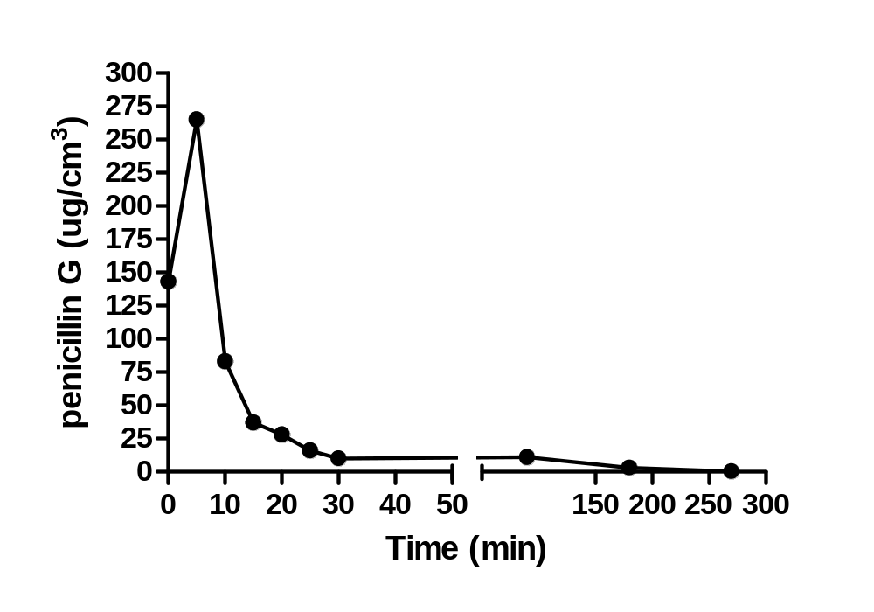
Figure S1. Penicillin G elution from Su Pen G was monitored by HPLC over 5 h

Hydrogel | Amine (mmol) | A₄₆₅
Su 60 14 | 143 | 1.003
Su PεK | 1660 | 0.184
Su 45 14 | 773 | 0.663
Su 75 14 | 93 | 1.03
Table S2. Methyl orange determination of amino groups available on hydrogel variants

Monitoring hydrogel cytotoxicity: HCE-T cells were cultured under standard tissue culture conditions of 37 °C and 5% CO₂. Dulbecco’s Modified Eagle’s Medium / Ham’s F12 (DMEM/F12) media containing 5% Fetal Calf Serum (FCS) with fungizone and penicillin / streptomycin supplementation was used.
A CCK-8 assay kit (Dojindo Laboratories, Kumamoto, Japan) was used to monitor cell proliferation at various time periods during the course of an 8-day cell culture period. A standard curve to determine cell number was carried out following the manufacturer’s guidelines. To setup the cytotoxicity study an aliquot of DMEM/F12 media was incubated with the hydrogel Su 60 14 and another aliquot was incubated without the hydrogel for 3 days. The incubated media aliquots were then used to culture the HCE-T cells. The cells were incubated under standard culture conditions for 4 h, 24 h, 48 h, 96 h, and 192 h after seeding with an initial density of 5 x 10⁴ cells. At each time-point CCK-8 solution (50 mm³) was added to the media (500 mm³) in each well. The cells were then incubated under standard culture conditions for 2 h. An aliquot (3 x 100 mm³) of solution from each well was pipetted into labelled wells in a 96-well plate. Suitable controls were also used. The absorbance was read at 485 nm using a FLUOstar Optima plate reader (BMG Labtech, Ortenberg, Germany) with a background reading at 600 nm and the results recorded.

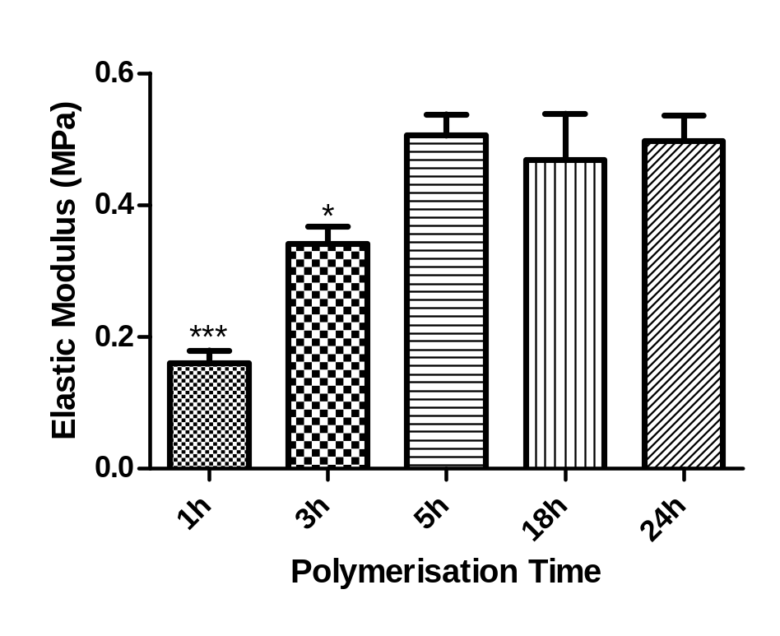

Figure S2. An Investigation of the optimal polymerization time for hydrogel Su 60 14 at 25 ºC. The elastic modulus was used as a measure of the polymerization end point. Error bars ±SD, * p < 0.05, ** p < 0.01, *** p < 0.005 N = 9.

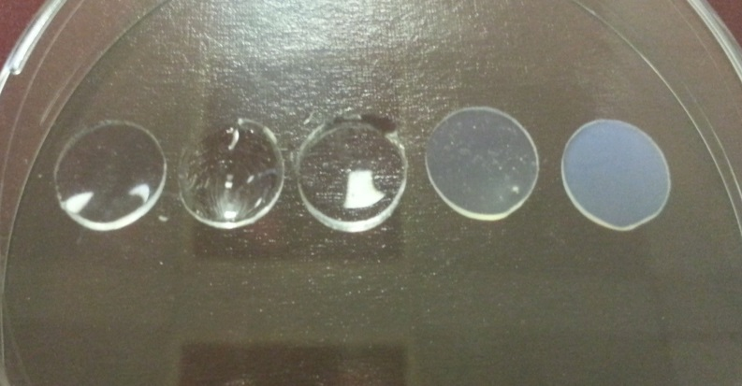
C6
C7
C8
C9
C10

Figure S3. A comparison of Su 65 15 gels polymerized under the same conditions except for different bis-carboxy fatty acid cross-linkers ((hexanedioic acid (C6) – decanedioic acid (C10)). All hydrogels were polymerized as sheets and cut to size (10 cm diameter) using a cork borer. A visible difference in transparency can be observed with an increase in bis-carboxy fatty acid chain length.

Percentage water content: Percentage water content of the hydrogel variants was determined following the gravimetric method. Each sample was removed from PBS storage and cut to approximately 1 cm². The samples were padded dry on a piece of wet Whatman 45 filter paper to remove surface water. A wet weight reading was taken at this point before the samples were placed in a desiccator under phosphorous pentoxide (P₂O₅) overnight to remove water. A reading was taken the next day to determine the dry weight of each sample. The following formula was used to determine the percentage water content of all the hydrogels tested:
wet weight - dry weight
wet weight X 100 (2)

Material | % Water Content | Elastic Modulus (MPa)
Hydroxyethyl methacrylate / methacrylic acid | 70 | 0.77 (+/- 0.11)
Su 60 13 (60 mol% cross-linked, 0.077 g cm⁻³ polymer density) | 67 (+/- 3.4) | 0.73 (+/- 0.12)
Su 60 14 (60 mol% cross-linked, 0.071 g cm⁻³ polymer density) | 69 (+/- 0.8) | 0.61 (+/- 0.07)
Vinyl pyrrolidone / methyl methacrylate | 70 | 0.49 (+/- 0.09)
Su 65 15 (65 mol% cross-linked, 0.066 g cm⁻³ polymer density) | 71 (+/- 1.6) | 0.46 (+/- 0.08)
Hydroxyethyl methacrylate / vinyl pyrrolidone | 55 | 0.36 (+/- 0.07)
Su 60 15 (60 mol% cross-linked, 0.066 g cm⁻³ polymer density) | 70 (+/- 1.7) | 0.31 (+/- 0.04)
Su PεK (Su 60 14 with pεK covalently attached) | 73 (+/- 0.9) | 0.84 (+/- 0.29)
Su Pen G (Su 60 14 with penicillin G ionically attached) | 70 (+/- 0.8) | 0.62 (+/- 0.12)
Table S3. Elastic Modulus and water content of the hydrogel variants prepared for this report compared to commercial lens materials [S3].

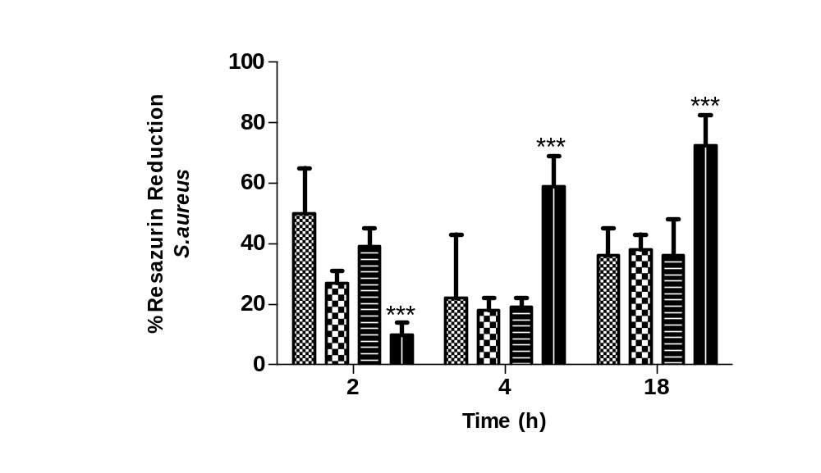Antimicrobial activity assay: A protocol for using resazurin to measure bacteria metabolic activity was adapted from Pettit et al. 2009 and used to determine bacterial burden on different hydrogels [S4]. Each sterilized hydrogel variant was placed in individual wells in a 24 well plate before being inoculated with S. aureus or E. coli [S5] inoculum (400 mm³ with approx. 5 x 10⁵ cfu cm⁻³ cells). Hydrogels were removed at 2 h, 4 h and 18 h time points and washed in PBS before being placed in a fresh 24 well plate. Resazurin (400 mm³ at 0.01 mg cm⁻³ in LB broth) was added to each hydrogel and incubated at 37 ⁰C for 45 min. After incubation aliquots (100 mm³) were removed in triplicate from each well and pipetted into a 96 well plate. Autoclave reduced resazurin served as a positive control whilst stock resazurin prior to assay served as a negative control. Fluorescence intensity was measured at 560 nm (excitation) and 592 nm (emission) using a FLUOstar Optima plate reader (BMG Labtech, Ortenberg, Germany).

Figure S4. Reduction of resazurin by S. aureus when cultured in the presence of octanedioic acid hydrogels cross-linked at different percentages. - 45 mol% cross-linked, 0.07 g cm⁻³ (Su 45 14) - 60 mol% cross-linked, 0.07 g cm⁻³ (Su 60 14) - 75 mol% cross-linked, 0.07 g cm⁻³ (Su 75 14) - Growth media control. Error bars ±SD, * p < 0.05, ** p < 0.01, *** p < 0.005 N = 9.

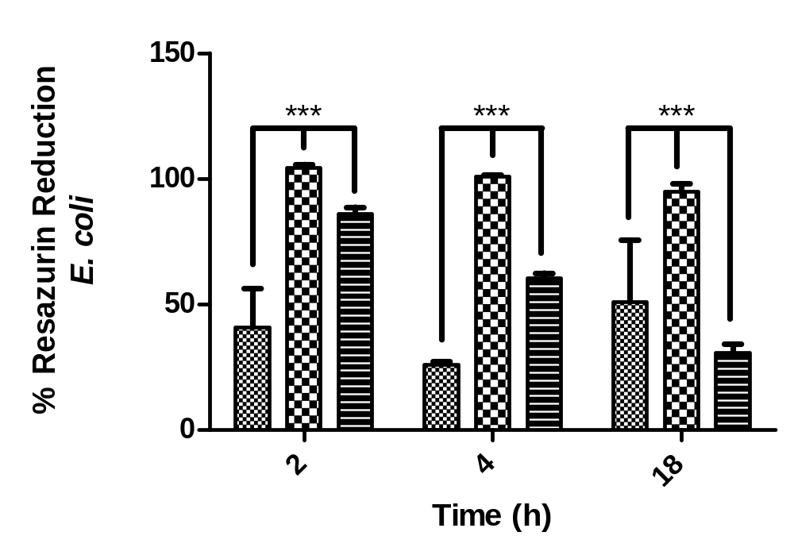
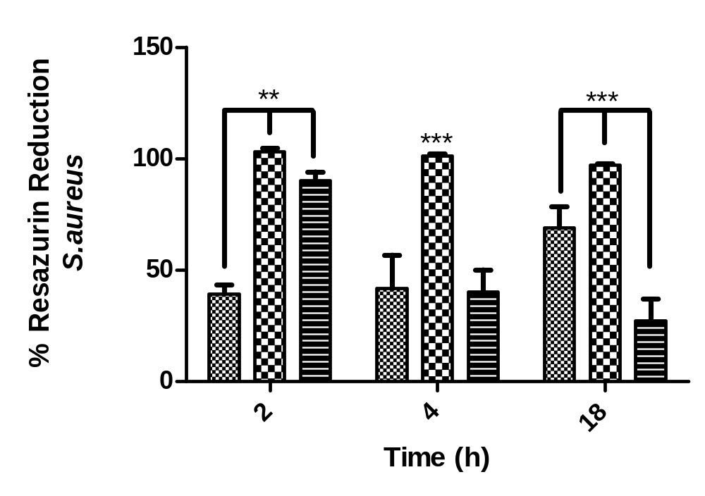
Figure S5. The reduction of resazurin by E. coli and S. aureus when cultured in the presence of octanedioic acid hydrogels. - Su 60 14 - Su Pεk - Growth media control. Error bars ±SD, * p < 0.05, ** p < 0.01, *** p < 0.005 N = 9.

References
_[S1] Z. Grabarek, and J. Gergely, Anal. Biochem. 1990, 185, 131.
_[S2] R.F. Itzhaki, Anal. Biochem. 1972, 50, 569.
_[S3] I. Tranoudis, N. Efron, Cont. Lens. Anterior. Eye. 2004, 27, 177.
_[S4] R.K. Pettit, C.A. Weber, and G.R. Pettit, Ann. Clin. Microbiol. Antimicrob. 2009, 8, 28.
_[S5] E.S. Duthie and L.L. Lorenz, J. Gen. Microbiol. 1952, 6, 95.
_[S6] M.J. Casadaban and S.N. Cohen, J. Mol. Biol. 1980, 138, 179.

