INITIATION OF THE GLOBAL BURDEN OF ANIMAL DISEASES (GBADS) PROGRAMME
*Jonathan Rushton, Mieghan Bruce, Camille Bellet, Paul Torgerson, Alexandra Shaw, Tom Marsh, David Pigott, Matthew Stone, Julio Pinto, Shannon Mesenhowski, Paul Wood
Institute of Infection and Global Health, University of Liverpool, Liverpool L3 5RF, UK (JR, CB); Murdoch University, Murdoch, WA, Australia (MB); Vet Suisse Faculty, University of Zurich, Zurich, Switzerland (PT); APM Consultants, Andover, UK (AS), Washington State University (TM), Pullman, WA, USA; Department of Global Health, University of Washington, Seattle, WA, USA (DP); The World Organisation for Animal Health, Paris, France (MS); The Food and Agriculture Organization of the United Nations, Rome, Italy (JP); Bill & Melinda Gates Foundation, Seattle, WA, USA (SM); and Independent Consultant, Melbourne, VIC, Australia (PW)
j.rushton@liverpool.ac.uk

A consistent and comparable description of animal diseases, the risk factors associated with them, and the effectiveness of intervention strategies to mitigate these diseases are important for decision making and planning. The economic impact of a pathogen or animal disease is a function of disease frequency, infection intensity, the effect of the disease on mortality and productivity in animals and its effects on human health, and efforts to respond to the disease.¹ All of these factors can vary over time between species and the contexts in which people and animals live, and need to be measured to understand the patterns of impact at local, national, and global levels. Animal health has major impacts on human health directly through zoonotic disease transmission, or indirectly through nutritional availability and environmental management.^{2,3}
For human health, the Global Burden of Disease (GBD) study has created a comprehensive dataset of diseases, injuries, and risk factors that is used to measure epidemiological levels and trends worldwide.⁴ There is no equivalent dataset for animal diseases. The burden of individual animal diseases, such as foot and mouth disease,⁵ and of multiple diseases in geographical regions such the UK are estimated to be high.^{6,7} Estimates range from a 20% reduction in the global production of animal-source food⁸ to animal production losses of up to 50% in developing countries.⁹ However, there is no systematic way to capture and measure losses associated with animal diseases, and data on expenditure for disease mitigation are not analysed in a way that allows comparisons to be made. These data gaps limits animal health policy making to individual disease reviews of impact at best, and anecdotal evidence at worst.¹⁰ A system is required that regularly collects, validates, analyses, and disseminates information on livestock production and animal health economic effects to achieve evidence-based policy making and impact on the Sustainable Development Goals on health, nutrition, environment, and poverty.
A workshop, led by the University of Liverpool and the N8 Agrifood Resilience Programme, was held to initiate a programme for the Global Burden of Animal Diseases (GBADs). It was hosted by the World Organisation for Animal Health (OIE), convened by the Bill & Melinda Gates Foundation, and brought together experts in animal health and livestock production data collection and analysis, and information generation.
Six key components of a GBADs programme were identified: disease classification, data collection, disease losses, animal health expenditure, sustainability, and equitability. Disease classification involves key areas of case definition, applicability in the field and with existing data, and engagement with animal owners and health-care advisers. For data collection, there was agreement on the importance of clarity on the types of data to be collected from the public and private sectors and that ownership and commercial sensitivities are thought through and treated with transparency. Disease losses covers the need for a framework that captures what losses will be included, how they will be measured, and how they will be reported. For animal health expenditure, public and private costs need to be separated and costs for different disease issues need to be attributed. In terms of sustainability, we identified the need for a mapping exercise to determine who should be linked to a process of defining the outcomes of GBADs in a structured and timely way. To ensure equitability, impacts in low-income countries must be presented in a way that is comparable to impacts in high-income countries.
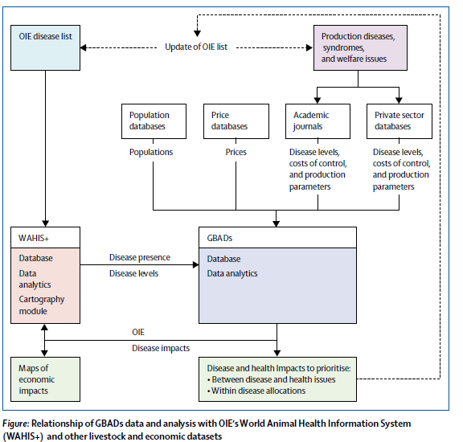
The subsequent GBADs programme will incorporate a disease classification system similar to WHO’s International Classification of Diseases;¹¹ the capture of disease prevalence; net production losses attributable to diseases; and the expenditure on health mitigation such as education, surveillance, prevention, control, and treatment. GBADs will rely on public and private datasets, and will incorporate the wider economic impacts of animal diseases such as price changes, employment, and investment given that they are a crucial part of human food systems (figure). The GBADs tools developed will assist in looking at inter-resource and intra-resource allocations for animal diseases at local, national, and international levels. A longitudinal GBADs dataset, akin to the GBD, will provide data for evidence-based econometric analysis of animal health policies and improve resource allocation. Overall, GBADs will advance understanding of animal health trends over time and the most effective and efficient means of reducing the burden of animal diseases, with subsequent impacts on human health either directly or indirectly.

Conflicts of interest
MS has received grants for animal health-related projects supported by the Bill & Melinda Gates Foundation. SM is employed by the Bill & Melinda Gates Foundation. We declare no other competing interests.

References
1. Rushton J, ed. The economics of animal health and production. Wallingford: CABI, 2009.
2. Rushton J, Uggla A, Magnusson U. Animal health in development—its role for poverty reduction and human welfare. Stockholm: Expert Group for Aid Studies/Expertgruppen för biståndsanalys, 2017.
3. Food and Agriculture Organization of the United Nations. The state of food and agriculture: livestock in the balance. Rome: Food and Agriculture Organization of the United Nations, 2009.
4. GBD 2016 DALYs and HALE Collaborators. Global, regional, and national disability-adjusted life-years (DALYs) for 333 diseases and injuries and healthy life expectancy (HALE) for 195 countries and territories, 1990–2016: a systematic analysis for the Global Burden of Disease Study 2016. Lancet 2017; 390: 1260–344.
5. Knight-Jones TJD, Rushton J. The economic impacts of foot and mouth disease—what are they, how big are they and where do they occur? Prev Vet Med 2013; 112: 161–73.
6. Bennett R. The “direct costs” of livestock disease: the development of a system of models for the analysis of 30 endemic livestock diseases in Great Britain. J Agric Econ 2003; 54: 55–71.
7. Bennett R, IJpelaar J. Updated estimates of the costs associated with thirty four endemic livestock diseases in Great Britain: a note. J Agric Econ 2005; 56: 135–44.
8. Vallat B. One world, one health. World Organisation for Animal Health, 2009. http://www.oie.int/en/for-the-media/editorials/detail/article/ one-world-one-health/ (accessed June 29, 2018).
9. Pradère J-P. Improving animal health and livestock productivity to reduce poverty. Rev Sci Tech 2014; 33: 710–35.
10. Rushton J, Gilbert W. The economics of animal health: direct and indirect costs of animal disease outbreaks. 84th General Session of the World Assembly of OIE Delegates, Paris, France; May 22–27, 2016. 84 SG/9. http://www.oie.int/fileadmin/home/eng/Media_Center/docs/pdf/SG2016/ A_84SG_9.pdf 2016 (accessed July 9, 2018).
11. WHO. Classification of diseases. 2018. http://www.who.int/classifications/ icd/en/ (accessed June 29, 2018).

