Defining filled and empty space: re-assessing the filled space illusion for active touch and vision
Elizabeth S. Collier & Rebecca Lawson
University of Liverpool, Liverpool, UK
Key words: Touch, vision, kinaesthetic, cutaneous, filled space illusion, length
Running head: Filled and empty space

Send correspondence to:

Elizabeth S. Collier
Department of Experimental Psychology
University of Liverpool
Eleanor Rathbone Building
Bedford Street South, Liverpool
L69 7ZA, U.K.
Email: e.s.collier@liverpool.ac.uk

Acknowledgements
The authors would like to thank Maria Sudell for her assistance coding the R script used in the statistical analyses. This work was supported by a grant from the Economic and Social Research Council to the first author [ES/J500094/1].
Abstract
In the filled space illusion, an extent filled with gratings is estimated as longer than an equivalent extent that is apparently empty. However, researchers do not seem to have carefully considered the terms filled and empty when describing this illusion. Specifically, for active touch, smooth, solid surfaces have typically been used to represent empty space. Thus it is not known whether comparing gratings to truly empty space (air) during active exploration by touch elicits the same illusionary effect. In Experiments 1 and 2, gratings were estimated as longer if they were compared to smooth, solid surfaces rather than being compared to truly empty space. Consistent with this, Experiment 3 showed that empty space was perceived as longer than solid surfaces when the two were compared directly. Together these results are consistent with the hypothesis that, for touch, the standard filled space illusion only occurs if gratings are compared to smooth, solid surfaces and that it may reverse if gratings are compared to empty space. Finally, Experiment 4 showed that gratings were estimated as longer than both solid and empty extents in vision, so the direction of the filled space illusion in vision was not affected by the nature of the comparator. These results are discussed in relation to the dual nature of active touch.
Introduction
Haptic perception has a dual nature which provides us with both cutaneous and kinaesthetic information (Lederman & Klatzky, 2009; Dupin, Hayward & Wexler, 2015). Cutaneous cues result from direct input to receptors in the skin. Moving the body through air provides some cutaneous information, particularly if the movement is at speed. However direct contact with a tangible surface provides stronger and more salient cutaneous cues. Kinaesthetic cues broadly refer to inputs from the musculo-skeletal system and arise primarily from limb movement (Dijkerman & de Haan, 2007; Lederman & Jones, 2011; Proske & Gandevia, 2009; 2012). Actively exploring a smooth, solid surface provides both cutaneous and kinaesthetic information, whereas moving the body through still air provides mainly kinaesthetic information.
It was long held that cutaneous cues are less informative about spatial features than kinaesthetic cues (Gibson, 1962; Magee & Kennedy, 1980). For example, Bergmann Tiest, Van der Hoff and Kappers (2011) suggested that although observers can perceive and discriminate lengths when only cutaneous cues are present, haptic length perception is primarily based on kinaesthetic information. However, this view has recently been challenged by Van Doorn and colleagues, who have shown that cutaneous cues alone can be used to estimate length (Van Doorn, Hohwy, Symmons, & Howell, 2012; Van Doorn, Hohwy & Symmons, 2012; Van Doorn, Richardson & Symmons, 2013). Indeed, they reported that participants were more sensitive to differences in length between stimuli when using cutaneous information alone than when using kinaesthetic information alone.
Consistent with the claim that cutaneous cues are an important source of spatial information, participants have been shown to overestimate the distance they need to move their hand to reach a visual target when cutaneous feedback is withdrawn. Ebied, Kemp and Frostick (2003) used anaesthesia to block cutaneous information to participant’s hands. This adversely affected participant’s ability to use a pen to follow the movements of a target on a screen. In the absence of cutaneous information, they overestimated how far they needed to move to reach the target each time it moved. Grip force on the pen was not affected by the anaesthesia so this result did not appear to be simply due to an impaired ability to use the experimental equipment. Instead, length information acquired through cutaneous inputs may not be processed in the same manner as information acquired through kinesthesis (Jastrow, 1886).
The study of perceptual illusions allows us to better understand typical perception by analysing systematic biases that can occur (Coren & Girgus, 1978). Illusions such as the filled space illusion (shown in Figure 1) have been used to study biases in length perception in both vision (Coren & Girgus, 1978; Eriksson, 1970; Mikellidou & Thompson, 2011; 2014) and touch (Dresslar, 1893; Hayward, 2008; Parrish, 1893; Sanders & Kappers, 2009; Suzuki & Arashida, 1992).
Figure 1: Typical configuration of the visual filled space illusion, where distance AB, filled with gratings, is perceived as longer than the unfilled, comparator distance BC. In fact distances AB and BC are equal.
Suzuki and Arashida (1992) directly compared the filled space illusion in vision and active touch. In both cases, extents filled with gratings were perceived as longer than smooth, solid surfaces and the strength of the illusion was comparable across the two modalities. Sanders and Kappers (2009) used the method of constant stimuli with a two-alternative forced choice task to investigate the filled space illusion in active touch. On each trial, blindfolded participants compared the length of a smooth, solid surface to that of a solid surface filled with gratings with either a 4mm or 8mm spatial period. The two extents differed in length by 0.0, 0.8, 1.6, 2.4 or 3.2cm. The filled space illusion was again obtained for touch: a smooth surface had to be physically longer to subjectively feel as long as gratings. The illusion was greater when the gratings were denser (1.1cm for 4mm gratings versus 0.9cm for 8mm gratings), matching the effect of changing the spatial period of the gratings on the visual filled space illusion (Coren & Girgus, 1978).
The filled space illusion is typically described in terms of empty and filled space, where extent A-B in Figure 1 is said to be filled (with gratings) and extent B-C is said to be empty. However, what defines an extent as ‘empty’ is not always clear. In particular, for touch, researchers have often, without explanation, used a smooth, solid surface to represent empty space when they have investigated the filled space illusion. In both Sanders and Kappers’ (2009) and Suzuki and Arashida’s (1992) studies, the stimuli were made from swell paper where the gratings and solid surfaces were embossed to be raised by only a small amount from the surface of the paper. Participants therefore had continual access to both cutaneous and kinaesthetic information for all stimuli because their finger was always in contact with a solid surface. “Empty space” in these experiments might be better described as “saturated” space. Given the importance of cutaneous information to haptic spatial perception, as outlined above, this issue raises the question of whether the nature of the stimulus that gratings are compared to matters for the filled space illusion in touch.
To our knowledge, only Parrish (1893) has compared length estimations for gratings relative to truly empty space for which no cutaneous information is available. Parrish used wooden blocks with raised rubber bumps (ranging from two bumps, with one on each end of the block, up to nine bumps evenly distributed along the block). Blocks with two bumps represented empty space and blocks with nine bumps represented maximally filled space. The stimuli were pressed against the inside of the participant’s forearm, so they felt only the bumps and not the blocks. Participants kept their arm stationary and so kinaesthetic cues were not available. Parrish found the reverse of the standard filled space illusion: empty space was judged as longer than filled space. This reverse filled space illusion may signal that biases in length perception differ depending on the relative availability of cutaneous and kinaesthetic information. Parrish claimed that the filled space illusion reversed when kinaesthetic cues were not available. However, her participants had limited access to cutaneous as well as kinaesthetic cues so the reversal of the filled space illusion could have resulted from either of these differences, or both.
In summary, for the filled space illusion in touch (and also, as described later, in vision) experimenters do not seem to have carefully considered the nature of the comparator and a solid surface has often been used as the comparator to represent unfilled space. In touch the distinction between a solid surface and truly empty space (air) may be particularly important because both cutaneous and kinaesthetic inputs provide length information and these inputs may be processed in different ways (Dupin et al, 2015; Ebied et al, 2003; Van Doorn, et al, 2012; 2013). In the present experiments, we investigated whether the nature of the comparator extent (whether a solid surface or empty space) that gratings are compared to influences the filled space illusion.
Experiment 1
In this experiment we tested whether the standard filled space illusion for active touch, namely that gratings feel longer than smooth, solid surfaces (Sanders & Kappers, 2009; Suzuki & Arashida, 1992), would reverse when people were asked to estimate the lengths of gratings compared to truly empty space. In contrast to Parrish (1893), but as in Sanders and Kappers (2009) and Suzuki and Arashida (1992), our participants actively explored stimuli in the same way on each trial and so the same kinaesthetic inputs were available for all stimuli. Cutaneous information was minimal when feeling the empty space extents but was present for the gratings and smooth, solid surface extents. We reasoned that if the filled space illusion in touch reverses as a result of a lack of movement, as Parrish (1893) proposed, then in this experiment the gratings should feel longer than both smooth, solid surfaces and empty space because people always actively explored the stimuli. In other words, we should find the standard filled space illusion irrespective of the nature of the comparator. If, however, the lack of cutaneous input caused the illusion to reverse in Parrish (1893) then we should find that participants overestimate the length of empty space compared to gratings even when they actively explore stimuli, just as Parrish found when her participants passively felt stimuli.
Method
Participants
Twelve participants (mean age = 20 years; 6 male) either volunteered or were given course credit for their time. Ethical approval for the present experiments was obtained from the relevant Research Ethics Committee at the Institute of Psychology, Health and Society at the University of Liverpool. All participants gave informed consent.
Stimuli and Apparatus
A laser-cutter was used to create four sets of 0.5cm deep acrylic plastic stimuli: empty, solid, 4mm and 8mm gratings, as shown in Figure 2. All stimuli were 29mm tall and ranged from 9 to 15cm in length in 1cm increments. For the gratings, the extent between the start and end bars contained bars which were 1mm wide and 21mm high, with gaps of 4mm or 8mm between them. The 8mm gratings were not used in Experiment 1. Sanders and Kappers (2009) noted that if the boundaries of unseen gratings explored by touch are not clearly distinguished from the grating bars then participants may overestimate the length of gratings due to uncertainty about where they end. We therefore followed Sanders and Kappers and used a solid bar (width varying from 3-7mm) to specify the start and end of the gratings and empty stimuli. Participants were told to consider the full length of the stimuli, from the start of the start bar to the end of the end bar when making their judgements.
Two 25cm long parallel tracks were fixed to a foamboard surface on a table. There was a 30mm gap between the tracks. On each trial a stimulus was slotted between the tracks. The tracks ensured that the stimulus did not move during a trial. Three drawing pins at the left and right end of the tracks, 25cm apart, marked the starting position of the participant's index finger and its endpoint respectively, as shown in Figure 2.
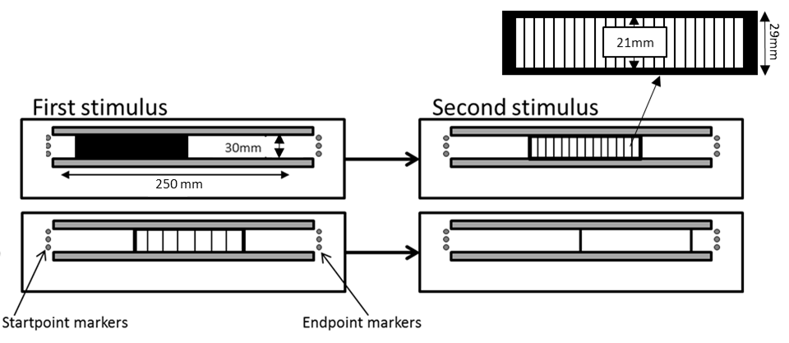

Figure 2: Setup for Experiments 1-3. The diagram shows two example trials using the four types of 12cm stimuli: solid extents followed by 4mm gratings (top) and 8mm gratings followed by empty extents (bottom). The distance of each stimulus from the startpoint markers was varied by the experimenter so that the two successive stimuli on each trial were always placed in different positions.
Design and Procedure
Six participants were assigned to each of two groups. The 4mm gratings were compared to empty stimuli for one group (the empty-gratings group) and to solid stimuli for the other group (the solid-gratings group). Participants were first shown the apparatus and examples of the stimuli (the 12cm grating and the appropriate 12cm comparator) and the task was explained to them. They were then blindfolded and were given 4 practice trials (comparing the 12cm grating to the appropriate 12cm comparator) before the experimental trials began. No feedback was provided during the practice trials.
On every trial the first stimulus was inserted between the tracks and then the experimenter guided the index finger of the participant’s right hand to the startpoint. Participants then moved their index finger to the right until they reached the endpoint beyond the stimulus and then back again to the startpoint. The first stimulus was then replaced by the second stimulus and the procedure was repeated. Participants were asked to try and move their finger at a constant rate (though note that Sanders and Kappers (2009) found that average finger movement speed did not influence length estimates). They were not permitted to touch the base of the apparatus with their finger during exploration and they were instructed to keep their hand raised to avoid doing so. Participants kept their elbow bent and were only permitted to rest their wrist on the edge of the tracks between trials. This meant that for empty stimuli, participants only received cutaneous input to their finger from the startpoint and endpoint markers and from the two bars marking the start and end of the stimuli. Participants responded by verbally stating which of the two stimuli felt longest, the first or the second. They received no feedback about their performance. To avoid participants using the distance between the stimuli and the start/endpoint markers as a cue for the length of the stimuli, the two stimuli to be compared on a given trial were always placed at different positions along the tracks, as shown in Figure 2.
On every trial a grating was compared to an empty stimulus for the empty-gratings group, or to a solid stimulus for the solid-gratings group. The grating was presented first on half of the trials and second on the remaining trials, and on half the trials the grating was the 12cm reference length and on the other half of trials the empty or solid stimulus was the 12cm reference length. The available length differences were -3cm, -2cm, -1cm, 0cm, 1cm, 2cm and 3cm, which were defined as [empty/solid - gratings]. For example, for the solid-gratings group there were four trial types that all tested the length difference of -2cm: these were solid 12cm then grating 14cm, solid 10cm then grating 12cm, grating 14cm then solid 12cm and, finally, grating 12cm then solid 10cm. Note that length difference was independent of whether the grating was presented first or second on a trial.
In total, participants completed 84 trials which tested each of the seven length differences three times in each of the four length difference trial types. The experiment lasted approximately one hour and participants were offered a short break after 42 trials.
Results and discussion
The proportion of times that participants stated that the comparator was longer than the gratings was plotted against the length differences. Cumulative Gaussians were then fitted for each participant, from which biases and 75% discrimination thresholds were calculated. Examples from the solid-gratings and empty-gratings groups are shown in Figure 3A. Mean Cumulative Gaussians for each group are shown in Figure 3B. Positive biases indicate that the empty or solid comparator had to be longer than the grating to feel equivalent in length, i.e. the standard filled space illusion for touch. Negative biases indicate that the grating had to be longer than the comparator to feel equivalent in length, i.e. the reverse illusion reported by Parrish (1893).
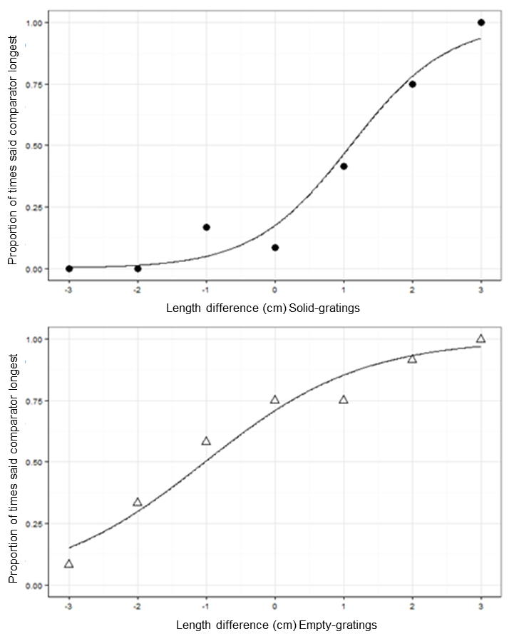
A

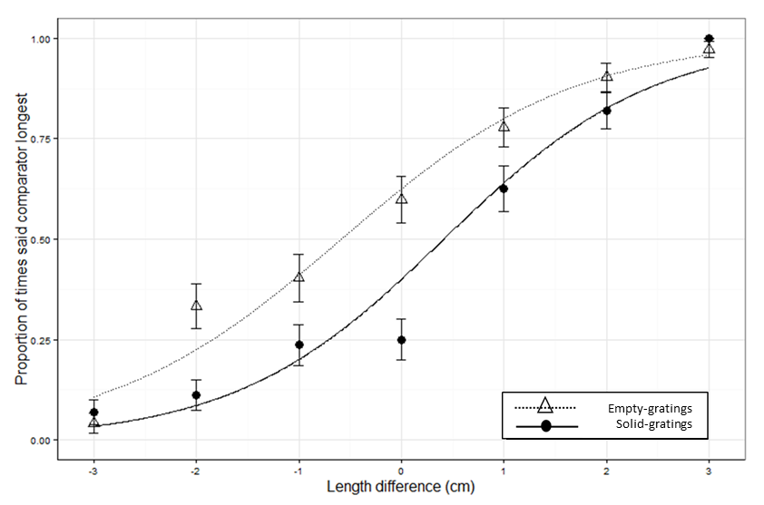

B

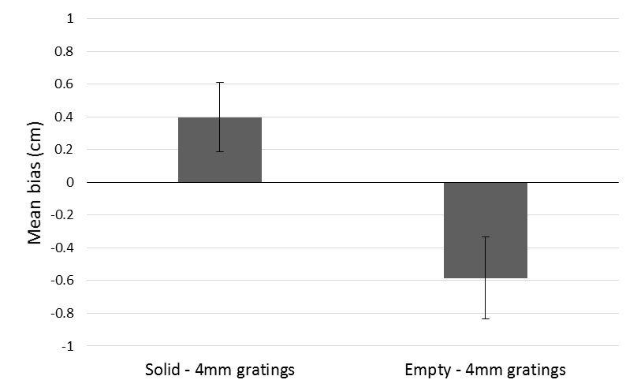
C

Figure 3: Results of Experiment 1: A: Cumulative Gaussian curve for one participant in the solid – gratings group (top) and one participant in the empty – gratings group (bottom) B: Mean Cumulative Gaussian curves for each group. C: Mean bias in cm for each group. Positive biases indicate that gratings were perceived as longer than the comparator (standard filled space illusion) whereas negative biases indicate that the comparator was perceived as longer than the gratings (reverse filled space illusion). All error bars show +/- one standard error of the mean.
B

Mean biases are shown in Figure 3C. One-sample t-tests showed that biases were not significantly greater than zero in the solid-gratings group (m=0.4cm, sd=0.5cm), t(5)=1.9, p=0.12, and they were not significantly lower than zero in the empty-gratings group (m=-0.6cm, sd=0.6cm), t(5)=-2.3, p=0.066, although this was a marginal result. However, an independent samples t-test revealed that biases for the empty-gratings group were significantly less than biases in the solid-gratings group, t(10)= -3.0, p=0.013. Mean 75% discrimination thresholds were 1.5cm (sd=0.3cm) for the solid-gratings group and 0.6cm (sd=0.6cm) for the empty-solid group.
The biases for the solid-gratings and empty-gratings groups differed significantly from each other. For the solid-gratings group, solid surfaces were, on average, 0.4cm longer than 4mm gratings when they were perceived as equal in length, whilst for the empty-gratings group, empty stimuli were, on average, 0.6cm shorter than 4mm gratings when they were perceived as equal in length. Our results show that solid and empty comparators have different influences on the perceived length of gratings, so the nature of the comparator matters in this task. Since our participants actively explored all of the stimuli in the same way, our results do not support Parrish’s (1893) assertion that a lack of movement caused the reversal of the filled space illusion in touch that she reported. Instead, our results suggest that the standard illusion weakens, and may reverse, when cutaneous information is minimised for empty space comparators.
Experiment 2
In Experiment 2 we replicated Experiment 1 by comparing length perception when gratings were compared to a solid surface or empty space but using a stronger within-subjects design. In addition we included a second set of gratings where the bars were 8mm apart, thus reducing the cutaneous information relative to the 4mm gratings. Based on the results of Experiment 1 and of previous studies of the filled space illusion in touch (Parrish, 1893; Sanders & Kappers, 2009), we expected that gratings would be perceived as longer than smooth, solid surfaces, but that gratings would be perceived as shorter than empty space. We also expected that the standard filled space illusion would be stronger for the denser, 4mm gratings than for the 8mm gratings, as reported by Dresslar (1893) and Sanders and Kappers (2009).
Method
Participants
Eight new participants (mean age = 25 years; 5 male) either volunteered or were given course credit for their time.
Apparatus and Stimuli
The apparatus and stimuli were identical to those used in Experiment 1 except that the set of 8mm gratings stimuli was also used.
Design and Procedure
The procedure was the same as that in Experiment 1 except as specified here. Instead of a between-subjects design we used a within-subjects design. Participants completed four conditions: empty–4mm gratings, empty–8mm gratings, solid–4mm gratings and solid–8mm gratings. There were 84 trials per condition, so each participant completed 336 trials across four sessions of 84 trials. Trials were presented in a different random order in each session for each participant and each block was made up of a mix of trials from all four conditions. Within each session participants were offered a short break after 42 trials. All sessions were completed within three weeks and each session lasted approximately one hour.
Results and discussion
Biases and 75% discrimination thresholds were calculated as in Experiment 1. Mean biases are shown in Figure 4. We conducted a repeated measures ANOVA on the biases with comparator (empty/solid) and spatial period (4mm/8mm) as factors. Biases for solid comparators (m=0.3cm, sd=0.6cm) were not greater than for empty comparators (m=-0.2cm, sd=0.6cm), F(1,7)=4.6, p=0.070, η_{p}²=0.4, although this was a marginal result. Biases for 4mm gratings (m=0.4cm, sd=0.5cm) were significantly greater than for 8mm gratings (m=-0.3cm, sd=0.5cm), F(1,7)=52.5, p<0.001, η_{p}²= 0.9. There was also a significant comparator × spatial period interaction, F(1,7)=6.1, p=0.043, η_{p}²= 0.5. To understand this interaction, post-hoc paired samples t-tests were conducted. Biases for solid-4mm gratings (m=0.8cm, sd=0.2cm) were significantly greater than for solid-8mm gratings (m=-0.2cm, sd=0.4cm), t(7)=4.2, p=0.001, so increasing the spatial period of the gratings increased the strength of the standard filled space illusion. Biases for empty-4mm gratings (m=0.02cm, sd=0.5cm) were significantly greater than biases for empty-8mm gratings (m=-0.4cm, sd=0.6cm), t(7)=2.6, p=0.031. Thus empty space seemed longer when compared to 8mm gratings than when compared to 4mm gratings. Replicating Experiment 1, biases for solid-4mm gratings were significantly greater than biases for empty-4mm gratings, t(7)=5.8, p=0.004. However, there was no significant difference between biases for solid-8mm gratings and empty-8mm gratings, t(7)=0.59, p=0.5.
One-sample t-tests showed that biases for solid–4mm gratings were significantly greater than zero, t(7)=11.7, p<0.001. Biases for solid–8mm gratings, t(7)=-1.5, p=0.17, empty–4mm gratings, t(7)=0.12, p=0.9, and empty–8mm gratings, t(7)=-2.0, p=0.08, were not significantly different from zero. Mean 75% discrimination thresholds were 1.8cm (sd=0.6cm) for the solid-4mm gratings condition, 0.8cm (sd=0.4cm) for the solid-8mm gratings condition, 1.2cm (sd=0.5cm) for the empty-4mm gratings condition, and 0.7cm (sd=0.5cm) for the empty-8mm gratings condition.
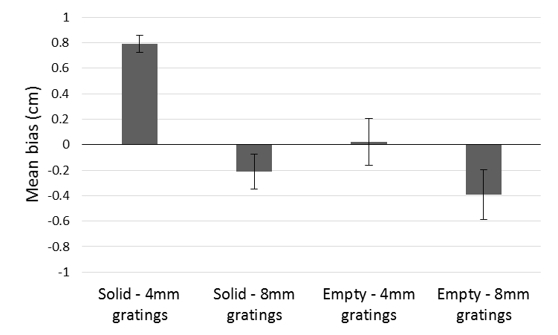
Figure 4: Mean biases in each condition in Experiment 2. Positive biases indicate show that gratings were perceived as longer than the comparator (standard filled space illusion), whereas negative biases indicate that the comparator was perceived as longer than the gratings (reverse filled space illusion). Error bars represent +/- standard errors of the mean.
As in Experiment 1, the results of Experiment 2 suggest that changing the comparator could influence the filled space illusion in touch as once again the biases for the solid-4mm gratings and the empty-4mm gratings groups differed significantly from each other. We will consider these results in more detail in the General Discussion.
Experiment 3
Experiments 1 and 2 varied the nature of the comparator when the length of gratings was estimated. In Experiment 3, we instead directly compared how long empty spaces felt relative to smooth, solid surfaces. Participants actively explored all stimuli in Experiments 1 and 2 and they used the same movements to feel gratings, solid extents and empty extents. Thus we assume that the reversal of the filled space illusion when comparing gratings to empty space reported by Parrish (1893) was not due to changes in kinaesthetic inputs. If the effects reported in Experiments 1 and 2 occurred because length is overestimated when cutaneous information is minimal for empty extents, then the length of empty extents should continue to be overestimated when they are compared directly to solid extents, as illustrated in Figure 5. Thus in Experiment 3 we tested the prediction that gratings are not required to elicit a bias in length estimation by active touch.
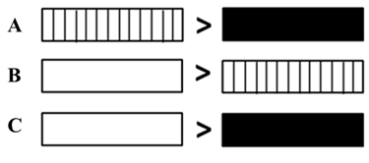
Figure 5: Reasoning behind Experiment 3. Though the results did not reach statistical significance, the results of Experiments 1 and 2 showed a trend where A) gratings were perceived as longer than solid surfaces (standard filled space illusion), and B) empty space was perceived as longer than gratings (reverse filled space illusion). Thus in Experiment 3 we predicted that C) empty space would be perceived as longer than solid surfaces.
Method
Participants
We tested 6 of the 8 participants who took part in Experiment 2 (the Expert group, mean age = 26 years; 4 males) and 6 new, naïve participants (the Naïve group, mean age = 27 years; 1 male). Participants either volunteered or were given course credit for their time.
Apparatus and Stimuli
The apparatus and stimuli were identical to those used in Experiment 1 and 2, except that only the empty and solid stimuli were used.
Procedure
The procedure was similar to that used in Experiments 1 and 2 except that on each trial both an empty and a solid stimulus were presented and no gratings stimuli were used. On half of the trials the 12cm reference length was an empty extent and on half of the trials it was a solid extent. Length differences were calculated as [solid – empty]. For example, the length difference of -2cm was specified by the following four combinations: solid 12cm then empty 14cm, solid 10cm then empty 12cm, empty 14cm then solid 12cm and, finally, empty 12cm then solid 10cm. There were 84 trials in total and the experiment took approximately 1 hour.
Results and discussion
Biases and 75% discrimination thresholds were calculated in the same way as in Experiments 1 and 2. Positive biases indicate that solid surfaces had to be longer than empty space to feel equivalent in length. Mean biases are shown in Figure 6. An independent samples t-test showed that biases for the Expert (m=0.5cm, sd=0.5cm) and Naïve (m=0.5cm, sd=0.7cm) groups did not differ from each other, t(10)=-0.12, p=0.8. One sample t-tests showed that biases were significantly greater than zero in both the Expert group, t(5)=2.2, p<0.001, and the Naïve group t(5)=1.7, p<0.001. Mean 75% discrimination thresholds were 1.4cm (sd=0.7cm) for the Expert group and 1.8cm (sd=0.8cm) for the Naïve group. In support of the indirect evidence from Experiments 1 and 2, the results of Experiment 3 provided direct evidence that extents in empty space are perceived as longer than extents of solid surfaces.
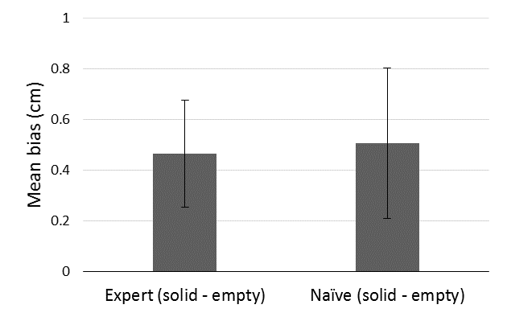
Figure 6: Mean biases in each condition in Experiment 3. Positive biases indicate that empty space was perceived as longer than solid surfaces. Error bars represent +/- standard errors of the mean.
Experiment 4
Experiments 1 and 2 suggested that haptic length estimation is influenced by whether gratings are compared to smooth, solid surfaces or empty space. Experiment 3 showed that empty space is overestimated relative to smooth, solid surfaces. Together these results show that, for touch, it matters whether the lengths to be estimated are gratings or solid surfaces or empty space. In Experiment 4, we tested whether stimulus type also influenced length estimation in vision. Both vision and touch are efficient at processing spatial information (Lawson, 2009) and the filled space illusion has been studied extensively in vision (e.g., Bulatov & Bertulis, 1999; Coren & Girgus, 1978; Deregowski & McGeorge, 2006; Eriksson, 1970; Mikellidou & Thompson, 2011; 2014). However, as for touch, the distinction between comparators consisting of smooth, solid surfaces versus empty space does not usually appear to have been carefully considered. Testing whether the nature of the comparator matters in vision as well as touch may help to establish why the comparator seems to matter for touch. Specifically, if the nature of the comparator does not matter for vision, then the effects reported in Experiments 1-3 were likely the result of modality-specific processes in touch. In Experiment 4 we used stereoscopy to present stimuli which were empty extents, gratings or smooth, solid surfaces.
Method
Participants
Sixteen participants (mean age=21 years; 6 male) took part for course credit. Participants either volunteered or were given course credit for their time.
Stimuli and apparatus
In Experiment 4 the stimuli lengths covered a narrower range (10.5-13.5cm in 0.5cm increments rather than 9-15cm in 1cm increments as used in Experiments 1-3) since visual length estimation was expected to be better than haptic length estimation. Stimuli were extents generated in PsychoPy (Peirce, 2007; 2008; 2015) and were presented on an LCD 3D screen (51cm × 29cm, resolution = 1920 × 1080 pixels). The extents were filled with a solid yellow block for the solid stimuli, with yellow bars for the gratings stimuli, and with a single yellow bar at each end of the extent for the empty space stimuli. All bars were 1mm wide and all stimuli were 30mm tall on the screen. For the gratings the bars were added at 4mm or 8mm intervals and, unlike Experiments 1-3, the start and end bars were the same width as the grating bars. As a result the lengths of the gratings were generally shorter than that specified because bars were only added up to the specified length. For example when the length of 11cm was specified, both the solid and empty stimuli were exactly 11cm on the screen but the 4mm gratings were 10.8cm long and the 8mm gratings were 10.4cm long. An exception was the reference length where all the stimuli were exactly 12cm long. This meant that for the solid-4mm gratings and empty-4mm gratings conditions there were 13 length differences (-1.5, -1.2, -1, -0.8, -0.5, -0.4, 0, 0.5, 0.8, 1, 1.2, 1.5 and 1.6cm) and for the solid-8mm gratings and empty-8mm gratings conditions there were 10 length differences (-1.5, -1, -0.8, -0.5, 0, 0.5, 0.8, 1, 1.5 and 1.6cm). Comparisons between the specified lengths and the actual lengths on the screen can be found in Appendix 1.

A

B
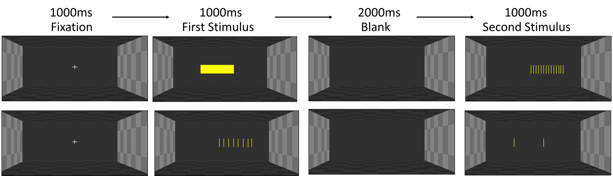
Figure 7: A: View of the box in which stimuli were presented in Experiment 4. B: An illustration of the time course of two example trials in Experiment 4 using the 12cm extents: top, a solid then 4mm gratings trial; bottom, an 8mm gratings then empty trial.
Participants sat approximately 60cm from the screen. To present the stereoscopic scene, two images were displayed superimposed on the screen with polarized filters. The images were left-eye and right-eye versions on an image of the inside of an empty box, as shown in Figure 7A. Throughout the experiment, participants wore 3D passive glasses, which also contained polarised filters. Since light only passed through the filter which was similarly polarised, only one of the images was presented to each eye, achieving the stereo effect. A stereo disparity of 20 pixels (50mm) was added between the left-eye and right-eye images. The sides of the box had a light grey chequer pattern and the top and bottom had a dark grey pattern. The back was solid grey to ensure that participants could not use any pattern information to estimate length. The stimuli were presented on the screen plane (with zero disparity) as shown in Figure 7B, and were perceived to be floating inside the box. During experimental trials, the first stimulus was laterally shifted by 2cm to the right of the centre of the screen and the second stimulus by 2cm to the left of the centre or vice versa.
Design and Procedure
The design replicated that of Experiment 2 so participants compared the length of gratings with either a 4mm or 8mm spatial period to comparators which were either solid surfaces or empty extents. We used a two-alternate forced choice design with the method of constant stimuli, as shown in Figure 7B. A short sound signalled the beginning of each trial. Participants then saw a central fixation cross for 1000ms followed by the first stimulus, which stayed on the screen for 1000ms. The screen was then cleared and only the background was visible for 2000ms. The second stimulus was then presented for 1000ms. Participants were prompted to choose which stimulus was longer. They responded by pressing ‘8’ on the number pad of the keyboard for the first stimulus or ‘2’ for the second stimulus. No feedback was given.
Prior to completing the main experiment, participants completed five practice trials in each of which the 12cm solid stimulus was followed by the 12cm 4mm gratings stimuli. As in Experiment 2 there were four blocks of 84 trials, giving 336 trials in total but all four blocks were completed within a single session. Blocks were made up of trials from all four conditions, trial order was fully randomised for each participant and participants were offered a break after every block. The experiment lasted approximately 45 minutes.
Results and discussion
Biases and slopes were calculated in the same way as in Experiments 1-3. Mean biases are shown in Figure 8. Positive biases indicate that the empty or solid comparator had to be longer than the grating to feel equivalent in length, i.e. the standard filled space illusion for vision. A repeated measures ANOVA where comparator (solid/empty) and spatial period (4mm/8mm) were within-subjects factors revealed that biases for empty comparators (m=0.8cm, sd=0.5cm) were marginally significantly greater than biases for solid comparators (m=0.5cm, sd=0.4cm), F(1,15)=4.2, p=0.059, η_{p}²= 0.2. In addition, biases for 4mm gratings (m=0.8cm, sd=0.4cm) were significantly greater than for 8mm gratings (m=0.5cm, sd=0.1cm), F(1,15)=9.4, p=0.008, η_{p}²= 0.4. There was no significant comparator × spatial period interaction, F(1,15)=0.06, p=0.8, η_{p}²= 0.004.
One-sample t-tests showed that mean biases were significantly greater than zero for solid-4mm gratings (m=0.7cm, sd=0.4cm), solid-8mm gratings (m=0.4cm, sd=0.3cm), empty-4mm gratings (m=0.9cm, sd=0.6cm), and empty-8mm gratings (m=0.6cm, sd=0.5cm), t(15)=7.1, t(15)=4.1, t(15)=6.7, and t(15)=5.3, respectively, all p<0.001. Mean 75% discrimination thresholds were 1.4cm (sd=0.3cm) for the solid-4mm gratings condition, 1.2cm (sd=0.3cm) for the solid-8mm gratings condition, 1.2cm (sd=0.8cm) for the empty-4mm gratings condition, and 1.3cm (sd=0.4cm) for the empty-8mm gratings condition.

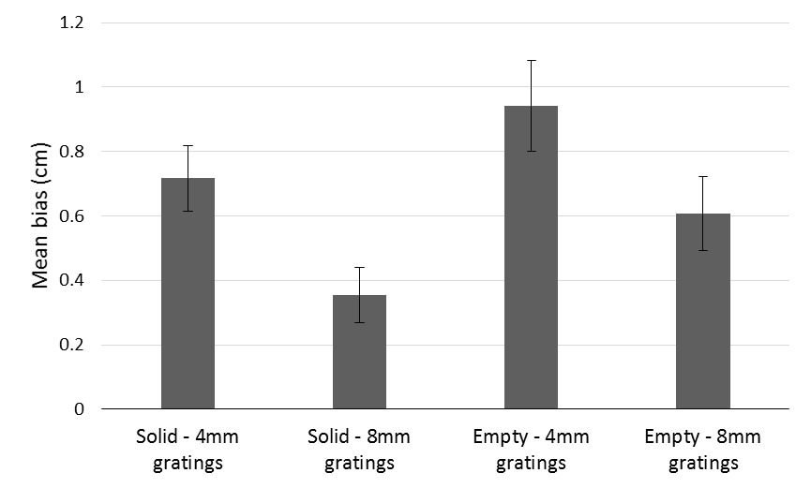
Figure 8: Mean biases in each condition of Experiment 4: Positive biases indicate that gratings were perceived as longer than the comparator (standard filled space illusion). Error bars represent +/- one standard error of the mean.
The results of Experiments 1-3 for touch showed that empty space felt longer than solid extents of the same length, and there was also a trend for empty space to feel longer than gratings. In contrast, in Experiment 4 for vision the standard filled space illusion was found whether gratings were compared to empty or solid extents, with the strength of the filled space illusion marginally greater when the comparator was empty rather than solid. This suggests that the nature of the comparator matters only for the filled space illusion in touch.
General Discussion
Previous researchers have usually, without comment, tested the filled space illusion in touch by asking participants to estimate the length of extents filled with gratings relative to smooth, solid comparators (e.g. Sanders & Kappers, 2009: Suzuki & Arashida, 1992) rather than relative to truly empty comparators. However, our results indicate that the nature of the comparator matters when people use touch to compare the length of extents. However, for vision we found that gratings were estimated as longer whether they were compared to empty or to solid extents. Only for touch did empty space seem longer than other extents. We suggest that this effect can be explained in terms of the dual-nature of haptic touch, as explained below.
To our knowledge, Parrish (1893) was the first to report that the filled space illusion can be reversed in touch. Her participants kept their arms stationary throughout her experiment so Parrish concluded that the reverse filled space illusion arose when arm movements were restricted. However, both kinaesthetic and cutaneous inputs were restricted in her experiment so an alternative reason for the reversal could have been that cutaneous, not kinaesthetic, cues were restricted. In Experiments 1 and 2 reported here, kinaesthetic inputs were constant because participants made the same hand and arm movements on every trial. Only cutaneous information varied across the different stimuli. Our results suggest that the reverse filled space illusion reported by Parrish may not have arisen from a lack of movement as she argued. Instead, we propose that the minimal cutaneous input available from empty extents made them feel longer than both gratings and solid extents, as elaborated below.
Dupin, Hayward and Wexler (2015) investigated how cutaneous and kinaesthetic cues are integrated in touch by providing only cutaneous information to one hand whilst providing only kinaesthetic information to the other hand. They found that participants were able to integrate the separated cutaneous and kinaesthetic signals into a coherent representation in order to identify the size of virtual triangles. When cutaneous and kinaesthetic cues were presented to different hands, participants seemed to rely more on movement/ presentation duration relative to when the two cues were presented to the same hand. Dupin et al suggested that the strategy used to judge size weighted cutaneous and kinaesthetic cues differently depending on how the information was presented.
Dupin et al’s conclusions are relevant for interpreting the results of Experiments 1-3 here. Our participants may also have used different strategies to estimate length depending on the availability of kinaesthetic and cutaneous cues. The weighting of kinaesthetic and cutaneous information matters because spatial information acquired kinaesthetically and cutaneously may not be processed in the same way and so length estimates may differ depending on the extent to which each cue is used. Increased cutaneous input may increase perceived length so smooth, solid surfaces feel shorter than 8mm gratings which, in turn, feel shorter than 4mm gratings, as has already been reported by Sanders and Kappers (2009) and as illustrated in Figure 9. Previous work has also suggested that estimates of length and distance are overestimated when observers rely on kinaesthetic information alone (Ebied et al, 2003; Jastrow, 1886). Thus for empty stimuli participants may rely primarily on kinaesthetic cues to estimate length, which may lead to these stimuli being perceived as longer than all other stimuli (Ebied et al, 2003; Jastrow, 1886).
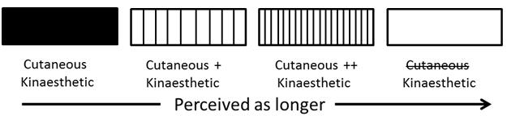
Figure 9: Diagram summarising our interpretation of the results of Experiments 1-3. The increased cutaneous input from the low density gratings means that they are perceived as longer than solid surfaces. Feeling high density gratings provides even more cutaneous input so these are perceived as still longer. However, when cutaneous input is minimal, for the empty extents, participants may switch strategies for length estimation and rely only on kinaesthetic information. This may lead to empty space being perceived as longer than the other kinds of stimuli.
Why might extents feel longer when we are primarily reliant on kinaesthetic, rather than cutaneous, information? One possibility is that the extra effort involved in keeping the finger raised and moving smoothly through empty space may explain why empty space was perceived as longer than solid surfaces. Other haptic illusions, for example the Radial-Tangential Effect (RTE; Davidon & Cheng, 1964; Wong, 1977) have been suggested to reflect differences in the amount of effort required to execute particular arm movements (McFarland & Soechting, 2007). The RTE refers to the bias to overestimate distances moved when making arm movements of equal distance radially (away from or towards the body) compared to tangentially (across the front or side of the body, keeping distance from the body constant). For example, Debats, Kingma, Beek and Smeets (2010) used a simulated arm to test whether differences in the moment arm (the horizontal distance from the shoulder joint to the arm’s centre of mass) affected perceived length for radial and tangential movements. The moment arm determines the amount of effort required to counteract gravitational forces and keep the arm at a constant vertical height. The moment arm changes during radial, but not tangential, movements, and more effort is required to counteract gravitational forces acting on the arm during radial movements, leading to an overestimation of length (Debats et al, 2010). A similar mechanism may explain why empty space was perceived as longer than solid surfaces in the present experiments. The finding that the filled space illusion did not reverse in vision (Experiment 4) supports this modality-specific account.
Another effect which may be related to our findings was reported by Bergmann Tiest and Hayward (2015). They found that when observers compared the size of solid circular disks (exploring an object from the outside) and holes (exploring an object from the inside) of equal size using their index finger, there was a non-significant tendency for them to perceive the holes as larger than the disks. However, we believe that it is unlikely that our results are due only to this effect. First, our participants did not only explore the inside of the empty stimuli in the empty space conditions of Experiments 1-3. Instead they initially felt the outside of the solid end bars of the stimuli as they moved their finger from the start to the end point and vice versa. Second, our participants were instructed to consider the full length of the stimuli, and this included the end bars of the empty stimuli.
Our results did not fully replicate Sanders and Kappers (2009) because the positive bias found when comparing smooth, solid surfaces to gratings was not significantly different from zero in Experiment 1 or, for 8mm gratings, in Experiment 2. This suggests that the standard filled space illusion in touch may not be as reliable and strong as the literature has previously suggested. In addition, the negative bias for comparing empty space to gratings was not significantly different from zero in Experiment 1 or 2. We suggest that future research investigating the relative importance of kinaesthetic and cutaneous cues to haptic length perception would be better served by a more sensitive and reliable task. Nevertheless we did consistently observe differences when we compared haptic estimations involving smooth, solid surfaces to those involving empty space in Experiments 1, 2 and 3 here.
In the present work, we found that gratings are perceived as longer when compared to solid surfaces than to empty space. The pattern of our data was consistent with Parrish (1893), suggesting that the filled space illusion might reverse when gratings are compared to empty space rather than to smooth, solid surfaces (Experiments 1 and 2). Supporting this hypothesis, we found that empty space appears longer than smooth, solid surfaces (Experiment 3). We did not find a comparable effect of the nature of the comparator for vision (Experiment 4), suggesting that the difference between empty space and solid surfaces in touch arises from modality-specific effects on how length is processed. We propose that the nature of the comparator may matter in touch due to the relative availability and use of cutaneous and kinaesthetic cues, and perhaps also the greater effort required to keep the finger aloft while exploring empty space. In conclusion, our sense of touch perceives the length of empty space, solid surfaces and gratings differently.
References
Bergmann Tiest, W. M., Van der Hoff, L. M. A., & Kappers, A. M. L. (2011, June). Cutaneous and kinaesthetic perception of traversed distance. In World Haptics Conference, IEEE (pp. 593-597).
Bergmann Tiest, W. M., & Hayward, V. (2015). Inside vs. outside: Haptic perception of object size. In World Haptics Conference, IEEE (pp. 94-99).
Bulatov, A., & Bertulis, A. (1999). Distortions of length perception. Biological Cybernetics, 80(3), 185-193.
Coren, S., & Girgus, J. S. (1978). Seeing is deceiving: The psychology of visual illusions, Lawrence Erlbaum, New Jersey.
Davidon, R. S., & Cheng, M. F. H. (1964). Apparent distance in a horizontal plane with tactile-kinesthetic stimuli. Quarterly Journal of Experimental Psychology, 16(3), 277-281.
Debats, N. B., Kingma, I., Beek, P. J., & Smeets, J. B. (2010). Muscular torque can explain biases in haptic length perception: a model study on the radial-tangential illusion. In Haptics: Generating and Perceiving Tangible Sensations (pp. 392-397). Springer Berlin Heidelberg.
Deregowski, J. B., & McGeorge, P. (2006). Oppel-Kundt illusion in three-dimensional space. Perception, 35(10), 1307.
Dijkerman, H. C., & de Haan, E. H. (2007). Somatosensory processes subserving perception and action. Behavioral and Brain Sciences, 30(2), 189-201.
Dresslar, F. B. (1893). III, Experiments on open and filled space for touch. American Journal of Psychology, 6, 332-342.
Dupin, L., Hayward, V., & Wexler, M. (2015). Direct coupling of haptic signals between hands. Proceedings of the National Academy of Sciences, 112(2), 619-624.
Ebied, A. M., Kemp, G. J., & Frostick, S. P. (2003). The role of cutaneous sensation in the motor function of the hand. Journal of Orthopaedic Research, 22(4), 862-866.
Eriksson, E. S. (1970). A field theory of visual illusions. British Journal of Psychology, 61(4), 451-466.
Gibson, J. J. (1962). Observations on active touch. Psychological Review, 69, 477–490.
Hayward, V. (2008). A brief taxonomy of tactile illusions and demonstrations that can be done in a hardware store. Brain Research Bulletin, 75(6), 742-752.
Helmholtz, H. (1925). Treatise on Physiological Optics, Translated from the 3rd German edition J. P. C. Southall (Ed.) Opt. Soc. Amer. (1925) Republished Dover, New York, 1962.
Jastrow, J. (1886). The perception of space by disparate senses. Mind, (44), 539-554.
Lawson, R. (2009). A comparison of the effects of depth rotation on visual and haptic three-dimensional object recognition. Journal of Experimental Psychology: Human Perception and Performance, 35(4), 911.
Lederman, S. J., & Klatzky, R. L. (2009). Haptic perception: A tutorial. Attention, Perception, & Psychophysics, 71(7), 1439-1459.
Lederman, S. J., & Jones, L. A. (2011). Tactile and haptic illusions. Haptics, IEEE Transactions, 4(4), 273-294.
Long, G. M., & Murtagh, M. P. (1984). Task and size effects in the Oppel-Kundt and irradiation illusions. The Journal of General Psychology, 111(2), 229-240.
Magee, L. E., & Kennedy, J. M. (1980). Exploring pictures tactually. Nature 283, 287–288.
McFarland, J., & Soechting, J. F. (2007). Factors influencing the radial-tangential illusion in haptic perception. Experimental Brain Research, 178(2), 216–227.
Mikellidou, K., & Thompson, P. (2011). Bisection and dissection of horizontal lines: The long and the short of the Oppel-Kundt illusion. Journal of Vision, 11(11), 1184-1184.
Mikellidou, K., & Thompson, P. (2014). Crossing the line: Estimations of line length in the Oppel-Kundt illusion. Journal of Vision, 14(8), 20.
Parrish, C. S. (1893). VIII, The cutaneous estimation of open and filled space. American Journal of Psychology, 6, 514–523.
Peirce, J. W. (2007). PsychoPy - psychophysics software in Python. Journal of Neuroscience Methods 162:8-13
Peirce, J. W. (2008). Generating stimuli for neuroscience using PsychoPy. Frontiers in Neuroinformatics, 2:10
Peirce, J. W. (2015). PsychoPy – A Psychology Software in Python. Retrieved from http://www.psychopy.org/PsychoPyManual.pdf.
Proske, U., & Gandevia, S. C. (2009). The kinaesthetic senses. The Journal of Physiology, 587(17), 4139-4146.
Proske, U., & Gandevia, S. C. (2012). The proprioceptive senses: their roles in signalling body shape, body position and movement, and muscle force. Physiological Reviews, 92(4), 1651-1697.
Sanders, A. F., & Kappers, A. M. L. (2009). Factors affecting the haptic filled-space illusion for dynamic touch. Experimental Brain Research, 192(4), 717-722.
Suzuki, K., & Arashida, R. (1992). Geometrical haptic illusions revisited: Haptic illusions compared with visual illusions. Perception & Psychophysics, 52(3), 329-335.
Van Doorn, G. H., Hohwy, J., Symmons, M. A., & Howell, J. (2012). The more they move the less they know: Cutaneous capture of kinesthesis? In Haptics Symposium (HAPTICS), IEEE, 177-182.
Van Doorn, G. H., Hohwy, J., & Symmons, M. A. (2012). Capture of kinesthesis by a competing cutaneous input. Attention, Perception, & Psychophysics, 74(7), 1539-1551.
Van Doorn, G. H., Richardson, B. L., & Symmons, M. A. (2013). Touch can be as accurate as passively-guided kinesthesis in length perception. Multisensory Research, 26(5), 417-428.
Wong, T. S. (1977). Dynamic properties of radial and tangential movements as determinants of the Haptic Horizontal-Vertical Illusion with an 'L' figure. Journal of Experimental Psychology: Human Perception and Performance, 3(1), 151.

Appendix 1
Specified length (cm) | Solid blocks  (cm, on screen) | Empty space  (cm, on screen) | 4mm gratings  (cm, on screen) | 8mm gratings  (cm, on screen)
10.5 | 10.5 | 10.5 | 10.4 | 10.4
11 | 11 | 11 | 10.8 | 10.4
11.5 | 11.5 | 11.5 | 11.2 | 11.2
12 | 12 | 12 | 12 | 12
12.5 | 12.5 | 12.5 | 12.4 | 12
13 | 13 | 13 | 12.8 | 12.8
13.5 | 13.5 | 13.5 | 13.2 | 12.8
The actual lengths presented in Experiment 4 for the four type of stimuli used.

There was a second condition in Experiment 3 which all participants completed. Here participants gained extra cutaneous information by moving their finger along the smooth, solid base of the apparatus between the startpoint and the start of the stimulus and also between the end of the stimulus and the endpoint rather than moving their finger above the base through air. Their finger thus only passed through empty space when moving between the start and end bars of the empty extents. These results are not reported here because some participants reported using a different strategy in this condition making it difficult to interpret in a theoretically meaningful manner.
This difference could have resulted from the irradiation illusion in which a bright extent appears longer than a darker extent of equal length (Coren & Girgus, 1979; Helmholtz, 1925; Long & Murtagh, 1984). The irradiation illusion would make the solid comparator appear longer than the empty comparator and this effect would work to weaken the filled space illusion for solid comparators relative to empty comparators.
We thank an anonymous reviewer for this suggestion.

