Effects of removing sheep grazing on soil chemistry, plant nutrition and forage digestibility: lessons for rewilding the British uplands

R.H. Marrs¹, R. Sánchez^{1,2}, L. Connor¹, S. Blackbird¹, J. Rasal¹ & R.J. Rose³

¹School of Environmental Sciences, University of Liverpool, Liverpool L69 3GP, UK.
²Parque Tecnológico de Boecillo, 205, 47151 Boecillo, Valladolid, Spain.
³CEH Lancaster, Centre for Ecology & Hydrology, Bailrigg, Lancaster LA1 4AP, UK.
calluna@liverpool.ac.uk
rausan@cartif.es
lescon@liverpool.ac.uk
black@liverpool.ac.uk
jen.rasal@gmail.com
rjr@ceh.ac.uk
Running head
Removal of sheep grazing: lessons for Rewilding

Keywords

Correspondence
Professor R H Marrs, School of Environmental Sciences, University of Liverpool, Liverpool L69 3GP, UK. Email: calluna@liverpool.ac.uk

Keywords: sheep grazing, soil chemical properties, herbage quality, long-term experiments, land abandonment, conservation, ecological restoration

Abstract
Rewilding is currently being proposed as a means of enhancing the conservation value of marginal land in many parts of the world. This is especially true in the British uplands where rewilding will almost certainly involve either a reduction in livestock grazing, or its complete removal. The aim of reducing stock numbers would be to reverse the degradation of these ecosystems that has been caused by past over-grazing. However, little is known about the likely outcomes, or the time-scales over which such ecosystem recovery might occur. Here, we report preliminary results from a recent study of eight sites at Moor House NNR in the north-Pennines, where permanent plots with- and without-sheep grazing were established between 1954–67 on a range of typical upland plant communities. Soils and vegetation were sampled, and their chemical properties analysed; for vegetation an assessment of the herbage quality for animal nutrition was also made. No significant differences in soil properties, above-ground biomass and nutritional status of the vegetation was detected that could be attributed to sheep grazing removal. The only significant effect associated with grazing removal was a reduced digestibility of the vegetation (greater Acid Detergent Fibre concentration) where sheep were removed. These results show that a rewilding strategy that relies only on reducing sheep numbers will have very little impact on ecosystem recovery in terms of soil or herbage chemistry over short- to medium-term time-scales. Rewilding policies, therefore, attempting to restore ecosystems degraded by over-grazing must, therefore, be viewed as long-term (> 50 years).

Introduction
Rewilding means different things to different people. Ideally, it should be focussed on the conservation at the big scale and the restoration of natural process with the introduction of wide-ranging large animals, especially top carnivores (Soulé & Noss, 1998). In practice, rewilding has included re-introductions of keystone species, for example the European beaver (Law et al., 2017), of top-carnivores, black bears (Malaney et al., 2018), lynx, (Gaston et al., 2016), wolves (Ripple et al., 2015; Beschta & Ripple, 2016), and of macro-herbivores (Baker et al., 2016; van Klink et al. 2016). In addition, the abandonment of land has also been described as rewilding and here land that has been managed usually for agriculture has had the management intensity reduced or stopped completely (Merckx & Pereira, 2015; Corlett, 2016). In the foreseeable future (by 2040) the amount of land potentially available for abandonment in Europe has been estimated at 71,277-211,814 km² (van der Zandena, et al., 2017) with suggestions that policies should concentrate on this marginal land where benefits to ecosystem services and ecological restoration might outweigh those derived from agriculture (Merckx & Pereira, 2015).
The British uplands have been central to this debate with suggestions of, amongst other measures, a policy of reducing deer numbers in Scotland (Dreary & Warren, 2017) and that grazing livestock should be more or less eliminated in upland ecosystems (Monbiot, 2013). Unfortunately, we know relatively little about the effects of reducing stock grazing pressures, especially to zero, and specifically how long it will take for any change to take effect. Removal of stock-grazing would be expected to impact on successional processes, promoting a move to woodland if below the natural tree-line, a change in species composition and a change in nutrient dynamics. For stock grazing there are two predicted impacts depending on the time-scale considered (Marrs et al., 1989). In the short-term, grazing could enhance nutrient cycling and hence make nutrients more available, but in the longer-term result in an overall decline as some nutrients are exported off the site (Perkins, 1978). Grazing removal should, therefore, result in an overall increase in nutrients held on site, but much of the above-ground material might reside in accumulating litter where it could be considered out of short-term circulation.
One way of starting to gain an understanding of the processes involved is to measure change in long-term exclosure experiments, set up to assess the impacts of removing stock grazing altogether. This approach should provide an insight into what might happen. However, because exclosures are usually relatively small-scale (<1000 m²) in comparison to the scale of rewilded areas, they only give a first approximation of likely impacts and timescales.
One good example of a series of such exclosure studies are those set up on Moor House NNR in the North of England between 1953 and 1967. These experimental sites, each with a sheep-grazed plot and an ungrazed comparator were distributed across the reserve to assess the effects of grazing removal on a range of plant community types that encompass a large proportion of British upland plant communities. The plant communities included vegetation dominated by dwarf-shrubs, grasses and sedges, growing on soils ranging from deep blanket peat through to brown-earth soils, and subject to very different, and indeed changing, sheep grazing pressures which are related to forage quality (Eddy et al., 1968; Rawes & Welch, 1969). These vegetation types, in common with those elsewhere in upland Britain, would be described as degraded by over-grazing with sheep (Fraser Darling, 1955; McGovern et al., 2011).
However, in common with many parts of upland Britain, there has been a reduction in sheep grazing pressure since the 1960s (McGovern et al., 2011). At the time that these studies were set up there were estimated to be ca. 15,400 sheep on the Reserve in the summer months; assuming a grazing area of 3500 ha, this equates to 4.4 sheep ha⁻¹. Numbers were then more than halved to 7000 sheep (2 sheep ha⁻¹) in 1972, after formalization of grazing rights under the Commons Registration Act (1965). Thereafter, the statutory Conservation Agency bought up some of the common grazing rights following the outbreak of Foot and Mouth disease in 2001, and grazing pressure was reduced again to ca. 3500 sheep (1 sheep ha⁻¹). It was hoped that this reduction would lead to an improvement in vegetation quality for conservation outcomes. However, for the purposes of this paper no sheep grazing is being compared to the “Business-as-usual” scenario for upland Britain, i.e. sheep grazing. Any change brought about by reducing the grazing pressure in upland grasslands must also be set against changes in species composition brought about through climate change (Mitchell et al., 2018) and changing atmospheric pollutant loads – elevated N (Mitchell et al. 2017; Pakeman et al., 2016) and elevated, and then reducing, S (Mitchell et al., 2018).
The experimental sites were originally set up to measure changes in plant community composition through time (Rawes, 1981; Rawes, 1983; Marrs et al., 1988). An holistic analysis of change in all experiments up to the year 2000 (Milligan et al., 2016) concluded that where sheep continued to graze there was a reduction in species diversity in abundance of vascular plants, grasses, lichens, liverworts and mosses; whereas herbs, sedges and shrubs increased. Removal of sheep grazing had some positive benefits; with herbs, mosses, sedges and shrubs increasing, but with reductions in grasses and liverworts compared to their grazed counterparts. There was no evidence of species invasion such as tree encroachment. However, these sites also provide an opportunity to assess how the reduction in sheep grazing has changed other aspects of these grazed ecosystems, in particular soil processes. A comparative study was carried out in the mid-1980s between 18-31 years after sheep were excluded. Although at that time there was an increase in both dry matter content and nutrient content in the litter at most sites, there were no consistent differences in soil properties in the ungrazed treatment, some sites become slightly more acidic and some less so (Marrs et al., 1989). The reduction in litter in grazed sites is a common phenomenon in ecological restoration (Lindenmayer et al., 2018).
Given that these sites have been degraded by extensive sheep grazing, we hypothesise that removal of the sheep grazing pressure will allow them to recover. We test this hypothesis here by assessing the effects of no sheep grazing versus the” business-as-usual” sheep grazing pressure on both soil properties and the nutritional properties of the vegetation after between 48-62 years free of grazing. The information collected allowed assessments of forage quality across a range of common upland ecosystems.

Methods
This study compared the chemical properties of soils and vegetation in an ungrazed exclosure and a comparator plot subject to free-range sheep grazing at eight sites on the Moor House reserve (Table S1; Fig. S1). The sites were located across a range of upland vegetation types that collectively cover ca. 80% of this reserve (Table S1) and are representative of many ecosystems found in much of upland Britain with six different National Vegetation Classification plant communities identified (Table S1).
Vegetation change has been described previously (Rawes, 1981; Rawes, 1983; Marrs et al., 1988; Milligan et al., 2016). The sheep grazing pressure across these plant communities is, however, not random, with up to 23.2 times greater densities on the most-grazed grassland communities compared to the least-grazed blanket bog ones (Table S1; Rawes & Welch, 1969).

Vegetation and soil sampling and processing
In late May 2015, at the start of the growing season, four random positions were located in both the enclosed and grazed plots at each site. At each position, the surface vegetation was harvested with secateurs to ground level within a 0.25 gm⁻² quadrat and two soil cores taken (1 cm diameter, 21 cm depth) and pooled. A random sub-sample was removed for sorting to species level. Both the sorted fractions and the residual fraction were dried at 80ºC for three days, dry weight measured and then converted to g m⁻². Species nomenclature follows Stace (2010).
The chemical properties of vegetation and soil samples were determined the methods of Allen (1989). Vegetation was ground to pass a 1mm sieve and the concentrations of C, N, P, K, Ca, Mg and Na measured after dry-ashing (Allen, 1989). For soils the following properties were measured: soil pH, soil available N nitrogen (NH₄-N and NO₃-N) and P, and exchangeable K, Ca, Mg and Na. These were assessed on fresh soils using 2M KCL as the extractant for available N and 2.5% vol:vol acetic acid for both available P and the cations. Thereafter, the soil was oven-dried and ground to pass a 1mm mesh. Total N and C determinations were made using a Thermo Scientific Flash 2000 Organic Elemental Analyser; NH₄-N and NO₃-N and P were analysed by colorimetry (P) on a Seal Analytical AA3 HR AutoAnalyser and cations by both absorption (Ca and Mg) and emission spectrophotometry (K and Na) on a Thermo Electron Corporation Solaar S4 AAS. Element concentrations were expressed as either % (C, N) or µg g⁻¹ (all others) for soils and as µmol g⁻¹ for vegetation.
For determinations of dietary fibre, larger samples were required, and accordingly individual plot samples were combined to produce four replicates of each of three plant community groups; Bog, Grass and the intermediate Juncus squarrosus\Nardus stricta grasslands (following Milligan et al. 2016, Table S1). Dry matter, Acid Detergent Fibre (ADF), Neutral Detergent Fibre (NDF) were determined by the Analytical Services Department, Central Analytical Services, SAC Commercial Ltd using standard procedures outlined in Allen (1989). Estimates of cell contents, and hemicellulose were determined using the protocol of Goering and Van Soest (1970). These were all expressed as g kg⁻¹. Crude protein (%) was estimated by multiplying the herbage nitrogen concentration x 6.25 (Allen, 1989).

Statistical analysis
All analyses were performed in the R statistical environment (R Core Team, 2017); the ‘vegan’ package was used for all multivariate analyses (Oksanen et al., 2017).
The main problem in analyzing data from these individual experiments is that they are replicated with only one sheep-grazed plot and an equivalent ungrazed exclosure at each site (Marrs et al., 1986; Milligan et al. 2016). Here, we have analyzed the eight experiments together as a randomized block experiment with the sites as blocks and the grazed/ungrazed plots as treatments; the analysis was performed on the mean data per plot to avoid pseudo-replication issues. A secondary issue is that experiments have been run for different periods of time, but any temporal effect will be site-specific and will be included within the site effect. Here, analysis of variance and its interpretation was performed using the ‘aov’ function in R. Model reduction sensu Crawley (2013) was performed using the ‘anova’ function and differences assessed using the ‘TukeyHSD’ function. QQ-plots were inspected to assess normality and transformations used as necessary (log_{e} and arcsin for percentages). Rank correlation coefficients (Kendall’s tau) were calculated between herbage and soil chemical variables using the ‘cor.test’ function.
Principle Components Analysis (PCA) of both vegetation and soil chemical data was performed using the ‘rda’ function on data standardized using the ‘decostand’ function. Site data were visualized by 2-dimensional standard-deviational ellipses fitted using the ‘ordiellipse’ function. Finally, plant and soil ordinations were compared using the ’procrustes’ and ‘protest’ functions (Lisboa et al., 2014).
Comparable historic data on some soil properties (pH and total N) were available for seven sites in the Centre for Ecology and Hydrology’s archive based on samples collected in 1985/6 (here denoted 1985). An assessment of temporal differences between sites, treatments and time was made using Generalized Linear Modelling (‘glm’ function).

Results
Effects on soil properties
Removal of sheep grazing had no significant effect on any of the soil properties measured (P >0.05). There were, however, highly significant site differences for all soil variables; these are detailed in Fig. S.2. The PCA results provide a summary; this analysis produced eigenvalues of 3.66 and 2.75 respectively accounting for 62% of the variation explained by the PCA. The sites were separated on axis 1 from those with large total C and N concentrations at the negative end, and high pH and available concentrations of NH₄-N, NO₃-N, K and Ca at the positive end (Fig. 1a). Separation on the second axis reflected a gradient of nutrient availability, low at the negative end to and high at the positive end (Fig. 1a). The sites showed a clear gradient from the Bog sites (Bog Hill, Silverband, Troutbeck Head) and the Juncus-dominated grassland at the negative end of axis 1 with high total C and N concentrations and the other grasslands placed nearer the positive end (Fig. 1b). The Nardus and Festuca-grasslands are positioned around the middle of axis 1 but at the positive end of axis 2, i.e. with greater concentrations of most available nutrients. The Agrostis-Festuca grassland at Knock Fell is situated furthest along axis 1 (high pH and available Ca concentrations) but has a low position on axis 2 reflecting its low available element concentrations.

Temporal effects on soil properties
There were significant differences between years for pH at seven of the eight sites; there was a slight reduction at the Bog sites and Festuca-grasslands (Hard Hill and Little Dun Fell), and slight increases at the Juncus squarrosus grassland and the calcareous grassland at Knock Fell (Fig. 2a). There was no significant change at the Nardus-grassland. There was only one significant interaction between grazing treatments and time; this was at the Agrostis-Festuca grassland at Knock Fell, where there was a significantly greater pH in the ungrazed treatment through time compared to the sheep-grazed one (Fig. 2b). Total N also increased through time at Little Dun Fell, there was no effect at other sites (Fig. 2c). No other significant temporal effects were detected.

Effects of herbage
Like the soils, removal of sheep grazing produced no significant differences in either the herbage biomass or the elemental composition (P>0.05). The herbage biomass showed marginally significant differences between sites (F_{7,8} = 4.18, P<0.03) with low values in Silverband (recovering bog) and the Festuca- and Agrostis-dominated grasslands at Little Dun Fell and Knock Fell respectively (Fig. 3a). There was, however, a significant negative relationship with elevation (Fig. 3b, regression equation: Herbage yield (g m⁻²) = 6113.396 - 6.526 x Elevation (m); F_{1, 6} = 20.88, r²_{adj} = 0.74, p= 0.0038. The herbage biomass at the lowest elevations was ca. 3000 g m⁻² reducing to ca. 1000 g m⁻² at the higher elevations. No significant relationship with sheep grazing density was detected (F_{1, 6} = 3.61, r²_{adj} = 0.30, p= 0.30).
The elemental composition of the herbage is detailed by element (Fig. S3) and summarized by the PCA which produced eigenvalues of 3.705 and 1.309 that accounted for 62.7% of the variation explained by the PCA. The chemical constituents were clearly separated along axis 1 from high C and C:N ratio at the negative end, Ca and Na were intermediate and N, P, K and Mg at the positive end (Fig. 4a); on axis 2 the cations and C:N ratio were plotted at the negative end and N and C were at the positive end. The sites showed a very clear sequence along axis 1 with the three bog sites at the negative end (high C) moving through to the grasslands at the positive end (high N, P, K, Mg, Fig. 4b).

Links between soil and herbage plant composition
There were significant positive rank correlations (P<0.0003) between herbage chemical properties and some soil variables total C, C:N ratio, exchangeable K and available as NO₃-N, NH₄-N and the summed total of available N; no significant correlation was detected with soil total N, available P and exchangeable Ca, Mg or Na. The Procrustes rotation test of the two multivariate analyses of the chemical composition of soils (Fig. 1) and herbage (Fig. 4) produced a significant correlation (r = 0.35, P=0.0020). Inspection of the residuals (Fig. S4) indicated that the greatest deviations were at Little Dun Fell and Knock Fell, Festuca- and Agrostis-Festuca-dominated grasslands respectively.

Effects on dietary components
The only significant effect of removal of sheep grazing was an increased ADF concentration in the ungrazed treatment compared to the sheep-grazed one (592±10 versus 542±20 g kg⁻¹ DM; F_{2,3} = 39.24, P = 0.0245592). There were, however, significant differences between the site groups for NDF (F_{2,3} = 36.91, P = 0.0077), ADF (F_{2,3} = 34.42, P = 0.0282), cell contents (F_{2,3} = 48.50, P = 0.0052), and crude protein (F_{2,3} = 20.55 P = 0.0177), but not for hemicellulose (P > 0.05). The NDF values were greater in the Nardus/Juncus grassland 719±11 g kg⁻¹ DM compared to bog or grass communities (635±11 and 664±8 g kg⁻¹ DM) whereas cell contents were lower (Nardus/Juncus = 195±11, Bog = 290±11, Grass = 256±9 g kg⁻¹ DM) (Fig. 5a,c). Crude protein showed an increasing trend from the Bog through Nardus/Juncus to the Grass communities, with the Bog communities (7.2±0.6%) being significantly lower than the Juncus/Nardus (8.9±0.4%) and Grass communities (9.45±0.5%) (Fig. 5d). ADF concentrations were lower in the grass community 522±13 g kg⁻¹ DM than both the Juncus/Nardus ones and bog, 578±18 and 601±34 g kg⁻¹ DM respectively (Fig. 5b).

Effects on herbage species composition
There were no significant differences between the proportion of litter in the herbage, with an overall mean value of 53 ± 0.02% (mean ± SE) or indeed most fractions of the vegetation. Dwarf shrubs were greatest in the bog communities (Bog Hill = 34±0.05%, Silverband = 8±0.06%, Troutbeck Head (14±0.06%) and the Agrostis-grassland at Knock Fell (8.7±0.07%, Vaccinium myrtillus) with much less in the other communities (<0.1%). Lichens were greatest in one of the bog communities (Bog Hill, 6.3±3.1%) and Hard Hill Festuca-grassland (7.4±3.0%) compared to all other sites (<0.1%). The graminoids were the only fraction to show a grazing treatment effect being greater in the grazed compared to the ungrazed treatments, 12.7±1.5 and 5.3±0.7 respectively.

Discussion
Current predictions of future land use suggest that marginal land use in Northern Europe will change over the next few decades through abandonment (van der Zandena, et al., 2017) or by massive reductions in numbers of grazing livestock in free-range grazing systems in some cases to zero (Dreary & Warren, 2017; Monbiot, 2013). This latter approach is a simple approach to rewilding. It assumes that over-grazing by livestock has degraded the ecosystem relative to its previous state over a long period and that by removing the cause of degradation, the ecosystems will recover to an approximation of their former state. This should involve a change in species composition and both herbage and soils quality. Here, this hypothesis was tested by measuring change in soils and herbage quality in long-term sheep exclosure studies on a range of common British upland plant communities.
We have already demonstrated that removal of sheep grazing has degraded the vegetation on these sites. In a holistic analysis of species change up to the year 2000 (Milligan et al., 2016), showed a reduction in overall species diversity where sheep grazing was continued, and that removal of sheep grazing benefitted some herbs, mosses, sedges and shrubs, but reduced grasses and liverworts. The reduction in overall diversity with continued sheep grazing is consistent with the views from elsewhere in the British uplands (Fraser Darling, 1955; McGovern et al., 2011). At most sites, the dominant species has remained in place but there was a changed hierarchy.
The results reported here rejects the hypothesis that there will be a rapid recovery in herbage biomass, plant nutrient content and herbage dietary components. The only variable that showed a significant difference between grazed and ungrazed treatments was the ADF concentration in the herbage, which was greater in ungrazed plots, suggesting reduced digestibility. All other herbage and soil variables measured showed no treatment effects. Therefore, removal of sheep has had very little impact on soil fertility or vegetation nutrition over the timescales of these relatively long-term experiments (48-62 years) and lag behind observed changes in species composition (Milligan et al., 2016). It is possible that more subtle effects may be picked up by restricting sampling to surface soils. Here, we used a standard soil depth to be comparable with other studies and samples taken were either still within the O-horizon or encompassed the entire profile (rendzinas). More subtle treatment-induced effects may be detectable through the assessment of microbiological communities or microbial-driven processes (de Vries et al., 2012); this remains to be determined. Changing pollutant loads (SO₂ and NO_{x}) have also varied over the course of these studies at Moor House and may have affected species responses (Monteith et al. 2017; Rose et al., 2017); clearly, they have not yet affected soil chemistry or herbage nutrition. Therefore, rewilding within the British uplands merely by reducing sheep grazing, will have very limited effect in the short term (48-62 years) of reversing ecosystem degradation caused by long-term sheep grazing.
It was also clear that the main differences in herbage quality and soil chemistry was between the differing plant communities tested, which in turn reflects their differing soil types and altitude. The altitudinal effect was presumably because of cooler temperatures and greater rainfall at higher elevations. There were no correlations detected with sheep grazing pressure and this may result the continued reduction in sheep numbers or from differential distribution patterns at each site. For example, it is feasible that as the sheep numbers drop, the grazing intensity could be maintained on the most productive Festuca- and Agrostis-Festuca grasslands (Rawes & Welch, 1969) with a disproportionately lower pressure on the blanket bog vegetation. This remains to be tested.
In ecological terms, we speculate that the derived degraded ecosystems have a high resistance to change, and if attempts are made to restore a wider diversity of plant species then either there must be an acceptance that this will take a very long time, i.e. greater than ca. 50 years or there must be an intervention approach. The former option is an unknown and can only be addressed by much longer term studies. There latter suggests are three potential constraints to the colonization by new species, a lack of (1) propagule availability, (2) regeneration niches (sensu Grubb, 1977), and (3) the small size of the experimental plots (Milligan et al., 2016). In terms of new colonists there has been no colonization by tree species in any of these experiments (Milligan et al., 2016), although in another, larger, long-term experiment at this site (Milligan et al., 2018) one small Betula sapling persisted for some time then died, and a few Picea sitchensis seedlings have been detected recently after a period of ca. 60 years grazing-free (R.H. Marrs pers. comm.). We have no information on the potential propagule banks or seed rain in these upland systems, but the combined biomass and litter present will probably be an obstacle to both to seed rain into the system and producing appropriate conditions for establishment (Lowday et al. 1992; Ghorbani et al., 2006). Alternatives would be to develop some form of intervention approach with both propagule addition and applied disturbance to aid colonization of new species. This requires an experimental approach.

Acknowledgements
We thank the staff of the former Nature Conservancy and successor bodies for their foresight in setting up these experiments and their continuation, the Environmental Change Network who maintain the experiments and the Heather Trust for financial support. MS Suzanne Yee produced the figures.

References
Allen, S.E., ed. (1989). Chemical Analysis of Ecological Materials, 2nd edn. Oxford, UK: Blackwells.
Baker, A.G., Cornelissen, P., Bhagwat, S.A., Vera, F.W.M. & Willis, K.J. (2016). Quantification of population sizes of large herbivores and their long-term functional role in ecosystems using dung fungal spores. Methods in Ecology & Evolution, 7, 1273-1281.DOI: 10.1111/2041-210X.12580.
Beschta, RL. & Ripple, W.J. (2016). Riparian vegetation recovery in Yellowstone: The first two decades after wolf reintroduction. Biological Conservation, 198, 93-103. DOI: 10.1016/j.biocon.2016.03.031.
Corlett, R.T. (2016). Restoration, Reintroduction, and Rewilding in a changing World. Trends in Ecology & Evolution, 31, 453-462. DOI: 10.1016/j.tree.2016.02.017.
Crawley, M.J. (2013). The R Book, 2nd edn. Chichester, UK: John Wiley and Sons.
Deary H. & Warren, C.R. (2017). Divergent visions of wildness and naturalness in a storied landscape: Practices and discourses of rewilding in Scotland's wild places. Journal of Rural Studies, 54, 211-222. https://doi.org/10.1016/j.jrurstud.2017.06.019.
de Vries, F.T., Bloem, J., Quirk, H., Stevens, C.J., Bol, R., Bardgett, R.D. (2012). Extensive management promotes plant and microbial nitrogen retention in temperate grassland. Plos One, 7, e51201. DOI: 10.1371/journal.pone.0051201.
Eddy, A., Welch, D. & Rawes, M. (1969). The Vegetation of the Moor House National Nature Reserve in the northern Pennines England. Vegetatio, 16, 239-284. https://doi.org/10.1007/BF00257019.
Fraser Darling, F. 1955. West Highland Survey: an essay in human ecology. London, UK: OUP.
Gaston, A., Blazquez-Cabrera, S., Garrote, G., Mateo-Sanchez, M.C., Beier, P., Simon, M.A., Saura, S. (2016). Response to agriculture by a woodland species depends on cover type and behavioural state: insights from resident and dispersing Iberian lynx. Journal of Applied Ecology, 53, 814-824. DOI: 10.1111/1365-2664.12629.
Goering, H.K. Van Soest. P.J. (1970). Forage fibre analysis (apparatus, reagents, procedures and some applications). USDA Agricultural Research Services Handbook No 379. Washington DC, US: USDA.
Ghorbani, J., Le Duc, M.G., McAllister, H.A., Pakeman, R.J., Marrs, R.H., (2006). Effects of the litter layer of Pteridium aquilinum on seed dynamics under experimental restoration. Applied Vegetation Science, 9, 127-136. https://doi.org/10.1111/j.1654-109X.2006.tb00662.x.
Grubb, P.J. (1977). The maintenance of species‐richness in plant communities: the importance of the regeneration niche. Biological Reviews of the Cambridge Philosophical Society, 52, 107-145. DOI: 10.1111/j.1469-185X.1977.tb01347.x
Law, A., Gaywood, M.J., Jones, K.C., Ramsay, P., Willby, N.J. (2017). Using ecosystem engineers as tools in habitat restoration and rewilding: beaver and wetlands. Science of the Total Environment, 605, 1021-1030. DOI: 10.1016/j.scitotenv.2017.06.173.
Lindenmayer, D.B., Blanchard, W. & Crane, M. & Michael D., & Sato, C. (2018). Biodiversity benefits of vegetation restoration are undermined by livestock grazing. Restoration Ecology. https://doi.org/10.1111/rec.12676.
Lisboa, F.J.G., Peres-Neto, P.R. Chaer, G.M., Jesus E. da C., Mitchell, R.J., Chapman S.J.,. Berbara R.L.L. 2014. Much beyond Mantel: bringing Procrustes association metric to the plant and soil ecologist’s toolbox. PLOS ONE, e101238. https://doi.org/10.1371/journal.pone.0101238.
Lowday, J.E. & Marrs, R.H. 1992. Control of bracken and the restoration of heathland. III. Bracken litter disturbance and heathland restoration. J. Appl. Ecol. 29: 212-217. http://www.jstor.org/stable/2404363.
McGovern, S.T., Evans, C.D., Dennis, P., Walmsley, C.A., McDonald M.A. (2011). Identifying drivers of species compositional change in a semi-natural upland grassland over a 40-year period. Journal of Vegetation Science, 22, 346–356. DOI: 10.1111/j.1654-1103.2011.01256.x.
Malaney, J.L., Lackey, C.W., Beckmann, J.P. Matocq, M.D. (2018). Natural rewilding of the Great Basin: Genetic consequences of recolonization by black bears (Ursus americanus). Diversity & Distributions, 24, 168-178 .DOI: 10.1111/ddi.12666.
Marrs, R.H., Rawes, M. Robinson, J.S., Poppitt, S.D. (1986). Long- term studies of vegetation change at Moor House NNR: guide to recording methods and database. (Merlewood R&D Paper 109). Grange-over-Sands, UK: Institute of Terrestrial Ecology.
Marrs, R.H., Bravington, M.J., Rawes, M. (1988). Long-term vegetation change in the Juncus squarrosus grassland at Moor House NNR in northern England. Vegetatio. 76, 179-187. https://doi.org/10.1007/BF00045478.
Marrs, R.H., Rizand, A., Harrison, A.F. (1989). The effects of removing sheep grazing on soil chemistry, above-ground nutrient distribution, and selected aspects of soil fertility in long-term experiments at Moor House NNR. Journal of Applied Ecology, 26, 647-661. DOI: 10.2307/2404089.
Milligan, G., Rose, R.J., O'Reilly, J., Marrs, R.H. (2018). Effects of rotational prescribed burning and sheep grazing on moorland plant communities: Results from a 60‐year intervention experiment. Land Degradation & Development, XX, 1–16. http://dx.doi.org/10.1002/ldr.2953.
Merckx, T. Pereira, H.M. (2015). Reshaping agri-environmental subsidies: From marginal farming to large-scale rewilding. Basic & Applied Ecology, 16, 95-103. DOI: 10.1016/j.baae.2014.12.003.
Milligan, G., Rose, R.J., Marrs, R.H. (2016). Winners and losers in a long-term study of vegetation change at Moor House NNR: effects of sheep-grazing and its removal on British upland vegetation. Ecological Indicators, 68, 89–101. http://dx.doi.org/10.1016/j.ecolind.2015.10.053.
Mitchell, R.J., Hewison, R. L., Britton, A.J., Brooker, R.W., Cummins, R.P., Fielding, D.A., Fisher, J.M., Gilbert, D.J., Hester, A.J., Hurskainen, S., Pakeman, R.J., Potts, J.M., Riach, D. (2017). Forty years of change in Scottish grassland vegetation: Increased richness, decreased diversity and increased dominance. Biological Conservation, 212, 327–336. http://dx.doi.org/10.1016/j.biocon.2017.06.027.
Mitchell, R.J., Hewison, R.L., Fielding, D.A., Fisher, J.M., Gilbert, D.J. Hurskainen, S., Pakeman R.J., Potts, J.M., Riach, D. (2018). Decline in atmospheric sulphur deposition and changes in climate are the major drivers of long-term change in grassland plant communities in Scotland. Environmental Pollution, 235, 956e964. https://doi.org/10.1016/j.envpol.2017.12.086.
Monbiot, G. (2013). Feral: Searching for enchantment on the frontiers of Rewilding. Allen Lane, London.
Monteith, D., Henrys, P., Banin, L., Smith, R., Morecroft, M., Scott, T., Andrews, C., Beaumont, D., Benham, S., Bowmaker, V., Corbett, S., Dick, J., Dodd, B., Dodd, N., McKenna, C., McMillan, S., Pallet, D., Pereira, M, Poskitt, J., Rennie, S., Rose, R., Schäfer, .S, Sherrin, L., Tang, S., Turner, A., Watson H. (2016). Trends and variability in weather and atmospheric deposition at UK Environmental Change Network sites (1993–2012). Ecological Indicators, 68, 21–35. https://doi.org/10.1016/j.ecolind.2016.01.061.
Oksanen, J., Blanchet, F.G., Kindt, R., Legendre, P., Minchin, P. R., O’Hara, R. B., Simpson, G. L., Solymos, P., Stevens M. H. H., & Wagner, H. (2016). Package ‘vegan’, community ecology package. http://vegan.r-forge.r-project.org. [Accessed on 12 December 2016].
Pakeman, R.J. Alexander, J., Brooker, R., Cummins, R., Fielding, D., Gore, S., Hewison, R., Mitchell, R., Moore, E., Orford, K., Pemberton, C., Trinder, C., Lewis, R. (2016). Long-term impacts of nitrogen deposition on coastal plant communities. Environmental Pollution, 212, 337-347. http://dx.doi.org/10.1016/j.envpol.2016.01.084.
Perkins, D.F. 1978. The distribution and transfer of energy and nutrients with the Agrostis-Festuca grassland ecosystem. In Production ecology of British Moors and Montane Grasslands. Eds O.W. Heal and D.F Perkins, pp. 375-395. New York, US: Springer-Verlag.
Rawes, M. (1981). Further results of excluding sheep from high-level grasslands in the north Pennines. J. Ecol., 69, 651-669. http://www.jstor.org/stable/2259690.
Rawes, M. (1983). Changes in two high altitude blanket bogs after the cessation of sheep grazing. J. Ecol., 71, 219-235. http://www.jstor.org/stable/2259974.
Rawes, M., Welch, D. (1969). Upland productivity of vegetation and sheep at Moor House National Nature Reserves, Westmorland, England. Oikos Supplementum, 11, 1-69.
R Core Team (2017). R: A language and environment for statistical computing. Vienna, Austria: R Foundation for Statistical Computing. URL https://www.R-project.org/. [accessed 1/7/2017].
Ripple, W.J., Beschta, R.L. & Painter, L.E. (2015). Trophic cascades from wolves to alders in Yellowstone. Forest Ecology & Management, 354, 254-260. DOI: 10.1016/j.foreco.2015.06.007.
Rodwell, J., ed. (1991). British plant communities. Vol. 2. Mires and heaths. Cambridge, UK: CUP.
Rodwell, J., ed. (1992). British plant communities. Vol. 3. Grasslands and montane communities. Cambridge, UK: CUP.
Rose R., Monteith, D.T., Henrys, P., Smart, S., Wood, C., Morecroft, M., Andrews C., Beaumont, D., Benhan, S., Bowmaker, V., Corbett, S., Dick, J., Dodd, B., Dodd, N., Flexen, M., McKenna, C., McMillan, S., Pallett, D., Rennie, S., Schafer, S., Scott, T., Sherrin, L., Turner, A. & Watson, H. (2016). Evidence for increases in vegetation species richness across the UK Environmental Change Network sites resulting from changes in air pollution and weather patterns. Ecological. Indicators 68, 52–62. https://doi.org/10.1016/j.ecolind.2016.01.005.
Soulé, M. & Noss, R. (1998). Rewilding and Biodiversity: complementary goals for continental conservation. Wild Earth, 8, 19-23.
http://www.michaelsoule.com/resource_files/167/167_resource_file1.pdf.
Stace C. 2010. New Flora of the British Isles. 3rd edn. Cambridge, UK: CUP.
van der Zandena, E.H., Verburga, P.H., Schulpa, C.J.E. & Verkerk, P.J. (2017). Trade-offs of European agricultural abandonment. Land Use Policy, 62, 290–301. http://dx.doi.org/10.1016/j.landusepol.2017.01.003
van Klink, R., Ruifrok, J.L., & Smit, C. (2016). Rewilding with large herbivores: Direct effects and edge effects of grazing refuges on plant and invertebrate communities. Agriculture Ecosystems & Environment, 234 ,81-97. DOI: 10.1016/j.agee.2016.01.050.

Figure 1. Principle Components Analysis of the soil chemical properties in the grazed (∆) and ungrazed (o) plots at the eight sites at Moor House NNR: (a) soil chemical properties, (b) all sampled quadrats and site positions described using 2D standard-deviational ellipses. Site codes: BH = Bog Hill, SB = Silverband, TH = Troutbeck Head, CH = Cottage Hill, RT = River Tees, HH = Hard Hill, LDF = Little Dun Fell and KF = Knock Fell.

Figure 2. Significant changes in soil pH and total N in the long term grazing exclosure sites at Moor House NNR: (a) sites that showed differences in pH between years, (b) interaction between grazing treatments and time at Knock Fell, and (c) differences in total N between years at Knock Fell. Site codes: BH = Bog Hill, SB = Silverband, TH = Troutbeck Head, CH = Cottage Hill, HH = Hard Hill, LDF = Little Dun Fell and KF = Knock Fell; Grazing treatment codes: G = sheep-grazed, UG = ungrazed; Significance codes (full data in Table S2): ns = not significant, P > 0.05; * = P<0.05; ** = P<0.01; *** = P <0.001.

Figure 3. Herbage biomass at each of the long term grazing exclosure sites at Moor House NNR: (a) by site, and (b) with respect to elevation Site codes: BH = Bog Hill, SB = Silverband, TH = Troutbeck Head, CH = Cottage Hill, RT = River Tees, HH = Hard Hill, LDF = Little Dun Fell and KF = Knock Fell.
Figure 4. Principle Components Analysis of the herbage chemical properties in the grazed (∆) and ungrazed (o) plots at the eight sites at Moor House NNR: (a) herbage chemical properties, (b) all sampled quadrats and site positions described using 2D standard-deviational ellipses. Site codes: BH = Bog Hill, SB = Silverband, TH = Troutbeck Head, CH = Cottage Hill, RT = River Tees, HH = Hard Hill, LDF = Little Dun Fell and KF = Knock Fell.

Figure 5. Dietary components of the herbage in three grouped vegetation types within the long term grazing exclosure sites at Moor House NNR: (a) NDF, (b) ADF, (c) cell contents, and (d) crude protein. P, and (e) K. Main vegetation types are denoted: Bog = Calluna/Eriophorum, Nardus/Juncus = Juncus squarrosus/Nardus stricta grassland, Grass = Festuca ovina/Agrostis capillaris grassland
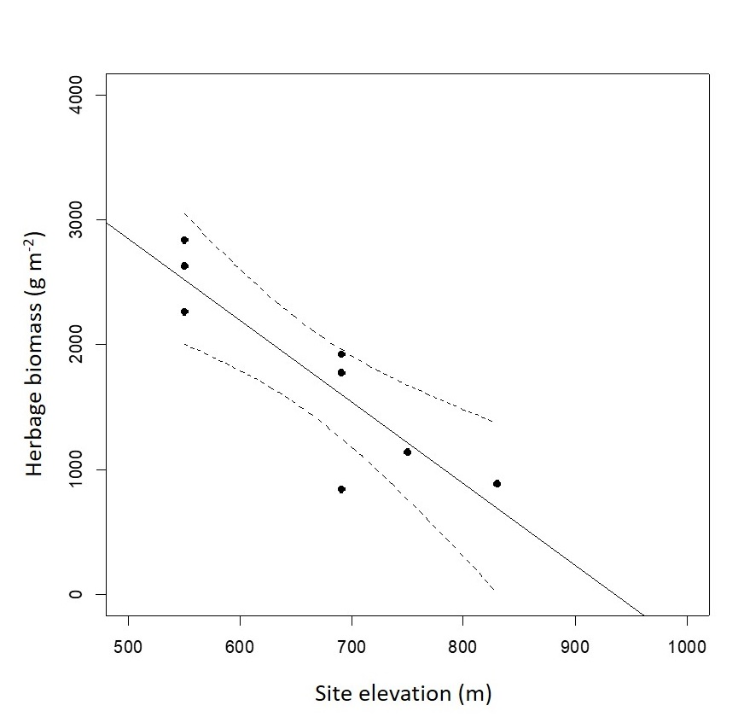
Graphical Abstract. Herbage biomass was related to elevation: presence/absence of sheep grazing had almost no effect on soil or plant nutrition.

(a)

(b)

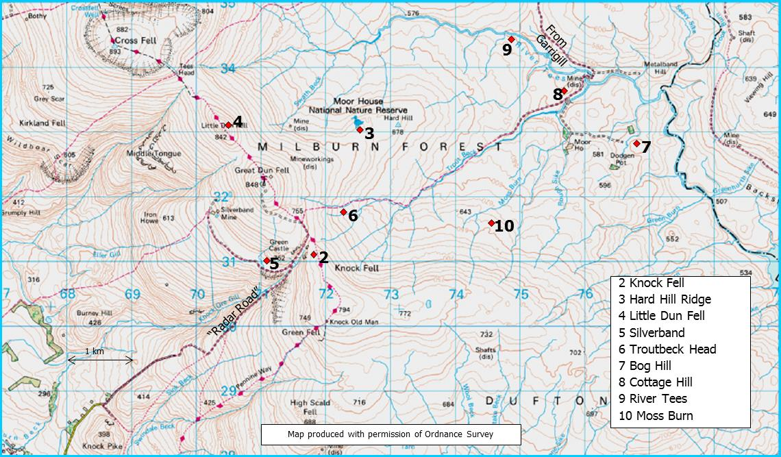

Fig. S1. (a) Location of Moor House NNR, and (b) a map of the Moor House site showing positions of all vegetation monitoring experiments.

Figure S2. Soil chemical properties of soils from the eight study sites at Moor House NNR; as there were no significant treatment effects between ungrazed and grazed plots data for these treatments have been pooled: (a) soil pH, (b) total soil carbon, (c) total soil nitrogen, (d) soil C:N ratio, (e) available NO3-N, (f) available NH4-N, (g) available P, and exchangeable concentrations of (h) K, (i) Na, (j) Ca and (k) Mg. Site codes: BH = Bog Hill, SB =- Silverband, TH = Troutbeck Head, CH = Cottage Hill, RT = River Tees, HH = Hard Hill, LDF = Little Dun Fell and KF = Knock Fell. Main vegetation types are denoted: Bog Calluna/Eriophorum, Js = Juncus squarrosus, NS = Nardus stricta, Fo = Festuca ovina and Ac = Agrostis capillaris.
Interpretation of Fig. S2
Significant differences were found between sites for all soil variables (Soil pH, F_{7,8} = 59.88, P < 0.0001; Total C, F_{7,8} = 46.09, P <0.0001; Total N, F_{7,8} = 8.156, P = 0.0041; C:N, F_{7,8} = 33.96, P < 0.0001; Available NO₃-N, F_{7,8} = 12.1 P = 0.0011; Available NO₃-N F_{7,8} = 7.292 P = 0.0059; available P, F_{7,8} = 20.33, P = 0.0002; exchangeable K, F_{7,8} = 8.737, P = 0.0033; exchangeable Na, F_{7,8} = 6.374, P = 0.0091; exchangeable Ca, F_{7,8} = 4.167, P = 0.0315; exchangeable Mg, F_{7,8} = 5.492, P = 0.0143).
The soil chemical properties reflected a change across the bog-grassland transition (Fig. 1). Soil pH was low (mean <4.0) in all sites except the Knock Fell Agrostis-Festuca grassland (mean±SE, 5.3±0.3). Total soil C was greatest in the Bog sites and Cottage Hill (Juncus squarrosus grassland), intermediate in the Nardus- and Festuca-dominated grassland (means all > 20%) and lowest in the Agrostis-Festuca grassland at Knock Fell (5.0±0.2%). Total soil N showed a similar pattern. The C:N ratio showed a clear transition from the bog sites (mean > 30%), through the Juncus-, Nardus- and Festuca-dominated grasslands (19-24%) to the lowest in the Knock Fell Agrostis-Festuca grassland (11.4±2.8%). Both available N concentrations showed similar responses, very low in the bog communities and the Juncus-community and greater in the Nardus, Festuca and Agrostis-Festuca grasslands. Available P values were low (<10 µg P g⁻¹) especially in the Knock Fell Agrostis-Festuca grassland with greatest concentrations found in the Festuca-dominated grasslands, 4.3±0.6 and 4.9±0.5 µg P g⁻¹ for Hard Hill and Little Dun Fell respectively; other sites were intermediate. Available cations showed variable responses. Available K was low in the bog and Juncus-dominated communities (<35 µg K g⁻¹) and greater in the Nardus, Festuca and Agrostis-Festuca-dominated communities (> 35 µg K g⁻¹). Lower concentrations of Na were found in the Agrostis-Festuca grassland at Knock Fell (11.6±1.1 µg Na g⁻¹, all other sites >20 µg Na g⁻¹) and larger concentrations of Ca were found at the Nardus grassland at the River Tees site and the Agrostis-Festuca grassland at Knock Fell albeit with large variability 300±106 and 383±133 µg Ca g⁻¹ respectively; other sites ranged between 46-150 µg Ca g⁻¹.

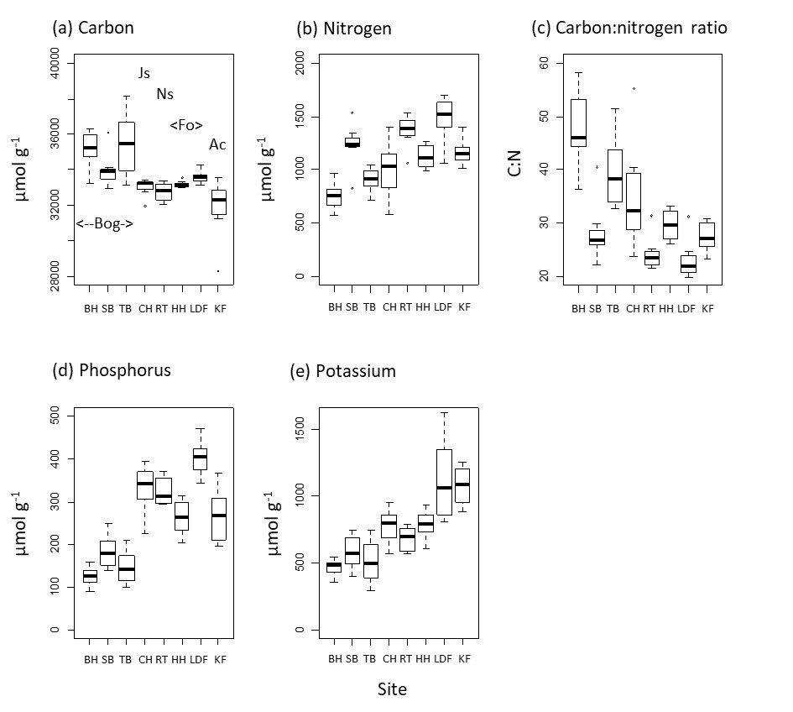

Figure S3. Chemical properties of the herbage from the eight sites at Moor House NNR; as there were no significant treatment effects between ungrazed and grazed plots data for these treatments have been pooled: (a) carbon, (b) nitrogen, (c) soil C:N ratio, (d) P, and (e) K. Site codes: BH = Bog Hill, SB =- Silverband, TH = Troutbeck Head, CH = Cottage Hill, RT = River Tees, HH = Hard Hill, LDF = Little Dun Fell and KF – Knock Fell. Main vegetation types are denoted: Bog = Calluna/Eriophorum, Js = Juncus squarrosus, NS = Nardus stricta, Fo = Festuca ovina and Ac = Agrostis capillaris.

Interpretation of Fig. S3
There were highly significant differences between sites for N (F_{7,8} = 23.84, P<0001), C:N (F_{7,8} = 14.68, P<0001), P (F_{7,8} = 18.06, P<0001), and K (F_{7,8} = 8.32, P<0001),, a marginal difference for C (F_{7,8} = 4.83, P=0.02), and no significant effects for Ca, Mg and Na (P>0.05). The elemental composition of the herbage showed two main responses; (1) CN, C:N ratio and K showed a changing response along the gradation from the bog communities to the Agrostis-Festuca-dominated grassland: C and C:N ratio both decreasing and N and K increasing, and (2) P showed a step response being lower in the three bog communities and greater in all the grassland ones.

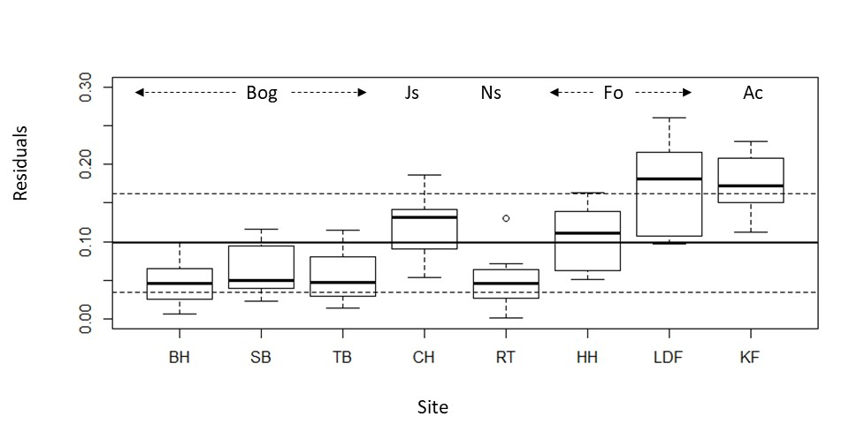

Figure S4. Residual derived from a Procrustes Rotation Analysis of the PCA analyses of the chemical properties of the soils (Fig. 1) and herbage (Fig.4) from the eight sites at Moor House NNR. Site codes: BH = Bog Hill, SB =- Silverband, TH = Troutbeck Head, CH = Cottage Hill, RT = River Tees, HH = Hard Hill, LDF = Little Dun Fell and KF = Knock Fell. Main vegetation types are denoted: Bog = Calluna/Eriophorum, Js = Juncus squarrosus, NS = Nardus stricta, Fo = Festuca ovina and Ac = Agrostis capillaris. Bold vertical line indicates the overall mean.

Table S1 Description of the eight sites each with a sheep-grazing exclosure a comparator grazed site at Moor House NNR in north-west England (data abstracted from Milligan et al., 2016).

Site Name | Plant community type – Dietary fibre analysis | Site code | British National Grid reference | Elevation (m) | Year established | Vegetation type according to  (Eddy et al., 1969) | NVC type according to (Mean Goodness of fit) | NVC description  (Rodwell, 1991, 1992) | Total area of pure stands of the vegetation types on the Moor House reserve (ha) | **Sheep Grazing Density  (sheep ha⁻¹)
Bog Hill | Bog | BH | NY 76789 32869 | 550 | 1953 | Calluna-Eriophorum | M19 (68%) | Calluna vulgaris-Eriophorum vaginatum blanket mire | 1169 | nd
Silverband | Bog | SB | NY 71059 30975 | 690 | 1966 | Eriophoretum (eroding) | M20b (71% ) | Eriophorum vaginatum blanket and raised mire: Calluna vulgaris-Cladonia spp. sub-community | 323 | 0.25
Troutbeck Head | Bog | TB | NY 72236 31760 | 690 | 1966 | Eriophoretum | M20b (73% ) | As above | 419 | 0.5
Cottage Hill | Juncus/Nardus | CH | NY 75801 33641 | 550 | 1967 | Juncus squarrosus grassland | U6b (61%) | Juncus squarrosus-Festuca ovina grassland: Carex nigra-Calypogeia trichomanis sub-community | 373 | 1.4
River Tees | Juncus/Nardus | RT | NY 74796 34485 | 550 | 1967 | Nardus stricta grassland | U5 (73%) | Nardus stricta-Galium saxatile grassland | 416 | 2.8
Hard Hill | Grass | HH | NY 72576 33034 | 690 | 1954 | Festucetum | H19a (61% ) | Vaccinium myrtillus-Cladonia arbuscula heath: Festuca ovina-Galium saxatile sub-community | 180 | 2.6
Little Dun Fell | Grass | LDF | NY 70475 33104 | 830 | 1954 | Festucetum | H19a (63%) | As above | - | 5.8
Knock Fell | Grass | KF | NY 71794 31267 | 750 | 1955 | Limestone Agrosto-Festucetum | CG10 (55% ) | Festuca ovina-Agrostis capillaris-Thymus praecox grassland | 125 | 5.8
*The total area of these communities makes up 3019 ha, i.e. 79% of the reserve area of 3842 ha, the remaining vegetation comprised predominantly re-colonising peatland, Sandstone scree and mosaics of the above vegetation classes (Eddy et al., 1969).
**Sheep grazing density was determined by dropping volume measurement (Rawes & Welch 1969); data were not available for Bog Hill.

Table S2. Results from the Generalized Linear modelling assessing effects of time; the intercept is the Cottage Hill grazed treatment in 1984. Site codes see Table S1, Ungrazed = UG and Year = 2015. Significance: ns=P>0.05, *=P<0.05, ** = P<0.01, ***=P<0.001.

Variable  (Δ AIC) | Treatment | Estimate | Standard Error | t-value | P | Significance
pH  (245.1) | (Intercept) | -29.428 | 10.525 | -2.796 | 0.006 | **
 | SiteHH | 76.861 | 15.004 | 5.123 | <0.001 | ***
 | SiteKF | 39.974 | 14.884 | 2.686 | 0.008 | **
 | SiteLDF | 57.505 | 15.591 | 3.688 | <0.001 | ***
 | SiteRT | 13.481 | 14.884 | 0.906 | 0.367 | ns
 | SiteSB | 58.091 | 17.231 | 3.371 | 0.001 | ***
 | SiteTB | 47.044 | 17.231 | 2.730 | 0.007 | **
 | UG | 15.888 | 14.884 | 1.067 | 0.288 | ns
 | Year | 0.017 | 0.005 | 3.153 | 0.002 | **
 | SiteHH:UG | -14.651 | 21.459 | -0.683 | 0.496 | ns
 | SiteKF:UG | -46.852 | 21.049 | -2.226 | 0.028 | *
 | SiteLDF:UG | 16.057 | 21.873 | 0.734 | 0.464 | ns
 | SiteRT:UG | -31.464 | 21.134 | -1.489 | 0.139 | ns
 | SiteSB:UG | -27.882 | 24.369 | -1.144 | 0.255 | ns
 | SiteTB:UG | -8.561 | 25.449 | -0.336 | 0.737 | ns
 | SiteHH:Year | -0.038 | 0.008 | -5.092 | <0.001 | ***
 | SiteKF:Year | -0.019 | 0.007 | -2.581 | 0.011 | *
 | SiteLDF:Year | -0.029 | 0.008 | -3.661 | <0.001 | ***
 | SiteRT:Year | -0.007 | 0.007 | -0.908 | 0.366 | ns
 | SiteSB:Year | -0.029 | 0.009 | -3.368 | 0.001 | **
 | SiteTB:Year | -0.023 | 0.009 | -2.724 | 0.007 | **
 | UG:Year | -0.008 | 0.007 | -1.070 | 0.287 | ns
 | SiteHH:UG:Year | 0.007 | 0.011 | 0.680 | 0.498 | ns
 | SiteKF:UG:Year | 0.023 | 0.011 | 2.213 | 0.029 | *
 | SiteLDF:UG:Year | -0.008 | 0.011 | -0.725 | 0.470 | ns
 | SiteRT:UG:Year | 0.016 | 0.011 | 1.486 | 0.140 | ns
 | SiteSB:UG:Year | 0.014 | 0.012 | 1.148 | 0.253 | ns
 | SiteTB:UG:Year | 0.004 | 0.013 | 0.338 | 0.736 | ns
Tot.N  (156.6) | (Intercept) | 9.133 | 15.350 | 0.595 | 0.553 | ns
 | SiteHH | -39.910 | 21.890 | -1.823 | 0.071 | ns
 | SiteKF | 8.528 | 21.710 | 0.393 | 0.695 | ns
 | SiteLDF | -46.550 | 22.740 | -2.047 | 0.043 | *
 | SiteRT | 7.540 | 21.710 | 0.347 | 0.729 | ns
 | SiteSB | -4.672 | 25.140 | -0.186 | 0.853 | ns
 | SiteTB | 22.390 | 25.140 | 0.891 | 0.375 | ns
 | UG | -2.197 | 21.710 | -0.101 | 0.920 | ns
 | Year | -0.003 | 0.008 | -0.448 | 0.655 | ns
 | SiteHH:UG | 36.380 | 31.300 | 1.162 | 0.247 | ns
 | SiteKF:UG | -12.580 | 30.700 | -0.410 | 0.683 | ns
 | SiteLDF:UG | 28.010 | 31.710 | 0.883 | 0.379 | ns
 | SiteRT:UG | -1.656 | 30.700 | -0.054 | 0.957 | ns
 | SiteSB:UG | 3.696 | 35.550 | 0.104 | 0.917 | ns
 | SiteTB:UG | -1.659 | 37.120 | -0.045 | 0.964 | ns
 | SiteHH:Year | 0.019 | 0.011 | 1.754 | 0.082 | ns
 | SiteKF:Year | -0.005 | 0.011 | -0.469 | 0.640 | ns
 | SiteLDF:Year | 0.023 | 0.011 | 2.013 | 0.046 | *
 | SiteRT:Year | -0.004 | 0.011 | -0.385 | 0.701 | ns
 | SiteSB:Year | 0.002 | 0.013 | 0.155 | 0.877 | ns
 | SiteTB:Year | -0.011 | 0.013 | -0.908 | 0.366 | ns
 | UG:Year | 0.001 | 0.011 | 0.093 | 0.926 | ns
 | SiteHH:UG:Year | -0.018 | 0.016 | -1.145 | 0.255 | ns
 | SiteKF:UG:Year | 0.006 | 0.015 | 0.411 | 0.682 | ns
 | SiteLDF:UG:Year | -0.014 | 0.016 | -0.897 | 0.372 | ns
 | SiteRT:UG:Year | 0.001 | 0.015 | 0.063 | 0.950 | ns
 | SiteSB:UG:Year | -0.002 | 0.018 | -0.091 | 0.928 | ns
 | SiteTB:UG:Year | 0.001 | 0.019 | 0.044 | 0.965 | ns

