Title: A unique presentation of a rare case of Primary CNS Plasmablastic lymphoma in a HIV+ and EBV+ patient
UT Khan^{1,2}; I Racu-Amoasii³; A Arumainathan¹; U Meswani⁴; AR Pettitt^{1,2}; G Menon³
¹Department of Haematology, Clatterbridge Cancer Centre, Prescot St, Liverpool, L7 8XP
²Institute of Translational Medicine, Department of Molecular and Clinical Cancer Medicine, University of Liverpool, Ashton Street, Liverpool, L69 3GE
³Haemato-oncology Diagnostic Service, Liverpool Clinical Laboratories, Prescot St, Liverpool, L7 8XP
⁴Countess of Chester Hospitals NHS Trust, Department of Haematology, Liverpool Road, Chester, CH2 1UL
Authors’ Contributions:
UTK performed literature search and wrote the paper
IR-A supplied the images
AA, UM and ARP critically reviewed the paper
GM designed and co-wrote the paper
Corresponding author: Dr. Umair Tahir Khan, Institute of Translational Medicine, Department of Molecular and Clinical Cancer Medicine, University of Liverpool, Liverpol, L69 3GE, email: ukhan@liv.ac.uk
Keywords: Primary, Plasmablastic lymphoma, CNS, HIV positive, polyclonal plasmacytosis

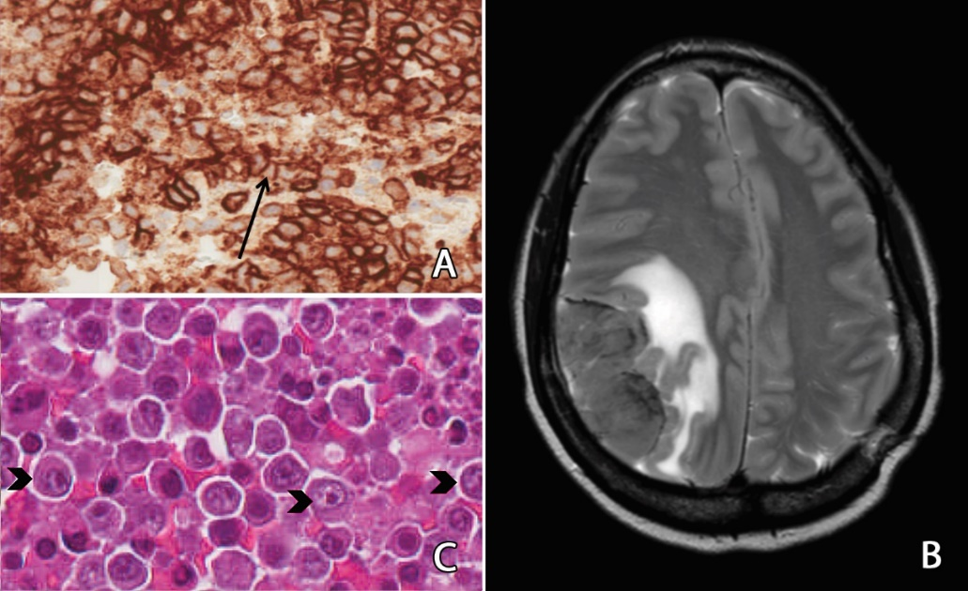
A 29-year-old woman presented with severe headaches, vomiting and drowsiness in January 2016. A CT scan of the brain at the time showed bilateral subdural haematomas with midline shift, sub-falcine herniation and hydrocephalus. The patient underwent a burr-hole procedure with surgical evacuation. At the time of surgery, an extradural mass was noted which was biopsied.
Further investigation showed that the patient was HIV seropositive with an EBV viraemia of 50400 copies/ml and a CMV viraemia of <250 copies/ml by PCR. She was noted to have polyclonal hypergammaglobulinaemia with a serum IgG level of 41.2 g/L. Screens for tuberculosis, schistosomiasis and HHV-8 viraemia were negative. The histology from the extradural mass showed an EBV-associated polyclonal expansion of plasma cells with no evidence of lymphoma (fig. 1A).
The patient commenced anti-retroviral therapy in the expectation that the EBV-associated plasma cell proliferation would regress following restoration of immune function in the absence of systemic lymphoma. However, the patient re-presented in April 2016 with severe headache and left hemiparesis. An MRI showed a new 6.6 x 3.2 x 5cm large enhancing extra-axial mass lesion in right parietal region (fig. 1B) which on repeat biopsy showed plasmablastic lymphoma (fig. 1C). The malignant cells in this disease have a plasma-cell phenotype with expression of CD138, CD38, Vs38c and IRF4/MUM1 with EBV-EBER expression. The patient commenced the MATRix regimen (methotrexate, cytarabine, thiotepa, rituximab) after pre-treatment with dexamethasone but failed to respond after 2 cycles and went on to receive palliative radiotherapy. She subsequently developed bowel obstruction and died in February 2017.
To our knowledge, this is the first report of an EBV-associated polyclonal expansion of plasma cells occurring in the brain. It is also the first report of a primary CNS plasmablastic lymphoma apparently evolving from polyclonal proliferation of plasma cells. Primary CNS plasmablastic lymphoma is very rare, with only eight cases reported in the literature. EBV-associated polyclonal expansion of plasma cells (with the propensity to evolve into lymphoma) is a well-known complication of allogeneic haemopoietic stem-cell transplant but is less well-described in the context of HIV infection. In the latter setting, plasmablastic lymphoma usually occurs de novo and predominantly affects the oral cavity, upper aerodigestive tract, orbit, skin, bone, soft tissues and gastrointestinal tract. The clinical course of our patient is in keeping with the dismal prognosis of plasmablastic lymphoma, with most patients dying within a year of diagnosis.

