The utility of HepaRG cells for bioenergetic investigation and detection of drug-induced mitochondrial toxicity

Laleh Kamalian^{a*}, Oisin Douglas^{a*}, Carol Jollyª, Jan Snoeys^{b}, Damir Simic^{c}, Mario Monshouwer^{b}, Dominic P. Williams^{d}, B. Kevin Parkª, Amy E. Chadwickª

Affiliations:
ª MRC Centre for Drug Safety Science, The Department of Clinical and Molecular Pharmacology, The University of Liverpool, Ashton Street, Liverpool, L69 3GE, UK (l.kamalian@liverpool.ac.uk, oisin.douglas@gmail.com, cejolly@liverpool.ac.uk, bkpark@liverpool.ac.uk, aemercer@liverpool.ac.uk respectively)
^{b} Pharmacokinetics Dynamics and Metabolism, Janssen Research and Development, Beerse, Belgium, JSNOEYS@its.jnj.com
^{c} Mechanistic and Investigative Toxicology, Janssen Research and Development, Spring House, PA, USA, dsimic3@ITS.JNJ.com
^{d} Innovative Medicines and Early Development | Drug Safety and Metabolism | Translational Safety, Darwin Building 310, Cambridge Science Park, Milton Rd, Cambridge, CB4 0FZ, United Kingdom, Dominic.P.Williams@astrazeneca.com
* These authors contributed equally to this study
Corresponding author: Laleh Kamalian
Address: MRC Centre for Drug Safety Science, the Department of Clinical and Molecular Pharmacology, the University of Liverpool, Ashton Street, Liverpool, L69 3GE, UK
Tel: 0044 (151) 7950382
Fax: 0044 (151) 7945540
Email: l.kamalian@liverpool.ac.uk
Abstract
The importance of mitochondrial toxicity in drug-induced liver injury is well established. The bioenergetic phenotype of the HepaRG cell line was defined in order to assess their suitability as a model of mitochondrial hepatotoxicity. Bioenergetic phenotyping categorised the HepaRG cells as less metabolically active when measured beside the more energetic HepG2 cells. However, inhibition of mitochondrial ATP synthase induced an increase in glycolytic activity of both HepaRG and HepG2 cells suggesting an active Crabtree Effect in both cell lines. The suitability of HepaRG cells for the acute metabolic modification assay as a screen for mitotoxicity was confirmed using a panel of compounds, including both positive and negative mitotoxic compounds. Seahorse respirometry studies demonstrated that a statistically significant decrease in spare respiratory capacity is the first indication of mitochondrial dysfunction. Furthermore, based upon comparing changes in respiratory parameters to those of the positive controls, rotenone and carbonyl cyanide m-chlorophenyl hydrazone, compounds were categorised into two mechanistic groups; inhibitors or uncouplers of the electron transport chain. Overall, the findings from this study have demonstrated that HepaRG cells, despite having different resting bioenergetic phenotype to HepG2 cells are a suitable model to detect drug-induced mitochondrial toxicity with similar detection rates to HepG2 cells

Key words: mitochondria; drug-induced liver injury; HepaRG; seahorse; glucose/galactose; bioenergetic phenotype

Abbreviations in alphabetical order
ALR: ATP-linked respiration
BCA: bicinchoninic Acid
BR: basal respiration
CCCP: cyanide m-chlorophenyl hydrazine
CPT: carnitine palmitoyl transferase
CYP450: cytochrome P450
DILI: Drug-induced liver injury
DMEM: Dulbecco Modified Eagle Medium‎
ECAR: extra-cellular acidification rate
ETC: electron transport chain
FBS: Foetal bovine serum
FCCP: carbonyl cyanide 4-(trifluoromethoxy)phenylhydrazone
FHH: Fresh human hepatocyte
GPER: glycolytic proton efflux rate
LDH: lactate dehydrogenase
MIP-DILI: Mechanism Based Integrated systems for Prediction of Drug Induced Liver Injury
MRC: maximum respiratory capacity
NMR: non-mitochondrial respiration
OCR: Oxygen consumption rate
OXPHOS: oxidative phosphorylation
PBS: phosphate buffered saline
PL: proton-leak
SD: standard deviation
SRC: spare respiratory capacity
XF Mito-Stress test: Seahorse mitochondrial stress test

Introduction
Drug-induced liver injury (DILI) is a major clinical concern and one of the main reasons for liver related hospitalisation in developed countries [1-3]. In many cases hepatotoxic potential is not detected during routine preclinical drug safety screens. This can arise due to the idiosyncratic nature of the hepatotoxicity [2] or, in cases such as fialuridine, due to the delayed onset of clinical DILI in combination with species selectivity [4, 5]. The cost of DILI is not only economic to the pharmaceutical industry due to drug attrition but it can also cause fatality in cases of pre- and post-approval severe liver injury [6]. Therefore, the development of new strategies to predict, during preclinical testing, the capability of a new compound to induce liver damage remains a major concern to both regulatory agencies and pharmaceutical industry.
Mitochondria are considered to be one of the main targets through which drugs can induce hepatocellular injury [7]. Around 50% of compounds that have received black box warnings for hepatotoxicity have been shown to have mitochondrial liabilities [8]. However, the preclinical assessment of mitochondrial toxicity has been limited by the lack of in vivo models suitable for the detection of mitochondrial toxicity, in part due to the nature of experimental rodents and their large respiratory capacity in addition to high levels of compensatory mechanisms [9].
Although fresh human hepatocytes (FHH) are considered the most physiologically relevant model system for investigating drug-induced hepatotoxicity, their utility is reduced by a number of factors including their infrequent and unpredictable availability, expense and innate inter-individual variation [10]. In addition, FHH have limited lifespan, tending to quickly alter their characteristic phenotype post-isolation [10]. Therefore, the development of more easily available and phenotypically consistent liver cell models would be highly advantageous for drug discovery, drug development and drug safety science [11, 12].
The in vitro identification of mitochondrial toxicants is hindered due to the tumorigenic origin of many hepatic cell lines owing to the Crabtree effect [13]; a situation where the energy requirements of a cell can be met by glycolysis alongside oxidative phosphorylation (OXPHOS). These cell lines are able to switch to glycolysis when OXPHOS is no longer available, for example due to hypo-oxygenation or mitochondrial damage, in order to produce sufficient ATP to continue survival [14]. Although glycolysis is less efficient in terms of ATP production than OXPHOS, it is sufficient for the cells to survive for a limited period. Thus when cells are cultured in a glucose rich environment mitochondrial damage is initially masked until ATP produced by glycolysis is no longer sufficient to support cell survival leading to a drop in ATP which coincides with other indications of cell death [15]. Over the last decade the Crabtree effect has been exploited to enable the detection of mitotoxicants in vitro. Specifically, cells are deprived of glucose, the main substrate of glycolysis, and are instead cultured in an alternative fuel source, galactose, that produces a net ATP production close to zero after glycolysis [16]. In this altered environment, drug-induced mitochondrial dysfunction cannot be masked by glycolytic ATP production, in fact, an early decrease in cellular ATP should be apparent before any signs of cell death appears [17, 18].
In our previous work we introduced the acute metabolic modification assay in HepG2 cells, which is a modified short glu/gal assay and used it to examine a panel of training compounds, selected by the MIP-DILI (Mechanism Based Integrated systems for Prediction of Drug Induced Liver Injury) consortium, consisting of compounds with positive or negative hepatotoxicity or mitochondrial toxicity (Table 1). This assay proved highly specific, i.e. all compounds identified as positive mitochondrial toxins were indeed reported in the literature as such [18]. However, due to a lack, or very low amount, of metabolizing enzymes in HepG2 cells, a limitation of this screen was that it might give false negative results when investigating drug metabolite-driven mitochondrial toxicity. Furthermore, due to the proliferative nature of HepG2 cells, long term incubation (> 7 days) of compounds can be difficult to model [18].
The HepaRG cell line is a hepato-carcinoma originated cell line [19], which once differentiated consists of two different cell populations; hepatocyte-like and epithelial cells. This mixed cell population are reported to have improved hepatocyte-like characteristics including more abundant cytochrome P450 (CYP450) enzymes, bile canaliculi structures and higher expression of bile acid transporters compared to HepG2 cells [20-24]. The presence of these physiological characteristics, alongside the fact that, once confluent, these cells stop proliferation which offers the opportunity to test toxicity over longer time-courses, makes them an attractive alternative in vitro model for the study of hepatotoxicity over other cell lines, including HepG2 cells [19, 25]. Several hepatotoxicity studies have been reported using HepaRG cells, however, their fitness as a screening model specifically for mitochondrial toxicity remains unclear. Therefore, this study was planned to define the utility of HepaRG cells as a screening tool for mitochondrial hepatotoxicity. Specifically, the bioenergetic phenotype of HepaRG cells in comparison to HepG2 cells was established, including whether they are subject to the Crabtree effect using the XF bioenergetic phenogram tool of Seahorse technology. Following this, the utility of HepaRG cells in screening for mitochondrial toxicants using the acute metabolic modification assay as well as respirometric analysis with the Seahorse respirometer was assessed. These assays were performed using a panel of MIP-DILI training compounds [7], previously used in the HepG2 model [18] (Table 1).

Table 1: A summary of literature review for the mitochondrial liabilities of the compounds used in this manuscript.
 | Compound | Primary Use | Clinical Availability | Hepatotoxic? | Mitochondrial Liability?
Controls | Rotenone | Insecticide | N/Aª | N/Aª | Yes
 | CCCP | Weak acid | N/Aª | N/Aª | Yes
 | Antimycin-A | Fish poison | N/Aª | N/Aª | Yes
 | Digitonin | Detergent | N/Aª | N/Aª | No
MIP-DILI Training compounds | Paracetamol | Pain killer | Available | Yes  mediated via reactive metabolites | Yes [26, 27]
 | Amiodarone | Anti-arrhythmic | Black-box warning | Yes | Yes [28, 29]
 | Nefazodone | Anxiolytic | Discontinued | Yes | Yes [30]
 | Buspirone |  | Available | Yes
 | Tolcapone | Anti COMT | Black-box warning | Yes | Yes [31, 32]
 | Entacapone |  | Available | No
 | Bosentan | Endothelin receptor antagonist | Available | Yes | Indirectly via bile acids [33]
 | Diclofenac | Nonsteroidal anti-inflammatory drug | Available | Yes | Yes [34]
 | Metformin | Antidiabetic | Available | No | Yes [35]
 | Perhexiline | Antianginal | Available | Yes | Yes [29]
 | Ximelagatran  via active form melagatran | Anticoagulant | Withdrawn | Yes | No [36]
 | Troglitazone | Antidiabetic | Withdrawn | Yes | Yes [37, 38]
 | Pioglitazone |  | Available | No
a: N/A because the chemical is not a pharmaceutical compound currently used as a drug.

Materials and methods
Materials
Foetal bovine serum (FBS), Dulbecco Modified Eagle Medium‎ (DMEM) high glucose, phosphate buffered saline (PBS) and collagen I rat protein were purchased from Life Technologies (Paisley, UK). All Seahorse consumables were purchased from Seahorse Bioscience or Agilent Technologies (Boston, USA and Santa Clara, USA respectively). HepaRG cells, basal media, growth and differentiation additives were acquired from Biopredic International (Saint Grégoire, France). Williams’ E Medium powder (with L-Glutamine, without glucose) was manufactured by United States Biological. HepG2 cells were acquired from the European Collection of Cell Cultures (Salisbury, UK). Cytotoxicity Detection Kit was purchased from Roche Diagnostics Ltd (West Sussex, UK). All other materials and compounds were purchased from Sigma Aldrich (Poole, Dorset, UK).

Cell culture
HepG2 cells were cultured and maintained in DMEM high glucose media containing L-glutamine (4 mM ) and glucose (25 mM), supplemented with 10% FBS (v/v), sodium pyruvate (1 mM) and HEPES (1 mM). All cells were incubated under humidified air containing 5 % CO₂ at 37 °C. Cells were used up to passage 20.
After thawing out, HepaRG cells were allowed to grow in HepaRG growth media (base media plus growth additives) for two weeks, changing the growth media twice a week. Cells were then seeded on to appropriate assay plates at seeding densities recommended by Biopredic International in HepaRG growth media, changing the media twice a week for two weeks. The cells were then allowed to fully differentiate in complete differentiation media (base media plus differentiation additives) for the subsequent two weeks, changing the media twice a week. The fully differentiated cells were used in the space of four weeks, being maintained in differentiation media. All experiments were performed using cells at passage number <20.

Seahorse mitochondrial stress test (XF Mito-Stress test)
Undifferentiated HepaRG cells were initially plated in collagen coated (50 µg/ml rat tail collagen type II in 0.02 M acetic acid) XF 96-well cell culture microplates at 3600 cells/well. Following differentiation, the culture medium was replaced by unbuffered XF basal medium (175 µl, pH 7.4) supplemented with glucose (25 mM), L-glutamine (2 mM) and sodium pyruvate (1 mM) before incubating in a CO₂ free incubator (37 °C). For the basic Mito-Stress test on untreated cells, three basal measurements, were followed by oligomycin, carbonyl cyanide 4-(trifluoromethoxy)phenylhydrazone (FCCP) and rotenone/antimycin-A, injected sequentially (1, 0.25 and 1µM/1µM respectively), with each injection followed by three measurement cycles. Where the compound was acutely injected, the drug injection was performed immediately after two basal measurement cycles, then followed by a standard XF Mito-Stress test as described. Oxygen consumption rate (OCR) (pmol/min) and extra-cellular acidification rate (ECAR) (mpH/min) values were normalised to the number of the cells in each well.
To determine the glycolytic contributions to total extracellular acidification the ECAR values were converted to glycolytic proton efflux rate (GPER) (pmol/min/10000cells) according to manufacturer guidelines [39]. This value is used throughout the manuscript instead of ECAR.
From each Mito-Stress test the OCR parameters of non-mitochondrial respiration (NMR= lowest measurement after rotenone/antimycin-A), basal respiration (BR= last measurement before oligomycin – NMR), proton-leak (PL= BR – lowest respiration after oligomycin), ATP-linked respiration (ALR = BR – PL), maximum respiratory capacity (MRC= highest measurement after FCCP – NMR) and spare respiratory capacity (SRC= MRC – BR) (Figure 1) were calculated. From GPER values basal and oligomycin-induced glycolysis (GPER values before and after oligomycin injection respectively) were calculated. To avoid repetition, the OCR and GPER values in this manuscript are in pmol/min/10000cells.

Figure 1: A typical seahorse Mito-Stress test trace. Port A, B, C and D refer to injection ports on the XF sensor cartridge. OCR: Oxygen Consumption Rate, BR: Basal Respiration, SRC: Spare Respiratory Capacity, MRC: Maximum Respiratory Capacity, ALR: ATP-Linked Respiration, PL: Proton Leak, NMR: Non-Mitochondrial Respiration
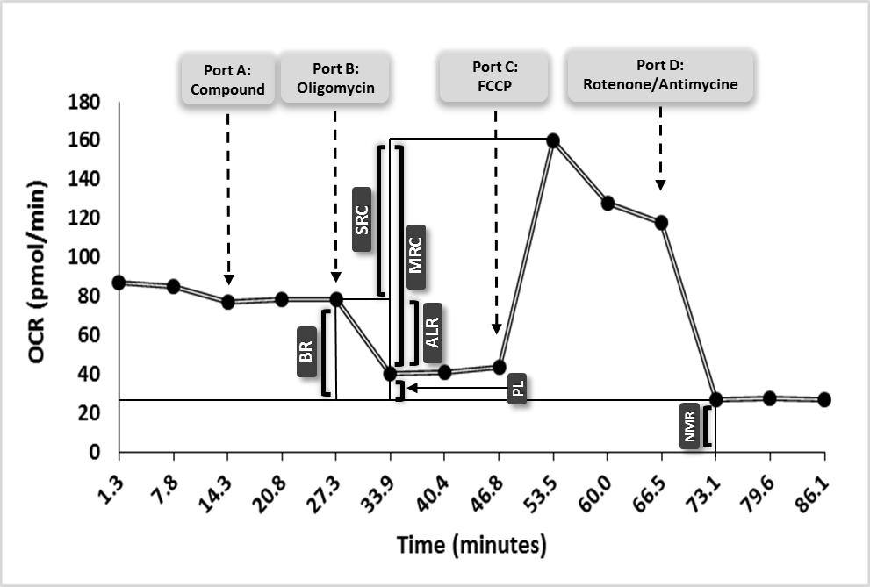

Bioenergetic phenogram of HepaRG and HepG2 cells
Bioenergetic phenotype is an entity introduced by Agilent Seahorse [40], used by many researchers [41], describing the bioenergetic profile of cells i.e. how they utilise mitochondrial respiration and glycolysis as their two major ATP sources. A phenogram, is the cross-points of OCR and GPER (or ECAR) values to describe energy derivation basally, or after the introduction of a test compound.

Acute metabolic switch assay with combined ATP-LDH-protein assay
Glucose and galactose assay media were prepared from serum- and glucose-free William’s E medium, made from Williams’ E Medium powder, supplemented with insulin (5 µg/ml), L-glutamine (2 mM), hydrocortisone (50 µM) and sodium bicarbonate (3.7 mg/ ml). To this was added either D-glucose at 11 µM, the concentration of glucose in differentiation media according to Biopredic International or D-galactose at10 mM.
On the day of assay, the fully differentiated cells were washed twice and then pre-treated with either glucose or galactose media (5 % CO₂ incubator, 37ºC, 2 h), then incubated (2 h) with drug or vehicle control. The concentrations used for rotenone, antimycin A and carbonyl cyanide m-chlorophenyl hydrazine (CCCP) (positive controls) and digitonin (negative control) ranged from 0.1 to100 µM, whilst the concentrations used for MIP-DILI training compounds ranged from 1.2 to 300 µM. In extended assays, a higher concentration range (> 300 µM) and longer incubation time (>2 h) were employed, the top concentration was selected for each drug separately according to literature [18]. In all cases the final concentration of DMSO in a well was at a constant 0.5 % (v/v).
Following drug incubation, media was removed and retained and cells were lysed in somatic cell ATP releasing reagent (100 µl). The lysate was used to determine the ATP and protein level of the each well using the Adenosine 5′-triphosphatebioluminescent somatic cell assay kit and BCA protein assay respectively according to manufacturer’s guidelines. The ATP content of each well was then normalised to the protein content of the same well. The lactate dehydrogenase (LDH) content of the lysate and media from the same well were measured separately according to the instructions of Cytotoxicity Detection Kit. The retained LDH within the cells was determined according to the following formula:
Cellular retained LDH = LDH in lysate/ (LDH in the lysate + LDH in the supernatant)
The ATP and retained LDH levels are reported as percentage of the vehicle.
The IC₅₀ values, the concentration at which cellular ATP or LDH level reach 50% of the vehicle control were calculated (Table 1). The criteria used to label a compound as direct mitochondrial toxin was applied as defined in previous work in HepG2 cells [18], thus: if the IC₅₀ obtained for ATP level in glucose media (IC₅₀-ATP-Glu) was significantly higher than the one of galactose media (IC₅₀-ATP-Gal), and also if the IC₅₀ obtained for LDH level in galactose media (IC₅₀-LDH-Gal) was significantly higher than IC₅₀-ATP-Gal, the compound was labelled as a mitochondrial toxicant. In addition, if the IC₅₀-ATP-Glu/IC₅₀-ATP-Gal and IC₅₀-LDH-Gal/IC₅₀-ATP-Gal ratios were two folds or more the compound was considered to be a mitochondrial toxicant.

Statistical analysis
Each experiment was performed on three or more independent occasions (n ≥3). IC₅₀ values were calculated using GraphPad Prism 7 software, and were expressed as a mean ± standard deviation (SD) up to 2 decimal points, unless the number was <0.01 in which case the number of decimals were increased to 3 decimal points. To test the difference between basal OCR and GPER values obtained from HepG2 or HepaRG cells before and after oligomycin injection, a paired Student-t Test was used. For all other statistical analysis comparing the values obtained from treated cells to the one from the vehicle control an unpaired Student t-test (two-sample t-test with Welch correction, assuming unequal variances) with 95% confidence interval was used. P values lower than 0.05 were considered as statistically significant for both tests.

Results
HepaRG cells perform less ATP-linked respiration, but reserve more spare respiratory capacity, than HepG2 cells.
The respiratory parameters of HepaRG cells were defined alongside the tumourogenic model counterpart, HepG2 cells (Figure 2). For each cell line the OCR values (pmol/min/10000 cells) corresponding to MRC, SRC, PL and ALR were calculated and then PL, ALR and SRC were expressed as a proportion of MRC (%). The results indicate a significantly higher (p = 0.031) proportion of ALR in HepG2 cells (53.1 ± 11.2%) compared to that of the HepaRG cells (31.0 ± 15.3%), whilst the SRC occupied a significantly greater proportion of the MRC in the HepaRG cells (59.6 ± 20.3%) than that in the HepG2 cells (28.0 ± 13.9%) (p = 0.024). Also the percentage of OCR corresponding to PL was significantly higher in HepG2 cells (19.0 ± 6.9) than in HepaRG cells (9.4 ± 5.4) (p = 0.004).

Figure 2: Comparison between respiratory components obtained from XF Mito-Stress test in untreated HepG2 and HepaRG cells presented as percentages of Maximum respiratory capacity (Maximum OCR) when Maximum OCR is set to 100%. OCR: Oxygen Consumption Rate, *: P values < 0.05 (Unpaired Student t-Test with Welch correction).
HepaRG and HepG2 cells express different bioenergetic phenograms at the resting condition, but both become more “glycolytic” in response to inhibition of mitochondrial ATP synthesis.
The bioenergetic phenogram of HepaRG and HepG2 cells was constructed from respirometry measurements basally, and after exposure to oligomycin (Figure 3). Before ATP-synthase inhibition (Basal), HepaRG cells were observed to have higher basal OCR values than HepG2 cells (3.64 ± 0.57 and 2.11 ± 0.98 pmol/min/10000 cells respectively). However, HepG2 cells produce ATP via glycolysis in their basal form (GPER 0.75 ± 0.15) whilst HepaRG cells do not (GPER 0 pmol/min/10000 cells). The difference between the two cell lines for both OCR and GPER values were statistically significant (p 0.022 and 0.001, respectively).
Following oligomycin injection, both cell lines shifted to the left to indicate an increase in glycolysis; higher GPER, and down, lower OCR (Figure 3). The changes in OCR and GPER values were statistically significant for both cell lines (p values of 0.016 and 0.007 for HepG2, and 0.002 and 0.014 for HepaRG, for differences in OCR and GPER values respectively).

Figure 3: Bioenergetic phenogram of HepG2 (black lines and symbols) and HepaRG (grey lines and symbols) cells without any treatment (basal) and when treated with oligomycin. OCR: oxygen consumption rate, GPER: glycolytic proton efflux rate, *: 0.01<P<0.05, **: 0.001<P≤0.01, (Paired Student t-Test, for difference between treated and untreated, or Unpaired Student-t Test with Welch correction, for difference between two cell lines.)

HepaRG cells can switch to glycolysis readily, and can be used in short glucose deprivation assay to screen for mitochondrial toxicity.
The ability of HepaRG cells to switch to glycolysis and their utility in a short metabolic switch assay was next evaluated using toxins with known toxicity mechanisms; complex I inhibitor rotenone, complex III inhibitor antimycin A and ETC uncoupler CCCP as positive controls and detergent digitonin as a negative control (Table 2 and Figure 4). In all positive controls the IC₅₀-ATP-Glu/IC₅₀-ATP-Gal and ratio IC₅₀-LDH-Gal/IC₅₀-ATP-Gal ratios were many folds greater than two. Furthermore, in these compounds, the difference between IC₅₀-ATP-Glu and –Gal and IC₅₀-ATP-Gal and –LDH-Gal were statistically significant and so all were successfully recognised as direct mitochondrial toxins (Table 2). Conversely, with digitonin IC₅₀-ATP-Glu/IC₅₀-ATP-Gal and IC₅₀-LDH-Gal/IC₅₀-ATP-Gal ratios were close to 1, a profile indicative of a cytotoxic compound.

Table 2: ATP and LDH IC50 values (µM) in glucose and galactose media. Table includes values for positive and negative mitotoxicity controls plus MIP-DILI training compounds reduced ATP and/or LDH level to 50% of the vehicle control

 | IC₅₀-ATP (µM) ± S.D. |  | IC₁₅₀-LDH (µM) ± S.D. |  | IC₅₀ATPglu/IC₅₀ATPgal  (p value) | IC₁₅₀LDHgal/IC₅₀ATPgal  (p value)
 | Glucose | Galactose | Glucose | Galactose
Control Compounds
Rotenone | >100 | 0.17 ± 0.04 | >100 | >100 | >605 (< 0.001) | >605 (< 0.001)
Antimycin A | 14.47 ± 5.18 | 0.06 ± 0.00 | >100 | >100 | >241 (0.040) | >1663.2 (< 0.001)
CCCP | >100 | 1.40±0.11 | >100 | >100 | >71 (< 0.0001) | >71 (< 0.001)
Digitonin | 7.65 ± 1.64 | 8.82 ± 2.01 | 6.80 ± 0.07 | 8.00 ± 2.07 | 0.87 (0.478) | 0.90 (0.646)
MIP-DILI Training Compounds
Amiodarone | 138.73 ± 5.72 | 62.44 ± 3.57 | >300 | >300 | >2.22 (< 0.001) | >4.80 (<0.001)
Nefazodone | 70.73 ± 11.16 | 33.13 ± 0.41 | >300 | >300 | >2.13 (0.028) | >9.05 (<0.001)
Tolcapone | 154.94 ± 12.50 | 91.86 ± 18.99 | >300 | >300 | >1.68 (0.017) | >3.26 (0.003)
Buspirone | >900 | 281.42 ± 8.15 | >900 | >900 | >3.20 (<0.001) | >3.20 (<0.001)
Perhexiline | 49.93 ±16.30 | 28.78 ± 3.88 | 48.98 ± 12.60 | 39.48 ± 8.72 | 1.73 (0.160) | 1.37 (0.147)
Troglitazone | 33.07 ± 0.48 | 31.40 ± 1.56 | 169.42 ± 6.22 | 173.18 ± 3.71 | 1.05 (0.220) | 5.51 (<0.001)

Figure 4: Short (2 hours) metabolic switch assay in HepaRG cells using rotenone, CCCP and antimycin-A as positive controls and digitonin as a negative control (serial concentrations up to 100 µM). Glucose and Galactose refer to media containing glucose and galactose respectively. Cellular ATP and LDH levels in the two different media are presented as percentages of the vehicle (DMSO) control.
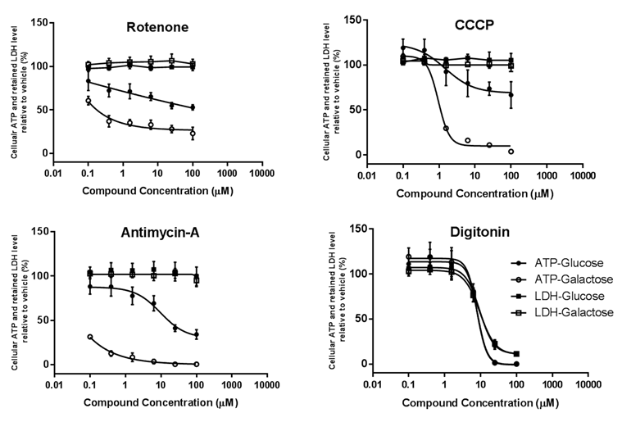

The acute metabolic switch assay can identify mitotoxic compounds in HepaRG cells.
Short two hours assay using up to 300 µM of the compounds: A set of MIP-DILI training compounds were examined to assess whether the acute metabolic switch for 2 hours, followed by 2 hour drug-incubation at low concentration could identify those with mitochondrial liability (Table 2, Figure 5).

Figure 5: Short (2 hours) metabolic switch assay in HepaRG cells using MIP-DILI training compounds. A: Compounds positive for mitotoxicity (concentrations up to 300 µM). B: Compounds positive for mitotoxicity (concentrations up to 900 µM). C: Compounds negative for mitotoxicity (concentrations up to 300 µM). D: Compounds which were cytotoxic (ATP and LDH levels reduced at the same time in both glucose and galactose media). Glucose and Galactose refer to media containing glucose and galactose respectively. Cellular ATP and LDH levels in the two different media are presented as percentages of the vehicle (DMSO) control.
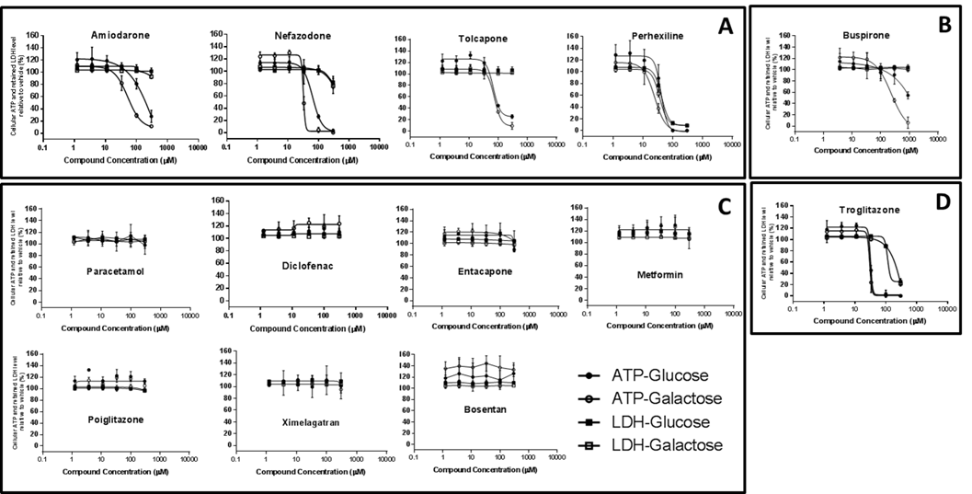

Four of the 12 training compounds, amiodarone, nefazodone, perhexiline and tolcapone, fulfilled the criteria for mitochondrial toxins. Buspirone also caused a significantly lower IC₅₀ value for ATP level in galactose than glucose media, after 2 hours incubation at 300 µM concentration, but only reduced the ATP level to 50% when used at 900 µM concentration. Therefore, this compound was also classified as a positive mitochondrial toxicant (Table 2). Troglitazone displayed a profile, in which the ATP and LDH level decreased in a rate not significantly different between glucose and galactose media. However, LDH level decreased at statistically higher IC₅₀ concentrations (169.4 ± 6.2 and 173.2 ± 3.7 µM in glucose and galactose media respectively) than ATP level (33.1 ± 0.5 and 31.4 ± 1.6 in glucose and galactose media respectively). Eight out of 12 compounds, including paracetamol, diclofenac, entacapone, metformin, pioglitazone and ximelagatran did not change ATP or LDH level in either glucose or galactose media in the tested concentration range (1.2-300 µM).
Longer duration assays using higher concentrations of compounds: The compounds which were identified as negative in the short two hour assay, were incubated with higher concentrations of the test substances and longer durations. The shortest period of incubation and lowest concentration at which the cellular ATP decreased to a significantly lower level in galactose media than in glucose media whilst the LDH level remained unchanged in both media was defined (Table 3). Paracetamol (2 h, 10 mM), diclofenac (6 h, 3 mM), entacapone (6 h, 1 mM) and metformin (8 h, 2.5 mM) met that criteria and thus could be classified as mitotoxic. Pioglitazone and ximelagatran did not reduce the ATP level significantly up to 24 hours, 2 mM and 2.7 mM respectively (Table 3, Figure 6).

Figure 6: Exposure of the compounds that were negative in the short assay to higher concentrations and/or for an extended duration. Graphs depict the lowest concentration and the shortest duration at which the compound reduced the ATP level in galactose media to: 1) a significantly lower level than ATP in glucose and, 2) a significantly lower level than that of the LDH level in galactose media. *: 0.01≤ P <0.05, **: 0.001≤ P <0.01, ***: 0.0001≤ P< 0.001, ****:P<0.0001 (Unpaired Student t-Test with Welch correction).

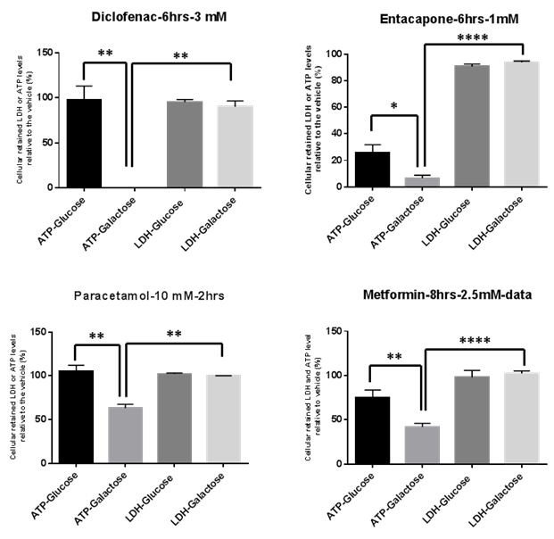

Table 3: Comparison of the mito-toxic effect of MIP-DILI training compounds on HepG2 and HepaRG cells. The concentrations (µM) shown correspond to the lowest concentration that reduced ATP level in galactose media significantly lower than in glucose media. Duration refers to the time point at which the mito-toxic effect was observed. p values were obtained using unpaired student-t Test of the difference.
Cell line | HepG2 |  |  |  | HepaRG
Compound | Conc. (µM) | Duration  (hours) | p-value | Mitochondrial liability | Conc. (µM) | Duration  (hours) | p-value | Mitochondrial liability
Amiodarone | 158 ± 30 | 2 | 0.001 | Yes | 63 ± 30 | 2 | 0.023 | Yes
Nefazodone | 17 ± 5 | 2 | 0.047 | Yes | 33 ± 5 | 2 | 0.002 | Yes
Troglitazone | 28 ± 8 | 2 | N/S | Yes | N/Aª | 2 | N/S | No
Tolcapone | 53 ± 4 | 2 | <0.001 | Yes | 92 ± 19 | 2 | 0.017 | Yes
Buspirone | 338 ± 105 | 2 | <0.001 | Yes | 281 ± 8 | 2 | 0.003 | Yes
Perhexiline | N/Aª | 2 | N/S | No | N/Aª | 2 | N/S | No
Paracetamol | 30000 | 4 | 0.018 | Yes | 10000 | 2 | 0.002 | Yes
Entacapone | 1000 | 4 | 0.003 | Yes | 1000 | 6 | 0.015 | Yes
Metformin | 3000 | 8 | 0.002 | Yes | 2500 | 6 | 0.029 | Yes
Diclofenac | 1000 | 4 | 0.029 | Yes | 3000 | 6 | <0.001 | Yes
Pioglitazone | 1000 | 4 | 0.002 | Yes | 2700ª | 24 | N/S | No
Ximelagatran | 2700ª | 8 | N/S | No | 2700^{b} | 24 | N/S | No
a: There was not ATP-IC₅₀₋gal and –glu concentrations were not was not significantly different.
b: The highest concentration that was used in the assay, without any significant change in ATP or LDH level in glucose or galactose media
N/S: Not significant
Conc.: Concentration

Spare respiratory capacity is the most sensitive parameter that is decreased if the compound is a mitotoxicant.
Rotenone, CCCP and the ten MIP-DILI training compounds were analysed by XF Mito-Stress test experiments. Pioglitazone and amiodarone were excluded from this study due to inconsistent solubility in XF media, at concentrations equal or higher than 250 and 75 µM respectively, which resulted in large variation between measurements. Test concentrations were selected which effectively reduced ATP levels in the absence of cytotoxicity, based upon metabolic switch assays (Table 3). The parameters of ALR and SRC were expressed as a percentage of vehicle control and the concentrations that reduced ALR and SRC to 50% of the vehicle control (IC₅₀) were calculated. Evidence of mitochondrial dysfunction, defined as a significant decrease in either ALR or SRC level compared to the vehicle control, was observed in 10 out of 12 compounds. SRC was observed to be the only measurement significantly decreased to 50% of the level of vehicle (induced by buspirone, nefazodone and tolcapone) and also to produce an IC₅₀ concentration lower than ALR (Rotenone, CCCP, perhexiline, troglitazone, paracetamol, entacapone and diclofenac), suggesting it to be a more sensitive measurement of whether a compound has a mitochondrial liability (Table 4).
Within the range of concentrations used for this assay, metformin and ximelagatran did not reduce either ALR or SRC level when compared to the vehicle control.

Table 4: Concentrations (µM) of rotenone, CCCP and MIP-DILI training compounds that reduced Spare Respiratory Capacity and ATP-Linked respiration to 50% of the vehicle control.
 | IC₅₀ (µM) ± SD
Compound | Spare respiratory capacity | ATP-linked  respiration
Rotenone | 0.02 ± 0.007 | 0.08 ± 0.05
CCCP | 0.39 ± 0.29 | 2.76 ± 1.12
Troglitazone | 26.18 ± 10.38 | 44.40 ± 9.64
Perhexiline | 52.86 ± 2.97 | 196.86 ± 0.001
Entacapone | 357.00 ± 207.12 | 241.19 ± 76.30
Diclofenac | 407.33 ± 152.96 | 523.61 ± 70.37
Paracetamol | 24430.06 ± 8426.73 | 29046.91 ± 3824.64
Buspirone | 272.05 ± 71.95 | >900
Nefazodone | 7.09 ± 1.57 | >300
Tolcapone | 10.28 ± 4.12 | >300
Amiodarone | >300 | >300
Ximelagatran | >300 | >300
Metformin | >2000 | >2000

A combined approach assessing SRC and ALR alongside BR can be used to predict mechanism of mitochondrial toxicity of a compound.
The profiles of ALR, SRC and BR were studied following the acute injection of compounds for evidence of specific mitochondrial toxicity mechanism based upon the profiles of rotenone and CCCP which have clearly defined mechanisms. As expected, rotenone showed significant decrease in SRC and ALR accompanied by a decrease in BR at concentrations as low as 0.2 nM. Therefore, this respiratory profile was deemed to indicate inhibition of the electron transport chain. CCCP also demonstrated a significant decrease in SRC at concentrations higher than 0.7 µM and a decrease in ALR, although it was not statistically significant. However, the BR level started to significantly increase from the lowest concentration (0.05 µM) as is expected from a compound with uncoupling properties. The two different profiles of OCR changes observed for rotenone and CCCP were thus deemed to represent two mechanisms of respiratory chain dysfunction; ETC inhibitors and uncoupling of OXPHOS (Figure 7A).
Ten MIP-DILI training compounds were tested for their acute effect on OCR using XF analyser. By comparing to the defined profiles, as described above, Ximelagatran increased the ALR but decreased BR, which was concomitant by a decrease in PL (data not shown) across the concentrations used for this assay (Figure 7B) therefore was not labelled to cause mitochondrial dysfunction. Paracetamol, nefazodone, buspirone, diclofenac and troglitazone decreased SRC with or without decrease in ALR, accompanied with either decreased or unchanged BR thus predicting that these compounds were primarily inhibitors of ETC complexes (Figure 7C). Tolcapone, entacapone and perhexiline showed decrease of SRC with or without ALR, but with concomitant increases in BR thus these compounds are predicted to have some uncoupling properties as part or main mechanisms of toxicity based on this method (Figure 7D). Metformin did not change either ALR or BR compared to the vehicle control in the range of concentrations tested in this study (2 mM) (Figure 7E).

Figure 7: The effect of the acute injection of compounds on respiratory parameters in XF-Mito-Stress test. A: Representative differences in respiratory profiles of rotenone and CCCP. B-D: Respiratory profiles of MIP-DILI training compounds. *, # and $ correspond to statistical significance (with multiples of each symbol indicating the level of significance as denoted in figure 5) in ATP-Linked respiration, Spare respiratory capacity and the Basal respiration respectively compared to vehicle control. (Unpaired Student t-test with welch correction)
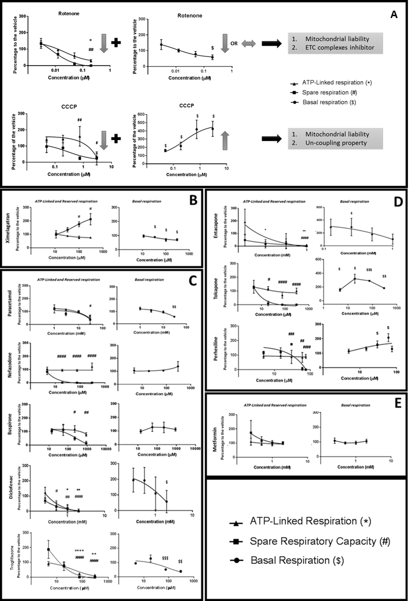

Discussion
Previously, hepatoma-derived cell lines such as HepG2 has proven useful in the study of mitochondria-driven hepatotoxicity [15, 17, 42-44]. Tumourogenic cells have an advantage over the use of FHH for the mitochondrial screening as the presence of the Crabtree effect enables the metabolic modification which underlies the glu/gal assay used by Pharma. However, the studies undertaken in this manuscript were designed to define the suitability of a more hepatocyte-like cell line, HepaRG cells, as a model of mitotoxicity. The bioenergetic profile of HepaRG cells was defined and their utility in the acute metabolic modification (glu/gal) assay for the identification of mitochondrial toxins established using a set of compounds well characterised in the HepG2 acute metabolic modification assay [18]. Finally, we used HepaRG cells to construct an analytical framework, using data generated from the seahorse mito-stress test, to categorise compounds according to the mechanism by which they induce mitochondrial dysfunction.
By defining the baseline bioenergetic phenotype of fully differentiated HepaRG cells it has been demonstrated that in these cells a lower proportion of MRC is attributed to ALR, but this is balanced by a higher SRC compared to HepG2 cells (Figure 2). This result can be rationalised due to the proliferative nature of HepG2 cells with a resultant high energy expenditure when compared with differentiated HepaRG cells which stop growing upon reaching confluence [45] and so have lower energy requirements . These investigations also revealed that the mitochondrial respiratory function of HepaRG cells responds in a similar manner to HepG2 cells when exposed to classic stimulants and inhibitors of mitochondrial electron transport chain, despite their differentiated status (Figure 4). The bioenergetic phenogram demonstrated that untreated HepG2 cells are more glycolytic than HepaRG cells, whilst HepaRG cells use more OXPHOS. However, in both models, when OXPHOS driven ATP synthesis is reduced, the cells can be seen to shift downwards and to the left, i.e. to a less OXPHOS but more glycolytic position (Figure 3). Based upon these findings it can be established that despite being a mixed population of differentiated hepatocyte-like and epithelial-like cells in a non-proliferative state, these HepaRG cells are subject to the Crabtree effect in a similar manner to HepG2 cells [46] which, therefore, makes them a suitable candidate for the acute metabolic switch assay.
The utility of the acute metabolic modification assay, as previously described [18], was confirmed in HepaRG cells using classic mitotoxins; rotenone, FCCP and antimycin A, as positive controls, and digitonin as a negative control. The parallel measurement of ATP and LDH as indicators of early stage mitochondrial dysfunction and cell toxicity respectively enabled the definition of a classification system for screening for mitochondrial toxicity. Accordingly, a significant decline in IC₅₀-ATP-Gal compared to IC₅₀-ATP-Glu indicates that the tested compound contains a mitochondrial liability. Furthermore, a significantly higher IC₅₀-LDH-Gal than IC₅₀-ATP-Gal indicates that mitochondrial dysfunction precedes cell death. [18]. Using these criteria in HepaRG cells, the short assay (2 h drug incubation) identified a group of mitotoxins which was largely comparable to those identified using the same technique in HepG2 cells [18]. Only troglitazone, a positive mitochondrial toxicant in HepG2, remained negative in HepaRG cells. However, in this case, although there was almost no difference between ATP level in glucose and galactose media in in HepaRG cells, there was a significant difference between the IC₅₀ values for cellular ATP and LDH, i.e. a decrease in ATP level suggestive of mitochondrial dysfunction of some sort before cell death (LDH). In this situation, any glycolytic activity present in glucose-media did not provide compensatory ATP production. It can be postulated that this result could arise in situations where glycolysis-mediated ATP production was insufficient and/or inhibited or if cellular-ATP demand was increased. It is therefore interesting to note that apoptosis, an ATP consuming process, has been demonstrated to be the predominant mechanism of troglitazone mediated cell death [47, 48]. Furthermore, there is evidence to support troglitazone as a specific ligand for PPARγ, with such binding reported to reduce glycolysis in cancer cells [49-51]. The combination of these two mechanisms may explain the simultaneous drop of ATP level in both glucose and galactose media after troglitazone treatment without significant elevation in LDH levels.
Perhexiline was defined as negative for mitotoxicity in both HepaRG and HepG2 cells (Table 3). In both cases this compound caused concomitant decreases in cellular ATP with increases in cell death at 2 hours, thus classifying perhexiline as a cytotoxic compound rather than a mitotoxin. Perhexiline is an inhibitor of carnitine palmitoyl transferase (CPT) -1 and -2, which is necessary for β -oxidation of fatty acids [52, 53]. The compound etomoxir, another CPT-1 inhibitor, has been shown to use this mechanism to induce an OXPHOS decrease in the absence of a substantial increase in glycolysis [54]. Therefore, it is possible that perhexiline may be subject to the same mechanism as etomoxir and that the concomitant decline of ATP in both glucose and galactose media is due to an inability to activate the compensatory mechanism of glycolysis.
Taken together these results confirm a shortcoming of the acute metabolic assay; its inability to identify mitochondrial toxicity not solely mediated via direct-electron transport chain dysfunction. This mirrors findings already described when using HepG2 cells [18].
The negative compounds from the first round of acute metabolic switch assay were subsequently exposed to higher concentrations of the compound for longer periods of time. Here mitochondrial toxicity was defined as the shortest time and lowest concentration at which the ATP level declined significantly more in the galactose media than in the glucose media, suggestive of mitochondrial dysfunction before cellular death. In HepaRG cells, paracetamol was identified as positive (2 hours at 10 mM) compared to the results obtained from HepG2 cells (30 mM in 8 hours) (Table 3). This increase in sensitivity could be attributed to the presence of CYP P450 enzymes in HepaRG cells which are required to convert paracetamol into its active metabolite NAPQI, which are lacking in HepG2 cells [55].
Pioglitazone did not show any decrease in ATP level in either media up to 24 hours in the HepaRG model. However, HepG2 cells were more sensitive, and did identify pioglitazone as a weak mitochondrial toxin. This lack of sensitivity reflects the clinical findings that pioglitazone causes less common and considerably less severe hepato- or mito- toxicity than troglitazone [56-58]. Additionally, in human hepatocytes the conversion of pioglitazone to its metabolites, hydroxyl- and keto-pioglitazone, predominantly via CYP-2C8 and -3A4, is the main detoxification and clearance route [59, 60]. The higher expressions of CYP450 enzymes in HepaRG cells, particularly CYP3A4, than HepG2 cells, may therefore increase CYP-mediated clearance which may underlie the lack of sensitivity to pioglitazone [55, 61].
By using the same set of compounds and experimental set-up to screen for mitotoxicants in HepaRG as previously published in HepG2 cells, it was possible to assess the utility of each model against each other. Based upon this limited set of compounds there were little apparent advantages in the use of HepaRG cells as a first-tier screening cell model in detecting mitotoxicants at up to 24 h of drug-exposure. Out of 12 MIP-DILI training compounds, during two rounds of assays, 10 compounds were identified as mitotoxic in HepG2 cells and 8 compounds in HepaRG cells. This outcome provides important information to consider when choosing the most appropriate hepatic model for mitochondrial screening at the first tier level. However, HepaRG cells may still prove advantageous in certain cases, such as the study of paracetamol when the toxicity is due to an active metabolite, or when assessing toxins for exposures longer than 24 hours to better replicate therapeutic regimens. One example of this is their use in the study of drug-induced mitochondrial DNA perturbation over extended time-periods (2 weeks) [62]. Moreover, the researcher were able to manipulate the HepaRG pehenotype to be examine these effects in a steatotic HepaRG model. Such manipulation and extended dosing is particularly relevant for mitotoxicity.
The panel of test compounds was also assayed for their effect on mitochondrial respiratory function using Seahorse technology. By probing respiratory parameters in real time, Seahorse analysis enables an additional insight into the mechanism action of the compounds. In this study, the acute injection method was employed to investigate the immediate effect of the compounds upon different respiratory parameters compared to the vehicle control. A change in SRC was the most sensitive parameter of mitochondrial dysfunction identifying 10 out of 12 compounds associated with mitotoxicity. Moreover, compounds which induced a 50 % decrease in ALR (7 out of 12) had a more potent effect on SRC, i.e. the SRC-IC₅₀ was lower inthan the ALR-IC₅₀. In addition, 3 of the 10 compounds which reached an SRC-IC₅₀ did not reach an ALR-IC₅₀ within the range of concentrations tested (Table 4). SRC as an early flag of mitochondrial dysfunction has been previously reported by others [63-66]. Early changes in SRC can be postulated to occur due to metabolic homeostasis aimed at preserving ATP-producing capacity when mitochondrial respiratory function is compromised. However, it should be highlighted that a change in SRC alone may not be a definitive indicator of mitochondrial toxicity, rather it is an early warning of mitochondrial dysfunction, prior to later effects such as decreased ATP-linked respiration.
The data presented in this report demonstrates that Seahorse respirometry detects more compounds as mitotoxic than the glu/gal assay. Troglitazone and perhexiline which were labelled negative mitochondrial toxins in the metabolic modification assay (Table 2 and 3), reduced both SRC and ALR in the seahorse mito-stress test (Table 4) compared to the vehicle control within the same range of concentrations for both assays. This finding is suggestive that seahorse assay may be a more sensitive tool for detecting mitochondrial dysfunction although the relatively low throughput of this assay renders it less suitable for screening large numbers of compounds in a first-tier toxicity program. Instead this technology could be more advantageous if deployed for subsequent confirmation of mitotoxin status with additional mechanistic detail. The mitochondrial toxicants rotenone and CCCP were used to produce a predictive, mechanism-based classification system based on the distinctive profile of changes in respiratory parameters produced during a mito-stress test. Rotenone, as an inhibitor of electron transport chain (ETC) complex I, reduces all parameters of mitochondrial respiration within a XF Mito-Stress test trace. Conversely, CCCP inhibits ATP synthesis by uncoupling the ETC, and as ATP synthesis is the rate limiting step of oxidative phosphorylation, basal respiration rate increases in its presence [67-69]. Therefore, at non-toxic concentrations, the distinctive uncoupler profile is characterised by a dose-dependent increase in BR, accompanied by decrease in available SRC and ALR. As the two different profiles are representative of different mechanisms of respiratory chain dysfunction; ETC inhibitors and uncouplers, it was possible to categorise the MIP-DILI training compounds into these to mechanistic categories. Paracetamol, nefazodone, buspirone, diclofenac and troglitazone, previously shown to effect one or more of the ETC complexes [30, 70, 71], were correctly categorised as ETC inhibitors. Tolcapone, entacapone and perhexiline were categorised as uncouplers, in agreement with the previously published studies [31, 53, 72, 73]. Metformin, however, did not significantly change any of the respiratory parameters measured. However although there is evidence in the literature in favour of ETC inhibition by this compound, it has only been considered a weak mitotoxicant [35, 74]. When this considered alongside the requirement for extended exposure reported here, the acute injection method may not provide sufficient exposure time for metformin to reveal its dysfunctional effect on ETC and respiratory parameters.
Ximelagatran exhibited an interesting profile in which SRC significantly increased in a dose-dependent manner, with a concomitant reduction in BR, but no change in ALR. When examined in more detail is was observed that these changes were accompanied by a reduction in PL (data not shown), which is the probable underlying cause of the reduction in BR. This may represent an early protective mitochondrial response to ximelagatran which would require more in-depth investigation.
This research demonstrates the value of both of these test systems for identifying drugs which contain mitochondrial liabilities and also those which are mitotoxic in vitro. However, caution must be taken in applying these findings to a potential clinical situation. For example, in the case of paracetamol which is safe at therapeutic levels, or troglitazone for which the role of mitotoxicity is unclear in DILI in man [75]. Therefore, together these tests must serve as a starting point to guide subsequent risk assessment throughout preclinical and clinical development.

Conclusion
The study of drug-induced hepatotoxicity is a complex field in which a range of models, assays and methods of analysis are available to identify mitotoxins and elucidate their mechanisms. This manuscript highlights some of the important factors to consider when planning such studies.
Extensive studies have been published investigating different characteristics of HepaRG cell. However to our knowledge this is the first study focusing specifically on the suitability of HepaRG cells for mitochondrial toxicity screening assays. In this manuscript, careful bioenergetic phenotyping and the use of classic mitochondrial toxicants has demonstrated that:
- These cells have a more OXPHOS mediated respiratory phenotype to HepG2 cells.
- HepaRG cells are suitable for use in the acute metabolic modification assay [18].
- Despite their specific advantages in physiological relevance, HepaRG cells provide similar levels of detection of mitotoxic compounds in the standard acute metabolic switch assay. This information is important considering the high costs of differentiated HepaRG compared to HepG2 cells.
- The potential advantage of HepaRG over HepG2 cells in mechanism based investigations in certain circumstances, including in the case of delayed-onset toxicity or P450-dependent toxicity, is important and should be considered when choosing a suitable model for investigating drugs with those toxicity profiles. We propose HepaRG cells could be considered as the in-vitro cell line of choice to re-assess an unknown compound that is identified as negative mitotoxins in the first tier HepG2 glu/gal screening assay.
- Using HepaRG cells, a framework for assessing and categorising compounds has been introduced using the often-complicated data from real-time respirometry offered by Seahorse technology, and its place within a mitotoxicity screening regimen.
  - SRC was recognised as the earliest sign of mitochondrial dysfunction, regardless of the mechanism of ETC dysfunction.
  - We were able to develop a system to categorise compounds as ETC inhibitors or uncouplers.
  - Careful analysis of respiratory parameters following acute exposure to test compounds can help to begin to gain insight into mechanisms involved in mitochondrial toxicity of a drug and may provide an additional more sensitive layer of detection during screening.

Funding
This work is supported by the European Community under the Innovative Medicines Initiative (IMI) Programme through [Grant Agreement number 115336 (MIP-DILI)] and Janssen Pharmaceutica N.V. [agreement ICD #387882], as part of the Drug Safety Centre supported by the Medical Research Council [grant number G0700654] to [LK]. [OD] was funded by an MRC Case Award in collaboration with AstraZeneca.

Acknowledgements
The authors would like to appreciate Dr Neil French for his administrative support regarding funding for this study, and Dr Dominic Williams for his supportive role as industrial supervisor of Oisin Douglas. The HepaRG cell line, media and supplements used for this investigation has been purchased and supported by Biopredic International (under MTA agreement No: 10528AAG10), for which the authors express their appreciation.

Conflict of Interests
The authors have no conflict of interests to disclose.

References
1. Kia, R., et al., MicroRNA-122: a novel hepatocyte-enriched in vitro marker of drug-induced cellular toxicity. Toxicol Sci, 2015. 144(1): p. 173-85. DOI: 10.1093/toxsci/kfu269.
2. Hussaini, S.H. and E.A. Farrington, Idiosyncratic drug-induced liver injury: an update on the 2007 overview. Expert Opin Drug Saf, 2014. 13(1): p. 67-81. DOI: 10.1517/14740338.2013.828032.
3. Iorga, A., et al., Drug-Induced Liver Injury: Cascade of Events Leading to Cell Death, Apoptosis or Necrosis. Int J Mol Sci, 2017. 18(5). DOI: 10.3390/ijms18051018.
4. Honkoop, P., et al., Mitochondrial injury. Lessons from the fialuridine trial. Drug Saf, 1997. 17(1): p. 1-7.
5. Lee, E.W., et al., Identification of the mitochondrial targeting signal of the human equilibrative nucleoside transporter 1 (hENT1): implications for interspecies differences in mitochondrial toxicity of fialuridine. J Biol Chem, 2006. 281(24): p. 16700-6. DOI: 10.1074/jbc.M513825200.
6. Lin, C. and S.R. Khetani, Advances in Engineered Liver Models for Investigating Drug-Induced Liver Injury. Biomed Res Int, 2016. 2016: p. 1829148. DOI: 10.1155/2016/1829148.
7. Dragovic, S., et al., Evidence-based selection of training compounds for use in the mechanism-based integrated prediction of drug-induced liver injury in man. Arch Toxicol, 2016. 90(12): p. 2979-3003. DOI: 10.1007/s00204-016-1845-1.
8. Han, D., et al., Regulation of drug-induced liver injury by signal transduction pathways: critical role of mitochondria. Trends Pharmacol Sci, 2013. 34(4): p. 243-53. DOI: 10.1016/j.tips.2013.01.009.
9. Pereira, C.V., et al., Mitochondrial bioenergetics and drug-induced toxicity in a panel of mouse embryonic fibroblasts with mitochondrial DNA single nucleotide polymorphisms. Toxicol Appl Pharmacol, 2012. 264(2): p. 167-81. DOI: 10.1016/j.taap.2012.07.030.
10. Heslop, J.A., et al., Mechanistic evaluation of primary human hepatocyte culture using global proteomic analysis reveals a selective dedifferentiation profile. Arch Toxicol, 2017. 91(1): p. 439-452. DOI: 10.1007/s00204-016-1694-y.
11. Sison-Young, R.L., et al., A multicenter assessment of single-cell models aligned to standard measures of cell health for prediction of acute hepatotoxicity. Arch Toxicol, 2017. 91(3): p. 1385-1400. DOI: 10.1007/s00204-016-1745-4.
12. Donato, M.T., et al., Cell lines: a tool for in vitro drug metabolism studies. Curr Drug Metab, 2008. 9(1): p. 1-11.
13. Crabtree, H.G., Observations on the carbohydrate metabolism of tumours. Biochem J, 1929. 23(3): p. 536-45.
14. Diaz-Ruiz, R., et al., The Warburg and Crabtree effects: On the origin of cancer cell energy metabolism and of yeast glucose repression. Biochimica Et Biophysica Acta-Bioenergetics, 2011. 1807(6): p. 568-576. DOI: 10.1016/j.bbabio.2010.08.010.
15. Marroquin, L.D., et al., Circumventing the Crabtree effect: replacing media glucose with galactose increases susceptibility of HepG2 cells to mitochondrial toxicants. Toxicol Sci, 2007. 97(2): p. 539-47. DOI: 10.1093/toxsci/kfm052.
16. Will, Y. and J. Dykens, Mitochondrial toxicity assessment in industry--a decade of technology development and insight. Expert Opin Drug Metab Toxicol, 2014. 10(8): p. 1061-7. DOI: 10.1517/17425255.2014.939628.
17. Swiss, R. and Y. Will, Assessment of mitochondrial toxicity in HepG2 cells cultured in high-glucose- or galactose-containing media. Curr Protoc Toxicol, 2011. Chapter 2: p. Unit2 20. DOI: 10.1002/0471140856.tx0220s49.
18. Kamalian, L., et al., The utility of HepG2 cells to identify direct mitochondrial dysfunction in the absence of cell death. Toxicol In Vitro, 2015. 29(4): p. 732-40. DOI: 10.1016/j.tiv.2015.02.011.
19. Gripon, P., et al., Infection of a human hepatoma cell line by hepatitis B virus. Proc Natl Acad Sci U S A, 2002. 99(24): p. 15655-60. DOI: 10.1073/pnas.232137699.
20. Turpeinen, M., et al., Functional expression, inhibition and induction of CYP enzymes in HepaRG cells. Toxicol In Vitro, 2009. 23(4): p. 748-53. DOI: 10.1016/j.tiv.2009.03.008.
21. Kanebratt, K.P. and T.B. Andersson, HepaRG cells as an in vitro model for evaluation of cytochrome P450 induction in humans. Drug Metab Dispos, 2008. 36(1): p. 137-45. DOI: 10.1124/dmd.107.017418.
22. Kanebratt, K.P. and T.B. Andersson, Evaluation of HepaRG cells as an in vitro model for human drug metabolism studies. Drug Metab Dispos, 2008. 36(7): p. 1444-52. DOI: 10.1124/dmd.107.020016.
23. Le Vee, M., et al., Functional expression of sinusoidal and canalicular hepatic drug transporters in the differentiated human hepatoma HepaRG cell line. Eur J Pharm Sci, 2006. 28(1-2): p. 109-17. DOI: 10.1016/j.ejps.2006.01.004.
24. Aninat, C., et al., Expression of cytochromes P450, conjugating enzymes and nuclear receptors in human hepatoma HepaRG cells. Drug Metab Dispos, 2006. 34(1): p. 75-83. DOI: 10.1124/dmd.105.006759.
25. Guillouzo, A., et al., The human hepatoma HepaRG cells: a highly differentiated model for studies of liver metabolism and toxicity of xenobiotics. Chem Biol Interact, 2007. 168(1): p. 66-73. DOI: 10.1016/j.cbi.2006.12.003.
26. Kon, K., et al., Mitochondrial permeability transition in acetaminophen-induced necrosis and apoptosis of cultured mouse hepatocytes. Hepatology, 2004. 40(5): p. 1170-9. DOI: 10.1002/hep.20437.
27. Parmar, D.V., et al., Mitochondrial ATPase: a target for paracetamol-induced hepatotoxicity. Eur J Pharmacol, 1995. 293(3): p. 225-9.
28. Fromenty, B., et al., Dual effect of amiodarone on mitochondrial respiration. Initial protonophoric uncoupling effect followed by inhibition of the respiratory chain at the levels of complex I and complex II. J Pharmacol Exp Ther, 1990. 255(3): p. 1377-84.
29. Kennedy, J.A., et al., Inhibition of carnitine palmitoyltransferase-1 in rat heart and liver by perhexiline and amiodarone. Biochem Pharmacol, 1996. 52(2): p. 273-80.
30. Dykens, J.A., et al., In vitro assessment of mitochondrial dysfunction and cytotoxicity of nefazodone, trazodone, and buspirone. Toxicol Sci, 2008. 103(2): p. 335-45. DOI: 10.1093/toxsci/kfn056.
31. Korlipara, L.V., et al., Differences in toxicity of the catechol-O-methyl transferase inhibitors, tolcapone and entacapone to cultured human neuroblastoma cells. Neuropharmacology, 2004. 46(4): p. 562-9. DOI: 10.1016/j.neuropharm.2003.10.015.
32. Fischer, J.J., et al., Capture compound mass spectrometry sheds light on the molecular mechanisms of liver toxicity of two Parkinson drugs. Toxicol Sci, 2010. 113(1): p. 243-53. DOI: 10.1093/toxsci/kfp236.
33. Fattinger, K., et al., The endothelin antagonist bosentan inhibits the canalicular bile salt export pump: a potential mechanism for hepatic adverse reactions. Clin Pharmacol Ther, 2001. 69(4): p. 223-31. DOI: 10.1067/mcp.2001.114667.
34. Moreno-Sanchez, R., et al., Inhibition and uncoupling of oxidative phosphorylation by nonsteroidal anti-inflammatory drugs: study in mitochondria, submitochondrial particles, cells, and whole heart. Biochem Pharmacol, 1999. 57(7): p. 743-52.
35. Carvalho, C., et al., Metformin promotes isolated rat liver mitochondria impairment. Mol Cell Biochem, 2008. 308(1-2): p. 75-83. DOI: 10.1007/s11010-007-9614-3.
36. Kenne, K., et al., Prediction of drug-induced liver injury in humans by using in vitro methods: the case of ximelagatran. Toxicol In Vitro, 2008. 22(3): p. 730-46. DOI: 10.1016/j.tiv.2007.11.014.
37. Garcia-Ruiz, I., et al., Pioglitazone leads to an inactivation and disassembly of complex I of the mitochondrial respiratory chain. BMC Biol, 2013. 11: p. 88. DOI: 10.1186/1741-7007-11-88.
38. Scatena, R., et al., Mitochondrial dysfunction by synthetic ligands of peroxisome proliferator activated receptors (PPARs). IUBMB Life, 2004. 56(8): p. 477-82. DOI: 10.1080/15216540400008416.
39. Mookerjee, S.A. and M.D. Brand, Measurement and Analysis of Extracellular Acid Production to Determine Glycolytic Rate. J Vis Exp, 2015(106): p. e53464. DOI: 10.3791/53464.
40. © Agilent Technologies, I. Cell Energy Phenotyping. 2017; Available from: http://www.agilent.com/en-us/products/cell-analysis-(seahorse)/seahorse-xf-consumables/kits-reagents-media/seahorse-xf-cell-energy-phenotype-test-kit/cell-energy-phenotyping.
41. Sarkar, S., et al., Manganese exposure induces neuroinflammation by impairing mitochondrial dynamics in astrocytes. Neurotoxicology, 2017. DOI: 10.1016/j.neuro.2017.05.009.
42. Eakins, J., et al., A combined in vitro approach to improve the prediction of mitochondrial toxicants. Toxicol In Vitro, 2016. 34: p. 161-70. DOI: 10.1016/j.tiv.2016.03.016.
43. Komulainen, T., et al., Sodium valproate induces mitochondrial respiration dysfunction in HepG2 in vitro cell model. Toxicology, 2015. 331: p. 47-56. DOI: 10.1016/j.tox.2015.03.001.
44. Sanuki, Y., et al., A rapid mitochondrial toxicity assay utilizing rapidly changing cell energy metabolism. J Toxicol Sci, 2017. 42(3): p. 349-358. DOI: 10.2131/jts.42.349.
45. Marion, M.J., et al., The HepaRG cell line: biological properties and relevance as a tool for cell biology, drug metabolism, and virology studies. Methods Mol Biol, 2010. 640: p. 261-72. DOI: 10.1007/978-1-60761-688-7_13.
46. Marroquin, L.D., et al., Circumventing the crabtree effect: Replacing media glucose with galactose increases susceptibility of HepG2 cells to mitochondrial toxicants. Toxicological Sciences, 2007. 97(2): p. 539-547. DOI: 10.1093/toxsci/kfm052.
47. Park, H., et al., Troglitazone Enhances the Apoptotic Response of DLD-1 Colon Cancer Cells to Photodynamic Therapy. Yonsei Med J, 2016. 57(6): p. 1494-9. DOI: 10.3349/ymj.2016.57.6.1494.
48. Wang, J., et al., Troglitazone induced apoptosis via PPARgamma activated POX-induced ROS formation in HT29 cells. Biomed Environ Sci, 2011. 24(4): p. 391-9. DOI: 10.3967/0895-3988.2011.04.010.
49. Abu Aboud, O., et al., Inhibition of PPARalpha induces cell cycle arrest and apoptosis, and synergizes with glycolysis inhibition in kidney cancer cells. PLoS One, 2013. 8(8): p. e71115. DOI: 10.1371/journal.pone.0071115.
50. Han, D., et al., NF-kappaB/RelA-PKM2 mediates inhibition of glycolysis by fenofibrate in glioblastoma cells. Oncotarget, 2015. 6(28): p. 26119-28. DOI: 10.18632/oncotarget.4444.
51. Wu, Y., et al., Combined inhibition of glycolysis and AMPK induces synergistic breast cancer cell killing. Breast Cancer Res Treat, 2015. 151(3): p. 529-39. DOI: 10.1007/s10549-015-3386-3.
52. Ashrafian, H., et al., Perhexiline. Cardiovasc Drug Rev, 2007. 25(1): p. 76-97. DOI: 10.1111/j.1527-3466.2007.00006.x.
53. Fromenty, B. and D. Pessayre, Inhibition of mitochondrial beta-oxidation as a mechanism of hepatotoxicity. Pharmacol Ther, 1995. 67(1): p. 101-54.
54. Pike, L.S., et al., Inhibition of fatty acid oxidation by etomoxir impairs NADPH production and increases reactive oxygen species resulting in ATP depletion and cell death in human glioblastoma cells. Biochim Biophys Acta, 2011. 1807(6): p. 726-34.
55. Sison-Young, R.L., et al., Comparative Proteomic Characterization of 4 Human Liver-Derived Single Cell Culture Models Reveals Significant Variation in the Capacity for Drug Disposition, Bioactivation, and Detoxication. Toxicol Sci, 2015. 147(2): p. 412-24. DOI: 10.1093/toxsci/kfv136.
56. Rezaiean Mehrabadi, A., et al., Study of the Effects of ATP Suppliers and Thiol Reductants on Toxicity of Pioglitazone in Isolated Rat Liver Mitochondria. Iran J Pharm Res, 2015. 14(3): p. 825-32.
57. Yokoi, T., Troglitazone. Handb Exp Pharmacol, 2010(196): p. 419-35. DOI: 10.1007/978-3-642-00663-0_14.
58. Gardner, O.S., et al., Peroxisome proliferator-activated receptor gamma-independent activation of p38 MAPK by thiazolidinediones involves calcium/calmodulin-dependent protein kinase II and protein kinase R: correlation with endoplasmic reticulum stress. J Biol Chem, 2005. 280(11): p. 10109-18. DOI: 10.1074/jbc.M410445200.
59. Kawaguchi-Suzuki, M., et al., A validated liquid chromatography tandem mass spectrometry method for simultaneous determination of pioglitazone, hydroxypioglitazone, and ketopioglitazone in human plasma and its application to a clinical study. J Chromatogr B Analyt Technol Biomed Life Sci, 2014. 969: p. 219-23. DOI: 10.1016/j.jchromb.2014.08.019.
60. Jaakkola, T., et al., Pioglitazone is metabolised by CYP2C8 and CYP3A4 in vitro: potential for interactions with CYP2C8 inhibitors. Basic Clin Pharmacol Toxicol, 2006. 99(1): p. 44-51. DOI: 10.1111/j.1742-7843.2006.pto_437.x.
61. Hart, S.N., et al., A comparison of whole genome gene expression profiles of HepaRG cells and HepG2 cells to primary human hepatocytes and human liver tissues. Drug Metab Dispos, 2010. 38(6): p. 988-94. DOI: 10.1124/dmd.109.031831.
62. Le Guillou, D., et al., Drug-Induced Alterations of Mitochondrial DNA Homeostasis in Steatotic and Nonsteatotic HepaRG Cells. J Pharmacol Exp Ther, 2018. 365(3): p. 711-726. DOI: 10.1124/jpet.117.246751.
63. Ball, A.L., et al., Identification of the Additional Mitochondrial Liabilities of 2-Hydroxyflutamide When Compared With its Parent Compound, Flutamide in HepG2 Cells. Toxicol Sci, 2016. 153(2): p. 341-51. DOI: 10.1093/toxsci/kfw126.
64. Whitaker, R.M., et al., Urinary ATP Synthase Subunit beta Is a Novel Biomarker of Renal Mitochondrial Dysfunction in Acute Kidney Injury. Toxicol Sci, 2015. 145(1): p. 108-17. DOI: 10.1093/toxsci/kfv038.
65. Shim, J., et al., Triclosan is a mitochondrial uncoupler in live zebrafish. J Appl Toxicol, 2016. 36(12): p. 1662-1667. DOI: 10.1002/jat.3311.
66. Zahno, A., et al., The role of CYP3A4 in amiodarone-associated toxicity on HepG2 cells. Biochem Pharmacol, 2011. 81(3): p. 432-41. DOI: 10.1016/j.bcp.2010.11.002.
67. Terada, H., Uncouplers of oxidative phosphorylation. Environ Health Perspect, 1990. 87: p. 213-8.
68. Berg JM, T.J., Stryer L. , The Regulation of Cellular Respiration Is Governed Primarily by the Need for ATP, in Biochemistry. 2002, W. H. Freeman: New York.
69. Mookerjee, S.A., et al., Mitochondrial uncoupling and lifespan. Mech Ageing Dev, 2010. 131(7-8): p. 463-72. DOI: 10.1016/j.mad.2010.03.010.
70. Lee, K.K., et al., Targeting mitochondria with methylene blue protects mice against acetaminophen-induced liver injury. Hepatology, 2015. 61(1): p. 326-36. DOI: 10.1002/hep.27385.
71. Panatto, J.P., et al., Inhibition of mitochondrial respiratory chain in the brain of rats after hepatic failure induced by acetaminophen. Mol Cell Biochem, 2011. 350(1-2): p. 149-54. DOI: 10.1007/s11010-010-0689-x.
72. Haasio, K., et al., Different toxicological profile of two COMT inhibitors in vivo: the role of uncoupling effects. J Neural Transm (Vienna), 2002. 109(11): p. 1391-401. DOI: 10.1007/s00702-002-0748-x.
73. Grunig, D., et al., The catechol-O-methyltransferase inhibitors tolcapone and entacapone uncouple and inhibit the mitochondrial respiratory chain in HepaRG cells. Toxicol In Vitro, 2017. 42: p. 337-347. DOI: 10.1016/j.tiv.2017.05.013.
74. Wessels, B., et al., Metformin impairs mitochondrial function in skeletal muscle of both lean and diabetic rats in a dose-dependent manner. PLoS One, 2014. 9(6): p. e100525. DOI: 10.1371/journal.pone.0100525.
75. Chojkier, M., Troglitazone and liver injury: in search of answers. Hepatology, 2005. 41(2): p. 237-46. DOI: 10.1002/hep.20567.

