**AUTOMATIC BALANCING MECHANISM IN PAY-AS-YOU GO PENSION SYSTEMS: A SOLUTION TO FACE DEMOGRAPHIC RISK AND RESTORES SUSTAINABILITY?**

**MECANISMO DE AJUSTE AUTOMATICO EN EL SISTEMA DE PENSIONES DE REPARTO: ¿SON UNA SOLUCION PARA CUBRIR EL RIESGO DEMOGRAFICO Y RESTAURAR LA SOSTENIBILIDAD**

María Ferrer Fernández [1], María del Carmen Boado Penas[2]

**Abstract**

This paper analyses the sustainability of the pay-as-you-go (PAYG) pension system in the presence of demographic uncertainty. Following the paper by Godínez-Olivares et al. (2016b), this paper designs automatic balancing mechanisms (ABMs) using the population structure of three representative countries. The selected countries present a very different age structure. The results show that, in all population structure studied, the variables need to be modified in order to guarantee the long-term financial sustainability.

**Keywords:** Optimisation; Population Ageing; Pensions; Sustainability

**Resumen**

En este trabajo se analiza la sostenibilidad del sistema de pensiones de reparto en presencia de la incertidumbre demográfica. Siguiendo el artículo de Godínez-Olivares et al. (2016b), esta investigación diseña mecanismos de ajuste automático utilizando la estructura de población de tres países representativos. Los países seleccionados presentan una estructura por edades muy diferente. Los resultados muestran que, en cada estructura poblacional, es necesario modificar las variables para garantizar la sostenibilidad financiera a largo plazo.

**Palabras clave:** Envejecimiento Poblacional; Optimización; Pensiones; Sostenibilidad

**1. Introduction**

The economic and financial situation of public pension systems and the need to ensure both their sufficiency and their sustainability are recurrent concerns in economic policy debates all over the world. Most countries have established pension system based on pay-as-you-go (PAYG) basis, where pension benefits are paid directly from current workers’ contributions and taxes. The success of this method of financing depends on the balance between the expenditure on pensions and the income from contributions. In recent years, significant changes in the population structure pose major risks to the financial sustainability, solvency and adequacy of PAYG pension system (OECD, 2014). Furthermore, the increase in budget deficits of social securities and the global financial crisis since 2008 have exerted additional stress on these issues (Torp, 2015).

Certainly, the main reason that PAYG pension systems have become a major problem is the excellent news that people are living longer. Improvements in life expectancy coupled with a decline in fertility rates are leading to an ageing population. Population ageing causes an imbalance in the age structure of the population with a predominance of elderly people. As a result, more and more pensioners have to be financed by fewer and fewer contributors. In addition to this, pension expenditure is higher when the number of people in retirement age is larger in relation to the working-age population (i.e., when the old-age dependency ratio increases) (Dang et al., 2001). This leads to negative financial consequences with respect to the financing of retirement and endangers the sustainability of the PAYG pension systems. In this context, population projections are used to forecast future demographic trends.

However, population projections are inherently inaccurate (Stoto (1983); Keilman (1998)). Although the trend towards population ageing is a well-known fact, the exact degree of ageing is quite uncertain, especially in the long run (Lutz and Goldstein, 2004). Life expectancy is increasing thanks to advances in medicine and technology. Nevertheless, it is not clear at what pace and, therefore, the average number of years that people will live in the future cannot be known for certain. In addition, birth rate trends are difficult to estimate, as these are affected by several cultural, social and economic factors. A number of studies have shown that uncertainty is usually underestimated in demographic forecasts used in long-range planning, such as public retirement programmes (see, e.g., Anderson et al. (2001); Booth (2006); Wilson (2013)). Whitehouse (2007) argues that the growth of life expectancy, especially at the retirement age, has been systematically underestimated.

In recent years, steps are being taken to consider not only projected increases in life expectancy but also the uncertainty concerning the projections (D’Addio and Whitehouse (2012); OECD (2012); D’Addio and Von Nordheim (2014)). With this in mind, some countries adjust the standard retirement age, benefit levels and/or years of contribution requirement in line with changes in life expectancy ((Turner, 2007); (Whitehouse, 2007); (OECD, 2011)). Other countries such as Sweden, Latvia, Italy or Poland have replaced the traditional Defined-Benefit (DB) PAYG schemes by Notional Defined-Contribution (NDC). Furthermore, some countries have decided to set up Automatic Balancing Mechanisms (ABMs) defined as a set of predetermined measures established by law to be applied immediately as required according to a solvency or sustainability indicator (Vidal-Meli´a et al., 2010).

This paper follows the theoretical ABM introduced by Godínez-Olivares et al. (2016b) to restore the sustainability of PAYG pension system in the presence of demographic uncertainty. The study identifies the optimal paths of the main variables (contribution rate, retirement age and indexation of pensions) that maintain the sustainability of the pension system during a 36-year period from 2015 to 2050. The projections of the population structure of three representative countries (Japan, Germany and India) are used. These countries have a very different age distribution. India represents a young population, Germany an ageing society and Japan an aged one. As expected, the results vary among the countries. Projections of the decision variables under the elderly population structure show greater changes than those under the ageing population. Even for the case of the youngest population, the variables still need to be modified to guarantee the financial sustainability over the period of the study. An analysis of the optimal values of the variables in each country gives a clear view of the impact of the ageing process on the sustainability of the PAYG pension system.

The remainder of the paper is organised as follows: Section 2 describes global demographic trends based on the latest data available from the United Nations (UN). Section 3 discusses the persistent uncertainty in demographic forecasts and summarises the main reforms carried out recently with special attention to those that link pensions to life expectancy. Section 4 defines the concept of ABM and introduces the one proposed by Godínez-Olivares et al. (2016b). Section 5 describes the data and shows a numerical application of the model given the three different population structures. Finally, Section 6 concludes and discusses further research.

**2. Global demographic trends**

Population patterns along with the cultural aspects of each country define, to a large extent, how pension systems are structured. Any changes to pension systems, both structural and parametric, are directly affected by demographic trends (Bonoli and Shinkawa, 2006).

The world population is gradually moving towards ageing in a context of demographic decline. The falling birth rate and the progressive increase in people’s life expectancy have a direct impact on the age composition of the population by reducing the number of people at younger ages and increasing the amount of elderly people. Despite the fact that there exist demographic differences between countries, an attempt is being made to find common features. According to Powell (2010), globalisation raises important questions concerning the power of the individual nation state to deal with social, economic and political issues regarding elderly people focusing on pensions.

From 1950 onwards, populations around the world have experienced more rapid change than in any other period of time (United Nations, 2015). After reaching 2.5 billion in 1950, the world population was estimated at 7.2 billion people in 2014. The annual growth of 82 million is generated in the poorest countries: 54 % in Asia, 33 % in Africa (DeSA, 2013). The global population is projected to be 8.5 billion in 2025 and 9.7 billion in 2050, with an average growth rate of 49 million per annum: 80 % in Africa and 12 % in Asia (United Nations, 2017).

The outlook for population growth published by the United Nations (UN) points to a generalized slowdown in practically all countries. In particular, the countries of Central, Eastern and Southern Europe will suffer a reduction and the countries of Asia a stagnation of the rate at which the number of individuals increases. In the former case, the reason is a marked population ageing (Gassen and Caswell, 2016). In the second, the cause is a normalisation of the population growth rate. Africa is predicted to be the only continent that will continue to experience considerable growth of population.

A number of papers have studied the effects of the population growth rate on the pension system. Cremer and Pestieau (2000) argue that when there is a drastic demographic decline, efficiency calls for a rapid phasing out of the PAYG system. Boucekkine et al. (2002) show that retirement age is endogenously affected by the rate of demographic growth. Heer and Irmen (2014) and Berk and Weil (2015) analyse the interaction of population growth rate and labor force productivity. A decrease in the rate of population growth increases the number of older workers. The ageing of the labor force have a significant impact on economic growth. Slow economic growth makes it difficult to pay long-term social security benefits (Bloom et al., 2010).

Fertility rates in developed countries are below the replacement level, which would ensure that the population remains constant. According to OECD (2011), this figure stands at 2.1 children per woman. As discussed in United Nations (2017), Europe and North America have the lowest fertility rates among all countries (about 1.5 children per woman). In other countries, such as India or Philippines, the average woman has between 2.1 and 5 children, while in 20 African countries women have an average of 5 or more children.

Low fertility rates have negative economic and social consequences including: i) reduction of cohorts of women of childbearing age, which promotes the process of population decline; ii) increasing the tax burden on working-age people in order to maintain the social welfare state; and iii) the ageing of working age population and their difficulty adapting to new technologies, which will reduce productivity and economic growth potential (see, e.g., Ashraf et al. (2013); Harper (2014) and Boldrin et al. (2015)).

Attention also needs to be paid to life expectancy at birth and at retirement age. Life expectancy at birth has a direct impact on the ability of the system to finance the payment of pension benefits. On the other hand, life expectancy at retirement age is a key element to consider when taking into account the sustainability of the public pension system and also private pensions and saving (Bloom et al., 2007). The population is living longer (3.6 years more in 2015 than in 2000) and this trend is expected to continue in the coming years. Globally, life expectancy at birth is projected to rise from 70.8 years in 2015 to 76.9 years in 2050 and to 82.6 years in 2100 (United Nations, 2017). Although life expectancy is highest in developed countries, the UN’s outlook indicates that it is in the underdeveloped countries where it will grow most in the years to come.

Life expectancy at age 60 has also increased considerably, mainly thanks to developments in health care. Currently, the highest life expectancy at age 60 stands at 26 years in Japan. The European Union average is 23.7 years, with 25 years for Spain and 23 for Germany. The lowest figures are in countries such as India with 17 years or South Africa with 16 (OECD, 2017).

As a consequence of these demographic trends, the evolution of the old-age dependency rate undergoes a very significant increase. This ratio can be defined as the ratio of older dependents (people older than 64) to the working-age population (those ages 15-64). Figure 1 shows the projected old-age dependency ratios for three selected countries from 2015 to 2050. Data are shown as the proportion of dependents per 100 working-age population. In Japan, the proportion is estimated to reach 70.85 by 2050. In the case of Germany, it is expected to increase from 32.25 to 58.56 over the reference period. For India, the change will be from 8.6 today to 20.5 by 2050.

Figure 1: Projections for the old-age dependency ratio, 2015-2050.



*Source:* Department of Economic and Social Affairs, United Nations database.

The old-age dependency ratio is extensively used as an indicator of the demographic magnitude of the burden supported by pension systems in countries with PAYG schemes. However, as Bongaarts (2004) argues, despite being a useful indicator of the ageing process, it does not measure real dependence. In addition to those over 65, there are other dependents. Although 65 is the standard age at which retirees access a full pension, reduced pensions are allowed earlier. For instance, early retirement is available at the age of 60 in Japan and 63 in Germany (OECD, 2015). On the other hand, the ratio does not take into account adults between 15 and 65 who are unemployed. Only those who have jobs can contribute to the financial maintenance of others. Therefore, much more revealing would be a ratio pensioners to workers which would be much larger and more alarming for these countries than the forecasts shown in Figure 1.

Population ageing can be defined as a change in the age structure of the population. Its most visible effect is the increase in the proportion of elderly people. Population structure by sex and age is represented graphically through population pyramids. Figures 2, 3 and 4 show the population pyramids in 2017 and its projections in 2050 for Japan, Germany and India, respectively.

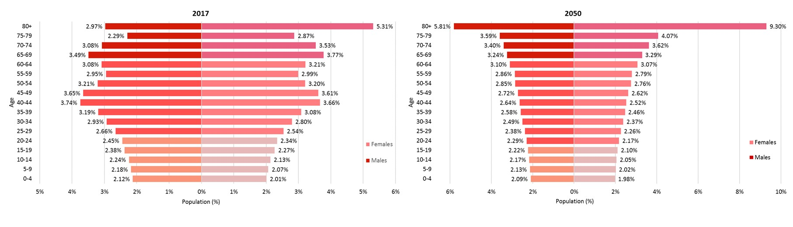Figure 2: Population pyramids for Japan.

*Source:* Department of Economic and Social Affairs, United Nations database.

Figure 3: Population pyramids for Germany

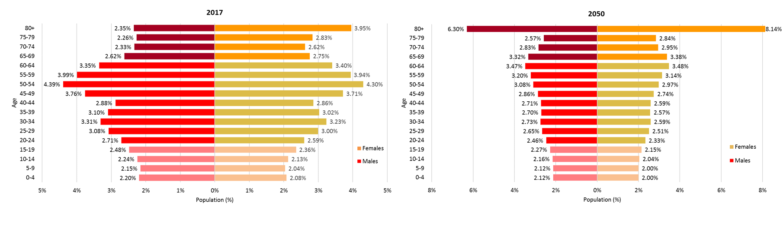

*Source:* Department of Economic and Social Affairs, United Nations database.

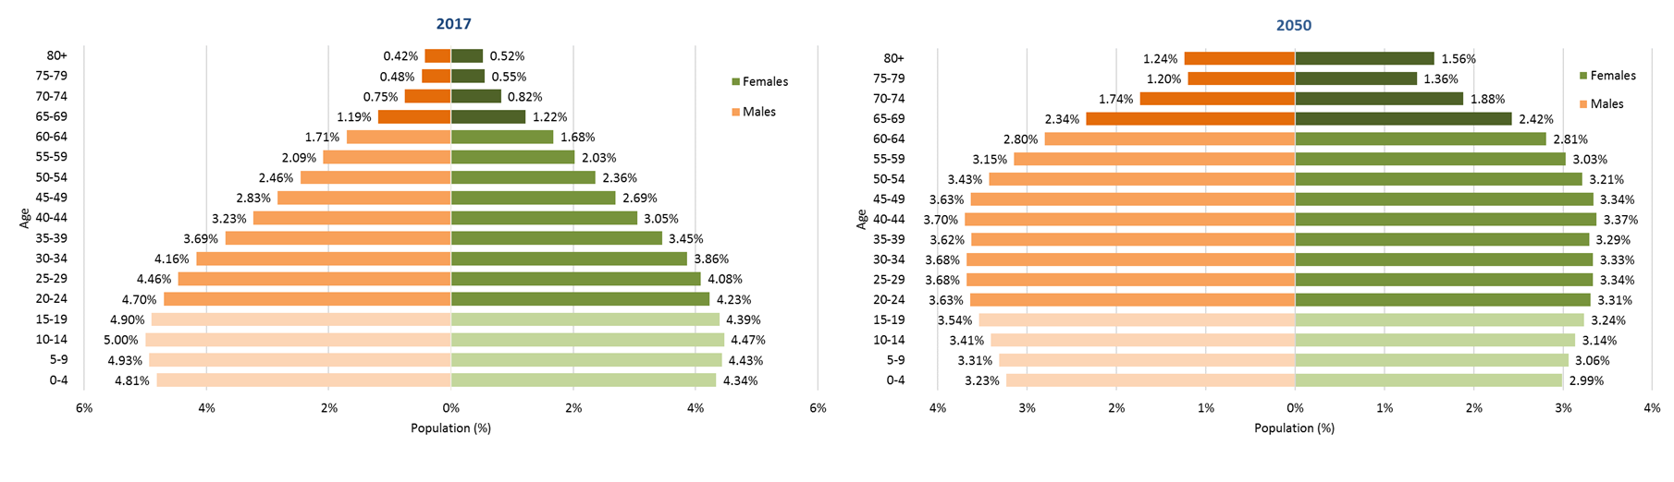Figure 4: Population pyramids for India.

Population pyramids for Japan have a base which is narrower than the central part and a significant percentage of elderly people. The proportion of people aged over 65 is estimated to reach 36.66 % by 2050. Japan represents, therefore, an aged population. This type of pyramid is typical of developed countries with low birth and mortality rates and limited population growth.

As shown in Figure 3, Germany is mimicking the trend of Japan’s population but several years later. The proportion of people aged over 65 is expected to increase from 27.71 % in 2017 to 32.33 % in 2050. Germany represents an ageing population. Birth rates and mortality rates are both low, and population growth is stable. This behaviour is attributed to strong economies, highly educated citizens and strong health systems.

On the other hand, population pyramids for India show a young and growing population. For India, the proportion of people aged over 65 will increase from 5.95 % in 2017 to 13.74 % in 2050. The decline of mortality rates and birth rates decline are generally the result of improved economic conditions and an increase in the status and education of women (World Bank, 2016).

Significant changes in age structures of the population threaten the sustainability of public pension systems. The following section describes some of the reforms carried out to meet the demographic challenge and guarantee the financial sustainability.

**3. Demographic challenge: Recent reforms**

Risks faced by public pensions are due to the fact that they are long-term agreements. Uncertainty about the future hampers planning to ensure that risks are fairly distributed among all parties of the agreement: taxpayers, retirees and government (Whitehouse, 2007). According to Barr and Diamond (2006), pension systems face considerable risks that are difficult to predict: macroeconomic shocks, policy risk, investment risk, management risk, annuities market risk and demographic risk. This section looks at demographic risks faced by PAYG pension systems. Section 3.1 discusses the persistent uncertainty in demographic forecasts. Section 3.2 summarises the main reforms carried out recently with special attention to those that link pensions to life expectancy.

**3.1 Uncertainty in population projections**

Population projections are estimates of total size or composition of populations in the future. The prediction of future scenarios is an important tool to make policy makers and citizens aware of the need to adjust pension plans according to demographic changes. Robert Holzmann, expert economist in pensions, states: “Demographic indicators are very important in predicting the future of pension systems. In PAYG pension systems, as these are based on transfers between generations, demographic indicators are critical to show how the transfers should be modified”.

In every model used to demographic projections elaborations, it is necessary to make predictions based on present information and historical recent trends. Therefore, it is important to bear in mind that any forecast implies a level of uncertainty regardless of the quality of basic information available and the instruments, tools and models applied. The degree of accuracy will be directly related to the degree of success in the formulation of the scenarios (Alho and Spencer (1985); Alho (1990)).

Undoubtedly, efficient reforms are sensitive to the accuracy of forecasts. As Lee and Tuljapurkar (1994) hold, obtaining adequate projections for the future population is important in governmental aspects such as public policy and particularly in relation to the implementation of government budgets to pensions systems. In this regard, Keilman (2008) examines the precision of the historical demographic forecasts provided by the National Statistical Offices of fourteen European countries. The author concludes that forecasts have not become more accurate in the last 25 years. Other studies evaluating the uncertainty in demographic projections have shown that uncertainty is usually underestimated in demographic forecasts used in long-range planning, such as public retirement programmes (Anderson et al. (2001); Booth (2006); Wilson (2013)).

Researchers and legislators often rely on the demographic projections produced by the United Nations (UN) or by the national statistical agency of each country. Lee (2011) analyses the un- certainties of the UN projections and shows that these do not consider the likelihood of errors. The projections are obtained through models which stand on a deterministic approach with several scenarios constructed by expert opinion aimed at providing a range of possible future results. This deterministic approach does not explain the probability at which these futuristic scenarios might occur and does not take into account the possible dispersion of results by placing too much confidence in the estimates (Okita et al., 2011). Deterministic scenarios may become inconsistent, to the extent that they distort the unpredictability of outcomes such as population size, fecundity or dependency ratios (Lee, 1998). Therefore, projections should be formulated in probabilistic terms, so that their expected accuracy can be assessed (Keilman et al., 2002).

In recent years, researchers have taken steps towards stochastic projection models that incorporate the measurement of some degree of uncertainty. Unlike deterministic projections, stochastic projections can be used to estimate a probability distribution for potential results. Stochastic population projections achieve a much greater understanding of the magnitude of uncertainty than that obtained from approaches based on high, medium and low scenarios or other traditional methods (see Keilman et al. (2002); Lassila and Valkonen (2008); Lee (2011); Gerland et al. (2014)). Along these lines, there is a particular interest in the more precise use of econometric techniques to generate stochastic projections which include probability distributions for a better management of uncertainty in predictions. For instance, Tuljapurkar and Burdick (2007) develop a stochastic demographic model to consider long-term fiscal planning for public budgets. More recently, Lassila et al. (2014) use stochastic population projections to assess the significant sustainability risk facing the Finnish private-sector pension system. The authors hold that a similar analysis in a country with a PAYG pension system would lead to even more worrying results.

The repercussion of the inaccuracy of forecasts on pension systems has been the recurrent need for reforms. However, in recent years, steps are being taken to consider not only projected increases in life expectancy but also the uncertainty concerning these projections (D’Addio and Whitehouse (2012); OECD (2012); D’Addio and Von Nordheim (2014)). Some of the measures recently implemented are described in the following subsection.

**3.2 Recent pension reforms**

Pension systems around the world have undergone different reforms in the last decades. The changes mainly focus on the adaptation of pensions to the new living conditions and on preserving the financial sustainability of the system. Typically, the adjustments seek a balance between the income from contributions and the expenditure on pensions. Thus, measures such as reductions in benefit levels and extension of the years of contribution required to receive a pension are observed.

Recently, almost all countries have established the age of retirement between 65 and 66 years. However, as set out in OECD (2015), many of the countries will increase the retirement age to 67-68 in the next years. Despite this, each country does so at different rates, mainly due to the immediacy required by its demographic trends. The more pronounced changes are in the Czech Republic, where the normal pension age is increasing from 62.7 to 68 by 2054 and in the Slovak Republic, where it will increase from 62 today to 67 in the future. In Australia, a pending reform is proposed that would extend the legal age to 70 by 2035 while in Sweden it has been discussed to increase the retirement age beyond 75 (Anderson and Backhans, 2013). Other countries, such as Portugal, adjust the standard retirement age in line with changes in life expectancy. That is also the case in Italy, where pension age is automatically extended as life expectancy increases, every three years until 2019 and every two years as of 2021. In Netherlands, the legal retirement age is gradually increasing to 66 in 2018 and 67 in 2021. Thereafter, the retirement age will be linked to life expectancy. The UK Government has also proposed to apply this measure from 2028.

The link to life expectancy in pensions has also been introduced in other ways. Italy, Poland and Sweden have incorporated a link to life expectancy with the replacement of traditional Defined- Benefit (DB) PAYG schemes by Notional Defined-Contribution (NDC). In NDC pension systems, each worker has a fictitious account in which the contributions during the entire working life are registered but not actually paid. Thus, the adoption of notional accounts changes the way pensions are calculated but not the concept of PAYG according to which the active workers finance the pensions of retirees. Once the time of retirement is reached, the accumulated value in the notional account is divided by a divisor that normally takes into account the life expectancy of the cohort, the indexation of pensions and the interest rate (OECD, 2012)[3]. Therefore, changes in life expectancy affect the amount of the initial benefit.

Other traditional PAYG counties also adjust the amount of the initial pension taking into account demographic trends. In particular, Portugal and Finland link the amount of the initial pension to changes in life expectancy. In Spain, a sustainability factor for pensions will enter into force in 2019. This will adjust the amount to be received by the beneficiary taking into account the increasing life expectancy. From 2027, the statutory retirement age in Denmark will be linked to life expectancy at age 60 with a five-year delay between the time of change in life expectancy and the adjustment to retirement age (Whitehouse, 2007). In France, the number of contribution years required to obtain a full pension benefit will increase from 41.5 to 43 by 2035 as life expectancy increases (OECD, 2015).

In the same vein, some countries such as Sweden, Canada, Germany, Japan and Finland, have decided to set up Automatic Balancing Mechanisms (ABMs)[4]. The next section defines the concept of ABM and introduces the one proposed by Godínez-Olivares et al. (2016b). The authors use optimisation techniques to design an ABM with which to restore the sustainability of the pension system while maintaining the liquidity at all times. This research follows the same methodology to analyse the impact of population ageing on the sustainability of the PAYG pension systems.

**4. Automatic balancing mechanism (ABM)**

An Automatic Balancing Mechanism (ABM) can be defined as a set of predetermined measures established by law to be applied immediately as required according to a solvency or sustainability indicator (Vidal-Meli´a et al., 2010). These mechanisms are designed to make the system self-adjusted in order to adapt it to demographic and economic changes and make the system sustainable.

According to Andrews (2016), for an ABM to operate efficiently, it must have the following characteristics: gradual, equitable, sustainable and transparent. Thus, any adjustment mechanism should consider: i) to what extent does each generation bear the adjustment in benefits or the increase of taxes necessary to re-balance the financial situation of the pension system; ii) on how many generations will the adjustment be made (how gradual is the reform); iii) the extent to which pensions are used as an instrument to act on inter-generational inequality. It is important to clarify the answers to these questions in order to achieve more transparent and, therefore, understandable reforms for the population. There are three main automatic mechanisms for changing pension values: adjustments in benefit levels; adjustments through indexation of pension’s payments; and/or adjustments through valorisation of earlier years’ earnings (D’Addio and Whitehouse, 2012). The ABM proposed by Godínez-Olivares et al. (2016b) finds the optimal paths of the main variables (contribution rate, normal retirement age and indexation of pensions) that guarantee not only the liquidity on an annual basis but also the financial sustainability of the PAYG pension system in the long run[5].The mechanism is detailed below.

**4.1. The Automatic Balancing Mechanism**

Godínez-Olivares et al. (2016b) uses nonlinear optimisation techniques to find the optimal path with respect to three variables: contribution rate, normal retirement age and indexation of pensions. This optimisation problem consists of minimising the net present value of the buffer fund, *Fn*, while considering constraints on the key variables and a liquidity restriction- that ensures that income from contributions are sufficient to pay expenditure on pension on an annual basis. The buffer fund is introduced to absorb unexpected events that could affect the liquidity of the system. The fund is acting as a buffer, in the sense that fluctuates deliberately in the short run and absorbs partially or completely the uncertainty in mortality, fertility rates or other events (Godínez-Olivares et al., 2016b). The variable *Fn* is calculated as:

*Fn* = (1 + *Jn*) *Fn−*1 + *cnWn*(*gn, x*(*r*)) − *Bn*(*gn ,x*(*r*)*,λn*)

where:

* + - *Jn* is the return of the fund during year *n*;
    - *cn* is the contribution rate at *n*;
    - *Wn*(*gn,* ) is the total contribution base paid at *n* that depends on the growth of wages, *gn*, and the retirement age, $x_{n}^{(r)}$;
    - *Bn* is the total spending on pensions at *n* that depends on, *gn*, and the indexation of pensions, *λn*.

The objective function, subject to constraints, is the following:

$$\min_{c_{n},x_{n},λ_{n}}\sum_{n=0}^{N}{\frac{F_{n}(c_{n},g_{n},x_{n}^{\left(r\right)},λ_{n})}{{(1+δ)}^{n}}}$$

$$s.t.=\left\{\begin{aligned}c_{min}≤c_{n}≤c_{max}; c_{1∆}≤\frac{c_{n+1}}{c_{n}}≤c_{2∆} \\ λ_{min}≤λ_{n}≤λ_{max}; λ_{1∆}≤\frac{λ_{n+1}}{λ_{n}}≤λ_{2∆} \\ x_{min}^{(r)}≤x_{n}^{\left(r\right)}≤x_{max}^{\left(r\right)}; x_{1∆}^{(r)}≤\frac{x_{n+1}^{(r)}}{x_{n}^{(r)}}≤x_{2∆}^{(r)} \\ F_{n}≥0.\end{aligned}\right.$$

where *δ* is the discount rate.

Lower bounds, $c_{min},x_{n}^{(r)},λ_{min}∈R$, and upper bounds, $c_{max}, x_{n}^{(r)},$ $λ_{max}∈R$, are set to avoid unrealistic changes in the key variables of the pension system. In addition, smooth constraints are imposed as $c_{1∆}≤\frac{c_{n+1}}{c_{n}}≤c_{2∆}$; $λ_{1∆}≤\frac{λ_{n+1}}{λ_{n}}≤λ_{2∆}$; $x_{1∆}^{(r)}≤\frac{x_{n+1}^{(r)}}{x_{n}^{(r)}}≤x_{2∆}^{(r)}$, to avert jump in path of the contribution rate, age of retirement and indexation of pensions. Finally, in order to ensure liquidity in the system, the liquidity constraint is set as $F_{n}≥0$, for all $n.$

**5. Results using three different population**

This section presents the optimal path of the contribution rate, the normal retirement age and the indexation of pensions for a generic PAYG pension system using the ABM defined in Section 4.1. The aim is to show the numerical application of the model using the population structure of three representative countries: Japan, Germany and India. First, the main data and assumptions are presented. Second, the results are discussed.

**5.1. Data**

* + - The demographic structures are obtained from the United Nations database[6]. The results are displayed from 2015 to 2050 (36-year time horizon). As shown in the population projections presented in Section 2, these countries have a very different age structure. India represents a young and growing population, Germany an ageing society and Japan an aged one.
    - Individuals are assumed to join the labour market at the age of 20. The same level of wages and pensions over time have been used in order to allow comparison of results. Figure 5 shows the normalised salary structure at the beginning of the study. Unemployment is not considered in our analysis.
    - The salaries are assumed to increase at an annual constant rate of 2.5 % (*gn* = *g* = 2*,*5 %) while the initial pension is calculated as 55 % of the final salary. The accumulated fund increases at an annual rate of 3 %.
    - The minimum values for the contribution rate, age of normal retirement and indexation of pensions are given respectively by 15 %, 65 and -2 %. The upper values are set as 20 %, 68 and 2 % respectively.
    - For smooth changes, it is assumed that the change in the normal retirement age varies between 1.5 and 4 months, the contribution rate between 0.3 % and 0.7 %, and the indexation of pensions between -0.5 % and 0.5 %.

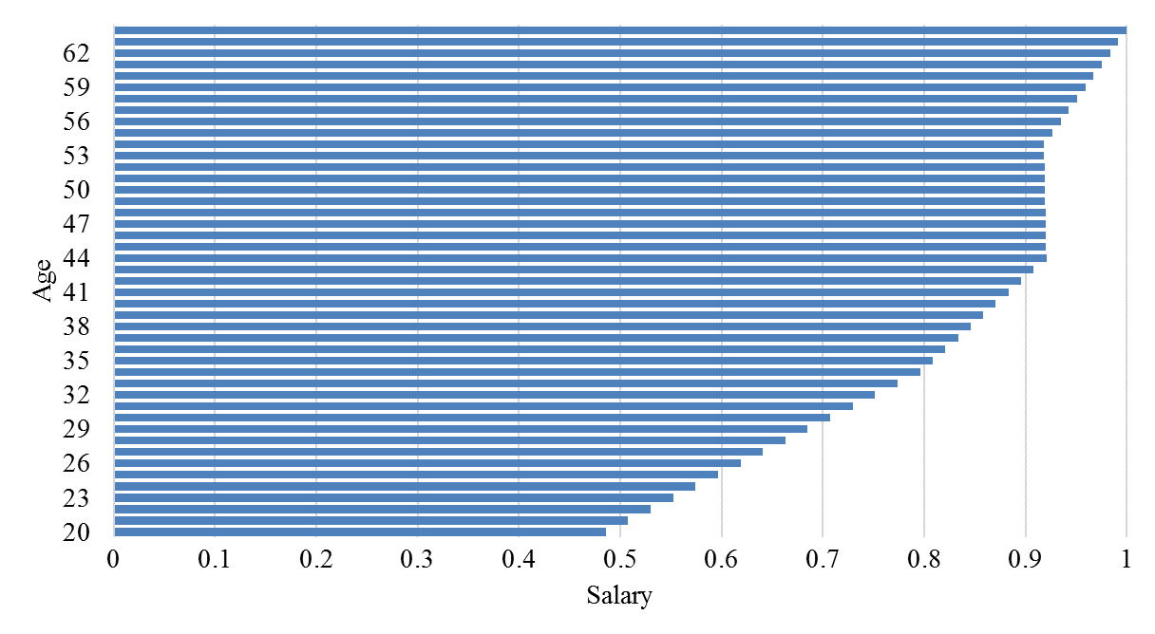Figure 5: Normalised salary structure in 2015.

**5.1. Results**

Figure 6 provides the optimal path of the contribution rate, the normal retirement age and the indexation of pensions using the population structure for Japan, Germany and India over a 36-year time horizon from 2015 to 2050[7]. The results are shown when the parameters are modified simultaneously.

Figure 6(a) shows that the age of retirement for Japan needs to increase from 65 to 68 over a period of 7 years. In the case of Germany, the age of retirement stabilises at 67 after 12 years. Even for the youngest population, i.e. India population, the normal retirement age would need to increase to 65.4 during the period of the study.

The indexation of pensions, Figure 6(b), decreases at the beginning of the period for the three countries. For the aged population, its value needs to decrease to -2 %. For Germany, the indexation of pensions stabilises at 0.6 % after 5 years whereas for India it does at 1.2 %.

As shown in Figure 6(c), the contribution rate stabilises at 16 % in the case of India. For Germany and Japan, the contribution rate reaches the values of 17.5 % and 20 % respectively at the end of the time horizon.

The results indicate that, even under the Indian population, the variables must be modified to ensure the sustainability of the pension system. As expected, changes under the Japanese population structure are more severe. Furthermore, it should be noted that the optimal value of the variables remains constant after a particular year once sustainability has been achieved.

Figure 6: Results of the Sustainability ABM when the three variables are projected simultaneously.

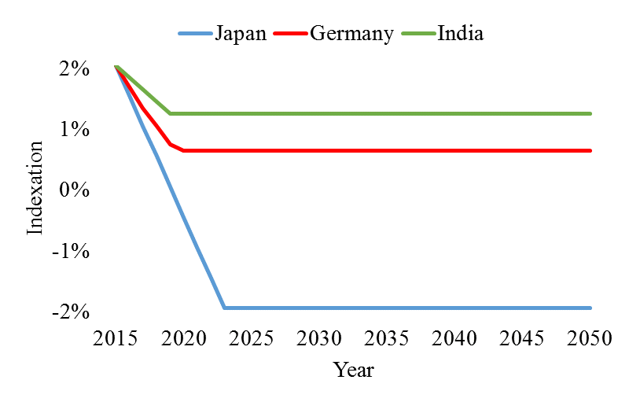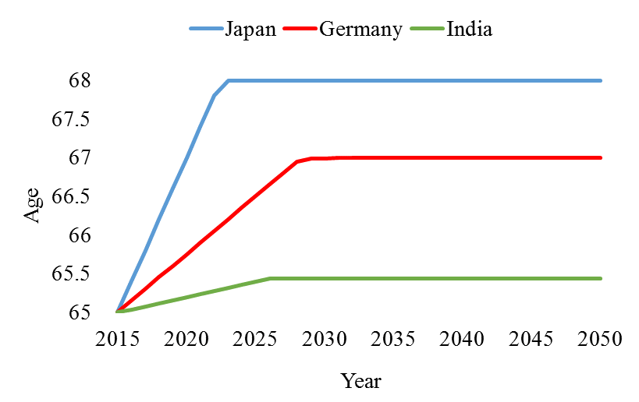 (a) Normal retirement age (b) Indexation of pensions

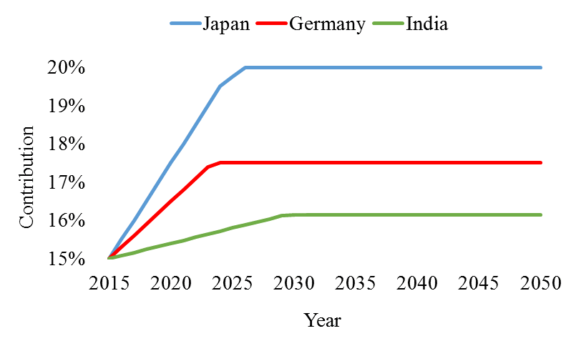(c) Contribution rate

**6. Conclusion and further research**

This study discusses the demographic uncertainty faced by pay-as-you-go (PAYG) pension systems. The public PAYG pension system is exposed to significant risks due to the process of population ageing. The increase in the average age of the population brings along a rise in the old-age dependency ratio as well as an increase in the number of years that people spend as retirees. As a result, fewer contributors have to finance more pensions for a longer time. This endangers the financial sustainability, solvency and adequacy of PAYG pension systems.

The assessment of financial sustainability as well as social security decisions rely upon demo- graphic projections. However, many studies show that the demographic forecasts on which policy makers have been based, unfortunately, have often proven to be wrong. The main reason for this is the consistently underestimation of uncertainty. The consequence on pension systems has been a wave of recurrent reforms, as the measures implemented achieved financial equilibrium only in the short term.

In recent years, policy efforts focus on maintaining the long-term financial balance. In this regard, there is a particular interest in implementing reforms that take into account the uncertainty of predictions. With this in mind, a variety of different approaches are being taking. A number of countries have set up mechanisms that automatically adjust some parameters of the system according to changes in life expectancy. In this way, these mechanisms are designed to address adverse demographic changes by automatically linking demographic developments to the pension system.

This research follows the paper by Godínez-Olivares et al. (2016b) to analyse the sustainability of the pay-as-you-go (PAYG) pension system in the presence of demographic uncertainty. With this aim, the research uses the projection of the population structure of three representative countries to identify the optimal paths (also called automatic balancing mechanisms - ABMs) of the contribution rate, normal retirement age and indexation of pensions that make a generic PAYG system sustainable. The three countries, Japan, Germany and India, have a different age distribution. The ageing of the population is more pronounced in Japan, where elderly people represent a high percentage of the population. Germany is mimicking the trend toward ageing of Japan but a few years later. India, on the other hand, still presents a young society. The pace of population ageing is slower in this country.

Not surprisingly, the results vary for each country. Since the Japanese society is more aged, the variables for this population structure reach higher values. However, the results show that, even for the country with less proportion of older people, the variables still need to be modified to ensure financial sustainability. For the pension systems to be sustainable, the age of normal retirement would need to increase to 65.4, 67 and 68 for India, Germany and Japan, respectively. The contribution rate should reach the values 16 %, 17.5 % and 20 %, whereas the indexation of pension would need to decrease to 1.2 %, 0.6 % and -2 %, respectively.

In this paper, we consider three different population structures using the same economic variables and pension rules. Therefore, the discrepancy in the results under each population structure confirms the importance of providing forecasts of the highest degree of accuracy. Further research is needed to perform sensitivity analysis of these population projections. It is shown that demo- graphic projections plays an important role in determining the optimal trajectory of the system variables. Therefore, inaccuracy of forecasts might lead to changes that will most probably turn out to be ineffective in the long run. Hence, the results highlight the extent of the impact of population ageing on the sustainability of pension systems. Further research would be focused on developing new techniques to forecast population structures, obtain more accurate information and, as a result, make better design of ABMs.

**References**

Alho, J. M., 1990. Stochastic methods in population forecasting. International Journal of forecasting 6 (4), 521–530.

Alho, J. M., Spencer, B. D., 1985. Uncertain population forecasting. Journal of the American Statistical Association 80 (390), 306–314.

Anderson, K., Backhans, M., 2013. Country document 2013-. Sweden. Pensions, health and long- term care.

Anderson, M., Tuljapurkar, S., Li, N., 2001. How accurate are demographic projections used in forecasting pension expenditure? In: Pensions: More information, less ideology. Springer, pp. 9–27.

Andrews, D., 2016. Some guiding principles for the development of self-adjusting mechanisms for sustainable retirement systems. International Actuarial Association ASTIN Colloquium (Lisbon, June 2016).

Ashraf, Q. H., Weil, D. N., Wilde, J., 2013. The effect of fertility reduction on economic growth. Population and development review 39 (1), 97–130.

Barr, N., Diamond, P., 2006. The economics of pensions. Oxford review of economic policy 22 (1), 15–39.

Berk, J., Weil, D. N., 2015. Old teachers, old ideas, and the effect of population aging on economic growth. Research in Economics 69 (4), 661–670.

Bloom, D. E., Canning, D., Fink, G., 2010. Implications of population ageing for economic growth. Oxford review of economic policy 26 (4), 583–612.

Bloom, D. E., Canning, D., Mansfield, R. K., Moore, M., 2007. Demographic change, social security systems, and savings. Journal of Monetary Economics 54 (1), 92–114.

Boldrin, M., De Nardi, M., Jones, L. E., 2015. Fertility and social security. Journal of Demographic Economics 81 (3), 261–299.

Bongaarts, J., 2004. Population aging and the rising cost of public pensions. Population and Development Review 30 (1), 1–23.

Bonoli, G., Shinkawa, T., 2006. Ageing and pension reform around the world: evidence from eleven countries. Edward Elgar Publishing.

Booth, H., 2006. Demographic forecasting: 1980 to 2005 in review. International Journal of Fore- casting 22 (3), 547–581.

Boucekkine, R., De la Croix, D., Licandro, O., 2002. Vintage human capital, demographic trends, and endogenous growth. Journal of Economic Theory 104 (2), 340–375.

Cremer, H., Pestieau, P., 2000. Reforming our pension system: Is it a demographic, financial or political problem? European Economic Review 44 (4), 974–983.

D’Addio, A. C., Von Nordheim, F., 2014. Towards an integrated agenda to deliver effective higher retirement ages: an issue note from the pension perspective. In: Workshops on Delivering Longer Working Lives and Higher Retirement Ages, Brussels 12th–13th November 2014. OECD.

D’Addio, A. C., Whitehouse, E., 2012. Towards financial sustainability of pension systems: The role of automatic-adjustment mechanisms in OECD and EU countries. Organization for Economic Cooperation and Development.

Dang, T.-T., Antolin, P., Oxley, H., 2001. Fiscal implication of ageing: projections of age-related spending.

DeSA, U., 2013. World population prospects: the 2012 revision. Population division of the department of economic and social affairs of the United Nations Secretariat, New York.

Gassen, N. S., Caswell, H., 2016. The determinants of population ageing and population decline in Europe, 2013–2080: A sensitivity analysis of Eurostat projections.

Gerland, P., Raftery, A. E., Sˇevˇc´ıkov´a, H., Li, N., Gu, D., Spoorenberg, T., Alkema, L., Fosdick, B., Chunn, J., Lalic, N., Bay, G., 2014. World population stabilization unlikely this century. Science 346 (6206), 234–237.

God´ınez-Olivares, H., Boado-Penas, M. d. C., Pantelous, A. A., 2016a. How to finance pensions: Optimal strategies for pay-as-you-go pension systems. Journal of Forecasting 35 (1), 13–33.

God´ınez-Olivares, H., María del Carmen Boado-Penas, M., Haberman, S., 2016b. Optimal strategies for pay-as-you-go pension finance: A sustainability framework. Insurance: Mathematics and Economics 69, 117–126.

Harper, S., 2014. Economic and social implications of aging societies. Science 346 (6209), 587–591.

Heer, B., Irmen, A., 2014. Population, pensions, and endogenous economic growth. Journal of Economic Dynamics and Control 46, 50–72.

Keilman, N., 1998. How accurate are the United Nations world population projections? Population and Development Review 24, 15–41.

Keilman, N., 2008. European demographic forecasts have not become more accurate over the past 25 years. Population and Development Review 34 (1), 137–153.

Keilman, N., Pham, D. Q., Hetland, A., 2002. Why population forecasts should be probabilistic- illustrated by the case of Norway. Demographic Research 6, 409–454.

Lassila, J., Valkonen, T., 2008. Uncertain demographics and pension policy. Revue ´economique 59 (5), 913–926.

Lassila, J., Valkonen, T., Alho, J. M., 2014. Demographic forecasts and fiscal policy rules. International Journal of Forecasting 30 (4), 1098–1109.

Lee, R., 2011. The outlook for population growth. Science 333 (6042), 569–573.

Lee, R. D., 1998. Probabilistic approaches to population forecasting. Population and Development Review 24, 156–190.

Lee, R. D., Tuljapurkar, S., 1994. Stochastic population forecasts for the United States: Beyond high, medium, and low. Journal of the American Statistical Association 89 (428), 1175–1189.

Lutz, W., Goldstein, J. R., 2004. Introduction: How to deal with uncertainty in population fore- casting? International Statistical Review 72 (1), 1–4.

OECD, 2011. Pensions at a glance 2011: Retirement-income systems in OECD and G20 countries. OECD Publishing.

OECD, 2012. Putting pensions on auto-pilot: automatic-adjustment mechanisms and financial sustainability of retirement-income systems. In: OECD, OECD Pensions Outlook 2012. OECD.

OECD, 2014. OECD Pensions Outlook 2014, OECD Publishing. [http://dx.doi.org/10.1787/](http://dx.doi.org/10.1787/9789264222687-en) [9789264222687-en](http://dx.doi.org/10.1787/9789264222687-en).

OECD, 2015. Pensions at a Glance 2015: OECD and G20 Indicators, OECD Publishing, Paris.

OECD, 2017. Health Statistics: Definitions, Sources and Methods. Life expectancy at birth and at various ages (40, 60, 65, and 80 years old). OECD.

Okita, Y., Pfau, W. D., Long, G. T., 2011. A stochastic forecast model for Japan’s population. Japanese Economy 38 (2), 19–44.

Powell, J. L., 2010. The power of global aging. Ageing International 35 (1), 1–14.

Stoto, M. A., 1983. The accuracy of population projections. Journal of the American Statistical Association 78 (381), 13–20.

Torp, C., 2015. Challenges of Aging: Pensions, Retirement and Generational Justice. Springer.

Tuljapurkar, S., Burdick, C., 2007. Population forecasts, fiscal policy, and risk. In: Government Spending on the Elderly. Springer, pp. 249–271.

Turner, J. A., 2007. Autopilot: self-adjusting mechanisms for sustainable retirement systems. Society of Actuaries Policy Paper.

United Nations, 2015. World population prospects. Key Findings and Advanced Tables. The 2015 Revision. Tech. rep., ESA/P/WP. 241, New York.

United Nations, 2017. World population prospects. Key Findings and Advanced Tables. The 2017 Revision. Tech. rep., ESA/P/WP. 248, New York.

Vidal-Meliá, C., Boado-Penas, M. d. C., Settergen, O., 2010. Improving the equity, transparency and solvency of pay-as-you-go pension systems: NDCs, the ab, and ABMs. M. Micocci, GN Gregoriou, & GB Masala, Pension Fund Risk Management: Financial and Actuarial Modeling, 419–472.

Vidal-Meli´a, C., del Carmen Boado-Penas, M., Settergren, O., 2009. Automatic balance mechanisms in pay-as-you-go pension systems. The Geneva Papers on Risk and Insurance-Issues and Practice 34 (2), 287–317.

Whitehouse, E., 2007. Life-expectancy risk and pensions: who bears the burden? OECD Social, Employment, and Migration Working Papers (60), 1.

Wilson, T., 2013. Quantifying the uncertainty of regional demographic forecasts. Applied Geography 42, 108–115.

World Bank, 2016. Global monitoring report 2015/2016: Development goals in an era of demographic change. Washington, DC: World Bank.

1. Las autoras agradecen la ayuda recibida del Ministerio de Economía y Competitividad (proyecto ECO2012-36685 y ECO2015-65826-P). Las autoras agradecen la ayuda y los valiosos comentarios de Humberto Godínez Olivares.

   Corresponding Author. Institute for Risk and Uncertainty, University of Liverpool. E-mail: [mariaff@liverpool.ac.uk](mailto:mariaff@liverpool.ac.uk).
2. 2 Institute for Financial and Actuarial Mathematics (IFAM), University of Liverpool.
3. In NDC, the individual bears the life expectancy risk. The rate at which accumulated balances are converted into future pension payments are set according to the projected life expectancy at the time of retirement. If there is a considerable increase in life expectancy, it may be that the accumulated amount is too low to obtain a sufficient pension benefit (Whitehouse, 2007).
4. See Vidal-Melia´ et al. (2009) and Vidal-Meli´a et al. (2010) for details on ABMs existing in Sweden, Canada, German, japan and Finland.
5. God´ınez-Olivares et al. (2016b) extend the optimisation model of God´ınez-Olivares et al. (2016a) which focused only on the liquidity of the system in a 20-year time horizon.
6. <http://www.un.org/en/development/desa/population/publications/database/index.shtml>
7. The analysis is limited to a 36 year time horizon since no further population data are available.