**Selection Policy of Manufacturers’ Online Channel:**

**Do it on One’s Own or Cooperate with Retailers**

*RufengWang, Bo Li†, Zhenhong Li and Pengwen Hou*

*College of Management and Economics, Tianjin University, Tianjin, 300072, China*

*†Corresponding author: Email: libo0410@tju.edu.cn*

*and*

*Dongping Song*

*School of Management, Liverpool University, Liverpool L69 3BX, UK*

[Citation: Wang, R., Li, B., Li, Z., Hou, P. and Song, D.P. (2017). Selection policy for a manufacturer’s online channel: do it oneself or cooperate with retailers, IMA Journal of Management Mathematics, 29(4), 393-414]

**Abstract:** With the development of e-commerce, some manufacturers are considering opening their own e-channels in addition to their traditional brick-and-mortar channels (a manufacturer dual-channel model). However, other manufacturers choose to cooperate with retailers to sell their products through the retailers’ e-channels and brick-and-mortar channels (a retailer dual-channel model). This paper compares these two dual-channel models in a unified framework, using the traditional single-channel supply chain as a benchmark. Stackelberg games are applied to obtain the optimal equilibrium solutions to the two models. Our analysis indicates that although the manufacturer can always obtain more profit through his own dual channels than through a retailer’s dual channels, the retailer dual-channel model can capture the online market better than the manufacturer dual-channel model. Thus, it is possible especially when the manufacturer just starts to enter the online market that the manufacturer may prefer to cooperate with the retailer rather than open his own e-channel in order to better win consumer acceptance of his online product. Furthermore, we find that the manufacturer’s ability to control the channels will greatly influence the online entry of the retailer. We present the conditions under which the profits of the manufacturer (or the retailer) will be enhanced (or worsened) in these two dual-channel models. Finally, we extend the models in two directions. First, we generalise the models to a situation in which both the manufacturer and the retailer open e-channels simultaneously. Second, we extend the models to include cases where the online discount rate is treated as a decision variable. Analytical results from the extended models are then discussed and interpreted.

**Keywords**: Supply chain management; Channel selection policy; Stackelberg game

1. **Introduction**

With the booming of the Internet in China, consumers are increasingly turning online to shop. A report from the China e-Business Research Center shows that total online retail sales increased to 3.8285 trillion Yuan by the end of December 2015, comprising 12.7% of the total retail sales of consumer goods, with a year-on-year increase of 35.7% (China e-Business Research Center, 2016a). Moreover, the online retail market sales in China are expected to reach 5.2218 trillion Yuan in 2016 (China e-Business Research Center, 2016b). Currently, manufacturers and retailers are opening e-channels mainly as a means to seize the popular online market. Some manufacturers in China who produce products such as cosmetics, liquor and electronics have built a distribution network consisting of numerous brick-and-mortar retailers over many years. It is thus necessary for them to evaluate whether they should open an online channel themselves or cooperate with retailers. It is noted that a number of large retailers such as Sunning (one of the largest electronics retailers in China) have already possessed online channels in addition to their brick-and-mortar stores. In practice, both types of channel selection strategies exist. For example, Maotai, a famous liquor manufacturer in China, has maintained its own e-channel in addition to its traditional brick-and-mortar channels since 2012. Gree, an electronics manufacturer, also opened an online channel at the end of December 2014. By contrast, many Chinese furniture manufacturers and electronics manufacturers choose to cooperate with retailers to sell their products to the online market, for example, IKEA and Five Star Appliance, the famous furniture mall and the third largest electronic retailer in China, respectively.

A mixed distribution mode through a brick-and-mortar channel and an e-channel is called a dual-channel supply chain. It can be a manufacturer dual-channel model in which the manufacturer opens an e-channel in addition to the retailer’s store channel, or it can be a retailer dual-channel model in which the retailer operates an e-channel along with her brick-and-mortar stores and the manufacturer uses these to distribute his products. Recently, with the rapid development of electronic commence in China, many manufacturers have been exploring which distribution strategies would be better for them, i.e., whether they should open an online channel on their own or cooperate with retailers that already possess dual channels. It should be noted that in a manufacturer dual-channel model, in addition to specialised manufacturing, the manufacturers must pay additional attention to market demand and the demand fluctuation associated with their online channel, which is not to their advantage. In the retailer dual-channel model, the manufacturers can focus on manufacturing; however, because all products are sold through the retailer’s channels, the manufacturer might slowly lose market control. This paper will first study the manufacturer dual-channel model and the retailer dual-channel model using the traditional single-channel supply chain as a benchmark; then, we analyse whether the manufacturer should open online channel or cooperate with retailers to distribute products through the retailers’ dual channels.

Prior research has addressed issues around either the suppliers opening an e-channel (Chiang et al., 2003; Huang and Swaminathan 2009; Cai et al. 2010) or retailers opening an e-channel (Tsay and Agrawal, 2004; Kireyev et al. 2014). However, all of these studies pay attention to the e-channel decision of just one member along the supply chain and emphasise pricing strategies and the channel conflicts between the traditional brick-and-mortar channel and the newly inserted e-channel. To eliminate channel conflicts, consistent or inconsistent pricing policies can be adopted (Cattani et al. 2006; Khouja, et al. 2010). Unlike the above references, we investigate whether the manufacturer, as a Stackelberg leader, should open an e-channel on his own or cooperate with the retailer’s dual channel. More specifically, we offer a comparison of the manufacturer and retailer dual-channel models in a single framework and analyse the impacts of these models on the channel members’ decisions and profits.

In the literature on dual-channel supply chains, many articles recognise the phenomenon of consumer heterogeneity in the valuation of a product in the e-commerce age (Chiang et al. 2003; Balakrishnan et al. 2014; Sousa et al. 2015). Following this observation, this paper assumes that consumers have heterogeneous valuations for a product. In fact, for high-priced products such as electronics, liquor and furniture, consumers tend to shop in brick-and-mortar stores and experience the products on their own. In addition, consumers may distrust e-channels when purchasing these products because they cannot physically interact with the products on the online channel, which may influence their purchase behaviours. Based on the above facts, several articles indicate that consumers have a lower valuation for the same product on e-channels than they do in brick-and-mortar channels (Chiang et al., 2003; Yan and Ghose, 2010; Yan et al., 2010; Xu et al., 2012; Ma et al. 2013). Moreover, Liang and Huang (1998), Kacen and Lee (2002) and Luo and Sun (2016) provide empirical evidence that consumer acceptance of e-channels is lower than that of brick-and-mortar channels. To overcome consumers’ lower acceptance of e-channels, price discounting has been used as a common strategy to promote sales in e-channels. One typical example is the annual Double 11 Festival in China, in which many e-tailers improve sales by offering price discounts on November 11th with great success. Evidence has shown that an online price discount can increase actual purchases by consumers (Park and Kim 2003; Chellappa et al. 2011; Zhang et al. 2013). Based on the above analysis, this paper makes the further assumptions that consumers have a lower acceptance of e-channels and that a discounted price is used in e-channels compared with the selling price in brick-and-mortar channels.

In this paper, we analyse a supply chain with a manufacturer and a retailer. The manufacturer will make decisions about the channel selection strategies between the manufacturer dual-channel model and the retailer dual-channel model in a single unified framework. We attempt to explore the following problems: (1) To better capture demand in the online market, how does the manufacturer make decisions regarding new distribution channel modes? (2) When an online channel is inserted into the distribution system, how does the manufacturer’s ability to control his channels under the different models affect the channel selection preferences of the retailer? (3) How does consumer acceptance of the e-channel and the price discount rate influence the decisions of the two members in the supply chain? Using Stackelberg game models, we examine the optimal equilibrium pricing and profits under the two dual-channel models. A traditional single-channel supply chain is also provided as a benchmark for comparison; the sensitivity of the important parameters is discussed. We discover that the manufacturer always benefits by opening his own online channel, but he may decide not to open an e-channel and instead cooperate with the retailer to capture the online market because the retailer has more experience in the market and has brick-and-mortar stores to support online sales. For the retailer, the monopoly benefit is the highest in the traditional single-channel supply chain. Whether the retailer prefers the manufacturer dual-channel model or the retailer dual-channel model depends on the combination of two parameters, consumer acceptance and the online price discount rate, and on the manufacturer’s ability to control the channels. We derive the conditions under which the profits of the manufacturer (or the retailer) will improve (or worsen) in relation to the discount rate and consumer acceptance in these two dual-channel models. Finally, we extend the models in two directions. First, we generalise the models to a situation in which both the manufacturer and the retailer can open e-channels simultaneously. Second, we extend the models to cases in which the online discount rate is treated as a decision variable.

The paper is organised as follows. In the next section, the relevant literature is reviewed. In Section 3, the notations are introduced and three models are formulated. In Section 4, we solve and analyse the models. The results of the three models are compared and interpreted in detail. Some extensions of the models and the managerial implications are discussed in Section 5. Finally, Section 6 draws conclusions and indicates paths for further research. Proofs of the Propositions are given in the Electronic Companion.

**2. Literature Review**

Supply chain management has been widely studied in the literature (Ghadimi et al. (2013) and Asgari et al (2016)). An emerging important topic is the competition between an e-channel and a traditional brick-and-mortar channel (Chiang et al., 2003; Cattani et al., 2006; Hsiao and Chen 2014; Pei et al. 2015; Li.et al. 2017). Two research streams can be identified within this literature: one stream focuses on the manufacturer dual-channel model, and the other discusses the issues of traditional retailers operating an e-channel.

In the first stream, there are fruitful studies addressing the manufacturer dual-channel model that are related to our research. For example, Cattani et al. (2006) found that not only the supplier who opened the dual channel gained more profit but also that the retailer benefited when an equal-pricing strategy was applied. Arya et al. (2007) and Cai (2010) similarly demonstrated that both the supplier and the retailer could benefit from adding an e-channel to the traditional single-channel supply chain. This conclusion does not always hold. In an asymmetric information setting, Li et al. (2015) showed that the supplier dual channel exacerbated double marginalisation and hurt both members under some conditions if the retailer was privately informed about market demand. Matsui (2016) considered two symmetric manufacturers and designed three types of distribution channels, including just brick-and-mortar channels, just online channels or coexisting offline and online channels. He found that if one manufacturer distributes his products through online and offline channels, then the other manufacturer should not adopt the same dual-channel distribution policy to compete. Ma et al. (2016) analysed a manufacturer’s distribution strategies by differentiating his products to sell in online channels and offline channels and discussed whether the manufacturer should open an online channel.

The second stream of related studies concerns the retailer dual-channel model with an emphasis on pricing strategy. For example, Liu et al. (2006) found that a brick-and-mortar retailer could develop its own online channel to pre-empt the entry of a pure-play e-tailer when price consistency across channels was not a constraint. Zhang (2009) addressed two questions: when should a traditional retailer adopt a multichannel strategy and when should the retailer use his e-channel to advertise offline prices. He concluded that multichannel retailing was not necessarily the best strategy for all retailers. Ofek et al. (2011) examined the effects of pricing and the levels of assistance provided in brick-and-mortar stores on the decisions of competing retailers who opened an e-channel in addition to their brick-and-mortar channels. Kireyev et al. (2014) proposed a price-matching policy for multichannel retailing and validated the effectiveness of this policy by observing many self-matching policies in numerous industries using a game model. Cao et al. (2016) considered three distribution channels: a store channel, an online channel and an online-to- store channel. They compared the performances of these three channels and obtained the conditions under which introducing a new online-to-store channel could result in higher product profits for the retailer. Here the “online-to-store channel” refers to the practice that customers can order products online and then pick up the products at a physical store.

In dual-channel or multichannel supply chains, an important phenomenon is consumer heterogeneity in the valuation of the products (Chiang et al. 2003; Balakrishnan et al. 2014，Luo and Sun 2016). For example, Yan et al. (2010) and Xu et al. (2012) assumed that an e-channel had lower consumer acceptance than a brick-and-mortar channel. Hsiao and Chen (2014) claimed that consumer acceptance of an e-channel might be higher or lower than that of a brick-and-mortar channel based on consumer preferences. Note that we consider high-priced products in our research context; it is reasonable to assume that an e-channel has lower consumer acceptance but offers a price discount to promote online sales. In fact, discounted prices have been an effective promotional method for e-channels. According to a study conducted by Anthem Marketing Solutions (2010), products priced over $90 were often less expensive online. In general, electronics and some personal care items have lower prices online. Specific examples include digital cameras (8% cheaper online) and GPS navigators (10% cheaper online). A more recent survey compared the 30 most popular smartphones from various offline retailers and leading e-commerce portals and found that online prices for smartphones are 5% lower than offline prices (Aulak, 2014). Based on these observations, we introduce a discount rate to represent the pricing difference between a brick-and-mortar channel and an e-channel so that the promotion behaviour in an online channel can be reflected in our models.

To the best of our knowledge, the existing relevant literature either focuses on the manufacturer dual-channel model or on the retailer dual-channel model. There is a lack of research that compares these two models. This paper aims to address the channel selection issue by formulating and analysing the manufacturer dual-channel model and the retailer dual-channel model in a single unified framework. The main purpose is to answer the following questions: should manufacturers open their own online channel or should they cooperate with their retailers, and what conditions influence this decision?

**3. Notations and Models**

**3.1 Model Representation**

This section investigates the selection strategies for choosing the manufacturer dual-channel model and the retailer dual-channel model given a continuum of heterogeneous consumers. In these two models, the manufacturer and the retailer open an e-channel in addition to a traditional retail channel. We denote these two models as Model 1 and Model 2, respectively. Furthermore, a traditional supply chain model consisting of a manufacturer and a traditional retailer is formulated as a benchmark (denoted Model 0). The three models are shown in Fig. 1 (a), (b) and (c), respectively.

In these models, we assume that the manufacturer produces only one product of high priced. Because of the high price of the product, each consumer is willing to purchase one and only one unit of product, and the demand of consumers is normalised to 1 (Chiang et al., 2003). For ease of exposition, the product cost and the e-channel operating cost of the manufacturer as well as the operating cost of the retailer’s brick-and-mortar channel are normalised to zero (Yan and Ghose, 2010). In addition, the manufacturer, as a Stackelberg leader, has sufficient channel power over the retailer, and all parties in the supply chain are risk-neutral and share identical information (Ma et al., 2013; Hsiao and Chen, 2014). Consumers are heterogeneous with product utility , and  is assumed to be uniformly distributed in [0,1]. A similar assumption has been widely used in the literature on consumer classification (Chiang et al., 2003; Chiang and Monahan, 2005; Ma et al., 2013，Luo and Sun 2016). Here, to represent the lower consumer acceptance of the e-channel, the parameter  is defined as consumers’ willingness to pay (wtp) for a product on the e-channel, subject to . That is, if a consumer has utility  with regard to the product in the brick-and-mortar channel, then that consumer has utility  with regard to that product in the online channel.

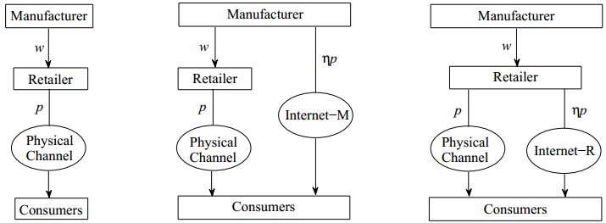

(a)Model 0 (b) Model 1 (c) Model 2

Fig. 1. Structures of Model 0, Model 1 and Model 2

Furthermore, the manufacturer decides the wholesale price ; the retailer decides the retail price  in Model , where ; and the manufacturer adopts the online price based on the retailer’s retail price in Model (), where  is the discount rate (i.e., the ratio between the retail price on the e-channel and that in the brick-and-mortar channel). In this paper, the discount rate is assumed to be exogenous. This makes the comparison between Model 1 and Model 2 easier and fairer because both models have the same discount rate. Empirical studies (e.g., Anthem Marketing Solutions 2010; Aulak 2014) show that online prices are generally lower than offline prices for relatively expensive items, and the average price difference can be categorised according to the product characteristics (e.g. smartphone 5% cheaper online, Digital Camera 8%, and GPS Navigator 10%). This implies that for the same type of product, the online price discount rates are generally similar. This justifies the assumption of an exogenous discount rate in our models. However, in Section 5, we will extend Model 1 and Model 2 by treating the discount rate as an endogenous decision variable, in which the optimal discount rates will take different values in the two extended models.

In Model 0, when a consumer decides whether to buy a product, he considers the utility that he will obtain . If , then the consumer will buy the product; otherwise, he will not. Thus, when , (i.e., ). Then, demand is denoted as  in Model 0 and .

Similarly, a consumer will obtain utilities  or  by purchasing a product from the brick-and-mortar channel or the e-channel, where  denote Model 1 and Model 2, respectively. If  and , then the consumer will purchase one product from the brick-and-mortar channel. That is, the consumer whose perceived product utility ** falls into the interval  will purchase the product from the brick-and-mortar channel. In contrast, if  and , then the consumer whose perceived product utility  falls into the interval  will purchase the product from the e-channel. Therefore, the demand through the brick-and-mortar channel and that through the e-channel are defined as  and , respectively;  and , and the total demand of the supply chain is .

Meanwhile, to ensure the existence of the dual-channel supply chain, the demand for each of the two channels must be positive. We can obtain positive demand when ; the brick-and-mortar channel and the e-channel exist at the same time. In addition, in both Model 1 and Model 2,  and . Moreover, in Model 1, ; otherwise, the retailer would directly buy the product from the manufacturer’s e-channel. In Model 2, to derive profit from the e-channel, the condition  is also necessary. Combining the conditions with , we obtain the constraints of Model 1 and Model 2 as  and .

**3.2 Model Formulation and Equilibrium Solutions**

This section will analyse the game models and obtain their equilibrium solutions under the three models, where  and () denote the retailer’s and the manufacturer’s profit functions, and the total profit of the supply chain is equal to ****; the superscript * represents the optimal equilibrium solutions by solving the Stackelberg games.



**Case 1. Model 0---Traditional supply chain model**

In the traditional supply chain model, neither member introduces the e-channel. Model 0 is used as a benchmark to compare how the members’ introduction of the e-channel influences the supply chain. For a given, the retailer's optimisation problem is



and the manufacturer’s optimisation problem is:



**Case 2. Model 1---The manufacturer’s dual-channel model**

In Model 1, the manufacturer introduces the e-channel. From what we have discussed above, . Because the manufacturer is the leader in the Stackelberg game, for a given, the retailer's problem is



Meanwhile, the manufacturer’s problem can be stated as



**Case 3. Model 2---The retailer’s dual-channel model**

In Model 2, the retailer introduces the e-channel. Similar to Case 2, for a given, the retailer's problem is



Then, the manufacturer’s problem can be stated as



With the above three cases, we apply the backward induction method to solve for their equilibrium solutions; these solutions are summarised in Table 1 in the Electronic Companion.

Furthermore, according to the definition in Steiner (2004), the retail gross margin () can be expressed by, whererepresents the manufacturer’s ability to control the channel; the lower the value of the  is, the stronger control the manufacturer has over the channel.

To compare the above three models in a unified framework, the joint feasibility conditions (i.e., Regionof ) of Models 0, 1, and 2 are determined by , . By solving the equations, we obtain the feasible region as:

,

where ,

 .

Details are presented in the Electronic Companion. In Region, positive profits exist in each channel in Models 0, 1 and 2. Thus, the following discussion will be limited to Region.

**Remark:** An important phenomenon in decentralised supply chains is double-marginalisation. The optimal prices and profits corresponding to centralised supply chains in Model *i* are listed in Table 2. We denote channel efficiency as the ratio of the optimal profit of the decentralised supply chain to that of the centralised supply chain. Spengler (1950) shows that the channel efficiency of a static decentralised supply chain is 75% due to the double-marginalization effect. Let ，where  represents the optimal profit of the supply chain in Model  and  represents the optimal profit of the centralized supply chain corresponding to Model . From Table 1 and Table 2 in the Electronic Companion, we can obtain the channel efficiency  for Model . It can be shown that , which quantitatively illustrates that the double-marginalisation effect would be alleviated if the manufacturer introduces an e-channel, whereas it would be exacerbated if the retailer introduces an e-channel.

**4. Comparisons and Analysis**

This section focuses on various comparisons and analyses of pricing, channel introduction policies and profits based on the solutions of the above three models. Meanwhile, we discuss the influences of some parameters, such as the discount rate and consumer acceptance of the e-channel, on the channel selection decisions of the two members and explore the management implications.

**4.1 Pricing decisions and channel control abilities**

First, we compare the pricing policies and offer the following Proposition 1.

**Proposition 1**. In the feasible region  of Models 0, 1 and 2, the optimal pricing decisions and the effective demands have the following properties:

(i) For the manufacturer’s wholesale prices, if , then ; and if , then . Fig. 2(a) shows the above region divisions.

(ii) For the retailer’s prices, , and the retail margin,

.

(iii) For the total effective demand of the three models, . For the effective demand of the brick-and-mortar channel, . For the effective demand of the online channel, .

The proof for (i) is given in the Electronic Companion, and the proofs for Propositions 1(ii) and (iii) are relatively straightforward and omitted.

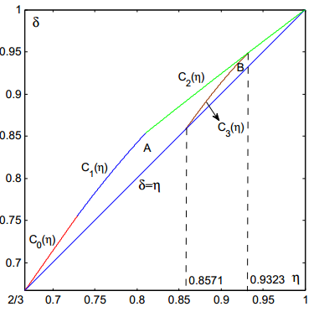 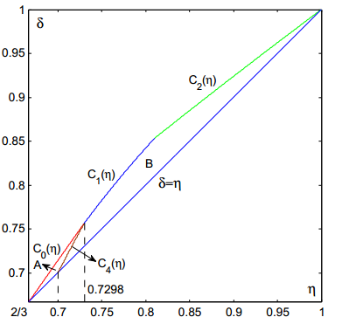

(a) Characterise wholesale prices (b) Characterise channel control ability

Fig. 2. Region divisions considering wholesale pricing and RGM in Models 0, 1 and 2

Proposition 1(i) shows that once the e-channel is introduced by the manufacturer (Model 1) or by the retailer (Model 2), the wholesale price will increase, compared with that in the model with only a brick-and-mortar channel. Together with Proposition 1(iii), we can see that introducing the online channel will benefit the manufacturer. Comparing the wholesale prices in Model 1 and Model 2, the wholesale price in Model 1 is higher than that in Model 2 whenis located in Region  in Fig. 2(a), but the reverse relationship holds whenis located in Region  in Fig. 2(a).

Proposition 1(ii) can be interpreted as follows. Once the manufacturer introduces the e-channel, the consumer can purchase the product not only from the retailer but also directly from the manufacturer. The retail price in the brick-and-mortar channel will decline to avoid losing more profit in Model 1, so the gap between the retail price in the brick-and-mortar channel and the retail price on the e-channel will decrease. The double-marginalisation problem will be alleviated by the decline in the retail price. If the retailer introduces an e-channel, she still monopolises the market and will increase the retail price in the brick-and-mortar channel to pursue more profits, thereby exacerbating the double-marginalisation effect.

Finally, Proposition 1(iii) indicates that by introducing an e-channel, the total market demand will expand, particularly through the manufacturer’s dual-channels. However, the demand through the brick-and-mortar channel will decline compared with that of the benchmark, i.e., the introduction of an e-channel will not only increase demand in the e- channel but will also appropriate some of the demand in the brick-and-mortar channel. From the viewpoint of expanding the network market, the demand will be better if the retailer introduces the e-channel because .

Let  denote the retail gross margin (*RGM*) in Model . The indicator  reflects the manufacturer’s channel control ability. We obtain the following result.

**Proposition 2.** In the feasible regions shown in Fig. 2(b), the *RGMs* in Models 0, 1 and 2 satisfy the following relationships:

1. If , then .
2. If , then .

The proofs are given in the Electronic Companion.

Proposition 2 reveals that once the e-channel is introduced by the manufacturer or the retailer, the manufacturer’s channel control ability will increase compared with his control ability over the single brick-and-mortar channel. Comparing Model 1 with Model 2, when  belongs to Region  in Fig. 2(b), the manufacturer has less channel control ability in Model 1 than that in Model 2. In contrast, the manufacturer possesses more channel control ability in Region , and most parts of the entire feasible region  belong to Region  in Fig. 2(b). Thus, opening his own online channel can strengthen the manufacturer’s control over the channels in most cases.

**4.2 Comparison of profits**

Next, comparisons are made between Model 1 and Model 2 with regard to the profits of the two members, with Model 0 again serving as the benchmark.

**Proposition 3.** In the feasible region , the two members’ profits in Models 0, 1 and 2 satisfy the following relationships:

(i) .

(ii) If , then ; and if , then . Here, the region divisions are shown in Fig. 3.

(iii) 

The proofs are given in the Electronic Companion.



Fig. 3. Region divisions considering the retailer’s optimal profits

Proposition 3(i) indicates that as long as an e-channel is introduced, the manufacturer’s profits will increase. This may reflect the trend in which most manufacturers tend to introduce an e-channel. By contrast, Proposition 3(ii) reveals that introducing an e-channel will result in less profit for the retailer compared to the benchmark Model 0. Moreover, Proposition 3(i) suggests that the manufacturer’s best channel option is to open the e-channel himself. However, from the perspective of capturing the maximum effective demand through the e-channel, the manufacturer may apt for the retailer to open the online channel based on the results for Proposition 1(iii). This is possible especially when the manufacturer just starts to enter the online market, under which he may focus more on winning consumer acceptance rather than maximizing the profit. Comparing Model 1 with Model 2, the retailer would prefer Model 1 if  is located in Region  in Fig. 3, and Model 2 if is located in Region  in Fig. 3. Furthermore, it is not difficult to understand that the retailer’s profit will decrease regardless of who (the manufacturer or the retailer) introduces the e-channel because the retail margin and demand through the brick-and-mortar channel will decrease (see Proposition 1 (ii)). Proposition 3 (iii) states that the total supply chain profit will increase if the manufacturer opens an online channel but decrease if the retailer opens it. This implies that in Model 1, the increased profit that the manufacturer gains by opening an e-channel is more than the decreased profit that the retailer loses. By contrast, in Model 2, the manufacturer’s gain from the retailer opening an e-channel is not sufficient to offset the retailer’s loss.

It may be valuable to examine the channel selection issue from the perspective of the wholesale price and the manufacturer’s control of the channel. The feasible region  can be divided into four sections, ‘a’, ‘b’, ‘c’ and ‘d’, shown in Fig. 4.

When  is located in Region ‘a’, we have  and . That is, the wholesale price in Model 1 is lower than that in Model 2, and the manufacturer’s channel control in Model 1 is weaker than it is in Model 2. From Proposition 3(ii), under this case, the retailer is better off in Model 1 than in Model 2. When  is located in Region ‘b’ or ‘c’, we have  and . In this case, the retailer will be better off with Model 1 in Region ‘b’, or with Model 2 in Region ‘c’. Why does the retailer prefer a different strategy when facing similar conditions? The reason may be that the different parameter combinations of  have different impacts on the prices and profits of the two members in the supply chain. For example, given a fixed , the discount rate in Region ‘b’ is smaller than that in Region ‘c’, that is, the price in the retailer’s e-channel is lower and perhaps her online demand will increase because of the lower price. However, the increase in demand will not offset the reduction in profit, so the retailer will cede the introduction of the e-channel in Region ‘b’. In contrast, given a fixed , consumer acceptance in Region ‘c’ is lower than it is in Region ‘b’, which induces the retailer to introduce an e-channel herself in Region ‘c’. When  is located in Region ‘d’,  and . Then, from Proposition 3(ii), we find that the retailer will be better off with Model 2. The above analysis is also summarised in Table 3, shown in the Electronic Companion.



Fig. 4. The region divisions when comparing and 

**4.3 Sensitivity Analysis of the Parameters**

In this section, we will continue to investigate the influence of two important parameters in Models 1 and 2 on the two channel members’ pricing, effective demand and profits.

**Proposition 4.** In the feasible region , the following properties for the sensitivity of the price discount rate are satisfied:

(i) In Model 1, ① if , then , and if , then , where the region divisions are shown in Fig. 5; ② , , , ; ③ , , .

(ii) In Model 2, ①, , ; ②, , .

For the proofs, see the Electronic Companion.



(a) Region divisions on  (b) Optimal prices with =0.85

Fig. 5. Impacts of the online discount rate  on the optimal prices

Proposition 4 may be interpreted considering three aspects: prices, demand and profits. First, we find that the wholesale price in Model 2 is always decreasing in , while the wholesale price in Model 1 is decreasing in  in Region  but increasing in Region . However, Region  is rather small as shown in Fig. 5(a). The retail price is increasing in  in Model 1 but decreasing in Model 2. For Model 1, if the manufacturer raises the wholesale price with the discount rate (i.e., Region A in Fig. 5(a)), then the retailer will correspondingly raise her selling price. However, it is interesting that when the manufacturer reduces the wholesale price to eliminate channel competition from the discount rate (i.e., Region  in Fig. 5(a)), we still find that the retailer will raise her selling price. Thus, the manufacturer introducing an online channel holds a greater threat to the retailer’s pricing policy when the discount rate varies. Unlike Model 1, because the e-channel and the brick-and-mortar channel both belong to the retailer, it is rational and easy to understand that the tendency of the selling price will be exactly the same as that of the wholesale price when the discount rate varies in Model 2. Fig. 5(b) illustrates the effect of the discount rate of the e-channel on the optimal prices with =0.85. In Model 2, the wholesale price and the selling price are the highest among the three models because the retailer is a monopolist in the online and offline channels. However, although the wholesale price in Model 1 is greater than the benchmark in Model 0, the selling price is the lowest from the three models. The results in Fig. 5(b) are consistent with those in Proposition 4. It is interesting to see that the wholesale price in Model 1 first rises slightly and then decreases as the discount rate increases.

Second, as the online discount rate increases, the demand through the online channel decreases, whereas the demand through the brick-and-mortar channel increases. However, total demand also decreases. This implies that the demand increase through the brick-and-mortar channel cannot offset the demand decrease through the online channel as the discount rate increases. The above results hold for both Model 1 and Model 2.

Third, in both Model 1 and Model 2, as the discount rate increases, the manufacturer’s profit decreases, whereas the retailer’s profit increases. However, the total supply chain profit decreases in Model 1 but increases in Model 2. In Model 1, when the discount rate is higher, the influence of the manufacturer-owned e-channel will become lower. Therefore, both the double-marginalisation problem and channel efficiencies will worsen. In Model 2, the manufacturer and the retailer reduce their prices with the increase in the discount rate. The double-marginalisation problem will be alleviated and the channel efficiencies improved.

|  |  |
| --- | --- |
|  |  |

With regard to the sensitivity of the consumer acceptance of the e-channel, we provide the results below.

**Proposition 5.** In the feasible region , the following properties for the sensitivity of consumer acceptance are satisfied:

(i) In Model 1: ① If , then , and if , then , where the region divisions are shown in Fig. 6; ② , ; ③.

(ii) In Model 2, ①, ;

②.

For the proofs, see the Electronic Companion.

Comparing Proposition 5 with Proposition 4, it is easy to find that the discount rate and consumer acceptance have completely opposite effects on the supply chain strategies (prices, demand and profits). Therefore, the results in Proposition 5 have an interpretation similar to that for Proposition 4. Fig. 6(b) illustrates the effect of the consumer acceptance of the e-channel on the optimal prices with =0.811.



(a) Region divisions of  (b) Optimal prices with 

Fig. 6. Impact of consumer acceptance  of the e-channel

**5. Extensions and discussions**

In this section, we first extend the models to a situation in which both the manufacturer and the retailer can introduce e-channels. Then, we extend Model 1 and Model 2 to the case in which the discount rate is treated as an endogenous decision variable. Finally, we discuss some managerial implications of this study.

**5.1 Extension to the case in which both members introduce e-channels**

In practice, it is possible for both the manufacturer and the retailer to introduce an e-channel simultaneously; this is a generalised model to Model 1 and Model 2, as shown in Fig. 7. To simplify the narrative, we denote this generalised model as Model . We suppose that e-channel demand is segmented into two parts and that the proportions for the retailer’s online channel and the manufacturer’s online channel are divided as .

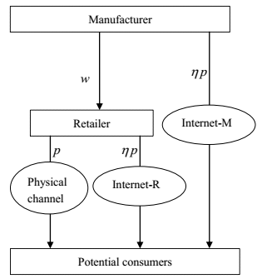

Fig. 7. The structure of both agents opening online channels (Model )

Obviously, when, the above structure will be reduced to Model 1, and when , it will become Model 2. Using similar arguments, we can obtain the profits of the two members as follows:





Using the backward induction method, we can derive the optimal prices as follows:

.

.

The effective demand and the optimal profits can be easily calculated according to and . It can be shown that  and  also hold in the feasible region . The proofs are given in the Electronic Companion.

**Proposition 6.** In the feasible region , , and .

For the proof, see the Electronic Companion.

Proposition 6 shows that in Model , the manufacturer’s profit decreases when the proportion of demand for the retailer’s e-channel increases. This is intuitively true. When  (the case in Model 1), the manufacturer can win the maximal profit because the retailer does not open an online channel; but when  (the case in Model 2), the manufacturer will achieve the minimum profit just through the retailer’s dual channels. That is, in Model, although the two agents open e-channels at the same time and the channel competition thus becomes intense, the manufacturer can still win more profit than he can in Model 2. Therefore, we can conclude that the manufacturer can always gain more profit by opening an e-channel.

However, for the retailer’s profit, it is difficult to provide an [explicit expression](http://www.baidu.com/link?url=bTKI9BK5d8vjPQm8rqe4C4cq1vJDwoZmu95dRj2gZnbpogMa7MBJfLF9jrlz22pF4inIhrUA4xWLBr0xwuKYyVm_8IkrykkOjmjTMOPMhcIA7OENUOWoXUZtV8fGgDHa) with respect to .Thus, some numerical examples of the influence of  on the retailer’s profits are illustrated. Note that in Fig. 3, comparisons are given between the retailer’s optimal profits in Model 1 and Model 2. To facilitate the comparison, we also take data of  or in Fig. 3 and illustrate the results in Fig. 8.

It can be seen that for  in Fig. 3, as  is increasing, the retailer’s profit is decreasing from Fig. 8(a) or decreasing first and then increasing from Fig. 8(b).  reaches its maximum at =0 for . For  in Fig. 3, the retailer’s profit is increasing in *s* from Fig. 8(c) or decreasing first and then increasing from Fig. 8(d).  reaches its maximum at  for . Through the experiments, we also observe that if we take the data of  in Fig. 3, then ; if we take the data of  in Fig. 3, then . These conclusions [coincide](http://www.baidu.com/link?url=rCg3I-aGujudbC1yxzDsBYWaPrNDb9MHNEU1c2bcAZkULVdYBIXH9XXOS9JroSb5E_2uxo9wbOO1GB0WY4Ho3ESYfV-7weG33ctrCMIQnsK) with the cases in Model 1 and Model 2.

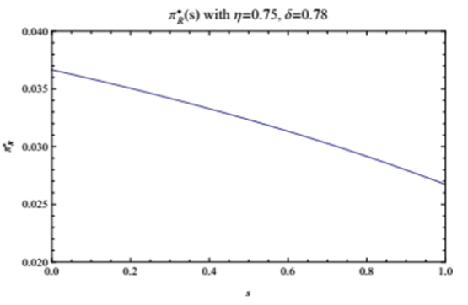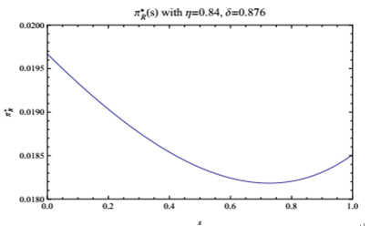

1. (b)

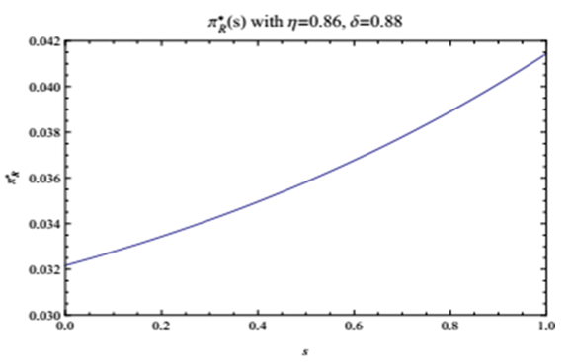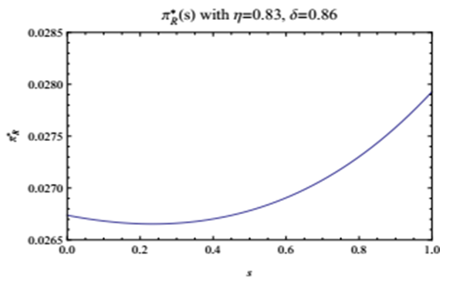

(c) (d)

Fig. 8. Impact of  on the retailer’s profits

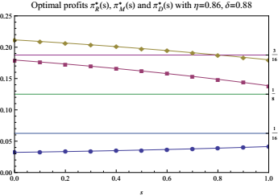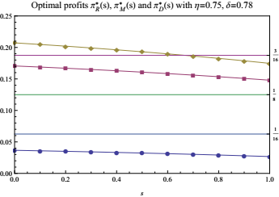

Fig. 9.  compared with the benchmark, where the three horizontal lines from bottom to top represent,and , respectively

Fig. 9 shows ,andtogether with the corresponding profits in the benchmark model. It appears that in both cases  and , the retailer is worse off, whereas the manufacturer is better off, when they both introduce e-channels simultaneously. In addition, the total supply chain profit is decreasing in *s*, which indicates that when the retailer’s demand proportion increases, it creates fierce competition.

**5.2 Extension to the cases where the discount rate is a decision variable**

In our discussion so far, we have assumed that the discount rate  is an exogenous input parameter. Note that online discount policy is an important promotion strategy. It would be interesting to investigate the cases in which the discount rate is treated as an endogenous decision variable. This section will extend Model 1 and Model 2 to examine the impact of this change the results.

**Case 1. Model 3-- the manufacturer’s dual-channel model with an endogenous discount rate**

Let Model 3 denote the case in which the manufacturer introduces an e-channel and decides the discount rate . The sequence of events is as follows. i) The manufacturer determines wholesale price  and discount rate . ii) The retailer responds by determining the appropriate retail price . iii) The consumers decide which channel to purchase the product from.

By the backward induction method，for a given , the retailer’s profit is



From the concavity of the objective functions in  and the first-order condition for , we arrive at



Given the retailer’s response function, the manufacturer’s profit is

.

Let the first partial derivatives of with respect to  and  be zero. From , we obtain:



Substitute (15) into ; it then follows



where. It can be shown that equation  has a unique solution in the interval . Let  denote this solution. In addition, we can show that  has a unique stationary point with respect to  in the region . In fact, the manufacturer achieves the maximum profit at the unique stationary point: .

However, with some algebraic calculation, we could find . This implies that the retailer would directly buy the product from the manufacturer’s online channel rather than from the traditional brick-and-mortar channel. To avoid such an unusual situation, the pricing decisions and the discount rate should satisfy the constraint: . Together with the constraints  and , the constraints can be summarised as follows:



From the above constraints, we can obtain the solution region, defined as , where

.

To better understand the discount rate decision, Fig. 10 shows the solution Region  and the discount rate decision with varying . This result is actually consistent with the sensitivity analysis in Proposition 4(i), which states that the manufacturer's profit is decreasing as the discount rate increases. Thus, on the boundary of the solution Region  with the smallest , the manufacturer can obtain his optimal profit. We have the result in Proposition 7.

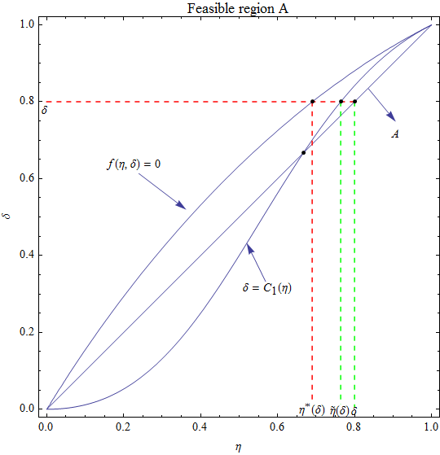

Fig. 10. Solution Regionin Model 3

**Proposition 7.** Suppose ; then, the optimal strategies of the manufacturer are given in , where  is given in (18) and  is given in (15).

**Case 2. Model 4-- the retailer’s dual-channel model with an endogenous discount rate**

Let Model 4 denote the case in which the retailer introduces the e-channel and decides the discount rate . We assume . The sequence of events is as follows. i) The manufacturer determines wholesale price . ii) The retailer responds by determining the appropriate retail price *p* and the discount rate . iii) The consumers decide which channel to purchase the product from.

By the backward induction method，for a given , the retailer’s profit is



Taking the first partial derivatives with respect to  and , we obtain





It can be shown that . This implies that the retailer’s profit will increase as the discount rate increases. In other words, in the feasible solution region, the retailer would choose the largest possible value of , i.e.,. This result is consistent with the sensitivity analysis of the price discount rate on the retailer’s profit in Proposition 4(ii). A result similar to that for Proposition 7 could be established for Model 4.

From the above analysis, it can be seen that in Model 1 and Model 3 under the condition , the manufacturer’s profit is optimal on the boundary of the feasible region with the smallest , whereas in Model 2 and Model 4 under the condition , the retailer’s profit is optimal on the boundary of the feasible region with the largest , i.e., . This means that regardless of whether the discount rate is treated as an exogenous input variable or an endogenous decision variable, the qualitative results regarding the impact of the discount rate on the player’s profit remain the same. However, clearly, in Model 3 and Model 4, the optimal discount rate  takes different values, and the optimal pricing decisions are more complicated. This makes the comparison between Model 3 and Model 4 more difficult and challenging, which requires further research.

In terms of Model , its extension to the case in which the manufacturer and the retailer determine their online discount rates separately is much more complicated and difficult to analyse, and so we are not able to obtain meaningful analytical results.

**5.3 Managerial implications**

Our research reveals some managerial insights for the manufacturer and the retailer in terms of their decisions about whether to introduce or abandon their e-channels.

In practice, the manufacturer dual channel (Model 1) and the retailer dual channel (Model 2) both exist. In comparison with the traditional brick-and-mortar channel (Model 0), we find that the manufacturer is always better off having his own online channel, but the retailer will be better off under certain conditions that are characterised by particular combinations of two parameters, i.e., consumer acceptance of the e-channel and the online discount rate. The implication is that manufacturers should choose to open their own e- channels. However, many traditional manufacturers in China, such as Maotai, have focused more on production for many years; thus, they may first choose to cooperate with a retailer. After accumulating experience in the online market and gaining consumer acceptance, they could then decide to open their own online channel.

From the retailer’s perspective, although her profit would decline after the introduction of the e-channel, different combinations of the consumer acceptance of the e-channel and the online discount rate  could impact her preference for Model 1 or Model 2. We are able to identify and characterise the regions of  to determine the retailer’s preference. In addition, we have shown that the retailer’s online demand will increase if a lower online price is offered to consumers (see Proposition 4(ii)). Therefore, to capture the online market, the retailer may choose to offer an online discount periodically. For example, the Double 11 Festival in China, has been a very successful event that attracts online consumers.

Some products, such as some famous brands in the apparel industry, including Tommy Hilfiger and Ralph Lauren, have both a retailer e-channel and a manufacturer-channel in addition to the traditional retail brick-and-mortar channel. This is represented in Model s in Section 5.1. Our results indicate that the manufacturer’s profit would be lower than it is in Model 1 but higher than it is in Model 2. Moreover, when the proportion of demand for the retailer’s e-channel increases, the manufacturer’s profit and the total supply chain profit are decreasing. This leads to fierce competition.

Under the condition in which the wholesale price is less than the online selling price (i.e.,), the manufacturer’s optimal profit in Model 1 or in Model 3 is achieved on the boundary of the feasible region by taking the smallest , whereas the retailer’s optimal profit in Model 2 or Model 4 could be achieved in the feasible region by taking the largest . That means, regardless of whether the discount rate  is treated as exogenous input variable or an endogenous decision variable, the discount rate has a similar impact on both the manufacturer’s and the retailer’s profits from a qualitative perspective, although the degree of impact and the boundary of the feasible solutions may be different.

**6. Conclusions**

This paper studies channel selection issues by considering whether the manufacturer or the retailer should open an e-channel in addition to the traditional brick-and-mortar channel. We capture the traditional brick-and-mortar channel (Model 0), the manufacturer dual-channel model (Model 1), and the retailer dual-channel model (Model 2) in a unified framework. Our models take into account two important phenomena: consumers’ lower valuation of the products sold through e-channels and sellers’ discount pricing behaviour in e-channels to promote sales. The optimal equilibrium-pricing decisions are derived using a Stackelberg game. Theoretic analyses and comparisons among these models are made with respect to the prices, demand, and profits for the two members and the entire supply chain.

The results show that the demand for the supply chain and the profit of the manufacturer increase regardless of who introduces the e-channel. However, the profit of the retailer will always decrease. Compared with the benchmark (Model 0), the total profit of the supply chain in Model 1 increases, whereas the total profit of the supply chain in Model 2 decreases. This reveals that the double-marginalisation effect will be alleviated if the manufacturer introduces an e-channel but will be exacerbated if the retailer introduces an e-channel. Although the manufacturer can always obtain more profit through his dual channel than through the retailer dual channel, the retailer dual channel can capture the market of the online channel better than the manufacturer dual channel. It is therefore possible that in order to grab the online market at the early stage of entry, the manufacturer may choose not open his own e-channel and instead cooperate with the retailer to win consumer acceptance of his online product. Furthermore, we find that the retailer’s preference for who opens the e-channel depends on the combination of consumer acceptance and the online price discount rate and is also related to the manufacturer’s ability to control the channels.

Finally, we develop two extensions of the models. First, we generalise the models to the situation in which both the manufacturer and the retailer can open e-channels simultaneously. Second, we extend the models to the cases in which the online discount rate is treated as a decision variable. It is shown that some main results can be carried over to the extended models.

Note that our models are based on the assumptions that the cost of the brick-and-mortar channel and the cost of the e-channel are both normalised to zero. However, in practice, the cost of the brick-and-mortar channel is likely to be higher than the cost of the e-channel. Further research is required in this direction. In addition, the extended models could be further analysed and compared, particularly in the case in which both the manufacturer and the retailer can open e-channels and decide discount rates.

**Acknowledgements**

The authors are grateful to two anonymous reviewers and the Associate Editor for their valuable and constructive comments, which have significantly improved the paper.

**References**

Anthem Marketing Solution (2010). Deal-seeking: online vs. offline. *White paper,* Oct 28, 2010. URL http://www.anthemedge.com/sites/default/files/Market%20Basket%20Analysis

%20102010.pdf

Aulak, G. (2014). The average price difference between online and offline prices of smartphones is just 5%, says survey. *The Economic Times,* Oct 27, 2014. URL http://economictimes.indiatimes.com/industry/services/retail/the-average-price-difference-between-online-and-offline-prices-of-smartphones-is-just-5-says-survey/articleshow/44943820.cms

Arya, A., Mittendorf, B., & Sappington, D. E. (2007). The bright side of supplier encroachment. *Marketing Science*, 26(5), 651-659.

Asgari, N., Nikbakhsh, E., Hill, A., & Farahani, R. Z. (2016). Supply chain management 1982–2015: a review. *IMA Journal of Management Mathematics,* 27(3).

Balakrishnan, A., Sundaresan, S., & Zhang, B. (2014). Browse‐and‐switch: Retail‐online competition under value uncertainty. *Production and Operations Management*, 23(7), 1129-1145.

Cai, G. G. (2010). Channel selection and coordination in dual-channel supply chains. *Journal of Retailing*, 86(1), 22-36.

Cao, J., So, K. C., & Yin, S. (2016). Impact of an “online-to-store” channel on demand allocation, pricing and profitability. *European Journal of Operational Research*, 248(1), 234-245.

Cattani, K., Gilland, W., Heese, H. S., & Swaminathan, J. (2006). Boiling frogs: Pricing strategies for a manufacturer adding a direct channel that competes with the traditional channel. *Production and Operations Management*, 15(1), 40.

Chiang, W. Y. K., Chhajed, D., & Hess, J. D. (2003). Direct marketing, indirect profits: A strategic analysis of dual-channel supply-chain design. *Management science*, 49(1), 1-20.

Chiang, W. Y. K., & Monahan, G. E. (2005). Managing inventories in a two-echelon dual-channel supply chain. *European Journal of Operational Research*, *162*(2), 325-341.

China e-Business Research Center, (2016a). 2015 China e-commerce market data monitoring report. URL http://www.100ec.cn/zt/upload_data/2015ls.pdf.

China e-Business Research Center, (2016b). 2016 China e-commerce market data monitoring report (Part I). URL <http://www.100ec.cn/zt/upload_data/2016hlwjr.pdf>.

Chellappa, R. K., Sin, R. G., & Siddarth, S. (2011). Price formats as a source of price dispersion: A study of online and offline prices in the domestic US airline markets. *Information Systems Research*, 22(1), 83-98.

Hsiao, L., & Chen, Y. J. (2014). Strategic motive for introducing internet channels in a supply chain. *Production and Operations Management*, 23(1), 36-47.

Huang, W., & Swaminathan, J. M. (2009). Introduction of a second channel: Implications for pricing and profits. *European Journal of Operational Research*, 194(1), 258-279.

Ghadimi, S., Szidarovszky, F., Farahani, R. Z., & Khiabani, A. Y. (2013). Coordination of advertising in supply chain management with cooperating manufacturer and retailers. *Ima Journal of Management Mathematics*,1(24), 1-19.

Kacen, J. J., & Lee, J. A. (2002). The influence of culture on consumer impulsive buying behavior. *Journal of consumer psychology*, 12(2), 163-176.

Kireyev, P., Kumar, V., & Ofek, E. (2014). Match your own price? self-matching as a retailers multichannel pricing strategy. *Tech. rep., Working Paper, Harvard Business School.*

Khouja, M., Park, S., & Cai, G. G. (2010). Channel selection and pricing in the presence of retail-captive consumers. *International Journal of Production Economics*, 125(1), 84-95.

Luo, L., & Sun, J. (2016). New Product Design under Channel Acceptance: Brick‐and‐Mortar, Online‐Exclusive, or Brick‐and‐Click. *Production and Operations Management*, *25*(12), 2014-2034.

Liu, Y., Gupta, S., & Zhang, Z. J. (2006). Note on self-restraint as an online entry-deterrence strategy. *Management Science*, *52*(11), 1799-1809.

Li, B., Hou, P. W., & Li, Q. H. (2017). Cooperative advertising in a dual-channel supply chain with a fairness concern of the manufacturer. *IMA Journal of Management Mathematics*. 28 , 259–277.

Li, T., Zhao, X., & Xie, J. (2015). Inventory management for dual sales channels with inventory-level-dependent demand. *Journal of the Operational Research Society*, 66(3), 488-499.

Liang, T. P., & Huang, J. S. (1998). An empirical study on consumer acceptance of products in electronic markets: a transaction cost model. *Decision support systems*, 24(1), 29-43.

Ma, S., Lin, J., & Zhao, X. (2016). Online store discount strategy in the presence of consumer loss aversion. *International Journal of Production Economics*, 171, 1-7.

Ma, W. M., Zhao, Z., & Ke, H. (2013). Dual-channel closed-loop supply chain with government consumption-subsidy. *European Journal of Operational Research*, 226(2), 221-227.

Matsui, K. (2016). Asymmetric product distribution between symmetric manufacturers using dual-channel supply chains. *European Journal of Operational Research*, 248(2), 646-657.

Ofek, E., Katona, Z., & Sarvary, M. (2011). “Bricks and clicks”: The impact of product returns on the strategies of multichannel retailers. *Marketing Science*, 30(1), 42-60.

Pei, Z., & Yan, R. (2015). Do channel members value supportive retail services? Why? *Journal of Business Research*, 68(6), 1350-1358.

Park, C. H., & Kim, Y. G. (2003). Identifying key factors affecting consumer purchase behavior in an online shopping context. *International Journal of Retail & Distribution Management*, 31(1), 16-29.

Sousa, R., Amorim, M., Rabinovich, E., & Sodero, A. C. (2015). Customer Use of Virtual Channels in Multichannel Services: Does Type of Activity Matter? *Decision Sciences*, 46(3), 623-657.

Steiner, R. L. (2004). The evolution and applications of dual-stage thinking. *The Antitrust Bulletin*, *49*(4), 877-909.

Spengler, J. J. (1950). Vertical integration and antitrust policy. *Journal of political economy*, *58*(4), 347-352.

Tsay, A. A., & Agrawal, N. (2004). Channel conflict and coordination in the e‐commerce age. *Production and Operations Management*, *13*(1), 93-110.

Xu, H., Liu, Z. Z., & Zhang, S. H. (2012). A strategic analysis of dual-channel supply chain design with price and delivery lead time considerations. *International Journal of Production Economics*, 139(2), 654-663.

Yan, R., & Ghose, S. (2010). Forecast information and traditional retailer performance in a dual-channel competitive market. *Journal of Business Research*, 63(1), 77-83.

Yan, R., Wang, J., & Zhou, B. (2010). Channel integration and profit sharing in the dynamics of multi-channel firms. *Journal of Retailing and Consumer Services*, *17*(5), 430-440.

Zhang, X. (2009). Retailers' multichannel and price advertising strategies. *Marketing Science*, *28*(6), 1080-1094.

Zhang, Z., Zhang, Z., Wang, F., Law, R., & Li, D. (2013). Factors influencing the effectiveness of online group buying in the restaurant industry. *International Journal of Hospitality Management*, *35*, 237-245.