Computational prediction and experimental realization of p-type carriers in the wide band-gap oxide SrZn_{1−x}Li_{x}O₂
Christos A. Tzitzeklis,^{a†} Jyoti K. Gupta,^{a†} Matthew S. Dyer,ª Troy D. Manning,ª Michael J. Pitcher,ª Hongjun J. Niu,ª Stanislav Savvin,ª Jonathan Alaria,^{b} George R. Darling,ª John B. Claridge ª and Matthew J. Rosseinsky.ª*

ª Department of Chemistry, Materials Innovation Factory, University of Liverpool, 51 Oxford Street, Liverpool, L7 3NY, UK.
^{b} Department of Physics, University of Liverpool, Liverpool, L69 7ZE, UK.
† These authors contributed equally to this work.
* Corresponding author. Email: rossein@liverpool.ac.uk

ABSTRACT:
It is challenging to achieve p-type doping of zinc oxides, which are of interest as transparent conductors in optoelectronics. A ZnO related ternary compound, SrZnO₂ was investigated as a potential host for p-type conductivity. First principles investigations were used to select from a range of candidate dopants the substitution of Li⁺ for Zn²⁺ as a stable, potentially p-type, doping mechanism in SrZnO₂. Subsequently, single phase bulk samples were prepared of a new p-type doped oxide, SrZn_{1−x}Li_{x}O₂ (0 < x < 0.06). The structural, compositional and physical properties of both the parent SrZnO₂ and SrZn_{1−x}Li_{x}O₂ were experimentally verified. The band gap of SrZnO₂ was calculated using HSE06 at 3.80 eV, and experimentally measured at 4.27 eV, which confirmed the optical transparency of the material. PXRD and ICP analysis were combined to show that single phase ceramic samples can be accessed in the compositional range x < 0.06. A positive Seebeck coefficient of 353(4) μV/K for SrZn_{1-x}Li_{x}O₂ where x = 0.021 confirmed that the compound is a p-type conductor, which is consistent with the pO₂ dependence of the electrical conductivity observed in all SrZn_{1-x}Li_{x}O₂ samples. The conductivity of SrZn_{1−x}Li_{x}O₂ is up to fifteen times greater than undoped SrZnO₂ (for x = 0.0278, 2.53 μS/cm, 600°C at 1 atm O₂).

1. INTRODUCTION
Doped zinc oxides are an important class of optoelectronic materials due to their high conductivity, high visible transparency and high abundance. Often used as electrodes in photovoltaic devices, LEDs, thin film transistors and ambipolar transistors, ZnO is a popular material and plays a huge role in the drive towards transparent electronics. However, this requires high quality n-type and p-type materials with equivalent optoelectronic properties. High quality n-type ZnO is readily available through doping with group III trivalent elements (Al, Ga, In) on the Zn²⁺ site, or group VII elements on the O²⁻ site, with n-type Al doped ZnO thin films presently being used in many applications, showing conductivity values as high as 1.17 × 10⁴ S cm⁻¹.¹
Producing high quality p-type transparent conductors remains a challenge and significant progress is required to achieve p-type properties approaching those of their n-type counterparts.² Attempts to form p-type ZnO by doping with group I elements (Li, Na, K)^{3–7} on the Zn²⁺ site or group V elements (N, P)^{8–10} on the O²⁻ site have attracted attention, both theoretically and experimentally, but obtaining a significant hole carrier concentration in ZnO is hindered by self-compensating native n-type defects (oxygen vacancies and/or zinc interstitials).¹¹ Additionally, impurity-induced holes (if formed) have limited mobility as they are strongly localised in deep acceptor levels,¹² at the highly electronegative oxide sites.¹³ Reported p-type conductivities in doped ZnO compounds in the form of thin films range from 2.0×10⁻⁶ S cm⁻¹ for N:ZnO,¹⁴ to 0.07 S cm⁻¹ for Zn_{0.995}Na_{0.005}O,⁶ confirmed by Seebeck coefficient and Hall effect measurements respectively. Co-doping with two or more elements can further increase the conductivity to 1.2 - 1.8 S cm⁻¹ observed for (Al,N):ZnO thin films.^{15–17} Despite the numerous attempts at p-type doping of ZnO there are still few convincing examples and concerns exist about reproducibility.¹⁸
Ternary zincates offer different options to stabilize the formal oxidation of zinc beyond the +II oxidation state because of the increased diversity of chemical environments both for zinc itself and for potential dopants. Ternary zincates containing electropositive cations, such as Sr²⁺, are expected to favour higher zinc oxidation states through enhanced covalent bonding with oxide.^{19,20} The only reported ternary p-type zinc-containing oxides are the spinels M₂ZnO₄ (M = Co, Rh, Ir) which all have intrinsic p-type character arising from acceptor like antisite defects and/or Zn vacancies, but all have band-gaps <3 eV and large hole effective masses.¹⁸ In all these cases, oxidation will take place at the transition metal (Co, Rh, Ir) with the zinc being electronically inactive due to the high ionization energies associated with its closed-shell configuration. Here we consider the doping of the wide band-gap ternary oxide SrZnO₂. In contrast to ZnO (which adopts the hexagonal wurtzite structure with a three-dimensional network of corner sharing ZnO₄ tetrahedra), SrZnO₂ has a two-dimensional orthorhombic structure with layers of corner-sharing ZnO₄ tetrahedra separated by Sr²⁺ ions in the sites between these layers, which are coordinated by seven oxide ions (Fig. 1). SrZnO₂ has a reported band-gap of 3.41 eV,¹⁷ similar to that of ZnO (3.37 eV),²¹ and the material has found use as a phosphor host.²² There are currently no published reports of the band structure or conductivity of SrZnO₂.
Computational tools are increasingly used to aid the understanding of materials properties and computational structure predictions have also successfully guided experimental studies resulting in accelerated discovery of new materials,^{23–26} with new tools being developed as computing power and theoretical understanding grows. Such methods for computationally screening large chemical spaces have also been implemented to identify potential p-type conducting compounds, however none have yet identified new p-type zinc oxides or led to experimentally demonstrated p-type materials.^{27,28}
In this paper, we report the p-type doping of SrZnO₂ using substitutions identified with Density Functional Theory (DFT) methods to guide synthetic studies. Introduction of Li as dopant was found computationally to be the most energetically favourable, giving a formation energy closest to the convex hull for substitution into the otherwise defect-free structure. Li was successfully incorporated into SrZnO₂ via experimental solid-state synthesis methods, affording a material with low visible light absorption and stable, albeit low, p-type conductivity.

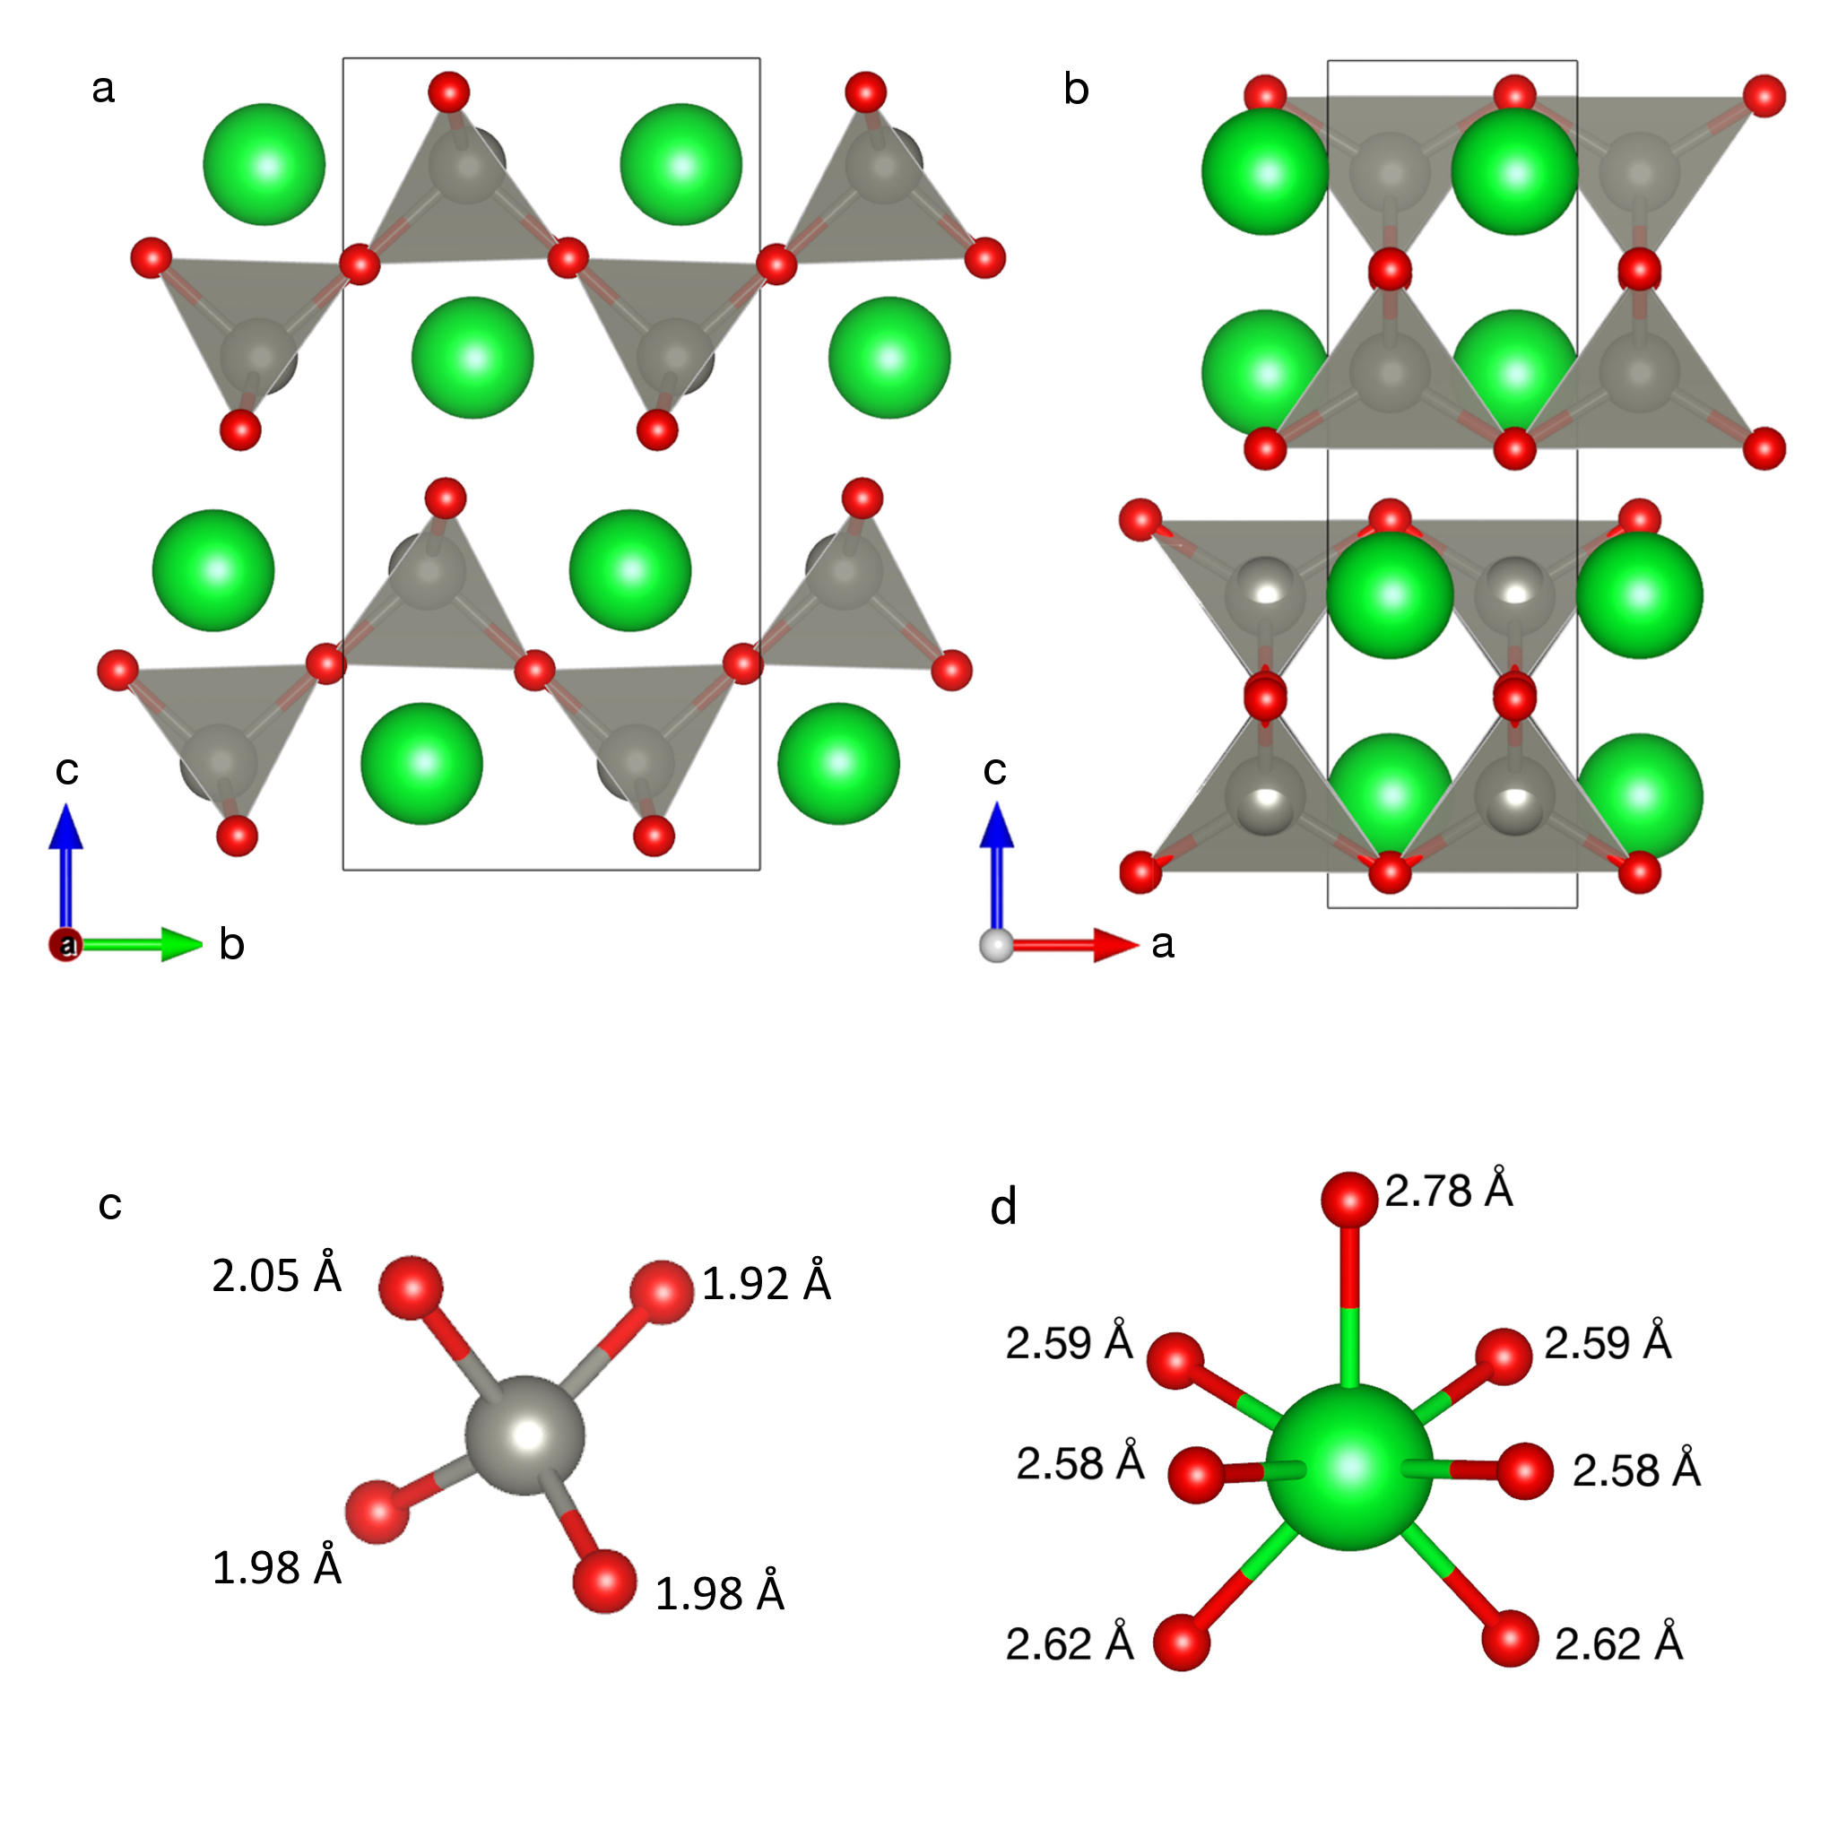

Fig. 1 Structure of SrZnO₂. Sr²⁺ ions are located between the corner-sharing ZnO₄ tetrahedra viewed a) along the a axis, b) along the b axis, c) the ZnO₄ tetrahedra with the Zn-O bond lengths indicated and d) the SrO₇ environment with the Sr-O bond lengths. Oxide ions are shown in red, Sr²⁺ in green and Zn²⁺ in grey.

2. METHODS
2.1 Computational: Calculations were performed using the plane wave based DFT code Vienna Ab-initio Simulation Package (VASP).²⁹ The core electrons were treated using the projector augmented wave method.^{30,31} The parent compounds ZnO and SrZnO₂ were investigated using the Hybrid functional (HSE06),^{32,33} using the default exchange mixing of 25% Hartree Fock and 75% of the generalized gradient approximation (GGA) of Perdew, Burke and Ernzerhoff (PBE)³⁴. The crystal structure of SrZnO₂ was obtained from the ICSD (Inorganic Crystal Structure Database,³⁵ ICSD no. 15913). SrZnO₂ has the Pnma space group with cell parameters a = 3.35 Å, b = 5.84 Å, c = 11.37 Å and 16 atoms per unit cell. The cell was optimized using Gamma- centered k-point sampling 8×4×2 and a cut-off energy of 520 eV. ZnO (ICSD 26170) was optimised using a k-point grid of 5×5×3, to compare the calculated properties of the two compounds.
Aliovalent substitution calculations were completed in VASP using PBE³⁴ as the exchange correlation functional, allowing faster convergence of the large structures to be obtained. A 2×4×1 super cell of the SrZnO₂ structure was made containing 128 ions and one atom was substituted with an aliovalent dopant, as listed in Table 1. A Monkhorst-Pack³⁶ k-point sampling and a cut-off energy of 520 eV was used. The ICSD³⁵ was screened to identify all possible competing phases and the stabilities of the doped compound were calculated by constructing the convex hull with respect to the lowest energy combination of competing phases, using the Python Materials Genomics, pymatgen, phase diagram package.³⁷ All structures were visualized using the VESTA package.³⁸

Table 1 Ionic radii of candidate p-type dopants for the substitution of Zn²⁺ and Sr²⁺ within SrZnO₂, with the corresponding coordination environments.³⁹
Ion | Coordination no. | Ionic Radius (Å) | Dopant ion | Ionic Radius(Å) | Difference in radii(Å)
Zn²⁺ | 4 | 0.60 | Li⁺ | 0.59 | -0.01
 |  |  | Ag⁺ | 1.00 | 0.40
Sr²⁺ | 7 | 1.21 | Na⁺ | 1.12 | -0.09
 |  |  | K⁺ | 1.46 | 0.25
 |  |  | Ag⁺ | 1.22 | 0.01

2.2 Experimental synthesis. SrZnO₂ samples were prepared via conventional solid state reactions using stoichiometric mixtures of SrCO₃ (99.99%) and ZnO (99.99%). Pellets were made and loaded into alumina crucibles, heated to 1090°C at 4ºC/min, and then annealed for 6 hours. The samples were reground and fired twice, under flowing oxygen (10 ml/min) to prevent the formation of ZnO impurities. Property measurements were completed on ceramic discs, prepared by cold isostatic pressing at 2000 bar for 15 minutes, followed by a final sintering step. SrZn_{1−x}Li_{x}O₂ samples were prepared by solid state reactions using stoichiometric mixtures of SrCO₃ (99.99%), ZnO (99.99%) and Li₂CO₃ (99.99%) to obtain nominal compositions of 0 < x ≤ 0.15. Sample mixtures were loaded into an alumina crucible between two sacrificial pellets and under a layer of sacrificial powder, all of the same composition, sealed with an alumina lid. They were heated to 1090°C at 4ºC/min under flowing oxygen and annealed for 6 hours. Pellets were reground between firings. Small samples of 0.2 g, used for exploratory synthesis, were fired three times, whereas larger 2.0 g samples, for optical and electronic property measurements, were fired until no unit cell volume change was observed from PXRD measurements (up to seven firings).
2.3 Powder X-ray Diffraction (PXRD): PXRD data were obtained from a Panalytical X’Pert Pro diffractometer operating in Bragg-Brentano geometry, with a monochromated Co Kα₁ source (λ = 1.78896 Å) and position-sensitive X’Celerator detector. Data were collected over the angular range 10° < 2θ < 110°, with a step size of 0.0167° and a time per step of 0.47 s. Lattice parameters were derived from Pawley refinements with the Topas Academic package (version 5).^{40,41} The background was modelled using a Chebyschev polynomial function and the lattice parameters, a sample height correction, peak profile functions and model-independent peak intensities were refined. Peak profiles were modelled with a pseudo-Voigt function. KCl was added as an internal standard for the determination of accurate relative lattice parameters.
2.4 Synchrotron Powder X-ray Diffraction (SXRD): Synchrotron powder X-ray diffraction patterns were recorded on the I11 beamline at Diamond Light Source (UK) at room temperature using a wide-angle position sensitive detector and an incident wavelength of 0.82603 Å. The samples were contained in 0.3 mm diameter borosilicate glass capillaries and spun to improve the powder averaging of the crystallites.
2.5 Inductively Coupled Plasma Optical Emission Spectroscopy (ICP-OES): Compositions were determined using a PerkinElmer Optima 2000 instrument. Solutions were prepared by digesting approximately 10 mg of sample in 40 ml of 0.1 M HNO₃ and diluted further in deionized water to a volume of 100 mL. The measurements were repeated three times for each sample.
2.6 Raman spectroscopy: The Raman spectra of the samples were recorded at ambient temperature on a Horiba HR800 instrument, with laser excitation at 514.5 nm, 2 mW power.
2.7 DC conductivity measurements: Sintered pellet samples were cut into rectangular shapes of approximately 1.5 × 2 × 11.5 mm, polished and wrapped with four Au wires, as shown in Fig. S8, for four-probe DC electrical property measurements. Au paste was painted on the Au electrodes, dried at 150 °C for 1 hour and subsequently fired at 550 °C for 2 hours to ensure good bonding. 0.05-0.5 mA DC was applied on the outer two probes using a constant-current supply (Keithley, 220 programmable current source) and voltage drops (in the two inner probes) were measured with a Keithley 2182 Nanovoltmeter. The partial pressure of oxygen was monitored in-situ using a zirconia-based pO₂-sensor (Rapidox 2100, Cambridge Sensotec Ltd.) and controlled by mixing O₂ and Ar with the use of mass flow controllers (Brooks Instruments, mod. 5850) governed by a control unit (Brooks,mod. 0154). The total gas flow rate was 30 mL min⁻¹. Measurements were performed after 3 hours equilibration at each oxygen partial pressure to ensure a stable conductivity.
2.8 AC impedance measurements: AC impedance spectroscopy measurements were performed using a Solartron Model 1255B frequency response analyzer coupled with a Solartron Model 296 dielectric interface or using a stand-alone Solartron Model 1260 system (Solartron Analytical, Farnborough, U.K.) from 1 Hz to 1 MHz between 400 and 600 °C. Au paste was applied on both sides of the pellet before firing at 550 °C for 2 hours to ensure good bonding. Measurements were performed in a range of oxygen partial pressures by controlling the ratio of O₂ and Ar as above. Impedance data were corrected for sample geometry (thickness/area of pellet) and analyzed using ZView (Version 9b, Scribner Associates, Inc., USA).
2.9 Thermopower measurements: Impedance measurements were performed using a high-temperature measurement cell (NorECs AS ProbostatTM, Oslo, Norway). Measurements were conducted from 550 to 600 °C under a pure oxygen atmosphere, using Pt paste electrodes. A temperature gradient was applied across the sample and the change in voltage was measured. The Seebeck coefficient (S) was obtained from
$\text{S= }\text{–}\text{Δ}\text{V} \text{/} \text{Δ}\text{T}$ (Equation 1)
where ΔV is the change in voltage across the sample resulting from a temperature difference of ΔT.
2.10 UV-Visible spectroscopy: UV-visible optical spectra were measured with a Shimadzu UV-2550 UV-visible spectrometer in the range of 200–800 nm, with a data point distance of 0.5 nm and an integration time of 2 s. Data were collected with a scan speed of 0.2 points/nm and slit width of 5 nm.
The diffuse reflectance spectra were analyzed using the Kubelka-Munk function (equivalent to the absorption coefficient), F(R_{a}):
$F\left(R_{a}\right)=\frac{α}{s}= \frac{{(1-R_{a})}^{2}}{2R_{a}}$, (Equation 2)
where α is the absorption coefficient, s is the scattering coefficient, and R_{a} is the energy dependent diffuse reflectance. Accurate optical gaps, were determined by extrapolation of the linear regions of Tauc plots to the energy axis.⁴²

3. RESULTS AND DISCUSSION
3.1 The Electronic Structure of ZnO and SrZnO₂: To assess the potential of SrZnO₂ to be a transparent p-type doped conductor we computed its electronic structure and compared it to that of ZnO. For transparency, SrZnO₂ must have an optical gap at least as large as that of ZnO (3.37 eV).²¹ Using the PBE functional, we obtain a direct band gap at the Γ point of 2.24 eV for SrZnO₂, compared to 0.73 eV obtained for ZnO. These band gaps are smaller than experimentally determined literature values of 3.41 eV for SrZnO₂,¹⁷ and 3.37 eV for ZnO,²¹ but GGA functionals are well-known to underestimate band gaps due to the self-interaction errors.⁴³ To obtain more accurate values, we repeated the calculations with the HSE06 hybrid functional.^{17,44} We obtain better agreement with the experimental lattice constants of the two materials (ESI Table S1), and, in agreement with previous calculations, the band gap for ZnO increases to 2.48 eV, but is still less than the experimental value. This has been attributed to the high d-band width resulting from the strong interaction between the O 2p and Zn 3d bands, which push the O 2p states very close to the Zn 4s, reducing the band gap.⁴⁴ For SrZnO₂ we obtain a band gap of 3.80 eV with HSE06, higher than the reported value of 3.41 eV. It is anticipated the calculated HSE06 band gap of SrZnO₂ will also be underestimated in the same manner as ZnO, as it is expected to have a high d-band width arising from the presence of the ZnO tetrahedra in the structure. Therefore it is predicted that SrZnO₂ is likely to have a larger band gap than 3.80 eV. We will return to this discrepancy between measured and computed band gaps of SrZnO₂ in section 3.5 below. Overall, the computed results indicate that the band gap of SrZnO₂ is larger than that of ZnO, therefore SrZnO₂ is expected to be a transparent material.
Band structures were calculated using the HSE06 functional and projected onto atomic orbitals for both ZnO and SrZnO₂ (Fig. 2). The hole effective mass can be used to provide an indication of hole mobility in a material. In order to obtain better p-type conductivity, the hole effective mass of SrZnO₂ must be smaller than that of ZnO, as a low effective mass, m*, equates to a high hole mobility. A value of m* = 0.67 m_{e} is obtained from the dispersion of the valence band edge from Γ towards Y (the direction with the strongest dispersion, the valence band edge is highly anisotropic) for SrZnO₂. This is lower than the hole effective mass of ZnO at the Γ point (2.48 m_{e} in the Γ to M direction), suggesting that hole mobility in SrZnO₂ should be no worse than that in ZnO (section 3 of ESI, Fig. S1 and S2).
The nature of the electronic states at the valence band and conduction band edges of SrZnO₂ are similar to those in ZnO. The top of the valence band of SrZnO₂ (between 0 and -4.0 eV) is dominated by O 2p states with some contribution from the Zn 3d states and the bottom of the valence band consists of the Zn 3d states with some contribution from O 2p states, as is seen in ZnO. The conduction band below 6.0 eV is dominated by the delocalized Zn 4s states, again similar to ZnO, with very minor contribution from Zn 4p and Sr 5s states.

Fig. 2 Computed band structures of a) ZnO and b) SrZnO₂ from HSE06 calculations. The radius of symbols represents the extent to which different atomic orbitals contribute to the electronic states. Projections are only shown for those atomic orbitals with a major contribution.

3.2 Predicted Substitutions for p-type Doping: We proposed to introduce p-type conductivity in SrZnO₂ by aliovalent substitution of 1+ cations at either the Sr²⁺ or Zn²⁺ site, as indicated in Table 1. The energy above the convex hull (ΔE) was calculated using the PBE functional for each doped material using the Python Materials Genomics (pymatgen) package,³⁷ to quantify the stability of the doped compounds (described further in section 4 of the ESI). A ΔE of 0 meV/formula unit (fu) represents a stable compound, and as can be seen from Table 2, none of the doped compounds are stable at 0 K. All are predicted to decompose into the stable parent SrZnO₂ and other dopant-containing competing phases, indicated in Table 2. SrZn_{1/32}Li_{31/32}O₂ lies closest in energy to the convex hull, with a ΔE of 7 meV/fu, suggesting that the introduction of Li in the Zn sites is the most likely of all the candidates to be an experimentally successful doping strategy.
Finite temperature effects were estimated by calculating the free energy of the doped compounds by inclusion of configurational entropy as described in section 5 of the ESI (Eqns S2 and S3). The results for SrZn_{1−x}Li_{x}O₂ and Sr_{1−x}Na_{x}ZnO_{2,} are shown in Fig. 3, with the remainder shown in Fig. S3. The formation of Sr_{1−x}Na_{x}ZnO₂ and Sr_{1−x}K_{x}ZnO₂ (Fig. S3a) are thermodynamically favoured only at high temperatures or at very low levels of doping. In contrast, SrZn_{1−x}Li_{x}O₂ formation is favoured at much lower temperatures. Fig. 3a shows that at 800 K doping should be favoured up to x ~ 0.075. According to Fig. S3(b-c), doping Ag into SrZnO_{2,} on either the Sr²⁺ or Zn²⁺ site, is thermodynamically unstable over the conditions calculated.

Table 2: Energies above the convex hull of the doped SrZnO₂ materials using PBE calculations.
Compound | Competing Phases | Energy above convex hull (ΔE, meV/ fu)
SrZnO₂ | - | 0
SrLi_{(1/32)}Zn_{(31/32)}O₂ | $\frac{\text{31}}{\text{32}}$SrZnO₂ + $\frac{1}{32}$SrO + $\frac{1}{64}$Li₂O₂ | 7
Sr_{(31/32)}Na_{(1/32)}ZnO₂ | $\frac{31}{32}$ SrZnO₂ + $\frac{1}{96}$ZnO + $\frac{1}{96}$NaO₂ +$\frac{1}{96}$Na₂Zn₂O₃ | 15
Sr_{(31/32)}K_{(1/32)}ZnO₂ | $\frac{31}{32}$ SrZnO₂ + $\frac{1}{48}$ZnO + $\frac{1}{96}$K₂ZnO₂ + $\frac{1}{96}$KO₂ | 11
SrAg_{(1/32)}Zn_{(31/32)}O₂ | $\frac{31}{32}$ SrZnO₂ + $\frac{5}{192}$SrO + $\frac{1}{192}$SrAg₆O₄ + $\frac{1}{64}$O₂ | 24
Sr_{(31/32)}Ag_{(1/32)}ZnO₂ | $\frac{185}{192}$SrZnO₂ + $\frac{7}{192}$ZnO + $\frac{1}{192}$SrAg₆O₄ + $\frac{1}{128}$O₂ | 33

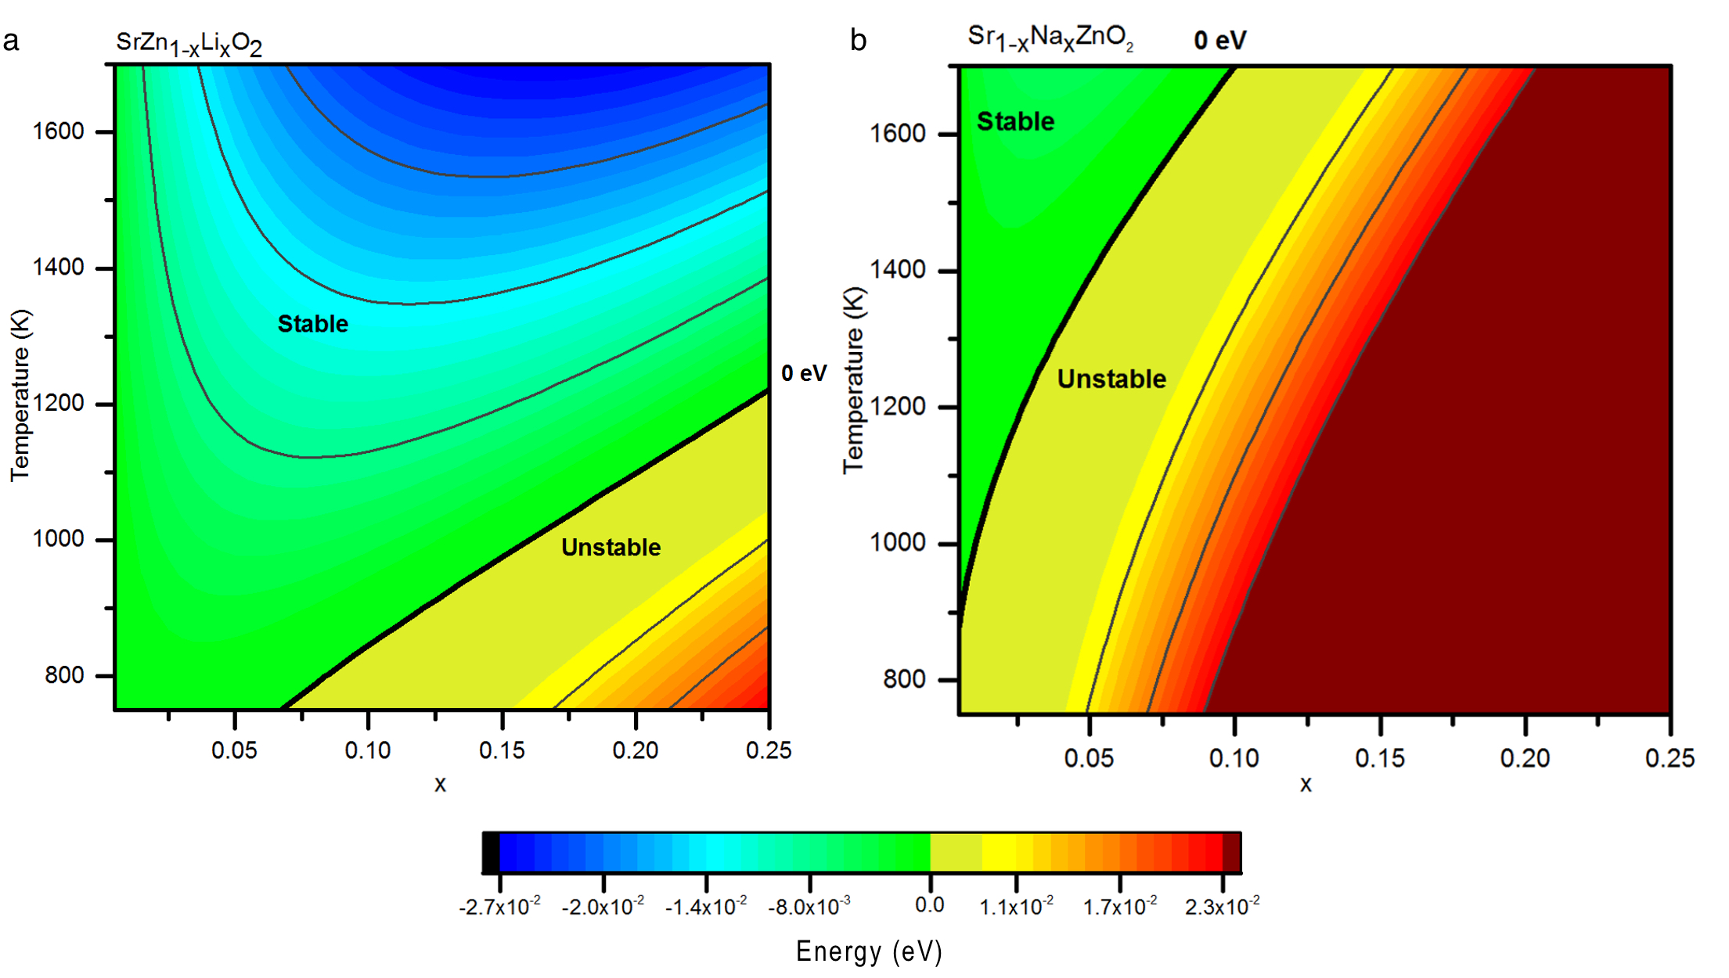
Fig. 3 Free energy analysis (in eV) of a) SrZn_{1−x}Li_{x}O₂ and b) Sr_{1−x}Na_{x}ZnO_{2,} where the bold black line represents the boundary between the thermodynamic stability and instability of the respective compounds.

Based on the rigid band model, the substitution energetics from the convex hull calculations and estimates of finite temperature effects, SrZn_{1−x}Li_{x}O₂ is the best candidate to be investigated experimentally and in the absence of compensating mechanisms or defects such as oxygen vacancies it should be a p-type material. These basic calculations indicate which substitution can likely be made and at which doping levels, however a doped material may contain other defects such as oxygen vacancies. It is more efficient at this point to attempt experimental synthesis to confirm if the substituted materials forms, and measure its properties, rather than pursue a more detailed computational study at a higher level of theory on what at this juncture is still a postulated compound.

3.3 Synthesis, Composition and Structure of SrZn_{1−x}Li_{x}O₂. SrZn_{1−x}Li_{x}O₂ was successfully synthesized as a single-phase material via ceramic synthesis methods (as summarized in the ESI section 6). This is consistent with the computational predictions. Exploratory synthesis of small 0.2 g SrZn_{1−x}Li_{x}O₂ samples with nominal compositions in the range of 0 ≤ x ≤ 0.15, was completed. ICP-OES analysis showed a systematic loss of lithium in the synthesized materials compared with the starting nominal composition (Fig. 4b). Samples with analyzed compositions of below x = 0.06 were found to be single phase by laboratory PXRD (Fig. 4a). Subsequent synchrotron PXRD and UV-visible spectroscopy experiments (section 3.5) demonstrate the presence of <1 wt.% ZnO impurities in some samples, which were not detected by laboratory PXRD (Fig. S15). The analytical, structural and chemical characterization of this series of samples, are presented in section 6.1 of the ESI. At higher analyzed Li contents (x >0.06), the Li loss is accompanied by the appearance of secondary phases in the laboratory PXRD patterns (Fig. 4b). Raman measurements on representative single-phase (x = 0.03, analyzed) and impurity-containing (x = 0.10, analyzed) samples, showed no evidence of the presence of Li₂CO₃ or LiOH impurities, consistent with successful substitution of Li into the parent material (Fig. S11).
A second series of larger (2.0 g) SrZn_{1−x}Li_{x}O₂ samples was synthesized for electrical property measurements (Fig. 5a). To obtain larger amounts of pure samples, the synthetic protocol was adjusted. The number of sintering cycles was increased (to a maximum of seven) until a stable unit cell volume was obtained for at least two subsequent firings (following a progressive reduction of unit cell volume after previous firings). The PXRD patterns of all the single-phase samples are consistent with the orthorhombic SrZnO₂ structure and their lattice parameters were extracted by Pawley refinements in space group Pnma, presented in Fig. S6. The resulting unit cell volumes were found to decrease approximately linearly with increasing analyzed lithium content (Fig. 5b), driven by a contraction of the unit cell along the crystallographic b axis (Fig. 5a). These results indicate that a single phase SrZn_{1−x}Li_{x}O₂ solid solution can be reproducibly synthesized for analyzed compositions with x < 0.06. In the following, the values given for x refer to the analyzed composition obtained using ICP-OES analysis.

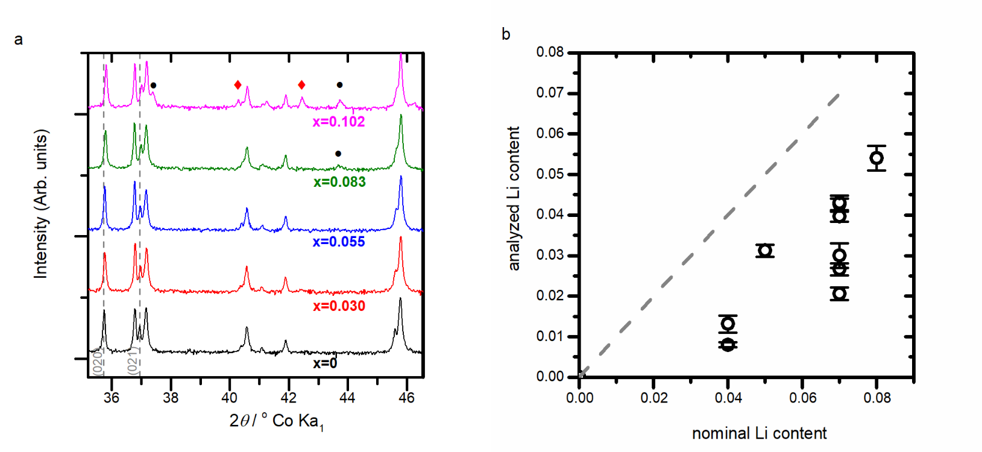
Fig. 4 a) Powder X-ray diffraction patterns stacked in order of increasing analyzed Li content for the 0.2g series of SrZn_{1−x}Li_{x}O₂ samples, plotted with square root intensity scaling to emphasize weak features. The symbol ◆ indicates the presence of ZnO peaks and unindexed peaks are indicated by the ● symbol. The values of x shown refer to the analyzed Li content. b) Analyzed lithium content against nominal composition of the as-synthesized samples, with the dashed grey line highlighting the 1:1 nominal to analyzed Li content ratio.

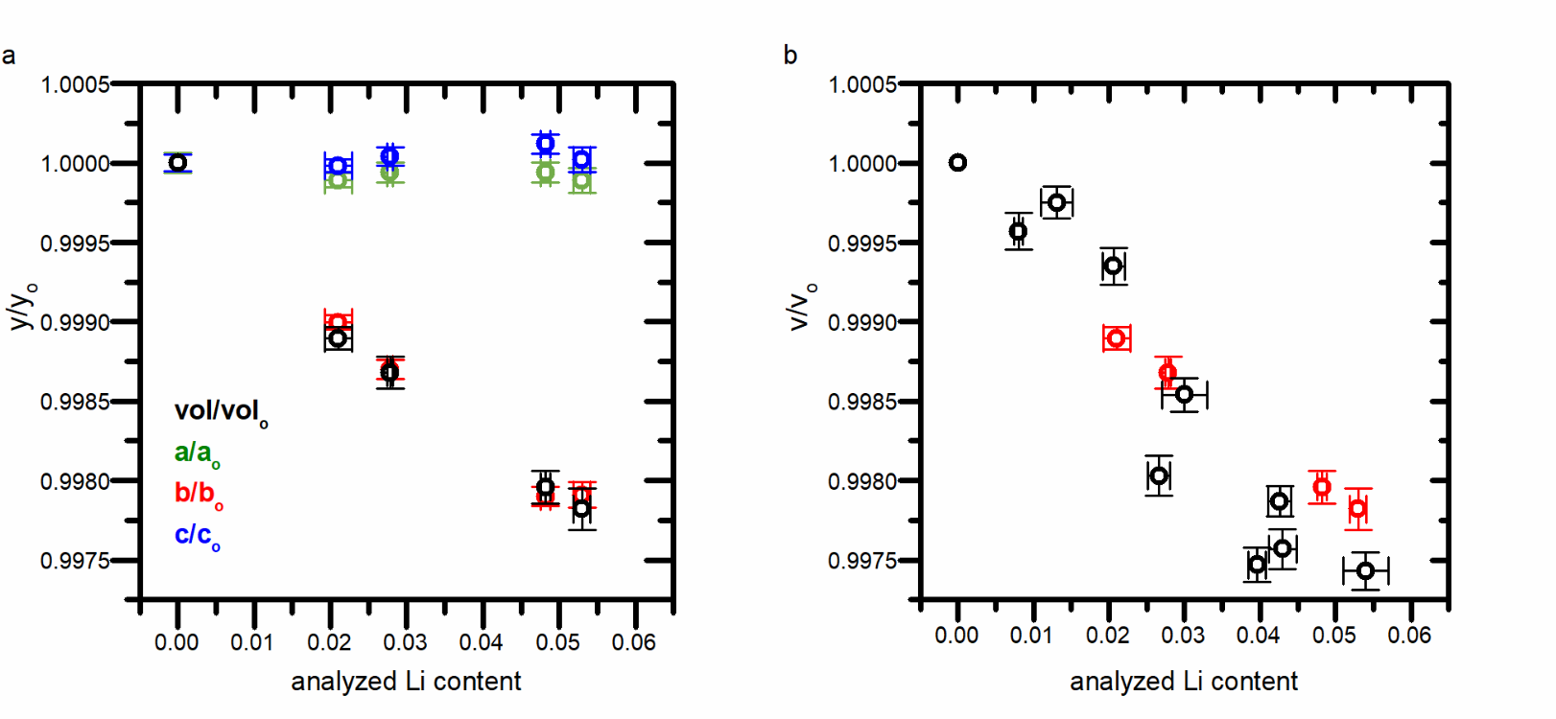
Fig. 5 (a) Refined unit cell parameters as a function of analyzed Li content (by ICP-OES) for 2.0 g SrZn_{1−x}Li_{x}O₂ samples with x = 0, 0.021, 0.028, 0.048 and 0.053 analyzed dopant content. Values are normalised to those of x = 0. Errors are given to 3×ESD. The absolute values of the cell parameters, calculated after Pawley refinements, are shown in section 7.5 of the ESI. (b) Change of unit cell volume as a function of analyzed Li content for both series of SrZn_{1-x}Li_{x}O₂ samples. The black circles represent the small 0.2 g samples and the red circles represent the large 2.0 g samples.

3.4 Electronic properties. Room temperature, ambient atmosphere conductivities of SrZn_{1-x}Li_{x}O₂ were too low to be measured reliably, as such we report conductivities above 500 ºC in oxygen. AC impedance measurements conducted on the 2.0g SrZn_{1−x}Li_{x}O₂ samples showed an increase in conductivity upon the introduction of Li, compared to undoped SrZnO₂, and in combination with the DC conductivity measurements confirm the predominant bulk contribution to the conductivity (see section 7.2 of the ESI). Variable temperature DC conductivity measurements (see Fig. 6a and section 7.3 of the ESI) for doped (x = 0.028) and undoped (x = 0) samples (from the same 2.0 g sample series) yielded an activation energy of 1.5 eV for both samples, indicating a similar mechanism of conductivity. To investigate the nature of the introduced carriers, variable pO₂ DC conductivity measurements were conducted on a new series of 2.0 g SrZn_{1−x}Li_{x}O₂ samples.
Before subjecting the samples to the full variable pO₂ conductivity measurement protocol, their stabilities were assessed under mixed O₂/Ar atmospheres, with different pO₂ levels, by heating them to 600°C and monitoring the DC conductivity in-situ over a period of several hours. Stable resistivity values were only obtained for pO₂ > 0.2 atm, suggesting gradual decomposition under oxygen-poor conditions. This is consistent with the need for an oxygen-rich environment in the synthesis of single phase materials (see section 2.2). Consequently, four-probe DC conductivity measurements were conducted at 600°C under controlled oxygen partial pressures in the range 0.3 ≤ pO₂ ≤ 1.0 atm. Following the application of each pressure change, the sample was allowed to equilibrate fully (typically > 3 hours) prior to measurement. After completing conductivity measurements, sample stability was assessed by PXRD and Li content (ICP) analysis. The unit cell volume was unchanged, but small losses of Li during conductivity measurement resulted in minor ZnO impurities being formed (Table S7, section 7.5 of the ESI).

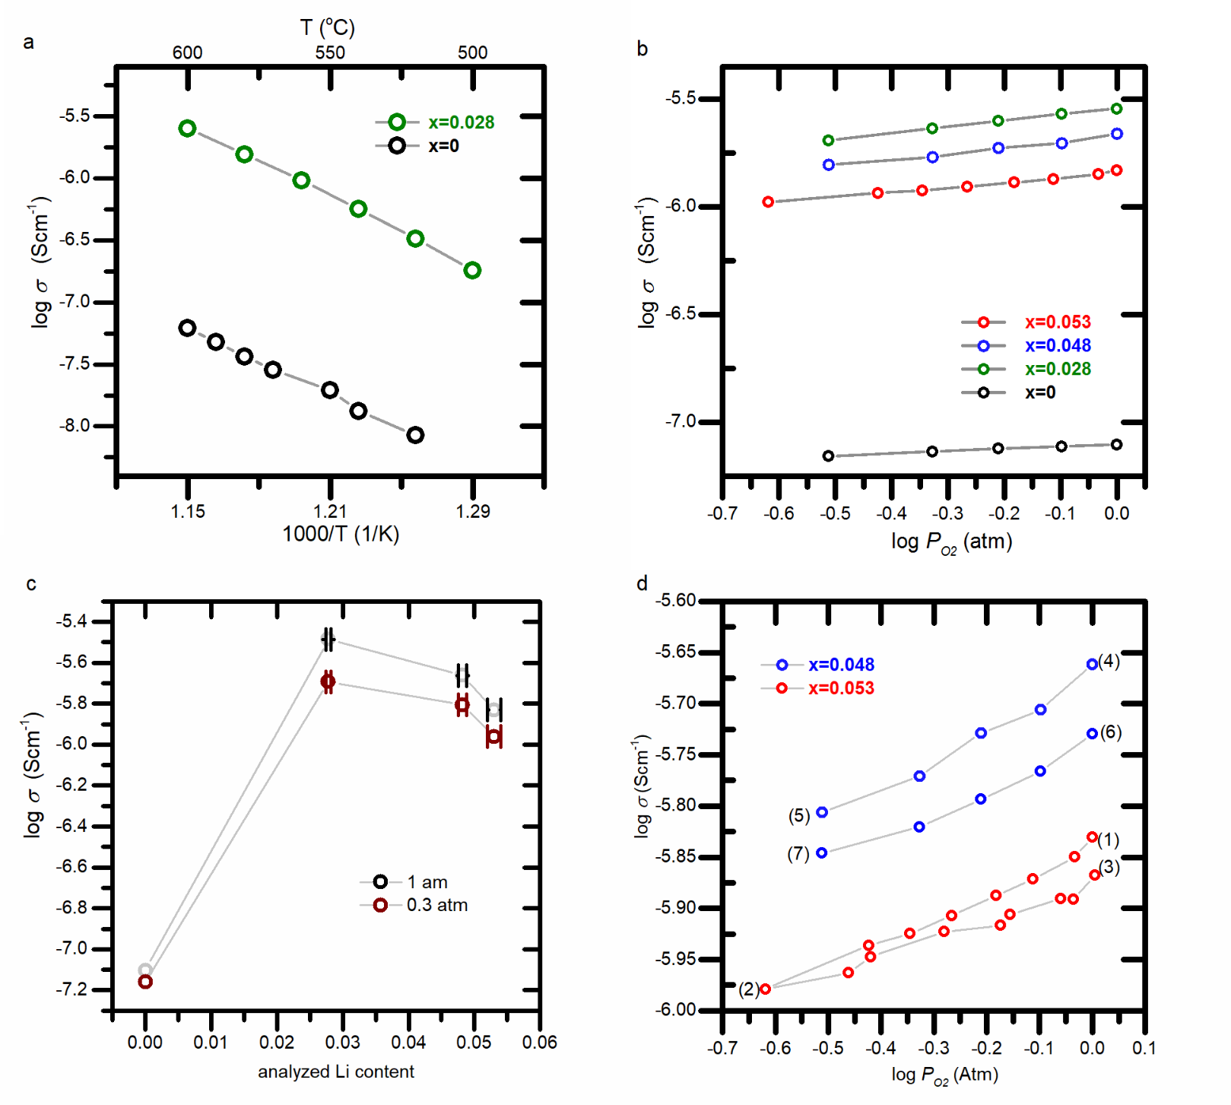
Fig. 6 DC conductivity measurements of 2.0 g SrZn_{1−x}Li_{x}O₂ samples. (a) Arrhenius plots for temperatures between 500°C and 600°C for x =0 (open green circle) and x =0.028 (open black circle). (b) Conductivity measurements as a function of pO₂, measured from high- to low-pO₂, at 600 °C for a second series of 2g SrZn_{1−x}Li_{x}O₂ samples, with x = 0, 0.028, 0.048 and 0.053. (c) Conductivity as a function of analyzed Li content in high- and low-pO₂ conditions. (d) Conductivity stability over time: the conductivity of an x = 0.053 sample (red points) was measured in steps from high to low pO₂, (from (1) to (2)) then measured as pO₂ was increased in steps back to 1 atm (from (2) to (3)). The conductivity of the x = 0.048 sample (blue points) was measured from high to low pO₂ (from (4) to (5)) then the measurements were repeated on the same sample after storage in dry air for 40 days (points (6) to (7)).

The DC conductivity as a function of pO₂ for three materials with different measured lithium content (x = 0.028, 0.048 and 0.053) is shown in Fig. 6b together with the conductivity of the parent phase SrZnO₂. All of the samples show an increase in conductivity with increasing pO₂, consistent with p-type conductivity. However, a clear difference was observed in the slopes of the conductivity plots between the undoped SrZnO₂ phase and the doped materials. Fitting the conductivity to a power law dependence, σ ∝ pO₂^{1/n}, the exponent (1/n) was found to be 0.11(1) for x = 0 but 0.28(1) for x = 0.028, 0.28(2) for x = 0.048 and 0.23(1) for x = 0.054. The increase of the power law exponent upon doping SrZnO₂ with Li, approaching σ ∼ pO₂^{1/4} for all doped compositions, is consistent with holes being the dominant charge carriers under oxidizing conditions.⁴⁵ Substituting Zn with Li in the pristine SrZnO₂ results in negatively charged ${Li}_{Zn}^{/}$ acceptor defects compensated by holes (experimentally at pO₂ > 0.2 atm). As the oxygen partial pressure decreases the concentration of holes decreases, giving rise to the observed pO₂ dependence (see also 7.4 section in the ESI).^{46,47} In Fig. 6c, the conductivities of SrZn_{1−x}Li_{x}O₂ samples are plotted as a function of Li content at pO₂ = 0.3 and 1.0 atm. These follow a common trend as conductivity initially increases with x, before decreasing on further doping, as the dopant Li ions start to act as scattering centers.
The DC conductivity of the x = 0.053 sample was measured in steps of decreasing pO₂ (Fig. 6d, points (1) – (2)), then in steps of increasing pO₂ (points (2) – (3)) back to 1 atm. The sample was found to maintain its p-type response throughout the cycle, although the exponent in the power law dependence of σ on pO₂ reduced from 0.23(1) to 0.17(1). PXRD and ICP-OES measurements on this sample before and after this experiment showed no change in the lattice parameters, but a small decrease in the Li content from x = 0.053 to 0.042 (Fig. S13 and Table S7 in the ESI). This confirms that SrZn_{1−x}Li_{x}O₂ is sufficiently robust for measurement of properties on a single pO₂ sweep, but that it will degrade by Li loss when maintained at high temperature for an extended period of time. In a test of long-term stability, the DC conductivity of the x = 0.048 sample was measured (Fig. 6d, points (4) – (5)) in steps on decreasing pO₂, and then re-measured by the same protocol after a period of 40 days (during which it was kept at atmospheric pressure in a desiccator, Fig. 6d points (6) – (7)). This confirmed that the p-type character of the material can be retained over long periods.
In order to directly conﬁrm the dominant carrier type for these compositions, Seebeck measurements were performed on a SrZn_{1−x}Li_{x}O₂ bar sample, with x = 0.021, over a temperature range from 550 to 600 °C using a high-temperature measurement cell under 1 atm of pO₂. The results are presented in Fig. 7. Three consecutive measurements of the Seebeck coefficient all yielded positive values of 353(4) μV/K, 317(3) and 307(5) μV/K (Fig. S14 in the ESI), confirming the p-type characteristics of the material.
Fig. 7 Seebeck voltage as function of temperature difference across the SrZn_{1−x}Li_{x}O₂ (x = 0.021) sample, measured with a high temperature measurement cell for temperatures in the range 560 – 600 °C. The Seebeck coefficient is determined from the slope.

3.5 Optical properties. UV-visible spectroscopy measurements were performed on samples of SrZn_{1−x}Li_{x}O₂ to investigate the effect of doping Li into SrZnO₂ on the optical properties and to determine the optical band gaps. Fig. 8a presents the Tauc plots for SrZn_{1−x}Li_{x}O₂ samples used for electrical property measurements. The optical band gaps for SrZnO₂ and SrZn_{1−x}Li_{x}O_{2,} were estimated by extrapolating to the energy-axis the linear region of a plot of (αhν)² appropriate for a direct transition, where the Kubelka-Munk function is substituted in place of α. A characteristic absorption can be seen for SrZnO₂ in the optical data at around 4.3 eV, which is higher than the literature reported band gap of 3.41 eV,¹⁷ and closer to the HSE06 computed band gap 3.80 eV. The discrepancy between the measured optical band gap and calculated fundamental gap could arise from deficiency in the computational method,⁴⁴ or be due to the influence of symmetry where the fundamental band gap is symmetry forbidden.⁴⁸ Absorption data shown in Fig. 8b, show two absorption edges, one belonging to SrZnO₂ (between 4.06 and 4.42 eV) and another at 3.18 - 3.35 eV, attributed to a minor ZnO impurity, which could only be identified using synchrotron PXRD (Fig. S15). The measured Kubelka-Munk absorption coefficient of ZnO at 3.3 eV (K-M_{ZnO} = 4.4) is >5000 times more intense than that of a pure sample of SrZn_{1−x}Li_{x}O₂ ( x = 0.021, K-M_{SZO} = 8.3 x 10⁻⁴) at the same energy, which means that even at very low concentrations ZnO will show strong features in the optical spectrum (ESI Section 8). The optical band gap of the SrZn_{1−x}Li_{x}O₂ samples was unchanged, within error, from the parent SrZnO₂ (Fig. 8a).

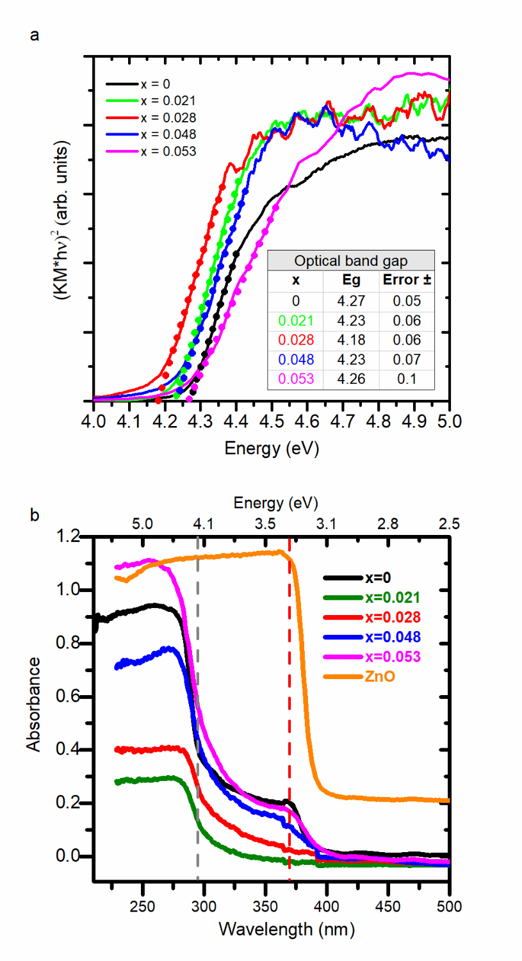
Fig. 8 (a) Tauc plots and (b) Absorption data of SrZn_{1−x}Li_{x}O₂ samples. The dashed lines represent the measured optical band gaps for SrZnO₂ (in grey) and ZnO (in red) at 4.27 eV and 3.37 eV respectively.

4. CONCLUSIONS.
Computation was used to screen for suitable p-type dopants in SrZnO₂ under the absence of compensating defects. Li⁺ replacement of Zn²⁺ was identified as the best substitution, and although lying above the convex hull at zero temperature, inclusion of configurational entropy indicated that SrZn_{1−x}Li_{x}O₂ should be stable at the elevated temperatures of synthesis. Subsequent experimental solid state synthesis yielded high quality single-phase Li-doped SrZnO₂, with incorporation of Li shown through ICP analysis and by changes in the unit cell volume from PXRD synchrotron data. The SrZn_{1−x}Li_{x}O₂ samples showed an increase in conductivity of more than an order of magnitude relative to the parent SrZnO₂. Conductivity was observed to increase with the partial pressure of oxygen, indicating p-type conductivity, confirmed by reproducible measurement of a positive Seebeck coefficient. The conductivities of SrZn_{1−x}Li_{x}O₂ were found to be in the range 1×10⁻⁶ to 3.5×10⁻⁶ S cm⁻¹ at 600°C, significantly lower than conductivities reported for other p-type conducting materials prepared in thin-film form. The low conductivity may be due to microstructural differences, compensation mechanisms, such as the formation of oxygen vacancies, which are known to exist in large concentration in ZnO or could result from strong trapping of the charges created by the dopants.⁴⁹ The formation of ${Li}_{i}$ defect states, which in Li:ZnO are known to act as donors, could also compensate for any p-type conductivity obtained from the ${Li}_{Zn}^{'}$ acceptor defects.¹⁴
Guiding the discovery of new materials by computational prediction of relative energetics of competing phases has now been demonstrated in a number of systems.^{23,25,50} In this work, we have shown that computational selection of dopants has led to the discovery of a new p-type zinc oxide. Such materials are extremely rare,¹⁸ with previous ternary examples relying on extensive redox activity at transition metals, whereas in SrZnO₂, the states at the Fermi level are derived from zinc and oxygen alone, without other, more readily oxidizable metallic elements participating.
Supporting Information
Supporting Information is available free of charge on the ACS Publications website at DOI:
Calculation methods (geometry optimization, band structure calculations, effective mass calculations, stability analysis, free energy analysis), experimental methods (exploratory synthesis, synthesis for measurements, electrical property measurements). (PDF)
Underlying data for this article can be accessed at https://datacat.liverpool.ac.uk/
Author Information
Corresponding author
Email: rossein@liverpool.ac.uk
Notes
The authors declare no competing ﬁnancial interest.
ACKNOWLEDGEMENTS.
We thank EPSRC for funding under EP/N004884. We thank Robert Jalarvo (NorECs, Oslo) for Seebeck measurements, Dr. George Miller and Dr. Konstantin Luzyanin (University of Liverpool) for ICP-OES measurements, and Dr. Alex Grigoropoulos and Dr. Christopher Collins for helpful discussion of the manuscript. We acknowledge Diamond Light Source for time on I11 under proposal EE-12336, and Dr. Claire Murray and Prof. Chiu Tang for assistance on the beam line. This work made use of the facilities of N8 HPC Centre of Excellence, provided and funded by the N8 consortium and EPSRC (EP/K000225/1). The Centre is coordinated by the Universities of Leeds and Manchester. We would also like to thank the University of Liverpool for allowing the use of the local HPC facilities.

REFERENCES.
(1) Agura, H.; Suzuki, A.; Matsushita, T.; Aoki, T.; Okuda, M. Low Resistivity Transparent Conducting Al-Doped ZnO Films Prepared by Pulsed Laser Deposition. Thin Solid Films 2003, 445, 263–267.
(2) Lorenz, M.; Rao, M. S. R.; Venkatesan, T.; Fortunato, E.; Barquinha, P.; Branquinho, R.; Salgueiro, D.; Martins, R.; Carlos, E.; Liu, A.; et al. The 2016 Oxide Electronic Materials and Oxide Interfaces Roadmap. J. Phys. D. Appl. Phys. 2016, 49, 433001.
(3) Lee, E. C.; Chang, K. J. Possible p -Type Doping with Group-I Elements in ZnO. Phys. Rev. B 2004, 70, 115210.
(4) Chawla, S.; Jayanthi, K.; Kotnala, R. Room-Temperature Ferromagnetism in Li-Doped p-Type Luminescent ZnO Nanorods. Phys. Rev. B 2009, 79, 125204.
(5) Carvalho, A.; Alkauskas, A.; Pasquarello, A.; Tagantsev, A. K.; Setter, N. A Hybrid Density Functional Study of Lithium in ZnO: Stability, Ionization Levels, and Diffusion. Phys. Rev. B - Condens. Matter Mater. Phys. 2009, 80, 195205.
(6) Lin, S. S.; Lu, J. G.; Ye, Z. Z.; He, H. P.; Gu, X. Q.; Chen, L. X.; Huang, J. Y.; Zhao, B. H. P-Type Behavior in Na-Doped ZnO Films and ZnO Homojunction Light-Emitting Diodes. Solid State Commun. 2008, 148, 25–28.
(7) Tay, C. B.; Chua, S. J.; Loh, K. P. Stable P-Type Doping of ZnO Film in Aqueous Solution at Low Temperatures. J. Phys. Chem. C 2010, 114, 9981–9987.
(8) Valour, A.; Chevire, F.; Tessier, F.; Grasset, F.; Dierre, B.; Jiang, T.; Faulques, E.; Cario, L.; Jobic, S. Preparation of Nitrogen Doped Zinc Oxide Nanoparticles and Thin Films by Colloidal Route and Low Temperature Nitridation Process. Solid State Sci. 2016, 54, 30–36.
(9) Panigrahy, B.; Bahadur, D. P-Type Phosphorus Doped ZnO Nanostructures: An Electrical, Optical, and Magnetic Properties Study. RSC Adv. 2012, 2, 6222–6227.
(10) Yao, B.; Xie, Y. P.; Cong, C. X.; Zhao, H. J.; Sui, Y. R.; Yang, T.; He, Q. Mechanism of P-Type Conductivity for Phosphorus-Doped ZnO Thin Film. J. Phys. D. Appl. Phys. 2009, 42, 15407.
(11) Kim, Y. S.; Park, C. H. Rich Variety of Defects in ZnO via an Attractive Interaction between O Vacancies and Zn Interstitials: Origin of $n$-Type Doping. Phys. Rev. Lett. 2009, 102, 86403.
(12) Kudo, A.; Yanagi, H.; Hosono, H.; Kawazoe, H. SrCu2O2: A p-Type Conductive Oxide with Wide Band Gap. Appl. Phys. Lett. 1998, 73, 220–222.
(13) Raebiger, H.; Lany, S.; Zunger, A. Origins of the P-Type Nature and Cation Deficiency in Cu2 O and Related Materials. Phys. Rev. B - Condens. Matter Mater. Phys. 2007, 76, 045209.
(14) Joseph, M.; Tabata, H.; Kawai, T. P-Type Electrical Conduction in ZnO Thin Films by Ga and N Codoping. Japanese J. Appl. Physics, Part 2 Lett. 1999, 38, L1205–L1207.
(15) Pathak, T. K.; Kumar, V.; Swart, H. C.; Purohit, L. P. P-Type Conductivity in Doped and Codoped ZnO Thin Films Synthesized by RF Magnetron Sputtering. J. Mod. Opt. 2015, 62, 1368.
(16) Pathak, T. K.; Kumar, V.; Purohit, L. P. Sputtered Al-N Codoped p-Type Transparent ZnO Thin Films Suitable for Optoelectronic Devices. Optik (Stuttg). 2016, 127, 603–607.
(17) Manavbasi, A.; LaCombe, J. C.; Batzill, M.; Diebold, U. A New Blue-Emitting Phosphor, SrZnO2:Pb2+, Synthesized by the Adipic Acid Templated Sol-Gel Route. J. Lumin. 2005, 79, 129–134.
(18) Zhang, K. H. L.; Xi, K.; Blamire, M. G.; Egdell, R. G. P -Type Transparent Conducting Oxides. J. Phys. Condens. Matter 2016, 28, 383002.
(19) Burdett, J. K.; Sevov, S. Stability of the Oxidation States of Copper. J. Am. Chem. Soc. 1995, 117, 12788–12792.
(20) Sleight, A. W. Electronic Structure and Valency in Oxide Superconductors. In Chemistry of superconductor materials: preparation, chemistry, characterization, and theory; Vanderah, T. A., Ed.; Materials science and process technology series; Noyes: Park Ridge, NJ, 1992; 720–721.
(21) Nishino, J.; Ohshio, S.; Kamata, K. Preparation of Zinc Oxide Films by Low-Pressure Chemical Vapor Deposition Method. MRS Proc. 1994, 363, 219–224.
(22) Taikar, D. R.; Joshi, C. P.; Moharil, S. V.; Muthal, P. L.; Dhopte, S. M. Synthesis and Luminescence of SrZnO2 Phosphors. J. Lumin. 2010, 130, 1690–1693.
(23) Dyer, M. S.; Collins, C.; Hodgeman, D.; Chater, P. A.; Demont, A.; Romani, S.; Sayers, R.; Thomas, M. F.; Claridge, J. B.; Darling, G. R.; et al. Computationally Assisted Identification of Functional Inorganic Materials. Science 2013, 340, 847–852.
(24) Bradley, K. A.; Collins, C.; Dyer, M. S.; Claridge, J. B.; Darling, G. R.; Rosseinsky, M. J. Reported and Predicted Structures of Ba(Co,Nb)1-ΔO3 Hexagonal Perovskite Phases. Phys. Chem. Chem. Phys. 2014, 16, 21073–21081.
(25) Collins, C.; Dyer, M. S.; Demont, A.; Chater, P. A.; Thomas, M. F.; Darling, G. R.; Claridge, J. B.; Rosseinsky, M. J. Computational Prediction and Experimental Confirmation of B-Site Doping in YBa2Fe3O8. Chem. Sci. 2014, 5, 1493.
(26) Enciso-Maldonado, L.; Dyer, M. S.; Jones, M. D.; Li, M.; Payne, J. L.; Pitcher, M. J.; Omir, M. K.; Claridge, J. B.; Blanc, F.; Rosseinsky, M. J. Computational Identification and Experimental Realization of Lithium Vacancy Introduction into the Olivine LiMgPO4. Chem. Mater. 2015, 27, 2074–2091.
(27) Hautier, G.; Miglio, A.; Ceder, G.; Rignanese, G.-M.; Gonze, X. Identification and Design Principles of Low Hole Effective Mass P-Type Transparent Conducting Oxides. Nat. Commun. 2013, 4, 2292.
(28) Sarmadian, N.; Saniz, R.; Partoens, B.; Lamoen, D. Easily Doped P-Type, Low Hole Effective Mass, Transparent Oxides. Sci. Rep. 2016, 6, 20446.
(29) Kresse, G.; Furthmüller, J. Efficient Iterative Schemes for Ab Initio Total-Energy Calculations Using a Plane-Wave Basis Set. Phys. Rev. B 1996, 54, 11169–11186.
(30) Kresse, G. From Ultrasoft Pseudopotentials to the Projector Augmented-Wave Method. Phys. Rev. B 1999, 59, 1758–1775.
(31) Blöchl, P. E. Projector Augmented-Wave Method. Phys. Rev. B 1994, 50, 17953–17979.
(32) Heyd, J.; Scuseria, G. E.; Ernzerhof, M. Hybrid Functionals Based on a Screened Coulomb Potential. J. Chem. Phys. 2003, 118, 8207–8215.
(33) Heyd, J.; Scuseria, G. E.; Ernzerhof, M. Erratum: “Hybrid Functionals Based on a Screened Coulomb Potential” [J. Chem. Phys. 118, 8207 (2003)]. J. Chem. Phys. 2006, 124, 219906.
(34) Perdew, J.; Burke, K.; Ernzerhof, M. Generalized Gradient Approximation Made Simple. Phys. Rev. Lett. 1996, 77, 3865–3868.
(35) https://www.fiz-karlsruhe.de/icsd.html. ICSD Web, FIZ Karlsruhe, Germany.
(36) Monkhorst, H.; Pack, J. Special Points for Brillouin Zone Integrations. Phys. Rev. B 1976, 13, 5188–5192.
(37) Ong, S. P.; Richards, W. D.; Jain, A.; Hautier, G.; Kocher, M.; Cholia, S.; Gunter, D.; Chevrier, V. L.; Persson, K. A.; Ceder, G. Python Materials Genomics (Pymatgen): A Robust, Open-Source Python Library for Materials Analysis. Comput. Mater. Sci. 2013, 68, 314–319.
(38) Momma, K.; Izumi, F. VESTA 3 for Three-Dimensional Visualization of Crystal, Volumetric and Morphology Data. J. Appl. Crystallogr. 2011, 44, 1272–1276.
(39) Shannon, R. D. Revised Effective Ionic Radii and Systematic Studies of Interatomic Distances in Halides and Chalcogenides. Acta Crystallogr. Sect. A 1976, 32, 751–767.
(40) Coelho, A. A. TOPAS Academic: General Profile and Structure Analysis Software for Powder Diffraction Data, Version 5.0, Bruker AXS; Karlsruhe: Germany, 2015.
(41) Coelho, A. A. Indexing of Powder Diffraction Patterns by Iterative Use of Singular Value Decomposition. J. Appl. Crystallogr. 2003, 36, 86–95.
(42) Stenzel, O. The Physics of Thin Film Optical Spectra: An Introduction, 2nd Edn.; Stenzel, O., Ed.; Springer International Publishing: Cham, 2016.
(43) Heyd, J.; Peralta, J. E.; Scuseria, G. E.; Martin, R. L. Energy Band Gaps and Lattice Parameters Evaluated with the Heyd-Scuseria-Ernzerhof Screened Hybrid Functional. J. Chem. Phys. 2005, 123, 4101.
(44) Yu, Z. G.; Gong, H.; Wu, P. Lattice Dynamics and Electrical Properties of Wurtzite ZnO Determined by a Density Functional Theory Method. J. Cryst. Growth 2006, 287, 199–203.
(45) Van Der Put, P. J. The Inorganic Chemistry of Materials: How to Make Things out of Elements; Springer US, 1998.
(46) Rickert, H. Electrochemistry of Solids - An Introduction; Springer-Verlag: Berlin, 1982.
(47) Ren, P.; Masó, N.; West, A. R. Hole Conductivity in Oxygen-Excess BaTi1-XCaxO3-X+δ. Phys. Chem. Chem. Phys. 2013, 15, 20943–20950.
(48) Walsh, A.; Da Silva, J. L. F.; Wei, S. H.; Körber, C.; Klein, A.; Piper, L. F. J.; Demasi, A.; Smith, K. E.; Panaccione, G.; Torelli, P.; et al. Nature of the Band Gap of In2O3 Revealed by First-Principles Calculations and X-Ray Spectroscopy. Phys. Rev. Lett. 2008, 100, 167402.
(49) Catellani, A.; Calzolari, A. Codoping and Interstitial Deactivation in the Control of Amphoteric Li Dopant in ZnO for the Realization of P-Type TCOs. Materials (Basel). 2017, 10, 332.
(50) Collins, C.; Dyer, M. S.; Pitcher, M. J.; Whitehead, G. F. S.; Zanella, M.; Mandal, P.; Claridge, J. B.; Darling, G. R.; Rosseinsky, M. J. Accelerated Discovery of Two Crystal Structure Types in a Complex Inorganic Phase Field. Nature 2017, 546, 280–284.

For Table of Contents Only

A stable doping mechanism for the introduction of p-type carriers into the transparent oxide SrZnO₂ was identified by a computational approach, guiding the bulk synthesis of a new p-type transparent oxide SrZn_{1−x}Li_{x}O₂ (x < 0.06). The p-type transport properties were confirmed by measurement of a positive Seebeck coefficient of 353(4) μV/K for SrZn_{0.979}Li_{0.021}O₂, with a measured band gap of 4.27 eV confirming its optical transparency.

