Special Issue on 1st International Aerospace Symposium on Acoustic Fatigue|September 11-12, 2017

EXPERIMENTAL STUDY OF MODE SHIFTING IN AN ASYMMETRICALLY HEATED RECTANGULAR PLATE

Elias Lopez-Alba^{1,2} [elalba@ujaen.es], Chris M. Sebastian¹ [cmsebast@gmail.com], Ana Catarina Santos Silva¹ [catsilva@liverpool.ac.uk] & Eann A. Patterson^{1*}[eann.patterson@liverpool.ac.uk]
¹School of Engineering, University of Liverpool, Liverpool, UK
²Department of Mechanical Engineering and Mining, Campus las Lagunillas, University of Jaén, Spain
ABSTRACT
Modal shifting and jumping in thermally buckled plates has been investigated previously using computational models; however, relatively few experimental explorations have been reported. In this study, the modal shifts and jumps in a simple rectangular plate or panel were investigated using digital image correlation to obtain detailed mode shapes. One face of the planar panel, which was 219x146 mm, was speckled and viewed with a stereoscopic digital image correlation system using pulsed-laser illumination and with a laser vibrometer at a single point. The other face was heated using a set of 1 kW quartz lamps to produce a non-uniform temperature distribution which progressively increased from room temperature to around 760K. An infra-red camera recorded the time-varying temperature distribution on the panel while it was excited with an electrodynamic shaker. A waterfall plot, or time-frequency spectrogram, showing natural frequencies as a function of time was generated, which highlighted the shifting response of the panel with temperature. The heating sequence was repeated and the panel excited at the natural frequencies identified in the waterfall plot, which permitted the corresponding mode shapes to be measured. These data showed that mode shifting and jumping was present with asymmetric heating, but not with spatially uniform heating, and was associated with thermally-induced buckling.
KEYWORDS: Elevated temperature; mode shifting; mode jumping; digital image correlation; thermal buckling; plates
*Corresponding author
INTRODUCTION
It has been recognised for some time that panels or plates subject to spatially non-uniform temperature distributions undergo buckling as the temperature distribution varies with time. In plates that are also subject to vibration, the buckling causes mode shifting [1] and mode jumping [2]. Mode shifting is the exchange of vibration modes when the plate is heated into the post-buckled state; while mode jumping is sudden transitions from one buckling mode to another. This type of behaviour could potentially occur in the panels that form the skin of aircraft designed to travel at hypersonic speeds or near the engine exhausts in more conventional aircraft as well as in fusion reactors. The presence of this type of behaviour could have a significant impact on the structural integrity and, hence, the service life of these structures.
It is well-known that the natural frequencies of vibrating plates or panels vary with in-plane stress such that compressive stresses reduce frequencies and tensile stress increase them [3]. When in-plane stresses are caused by constraint due to thermal expansion then increases in temperature may cause natural frequencies to reduce and, or increase. The behaviour is complicated by the presence of boundary conditions that cause buckling of the plate; and spatially non-uniform temperature distributions can induce such conditions, without any external constraint, as a consequence of local areas of tension and compression [4]. Bailey [5] investigated this type of behaviour in double-wedge square-cantilever plates with thin edges to induce local constraint, while Kaldas and Dickinson [6] induced in-plane stresses by introducing a weld along the centre line of a rectangular plate; in both cases, the temperature range observed was not large, but they confirmed the linear relationship between the natural frequency and compressive load for some modes but not for others. When narrowband acoustic loading is combined with thermal loading, clamped rectangular plates have been shown to exhibit aperiodic snap-through phenomena that are characterised by large non-linear amplitudes [7], while pre- and post-buckling regimes with small amplitudes exhibited linear responses. There are many studies reported in the literature of analytical and numerical modelling of post-buckling behaviour and snap-through phenomena, including more recently by Chen and Virgin [8, 9] who investigated mode jumping and shifting in simply-supported rectangular plates heated deeply into the post-buckled state; while Ribeiro [10] studied plates with fixed boundaries. More recently, using the finite element method, Jeyaraj [11] investigated the behaviour of vibrating isotropic plates subject to non-uniform thermal loading and Han et al [12] studied the free vibration and buckling of foam-filled corrugated sandwich plates under thermal loading. However, there is very little experimental evidence to support these modelling studies [13], primarily because of the difficulty associated with acquiring modal shapes at elevated temperatures. Murphy et al [7] used a central strain gauge to confirm the behaviour of rectangular steel plates of dimensions 300x375x1.5mm subject to sinusoidal and broadband excitation with modest temperatures. Jeon et al [14] investigated the free vibration of rectangular plates (100x100x2mm) plate subject to rapid thermal loading with halogen lamps using a laser scanning vibrometer with thermocouples to monitor the temperature; and Jin et al [15] used digital image correlation to characterise thermal buckling of a compound disc consisting of a 50mm aluminium disc surrounded by a titanium ring which was heated to 160°C, without mechanical loading or excitation. Recently, time-frequency spectrograms or waterfall plots have been measured to characterise the temporal variation in modal behaviour of structures during heating using a nominally uniform temperature distribution [16]. More generally, Helfrick et al [17] and Reu et al [18] reviewed the advantages and disadvantages of using DIC for full-field vibration measurements, while Beberniss and his co-workers [19, 20] have used high-speed digital image correlation to capture the nonlinear response of structures included computing the FRF using data from selected locations. Scanning laser vibrometers also enable high-resolution displacement fields to be measured but the sequential measurements result in very long test periods particularly when the region of interest is large [21]. The aim of this study was to generate detailed measurement data for a vibrating plate subject to asymmetric heating that could be used to support and validate computational modelling. To this end, a time-frequency spectrogram has been obtained for a simple rectangular plate subject to a spatially non-uniform temperature distribution as it is heated from room temperature into the post-buckling state and, through the use of a pulsed laser system for stereoscopic digital image correlation (DIC) [22], the corresponding mode shapes have been measured.

METHODOLOGY
A rectangular plate 219mm x 146mm was cut from a 1mm thick plate of Hastelloy X (American Special Metals Inc., Miami FL, USA) and a 5mm diameter hole was drilled at its centre. The physical properties of the plate were not measured but typical values can be found in Table 1 [23]. The plate was spray-painted with a thin coat of matt black paint (VHT Flameproof, Cleveland OH, USA) on the front and back surfaces to aid heat transfer and to provide a base for a DIC speckle pattern. The speckle pattern was sprayed onto one face of the plate using white paint (VHT Flameproof, Cleveland OH, USA). The plate was mounted on a shaker (V100, Data Physics, San Jose CA, USA) using a M4 stainless steel rod, which was secured through the hole using a nut. The stinger was the only external attachment to the plate so that it can be considered a ‘free-free-free-free’ plate. The speckled surface faced away from the shaker and a set of halogen quartz lamps (QIR 240 1000 V2D, Ushio, Steinhöring, Germany) were placed between the shaker and the plate, on either side of the stinger, as shown in figures 1 and 2. The lamps were arranged in sets of five in specially designed mounts with stainless steel backing sheets that reflected their output towards the plate and shielded the shaker. Each lamp had an output of 1kW and a colour temperature of 3210K. The lamps were located 1.5cm from the surface of the plate and were spaced at 3.5cm (centre-to-centre) with lamps adjacent to the stinger being 5cm from it. A typical heat map for one lamp is shown in figure 3.
The behaviour of the plate was monitored using a laser vibrometer (OFV-503, Polytec GmbH, Waldbronn, Germany) which was aimed at a small area in one corner of the plate where the paint had been removed and the metal surface polished using wet P800 paper in order to provide a strong reflection of the signal. An uncooled micro-bolometer (TIM 400, Micro-Epsilon UK, Birkenhead, UK) was used to monitor the temperature distribution on the specked surface of the plate. A pulsed-laser stereoscopic digital image correlation (DIC) system was used to record the shape of the plate. This system consisted of an Nd: YAG laser (Nano L200-10, Litron, Rugby, UK) that emitted a 4 nanosecond pulse of light at 532nm, which passed through a specially designed set of optics that expanded the laser beam and removed the speckle using an optical Fourier filter. The images for digital correlation were acquired by a pair of 1624x1234 pixel CCD cameras (2MP Stingray F-201b, Allied Vision Technologies GmbH, Stradtroda, Germany) to which were fitted optical narrowband filters centred on 532nm, so that data was only acquired during the laser pulse and the cameras were not saturated by the heating lamps. The cameras were controlled by a trigger box and software (Q-400 system, Dantec Dynamics GmbH, Ulm, Germany) and had a frame rate of 10 frames per second. The images were processed using the Istra 4D software supplied with the DIC system and employing square facets of 25 pixels with a centre-to-centre spacing of 21 pixels.
The experiment was conducted in two stages using the set up shown in figures 1 and 2. First, the vibrometer was used to establish a time-frequency spectrogram for the chosen heating sequence, as shown in figures 3 and 4. In the second stage, time-frequency spectrogram was employed as a map and the modal shapes of the plate were determined, for particular thermal conditions and the corresponding natural frequencies, using the digital image correlation system.
In the first stage of the experiment, a broadband random excitation between 0 and 500 Hz was applied to the plate using vibration controller (ABACUS, Data Physics, San Jose CA, USA) and a 1kW power amplifier system (DSA1-1K, Data Physics, San Jose CA, USA). An accelerometer, attached to the output face of the actuator of the shaker, provided the input signal while the output signal was taken from the vibrometer. The two signals were processed, using the signal analyser provided with the shaker system (SignalCalc, Data Physics, San Jose CA, USA), to obtain the transfer response function for the plate. This measurement was started at room temperature and then, after a nominal 10 seconds, the lamps were switched on, at full power, to heat the plate while the analysis was performed continuously. The results are shown in figure 4, in the form of the time-frequency spectrogram, for the uniform heating of the plate using two sets of lamps arranged on each side of the stinger. The contours of high magnitude values of the transfer function show the change in natural frequencies as the temperature of the plate increases; there is no evidence of mode shifting or jumping because the uniform temperature distribution does not generate any of the constraints that are required to induce this type of behaviour. However, the time-frequency spectrogram for the asymmetric heating shown in figure 5 exhibits much more complex behaviour with evidence of both mode shifting and jumping taking place, which were investigated in more detail in the second stage of the experiment. The asymmetric heating was produced using only four of the five lamps in the set on the left side of the plate, which produced the time-varying temperature distributions shown in figure 5. The second stage of the experiment was conducted with only the asymmetric heating.
The goal of the second stage of each experiment was to track the modes through the corresponding spectrogram from the first stage. Consequently, the heating of the plate was repeated but a single frequency excitation was applied to the plate using the shaker controlled by a function generator and data recorded using the digital image correlation system. The single frequencies were selected using the time-frequency spectrogram to identify the natural frequency at a specific time in the heating sequence. In general, DIC data could only be acquired for one natural frequency during each heating sequence and, hence, the heating sequence had to be repeated many times to allow the modal shapes to be measured along the contour lines in the spectrogram.

RESULTS AND DISCUSSION
A large number of deflection shapes were measured in the second stage of the experiment at single frequencies corresponding to the natural frequencies identified in the time-frequency spectrogram in figure 5; and hence, it is appropriate to refer to them as mode shapes, as opposed to operating deflection shape which would contain components of forced vibration [24]. The results obtained from digital image correlation at room temperature are shown in figure 6 together with the initial twenty seconds of the spectrogram for the asymmetric heating shown in figure 5. The room temperature portion of the spectrograms were always identical.
The modal shapes were measured using stereoscopic digital image correlation and then used to track the mode shifting and jumping that occurred during heating of the plate. For instance, figure 7 shows that in the range 300 to 500 Hz there are three modes that shift during asymmetric heating of the plate. The higher frequency mode, which at room temperature is found at 402 Hz, initially reduces in frequency with heating and then rises to a steady-state of 413Hz during plate heating. However, the two lower frequency modes exhibit large excursions from their room temperature states and shift position twice before reaching a steady state after about 60 seconds of heating. It is noticeable that the form of the modal shapes changes after the first shift at 19 seconds with some loss of symmetry in the modal shape that occurs at 359 Hz at room temperature and a phase reversal of the shape that occurs at 374Hz at room temperature. There is further distortion of the shapes after the second shift that occurs at 49 seconds.
In the interval between 200 Hz and 350 Hz (see figure 8), two modes are present at room temperature that almost merge after approximately 50 seconds before separating again without any shifting or jumping.
Below 200Hz (shown in figure 9) the dominant first bending mode at 69Hz disappears around 40 seconds into the heating sequence. The less prominent diagonal bending mode is present at 87Hz at room temperature and shifts down in frequency to 57Hz under the steady state heating conditions at 100 seconds. However, a second diagonal bending mode appears at 60 seconds into the heat sequence at 120 Hz. Unfortunately, because of constraints on resources, it was not possible to track the modes below 50Hz or to obtain more detail on the mode jumping and shifting between 50 and 200 Hz.
It can be seen from the time-frequency spectrum in figure 5, as well as the extracts in figures 7 to 9, that the plate undergoes a major change in behaviour between 40 and 60 seconds into the assymetric heating sequence, with mode shifting and jumping over a wide range of frequencies. When the plate was subject to the same heating sequence in the absence of the mechanical excitation, then it exhibited buckling at the same stage of the sequence, as shown by the plot of out-of-plane displacement as function of time in figure 10. The plate takes up a new stable shape after about 70 seconds, i.e. following a buckling process in which it transitions from one equilibrium shape to another. Hence, it would appear that the mode shifting and jumping is associated with a change in the static configuration of the plate caused by the spatially non-uniform temperature distribution as predicted by Chen & Virgin [8, 9]. This behaviour is similar to the elastic buckling observed by Thornton et al [25], when they heated a rectangular plate with a single quartz bulb to a maximum temperature of about 190°C and measured the temperature distribution with 29 thermocouples and displacement with 15 linear variable differential transducers.
It has been shown previously that the relative measurement uncertainty for the pulsed-laser digital image correlation system is less than 4% when used to measure modal shapes for frequencies from 120 Hz to 2000 Hz. So, it is unlikely there are significant errors in the shape measurements; however, it was difficult to control the synchronisation of the heating process and the capture of images for the DIC and, hence, there could be some errors associated with a lack of synchronisation. These errors could be responsible for the apparent phase reversal of some of the modal shapes.
The data presented illustrate the potential for experimental validation of numerical and analytical models of mode shifting and jumping. A relatively small selection of data has been presented in the interests of space; however, very extensive data can be acquired relatively easily although the experiments are time-consuming. Sebastian et al [17] have discussed the use of image decomposition to reduce the dimensionality of modal data to allow statistical comparisons with detailed predictions from models; and the modal shape data from a time-frequency spectrogram could be compressed in a similar way to allow equivalent quantitative comparisons for the purpose of model validation and updating.

CONCLUSIONS
Physical tests have been conducted on a simple rectangular plate subject to broadband excitation between 0 and 500 Hz while being heated to around 760K using multiple quartz lamps. The arrangement of the lamps could be easily modified to achieve non-uniform heating both spatially and temporally, while recording the surface temperature distribution of the plate with a micro-bolometer and its surface shape using a pulse-laser digital image correlation system. The investigation of modal shapes has been guided by a time-frequency spectrogram recorded using a laser vibrometer during the heating sequence, which allowed the correlations between modal shapes, frequency and time or temperature to be made. The results showed that mode shifting and jumping was present when asymmetric heating was applied to the plate but was not present with spatially uniform heating, which concurs with earlier modelling studies; and it is associated with the thermally-induced buckling.

ACKNOWLEDGEMENTS
This effort was sponsored by the Air Force Office of Scientific Research, Air Force Material Command, USAF under grant number FA9550-12-1-0386. The U.S. Government is authorised to reproduce and distribute reprints of Governmental purpose notwithstanding any copyright notation thereon. Lt. Col. Dave Garner (EOARD) and Dr Jaimie S Tiley (AFOSR) were the program officers for this grant. The authors are grateful to Dr Ravi Chona, Structural Sciences Center, U.S. Air Force Research Laboratory, Dayton, OH for a number of discussions that motivated this study.

REFERENCES
- Leissa AW, Vibration of plates, NASA Technical Report SP-160, National Aeronautics and Space Administration, 1969.
- Schaeffer D & Golubitsky M, Boundary conditions and mode jumping in the buckling of a rectangular plate, Communications in Mathematical Physics, 69:209-236, 1979.
- Timoshenko S, Young DH & Weaver W Jr, Vibration problems in engineering, 4th edition, Wiley: New York, 1955.
- Mead DJ, Vibration and buckling of flat-free plates under non-uniform in-plane thermal stresses, J. Sound & Vibration, 260:141-165, 2003.
- Bailey CD, Vibration and local instability of thermally stressed plates, Computer Methods in Applied Mechanics & Engng., 25:263-278, 1981.
- Kaldas MM & Dickinson SM, The flexural vibration of welded rectangular plates, J. Sound & Vibration, 75:163-178, 1981.
- Murphy KD, Virgin LN & Rizzi SA, Characterising the dynamic response of a thermally loaded acoustically excited plate, J. Sound & Vibration, 196(5):635-658, 1996.
- Chen H & Virgin LN, Dynamic analysis of modal shifting and mode jumping in thermally buckled plates, J. Sound & Vibration, 278:233-256, 2004.
- Chen H & Virgin LN, Finite element analysis of post-buckling dynamics in plates - Parts I & II, IJ Solids & Structures, 43: 3983-4027, 2006.
- Ribeiro P, Thermally induced transitions to chaos in plate vibrations, J Sound & Vib., 299:314-330, 2007.
- Jeyaraj P, Buckling and free vibration behaviour of an isotropic plate under non-uniform thermal load, IJ Structural Stability & Dynamics, 13(3):1250671, 2013.
- Han B, Qin K-K, Zhang Q-C, Zhang Q, Lu TJ & Lu B-H, Free vibration and buckling of foam-filled composite corrugated sandwich plates under thermal loading, Composite Structures, 172:173-189, 2017.
- Sun K, Zhao Y & Hu H, Experimental studies on finitie element model updating for a heated beam-like structure, Shock & Vibration, 143254, 2015.
- Jeon BH, Kang HW & Lee YS, Free vibration characteristics of rectangular plates under rapid thermal loading, Proc. 9th Int. Conf. on Thermal Stress, Budapest, Hungary, June 5-9, 2011.
- Jin TL, Ha NS & Goo NS, A study of the thermal buckling behavior of a circular aluminium plate using the digital image correlation technique and finite element analysis, Thin-walled struct., 77:187-197, 2014.
- Zhang X, Yu K, Bai Y & Zhao R, Thermal vibration characteristics of fiber-reinforced mullite sandwich structure with ceramic foams core, Composite Structures, 131:99-106, 2015.
- Helfrick MN, Niezrecki C, Avitabile P & Schmidt T, 3D digital image correlation methods for full-field vibration measurement, Mechanical Systems & Signal Processing, 25:917-927, 2011.
- Reu P, Rohe D and Jacobs L, Comparison of DIC and LDV for practical vibration and modal measurements, Mechanical Systems and Signal Processing, 86:2-16, 2017.
- Beberniss T and Ehrhardt D, High-speed 3D digital image correlation vibration measurement: Recent advancements and noted limitations, Mechanical Systems and Signal Processing, 86: 35-48, 2015.
- Ehrhardt D, Allen M, Yang S and Beberniss T, Full-field linear and nonlinear measurements using continuous-scan laser Doppler vibrometry and high speed three-dimensional digital image correlation, Mechanical Systems and Signal Processing, 86:82-97, 2017.
- Rothberg SJ, Allen MS, Castellini P, Di Maio D, Dirckx JJJ, Ewins DJ, Halkon BJ, Muyshondt P, Paone N, Ryan T, Steger H, Tomasini EP, Vanlanduit S & Vignola JF, An international review of laser Dopplervibrometry: making light work of vibration measurement, Optics & Lasers in Engineering, 99:11-22, 2017.
- Sebastian CM, Lopez-Alba E & Patterson EA, A comparison methodology for measured and predicted displacement fields in modal analysis, J. Sound & Vib., 400(21):354-368, 2017.
- Schwarz BJ & Richardson MH, Introduction to operating deflection shapes, CSI Reliability Week 10:121-126, 1999.
- Thornton EA, Coyle MF & McLeod RN, Experimental study of plate buckling induced by spatial temperature gradients, J. Therm. Stress, 17(2):191-212, 1994.

Table 1: Typical physical properties of Hastelloy X [from [23]]
 | Temperature, °C | Metric Units
Density | 22 | 8.22 g/cm3
Melting range | 1260 - 1355
Dynamic modulus of elasticity  (heat treated at 1177°C, rapid cooled) | Room | 205 GPa
 | 93 | 203 GPa
 | 204 | 197 GPa
 | 316 | 192 GPa
 | 427 | 184 GPa
 | 538 | 178 GPa
 | 649 | 170 GPa
 | 760 | 161 GPa
 | 871 | 153 GPa
 | 982 | 141 GPa
Mean coefficient of thermal expansion | 26 - 93 | 13.9 10⁻⁶ m/m-°C
 | 26 - 538 | 15.1 10⁻⁶ m/m-°C
 | 26 - 649 | 15.5 10⁻⁶ m/m-°C
 | 26 - 732 | 15.8 10⁻⁶ m/m-°C
 | 26 - 816 | 16.0 10⁻⁶ m/m-°C
 | 26 - 899 | 16.4 10⁻⁶ m/m-°C
 | 26 - 982 | 16.6 10⁻⁶ m/m-°C
Poisson’s ratio | 22 | 0.32

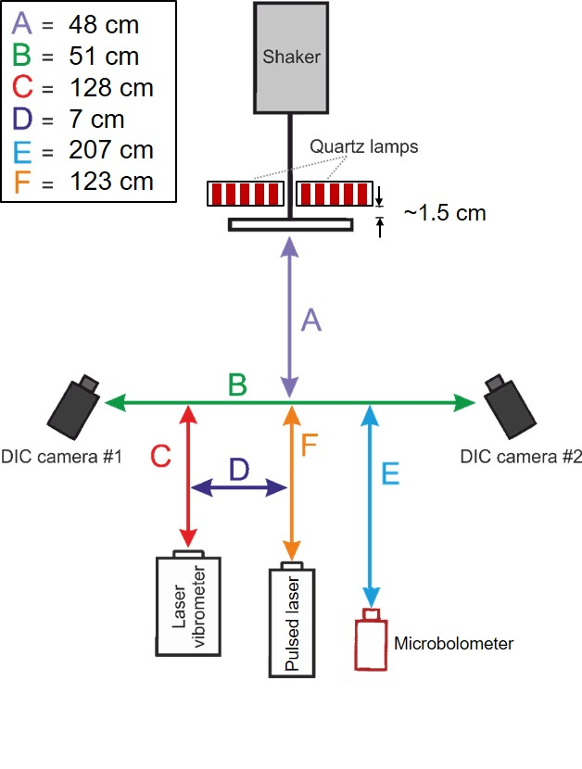

Figure 1: Diagram showing the experimental arrangement.

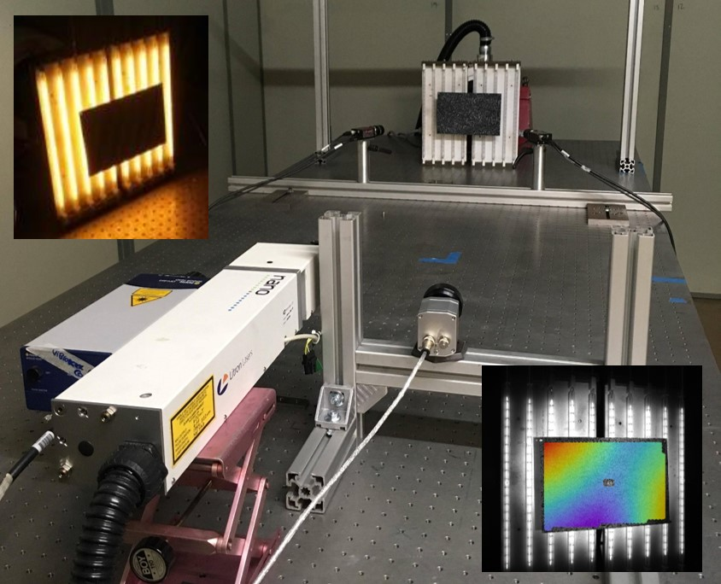

Figure 2: Photograph of the experimental arrangement showing the plate in the background in front of two sets of lamps with the shaker behind them and the vibrometer, pulsed-laser and micro-bolometer (from left to right) in the foreground; and inset, with the lamps switched on: the image obtained from DIC camera with the narrowband filters removed (top left), and the out-of-plane data from DIC overlaid on a DIC camera image obtained using the pulse-laser illumination (bottom right).

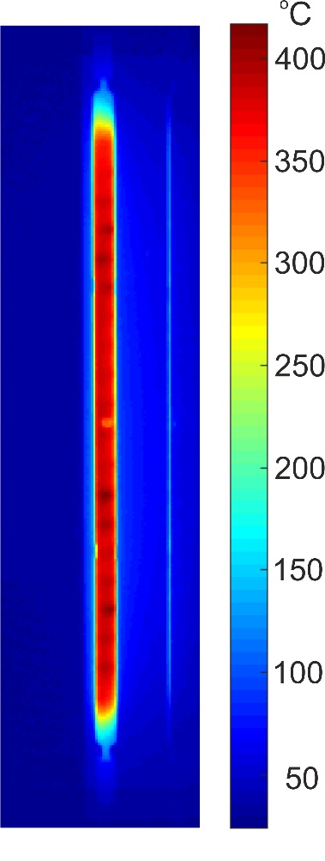

Figure 3: Heat map for a typical quartz lamp at steady state under full power.

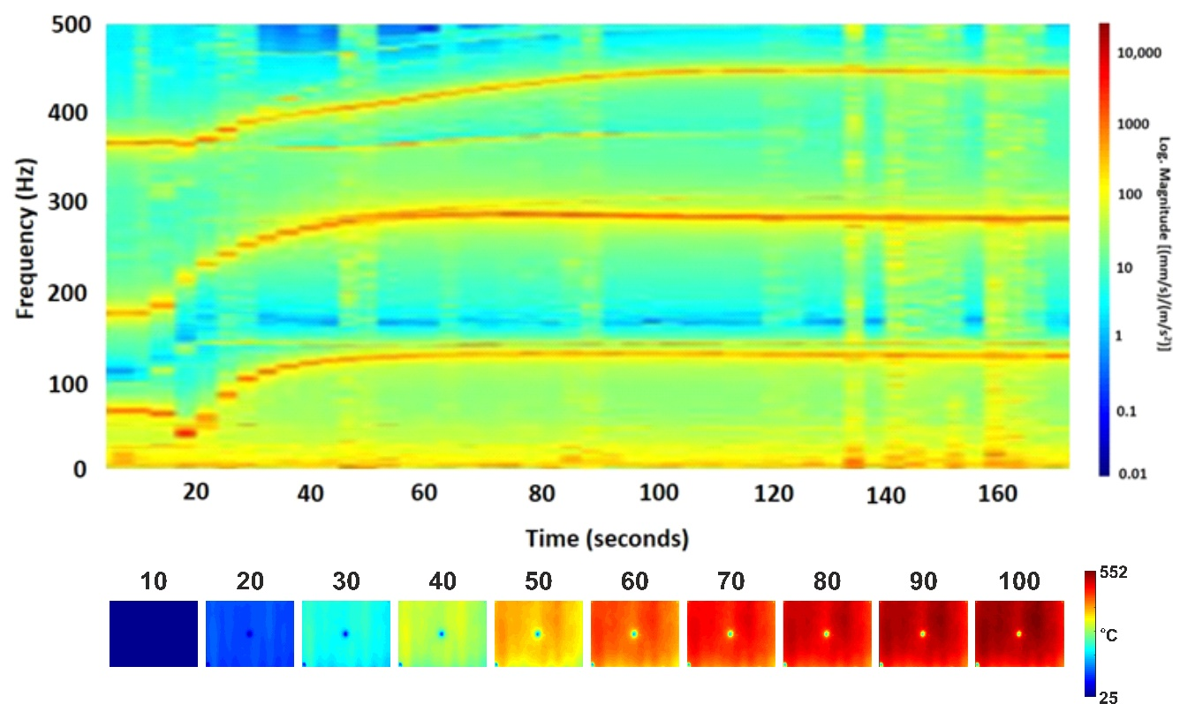
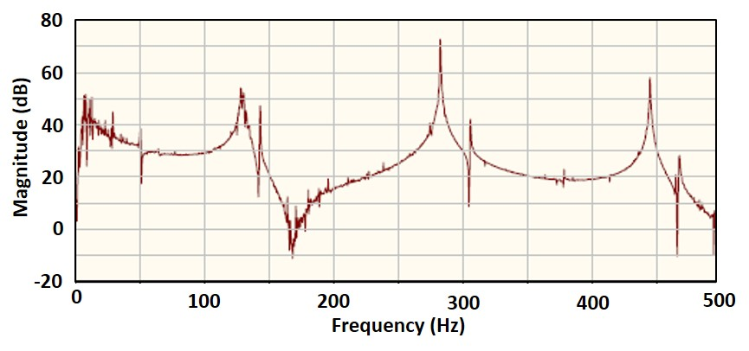

Figure 4: Time-frequency spectrogram (top) for the plate subject to uniform heating from room temperature by two sets of lamps that were switched on after 10 seconds, as illustrated by thetemperature distributions (middle) measured by the microbolometer. Each vertical slice through the spectrogram represents the transfer response function for that instant in time, as shown in the bottom graph.

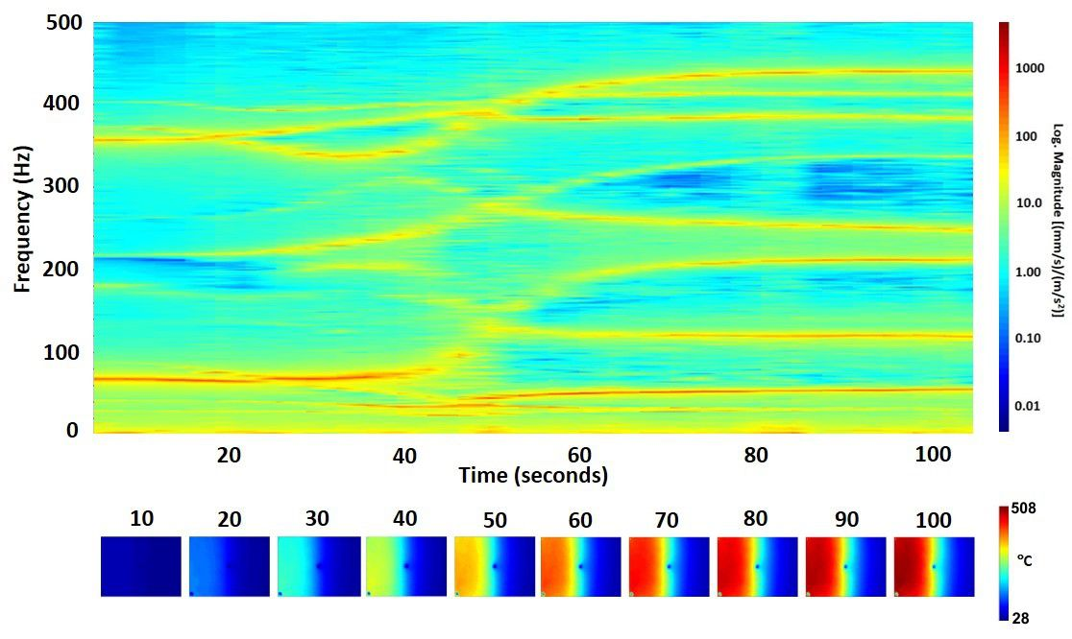

Figure 5: Time-frequency spectrogram for the plate subject to heating from room temperature by the asymmetric arrangement of four 1kW lamps switched on at 10 seconds (top), together with the resultant temperature distributions obtained from the microbolometer (bottom).

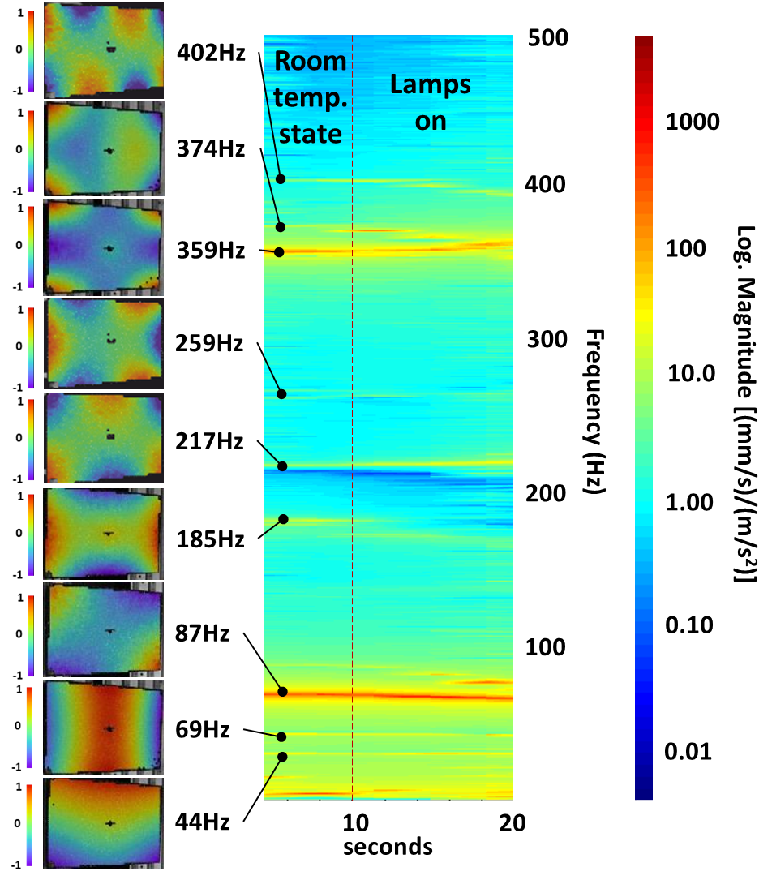
Figure 6: Normalised modal shapes (left) measured using digital image correlation at room temperature when the plate was excited at the single frequencies identified from the time-frequency spectrogram (right) prior to switching on the lamps at nominally ten seconds (as shown by vertical dashed line).

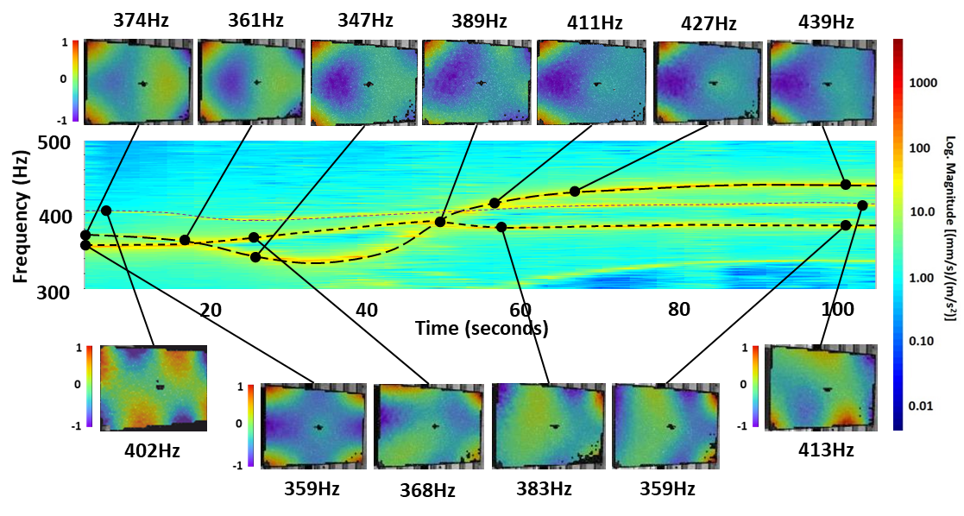
Figure 7: Time-frequency spectrogram (middle) between 300 and 500 Hz for the asymmetric heating shown in figure 5 with two modes shown that exhibit mode shifting (long and medium dashed lines) together with the corresponding normalised mode shapes obtained from digital image correlation, together with a third mode whose frequency is almost constant with heating (short dashes). The colour bar refers to the time-frequency spectrogram.

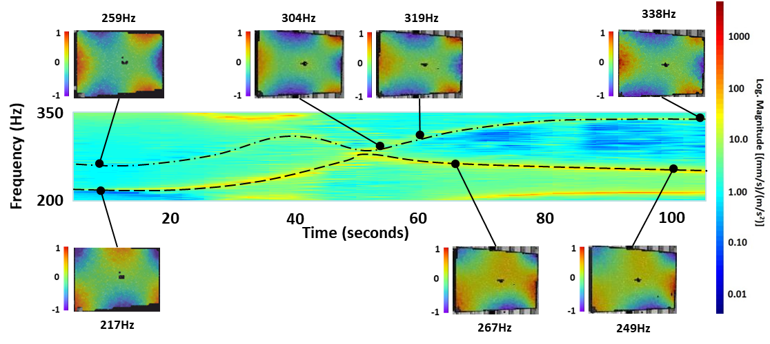
Figure 8: Time-frequency spectrogram (middle) between 200 and 350 Hz for the asymmetric heating shown in figure 5 with two modes at room temperature that almost merge after approximately 50 seconds before separating again, together with their corresponding mode shapes obtained from digital image correlation. The colour bar on the right refers to the time-frequency spectrogram and shapes are normalised.

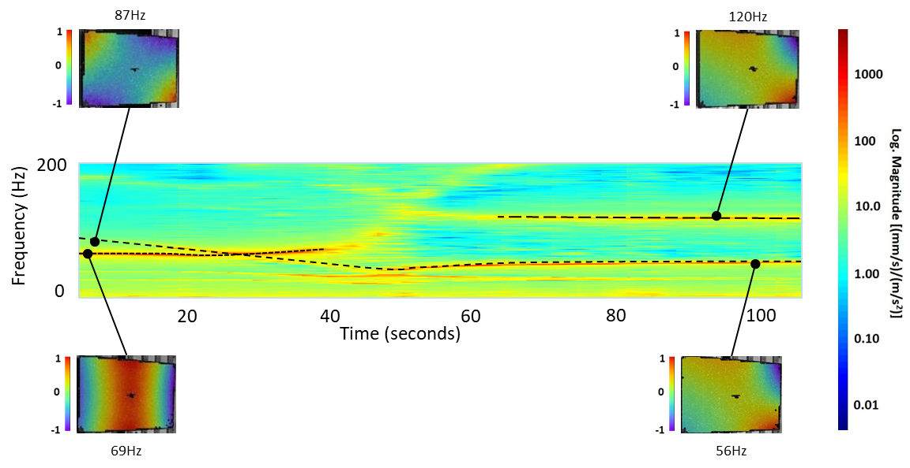
Figure 9: Time-frequency spectrogram (middle) below 200 Hz for the asymmetric heating shown in figure 5 showing the first bending mode at 69Hz (short dashes) disappearing about 40 seconds into the heating sequence and an additional diagonal bending mode (long dashes) appearing about 60 seconds into the sequence at 120Hz; a diagonal bending model at 87Hz at room temperature shifts frequency to 56 Hz during the heating sequence (medium dashes). The colour bar on the right refers to the time-frequency spectrogram and the shapes are normalised.

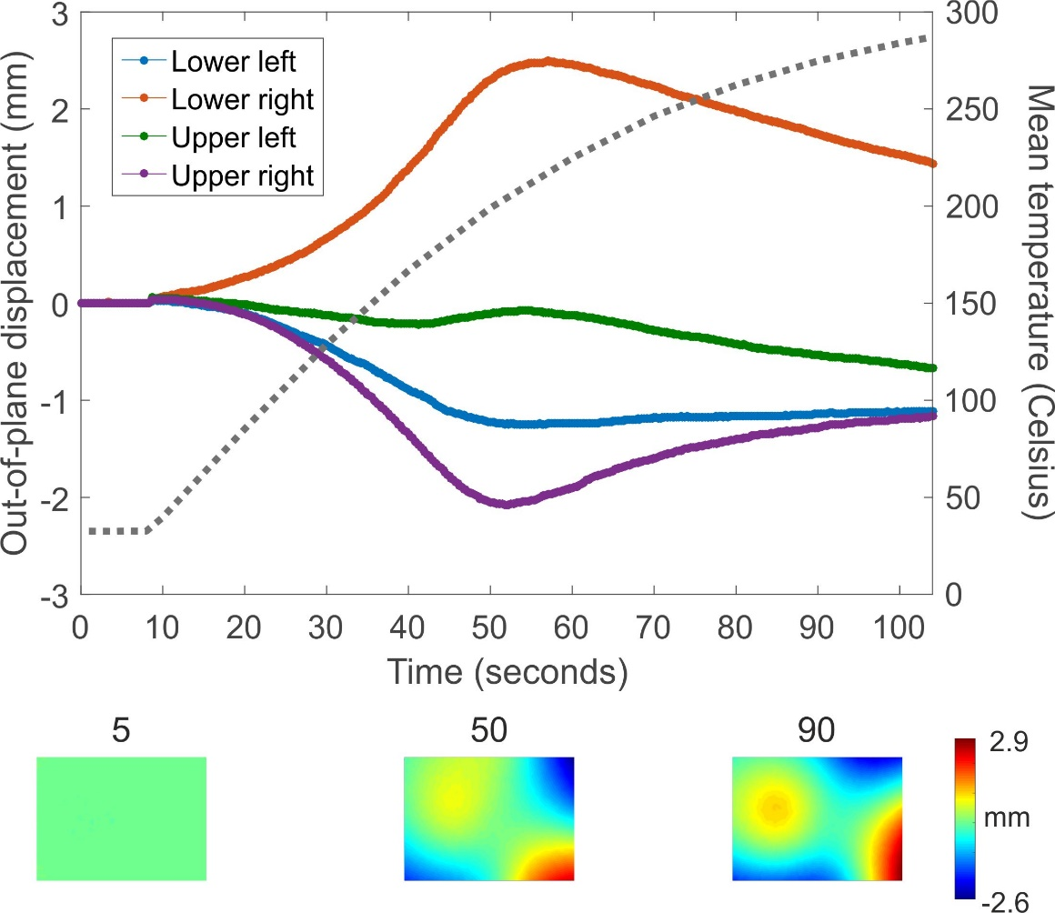

Figure 10: Out-of-plane displacements at the corners of the asymmetrically heated plate as a function of time during heating sequence together with the mean temperature of the plate (dashed lines) with displacement maps shown below; the displacement measurements were made using digital image correlation in the absence of any mechanical excitation and show the thermal buckling of the plate occurring between 40 and 60 seconds.

