Effects of male postpartum depression on father-infant interaction: The mediating role of face processing

Sabrina Koch¹
Leonardo De Pascalis²
Fabielle Vivian¹
Anelise Meurer Renner¹
Lynne Murray³
Adriane Arteche¹
¹ School of Health, Pontifícia Universidade Católica do Rio Grande do Sul (PUCRS), Brazil
² Department of Psychological Science, University of Liverpool, United Kingdom
³ Department of Psychology, University of Reading, United Kingdom

The study was approved by the ethics committee of Pontificia Universidade Católica do Rio Grande do Sul and therefore has been performed in accordance with the ethical standards laid down in the 1964 Declaration of Helsinki and its later amendments. All persons gave their informed consent prior to their inclusion in the study. All authors declare no conflicts of interest.

Address for correspondence and reprint requests to: Adriane Arteche, School of Health, Pontifícia Universidade Católica do Rio Grande do Sul (PUCRS), Av. Ipiranga, 6681 - Prédio 11, sala 925, CEP 90619-900, Porto Alegre, RS, Brazil; e-mail: adriane.arteche@pucrs.br

Abstract
It is estimated that postpartum depression affects up to 25% of men. Despite such high prevalence, the majority of studies on postpartum depression are focused on mothers, and the role of paternal depression and its effects on infant development have been overlooked by researchers and clinicians. The present study aimed to fill this gap by investigating the effect of paternal postpartum depression on father-infant interactions. Additionally, we examined whether differences in face recognition mediated the effects of paternal postpartum depression on father-infant interactions. 61 father-infant dyads (17 postpartum depression, 44 controls) took part in the study. Results revealed that, compared to controls, fathers with postpartum depression had a worse pattern of interaction with their infants on measures of responsiveness, mood and sensitivity; they also had greater difficulty in recognizing happy adult faces, but greater facility in recognizing sad adult faces. Depressed fathers attributed greater intensities to sad adult and infant faces. The tendency to attribute greater intensity to sad adult faces was confirmed as a partial mediator of the effect of paternal postpartum depression on father responsiveness and as a full mediator of the effects of paternal depression on father sensitivity. Clinical implications and suggestions for further studies are discussed.
Key-words: father postpartum depression; face recognition; father-infant interaction

Abbreviations: PND-F – Postnatally depressed father; EPDS – Edinburgh Postnatal Depression Scale; SCID - Structured Clinical Interview for DSM-IV-TR Axis 1 Disorders; BDI – Beck Depression Inventory; BAI – Beck Anxiety Depression Inventory; GRS - Father-Infant Interaction- Global Rating Scale for Mother-infant interaction

- Introduction
Most studies about postnatal depression focus on mothers (e.g., Evans et al., 2012; Murray et al., 2011; O’Hara & McCabe, 2013; Stein et al., 2012) whilst paternal mental health and the changes experienced by men in the postpartum period have been repeatedly overlooked by researchers and clinicians. Results of a British cohort study carried out by Ramchandani and collaborators (2008) showed that by eight weeks postpartum the prevalence of fathers with postnatal depression (PND-F) varied between 2.5% and 3.6%. Another cohort study conducted in Australia by Matthey and collaborators (2000) reported a prevalence of PND-F between 2.8% and 5.3%. Recently, a meta-analysis conducted by Cameron, Sedov and Tomfohr-Madsen (2016) reported an average prevalence rate of paternal pre and postpartum depression of 8%, but in some countries and samples paternal postpartum depression prevalence may reach considerably higher rates (e.g. 17% Suto et al., 2016; 25% Soliday, McCluskey-Fawcett & O’Brien, 1999) highlighting the need to assess and support fathers during the postnatal period.
A growing body of research has linked PND-F to an increased risk of children developing emotional, cognitive and behavioral problems (Ballard, Davis, Cullen, Mohan, & Dean, 1994; Davé, Sherr, Senior, & Nazareth, 2008; Fletcher, Feeman, Garfield, & Vimpani, 2011; Martina & Narayanan, 2016; Matthey, Barnett, Ungerer, & Waters, 2000; Murray & Cooper, 1997; Natsuaki et al., 2014; Paulson, Bazemore, Prevalence, & Fac, 2010; Ramchandani et al., 2008; Ramchandani, Stein, Evans, & O’Connor, 2005; Schumacher, Zubaran, & White, 2008; Spector, 2006; Sweeney & MacBeth, 2016). A meta-analysis conducted by Gentile and Fusco (2017) investigated the effects of untreated paternal depression on offspring outcomes- namely, developmental difficulties, behavioral problems, and specific risks of psychopathology. A total of 23 studies were included and results revealed consistent findings, suggesting significant negative effects of paternal depression throughout children’s development and, in particular, during infancy and first years of childhood. Notably, these effects have been reported to be independent of the effects of maternal postnatal depression on the child, a result that may be especially significant since postnatal depression impacts children in a sensitive and critical period for their development (Ramchandani et al., 2011).
Research examining mediation effects in order to understand the route whereby father depressive symptoms affect children’s behavior and cognition revealed inconsistent findings concerning demographic mediators such as social class and education (Gentile & Fusco, 2017). Conversely, results on relational variables, such as impaired father-child interactions, have shown a more consistent pattern of findings, suggesting that there may be a stronger link between paternal depression and offspring impaired development (Wilson & Durbin, 2010). Indeed, a meta-analysis conducted by Sweeney and MacBeth (2016) included 21 studies, and the results indicated that the most common mediators of the effects of PND-F on offsprings’ less optimal development were paternal hostility, low father involvement and fathers’ negative expressiveness. One of the first studies conducted on the topic (Field, Hossain & Malphrus, 1999) assessed 80 couples and their children, and showed significant differences in the interactions of depressed fathers from non-depressed fathers and their infants, regardless of whether or not the mother suffered from PND.
More recently, differences in specific paternal behaviors have also been examined in depressed and control fathers. Paternal speech was investigated in a study with 38 fathers (19 depressed) and results revealed that PND-F fathers made more statements focused on themselves rather than their children, and also made more negative and critical statements regarding their infants than fathers not affected by PND-F (Sethna, Murray, & Ramchandani, 2012). In a larger observational study (192 fathers, 54 depressed) Sehtna et al. (2015) showed that paternal depression was related to greater withdrawn parental behavior in father-infant play interactions on a floor-mat when the infant was three months old.
Data from studies on maternal postnatal depression suggest that these patterns of impaired caregiver-infant interactions may be largely related to parental difficulties in recognizing infants emotions. As such, recognition of facial expressions is considered a key mediator of the effect of maternal postnatal depression on the quality of caregiver-infant interaction (Arteche et al., 2011; Stein et al., 2010). Studies on depression and face recognition present heterogeneous methods with varying exposure times and stimuli type. Time of stimulus exposure seems to be a key factor in the recognition of facial expressions, with 200 milliseconds being considered sufficient to identify facial expressions (Schyns, Petro, & Smith, 2009). Accordingly, the unlimited exposure times or greater than 1 second exposures used in most studies do not mimic real life situations and may attenuate subtle differences between groups investigated (Vasconcellos, Salvador-Silva, Dias, Davóglio, & Gauer, 2014).
Despite methodological heterogeneity, results tend to show that depression is associated with impairments in the ability to recognize emotional adult faces, with findings pointing to a bias towards sad faces (Gotlib, Krasnoperova, Joormann & Yue, 2004; Joormann & Gotlib, 2007; Maniglio et al., 2014), and with depressed individuals even outperforming controls in recognition of sad faces (Gollan, McClosey, Hoxha & Coccaro, 2010) and/or having difficulties in identifying happy faces (Isaac et al., 2014; Stein et al., 2010). However, few studies have examined these effects in samples of parents and using infant faces. Compared to healthy controls, women with postnatal depression have greater difficulty in identifying happy and fearful adult faces, and when compared depressed women outside the postpartum period, they have greater difficulty in identifying adult faces depicting disgust and anger (Flanagan, White, & Carter, 2011). Using infant face stimuli, Pearson et al (2010) assessed pregnant women and found that compared to non-depressed mothers, depressed participants found it easier to disengage from distressed infant faces – a finding that has a substantial impact on parent-child interaction. Furthermore, using infant faces as stimuli, mothers with postpartum depression were found to judge neutral faces as less neutral than non-depressed mothers (Gil, Teissdre, Chambres, & Droit-Volet, 2011).
A pioneer study (Arteche et al., 2011) conducted with 89 mothers (34 Generalized Anxiety Disorder, 21 Major Depressive Disorder, and 34 controls) used a ‘morphed infants’ faces task when children were between 10 and 18 months, and showed that depressed mothers were less accurate than controls in identifying happiness in infant faces, potentially leading to less positive responses to infant behaviors. Such processing, in a father-infant interaction, may be similarly associated with lower levels of responsiveness to the infant, with a negative impact on child development (Arteche et al., 2011; Murray, Marwick, & Arteche, 2010; Stein et al., 2010; Yarrow et al., 1984). So far, no study has investigated this hypothesis in a sample of PND-F.
Based on a comprehensive model on the effect of paternal postpartum depression on father-infant interactions, the present study therefore aimed to investigate whether recognition of facial expressions act as mediators of the effects of postpartum depression on father-infant interactions. A community sample of newborns was recruited in health centers and in a maternity ward in South Brazil. Parents were screened for depression and fathers´ ability to recognize emotional faces was assessed through a computerized task. Free play father-infant interactions were recorded as described below. We expected depressed fathers to show a poorer pattern of interaction with their infants when compared to controls. We also expected this effect to be partially mediated by paternal lower accuracy in recognition of happy and neutral adult and baby faces and by paternal attribution of greater intensity to sad adult and baby faces and attribution of lower intensity to happy adult and baby faces.
2. Method
Participants
Sixty-four (64) couples with infants aged between two weeks and 4 months of life were recruited for the study. Inclusion criteria were: a) parents aged > 18 years and < 60 years, b) full-term infants (>37 weeks), with a minimum birth-weight of 2.0 kg and without health problems and c) parents cohabiting. All fathers were screened using the SCID, the BDI and the EPDS. Mothers were assessed using the BDI and the EPDS only. Inclusion criteria for PND-F included positive SCID and/or BDI (≥15 points) + EPDS (≥10 points). The same criteria (except for the SCID) were applied to mothers. Of the 64 triads (father-mother-infant) who met the inclusion criteria for participation in the study, three were lost. In two cases it was not possible to record father-infant interactions, and in one case the objective assessment was not performed. Therefore, the sample reported in the present article concerns 61 triads. A total of 17 men and 17 women (27.9%) met the diagnostic criteria for PND. In four cases both the father and the mother met the diagnostic criteria for PND. Results presented in this manuscript concern the 17 fathers with PND-F and the 44 control fathers and their infants.
Participants were recruited in health centers and on the local maternity ward. Parents with infants were invited to participate in the study. Data collection took part in the residence of the participants. The first author conducted all home visits. The study was approved by the School - Clinic of Psychology of Universidade Regional e Integrada do Alto Uruguai e das Missões and the Municipality of Frederico Westphalen - RS, Brazil as well as by the Research Ethics Committee of Pontifícia Universidade Católica do Rio Grande do Sul (PUCRS). All participants gave signed informed consent.
2.2 Instruments
2.2.1 Father Mental State
2.2.1.1 Structured Clinical Interview for DSM-IV-TR Axis 1 Disorders (SCID – Depression Module; First, Spitzer, Gibbon, & Wlliams, 1997): The SCID is a semi-structured interview for AXIS I diagnosis. A high level of reliability and evidence of validity have been reported elsewhere (Basco et al., 2000; Zanarini et al., 2000). All SCIDs were conducted by the first author (a trained clinical Psychologist) and supervised by the last author.
2.2.1.2 Edinburgh Postnatal Depression Scale (EPDS; Cox, Holden, & Sagovsky, 1987): This scale consists of 10 self-report items on a three- point Likert scale concerning depressive symptoms commonly observed in the postnatal period. The scale has a good internal consistency (Cronbach’s alpha α = 0.87). The Brazilian version showed adequate sensitivity and specificity rates (Santos et al., 2007) and scores ≥ 10 (Santos, Martins, & Pasquali, 1999) are considered indicative of postnatal depression.
2.2.1.3 Beck Depression Inventory II (BDI-II; Beck, Steer, & Brown, 1996): The BDI-II is a 21-item self-reported measure of depression. It uses a range scale from 0 to 3 to assess severity of symptoms and has shown good internal consistency rates (Cronbach’s alpha α > 0.80) in studies with Brazilian samples (Gorenstein & Andrade, 1996).
2.2.1.4 Beck Anxiety Inventory – Brazilian version (BAI; Cunha, 2001): The BAI consists of 21 questions. Each question has four possible answers on how the individual felt during the past week, expressed in common anxiety symptoms and has shown good internal consistency rates (Cronbach’s alpha α > 0.87) in studies with Brazilian samples (Cunha, 2001).
2.2.2 Facial Recognition Assessment
2.2.2.1 Facial affect recognition task: The adult facial affect stimuli used in this study were developed by Vasconcellos et al. (2014) - Facial Expression Recognition Brazilian Task (FERBT). Vasconcellos et al. (2014) selected 26 facial expressions of happiness (4), anger (4), sadness (4), disgust (4), surprise (4), fear (4), and neutral (2), based on evidence for the universality of these emotions (Ekman & Friesen, 2003). In order to represent the multiracial Brazilian population, the authors used pictures from two male and two female professional actors of White, Mixed, and Black ethnicity. For the current study just faces of happy, sad and neutral emotions were analyzed. The 13 infant faces (five happy, five sad, and three neutral) used in this study were developed by Arteche, Vivian, Dalpiaz, and Salvador-Silva (2016) and depicted infants from White, Mixed-race and Black backgrounds representing the Brazilian racial diversity.
Images of facial expressions were randomly presented in three separate blocks of trials with durations of 200 ms, 500 ms and 1000 ms. Participants were first exposed to a block of infant faces, followed by a block of adult faces. After each face was displayed, participants were required to classify the emotion using a menu containing seven options (the six emotions plus the neutral face option) by pressing the corresponding numeric key on a keyboard. Next, participants rated the level of intensity of the emotion (1-very low intensity to 5-very high intensity) also using the corresponding numeric key. We set no time limit for participants to emit a response. The task was conducted on a notebook with a 14.7" screen, placed approximately 50 centimeters away from the participant.
2.2.3 Father-Infant Interaction Assessment
2.2.3.1 Father - Infant Interaction - Global Rating Scale for Mother-infant interaction – GRS (Gunning & Murray, 2002): Father-infant interaction was assessed by direct observation. Infants were assessed along with their fathers, with the infant placed on an infant comfort/seat, cradle, father’s lap or couch. The father was allowed to select the child’s position, as long as there was eye contact between father and infant. The father was told to interact with his child, being allowed to freely play and talk to the infant, with or without the aid of objects or toys, for five minutes (Murray, Fiori-Cowley, Hooper, & Cooper, 1996). Interactions were assessed every minute, according to the procedure of Murray, Cooper, Creswell, Schofield and Sack (2007). The coding scheme comprises the following dimensions: caregiver (factor 1 - responsiveness, factor 2 – mood, and factor 3 – sensitivity), for the infant (factor 1 - attention to the father, and factor 2 - mood) and finally, the dimension of the interaction of the pair, coded on a 5 - point Likert scale. A blind research assistant carried out coding of father-infant interactions. The first author also coded 30% of the videos exclusively for establishing reliability. Kappa ranged between k = 0.50 and k = 0.70.
2.2.3.2. Parental Care Questionnaire (Tokumaru, Zortea, Howat-Rodrigues & Andrade, 2011). Father involvement on infant every day caring was assessed via 16 likert - type questions (1 – never involved to 7- always involved). Mothers were requested to rate how much the father took part in activities such as changing nappies, bathing, changing clothes, taking to the doctor, putting to bed, playing etc.
2.3 Data analysis
The effect of paternal education, sex of the infant and parity, and the effect of PND-F on father-infant interactions were investigated using series of MANOVAs. The latter were also conducted taking into account demographics and maternal depression as covariates. For these sets of analysis, dimensions of the father, dimensions of the infant and dimensions of the dyad were considered as dependent variables, and each demographic variable was entered separately as an independent factor. Next, a series of MANOVAS were performed to investigate the effect of demographic variables on the accuracy and intensity of face processing, followed by a series of repeated measures analysis to investigate the effect of time of exposure and PND-F on the same outcomes. In both strategies, blocks of each emotion (happy, sad, and neutral) from each stimuli type (adult and baby faces) and rate (accuracy and intensity) on the three exposure times (200 ms, 500 ms and 1000 ms) were entered as dependent variables, whereas demographics and father depression were separately considered independent factors. Subsequently, following Baron and Kenny (1986), a series of regression analyses investigated whether face recognition mediated the effect of PND-F on father-infant interaction. All indirect effects were estimated with bias-corrected bootstrapping (5000 samples). The SPSS statistical package was used for data analysis. Following Thiese, Ronna and Ott (2016), a p<.05 threshold was applied for simple effects whereas a p<.10 was used for complex relationships (i.e. mediation tests and multiple comparison adjustments).
3. Results
PND-F fathers were slightly older than controls. The average income of the sample was 5.85 (SD = 6.54) times the minimum national wage and there was no difference between PND-F and controls [F (1, 59) = 0.30, p = .58, n² = .005]. Parental involvement in everyday caring for the baby was high with both groups, being described by their partners as ‘a lot’ involved with daily caring for the child [F (1, 59) = 0.01, p = .92, n² = .001, PND-F M = 5.29 (SD = 1.01), control M = 5.27 (SD = 0.86)]. As shown in Table 1, there was no difference between groups concerning education and occupation. As expected, the majority of the PND-F group reported past depressive episodes on the SCID, while only 9.1% of the controls had had such experience. In addition, postnatally depressed fathers were significantly more likely to show a moderate/severe scoring on the BAI than controls. Most infants were the first child of both parents and were 1 - 2 months old, with no differences between groups. A significantly greater number of PND-F fathers had male children.
TABLE 1 ABOUT HERE
Effect of demographic variables and PND-F on Father-Infant Interaction
Distributions of father-infant interaction scores did not reveal outliers, with the exception of father responsiveness and infant mood. Significant effects of paternal age [F (1,59) = 7.06, p = .010, n² = .110] and sex of the infant [F (1,57) = 5.94, p = .018, n² = .09] were observed on the sensitivity factor, with younger fathers (M = 3.85, SD = 0.54) being more sensitive than older ones (M = 4.23, SD = 0.52), and fathers of boys (M = 3.91, SD = 0.46) being more sensitive than fathers of girls (M = 3.33, SD = 0.55). Regarding the effect of PND-F on father-infant interaction, significant effects were observed on all dimensions, with PND-F fathers being significantly less responsive, less sensitive and displaying a more negative mood than controls (see Figure 1). Infants of fathers with PND-F also showed lower levels of attention to their fathers than children of controls. These analyses were run again, taking into account father age, infant sex and maternal depression (based on EPDS + BDI scores) as covariates, and all findings remained unaltered.
FIGURE 1 ABOUT HERE.
Effect of demographic variables, time of exposure and PND-F on recognition of facial expressions
Regarding the effects of demographic variables on face recognition, fathers with higher education were better at recognizing sad infant faces at 500 ms [F (1, 59) = 5.71, p = .020, n² = .088]. When compared to non-primiparous fathers, primiparous correctly identified a greater number of happy adult faces at 1000 ms [F (1, 59) = 2.11, p = .027, n² = .080]. Fathers of boys obtained a greater number of correct answers in relation to neutral infant faces at 500 ms [F (1, 59) = 5.40, p = .024, n² = .084] than fathers of girls.
A significant time of exposure effect was observed on infant face accuracy. Overall, longer exposure times were related to poorer accuracy for happy infant faces [F (2, 118) = 9.04, p < .001, n² = .130] and a 500 ms exposure time was related to poorer accuracy for neutral infant faces [F (2, 118) = 9.43, p = .001, n² = .138]. Significant exposure time effects were also observed on intensity ratings of adult faces. Lower intensities were attributed to happy adult faces at 200 ms [F (2, 118) = 205.96, p < .0001, n² = .777] and to sad [F (2, 118) = 18.34, p < .0001, n² = .237] and neutral [F (2, 118) = 56.77, p = .001, n² = .49] adult faces at 500 ms. A significant time * PND-F effect was observed on intensity ratings of sad adult faces [F (2, 118) = 16.26, p < .0001, n² = .216] with PND-F fathers increasing their attribution of sadness at longer exposure times.
Regarding the effect of paternal postnatal depression, a significant main PND-F effect was observed on responses to happy adult faces [F (1, 59) = 15.84, p < .0001, n² = 0.21] and sad adult faces [F (1, 59) = 9.70, p = .003, n² = 0.14] with PND-F fathers showing lower accuracy rates than controls for happy faces, but higher accuracy rates than controls for sad faces. Results also revealed significant PND-F effects at specific exposure times. Compared to controls, PND-F fathers had more difficulty in recognizing happy faces at 200 ms and 500 ms, but were better in recognizing sad adult faces at 1000 ms (see Table 2).
TABLE 2 ABOUT HERE
There was a significant main PND-F effect on responses to sad adult faces [F (1, 59) = 29.13, p < .0001, n² = .331] and sad infant faces [F (1, 59) = 8.37, p = .005, n² = .124], with postnatally depressed fathers attributing greater intensities as compared to controls. PND-F fathers also attributed significantly more sadness to adult faces at 1000 ms and less happiness at 1000 ms and more sadness at 1000 ms for infant faces (see Table 3).
TABLE 3 ABOUT HERE
Mediators of the Effect of PND-F on father-infant interaction
Having found a significant effect of PND-F on all paternal dimensions measured during father-infant interactions (i.e, Sensitivity, Responsiveness, Mood), mediation analyses were run to test whether this was explained by the effect paternal depression had on the recognition of facial expressions (both accuracy and intensity). In line with Step 3 of the classical Baron and Kenny (1986) method for mediation analysis, the effect of potential mediators on paternal interactive dimensions was tested, controlling for the influence of PND-F. Given the large number of parallel tests, to control familywise error, the Benajamin-Hochberg correction was used, within sets of stimuli with the same time of exposure.
No facial recognition variable had a significant effect on paternal expressed mood during interaction, controlling for PND-F. The intensity fathers attributed to sad adult faces at 1000 ms, however, significantly, and negatively, affected responsiveness (b (SE) = -0.345 (0.137), p = 0.014, corrected p = 0.087). A significant indirect effect of PND-F on paternal responsiveness, through the intensity attributed to sad adult faces at 1000 ms, was found (b = -0.281 (.0115) 95% BCa CI= -0.519 - -0.058), although this mediation was found to be partial, according to the Baron and Kenny (1986) criteria, as the effect of PND-F remained significant (b (SE) = -0.405 (0.167), p = 0.019), albeit reduced in magnitude by the inclusion of the mediator.
The intensity attributed to sad adult faces (1000 ms) was also significantly, negatively associated with paternal sensitivity [b (SE) = -0.412 (0.155), p = 0.010, corrected p = 0.062]. A full mediation of the effect of PND-F on the latter, through the former, was found (indirect effect: b = -0.336 (.0125) 95% BCa CI= -0.549 - -0.050), with the effect of PND-F on paternal sensitivity made non-significant by the inclusion of the mediator. Figure 2 depicts our significant mediation models.
FIGURE 2 ABOUT HERE
4. Discussion
This study aimed to explore whether recognition of facial expressions mediated the effects of paternal depression on father-infant interactions. Our results showed that the tendency to attribute greater intensity to sad adult faces was confirmed as a partial mediator of the effect of paternal postpartum depression on fathers’ responsiveness, and as a full mediator of the effects of paternal depression on fathers’ sensitivity. To our knowledge, this is the first study to investigate the routes whereby paternal postnatal depression affect father-infant interactions, assessing both face recognition and dyadic interactions in a male sample. A community sample of 61 father-infant dyads recruited in health centers and in a maternity ward of South Brazil took part in the study. In this sample, 17 fathers scored above the cut off point for postnatal depression. The effect of PND-F on father-infant interaction in our sample was remarkably significant. Fathers diagnosed with PND-F showed difficulties in all dimensions of interaction with their infants. Fathers with beck anxiety
postpartum were less responsive to the needs of the infants, less sensitive to their infants and less warm and affectionate, and displayed a more negative mood in the responses to their infants compared to non-depressed fathers. Such findings corroborate the results of Wilson and Durbin (2010), who examined dimensions of paternal interaction with offspring, and also studies on maternal postnatal depression that revealed poorer interactions in dyads of postnatally depressed mothers and their infants (Field, 2010) . These findings are of particular relevance given the importance of infancy interactions to later offspring mental health (Sweeney & MacBeth, 2016). Notably, our effects were independent of maternal mental health, pointing to a specific effect of paternal emotional state on parent-child interactions.
In our study, fathers with PND had more difficulty than controls in recognizing happy adult faces at 200 ms and 500 ms, but were better in recognizing sad adult faces at 1000 ms. PND-F fathers also attributed higher levels of sadness to adult and to infant faces at 1000 ms and perceived happy faces at 1000 ms as less happy than controls. These results corroborate the previous literature that showed impairments in recognition of happy stimuli (Isaac et al., 2014; Stein et al., 2010) and a bias towards sad stimuli (Gollan, McClosey, Hoxha & Coccaro, 2010). Interestingly, our significant PND-F effects were observed at 200 ms and 500 ms, but mostly at 1000 ms, suggesting that cognitive biases operate not only in terms of subtle processing, but also, and mainly, at more conscious levels. This pattern is key to understanding the impact that deficits in parents’ emotional assessment of infants may have on child development given that misinterpretation of offspring emotions may alter parents´ pattern of interacting.
Due to difficulties in correctly assessing emotional faces, PND-F fathers may be less responsive and less sensitive to their infants, and therefore display an overall more negative pattern of interaction with their children. Accordingly, the clinical impact of paternal depression on cognitive, social and emotional development of children, especially male children, is a matter of concern. This hypothesis was corroborated in our mediation analysis. Our model confirmed responses concerning the intensity of sad faces at 1000 ms as a mediator of the effects of PND-F on father-infant interaction, in particular on paternal responsiveness and sensitivity. Interestingly, our significant models comprised ratings of intensity (but not accuracy), in adult (but not infant) and in sad (but not happy) faces. Additionally, a full mediation was confirmed for sensitivity, whereas a partial mediation was confirmed for responsiveness. It could be argued that although significant group differences were observed in accuracy, rates of correct responses were still high in both groups (over 73% for all emotions at all exposure times). Therefore, it is possible that although postnatally depressed fathers did not perform as well as controls, they were still able to achieve minimum levels of accuracy.
Notably, our model was confirmed for intensity responses to sad, but not happy faces, suggesting that over-rating negative emotions has a stronger impact on father-infant interactions than difficulties in correctly assessing happy emotions. It is worth noting that group effects were indeed stronger for sad faces, suggesting that PND-F fathers display a greater bias towards intensifying sad faces which, in turn, compromises their interactions with their children. Our significant mediation models were observed for adult faces (not infant faces). Infant faces stimuli used in this study depicted infants´ faces at high intensity and deficits in face recognition with greater effect sizes may occur in expressions with lower intensities. This hypothesis is corroborated by the very high accuracy rates observed for our infant faces. Considering the three emotions and the three exposure times, the lowest average accuracy rate observed for infant faces was 83%.
This study provided evidence for a partial mediation model for responsiveness and a full mediation model for sensitivity. The responsiveness dimension assessed in this study comprises the paternal ability to be responsive and to actively capture and imitate infants´ cues, as well as to respond to infants´ expressions and vocalizations. It therefore includes not only the father’s ability to decode infants´ needs, but also behavioral responses that may be learned, and that are related not only to the interpretation of infant emotional expressions, but also to broader experiences and culture. Conversely, the dimension of sensitivity comprises the ability to interpret subtle needs, being empathic and not avoiding visual contact. This dimension is more closely related to empathy and subtle behaviors, rather than to active behavior and imitative actions. Recognition of emotional faces has been related to theory of mind and emotional empathy in previous studies (Ávila, Morais, Bomfim, & Chagas, 2016; Bolat et al., 2017). It could be argued that attribution of intensity to emotional faces is of particular relevance to an empathic behavior and, in our study, fully explains the link between PND-F and paternal low sensitivity.
This study has some limitations. Our sample was relatively small. Thus, prevalence data should be interpreted with caution.The location of the research (an inner city area) can be considered another limiting factor, since data from the capital of the state could have provided a more comprehensive picture of the target population than data from the inner city where the local population has a family income higher than the average income of families in the state capital. In addition, the first author conducted all SCIDs and was also responsible for establishing reliability on video ratings. Further studies are needed to include mothers and perform analyses to control the effect of maternal PND on father-infant interactions, and also to use more than one blind rater for the observational data. Finally, the infant faces used in this study depicted emotions at high intensities, and therefore future research should include lower intensity stimuli. We also suggest that longitudinal studies are conducted including moderators, such as socioeconomic level and parental schooling.
This research did not receive any specific grant from funding agencies in the public, commercial, or not-for-profit sectors.

References
- Arteche, A., Joormann, J., Harvey, A., Craske, M., Gotlib, I. H., Lehtonen, A., Stein, A. (2011). The effects of postnatal maternal depression and anxiety on the processing of infant faces. Journal of Affective Disorders, 133(1–2), 197–203. http://doi.org/10.1016/j.jad.2011.04.015
- Arteche, A. X., Vivian, F. A., Dalpiaz, B. P., & Salvador-Silva, R. (2016). Effects of sex and parental status on the assessment of infant faces. Psychology & Neuroscience, 9(2), 176–187. http://doi.org/10.1037/h0101552
- Ávila, R. F., Morais, D., Bomfim, A. J., & Chagas, M. H. (2016). Empatia e reconhecimento de expressões faciais de emoções básicas e complexas em estudantes de Medicina. Jornal Brasileiro de Psiquiatria, 65(3), 209-14. http://doi.org/ 10.1590/0047-2085000000126
- Ballard, C. G., Davis, R., Cullen, P. C., Mohan, R. N., & Dean, C. (1994). Prevalence of postnatal psychotic morbidity in mothers and fathers. British Journal of Psychology, 164, 782–788. http://doi.org/10.1192/bjp.164.6.782
- Baron, R., & Kenny, D. (1986). The moderator-mediator variable distinction in social psychological research. Journal of Personality and Social Psychology, 51(6), 1173–1182. http://doi.org/10.1037/0022-3514.51.6.1173
- Basco, M. R., Bostic, J. Q., Davies, D., Rush, A. J., Witte, B., Hendrickse, W., & Barnett, V. (2000). Methods to improve diagnostic accuracy in a community mental health setting. American Journal of Psychiatry, 157(10), 1599–1605.
- Beck, A. T., Steer, R. A., & Brown, G. K. (1996). Beck depression inventory-II. San Antonio, 78204–2498.
- Bolat, N., Eyuboglu, D., Eyuboglu, M., Sargin, E., & Eliacik, K. (2017). Emotion recognition and theory of mind deficits in children with attention deficit hyperactivity disorder. Anatolian Journal of Psychiatry, 18(3), 1. https://doi.org/10.5455/apd.237695
- Cameron, E. E., Sedov, I. D., Tomfohr-Madsen, L. M., Adams, R., Association, A. P., Areias, M. E. G., … Fisher, J. (2016). Prevalence of paternal depression in pregnancy and the postpartum: An updated meta-analysis. Journal of Affective Disorders, 206, 189–203. http://doi.org/10.1016/j.jad.2016.07.044
- Cox, J. L., Holden, J. M., & Sagovsky, R. (1987). Detection of postnatal depression. Development of the 10-item Edinburgh Postnatal Depression Scale. The British Journal of Psychiatry, 150(6), 782–786.
- Cunha, J. C. (2001). Manual da versão em português das escalas Beck.
- Davé, S., Sherr, L., Senior, R., & Nazareth, I. (2008). Associations between paternal depression and behaviour problems in children of 4-6 years. European Child and Adolescent Psychiatry, 17(5), 306–315. http://doi.org/10.1007/s00787-007-0672-6
- Ekman, P., & Friesen, W. V. (2003). Unsmasking the face: A guide to recognizing emotions from facial clues. Ishk.
- Evans, J., Melotti, R., Heron, J., Ramchandani, P., Wiles, N., Murray, L., & Stein, A. (2012). The timing of maternal depressive symptoms and child cognitive development: A longitudinal study. Journal of Child Psychology and Psychiatry and Allied Disciplines, 53(6), 632–640. http://doi.org/10.1111/j.1469-7610.2011.02513.x
- Field, T. (2010). Postpartum Depression Effects on Early Interactions, Parenting, and Safety Practices: A Review. Infant Behavior & Development, 33(1), 1. http://doi.org/10.1016/j.infbeh.2009.10.005
- Field, T. M., Hossain, Z., & Malphurs, J. (1999). “Depressed” fathers’ interactions with their infants. Infant Mental Health journal1, 20(3), 322–332.
- Field, T., Morrow, C., & Adlestein, D. (1993). Depressed mothers’ perceptions of infant behavior. Infant Behavior and Development1, 16(1), 99–108.
- First, M. B., Spitzer, R. L., Gibbon, M., & Wlliams, J. B. (1997). Structured clinical interview for DSM-IV clinical version (SCID-I/CV).
- Flanagan, T. J., White, H., & Carter, B. G. (2011). Differential impairments in emotion face recognition in postpartum and nonpostpartum depressed women. Journal of Affective Disorders, 128(3), 314–318. http://doi.org/10.1016/j.jad.2010.07.021
- Fletcher, E., Feeman, C., Garfield, G., & Vimpani, G. (2011). The effects of early paternal depression on children’s development. Med. J., 195(11), 685–689.
- Gentile S, Fusco ML. Untreated perinatal paternal depression: Effects on offspring (2017). Psychiatry Res, 252, 325-332. doi:10.1016/j.psychres.2017.02.064.
- Gil, S., Teissèdre, F., Chambres, P., & Droit-Volet, S. (2011). The evaluation of emotional facial expressions in early postpartum depression mood: A difference between adult and baby faces? Psychiatry Research, 186(2-3), 281–286. http://doi.org/10.1016/j.psychres.2010.06.015
- Gollan, J.K., McCloskey, M., Hoxha, D., & Coccaro, E. (2010). How do depressed and healthy adults interpret nuanced facial expressions? Journal of Abnormal Psychology, 119, 804-810. doi: 10.1037/a0020234.
- Gorenstein, C., & Andrade, L. H. S. G. (1996). Validation of a Portuguese version of the Beck Depression Inventory and the State-Trait Anxiety Inventory in Brazilian subjects. Brazilian Journal of Medical and Biological Research, 29(4), 453–457.
- Gotlib, I., Krasnoperova, E., Joormann, J., & Yue, D. (2004). Attentional bias for negative interpersonal stimuli in clinical depression. Journal of Abnormal Psychology, 113, 127-135.doi:10.1037/0021-843X.113.1.121
- Gunning, M., & Murray, L. (2002). The global ratings of mother-infant interaction at 2 and 4 months 9. In Word Association for Infant Mental Health.
- Joormann, J., & Gotlib, I. (2007). Selective attention to emotional faces following recovery from depression. Journal of Abnormal Psychology, 116, 80-85. doi: 10.1037/0021-843X.116.1.80
- Martina K. Narayanan n, A. N. T. (2016). Associations between maternal and paternal depressive symptoms and early child behavior problems: Testing a mutually adjusted prospective longitudinal model. Journal of Affective Disorders, 196, 181–189. http://doi.org/10.1016/j.jad.2016.02.020
- Matthey, S., Barnett, B., Ungerer, J., & Waters, B. (2000). Paternal and maternal depressed mood during the transition to parenthood. Journal of Affective Disorders, 60(2), 75–85. http://doi.org/10.1016/S0165-0327(99)00159-7
- Murray, L., Arteche, A., Fearon, P., Halligan, S., Goodyer, I., & Cooper, P. (2011). Maternal postnatal depression and the development of depression in offspring Up to 16 years of age. Journal of the American Academy of Child and Adolescent Psychiatry, 50(5), 460–470. http://doi.org/10.1016/j.jaac.2011.02.001
- Murray, L., Cooper, P., Creswell, C., Schofield, E., & Sack, C. (2007). The effects of maternal social phobia on mother-infant interactions and infant social responsiveness. Journal of Child Psychology and Psychiatry and Allied Disciplines, 48(1), 45–52. http://doi.org/10.1111/j.1469-7610.2006.01657.x
- Murray, L., & Cooper, P. J. (1997). Postpartum depression and child development. Psychological Medicine, 27(2), 253–260. http://doi.org/10.1017/S0033291796004564
- Murray, L., Fiori-Cowley, A., Hooper, R., & Cooper, P. (1996). The impact of postnatal depression and associated adversity on early mother-infant interactions and later infant outcomes. Child Development, 2512–2526.
- Murray, L., Marwick, H., & Arteche, A. (2010). Sadness in mothers’ “baby-talk” predicts affective disorder in adolescent offspring. Infant Behavior and Development, 33(3), 361–364. http://doi.org/10.1016/j.infbeh.2010.03.009
- Natsuaki, M. N., Shaw, D. S., Neiderhiser, J. M., Ganiban, J. M., Harold, G. T., Reiss, D., & Leve, L. D. (2014). Raised by Depressed Parents: Is it an Environmental Risk? Clinical Child and Family Psychology Review, 17(4), 357–367. http://doi.org/10.1007/s10567-014-0169-z
- O’Hara, M. W., & McCabe, J. E. (2013). Postpartum depression: current status and future directions. Annual Review of Clinical Psychology, 9, 379–407. http://doi.org/10.1146/annurev-clinpsy-050212-185612
- Paulson, J. F., Bazemore, S. D., Prevalence, H. E., & Fac, R. (2010). CLINICIAN ’ S CORNER Prenatal and Postpartum Depression in Fathers. Methods, 303(19), 1961–1969.
- Pearson, R. M., Cooper, R. M., Penton-Voak, I. S., Lightman, S. L., & Evans, J. (2010). Depressive symptoms in early pregnancy disrupt attentional processing of infant emotion. Psychological Medicine, 40(4), 621–31. http://doi.org/10.1017/S0033291709990961
- Ramchandani, P. G., Psychogiou, L., Vlachos, H., Iles, J., Sethna, V., Netsi, E., & Lodder, A. (2011). Paternal depression: An examination of its links with father, child and family functioning in the postnatal period. Depression and Anxiety, 28(6), 471–477. http://doi.org/10.1002/da.20814
- Ramchandani, P. G., Stein, A., O’Connor, T. G., Heron, J., Murray, L., & Evans, J. (2008). Depression in men in the postnatal period and later child psychopathology: a population cohort study. Journal of the American Academy of Child and Adolescent Psychiatry, 47(4), 390–398. http://doi.org/10.1097/CHI.0b013e31816429c2
- Ramchandani, P., Stein, A., Evans, J., & O’Connor, T. G. (2005). Paternal depression in the postnatal period and child development: A prospective population study. Lancet, 365(9478), 2201–2205. http://doi.org/10.1016/S0140-6736(05)66778-5
- Santos, M. F. S., Martins, F. C., & Pasquali, L. (1999). Post-natal depression self-rating scales: Brazilian study. Rev Psiq Clin, 26(2), 32–40.
- Schyns, P. G., Petro, L. S., & Smith, M. L. (2009). Transmission of facial expressions of emotion co-evolved with their efficient decoding in the brain: behavioral and brain evidence. PLoS One, 4(5), e5625. doi:10.1371/journal.pone.0005625
- Schumacher, M., Zubaran, C., & White, G. (2008). Bringing birth-related paternal depression to the fore. Women and Birth, 21(2), 65–70. doi: 10.1016/j.wombi.2008.03.008
- Sethna, V., Murray, L., & Ramchandani, P. G. (2012). Depressed fathers’ speech to their 3-month-old infants: a study of cognitive and mentalizing features in paternal speech. Psychological Medicine, 42(11), 2361–2371. doi: 10.1017/S0033291712000487
- Soliday E., McCluskey-Fawcett K. & O’Brien M. (1999) Postpartum affect and depressive symptoms in mothers and fathers. American Journal of Orthopsychiatry 69, 30–38.
- Spector, A. Z. (2006). Fatherhood and Depression: a Review of Risks, Effects, and Clinical Application. Issues in Mental Health Nursing, 27(8), 867–883. doi: 10.1080/01612840600840844
- Stein, A., Arteche, A., Lehtonen, A., Craske, M., Harvey, A., Counsell, N., & Murray, L. (2010). Interpretation of infant facial expression in the context of maternal postnatal depression. Infant Behavior and Development, 33(3), 273–278. doi: 10.1016/j.infbeh.2010.03.002 http://doi.org/10.1016/j.infbeh.2010.03.002
- Stein, A., Craske, M. G., Lehtonen, A., Harvey, A., Savage-McGlynn, E., Davies, B., Counsell, N. (2012). Maternal cognitions and mother-infant interaction in postnatal depression and generalized anxiety disorder. Journal of Abnormal Psychology, 121(4), 795–809. http://doi.org/10.1037/a0026847
- Suto, M., Isogai, E., Mizutani, F., Kakee, N., Misago, C., & Takehara, K. (2016). Prevalence and Factors Associated With Postpartum Depression in Fathers: A Regional, Longitudinal Study in Japan. Research in Nursing & Health. http://doi.org/10.1002/nur.21728
- Sweeney, S., & MacBeth, A. (2016). The effects of paternal depression on child and adolescent outcomes: A systematic review. Journal of Affective Disorders, 205, 44–59. http://doi.org/10.1016/j.jad.2016.05.073
- Thiese, M. S., Ronna, B., & Ott, U. (2016). P value interpretations and considerations. Journal of Thoracic Disease, 8(9), E928–E931. http://doi.org/10.21037/jtd.2016.08.16
- Tokumaru, Rosana Suemi, Zortea, Tiago Carlos, Howat-Rodrigues, Anna Beatriz Carnielli, & Andrade, Alexsandro Luiz De. (2011). Diferenças no investimento materno em função de variáveis socioambientais. Estudos de Psicologia (Natal), 16(1), 49-55. https://dx.doi.org/10.1590/S1413-294X2011000100007
- Vasconcellos, S., Salvador-Silva, R., Gauer, V., & Gauer, G. (2014). Psychopathic traits in adolescents and recognition of emotion in facial expressions. Psicologia: Reflexão e Crítica, 27(4), 768-774.https://dx.doi.org/10.1590/1678-7153.201427417
- Wilson, S., & Durbin, C. E. (2010). Effects of paternal depression on fathers’ parenting behaviors: A meta-analytic review. Clinical Psychology Review, 30(2), 167–180.
- Yarrow, L. J., Macturk, R. H., Vietze, P. M., Mccarthy, M. E., Klein, R. P., & Mcquiston, S. (1984). Developmental Course of Parental Stimulation and its Relationship to Mastery Motivation During Infancy. Developmental Psychology, 20(3), 492–503. http://doi.org/10.1037/0012-1649.20.3.492
- Zanarini, M. C., Skodol, A. E., Bender, D., Dolan, R., C., S., Schaefer, E., & Gunderson, J. G. (2000). The collaborative longitudinal personality disordrs study: Reliability of axis I and II. Journal of Personality Disorders, 14(4), 291–299.

Table 1. Sample Characteristics
 | Control  (n = 44) |  | PND-F  (n = 17) |  | Statistics
 | M | SD | M | SD | F(1,59) | p
FATHER CHARACTERISTICS
Age | 31.82 | (4.51) | 35.12 | (5.40) | 5.88 | .018
 | N | % | N | % | χ²(1) | p
Education  Secondary education  Graduate or postgraduate | 21  23 | 47.70  52.30 | 09  08 | 52.90  47.10 | 0.64 | .544
Occupation  Employed  Not employed | 44  00 | 100.0  0.0 | 16  01 | 94.10  5.90 | 2.63 | .105
Past Depression Diagnosis  Yes  No | 04  40 | 9.10  90.90 | 16  01 | 94.10  5.90 | 46.19 | .001
Current Anxiety  Moderate-Severe  Normal-Mild | 02  42 | 4.50  95.50 | 04  13 | 23.50  76.50 | 12.84 | .001
INFANT CHARACTERISTICS
Sex  Male  Female | 22  22 | 50.0  50.0 | 14  03 | 82.40  17.60 | 5.30 | .020
Age  1-2 months  3-4 months | 20  24 | 45.50  54.50 | 11  06 | 64.70  35.30 | 1.81 | .178
Only Child  Yes  No | 31  13 | 70.50  29.50 | 09  08 | 52.90  47.10 | 1.67 | .197
Abbreviation. PND-F = Father postnatal depression.

Table 2. PND-F effect on rates of correct responses of adult and infant faces.
 | M(SD) |  | Statistics
 | Control  (n=44) | PND-F  (n=17) | F(1, 59) | p | Eta²
HAPPY ADULT
200 | 92.05  (11.78) | 75.00  (17.68) | 19.17 | .000 | .240
500 | 89.20  (14.66) | 73.53  (20.67) | 11.05 | .002 | .160
1000 | 89.20  (14.66) | 83.82  (23.24) | 1.17 | .284 | .020
SAD ADULT
200 | 82.39  (19.12) | 88,24  (12.86) | 1.34 | .250 | .020
500 | 82.39  (18.35) | 91.18  (12.31) | 3.31 | .074 | .050
1000 | 82.95  (20.72) | 97.06  (8.30) | 7.35 | .009 | .110
NEUTRAL ADULT
200 | 72.73  (31.35) | 88.24  (21.86) | 3.48 | .067 | .050
500 | 80.68  (26.88) | 76.47  (31.21) | 0.27 | .602 | .005
1000 | 79.55  (32.92) | 79.41  (35.61) | 0.001 | .989 | .000
HAPPY INFANT
200 | 93.64  (10.36) | 88.24  (12.37) | 2.98 | .089 | .050
500 | 93.30  (12.36) | 96.50  (7.85) | 1.68 | .199 | .030
1000 | 86.36  (13.5) | 83.53  (12.71) | 0.56 | .458 | .009
SAD INFANT
200 | 90.91  (13.26) | 89.41  (14.35) | 0.14 | .701 | .003
500 | 91.36  (10.91) | 95.29  (8.74) | 1.76 | .189 | .020
1000 | 95.00  (10.67) | 96.47  (7.85) | 0.26 | .608 | .004
NEUTRAL INFANT
200 | 88.43  (17.80) | 94.06  (17.76) | 1.22 | .273 | .020
500 | 86.14  (19.71) | 78.06  (20.47) | 2.01 | .161 | .030
1000 | 96.14  (10.91) | 96.00  (11.29) | 0.002 | .966 | .000
Abbreviation. PND-F = Father postnatal depression. Note: 200, 500, 1000 = stimuli exposure time in milliseconds

Table 3. PND-F effect on intensity ratings of adult and infant faces.
 | M(SD) |  | Statistics
 | Control  (n=44) | PND-F  (n=17) | F(1, 59) | p | Eta²
HAPPY ADULT
200 | 2.61  (0.28) | 2.54  (0.37) | 0.71 | .401 | .012
500 | 3.97  (0.33) | 3.99  (0.39) | 0.21 | .650 | .004
1000 | 3.54  (0.33) | 3.44  (0.27) | 1.31 | .256 | .022
SAD ADULT
200 | 3.22  (0.29) | 3.35  (0.26) | 2.41 | .126 | .039
500 | 2.93  (0.37) | 3.02  (0.40) | 0.70 | .403 | .012
1000 | 2.99  (0.45) | 3.80  (0.28) | 48.81 | .0001 | .442
NEUTRAL ADULT
200 | 3.35  (0.54) | 3.29  (0.47) | 0.15 | .700 | .003
500 | 1.92  (0.54) | 2.20  (0.75) | 2.74 | .103 | .044
1000 | 2.64  (0.58) | 2.70  (0.68) | 0.11 | .742 | .002
HAPPY INFANT
200 | 3.30  (0.33) | 3.38  (0.31) | 0.78 | .380 | .013
500 | 3.35  (0.26) | 3.29  (0.28) | 0.71 | .403 | .012
1000 | 3.74  (0.32) | 3.54  (0.29) | 5.15 | .027 | .080
SAD INFANT
200 | 3.92  (0.43) | 4.16  (0.47) | 3.46 | .068 | .055
500 | 4.10  (0.46) | 4.30  (0.37) | 2.50 | .119 | .041
1000 | 4.02  (0.35) | 4.27  (0.40) | 5.43 | .023 | .084
NEUTRAL INFANT
200 | 2.80  (0.39) | 2.74  (0.32) | 0.28 | .593 | .005
500 | 2.57  (0.28) | 2.47  (0.37) | 1.41 | .239 | .023
1000 | 2.85  (0.33) | 2.82  (0.39) | 0.10 | .746 | .002
Abbreviation. PND-F = Father postnatal depression. Note: 200, 500, 1000 = stimuli exposure time in milliseconds.

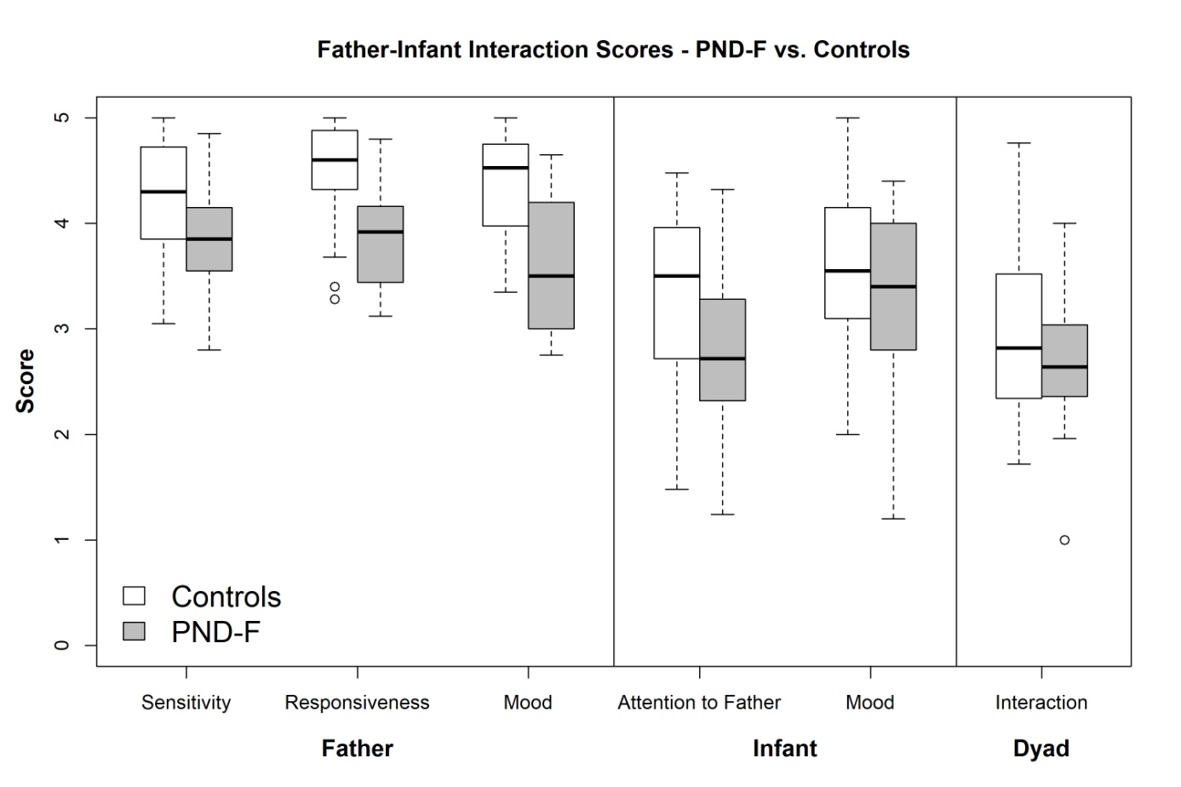
Abbreviation: PND-F: Father postnatal depression
Figure 1. Mean and standard deviation of father-infant interactions for controls and PND-F

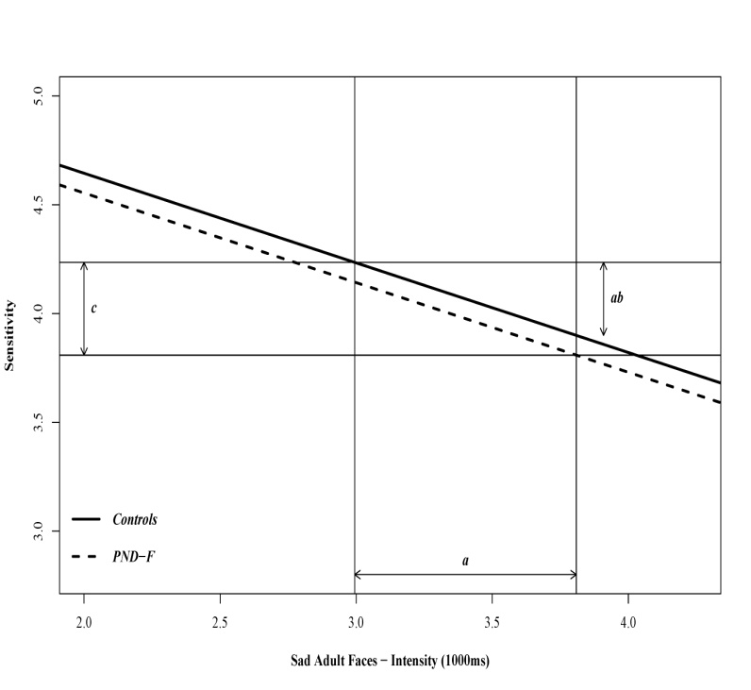
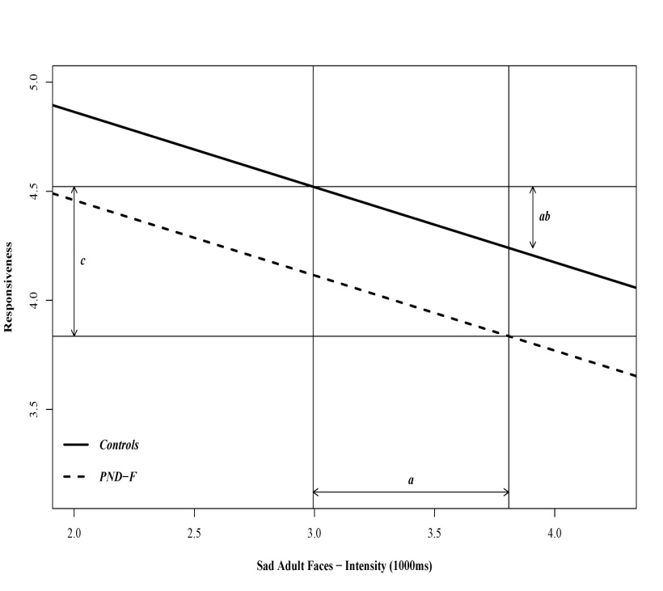
Note: "c" represents the direct effect of paternal depression on the dependent variable (either responsiveness, or sensitivity); "a" represents the effect of paternal depression on the mediator; "ab" represents the portion of "c" that is mediated.
Figure 2. Mediator effect of adult sadness intensity on the relationship between postpartum depression and sensitivity and responsiveness dimensions

