Investigating the Impact of Architectural Form and Wind Direction on the Performance of a Passive Downdraught Evaporative Cooling Tower in Saudi Arabia
ALSHENAIFI, M., SHARPLES, S.

University of Liverpool, Liverpool, UK

ABSTRACT: Buildings in Saudi Arabia consumes approximately 80% of the electricity generated in the country. Saudi Arabia’s hot, arid climate, with summer temperatures frequently exceeding 45°C, means that air conditioning uses nearly 50% of the country’s electricity, and virtually all the electricity is generated from fossil fuels. Passive cooling techniques could be a sustainable alternative to conventional air-conditioning systems when integrated properly within a building. A Passive Downdraught Evaporative Cooling (PDEC) tower is considered as one of the most efficient passive systems and was investigated in this study. A single storey open plan room with a PDEC tower was digitally modelled and then changes in wind direction and architectural form were simulated to see the effect on the PDEC performance. IES VE software was selected for the simulations as it can conduct a dynamic thermal simulation for PDEC systems. A weather file for Riyadh was obtained from the software Meteonorm. The study demonstrated that significant cooling can be achieved by PDEC towers, but that their effectiveness was greatly reduced by changes in wind direction linked to opening distributions in the room attached to the PDEC tower.
KEYWORDS: Passive Cooling, Passive Downdraught Evaporative Cooling, Cool Towers, Buffer Zone

1. INTRODUCTION
In 2016 Saudi Arabia was the largest oil consuming nation in the Middle East, and 10th in the world, with a total consumption of approximately 3.9 million barrels per day (b/d). The average direct burn of crude oil for power generation is more than 700,000 b/d during the summer months [1]. Buildings consume approximately 80% of the total electricity generated, and air conditioning represent most of that consumption [1]. It is obvious that buildings play a substantial role in Saudi Arabia’s energy consumption. Passive cooling systems can significantly reduce cooling demand for buildings. This study investigated one such cooling system – the Passive Downdraught Evaporative Cooling (PDEC) tower – and assessed how architectural form and wind direction affect the performance of a PDEC system in a Saudi summer.

2. LITERATURE AND BACKGROUND

The term ‘passive cooling’ describes a process that relies on a natural environmental heat sink to achieve cooling. Passive cooling strategies can be classified to four major types based on the natural heat sinks: (i) Natural ventilation (night ventilation), (ii) night sky radiation, (iii) ground cooling, (iv) evaporative cooling [2]. Passive Downdraught Evaporative Cooling (PDEC) towers are categorized as a direct evaporative cooling technique. When hot dry air passes through a water medium, the evaporation of the water occurs as sensible heat is converted into latent heat, and the air temperature decreases as the relative humidity level increases. A PDEC tower consists of a wind catcher at the top of a tower, an evaporative/water medium, and a shaft to deliver the caught, cooled air to an occupied space via openings at the bottom of the tower. Hot and arid climatic regions provide an ideal environment for PDEC systems, and an up to 80% reduction of wet bulb depression (WBD) can be produced, which would ultimately lead to a significant reduction in cooling energy consumption [3]. Contemporary applications of PDEC towers can be classified as four different types based on the evaporation method [3]:

Cool towers (wetted pads).

Shower towers (large droplets of spray)

PDEC with wetted porous ceramic

Misting towers (misting nozzles)

In this study, the PDEC with misting approach was used. The flexibility to control water pressure and droplet size in this technique makes it the most efficient among the various options [3]. A smaller droplet size increases the evaporation rate, which leads to a higher amount of cooling.

Due to the climatic dependency of the PDEC system, several factors can affect PDEC performance. These factors include climate, the tower geometry, the tower height, water droplet size, water flow rate and the evaporation technique. Several recent studies have investigated, analytically and experimentally, some of these factors [4,5]. However, most studies have treated the PDEC tower as a standalone structure. In this study the tower was coupled to a large room and openings in the room were altered to see the influence of the attached building’s architectural form on PDEC performance.

2.1 PDEC case study with misting nozzles
The Torrent Research Centre in Ahmadabad, India involved the first large application of misting nozzles spraying in to the top of a tower inlet. The Centre had incorporated the PDEC system in to four buildings. In each building the PDEC system was located above a central atrium separating offices from laboratories. When the outside temperature reached its maximum, the PDEC could reduce the interior temperature by between 10 to 15°C. The system has achieved a 64% energy savings in cooling demand when compared to a conventional air conditioning system [6].

2.3 Climate of Riyadh, Saudi Arabia
Riyadh, latitude 24.65°N, in the central region of Saudi Arabia, was the chosen site for this study. Its climate is characterized as hot and arid, with external dry bulb temperatures (DBT) in summer reaching 45°C (Fig. 1). The average DBT and wet bulb temperatures (WBT) are 36.5°C and 18.8°C, respectively. The daytime relative humidity is below 20% during the same period. The prevailing wind directions during the summer season are north and north-west (Fig. 2). The high potential for PDEC systems in Riyadh is because of the significant difference between dry-bulb and wet-bulb temperature (WBD).

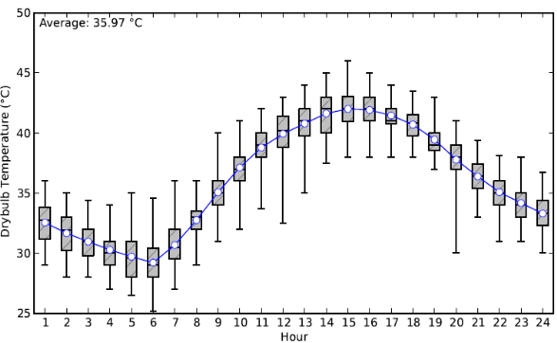
Figure 1: Range of mean hourly summer dry bulb temperatures, Riyadh. Source: epw.klimaat.ca

3. RESEARCH METHODOLOGY
This study aimed to evaluate the effect of the architectural design of a space linked to a PDEC tower. The purpose of the research was to maximize the performance of the PDEC tower in Saudi Arabia by improving the architectural design of the coupled building to act as one integrated design.
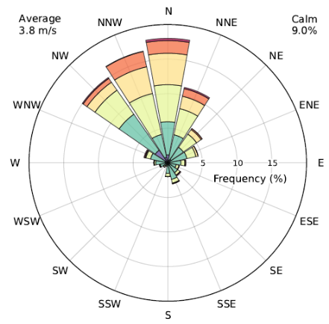

Figure 2: Frequency of wind direction and speed in summer, Riyadh. Source: epw.klimaat.ca

This study evaluated how wind direction and the addition of a buffer space to a room impacted on PDEC performance. A PDEC tower was located centrally and internally against the rear north wall of a single storey room connected to the tower (Fig. 3). The developed computer model applied the typical construction/material details of Saudi Arabia. The model construction specification is described in Table 1, and the tower specifications in Table 2. Most of the literature considers either 4:3 or 3:2 as a suitable aspect ratio for a rectangular tower. The dimensions of this study’s tower cross-section were 1.6m x 2.5m, following the 3:2 aspect ratio. The width of the tower was parallel to the direction of the prevailing wind direction.
A previous study recommended a tower height of double to triple the width of the tower [5]. As a result, a tower height of 5m was initially set for this study. At the base of the tower three openings faced the room and had a total opening area of 3.43 m². A horizontal clerestory window was placed in the room’s south façade with an opening area of 3.55m² (i.e. slightly larger than the tower’s supply openings). This model was used as the base case design for the computer study (Fig. 3). Other opening configurations were also tested (shown in Fig. 13).
IES VE software was selected for the study as it can simulate PDEC systems that use misting nozzles and changeable cooling efficiency rates [7]. A current epw weather file for Riyadh was produced from Meteonorm, which is a commercial weather reference software tool [8]. Two different weather scenarios were tested in the simulations – (i) a very hot July day with northerly winds and (ii) a slightly cooler August days with some southerly winds.

Table 1: Construction specifications for the building
 | Construction Specifications
Building Height | 3.5m
Floor dimensions | 7.5m x 9m
Floor area | 63.75 m²
External walls | 25mm external cement plaster + 100mm hollow concrete block + 50mm expanded polystyrene + 150mm hollow concrete block + 25mm internal cement plaster
Roof | gravel + 100mm expanded polystyrene + membrane+ 200mm concrete slab
Glazing | 6mm outer pane + 12mm cavity + 6mm inner pane
South opening area | 3.55 m²
Table 1: PDEC tower parameters and specifications
 | PDEC tower specifications
Assumed cooling efficiency | 80%
Tower Height | 5m
Tower cross-section Dimensions | 1.5m x 2.5m
Wind Catcher | Four sides louvres with 80% openable area (total area: 5.76 m²)
Supply openings | Three openings facing the room (total area: 3.43 m²)

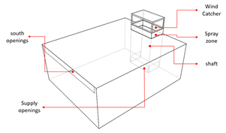
Figure 3: Base case building model and PDEC tower geometry

3.1 Model Validation
To check that the IES model had been configured correctly, the model was tested against experimental data derived from a European Union (EU) PDEC project [9]. The experimental building, shown in Fig. 4, was built in Catania, Italy, and consisted of a tower with two rooms attached to the north and south sides of the tower [9]. The PDEC tower dimensions were 4.1m x 4.4m x 10.7m. The wind catcher had two openings, each measuring 1.7m x 3.7m, and facing the east and west, which represented the prevailing wind direction. Data loggers were placed outside and within the building. The outdoor data recorded included solar radiation, air temperature, relative humidity, wind direction, and wind speed. Air temperatures and relative humidities were measured at different locations within the tower and the room.
A model of the Catania tower was created in IES VE. All the building details and opening profiles were considered when running the simulation. The simulation was run for 24 hours for the 30th July at a two minute time step.

The IES results for the north-coupled room were compared with average measured data. Figs. 5 and 6 show the good agreement between the measured and predicted data for the internal DBT and relative humidity, which gave confidence to develop an IES model for the Riyadh tower and room.

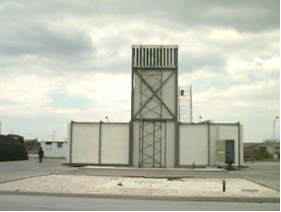
Figure 4: Experimental PDEC tower built in Catania [9].

4. RESULTS AND DISCUSSION
For the Riyadh tower the efficiency of the PDEC system was set in the IES model to be approximately 80% of the dry bulb to wet bulb temperature (wet bulb depression). Two days (scenarios) were considered. For scenario (i) on July 29th the maximum external air temperature peaked around 46°C mid-afternoon while the maximum external wet bulb temperature was around 21.5°C. The average external relative humidity was 14%.
Fig. 7 shows the wind speed and wind direction for July 29th generated from the weather file using IES software. The right vertical line represents the wind speed. The left vertical line refers to the wind direction, with the convention that a wind direction from the North is 0°, East 90°, South 180° and West 270°.

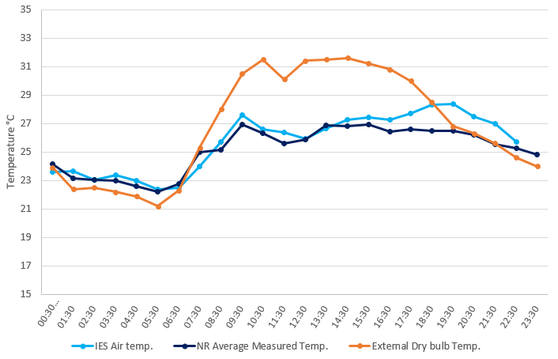
Figure 5: Comparison between measured and predicted internal air temperatures in room in Catania PDEC tower

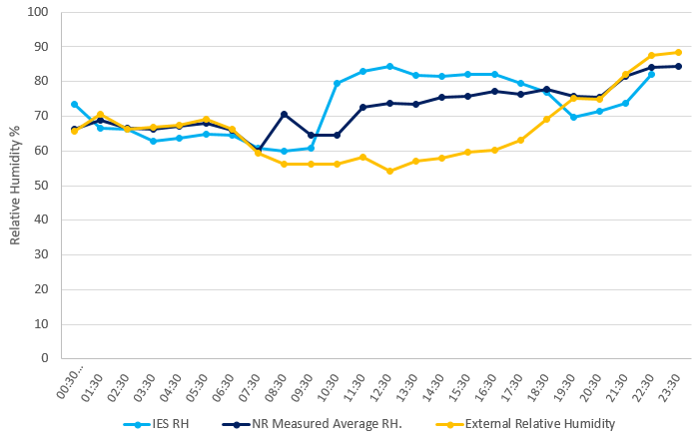
Figure 6: Comparison between measured and predicted internal relative humidities in room in Catania PDEC tower

The sharp fluctuation in the wind direction line does not necessarily mean a big change in the wind direction. For instance, in Fig. 7, the wind direction was approximately between 250° and 325° (WNW) for most of the day, and then suddenly swung around to 15° (NNE) at 14:00. This means the wind direction has only moved from WNW to NNE although the change looks more dramatic on the graph. Thus, for scenario (i), the winds were mostly from the north (i.e. directly on to the tower) with a maximum wind speed of 4.6m/s (Fig. 7). Fig. 8 shows the hourly external dry bulb and wet bulb air temperatures and the PDEC-generated internal air temperatures in the room. Fig. 8 shows how effective the PDEC system was, with a peak internal temperature around 27.2°C compared to an outdoor peak around 46°C. The internal relative humidity dramatically increased to around 60% during the day (Fig. 9). This is attributed to the stable weather conditions and lower humidity levels during the day (Figs. 7 and 9).
For scenario (ii) on August 2nd the day was slightly cooler, with a maximum external DBT and WBT of around 40°C and 18.7°C respectively, and a mean relative humidity around 15%. The wind direction was mostly from the north west but changed to the south and south east from 14.30 to 16.30 and 20.00 to 21.00 and so struck the building before reaching the tower (Fig. 10). The wind speed was higher compared to scenario (i), increasing through the day and reaching 9.2m/s around 16.00 (Fig. 10).

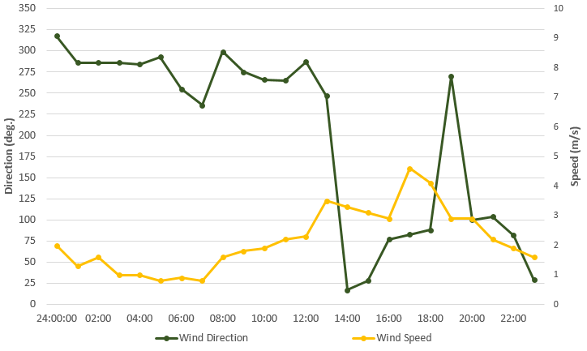
Figure 7: Wind speed and wind direction, July 29th.

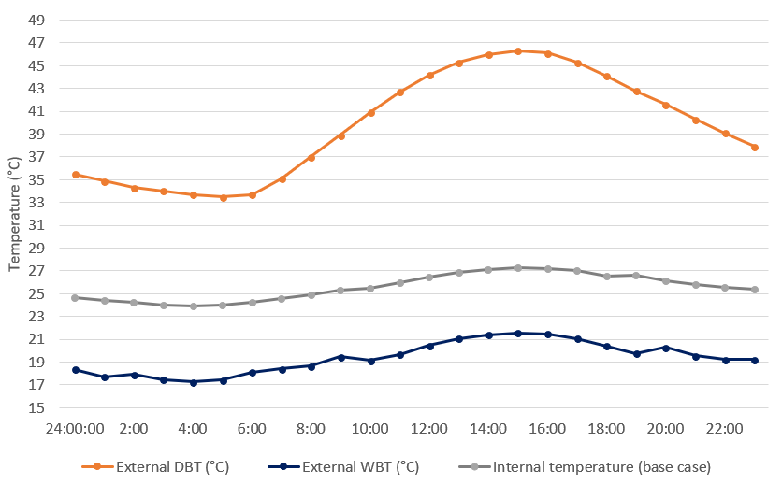
Figure 8: External and internal air temperatures, July 29th.

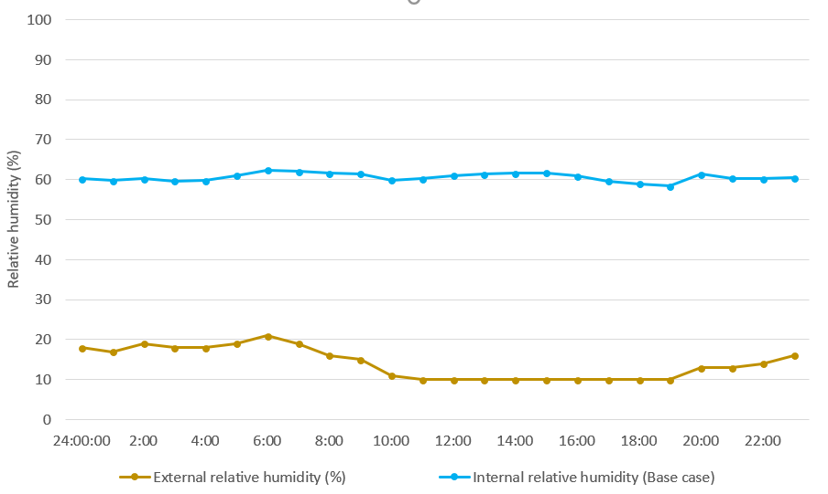
Figure 9: External and internal relative humidity, July 29th.

The results for scenario (ii) were not as expected when compared to those from scenario (i), with a reduction in the PDEC effectiveness being observed that was related to the unstable weather conditions. Figs. 10 and 11 show how the change in wind direction greatly reduced the effectiveness of the PDEC tower between 14.30 and 16.30 and between 20.00 and 21.00, when the wind direction became southerly. Internal temperatures peaked around 35.5°C and stayed higher than in the July scenario. The internal relative humidity had dramatically decreased when the winds were southerly (Fig. 12). This suggests that the clerestory window opening in the south façade was allowing a positive pressure to be generated in the room that acted against the ingress of cool air from the tower.

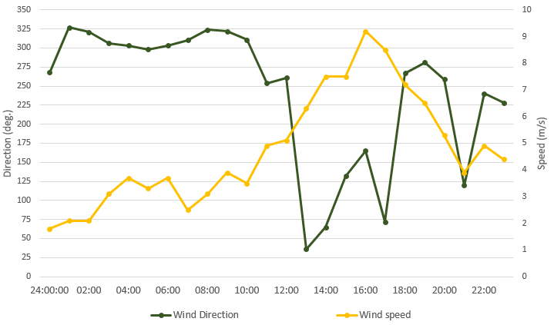
Figure 10: Wind speed and wind direction, Aug 2nd.

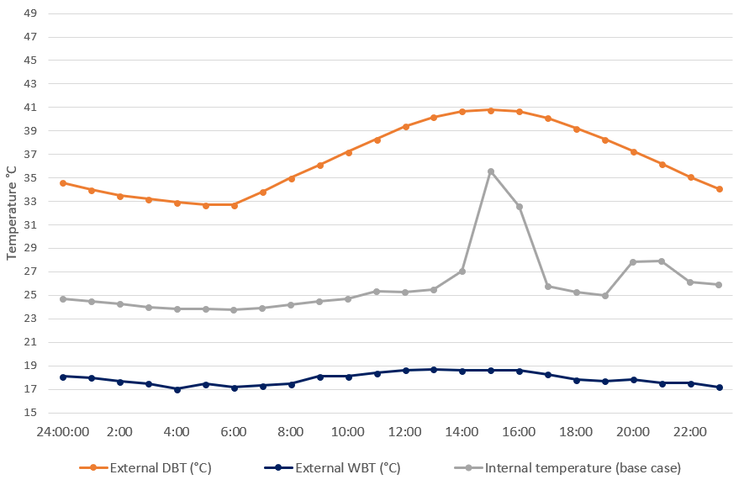
Figure 11: External and internal air temperatures, Aug 2nd.

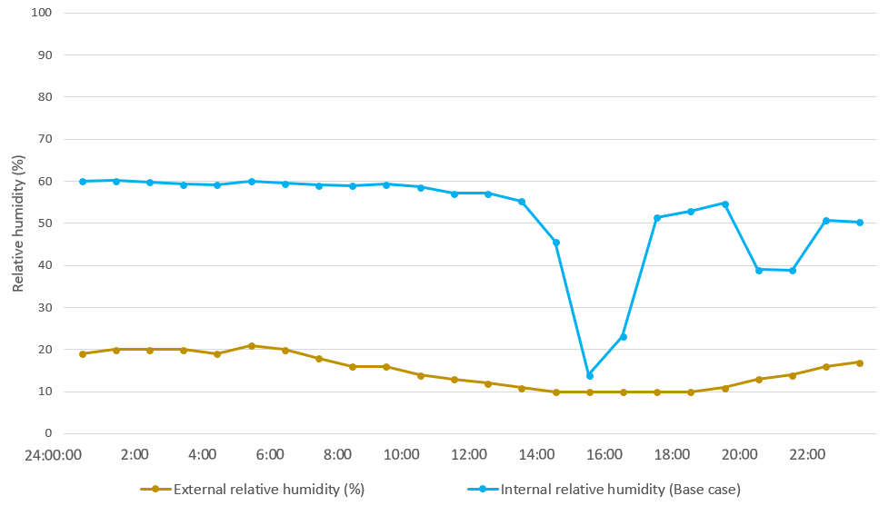
Figure 12: External and internal relative humidity, Aug 2nd.

Since wind direction played an important role in the performance of the PDEC tower, a double-skin type buffer zone corridor was then created on the south façade to test if the window could be protected and the tower performance improved for southerly winds. The buffer zone and the further improvements were developed based on recommendations from the literature [10]. The parameters that have been considered included buffer depth, buffer height, opening sizes, and opening placement. The investigation included many different configurations to improve the air movement of the PDEC within the space. Several cavity depths were tested, and it was found out that this parameter had no large influence on the overall performance of the PDEC tower. So, a cavity depth of 0.4m was chosen for this study. Three configurations were chosen for this study in addition to the base case (Fig. 13). These three configurations represented the major changes that has been discovered during the research modelling process. The first configuration had two openings located at the floor and ceiling of the buffer zone. The second configuration had two openings at the top north and south side of the buffer zone in addition to the floor opening. The floor opening was removed for the third configuration.
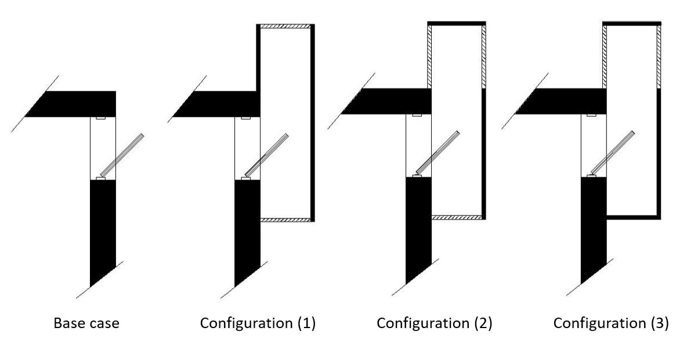
Figure 13: Base case and the three different configurations

Fig. 14 shows the internal air temperatures for the July 29th (northerly wind) conditions for the base case without the buffer zone and the three different zoned configurations. The addition of the buffer zone had little impact on the July tower performance, which might be expected for northerly low speed winds. However, Fig. 15 shows the positive impact of the buffer zones on the August tower performance during southerly wind conditions between 14.30 and 16.30 and between 20.00 and 21.00, but there was a negative impact after the wind changed direction. An interesting finding was that the internal temperature went up between 12.00 and 14.00, and between 16.30 and 18.30 when winds were blowing from north. The only logical explanation for this change was the higher wind speed as this scenario was working properly during steady wind conditions. The pressure increases on the buffer openings due to higher wind speeds has affected the performance negatively. So, the first configuration would provide better results only for southerly winds and lower wind speed conditions, otherwise, the base case performed better most of the time as the prevailing wind direction was northly.
For the second configuration, the top opening was replaced with two openings at the top north and south side of the buffer zone. This was developed to minimize the positive pressure of the wind speed, so the leeward side opening could negatively pressurize the buffer zone. Although the results showed that the situation had improved, the negative effect of the wind speed still had an impact on this configuration (Fig. 15).

The bottom opening was then eliminated for the third configuration. The purpose behind this was to create a stack effect within the buffer zone. The results showed that significant improvement was achieved during this scenario (Fig. 15). This configuration gave the best results compared with the other scenarios for most of the time and during different weather conditions. The two upper openings had decreased the pressure within the buffer zone cavity while the elimination of the bottom opening helped to create a stack effect.

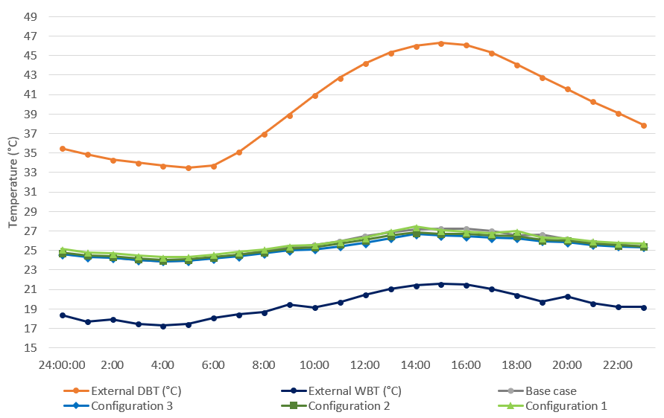
Figure 14: Comparison between results of the base case and the three buffer zone configurations, July 29th

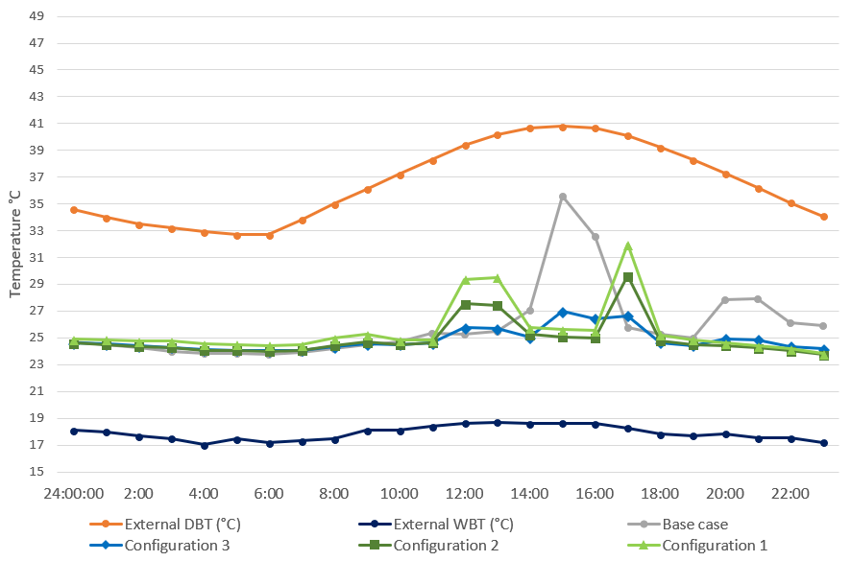
Figure 15: Comparison between results of the base case and the three buffer zone configurations, Aug 2nd

Although many summertime simulations have been made, the two scenarios presented here give a good representation of how the PDEC system performed for a range of summer wind speeds and wind directions. Due to a limitation on number of pages, it was not possible to represent more analyses here for the whole summer. However, it should be mentioned that the findings that were observed in the second scenario (Aug 2nd) occurred during many other days (e.g. Jun 4th, Jun 6th, Jul 2nd, Aug 8th etc.), and under similar weather conditions. Overall, the PDEC tower performed well as Riyadh generally has a stable weather system during most of the summer season. Full season analysis and representation in the future is highly recommended to better understand the overall performance of the PDEC system and will be presented in future work.

4. CONCLUSION
This paper has investigated the impact of architectural form on the performance of a PDEC tower. The tower was virtually created and linked to a room. The software IES VE was used to conduct the simulation of the PDEC system, and the tower’s predicted performance was impressive in Saudi Arabian climatic conditions. However, the performance was affected by changes in wind direction and wind speed. A buffer zone was added to the south side of the coupled space to minimize the negative effect of the winds. By assessing many configurations of the suggested solution, the performance was improved significantly. Further analysis, involving modelling and monitoring, will be conducted to better understand the relationships between the tower and room factors. Other architectural elements, such as roof openings might improve the performance of the PDEC system and provide more architectural design options. Detailed analysis including CFD would also provide a deeper understanding of the findings.

REFERENCES
1. Electricity & Cogeneration Regulatory Authority (ECRA)
Statistical Booklets 2016, [Online], Available at:
http://www.ecra.gov.sa/ [10 Nov 2017].
2. Lechner, N., (2014) Heating, Cooling, Lighting:
Sustainable Design Methods for Architects. 4th ed., John
Wiley & Sons.
3. Ford, B. and R. Schiano-Phan, (2010). The Architecture
and Engineering of Downdraught Cooling. PHDC Press,
Bologna, Italy.
4. Belarbi, R., Ghiaus, C. and F. Allard, (2006). Modeling of
water spray evaporation: application to passive cooling of
buildings. Solar Energy, 80: p. 1540–1552.
5. Kang, D. and R. K. Strand, (2016). Significance of
parameters affecting the performance of a passive
downdraught evaporative cooling (PDEC) tower with a
spray system. Applied Energy, 178: p. 269-280.
6. Ford, B., Patel, N., Zaveri, P. and Hewitt, M., (1998).
Cooling without air conditioning: The Torrent Research
Centre, Ahmedabad, India. Renewable Energy, 15: p. 177-
182.7.
7. Buckley, L., (2014) Simulating a Passive Downdraft
Evaporative Cool Tower. In Proceedings eSim 2014. Ottawa,
Canada, May 8-9
8. Meteonorm: [Online]. Available at:
http://www.meteonorm.com/ [29 Nov 2017].
9. Galatà, A and S. Sciuto, (1997). Passive Evaporative
Cooling : the PDEC project. In International Thermal Energy
and Environment Congress. Marrakesh, Morroco, June.
10. Gratia, E. and A. de Herde, (2007). Guidelines for
improving natural daytime ventilation in an office building
with a double-skin façade. Solar Energy, 81: p. 435-448.

