Wave-driven sediment resuspension and salt marsh frontal erosion alter the export of sediments from macro-tidal estuaries
Xiaorong Li*, Nicoletta Leonardi, Andrew J. Plater
Department of Geography and Planning, School of Environmental Sciences, University of Liverpool, Roxby Building, Chatham Street, Liverpool, L69 7ZT. *lixr@liverpool.ac.uk.

Abstract
The impact of wind waves and salt marsh erosion on sediment transport dynamics of macro-tidal estuarine systems has been examined using a numerical model. Morphological changes associated with salt marsh erosion facilitate the propagation of waves to the marsh edges, and increase the resuspension and export of sediments from the estuary. Results also highlight the impact of tidally-modulated changes in wave action upon sediment transport dynamics throughout a tidal cycle and from neap to spring tide. In particular, wave action at the landward margin of the estuary is limited by the shallow water depth, and tidally induced increments in water depth only cause a modest increase in wave shear stresses. At the seaward side of the domain, the impact of waves is limited by the deeper water, and tidally induced water level variations have a more significant control on wave shear stresses. The outcomes contribute new insights that are important for the sediment budget of macro-tidal estuaries facing climate change and have implications for the long-term morphological evolution of estuarine wetlands.

1. Introduction
Located at the interface between the marine and terrestrial environment, estuarine systems are characterized by complex hydrodynamics and sediment transport processes. Further, estuaries are highly valuable from an economic and ecological point of view (e.g. USEPA, 1993; Feagin et al., 2009; Friedrichs, 2011). Highly productive habitats such as salt marshes are commonly found in estuaries and low-energy zones. Thanks to their location and vegetated surfaces, salt marshes provide a variety of ecosystem services (Barbier et al., 2011). For instance, they can retain sediments and pollutants and store large amount of carbon over decadal to geological timescales through burial of organic matter (e.g. Mcleod et al., 2011); they can act as natural buffers against storm surges and wind waves (e.g. Temmerman et al., 2013; Möller et al., 2014, Leonardi et al., 2018); provide natural habitats for plants and animal communities (e.g. Boesch and Turner, 1984; Deegan et al., 2002; Mudd et al., 2009), and offer a place for recreational and tourist activities ( e.g. Costanza et al., 2008).
Globally, salt marshes are facing challenges to their survival due to climate change and stressors associated with urban development (Raposa et al., 2017). Vegetation shifts, salt marsh dieback, surface ponding, and lateral erosion have been widely observed, and in spite of numerous insightful studies it is still difficult to understand how these ecosystems might respond to changes in external agents (e.g. Hartig et al., 2002; Blum and Roberts, 2009; Kirwan and Megonigal, 2013; Leonardi et al., 2016a). Ultimately, the survival of salt marshes depends on the sediment budget of the system (e.g. Ganju et al., 2005, 2017; Fagherazzi et al., 2013). Indeed, sediment budgets represent a spatially integrated measure of competing constructive and destructive forces: a sediment surplus may result in salt marsh vertical growth and/or lateral expansion, while a sediment deficit may result in drowning and/or lateral contraction (Ganju et al. 2017).
Sediment transport dynamics and the sediment budget of estuarine systems can be affected by a number of factors, including tidal regime (Dronkers, 1986; Roberts et al., 1998), wind and wave climate (e.g. Schwimmer, 2001; Marani et al., 2011; Leonardi et al., 2016b), biological elements, anthropogenic activities (van der Wal and Pye, 2003) and sediment availability such as that of fluvial provenance, seabed erosion and alongshore transport (van der Wal and Pye, 2004).
Macro-tidal estuaries have tidal ranges greater than 4 m, experience large variations in water level and have extensive intertidal areas. These large tidal fluctuations influence the generation and propagation of waves as well as the magnitude of bottom shear stresses throughout tidal cycles. Despite being frequently defined as tide-dominated, wave-induced bottom shear stresses in macro-tidal estuaries can vary significantly and influence sediment transport pathways. In particular, during high tide, wind waves can easily propagate toward salt marsh edges and this has been found to inhibit sediment deposition in the lower salt marsh regions (e.g. Davidson-Arnott et al., 2002) as wave-induced vertical mixing of the water column keeps sediments in suspension for longer (Spencer et al., 2016a). The increased wave energy reaching the seaward margins of salt marshes during high tide can also enhance local scour and erode salt marsh boundaries (e.g. Leonardi et al., 2016a).
The transfer of energy from wind waves to the bottom is depth-limited: deeper areas are not influenced by wave-induced bottom shear stresses because wave orbital velocities do not affect the bottom; very shallow areas do not allow wave generation and propagation and similarly experience low bottom shear stresses (e.g. Fagherazzi et al., 2006). These dynamics have been widely recognized and explored within the context of coastal environments having different average water depths but there are fewer studies investigating the tidally-modulated changes in wave shear stress and their impact on the sediment budget of the system. The Ribble Estuary has a spring tidal range of 8 m and extensive fetch values allowing the generation of fully developed waves. It thus represents the ideal environment for the analysis of compound tide-wave interactions.
Within the context of morphological changes due to salt marsh erosion, increases in water depth close to the margin of the salt marsh as a result of erosion of the marsh boundary can facilitate wave propagation and enhance sediment resuspension, providing favourable conditions for further erosion of the salt marsh and scouring of the tidal flat. Indeed, research has also investigated how salt marsh erosion is influenced by changes in marsh areal extent (e.g. Mariotti and Fagherazzi, 2013; Fagherazzi et al., 2013). For instance, the existence of a critical tidal flats width has been suggested, beyond which irreversible salt marsh erosion takes place due to the generation of local waves which are sufficiently high to erode the salt marsh boundaries (Mariotti and Fagherazzi, 2013). However, these studies mainly focused on direct marsh erosion dynamics (i.e., wave-induced lateral erosion) and less attention has been given to variations in sediment fluxes caused by morphological changes which could indirectly affect the long-term sustainability of wetlands through alteration of the sediment budget.
The aim of this research is therefore to evaluate bed shear stress and sediment budget of macro-tidal estuarine systems under the influence of wind waves and morphological changes due to salt marsh erosion. The interest in the sediment budget is justified by previous studies supporting the hypothesis of a positive budget as a necessary condition for the long-term sustainability of coastal wetlands (e.g. Ganju et al., 2005, 2017; Fagherazzi et al., 2013). A salt marsh complex is defined not only by the vegetated marsh plain but also the entire suite of geomorphic features including adjacent estuarine/marine seabed, and intertidal flats. Indeed sediments which belong to tidal flats and the nearby seabed contribute to salt marsh stability because: i) as long as they remain deposited in the proximity of marsh platforms, they represent a store of sediments available for re-suspension and re-delivery to the salt marsh during storm events; and ii) an abundance of sediments on the tidal flats avoid scouring of the seabed which could, in turn, promote wave energy propagation and salt marsh frontal erosion.

2. Study area
The Ribble Estuary (Fig. 1), located north of Liverpool Bay, Northwest England, UK, is a tidally dominated estuary (Moore et al., 2009; Wakefield et al., 2011). The ordinary tidal range in the estuary is 8.0 m at spring tide, and 4.4 m at neap tide (UKHO, 2001). Tides in the estuary are asymmetrical, with flood tides having shorter duration than ebb tides (Burton et al., 1995; Lyons, 1997). The tidal prism, i.e. the volume of water between mean high tide and mean low tide, of the estuary is ~ 9.5×10⁹ m³ (Li et al., 2018). Despite being tidally dominated, the estuary experiences moderate wave energy with waves coming from the relatively shallow Irish Sea (Van der Wal et al., 2002). Prevailing winds come from the west and north-west (Fig. 2), and given the estuary geometry, the largest waves also come from the west (Pye and Neal, 1994).
The estuary is funnel shaped, and its channel is relatively straight and narrow due to extensive engineering work carried out around the turn of the 20th century (Van der Wal et al., 2002). The estuary is incised into Permo-Triassic bedrock, which is covered by Quaternary deposits up to 50 m in thickness (Van der Wal et al., 2002).
Extensive salt marshes are present on the south side of the estuary. The most abundant species of plants include Festuca rubra and several grasses of the Spartina family. Patches of salt marshes are also found on the north side of the estuary (Figure 1C). These salt marshes are formed from sediments derived from the bed of the Irish Sea as well as silt and clay-size sediments coming from the River Ribble (Van der Wal et al., 2002; Lymbery et al., 2007). These conditions present the Ribble Estuary as an ideal test case for examining the impacts of hydrodynamic-morphodynamic-morphological interactions in a macro-tidal estuary.

3. Methods
The numerical model Delft3D was used to compute the hydrodynamics and sediment transport of the estuarine system. There are two main considerations for choosing Delft3D as the numerical tool in this research: i) Delft3D includes fully coupled three-dimensional wave-current-sediment modules, which is critical for realistic modelling of sediment transport dynamics of estuarine systems; and ii) Delft3D contains a comprehensive vegetation module which models the effect of vegetation on the flow field by integrating the influence of plants into the momentum and turbulence equations.
The third-generation, spectral action, balance-based model Simulating Waves Nearshore (SWAN) was fully coupled with Delft3D for the computation of sea waves. The sediment-transport module of Delft3D includes both suspended-load and bed-load transport of multiple cohesive and non-cohesive sediment fractions. The suspended load is calculated through the advection–diffusion equation. The bed-load transport is computed using the empirical transport formulation proposed in Van Rijn (1993) (note that the sediment transport formulation set in Van Rijn (1993) includes both suspended-load and bed-load). The model takes into account the vertical diffusion of sediments due to turbulent mixing and sediment settling due to gravity. In the case of non-cohesive sediments, the exchange of sediments between the bed and the flow is computed by evaluating sources and sinks of sediments near the bottom. Sources of sediments are due to upward diffusion, while sediment sinks are caused by sediments dropping out from the flow due to their settling velocity (Van Rijn, 1993). In case of cohesive sediments, the Partheniades–Krone formulations for erosion and deposition are used (Partheniades, 1965).
The effect of vegetation on the velocity field and on the vertical velocity structure is taken into account through an additional source term for friction, and additional terms for turbulent kinetic energy generation and dissipation. Plants are thus schematized as vertical cylinders whose most important characteristics include average stem diameters, density, and height above the bed (e.g. Rodi, 1993; Baptist et al., 2007). A more detailed description about Delft3D and its implementation can be found in the Delft3D-FLOW User Manual (Delft Hydraulics, 2014).
The set-up of the model, including the computation domain of the model and the bathymetry of the study area, as well as the bottom sediment compositions, are presented in Fig. 1B and Fig. S1, respectively. The bathymetry of the model is obtained through combining data downloaded from EDINA DIGIMAP for the open sea and LiDAR data for the coastal areas, with Vertical Offshore Reference Frame (VORF) corrections provided by the UK Hydrographic Office used to adjust the two bathymetry datasets to Mean Sea Level (MSL). The sediments within the model domain are grouped into four fractions including gravel (non-cohesive), sand (non-cohesive), very fine sand (non-cohesive) and mud (cohesive) (refer to Li et al., 2018 for detailed specifications). The initial spatial distribution of the sediment fractions is created based on the British Geological Survey (BGS) GIS-maps for seabed sediments and parent material (near-surface geology) for the sediments on the landward side of the domain.
The model has a tidal and a fluvial open boundary, driven by data provided by the Extended Area Continental Shelf fine grid (CS3X) model and a time series of daily-averaged river discharge values downloaded from the National River Flow Archive, respectively. The model was developed and calibrated by Li et al. (2018), to which we refer the reader for a full description of the model set-up, validation, and boundary conditions.
Model runs have been carried out considering the present areal extent of the salt marshes and two erosion scenarios, i.e. erosion scenarios corresponding to a 50% and 100% removal of the salt marsh on the south side of the estuary (Fig. 1C). In Fig. 1, black lines (panel B), and white dashed lines (panel C) indicate the location of two internal boundaries enclosing the salt marsh area used for the calculation of net sediment fluxes. Throughout the manuscript these internal boundaries will be referred to as riverine and ocean boundaries (~12 km and ~0.4 km long, respectively), differing from the boundaries of the numerical domain which will instead be called open boundaries. The majority of the analysis will focus on the enclosed domain in between the two internal boundaries as this zone includes the salt marsh that can potentially be impacted by variations in sediment fluxes. For the numerical experiments accounting for salt marsh erosion, erosion is simulated by removing the vegetation cover and by altering the bathymetry to replace elevation values of the eroded salt marsh with depth values of the adjacent tidal flats.
To investigate the impacts of waves on sediment transport dynamics, a set of idealized simulations is conducted for each saltmarsh coverage scenario, for a total of 75 one-month numerical experiments. Specifically, the hydrodynamics and sediment transport of the system are simulated under the influence of three wind intensities and eight different wind directions, as well as under the sole tidal influence including both spring and neap tide. The tested wind intensities correspond to the 10th, 50th and 90th percentiles of the hourly wind record (independent of direction) collected by the UK Met Office at the ‘Blackpool Squires Gate’ weather station for year 2008 which witnessed a few extreme events in the UK waters. The corresponding wind speeds are given in Table 1. The eight wind directions are defined from 0 degrees (north) to 360 degrees with 45 degree intervals. For the NW, W and SW wind cases, wave open boundary conditions corresponding to a fully developed sea are assigned at the west open boundary of the model, and the significant wave heights (H_{s}) and peak wave periods (T_{p}) given through the wave open boundary conditions are defined based on the UK Met Office scale (Table 1). For the other wind directions, significant wave height (H_{s}) and peak wave period (T_{p}) are 0 due to negligible fetch values.

4. Results
4.1 Changes in bed shear stress and suspended sediments
Significant wave height values during spring and neap high water, and for westerly winds are shown in Fig. 3; results are presented for three salt marsh erosion scenarios (0%, 50%, 100% erosion), and waves generated by winds at the 10th and 90th percentiles (see Fig. S2 for all wave scenarios). During the neap tide (Fig. 3A, S2A), given the lower high water, even for winds at the 90th percentile and a fully developed sea, wave height decreases rapidly and areas near the salt marsh edge experience almost no waves. Under these conditions, morphological changes due to salt marsh erosion do not affect the spatial distribution of significant wave heights. During spring high water (Fig. 3B, S2B), small to medium waves, i.e. 10th and 50th percentiles, propagate closer to the marsh edges, and large waves, i.e. for the 90th percentile winds, can propagate over the salt marsh. For the 90th percentile wind scenario, morphological changes due to salt marsh erosion significantly impact the spatial distribution of wave heights (Fig. 3B, S3).
A time series of shear stress values spatially averaged over the enclosed domain in between the two internal boundaries (Fig. 1C) is presented for neap and spring tides (Fig. 4). Results include ‘current-only’ and ‘wave-imposed’ scenarios corresponding to different wind intensities and directions. Maximum bed shear stress values are significantly higher during spring tide when the tidal prism and tidal currents are the greatest. When wind waves are present, the difference in bed shear stress between neap and spring tide is significantly enhanced, especially for westerly winds. For spring tide and wind waves at the 90th percentile, peak values in shear stress almost double; the largest increase in maximum shear stress is 1.2 N/m², and the largest increase in minimum shear stress is 0.3 N/m². Generally, changes in bed shear stress remain relatively small in the case of neap tide and for waves at the 10th and 50th percentile, while large increases are present for the 90th percentile test cases.
Fig. 5 shows a spatially-averaged time series of the total mass of suspended sediments within the enclosed domain for two neap and two spring tidal cycles. Results are presented for a tide-only scenario and for three wave-incorporated scenarios corresponding to westerly winds at the 10th, 50th, and 90th percentile. For each wave condition, three salt marsh erosion scenarios are considered, i.e. no salt marsh erosion, 50% and 100% salt marsh erosion. Results are presented for the westerly wind as this is the prevalent wind direction, which also aligns with the estuarine channel.
In agreement with the above-mentioned increase in shear stress, under the influence of wind waves there is an increase in the total mass of suspended sediments during both neap and spring tides, with changes being higher during spring tide. Changes in the maximum total mass of suspended sediments caused by the 90th percentile waves are 1.85×10⁸ and 3.95×10⁸ kg for neap and spring tides, respectively. Changes in minimum values are less significant, i.e. from no waves to the 90th percentile waves the total mass of sediment in suspension is increased by 2.24×10⁷ and 1.60×10⁷ kg for neap and spring tides, respectively, which represents a small variation in comparison with the total amount of suspended sediments of the tide-only case.
Hypothetical salt marsh erosion scenarios are also tested. When compared to the impact of wind waves during both spring and neap tides, changes caused by salt marsh erosion to the total mass of suspended sediments within the enclosed domain are much smaller. However, during spring tide, and in the case of large waves corresponding to the 90th percentile wind, a noticeable increase in the total mass of suspended sediments can be observed for the 50% and 100% salt marsh erosion scenarios. As the salt marsh erodes, for spring tide, the peak total mass is increased by 4% from 4.03×10⁸ (no marsh erosion) to 4.20×10⁸ kg (50 % marsh erosion) and by 7% to 4.30×10⁸ kg (100% marsh erosion). The minimum total mass is increased by 26% from 2.25×10⁷ to 2.83×10⁷ kg and by 42% to 3.19×10⁷ kg for 50% and 100% marsh erosion cases respectively. Changes during neap tide are smaller. For the peak total mass, it is increased by 2% from 1.69×10⁸ to 1.73×10⁸ kg for both the 50 % and 100% marsh erosion scenarios. The minimum total mass is increased by 13% from 2.49×10⁷ to 2.81×10⁷ kg (50 % marsh erosion) and by 20% to 3.00×10⁷ kg (100 % marsh erosion).
4.2 Changes in sediment fluxes
To further evaluate the sediment budget of the system under different wave conditions and salt marsh erosion scenarios, sediment fluxes through the two internal boundaries depicted in Fig. 1C are calculated over four neap and four spring tidal cycles. Sediment fluxes are calculated by multiplying velocity, sediment concentration, and water depth, which are then averaged along the boundaries. Fluxes are positive when indicating sediment entering the enclosed domain (i.e. sediment import) and negative otherwise (see Fig. 1C).
Fig. 6 and Fig. 7 show sediment fluxes at the ocean and riverine boundary for a tide-only case and for a wave scenario corresponding to westerly winds at the 90th percentile (see Fig. S4 and Fig. S5 for all tested scenarios); different salt marsh erosion configurations are also considered. For both boundaries, sediment fluxes fluctuate due to the large impact of tidal motion. Furthermore, positive and negative fluxes are not symmetrical, and for both boundaries negative fluxes (exiting the enclosed domain) are much larger than the positive ones (entering the enclosed domain), suggesting that sediments are exported seaward at the ocean boundary and landward at the riverine boundary.
When waves are added to the system the sediment-exporting trend is maintained at both internal boundaries, and signal fluctuations increase and remain higher in case of spring tide. For the ocean boundary, the presence of waves significantly increases negative fluxes (seaward sediment export) occurring during ebb periods, while the enhancement in positive fluxes (sediment import) is smaller, which further enhances the asymmetry of the system. For the riverine boundary, the impact of waves on both magnitude and asymmetry of the fluxes is smaller in comparison with that at the ocean boundary.
For the ocean boundary, changes in salt marsh areal extent caused undetectable effects on the sediment fluxes during neap tides (Fig. 6, S4), while during spring tide, negative fluxes are enhanced as a result of salt marsh erosion for the 50th and 90th percentile wave scenarios. For the riverine boundary, the impact of salt marsh erosion on the sediment fluxes remain minimal in the case of neap tide. However, significantly larger changes are observable during spring tide, especially for the 90th percentile wind case during which both positive and negative fluxes are increased. This is because the riverine boundary is located closer to the newly formed tidal flats originated as a consequence of salt marsh erosion, over which waves can propagate more easily.
To better quantify the net import and export of sediment from the enclosed domain, sediment fluxes through the ocean and riverine boundaries have been time-integrated over four tidal cycles. Table 2 gives the net transport exiting the enclosed domain for a tide-only case. As suggested before, net fluxes are always negative, and sediments are exported either landward or seaward; during neap tide the landward export of sediments is around 60 times higher than the export of sediments seaward, while during spring tide this difference reduces, and the landward export becomes around 15 times higher than the seaward one. Indeed, from neap to spring tide the seaward export of sediments is increased ten times, while the landward export of sediments is only doubled.
Changes in net transport at the ocean and riverine boundaries due to the inclusion of wind waves, and during both neap and spring tide, are given in Fig. 8 for all eight wind directions. Results are presented in terms of percentage changes with respect to the tide-only scenarios. Since the net fluxes of the tide-only scenarios are negative, positive values (red colours) in the pie charts indicate increases in export of sediments, while negative values (blue colours) indicate decreases in net export.
Percentage changes at the ocean boundary are significantly larger than the ones at the riverine boundary for all different wind directions and magnitudes. For the ocean boundary, percentage changes during neap tide are larger than those during spring tide because the net flux of the tide-only case during neap tide is one order of magnitude smaller than that during spring tide (see Table 2); on the other hand, for the riverine boundary and for the tide-only case, the net fluxes are of the same order of magnitude during both neap and spring tides, leading to similar wave-induced percentage changes.
For the ocean boundary under calm to rough sea conditions (10th and 50th percentile), the more significant changes in net transport occurred when the wind directions were 225˚, 270˚ and 315˚, during which wave boundary conditions were present at the seaward open boundary. Sediment transport at the riverine boundary is significantly less affected by the incorporation of wind waves. Changes are smaller than 1% during both neap and spring tides, and for all three wave intensities. Pie charts for the 50% and 100% erosion scenarios show a similar behaviour and are presented in the supplementary material (Fig. S6, S7).

5. Discussion
5.1 Positive feedback between wave-driven sediment resuspension and frontal erosion
This research explores the impact of wind waves and frontal salt marsh erosion on sediment transport dynamics of macro-tidal estuarine systems. Although storms and wave-induced sediment resuspension have been found to significantly contribute to the maintenance of salt marsh platform elevations (e.g. French, 1993; Schuerch et al., 2012, 2013), wind waves are also one of the main causes for lateral erosion of salt marsh boundaries as they scour and remove sediments directly from vertical scarps. Indeed, the presence of wind waves is frequently associated with detrimental impacts in terms of salt marsh resilience (e.g. van der Wal and Pye, 2004; Wolters et al., 2005). Within this context, our results indicate that apart from the direct impact of wind waves on salt marshes, wind waves can also indirectly influence the resilience of the salt marsh by increasing the export of sediments from the estuary.
In addition to wave/storm-induced sediment deficit of the system, our results also indicate that changes in the topology of the estuary due to salt marsh erosion can cause enhanced seaward and landward export of sediment from the vicinity of the salt marsh, leading to potential further loss of wetland areas. This is mainly due to facilitated propagation of waves over newly formed tidal flats as a result of salt marsh erosion (see Section 4.1) with consequent increases in bottom shear stress and sediment resuspension. Similar findings, i.e. continuous inundation and creation of localized source of sediments caused by erosion of salt marsh platform, are documented in a previous research that investigated the impact of salt marsh areal contraction on the sediment budget of a macro-tidal estuary under tide-only conditions (Li et al., 2018). Within this context, morphological changes of estuaries can also alter tidal regimes, including tidal prism, tidal asymmetry, and residual tidal current (Dronkers, 1986; van der Wal and Pye, 2004; Prandle, 2009), which in turn affect wave dynamics (Davidson-Arnott et al., 2002) and ultimately influence the sediment budget of the system. For instance, increased tidal range, current velocity and wave height resulting from land reclamation have been associated with lateral erosion of the seaward edge of saltmarshes in the inner Thames estuary (Pye, 2000; van der Wal and Pye, 2004).
The above-mentioned intertwined processes between wave action and changes in estuarine morphology caused by salt marsh erosion are depicted in Fig. 9 and are identified as a positive feedback loop: wind waves promote erosion of salt marshes both directly, by impacting the marsh boundary, and indirectly by enhancing the export of sediments from the system; this in turn changes the morphology of the estuary with deepened water at the margin of the salt marsh, reducing wave energy dissipation and enhancing resuspension of sediments, leading to increased export of sediment and exacerbated salt marsh deterioration. Indeed, such deterioration has been observed for many salt marshes around the globe as a function of relative sea-level rise (e.g. Ellison, 1993; Hartig et al., 2002; Craft et al., 2009; Crosby et al., 2016; Spencer et al., 2016b) and changes in wave climate (e.g. Schwimmer, 2001; van de Koppel et al., 2004; Marani et al., 2011).
5.2 Relationship between wave-driven bed shear stress and water depth
The seaward and landward parts of the system have different sensitivity to the inclusion of waves. In particular, waves have a greater impact on sediment fluxes at the ocean boundary than those at the riverine boundary. This is explained by considering variations in wave-generated bed shear stress with water depth over a tidal cycle. Wave-induced bed stress follows a non-monotonic relationship with water depth, as indicated by previous studies (Fagherazzi et al., 2006; Payo et al., 2016), and illustrated in Fig. 10. For very shallow water, wave-generated bed stress increases with increasing water depth; however, once the water depth has reached a critical point, increasing water depth reduces the shear stress as waves’ orbital velocities stop impacting on the bottom. The water depth at the riverine boundary is significantly shallower with respect to that at the ocean boundary, and subject to smaller tide-driven variations; therefore, for locations near the riverine boundary the wave-generated bed shear stress is smaller, and changes in bed shear stress associated with water level variations are also smaller with respect to the ocean boundary (Fig. 10). On the other hand, the ocean boundary experiences larger fluctuations in wave-induced bed shear stress due to water depth fluctuations caused by tidal motion, and depth values are larger than the threshold value above which wave-generated bed shear stress decreases with increasing depth. This explains the larger and asymmetric impact of wind waves at the ocean boundary, and the smaller, and less asymmetric impact of waves at the riverine boundary.
The derived relationship between wave-driven bed shear stress and water depth can provide insight into depositional and erosional dynamics of macro-tidal estuaries. For instance, the non-linear relationship depicted in Fig. 10, together with spatially-varying tidal fluctuations and sediments properties, influences the divergent and or convergent nature of sediment fluxes across different parts of the estuary and the period of time during which deposition is allowed. Further, within the context of sea-level rise, areas where salt marsh surface fails to ‘keep-up’ will initially experience rapidly increasing erosion due to the positive feedback loop mentioned above; the resulting increased water depth as a combined result of surface erosion and sea-level rise will then reach a threshold beyond which the erosional wave action becomes minimized and the deposition/erosion pattern reversed.
5.3 Effect of morphological changes on future erosion events
Our results show that changes in the amount of sediment in suspension associated with salt marsh degradation are higher in case of very large waves and during spring tide (Section 4.1). This is because during spring tide the water depth is higher and allows waves to easily propagate to the margins of the eroding salt marsh. Together with the tidally-induced modulation of wave shear stresses throughout individual tidal cycles, the importance of spring-neap alternation for wave propagation highlights the importance of water depth in regulating the effect of waves.
Morphological changes in the estuary, in particular changes in the geometry of the estuary due to lateral erosion of the salt marsh boundary, can lead to significant variations of the estuary width which, in turn, alters the dissipative and/or funnelling character of the estuarine system and influences both tides and surge propagation (e.g. Lyddon et al., 2018). Changes in surge propagation will alter the extent of flooding during storm events and the redistribution of sediments on salt marsh platforms, which plays a key role in the maintenance of these vegetated surfaces and their susceptibility to future erosion events and sea-level rise. Another morphological interaction associated with salt marsh erosion is the transformation of the marsh front which can lead to modification of the wave attenuation process (e.g. Möller and Spencer, 2002; Leonardi and Fagherazzi, 2014), which can subsequently alter the level of exposure of inland areas to marine hazards.
Facilitation of the propagation of wave energy toward the salt marsh seaward boundary may lead to increases in wave-induced erosion during normal weather events which, given their high frequency, have been identified as accountable for the majority of the erosion hazard (e.g. Leonardi et al., 2016b). Together with inland constraints due to human interventions, this might lead to a squeezing of coastal marshes (e.g. van der Wal and Pye, 2004). On the other hand, the latter mechanisms may be mitigated by the presence of slumped salt marsh blocks and sediments coming from the marsh and deposited on the seabed in close proximity to the salt marsh edge; these might serve as buffers against wave action and potentially facilitate new vegetation encroachment if the height of the deposit is sufficient.
It is thus important to identify mechanisms responsible for the export of these important sediment stores, including not only significant resuspension events during storms but also morphologically-induced changes in tidal propagation which may alter the flood/ebb dominance character of the system and, in turn, influence the export of sediments even in the absence of waves. Given the long-term climate change projections, particularly in relation to changes in storm frequency and magnitude, morphological changes of estuaries should be afforded sufficient attention to prevent the large-scale loss of wetlands.
5.4 Limitation of the model
The model used in this research considers hydrodynamics and sediment transport in the modelled estuary under topographies posterior to three idealized salt marsh erosion scenarios. Compared to models that take into consideration the two-way interactions between hydro-sediment processes and estuarine morphology (e.g. Zhou et al., 2016; D'Alpaos and Marani, 2016; Mariotti and Canestrelli, 2017) which, therefore, treat and witness salt marsh erosion as a continuous process, the erosion of the marsh in the current research might seem rather abrupt. However, it should be noted that the simulated scenarios, in which the salt marsh has been eroded substantially, are designed to produce recognizable impacts of frontal erosion on sediment transport dynamics and our approach is necessary to isolate the impact of salt marsh lateral erosion from other interconnected mechanisms including the continuous marsh-tidal flat compound evolution.
Given a constant frontal erosion rate of the order of meters per year (e.g. Leonardi et al., 2018), the lateral erosion scenarios considered in the current research, i.e. 50% and 100% removal of the salt marsh areal extent, would require time-scales of the order of centuries. The time-scales could be even longer if the erosional events are intermittent and the sediment deposition and salt marsh recovery periods are taken into consideration. In this particular case, the recurrence intervals of high energy waves, i.e. the 90th percentile waves, is 19 years (estimated based on historical data collected at the ‘Blackpool Squires Gate’ station by the UK Met Office), which indicate a potential decadal-scale re-delivery of sediments from the deeper estuary areas to the salt marsh surface due to the occurrence of large waves. By simply manipulating the bathymetry of the salt marsh area to simulate erosion, the remainder of the estuary is assumed to remain unchanged over long timescales. This is likely to result in inaccurate predictions of sediment transport dynamics, especially considering the close source-sink relation between the salt marsh, the fronting tidal flat, and the rest of the estuary. For instance, the small salt marsh located on the northern part of the estuary could also be eroded along with the salt marsh located on the southern part, contributing to the total amount of suspended sediment in the estuary. Alternatively, the erosion of the salt marsh on the northern part of the estuary could also become a source of sediment for the recovery of the salt marsh on the south side of the estuary.
With the riverine boundary spanning across the width of the river channel, the model can capture both the landward sediment fluxes during flood tides and the seaward fluxes during ebb tides. The sediment fluxes in both directions include the contribution from river flow, especially during flood events when the river discharge is high and the riverine flow can carry a large amount of material from the upstream areas into the estuary, including nutrients and suspended sediments (e.g. Ogston et al., 2000; Brodie et al., 2010). As the occurrence of such flood events is relatively infrequent, the impact of high river discharge on the sediment fluxes has not been captured by the model. As there were no extreme floods during the simulated period, this could result in discrepancies between the modelled and actual sediment budget of the system for time-scales equivalent to the return period of large flood events.
Due to the abundance of mud in the study area, the formulations representing the dynamics of cohesive sediments are of high importance, especially the formulations for erosion and deposition. In this research, the classical Partheniades-Krone formulations are used to calculate the erosion and deposition of cohesive sediments without taking into consideration the influence of biota and biological materials within the substrate. However, their impacts can be critical. For example, biota within the substrate can facilitate the form of biofilm, which can then raise the critical erosion bed stress and subsequently influence the initiation of sediment erosion (e.g. Chen et al., 2017; Thompson et al., 2017). Similarly, the presence of seagrass can reduce the amount of sediment in suspension and alter the exchange of sediments between tidal flats and the salt marsh platforms (e.g. Donatelli et al., 2018). Further, sediment flocculation can significantly alter the settling velocity and deposition rate of silt/clay-rich suspended materials (e.g. Te Slaa et al., 2013; Shen and Maa, 2015). Therefore, inaccuracy in the model-predicted sediment transport dynamics can also be caused by the limitation of the numerical model itself (i.e. the controlling equations and parametrizations).
The analysis of the sediment export/import characteristics of the system presented in Section 4 is based largely on the computation of sediment fluxes at the two internal boundaries by averaging fluxes of the cells on the boundaries, and the fluxes of the individual cells are obtained by multiplying velocity, sediment concentration and water depth. Due to the local deposition/erosion of sediment determined by local bed shear stress, sediment fluxes are likely to be spatially variable. Therefore, the absolute values of fluxes presented in this research are likely to be sensitive to the locations of the internal boundaries. However, the differences in sediment fluxes calculated on the same boundaries but under varying conditions are able to reveal consistent schematic consequences of waves and salt marsh erosion on the sediment budget of the system, regardless of the locations of the internal boundaries.

6. Conclusions
The impact of wind waves and salt marsh erosion on the sediment budget and sediment transport in macro-tidal estuarine systems have been studied using a process-based numerical model applied to the Ribble Estuary, UK as representative of funnel-shaped macro-tidal estuaries which are present in many areas worldwide. It is found that the wave-induced bottom shear stress is depth-limited at the seaward as well as landward margins of the estuarine system and is maximum for intermediate water depths. Wind waves increase the export of sediments but the magnitude of wave-induced changes in sediments export at the seaward boundary is higher than that at the landward boundary. Further, wave-induced bottom shear stresses are strongly modulated by tidal water levels, with the seaward part of the estuary being subject to higher fluctuations in bed shear stress throughout the tidal cycle.
Salt marsh erosion increases the landward export of sediment and does not significantly impact the sediment fluxes at the seaward margin of the estuary. As the erosion of salt marshes is frequently promoted by wave action and both salt marsh erosion and the presence of waves enhance the export of sediments, the sediment budget that is essential for wetland maintenance is reduced. Results suggest the existence of a positive feedback loop between wave action and morphological changes which could compromise the long-term resilience of salt marshes.
Our analysis emphasizes the critical role of assessing changes in sediment fluxes resulting from variations and the compound interactions among tidal inundation hydro-period, wave climate and salt marsh morphodynamics. We suggest that a regular assessment of changes in the import and/or export of sediments can provide insights into the ‘health’ of coastal wetlands in estuarine systems worldwide.

Acknowledgment
This work was supported by the EPSRC research grant: EP/I035390/1, Adaptation and Resilience of Coastal Energy Supply (ARCoES), and NERC research grant: NE/N015614/1, Physical and biological dynamic coastal processes and their role in coastal recovery (BLUE-coast).
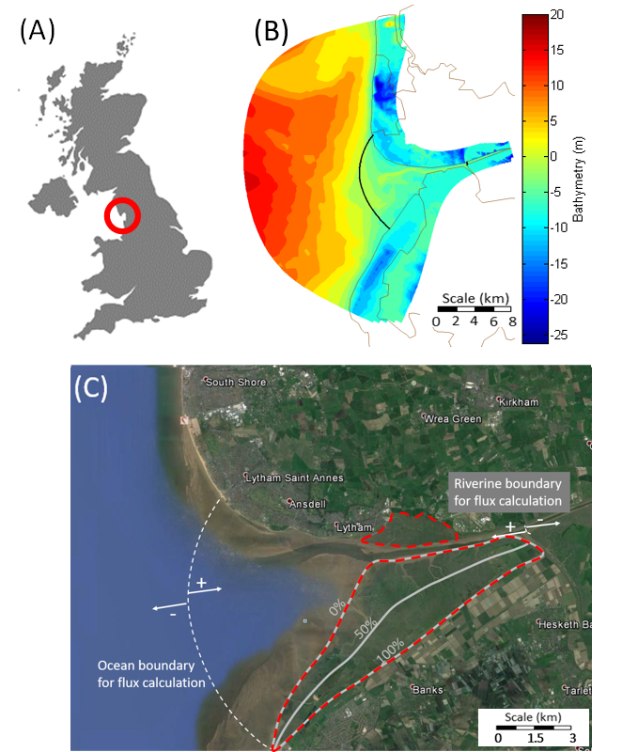
Figure 1 (A) Location of study site; (B) bathymetry of the Ribble estuary; (C) aerial view of the study site; grey contour lines indicate simulated salt marsh erosion scenarios. The red dashed lines indicate the total area covered by salt marsh. Percentage reductions are based on LiDAR data. The two white dashed lines indicate where sediment fluxes are calculated. These two lines are also imposed on (B) as black solid lines.

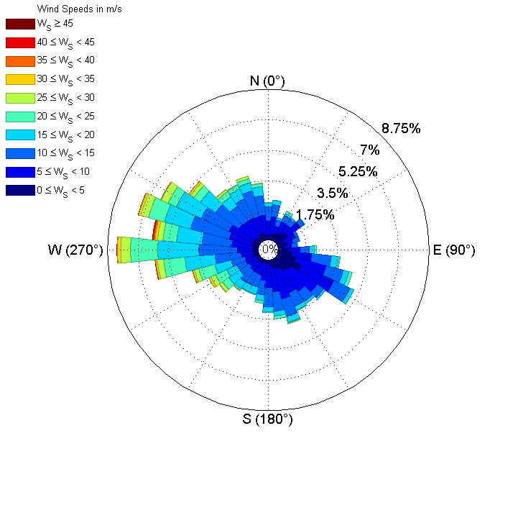
Figure 2 Wind rose of hourly wind record for year 2008 collected at the ‘Blackpool Squires Gate’ weather station by the UK Met Office.

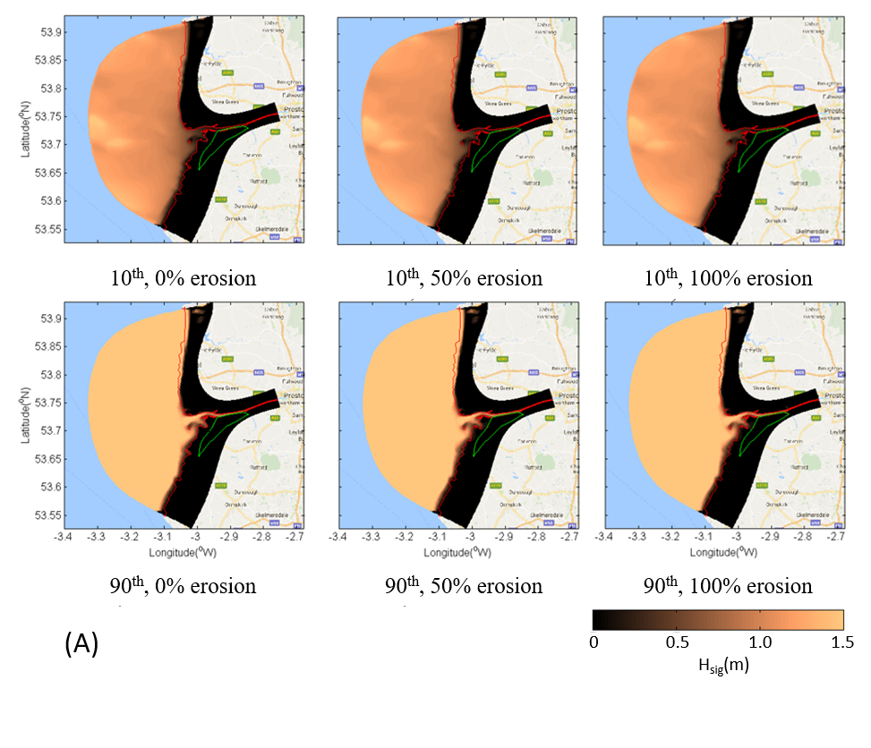
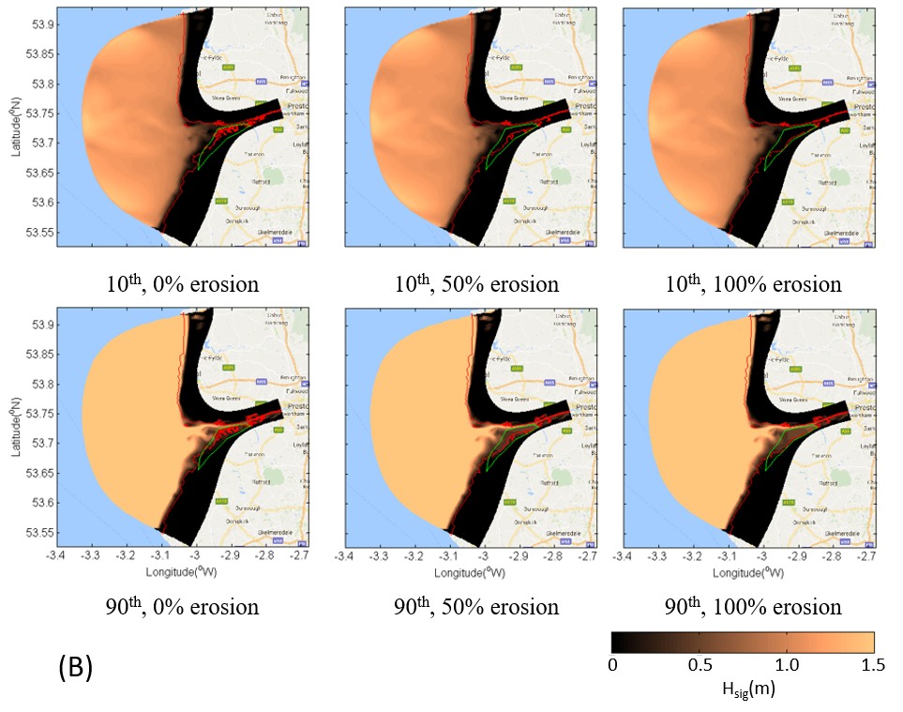
Figure 3 (A) Distribution of significant wave height at high water during neap tide, and for wind from the west. (B) Distribution of significant wave height at high water during spring tide, and for winds coming from the west. In the figure, the red lines indicate the watermarks at high tide, while the green lines enclose the salt marsh area in case of no erosion.
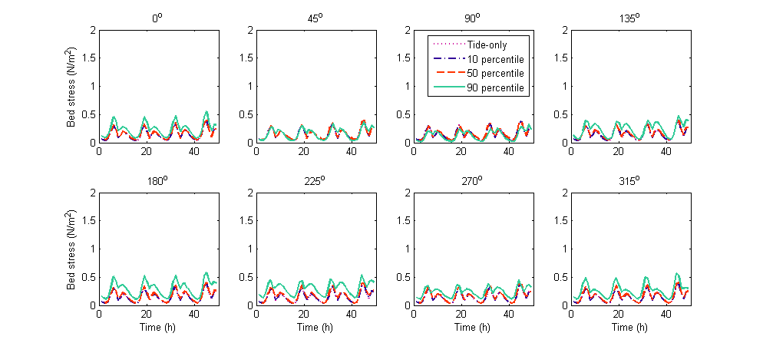
(A) Neap tide
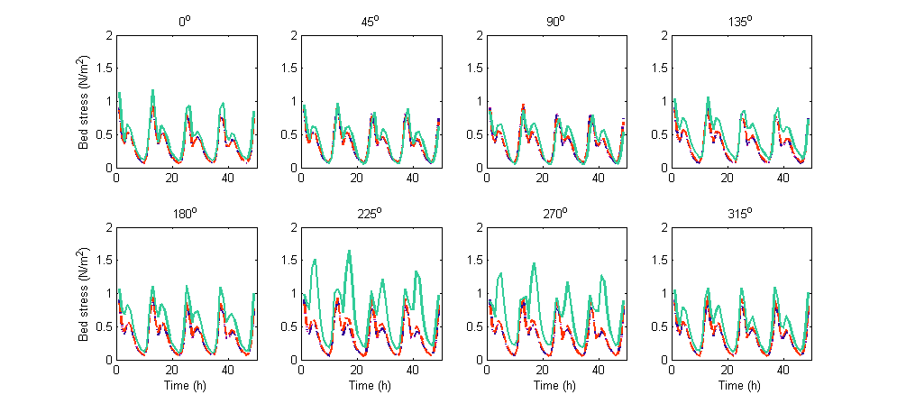
(B) Spring tide
Figure 4 Bed shear stress averaged over the enclosed domain for (A) neap and (B) spring tides. Results are presented for tide-only and wave-imposed scenarios.
(A) Neap tide
(B) Spring tide
Figure 5 Total mass of suspended sediment within the enclosed domain for two neap and two spring tidal cycles. Results are presented for four test sets: three westerly wind (270º) intensities and tide only. Three salt marsh erosion scenarios are considered for each of the test sets: no marsh erosion, 50% marsh erosion and 100% marsh erosion.

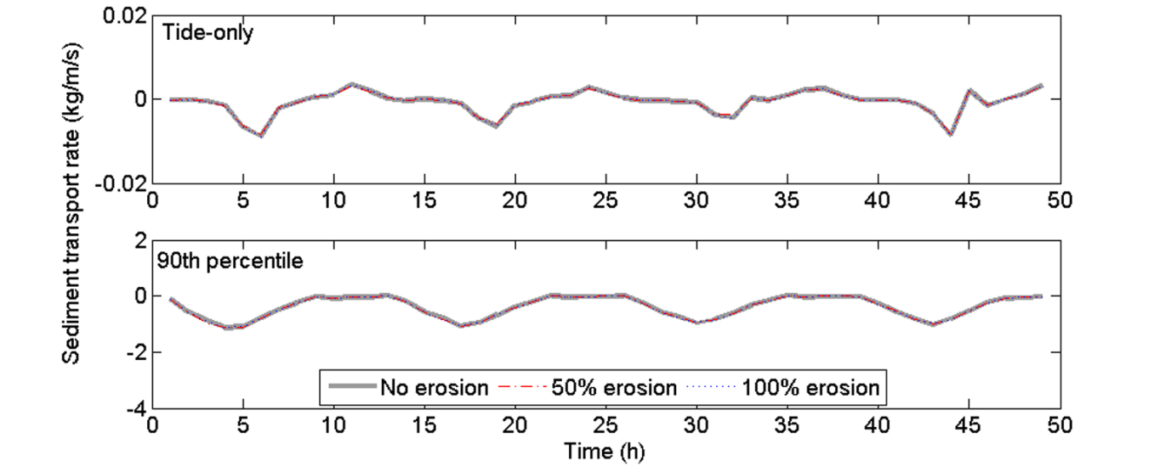
(A) Neap tide
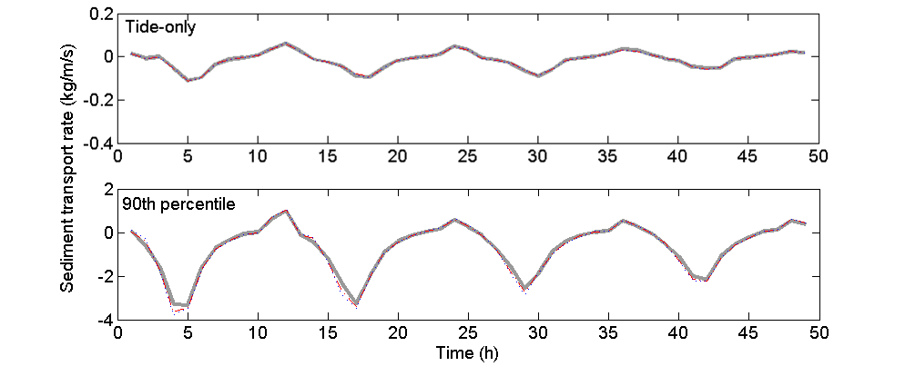
(B) Spring tide
Figure 6 Sediment fluxes at the ocean boundary for (A) neap and (B) spring tides. Results are presented for a tide-only case and a wave-incorporated case with westerly wind at the 90th percentile. For each case, three salt marsh erosion scenarios are considered: no marsh erosion, 50% marsh erosion and 100% marsh erosion.

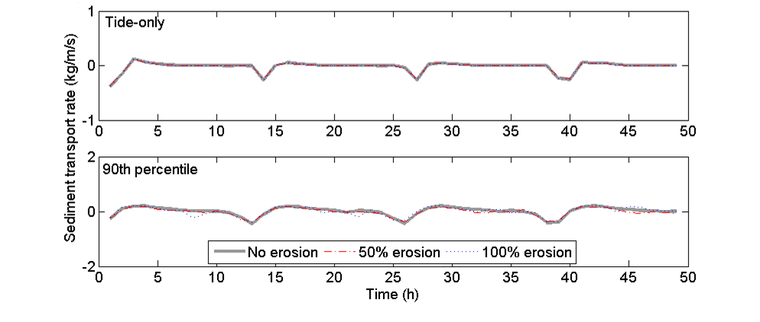
(A) Neap tide
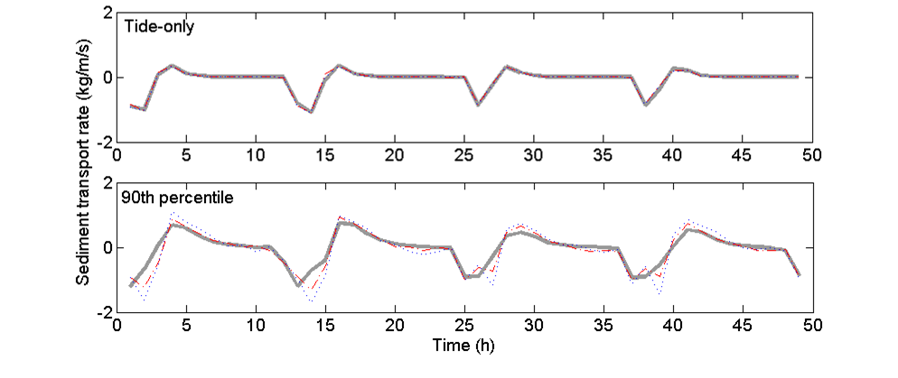
(B) Spring tide
Figure 7 Sediment fluxes at the riverine boundary for (A) neap and (B) spring tides. Results are presented for a tide-only case and a wave-incorporated case with westerly winds at the 90th percentile. For each case, three salt marsh erosion scenarios are considered: no marsh erosion, 50% marsh erosion and 100% marsh erosion.

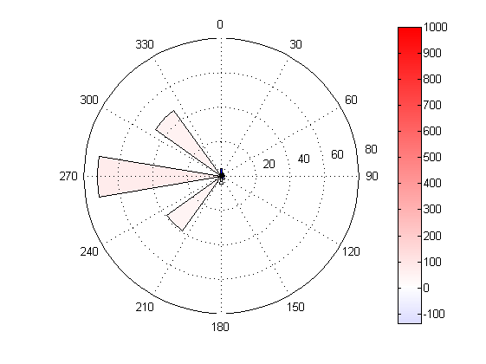  10th, ocean boundary | 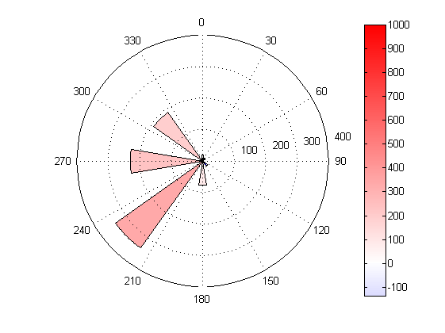  50th, ocean boundary | 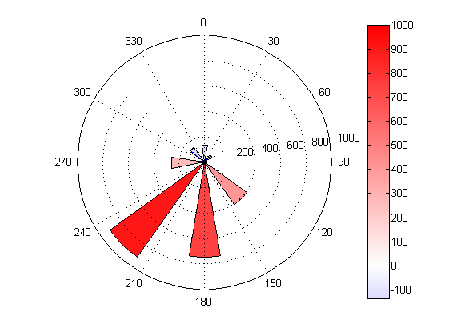  90th, ocean boundary
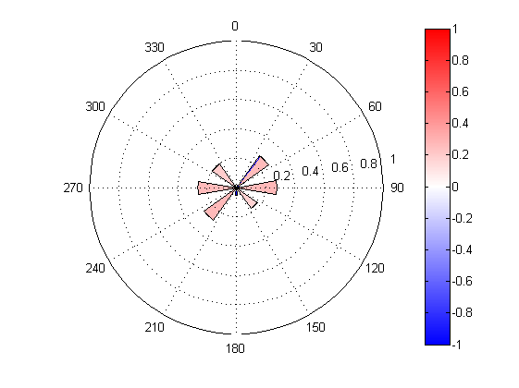  10th, riverine boundary | 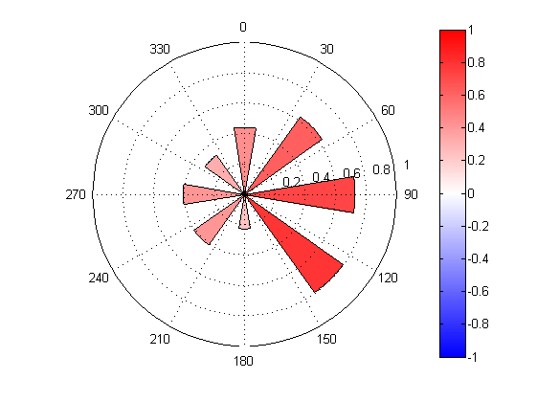  50th, riverine boundary | 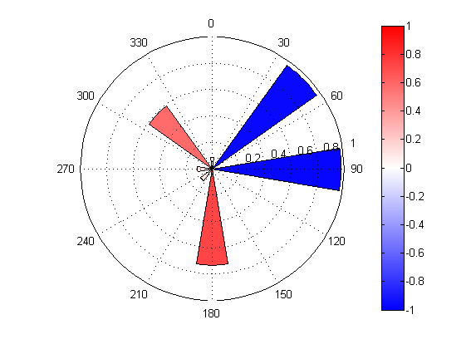  90th, riverine boundary
(A) Neap tide
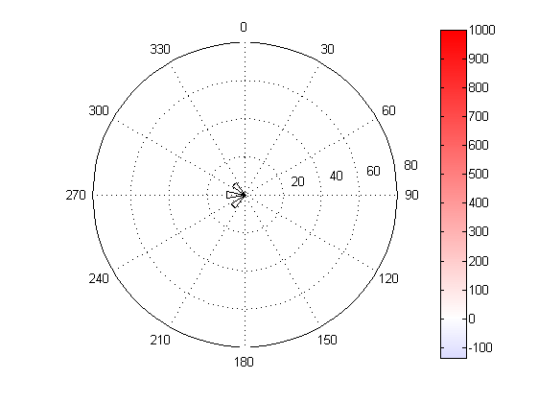  10th, ocean boundary | 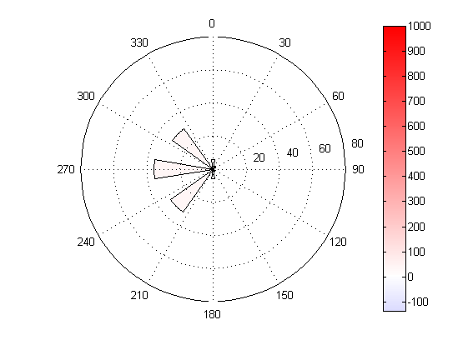  50th, ocean boundary | 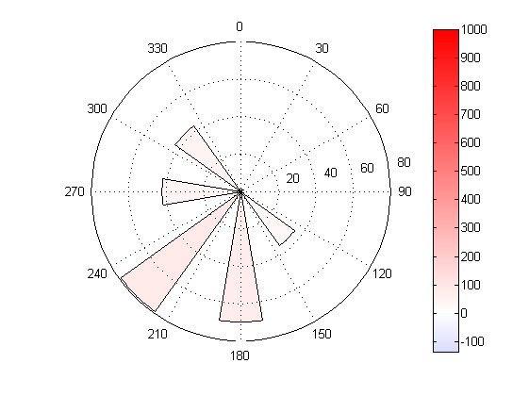  90th, ocean boundary
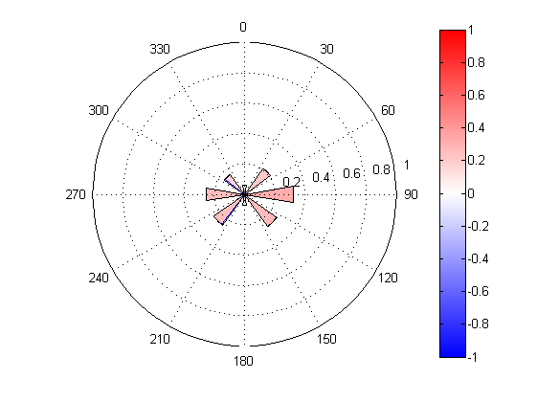  10th, riverine boundary | 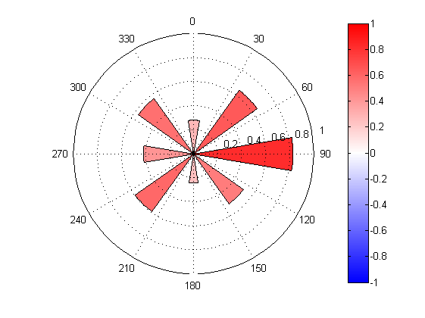  50th, riverine boundary | 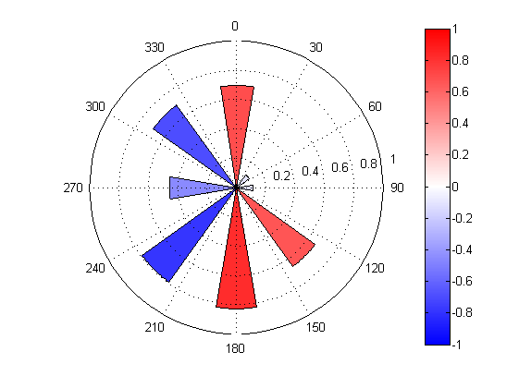  90th, riverine boundary
(B) Spring tide
Figure 8 Changes in net transport at the ocean and riverine boundaries caused by the inclusion of winds and waves in the model. Results are presented for the 0% salt marsh erosion cases.
More waves
Increase in bottom
shear stress
Increased
export of sediments
Salt marsh erosion
Figure 9 Positive feedback between wave action and salt marsh erosion. Direct (continuous line) and indirect mechanisms contributing to salt marsh deterioration through changes in the sediment budget (dashed lines). 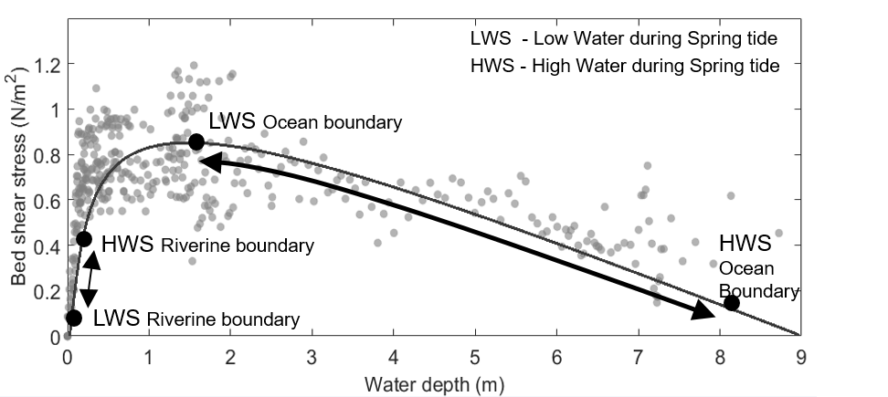
Figure 10 Wave-driven bed shear stress across the enclosed domain in between the two internal boundaries as a function of water depth. The figure is created based on model predictions for the 0% marsh erosion scenario with the 90th percentile wave coming from the west (270°). High and low water during spring tide for both riverine and ocean boundary are indicated in the figure as black dots.

 | 10th Percentile | 50th Percentile | 90th Percentile
Wind speed (m/s) | 5.9 | 14.5 | 27.8
H_{s} (m) | 1.2 | 5.3 | 13
T_{p} (s) | 5 | 10 | 13
Table 1 The 10th, 50th and 90th percentile of wind speed of the hourly wind record and their corresponding significant wave heights and peak wave periods at the open boundary. Note the wave open boundary conditions, H_{s} and T_{p}, are only applied in NW, W and SW wind cases. They are 0 for the other cases.

 | Neap tide | Spring tide
Ocean boundary | -343 | -3955
Riverine boundary | -20698 | -58691
Table 2 Net transport of sediment at the two internal boundaries of the baseline cases, i.e. not considering waves, over four neap and four spring tide cycles. Negative values at the ocean and the riverine boundaries indicate seaward and landward export of sediment from the enclosed domain respectively. (Units: kg/m)
References
Baptist, M. J., Babovic, V., Rodríguez Uthurburu, J., Keijzer, M., Uittenbogaard, R. E., Mynett, A., & Verwey, A. (2007). On inducing equations for vegetation resistance. Journal of Hydraulic Research, 45(4), 435-450.
Barbier, E. B., Hacker, S. D., Kennedy, C., Koch, E. W., Stier, A. C., & Silliman, B. R. (2011). The value of estuarine and coastal ecosystem services. Ecological monographs, 81(2), 169-193.
Blum, M. D., & Roberts, H. H. (2009). Drowning of the Mississippi Delta due to insufficient sediment supply and global sea-level rise. Nature Geoscience, 2(7), 488-491.
Boesch, D. F., & Turner, R. E. (1984). Dependence of fishery species on salt marshes: the role of food and refuge. Estuaries and Coasts, 7(4), 460-468.
Brodie, J., Schroeder, T., Rohde, K., Faithful, J., Masters, B., Dekker, A., Brodie, J., Schroeder, T., Rohde, K., Faithful, J., Masters, B., Dekker, A., Brando, V., & Maughan, M. (2010). Dispersal of suspended sediments and nutrients in the Great Barrier Reef lagoon during river-discharge events: conclusions from satellite remote sensing and concurrent flood-plume sampling. Marine and Freshwater Research, 61(6), 651-664.
Burton, D. J., West, J. R., Horsington, R. W., & Randle, K. (1995). Modelling transport processes in the Ribble Estuary. Environment international, 21(2), 131-141.
Chen, X. D., Zhang, C. K., Paterson, D. M., Thompson, C. E. L., Townend, I. H., Gong, Z, Zou & Feng, Q. (2017). Hindered erosion: The biological mediation of noncohesive sediment behaviour. Water Resources Research, 53 (6), 4787-4801
Costanza, R., Pérez-Maqueo, O., Martinez, M.L., Sutton, P., Anderson, S.J. and Mulder, K. (2008). The value of coastal wetlands for hurricane protection. AMBIO: A Journal of the Human Environment, 37(4), 241-248.
Craft, C., Clough, J., Ehman, J., Joye, S., Park, R., Pennings, S., Guo, H. & Machmuller, M. (2009). Forecasting the effects of accelerated sea‐level rise on tidal marsh ecosystem services. Frontiers in Ecology and the Environment, 7(2), 73-78.
Crosby, S. C., Sax, D. F., Palmer, M. E., Booth, H. S., Deegan, L. A., Bertness, M. D., & Leslie, H. M. (2016). Salt marsh persistence is threatened by predicted sea-level rise. Estuarine, Coastal and Shelf Science, 181, 93-99.
D’Alpaos, A., & Marani, M. (2016). Reading the signatures of biologic–geomorphic feedbacks in salt-marsh landscapes. Advances in water resources, 93, 265-275.
Davidson-Arnott, R. G., Van Proosdij, D., Ollerhead, J., & Schostak, L. (2002). Hydrodynamics and sedimentation in salt marshes: examples from a macrotidal marsh, Bay of Fundy. Geomorphology, 48(1-3), 209-231.
Deegan, L. A., Hughes, J. E., & Rountree, R. A. (2002). Salt marsh ecosystem support of marine transient species. In Concepts and controversies in tidal marsh ecology. Springer Netherlands, 333-365.
DELFT Hydraulics (2014). Delft3D-FLOW User Manual: Simulation of multi-dimensional hydrodynamic flows and transport phenomena. Tech. rep., including sediments. Technical report. https://oss.deltares.nl/documents/183920/185723/Delft3D-FLOW_User_Manual.pdf
Dronkers, J. (1986). Tidal asymmetry and estuarine morphology. Netherlands Journal of Sea Research, 20, 117-131.
Donatelli, C., Ganju, N.K., Fagherazzi, S. and Leonardi, N. (2018). Seagrass Impact on Sediment Exchange Between Tidal Flats and Salt Marsh, and The Sediment Budget of Shallow Bays. Geophysical Research Letters, 45(10), 4933-4943.
Ellison, J. C. (1993). Mangrove retreat with rising sea-level, Bermuda. Estuarine, Coastal and Shelf Science, 37(1), 75-87.
Fagherazzi, S., Carniello, L., D'Alpaos, L., & Defina, A. (2006). Critical bifurcation of shallow microtidal landforms in tidal flats and salt marshes. Proceedings of the National Academy of Sciences, 103(22), 8337-8341.
Fagherazzi, S., Mariotti, G., Wiberg, P.L. and McGLATHERY, K.J. (2013). Marsh collapse does not require sea level rise. Oceanography, 26(3), 70-77.

Fagherazzi, S., Mariotti, G., Wiberg, P.L. and McGLATHERY, K.J. (2013). Marsh collapse does not require sea level rise. Oceanography, 26, 70-77.
Feagin, R. A., Lozada-Bernard, S. M., Ravens, T. M., Möller, I., Yeager, K. M., & Baird, A. H. (2009). Does vegetation prevent wave erosion of salt marsh edges? Proceedings of the National Academy of Sciences, 106, 10109-10113.
French, J. R., & Spencer, T. (1993). Dynamics of sedimentation in a tide-dominated backbarrier salt marsh, Norfolk, UK. Marine Geology, 110(3-4), 315-331.
Friedrichs, C. T. (2011). Tidal Flat Morphodynamics: A Synthesis. Treatise on Estuarine and Coastal Science. Academic Press, Waltham, 137-170.
Ganju, N. K., Kirwan, M. L., Dickhudt, P. J., Guntenspergen, G. R., Cahoon, D. R., & Kroeger, K. D. (2015). Sediment transport‐based metrics of wetland stability. Geophysical Research Letters, 42(19), 7992-8000.
Ganju, N. K., Defne, Z., Kirwan, M. L., Fagherazzi, S., D’Alpaos, A., & Carniello, L. (2017). Spatially integrative metrics reveal hidden vulnerability of microtidal salt marshes. Nature communications, 8, 14156.
Hartig, E. K., Gornitz, V., Kolker, A., Mushacke, F., & Fallon, D. (2002). Anthropogenic and climate-change impacts on salt marshes of Jamaica Bay, New York City. Wetlands, 22(1), 71-89.
Kirwan, M. L., & Megonigal, J. P. (2013). Tidal wetland stability in the face of human impacts and sea-level rise. Nature, 504(7478), 53-60.
Leonardi, N., & Fagherazzi, S. (2014). How waves shape salt marshes. Geology, 42, 887-890.
Leonardi, N., Defne, Z., Ganju, N. K., & Fagherazzi, S. (2016a). Salt marsh erosion rates and boundary features in a shallow Bay. Journal of Geophysical Research: Earth Surface, 121, 1861-1875.
Leonardi, N., Ganju, N. K., & Fagherazzi, S. (2016b). A linear relationship between wave power and erosion determines salt-marsh resilience to violent storms and hurricanes. Proceedings of the National Academy of Sciences, 113, 64-68.
Leonardi, N., Carnacina, I., Donatelli, C., Ganju, N. K., Plater, A. J., Schuerch, M., & Temmerman, S. (2018). Dynamic interactions between coastal storms and salt marshes: A review. Geomorphology, 301, 92-107.
Li, X., Plater, A., & Leonardi, N. (2018). Modelling the Transport and Export of Sediments in Macrotidal Estuaries with Eroding Salt Marsh. Estuaries and Coasts, 41(6), 1551-1564.
Lymbery, G., Wisse, P., & Newton, M. (2007). Report on coastal erosion predictions for Formby Point, Formby, Merseyside. Sefton Council. http://modgov.sefton.gov.uk/moderngov/Data/Cabinet%20Member%20-%20Environmental%20(meeting)/20070509/Agenda/Item%2005A.pdf
Lyons, M. G. (1997). The dynamics of suspended sediment transport in the Ribble Estuary. Water, Air, and Soil Pollution, 99(1-4), 141-148.
Marani, M., d'Alpaos, A., Lanzoni, S. and Santalucia, M. (2011). Understanding and predicting wave erosion of marsh edges. Geophysical Research Letters, 38, L21401.
Mariotti, G., & Fagherazzi, S. (2013). Critical width of tidal flats triggers marsh collapse in the absence of sea-level rise. Proceedings of the national Academy of Sciences, 110(14), 5353-5356.
Mariotti, G., & Canestrelli, A. (2017). Long-term morphodynamics of muddy backbarrier basins: Fill in or empty out?. Water Resources Research, 53(8), 7029-7054.
Mcleod, E., Chmura, G.L., Bouillon, S., Salm, R., Bjӧrk, M., Duarte, C.M., Lovelock, C.E., Schlesinger, W.H., & Silliman, B.R. (2011). A blueprint for blue carbon: toward an improved understanding of the role of vegetated coastal habitats in sequestering CO₂. Frontiers in Ecology and the Environment, 9(10), 552-560.
Möller, I., & Spencer, T. (2002). Wave dissipation over macro-tidal saltmarshes: Effects of marsh edge typology and vegetation change. Journal of Coastal Research, 36(1), 506-521.
Möller, I., Kudella, M., Rupprecht, F., Spencer, T., Paul, M., Van Wesenbeeck, B. K., Wolters, G., Jensen, K., Bouma, T. J., Miranda-Lange, M. & Schimmels, S. (2014). Wave attenuation over coastal salt marshes under storm surge conditions. Nature Geoscience, 7(10), 727-731.
Moore, R. D., Wolf, J., Souza, A. J., & Flint, S. S. (2009). Morphological evolution of the Dee Estuary, Eastern Irish Sea, UK: a tidal asymmetry approach. Geomorphology, 103, 588-596.
Mudd, S. M., Howell, S. M., & Morris, J. T. (2009). Impact of dynamic feedbacks between sedimentation, sea-level rise, and biomass production on near-surface marsh stratigraphy and carbon accumulation. Estuarine, Coastal and Shelf Science, 82, 377-389.
Ogston, A. S., Cacchione, D. A., Sternberg, R. W., & Kineke, G. C. (2000). Observations of storm and river flood-driven sediment transport on the northern California continental shelf. Continental Shelf Research, 20(16), 2141-2162.
Partheniades, E. (1965). Erosion and deposition of cohesive soils. Journal of the Hydraulics Division, 91, 105-139.
Payo, A., Hall, J. W., French, J., Sutherland, J., van Maanen, B., Nicholls, R. J., & Reeve, D. E. (2016). Causal Loop Analysis of coastal geomorphological systems. Geomorphology, 256, 36-48.
Prandle, D. (2009). Estuaries: dynamics, mixing, sedimentation and morphology. Cambridge University Press.
Pye, K., & Neal, A. (1994). Coastal dune erosion at Formby Point, north Merseyside, England: causes and mechanisms. Marine Geology, 119, 39-56.
Pye, K. (2000). Saltmarsh erosion in southeast England: mechanisms, causes and implications. British saltmarshes, 22, 359-396.
Raposa, K. B., Weber, R. L., Ekberg, M. C., & Ferguson, W. (2017). Vegetation dynamics in Rhode Island salt marshes during a period of accelerating sea level rise and extreme sea level events. Estuaries and Coasts, 40(3), 640-650.
Roberts, W., Dearnaley, M. P., Baugh, J. V., Spearman, J. R., & Allen, R. S. (1998). The sediment regime of the Stour and Orwell estuaries. Physics of estuaries and coastal seas. Balkema, Rotterdam, 93-102.
Rodi, W. (1993). On the simulation of turbulent flow past bluff bodies. Journal of Wind Engineering and Industrial Aerodynamics, 46, 3-19.
Schuerch, M., Rapaglia, J., Liebetrau, V., Vafeidis, A. and Reise, K. (2012). Salt marsh accretion and storm tide variation: an example from a barrier island in the North Sea. Estuaries and Coasts, 35(2), 486-500.
Schuerch, M., Vafeidis, A., Slawig, T. and Temmerman, S. (2013). Modeling the influence of changing storm patterns on the ability of a salt marsh to keep pace with sea level rise. Journal of Geophysical Research: Earth Surface, 118(1), 84-96.
Schwimmer, R.A. (2001). Rates and processes of marsh shoreline erosion in Rehoboth Bay, Delaware, USA. Journal of Coastal Research, 17, 672-683.
Shen, X., & Maa, J. P. Y. (2015). Modeling floc size distribution of suspended cohesive sediments using quadrature method of moments. Marine Geology, 359, 106-119.
Spencer, T., Möller, I., Rupprecht, F., Bouma, T. J., Wesenbeeck, B. K., Kudella, M., Paul, M., Jensen, K., Wolters, G., Miranda-Lange, M. & Schimmels, S. (2016a). Salt marsh surface survives true-to-scale simulated storm surges. Earth Surface Processes and Landforms, 41(4), 543-552.
Spencer, T., Schuerch, M., Nicholls, R. J., Hinkel, J., Lincke, D., Vafeidis, A. T., Reef, R., McFadden L. & Brown, S. (2016b). Global coastal wetland change under sea-level rise and related stresses: The DIVA Wetland Change Model. Global and Planetary Change, 139, 15-30.
Temmerman, S., Meire, P., Bouma, T. J., Herman, P. M., Ysebaert, T., & De Vriend, H. J. (2013). Ecosystem-based coastal defence in the face of global change. Nature, 504, 79-83.
Te Slaa, S., He, Q., van Maren, D. S., & Winterwerp, J. C. (2013). Sedimentation processes in silt-rich sediment systems. Ocean Dynamics, 63(4), 399-421.
Thompson, C. E. L., Williams, M. E., Amoudry, L., Hull, T., Reynolds, S., Panton, A., & Fones, G. R. (2017). Benthic controls of resuspension in UK shelf seas: implications for resuspension frequency. Continental Shelf Research. In press.
UKHO (2001). Admiralty Tide Tables. United Kingdom and Ireland (including European Channel Ports). UK Hydrographic Office, Taunton.
USEPA (1993). Methods for measuring the acute toxicity of effluents to freshwater and marine organisms. Office of Research and Development, Washington, DC. EPA/600/4-90/027F
van de Koppel, J., van der Wal, D., Bakker, J. P., & Herman, P. M. (2004). Self-organization and vegetation collapse in salt marsh ecosystems. The American Naturalist, 165(1), E1-E12.
Van der Wal, D., Pye, K., & Neal, A. (2002). Long-term morphological change in the Ribble Estuary, northwest England. Marine Geology, 189, 249-266.
Van Der Wal, D., & Pye, K. (2003). The use of historical bathymetric charts in a GIS to assess morphological change in estuaries. The Geographical Journal, 169(1), 21-31.
Van der Wal, D., & Pye, K. (2004). Patterns, rates and possible causes of saltmarsh erosion in the Greater Thames area (UK). Geomorphology, 61(3-4), 373-391.
Van Rijn, L. C. (1993). Principles of sediment transport in rivers, estuaries and coastal areas. Aqua publications Amsterdam.
Wakefield, R., Tyler, A. N., McDonald, P., Atkin, P. A., Gleizon, P., & Gilvear, D. (2011). Estimating sediment and caesium-137 fluxes in the Ribble Estuary through time-series airborne remote sensing. Journal of environmental radioactivity, 102, 252-261.
Wolters, M., Bakker, J. P., Bertness, M. D., Jefferies, R. L., & Möller, I. (2005). Saltmarsh erosion and restoration in south‐east England: squeezing the evidence requires realignment. Journal of Applied Ecology, 42(5), 844-851.
Zhou, Z., Ye, Q., & Coco, G. (2016). A one-dimensional biomorphodynamic model of tidal flats: Sediment sorting, marsh distribution, and carbon accumulation under sea level rise. Advances in Water Resources, 93, 288-302.

