Twenty years of the International Journal of Logistics Research and Applications: A bibliometric overview

Abstract: In commemoration of the 20th anniversary of the International Journal of Logistics Research and Applications, this study presents a general overview of the journal from 1998 to 2017 by using a bibliometric analysis. The objective is to identify the leading trends that have affected the journal during this time frame. In so doing, this study analyses a wide range of bibliometric issues including the publication and citation evolution of the journal, articles that cite the IJLRA, most-cited papers, most productive and influential authors, institutions and countries, and the evolution of author keywords. Additionally, the work develops a graphical visualisation of the bibliographic material published in IJLRA.
Keywords: supply chain, logistics, bibliometric, citation analysis, literature review

1. Introduction
The International Journal of Logistics Research and Applications (IJLRA) was launched in 1998 by Professor Martin Christopher of Cranfield School of Management, UK, and Professor Douglas Lambert of Ohio State University and University of North Florida, USA, in response to the tremendous growth of interest in logistics research. Since then, IJLRA has provided a global forum for researchers and practitioners to exchange new ideas and practices in order to enhance our understanding of logistics research and logistics applications.
Today, IJLRA is led by Professor Andrew Lyons from the University of Liverpool and Professor Ming K Lim from Coventry University and Chongqing University. Given the growing importance of supply chain management, IJLRA has broadened its scope from a journal with a purely logistics focus to one that recognises the critical role logistics plays within the wider supply chain domain. This positioning allows and attracts academics and practitioners to publish their theoretical and practical studies related to logistics and supply chain management in IJLRA.
In 2017, IJLRA completed its twentieth year of publication. In celebration of the 20th anniversary of IJLRA and honouring its status as one of the leading journals dedicated to logistics and supply chain management, we conduct a comprehensive bibliometric study. In the literature, it is very common to organise a bibliometric study when the journal reaches an important milestone in the journal’s development. Van Fleet et al. (2006) performed a study on the first 30 years of the Journal of Management. Laengle et al. (2017) studied the evolution of the European Journal of Operational Research over 40 years of existence. Cancino et al. (2017) analysed Computers & Industrial Engineering between 1976 and 2015 to celebrate its 40th anniversary.
The bibliometric study addresses the following research questions: 1) What are the distribution of publications and citations across the time period? 2) Which journals are citing IJLRA articles? 3) Which are the top-cited papers of the journal? 4) Who are the most productive and influential authors, institutions and countries? 5) What are the publication patterns of the journal? 6) What are the main topics published in the journal? The main objective of this article is to reveal the contribution of IJLRA to scientific research and its most influential thematic work in logistics and supply chain management since its first publication in 1998 until 2017.
This work justifies its contribution to the progress of logistics and supply chain management from several perspectives. First, for readers it is helpful to have an overview of the types of publications, journal style and topics of interest for review. Second, for current and potential authors, it serves as a guide orientating them in relation to content, topics of interest, and, in general, providing them with a historical roadmap that may help with their plans to publish their research in this journal. Thirdly, for the entire scientific community (publishers, academics, authors, and readers) this study represents a useful tool to showcase the progress and evolution that IJLRA has experienced during its 20-year history highlighting trends that can signal new opportunities and relevant challenges to support or re-direct strategic decisions by journal editors.
The remainder of the paper is structured as follows. Section 2 briefly reviews the bibliometric methodology. Section 3 presents the results of the bibliometric analysis. Concluding remarks and limitations are summarised in Section 4.

2. Bibliometric methods
Bibliometric methods use bibliographic data from publication databases to construct structural images of scientific fields (Zupic and Čater 2015). They are also an effective way to describe, evaluate and monitor published research in a journal. Bibliometric methods have traditionally been divided into two categories according to whether they yield activity or relationship indicators. The former provide data relating to the force of impact or strength of influence of research efforts, while the latter trace the links and interaction between different researchers and different fields of research (Ramos 2004). The detailed method used in this study is summarised as follows:
(1) The full articles are accessed via the official webpages of IJLRA in the Taylor & Francis online database from its first issue in 1998 through 2017. From these articles, we extracted the title, authors, affiliations, and keywords.
(2) For the number of citations, Web of Science (WoS), Scopus, and Google Scholar (GS) are the main three comprehensive citation databases (Bar-Ilan 2010), which provide searchable citation statistics on an individual, un-aggregated publication level. Unfortunately, WoS and Scopus provide the articles in IJLRA from 2008, which means the citations of IJLRA publications are absent from WoS and Scopus between 1998 and 2007. To maintain consistency, GS was used to collect citations in May and June 2018. The results give a picture of the current situation, but may change over time, particularly for the most-recent publications for which impact may still be growing.
(3) The citing of IJLRA information, which is used to analyse articles that cite the IJLRA, is not convenient to obtain from GS. The citing records in GS are retrieved in a way that is very impractical for use with large sample sizes, requiring a very tedious process of manually extracting, verifying, cleaning, organising, classifying, and saving the bibliographic information into meaningful and usable formats (Meho and Yang 2007). Moreover, unlike WoS and Scopus, GS does not allow re-sorting of the retrieved sets in any way, such as by date, author name, or data source. Therefore, the bibliometric study on the analysis of articles that cite the IJLRA is based on the results obtained from the WoS database.
(4) After building the articles’ database, the Gephi software was used to visualise the results graphically.

3. Results and discussion
This section presents the results for the IJLRA and focuses on exploring its performance, evolution and trends over the last two decades. The results derive from a bibliometric analysis obtained from the official information published by Taylor & Francis online in conjunction with GS and the WoS database. To date, 573 studies have been reviewed which included 25 editorials, 4 corrigenda, 17 book reviews, and 481 research articles and case reports. Editorials, corrigenda and book reviews are excluded because they were not subject to a peer review process. Based on the remaining 481 articles, this section presents a bibliometric study of IJLRA to address the six research questions posed in Section 1.

3.1 Publications and citations across the time period
IJLRA started publishing articles in 1998, as shown in Figure 1. In the first decade, the number of articles published was around 20 per year. In the second decade, the number of articles published increased to around 30 per year. This is in contrast to a much larger increase in the number of submissions every year for other logistics and supply chain journals (Kilubi and Haasis 2016; Crum and Poist 2011).
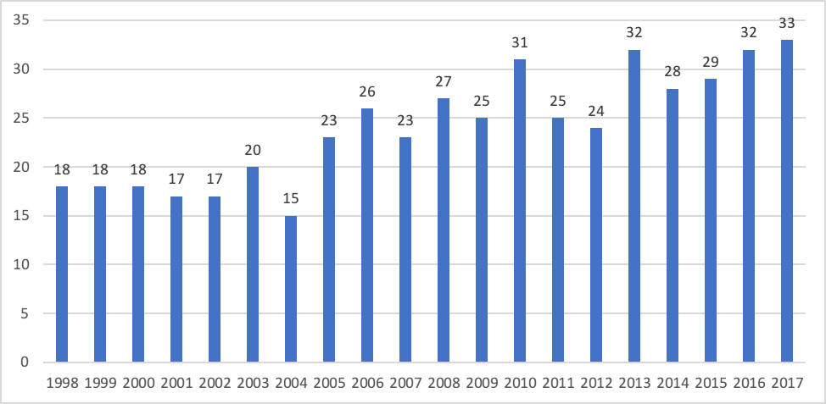
Figure 1. Number of publications per year across the period studied

There are several approaches to measuring the influence and impact of papers. One of the most straightforward methods is to determine the number of citations for an article. However, one of the drawbacks of this method is that, typically, older papers are expected to have higher citation rates. In addition, the articles’ electronic accessibility also plays an influential role. Allowing for these initial limitations, it was decided to evaluate the papers on citation count. Figure 2 shows the number of citations of articles per year. As illustrated, most citations occurred from 2002 to 2008, totaling 61.94% of all citations. In the 2002 to 2008 date range, 1394 is the average number of citations per year.

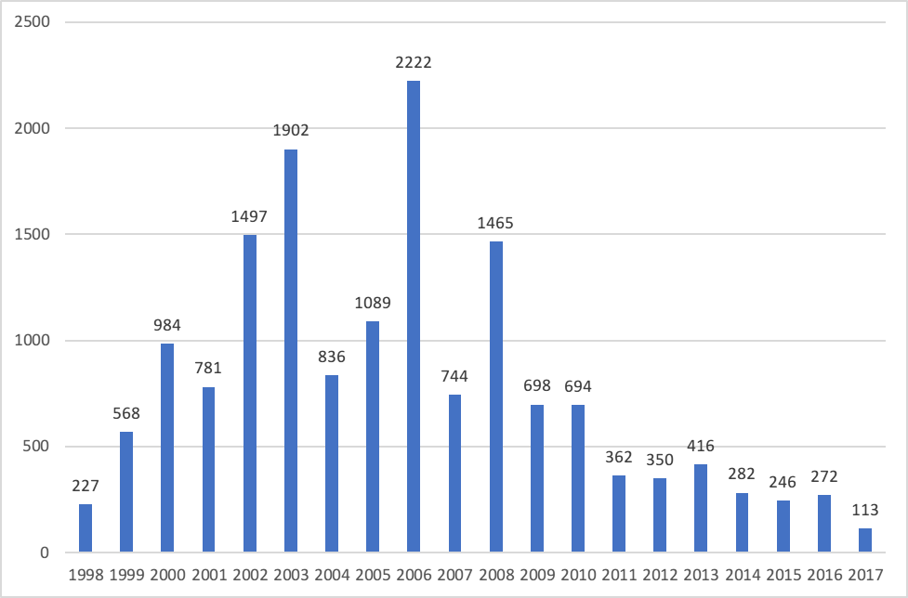
Figure 2. Number of citations for the articles per year (Access date: 2018.05.17)

Next, let us consider the annual citation structure of IJLRA. To do so, we examine several specific citation thresholds to establish the number of articles published in each year that have exceeded each of the respective thresholds. Table 1 presents the results.

Table 1. Annual citation structure of IJLRA
Year | 200 | 100 | 50 | 10 | 1 | TP | TC | TC/TP
1998 | 0 | 0 | 1 | 7 | 16 | 18 | 227 | 12.61
1999 | 0 | 0 | 3 | 14 | 18 | 18 | 568 | 31.56
2000 | 1 | 3 | 7 | 13 | 17 | 18 | 984 | 54.67
2001 | 0 | 1 | 6 | 16 | 17 | 17 | 781 | 45.94
2002 | 3 | 6 | 9 | 14 | 16 | 17 | 1497 | 88.06
2003 | 1 | 3 | 6 | 18 | 20 | 20 | 1902 | 95.10
2004 | 1 | 1 | 7 | 12 | 15 | 15 | 836 | 55.73
2005 | 1 | 2 | 8 | 20 | 23 | 23 | 1089 | 47.35
2006 | 3 | 4 | 7 | 20 | 26 | 26 | 2222 | 85.46
2007 | 0 | 1 | 4 | 19 | 22 | 23 | 744 | 32.35
2008 | 1 | 1 | 5 | 22 | 27 | 27 | 1465 | 54.26
2009 | 0 | 0 | 3 | 20 | 25 | 25 | 698 | 27.92
2010 | 0 | 0 | 3 | 21 | 31 | 31 | 694 | 22.39
2011 | 0 | 0 | 1 | 13 | 24 | 25 | 362 | 14.48
2012 | 0 | 0 | 1 | 12 | 24 | 24 | 350 | 14.58
2013 | 0 | 0 | 0 | 18 | 32 | 32 | 416 | 13.00
2014 | 0 | 0 | 0 | 9 | 27 | 28 | 282 | 10.07
2015 | 0 | 0 | 0 | 10 | 29 | 29 | 246 | 8.48
2016 | 0 | 0 | 0 | 7 | 32 | 32 | 272 | 8.50
2017 | 0 | 0 | 0 | 4 | 24 | 33 | 113 | 3.42
Total | 11 | 22 | 71 | 289 | 465 | 481 | 15748 | 32.74
% | 2.29% | 4.57% | 14.76% | 60.08% | 96.67% | 100%
Note: TP is total number of publications; TC is total number of citations; TC/TP is number of cites per publication; % is percentage of publications.

It appears from Table 1 that the journal has been able to maintain an impressive level of citations over its entire lifetime, with each paper having 32 citations on average. Obviously, the contributions from recent years still need some time to catch up. It is worth noting that most of the highly-cited papers have been published in the first decade from 1998-2007. Around 5% of the papers have received one hundred citations or more. Around 60% of the papers received at least ten citations, and 96.67% have received at least one citation. In total, the journal has received 15 thousand citations since its creation for articles indexed in the GS database.

3.2 Analysis of articles that cite the IJLRA
Another interesting topic is where IJLRA is cited. This criterion indicates the sources of IJLRA’s sphere of influence. As depicted in Section 2, we use the citation report provided by WoS to conduct the analysis in this section. It is worth noting that WoS provided the reports of publications in IJLRA from 2008. Table 2 presents the ten journals, years, universities, and countries that have most articles citing IJLRA.
IJLRA is the journal with the highest number of articles citing IJLRA. This finding is not surprising and quite logical as the material appearing in IJLRA tends to influence future research in the same journal. International Journal of Production Economics and International Journal of Production Research cite IJLRA frequently, with 67 and 47 articles, respectively. In general, operations management journals are prominent although some general management journals also have respectable figures for their IJLRA cites.
With respect to different countries, the USA, China and the UK are unsurprisingly the countries that cite IJLRA the most. However, some unexpected countries appear in very good positions including Italy in the fourth position and Iran in eighth. With respect to contributing institutions, the Nanyang Technological University is the one with the highest number of publications citing IJLRA.

Table 2. Number of studies citing IJLRA
R | Journal | TP | Year | TP | Institutions | TP | Country | TP
1 | INT J LOGIST-RES APP | 115 | 2018 | 194 | Nanyang Tech Univ. | 36 | USA | 213
2 | INT J PROD ECON | 67 | 2017 | 368 | Cardiff Univ. | 28 | China | 180
3 | INT J PROD RES | 47 | 2016 | 317 | Lund Univ. | 26 | UK | 173
4 | EUR J OPER RES | 45 | 2015 | 249 | Hong Kong Polytech Univ. | 23 | Italy | 117
5 | INT J PHYS DISTR LOG | 44 | 2014 | 143 | Islamic Azad Univ. | 21 | India | 114
6 | INT J LOGIST MANAG | 42 | 2013 | 113 | Univ. Tehran | 19 | Germany | 109
7 | COMPUT IND ENG | 38 | 2012 | 75 | RMIT Univ. | 18 | Sweden | 86
8 | J CLEAN PROD | 33 | 2011 | 52 | Univ. Antwerp | 18 | Iran | 85
9 | SUPPLY CHAIN MANAG | 32 | 2010 | 26 | Tech Univ. Darmstadt | 17 | Australia | 74
10 | TRANSPORT RES E-LOG | 30 | 2009 | 15 | Cranfield Univ. | 16 | Turkey | 68
Note: R means rank.

3.3 Top-cited papers across the time
Since its first publication, IJLRA has published many influential logistics and supply chain management research articles. Table 3 presents a list with the 20 most-cited studies of all time appearing in IJLRA according to the results found in GS.
The most cited paper was published by Jüttner, Peck, and Christopher (2003) and has 1201 citations. It is a review paper on supply chain risk management. The second most cited paper was published by Tang (2006) about robust strategies for mitigating supply chain disruptions, which has received 831 citations. Note that the former editor-in-chief, Martin Christopher, has four papers in this list. Jüttner, from Cranfield University and Towill, from Cardiff University both have two papers in this list.

Table 3. The 20 most cited articles in IJLRA according to GS
R | TC | Title | Author (year) | C/Y
1 | 1201 | Supply chain risk management: outlining an agenda for future research | Jüttner, Peck, and Christopher (2003) | 85.79
2 | 831 | Robust strategies for mitigating supply chain disruptions | Tang (2006) | 75.55
3 | 745 | Facility location in humanitarian relief | Balcik and Beamon (2008) | 82.78
4 | 310 | Inventory modelling for complex emergencies in humanitarian relief operations | Beamon and Kotleba (2006) | 28.18
5 | 298 | Effective Cross Docking for Improving Distribution Efficiencies | Apte and Viswanathan (2000) | 17.53
6 | 296 | Reconciling supply chain vulnerability, risk and supply chain management | Peck (2006) | 26.91
7 | 263 | Logistics versus supply chain management: An international survey | Larson and Halldorsson (2004) | 20.23
8 | 250 | Utilising Simulation to Enhance Value Stream Mapping: A Manufacturing Case Application | McDonald, Van Aken, and Rentes (2002) | 16.67
9 | 246 | Understanding, Implementing and Exploiting Agility and Leanness | Aitken, Christopher, and Towill (2002) | 16.40
10 | 220 | The Supply Chain Strategy Conundrum: To be Lean Or Agile or To be Lean And Agile? | Towill and Christopher (2002) | 14.67
11 | 218 | Emergency relief logistics: an evaluation of military, non-military and composite response models | Pettit and Beresford (2005) | 18.17
12 | 189 | The efficiency of European container ports: A cross-sectional data envelopment analysis | Cullinane and Wang (2006) | 17.18
13 | 153 | From Traditional Purchasing to Supplier Management: A Fuzzy Logic-based Approach to Supplier Selection | Bevilacqua and Petroni (2002) | 10.20
14 | 133 | The Use of Third-party Logistics Services by Large US Manufacturers, The 2000 Survey | Lieb and Miller (2002) | 8.87
15 | 132 | Becoming an "Interesting" Customer: Procurement Strategies for Buyers without Leverage | Christiansen and Maltz (2002) | 8.80
16 | 129 | Semi-integrated Supply Chains: Towards the New Era of Supply Chain Management | Bask and Juga (2001) | 8.06
17 | 128 | Transhipment Port Selection and Decision-making Behaviour: Analysing the Taiwanese Case | Lirn, Thanopoulou, and Beresford (2003) | 9.14
18 | 128 | Logistics platforms for improved strategic flexibility | Abrahamsson, Aldin, and Stahre (2003) | 9.14
19 | 123 | Supply Chain Management and Management Accounting: A Case Study of Activity-Based Costing | Dekker and Van Goor (2000) | 7.24
20 | 122 | Supply Chain Relationships: Making the Transition to Closer Integration | Christopher and Jüttner (2000) | 7.18
Note: abbreviations available in Table 1 and Table 2, except for C/Y means citations per year.

3.4 Most productive and influential authors, institutions and countries
Besides the authors listed in Table 3, many others also have contributed significantly to IJLRA. Table 4 presents a list of the top twelve authors with more than four publications in IJLRA. The ranking is based on the author’s total number of publications and not on authorship order. In order to get a general picture of the results of each author, the table considers several bibliometric indicators for IJLRA publications: the number of papers, the number of citations, the citations per paper, and h-index. With regard to total number of publications, Professor Hokey Min is the most productive author in IJLRA with 11 articles. With regard to total number of citations, Professor Christopher is the most influential author in IJLRA with 1907 citations.

Table 4. The most productive and influential authors in IJLRA
Rank | Author | Affiliation | Country | TP | TC | TC/TP | h
1 | Min, H. | Univ. of Louisville (before 2006)  Bowling Green State Univ. (after 2006) | USA | 11 | 193 | 17.55 | 50
2 | Christopher, M. | Cranfield Univ. | UK | 7 | 1907 | 272.43 | 68
3 | Cherrett, T. | Univ. of Southampton | UK | 7 | 98 | 14.00 | 20
4 | Bottani, E. | Univ. of Parma | Italy | 6 | 162 | 27.00 | 21
5 | Browne, M. | Univ. of Westminster | UK | 5 | 168 | 33.60 | 35
6 | Van Der Vorst, J. G. A. J. | Wageningen Univ. | Netherlands | 5 | 157 | 31.40 | 37
7 | Rizzi, A. | Univ. of Parma | Italy | 5 | 100 | 20.00 | 17
8 | Dinwoodie, J. | Plymouth Univ. | UK | 5 | 66 | 13.20 | N.A
9 | Tang, C. S. | Univ. of California, Los Angeles | USA | 4 | 961 | 240.25 | 50
10 | Allen, J. | Univ. of Westminster | UK | 4 | 124 | 31.00 | N.A
11 | Naim, M. M. | From Leicester Univ., to Univ. of Newcastle upon Tyne, to Brunel Univ. | UK | 4 | 86 | 21.50 | 47
12 | Bourlakis, M. | Brunel Univ. | UK | 4 | 66 | 16.50 | 25
Note: abbreviations available in Table 1 and Table 2. The h-index was obtained from GS and N.A means not available.

In Figure A1, we display the co-author network built from the bibliographic record. We applied the Louvain modularity method (Blondel et al. 2008) to detect the authors’ community in this network. The size of the nodes corresponds to the number of co-authors, which is the degree index in the network. Cherrett, T. has 17 co-authors, followed by Min, H. with 13 co-authors, Naim, M. M. with 12 co-authors and Van Der Vorst, J. G. A. J. with 11 co-authors. The communities in Figure A1 confirmed the results in Table 4. Figure 3 depicts a simplified bibliographic coupling of authors with a minimum threshold of four links.
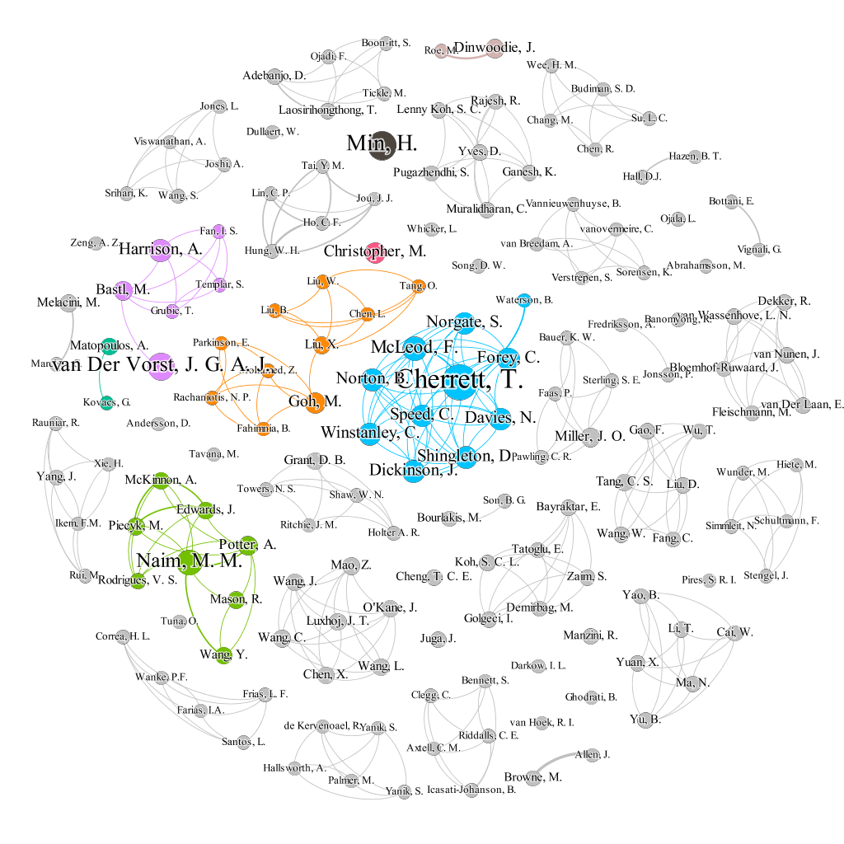
Note: Node indicates author, and edge indicates co-author relationship.
Figure 3. Simplified co-author network

A total of 485 institutions from all over the world have published in IJLRA. Figure 4 presents the institutions’ collaboration network considering a minimum threshold of two degrees in each institution. The full collaboration network is given in the Appendix (Figure A2). It is worth noting that we do not double calculate the same institution in each article. Table A2 presents the most productive institutions which are ranked according to the number of publications of each institution. Cranfield University is the most productive and influential institution from both the total number of publications and total number of citations.
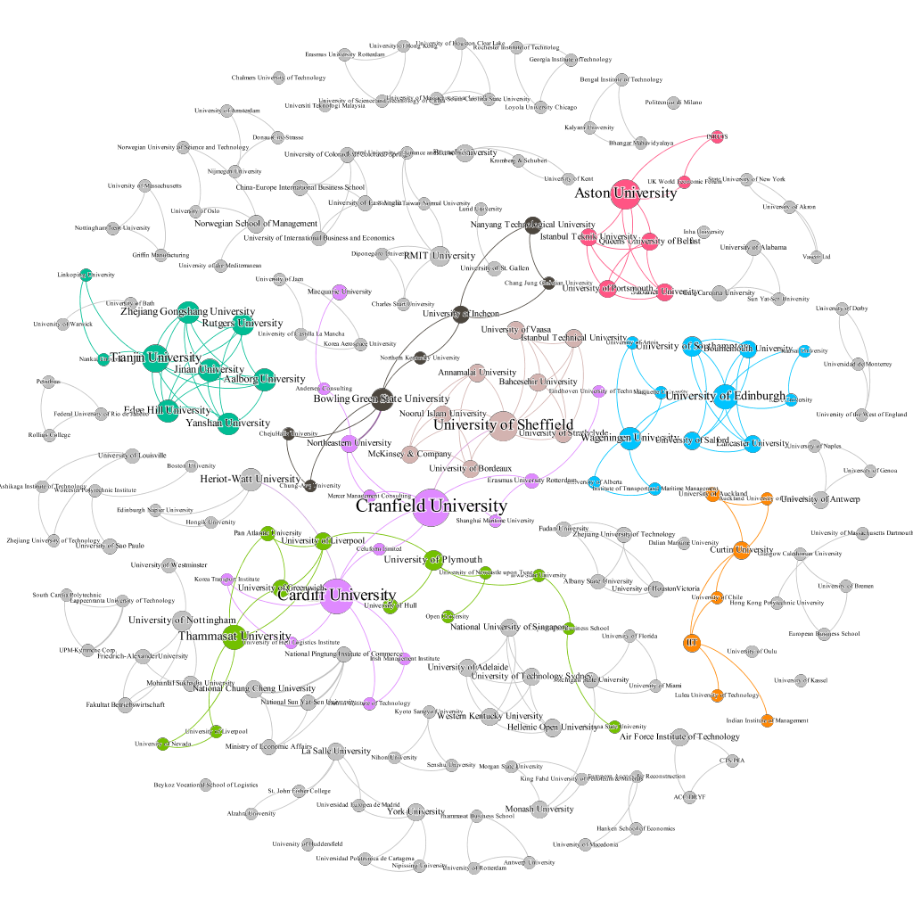
Note: Node indicates institution, and edge indicates co-institution relationship.
Figure 4. Simplified institutions’ collaboration network

Next we scale up to the country level. Figure 5 presents the most productive countries by using a bibliographic coupling analysis. In terms of total number of publications, the UK is the country with the highest number of publications with 137 in IJLRA, 5299 citations, and 11 papers that have been cited at least 100 times in GS with an average of 38.68 citations per publication. The UK also has an average of 2.07 publications and 80.67 citations per million inhabitants. IJLRA was launched in the UK so it is understandable that UK contributions are core of the journal. The UK is followed by is the USA, Sweden and Italy.
Per capita, a number of European countries publish well. In particular, researchers in Finland, Sweden, Cyprus, the UK, Norway and Denmark contribute significantly to IJLRA. Exact numbers are given in Table A2 of the Appendix.
Notably, the most influential countries are mainly from North America and Europe. Developing countries are still far away from the leading positions but are starting to increase their profiles, and expectations are that these countries will increase their presence in IJLRA. Noteworthy are the results of China, which show strong potential, having grown quickly during the last few years.

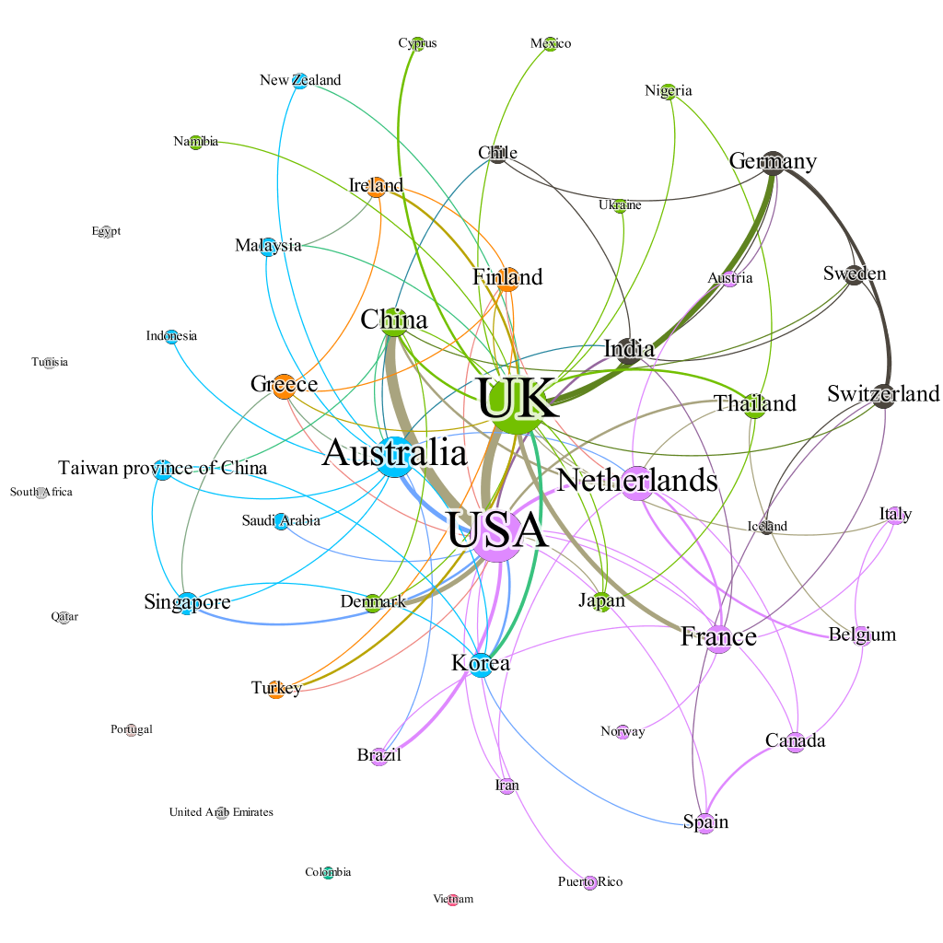
Note: Node indicates country, and edge indicates co-country relationship.
Figure 5. Bibliographic coupling of countries with publications in IJLRA

3.5 Publication patterns
The 481 published papers represent the efforts of authors from 42 countries across the world with 73.60% of the published articles emanating from ten countries as shown in Figure 6. We chose to use the country of residence of the corresponding author because we believe that the corresponding author was the author most likely to have been the driving force behind the article. Around twenty percent of all published papers involved authors from more than one country, with this being almost always a collaboration between authors from two countries, except in 20 instances (21.51%) where it extended to three or more countries.

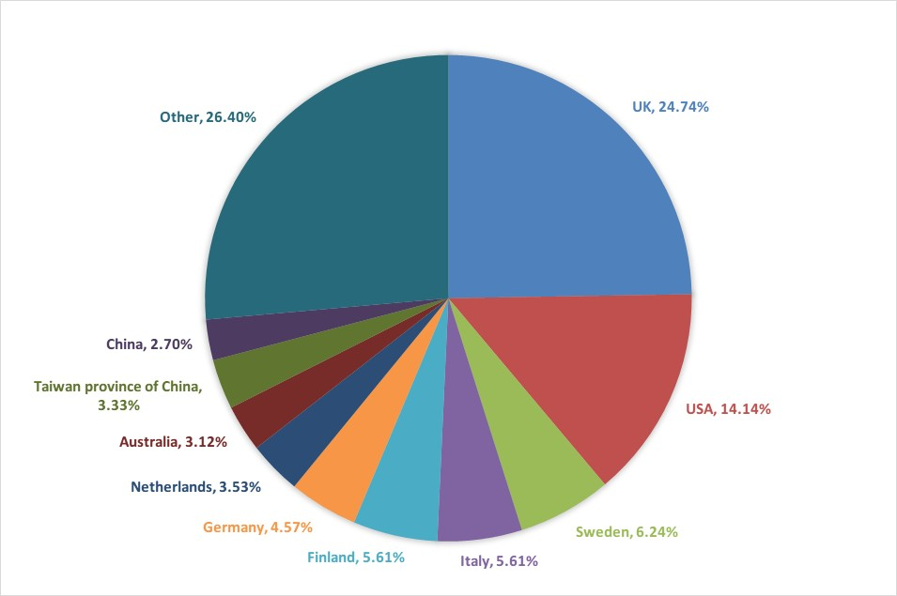
Figure 6. Country of origin of papers published in IJLRA, 1998-2017

The size of the author teams for these papers is also worth examining, as shown in Figure 7. It was most common for an article to have two authors (38.67%). The clear majority of papers had four or less authors (94.22%). Considering the increasing number of cross-national collaborations in the field, it is likely that many future studies published in IJLRA will involve multiple investigators and the number of co-authors will continue to increase.

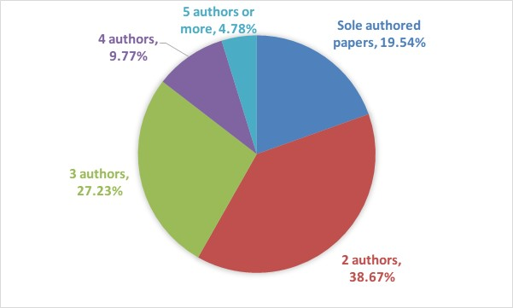
Figure 7. Size of author teams of papers published in IJLRA, 1998-2017

3.6 Evolution of author keywords
Since our aim is to assess the evolution of author keywords, it is necessary to divide the study period into a number of sub-periods. The articles in IJLRA have author keywords after 2005. So we divided 2005-2017 into 3 sub-periods: 2005-2009, 2010-2014, and 2015-2017. Figure A3, Figure A4, Figure A5, and Figure A6 illustrate the most frequently used keywords and their relationships over the entire lifetime and the three intervals, respectively. In Table A3 of the Appendix, we also present the related top-20 keyword list both over the complete journal lifetime and the three intervals. Note that degree number indicates the degree of keywords in keyword co-occurrence networks, and frequency number indicates the number of times the keyword appeared.
It appears from Figure A3 to Figure A6, and Table A3 in the Appendix, that many of the key topics have persisted over the entire lifetime of the journal, such as supply chain, supply chain management, logistics, and case study. There are some noteworthy developments though. The research related to China has grown in importance in recent years, even taking the top five spot since 2015. Before 2010, modeling, simulation and metaheuristics were in the top 20 of the ranking. With increasing research emphasis being placed on environmental issues, green logistics and sustainability have climbed in the ranking significantly, with the latter taking fourth place between 2015 and 2017.

4. Concluding remarks and limitations
In 2017, the International Journal of Logistics Research and Applications celebrated its 20th anniversary. Since its founding, IJLRA has given voice to a growing international and interdisciplinary community of researchers in the field of logistics and supply chain management as this historical and bibliometric review has shown.
From an analysis of bibliometric indices of the 481 full-length articles from 1998-2017, a number of highlights can be summarised: (1) The annual number of publications shows a gradual increase in IJLRA in recent years. (2) The publications that have received the most attention from the research community are in the area of operations management. (3) The most cited paper was published by Jüttner, Peck, and Christopher (2003) and has 1201 citations in GS. (4) Professor Hokey Min is the most productive author in IJLRA with 11 articles and former editor-in-chief Professor Martin Christopher is the most influential author in IJLRA with 1907 citations. (5) Cranfield University is the most productive and influential institution. (6) The country with the most publications in IJLRA is the UK, and international submissions are large with submissions from 42 different countries. (7) It is common for articles in IJLRA to have a single author or two authors, and we speculate the number of co-authors is likely to increase due to cross-national studies. (8) The four most prevalent themes for articles are supply chain, supply chain management, logistics, and case study, while green logistics and sustainability have been growing quickly since 2015.
Although the study gives a complete picture of the leading trends of IJLRA, it has some limitations. However, these limitations are not exclusive to bibliometrics but are present in any non-experimental discipline. For example, logistics and supply chain research is interdisciplinary within the business and management field. Therefore, some topics may receive more attention than others regardless of their importance. These topics tend to receive more citations, thus making them more relevant than others when performing bibliometric analyses.

Reference

Appendix A Tables and Figures with additional results

Table A1. The most productive institutions in IJLRA
R | Country | TP | TC | TC/TP | 100 | 50 | 20
1 | Cranfield Univ. | 25 | 2166 | 86.64 | 5 | 9 | 13
2 | Cardiff Univ. | 19 | 880 | 46.32 | 4 | 7 | 12
3 | Univ. of Plymouth | 11 | 66 | 6.00 | 2 | 3 | 4
4 | Heriot-Watt Univ. | 10 | 232 | 23.20 | 0 | 3 | 6
5 | Univ. of Southampton | 8 | 98 | 12.25 | 0 | 0 | 3
6 | Chalmers Univ. of Tech. | 8 | 85 | 10.63 | 0 | 0 | 3
7 | Indian Inst. of Tech. | 8 | 79 | 9.88 | 0 | 0 | 2
8 | Linköping Univ. | 7 | 341 | 48.71 | 1 | 3 | 4
9 | Univ. of Parma | 7 | 247 | 35.29 | 0 | 2 | 4
10 | Helsinki Univ. of Tech. | 6 | 218 | 36.33 | 0 | 3 | 4
11 | Nanyang Tech. Univ. | 6 | 75 | 12.50 | 1 | 1 | 3
12 | Bowling Green State Univ. | 6 | 36 | 6.00 | 0 | 0 | 2
13 | Univ. of Westminster | 6 | 176 | 29.33 | 0 | 0 | 6
14 | Univ. of Newcastle upon Tyne | 5 | 315 | 63.00 | 1 | 3 | 4
15 | Univ. of Oulu | 5 | 65 | 13.00 | 1 | 1 | 3
16 | Inha Univ. | 5 | 29 | 5.80 | 0 | 0 | 0
17 | Wageningen Univ. | 5 | 164 | 32.80 | 0 | 1 | 2
18 | Aston Univ. | 5 | 78 | 15.60 | 0 | 0 | 1
19 | Univ. of Louisville | 5 | 111 | 22.20 | 0 | 0 | 3
20 | Politecnico di Milano | 5 | 30 | 6.00 | 0 | 0 | 0
21 | Lund Univ. | 5 | 192 | 38.40 | 0 | 2 | 3
22 | Hong Kong Polytech Univ. | 5 | 118 | 23.60 | 0 | 2 | 4
23 | Univ. of Hull | 4 | 13 | 3.25 | 0 | 0 | 1
24 | Univ. of California | 4 | 961 | 240.25 | 1 | 2 | 3
25 | Univ. of São Paulo | 4 | 34 | 8.50 | 1 | 2 | 3
26 | Thammasat Univ. | 4 | 100 | 25.00 | 0 | 1 | 2
27 | Univ. of Wales | 4 | 56 | 14.00 | 0 | 0 | 1
28 | Northeastern Univ. | 4 | 141 | 35.25 | 1 | 2 | 2
29 | Univ. of Huddersfield | 4 | 12 | 3.00 | 0 | 1 | 1
30 | RMIT Univ. | 4 | 15 | 3.75 | 0 | 0 | 0
 | 32 institutions | 3 | 32 | 2151 | 67.22 | 5 | 11
 | 52 institutions | 2 | 52 | 1735 | 33.37 | 5 | 16
 | 371 institutions | 1 | 371 | 4729 | 12.75 | 7 | 32
Note: abbreviations available in Table 1 and Table 2.

Table A2. The most productive countries in IJLRA
R | Country | TP | TC | TC/TP | Pop | TP/Pop | TC/Pop | 100 | 50 | 20
1 | UK | 137 | 5299 | 38.68 | 66,182 | 2.07 | 80.07 | 11 | 29 | 64
2 | USA | 87 | 3995 | 45.92 | 324,459 | 0.27 | 12.31 | 8 | 15 | 40
3 | Sweden | 31 | 856 | 27.61 | 9,911 | 3.13 | 86.37 | 0 | 7 | 15
4 | Italy | 30 | 761 | 25.37 | 59,360 | 0.51 | 12.82 | 1 | 5 | 11
5 | Finland | 27 | 698 | 25.85 | 5,523 | 4.89 | 126.38 | 1 | 5 | 12
6 | Germany | 29 | 291 | 10.03 | 82,114 | 0.35 | 3.54 | 0 | 1 | 5
7 | Netherlands | 22 | 490 | 22.27 | 17,036 | 1.29 | 28.76 | 1 | 2 | 9
8 | Australia | 21 | 139 | 6.62 | 24,451 | 0.86 | 5.68 | 0 | 1 | 4
9 | Taiwan province of China | 15 | 241 | 16.07 | 23,626 | 0.63 | 10.20 | 0 | 1 | 4
10 | China | 22 | 272 | 12.36 | 1,409,517 | 0.02 | 0.19 | 0 | 2 | 8
11 | India | 17 | 186 | 10.94 | 1,339,180 | 0.01 | 0.14 | 0 | 0 | 4
12 | Canada | 10 | 142 | 14.20 | 36,624 | 0.27 | 3.88 | 0 | 1 | 5
13 | Norway | 8 | 219 | 27.38 | 5,305 | 1.51 | 41.28 | 0 | 2 | 3
14 | Brazil | 10 | 118 | 11.80 | 209,288 | 0.05 | 0.56 | 1 | 2 | 4
15 | Spain | 8 | 118 | 14.75 | 46,354 | 0.17 | 2.55 | 0 | 0 | 4
16 | Japan | 8 | 17 | 2.13 | 127,484 | 0.06 | 0.13 | 0 | 0 | 1
17 | Greece | 9 | 161 | 17.89 | 11,160 | 0.81 | 14.43 | 0 | 1 | 5
18 | Korea | 13 | 80 | 6.15 | 50,982 | 0.25 | 1.57 | 0 | 0 | 2
19 | Turkey | 7 | 107 | 15.29 | 80,745 | 0.09 | 1.33 | 0 | 0 | 3
20 | Singapore | 8 | 101 | 12.63 | 5,709 | 1.40 | 17.69 | 1 | 1 | 3
21 | France | 13 | 130 | 10.00 | 64,980 | 0.20 | 2.00 | 0 | 1 | 6
22 | Belgium | 7 | 97 | 13.86 | 11,429 | 0.61 | 8.49 | 0 | 0 | 3
23 | Ireland | 6 | 120 | 20.00 | 4,762 | 1.26 | 25.20 | 0 | 1 | 3
24 | Thailand | 6 | 130 | 21.67 | 69,038 | 0.09 | 1.88 | 0 | 1 | 2
25 | Denmark | 6 | 173 | 28.83 | 5,734 | 1.05 | 30.17 | 2 | 3 | 4
26 | Austria | 4 | 37 | 9.25 | 8,735 | 0.46 | 4.24 | 0 | 0 | 0
27 | Cyprus | 3 | 139 | 46.33 | 1,180 | 2.54 | 117.84 | 0 | 2 | 2
28 | Switzerland | 8 | 69 | 8.63 | 8,476 | 0.94 | 8.14 | 0 | 0 | 4
29 | New Zealand | 3 | 60 | 20.00 | 4,706 | 0.64 | 12.75 | 0 | 0 | 1
30 | Iran | 4 | 54 | 13.50 | 81,163 | 0.05 | 0.67 | 0 | 0 | 1
31 | Egypt | 3 | 31 | 10.33 | 97,553 | 0.03 | 0.32 | 0 | 0 | 0
32 | United Arab Emirates | 2 | 22 | 11.00 | 9,400 | 0.21 | 2.34 | 0 | 0 | 0
33 | Malaysia | 4 | 82 | 20.50 | 31,624 | 0.13 | 2.59 | 0 | 1 | 1
34 | South Africa | 2 | 12 | 6.00 | 56,717 | 0.04 | 0.21 | 0 | 0 | 0
35 | Portugal | 2 | 73 | 36.50 | 10,330 | 0.19 | 7.07 | 0 | 0 | 2
36 | Puerto Rico | 1 | 7 | 7.00 | 3,663 | 0.27 | 1.91 | 0 | 0 | 0
37 | Qatar | 1 | 78 | 78.00 | 2,639 | 0.38 | 29.55 | 0 | 1 | 1
38 | Colombia | 1 | 8 | 8.00 | 49,066 | 0.02 | 0.16 | 0 | 0 | 0
39 | Tunisia | 1 | 8 | 8.00 | 11,532 | 0.09 | 0.69 | 0 | 0 | 0
40 | Chile | 2 | 5 | 2.50 | 18,055 | 0.11 | 0.28 | 0 | 0 | 0
41 | Vietnam | 1 | 5 | 5.00 | 95,541 | 0.01 | 0.05 | 0 | 0 | 0
42 | Saudi Arabia | 1 | 57 | 57.00 | 32,938 | 0.03 | 1.73 | 0 | 1 | 1
Note: abbreviations available in Table 1 and Table 2 except for: Pop for population in thousands, TP/Pop and TC/Pop denote total publications and citations per million inhabitants.

Table A3. Most common author keyword occurrences in IJLRA
Global |  |  |  |  | 2005-2009 |  |  |  | 2010-2014 |  |  |  | 2015-2017
R | Keyword | d | f |  | Keyword | d | F |  | Keyword | d | F |  | Keyword | d | f
1 | Supply chain management | 142 | 43 |  | Logistics | 53 | 14 |  | Supply chain management | 70 | 19 |  | Supply chain management | 47 | 14
2 | Logistics | 112 | 31 |  | Supply chain management | 34 | 10 |  | Case study | 34 | 10 |  | Logistics | 39 | 10
3 | Case study | 76 | 23 |  | Supply chain | 22 | 9 |  | Simulation | 31 | 8 |  | Case study | 32 | 9
4 | Supply chain | 62 | 22 |  | Case study | 13 | 4 |  | Supply chain | 30 | 9 |  | Sustainability | 26 | 6
5 | Simulation | 51 | 16 |  | Freight transport | 12 | 3 |  | Logistics | 25 | 7 |  | China | 17 | 4
6 | China | 34 | 9 |  | Reverse logistics | 11 | 4 |  | Green logistics | 22 | 5 |  | Simulation | 16 | 4
7 | Reverse logistics | 33 | 9 |  | Supply chain integration | 10 | 3 |  | Optimisation | 21 | 5 |  | Reverse logistics | 15 | 3
8 | Freight transport | 31 | 8 |  | Manufacturing planning and control | 9 | 2 |  | Information sharing | 20 | 4 |  | Freight transport | 15 | 4
9 | Sustainability | 30 | 7 |  | Simulation | 9 | 4 |  | Distribution | 18 | 3 |  | Supply chain | 15 | 4
10 | Optimisation | 29 | 7 |  | Dynamic programming | 9 | 2 |  | UK | 17 | 4 |  | Supply chain risk management | 14 | 4
11 | Green logistics | 29 | 7 |  | Core competence | 8 | 2 |  | Flexibility | 14 | 3 |  | Food supply chain | 13 | 3
12 | Supply chain integration | 26 | 7 |  | Yield and revenue Management | 8 | 2 |  | Global sourcing | 13 | 4 |  | Performance | 13 | 3
13 | UK | 25 | 6 |  | Modelling | 8 | 2 |  | Bullwhip effect | 12 | 3 |  | Supply chain performance | 12 | 3
14 | Information sharing | 25 | 6 |  | Customer service differentiation | 8 | 2 |  | Facility location | 12 | 2 |  | Supply chain dynamics | 12 | 3
15 | Flexibility | 24 | 6 |  | Logistics service | 8 | 2 |  | Supply chain integration | 11 | 3 |  | Supply chain agility | 12 | 3
16 | Supply chain risk management | 22 | 7 |  | Inventory management | 8 | 2 |  | Integration | 11 | 3 |  | Innovation | 12 | 3
17 | Modelling | 20 | 5 |  | Metaheuristics | 8 | 2 |  | China | 11 | 3 |  | Risk management | 12 | 3
18 | 3PL | 19 | 6 |  | 3PL | 8 | 3 |  | E-procurement | 11 | 3 |  | Green supply chain management | 10 | 2
19 | Automotive industry | 19 | 4 |  | New Zealand | 7 | 2 |  | Network design | 10 | 2 |  | Maritime logistics | 10 | 3
20 | Risk management | 19 | 6 |  | China | 7 | 2 |  | Geographic dispersion | 10 | 2 |  | Sustainable supplier selection | 10 | 3
Note: abbreviations available in Table 1 and Table 2 except for: d means degree of keyword in keywords co-occurrence networks, f indicates keyword frequency.

Figure A1. Co-author network
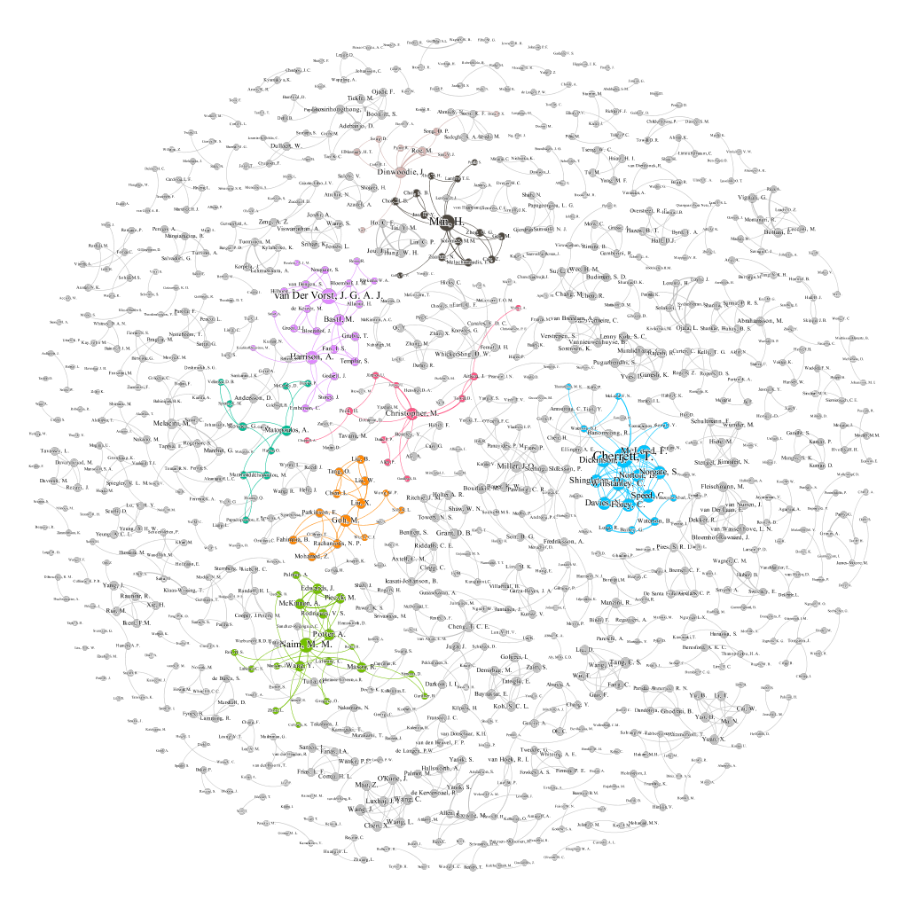

Figure A2. Institutions’ collaboration network
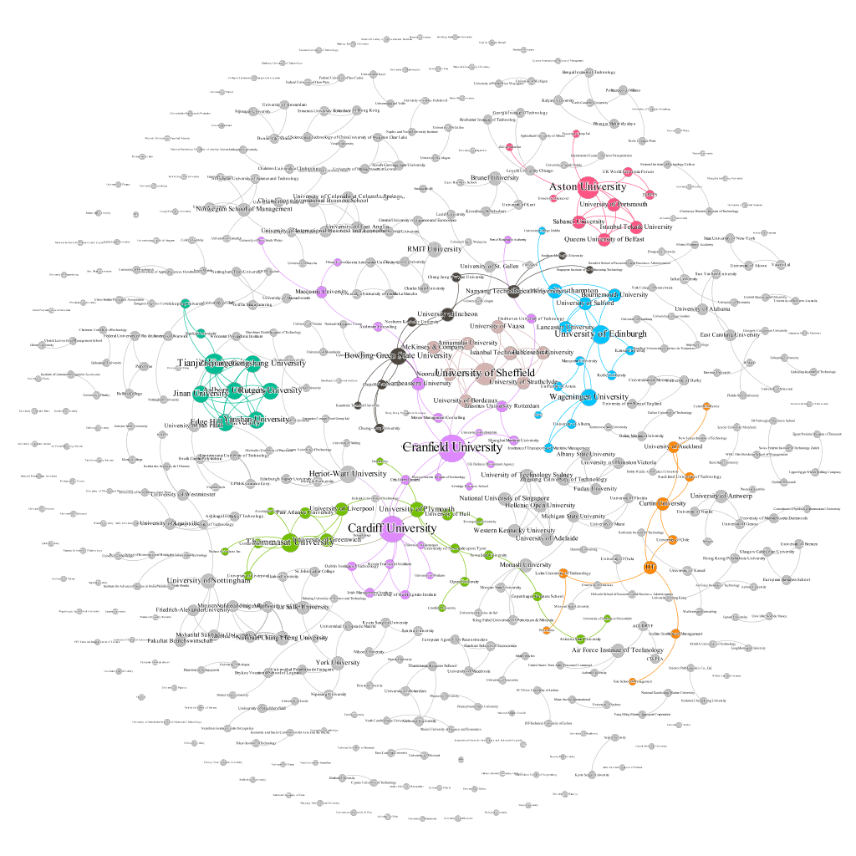

Figure A3. Co-occurrence of author keywords of articles in IJLRA, 2005-2017
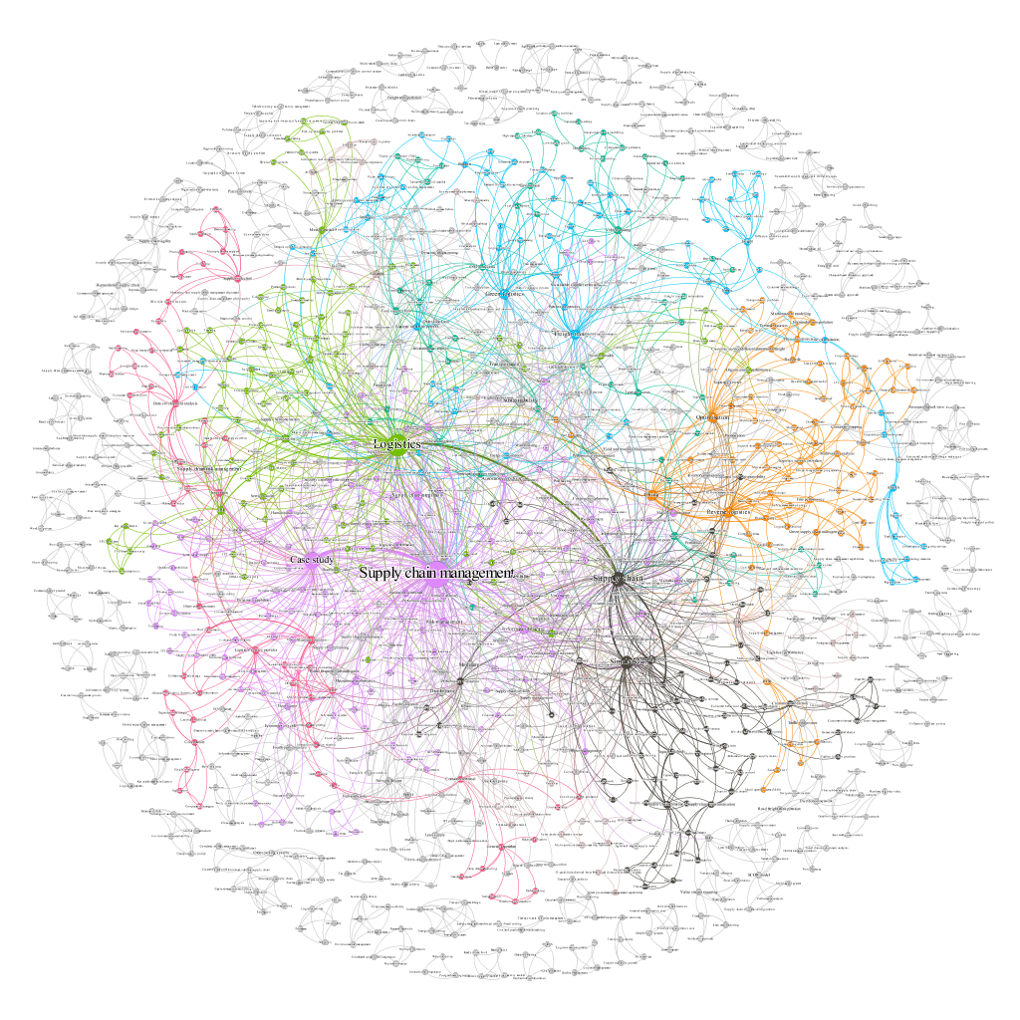

Figure A4. Co-occurrence of author keywords of articles in IJLRA, 2005-2009
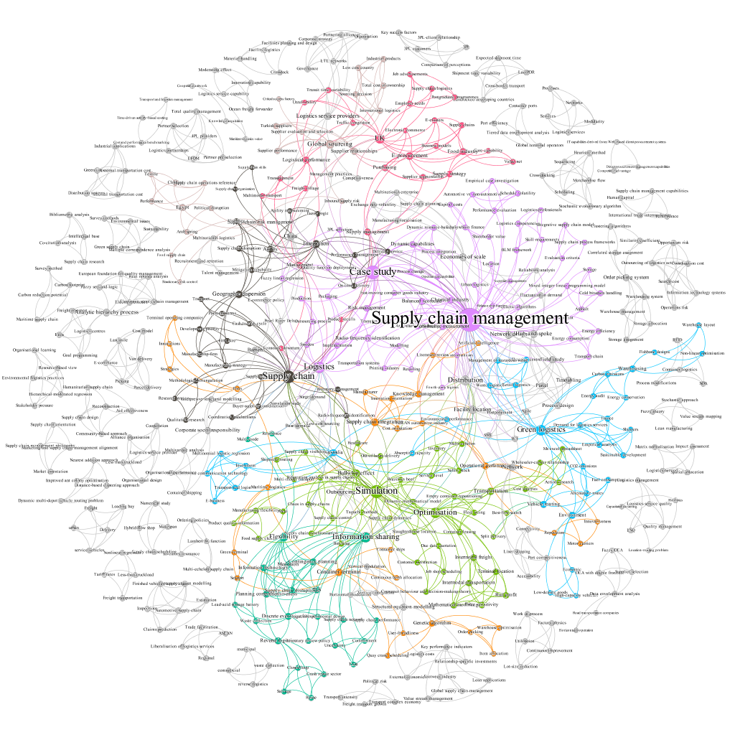

Figure A5. Co-occurrence of author keywords of articles in IJLRA, 2010-2014

Figure A6. Co-occurrence of author keywords of articles in IJLRA, 2015-2017


