Vibration analysis of a complex fluid-conveying piping system with general boundary conditions using the receptance method

T. Zhang a,[1]*, H. Ouyang b, C. Zhao a, Y.J. Ding a

a School of Naval Architecture and Ocean Engineering, Huazhong University of

Science & Technology, Wuhan 430074, China

b School of Engineering, University of Liverpool, The Quadrangle, Liverpool L69 3GH, UK

Abstract

In this paper, a new set of six-variable linear partial differential equations of motion of fluid-conveying pipes with general boundary conditions are derived using the Hamilton principle and these equations are solved by the receptance method. The frequencies of the straight pipes conveying fluid with or without elastic supports are determined and the results are compared with experimental ones. Then a fluid-conveying, semi-circular pipe and complex piping system with different kinds of boundary conditions are studied. These pipes are divided into some straight pipe units and are assembled using the receptance method. The numerical results show that the receptance method is efficient for pipes with arbitrary geometrical layouts and support types, and once the dynamic receptance of the elastic support of a piping system is obtained via experiment, its dynamic stability at different fluid velocities can be analysed by the receptance method.

Keywords: complex fluid-conveying piping, general boundary, receptance method

# Introduction

Fluid-conveying pipes are extensively used in engineering applications especially in oil transportation, heat exchangers and water-supply systems and so on. Due to particular environmental conditions, the design of pipe systems can be very complex. Paı̈doussis [1]systematically reviewed the dynamics of two different kinds of straight pipes: pipes with supported ends and cantilevered pipes, which were solved by an analytical method [2]. As the geometrical layout and support types become complex, an analytical method is not sufficient, and there are many numerical methods that can be adopted to solve the dynamic behavior of fluid-conveying pipes, such as the finite element method (FEM) [3-10], wave approach[11, 12], transfer matrix method (TMM) [13-16] and differential quadrature method (DQM) [17]. These methods seem sufficient in solving the dynamics of these pipes, and each having its own advantages and disadvantages in practice. What's more, various research topics about fluid-conveying pipes have been reported recently [18-21]; for example, Zhang [18] put forward a material model made up of fluid-conveying carbon nanotubes to absorb acoustic nanowave; Mnassri [19] presented the modal analysis of an elastic cylinder with compressible viscous fluid.

It must be said that those complex fluid-conveying pipes with classical boundary conditions have been widely investigated, but pipes with complex boundary conditions have rarely been studied. Here classical boundaries refer to simply-supported, free, clamped and sliding boundaries. However, in engineering applications, boundary conditions are not limited to these. To reduce vibration, more and more elastic supports are used on piping systems. In order to deal with this kind of supports, the receptance method [22, 23] is adopted in this paper to deal with all kinds of boundary conditions like rigid constraints or elastic supports. One notable advantage of the receptance method is that the receptance of an elastic support can be measured by experiment [24, 25]. Elastic supports are treated as linear springs connected at the end of each pipe unit in the receptance method.

In this paper, a set of six-variable linear partial differential equations of motion of fluid-conveying pipes with general boundary conditions are derived using the Hamilton principle and these equations are solved by the receptance method. The displacements in four directions (three perpendicular displacements and angular displacement) are expressed in an improved Fourier series method which is particularly convenient to simulate general boundaries. For a complicated pipeline system consisting of curved pipes or 3D complex pipes, the pipes are divided into some simple straight units. Laplace transform is applied to each unit to get the frequency response function (FRF) or receptance matrix, and the overall FRF receptance matrix of the whole pipes can be assembled from those of the pipe units.

To validate the receptance method, different kinds of fluid-conveying pipes are investigated respectively and the theoretical results are compared with the experimental results. In the case that there are no experimental results available, the method is assessed against some other methods mentioned above. After that, the natural frequencies and the critical flow velocities of a complex piping system with general boundary conditions are analysed. The results show that the receptance method is accurate and effective.

# Receptance matrix of a straight fluid-conveying pipe with general boundaries

## The derivation of a uniform fluid-conveying pipe element

A uniform Euler-Bernoulli beam is used to model the typical slender fluid-conveying pipe in this paper. A local Cartesian coordinate system is defined at the left end of the pipe, as shown in Fig. 1. For general boundary conditions, there are six springs: three rotational ones about the *X*, *Y* and *Z* axes and three linear ones along these three directions. In general, it is assumed that there are *nm* devices (modelled as masses) along the span of the pipeline and the *i*th lumped mass is denoted by  (*i*=1,2,…*nm* ) and the polar moment of inertia about the *X*-axis is denoted by  for convenience of notation. The fluid velocity inside the pipe is *V*, and a balanced tensile force *T0* is applied at both ends (pulling is positive and pushing is negative). It is assumed that the pipe does not discharge fluid to the atmosphere at the two ends and the fluid pressure is constant along the pipeline.

According to the theory of three-dimensional Euler-Bernoulli beams, the longitudinal, transverse and vertical displacements at a point on the centreline of a straight pipe are denoted by *u*, *v* and *w,* in the local coordinate system, and *ϕ, θ* and *φ* are rotations of the cross section about the three coordinate axes at the point.



For an Euler-Bernoulli beam, the relation between the rotations and the displacements can be prescribed as follows:



in which a dash denotes a derivative with respect to *x*.

The governing differential equation of the system can be obtained from the extend Hamilton’s principle:



where *T* and *U* are the kinetic energy and the elastic potential energy of the system respectively, and 𝛿*W* is the virtual work by external forces. A dot above a symbol denotes a derivative with respect to time *t*. The last term on the left-hand side of Eq. is the non-conservative work done by the fluid, and *m*f is the fluid’s mass per unit length. ***τ*** and ***R*** are the outward normal vector of the cross section and the displacement vector respectively.

The elastic potential energy of the system consists of two parts: the strain energy *U*pof the pipe structure and the potential energy of all springs *U*k. According to the slender beam theory, the strain energy can be expressed in the form:



where *EI*, *EA* and *GJ* represent the flexural, axial and torsional rigidity of the pipe respectively. *ε*0 is the normal strain caused by the tensile force, and Θ(*ε*3) is a term at the third order of magnitude that is ignored in this study. The potential energy of the six springs is given by:



where *x0*=0 and *x1=l*, and *δ*(*x-xi*) is the Dirac Delta function.  and (j=1, 2, 3) represent the displacements and rotations respectively.

The total kinetic energy of the system also can be divided into three parts, and the first part is the kinetic energy *T*p of the pipe wall, which can be represented by:



where *m*p is the mass of per unit length of the pipe, and *ρ*pis the density of the pipe.

When the rotary inertia effect and the secondary flow effect are neglected, then the kinetic energy *T*f of fluid inside the pipe can be described as:



Similarly, as the third part of total kinetic energy of the system, the kinetic energy of all *nm* lumped masses on the pipe can be written as:



where  and  are mass and polar moment of inertia of the *i*th lumped mass.

Considering general cases, the external force vector **F** acting on the pipe can be defined as follows:



Suppose that there are only concentrated forces applied on the two ends of the pipe, and gravity and the pressurization effects are neglected, then the work done by the external forces can be expressed as:



The improved Fourier series method [26, 27] is used to get the discrete equations of motion in this paper, and the displacements may be represented as series of the basic functions:



According to the improved Fourier series method, functions ** in Eqs. can be given respectively by:



where *N* is the number of terms in the truncated series of the basic functions, and special functions *fi* (*x*) (*i*=1,2,3,4) are defined by:



Substituting the expressions of the all kinds of energy into Eq., and using the displacements that are linear combinations of series of the basic functions in Eqs., one can get a variational equation in which vectors **q***u* ,**q***v* ,**q***w* and **q***ϕ*are the unknowns. The elements of these vectors can also be considered a set of generalized coordinates of the displacements, and a procedure of variational operations with respect to all these generalized coordinates of the displacements is executed, so that the following equation governing the motion of the fluid-conveying pipe is obtained:



in which:



where



The elements of the matrixes  in equation (14) are given in Appendix A of another published paper of the authors [23]. Superscripts ‘0’ and ‘1’ denote separately the force loaded on the left end and right end of the pipe, and vectors,,,, and are given as follows:



The Laplace transform of Eq. is



where **h***u* ,**h***v* ,**h***w* and **h***ϕ*arethereceptance matrices for the four displacement which are uncoupled, and these receptance matrices can be obtain by:



Using Eqs. the 12 quantities of harmonic displacement response of the two ends can be rewritten in the form of the vector:



By substituting Eqs. into the above equation, and applying the relationship of the force vector in Eqs., one can rewrite the following equation in terms of the receptance matrix as



where , and **h(s)** can be expressed as follows:



where **h(s)** is a square matrix that relates the forces and moments at the two ends of the pipe element to the displacements at the two ends of the pipe element and its elements are FRF, and the element located at the *i*th row and *j*th column represents the harmonic response at the *i*th degree-of-freedom caused by a single harmonic force or moment acting at the *j*th degree-of-freedom.

If receptance FRF matrix **h(s)** is nonsingular (this can be guaranteed in engineering because damping is always present in practice), another version of Eqs. is:



The dynamic stiffness matrix **z(s)** is very useful if viscous damping at the two ends of the pipe is also considered.

The receptance FRF matrix can fully characterize the linear dynamics of a fluid-conveying pipe. Using frequency sweeping method, one can calculate the response amplitude at each frequency to get the receptance curve where the natural frequencies are obtained from the peak values. However, the maximum modal shape order of the Euler-Bernoulli beam model depends on *N*. So the maximum natural frequency of the system that one can get is limited by *N*, and it increases with *N*. It can be called the cut-off frequency denoted as *f*c, and can be obtained by directly solving Eqs..

In fact, there are four kinds of pipe vibration modes from Eqs.: vibration modes in three perpendicular directions and vibration modes in the form of rotation about the *X*-axis, and they are independent. Then the maximum natural frequencies for the four kinds of vibrations can easily be computed by solving the eigenvalues problem of the four equations in the Eqs. respectively. Unlike the FEM, any number of analytical frequencies can be determined.

## The super-element of the fluid-conveying pipeline without branches

An industrial pipeline can be very complex, and a modular modelling approach should be a good method to analyse the dynamics of the system. One can divide a complex piping system into some simple components (modules), and the linear dynamics of the whole system can be described by the receptance frequency response functions of these components.

Consider a complex pipeline without any branches and suppose that there are no external forces on it except at the two ends. Then this pipeline component can be modelled by some straight fluid-conveying pipe units connected end to end, and the receptance FRF matrix of each pipe element can be obtained with the above mentioned equations. In the local coordinate of a pipe unit (shown in Fig.2), the dynamics of the *i*th pipe element can be expressed as:



where subscript ‘*i*’ indicates the *i*th pipe unit. The displacement and force vectors are defined in the local coordinate of the pipe unit. To get the receptance FRF matrix  in the global coordinate system, the coordinate transformation matrix **T** is introduced [12, 16]. The coordinate transformation matrix is only related to the pipe unit’s geometric relationship. Thus the relationship between the local receptance FRF matrix and the global receptance FRF matrix can be expressed as below:



Suppose a pipeline component is modelled with *n* straight pipe elements (shown in Fig. 2), one can obtain all the receptance FRF matrices of the *n* straight pipe elements, and the receptance FRF matrix of the whole pipeline component can be assembled from those of the pipe elements.

Here an example of 3 pipe elements is used to illustrate the above process. In the global coordinate system, the FRF matrices of the three pipe elements can be expressed in the form of the partitioned matrices as follows:



where the superscript of partitioned matrices denotes the pipe unit id number in the pipeline component, and subscript ‘0’ indicates the left end and ‘1’ the right end, and dimension of all partitioned matrices in Eqs. is 6×6. Then the dynamic stiffness matrix can be obtained using Eqs.:



With the FRF methods of coupled structure analysis, the integrated dynamic stiffness matrix of the pipe-super-elements including three pipe elements can be written as:



In fact, for a pipeline with *m* pipe-super-elements, the process of assembling the overall dynamic stiffness matrix can similarly take the form of:



where ‘*p’* and ‘*q’* denote two end nodes of each pipe-super-element in the whole system which are also the row number and column number of each pipe-super-element partitioned dynamic stiffness matrix located in the overall dynamic stiffness matrix respectively, and then the four partitioned matrices of each pipe-super-element are added into the overall dynamic stiffness matrix by the row number and column number of the partitioned matrices.

The overall receptance FRF matrix can be obtained as follows:



The dimension of the receptance FRF matrix would be relatively large if the number of straight pipe units is large, and model reduction methods is very useful to reduce the cost of computation. The receptance FRF matrix can be decomposed into nine parts according to the degrees of freedom (DOFs) of the pipeline components.



where subscripts ‘0’and ‘1’ refer to DOFs of the left end and the right end of the pipeline component respectively, and subscript ‘a’ refers to the DOFs of the middle points.

A complex industrial pipeline can always be modelled with a number of pipeline components which are connected by two ends, wherefore a pipe-super-element which only includes the DOFs of the two ends is more efficient for analysing the dynamics of the whole system. One can get a reduced receptance FRF matrix by directly deleting the elements of receptance FRF corresponding to the middle DOFs of the pipeline component from Eqs. if there is not any force acting at these middle points. The new receptance FRF matrix of the pipe-super-element are denoted by:



whereis a 12×12 matrix and it can be decomposed into four partitioned FRF matrices.

# Rigid constraints and the receptance supports in the pipeline

Completely rigid constraints do not actually exist in industrial pipelines, and a spring with very large stiffness coefficient is usually used to simulate a rigid constraint; but this stiffness coefficient of the springs will result in poor accuracy of the receptance matrix because of a large condition number of the matrix. An alternative method described below can be used to overcome the drawback.

When a pipeline has rigid constraint boundaries, every position where a rigid constraint is located should become an end node of a pipe-super-element. Neglecting the rigid constraints temporarily, the overall dynamic stiffness matrix **Z** of the system can be obtained by the afore-mentioned process, and matrix **Z** should include all DOFs that are constrained rigidly. The equation of motion for the system without rigid constraints can be written as:



If a DOF **are constrained rigidly for example, it means:



Substituting Eqs. into Eqs., one can obtain *n*-1 equations which are expressed with a reduced dynamic stiffness matrix, formed simply by deleting the *i*th rows and the *i*th column of **Z**. Therefore the reduced receptance FRF matrix  can be computed from:



If there are multi DOFs which are constrained rigidly in the pipeline system, the overall receptance FRF matrix **H** can also be obtained using the process described above.

In the field of aeronautical and shipbuilding industry, the installation of pipeline system is usually equipped with elastic supports in order to isolate vibration. And it can be difficult if one wants to model accurately the flexible installation of the support equipment as only ordinary springs. On the other hand, the impedance or receptance of the support equipment can be measured accurately enough and these measured data should be used in solving the dynamics of complicated pipelines.

Suppose that the *i*th DOF of a pipeline system has a flexible support, and the measured receptance data of the flexible support at the connection point is denoted by **hi**. Then the dynamic stiffness matrix for the coupled structure of the pipeline and the support can be written as:



on the assumption that there is no external force applied anywhere on the flexible support (except at the connection point) and the receptance data of the flexible support are separately measured with the same boundary condition as that after the connection. This matrix expression can be derived from the receptance modification theory which was clearly presented in [28-30].

# Experimental validation and discussion

In this section, both the experiment work and the numerical analysis are used to get the dynamics of the fluid-conveying pipes. To verify the formulations of the reception method and the elastic support which is used in the receptance method, the frequencies calculated by the receptance method are compared with those of experiments. The pipes used in experiments are of two kinds of material: the polymethyl methacrylate (PMMA) pipe and the PP-R pipe. Tab. 1 shows the physical parameters of the two kinds of material which are obtained from test data in manufacturer. Firstly, a straight pipe with clamp-clamp boundary conditions is tested to determine the fluid flow velocity influence on the dynamics of the fluid-conveying pipe. Then the vibration characteristics of a semi-circular pipe are analysised. Lastly, the experiment of complex 3D pipes with elastic supports is presented, and the effects of the internal fluid velocities on the dynamics of the pipes are given in details.

## Straight fluid-conveying pipes with rigid support

The experiment apparatus for the PMMA Straight pipes is shown in Fig. 3. The water comes from the pressure tank; the control valve is used to adjust the quantity of flow which can be read from the flowmeter. Fixed supports are installed on both ends of the pipe. Tab. 1 shows the physical parameters of the PMMA pipe.

Fig. 4 gives the experimental FRFs at the still water condition and *V*=7.3m/s condition excited by an impact hammer at the middle of the two supports and measured by the acceleration transducer placed one meter away from the right support in the experiment. The natural frequencies extracted from the experimental FRFs are compared with the results calculated by the reception method.

Tab. 2 gives the comparison in details. It can be seen that the first natural frequency decreases as the fluid velocities increases according to both the experiment and the reception method, and the reception method is in good agreements with the experimental data.

## Semi-circular fluid-conveying pipes with elastic support

Many researchers like Chen [31-33], and Misra et al[7, 15, 34] have studied the vibrations and stability of the semi-circular fluid-conveying pipe based on the conventional inextensible theory. For a semi-circular pipe, there are actually two kinds of motions due to the geometry of the pipeline. These are the motion along the centreline of the pipe and the motion perpendicular to it, namely the in-plane and out-of-plane motions. Past studies of the dynamics of the semi-circular fluid-conveying pipes mostly dealt with rigid boundaries such as a clamped end, a cantilevered end or a sliding end, but rarely with an elastic support. In this section the dynamics of the semi-circular pipe with different boundary conditions including an elastic support is discussed using the receptance method.

Shown in Fig. 5, a semi-circular pipe is described, and the material properties and dimensions are: *ρp* =7900kg/m3, *ρf* =1000kg/m3, *E* =200GPa, *G* =76.9GPa, *R* =0.7m, DO =100mm, DI =94mm. The effect of different boundary conditions on the dynamics of the fluid-conveying pipe is discussed in this section.

The curved pipe is divided into some uniform straight elements. It can be seen from Tab. 3 that with a small number of elements the natural frequencies can easily reach the convergence by this method. For convenience of comparison, the dimensionless natural frequency and the dimensionless ﬂuid velocity are introduced as follows:



In this paper the number of the pipe units that form the super-element is set to 10 and the whole pipe is one super-element. The table reveals high accuracy for the receptance method in comparison with the FEM in [6].

Fig. 6 shows the impact of fluid velocity on the lowest four natural frequencies of both the in-plane and out-of-plane motions for the semi-circular fluid-conveying pipe, in which all the results are transformed into dimensionless ones. Solid lines indicate results of the receptance method and the dots indicate results of the conventional inextensible theory in [6]. From the figure, one can see that the lowest four natural frequencies of both the in-plane and out-of-plane motions decreases as the velocity increases, and the pipe may lose stability by buckling at the critical velocity *V\**=3.00 for the in-plane motions and *V\**=1.58 for the out-of-plane motions.

Unlike the rigid support, when one end of the semi-circular pipe is elastically supported, the dynamics of the pipe change considerably. Fig. 7 gives the frequencies for both in-plane and out-of-plane motions of a clamp-elastic support semi-circular fluid-conveying pipe, where the stiffness of the elastic support in all three perpendicular directions is 105N/m. The natural frequencies (first mode) calculated for the in-plane motions and out-of-plane motions get closer as the right-hand side support varies from rigid to elastic one. This is mainly because the stiffness of a rigid support is regarded as infinite, and thus the geometry of the pipe plays the principal role on the in-plane and out-of-plane vibrations; but for an elastic support, both the geometry of the pipe and the stiffness of the support are influential for the in-plane and out-of-plane vibrations. As a result, the in-plane frequencies decreases to a larger scale compared with the out-of-plane frequencies with decreasing stiffness of the elastic support. Fig. 7 shows that the in-plane frequencies and the out-of-plane frequencies are nearly the same.

## Complex fluid-conveying piping system with elastic support

In the shipbuilding industry, the design of a piping system is usually very complicated. To demonstrate the feasibility of the receptance method in solving complex piping systems, vibration test and numerical analysis of a typical fluid conveying piping system is presented in this section. Laser displacement sensors and impact hammer are used in the experiment. The frequency response analysis is carried out and the results are discussed as follows.

As is shown in Fig. 8, the complex piping system installed on the vibration isolating raft frame is made up of straight PP-R pipes (its material properties are given in Tab. 1) and elbows which are regarded as straight pipes junction to simply the mathematical model. Two ends of the piping system are both clamped, and the other supports beneath the piping system are industry rubber isolators. The receptance matrix of these flexible supports is obtained from measured data which include amplitude and phase, as shown in Fig. 9. The receptance data at all directions of flexible supports are measured respectively by laser displacement sensor under impact hammer ecitation. The specific experimental device and testing method for axial and vertical receptances of flexible supports is shown in Fig.10. Given the similar position and the same support structure of Node 8 and Node 9, the receptances of these two supports should be similar (which is confirmed by the measured results) and hence the averaged receptance curve is taken for the receptances of both nodes. H1X, H1Y and H1Z represent measured receptance of a support in the *X*, *Y* and *Z* directions for Node 8 and Node 9, respectively. Node 2, Node 4 and Node 5 also receive the same treatment to their receptances. H2X, H2Y and H2Z represent measured receptance data of supports for Node 2, Node 4 and Node 5, respectively. In the simulation, there are totally 11 straight pipe units to form the complex super pipe element.

From Tab. 4 below, it can be found that the maximum error of the natural frequencies of the empty pipe as well as the fluid conveying pipe is about 7.79%, which occurs in the thirdnatural frequency for the pipe containing still water. The amplitude and phase curve of the point receptance for Node 11 (Node position is shown in Fig. 8) in the *Z*-direction at the velocity of 5.1 m/s are presented in Fig. 11. It can be seen that the analysis receptance curves correspond with the experimental receptance curves well. The analytical first natural frequency of the complex piping system is 8.77Hz which have an only 1.90% error compared with the experimental result. In general, the receptance method can estimate the receptances of complex fuid-conveying piping system effectively.

The effect of velocity on natural frequencies for the complex piping system is shown in Fig. 12. One can see that the first four natural frequencies are decreasing monotonically when the velocity is lower than 40.1m/s. Besides, at the flow velocity of about 17m/s, the 3rd Mode frequency (ranked at zero flow velocity) becomes the 2nd Mode frequency and then decreases to zero with the flow velocity reaching 43.6m/s, which is regarded as the critical velocity.

# Conclusions

A new set of equations with receptance method are derived for the vibrations of complex fluid-conveying pipes in this paper. The mathematical expressions of these equations are considerably simple and can easily be programmed. The biggest advantage of the equations is their convenience in dealing with industry pipes with complex support conditions. The vibration characteristics for different geometric model of pipes conveying fluid with general boundaries are investigated respectivelyusing the receptance method, and the results are in good agreement with the corresponding experiment tests.

The natural frequencies of straight fluid-conveying pipes decrease as the fluid velocity increases gradually. For semi-circular fluid-conveying pipes with rigid supports, the in-plane frequencies are much higher than the out-of-plane frequencies due to the key role of the geometry of the pipes. When the support of semi-circular fluid-conveying pipes varies from rigid to elastic one, in-plane frequencies obviously decrease and are nearly close to out-of-plane frequencies. It is found that the mode orders of complex fluid-conveying piping system will change with the increase of flow velocity.

Acknowledgements

This study was supported by the National Defence Fund of Huazhong University of Science and Technology (No. 01-18-140019). A large part of this work was carried out at the School of Engineering, University of Liverpool during the year-long visit of the first authors.

Reference

1. Paı̈doussis MP, Li GX. Pipes conveying fluid: a model dynamical problem. J Fluids Struc 1993;7(2):137-204.
2. Paı̈doussis MP. Slender Structures and Axial Flow. 1998: Academic Press.
3. Pak CH, Hong SC, Yun YS. On the vibrations of three-dimensional angled piping systems conveying fluid. Ksme J 1991;5(2):86-92.
4. Wu JS, Shih PY. The dynamic analysis of a multispan fluid-conveying pipe subjected to external load. J Sound Vib 2001;239(2):201-15.
5. Sinha JK, Singh S, Rao AR. Finite element simulation of dynamic behaviour of open-ended cantilever pipe conveying fluid. J Sound Vib 2001;240(1): 189-94.
6. Misra AK, Paidoussis MP, Van KS. On the dynamics of curved pipes transporting fluid. Part I: Inextensible theory. J Fluids Struc1988;2(3):221-44.
7. Misra AK, Paidoussis MP, Van KS. On the dynamics of curved pipes transporting fluid Part II: Extensible theory. J Fluids Struc 1988;2(3):245-61.
8. Zhai HB, Wu ZY, Liu YS, Yue ZF. In-plane dynamic response analysis of curved pipe conveying fluid subjected to random excitation. Nucl Eng Des 2013;256(0):214-26.
9. Sadeghi MH, Karimi-Dona MH. Dynamic behavior of a fluid conveying pipe subjected to a moving sprung mass-An FEM-state space approach. Int J Pres Ves Pip 2011;88(4):123-31.
10. Kochupillai J, Ganesan N, Padmanabhan C. A new finite element formulation based on the velocity of flow for water hammer problems. Int J Pres Ves Pip 2005;82(1):1-14.
11. Koo GH, Park YS. Vibration reduction by using periodic supports in a piping system. J Sound Vib. 1998;210(1):53-68.
12. Koo GH, Park YS. Vibration analysis of a 3-dimensional piping system conveying fluid by wave approach. Int J Pres Ves Pip 1996; 67(3):249-56.
13. Dai HL, Wang L, Qian Q, Gan J. Vibration analysis of three-dimensional pipes conveying fluid with consideration of steady combined force by transfer matrix method. Appl Math Comput 2012;219(5):2453-64.
14. Huang Y, Zeng G, Wei F. A new matrix method for solving vibration and stability of curved pipes conveying fluid. J Sound Vib 2002;251(2):215-25.
15. Dong ML, Choi MJ, Oh TY. Transfer matrix modelling for the 3-dimensional vibration analysis of piping system containing fluid flow. Ksme J 1996;10(2):180-9.
16. Shen H, Wen J, Yu D, Wen X. The vibrational properties of a periodic composite pipe in 3D space. J Sound Vib 2009;328(1-2):57-70.
17. Wang L, Ni Q. In-plane vibration analyses of curved pipes conveying fluid using the generalized differential quadrature rule. Comput Struct 2008;86(1–2):133-9.
18. Zijun Zhang, Yongshou Liu, Hailong Zhao, Wei Liu. Acoustic nanowave absorption through clustered carbon nanotubes conveying fluid. Acta Mechanica Solida Sinica 2016;29(3):257-270.
19. Mnassri I, Baroudi A E. Vibrational frequency analysis of finite elastic tube filled with compressible viscous fluid. Acta Mechanica Solida Sinica 2017;30(4):435-444.
20. Zhang Y W, Zhou L, Fang B, et al. Quantum effects on thermal vibration of single-walled carbon nanotubes conveying fluid. Acta Mechanica Solida Sinica 2017;30(5):550-556.
21. A Wang L, Hong Y, Dai H, et al. Natural Frequency and Stability Tuning of Cantilevered CNTs Conveying Fluid in Magnetic Field. Acta Mechanica Solida Sinica 2016;29(6):567-576.
22. Ram YM, Mottershead JE. Receptance method in active vibration control. AIAA J 2007;45(3):562-7.
23. Zhang T, Ouyang H, Zhang YO, Lv BL. [Nonlinear dynamics of straight fluid-conveying pipes with general boundary conditions and additional springs and masses](https://www.researchgate.net/publication/301757283_Nonlinear_dynamics_of_straight_fluid-conveying_pipes_with_general_boundary_conditions_and_additional_springs_and_masses). Appl Math Model 2016;40(17-18):7880-900
24. Wang M, Wang D, Zheng G. Joint dynamic properties identification with partially measured frequency response function. Mech Syst Signal Pr 2012;27: 499-512.
25. Zhang J, Richards CM. Parameter identification of analytical and experimental rubber isolators represented by Maxwell models. Mech Syst Signal Pr 2007; 21(7):2814-32.
26. LI WL. Free vibration of beams with general boundary conditions. J Sound Vib 2000;237(4):709-25.
27. Du J, Li WL, Liu Z, Yang T, Jin G. Free vibration of two elastically coupled rectangular plates with uniform elastic boundary restraints. J Sound Vib 2011;330(4):788-804.
28. Mottershead, J E, Ram Y M. Inverse eigenvalue problems in vibration absorption: passive modification and active control. Mechanical systems and signal processing 2006;20(1), 5-44.
29. Birchfield N, Singh K V, Singhal S. Dynamical Structural Modification for Rotordynamic Application. ASME 2013 International Design Engineering Technical Conferences and Computers and Information in Engineering Conference 2013;V008T13A056-V008T13A056.
30. Ouyang H, Zhang J. Passive modifications for partial assignment of natural frequencies of mass–spring systems. Mechanical Systems & Signal Processing 2015;50-51:214-226.
31. Chen S. Vibration and stability of a uniformly curved tube conveying fluid. Acoust Soc Am 1972;51(1B):223-32.
32. Chen S. Flow-induced in-plane instabilities of curved pipes. Nucl Eng Des 1972;23(1):29-38.
33. Chen S. Out-of-plane vibration and stability of curved tubes conveying fluid. J Appl Mech 1973;2(40):362-8.
34. Jung D, Chung J. A steady-state equilibrium configuration in the dynamic analysis of a curved pipe conveying fluid. J Sound Vib 2006;294(1–2):410-7.

Fig. 1 Schematic of a fluid-conveying pipe with lumped masses

*T0*

*X*

*Y*

*Z*

*T0*

*V* (fluid velocity)

Cross section of the pipe

DI

Do

l





*k02,K02*

*k01,K01*

*k03,K03*

*k12,K12*

*k13,K13*

*k11,K11*



…

Pipe element 1

Pipe element 2

Pipe element 3

Pipe element n

1

0

1

1

1

0

0

0

0

1

Super-element

Fig. 2 The pipe elements and super-element

Pressure Tank

Control Valve

Flowmeter

Acceleration Sensor

Dynamic Signal Acquisition

Rigid Support

PMMA Pipe

Pressure Gauge

G

Rigid Support

Flexible Pipe

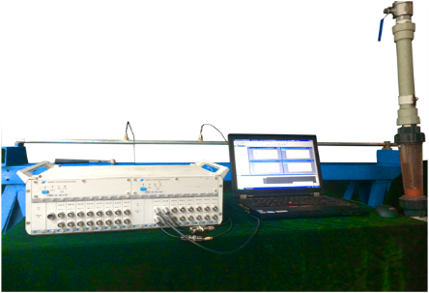

Excitation location

935mm

1000mm

Fig. 3 Schematic diagram and figures of the experimental apparatus

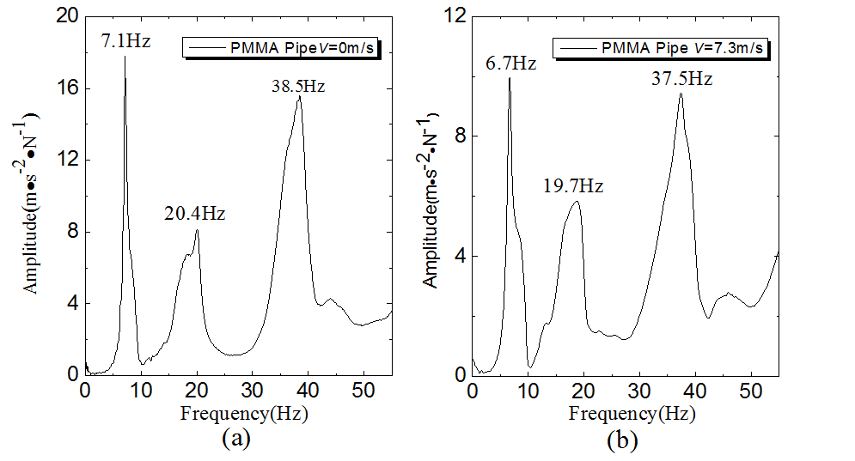

Fig. 4 Experimental FRFs (acceleration): (a) PMMA pipe with still water; (b) PMMA pipe with *V*=7.3m/s

R

*X*

*Y*

*Z*

Fig. 5 A semi-circular pipe conveying fluid

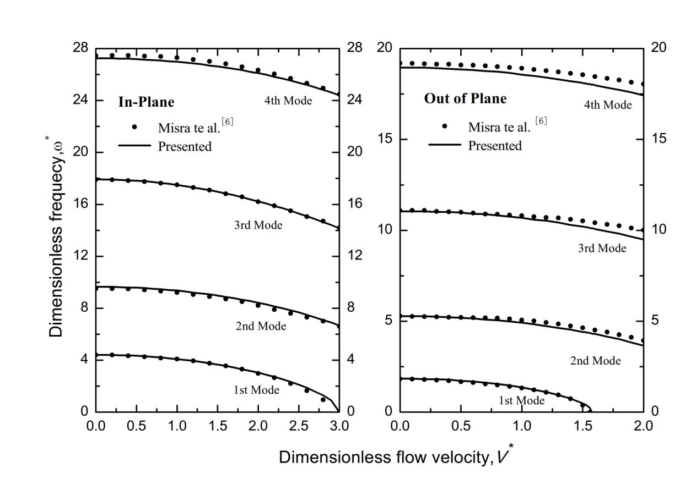

Fig. 6 Dimensionless natural frequencies ω* on versus the dimensionless ﬂuid velocity *V\** for the semi-circular ﬂuid conveying pipe under clamp-clamp boundary conditions.

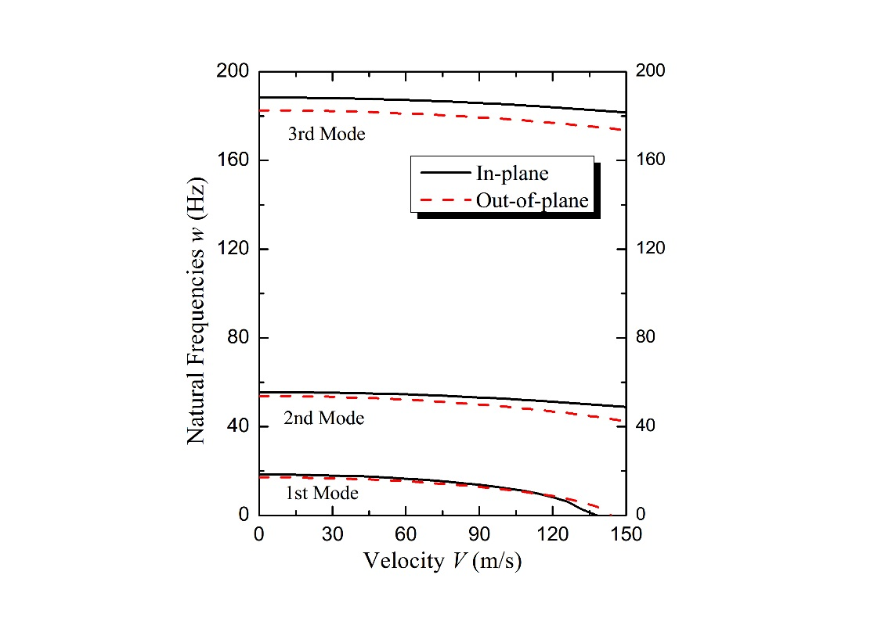

Fig. 7 Natural frequencies ω for in-plane and out-of-plane motion of a semi-circular pipe with clamped-elastic ends as functions of the ﬂow velocity *V.*

(b)

(a)

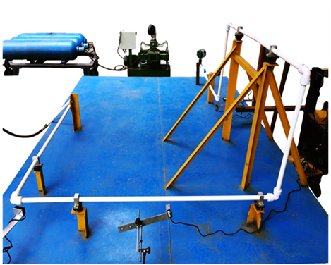

Pressure Tank

Water Pump

Laser Displacement Sensor

Flexible Pipe

Vibration isolating Raft Frame

Fig. 8 A complex fluid-conveying pipe system: (a)The analytical model; (b)Experiment installation

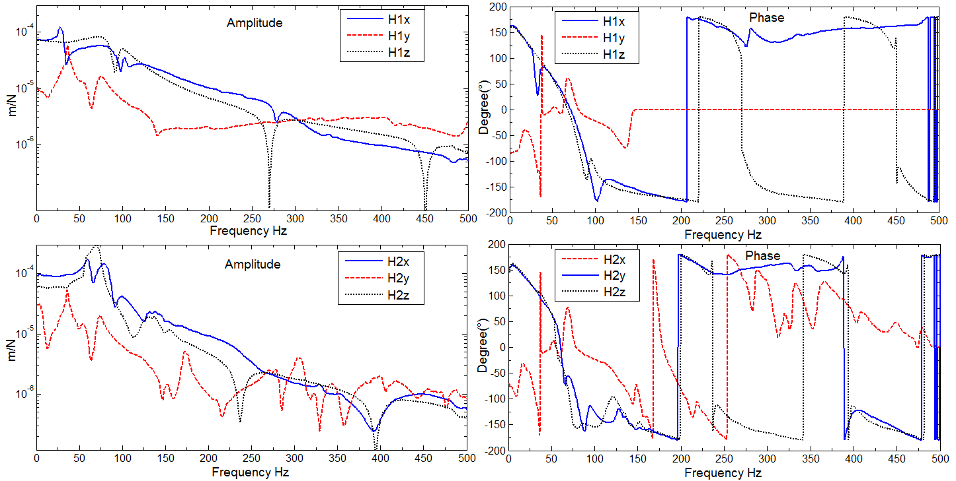

Fig. 9 The receptance data of the rubber isolator conducted by experiment

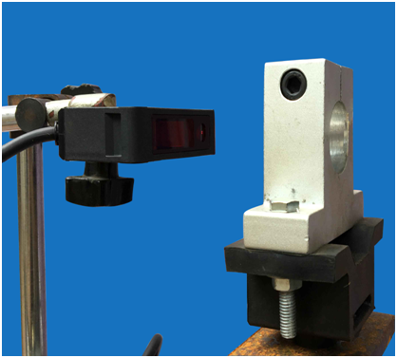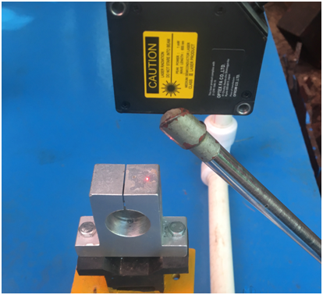

(a)

(b)

Fig. 10 receptance test of flexible supports, (a) test of axial receptance, (b) test of vertical receptance

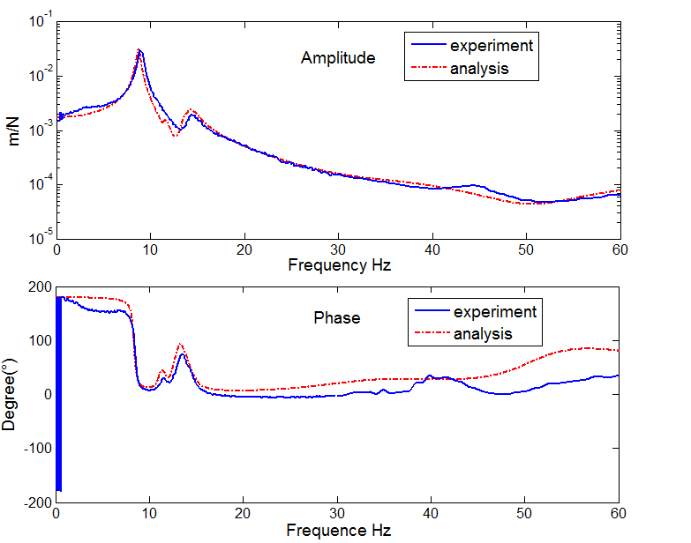

Fig. 11 The amplitude and phase of point receptance of Node11with flow velocity at 5.1 m/s

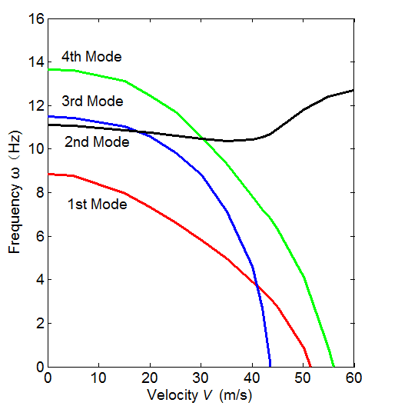

Fig. 12 Natural frequencies ω of the complex piping system as functions of the ﬂow velocity *V*

1. * Corresponding author.

   E-mail address:zhangt7666@mail.hust.edu.cn (T. Zhang)