Small modular High Temperature Reactor Optimisation – Part 1:
A comparison between Beryllium oxide and nuclear graphite in a small scale high temperature reactor
S.Atkinsonª , T.J.Abram^{b}, D.Litskevich^{c} , B.Merk^{c}
ªMaterials Science and Engineering, University of Sheffield, Sir Robert Hadfield Building, Mappin St, Sheffield S1 3JD
^{b}School of Mechanical, Aerospace & Civil Engineering, University of Manchester
^{c}School of Engineering, The Quadrangle, University of Liverpool, Brownlow Hill, Liverpool, L69 3GH

Abstract
The small modular reactor market is starting to take shape for the future global energy challenges, with several major players emerging with new technologies. To maximise the potential in this market, the most appealing designs will have to be financially favourable and low risk for investors. Due to its perceived lower risk, this article investigates a high temperature reactor conceptual design proposal, the U-Battery. One of the challenges which high temperature reactors face, is the material selection due to the high temperature in the core and the temperature gradients across the core in addition to the mechanical effects which graphite faces as it ages. The original design is based on using a novel Beryllium oxide reflector. This article investigates the consequences of replacing this novel approach with the more common approach of a graphite reflector.
This article aims to provide a comparison between Beryllium oxide and nuclear graphite as a neutron reflector for high temperature reactor. The article emphasises on at what additional costs Beryllium oxide create and if graphite could meet the same performance at lower cost. To deduce a comparison between the materials, a model based around the U-Battery was produced. A neutronic analysis implied that to obtain a similar performance the core would be require 23% larger radial reflectors and 75% larger axial reflectors made if graphite rather than that of Beryllium. However, the cost of the graphite reflected core would be nearly half of that of a Beryllium design. The neutronic analysis demonstrates that the graphite design can be an efficient alternative to the Beryllium reflector creating even slightly better power distributions.

Introduction
Nuclear power is a viable method of providing low carbon energy for the future commitments of many developed nation (Brook et al., 2014). With the popularity of their potential being seen across developing nations, this has led to over 45 countries actively considering nuclear power programs, ranging from Asia to Europe. This provides an emerging market in the future, with many different requirements and business opportunities recognised in the UK (World Nuclear Association, 2018). At present the most common nuclear reactors are light water reactors (LWR), due to the nuclear communities in depth understanding of their performance. Unfortunately, despite their popularity, the time taken to build the latest LWRs has been excessive which led to significant cost overrun due to delayed delivery and this has harmed nuclear powers reputation (Ward, 2017).
To overcome these issues, new smaller, easier to deploy reactors are being considered and promoted in many countries like the UK (Department for et al., 2018).These are termed small modular reactors (SMRs) due to their modular nature and lower electrical capacity (<300 MWe). Several companies aim to prove that they are capable of building SMRs in a reasonable time scale and to a high safety standard. However, one of the major challenges that these new nuclear plants face is the drive to become economically viable against the existing LWRs. There are cases where becoming small provides advantages, such as the parts can now become smaller, thus easier to manufacture and to transport, thus workshop manufacturing and transport becomes attractive. Due to their modular design, the concept of economy of multiples and serial production comes into play. In the case of a significant market size this has the potential for reduced production costs which can be achieved through centralised manufacturing and single installation teams employed (Locatelli et al., 2014), (Gottlieb and Haugbølle, 2010). This can lead to a sustainable, healthy market for construction of new plants as well as to the renewal of experience of construction workforce.
Another advantage of SMRs is due to their smaller size, a lot of the traditional safety systems in LWRs are no longer required. This has seen the rise of passive and inherent safety features to reduce the overall costs compared to that of traditional power plants which are built on the basis of large amounts of redundancy and diversity (Kamyab and Nematollahi, 2012; Lang et al., 2017). Currently there are only predictions regarding the overall economic benefits of switching to SMRs technologies, however, some of these are promising, mainly due to the inclusion of new nuclear reactor designs which step away from traditional LWRs (Abdulla et al., 2013) (Nuclear energy insider, 2016) (Ding et al., 2011).
In particular, high temperature reactors (HTR) have seen some of the furthest developments in the SMR market, with the HTR-PM within the final stages of construction (World Nuclear News, 2018),(Zhang et al., 2016). The concept of HTR-PM is following the pebble bed HTR design, which was originally a German concept (W. Rausch, 1967), but is now being developed by Chinese nuclear industries. During the operation of the German pebble bed reactors, clear benefits in switching to SMR designs have been identified (G.H. LOHNERT, 1990; Schenk et al., 1990) due to the better utilization of the passive safety features of the tristructural-isotropic (TRISO) fuel particles. TRISO fuel is sealed by multiple layers, which have been proven to retain fission products if the particles never to reaches 1600 °C (Japan atomic energy research centre - JAERI 1332, 1994). From a design perspective, this is advantageous to SMRs, due to the ability to remove heat from a system preferring a low volume to surface ratio design.
One intriguing HTR SMR design which is emerging from the UK is the U-Battery (Ding et al., 2011), which aims to become a more versatile small reactor. The U-Battery has been termed a “micro” reactor, due to its small physical size and the original design aimed to be able to ship the unit by truck, which allows access to very remote locations such as oil and mining facilities. As HTRs have the ability to produce high temperatures, this allows them to be considered for other uses such as hydrogen production (Elder and Allen, 2009) or process heat delivery. Thus, the reactor would be appealing to a variety of the user’s needs, rather than directly competing with standard base load. This is a particularly useful in a long-term strategy for nuclear, as the purpose of the reactor can change to accommodate this (Merk et al., 2017).
This article explores the initial concept of the 10MWth U-Battery, which originally hosted a Beryllium oxide reflector as well as the opportunity to replace the Beryllium with a more common graphite reflector. A nuclear reactor operates by providing a fission chain reaction, this process requires large amounts of neutrons within the core. As neutrons directions cannot be controlled, reflectors are used as a way of scattering neutrons back into the core once they reach the outside of the fuel area. Beryllium oxide has a higher probability of scattering a neutron than that of the traditional material, nuclear graphite.
The inclusion of the very high temperature reactor (VHTR) in generation IV designs poses the question if investment in Beryllium oxide as a future reflector material is worthwhile. Currently, there is limited research on Beryllium oxides long term effects under high temperature and radiation damage. The major information dates to research being from the 1960s, this research provides an insight into the difficulties of working with Beryllium such as volume expansion, helium and tritium production and embrittlement over time (Pigg et al., 1973), (BÜRKHOLZ, 1966), (PRYOR, 1964). (Chakin et al., 2004).
There is currently a large drive within the fusion community to work with Beryllium oxide due to its ability to breed tritium (Chakin et al., 2016), this will possibly allow a significant increase in the knowledge base in the future, which could see more favourable results in nuclear environments. In contrast to this, nuclear graphite is one of the most well understood materials within the nuclear community, this is due to its extensive use in commercial reactor operation.
The second drawback of Beryllium oxide is the price, with the cost of Beryllium being 265 €/kg compared to 65 €/kg for nuclear graphite (Ding et al., 2011). When considering the volumes required, this is a significant expenditure, thus any benefits must be proportional to this.
This raises the question, at which point can we achieve comparable behaviour using nuclear graphite as that of which it would be promising using Beryllium oxide? By adapting the U-Battery design, this article aims to investigate at which point the two materials will provide the same performance as one another. Once a model is produced with similar behaviour, the criteria for determining the benefits of the switch will be focused on. Initially a brief overview of the material properties is undertaken, this aims to determine any direct influences the two materials will have under a performing within a HTR. The second test will investigate the materials burnup over time. The third test investigates the effect of the reflector material on the power distribution within the core, determining if this provides additional thermal impacts on the highest power regions of the core. The final test is the overall cost of the change in materials and determining if this cost of the system.

Basic Data on Beryllium Oxide and Graphite
Beryllium is an element which is almost exclusively mined in the USA, where they currently retain 90% of the global Beryllium production (AZO Materials, n.d.). Beryllium is classed as a non-scarce mineral, indicating that there is a large supply available, and that at current demand the supply will last for over a thousand years. However, Beryllium is the most expensive mineral due to it being in high demand (Henckens et al., 2016). A large part of this demand is due to Beryllium oxide (BeO) holding some distinct properties which make it attractive for use in several industries. These properties include a low density and high strength, high thermal conductivity and a high permittivity. These properties have led to an increase in demand in industries such as aerospace, military, alloys and microwave applications.
This following section aims to try to provide a comparison between nuclear graphite and BeO to produce an in-depth analysis of the properties of the materials that would directly affect their application within a nuclear environment.

Thermo-physical Properties
The first point for the evaluation will be concentrated around the materials’ properties. With a like to like comparison of the thermo-physical properties within the context of HTRs, see Table 1.
Table 1- Properties of Beryllium oxide [1] and Nuclear graphite
 |  | Material
Property | Unit | BeO | Nuclear graphite
Density | kg/m³ | 2850 (Ding et al., 2011) | 1800
Thermal conductivity | W/mK | 265 | 133 (Ding et al., 2011)
Specific heat capacity at 30 °C | J/kg.K | 750 | 720 (Idaho National Laboratory, 2016)
Thermal expansion | 10⁻⁶/k | 7.4 | 2.5x10⁻⁵ (Idaho National Laboratory, 2016)
Coefficients of volumetric thermal expansion | 1/k | 24 x 10⁻⁶ (IAEA, 2006) | 9.6-14.7 x 10⁻⁶ (IAEA, 2006)
Melting temperature | K | 2787 | 4800 (Savvatimskiy, 2005)
Cost | €/kg | 265 (Ding et al., 2011) | 65 (Ding et al., 2011)

The density of BeO, given in Table 1 is taken quite conservatively at 2850 kg.m⁻³ as this can be as high as 3000 kg.m⁻³, which will have some consequences on the scattering properties. However, the additional density over graphite will have an impact on the total mass of the core. This might be a concern when considering the construction of the core and the transport of a whole assembled core as would be desirable for a micro reactor design.
During the operation for a HTR core, the exterior of the core is surrounded by a barrel, made of steel. In normal operational conditions, this barrel is required to be kept under ~425 °C, this is due to material regulation imposed by ASME due to graphitization of steels occurring at these temperatures (ASM, 1997). In the case of having a high thermal conductivity of the side reflector, this increases the temperature of the barrel making this limit harder to achieve. This will require additional thermal insulation in the case of Beryllium oxide, thus allowing for this temperature to be maintained. However, in the case of emergency cooling and decay heat removal a balance between heat removed and heat generated is desired, so that the heat is dissipated and conducted to the surface of the reactor vessel as fast as it is produced. In the case of the VHTR the temperatures will be considerably higher, thus the required increase in size due to the additional thermal conductivity might be significant. Finally, this is a case for the optimisation between operational requests and safety requirements which must be performed for both cases individually.
In addition, thermal conductivity is also a property that changes two-fold, initially with temperature and secondly with irradiation. The current literature on irradiated Beryllium oxide’s thermal conductivity change over temperature ranges is limited to 80 °C, however, an annealing process taking place at higher temperatures seems to show lower impact on thermal conductivity cause by radiation damage (M.k.Cooper, 1963).
Another variance is the specific heat capacity, where values are very similar between graphite and Beryllium oxide. In the case of a loss of coolant accident, the specific heat capacity governs the rate at which the side reflector can absorb the energy emitted by the fuel, thus a larger number would be preferable.
Another aspect key to the reflector is the coefficient of thermal expansion, as the core heats up the reflector will expand. In the case of normal operation this is undesired as the scattering properties are reduced and additional flow paths could be opened between the core and the reflector when different materials are used in the core and the reflector. In the case of accidental scenarios, a higher value is preferred as the moderation reduction will aid with the reduction in of power. The implications of radiation damage could be problematic due to the volume expansion caused, this could see additional cracking over the sixty-year lifetime of the core. Due to the additional thermal expansion, the gaps between the reflector blocks would be required to be 63% larger in Beryllium to accommodate this additional expansion, thus reducing the overall moderation effects.
Both materials melting temperatures seem to be significantly higher than the of temperatures limits created by other components. Another potential option would be to use pure Beryllium, as used in research reactors (Chakin et al., 2004). However, Beryllium has a lower melting temperature of 1560 K, which could potentially be encountered during accident scenarios (Pohanish, 2017).

Neutronic Properties
Beryllium is currently being considered as an advanced reflector material for nuclear reactors due to its superior scattering cross section compared to nuclear graphite, due to the high density and low atomic number of the elements. This is depicted in Figure 1.
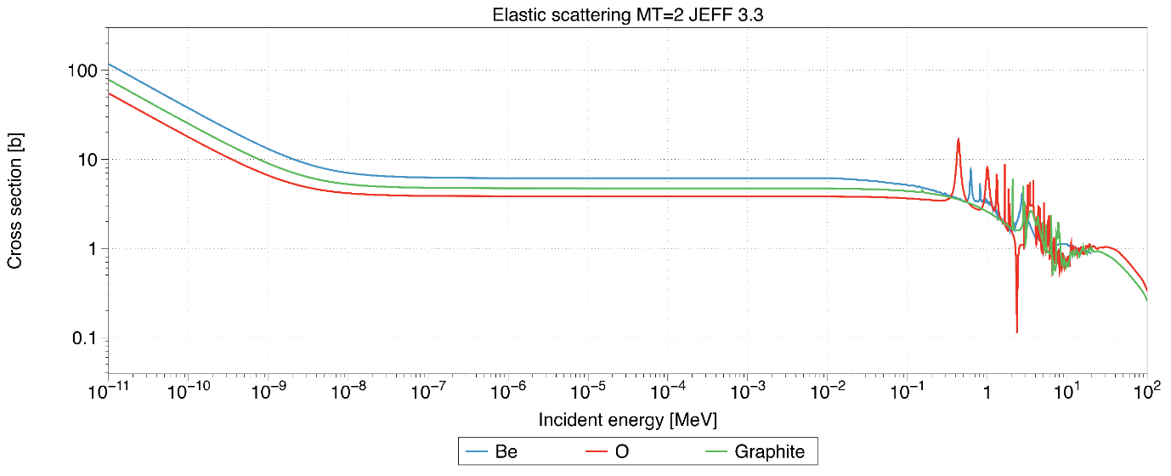
Figure 1- Scattering cross sections for Be, O and Graphite produced using JEFF 3.3 data libraries
From Figure 1, Beryllium oxide has a higher chance of scattering the neutron down to the thermal range of 0.0025 eV which utilises the capture cross section of U²³⁵ to initiate fission.
One negative impact of the Beryllium oxide is the penalty that there is additional capture in both oxygen and beryllium compared to graphite as highlighted in Figure 2.
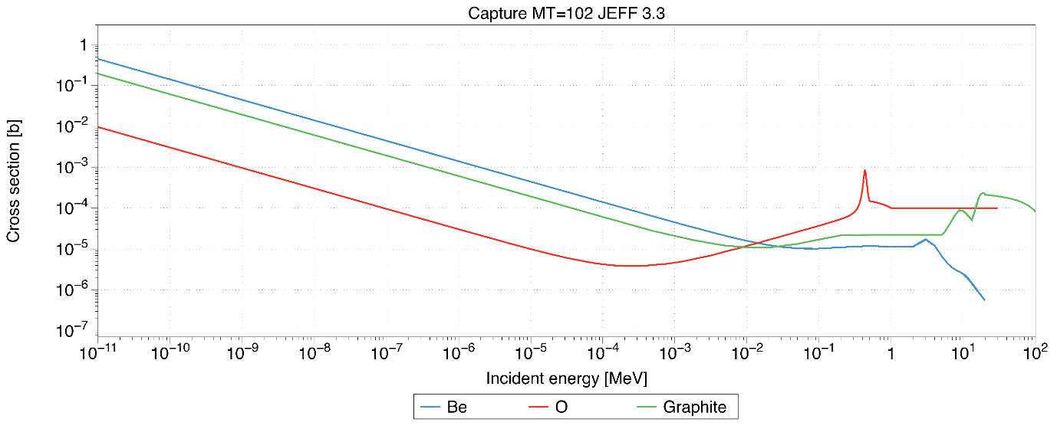
Figure 2 – Capture cross sections for Be, O and Graphite produced using JEFF 3.3 data libraries.

One method to compare moderator properties is using the moderation ratio, which is a ratio between the scattering to the absorption cross sections. Due to Beryllium oxides higher absorption the moderator ratio is 247, compared to graphite’s 242 (Apse et al., 2011).
Financial Impact
Beryllium oxide is expensive, with a cost of 265 €/kg compared to 65 €/kg for nuclear graphite [4]. This is a significant price difference when considering the volume of side reflector materials required.
One additional problem that comes with the use of nuclear power is the difficulty of disposing the nuclear waste, this has now been incorporated into the new plants which has to design for decommissioning (Nuclear Energy Agency, 2010). With the global stockpile of irradiated graphite reaching 250,000 tonnes the idea of direct repository disposal is currently being considered (Jensen and Nonbel, 1999), thus making this material expensive in decommissioning. The current stockpile of nuclear graphite is considered as intermediate level waste (NDA, 2012), implying that it does emit radiation, mainly in the form of C¹⁴. The cost of disposing of this waste has not yet been determined, as there is an ongoing debate regarding the cost of geological disposal of nuclear waste. The nuclear decommissioning authority provided an estimation that intermediate level waste would cost €12744 €* per m³ (NDA, 2012), yet there are reports of the actual cost increasing to €226k €* per m³ (Jackson, 2008). However, alternation approaches to deal with the problem are being investigated (Theodosiou et al., 2017). These significant costs could alter the choice of moderating material as decommissioning costs are due to be associated with new build projects. Agency
From the perspective of decommissioning Beryllium oxide, there has been very little research into the process of how to deal with it as nuclear waste. Due to cost of decommissioning, the overall reduction in the volume of waste while using Beryllium instead of graphite could be a significant driver towards using Beryllium. However, until further research has been conducted into the disposal of Beryllium oxide, estimates of the total savings cannot be accurately made.

Licencing
Nuclear graphite is one of the most well-known materials in the nuclear industry at least in the UK, due to its extensive use in the Advanced Gas cooled Reactors (Nonbel, 1996) and the Magnox reactors (Jensen and Nonbel, 1999). These reactors have been operational since the beginning of the civil nuclear era and thus have been extensively performance tested. This has placed the UK as the world leader in graphite moderated cores, thus there is now sufficient data existing for safety cases related to the inclusion of graphite in new nuclear cores.
Beryllium oxide has currently only been used in test reactors (Jensen and Nonbel, 1999) thus the amount of data on performance in nuclear environments is currently minimal. This would make the case for licencing
arrangements significantly harder and extensive/expensive tests would need to be performed to provide this data.
*£9,170 in 2011 prices and 1.13 Euros per GBP, applying 3% inflation annually until 2018.

Codes, Data and Models

Design Concept
The design considered is loosely based on the U-Battery concept which aims for a fast deployment using readily available technology. The use of Beryllium oxide for the reflector goes against the trend, as Beryllium oxide is not a regular material in nuclear reactors. This means, there is very little operational experience for this material available, so this would require significant experimental support performing an additional safety case. The initial U-Battery report (Ding et al., 2011) initially stated that the inclusion of a beryllium oxide side reflector would increase the overall full power lifecycle to five years. This was investigated and it was determined that to achieve this the carbon density which was originally used was 2.23 g cm⁻³ which is significantly higher than the usually applied density of nuclear graphite ~1.8 g cm⁻³ (GrefTECH international, 2014). The difference in total reactor lifetime are 706 days between the two models, the detailed calculations results on this difference is included in the appendices.

Methodology
The comparison between the two reflector materials will take place by determining the overall performance difference across the core. All neutronic results presented are simulated through a Monte Carlo simulation routine using the Serpent 2.1.27 (Leppänen et al., 2015), using data libraries JEFF 3.1.1.
The analysis will start with the original U-Battery 10MWth design which consists of 25 cm of side reflector (Ding et al., 2011) as reference configuration. The initial test will look at modelling the 320 cm in active core height, to determine the K_{eff} with the Beryllium oxide side reflectors. Then the Beryllium oxide will be replaced by graphite and the reflector dimensions will be extended until the same K_{eff} is reached. At this point, there will be a known volume of graphite which has to be introduced to obtain the same reflector effect. The same test will be performed axially with the new graphite side reflectors in place, until the same reactivity coefficient (K_{eff}) as in the original Beryllium oxide model is achieved. The idea behind this methodology is that the same initial core performance should be achieved by both models. The finding of the equivalent model is important to perform further operational tests.
Following this, a maximum full power day’s test will be made to determine the overall total fuel lifetime for both configurations. This will allow us to study the effect of the reflector from a neutron economy perspective. Graphite has a negligible capture cross section, compared to the beryllium in the thermal spectrum range. This would bring forward the hypothesis that the beryllium oxide would perform to a lower standard towards the end of the lifetime of the reactor.
The power profile of the core is examined at the start-up, to determine if there are any beneficial effects of the Beryllium oxide reflector. These could include the advantage of an improved power distribution with lower radial and axial peaking.
The change in volume due to the reflector size change causes other parts of the core to increase too, such as the reactor pressure vessel. This will have an increased cost on the reactor and will then be included in a cost benefit analysis.
Based on a mathematical procedure, the cost analysis of the core will be provided using the assumption that the reactor pressure vessel (RPV) will be located one meter below the bottom reflector and 1.7 m above the top reflector. Thus, the overall material volume changes can be calculated accordingly.

Results and Discussion
The first test aims to find the dimensions of the core which provide the same neutronic performance at the beginning of life with graphite reflector instead of Beryllium oxide. The first test looks to find a radius of side reflector which leads to a K_{eff} = 1.10762. Figure 3 depicts the core dimension increase with increasing thickness of the reflector until the point of 83.5 cm, where the K_{eff} is nearly identical to that of the Beryllium oxide reference case.
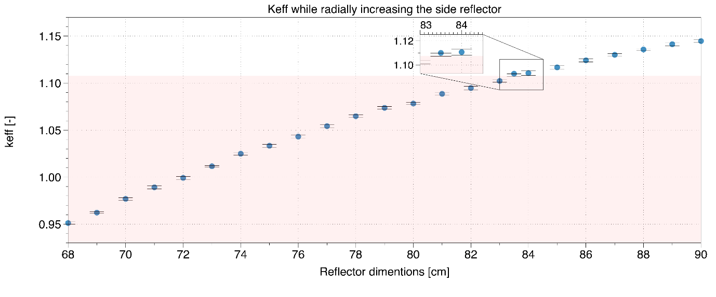
Figure 3- K_{eff} depending on the thickness of the side reflector, where the pale colour represents the reference point of 1.10762.
In the following search the dimension of the top/bottom reflectors were increased to find a dimension that would provide the same K_{eff} to the original U-Battery reference with K_{eff} = 1.12257, as shown in Figure 4.
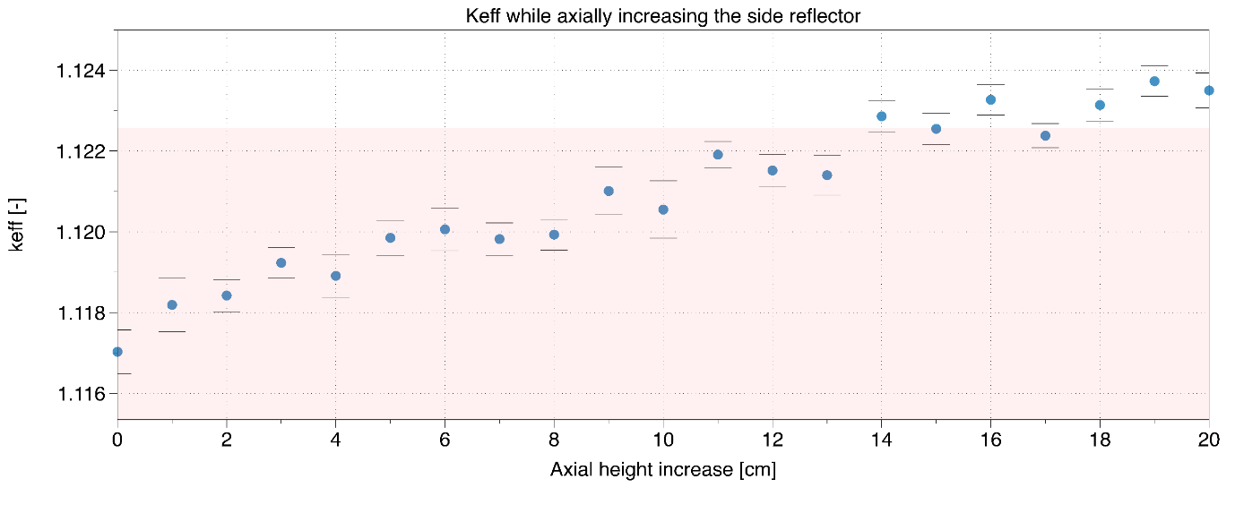
Figure 4- Axial changes of the core and their neutronic implications, where the pale colour represents the point of 1.12257.
Figure 4 implies that the axial reflector height provides a far less significant benefit to the system compared to that of radial. The sensitivity Figure 4 shows an increase in reactivity with increasing size, but some of this is lost due to the increase in errors due to the small scale of the reflectors benefits.
It was noted from Figure 3 and Figure 4 that the new dimensions of the alternative U-Battery conceptual design with graphite reflector have increased radially from 68 cm to 83.5 cm and axially from 20 cm to 35 cm. the configuration of the original U-Battery proposal and the alternative system are depicted in Figure 5.
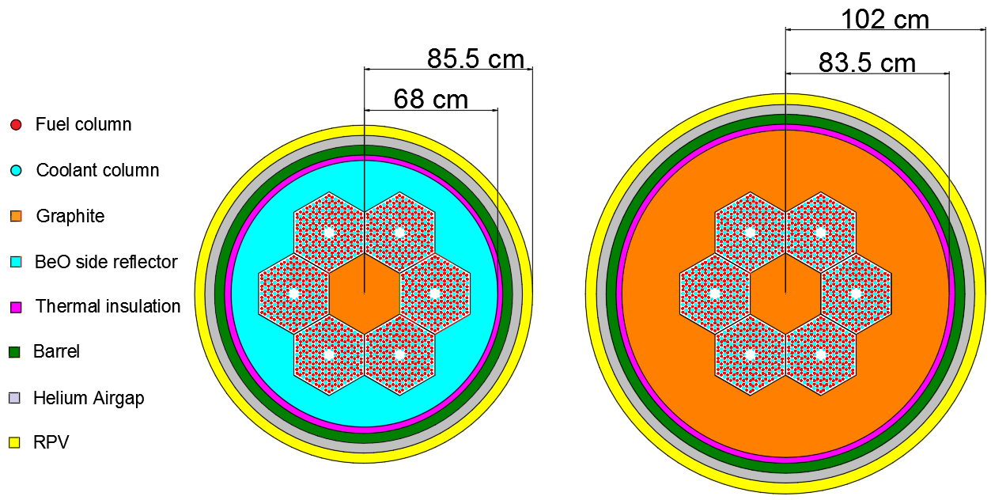
Figure 5- Left: Original U-Battery design, Right: Equivalent model representation with graphite reflector
The next stage investigates the long-term effects on the burnup of the nuclear fuel caused by the changing of the reflector. Beryllium is susceptible to transmutation, so seeing the effect on how this changes the moderation over time should be considered. To calculate this, the volumes of each reflector is calculated and then the reflector material undertakes depletion. The long-term effects are shown in Figure 6.
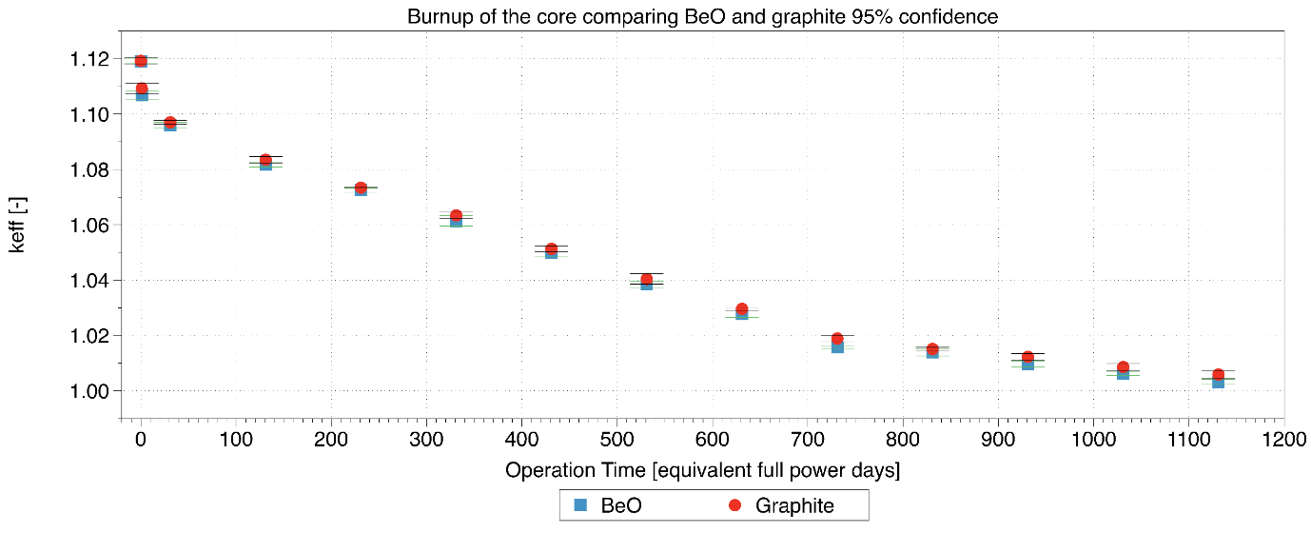
Figure 6- Change of the effective system K_{eff} over operational time for the difference reflectors with 95% confidence in the Monte-Carlo results.
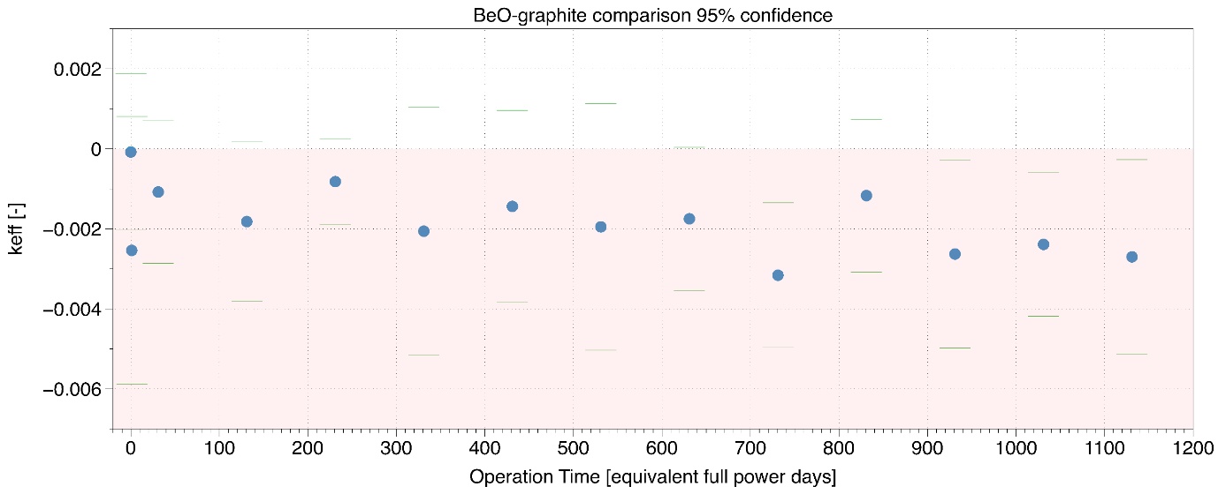
Figure 7- Difference in the change in K_{eff} (BeO case – Graphite case) between BeO and graphite reflector case with 95% confidence.
Figure 6 implies that the system K_{eff} decreases with increasing operation tie which is to be expected since the fissile material content of the core is reduced to produce energy by fission of the fissile material in the initial loading. Identical fuel loading between the two reflectors which are normalised to the same power, yet due to the increased capture characteristics of the Beryllium reflector, the end of fuel cycle lifecycle is slightly lower than that of graphite as highlighted in Figure 7. The reason for this is due to the gradual transmutation of O¹⁶ and B⁹ over the fuel cycle reduce the moderating properties significantly faster than that of the graphite reflector.
Figure 7 determines that the difference is small over a period of five years, however, the significance of this over a lifetime of 60 years might require additional fuel loading.
The next test examines how the power production is distributed across the fuel block. Serpent does not allow for implicit modelling of the TRISO fuel when recording the power distribution, so in this case the fuel columns are homogenised in both cases. Figure 6 is a CAD representation of the back half of the fuel block in Figure 9, with the green lines representing the position of the side reflector. The distribution of normalised power was normalised to one with reflective boundary conditions in the Z axis.
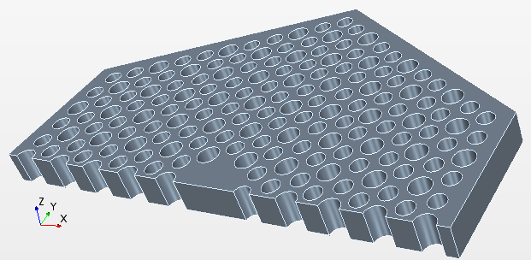
Figure 8 - CAD drawing of the half fuel block representation in Figure 8
Figure 9- Fuel column wise power distribution in the half fuel block for the graphite reflected core.
Figure 9 indicates that the highest power is situated at the centre of the fuel block at the side facing the central reflector in the centre of the where the centre is at (0,0). Due to the reflector materials being situated around the centre and the outsides this provides a high number of thermal neutrons and thus the peaks in power. Due to the small geometry of the core, the centre of the fuel block often does not see as many thermalized neutrons as the sides where prompt neutrons are born and often pass through the centre before thermalisation.
The difference in the fuel column power between the graphite case and the beryllium case is shown in Figure 10.

Figure 10- Fuel column wise difference in the power production across the centre of the graphite fuel block (BeO case – Graphite case)
Figure 10 indicates that the graphite reflector is producing a larger power at the pins directly adjacent to the side reflector. There are two aspects which could cause this, initially the thicker reflector in the graphite provides less neutrons leaking out from the core and thus a higher percentage returning from the central reflector. The second reason is that the additional absorption from Beryllium is reducing the neutrons returning adjacent to the side reflector. The figure also points to the highest power pins in the centre of the core, see a direct increase in power in the beryllium oxide system, this would therefore contribute more towards the burnup of the fuel columns and a higher power peaking in the centre of the core. Both having a negative impact on the overall performance of the core.
In addition, Figure 10 highlights that the top of the fuel blocks (maximum Y position) a significantly increase of power due to the beryllium, this is due to the additional scattering between the fuel block regions.
Following the identification of the highest power column power in the radial slice, the next investigation is concentrated towards the hottest column at the central reflector with an axial power distribution as displayed in Figure 11Figure 12.
Figure 11- Axial power distribution in the most powerful single column in the graphite reflector case
The more detailed investigation in Figure 12 shows the delta power between the graphite case and the beryllium case. Here it must be mentioned that this picture is for one specific fuel column which obviously created a higher power in the BeO case than in the graphite case. However, the overall power in the system is identical in both cases.
Figure 12- Power variance in most powerful pins (BeO case – Graphite case)
On the one hand, in the observed column, the main power increase in the Beryllium case comes at the top and bottom compacts, where the fuel burnup is not at its maximum power as with the centre. This is most probably a result of the increased moderation properties of the beryllium. In this case the higher power at the centre in the graphite case is causing additional loading on the highest power pins, despite this additional loading only being small.

Financial Analysis
The next step is to determine the new costs of the reactor core when making the required change in the dimensions of the reflector. Now the equivalent axial and radial dimensions have been calculated, the new costs of each materials can be determined. The new dimensions are shown in Table 4.

Table 4 - New radial and axial dimensions for the graphite reflector for comparison with the original proposal using BeO reflector
 | Radial dimensions (m) |  | Axial dimensions (m)
Material | BeO | Graphite | BeO | Graphite
Side reflector | 0.68 | 0.835 | 6.3 | 6.6
Thermal insulation | 0.03 | 0.03 | 6.3 | 6.6
Barrel | 0.05 | 0.05 | 6.3 | 6.6
Helium airgap | 0.05 | 0.05 | 6.3 | 6.6
RPV | 0.056 | 0.056 | 6.3 | 6.6
By assuming that the volumes of the top and bottom of the core form a sphere together, halving this sphere provides an insight into the new volume changes between the two models, presented in Table 5.
Table 5 - The total volume of each material for the graphite reflector for a comparison with the original proposal using the BeO reflector
 | Volume during cylindrical position (m³) |  | Volume during spherical top/bottom (m³)
Material | BeO design | Graphite Design | BeO design | Graphite Design
Side reflector | 6.636 | 11.941 | N/A | N/A
Thermal insulation | 0.825 | 1.057 | 0.182 | 0.272
Barrel | 1.455 | 1.845 | 0.340 | 0.498
Helium airgap | 1.554 | 1.949 | 0.387 | 0.555
RPV | 1.858 | 2.306 | 0.494 | 0.694
This allows the total cost of each material to be determined, using the basic costs per kg of each design as found in the U-Battery report (Ding et al., 2011). A cost breakdown of the new core is presented in Table 6.

Table 6- – Cost break down of raw materials for both designs
 |  |  | Total mass of each material (Kg) |  | Total cost of materials (€)
Material | Density (Kg/m3) | Cost (€/kg) | BeO design | Graphite design | BeO design | Graphite design
BeO | 2850 | 265 | 18914 | N/A | 5012161 | N/A
Graphite fuel blocks | 1800 | 65 | N/A | 21494 | N/A | 1397121
Thermal insulation | 1800 | 40 | 1813 | 1904 | 72537 | 76148
Barrel | 8000 | 42 | 14354 | 18746 | 602878 | 787313
RPV | 8000 | 42 | 18816 | 24001 | 790261 | 1008031
 | Total mass (tonnes) |  | 54 | 66
 | Total cost of the materials (M€) |  | 6.48 | 3.27
Some assumptions have been made to produce Table 6, where the additional thermal conductivity with the Beryllium is likely to require more thermal insulation. However, to quantify this would be difficult at this stage. The overall volume increase of the graphite case is 27.5% larger to achieve the same performance, this has a significant increase on the mass with an additional 12 tonnes. The implications of this would be that transporting the core to the site would be more challenging, however, due to the mass being over 44 tonnes the unit would already be designated as an abnormal load within the UK (Drivers & Vehicle Standards Agency, 2017). Abnormal loads have restrictions on routes which that can be used within the UK.
One of the main issues falls with the cost in Table 6, where the cost saving of using graphite is 50%. As costs are one of the main drivers of SMRs, the benefit of a reduced size core is not as beneficial as the total cost of materials.
The margin of costs from Table 6 implies that even taking then higher volume and decommissioning costs, graphite is still 31% cheaper than the beryllium oxide design.

Conclusion
This paper has investigated the comparison between Beryllium oxide and nuclear graphite as a side reflector material for a generic high temperature micro reactor based on the U-Battery design. The first test confirmed that a graphite reflected core would be significantly larger than a Beryllium reflected core, with the overall required reflector volume of an additional 5.3 m³ or approximately 80% more to achieve almost the same neutronic performance. These calculations showed that the radial contribution was much more significant in comparison to that of the axial contribution where the K_{eff} changes were much smaller. The reason for this is the tall, thin design of the U-Battery where radial changes have a larger effect due to the proximity to a much higher volume of fuel blocks.
The burnup curve provided an indication over the lifetime of the core that the Beryllium reflector suffered from slightly fewer full power days to that of the graphite reflector. This is likely to be due to the reduction in moderation over time due to transmutation of the Beryllium, which is less significant in graphite.
The third test examined the power profiles in radial and axial directions based on the radial slice through an infinite system and the evaluation of the power distribution within the hottest fuel column. The radial distribution saw an increased power profile towards the side reflector due to contributions from the increase in side reflector volume and due to the absorption within the beryllium. There was a slightly higher overall power distribution in the hottest pins within the beryllium case, this was investigated and determined to be towards the top/bottom of the fuel columns so did not provide any additional loading. The graphite reflector saw a very small increase within the centre of the hottest pins.
The financial analysis took account for the larger core size when using a graphite reflector. However, due to the high premium cost of Beryllium the originally proposed reactor would cost nearly twice as much as the graphite model. Like most industries, the driving force behind material choices is heavily influenced by the cost of the design. In the case of SMRs, the volume reduction does not justify doubling the material costs. Relating to this, this nuclear waste would be significantly reduced. Taking the higher estimation of €226k m³ this adds an additional €1.2 m, in which case graphite would still be the recommended material. There is currently significant research being undertaken in the field of volume reduction of graphite waste which might reduce these costs. Further work regarding reprocessing and decommissioning of Beryllium oxide is required to make accurate cost estimations in this field.
One issue highlighted was the novelty of Beryllium within the nuclear industry, with limited data on nuclear scenarios highlighted within the literature, there is still a significant gap in materials knowledge to provide a safety case for the material. Where as in the case of graphite, this material is well understood, and has already multiple safety cases undertaken within the UK. To develop the safety cases required for Beryllium would delay deployment as this report has shown that graphite can perform to the same standards.
Overall this paper has overviewed Beryllium oxide and has concluded that for a size perspective, then Beryllium oxide is significantly better than that of graphite. However, the capital cost of the material is significantly higher than that of graphite and thus the overall performance benefit does not warrant the use of Beryllium when compared to other well-known materials such as nuclear graphite.

Appendices
The original U-Battery report (Ding et al., 2011) stated that a five year fuel lifecycle could be achieved in the core configuration in Figure 5. The initial aims investigated replicating these results by using the data provided in the U-Battery manual will be given here. These values are represented in Table 7.
Table 7 - Left, Radial dimensions, Right Axial dimensions of the original U-Battery design
Radial dimensions |  |  |  | Axial dimensions
Part | Material | Radius (cm) |  | Part | Material | Height (cm)
Side reflector | BeO | 68 |  | Side reflector | BeO | 370
Thermal insulation | SiC | 73 |  | Thermal insulation | SiC | 370
Barrel | Steel | 75 |  | Barrel | Steel | 370
Airgap | Helium | 80 |  | Airgap | Helium | 370
RPV | Steel | 90 |  | RPV | Steel | 678.058
 |  |  |  | Top helium | Helium | 183.158
 |  |  |  | Bottom helium | Helium | 96.9
Table 8 - Triso layers dimensions
Triso layers | Radius (cm)
Fuel | 0.025
Buffer | 0.034
PyCi | 0.038
SiC | 0.0415
PyCo | 0.0455

The test looked to achieve the five-year life cycle, the report discusses packing factors ranging from 0.3 to 0.35 so these values were determined using the original material compositions as shown in Table 9. From Figure 13, the full five-year life cycle was not possible to achieve. To determine what caused this, a range of tests were performed, and it was determined that by changing the graphite density to the atomic density of graphite (2.3 g.cm³) then a five-year life cycle was achieved as shown in Figure 14
Table 9 - Material compositions of the original U-Battery design
Part | Material | Composition | Mass fraction | Temperature (k) | Density original g/cm3 | Density new g/cm3
Side reflector | BeO | Be 9 | 0.360 | 873.15 | 2.8 | 2.8
 |  | O 16 | 0.640
Thermal insulation | SiC | Si 28 | 0.500 | 973.5 | 3.2 | 3.2
 |  | C 12 | 0.500
Barrel/RPV | Steel | Ni 58 | 0.107 | 673.5 | 8 | 8
 |  | Ni 59 | 0.043
 |  | Ni 60 | 0.002
 |  | Cr 52 | 0.002
 |  | Mo 96 | 0.260
 |  | Fe 56 | 0.151
 |  | Si 28 | 0.076
 |  | Mn 55 | 0.149
 |  | C 12 | 0.032
 |  | P 31 | 0.084
 |  | S 32 | 0.171
Airgap/Top/ Bottom Helium | Helium | H 4 | 1.000 | 600 | 0.002 | 0.002
Fuel block/Central reflector | Carbon | C 12 | 1.000 | 973.15 | 2.3 | 1.8
Fuel | UO2 | U235 | 0.176 | 1023.15 | 10.5 | 10.5
 |  | U238 | 0.705
 |  | O 16 | 0.119
Buffer layer | Carbon | C 12 | 1.000 | 1023.15 | 1 | 1
SiC layer | SiC | Si 28 | 0.500 | 1023.15 | 3.2 | 3.2
 |  | C 12 | 0.500
Pyrolitic carbon inside | Carbon | C 12 | 1.000 | 1023.15 | 1.9 | 1.9
Pyrolitic carbon outside | Carbon | C 12 | 1.000 | 1023.15 | 1.87 | 1.87
Compact matrix | Carbon | C 12 | 1.000 | 1023.15 | 2.3 | 1.745

The original results claim a five-year life cycle with the 10MWth design using the beryllium reflector. The results describe a range of packing factors between 30-35%, Figure 13 aims to reproduce the five-year life cycle with the materials in the original report.
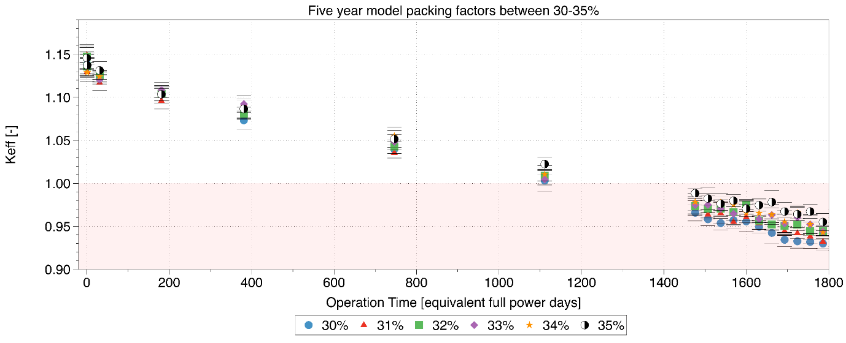
Figure 13 – Original results based on the data of the U-Battery report
Figure 14 shows the same tests with a carbon density of 2.3 g.cm³.
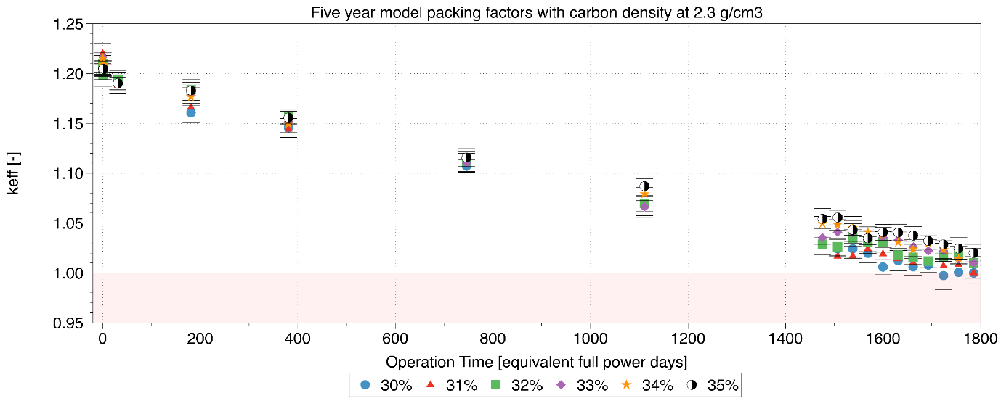
Figure 14 – Carbon at 2.3 g.cm³ lifecycle results
Comparing the Figure 13 and Figure 14, this provided the evidence that the original U-Battery report is based on a too idealistic value for the carbon density. The more realistic approach based on a literature survey on the graphite density leads to a clear reduction in the expected operational time of the reactor core from about 1800 equivalent full power days to 1200.

Acknowledgements
The authors would like to acknowledge the assistance given by The University of Manchester IT Services, for the use of the Computational Shared Facility and professional support. The developers of the Serpent code for their continued support throughout the. For funding gratitude is owed to the ESPRC under the Nuclear First program - EP/G037140/1.
References
Abdulla, A., Azevedo, I.L., Morgan, M.G., 2013. Expert assessments of the cost of light water small modular reactors. Proc. Natl. Acad. Sci. 110, 9686–9691. https://doi.org/10.1073/pnas.1300195110
Apse, V., Artisyuk, V., Kulikov, E., Kulikov, G., Shmelev, A., 2011. Lead Containing Mainly Isotope 208 Pb: New Neutron Moderator, Coolant and Reflector for Innovative Nuclear Reactors [WWW Document]. URL http://www.csvts.cz/spolecnosti/cns/jb/doc/papers/ENYGF2011/06_02_Kulikov_paper.pdf%5Cnpapers3://publication/uuid/37CABE29-4EC6-487B-AD92-B26EEF02066B (accessed 5.11.18).
ASM, 1997. ASM Specialty Handbook: Heat-Resistant Materials. ASM International.
AZO Materials, n.d. Properties Beryllium Oxide - Beryllia [WWW Document]. URL https://www.azom.com/properties.aspx?ArticleID=263 (accessed 5.11.18).
Brook, B.W., Alonso, A., Meneley, D.A., Misak, J., Blees, T., van Erp, J.B., 2014. Why nuclear energy is sustainable and has to be part of the energy mix. Sustain. Mater. Technol. 1, 8–16. https://doi.org/10.1016/j.susmat.2014.11.001
BÜRKHOLZ, A., 1966. Irradiation damage in beryllium oxide [WWW Document]. URL http://aei.pitt.edu/91153/1/3054.pdf (accessed 5.11.18).
Chakin, V., Rolli, R., Vladimirov, P., Moeslang, A., 2016. Tritium and helium release from beryllium pebbles neutron-irradiated up to 230 appm tritium and 3000 appm helium. Nucl. Mater. Energy 9, 207–215. https://doi.org/10.1016/j.nme.2016.07.007
Chakin, V.P., Melder, R.R., Belozerov, S. V, 2004. Experience of Beryllium Blocks Operabon in the SM and MIR Nuclear Reactors usefull for Fusion [WWW Document]. URL https://inis.iaea.org/collection/NCLCollectionStore/_Public/36/116/36116741.pdf (accessed 8.16.18).
Department for, Business, E., Strategy, & I., 2018. Advanced Nuclear Technologies [WWW Document]. URL https://www.gov.uk/government/publications/advanced-nuclear-technologies/advanced-nuclear-technologies (accessed 5.11.18).
Ding, M., Kloosterman, J.L., Kooijman, T., Linssen, R., 2011. Design of a U-Battery ® [WWW Document]. URL http://www.janleenkloosterman.nl/reports/ubattery_final_201111.pdf (accessed 5.11.18).
Drivers & Vehicle Standards Agency, 2017. Special types enforcement guide [WWW Document]. URL https://www.gov.uk/government/publications/special-types-enforcement-guide/special-types-enforcement-guide (accessed 5.5.18).
Elder, R., Allen, R., 2009. Nuclear heat for hydrogen production: Coupling a very high/high temperature reactor to a hydrogen production plant. Prog. Nucl. Energy 51, 500–525. https://doi.org/10.1016/j.pnucene.2008.11.001
G.H. LOHNERT, 1990. TECHNICAL DESIGN FEATURES AND ESSENTIAL SAFETY-RELATED PROPERTIES OF THE HTR-MODULE. Nucl. Eng. Des. 121 259-275 121, 259–275.
Gottlieb, S.C., Haugbølle, K., 2010. The repetition effect in building and construction works [WWW Document]. URL http://vbn.aau.dk/files/19224303/SBi_2010-03.pdf (accessed 5.11.18).
GrefTECH international, 2014. XT Super Fine Grain Graphite [WWW Document]. URL http://www.graftech.com/wp-content/uploads/2014/12/GRAFSTAR%25e2%2584%25a2-XT-Graphite-Sell-Sheet.pdf (accessed 5.5.18).
Henckens, M.L.C.M., van Ierland, E.C., Driessen, P.P.J., Worrell, E., 2016. Mineral resources: Geological scarcity, market price trends, and future generations. Resour. Policy 49, 102–111. https://doi.org/10.1016/j.resourpol.2016.04.012
IAEA, 2006. Thermophysical Properties of Materials for nuclear engineering. https://doi.org/ISBN 978–92–0–106508–7
Idaho National Laboratory, 2016. Thermal Properties of G-348 Graphite [WWW Document]. https://doi.org/INL/EXT-16-38241
Jackson, I., 2008. Nukenomics: The commercialisation of Britain’s nuclear industry. Progressive Media Markets Ltd.
Japan atomic energy research centre - JAERI 1332, 1994. Design of the HTTR.
Jensen, S.E., Nonbel, E., 1999. Description of the Magnox Type of Gas Cooled Reactor.
Kamyab, S., Nematollahi, M., 2012. Performance evaluating of the AP1000 passive safety systems for mitigation of small break loss of coolant accident using risk assessment tool-II software. Nucl. Eng. Des. 253, 32–40. https://doi.org/10.1016/j.nucengdes.2012.07.019
Lang, M., Xie, H., Dong, Y., 2017. Three Design Basis Accidents’ Analysis on the HTR-10GT. Sci. Technol. Nucl. Install. 2017, 1–13. https://doi.org/10.1155/2017/1686291
Leppänen, J., Pusa, M., Viitanen, T., Valtavirta, V., Kaltiaisenaho, T., 2015. The Serpent Monte Carlo code: Status, development and applications in 2013. Ann. Nucl. Energy 82, 142–150. https://doi.org/10.1016/j.anucene.2014.08.024
Locatelli, G., Bingham, C., Mancini, M., 2014. Small modular reactors: A comprehensive overview of their economics and strategic aspects. Prog. Nucl. Energy 73, 75–85. https://doi.org/10.1016/j.pnucene.2014.01.010
M.k.Cooper, A. r. P. and G.Z.A.S., 1963. The effect of neutron irradiation on the thermal conductivity of beryllium oxide. J. Nucl. Mater. 64, 320–326.
Merk, B., Litskevich, D., Whittle, K.R., Bankhead, M., Taylor, R.J., Mathers, D., 2017. On a long term strategy for the success of nuclear power. Energies 10, 1–19. https://doi.org/10.3390/en10070867
NDA, 2012. Assessment of the geological disposal facility implications for the products of reprocessing compared to direct disposal of the spent fuel. Didcot. https://doi.org/NDA Technical note no. 16518861
Nonbel, E., 1996. Description of the Advanced Gas Cooled Type of Reactor [WWW Document]. URL http://www.iaea.org/inis/collection/NCLCollectionStore/_Public/30/052/30052480.pdf (accessed 5.11.18).
Nuclear Energy Agency, 2010. Applying Decommissioning experience to the Design and Operation of new power plants [WWW Document]. https://doi.org/NEA No. 6924
Nuclear energy insider, 2016. Moltex Energy sees UK, Canada SMR licensing as springboard to Asia _ Nuclear Energy Insider [WWW Document]. URL https://analysis.nuclearenergyinsider.com/moltex-energy-sees-uk-canada-smr-licensing-springboard-asia (accessed 5.11.18).
Pigg, J.C., Garrison, A.K., Austermann, S.B., 1973. Radiation damage in beryllium oxide single crystals. J. Nucl. Mater. 49, 67–74.
Pohanish, R.P., 2017. Sittig’s Handbook of Toxic and Hazardous Chemicals and Carcinogens. Elsevier.
PRYOR, B.S.H. and A.W., 1964. The effect of neutron irradiation on beryllium oxide. J. Nucl. Mater. 14, 96–110.
Savvatimskiy, A.I., 2005. Measurements of the melting point of graphite and the properties of liquid carbon (a review for 1963-2003). Carbon N. Y. 43, 1115–1142. https://doi.org/10.1016/j.carbon.2004.12.027
Schenk, W., Pott, G., Nabielek, H., 1990. Fuel accident performance testing for small HTRs. J. Nucl. Mater. 171, 19–30. https://doi.org/10.1016/0022-3115(90)90342-K
Theodosiou, A., Jones, A., Marsden, B., 2017. Thermal Oxidation of Nuclear Graphite: A Large Scale Waste Treatment Option [WWW Document]. PLoS One. https://doi.org/https://doi.org/10.1371/journal.pone.0182860
W. Rausch, S.U., 1967. Development of high temperature reactors in Germany [WWW Document]. URL http://aei.pitt.edu/91270/1/3493.pdf (accessed 7.21.18).
Ward, A. (Financial T., 2017. Nuclear plant nears completion after huge delays [WWW Document]. Financ. Times. URL https://www.ft.com/content/36bee56a-3a01-11e7-821a-6027b8a20f23 (accessed 5.5.18).
World Nuclear Association, 2018. Emerging Nuclear Energy Countries [WWW Document]. URL http://www.world-nuclear.org/info/Current-and-Future-Generation/Nuclear-Power-in-the-World-Today/ (accessed 5.5.18).
World Nuclear News, 2018. First HTR-PM vessel head in place [WWW Document]. URL http://www.world-nuclear-news.org/NN-First-HTR-PM-vessel-head-in-place-0401185.html (accessed 5.11.18).
Zhang, Z., Dong, Y., Li, F., Zhang, Z., Wang, H., Huang, X., Li, H., Liu, B., Wu, X., Wang, H., Diao, X., Zhang, H., Wang, J., 2016. The Shandong Shidao Bay 200 MWe High-Temperature Gas-Cooled Reactor Pebble-Bed Module (HTR-PM) Demonstration Power Plant: An Engineering and Technological Innovation. Engineering 2, 112–118. https://doi.org/10.1016/J.ENG.2016.01.020

