**Using Everyday Engineering Examples to Engage Learners on a MOOC**

Eann A. Patterson

School of Engineering, University of Liverpool, Liverpool, UK [eann.patterson@liverpool.ac.uk]

**Abstract**

A Massive Open Online Course (MOOC) on the laws of thermodynamics has been designed using the 5Es (Engage, Explore, Explain, Elaborate, Evaluate) lesson planning methodology and delivered using everyday engineering examples to provide familiar contexts for both a global cohort of more than three thousand learners ranging in age from teenagers to septuagenarians in 137 different countries plus a large class of 355 university undergraduates. In addition to the structured pedagogy, the MOOC included innovations in the use of practical exercises, that could be performed in the learner’s kitchen, and worked examples to enhance the learning experience. The MOOC was provided in parallel with an introductory undergraduate course and as an additional learning resource for the undergraduate students. A little less than one-fifth of the undergraduates participated in the MOOC and just over half of these responded that it would be an acceptable substitute for traditional lectures. The percentage completing the MOOC was relatively high at 28% compared to 21% for other MOOCs on the same platform, which is attributed to the pedagogy and strong support for social learning based on a survey of fully participating learners in the last week of the five-week course.

Keywords: MOOC, thermodynamics, everyday examples, constructionist learning, engineering, undergraduate, context, practical exercises, social learning.

1. **Introduction**

Perhaps the first Massive Open Online Course (MOOC) to be offered by a university was 'Connectivism and Connective Knowledge' by Siemens and Dawnes at the University of Manitoba [1] in 2008. In the intervening years, there has been an explosion in the provision of MOOCs, for instance Harvard and MIT offered 68 MOOCs between 2012 and 2014 [2], and more than 1000 courses from 112 universities were offered by Coursera during 2015 [3]. MOOCs are characterised by being open, i.e. free, provided via the internet, having a large number of students and a high level of social interaction. The latter differentiates MOOCs from other types of Open Educational Resources (OER), such as Open Course Ware (OCW), because a MOOC includes learning support for a large number of learners within a defined time period [1]. There is considerable scepticism about the appropriateness of MOOCs, especially amongst academic leaders; however, attitudes amongst academic staff has been improving, particularly amongst instructors who have taught an on-line course though some still report that MOOCs result in less learning and lower quality student-teacher interaction than in face-to-face courses [3]. This mixed set of views on MOOCs perhaps derives from a lack of clarity about their purpose and the appropriate pedagogy to deploy in their provision [4,5]. There has been significant discussion about the role of MOOCs and two purposes appear most frequently, namely to democratize higher education, in both economic and geographic terms, and to provide learning opportunities for professionals following graduation [3]. Perhaps unsurprisingly, the majority of MOOCs in engineering are in fields associated with information and communication technologies [6] and there is a relatively small number in the engineering sciences. Against this background, this paper reports on the design and implementation of a MOOC on the laws of thermodynamics, in which the constructionist learning approach based on 5Es (Engage, Explore, Explain, Elaborate, Evaluate) lesson planning [7] was combined with teaching in the context of everyday engineering examples [8]. The feedback from learners and the course statistics imply that the pedagogy enhanced student motivation, understanding and participation in terms of gender, age and culture.

**2. Background**

Thermodynamics has traditionally been perceived as a difficult subject to learn and teach by university students and professors respectively. While the importance of the laws of thermodynamics to almost every sector of science and engineering is recognised by the cognoscenti, the laws and their implications are almost unknown to the general public. In his classic lecture and book, 'Two Cultures', Snow equates the significance in our culture of the second law of thermodynamics to Shakespeare's plays and laments that, while most of those members of society who are educated in the sciences are aware of Shakespeare's work, very few of those educated in the humanities are aware of the second law [9]. Some [10, 11] have argued that the inability of scientists and engineers to express the second law in simple and unambiguous terms is, in part, responsible for the general lack of understanding of it. Hence, the motivation when deciding to offer a MOOC on the laws of thermodynamics was to attempt to address these issues. In other words, to attempt provide a resource that would support an increase in the public understanding of engineering and science and at the same time a learning resource for engineering undergraduate students being introduced to the laws of thermodynamics in a traditional university course. The former motivation aligns with democratization of higher education, which is a common goal of MOOCs, but combining it with the latter motivation raises the level of ambition for the learning relative to most MOOCs that are focussed on the democratization role. This combination of roles made it important to consider the appropriate pedagogical approach for the MOOC so that it would enhance the confidence of non-engineers and non-scientists that they understand the implications of the laws of thermodynamics. In particular, it was important to avoid the potential confusion caused by introducing engineering and scientific artefacts and terminology that traditionally are seen as integral to teaching thermodynamics; but for many learners, add layers of apparently complicated concepts and information that obscure the broader significance of the laws of thermodynamics.

At the time of this study, introductory thermodynamics was taught to all undergraduate students entering the School of Engineering at the University of Liverpool as part of a module entitled Fluid Mechanics with Thermodynamics which had a credit value of fifteen in a credit system where an academic year is 120 credits. For some years, thermodynamics had been taught over a six-week period with three hours per week of student-staff contact in a lecture theatre and a single three-hour laboratory exercise that the students performed in groups of five or six. The three hours per week in the lecture theatre was divided into two fifty-minute lectures and a fifty-minute example class (in common with most universities, ten minutes of each timetable hour is used for students to move from one activity to another). In an attempt to overcome the traditional obstacles encountered by university students when learning thermodynamics, no attempt is used to follow a traditional textbook and instead 'The Laws of Thermodynamics: A Very Short Introduction' by Atkins [12] was recommended. This book is designed for the lay-person, which after all is the status of students when they enter the course, and is short enough to read from cover-to-cover in a small number of sessions. The lecture course followed the structure of the book and used everyday engineering examples [8] to engage students, explore topics, explain principles, elaborate through analysis and then to evaluate student understanding through setting problems, i.e. following the 5Es lesson plan [7]. This approach was adopted in the lecture course because previous research had shown that in classes where this approach was used significantly more students rated their learning as high or significant than in control classes (85% vs. 70%, χ2=4.08, p<0.05) when there was no significant difference between control classes (67% vs. 62%) [13]. This earlier study also found that there was no significant correlation of the level of difficulty with student understanding or participation when the approach was used, which implies that it would be effective in MOOCs where many learners might find the concepts difficult. Engaging students in a lecture course on introductory thermodynamics using everyday examples requires the use of a wide range of artefacts in the classroom, such as flasks of coffee, water bottles and cups (isolated, closed and open systems), several packets of balloons (entropy of a system) and a hair dryer (heat and mass flow). Many lesson plans and everyday examples are available via a series of booklets and on-line [14], not just for thermodynamics [15] but also introductory solid mechanics [16], dynamics[17] and fluid mechanics [18]. However, their use in a large lecture theatre with more than 300 students is challenging even with live digital cameras available to relay the action from the front of the lecture theatre to a large screen. Therefore, the MOOC offered the opportunity to provide access to these demonstrations and explanations in a format that students could review as often as they wanted and provide the instructor with greater control of the demonstration. Similarly, timetabling a large cohort of students though laboratory experiments creates challenges in terms of the ratio of students to equipment and to demonstrators. So, the concept of designing practical exercises that could be performed by MOOC participants individually in a domestic kitchen with the same objectives as a traditional laboratory class, i.e. to acquire skills in conducting experiments, acquiring and processing data, and to illustrate some thermodynamic principles, seemed to be a worthwhile challenge that could lead to a paradigm shift in teaching and learning strategy. The intention was to blend the modes of delivery for the university students so that they could participant in face-to-face learning opportunities and on-line activities together with a wider learning community. Others have used some level of blending of either pedagogies or on-line and face-to-face teaching, for instance Rayyan et al [19] and Delgado Kloos et al [20] respectively, but this study pushes these ideas further.

3. **Course Design**

The intention, as described in above, was both to increase public understanding of thermodynamics and to provide a learning resource for undergraduate students. Hence, the latter purpose implied the syllabus for the MOOC needed to match the syllabus of the undergraduate module in order to be useful and effective for the undergraduates. The MOOC was delivered using the FutureLearn platform and there was a strong steer from FutureLearn to offer a four- or five-week course based on their statistical analysis of successful completion in previous courses. So, it was decided to offer a five-week MOOC synchronized to weeks 2 to 6 of the undergraduate course. Each week of the five-week MOOC consisted of approximately fifteen short steps. The steps were a mixture of short videos (less than 5 minutes), audio recordings, articles, worked examples and on-line discussions. The detailed structure and content of the MOOC is shown in Table 1.

The first week of the undergraduate course was used to brief the undergraduate students and to encourage them to register for the MOOC. The university course started at the beginning of second semester (February 2016) for about 355 undergraduate students in their first year of a wide variety of engineering programmes including aerospace engineering, civil engineering, industrial design, mechanical engineering, and mechatronics. The teaching schedule and syllabus followed in the undergraduate course is shown in Table 2. The only substantive change relative to previous years was the replacement of a three-hour laboratory exercise on heat exchangers with three short practical exercises for students to do as homework. The undergraduate course also included weekly problem-sheets that each contained four problems designed to allow students to practice their problem-solving skills and test their understanding of the thermodynamics topics taught that week. The example classes were used to demonstrate problem-solving skills applied to the relevant thermodynamics topics. In addition, small group tutorials were held each week to support the undergraduate students in this problem-solving activity. The tutorials were one hour long and provided by all members of the academic staff in the School of Engineering who were supplied with annotated solutions to the problems. The tutorials also supported a similar approach in a parallel course in mechanics of solids.

The problem-solving formed the last ‘E’, Evaluate in the 5Es learning scheme [7], in which students evaluate their learning. The first four ‘E’s, Engage, Explore, Explain and Elaborate were used to structure each lecture with everyday engineering examples providing context for the thermodynamics. The same approach was employed in designing the approximately fifteen steps in each week of the MOOC, except that the small size of each step meant that only a single ‘E’, or sometimes a transition from one ‘E’ to the next, could be contained in a step. Instead, a cluster of MOOC steps represented the progression through the first four ‘E’s and each week contained at least a couple of clusters, as shown in Table 1. In the MOOC, the fifth ‘E’ was provided using problems that learners were asked to solve prior to watching a video in which the instructor worked through the solution using Clear Screen TechnologyTM. These worked examples were of the same level of difficulty as those set on the problem-sheets for the undergraduate students. Unlike in the undergraduate course, learners on the MOOC were introduced to the 5Es concept and its use with everyday engineering examples as part of the introduction to the course and the steps were labelled to indicate which ‘E’ they addressed.

Practical exercises are an important feature of most engineering courses and so it was believed to be important to provide an equivalent opportunity for learners on the MOOC. However, MOOC learners do not have access to engineering laboratories and so an alternative approach was taken that involved using their kitchen at home as their laboratory. A series of three practical exercises were designed to be performed using standard kitchen equipment plus three additional items, namely a digital barbeque thermometer, a plumber’s manometer and a domestic plug-in energy meter. These three items can be purchased in the UK for less than £20 in total and were loaned as a set to each undergraduate student while on-line sources for purchasing them were recommended in the MOOC. The objectives of the three practical exercises were (i) to evaluate the efficiency of a kettle; (ii) to obtain an estimate of the universal gas constant and the value of absolute zero in degrees Celsius; (iii) to determine the overall heat transfer coefficient of a coffee cup. An instruction sheet was prepared for each practical exercise in the usual way and the procedures tested by the instructor, then individually by a small group of post-graduate students followed by a small group of summer interns who were second year undergraduate students in engineering. The students who performed the tests were simply given the instruction sheet, the additional three items and asked to complete the exercises and provide feedback. This process of test and review was important because these practical exercises were designed to be performed without the support of a demonstrator. No substantial changes were made to design of the practical exercises as a result of the tests and reviews. However, the instruction sheets were revised and for the MOOC these sheets included photographs of each stage in the experiment. MOOC learners were invited to post their results on a media wall (see figure 1) while undergraduate students were required to submit a two-page technical report on each practical exercise, which together were worth five percent of the 15-credit module.

The practical exercises were scheduled for weeks 1, 2 and 4 of the MOOC with quizzes replacing them in weeks 3 and 5. These quizzes were the only form of assessment in the MOOC whereas the undergraduate course was assessed using a written examination at the end of the academic year. The examination, which was worth 90% of the 15-credit module, covered both Fluid Mechanics and Thermodynamics. The thermodynamics portion represented forty percent of the undergraduate course, i.e. 6 credits or 60 hours of total student effort. Nominally, the time allocation was 21 hours in the lecture theatre (two 1-hour lectures and a 1-hour example class each week for 6 weeks plus a revision week at the end of the semester), three 3-hour practical exercises (including preparation of a report) and 75 minutes of examination time, leaving approximately 30 hours for private study including tackling the problem-sheets. The MOOC was designed to require 3 hours per week of engagement by learners.

The timeline for the design and development of the MOOC started with preparation of a storyboard in April 2015 followed by the production of articles, practical exercises and quizzes in summer 2015. About twenty-five 3-minute videos were filmed and edited in the last quarter of 2015 by the eLearning Unit at the University of Liverpool. The MOOC was offered for the first time at the beginning of February 2016.

4. **Results**

Learners on the MOOC were able to indicate when they had completed a step by ticking a box on-screen. On this self-declared basis, all of the steps in the MOOC were completed by 1006 learners, or about 28% of the 3,460 who declared completion of at least one step, which compares favourably with the 21% average for FutureLearn courses. Some demographic information was collected when learners enrolled in the MOOC and also in an end-of-course survey that learners were invited to complete when they reached week 5 of the course. The global distribution of active learners is shown by the temperature map in figure 2 and the distribution by age in figure 3. It can be observed that the age profile of those completing the enrollment survey is more skewed towards older learners than the for all FutureLearn courses. However, fully participating learners, i.e. those who self-declared completion of all steps in the course, were older with 35% over 65 and 75% over 45 years old.

The MOOC contained some significant innovations and hence, with ethical approval from the University, an on-line questionnaire was prepared specially to obtain feedback from MOOC learners who reached week 5 of the course. There were 1006 of these 'fully participating learners' of which 376 replied to the on-line questionnaire that was accessed via a link from the MOOC; however, about 115 respondents did not respond to the first four questions and 125 did not respond to at least one of the remaining questions so that there are only about 260 complete responses to the questionnaire (see Table 3). The distribution of highest formal qualifications of the fully participating learners were normally distributed around a Master’s degree in a very wide range of subjects from biologists to historians including some engineers. Two-thirds were male.

Just over 6% of respondents signed up to support their undergraduate studies and of these 24% strongly agreed and 53% agreed that the MOOC enhanced their understanding of thermodynamics, with the remainder being neutral (see Table 4). When asked if the MOOC could replace traditional lectures 56% agreed strongly or agreed, 33% were neutral and 11% disagreed. These numbers correspond approximately with the 53% of undergraduate students who declared that they did not continue to attend the traditional lectures.

Most respondents (60%, 65% & 55% for practical exercises #1, #2 & #3 respectively) did not have access to the required equipment and did not perform the practical exercises (70%, 82% & 73% respectively). Nevertheless, almost half of respondents reported that the practical exercises contributed to their understanding of the topics (52%, 40% & 46% respectively). This result, which is tabulated in Table 5, might seem strange at first sight, but it should be noted that learners who completed the practical exercises posted their results and photographs on a media board (see figure 1) and discussed them on-line in the comments section of the relevant step so that others could learn from their experience. Hence, despite the relative low rate of completion (25%) of the practical exercises, they made an important contribution to learning. There was some concern at the outset that the undergraduate students would not perform the practical exercises at home; however slightly more students submitted at least one technical report in the thermodynamics (88% [=311/355]) than submitted the report for the single 3-hour laboratory class in fluid mechanics (81% [=288/355]), with only 7% (=24/355) of the undergraduate cohort failing to submit coursework in either fluid mechanics or thermodynamics. However, 19% (=67/355) only submitted a technical report on the first thermodynamic practical exercise. The average score in the module examination on the thermodynamics questions was 42.6% compared to the average for the previous year which was 40% and the corresponding averages for the examination scores on the fluid mechanics questions were 54.2% and 55%. Overall the average result in the module was 48.8% compared to 48% in the previous year. Students who failed the module were able to retake the examination and resubmit coursework during the summer vacation.

An additional question was inserted in the module feedback question for the undergraduate students which asked whether or not the student had enrolled in the MOOC and 17% of 87 respondents replied positively. This is a disappointingly low response rate for the module feedback forms but we can conclude that about 60 University of Liverpool undergraduate students enrolled in the MOOC, which correlates with the 6% in the MOOC survey who responded that they were following the MOOC to support their undergraduate students.

5. **Discussion**

5.1 *Implementation of innovations*

There were three main innovations introduced in the production and delivery of the MOOC. The most fundamental was the use of a pedagogy based on constructivist learning theory and, in particular, 5Es lesson plans [7] using everyday engineering examples to provide a context that is familiar to the learners on the MOOC and the students on the undergraduate module [8]. Previous research had demonstrated the effectiveness of this approach in the classroom/lecture theatre environment [13]; however, this is believed to be the first time it has been used in a MOOC. The 5Es lesson planning structure was modified by applying it to clusters of MOOC steps rather than a single lesson, which ensured that the steps provided logical development of ideas when taken in sequence. The use of everyday engineering examples created a common denominator to which most of the MOOC learners could relate their past experiences. This is important because research has shown that a lack of familiarity may induce students to panic about the context and fail to listen to the instruction being provided[21]. Hence, in teaching introductory engineering science, our task is to find the experiences that are common to the class and use them to illustrate engineering principles; however, this is difficult when the class consists of more than 3,400 people who vary in age from 13 to 78 and are in 137 different countries. It is important that the examples chosen should not be trivial or irrelevant because it has been found that the perceived usefulness of learning influences the motivation of students [22]. Hence, the choice of everyday examples is critical to provide a transparent connection to students' experience and a basis for straightforward implementation of engineering principles [8]. Well-chosen everyday examples provide familiarity and increase perception of relevance, which both increase student motivation, and also build on prior experiences. They also provide future observational opportunities that engage and then progress students around the learning cycle proposed by Honey and Mumford [23], i.e. having an experience, reviewing the experience, concluding from the experience and planning the next steps before having the experience again, and so on. A number of everyday engineering examples were common to the MOOC and the undergraduate lectures so as to reinforce the learning cycle for the students, including; a coffee flask, cup and water bottle to illustrate types of systems; a radiator in a central heating system to illustrate types of heat transfer; and balloons to demonstrate irreversibility. However, the MOOC offered the opportunity to use many more everyday examples including a car, a refrigerator and a shower, to discuss thermal efficiency, vapour cycles and statistical thermodynamics respectively.

The second major innovation was the deployment of practical exercises as homework assignments. These were integrated into the use of everyday examples by using familiar objects such as a kettle and a coffee cup in exercises #1 and #3. The use of plumber's manometer in exercise #2 involved something unfamiliar to most undergraduate students and MOOC learners. The feedback suggested that they found this exercise the most difficult to perform. There was a significant amount of social learning associated with these homework assignments, both amongst undergraduates who formed ad hoc groups to perform the experiments and MOOC learners who corresponded with one another (107 comments posted per practical exercise compared an average of 87 comments per step) and posted results on a media board (see figure 1). Indeed, the level of social learning was so high that although three-quarters of MOOC learners did not perform the experiments, overall 46% of MOOC learners reported that the experiments contributed to their understanding. This makes a clear case for including practical exercises in MOOCs on technical subjects providing familiar objects are used and good mechanisms are in place to support social learning.

The third innovation implemented in the MOOC was the use of a glass screen to present worked examples. This allowed the instructor to face and talk to the camera while solving a problem using the principles described in the prior steps. This approach was trademarked as Clear Screen TechnologyTM by the eLearning Unit at the University of Liverpool and involved the instructor writing the solution on a glass screen using chalkboard pens while being filmed through the glass. In editing the image was reversed so that the writing was no longer a mirror image (see figure 4). Six worked examples were included in the MOOC as steps 7, 10, 10, and 6 in weeks 1, 2, 4 and 5 respectively and as steps 5 and 9 in week 3 (see Table 1). The problems solved were different to those used in the example classes in the undergraduate course, so that they provided an additional learning resource for the undergraduate students. The comments on this method of delivery were overwhelmingly favourable with only a few learners complaining about the visibility of some of the text against the background. More statistical information on the feedback is given in the next section.

An unplanned and late innovation was the production of a recorded question and answer session at the end of each week. The questions were selected from the large number of comments made each week on the basis of the popularity, importance or difficulty. An audio recording was made with one of the instructor's postgraduate students asking the questions and the instructor answering them. The recording was added as an extra step at the end of each week on a week-by-week basis, as shown in Table 1.

5.2 *Feedback*

About 18% of learners, or about 670 people participating in the MOOC posted 6,500 comments in five weeks. Many of these comments were part of the processes of social learning mentioned in the previous section; however, many were comments and feedback on the course. The overwhelming majority of these feedback comments were positive though there were some critical and negative comments. In order to obtain a more objective view of the feedback, MOOC learners were invited to participate in on-line survey in week 5 and 376 responded.

All five weeks of the course were completed by 80% of the survey respondents and 45% of them found the material difficult or very difficult. However, 48% and 37% rated their experience of the MOOC in terms of learning as ‘excellent’ and ‘good’ respectively with similar responses in terms of their enjoyment (46% and 43% respectively). These results are summarised in figure 5 and support the earlier conclusion by Campbell et al [13] that the level of difficulty is not correlated to success when everyday engineering examples are used within 5Es lesson plans.

The survey asked respondents about the quality of the structure of the MOOC and 25% responded excellent, 55% well-structured and 15% ok, suggesting that the use of the 5Es lesson planning was effective. Everyday Engineering Examples were reported to be effective or very effective in enhancing their understanding by 88% of respondents. However, 38% of respondents felt that the Everyday Engineering Examples were not always relevant to their experiences although 55% felt they were always relevant. Hence, some additional effort to increase the relevance of examples would seem to be appropriate and might be expected to raise rates of understanding and course completion.

The use of Clear Screen TechnologyTM in the presentation of worked examples was reported to be effective or very effective by 83% of respondents and to contribute to learning very effectively or effectively by 75%, even though 31% found them difficult to follow (29%) or could not follow them at all (2%). 54% respondents would have liked to see more worked examples but 15% would not.

There were 6,500 comments were posted during the MOOC, or about one every 7.7 minutes. These comments ranged from questions seeking clarification or amplication on a topic, though personal insights on a topic to invited responses in discussion forums (for example steps 12 weeks 1, 2 & 4 in Table 1). Responses to many of these comments were provided by other participants on the MOOC; however, the course team monitored these responses, guided discussions where appropriate and addressed unanswered questions. The global distribution of participants in the MOOC meant that comments were made throughout the 24 hours of each day; however, the course team was active for about an hour every twelve hours. The response to questions and comments during the MOOC by the course team was rated as very important or important to 84% of the respondents. This contrasts to about 18% of learners posting comments. In other words, many more people are passive participants in the process of social learning and benefitted from it significantly. Perhaps this is a reason for the relatively high proportion of women (33%) amongst the fully participating learners compared to typical engineering and technology degree-level courses in the UK (15% and 14% respectively in 2012 [24] and 2014 [25]) since it is well-known that vicarious experiences are more important to women than men [26] and that supportive instructors increase the self-efficacy of women in maths-related subjects. Social support has also been found to be a predictor of female performance in physics courses [27].

5.3 *Instructor's perspective*

The design, writing, production and running of the MOOC was a major undertaking equivalent to designing and teaching a new course or module from a blank piece of paper. However, now that the MOOC exists it can be offered again with relatively little preparation. In a seminar given to his teaching colleagues towards the end of its production and before it went live, the author offered five reasons for wanting to teach a MOOC. Namely, (i) to educate the general public and in particular to increase public understanding of thermodynamics and its role in everyday life and global issues; (ii) to stimulate innovation in teaching in the light of a changing landscape in the UK in terms of student numbers, expectation and funding; (iii) to enhance the global profile and reputation of the School of Engineering at the University of Liverpool; (iv) to support recruitment and outreach and (v) to have some fun handling the challenges.

The data in figures 2 and 3 would suggest that the MOOC has reached a wide range of people and the level of social learning that occurred would support the conclusion that a significant level of education has been delivered to this section of the general public. In the process, awareness of the University of Liverpool and the School of Engineering has been raised with about 7,500 people who enrolled for the course in 137 countries and there is some anecdotal evidence, through email and face-to-face conversations at university open days, that this is impacting on recruitment through prospective students choosing to include the University of Liverpool in their list of universities to which they intend to apply. Since the first section of this discussion included a review of the innovations introduced during the production and delivery of the MOOC, it can be concluded that four out of five of the reasons were justified. The fifth reason about the fun involved in meeting the challenge is harder to quantify. Undoubtedly, the skill of speaking to a camera takes some practice and there is a reward in terms of achievement and satisfaction in producing high-quality video clips that connect together to tell a story. However, the unexpected reward was the enjoyment of the interaction with the learners around the world during the course. This was because some of their questions, including (or perhaps especially) the tangential ones, stimulated thinking about concepts in new ways and increased the instructor's knowledge and understanding. Hyde has suggested that ideas should be considered as gifts in science and that the exchange of gifts has a positive impact on the feelings of the donor and recipient[28]. This occurred in the MOOC both between the instructor and the learners as well as between learners; whereas, in the author's experience, this is a culture that has been largely lost from the undergraduate classroom. This is in part a consequence of the increasing size of undergraduate cohorts and is to the detriment of both the instructor and students. So, it was an unexpected pleasure to rediscover it on-line. It is acknowledged that this experience is contrary to those reported by some others [3] who found more and better interaction in face-to-face teaching; however, this is probably a function of the cohort size in face-to-face teaching and the structure of the on-line course.

6. **Conclusions**

The pedagogical design of a MOOC on introductory thermodynamics has been described and includes a number of innovative features, including planning clusters of steps in the MOOC to incorporate the constructionist learning concept of the 5Es, the use of practical exercises as 'homework' assignments and the deployment of Clear Screen TechnologyTM to work through problem solutions while talking to the camera. These innovations combined with a strong level of support for social learning resulted in a relatively high percentage completion for the MOOC (28%) with women making up one third of the population of fully participating learners who completed 80% or more of the 75 MOOC steps that were delivered over five weeks.

The MOOC was designed for delivery in parallel with an undergraduate cohort of about 350 students at the University of Liverpool. The same curriculum was used for both courses and the MOOC provided an additional learning resource for the undergraduates, which relatively few of them used (17%) and the MOOC appeared to have no impact on the examination results. However, the undergraduates were required to complete the practical exercises and the percentage completion was similar to traditional laboratory classes. These results imply that it is possible for undergraduate students to be set practical exercises as homework assignments with the same objectives as traditional laboratory classes, i.e. to acquire experimental skills, to collect and process data, and to illustrate a scientific principle. Only about a quarter of learners on the MOOC completed these exercises but nearly half of learners (46%) declared that the exercises contributed to their learning. It is concluded that this occurred as a result of the social learning via media boards and comments in the MOOC. Therefore, it is recommended that practical exercises should be incorporated into MOOCs on technical subjects providing familiar objects are used and good mechanisms are in place to support social learning

The comments during the MOOC and the survey of fully participating learners suggest that the pedagogy enhanced the motivation, understanding and participation of learners across a wide age range and in 137 different countries. Hence, it made contribution to democratising higher education and enhancing public understanding of engineering science. The participation rate (17%) amongst undergraduates was disappointingly low but their feedback suggests that about half of them (56%) would consider the MOOC an acceptable replacement for traditional lectures; perhaps a compromise approach would be to deploy the MOOC as a co-requisite to a traditional course in a blended learning approach.

**References**

1. Zhan Z, Fong PSW, Mei H, Chang X, Liang T & Ma Z, Sustainability education in massive open online courses: ac content analysis approach, *Sustainability*, 7:2274-2300, 2015.
2. Hansen JD & Reich J, Democratizing education? Examining access and usage patterns in massive open online courses, *Science*, 350(6265):1245- 1248, 2015.
3. Evans S & Myrick JG, How MOOC instructors view pedagogy and purposes of massive open online courses, *Distance Education*, 36(3):295-311, 2015.
4. Sinclair J, Boyatt R, Rocks C et al, Massive open online courses: a review of usage and evaluation, *IJ Learning Technology*, 10(1):71-93, 2015.
5. Literati, I., Implications of massive open online courses for higher education: mitigating or reifying educational inequalities? *Higher Education Research & Development*, 34(6):1164-1177, 2015.
6. Borras-Gene O, Martinez-Nunez M & Fidalgo-Blanco A, new challenges for the motivation and learning in engineering education using gamefication in MOOC, *IJ Engineering Education*, 32(1B):501-512, 2016.
7. Atkin JM & Karplus R, Discovery or invention? *Science Instructor*, 29(5):45-47, 1962.
8. Patterson EA, Campbell PB, Busch-Vishniac I & Guillaume DW, The effect of context on student engagement in engineering, *European J. Engineering Education*, 36(3):211-224, 2011.
9. Snow CP, *The Two Cultures: and A Second Look*, Cambridge University Press, Cambridge, 1964.
10. Uffink J, Bluff your way in the second law of thermodynamics. *Studies in History and Philosophy of Science Part B: Studies in History and Philosophy of Modern Physics*, *32*(3), 305-394, 2001.
11. Akih-Kumgeh B, Toward improved understanding of the physical meaning of entropy in classical thermodynamics, Entropy 16(7):270, 2016.
12. Atkins P., *The laws of thermodynamics: a very short introduction*, Oxford: Oxford University Press, 2010.
13. Campbell PB, Patterson EA, Busch Vishniac I, Kibler T, Integrating Applications in the Teaching of Fundamental Concepts, *Proc. 2008 ASEE Annual Conference and Exposition*, (AC 2008-499), 2008.
14. <https://realizeengineering.blog/everyday-engineering-examples/> (accessed 17th April, 2018).
15. Patterson, E.A., (ed), *Real Life Examples in Thermodynamics*, East Lansing: Michigan State University, 2010.
16. Patterson, E.A., (ed), *Real Life Examples in Mechanics of Solids*, East Lansing: Michigan State University, 2008.
17. Patterson, E.A., (ed), *Real Life Examples in Dynamics*, East Lansing: Michigan State University, 2009.
18. Patterson, E.A., (ed), *Real Life Examples in Fluid Mechanics*, East Lansing: Michigan State University, 2011.
19. Rayyan S, Fredericks C, Colvin KF, Liu A, Teodorescu R, Barrantes A, Pawl A, Seaton DT & Pritchard DE, A MOOC based on blended pedagogy, *J. Computer Assisted Learning*, 32:190-201, 2016.
20. Delgado Kloos D, Muniz-Merino PJ, Alario-Hoyes C et al, Mixing and blending MOOC technologies with face-to-face pedagogies, *Proc. 2015 IEEE Global Engineering Education Conference*, 967-971, 2015.
21. Rosser SV, Gender issues in teaching science, in S. Rose. and B. Brown (eds.), *Report on the 2003 Workshop on Gender Issues in the Sciences*, pp. 28-37, 2004.
22. Wigfield A, Eccles JS, Expectancy-value theory of motivation, *Contemporary Educational Psychology*, 25(1): 68-81, 2000.
23. Honey P, Mumford A. *The Manual of Learning Styles* 3rd Ed. Peter Honey Publications Limited, Maidenhead, 1992.
24. WISE (2012). *Women in Science, Technology, Engineering & Mathematics: from Classroom to Boardroom*. UK Statistics 2012, accessed on 17th April 2018 at <https://www.wisecampaign.org.uk/resources/2012/12/uk-statistics-2012>
25. WISE (2014). *Women in Science, Technology, Engineering & Mathematics: from Classroom to Boardroom*. UK Statistics 2014, accessed on 17th April 2018 at [https://www.wisecampaign.org.uk/resources/2015/07/wise-statistics-2014](https://www.wisecampaign.org.uk/resources/2015/07/wise-statistics-2014%20)
26. Zeldin, A.L. & Pajares F., Against the odds: self-efficacy beliefs of women in mathematical, scientific and technological careers, *Am. Education Res. Journal*, (1):215-46, 2000.
27. Hazari, Z., Tai, R.H. & Sadler P.M., Gender differences in introductory university physics performance: the influence of high school physics preparation and affective factors, *Science Education* 91(6):847-76, 2007.
28. Hyde L, *The Gift: Creativity and the Artist in the Modern World*, London: Cannongate, 2012.
29. Delanda, M., 'The Storm in the Computer’ in *Philosophy and Simulation: The Emergence of Synthetic Reason*, London: Continuum, 2011.
30. Braun, S., Ronzheimer, J.P., Schreiber, M., Hodgman, S.S., Rom, T., Bloch, I. & Schneider, U., Negative absolute temperature for motional degrees of freedom, *Science*, 339(6115):52-55, 2013.

Table 1: Storyboard for MOOC on Energy: Thermodynamics in Everyday Life

|  |  |  |  |  |  |
| --- | --- | --- | --- | --- | --- |
| **Wk 1** | **Step 1: Video** [Engage] | **Step 2: Video** | **Step 3: Video** [Engage] | **Step 4: Video** | **Step 5: Video** [Explore] |
| **Energy conservation** | Course Introduction, a brief overview of course (02:42) | Tips to help you learn (00:41) | Exploring energy issues in two interviews with researchers (06:22) | Introduction to the week's content (00:57). | What is energy? Discussion of the many forms of energy (03:36) |
| **Step 6: Article** [Explain] | **Step 7: Video** [Elaborate] | **Step 8: Video** [Engage] | **Step 9: Video** [Explore] | **Step 10: Video** [Engage/Explore] |
| 1st law equation introduced for a banana eating cyclist. | Worked example: air-fuel mixture in rigid container (15:18). | 0th law & Thermal Equilibrium introduced over coffee (02:33) | Temperature scales and thermometers in laboratory (02:24) | Introduction to statistical thermodynamics in shower (03:29) |
| **Step 11: Audio** [Elaborate] | **Step 12: Discussion** [Evaluate] | **Step 13: Article** [Evaluate] | **Step 14 : Article** | **Step 15: Audio** |
| Introduction to next step (03:51). | Discussion forum on chains of energy transformation. | Practical exercise on energy balance and efficiency. | Wrap up & review of week | Question & answer session based on comments (06:51) |

|  |  |  |  |  |  |
| --- | --- | --- | --- | --- | --- |
| **Wk 2** | **Step 1: Video** | **Step 2: Video** [Engage] | **Step 3: Video** [Engage/Explore] | **Step 4: Video** [Explore/Explain] | **Step 5: Article** [Explore/Explain] |
| **Thermodynamic systems** | Recap on previous week and introduction to new week (01:09) | Where does our energy come from? National energy supply (03:15) | Simple systems for complex processes: defining systems (02:16) | Natural energy storage: internal energy & heat capacity (04:41 ). | Summary of chapter 1 in [27] |
| **Step 6: Video** [Explain] | **Step 7: Article** [Elaborate] | **Step 8: Video** [Engage/Explore] | **Step 9: Article** [Explain] | **Step 10: Video** [Elaborate] |
| Bombs & enthalpy: in calorimeter laboratory (02:56). | Concepts of piston, spring and shaft work. | Cycles that work including steam engine at Quarry Bank Mill (02:42) | Explanation of gas cycles in pressure-volume domain (02:24) | Worked example: combustion in a cylinder (08:55) |
| **Step 11: Audio** [Elaborate] | **Step 12: Discussion** [Evaluate] | **Step 13: Article** [Evaluate] | **Step 14 : Article** | **Step 15: Audio** |
| Introduction to next step (02:33). | Discussion forum on Euclid's first axiom and zeroth law. | Practical exercise on gas constant & absolute zero. | Wrap up & review of week | Question & answer session based on comments (06:37) |

|  |  |  |  |  |  |
| --- | --- | --- | --- | --- | --- |
| **Wk 3** | **Step 1: Video** | **Step 2: Video** [Engage] | **Step 3: Video** [Explore] | **Step 4: Article** [Explain] | **Step 5: Video** [Elaborate] |
| **Energy flows** | Recap on previous week and introduction to new week (01:08) | Heat and mass flows: hair-dryers and jet engines (03:20) | Heat transfers associated with a bathroom radiator (05:53) | A watched kettle never boils: Leidenfrost effect. | Worked example: double-glazed window (17:03) |
| **Step 6: Video** [Engage/Explore] | **Step 7: Article** [Elaborate] | **Step 8: Article** [Elaborate] | **Step 9: Video** [Elaborate] | **Step 10: Video** |
| Steady flow energy explained via a jet pack (01:34). | Energy and mass: how mass effectively transport energy | How a jet engine works - short introduction & recommended urls | Worked example: hand-dryer (07:49) | Review of first of law of thermodynamics for a system (09:14) |
| **Step 11: Quiz** [Evaluate] | **Step 12: Video** [Evaluate] | **Step 13: Article** | **Step 14 : Audio** |  |
| Five multiple-choice questions based on first three weeks. | Introduction to perpetual motion design project (03:56). | Wrap up & review of week. | Question & answer session based on comments (07:32) |  |

|  |  |  |  |  |  |
| --- | --- | --- | --- | --- | --- |
| **Wk 4** | **Step 1: Video** | **Step 2: Video** [Engage] | **Step 3: Video** [Explore] | **Step 4: Video** [Explain] | **Step 5: Video** [Explain] |
| **Machines & efficiency** | Recap on previous week and introduction to new week (00:49) | What all the world desires: power: intro to second law (03:21) | Entropy: arising from Clausius statement of 2nd law (03:23) | Sneezing in the library: explanation of entropy (02:05). | Penguins and entropy: Boltzmann's definition of entropy (04:31) |
| **Step 6: Video** [Explain] | **Step 7: Video** [Explore/ Explain] | **Step 8: Article** [Elaborate] | **Step 9: Audio** [Elaborate] | **Step 10: Video** [Elaborate] |
| Power cycles: power stations as giant steam engines (03:03). | Refrigeration cycles: moving energy from cold to hot spaces (02:25) | Ideal performance: thermal efficiency & Carnot efficiency. | Power station losses (06:19) | Worked example: spark ignition engine (07:57) |
| **Step 11: Audio** [Elaborate] | **Step 12: Discussion** [Evaluate] | **Step 13: Article** | **Step 14 : Article** | **Step 15: Audio** |
| Introduction to next step (03:50) | Discussion forum on socio-economic examples of entropic decay . | Practical exercise on overall heat transfer coefficient of coffee cup. | Wrap up & review of week. | Question & answer session based on comments (08:17) |

|  |  |  |  |  |  |
| --- | --- | --- | --- | --- | --- |
| **Wk 5** | **Step 1: Video** | **Step 2: Video** [Engage] | **Step 3: Article** [Explore/Explain] | **Step 4: Video** [Explain] | **Step 5: Article** [Elaborate] |
| **Available energy & beyond zero** | Recap on previous week and introduction to new week (01:22) | Spontaneous change: on cheating the second law (02:16) | Gibbs Energy and its derivation. | Living off Gibbs Energy: coupling processes (02:09). | Gibbs function: derivation of isentropic relations for ideal gas. |
| **Step 6: Video** [Elaborate] | **Step 7: Video** [Engage] | **Step 8: Article** [Explore] | **Step 9: Video** [Explain] | **Step 10: Article** [Elaborate] |
| Worked example: air-powered car (13:13) | Third law: no one really cared until...superconductivity (03:21 | Superconductivity: short introduction and recommended urls | Approaching absolute zero: three methods explained (05:58) | Beyond absolute zero: article from Science [28] |
| **Step 11: Quiz** [Evaluate] | **Step 12: Article** | **Step 13: Video** | **Step 14 : Audio** |  |
| Five multiple-choice questions based on last two weeks. | Wrap up & review of week. | Course farewell (01:46). | Question & answer session based on comments (11:24) |  |

Table 2: Teaching schedule for thermodynamics portion of undergraduate module

|  |  |  |  |
| --- | --- | --- | --- |
| **Week** | **Activity** | **Title** | **Topics covered** |
| Week 1 | Lecture #0 | Introductory Lecture  FutureLearn & Labs | Recommended reading & on-line learning materials. Basic concepts of thermodynamics, including systems, state, state postulates, equilibrium, process, cycle, pure substance and ideal gas**.** |
| Example class | Piston-cylinder analysis |  |
| Week 2 | Lecture #1 | Zeroth law | Thermal equilibrium, zeroth law, temperature scales, thermometers, diathermic and adiabatic, introduction to statistical thermodynamics, Boltzmann's distribution, ideal gas law. |
| Example class | Analysis for practical #1 |  |
| Lecture #2 | First law | Concept of work & work capacity, state functions, concept of heat, Joule's experiment, first law for an isolated system, concept of efficiency, global energy flux & greenhouse gas effect. |
| Week 3 | Lecture #3 | Energy Analysis | Equivalence of heat and work, heat transfer resulting from random motion of molecules and work from uniform motion, heat capacity. |
| Example class | Heat from hand clapping |  |
| Lecture #4 | Energy cycles | Piston-cylinder devices, quasi-static expansion of gases, gas cycles, polytrophic processes, enthalpy. |
| Week 4 | Lecture #5 | Heat transfer | Conduction, convection & radiation. Fourier's law, Newton's law of cooling, heat transfer through layered structures, Stefan-Boltzmann law. |
| Example class | Conducting wire |  |
| Lecture #6 | Mass transfer | Einstein's equation. Conservation of mass. Flow energy, steady flow energy equation. Nozzles, diffusers, turbines, compressor & throttles. |
| Week 5 | Lecture #7 | Second Law | Clausius & Kelvin statements of the 2nd law, concept of entropy, generic statement of 2nd law, irreversibility, Boltzmann definition of entropy. |
| Example class | Analysis for practical #3 |  |
| Lecture #8 | Heat engines & pumps | Vapour power cycle, external combustion engines, efficiency of heat engines, refrigerators and heat pumps. |
| Week 6 | Lecture #9 | Free Energy | Free/available energy, Gibbs Energy, Helmholtz Energy & coupled processes. Isentropic relations for pressure, temperature and volume. Maxwell's demon. |
| Example class | Entropy in tyre inflation |  |
| Lecture #10 | Third Law | Third law, superconductivity, routes to absolute zero, research on negative absolute temperatures. |

Table 3: Data relating to number of participants in MOOC

|  |  |  |
| --- | --- | --- |
| Active  learners | 3,460 | MOOC participants declaring completion of at least one step |
| Fully participating learners | 1,006 | MOOC participant declaring completion of all steps |
| Active survey respondents | 376 | Fully participating learners who responded to at least one question on exit survey |

Table 4: Percentage responses regarding enhancement of learning and replacement of traditional lectures from fully participating learners who responded to all questions on exit survey and who stated they pursued the MOOC to support their undergraduate studies.

|  |  |  |
| --- | --- | --- |
|  | Enhanced learning of thermodynamics | Replacement for traditional lectures |
| Strongly agree | 24 | 14 |
| Agree | 53 | 42 |
| Neutral | 23 | 33 |
| Disagree | 0 | 11 |
| Strongly disagree | 0 | 0 |

Table 5: Percentage responses regarding practical exercises from fully participating learners who responded to all questions on exit survey (260 respondents).

|  |  |  |  |
| --- | --- | --- | --- |
|  | No access to equipment | Practical not performed | Practical contributed to understanding |
| Practical exercise #1 | 60 | 70 | 52 |
| Practical exercise #2 | 65 | 82 | 40 |
| Practical exercise #3 | 55 | 73 | 46 |

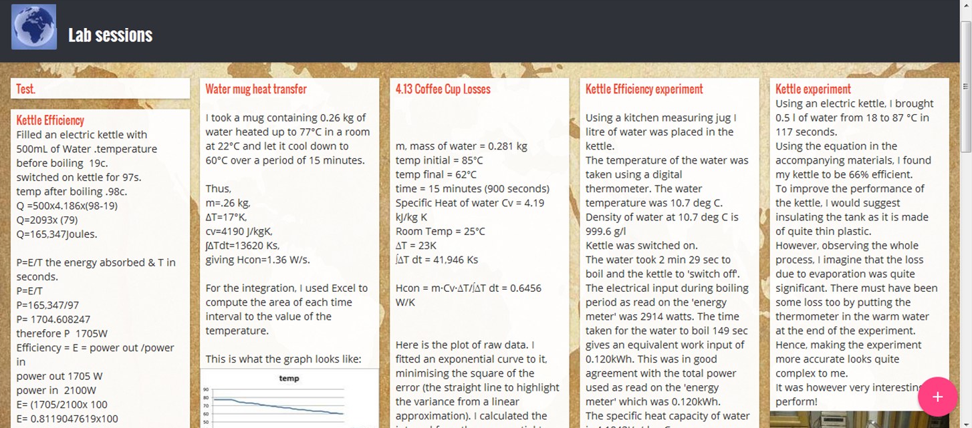

Figure 1: Extract from media wall in MOOC that support the practical exercises (steps 13 in weeks 1, 2 and 4), which is provided for illustrative purposes.



Figure 2: 'Temperature' map showing distribution of 2805 active learners with a maximum of 1255 in the UK and a minimum of 1, countries with zero learners are shown in grey and there are 137 countries have non-zero values.

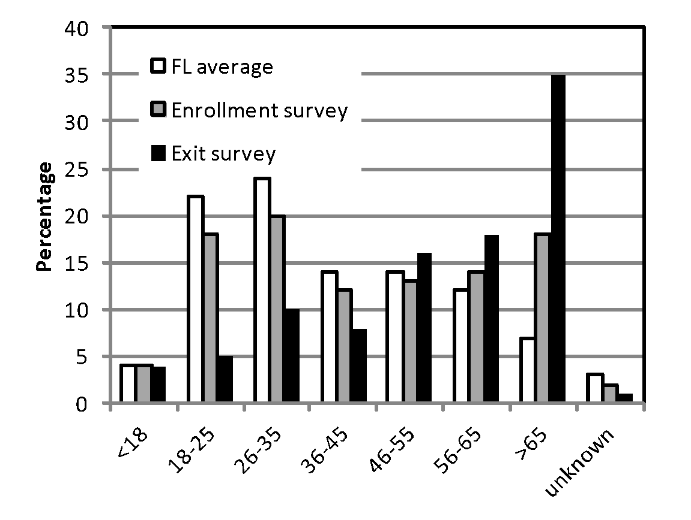

Figure 3: Participation in MOOC by age based on FutureLearn (FL) enrolment survey (3,460 responses) and author's exit survey (376 respondents).

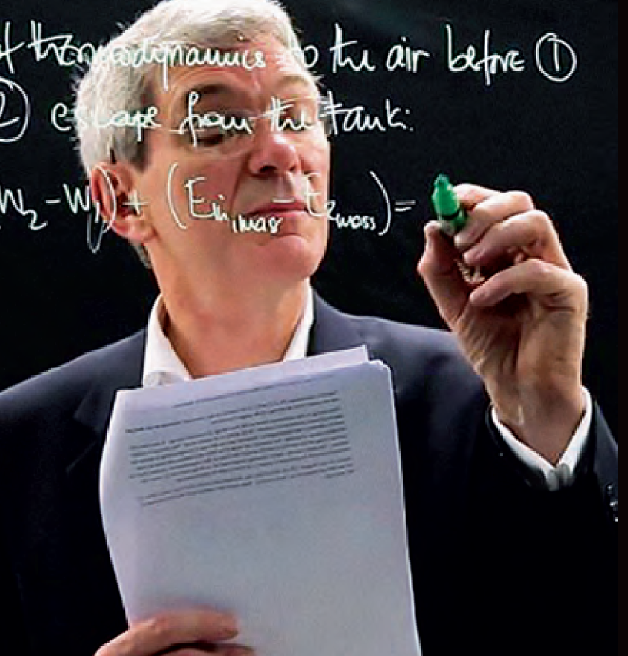

Figure 4: Instructor using Clear Screen Technology to illustrate solution to example problem (from step 6 in week 5)

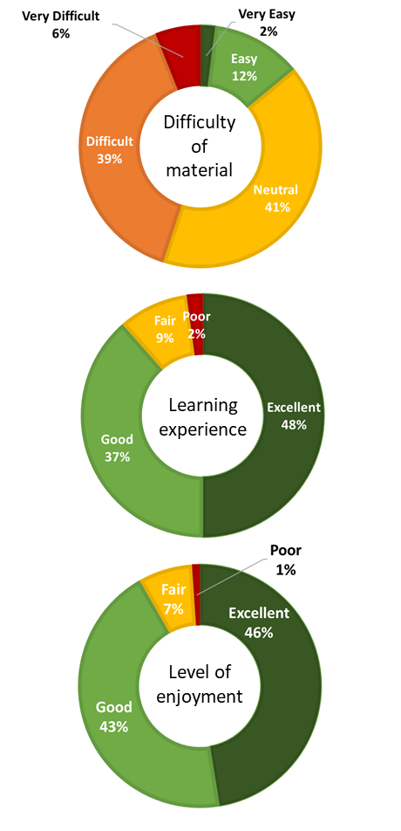

Figure 5: Feedback from fully-participating learners on difficulty of material (top); their learning experience (middle); and their enjoyment (bottom).