Fast Synthesis of Gibbsite Nanoplates and Process Optimization using Box-Behnken Experimental Design
Xin Zhang¹, Xianwen Zhang², Trent R. Graham³, Sebastien Kerisit¹, Carolyn I. Pearce⁴, B. Layla Mehdi¹, Nigel D. Browning¹, Sue B. Clark⁴, and Kevin M. Rosso^{1,}*
1 – Physical and Computational Sciences Directorate, Pacific Northwest National Laboratory, Richland, WA, USA
2 – School of Automobile and Transportation Engineering, Hefei University of Technology, Hefei, China
3 – The Voiland School of Chemical and Biological Engineering, Washington State University, Pullman, WA, USA;
4 – Energy and Environment Directorate, Pacific Northwest National Laboratory, Richland, WA, USA;

*Corresponding author. Email: kevin.rosso@pnnl.gov
Abstract.

Introduction
Gibbsite, α-Al(OH)₃, is an important natural and industrial material which is used in a wide variety of applications including as a flame retardant, adsorbent, polishing agent, filler, coating material, and rheology enhancer¹⁻⁵. Gibbsite has also been used in the biomedical industry, for instance, as a vaccine adjuvant and a substrate for direct treatment of stomach diseases^{6,7}. Gibbsite is furthermore one of the most important precursors for the preparation of various alumina products, such as high surface area α-Al₂O₃, which have a broad range of applications in the ceramics and metallurgical industries and as adsorbents or supports for catalysts^{3,8} [REFS]. Finally, gibbsite is a major constituent in high-level nuclear waste stored in large quantities at the Hanford Site, Washington, U.S.A., with future processing plans dependent on developing a predictive understanding of the growth and dissolution behavior of this material in particular⁹.
In most cases, the chemical behavior of gibbsite in these systems depends strongly on its physical properties such as particle size and shape. For example, for applications as an adsorbent, rheology enhancer, vaccine adjuvant, or precursors for the preparation of the high surface area α-Al₂O₃, highly nanoscale gibbsite is desirable^{3,8,10,11}. And for developing a fundamental understanding of gibbsite reactivity in complex systems such as nuclear waste, gaining precise control of particle crystallinity, size, morphology, and structural perfection of crystallite facets is critical^{3,11-21}. Therefore, there is a continuous interest in developing advanced methods to synthesize gibbsite materials that are uniform at the nanoscale.
Gibbsite has a hexagonal crystal structure, comprised of quasi-2D layers of edge-sharing octahedral Al³⁺(OH)₆ sheets each having 2/3 of the octahedral cavities occupied, and sheets are weakly bound together along the c-axis by hydrogen bonding. This structure thus tends toward a platelet crystallite habit, featuring a dominant (001) basal surface bounded by relatively stable (110) and (010) edge facets and less stable (100) facets [Peskleway et al 2003 Am. Min].
Gibbsite synthesis is achievable through various routes. Traditionally, it was prepared following the industrial process of manipulating Bayer liquors.^{14,16,19} Such gibbsite, usually several to hundreds of micrometers in size, shows very rough surfaces at the microscale.^{14,16} Because Bayer liquors entail very high concentrations of sodium aluminate and typically contain impurities, these undesirable components comprise a large fraction of the adsorbed residual.^{14,19} More recent synthesis protocols emphasizing size and shape control have been developed. For example, using more dilute sodium aluminate solution as the aluminum precursor, and adding a surfactant such as cetyl trimethylammonium bromide (CTAB) as a particle capping agent, prismatic “bar-shaped” gibbsite that is disproportionately extended along the c-axis and features prominent edge facets can be prepared hydrothermally.²² However, the size of these bar-shaped particles (longest dimension along c-axis) was up to several micrometers, with a specific surface area too low for most applications.
Growth of synthetic gibbsite particles is well known to be influenced by organic additives, suggesting another means of gaining control of physical properties. For example, particles approaching the nanoscale can be prepared by a simple thermal treatment of aluminum alkoxides mixed with hydrochloric acid (HCl).^{11,20,21,23} Generally, the procedure entails two steps: (1) obtain a clear sol via mixing an aqueous solution of aluminum alkoxides with HCl followed by stirring 7-10 days at room temperature; (2) heat the sol solution up to 100 ºC for around 3 days to precipitate gibbsite with a yield of 41%-66%. Typical products are nanoplates approximately 200 nm in diameter. However, this procedure is slow, consuming more than 10 days. A modified method shortens the synthesis period to 4 days by using a single aluminum alkoxide as the precursor and introducing an intermediate preheating step to accelerate the precursor's hydrolysis/peptization.³ However, although again nanoplates approximately 200 nm in size result, the yields decreases to less than 30%. Incidentally, platelets of larger size (up to 1 µm) could be prepared by repeating the seed growth procedure (step two above). However, in all these cases with organic additives, similar to the case for CTAB, there is a purity concern for the platelet surfaces due to organic precursor residue.
For clean inorganic routes, the most flexible approach entails use of amorphous aluminum hydroxide [Al(OH)₃] gel as the precursor and controlling the properties of the gibbsite product through aging time, temperature, and solution pH. Care must be taken in the gel preparation method, which can also influence the quality of the product. A gel precipitated by adding ammonia aqueous solution into aluminum nitrate hexahydrate [Al(NO₃)₃·6H₂O] aqueous solution was used to adjust the pH up to 8 at 75 ºC, which when followed by aging at same temperature for more than two days provided irregular gibbsite particles 10-20 µm in diameter.¹³ A similar gel, prepared by using aluminum nitrate nonahydrate [Al(NO₃)₃·9H₂O] and ammonia aqueous solution, titrated to pH 5 and aged at 100 ºC for 10 days yielded uniform hexagonal gibbsite platelets 600-800 nm in size.²⁴ This modified procedure offered better quality gibbsite, but for most applications the product size is too big and the synthesis time too long. When the pH of the gel precursor was 7 and 10, the corresponding products were respectively amorphous or boehmite (γ-AlOOH) with small amount of impurity of bayerite. Smaller gibbsite nanoplates could be obtained by aging at lower temperature, but the working time is much longer and the yield low. For example, preparing the gel via mixing aluminum chloride (AlCl₃) aqueous solution and sodium hydroxide (NaOH) aqueous solution and keeping the system pH value around 4.6 followed by aging the gel at 70 ºC^{2,25} for 1-4 months and 50 ºC for 1-2 months^{10,26}, gibbsite nanoplates with the size 200-300 nm and 100-200 nm were obtained, respectively. By comparison, these methods highlight the sensitivity of this gel-based approach to aging time, temperature, and pH. It also exemplifies the present lack of systematic understanding of the relative importance of these three master variables. Finally, with respect to production scale-up of nanoparticles of precisely defined size and shape, all the above-mentioned methods have drawbacks related to the apparent inverse relationship between longer synthesis times needed to achieve smaller particle sizes.
Here we report a simple hydrothermal method to fast-synthesize euhedral hexagonal gibbsite nanoplates with diameters from 200 to 400 nm and thickness from 8 to 20 nm by using a Al(OH)₃ gel precursor, made via adding NaOH (aq.) to Al(NO₃)₃·9H₂O (aq.) to adjust the pH to around 5. The effect of aging temperature and time, system pH value and precursor concentration on the size and morphology of gibbsite and product yield was studied in detail. Furthermore, the product yield was maximized up to 87.5% after process optimization informed using statistical experimental design. Confirmatory evidence for the formation of high quality gibbsite nanoplates were obtained by powder X-ray diffraction (XRD), scanning electron microscopy (SEM), scanning/transmission electron microscopy (S/TEM), synchrotron X-ray absorption spectroscopy (XAS), and atomic force microscopy (AFM).
Experimental Methods
Synthesis of Gibbsite Nanoplates
Samples were grown using a hydrothermal method: Typically, Al(NO₃)₃·9H₂O (≥98%, Sigma-Aldrich) was dissolved into deionized water under stirring to form a homogeneous solution with a concentration of 0.25 M at room temperature, followed by adding 1 M NaOH (≥98%, Sigma-Aldrich) aqueous solution to adjust the pH to around 5.0. After continuous stirring for 1 h, the solution was centrifuged to collect gel-like precipitates. The gel was washed with deionized water three times. Gels were dispersed into water solution with pH from 1~13.5 (HCl for acid and NaOH for base) and then the solution was transferred to a 20 ml Teflon autoclave. The concentration of gels ranged from 0.1 M to 1 M and the volume of the gel solution was 16 mL. The Teflon autoclave was sealed into a Parr bomb and was heated in an electric oven with rotator at 60~100 ºC for 12~96 h. The rotation speed is around 10 rpm. The resulting white product was recovered by centrifuging and washing with deionized water three times. The solid sample obtained was dried in the oven at 80 ºC overnight. Samples were characterized by various techniques including XRD, TEM, SEM, XAS and AFM.
X-ray Diffraction (XRD)
XRD patterns of the samples were recorded on a Philips X’pert Multi-Purpose Diffractometer (MPD) (PANAlytical, Almelo, The Netherlands) equipped with a fixed Cu anode operating at 50 kV and 40 mA. XRD patterns were collected in the 5-60° 2θ-range. Phase identification was performed using JADE 9.5.1 from Materials Data Inc., and the 2012 PDF4+ database from International Center for Diffraction Data (ICDD) database.
Scanning Electron Microscopy (SEM)
The morphologies of as-prepared gibbsite samples were examined by Helios NanoLab 600i SEM (FEI, Hillsboro, OR). All samples were sputter coated a thin layer of carbon prior to them (∼5 nm) to ensure good conductivity and imaging.
Transmission Electron Microscopy (TEM)
As-prepared gibbsite samples were dispersed in water by a sonicator for 5 min. Samples for TEM (FEI Titan TEM) observation were prepared by placing drops of gibbsite water suspensions onto the copper grid (Lacey Carbon, 300 mesh, Copper, Ted Pella, Inc.), which was then dried under ambient conditions prior to being introduced into the TEM chamber. The samples were imaged by using an acceleration voltage of 300 kV.
LAYLA STEM METHODS PARAGRAPH HERE
Synchrotron X-ray Absorption Spectroscopy (XAS)
Al and O K-edge X-ray absorption spectroscopy (XAS) data for gibbsite were measured on Beamline 6.3.1.1 at the Advanced Light Source (Berkeley, CA). A powdered sample was pressed into indium foil and mounted onto a copper sample probe using silver paint. The XAS signal was monitored at room temperature in total-electron-yield (TEY) mode with an effective probing depth of ∼ 4.5 nm. A reference spectra of corundum (Al₂O₃) was used to calibrate the energy scale (Ildefonse et al., 1998). The photon energy resolution values for Al K-edge spectroscopy was 0.75 eV.
Atomic Force Microscope (AFM)
The thickness of as-prepared gibbsite nanoplates were obtained with the Dimension Icon AFM (Bruker, USA) operating in contact mode. AFM tips (MLCT, Bruker, USA) used were standard silicon nitride with Au conductive coating. All images were collected at a scan rate of 1 Hz with 512 × 512 lines scan. All samples were made by placing drops of gibbsite/water suspensions onto silicon substrates, and the solution was removed after several minutes. The substrate was then washed several times using DI water and dried using high purity nitrogen. Polished silicon wafers were purchased from Nova Electronic Materials Ltd. The diced silicon substrates were washed two times using DI water and then ethanol via sonication for 5 min. Finally the diced silicon substrates were treated using plasma cleaner for 30 min under Ar followed by ozone cleaner for 30 min before to use.
Box-Behnken Design (BBD)
BBD is an independent quadratic design in that it does not contain an embedded factorial or fractional factorial design. In this design the treatment combinations are at the midpoints of edges of the process space and at the center. These designs are rotatable and require 3 levels of each factor. The designs have limited capability for orthogonal blocking compared to the central composite designs.
The BBD of reaction yield optimization allows a prediction of the combined effects of three controlled factors of 15 runs, as shown in Table 1. Three levels were attributed to each factor, coded as -1 (low), 0 (medium), and +1 (high). Runs 7, 8, and 11 were performed with the variable parameters at the middle level (center point runs).
The adequacy of the models and statistically significant terms were identified by the analysis of variance (ANOVA) of BBD. ANOVA was performed at an alpha level of 0.05 to evaluate the significance of second-order model. The F statistic and lack-of-fit test were obtained to determine if the regression models were adequate to fit the data.
Table 1. Experimental table for 3-level, 3-factor Box-Behnken Design
 | Dependent variables response
Run | Factor 1 | Factor 2 | Factor 3
BBD 01 | 0 | 1 | 1
BBD 02 | 1 | 0 | 1
BBD 03 | -1 | 0 | -1
BBD 04 | 1 | -1 | 0
BBD 05 | 1 | 1 | 0
BBD 06 | 0 | 1 | -1
BBD 07 | 0 | 0 | 0
BBD 08 | 0 | 0 | 0
BBD 09 | 0 | -1 | -1
BBD 10 | -1 | 0 | 1
BBD 11 | 0 | 0 | 0
BBD 12 | 1 | 0 | -1
BBD 13 | -1 | 1 | 0
BBD 14 | 0 | -1 | 1
BBD 15 | -1 | -1 | 0

Results and Discussion
The Effect of Temperature
We first examined the effect of temperature on the synthesis of gibbsite. Temperature modulates the extent of supersaturation with respect to the aluminate ion and affects crystal growth kinetics^{18,27}. As shown in Table 2 (entries 1–5) five different temperatures of 60, 70, 80, 90, and 100 ºC were investigated, using an initial reaction time of 72 h and an initial pH of 7.0. XRD was used to check phase purity and crystallinity of the samples resulting from each temperature, as shown in Figure 1. Products prepared at low temperature (60 and 70 ºC) contained an amorphous phase, which not only appeared in the XRD patterns (Figs. 1a and 1b) but was also identifiable in TEM selected area (electron) diffraction (SAED) analysis (Figs. 2a-2c for 60 ºC and 2d-2e for 70 ºC). Furthermore, for these two lowest temperatures the gibbsite yield was less than 40% (Table 2, entries 1 and 2). However, products prepared at higher temperatures (80, 90 and 100 ºC) were pure gibbsite, as determined based on both XRD (Figs. 1c-1e) and TEM SAED analysis (Fig. 2f), and the yield was higher than 80% (Table 2, entries 3-5). Surface sensitive Al K-edge XAS was used to probe the bonding and symmetry of the local environment around the Al atoms within ~4.5 nm of the gibbsite surface. The Al K-edge XAS spectrum of the synthetic gibbsite (Fig. XXA) consists of a broad peak (~8 eV wide), with two distinguishable absorption features, one feature (a) is a shoulder at 1568 eV and the other (b) is a broad, intense feature at 1570 eV, in good agreement with previously reported gibbsite spectra (Ildefonse et al., 1998; Hu et al., 2008). These features arise from the gibbsite structure, which consists of octahedral layers with two Al sites located in distorted octahedra and Al-O distances from 1.832 Å to 1.947 Å (Saalfeld and Wedde, 1974). The O K-edge XAS spectrum of gibbsite (Fig. XXB) is sensitive to the O bonding environment at the surface, and arises from O 1s transition to O 2p unoccupied states mixed with the ligand s, p, and sp orbitals (Stohr, 1992). There are two distinguishable peaks in the O K-edge spectrum for gibbsite (Fig. XXB), one (a) at 535 eV and one (b) 540 eV, that can be assigned to σ∗ transitions of Al–O and O–H bonding (Hu et al., 2008). The combination of surface sensitive Al and O K-edge XAS demonstrates that the bulk gibbsite structure and chemistry is represented at the surface, which is of significance when considering surface-mediated mineral transformations.
Particle size and morphology were strongly affected by temperature. SEM indicated the low temperature products contained irregular nanoparticles (Figs. 3a and 3b), but at higher temperature the gibbsite took the form of uniform hexagonal nanoplates (Figs. 3c-3e). LAYLA STEM RESULTS OVERVIEWED HERE. The transition from rough irregular nanoparticles to a well-defined crystal habit may be explained by the higher degree of supersaturation in low temperature runs, which promotes disordered crystal growth²⁷. In particular, gibbsite crystal growth has been reported to occur through a screw dislocation growth mechanism at low supersaturation and a two dimensional nucleation growth mechanism at higher supersaturation¹⁸. Among these more successful runs at higher temperatures, a statistical analysis of particle size from the SEM imaging data indicated the nanoplates systematically increased in diameter from 280±35 nm to 369±51 nm with increasing the temperature from 80 ºC to 100 ºC, respectively (Table 2, entries 3-5). AFM was used to study the thickness of these gibbsite nanoplates. As shown in Figure S1, nanoplate thickness also systematically increased with increasing the temperature from 80 ºC to 100 ºC. For most applications of interest, the smallest nanoplates achievable at high purity are desired. We therefore emphasize the 80 ºC condition as we explored the effects of other system variables as discussed below.
Table 2. Overview of gibbsite synthesis conditions and resulting products.
Entry | Concentration (M) | pH | Temp.  (ºC) | Time (h) | Product | Morphology | Yield (%)
1 | 0.5 | 7 | 60 | 72 | Amorphous gel with minor gibbsite | Nanoparticles with minor hexagonal nanoplates | 25.2
2 | 0.5 | 7 | 70 | 72 | Amorphous gel with minor gibbsite | Nanoparticles with minor hexagonal nanoplates | 36.8
3 | 0.5 | 7 | 80 | 72 | Gibbsite | Hexagonal nanoplates | 82.6
4 | 0.5 | 7 | 90 | 72 | Gibbsite | Hexagonal nanoplates | 84.3
5 | 0.5 | 7 | 100 | 72 | Gibbsite | Hexagonal nanoplates | 83.6
6 | 0.5 | 7 | 80 | 12 | Trace solids | - | -
7 | 0.5 | 7 | 80 | 24 | Trace solids | - | -
8 | 0.5 | 7 | 80 | 48 | Gibbsite | Hexagonal nanoplates | 29.2
9 | 0.5 | 7 | 80 | 96 | Gibbsite | Hexagonal nanoplates | 83.2
10 | 0.5 | 1 | 80 | 72 | Gibbsite | Hexagonal nanoplates | 36.5
11 | 0.5 | 3 | 80 | 72 | Gibbsite | Hexagonal nanoplates | 68.2
12 | 0.5 | 5 | 80 | 72 | Gibbsite | Hexagonal nanoplates | 76.6
13 | 0.5 | 10 | 80 | 72 | Gibbsite | Hexagonal nanoplates | 83.9
14 | 0.5 | 12 | 80 | 72 | Gibbsite | Hexagonal nanoplates | 84.8
15 | 0.5 | 13.5 | 80 | 72 | 70% Gibbsite, 30% Bayerite | Nanorods with irregular nanoparticles | 88.5
16 | 0.1 | 7 | 80 | 72 | Gibbsite | Hexagonal nanoplates | 56.2
17 | 0.25 | 7 | 80 | 72 | Gibbsite | Hexagonal nanoplates | 80.6
18 | 0.75 | 7 | 80 | 72 | Gibbsite with trace amorphous gel | Hexagonal nanoplates with nanoparticles | 76.5
19 | 1 | 7 | 80 | 72 | Gibbsite with trace amorphous gel | Hexagonal nanoplates with nanoparticles | 50.2

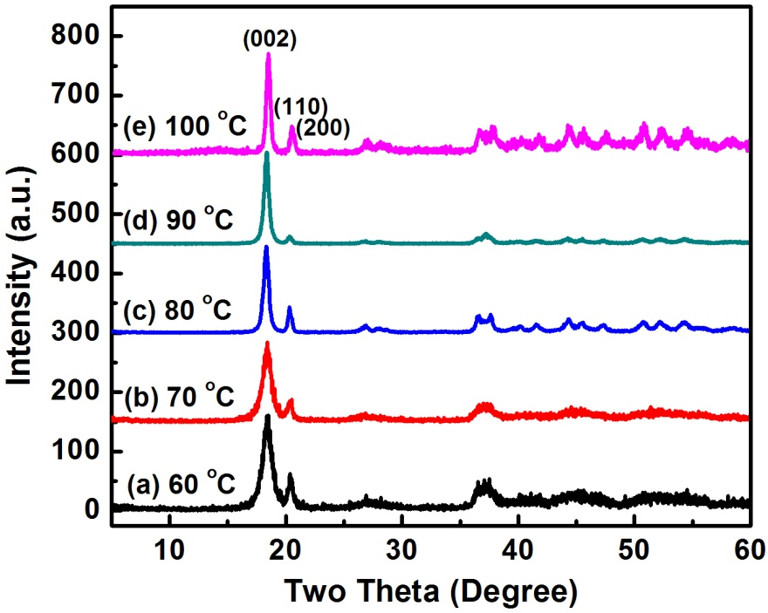
Figure 1. XRD patterns of gibbsite after 3 d synthesized at different temperatures: (a) 60; (b) 70; (c) 80; (d) 90; and (e) 100 ºC.

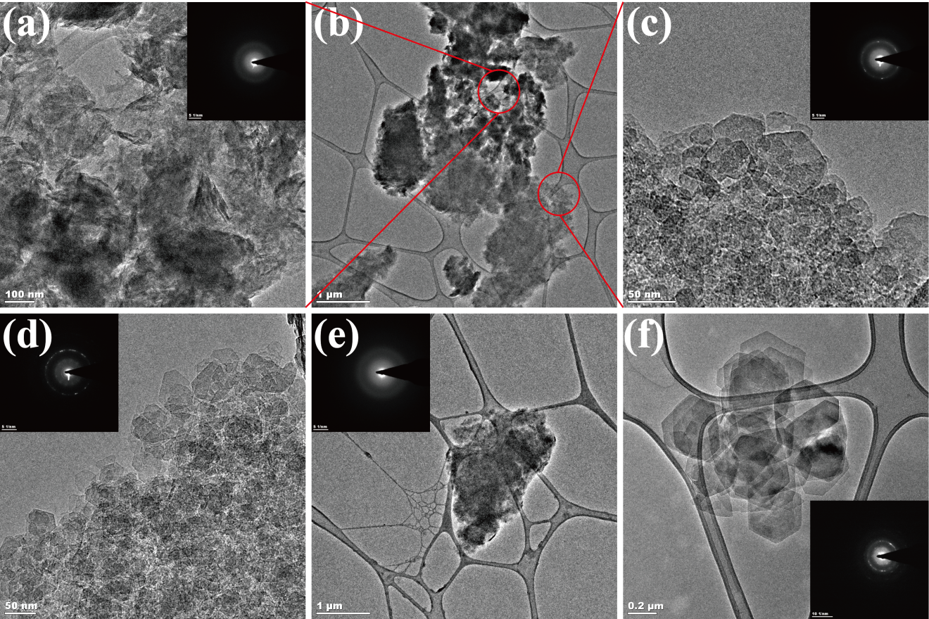
Figure 2. TEM and diffraction data of gibbsite after 3 d synthesized at different temperatures: (a) - (c) 60; (d) and (e) 70; and (f) 80 ºC.

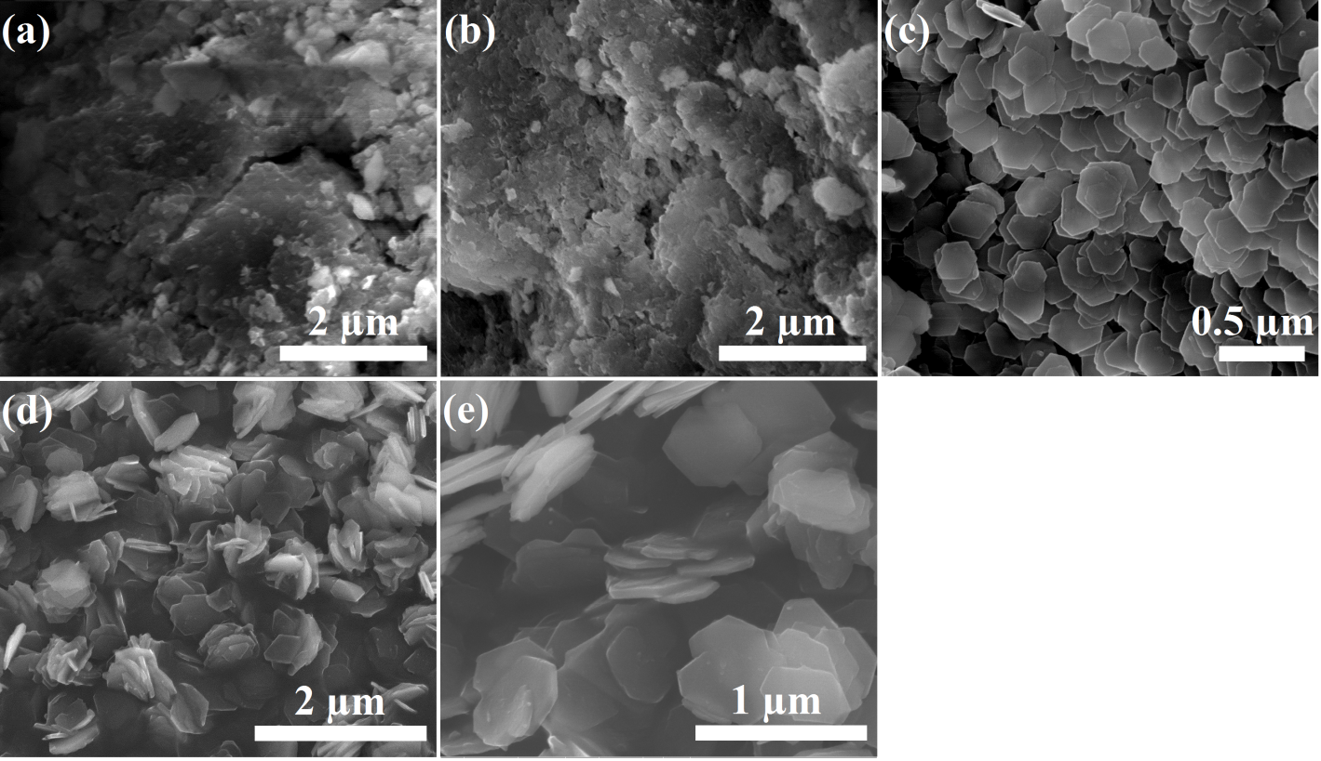
Figure 3. SEM images of gibbsite synthesized after 3 d at different temperatures: (a) 60; (b) 70; (c) 80; (d) 90; and (f) 100 ºC.

The Effect of Reaction Time
For a synthesis temperature of 80 ºC, we next examined the effect of reaction time (Table 2, entries 3, 6–9). With respect to product yield, not surprisingly only a minimal amount of crystalline product appeared after short reaction times (12 and 24 h). The yield increased substantially and systematically from 29% to 82.6% when the reaction time was increased to 48 h and then to 72 h, respectively. However, there was no obvious additional increase in yield when the reaction time was extended to 96 h. XRD indicated that all samples collected at 48 h, 72 h, and 96 h were pure gibbsite. SEM showed that the morphologies of all these three samples were hexagonal nanoplates with sizes from 200 to 400 nm (Figs. 3C and S2). The increase in yield between 12 and 72 h is consistent with the continuous precipitation of soluble aluminate species. However, because over time there was no obvious change of nanoparticle size suggests that crystal growth was based on a heterogeneous nucleation mechanism. Because the 72 h reaction time produced the finest particle size and high yield, this was taken as the reaction time of choice for investigating the effect of pH on product characteristics.
The Effect of pH
We next investigated the effect of initial pH on the resulting gibbsite nanoplates. For 80 ºC and 72 h, we examined seven different pH values, including 1, 3, 5, 7, 10, 12, and 13.5, as shown in Table 2 (entries 3, 10–15). XRD indicated samples synthesized from pH 1 to 12 were pure gibbsite (Figs. 1C, 4a-4e). However, the sample synthesized at pH 13.5 was a mixture of 70% gibbsite and 30% bayerite (Fig. 4e). SEM showed that the samples synthesized from pH 3 to 12 maintained a hexagonal nanoplate shape with diameters of 200-400 nm (Figs. 3c, 5b-5e). But the sample synthesized at pH 1 were nanoplates with irregular boundaries at the edges (Fig. 5a), and the gibbsite fraction of the product synthesized at pH 13.5 was a bar-shaped product with the lengths up to several micrometers (Fig. 5f). It is noteworthy to point out that, although even highly acidic conditions can be used to prepare gibbsite nanoplates, the reaction yield was much lower than in highly basic conditions (Table 2, entries 3, 10–15). Generally pH values influence the morphology and yield of gibbsite through a variety of mechanisms including: modulating aluminum ion cluster and aluminate speciation in solution²⁸⁻³⁰, sorption and stabilization of crystal facets³¹, and by influencing cluster-cluster and colloid-colloid interactions and aggregation through variation of the ionic strength of the solution¹⁹. We note that while there was no significant change in yield from the pH 5 to 12. In the end, pH 7 was selected as the reaction condition to investigate the effect of precursor concentration.
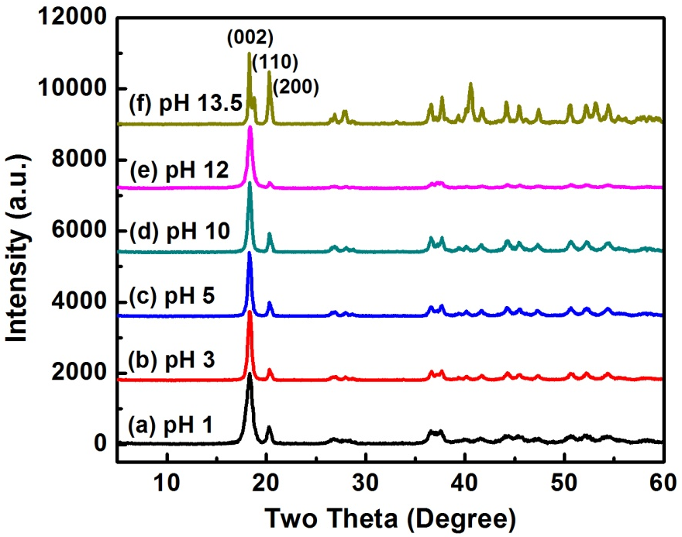
Figure 4. The XRD patterns of as-prepared gibbsite in different pH: (a) 1; (b) 3; (c) 5; (d) 10; (e) 12; and (f) 13.5.

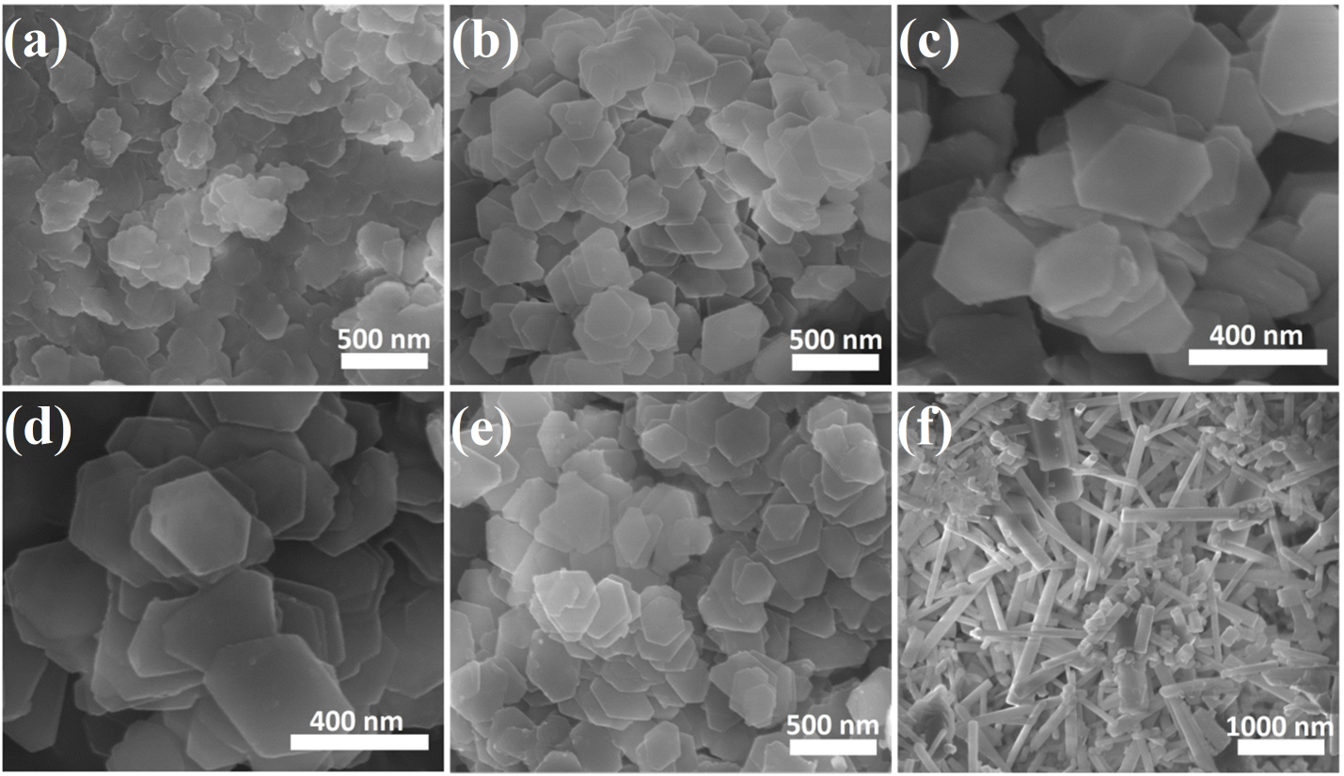
Figure 5. The SEM images of as-prepared gibbsite in different pH: (a) 1; (b) 3; (c) 5; (d) 10; (e) 12; and (f) 13.5.

Yield Optimization Based on Statistical Experimental Design
Gibbsite characteristics that resulted from exploring effects of temperature, time, and pH led to some desirable conditions for morphologically well-defined nanoplates. For example, temperature was the most important factor to control the particle size, with smaller sizes always resulting from lower temperature. To obtain smallest uniform gibbsite nanoplates with reasonable yield, 80 ºC appeared to be the most ideal. However, to extend these insights into considerations of optimizing product yield, we also needed to examine the primary yield-limiting role of precursor concentration. Five different concentrations, including 0.1, 0.2, 0.5, 0.75, and 1.0 M, were investigated (Table 2, entries 3, 16–19). XRD confirmed that in all cases the product was pure gibbsite (Fig. 1C, S3). SEM confirmed no obvious influence on particle size and shape, except for samples resulting from 0.75 and 1 M precursor concentrations, which yielded particles mildly irregular in shape either intrinsically or more likely as a result of being coated with trace residual unreacted gel (Fig. S4) (visible excess gel was recovered from these higher concentration experiments). We thus excluded these two highest concentrations from further consideration.
On the basis of application of a statistical analysis approach applied to the 80 ºC temperature choice, we were able to convert the observed trends for the remaining system variables of reaction time, pH value, and precursor concentration into a synthesis strategy optimized to an 87.% yield. To obtain these optimal conditions, three factors and three levels BBD approach was used, including 0.2, 0.35, and 0.5 M for the precursor concentration, 5, 8.5, and 12 for the pH value, and 40, 56, and 72 h for the reaction time³²⁻³⁴. The response value of reaction yield was observed ranging from 6.3 to 86.69 in Table 2.
Table 3. The Box-Behnken design and result.
Entry | Concentration (M) | pH | Reaction time (h) | Reaction yield (%)
1 | 0.35 | 12 | 72 | 47.85
2 | 0.5 | 8.5 | 72 | 86.69
3 | 0.2 | 8.5 | 40 | 26.44
4 | 0.5 | 5 | 56 | 43.27
5 | 0.5 | 12 | 56 | 34.29
6 | 0.35 | 12 | 40 | 6.30
7 | 0.35 | 8.5 | 56 | 42.12
8 | 0.35 | 8.5 | 56 | 44.64
9 | 0.35 | 5 | 40 | 11.68
10 | 0.2 | 8.5 | 72 | 81.73
11 | 0.35 | 8.5 | 56 | 47.39
12 | 0.5 | 8.5 | 40 | 8.81
13 | 0.2 | 12 | 56 | 30.47
14 | 0.35 | 5 | 72 | 70.17
15 | 0.2 | 5 | 56 | 41.47

Table 4. ANOVA for response of dependent variables.
 | DF | Seq SS | Adj SS | Adj MS | F | P
Regression | 9 | 7968.25 | 7968.25 | 885.36 | 22.10 | 0.002
Linear | 3 | 7088.72 | 7088.72 | 2362.91 | 58.98 | 0.000
Concentration | 1 | 6.19 | 6.19 | 6.19 | 0.15 | 0.710
pH | 1 | 284.09 | 284.09 | 284.09 | 7.09 | 0.045
Time | 1 | 6798.43 | 6798.43 | 6798.43 | 169.71 | 0.000
Square | 3 | 679.19 | 679.19 | 226.40 | 5.65 | 0.046
Concentration*Concentration | 1 | 115.20 | 84.68 | 84.68 | 2.11 | 0.206
pH*pH | 1 | 556.64 | 543.57 | 543.57 | 13.57 | 0.014
Time*Time | 1 | 7.36 | 7.36 | 7.36 | 0.18 | 0.686
Interaction | 3 | 200.34 | 200.34 | 66.78 | 1.67 | 0.288
Concentration*pH | 1 | 1.02 | 1.02 | 1.02 | 0.03 | 0.879
Concentration*Time | 1 | 127.56 | 127.56 | 127.56 | 3.18 | 0.134
pH*Time | 1 | 71.75 | 71.75 | 71.75 | 1.79 | 0.238
Residual Error | 5 | 200.3 | 200.3 | 40.06
Lack-of-Fit | 3 | 186.43 | 186.43 | 62.14 | 8.96 | 0.102
Pure Error | 2 | 13.87 | 13.87 | 6.94
Total | 14 | 8168.55

The ANOVA of reaction yield for the nanoplates is given in Table 4. The model F value of 22.1 and low p-value of 0.002 imply that the model is significant. Moreover, the most significant factor is time while the factor of concentration is insignificant. The correlation coefficient (R2) was also used for the percentage variability of the optimized parameters. The good predictability of the models can be indicated by correlation coefficient (R2) was 0.976. This result means that 97.6 % of the total variation on product yield data can be described by the selected model.
The mathematical equation for predicting the optimum point between the three variables in the coded levels and the response can be expressed as follows:
Y=44.7192Constant-0.8799$X_{1}^{}$-59592$X_{2}^{}$+${29.1514X}_{3}^{}$4.7889$X_{1}^{2}$-12.1333$X_{2}^{2}$
+0.5058 $X_{1}*X_{2}$+5.6471 $X_{1}*X_{3}$-4.2354 $X_{2}*X_{3}$
where Y, X₁, X₂, X₃ represent reaction yield, concentration, pH and time, respectively.
This equation reveals how the individual factors or double interaction affected yield. Coefficients of one factor in the equation indicate the effect of the particular factor, whereas coefficients of two factors and second-order terms indicate the interaction between the three factors and a quadratic effect, respectively. The positive sign in front of the terms represents a synergistic effect, while a negative sign represents an antagonistic effect.

Table 5 The optimal factors and the experimental verification value
Gel concentration (M) | pH | Time (h) | Yield (%)
 |  |  | Predict | Experimental
0.5 | 9.2 | 72 | 87.77 | 87.52

Based on the results of BBD experiment, together with the quadratic equation fitting of these three variables of gel concentration, pH and time, the predicted response value of reaction yield was 86.77 and the optimal combination of each factor was determined by Minitab software and the experimental verification value is 87.52%, as shown in Table 5.
Conclusions
We developed a new hydrothermal method to fast-prepare euhedral hexagonal gibbsite nanoplates within a diameter range of 200-400 nm from an Al(OH)₃ gel precursor. The new synthesis involves very simple procedures. The separate effects of gel concentration, pH and time on the reaction yield were investigated using a statistical design approach. The p-value, F statistics and R² statistics of ANOVA shows that the models can be adequately describe the data and all the three factors are the dominant factors influencing the response of reaction yield. The optimum synthesis conditions obtained by the BBD optimization tool for the predicted models were conducted and it was found that the experimental and predicted values were in excellent agreement with the statistical analysis. At 80 ºC, the optimum synthesis conditions of gel concentration at 0.5 M, pH at 9.2, and time at 72 h maximized the reaction yield up to ~87%. On the basis of these optimized experimental conditions, the synthesis procedure, which is both cost-effective and environmentally friendly, has the potential for scale-up for mass production of high quality gibbsite material for various research and development, and industrial, applications.
Acknowledgement:
This work was supported as a part of IDREAM, an Energy Frontier Research Center funded by the U.S. Department of Energy (DOE), Office of Science. A portion of this research was performed using EMSL, a national scientific user facility sponsored by the DOE Office of Biological and Environmental Research and located at Pacific Northwest National Laboratory (PNNL). PNNL is a multiprogram national laboratory operated for DOE by Battelle. The work performed at the ALS is supported by the Director, Office of Science, Office of Basic Energy Sciences of the U.S.
Department of Energy under Contract No. DE-AC02-05CH11231, and we acknowledge Alpha N’Diaye for his assistance with XAS measurements.

References:
1 Yen, Y.-Y., Wang, H.-T. & Guo, W.-J. Synergistic effect of aluminum hydroxide and nanoclay on flame retardancy and mechanical properties of EPDM composites. Journal of Applied Polymer Science 130, 2042-2048, doi:10.1002/app.39394 (2013).
2 Huittinen, N. et al. Sorption of Cm(III) and Gd(III) onto gibbsite, alpha-Al(OH)(3): A batch and TRLFS study. Journal of colloid and interface science 332, 158-164, doi:10.1016/j.jcis.2008.12.017 (2009).
3 Louaer, S., Wang, Y. & Guo, L. Fast synthesis and size control of gibbsite nanoplatelets, their pseudomorphic dehydroxylation, and efficient dye adsorption. ACS applied materials & interfaces 5, 9648-9655, doi:10.1021/am402677v (2013).
4 Weerasooriya, R., Seneviratne, W., Kathriarachchi, H. A. & Tobschall, H. J. Thermodynamic assessment of Hg(II)-gibbsite interactions. Journal of colloid and interface science 301, 452-460, doi:10.1016/j.jcis.2006.05.054 (2006).
5 Weerasooriya, R., Tobschall, H. J., Wijesekara, H. K. D. K., Arachchige, E. K. I. A. U. K. & Pathirathne, K. A. S. On the mechanistic modeling of As(III) adsorption on gibbsite. Chemosphere 51, 1001-1013, doi:10.1016/s0045-6535(03)00157-7 (2003).
6 Shi, Y., HogenEsch, H., Regnier, F.E. and Hem, S.L., . Detoxification of endotoxin by aluminum hydroxide adjuvant. Vaccine 19, 1747-1752 (2001).
7 Ulanova, M., Tarkowski, A., Hahn-Zoric, M. & Hanson, L. A. The Common vaccine adjuvant aluminum hydroxide up-regulates accessory properties of human monocytes via an interleukin-4-dependent mechanism. Infect Immun 69, 1151-1159, doi:10.1128/IAI.69.2.1151-1159.2001 (2001).
8 Santos, P. S., Santos, H. S. & Toledo, S. P. Standard transition aluminas. Electron microscopy studies. Mater. Res. 3, 104-114 ( 2000).
9 Reynolds, J. G., Cooke, G. A., Herting, D. L. & Warrant, R. W. Evidence for dawsonite in Hanford high-level nuclear waste tanks. Journal of hazardous materials 209-210, 186-192, doi:10.1016/j.jhazmat.2012.01.018 (2012).
10 Kumara, C. K., Ng, W. J., Bandara, A. & Weerasooriya, R. Nanogibbsite: synthesis and characterization. Journal of colloid and interface science 352, 252-258, doi:10.1016/j.jcis.2010.08.083 (2010).
11 Wijnhoven, J. E., van't Zand, D. D., van der Beek, D. & Lekkerkerker, H. N. Sedimentation and phase transitions of colloidal gibbsite platelets. Langmuir : the ACS journal of surfaces and colloids 21, 10422-10427 (2005).
12 Li, H., Addai-Mensah, J., Thomas, J. C. & Gerson, A. R. The influence of Al(III) supersaturation and NaOH concentration on the rate of crystallization of Al(OH)3 precursor particles from sodium aluminate solutions. Journal of colloid and interface science 286, 511-519, doi:10.1016/j.jcis.2005.01.083 (2005).
13 Cesteros, Y., Salagre, P., Medina, F. & Sueiras, J. E. A New Route to the Synthesis of Fine-Grain Gibbsite. Chem. Mater. 13, 2595-2600 (2001).
14 Freij, S. J. & Parkinson, G. M. Surface morphology and crystal growth mechanism of gibbsite in industrial Bayer liquors. Hydrometallurgy 78, 246-255, doi:10.1016/j.hydromet.2005.04.001 (2005).
15 Freij, S. J., Parkinson, G. M. & Reyhani, M. M. Atomic force microscopy study of the growth mechanism of gibbsite crystals. Physical Chemistry Chemical Physics 6, 1049, doi:10.1039/b312505j (2004).
16 Freij, S. J., Parkinson, G. M. & Reyhani, M. M. Direct observation of the growth of gibbsite crystals by atomic force microscopy. Journal of Crystal Growth 260, 232-242, doi:10.1016/j.jcrysgro.2003.08.064 (2004).
17 Fu, W., Vaughan, J. & Gillespie, A. Aspects of the Mechanism of Nucleation and Intergrowth of Gibbsite Crystals on Sodium Oxalate Surfaces in Concentrated Alkaline Solutions. Crystal Growth & Design 15, 374-383, doi:10.1021/cg501465v (2015).
18 Li, T. S., Livk, I. & Ilievski, D. Supersaturation and temperature dependency of gibbsite growth in laminar and turbulent flows. Journal of Crystal Growth 258, 409-419, doi:10.1016/s0022-0248(03)01557-4 (2003).
19 Sweegers, C. et al. Morphology, evolution and other characteristics of gibbsite crystals grown from pure and impure aqueous sodium aluminate solutions. J. Cryst. Growth 233, 567-582 (2001).
20 Wierenga, A. M., Lenstra, T. A. & Philipse, A. P., pp.. Aqueous dispersions of colloidal gibbsite platelets- synthesis, characterisation and intrinsic viscosity measurements. Colloid Surface A 134, 359-371 (1998).
21 Wijnhoven, J. E. Seeded growth of monodisperse gibbsite platelets to adjustable sizes. Journal of colloid and interface science 292, 403-409, doi:10.1016/j.jcis.2005.06.018 (2005).
22 Liu, Y. et al. Synthesis and characterization of gibbsite nanostructures. J. Phys. Chem. C 112, 4124-4128 (2008).
23 van der Beek, D. & Lekkerkerker, H. N. Liquid crystal phases of charged colloidal platelets. Langmuir : the ACS journal of surfaces and colloids 20, 8582-8586 (2004).
24 Shen, S., Chow, P. S., Chen, F., Feng, S. & Tan, R. B. H. Synthesis of submicron gibbsite platelets by organic-free hydrothermal crystallization process. Journal of Crystal Growth 292, 136-142, doi:10.1016/j.jcrysgro.2006.04.081 (2006).
25 Hiemstra, T., Yong, H. & Van Riemsdijk, W. H., . Interfacial charging phenomena of aluminum (hydr) oxides. Interfacial Charging Phenomena of Aluminum (Hydr)oxides. Langmuir : the ACS journal of surfaces and colloids 15, 5942-5955 (1999).
26 Rosenqvist, J., Persson, P. & Sjöberg, S. Protonation and charging of nanosized gibbsite (α-Al (OH) 3) particles in aqueous suspension. Langmuir : the ACS journal of surfaces and colloids 18, 4598-4604 (2002).
27 Sonthalia, R., Behara, P., Kumaresan, T. & Thakre, S. Review on alumina trihydrate precipitation mechanisms and effect of Bayer impurities on hydrate particle growth rate. International Journal of Mineral Processing 125, 137-148, doi:10.1016/j.minpro.2013.08.002 (2013).
28 Casey, W. H. Large aqueous aluminum hydroxide molecules. Chem. Rev. 106, 1-16 (2006).
29 Swaddle, T. W. et al. Kinetic evidence for five-coordination in AlOH (aq) 2+ ion. Science 308, 1450-1453 (2005).
30 Casey, W. H., Phillips, B. L. & Furrer, G. Aqueous aluminum polynuclear complexes and nanoclusters: a review. Rev. Mineral. Geochem. 44, 167-190 (2001).
31 Preocanin, T., Abdelmonem, A., Montavon, G. & Luetzenkirchen, J. Charging Behavior of Clays and Clay Minerals in Aqueous Electrolyte Solutions — Experimental Methods for Measuring the Charge and Interpreting the Results. doi:10.5772/62082 (2016).
32 Ba-Abbad, M. M., Chai, P. V., Takriff, M. S., Benamor, A. & Mohammad, A. W. Optimization of nickel oxide nanoparticle synthesis through the sol–gel method using Box–Behnken design. Materials & Design 86, 948-956, doi:10.1016/j.matdes.2015.07.176 (2015).
33 Bingöl, D., Veli, S., Zor, S. & Özdemir, U. Analysis of adsorption of reactive azo dye onto CuCl2 doped polyaniline using Box–Behnken design approach. Synthetic Metals 162, 1566-1571, doi:10.1016/j.synthmet.2012.07.011 (2012).
34 Ferreira, S. L. et al. Box-Behnken design: an alternative for the optimization of analytical methods. Anal Chim Acta 597, 179-186, doi:10.1016/j.aca.2007.07.011 (2007).

