High temperature modal analysis of a non-uniformly heated rectangular plate: experiments and simulations
A. C. Santos Silva^{1a}, C. M. Sebastian¹, J. Lambros² and E.A. Patterson¹
¹School of Engineering, University of Liverpool, The Quadrangle, Brownlow Hill, Liverpool, L69 3GH, UK
²Department of Aerospace Engineering, University of Illinois, 306 Talbot Laboratory, 104 S. Wright St., Urbana, Illinois 61801, USA
ªcatsilva@liverpool.ac.uk

Keywords: Thermo-acoustic loading; Non-uniform heating; Stereo digital image correlation; High temperature measurement; Infrared heating; Orthogonal decomposition; Full-field mode shape acquisition; Thermal buckling

Abstract
Structures in demanding environments where high-temperatures and high-frequency vibratory loads are combined often experience fatigue which shortens their lifecycle. A limited amount of experimental data is available on the mechanical behaviour of plates under such thermo-acoustic loading. In this work, on Hastelloy-X plates, non-contact techniques were used to simultaneously acquire full-field temperature and out-of-plane displacement data for a thin plate. The plate was heated using halogen quartz lamps arranged in two different configurations and mechanically loaded using a commercially-available shaker. The centre of the plate was mounted to the shaker through a stinger with a bolted connection. The structure’s resonant frequencies were determined using experimental modal analysis when mechanically loading the plate using a randomly varying signal from 0 to 800 Hz. Modal shapes were studied by exciting the plate to its first eleven resonant frequencies and acquiring displacement data using a PL-DIC (Pulse Laser Digital Image Correlation) method. Infra-red imaging was used to acquire temperature maps across the specimen. A finite element model was developed to include temperature-dependent material properties in the prediction of the plate’s resonant frequencies and mode shapes. For the first time, experimental results showed the resonant response of the plate to strongly depend on the temperature distribution across the structure, correlating well with past predictive work in the literature. This was supported by the results from the finite element model, which were validated against experimental data and found to yield reliable predictions.
- Introduction
A limited amount of experimental research has been performed on the modal behaviour of thermally stressed plates. An improved understanding of the issue is particularly important in the design and monitoring of structures in demanding environments such as those associated with hypersonic flight, where fluctuating air pressure and velocity gradients promote mechanical excitation whilst inducing aerodynamic heating. Similarly, fusion energy reactors also experience thermo-mechanical loading as panels which operate at high temperatures are affected by turbulence promoted by plasma circulation in the divertor. The majority of prior experiments have acquired only point-wise data for displacement and/or temperature. Experiments on the response of thermo-acoustically loaded plates were performed by Ng and Clevenson [1], Istenes et al. [2] and Murphy et al. [3]. In these experiments, the authors observed phenomena such as snap-through and modal frequency shifts in plates exposed to nonlinear large amplitude vibrations at elevated temperatures. However, no simultaneous full-field temperature and modal displacement data was gathered in the reported experiments. The motivation for this study was to acquire such data that could be used to enhance understanding of these phenomena and to support the validation of computational models.
Digital Image Correlation (DIC) allows the measurement of displacement and deformation data over a range of loading conditions, length scales and temperatures. The challenges of high temperature DIC have been reviewed recently by Berke et al. [4] who identified that a main challenge is the increase in radiation at high temperatures which saturates the sensors. However, high temperature measurements can be accomplished straightforwardly using narrow bandwidth illumination and, or optical bandpass filters [5-9]. This approach was used by Berke et al. [4] in a modal study of a rectangular Hastelloy-X plate, while Sebastian [5] used a 532 nm pulsed laser and bandpass filters in a similar study of a plate.
Mead [6] focused on the analytical and computational study of ideal, free, rectangular Kirchhoff plates subjected to in-plane thermal stresses resulting from non-uniform temperature distributions. For simplicity, a constant Young's modulus and linear expansion coefficient were assumed. The simulations showed the stressed state of the plates had an effect on the resonant frequencies of each mode. Additionally, Mead's results showed that the order in which particular mode shapes appeared had switched as the excitation frequency was increased in a phenomenon called mode shifting. Further simulation studies at high temperature using temperature independent material properties were performed by Chen and Virgin [7] and Jeyaraj et at. [8]. Chen and Virgin's work focused on the modal behaviour of post-buckled aluminium plates exposed to complex thermal distributions and showed changes in modal frequencies with temperature, demonstrating the dynamic instability of the thermally buckled structure. Mode shifting was found to be absent in the post-buckled regime if the plate underwent a second buckling event. Jeyaraj et al. performed a modal analysis of isotropic plates under a spatially uniform thermal load and various boundary conditions: fully clamped, simply supported and free edges. For all of the boundary conditions studied, a decrease in frequency for each mode was demonstrated with increasing uniform temperature. Moreover, Jeyaraj et al. showed the disappearance of the first mode as the temperature approached the critical buckling value.
Relatively few studies using temperature-dependent material properties have been reported: Ko [9] predicted the post-buckled shapes of rectangular plates subject to dome-shaped temperature distributions and found the critical temperature at which buckling occurred; Ibrahim et al. [10] studied the nonlinear random response of functionally graded materials (FGM) panels under combined thermal and acoustic loads using a nonlinear finite element model; while Talha et al. [11] investigated the random vibration response of FGM plates and analysed the effect of uncertainty in material properties on the frequency response. However, none of these studies investigated the effect of temperature on resonant frequencies and mode shapes, for which Berke et al. [4] developed an FE model based on small strains and a linear elastic response with no thermal expansion or conduction included. The dependence of the Young's modulus on temperature was introduced in Berke et al. by assigning specific values of modulus to nodes based on a discrete temperature distribution, which was calculated from measured strain data and the material properties published by the manufacturer. Berke et al. compared their predictions to measurements using proper orthogonal decomposition (also known as image decomposition) and found a good agreement. However, some differences were observed between the predicted and experimentally determined resonant frequencies in their results.
Hence, it is possible to identify several gaps in knowledge, which the present study attempts to address. First, to the authors’ knowledge, no experimental modal analyses with concurrent acquisition of full-field temperature and full-field displacement data have been reported. Second, the authors found no evidence in the literature comparing high temperature resonant frequencies and mode shapes using a range of non-uniform temperature distributions. Third, despite substantial research on the modal analysis of plates at high temperatures, a temperature-dependent material model does not appear to have been used in studies of thermally stressed plates to predict modal frequencies and shapes as the temperature increases. The present work aims to address these knowledge gaps by pursuing three objectives: 1) to concurrently acquire high-quality, full-field displacement and temperature data whilst exciting a thermally-loaded thin plate to its natural frequencies; 2) to study the effect of different nonlinear temperature distributions on the mode shapes and resonant frequencies of the structure; 3) to develop a finite element model capable of predicting the plate’s resonant frequencies and associated mode shapes using different temperature distributions applied to the structure.

2.1 Methodologies
Experiments were conducted on a 219 x 146 x 1 mm plate, made from Hastelloy-X [American Special Metals Inc., Miami, FL, USA], which is a nickel-based super alloy, widely used in high temperature industrial applications. A 5 mm hole was drilled in the centre of the plate for the insertion of a stinger (300 mm M4 stainless steel threaded rod) to attach the specimen to a mechanical shaker via a bolted connection. No other constraints or supports were used to restrain the plate.
The plate was prepared for high temperature DIC by spraying it with a uniform layer of commercially-available refractory black paint (VHT Flameproof, Cleveland, Ohio, USA). A white version of the same paint was used to create a random speckle pattern. The more usual reverse colour scheme was considered but disregarded because the black background used here enables a larger transfer of radiation and results in higher specimen temperatures. An image of the resulting speckle pattern is shown in Figure 1. All experiments were conducted with the longitudinal axis of the plate in the horizontal orientation.
Halogen quartz lamps with a power output of 1 kW each and a colour temperature of 3210 K were used for heating the specimen. The lamps were mounted in arrays with a reflective back-plate and were placed on the opposite side of the specimen from the DIC system. Two different lamp setups were used, and are shown schematically in Figure 2, to create different temperature distributions on the specimen: 1) transverse heating using four vertically-oriented lamps centred around the plate’s bolted constraint; and 2) longitudinal heating using two horizontally-oriented lamps aligned with the bottom edge of the plate. For reference purposes, a uniform room temperature (25°C) distribution was also studied. Two types of mechanical loading experiments were performed at each temperature distribution: broadband loading and single-frequency sinusoidal loading. These experiments were conducted after 130 seconds of heating, at which point the plate had reached a steady state temperature distribution.
Figure 3 shows a schematic of the test setup used in both broadband and modal tests.

2.2 Broadband loading
In order to determine the specimen’s resonant frequencies, a Fast Fourier Transform (FFT) was computed while it was subject to broadband excitation. This provided the response's transfer function in which the peaks correspond to the resonant frequencies. Mechanical excitation of the specimen was achieved by a commercially-available shaker (V100, DataPhysics, San Jose, CA, USA) and 1kW power amplifier system (DSA1-1K, DataPhysics) which was capable of imparting a random force of 533 N (RMS) and a maximum cyclic force of 1000 N. A random signal between 0 and 800 Hz from a vibration controller (ABACUS, DataPhysics) was used to drive the shaker. The frequency range is typical of those experienced by thin, lightly-damped structures in aircraft that are susceptible to high-cycle or sonic fatigue [12].
The input, or reference signal for the response function, was supplied by an accelerometer attached to the shaker’s membrane; this location was preferable to the plate itself where the accelerometer would have influenced the behaviour of the plate and the measured signal was more representative of the input to the plate than the output from the vibration controller. The output signal was measured using a commercially-available laser Doppler vibrometer (OFV-503, Polytec GmbH, Waldbronn, Germany) focused on a corner of the plate. Optimisation of the signal strength was achieved by aiming the laser at a reflective section on the plate’s surface. At room temperature, adequate surface reflectivity was achieved using a piece of retroreflective tape, whilst for high temperature tests a section of approximately 7.5 x 7.5 mm was polished with wet P800 sanding paper. The input and output signals were supplied to signal analyser software (SignalCalc, Data Physics) which computed the transfer function associated with the reference signal and the output signal.
Six repetitions were performed to determine the mean resonant frequencies of the first eleven modes. This was then repeated for each of the three temperature distributions analysed: room temperature, transverse heating, and longitudinal heating.

2.3 Single-frequency sinusoidal loading
A function generator was used to control the V100 DataPhysics shaker and to create a sine waveform to excite the specimen at each of its resonant frequencies, which had been determined using broadband excitation. The amplitude of excitation was specified to approximately match the values recorded by the Doppler vibrometer during broadband loading in order to satisfy small amplitude assumptions required for linear modal analyses. The full-field out-of-plane displacement of the plate was measured using a commercially-available stereoscopic DIC system (Q-400 system, Dantec Dynamics GmbH, Ulm, Germany) consisting of two 1624x1234 pixel CCD Firewire cameras (2MP Stingray F-201b, Allied Vision Technologies GmbH, Stradtroda, Germany) fitted with a set of 12 mm lenses (Cinegon, 1.4/12, Schneider) adjusted to an f-stop of 2.8. The maximum frame rate of the cameras was 14 frames per second at full resolution. This setup resulted in an average spatial resolution of 0.18 mm/pixel. Image capture and displacement calculation was performed using Istra 4D software supplied with the DIC system. Image correlation was performed with facets of 25x25 pixels with a centre-to-centre spacing of 21 pixels.
A pulsed-laser was used to provide stroboscopic illumination of the specimen. This consisted of an Nd:YAG laser (Nano L200-10, Litron, Rugby, England) that emitted a 4 nanosecond pulse of green light (532 nm) which was expanded after passing through an optical FFT to produce a speckle-free beam. Optical bandpass filters with a centre wavelength of 532 nm and 4nm bandwidth were fitted to the standard DIC cameras in order to block any light outside of the wavelength of the laser.
Simultaneous triggering of the laser pulse and DIC image acquisition was achieved by routing the signal from the function generator to a timing box connected to both the laser and CCD cameras. The dynamic motion of the plate was captured by phase-stepping the image acquisition relative to the excitation signal and 40 images were captured at π/10 increments [13]. This phase-stepping approach yielded the deformed shape through the vibration cycle and allowed it to be confirmed that the measured shape was a standing wave corresponding to a modal shape. The modal shapes corresponding to the maximum excursion are shown in Figure 4.
Two types of thermal camera were used in the high temperature experiments. Initially, a commercially-available thermal camera (SC7650E, FLIR, North Billerica, MA, USA) was used to monitor the temperature distribution on the surface of the specimen. The camera has a focal plane array of 640x512 pixels with a maximum recording rate of 100 frames per second at this resolution and a typical sensitivity of 20 mK at wavelength from 3 to 5 µm. A neutral density (ND) filter was fitted to the camera to prevent saturation and a manual calibration was performed with the aid of a laser thermometer (Fluke 62, Fluke UK Ltd, Norfolk, UK). The specimen occupied an area of 278x184 pixels in this camera’s field of view (FOV), which was used to acquire the temperature distribution during transverse heating, as shown in Figure 2 (top). The calibration of the camera was prone to error due to the complicated process involved; and so, in subsequent experiments a factory-calibrated micro-bolometer with an accuracy of ±2°C or ±2% (whichever is greater) was used. The commercially-available uncooled micro-bolometer (TIM 400, MICRO-EPSILON UK, Birkenhead, UK) with a 25x25 µm focal plane array sensor had a 382x288 pixel resolution and had a maximum frame rate of 80Hz. The sensor is sensitive to a spectral range of 7.5 to 13 µm and a thermal sensitivity of 0.1K with the chosen telephoto lens (13° x 10° FOV / F = 1.0). Typical measurements from this bolometer are shown in Figure 2 (bottom). A K-type thermocouple was used to compare point-wise temperature measurements to those acquired with the micro-bolometer in order to study the influence of temperature on the emissivity of the painted plate. The results showed an increase in emissivity of 0.08 between room temperature (0.89) and approximately 600°C (0.97). Thus, the full-field temperature maps measured at the elevated temperatures were corrected assuming a uniform emissivity of 0.97. The change in temperature from room temperature to the elevated temperatures shown in Figure 2 correspond to an increase of 0.09% in the dynamic elasticity modulus of Hastelloy X [14], which is a very small change when compared to the approximate 15.4% decrease in the Young’s modulus the material experiences between room temperature and 600°C (from 205 GPa to approximately 175 GPa).
The specimen was allowed to cool between each single frequency excitation experiment; consequently for each experiment: 1) the initial deformed shape of the plate at room temperature was acquired using DIC; 2) the temperature distribution across the plate’s surface was monitored and recorded using a thermal camera; and 3) the FE model was updated to include the measured initial shape of the plate and the achieved temperature distribution. The resultant measured and predicted modal shapes are shown in Figures 4 and 5 respectively.

2.4 Finite element model
A finite element model was developed using HyperWorks® (Altair Engineering, Michigan, USA) for the pre- and post-processing and LS-Dyna (Livermore Software Technology Corporation, California, USA) as the solver. Temperature-dependent material property values provided by the manufacturer [14] were incorporated into an isotropic thermal material model (MAT_ELASTIC_PLASTIC_THERMAL) available in LS-Dyna. Small strain elastic response was assumed in all of the simulations.
As mentioned in the previous section, the shape of the FE mesh was defined using the shape of the specimen at room temperature, computed from the DIC data using Istra 4D and shown in Figure 6. Any missing values in the raw DIC data were interpolated using the cubic convolution method, which was chosen to avoid distortion and mosaic effects that can be introduced by other methods [15]. The geometry was discretised into 2x2 mm shell elements with hourglass control to avoid spurious modes of deformation. A custom MATLAB script assigned a temperature value to each node of the mesh based on the measured temperature distributions. It was assumed that through-thickness temperature gradients were negligible and no damping was modelled.
The boundary conditions in the model were a simplification of those in the experiments because the hole for the stinger and the bolted connection were not represented and instead a single node at the centre point of the plate was fully constrained. The spatial distribution of temperature was increased proportionally assuming a linearly increasing thermal load with time (over a time period of 130 seconds) applied to each node to reflect the experimental protocol, starting at room temperature and ending with the corresponding measured steady state temperature.
An implicit eigenvalue analysis was used to extract the first eleven resonant frequencies and corresponding modal shapes, shown in Figure 5, at both room temperature and after heating for 130 seconds. The predicted and measured values of resonant frequency are compared in Figure 7. The predicted and measured modal shapes were compared using proper orthogonal image decomposition, following the method recommended by CEN [16] and employed by Berke et al [4]. In this method, the data describing a modal shape were treated as an image and decomposed using Chebyshev polynomials to generate a set of coefficients. The original mode shape data were reconstructed using the coefficients and the average residual from the reconstruction (u_{resid}) was calculated and found to vary from 0.005 to 0.054 for the room temperature results, from 0.014 to 0.097 for the transverse heating results and from 0.017 to 0.083 for the longitudinal heating results. The CEN guide recommends that no clusters of residuals between the original and reconstructed data should be greater than 3 times the average square residual of the data fit; where a cluster is a group of adjacent pixels comprising 0.3% of the total of number of pixels in the dataset [12]. Pixels corresponding to missing data in the original dataset were excluded from this criterion.
Euclid [17], a program by Christian and Patterson, was used to decompose the measured and predicted modal shapes and the resultant coefficients are shown in Figure 8. Missing measurement data, for instance around the nut attachment area, were interpolated by the program using the nearest neighbour interpolant function.

- Results and discussion
There is excellent agreement between the predicted and measured resonant frequencies at room temperature and at high temperatures, which are plotted against one another in Figure 9. The maximum standard deviations of the measured resonant frequencies are 5.5 Hz for room temperature (corresponding to mode 10), 2.1 Hz for transverse heating (mode 10) and 14.3 Hz for longitudinal heating (mode 11). These standard deviations are all smaller than the difference in frequency between modal frequencies which implies that they are not significant.
Room temperature resonant frequencies were plotted against the corresponding high temperature data in Figure 10a) so as to identify the influence of temperature on the resonant frequency response. For longitudinal heating, there is no significant change in resonant frequencies because all of the data points corresponding to both the measurements and predictions lie along the line of equality. A linear regression between experimental room temperature and longitudinal heating frequency results supports this observation as it has a gradient of 0.96 with an R² of 0.98 (gradient of 0.92 and R² of 0.97 for FE predictions). However, when transverse heating is applied, the resonant frequency of each mode increased by approximately 24% based on a linear regression with an R² value of 0.99; while the FEA predicted a 28% increase with an R² value of 0.99 for equivalent conditions. The difference in behaviour is probably a result of the difference in the deformed shapes that occur due to the heating alone, which are shown in Figure 11. At steady state the through-thickness temperature difference was below the uncertainty range of the micro-bolometer; however, the high in-plane temperature gradients caused localised differential expansions of the plate leading to non-uniform in-plane compressive and tensile stresses that caused bending of the initially deformed plate. The transverse heating generated a doubly-curved ‘dome’ shape whereas the longitudinal heating created a largely singly-curved shape. These results appear to support the mechanism postulated by Mead [6], based on his simulation results, that non-uniform heating induces thermal stresses which provide a higher structural resistance to deformation. However, this might not always occur because the material would be expected to soften at high temperatures, i.e., the material stiffness will reduce with temperature. This will result in a competition between changes in shape caused by thermal softening and by structural or geometric stiffening, with the latter expected to become dominant at higher temperatures. However, for the conditions in the reported experiments, the changes in geometric stiffness appear to dominate the shape changes with higher frequency, shorter wavelength excitation required when the plate stiffness increases. The double curvature generated by the transverse heating would be expected to provide an enhanced structural or geometric resistance to the deformation required to generate all mode shapes and hence to exhibit higher resonance frequencies at higher temperatures as seen in figure 10a); while the single curvature associated with the longitudinal heating would enhance the resistance to some modes and reduce it to others. The absence of a significant change in resonant frequency with either transverse or longitudinal heating for rigid body modes (modes 1 and 2) provides some additional support for this hypothesis.
Figure 7 shows that the FE results for resonant frequencies at room temperature had the highest average relative error against experimental data at approximately 5.6%, which is larger than the mean standard deviation for the experimental readings. These discrepancies might be a result of the difference in boundary conditions between experiment and simulation. In particular, the bolted connection that experimentally constrains the plate prevents a displacement gradient forming whereas the single node constraint used in the FE model does not. The magnitude of the material’s Young’s modulus is at its highest at room temperature, therefore providing an increased resistance to deformation in response to the excitation force provided. Hence, at higher temperatures, the influence of the structural reinforcement of the constraint is less significant and less energy is needed to deflect the material around the bolted connector. Thus, because the FE model includes a simplified constraint which allows a displacement gradient to form, frequency and shape results at room temperature are more affected by the difference between simulation and experimental boundary conditions. This is consistent with the lower average relative errors against experimental data for the frequency predictions at high temperatures, i.e., 4.7% in transverse heating (maximum of 7.1% for mode 8) and 2.5% in longitudinal heating (maximum of 5.4% for mode 7).
Figure 4 (middle) and Figure 4 (right) show DIC out-of-plane displacement maps for the temperature distributions shown in Figure 2. By comparing the mode shapes presented in these figures with the room temperature results in Figure 4 (left), it is possible to identify some changes in modal shape with thermal load. A mode shifting phenomenon is also present when thermally loading the plate, as mode 6 at room temperature becomes mode 5 following longitudinal heating. This means the natural order of occurrence of the modes in the frequency spectrum changes as the temperature increases and the plate changes shape. This behaviour is similar to the computational results obtained by Chen and Virgin [7, 18] who found veering or switching of modes occurred when there was a change in the static configuration of a plate caused by a spatially non-uniform temperature.
Qualitatively, predicted mode shapes in Figure 5 agree with experimentally measured displacement maps in Figure 4. Mottershead and his co-workers [19-21] have used both the Modal Assurance Criterion (MAC) and orthogonal decomposition approach for the comparison of measured and predicted mode shapes and concluded that the MAC is inadequate for revealing subtle differences. Hence, orthogonal decomposition was used here to quantify the agreement between the predicted and measured mode shapes following the process used by Berke et al. [4] and recommended in the CEN guide for validation of computational mechanics models [16]. The CEN guide suggests that the predictions from a model can be considered to exhibit acceptable agreement with measurements when, following decomposition, the coefficients representing the predicted data field are plotted as functions of the corresponding coefficients representing the measured data and fall within
$S_{P}=S_{M}±2u\left(S_{E}\right)$ , (1)
where $S_{M}$ and $S_{P}$ are the coefficients representing the measured and predicted data, respectively; and $u(S_{E})$ is the experimental uncertainty [16]. The minimum measurement uncertainty (u_{meas}) was taken as 1.9% of the data range based on an evaluation of the same system by Sebastian et al [13] and a methodology described by Hack et al. [22]. The CEN guide recommends combining the minimum measurement uncertainty and the reconstruction error to obtain the experimental uncertainty. In this case, that would result in different values for the acceptability limit for each dataset defined by Eq. (1), which makes interpretation more difficult; hence, instead the reconstruction error was replaced by the minimum measurement uncertainty to give a constant value for the acceptability limits in Figure 8. When this analysis was performed for each of the 11 resonant mode shapes at each of the three thermal conditions, i.e., room temperature, longitudinal heating and transverse heating, it was found that all of the predicted shapes were acceptable. Whilst 50 kernels were used in the decomposition of data, the presentation of results in Figure 8 was simplified by employing a methodology described by Lampeas et al. [23] in which only the coefficients above or equal to 10% of the largest coefficient are used in the representation of data whilst maintaining a correlation coefficient greater than 0.95 between the original data fields and those reconstructed from the remaining coefficients.
After the reliability of the finite element model had been demonstrated, it was used to explore the influence of the applied temperature profile on the behaviour of the plate. The transverse heating in Figure 2 (top) involved transversely heating the centre of the plate whilst the longitudinal heating shown in Figure 2 (bottom) was applied to only a single longitudinal edge. The FE model was modified to study the effect of heating (a) the centre of the plate longitudinally and b) heating a single transverse edge. The corresponding deformed shapes due to these heating regimes were obtained by rotating the shape data in Figure 2 through $π/2$ and transforming them to conform to the FE mesh. The resultant predicted resonant frequencies are presented in Figure 10b) and show, as in Figure 10a), that heating a single edge produces little change in resonant frequencies; but, longitudinally heating the plate’s centre causes an upward shift in the resonant frequencies, except for the rigid body modes which remain unchanged.
In this study, the plate was heated into the post-buckling regime and different spatial distributions of applied thermal load where used to induce different buckled shapes, as shown in Figure 11. Inevitably, the plate will have contained some residual stresses induced by the processes used to manufacture it and these resulted it being non-planar at room temperature, as shown in Figure 6. However, this initial curvature at room temperature was small compared to the post-buckled shapes, which were approximately 4.8 and 7.8 times larger for longitudinal and transverse heating shapes, respectively; and, hence it is reasonable to conclude that thermal buckling dominates the shape changes that occurred with heating, rather than the residual stresses due to manufacturing. The behaviour of simply-supported rectangular plates heated into the post-buckling regime has been investigated previously using point measurements by Murphy et al [3] and using analytical and numerical modelling by Chen and Virgin [7] and by Jeyaraj et al. [8]. However, this study represents a significant advance by developing and demonstrating the technology to acquire detailed whole-field measurements and by making quantitative comparisons with predictions from a computational model. The results provide more detailed information on the behaviour reported in previous work and highlight the requirements for a reliable computational model. The measurement technology and modelling approaches are applicable to panels subject to thermo-acoustic loading found in hypersonic flight vehicles and fusion reactors and should contribute to development of more reliable designs.

- Conclusions
In this work, the first concurrent acquisition of full-field temperature and full-field out-of-plane displacement data has been presented for the resonant response of a plate subjected to combined thermal (up to approximately 550°C) and vibratory loads (up to 800 Hz). The study of the first eleven resonant modes of the structure expanded upon the number of modes investigated in the published literature, allowing the measurement of modal shapes with an increasing level of geometric complexity.
The inclusion of quasi-continuous, full-field experimental measurements of temperature and shape in a temperature dependent material model was shown to improve the reliability of predictions when compared to more simplistic models.
For a centrally-constrained plate with free edges, the results showed resonant frequencies to change with temperature and to be strongly dependent on the spatial temperature distribution across the structure. For spatially non-uniform temperature distributions, the plate changed shape and sought to reach a stable state, which influenced the amount of energy required to excite each mode shape. Experimentally, transverse heating yielded an increase in resonant frequency with temperature, whilst longitudinal heating did not generate a significant change. FE predictions using the same temperature distributions rotated by $π/2$ suggested that these results are a consequence of the difference in curvature of the plate at high-temperatures in a steady state.
The influence of thermal load on the resonant response of the plate at high temperature has been numerically and, for the first time, experimentally demonstrated and the results correlated well with Mead’s [6] analytical predictions. Consequently, it is critical for the reliability of FE predictions of behaviour at high temperatures that thermal loading is effectively represented because it is responsible for both changes in material properties and changes in the structural properties, i.e., changes in geometric stiffness.

Acknowledgements
This effort was sponsored by the European Office of Aerospace Research and Development and the Air Force Office of Scientific Research, USAF under grant numbers FA9550-16-1-0091 and FA9550-16-1-0055. The U.S. Government is authorized to reproduce and distribute reprints of Governmental purpose notwithstanding any copyright notation thereon. Lt. Col. David Garner (EOARD) and Dr. Jaimie S Tiley (AFOSR) are the program officers for these grants respectively. The authors are grateful for further support from the UK’s Engineering and Physical Sciences Research Council (EPSRC).

References
[1] C. F. Ng and S. A. Clevenson, “High-Intensity Acoustic Tests of a Thermally Stressed Plate,” J. Aircr., vol. 28, no. 4, pp. 275–281, 1991.
[2] R. R. Istenes Jr., S. A. Rizzi, and H. F. Wolfe, “Experimental Nonlinear Random Vibration Results of Thermally Buckled Composite Panels,” 36th Struct. Struct. Dyn. Mater. Conf., no. 2–3, pp. 1559–1568, 1995.
[3] K. Murphy, L. N. Virgin, and S. A. Rizzi, “Characterizing the Dynamic Response of a Thermally Loaded, Acoustically Excited Plate,” J. Sound Vib., vol. 196, no. 5, pp. 635–658, 1996.
[4] R. B. Berke, C. M. Sebastian, R. Chona, E. A. Patterson, and J. Lambros, “High Temperature Vibratory Response of Hastelloy-X: Stereo-DIC Measurements and Image Decomposition Analysis,” Exp. Mech., vol. 56, no. 2, pp. 231–243, 2015.
[5] C. Sebastian, “Toward the Validation of Thermoacoustic Modelling in Aerospace Structures,” PhD Thesis, University of Liverpool, 2015.
[6] D. J. Mead, “Vibration and buckling of flat free-free plates under non-uniform in-plane thermal stresses,” J. Sound Vib., vol. 260, pp. 141–165, 2003.
[7] H. Chen and L. N. Virgin, “Dynamic analysis of modal shifting and mode jumping in thermally buckled plates,” J. Sound Vib., vol. 278, no. 1–2, pp. 233–256, 2004.
[8] P. Jeyaraj, C. Padmanabhan, and N. Ganesan, “Vibration and Acoustic Response of an Isotropic Plate in a Thermal Environment,” J. Vib. Acoust., vol. 130, no. 5, p. 051005, 2008.
[9] W. L. Ko, “Thermal buckling analysis of rectangular panels subjected to humped temperature profile heating,” NASA/TP, vol. 2120241, 2004.
[10] H. H. Ibrahim, H. H. Yoo, M. Tawfik, and K. S. Lee, “Thermo-acoustic random response of temperature-dependent functionally graded material panels,” Comput. Mech., vol. 46, no. 3, pp. 377–386, 2010.
[11] M. Talha and B. N. Singh, “Stochastic vibration characteristics of finite element modelled functionally gradient plates,” Compos. Struct., vol. 130, pp. 95–106, 2015.
[12] T. Beberniss, M. Spottswood, and T. Eason, “High-Speed Digital Image Correlation Measurements of Random Nonlinear Dynamic Response,” Exp. Appl. Mech., vol. 6, pp. 171–186, 2011.
[13] C. M. Sebastian, E. López-Alba, and E. A. Patterson, “A comparison methodology for measured and predicted displacement fields in modal analysis,” J. Sound Vib., vol. 400, pp. 354–368, 2017.
[14] Haynes International, “HASTELLOY® X ALLOY,” 1997. [Online]. Available: http://www.haynes.ch/doc/HASTELLOY_X.pdf. [Accessed: 25-Jan-2017].
[15] D. Han, “Comparison of Commonly Used Image Interpolation Methods,” Proc. 2nd Int. Conf. Comput. Sci. Electron. Eng. (ICCSEE 2013), pp. 1556–1559, 2013.
[16] “CWA 16799, Validation of computational solid mechanics models.” Comite Europeen de Normalisation, 2014.
[17] Christian WJR; Patterson EA, “Euclid Ver: 1.01,” 2018. [Online]. Available: http://www.experimentalstress.com/software.htm.
[18] H. Chen & L.N. Virgin, "Finite element analysis of post-buckling dynamics in plates. Part II: A non-stationary analysis." IJ Solids & Structures, 43(2006):4008-4027.
[19] W. Wang, J. E. Mottershead, and C. Mares, “Vibration mode shape recognition using image processing,” J. Sound Vib., vol. 326, no. 3–5, pp. 909–938, 2009.
[20] W. Wang et al, Image analysis for full-field displacement/strain data: methods and applications, Appl. Mech. Mater. 70 (2011) 39–44.
[21] Y. H. Chang, W. Wang, T. Siebert, J. Y. Chang, and J. E. Mottershead, “Basis-updating for data compression of displacement maps from dynamic DIC measurements,” Mech. Syst. Signal Process., vol. 115, pp. 405–417, 2019.
[22] E. Hack, X. Lin, E. A Patterson, and C. M. Sebastian, “A reference material for establishing uncertainties in full-field displacement measurements,” Meas. Sci. Technol., vol. 26, no. 7, p. 075004, 2015.
[23] G. Lampeas, V. Pasialis, X. Lin, and E. A. Patterson, “On the validation of solid mechanics models using optical measurements and data decomposition,” Simul. Model. Pract. Theory, vol. 52, pp. 92–107, Mar. 2015.

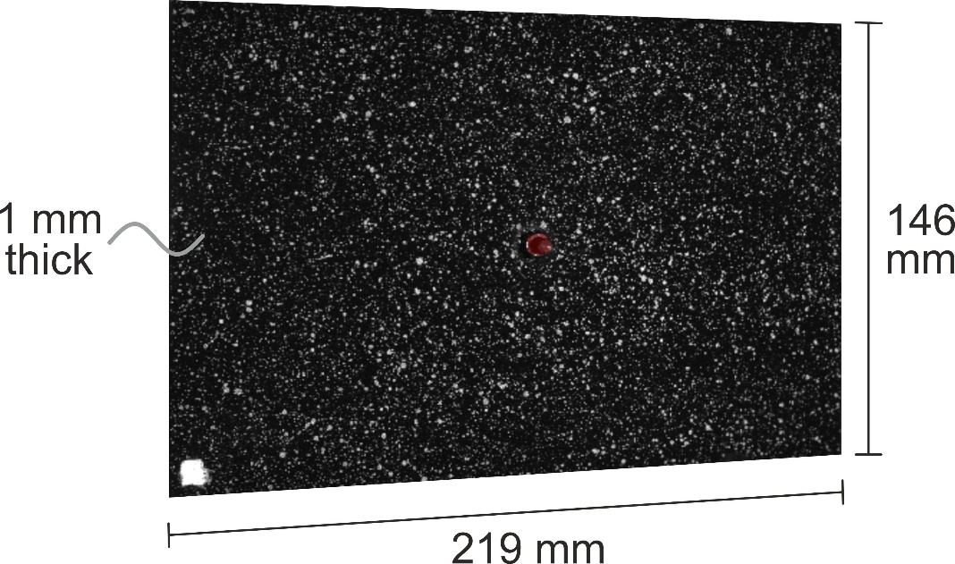

Figure 1. Photograph of the plate showing the painted speckle pattern used for digital image correlation (DIC). Image from the left camera of the stereo-vision system shown.
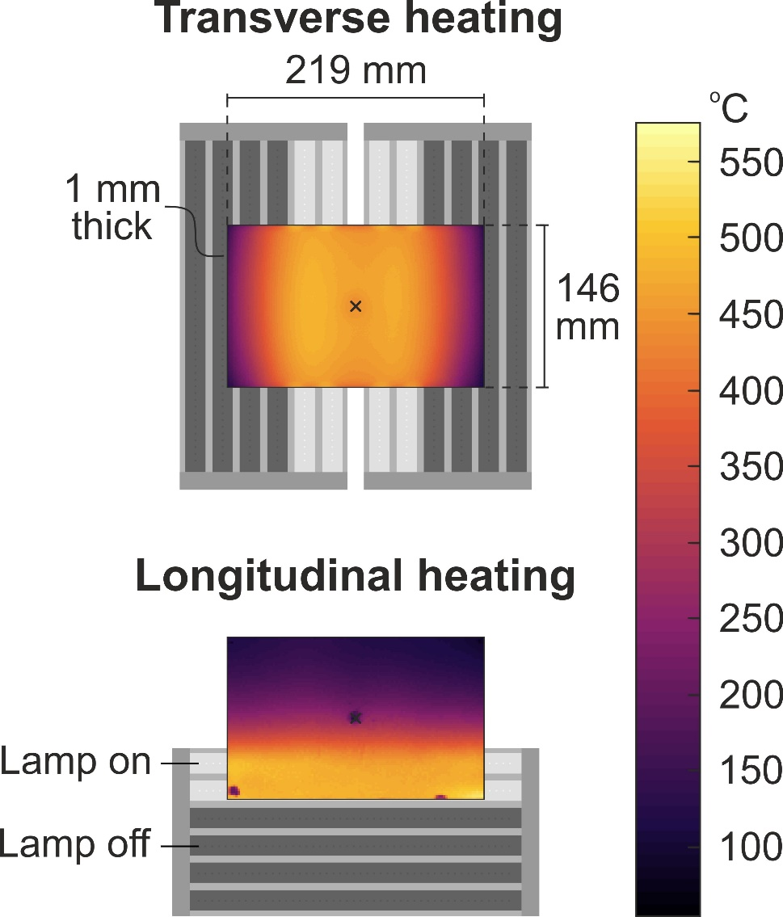

Figure 2. Configuration of lamps in grey illustrating transverse heating with four lamps in light grey (top) and longitudinal heating with two lamps in light grey (bottom) together with the resultant measured temperature distributions for the plate shown as overlays. Note that the anomalies in the temperature distributions correspond to zones of increased reflectivity where the vibrometer was focused.

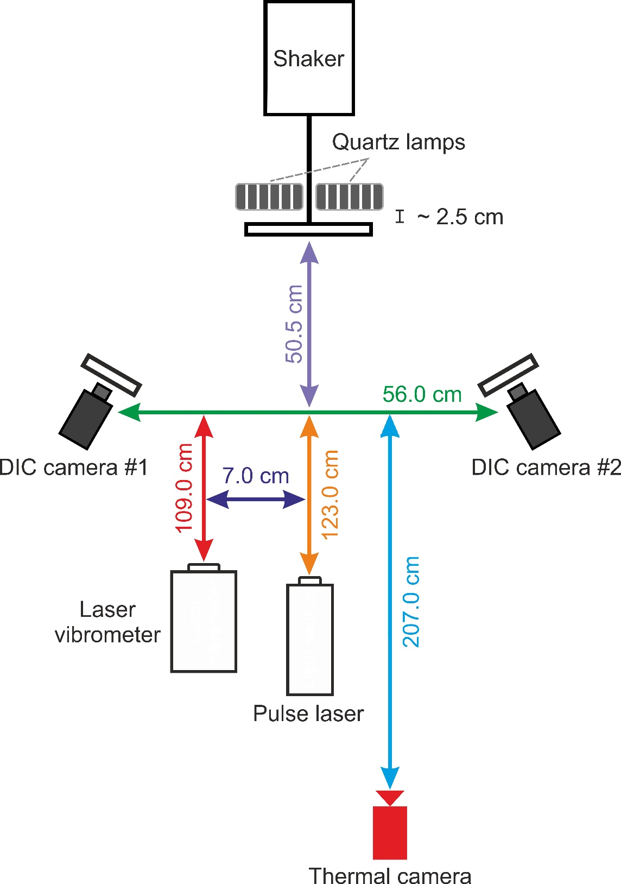
Figure 3. Schematic diagram of test setup.

Figure 4. Measured (DIC) displacement maps for the test plate subject to the three temperature regimes: room temperature (left), transverse heating of the centre of the plate (middle) and longitudinal heating on one edge (right). All displacements are in mm.
Figure 5. Predicted (FE) mode shapes for the test plate subject to the three temperature regimes: room temperature (left), transverse heating of the centre of the plate (middle) and longitudinal heating on one edge (right).
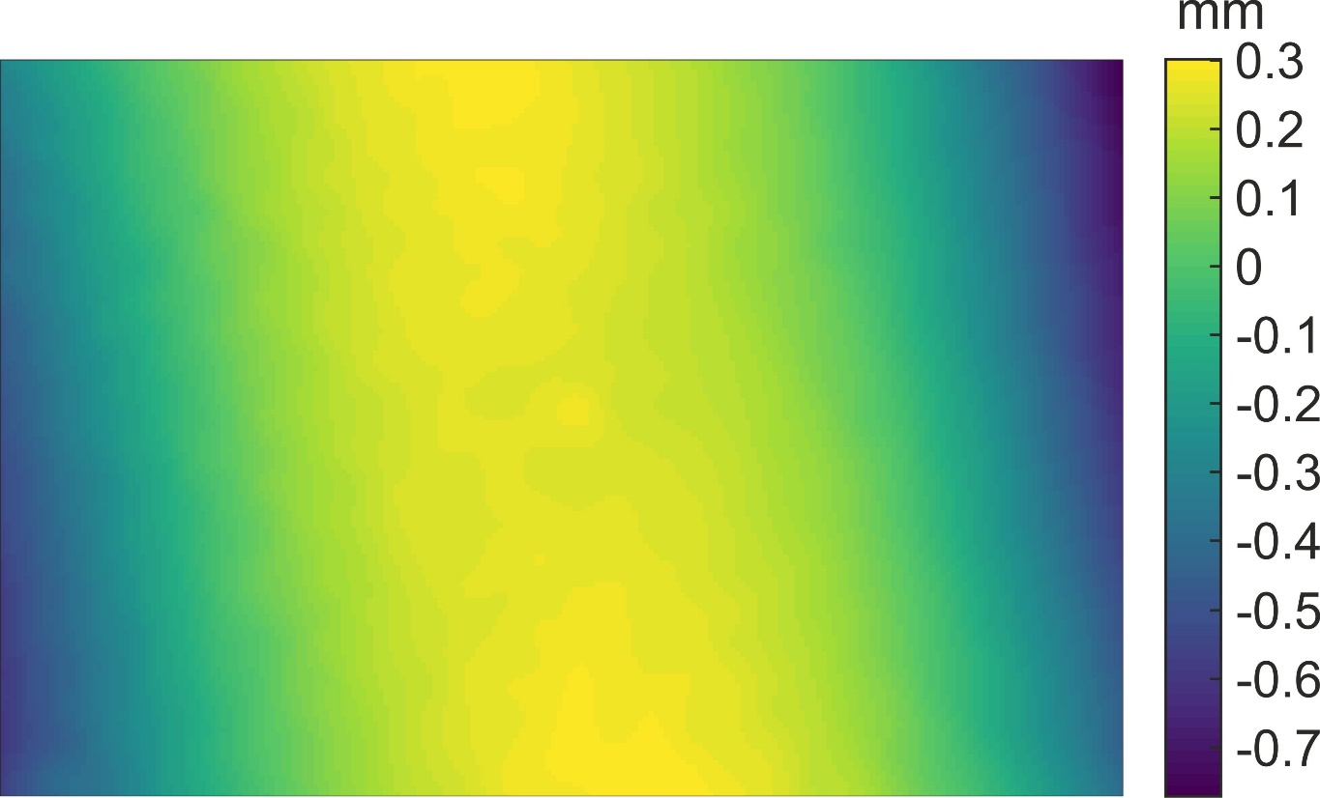
Figure 6. Finite element shape computed using DIC contour measurements of the plate at room temperature.

Figure 7. Measured (solid bars) and predicted (shaded bars) resonant frequencies for a) uniform room temperature; b) transverse heating of the centre of the plate; c) longitudinal heating on one edge. Relative errors of predictions against measurement data are shown in parenthesis.
Figure 8. Comparison of Chebychev coefficients from the orthogonal decomposition of measurements (horizontal axis) and predictions (vertical axis) data. Fifty Chebychev kernels were used in the decomposition of the measurement and prediction data. The first kernel was excluded from the plots as it describes rigid out-of-plane translation only and is unrelated to the deformation of the plate.

Figure 9. Predicted resonant frequencies plotted against experimental results.
Figure 10. High temperature resonant frequencies plotted against room temperature results for: a) transverse heating along the centre of the plate and longitudinal heating along a single horizontal edge (experiments and simulations); b) longitudinal heating of the centre of the plate and transverse heating of a single vertical edge (simulations only). Insets for the corresponding temperature map for each data set are presented and their temperature colour bar as shown in Figure 2.
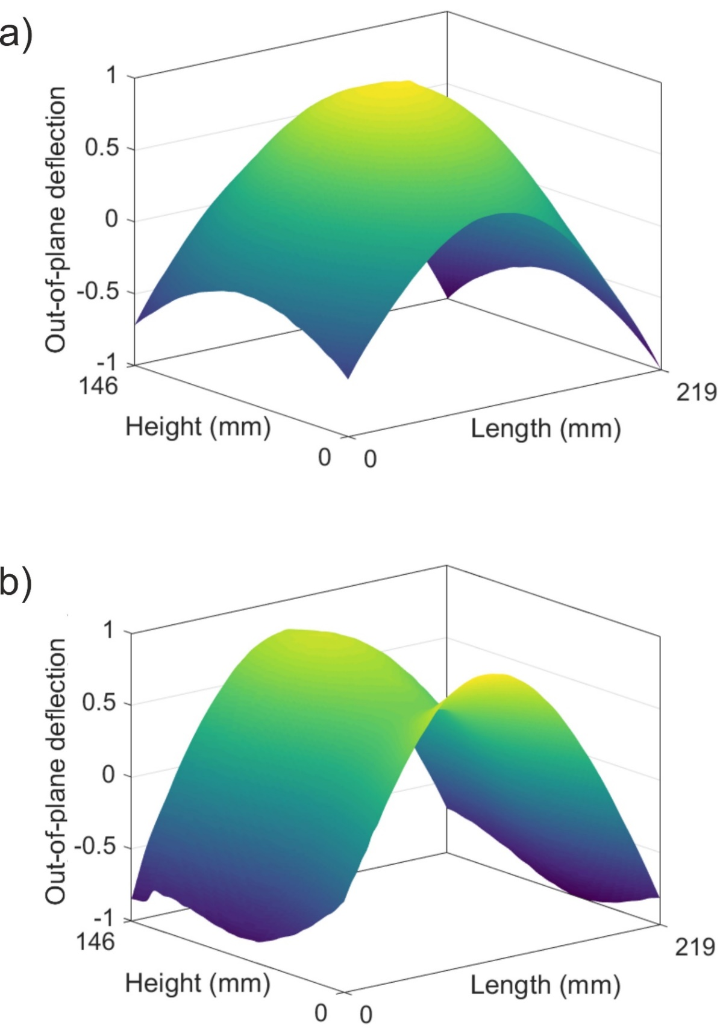
Figure 11. Measured deformed shape of the plate in the absence of mechanical excitation but following the transverse heating along the centre of the plate (top) and of a single longitudinal edge (bottom). The datasets have been normalised between -1 (dark purple) and 1 (yellow) because the energy inputs in the two cases are different and hence the absolute deformations are not directly comparable. Missing DIC data due to the bolted constraint has been interpolated using the cubic convolution method.

