Monitoring the Foreign Exchange Rate Benchmark Fix
Hossein Jahanshahloo ^{a,}*, Charlie X. Cai ^{b}, Kevin Keasey ^{c}

Abstract
In the presence of the manipulation of the World Markets/Reuters (WMR) benchmark in the FX market, regulators need a robust and timely methodology that identifies potential manipulation to better direct their limited resources towards more targeted in-depth investigation. We develop a manipulation index (ManIx) that captures the potential manipulation intention of dealers during the fixing period through a unique algorithm and simulation. The application of this model (using a dataset with dealers’ identities) is able to identify banks that are prone to potential manipulative behavior. The results concerning the identified banks are supported by the regulatory investigations.

Keywords: Simulation, Regulation Technology, WMR Fixing, FX Market Manipulation
JEL classification: G31, G18, O24
ª Leeds University Business School, Leeds, LS2 9JT, United Kingdom
^{b} Management School, University of Liverpool, Liverpool, L69 3BX, United Kingdom
^{c} Institute of Banking and Investment, University of Leeds, Leeds University Business School, Leeds, LS2 9JT, United Kingdom
*Corresponding author: Hossein Jahanshahloo, Tel: +441133439779
E-mail addresses: H.Jahanshahloo@leeds.ac.uk (H.Jahanshahloo), X.Cai7@liverpool.ac.uk (C.X. Cai)

1. Introduction
This paper proposes the first test to monitor the behavior of dealers, in the foreign exchange (FX) market around the WMR (World Market Reuters) fixing window. The FX market is a decentralized market with dealers spread across the globe conducting trades 24 hours a day. The around the clock trading poses a challenge to determining a daily closing price. Such a concept is needed for any entity that holds multi-currency portfolios to evaluate the value and performance of their holdings. The World Market Company (WM) in conjunction with Thomson Reuters launched the Closing Spot Rate Service, also known as the WMR Fix Rate or London Close, in January 1994. The WMR Fix Rate “has become a de facto standard for the closing spot rate” (FCA 2014b). Given the importance of this fix rate for a whole range of financial instruments and contracts, it has been a shock to the financial system and regulators to find out that the fix rate has been subject to manipulation. The widespread scandal concerning the manipulation has led to heightened concerns as to the lack of regulatory oversight and weaknesses in the design of the FX market.
Given the manipulation issue, the focus of the regulatory investigations and media attention has been on tracking trading activities for potential manipulation and collusive behavior (FCA 2014a; 2014b; 2014c; 2014d; Finch and Vaughan 2014). It is, however, costly for regulators to investigate and, therefore, effectively identifying potential investigation targets is itself an important task. With the rise of algorithmic and high-frequency trading within this market, the challenge facing regulators is the design of a method that can monitor and provide a timely warning signal that prompts further investigation. We aim to fill this void in the market microstructure literature by exploring the possibility of developing a monitoring system that can detect abnormal market behavior.
The FX market is predominantly a quote driven market. Dealers’ quotes are disseminated in real time across a few large platforms with Thomson Reuters being by far the largest and most comprehensive. We accordingly collect and construct a unique tick-by-tick dataset from the Thomson Reuters platform that contains dealers’ high frequency bid and ask quotes. The most prominent feature of this dataset is that the identity and location of the quote disseminators are recorded. This allows us to observe closely how individual dealers contribute to price discovery around the WMR fixing at 4 o’clock (henceforth the fix). Our final dataset spans from 2nd April 2013 to 27th March 2014 and contains 87,447 quotes from EUR:GBP, EUR:JPY, EUR:USD, GBP:USD, and USD:JPY. These currencies are the most traded, liquid, and important currency pairs in the FX market, forming 77.65% of the $5.4 trillion a day FX trades (BIS 2013).
We start our analysis of the abnormal behavior of dealers by understanding their “manipulative” objective functions when participating in the fixing process. The WMR benchmark fixing process is based on the median of the trade/quote prices within one minute centered at 4pm London time. Our procedure of capturing potential manipulation behavior is achieved in two phases. First, in the identification phase, we identify those quotes updates that are strategically and systematically contributing to moving the current median of the prices towards the final median of the prices in the fixing window. The idea is that before every quote update, dealers examine the distribution of the posted quotes since the beginning of the fixing window and post their quotes so that it will move the median in towards the desired direction. We count the number of such identified quote actions for each dealer and create a daily measure that we refer to as the ManIx.
The second phase is statistical verification. The ManIx measure is, therefore, intended to capture a specific type of quoting behavior that is in line with the manipulation motive. However, it is possible that a dealer has a high ManIx by a random coincidence, when posting their quotes. In order to determine that the ManIx score for individual banks is capturing the strategic and systematic behavior of dealers, we examine the significance of the ManIx score through bootstrap simulations. In our simulations, for a given fixing period, we change only one aspect of the dealers’ quotes, the timing. In other words, we maintain all dealers’ number of quotes and the quote movements, relative to the previous quote in the fixing window, while randomizing the sequence of their quotes in the fixing window. Such a design randomizes the dealers’ quotes with respect to the current median. If dealers’ quotes are not strategically conditional on the median of the quotes before their quotes, their ManIx measured from their realized quote should not be significantly different from the mean ManIx measure constructed from these bootstrap simulations. A significant realized ManIx compared to the bootstrap distribution would suggest that the realized ManIx is most likely to be due to systematic and strategic behavior.
We identify 13 out of 69 dealer-locations in our dataset that have at least one realized ManIx score in one of the five currency-pairs that is significant at the 5% level when compared to the simulated scores. In order to verify the effectiveness and accuracy of our model in capturing realized manipulation, we conduct an extensive search of regulatory investigations and press releases for a full list of banks that have been investigated. We find that by mid December 2015, there are nine banks that have been investigated or sued by their investors and many cases are still on going. These investigations have led to a total of more than $11.8 billion of fines across the globe. In addition, more than 40 traders have been fired, suspended, put on leave, or resigned since the start of the investigations (McGeever 2014).
When we compare our identified list with the investigation list, we find that eight dealer-locations among the top identified banks sorted by the number of significant ManIx, have been either fined by regulators or have internal investigations. Among these banks, we identify four banks that have been heavily fined by regulators and these account for 68% ($8 billion) of the total fines imposed by regulators and through court settlements. This confirms the power of the ManIx in capturing the abnormal behavior of banks that is of interest to regulators. We implement ManIx method on March 2016 to observe whether there has been changes in the quotation behavior of dealers after the breakout of the scandal and the regulatory investigations. We show that ManIx demonstrates a decrease in its frequency of occurrence, on average, compared to the 2013-14 period. However, there are still some signs of significant ManIx that may be worth close monitoring by regulators.
One of the important insights of the regulatory investigations is that the manipulators are not acting alone and collude via the sharing of information through chat rooms (Finch and Vaughan 2014; Ahmed 2014). Directly detecting and investigating such networks requires special access to information that is deemed to be private and confidential. Although ManIx is designed to capture the abnormal behavior of individual dealers, it is possible to use it to infer potential collusion through coordinated manipulation. To quantify the potential extent of collusion, we map out the coincidences of banks that have abnormal behavior in the same fixing period. In other words, by counting the number of days two banks have a significant ManIx score in the same currency pairs, we can identify potential collusion networks. Our analysis identifies that some networks exist that are of potential interest to regulators - there is, of course, a lack of public information to verify these findings at this stage. This analysis illustrates the potential application of ManIx in a network analysis context.
Our research contributes to the market microstructure literature and regulation technology (RegTech) framework in the following ways. First, we address the challenge of monitoring the unregulated FX market through a novel algorithm that can serve as an automated timely warning system to regulators and banks. Our study extends the existing market microstructure literature on the WMR fix such as Evans (2018) who studies the behavior of 21 currency pairs around the WMR fix window. He finds uncommon behavioral of the exchange rates around the fix that do not align with the prediction of microstructure models. We extend this line of enquiry by studying the motive of quotation around this period. Traditional theoretical study on the market making activities normally assume dealers are risk natural and not interested in betting on the direction of the market (Kyle 1985; Glosten and Milgrom 1985). Instead they post bid and ask quotes to attract volume of business and earn the spread accordingly. Our study emphasizes on the importance of taking into consideration the motivation of dealers in posting their bid and ask quotes by considering the direction of price movements. We show that this will provide further insight about dealers’ quotation behavior especially during a period that the prices have wider implications than only affecting the trades.
Second, and more generally, our study contributes to the new debate on the response of regulators to the rapid changes in financial technology. The availability of big-data and high-speed computing could create a new generation of regulatory technology; referred to as RegTech in a report by the UK Government (Government Office for Science 2015). We demonstrate, in the context of the FX market, that it is feasible to design an automated early warning/monitoring system. Our study also provides a first demonstration that by reverse engineering, it is possible to design a monitoring system for a fixing price process.
Finally, this study constructs and uses a unique dataset that highlights the potential of quote data in demonstrating potential misbehavior in the FX market. We show how market monitoring is implementable by using quote data. Dealers who have manipulation intentions should have a cohesive strategy in both their trading and quoting, since most transactions originate from a quote. We identify potential manipulation behavior in the quote data that affects the quality of the WMR Fix price.
The rest of this paper is structured as follows. Section 2 discusses the background, motivation of this paper, and explains the structure of the FX market and our dataset. The methodology of WMR fix rate calculation and how and why the fix rate was manipulated is also presented in Section 2. Section 3 explains the ManIx methodology and Section 4 presents the results of implementing ManIx and compares our findings to media reports and regulatory investigations and Section 5 concludes.

2. Background, Motivation and Data

2.1. The Forex Market – A Quote Driven Market
The FX market is a geographically dispersed, decentralized, quote driven, and primarily over the counter market (FSB 2014). Due to these attributes, there is not a single database that contains all the transactions conducted in this market. However, active dealers in the FX market disseminate the price that they are willing to trade on, in the form of indicative data (Goodhart and O'Hara 1997). Indicative quotes are disseminated on different platforms with the most important one being Thomson Reuters (Martens and Kofman 1998); more than 50% of all the electronic trading in the foreign exchange market occurs on the Reuters platform (Risk 2011) and the majority of the main players in the FX market disseminate their indicative quotes on this platform.
In recent years, advances in communication technology have contributed to the integration of the FX market and enabled customers to access multi-pricing sources simultaneously. This has led to an increased share of electronic trading in the FX market, with 90% of the trades in the FX spot market being conducted via electronic platforms. Though the overwhelming majority of the FX market trades occur on electronic platforms, there is not a single database that includes all the trades in this market. However, the vast majority of transactions in the FX market, conducted on an electronic platform, originate from a quote in two ways. First, a customer asks for a quote from a dealer or multiple dealers, simultaneously, for ask and bid prices for a specific size and subsequently accepts the desired side. Second, dealers stream a series of quotes, with predefined sizes. A trader could accept either side of a quote (ask or bid) and conduct a transaction (RBS 2014a; 2014b). In either of the situations, a quote disseminated by a dealer is displayed on multiple electronic platforms, while a transaction is recorded merely on a single platform. Furthermore, a quote is disseminated with the identity of the disseminator, while transaction data do not include any identity information due to privacy reasons.
Based on the aforementioned reasons, a comprehensive set of quotes with the identity of their disseminators, is the most adequate, available dataset to study the FX market, should the behavior of individual dealers be the focus of the analysis.

2.2. The WMR Benchmark, Calculation, Manipulation, and Motivation
In 1990 the World Markets (WM) Company, a small actuarial firm in Edinburgh, needed a single exchange rate for valuing the international portfolio of its pension fund clients. Until then a closing rate, published by Financial Times on the next day, was being used. The WM Company proposed their idea of producing a “carefully defined, cleaned, and screened benchmark” with Reuters (Willson-Taylor 2013). The FX Fix rate was introduced by the WM Company by using a Reuters’ data feed in 1994 (The WM Company 2015). The fix price, calculated by the WM, is the outcome of the median of the snapshots of ask and bid prices, independently and does not consider the size of the trades (Evans 2018). Over the fixing window the actual trades executed, and the bid and offer rates are sampled every second by WM. Where trade data are available, they will be used to generate bid and ask prices by applying the bid-ask spread at the time of the trade captured. For example, a public buy trade will be traded at the ask price; this trade price minus the bid-ask spread will produce the bid price at the time of the captured trade. The captured market data are subject to currency specific systematic tolerance checks that will identify outlying data. When the trade data are not sufficient or unavailable, quoted bid and ask data are used in the pool of calculation. After the finalization of the data capture, the medians of bid and ask prices are calculated and subsequently the mid-rate is formed based on these bid and ask medians. Finally, to obtain the bid and offer price from the mid-rate, a minimum standard spread is applied to the mid-rate to calculate the new bid and ask price (The WM Company 2015). Therefore, these medians are the most prominent and fundamental elements in constructing the fix price. We conjecture that the manipulation of these medians is likely to lead to the manipulation of the fix price.
The daily Fix rate produced by WM/Reuters at 4pm London time, also known as WMR Fix rate or London closing rate, “is by far the dominant benchmark being used, not just in FX, but also as a key input in multi-currency equity, bond, and credit indices” (FSB 2014). Due to the prominence of this benchmark and in response to the recent scandal in the FX Fix rate, HM Treasury in the UK has brought WMR and six other benchmarks “into the regulatory perimeter [to] enable close and continuous supervision by the UK regulators, as well as providing specific powers of enforcement against those that manipulate these benchmarks” (HM Treasury 2015).
The Fix rate is used in a variety of financial benchmarks and by a majority of investment entities that invest globally such as asset managers (including ETFs and corporate end users), non-financial corporates, and index providers (FSB 2014). One of the reasons for the emergence and attractiveness of manipulating the fix rate is the process, at which trading at the fix price occurs, that allows firms to front-run their clients’ orders. Due to the growth in demand for trading at a fixed rate and a consequent increase in competition from banks for this business, FX dealers have increasingly agreed to buy from or sell to their clients at the mid-point fix price, rather than applying the spread. Prior to the determination of the mid-point fix price, clients place orders (with a predetermined currency, volume and direction) with a firm. The firm, by agreeing to transact with clients at the fix rate, that is yet to be determined, exposes itself to price movements at the fix. In order to manage the risk of trading at the mid-point Fix rate, dealers attempt to manage their risk by trading before and around the fixing window. A firm with a net client order to buy (sell) at the fix will make profit if the rate that it buys (sells) the currency is below the fix rate that it sells to its clients (FCA 2015). It is clear that the larger the size of a dealer’s clientele, the easier it will be, for the dealer, to ‘predict’ the direction of the price movement.
The WMR Fix rate manipulation scandal that unfolded in 2014 shook the foundation of many banks. These investigations have resulted in the largest ever fines imposed by regulators on a group of banks (Ring and Vaughan 2014). The Bank of England fired its chief currency dealer, Martin Mallett, because of his failure to inform his superiors of the practice of sharing clients’ information by traders (Vaughan and Hamilton 2014). There have been many investigations and law suits since 2014. More details of these investigations are discussed in section 4.

2.3. Data
We start our investigation by constructing a unique high frequency dataset, accurate to a millisecond that contains dealers’ identities. We collected our dataset from the Thomson Reuters platform. Our dataset contains quotes from EUR:GBP, EUR:JPY, EUR:USD, GBP:USD, and USD:JPY. The dataset spans from April 2nd, 2013 to March 27th, 2014. There are 92 dealers from 5 continents, 42 countries and 49 cities that form 104 dealer-locations – of which 69 are active around the fixing window.
Table 1 reports the descriptive statistics of our dataset of the one-minute fixing window: from 15:59:30.000 to 16:00:30.000. It contains 225 days with 87,447 quotes in total for all the five currency pairs. GBP:USD is the most active currency with an average of 92 quotes per day, within the fixing window, while USD:JPY is the least active with an average of 72 quotes per day. These statistics show that for all currency pairs more than one quote per second is disseminated that demonstrates the high frequency nature of these currency pairs.

[Table 1 Here]

For dealer information, the Dealers/Locations column depicts the total number of unique dealers/locations in our dataset. The reason for distinguishing between the branches of the same dealers in different locations is due to their different characteristics. For instance, the Royal Bank of Scotland (RBS) has two branches, one in New York and one in London. The London branch is active from 8am to 4pm GMT time while the one in New York is active around the clock. In total, there are 69 unique dealer/locations across 37 cities in our dataset. For more information regarding the dealers, their locations, and the currency pairs they are active in, see the appendix.

3. The Manipulation Intention Index (ManIx)
To search and identify the potentially manipulative behavior of market participants, we begin by analyzing the objective of manipulative behavior. We note that the outcome of the manipulation is influenced by the fixing methodology. In order to calculate the fix price, WM Company captures snapshots of trades/quotes, for 60 seconds centered at 4pm GMT, at the interval of one second. Then after validation of the captured snapshots the medians of bid and ask prices are calculated and the minimum standard spread is applied to produce the final fix price (The WM Company 2015). Thus, a market participant who wishes to manipulate the fix rate should do so by manipulating the median price, since it is the most prominent element of the fix price calculation process.
Since the fix rate calculation is based on the median of trades during the fixing window, traders who intend to manipulate the rate are aware that in order to put the highest possible pressure on the fix rate break their transactions into smaller trades (Vaughan et al 2013). Therefore, traders who intent to manipulate the fix are aware that placing large orders are less effective than breaking a large order to smaller orders. Furthermore, due to the validation process of the fix rate methodology and because the fix rate is calculated based on the median of the prices not the average, traders are aware that extreme trades or quotes cannot impact the fix rate.
By having these characteristics of the fix rate methodology and behavior of dealers around the fix rate, we design our algorithm accordingly. Our proposed method for identifying manipulative behavior consists of two phases, identification and statistical verification. The first phase, identification, identifies those quote updates that contributed to the movement of the current median towards the final median, where the current median is the median of the quotes since the start of the fixing period up to the current quote. The idea behind this phase is that for every quote update, if a dealer has manipulation intention, the dealer strives to move the median towards the intended direction. The second phase, statistical verification, determines whether the realized measures of manipulation intention are statistically significant.

3.1. The Identification Phase
Our proposed methodology identifies those quote updates that are contributing to the movement of the current median towards the final median, where the current median is the median of the quotes since the start of the fixing period up to the current quote. The idea behind our methodology is that for every quote update, if a dealer has manipulation intention, the dealer strives to move the median towards the intended direction. For successful manipulations, the realized medians would be a good proxy for dealers’ manipulation targets. Our methodology determines whether a set of quotes, disseminated by a dealer is placed strategically to move the Fix price. Specifically we have two conditions to classify each quote as a Potentially Manipulative Quote (PMQ):
 | $$IF\left\{\begin{aligned}S\left(F_{m}-C_{m}\right)*S\left(P_{t}-C_{m}\right)=1 \\ and \\ S\left(F_{m}-C_{m}\right)*S\left(P_{t}-P_{t-1}\right)=1\end{aligned}\right. \overset{⇒}{ } PMQ=1, otherwise PMQ=0$$ | (1)
Where F_{m}, C_{m}, P_{t}, and P_{t-1} are the final median, current median, the quote price at time t, and quote price at time t-1, respectively; final and current medians are the final median of the price in the fixing windows and the median up to the current quote, respectively; S(x) is the sign of x and is equal to +1, 0, and -1 when x is positive, zero, and negative, respectively. If PMQ is equal to 1 it means that the quote could potentially be manipulative and otherwise, if zero. By definition, the PMQ for the first quote is zero since there is no activity before it in the fixing window to compare it with.
Formula (1) states that a manipulative quote is a quote that meets two conditions. First, the sign of the difference between the final and current median is equal to the sign of the difference between current price and the current median, we call it the location condition. This suggests that the new quoted price will move the current median towards the final median. Second, the sign of the difference between the final and current median is equal to the sign of the difference between the current price and the previous price, we call it the direction condition. This suggests that the direction of the latest quote is in the same direction as the intended median movement. The reason for this second condition is to capture a strong form of manipulative behavior. For example, when quoting to move the median down, a down tick quote is more likely to be so when the resulting latest quote is at a lower level for others to follow. To put it simply, formula (1) determines whether the current quote is moving the price towards the final median.
The final step of the identification phase is constructing the ManIx score for a given fixing session. In order to do so, we aggregate the PMQ score of each dealer in each fixing daily. Thus, the ManIx score is formulated as below:

 | $${ManIx}_{i,j}=\sum_{k=1}^{n}{{PMQ}_{k}*D_{i} }$$ | (2)

Where ManIx_{i,j} is the aggregated PMQ score for dealer i in day j, n is the number of all quotes in the fixing window j, and PMQ_{k} is the PMQ score for quote k. D_{i} is a dummy variable equal to 1 when quote k belongs to dealer i and 0 otherwise.

3.2. The Statistical Verification Phase
The aim of this research is to develop a framework and a methodology that can identify manipulative behaviors within the WMR fixing window. Our methodology, ManIx, identifies which quotes strategically contribute to the final realization of the Fix rate. Such behavior, per se, is not necessarily a sign of manipulative behavior since it could be just a coincidence that the quote meets our specified condition in the course of price discovery. Strategically placing quotes in order to move it in a dealer’s desired direction and successfully doing so is a manipulative behavior. The question that needs addressing is how to differentiate the random from the systematic strategic behavior of a dealer. To this end, we design a bootstrap test for our ManIx statistics that maintains the same process of price discovery while examining the strategic placement of quotes to manipulate the fix rate.
We run simulations that randomize dealers’ quoting sequences while maintaining their quoting characteristics (size and direction of the tick movement). Maintaining the number of quotes and the size of tick movement in their quotes control for the potential size effect and information effect that may affect the calculation of ManIx. For example, for a dealer who quotes more often, then it is more likely that they will have a false positive ManIx by chance. Comparing the realized ManIx with a bootstrap simulation that maintains such a property will control for such a potential bias.
For each day, in each currency pair, we generate 10,000 series of randomized quotes. All of these randomized sequences have the same total price movement, and dealers maintain their number of quotes and the associated tick movements as the realized sequence in the fixing. The only thing that changes is the location of the dealers’ quotes in the overall sequence. After generating these series, we calculate the simulated PMQ and ManIx scores for each dealer in that day.
The design of this verification is to differentiate a dealer’s contribution to price discovery from manipulation. The simulated sequences will maintain the same level of contribution to price discovery (the total number of ticks that a dealer would have moved the price) while the timing of the contribution is different. In these simulated sequences, there will be quotes that have PMQ equal to 1 but are due to randomness. The assumption is that if a dealer is making quotes to time the market so that the median will move towards an intended direction, their realized ManIx for that fixing session will be at the right tail of the ManIx distribution generated from the 10,000 randomized quote sequences; otherwise, the realized ManIx will be indistinct from that of the randomized sequences. The point that should be emphasized here is that each dealer’s original ManIx score is compared with its own simulated ManIx score generated from the 10,000 randomized sequences. In other words, each dealer’s ManIx score is compare to its own simulated ManIx score, not other dealers. This comparison in this manner controls for the number of quotes (market share) of the dealer and size effect.
To exemplify the process of the verification phase, consider the following example. Assume five quotes, Q1 to Q5, are disseminated by three dealers, A, B, and C and the sequence of the quotes is given in Table 2. Panel A, demonstrates the original quote series. The subscripts for a dealer demonstrate the sequence of price for that dealer. We start the randomized sequence by keeping the first quote the same as the original sequence, in order to maintain the start and finish prices for all the sequences to be the same as the original one. For instance, Panel B shows an illustration of our randomization. Q1 to Q5 are randomized as Q1, Q5, Q2, Q3, and Q4. In order to rebuild the price series after randomization, we apply the price change of the quote in the sequence. For example, the second quote in the randomized series is Q5, which was B2 in the original quote. The corresponding price change for B2 was “-0.1”. Therefore, the price in the randomized series will be the previous price plus the corresponding change, which is equal to 1.8 + (-0.1) = 1.7. Notice that the total contribution to price discovery of each dealer is maintained. For example, for dealer B their total contribution to price discovery is zero in both panels (0.1 + (-0.1) = 0). What is different is the timing of these contributions to the sequence. If the timing is strategic to manipulate the fixing, a randomization will remove this effect and, therefore, reduce the possibility of generating a positive ManIx signal in the randomization.
For each day, in each currency pair, we generate 10,000 series of randomized quotes. After generating these series, we calculate the PMQ and ManIx scores for each of the dealers in that day. To determine whether a dealer’s quoting behavior was a result of random or strategic quoting, we identify where the original ManIx score lies within the simulated ManIx scores distribution. If the original ManIx score lies within the first top 5% of the simulated ManIx score histogram, the behavior of the dealer on that day is classified as manipulative, otherwise it is classified as random or non-manipulative.

[Table 2 Here]

Figure 1 illustrates a simulation distribution for ask price of RBS (New York branch) on 21st June 2013 for the GBP:USD currency pair with the realized ManIx score of 17. Out of the 10,000 simulated ManIx scores, only 0.92% of them are larger or equal to the realized ManIx score by the dealer on the day. In other words, the original ManIx score, realized by the dealer, lies within the top 5% of the simulated ManIx distribution of the dealer and, consequently, we identify the dealer’s ask quotes as manipulative.

[Figure 1 Here]

4. Results and Discussion

4.1. An Overview of Fix Rate Discovery
Table 3 reports the daily distribution of the average PMQ per quote. For each day, the average PMQ is calculated for each currency pair using all quotes. Such per quote averages give an idea of the frequency of quotes that are captured as potentially manipulative by the ManIx. Panel A shows that on average the number of quotes that are deemed to be potentially manipulative range from 13 (11) to 22 (21) percent for the Ask (Bid) price. For instance, the daily mean of the average PMQ per quote is 0.1334 for EUR:GBP. This means that on average, almost, 1 out of 7.5 quotes coincide with our manipulation definition.

[Table 3 Here]

4.2. ManIx and Regulatory Investigations
Table 4, panel A, reports the dealers with significant ManIx that are identified as manipulator after verification phase. If the realized ManIx score lies within the top 5% of the simulated ManIx score, the dealer’s behavior in that day is classified as manipulative, otherwise it is classified as random or non-manipulative. The highlighted dealers are the dealers that are also identified by regulatory investigations as manipulators. In terms of the EUR:GBP, EUR:JPY, EUR:USD, GBP:USD, and USD:JPY currency pairs we identify 7, 6, 5, 7, and 3 dealers, respectively, who exhibited manipulative behavior. The number of days that dealers have manipulated the market varies amongst the dealers. In all the currency pairs, Barclays and the Royal Bank of Scotland, both London and New York branches, Rabobank, and Societe Generale demonstrate considerably greater manipulative behavior than other dealers.
Table 4, panel A, raises two questions. The first question is that whether the identified dealers as manipulators are the dealers that have higher quote activity. Table 4, panel B, shows in general this the case. For example, the most active dealer in these currency pairs (RBS-NYC) has the highest frequency of manipulative behavior. The second question is whether dealers’ quoting activity changes before and within the fixing period. To answer this question, we calculate the average number of quotes per minute for each dealer and in total from15:30 to 15:58 refereeing to as non-fix period and compare it with the average number of quotes in the fixing window. The highlighted cells in panel B show that a dealer’s average quoting frequency statistically significantly changes before and within the fixing window. This is mainly the case for the dealers who are identified as manipulators in panel A.
Overall, out of 69 dealers in our dataset, 32 dealers exhibit different quoting behavior before and within the fixing window. However, the behavior change is not always only increase in dealers’ quoting frequency. There are instances that some dealers reduce their quoting frequency within the fixing window relative to the period before it. This finding serves as some evidence of intent to manipulate the fix rate; however, this is neither sufficient nor necessary. This evidence further demonstrates the need for development of ManIx algorithm. Finally, the total row in panel B, demonstrates the average number of quotes per minute from15:30 to 15:58 and the fixing window. In line with Evans (2018) finding, for all currency pairs we observe a statistically significant increase in number of quotes in fixing window relative to the period before.
Table 4, panel A, provides a short list that can guide regulators in their potential investigations of manipulation. How can this list be verified and, therefore, provide evidence for the validity of our methodology? It is unlikely to be able to identify manipulation using publicly available data (even ex-post) as we discussed earlier, and this is one of our motivations behind developing ManIx. The manipulative behavior can only be identified and confirmed through detailed investigation with access to private trade and chat records. Such investigations are costly to both regulators and banks and, therefore, if ManIx can act as an effective monitoring system it will help direct the limited regulatory resource to more targeted investigations. To validate our measure, we compile a table of banks that have been investigated and fined.
Table 5 reports a collection of fines imposed on to the banks following the investigations and law suits around the globe. It shows that most of the investigations have happened in the UK and US. For example, the UK’s Financial Conduct Authority (FCA) fined five banks $1.7 billion for manipulating the WMR benchmark in November 2014 and Barclays $441 in May 2015 (FCA 2014e; 2015). In the US, the Commodity and Future Trading Commission (CFTC) fined five banks: Citibank, HSBC, JPMorgan, RBS, and UBS a total of $1.4 billion in November 2014 and Barclays for $400 million in May 2015 (CFTC 2014; 2015).

[Table 4 Here]
[Table 5 Here]
The regulatory investigations are being followed by lawsuits from investors against involved banks in WMR fix rate manipulation. In a lawsuit brought by the Scott and Scott law firm against involved banks: Barclays, RBS, and UBS settled with their investors for $384 million, $255 million, and $135 million, respectively (Kleinman 2015; Kennedy 2015). In addition, the Scott and Scott law firm brought a lawsuit against Societe Generale for its role in manipulating the WMR Fix rate (Voris 2015). In addition, more than 40 traders have been fired, suspended, put on leave, or resigned since the start of the investigations (McGeever 2014).
Comparing the list of banks being fined by regulators to our identified list, we have two important observations. First, we identify four out of the top five banks that have been heavily fined by regulators. The exception is JP Morgan who is more active on the EBS platform and not featured in our Thomson Reuter’s database. Economically, 68% ($8 billion) of the regulator fines are from the top 8 banks that have been identified by ManIx in Table 4. If the regulators focused their investigations on our identified list, they would have covered the major suspects. Importantly, having such a monitoring system in place would speed up the response of investigators to potential manipulation as a timely signal would be generated by the ManIx. Second, although some banks were not investigated by regulators, they conducted their own internal investigations into the attempted manipulation of the WMR fix rates by their employees. In May 2014, Commerzbank AG, Germany’s second largest lender, fired one FX trader and suspended another one on suspicions of the attempted manipulation of the Polish zloty's euro exchange rate (Schuetze and McGeever 2014). Rabobank that was fined $974 million during 2014 for manipulating interest rates, suspended two senior FX traders, Gary Andrews and Chris Twort, employees of the bank since 2004 and 2010, respectively (Van Gaal and Choudhury 2014). The New York State regulator, subpoenaed Societe Generale in December 2014, a month after US, UK and Swiss regulators concluded their probe into the rigging of the FX rate (Saks-McLeod 2015).
Overall, the media reports and regulatory findings discussed above confirm that the banks highlighted by our monitoring methodology have been investigated by regulators. This supports the notion that our monitoring methodology aligns with the actions of regulators and should provide value because of its time and cost-effective design. Our methodology, however, also signals potential manipulative behavior by banks that have not been investigated. Whether these are false positives in our estimation or a lapse in regulatory activity is open to question and can only be clarified by further regulatory investigation in the future.

4.3. Out of Sample Test
One interesting question to ask is what has happened to the quotation behavior of dealers after the breakout of the scandal and especially the regulatory investigations. Two main structural changes have taken place. First, from February 2015, the fixing period has changed from 60 seconds to 300 seconds. Second, there are more dealers involved in the fixing window in 2016 than was the case for 2013 and 2014. To demonstrate the application in this new environment, Table 6 reports the results of ManIx for the period from the 2nd March to 30th March 2016.
[Table 6 Here]

Table 6 shows there are some significant results. Particularly, RBS and Rabobank have the highest number of significant days. In order to compare these results with those of 2013-14, since there are different number of days and dealers in the two periods, we calculate the total number of dealer-days for each currency pair for each period. By dividing the total number of identified events (significant ManIx) in each currency by the total number of dealer-days, we can observe the occurrence of the frequency of manipulation. By comparing the columns event per dealer-day (E/DD) in Table 7 we can ascertain if the frequency has changed between the periods 2013-14 and March 2016.

[Table 7 Here]

Table 7 shows the results of comparing the frequency of manipulative behavior by dealers in 2013-14 and 2016 periods. With the exceptions of the EUR:GBP and USD:JPY currency pairs, there is a reduction in the frequency of significant ManIx occurrence. After the change in the fix rate calculation and the exhaustive investigations by regulators, ManIx shows a decrease in its frequency of occurrence on average. Nevertheless, there are still some signs of significant ManIx that may be worth close monitoring by regulators.
After February 2015 the increase in the length of fixing window from 60 seconds to 300 seconds may deter manipulation as it is more difficult to influence the ultimate benchmark fixed rate. There can be an argument that no new algorithm is required and the small number of identified dealers in table 6 might be false positive. However, there is always a need for a monitoring algorithm such as ManIx, specifically with the growth of high frequency traders in the FX market. While the fix rate manipulation was done by human traders and identified by their communication, identification of algorithmic manipulation will be more difficult.

4.4. Network Analyses – Signs of Collusion
One of the arguments for not regulating the FX market is that given its size and competition, it is less than likely that any one bank can manipulate this market. Manipulating the fix rate requires a considerable amount of capital and coordination between colluding traders. For example, some traders disclosed to Bloomberg news that they would need more than €200 million to have a possibility of moving the fix rate (Vaughan et al, 2013). Furthermore, the manipulation could “backfire” if another party enters the market with a large order in the opposite direction. Indeed, there is the suggestion that the manipulators are not acting alone and collude via the sharing of information through chatrooms (Ahmed 2014; Finch and Vaughan 2014). However, directly detecting and investigating such networks requires special access to information that is deemed to be private and confidential.
Three methods of collusion can be deduced from the regulators’ findings (FCA 2014d). First, traders transfer all the orders to one trader who executes the orders in the collective desired direction. Second, traders transfer their orders to two or more traders and these traders join forces and third, trading with dealers out of the network by giving them orders to trade in the desired direction. Since in the first case scenario the manipulation is conducted merely by one dealer, it is not possible to identify the network of dealers behind the manipulation with the existing data. The second and third methods suggest that the collusion will have a trail of coordination in the trading activity. While our ManIx measure is designed to capture manipulative intention on a quote by quote basis, examining all dealers’ quotes in the same fixing window will flag up potential collusion networks. To this end, we draw network graphs of banks that have significant manipulative behavior in a same fixing window.
When identifying the list of potential manipulative banks, we apply a strong statistical criterion of 5% significance in identifying the significant ManIx. This produces the short and focused list of banks in Table 4. However, in order to identify potential collusion effects, we choose a more relaxed criterion of 10% significance when identifying individual significant ManIx. This follows the logic that when banks collude to achieve manipulation, the act of manipulation will be less obvious in each individual bank. These network graphs are reported in Figure 2. Any two banks that have a significant ManIx on the same day for a given pair of currency will have a connection value of one. We count all these connections for all dealers in each fixing. The lines and their colors show the connections and direction of manipulation, respectively, while the size of each node shows its prominence in the network.
The network analyzes in Figure 2 demonstrate three features of such networks. First, there can be a large network of interconnected banks. For example, this is illustrated in Panels A and C. They show that a large number of banks are interconnected by their manipulated behaviors. For example, in Panel A for the EUR:GBP currency pair, there has been suspected collusion between four banks: Rabobank, Danske Bank, CIBC, and Barclays. Second, there can be more than one network identified. This is illustrated in Panels B, D and E. This fragmentation demonstrates that not all the manipulators are connected. Finally, some banks are found to play a dominant role in the network. For example, Barclays has a centrality and a prominent role with the highest number of connecting banks in Panel A for the EUR:GBP currency pair. Similarly, RBS-NYC has played the central role in the EUR:JPY, EUR:USD and GBP:USD currency pairs, while RBS-LON plays the central role in the USD:JPY currency pair.
[Figure 2 Here]
In the regulators’ investigative findings (discussed in Section 4) the individual banks who manipulated the fix rate were identified. However, there was very little mention as to which banks colluded over which currencies. Therefore, verification of our findings in this section based on the regulators’ findings or media reports is not possible. The only chatroom members identified by regulators are “The Cartel” chatroom that consisted of traders from JP Morgan, UBS, and Citigroup (Finch and Vaughan 2014). However, this chatroom was not the only existing network of manipulators and there existed different chatrooms with names such as “The A Team”, “The 3 Musketeers”, and “The Players” (Ahmed, 2014). The network analysis presented here is, however, a way to detect potential collusive behavior and it could be a toolkit for regulators and banks to further target the investigation of collusion.

5. Conclusion
The WMR benchmark rate is important for a number of financial instruments and markets, and its seemingly extensive manipulation has given rise to a lot of regulatory ‘interest’. The problem facing regulators in tackling this issue in a timely and effective manner is having data and a methodology that identifies potential manipulation as it progresses. In response to this issue we construct a dataset based on quotes and develop an index (ManIx) that is able to capture the intended manipulation of the benchmark rate. We identify banks that are prone to potential manipulative behavior and use ex post regulator investigation data to verify our findings. Essentially, we provide a warning system that will help regulators and FX market participants to keep up with the speed and size of the FX market in order to conduct their monitoring and investigative activities.
The exercise of developing an automatic monitoring system is of great importance to regulators given the rapid increase of speed in the financial markets. Having an automatic monitoring system will help regulators to allocate their limited resources to timely investigations. We demonstrate the feasibility of developing such a regulation technology and test its effectiveness. Our out of sample analysis provides some evidence of improvement in the fixing quality after the regulators’ investigation and the adjustment of the fixing methodology. Nevertheless, there are still some signs of significant ManIx that may be worth close monitoring by regulators. The limitation of the current study is the unavailability of transaction data with identity; however, such data can only be made available via requests from regulators. Finally, the application of this technology is not confined to foreign exchange rate fixing. For example, it can be applied to securities data to identify manipulation near the close of day trading. This is potentially important in days when the closing price has important implications for other markets such as derivative settlement or index membership.

Appendix – Active Dealers, Their Locations and the Number of Quotes during the Fix
Panel A. Active Dealers in Africa
Name | Country | City | €:£ | €:¥ | €:$ | £:$ | $:¥
ABSA BANK | SOUTH AFRICA | JOHANNESBURG |  |  | 11
NEDBANK | SOUTH AFRICA | JOHANNESBURG |  |  |  | 2,522
Panel B. Active Dealers in Asia
Name | Country | City | €:£ | €:¥ | €:$ | £:$ | $:¥
AL HILAL BANK | UAE | ABU DHABI |  |  | 4 | 4
ASYA KATILIM BANKASI A.S | TURKEY | ISTANBUL |  |  | 53 | 59
BANK MUSCAT | SAUDI ARABIA | RIYADH |  |  | 8 | 5
BANK OF COMMUNICATION | CHINA | SHANGHAI | 41 | 44 |  | 41 | 43
INDUSTRIAL AND COMMERCIAL BANK OF CHINA | HONG KONG | HONG KONG |  |  | 12 | 9 | 11
ING BANK | TURKEY | ISTANBUL |  |  |  | 811
KASPI BANK | KAZAKHSTAN | ALMATY |  |  | 383 | 388 | 353
NATIONAL BANK OF OMAN | OMAN | MUSCAT |  |  | 7 | 7 | 6
OMAN ARAB BANK | OMAN | MUSCAT |  |  | 8 |  | 6
PROMSVYAZ BANK | RUSSIA | MOSCOW |  |  | 14
QATAR ISLAMIC BANK | QATAR | DOHA |  |  | 497
YAPI KREDI BANK | TURKEY | ISTANBUL |  |  | 6 | 210
Panel C. Active Dealers in Australia
Name | Country | City | €:£ | €:¥ | €:$ | £:$ | $:¥
LLOYDS BANK | AUSTRALIA | SYDNEY | 45
WESTPAC BANK | AUSTRALIA | SYDNEY | 71 | 88 | 59 | 89 | 72
Panel D. Active Dealers with Multiple Location
Name | Country | City | €:£ | €:¥ | €:$ | £:$ | $:¥
AUSTRALIA AND NEW ZEALAND BANKING GROUP | GLOBAL FOREX | GLOBAL FOREX | 1
BANQUE INTERNATIONALE A LUXEMBOURG | GLOBAL FOREX | GLOBAL FOREX | 3 | 2 | 1
BARCLAYS | GLOBAL FOREX | GLOBAL FOREX | 1,336 | 1,105 |  | 799 | 677
DEUTSCHE BANK AG LONDON | GLOBAL FOREX | GLOBAL FOREX | 149 | 7 | 82 | 2 | 1
GOLDMAN SACHS INTERNATIONAL | GLOBAL FOREX | GLOBAL FOREX | 15 | 7 | 5 | 6 | 2
HSBC | GLOBAL FOREX | GLOBAL FOREX | 24 |  | 6 | 3
HSBC BANK USA | GLOBAL FOREX | GLOBAL FOREX | 11 |  | 2 | 1
KBC GROUP | GLOBAL FOREX | GLOBAL FOREX | 2 | 686 |  | 318 | 601
NATIONAL AUSTRALIA BANK | GLOBAL FOREX | GLOBAL FOREX |  |  | 3
NEDBANK | GLOBAL FOREX | GLOBAL FOREX |  |  | 84 | 156 | 4
SOCIETE GENERALE | GLOBAL FOREX | GLOBAL FOREX | 69 |  | 383 | 192 | 12

Panel E. Active Dealers in America
Name |  | Country | City | €:£ | €:¥ | €:$ |  | £:$ | $:¥
BANK OF MONTREAL-BANQUE DE MONTREAL |  | CANADA | MONTREAL |  |  | 54 |  | 107 | 56
Brown Brothers Harriman & Co |  | U.S.A | NEW YORK |  | 311 | 291 |  | 289 | 288
RADA FOREX |  | U.S.A | NEW YORK |  | 9 |  |  | 1 | 4
RBS |  | U.S.A | NEW YORK | 4,045 | 4,244 | 4,426 |  | 4,460 | 4,144
SKANDINAVISKA ENSKILDA BANK |  | U.S.A | NEW YORK | 286 |  |  |  | 386
THE BANK OF NEW YORK MELLON |  | U.S.A | NEW YORK |  |  | 546 |  | 755 | 564
INTERCAM BANK |  | MEXICO | MEXICO CITY |  |  | 4 |  | 236
Panel F. Active Dealers in Europe
Name | Country |  | City | €:£ | €:¥ | €:$ | £:$ |  | $:¥
ALLIED IRISH | IRELAND |  | DUBLIN | 427 | 513 | 342 | 498 |  | 330
BANCA AKROS | ITALY |  | MILAN | 217 | 224 | 116 | 265 |  | 259
BANCA MONTE DEI PASCHI DI SIENA | ITALY |  | MILAN | 32 | 34 | 22
BANCO COMMERCIAL PORTUGUES SA | PORTUGAL |  | LISBON |  | 1,517
BANCO DE SABADELL | SPAIN |  | SABADELL | 244 | 257 | 172
BANCO POPOLARE | ITALY |  | BERGAMO | 252 | 259 | 148 | 210
BANCPOST SA | ROMANIA |  | BUCHAREST |  |  |  | 125
BANK BPH SA | POLAND |  | WARSAW | 58 |  | 61 | 74 |  | 63
CAIXA GERAL DE DEPOSITOS | PORTUGAL |  | LISBON | 69 | 72 |  | 4
CANADIAN IMPERIAL BANK OF COMMERCE CIBC | CANADA |  | TORONTO | 402 | 501 |  | 572
CITIBANK | CZECH REPUBLIC |  | PRAGUE |  |  | 1,768
COMMERZBANK | GERMANY |  | FRANKFURT | 946 | 860 | 979 | 1,058 |  | 695
COMMONWEALTH BANK OF AUSTRALIA | UNITED KINGDOM |  | LONDON |  |  |  |  |  | 1,491
DANSKE BANK | DENMARK |  | COPENHAGEN | 781 | 696 | 328 | 347 |  | 268
DBS BANK | HONG KONG |  | HONG KONG |  |  | 761 |  |  | 850
DEN NORSKE BANK | NORWAY |  | OSLO |  |  | 1 | 9 |  | 13
DIE ERSTE OESTERR. SPAR-CASSE BANK | AUSTRIA |  | VIENNA |  |  | 97 |  |  | 103
HSBC | UNITED KINGDOM |  | LONDON |  |  | 313 | 50
I.C.M. INVESTMENTBANK AG | ITALY |  | MILAN |  |  | 140
INDUSTRIAL AND COMMERCIAL BANK OF CHINA | UNITED KINGDOM |  | LONDON |  |  | 261
INTESA SANPAOLO BANK | ITALY |  | MILAN | 347 | 342 | 324 | 340
LANDESBANK BADEN-WÜRTTEMBERG | GERMANY |  | STUTTGART | 101 | 107 | 95 | 106
NORDEA BANK | DENMARK |  | COPENHAGEN | 245 | 316 | 284 | 318 |  | 303
PALATINE BANK AND TRUST | FRANCE |  | PARIS | 8 | 14 | 12 | 11 |  | 10
PIRAEUS BANK | GREECE |  | ATHENS | 72 | 76 | 49
RABO BANK FINANCIAL GLOBAL MARKET | UNITED KINGDOM |  | LONDON | 816 | 133 | 562 | 587 |  | 603
RAIFFEISEN BANK | ALBANIA |  | TIRANA |  |  | 24
RBS | UNITED KINGDOM |  | LONDON | 2,070 | 1,624 | 2,765 | 2,552 |  | 1,983
SANTANDER | SPAIN |  | MADRID | 224 | 9 |  | 209
SKANDINAVISKA ENSKILDA BANK | SWEDEN |  | STOCKHOLM | 756 | 413 |  |  |  | 738
SOCIETE GENERALE | FRANCE |  | PARIS | 576 | 857 | 677 |  |  | 264
UBS | SWITZERLAND |  | ZURICH | 368 | 385 | 378 | 375 |  | 306
WGZ BANK | GERMANY |  | DÜSSELDORF | 912 | 925 | 815 | 927
ZUERCHER KANTONALBANK | SWITZERLAND |  | ZURICH | 123 | 171 | 128 | 179 |  | 100

References
Ahmed, K.2014. “RBS boss admits – I cringed when I read forex chat room messages”. [Online]
Available at: http://www.bbc.co.uk/news/business-30027544.
Bank For International Settlements. 2011. “High-frequency trading in the foreign exchange market.”.
Bank For International Settlements. 2013. “Triennial Central Bank Survey Foreign exchange turnover in April 2013: preliminary global results.” Bank For International Settlements.
Bloomberg Visual Data. 2015. “Forex Investigation a Global Affair.” [Online]
Available at: http://www.bloomberg.com/infographics/2014-08-13/forex-investigation-a-global-affair.html.
Cabrera, J., Wang, T. & Yang, J.2009. “Do futures lead price discovery in electronic foreign exchange markets?” Journal of Futures Markets 29 (2): 137-156.
CFTC: U.S. Commodity Futures Trading Commission. 2014. “CFTC Orders Five Banks to Pay over $1.4 Billion in Penalties for Attempted Manipulation of Foreign Exchange Benchmark Rates”. [Online] available at http://www.cftc.gov/PressRoom/PressReleases/pr7056-14.
CFTC: Commodity Futures Trading Commission. 2015. “Barclays to Pay $400 Million Penalty to Settle CFTC Charges of Attempted Manipulation and False Reporting of Foreign Exchange Benchmark Rates.” [Online] available athttp://www.cftc.gov/PressRoom/PressReleases/pr7181-15.
DOJ: Department of Justice. 2015. “Five Major Banks Agree to Parent-Level Guilty Pleas.” [Online] available at http://www.justice.gov/opa/pr/five-major-banks-agree-parent-level-guilty-pleas.
Evans, M. 2018. “Forex trading and the WMR Fix”. Journal of Banking & Finance 87: 233-247.
Fed: Federal Reserve. “Press Release”. 2015. [Online] available at http://www.federalreserve.gov/newsevents/press/enforcement/20150520a.htm.
FCA: Financial Conduct Authority. 2014a.“Citibank Final Notice.”
FCA: Financial Conduct Authority. 2014b. “HSBS Final Notice.”
FCA: Financial Conduct Authority. 2014c. “Royal Bank of Scotland Plc Final Notice.”
FCA: Financial Conduct Authority. 2014d. “UBS AG Final Notice.”
FCA: Financial Conduct Authority. 2014e. “FCA fines five banks £1.1 billion for FX failings and announces industry-wide remediation programme.” [Online] available at http://www.fca.org.uk/news/fca-fines-five-banks-for-fx-failings.
Financial Conduct Authority. 2015. “Barclays Bank PLC Final Notice.”
FSB: Financial Stability Board. 2014. “Foreign Exchange Benchmarks.”
Finch, G. & Vaughan, L.2014. “Traders Boasted of Whacking FX Market.” [Online]
Available at: http://www.bloomberg.com/news/articles/2014-11-13/-cartell-chat-room-traders-boasted-of-whacking-fx-market.
FINMA: “FINMA sanctions foreign exchange manipulation at UBS.” 2014. [Online] available at https://www.finma.ch/en/news/2014/11/mm-ubs-devisenhandel-20141112/.
Glosten, L. R. & Milgrom P. R. 1985. “Bid, ask and transaction prices in a specialist market with heterogeneously informed traders”. Journal of Financial Economics 14 (1): 71-100.
Goodhart, C. A. & O'Hara, M. 1997. “High frequency data in financial markets: Issues and applications”. Journal of Empirical Finance 4 (2-3): 73-114.
Government Office for Science. 2015. “Fin Tech Futures The UK as a World Leader in Financial Technologies.”
HM Treasury. 2015. [Online] Available at: http://www.legislation.gov.uk/ukdsi/2015/9780111127629/pdfs/ukdsiem_9780111127629_en.pdf.
Kennedy J. 2015. “Forex Suit Adds Japanese, Canadian, French, UK Banks.” [Online] available at http://www.law360.com/articles/686131/forex-suit-adds-japanese-canadian-french-uk-banks.
Kleinman M. 2015.“UK Bank Trio Agree $924m Forex-Rigging Bill. “ [Online] available at http://news.sky.com/story/1574604/uk-bank-trio-agree-924m-forex-rigging-bill .
Kyle, A. 1985. “Continuous Auctions and Insider Trading”. Econometrica, 53 (6): 1315-1335.
Martens, M. & Kofman, P. 1998. “The inefficiency of Reuters foreign exchange quotes”. Journal of Banking and Finance, 22 (3): 347-366.
McGeever, J. 2014. “Exclusive - FX chatrooms show traders shared order, price details”: sources. [Online]
Available at: http://uk.reuters.com/article/2014/06/19/uk-fx-investigation-idUKKBN0EU1GH20140619.
NYDFS: New York Department of Financial Services. 2015. “Press Release.” [Online] available at http://www.dfs.ny.gov/about/press/pr1505201.htm.
OCC: Office of the Comptroller of the Currency. 2014. “OCC Fines Three Banks $950 Million for FX Trading Improprieties.” [Online] available at http://www.occ.treas.gov/news-issuances/news-releases/2014/nr-occ-2014-157.html.
RBS., 2014a. “RBS Market Place.” [Online]
Available at: https://www.rbsm.com/psp/public/pagebuilder.aspx?page=rp8000&video=fx-quote.
RBS., 2014b. “RBS Market Place.” [Online]
Available at: https://www.rbsm.com/psp/public/pagebuilder.aspx?page=rp8000&video=fx-stream.
Rime, D. & Schrimpf, A. 2013. “ The anatomy of the global FX market through the lens of the 2013 Triennial Survey.” Bank for International Settlement.
Ring, S. & Vaughan, L. 2014. “Citigroup, JPMorgan Pay Most in $4.3 Billion FX Rig Cases” [Online]
Available at: http://www.bloomberg.com/news/articles/2014-11-12/banks-to-pay-3-3-billion-in-fx-manipulation-probe.
Risk, H. 2011. Euromoney. [Online]
Available at: http://www.euromoney.com/Article/2913198/Bloomberg-challenges-FX-multi-dealer-incumbents.html.
Saks-McLeod, A. 2015. “New York State regulator investigates major banks for FX rigging.” [Online]
Available at: http://leaprate.com/2015/03/new-york-state-regulator-investigates-major-banks-for-fx-rigging/.
Schuetze, A. & McGeever, J. 2014. “Commerzbank fires one forex trader and suspends another - sources. “ [Online] Available at: http://uk.reuters.com/article/2014/05/21/uk-commerzbank-forex-idUKKBN0E111720140521.
Scott and Scott. 2015. “Scott and Scott 2015 In re foreign exchange benchmark rates antitrust litigation.” [Online] available at https://www.scott-scott.com/73115redcomplaint.pdf.

Thomson Reuters. 2014. “Thomson Reuters Eikon For Foreign Exchange Professionals Who Seek More.” [Online] Available at: http://financial.thomsonreuters.com/content/dam/openweb/documents/pdf/financial/eikon-foreign-exchange.pdf.
Van Gaal, M. & Choudhury, A. 2014. “Rabobank Suspends Two London Currency Traders After Probe.” [Online] Available at: http://www.bloomberg.com/news/articles/2014-10-07/rabobank-suspends-two-london-currency-traders-after-probe.
Vaughan, L., Finch, G. & Choudhury, A. 2013. “Traders Said to Rig Currency Rates to Profit Off Clients.” [Online] Available at: http://www.bloomberg.com/news/articles/2013-06-11/traders-said-to-rig-currency-rates-to-profit-off-clients.
Vaughan, L. & Hamilton, S. 2014. “BOE Chief FX Dealer Fired as Probe Faults Non-Escalation.” [Online]
Available at: http://www.bloomberg.com/news/articles/2014-11-12/boe-chief-currency-dealer-fired-after-not-reporting-risks.
Voris, B. V. 2015. “Standard Chartered, Societe Generale Added to Forex Lawsuit.” [Online]
Available at: http://www.bloomberg.com/news/articles/2015-08-01/standard-chartered-societe-generale-added-to-forex-lawsuit.
Willson-Taylor, S. 2013. “The story of the Fix. How we got here, how to fix the fix, and how not to have to use it (for trading) in the first place.” Molton Markets Inc.
The WM Company. 2015. “WM/Reuters Spot and Forward Rates Methodology Guide.” [Online]
Available at: http://www.wmcompany.com/pdfs/WMReutersMethodology.pdf.

Tables and Figures
Table 1- Dataset Summary Statistics

Currency | Days | Sum | Mean | Min | Max | STD | Dealers | Locations | Dealers/Locations
EUR:GBP | 212 | 16,156 | 76.21 | 48 | 122 | 13.28 | 36 | 22 | 38
EUR:JPY | 216 | 16,825 | 77.89 | 55 | 108 | 10.76 | 33 | 21 | 34
EUR:USD | 215 | 18,571 | 86.38 | 48 | 127 | 14.42 | 49 | 31 | 52
GBP:USD | 224 | 20,672 | 92.29 | 44 | 144 | 16.14 | 44 | 28 | 47
USD:JPY | 210 | 15,223 | 72.49 | 36 | 118 | 13.35 | 33 | 18 | 34
Total | 225 | 87,447 | 388.65 |  |  |  | 64 | 37 | 69

This table reports the descriptive statistics of our dataset of the one minute fixing window: from 15:59:30.000 to 16:00:30.000 between April 2nd, 2013 to March 27th 2014. We collected our dataset from the Thomson Reuters platform. The Days column shows the number of days that we were able to capture the data without any interruption. The Sum, Mean, Min, Max, and STD columns report the total, average, minimum, maximum and standard deviation of the number of quotes in the one minute fixing window, respectively. The Dealers and Locations columns depict the total number of distinct dealers and locations that are active within the fixing window in our dataset, respectively. The Dealers/Locations column depicts the total number of unique dealers/location in our dataset.

Table 2 – Randomization process

Panel A – Original Price Series
Quote | Q₁ | Q₂ | Q₃ | Q₄ | Q₅
Price | 1.8 | 1.9 | 2.1 | 1.7 | 1.6
Dealer | A₁ | B₁ | A₂ | C₁ | B₂
Change | 0 | 0.1 | 0.2 | -0.4 | -0.1
Panel B – Randomized Price Series
Quote | Q₁ | Q₅ | Q₂ | Q₃ | Q₄
Price | 1.8 | 1.7 | 1.8 | 2.0 | 1.6
Dealer | A₁ | B₂ | B₁ | A₂ | C₁
Change | 0 | -0.1 | 0.1 | 0.2 | -0.4

This table exemplifies the process of the verification phase and how the randomized sequence of prices is generated while maintaining the same price discovery process. Panel A shows the original price series and panel B shows the randomized price series.

Table 3 – PMQ Summary Statistics

 |  | Average PMQ Ask |  |  |  |  |  | Average PMQ Bid
Currency | N | Mean | Median | Std Dev | Min | Max |  | Mean | Median | Std Dev | Min | Max
EUR:GBP | 212 | 0.1334 | 0.1343 | 0.1014 | 0 | 0.4111 |  | 0.1314 | 0.1149 | 0.0920 | 0 | 0.3623
EUR:JPY | 216 | 0.2194 | 0.2298 | 0.1035 | 0 | 0.4247 |  | 0.2042 | 0.2051 | 0.0990 | 0 | 0.4267
EUR:USD | 215 | 0.1499 | 0.1429 | 0.0905 | 0 | 0.3697 |  | 0.1481 | 0.1481 | 0.0887 | 0 | 0.4118
GBP:USD | 224 | 0.2099 | 0.2215 | 0.0956 | 0 | 0.3910 |  | 0.1903 | 0.1971 | 0.0988 | 0 | 0.4235
USD:JPY | 210 | 0.1456 | 0.1419 | 0.0808 | 0 | 0.3614 |  | 0.1479 | 0.1421 | 0.0894 | 0 | 0.3500

This table reports the average portion of quotes in day that have obtained PMQ equal to 1. Column N represents the number of days available in our dataset for a currency pair. Mean, Median, Std Dev, Min, and Max represent the summary statistics.

Table 4 – Dealers with Manipulative (Significant Abnormal) Activities during Fixing and Their Quoting Behavior
Panel A. Identified Dealers With Manipulative Behavior
 |  |  | EUR:GBP |  |  |  |  | EUR:JPY |  |  |  |  | EUR:USD |  |  |  |  | GBP:USD |  |  |  |  | USD:JPY |  |  |  |  | Sum
Dealer |  | Location | C_{Total} | C_{Ask} |  | C_{Bid} |  | C_{Total} | C_{Ask} |  | C_{Bid} |  | C_{Total} | C_{Ask} |  | C_{Bid} |  | C_{Total} | C_{Ask} |  | C_{Bid} |  | C_{Total} | C_{Ask} |  | C_{Bid}
1 | RBS | NYC | 207 | 5 |  | 3 |  | 211 | 6 |  | 7 |  | 211 | 6 |  | 3 |  | 219 | 13 |  | 8 |  | 205 | 3 |  | 4 |  | 58
2 | RBS | LON | 196 | 4 |  | 5 |  | 198 | 4 |  | 4 |  | 198 | 1 |  | 9 |  | 203 | 11 |  | 10 |  | 197 | 2 |  | 5 |  | 55
3 | BARCLAYS | GFX | 212 | 0 |  | 2 |  | 194 | 2 |  | 2 |  |  |  |  |  |  | 223 | 0 |  | 1 |  |  |  |  |  |  | 7
4 | RABOBANKGFM | LON | 162 | 0 |  | 1 |  | 44 | 1 |  | 0 |  |  |  |  |  |  |  |  |  |  |  | 162 | 1 |  | 1 |  | 4
5 | SOC GENERALE | PAR | 200 | 1 |  | 0 |  | 215 | 0 |  | 2 |  | 211 | 0 |  | 1 |  |  |  |  |  |  |  |  |  |  |  | 4
6 | UBS | ZUR |  |  |  |  |  |  |  |  |  |  |  |  |  |  |  | 212 | 1 |  | 1 |  |  |  |  |  |  | 2
7 | CITIBANK | PRG |  |  |  |  |  |  |  |  |  |  | 209 | 0 |  | 2 |  |  |  |  |  |  |  |  |  |  |  | 2
8 | COMMERZ BANK | FFT | 211 | 1 |  | 0 |  |  |  |  |  |  |  |  |  |  |  | 223 | 1 |  | 0 |  |  |  |  |  |  | 2
9 | KBC | GFX |  |  |  |  |  | 159 | 2 |  | 0 |  |  |  |  |  |  |  |  |  |  |  |  |  |  |  |  | 2
10 | BK MONTREAL | MON |  |  |  |  |  |  |  |  |  |  |  |  |  |  |  | 29 | 1 |  | 1 |  |  |  |  |  |  | 2
11 | BANCA AKROS | MIL |  |  |  |  |  |  |  |  |  |  |  |  |  |  |  | 150 | 1 |  | 0 |  |  |  |  |  |  | 1
12 | ICBC | LON |  |  |  |  |  |  |  |  |  |  | 73 | 1 |  | 0 |  |  |  |  |  |  |  |  |  |  |  | 1
13 | WGZ BANK | DUS | 115 | 0 |  | 1 |  |  |  |  |  |  |  |  |  |  |  |  |  |  |  |  |  |  |  |  |  | 1
 | Total |  |  | 11 |  | 12 |  |  | 15 |  | 15 |  |  | 8 |  | 15 |  |  | 28 |  | 21 |  |  | 6 |  | 10 |  | 141
Panel B. Identified Dealers Average Quoting Frequency per Minute Within and Before Fixing Window
 |  |  | EUR:GBP |  |  |  | EUR:JPY |  |  |  |  | EUR:USD |  |  |  |  | GBP:USD |  |  |  |  | USD:JPY
Dealer |  | Location | Fix |  | Non-Fix |  | Fix |  |  | Non-Fix |  | Fix |  |  | Non-Fix |  | Fix |  |  | Non-Fix |  | Fix |  |  | Non-Fix
1 | RBS | NYC | 19.54 |  | 11.59 |  | 20.11 |  |  | 16.81 |  | 20.98 |  |  | 14.63 |  | 20.37 |  |  | 14.23 |  | 20.21 |  |  | 14.41
2 | RBS | LON | 10.56 |  | 4.05 |  | 8.20 |  |  | 5.80 |  | 13.96 |  |  | 6.96 |  | 12.57 |  |  | 4.89 |  | 10.07 |  |  | 6.42
3 | BARCLAYS | GFX | 6.30 |  | 4.98 |  | 5.70 |  |  | 4.66 |  |  |  |  |  |  | 3.58 |  |  | 2.90 |  | 3.25 |  |  | 2.78
4 | RABOBANK | LON | 5.04 |  | 3.34 |  | 3.02 |  |  | 3.10 |  | 3.41 |  |  | 3.18 |  | 3.35 |  |  | 3.14 |  | 3.72 |  |  | 3.24
5 | SOC GENERALE | PAR | 2.88 |  | 2.10 |  | 3.99 |  |  | 3.21 |  | 3.21 |  |  | 2.70 |  |  |  |  |  |  | 2.84 |  |  | 2.56
6 | UBS | ZUR | 1.77 |  | 1.70 |  | 1.80 |  |  | 1.81 |  | 1.80 |  |  | 1.78 |  | 1.77 |  |  | 1.74 |  | 1.59 |  |  | 1.61
7 | CITIBANK | PRG |  |  |  |  |  |  |  |  |  | 8.46 |  |  | 5.91
8 | COMMERZ BANK | FFT | 4.48 |  | 4.16 |  | 4.02 |  |  | 3.44 |  | 4.57 |  |  | 4.65 |  | 4.74 |  |  | 4.26 |  | 3.33 |  |  | 3.12
9 | KBC | GFX | 1.00 |  | 1.62 |  | 4.31 |  |  | 3.64 |  |  |  |  |  |  | 2.47 |  |  | 2.31 |  | 3.80 |  |  | 3.06
10 | BK MONTREAL | MON |  |  |  |  |  |  |  |  |  | 2.08 |  |  | 2.84 |  | 3.69 |  |  | 4.19 |  | 2.07 |  |  | 2.85
11 | BANCA AKROS | MIL | 1.55 |  | 1.32 |  | 1.64 |  |  | 1.68 |  | 1.33 |  |  | 1.17 |  | 1.77 |  |  | 1.53 |  | 1.79 |  |  | 1.77
12 | ICBC | LON |  |  |  |  |  |  |  |  |  | 3.58 |  |  | 3.64
13 | WGZ BANK | DUS | 7.93 |  | 7.49 |  | 7.91 |  |  | 7.74 |  | 7.09 |  |  | 7.02 |  | 7.66 |  |  | 7.07
 | Total |  | 76.21 |  | 54.90 |  | 77.89 |  |  | 69.29 |  | 86.38 |  |  | 70.25 |  | 92.29 |  |  | 76.67 |  | 72.49 |  |  | 59.05
Panel A reports a list of dealer-locations that are identified by the verification process to have a significant ManIx score at 5% level. Columns C_{Bid} and C_{Ask} report the number of days a dealer’s ManIx measures are significant for the Bid and Ask prices, respectively. The shaded rows indicate banks that are featured in regulatory investigations, summarized in Table 5. C_{Ask}, and C_{Bid} columns, in the total row, at the bottom of the table, show the total number of times that ask and bid price have been manipulated, respectively. Panel B reports the daily average number of quote for each dealer within and before the fixing window, from 15:30:00.000 to 15:58:59.999. The highlighted cells in gray shows that a dealer’s averages number of quotes is significantly different within and before the fixing window. The data, for panel B, is obtained from Thomson Reuters Eikon and spans from April 2nd, 2013 to March 27th, 2014. The total row depicts the average number of quotes per minute before the fixing window (from 15:30:00.000 to 15:58:59.999) and within the fixing window.

Table 5 – Investigations, Law Suits and Fines

Country | U.K. | Swiss | United States of America |  |  |  |  |  | Total
Sources | 1 | 2 | 3 | 4 | 5 | 6 | 7 | 8
Investigation | FCA | FINMA | CFTC | OCC | DOJ | Fed | N.Y.D.F.S | Scott + Scott
Banks
BARCLAYS | 441 |  | 400 |  | 650 | 342 | 485 | 384 | 2,702
CITI | 358 |  | 310 | 350 | 925 | 342 |  |  | 2,285
JP MORGAN | 352 |  | 310 | 350 | 550 | 342 |  | 99.5 | 2,004
RBS | 344 |  | 290 |  | 395 | 274 |  | 255 | 1,558
UBS | 371 | 139 | 290 |  | 203 | 342 |  | 135 | 1,480
HSBC | 343 |  | 275 |  |  |  |  | 285 | 903
BOA |  |  |  | 250 |  | 205 |  | 180 | 635
BNP PARIBAS |  |  |  |  |  |  |  | 249 | 249
GOLDMAN SACHS
Total | 2,209 | 139 | 1,875 | 950 | 2,723 | 1,847 | 485 | 1,588 | 11,816

This table reports a collection of fines imposed on the banks following the investigations and law suits. The data are collected from various regulatory press releases and news disclosures. Since some investigations are still on going, this table covers all announcements up to December 2015. The fines are reported in millions of dollars. FCA: Financial Conduct Authority, FINMA: Swiss Financial Market Supervisory Authority, CFTC: Commodity Futures Trading Commission, OCC: office of the comptroller of the currency, DOJ: Department of Justice, Fed: Federal Reserve, N.Y.D.F.S: New York State Department of Financial Services, Scott + Scott: Scott and Scott LLP Law Firm. The shaded rows indicate banks that are identified in Table 4. Sources of the fines are FINMA (2015), OCC (2014), FCA (2014 e; 2015), CFTC (2014; 2015), DOJ (2015), Fed (2015), NYDFS (2015), Scott and Scott (2015).
Table 6 – Dealers with Manipulative Activities during Fixing

 |  | EUR:GBP |  |  | EUR:JPY |  |  | EUR:USD |  |  | GBP:USD |  |  | USD:JPY |  |  | Sum
Dealer | Location | C_{T} | C_{A} | C_{B} | C_{T} | C_{A} | C_{B} | C_{T} | C_{A} | C_{B} | C_{T} | C_{A} | C_{B} | C_{T} | C_{A} | C_{B}
RBS | LON | 19 | 1 | 1 | 19 | 0 | 1 |  |  |  |  |  |  | 19 | 0 | 1 | 4
Rabobank | LON | 18 | 0 | 2 |  |  |  | 19 | 0 | 1 | 18 | 0 | 1 |  |  |  | 4
Barclays | LON | 20 | 0 | 1 | 20 | 1 | 0 |  |  |  |  |  |  |  |  |  | 2
BNY Mellon | NYC |  |  |  |  |  |  |  |  |  |  |  |  | 18 | 1 | 0 | 1
Total |  | 20 | 1 | 4 | 20 | 1 | 1 | 20 | 0 | 1 | 20 | 0 | 1 | 20 | 1 | 1 | 11

This table reports a list of dealer-locations that are identified by the simulations to have manipulative/significant-abnormal activity in March 2016. If the realized ManIx score is significant at the 5% level given the simulated ManIx distribution from the 10,000 simulations, the dealer’s behavior in that day is classified as manipulative - otherwise it is classified as random or non-manipulative. This table reports the total number of days a dealer participates in the fixing and the number of days their ManIx measures are significant for the Bid and Ask prices. Columns CT, CA, and CB demonstrate the total number of days that a dealer has been active and total number of significant ManIx for ask and bid, respectively.

Table 7 – Frequency of Manipulation Occurrence

 |  | 2013-2014 |  |  | 2016
Currency | Dealer-Day |  | Events | E/DD | Dealer-Day | Events | E/DD
EUR:GBP | 3,982 |  | 23 | 0.58% | 384 | 5 | 1.30%
EUR:JPY | 3,895 |  | 30 | 0.77% | 381 | 2 | 0.52%
EUR:USD | 4,276 |  | 23 | 0.54% | 415 | 1 | 0.24%
GBP:USD | 4,653 |  | 49 | 1.05% | 390 | 1 | 0.26%
USD:JPY | 3,404 |  | 16 | 0.47% | 317 | 2 | 0.63%
Total | 20,210 |  | 141.00 | 0.70% | 1887.00 | 11.00 | 0.58%

This table reports the frequency of the occurrence of significant ManIx for the 2013-14 and 2016 periods. The column Dealer-Day shows the total number of dealers who have been active in all days in a currency pair. The column Events reports the number of significant ManIx for both ask and bid. The column E/DD is the percentage of significant ManIx occurrence that has been calculated by dividing Events by Dealer-Day.

Figure 1 - Example of Statistical Verification through Bootstrapping
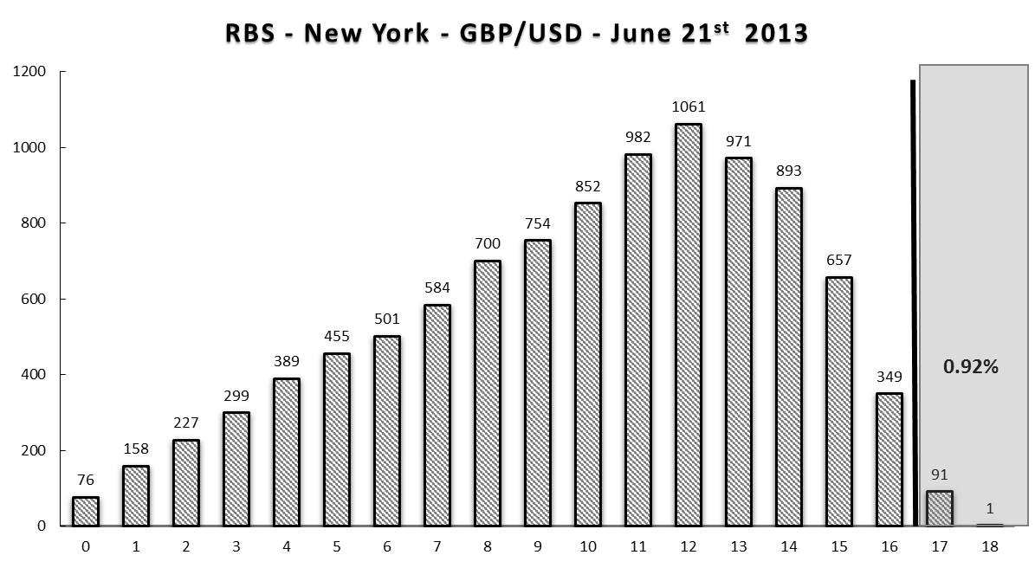
Figure 1 illustrates a simulation distribution for one dealer day for RBS New York. The realized ManIx for RBS New York on June 21st, 2013 is equal to 17, which lies within the top 5% of the bootstrapping distribution. Since this value stands at the top 5% of the bootstrapping, the behavior of RBS New York on the day is classified as manipulative.

Figure 2 – Manipulative Networks
Panel A. EUR:GBP
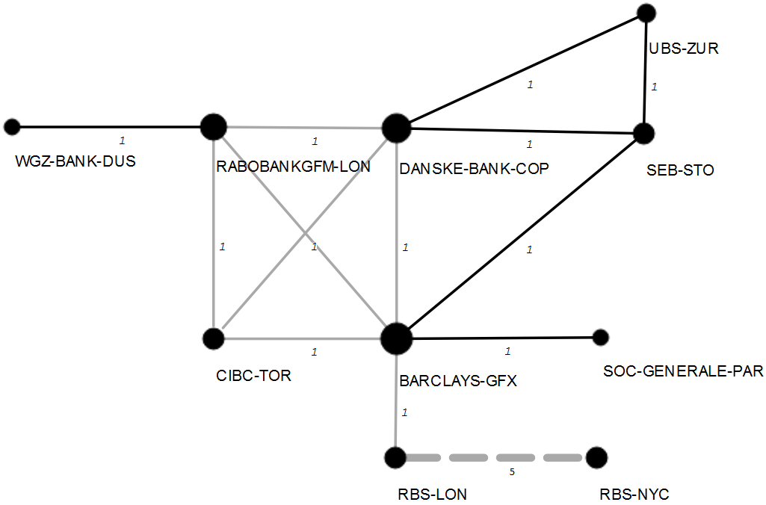

Panel B. EUR:JPY
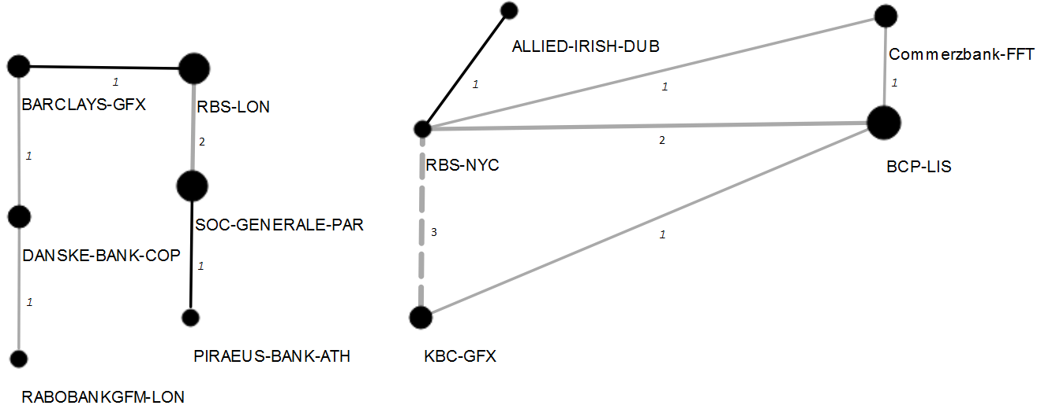

Panel C. EUR:USD
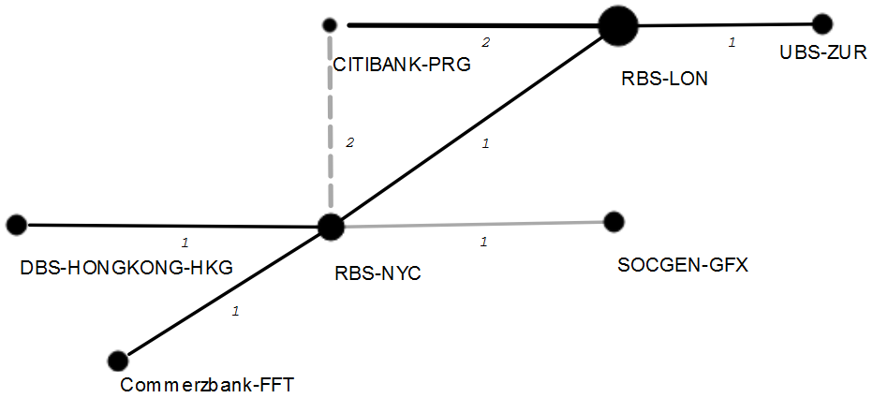
Panel D. GBP:USD
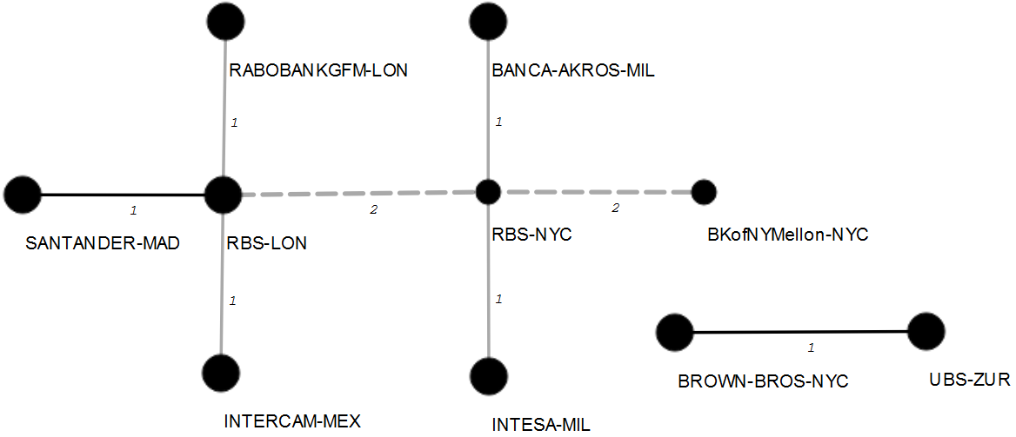
Panel E: USD:JPY
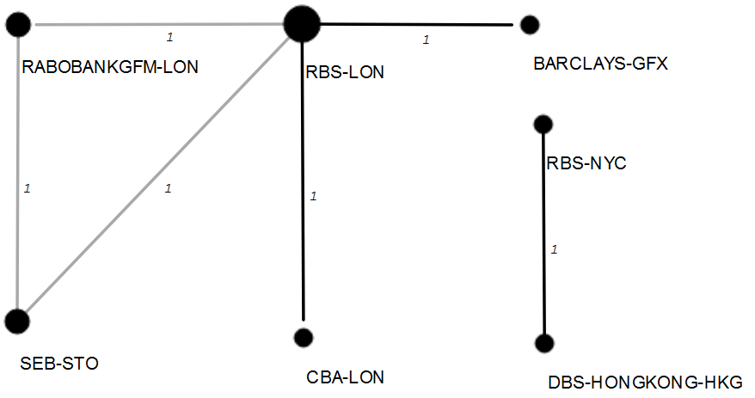

This figure illustrates the identified network of manipulators for each of the five currency pairs. In order to identify the network of manipulators, the network connection and strength is determined by the number of the times that any two banks have a significant ManIx for a currency pair on a same day. The weight on each link demonstrates the number of days that a specific pair of dealers may have colluded together. The grey, black, and grey dashed lines illustrate collusion between dealers in manipulating bid, ask, and both bid and ask prices, respectively.

Notes

The economic importance of the WMR fix rate arises from its application in the valuation of equity portfolios and derivatives (Evans 2018).
On June 12, 2013, Bloomberg news reported that traders in five banks manipulated the fix rate affecting $3,600,000,000,000 assets “in funds including pension and savings accounts that track global indexes” (Vaughan et al, 2013). The breaking of this news triggered 20 investigations in 10 countries and the European Union (Bloomberg Visual Data 2015) resulting in $11,800,000,000 fines as of December 2015.
The Bank for International Settlement’s estimated share of automated spot trading in the FX market is 24.7% of $4.124 billion (BIS 2011). Rime and Schrimpf (2013 p.40) report that “EBS estimates that around 30%-35% of volume on its trading platform is HFT-driven.”
See section 2.1 for further discussion of the quote driven nature of the FX market.
Although the Electronic Broker System (EBS) is known as the main venue for the price discovery of the Euro and Yen (Cabrera et al, 2009), Thomson Reuters claims that it matches the venues that are providing liquidity in the EBS (Thomson Reuters 2014).
From February 2015, the fixing period has increased from 1 minute (60 seconds) to 5 minutes (300 seconds).
It is difficult to observe dealers’ real intentions. In practice, we use the observed final median as a measure of dealers’ manipulation targets. This design captures only successful manipulative attempts. In other words, our approach is a conservative estimate of the true manipulation in the market.
Such a bootstrap design also has the important benefit of controlling for a size effect as we discuss later in the methodology session.
Although we take great comfort that the banks identified via our methodology are close to the regulatory investigations’ findings, we recognize that there may be false positives in our test. Not all the banks that we have identified have been investigated by the regulators. Whether or not these are false positive will only be found if regulators initiate investigations and release their findings.
“In response to the rapidly changing financial landscape the FCA set up Project Innovate and so regulators are working to keep up with new business models entering the financial system” (Government Office for Science 2015).
See section 2.1 for further details.
These two ways that a quote becomes a trade shows that every trade is not necessarily executed at the best price.
Explanatory memorandum to the Financial Services and Markets Act 2000 (regulated activities) (amendment) order 2015 no. 369, section 2, by HM treasury.
“WM performs tolerance checks at the time the data are sourced and again after the calculation of the benchmark is complete. This may result in some captured data being excluded from the fix calculation.” (The World Market Company 2015). Though the mid-price Fix rate is the most common form of use, the Fix rate is published as bid and ask prices. As a result, in our methodology we also examine the bid and ask quotes separately to analyze the behavior of dealers.
It is possible to quote a price lower than the current median while higher than the last quote price. Such a quote would be a less effective manipulation than a down tick quote (a quote that has a quote price lower than the previous quote price).
The division of 1 by 0.1334 yields 7.5, which means 1 quote out of 7.5 quotes contribute to fix rate discovery.
Note that only dealers that have at least one significant ManIx are included in the list.
We remove the 15:59 because 30 seconds of the fixing window falls in this minute.
Although some examples of these banks’ manipulations were published by the FCA, there is no comprehensive information on the currencies that they manipulated.
Similarly, BoA and BNP Paribas are not in our database. These banks are more active in the EBS platform.
Since manipulative quotes in each given fix section has a common target median, banks having significant manipulative behaviors can be seen as having common intended manipulative goal.

