Small Modular High Temperature Reactor Optimisation Part 2:
Reactivity control for prismatic core high temperature small modular reactor, including fixed burnable poisons, spectrum hardening and control rods.
S.Atkinsonª , D.Litskevich^{b} , B.Merk^{b}
ªDepartment of Materials Science and Engineering, Sir Robert Hadfield Building, Mappin Street, Sheffield, United Kingdom
^{b}School of Engineering, The University of Liverpool, Brownlow Hill, Liverpool, L69 3GH, United Kingdom

Abstract
This article investigates a high temperature prismatic core small modular reactor concept based on the U-Battery. To achieve a long operational time without reloading of the fuel, a high fissile fuel load is required, to provide the required excess reactivity which needs to be compensated to allow safe operational states in all stages of the life of the core. This is achieved through the means of reactivity control methods. In this article we deploy a design methodology for controlling the reactivity in a design based on the U-Battery.
The initial excess reactivity within the core was 2000 pcm, implying that the reactivity control systems were required to bring this to unity. To reduce this reactivity, we investigated three main reactivity control methods. Initially the control rod designs which is kept constant. Then a full range of fixed burnable poison designs are evaluated. The final reactivity control method investigated the process of flux spectrum hardening by changing the moderation within the core.
This work managed to identify that maximum full power days without any reactivity control as 1364 days. The fixed burnable poisons deployed reduced this lifetime by 62 days due to a reduced neutron economy. However, by removing part of the central reflector the flux spectrum hardens (increases the proportion of fast neutrons) this provides additional bred plutonium provided an additional 62 full power operating days. The meant that the overall design saw no lifetime reduction due to reactivity control devices, without including the use of control rods.
Due to the implemented reactivity control systems, the highest point of reactivity has been identified as 1.03, this meant that the control rod position required to reduce this reactivity is limited to the maximum of 50% insertion. Identifying the power profile at this position showed additional loading at the fuel below this point, where additional thermal distribution work will be undertaken.

Introduction
The small modular reactor (SMR) design this article investigates is based on the U-Battery design (Ding et al., 2011). The U-Battery is a high temperature SMR, the core is based on the prismatic core design, like the High Temperature Engineering Test Reactor in Japan. The design aims to utilise the extensive knowledge of graphite moderated gas cooled reactors within the UK. The design uses helium as a coolant, to provide elevated outlet temperatures while avoiding oxidising the graphite. One of the key aspects of the U-Battery is its aim to utilise the micro reactor market with its small size of only 10 MWth, this is particularly useful in remote locations such as off grid facilities, including mining, oil and gas. In addition to this, the outlet temperature of ~750 °C could see additional market potential, such as chemical processes. Due to the remote aspect, it is desirable to optimise the fuel cycle to as long as possible, to reduce costs of refuelling due to difficulties of accessing the reactor. To achieve this a high fuel loading is used of 30% packing factor with 20% ²³⁵U, to achieve the maximum amount of full power days. This provides a challenge when considering the excess reactivity of core.
Excess reactivity, also known as the reactor being supercritical, is when there are being more neutrons produced than lost within the system. In most cases the most apparent time for this is when the fuel is completely fresh. Excess reactivity is apparent when there is a higher amount of neutrons is available as required to keep the reactor critical thus the core is producing more neutrons than it is consuming. However, this excess reactivity is required for long term operation when no fuel should be added. In this case there can be a runaway effect were the neutron flux would increase, causing excess heating which can cause damage to the core.
Excess reactivity is controlled through different mechanisms depending on the reactor. In the case of the AP1000 reactivity is controlled by adding boron, a neutron poison, to the coolant this complements the use of the control rods which would act locally. In addition, burnable poison materials are added to certain fuel pellets, either using a boride coating or the incorporation of gadolinium oxide to the fuel (Environment Agency, 2011). The use of soluble boron is particularly useful as the coolant is circulated and thus the boron concentration is controlled easily using this mixing technique and the neutron absorption is very homogeneous. In the case of high temperature reactors (HTRs) this is not an option, due to the helium being too light to host absorbing materials. In the case of HTRs burnable poisons are inserted at the beginning of the lifetime of the reactor and then burnt out slowly. Due to their invariable nature, they are termed fixed burnable poisons (FBPs) (Japan atomic energy research centre - JAERI 1332, 1994).
One of the most common fast acting methods of control comes in the form of control rods. Control rods are used to change the amount of power inside of the reactor by absorbing neutrons by using high neutron absorbing elements. Due to their positioning, the control rods tend to remove neutrons from the axial top or bottom of the core and thus distort the natural power profile of the core. This implies that the use of control rods should be minimal, yet sufficient enough that the reactor is always comfortably in a position of controlled reactivity, thus critical.
The only operational prismatic core HTR is the high temperature test reactor (HTTR) which is well documented regarding the reactivity control methodology (Japan atomic energy research centre - JAERI 1332, 1994). In the case of the HTTR the reactivity control is mainly assured by the sixteen control rods. During start up there are thirty pairs of 50 cm fixed burnable poison at the top of the core as shown in Figure 1 (Bess and Dolphin, 2006).
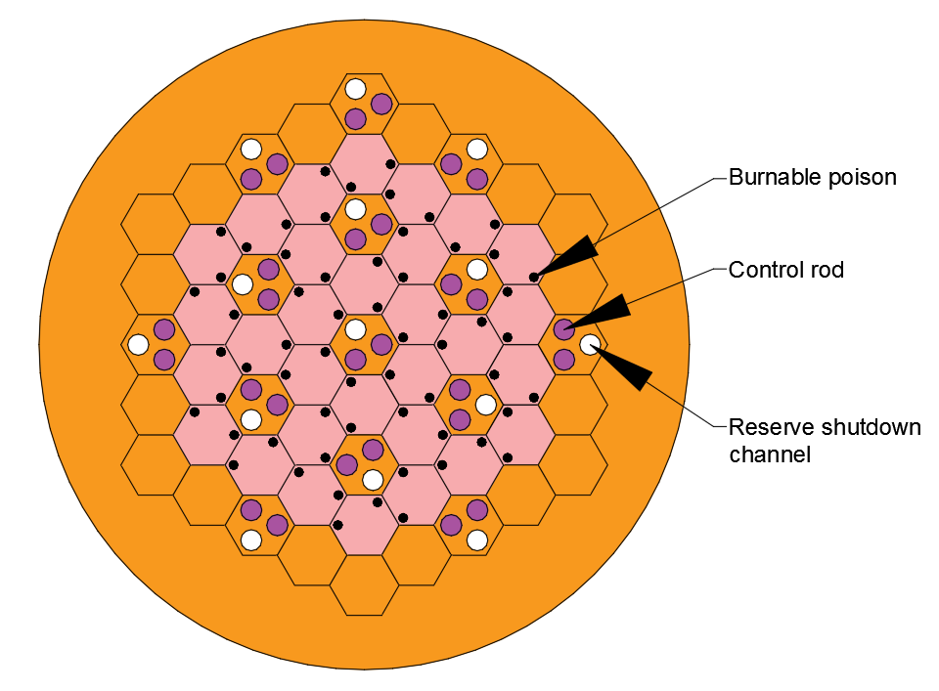
Figure 1- Reactivity control in the HTTR
This is particularly useful as the HTTR uses a manipulated enrichment policy to control the power profile with the top of the reactor having as high as 10% enrichment and the bottom as low as 3.4% (Ortensi et al., 2010). This means that the insertion of the control rods leads to flattening the flux across the axial height of the core. In the case of the U-Battery, one of the main criteria was an operating fuel cycle lifetime of five years. Using a reduced enrichment or packing factor of the fuel, would impede the overall total lifetime of the core. Considering this, a harder burnable poisoning regime is required to overcome this issue.
This article aims to provide a concept for reactivity control devices to control the excess reactivity in the U-Battery concept design. To achieve this multiple arrangement of control configurations, must be designed to determine the most suitable design. This article aims to provide a safe reactor concept and to understand the maximum full power days the U-Battery concept can achieve.

Codes, Data and Models

Design Concept
The design considered is loosely based on the U-Battery concept which aims for a fast deployment using readily available technology. When Urenco commissioned the initial design of the U-Battery in 2011 (Ding et al., 2011) extensive work was undertaken from a neutronic perspective at Tu-Delft (Ding and Kloosterman, 2014a, 2014b, 2013, 2011; Verrue et al., 2014) with regards to the 20MWth model. Following the economic analysis of the basic 10MWth and 20MWth designs, it was determined that the next stages will progress with the 10MWth design.
The initial U-Battery report (Ding et al., 2011) initially stated that the inclusion of a beryllium oxide side reflector increased the overall full power lifecycle of the 10MWth design. This initial design was analysed and it was determined that the overall lifecycle was over predicted 706 days as explained in detail in (S.Atkinson , T.J.Abram, D.Litskevich, n.d.). To achieve a long operating lifecycle is part of the main design concept, so achieving as near to five years as possible is one of the purposes of this design.
Material selection is important when considering the reactor design and the above-mentioned fast deployment. To allow for easy deployment, the materials should ideally have been used before to allow for a safety case to be carried out. In the case of the poisons, Gd₂O₃ is currently used within the advanced gas-cooled reactor (AGR) fleet (Nonbel, 1996) as well as LWRs (A. PETIT, 2012). In addition to this B₄C in the control rods of almost all kinds of reactors.
When considering the design of the control rods, the use of material choices is important. The latest generation of LWRs the AP1000 which passed the generic design assessment, uses Silver-Indium-Cadmium alloy (Westinghouse, 1994) which isn’t suitable due to temperature constraints (H.Uetsuka, 1989). The South African PBMR project used B₄C as an absorber with an Inc800H alloy (Tyobeka et al., 2008) as shown in Figure 2.
In the case of the this design the control rods are much smaller, with the main variable being the thickness of the boron carbide layer to create a much stronger poisoning presence as shown in Figure 2.
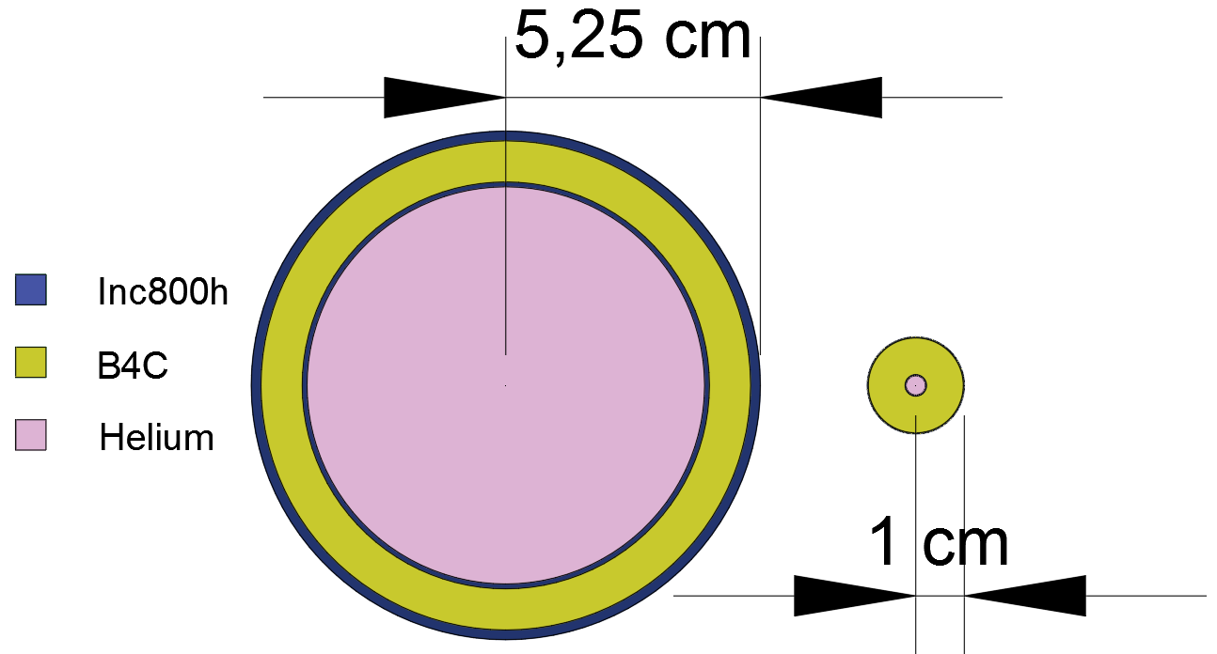
Figure 2- Left, PBMR Inc800H control rod. Right, U-Battery control rod
Table 1- Control rod description
 | PBMR |  | U-Battery concept
 | Outer radius (cm) | Thickness (cm) | Outer radius (cm) | Thickness (cm)
Inner Inc800h | 4.2 | 0.1 | 0.2 | 0.02
B4C | 5.05 | 0.85 | 0.98 | 0.96
Outer Inc800h | 5.25 | 0.2 | 1 | 0.02

Due to the small size of the core, the control rod positioning becomes difficult to keep the symmetry. We propose six control rods placed at the exterior of the active core within the side reflector as depicted by Figure 3.
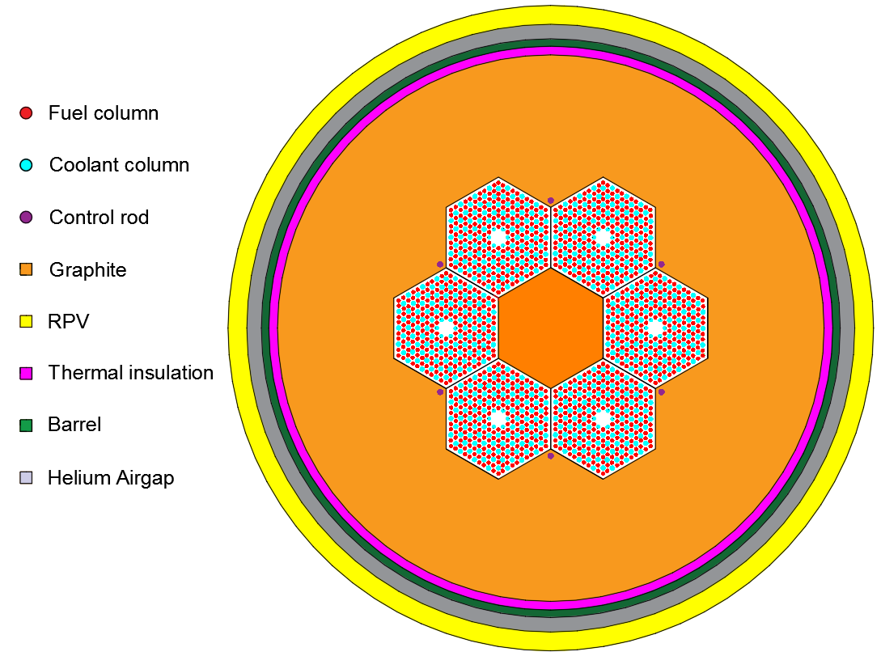
Figure 3- Control rod positions
The control rods design in this article are not varied. All control rods are moved simultaneously to preserve a symmetrical power profile across the radial core. A full breakdown on the geometrical description can be found in the appendices.
All neutronic results presented are simulated through a Monte Carlo simulation routine using the Serpent 2.1.27 (Leppänen et al., 2015), using data libraries JEFF 3.1.1 (Santamarina et al., 2009). Serpent has been validated with consistent results against the Very High Temperature Critical Assembly benchmark and is thus considered a dependable tool for the following analysis (Bostelmann et al., 2016).

Methodology
FBPs are designed to provide sufficient reactivity repression for the start of the lifecycle of the fuel, three different locations are investigated. The aim is to reduce the effective multiplication factor (K_{eff}) of the core to a reasonable level, which can then be controlled in conjunction with traditional control rod mechanisms. In this case an arbitrary value of K_{eff} of 1.02 is chosen as a safety margin so avoid the risk of reaching subcriticality. With the inclusion of poisons the aim was to reduce the initial K_{eff} to ~1.05. To effectively implement the poisons locations the areas of high power distribution are considered the most effective, these areas are within the vicinity of the central reflector and side reflector, rather than towards the centre of the fuel block.
Serpent option allowing for the implicit modelling of the TRISO fuel particles was used in this study. The packing factor was set to 30%. The fuel elements excluded modelling of the bypass helium airgap to aid in computational time. Due to the nature of burnup being critical to these studies, the fuel compacts were separated every 10 cm and modelled as explained in detail in previous studies (S. Atkinson et al., 2018).
Design 1

Design 1 aims to keep use a small coating of Gd₂O₃ across the centre of the fuel columns. As witnessed in the fuel rotation experiment (S. Atkinson et al., 2018), the centre of the fuel columns is being depleted the fastest, so by slowing the depletion within this region will help provide a more even burnup. The poison is applied in the form of a thin sleeve of 0.005 cm around the 0.635 radius fuel column, in design 1, this is applied in a 160 cm section at the centre of the 320 cm fuel column as shown in Figure 4. It was noted that the K_{eff} at this point was significantly reduced to 0.98. The process of removing the FBP’s to a point where the K_{eff} reached the desired range, focused on keeping the coating on the highest burnup sections. These were, next to the central reflector and the external reflector (S.Atkinson , T.J.Abram, D.Litskevich, n.d.).
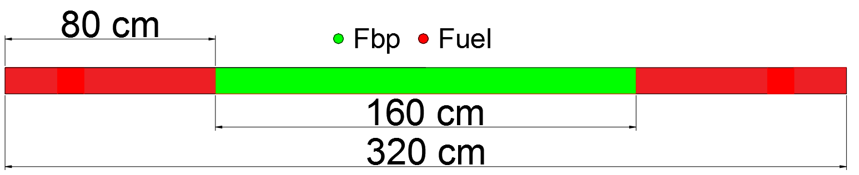
Figure 4- FBP sleeve. Due to the thin nature of the fuel columns, the height to not to scale
The correct K_{eff} range was obtained from the configuration in Figure 5.
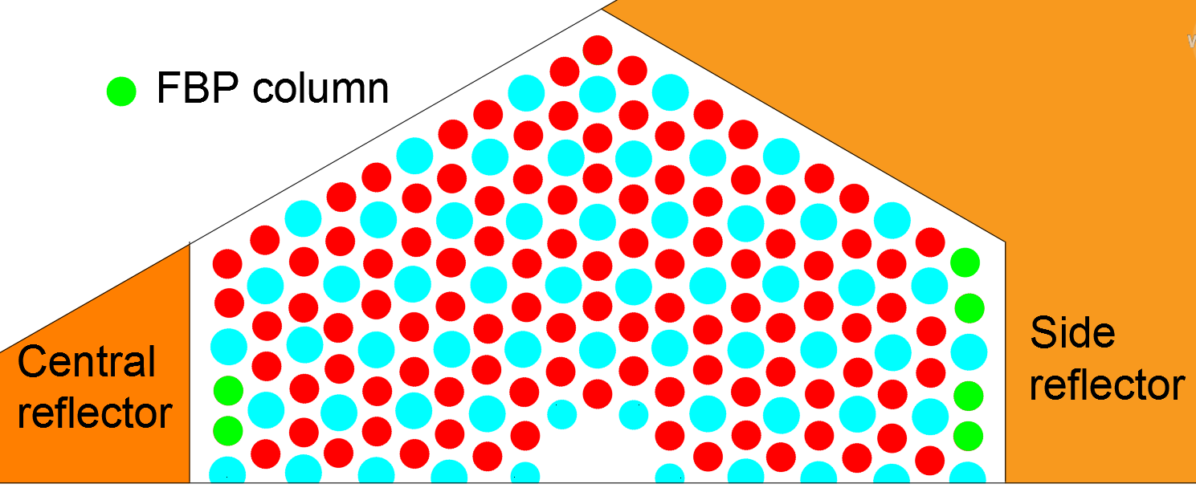
Figure 5- Design 1 poison column locations
This design provided a K_{eff} reduction to 1.04482.

Design 2

This design looks to use the same depth coating across specific fuel columns. In this case the inspiration taken from the U-Battery report and used the fuel columns in the initial report (Ding et al., 2011) as shown in Figure 6 to avoid any opportunity of rotational misplacement of the fuel blocks.
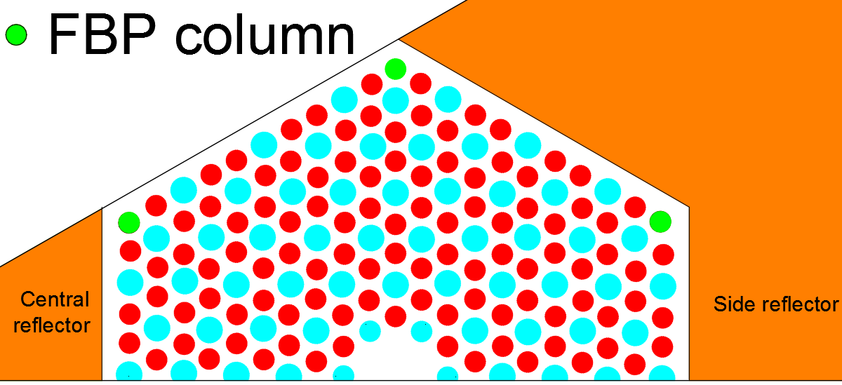
Figure 6- Original report FBP locations
From earlier work looking at fuel rotation (S. Atkinson et al., 2018), it was noted that at 20-30 cm at the tops of the fuel columns, the burnup was high. A thin coating of poisons was added at the top and bottom of these fuel columns as shown in Figure 7 at this point the K_{eff} was at 1.09056.
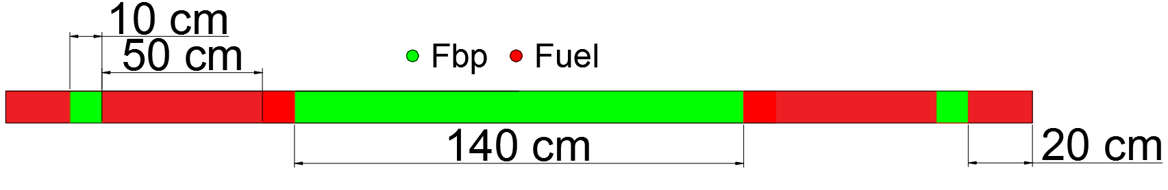
Figure 7- Poison sleeve on the corner design
To remedy this, the 140 cm sleeve was added to the two pins closest to the centre of the central reflector as shown in Figure 8. This reduced the K_{eff} to the acceptable level of 1.05137.
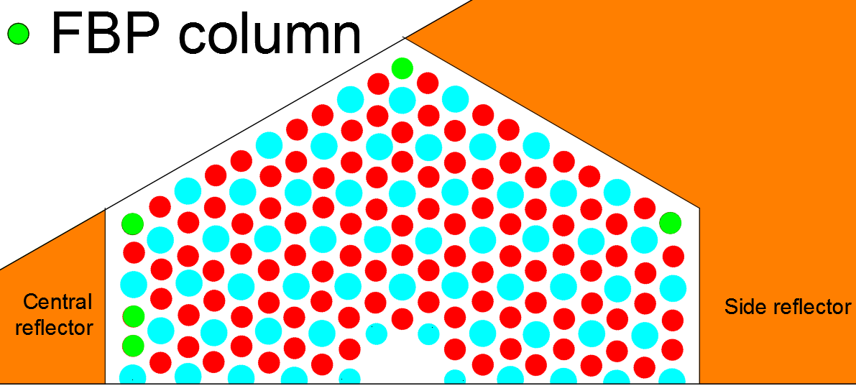
Figure 8- Final design 2 FBP locations
Design 3

The third design is a more conceptual design. The concept used the centre 100 cm’s to place small 0.04 cm radius Gd₂O₃ particles amongst the fuel columns. The fuel particles were to be arranged in such a set up so that the packing factor of the poisons would repress the flux sufficiently at the centre of the reactor core. This initial concept looked to split the centre 100 cm’s of the fuel columns up into sections and then add the packing factor of poisons as shown in Figure 9.
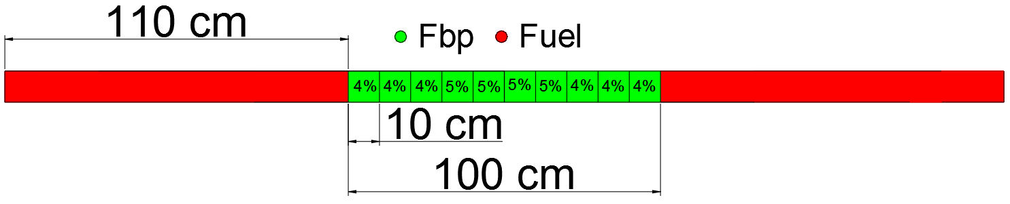
Figure 9-Poisons packing factor within their 10 cm fuel region
This set up provided a K_{eff} of 1.04933.
Summary

Each of the designs looks to utilise a different strategy to place the poisons. Design 1 looks to use the side reflectors, Design 2 looks to use the corners and Design 3 has a steady amount of poisons across the core. The total amount of poisons is summarised in Table 2.
Table 2- Summary of the poison designs
Design | Volume of poisons (cm³) | Initial K_{eff}
1 | 269 | 1.04482
2 | 207 | 1.05137
3 | 348 | 1.04933

From Table 2, it is clear to see that the overall poison volume does not necessarily dictate the starting K_{eff}. This is due to the positioning of the poisons, where Design 3 does not heavily load any section with poisons as they are spready out quite evenly across the centre of the core.
Following the initial K_{eff}, the FBPs are then burnt at 10MWth to determine the overall lifetime of the reactor at this point.

Results and discussion
The initial test is to determine the FBPs behaviour over time. This was done by burning the reactor for 1000 days with the poisons.
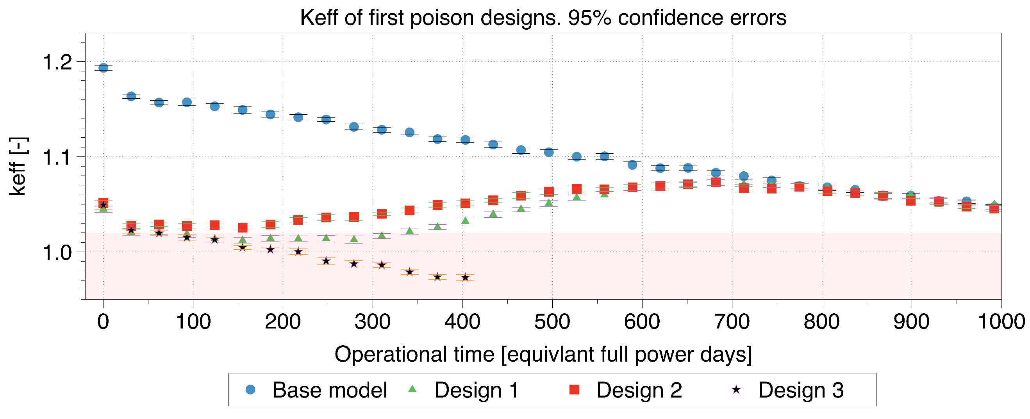
Figure 10- K_{eff} burnup of the three poison designs
Comparing the base model’s K_{eff} to that of the initial K_{eff}, the three poison designs all easily achieved the large reactivity reduction required. However, the worst performer was Design 3 where the K_{eff} didn’t recover, obviously due to the too high poison loading. Designs 1 and 2 both saw a dip in K_{eff}, in the case of Design 2 the K_{eff} is higher between days 100-600, implying this would require a larger amount of work with the control rods to reduce the K_{eff} to unity. For this reason, the most appropriate design to continue with is Design 1.
One worrying trend with Figure 10 is that the peaking of the second rise reaches a K_{eff} of 1.0725 at ~700 days and this is larger than that of the initial 1.05 starting target. The reason for this is that the poisons are being burnt up too quickly. To remedy this, the use of small 0.4 cm rods of 20 cm height is placed within the centre of some fuel columns of Design 1. The positioning of these rods models is shown in Figure 11.

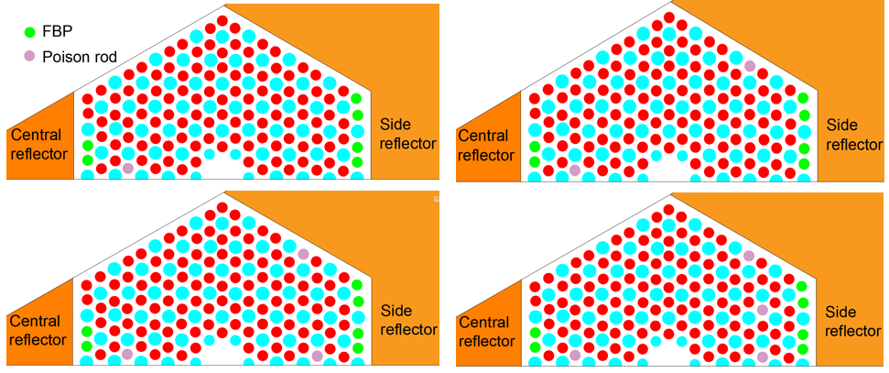
Figure 11- Additional poison rod positions included top left, 1 rod, top right, 2 rods, bottom left three rods and bottom right, 4 rods.
The aim in this case is to determine the overall impact of these rods on the K_{eff}.
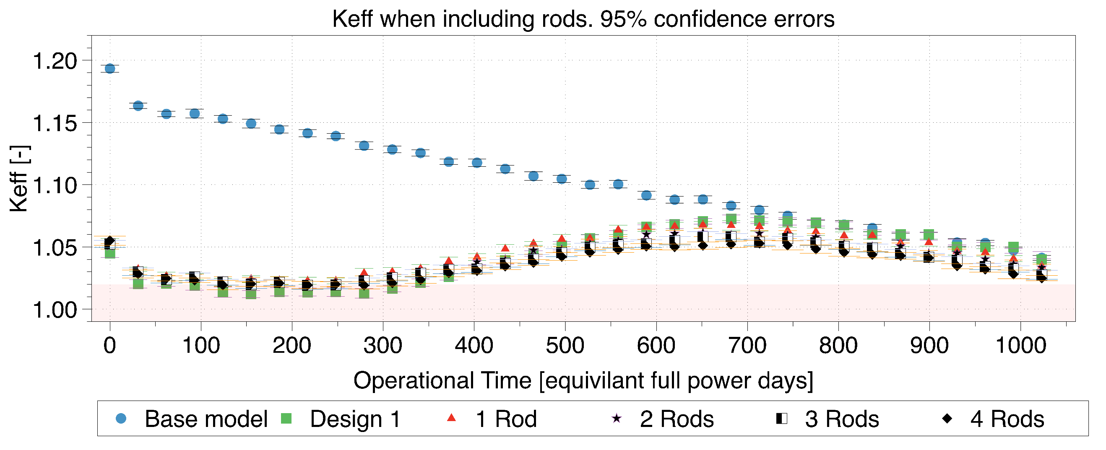
Figure 12- Adding poison rods in the centre
Figure 12 shows that the rods do reduce the second reactivity peak, however, it was noted that the K_{eff} line does not re-join the base model. The main reason for this was suspected that the poisons were remaining in the core. To determine this, the four rod design poison materials compositions were monitored. The numbering of the poison rods is depicted in Figure 13.
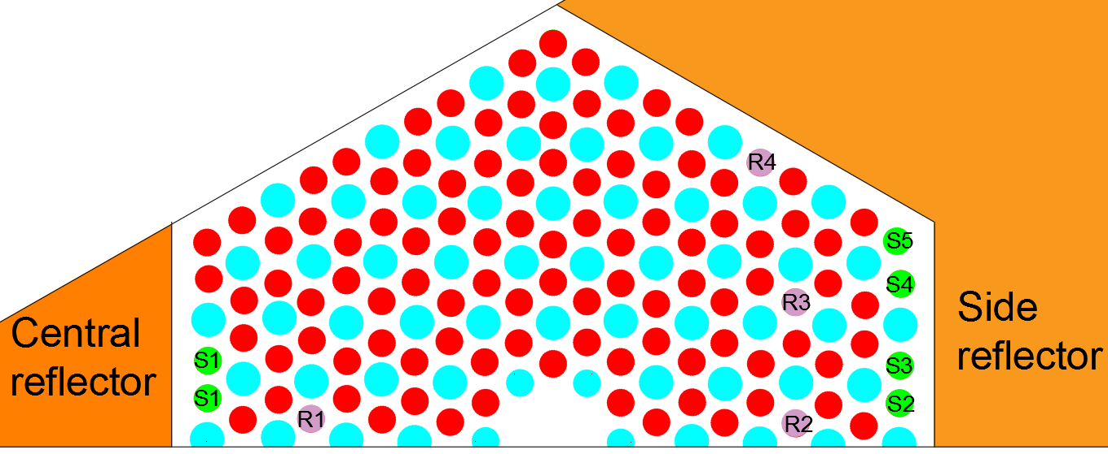
Figure 13- Sleeve and rod positions for material compositions in Figure 14 and Figure 15.
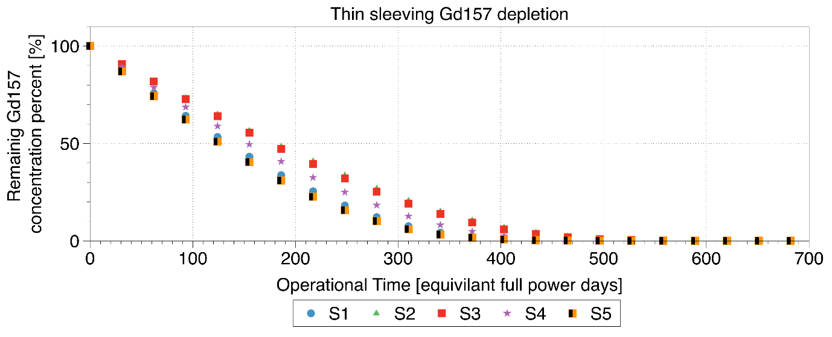
Figure 14- Thin sleeving depletion to first peak in K_{eff}
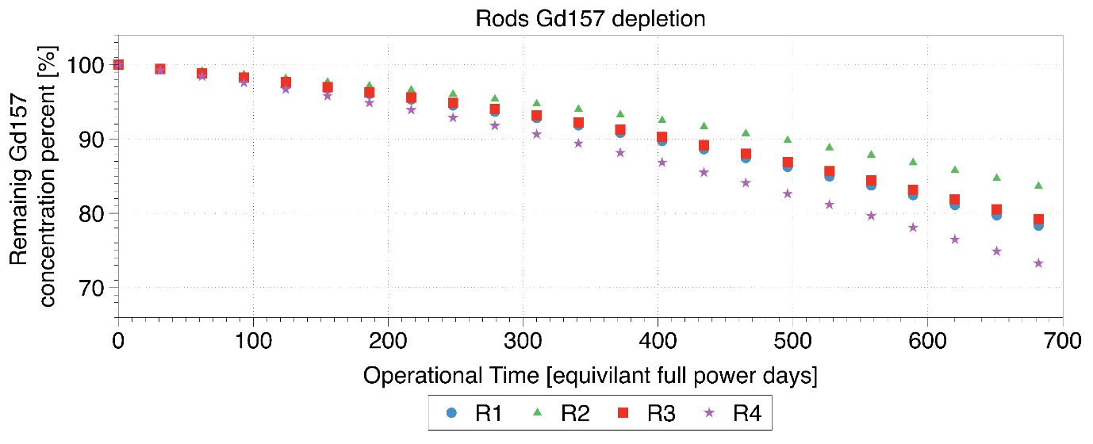
Figure 15- Small central rods depletion, up until first peak
Figure 14 explains the rise in K_{eff} in Figure 10 following day 300. This is due to the poison sleeve having been significantly depleted as shown by Figure 14. The K_{eff} then raises up until the point of 700 days. From Figure 15, the four rods all have a significant amount of Gd¹⁵⁷ remaining, at this point still, this is penalising the overall equivalent full power days of the system. A further test was performed to determine the overall difference in K_{eff} between the single rod system and that of the four-rod system, as shown in Figure 16.
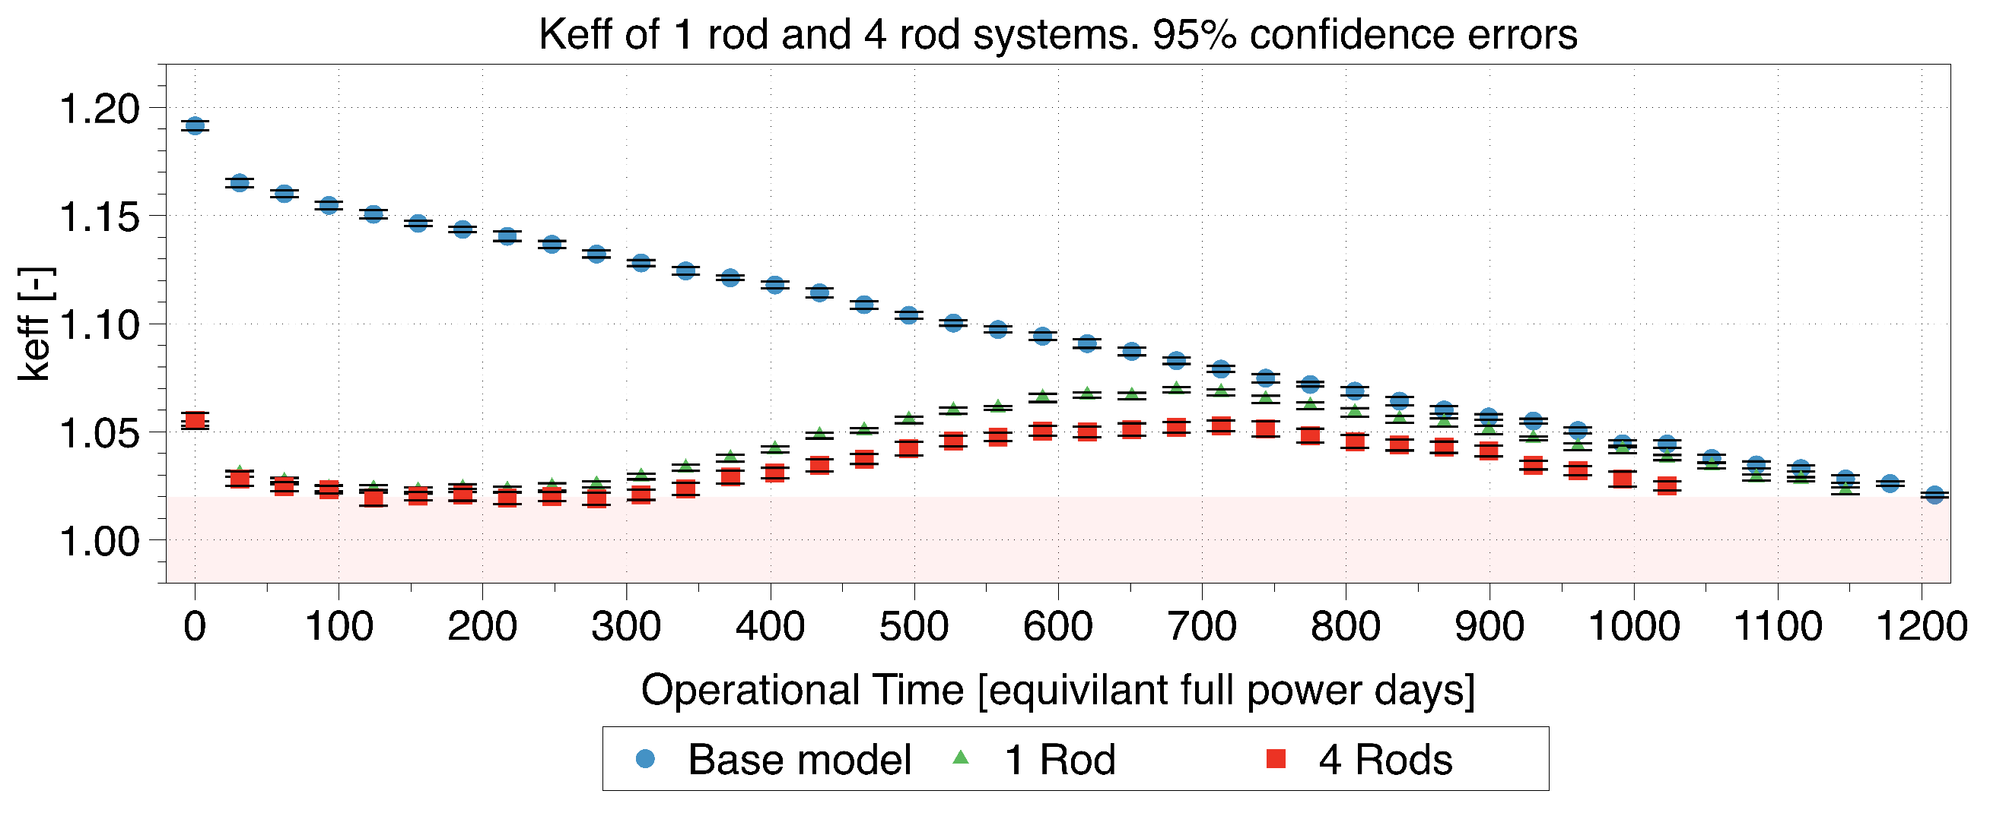
Figure 16- 1 and 4 rod models until 1.02 point
From Figure 16, each of the designs with rods included, does reduce the total lifetime in days. However, the total loss in days for a single rod is 62 days, whereas this is increased to 186 lost days for four rods. Due to this severe lifetime impact, a single rod design was chosen to be the preferred method of control, if there is no better way for reactivity compensation. However, there is additional space for optimisation. This still leaves a significant increase in K_{eff} at the start of life but reduces the second peak slightly. At this point the control rods were inserted at the peak of the 1 rod design, to the point of maximum depth (320 cm), the K_{eff} was reduced to 0.922, implying that under these conditions the reaction could easily be stopped under the control rods. To further this study an investigation was undertaken to determine the effect of malfunctioned control rods, which might not deploy due to issues with the control rod drive mechanism. This aimed to provide evidence on the amount of reactivity redundancy within the system, the results are shown in Table 3.
Table 3- K_{eff} during the Stuck rods during the highest reactivity point in the cycle
Number of stuck rods | K_{eff} | 95% confidence error pcm
1 | 0.91658 | 123
2 | 0.93979 | 105
3 | 0.96428 | 131
4 | 0.98667 | 120
5 | 1.01104 | 97

Table 4 highlights that during an accident scenario there is the potential in the control rod design to provide sufficient reactivity reduction that four out of the six rods can be stuck, and the core will still be subcritical. This is reassuring from a design perspective due to the amounts of redundancy the design has already built into it.
When considering the remaining activity, this is still significantly large to be held down by the form of control rods, due to the flux suppression to the bottom of the core which will lead to an unacceptable power distribution. To accommodate this, a novel method of K_{eff} reduction is used in the form of variable moderation which is covered in detailed in the literature (Seddon Atkinson et al., 2018 2). Due to the small size of the core the central reflector has a significant effect on the thermalisation of neutrons. By manipulating the position of the central reflector, the thermal neutrons within the system should dramatically reduce, thus significantly reducing the K_{eff} of the system.
For this case the variable part central reflector has a 26 cm diameter cylinder cut from the centre as shown in Figure 17. This cylinder can then be manoeuvred to change the moderation within the centre of the core.
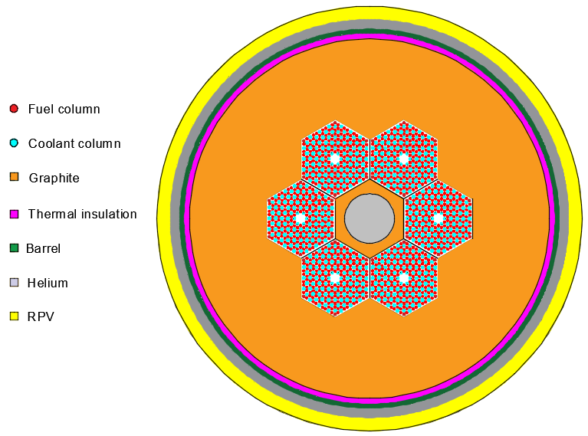
Figure 17- Variable central reflector, while removed the centre becomes helium based
The moveable moderator would not be limited to a K_{eff} value of 1.02, as with the poisons as this method of control is variable, implying that the central reflector manoeuvring could be used in conjunction with the control rods. Due to the change in moderation not having a significant negative effect in the neutron economy, it would be preferred to move the central reflector than the control rods, however, use of the central reflector should require user input.
Figure 18 is the new K_{eff} curve with the central reflector completely removed up until point P1.
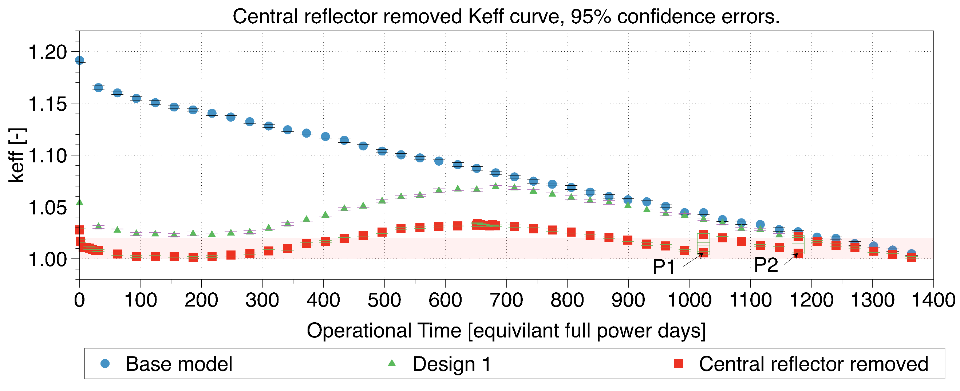
Figure 18- K_{eff} using the central reflector as an effective reactivity control device
From Figure 18 it is noted that the initial K_{eff}, even within the first day, drops below that of 1.02, this is due to the build up of Xenon during the fission process. At this stage the control rods would be used to aid start-up and keep the K_{eff} to unity. The lowest point at which the poisons drop keeps the core above unity due to the central reflectors removal, this is at day 186, where the K_{eff} once again starts to rise. The second rise is now reduced significantly to 1.033 at ~700 days due to the sleeving poisons being significantly reduced as previously shown, this implies that the control rods still need to take a slightly higher amount of reactivity from the core at this point than at the begin of life. Denoted by points P1 and P2 respectively are the positions where the central reflector has been re-inserted by 50% of its total height. This 50% figure was chosen to reduce movement and thus any risk associated with it, this also provided the 0.02 reactivity which was thought to be easily controlled by the control rods. The total lifetime is the same as that of the base model, which shows the small lifetime increase has effectively cancelled out the lifetime lost by the inclusion of FBPs.
Following the curve of Figure 18, it is important to appreciate the power distribution across the core during these periods. As previously mentioned the control rod insertion will dramatically affect the power distribution at certain points in the life cycle, this might imply that certain fuel compacts could face a strong over power, particularly at the bottom of the core. The most well powered pins are those within the centre of the core or the outside, depending on the central reflector position. The power distribution is displayed across half of a fuel block as depicted in Figure 19.
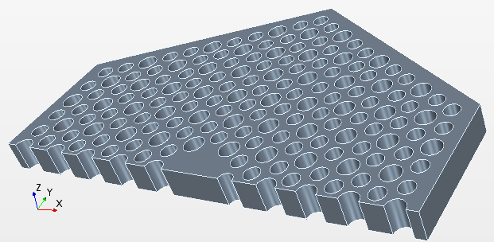
Figure 19- Half of a fuel block model, with the side reflector position highlighted by the blue lines
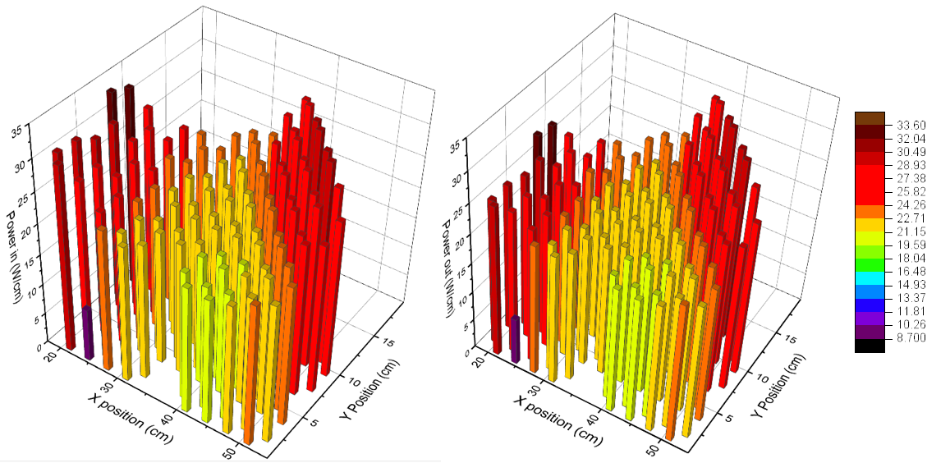
Figure 20- Power distribution at day zero. Left; With the central reflector fully inserted. Right, with central reflector fully removed

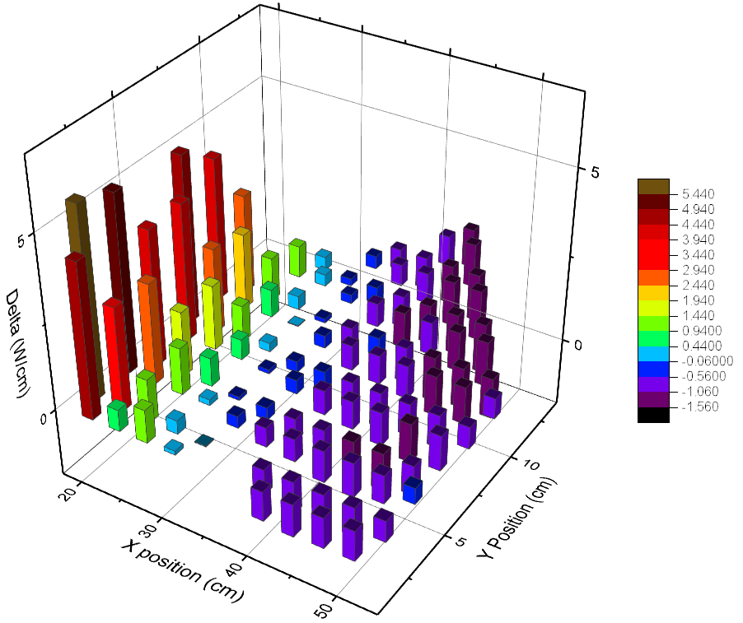
Figure 21 - Delta of the power distributions (central reflector in - out)
From Figure 20, there is an obvious trend that the power distribution shifts across from the centre of the core to the outside when the central reflector is removed. This is useful in the case where the centre of the core is burning up less at the points in time when the central reflector is removed, thus shifting the highest loading pins close to by the side reflector. The closest pin at X 20 cm has a significantly reduced power, this is due to this pin hosting the small poison rod from Figure 11. To a lesser degree the other poisons are noticeable, as in the poisons at the centre of the core are not the highest power pins.
Figure 21 identifies the change in power with the central reflector in and out. This highlights that when the central reflector is in, the power is heavily dependant on the fuel pins by the central reflector due to the additional moderation, making these the highest burnup pins. When removing the central reflector this trend is reversed as the pins at the side reflector receive the highest loading. This provides a power balancing between two different locations within the core.
The next experiment determines the power distribution under the condition of the maximum K_{eff} case, in this case it is during the second peaking of the system, where the K_{eff} reaches 1.033. At this point the control rods are inserted and the axial power distribution is considered.
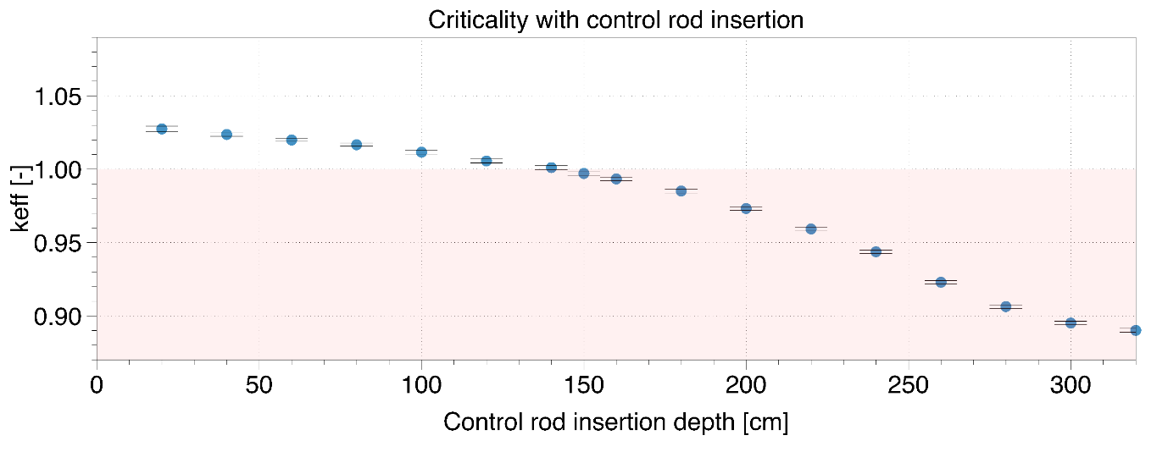
Figure 22- Control rod insertion at peak reactivity
Figure 22, the core becomes subcritical once the rods are inserted by 150 cm. At this point the power distribution is once again considered since this is the most distorted power distribution during the life of the core. In this case the axial power distribution is most important, due to the deeply inserted control rods. in this operational point the central reflector is removed so the highest power pins were towards the side reflector. This axial power distribution is included in Figure 23.
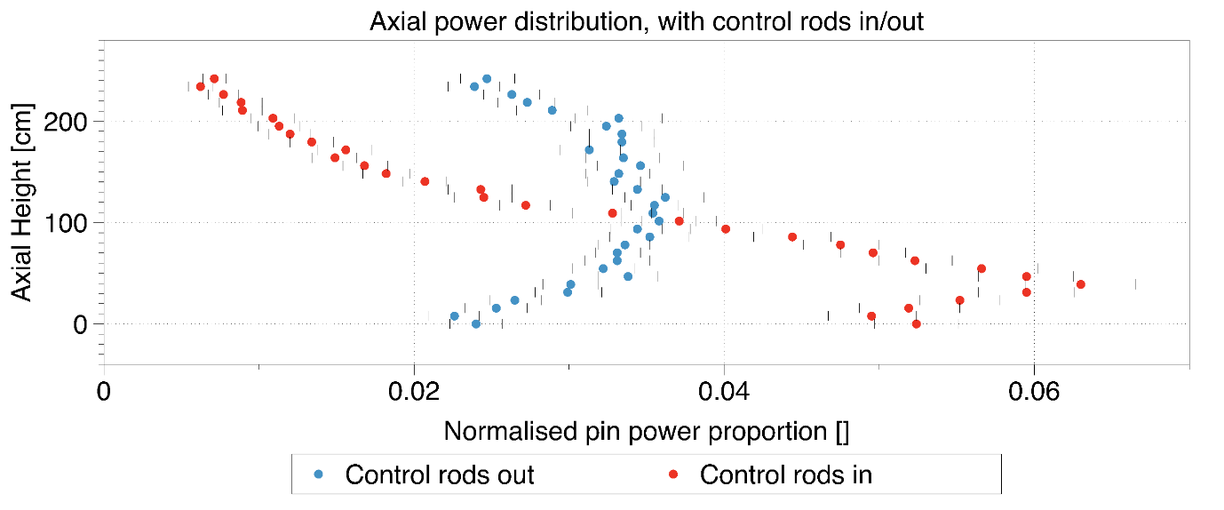
Figure 23 - Axial power distribution with the control rods inserted. The power is normalised across the total of that pin
Figure 23 clearly shows, the power shifts down significantly due to the insertion of the control rods to 150 cm. The power then almost in a linear fashion rises across the pins below this. This causes over double the power density in these pins to be experienced during this period. This must be considered in the design criteria of the fuel compacts/pins to determine the maximum temperature within these TRISO compacts. Further analysis on the thermal effects of this procedure will be required to determine the overall severity of these effects on the system.

Conclusion
This paper has investigated several methods of reactivity control within a small modular HTR based on the adopted U-Battery design. The overall goal aimed to exhibit how different control methods are used and interplay to manipulate the reactivity at different stages of a single fuel cycle, while trying to keep the minimum dependency on the control rods. The initial K_{eff} of the system was at 1.2, with the main aim being to reduce this to ~ 1.05 with FBP’s. Three different FBP designs were investigated, the first focused on adding the poisons to the high-power areas, at the side reflector and the central reflector. The second, focused on the points of the hexagonal fuel blocks as described in the initial U-Battery report (Ding et al., 2011) and the third by uniformly placing FBP’s at the centre of the fuel pins.
The first design showed the highest promise, with the flattest K_{eff} profile, thus removing the dependency from the control rods however, this showed a rising peak in K_{eff} once the small poison sleeves were depleted. It was accepted this peak was too large (~1.07) to overcome by the control rods alone. Following this, the spectrum hardening technique was used by manipulating the central reflector to reduce the probability of fission. This provided significant additional reactivity control within the system. The central reflectors breeding method cancelled out the fuel lifetime penalty which had been introduced by the inclusion of the FBPs, bringing the overall lifetime of the reactor to 1364 days, the same as without any poisons included.
The removal of the central reflector allows the operator to balance the power distribution across the core well radially, this is due to the highest power pins being swapped between the inside to outside of the fuel block.
During the insertion of the control rods at the highest peak, it was shown that the power profile will be significantly distorted leading to a strong power increase in the lower parts of the core. A full thermal analysis (like a fuel performance analysis in a LWR) should be performed to determine the peak temperatures experienced within these fuel regions to determine if safe operating limits are likely to be breeched. This operational point has the potential to be the limiting factor in the core design parameters like the pin/compact power.

Further work
This article has begun to investigate the methods to control the reactivity of a single fuel cycle. This has prompted several other aspects which have not been considered and should be considered in further work. For example, like the AGR reactors, the use of grey control rods for power manipulation could be considered. These grey control rods would add additional finer control over the power distribution.
This design saw a peak in reactivity at which the power maximum has been discovered. At this point a full thermal analysis should be performed to determine the maximum temperature on these fuel compacts.

Appendices
The core geometry was originally based on the U-Battery, however, studies regarding the effectiveness determined that there was no significant benefit of using graphite as a moderator (S.Atkinson , T.J.Abram, D.Litskevich, n.d.). Thus, the new core geometry is listed below.
Table 4- Material compositions for the revised conceptual U-Battery design
Component | Material | wt% | Density (g.cm⁻³) | Temperature (K)
Fuel | U235 | 0.18 | 10.8 | 1023.15
 | U238 | 0.70
 | O | 0.12
 | Buffer | 100.00 | 1
 | IpyC | 100.00 | 1.9
 | Si | 100.00 | 3.2
 | OpyC | 100.00 | 1.87
Matrix | C | 100.00 | 1.75 | 1023.15
Coolant | He | 100.00 | 0.0033 | 674.15
Central Reflector | C | 100.00 | 1.8 | 973.15
Side/top/bottom reflector | Be | 36.04 | 3.05 | 873
 | O | 63.96
Thermal insulation | Si | 70.05 | 3.2 | 673
 | C | 29.95
Side coolant | He | 100.00 | 0.0033 | 674.15
Barrel/RPV | Ni | 15.13 | 8 | 673/300
 | Cr | 0.19
 | Mo | 25.98
 | Fe | 15.12
 | Si | 7.61
 | Mn | 14.88
 | C | 3.25
 | P | 8.39
 | S | 17.07

Table 5- Radial dimensions of the new conceptual design
Core Attribute | Thickness (cm) | Radius of core used (cm)
Active core | 108
Graphite side reflector | 40 | 94
Graphite insulation | 3 | 97
Barrel | 2.54 | 99.54
Helium Gap | 5 | 104.54
RPV | 5.6 | 110.14

Table 6- Axial dimensions of the new conceptual design
Axial attribute | Size (cm)
Total core height | 678
RPV height | 667
Air gap height | 420
Barrel height | 420
Thermal insulation | 420
Helium top area | 183
Helium bottom area | 67
Graphite top reflector | 50
Graphite bottom reflector | 50
Active core | 320
Acknowledgements
The authors would like to acknowledge the assistance given by The University of Manchester IT Services, for the use of the Computational Shared Facility and professional support. The developers of the Serpent code for their continued support throughout the. For funding gratitude is owed to the ESPRC under the Nuclear First program - EP/G037140/1.

References
A. PETIT, G.C., 2012. PCSR – Sub-chapter 4.3 – Nuclear Design. Paris & Montroughe.
Atkinson, S., Litskevich, D., Merk, B., 2018 2. Variable Reactivity Control in Small Modular High Temperature Reactors Using Moderation Manipulation Techniques. Energies 11, 1897. https://doi.org/10.3390/en11071897
Atkinson, S., Whittle, K.R., Dean, J.S., Abram, T.J., 2018. Prismatic core high temperature reactor fuel modelling incorporating fuel rotation. Nucl. Eng. Des. 331, 153–161. https://doi.org/10.1016/j.nucengdes.2018.02.040
Bess, J.D., Dolphin, B.H., 2006. EVALUATION OF THE START-UP CORE PHYSICS TESTS AT JAPAN’S HIGH TEMPERATURE ENGINEERING TEST REACTOR (FULLY-LOADED CORE), OECD-NEA, HTTR-GCR-RESR-001 CRIT-SUB-REAC-COEF-KIN-RRATE.
Bostelmann, F., Hammer, H.R., Ortensi, J., Strydom, G., Velkov, K., Zwermann, W., 2016. Criticality calculations of the Very High Temperature Reactor Critical Assembly benchmark with Serpent and SCALE/KENO-VI. Ann. Nucl. Energy 90, 343–352. https://doi.org/10.1016/j.anucene.2015.12.008
Ding, M., Kloosterman, J.L., 2014a. Thorium utilization in a small long-life HTR. Part II: Seed-and-blanket fuel blocks. Nucl. Eng. Des. 267, 245–252. https://doi.org/10.1016/j.nucengdes.2013.08.076
Ding, M., Kloosterman, J.L., 2014b. Thorium utilization in a small long-life HTR. Part II: Seed-and-blanket fuel blocks. Nucl. Eng. Des. 267, 245–252. https://doi.org/10.1016/j.nucengdes.2013.08.076
Ding, M., Kloosterman, J.L., 2013. Thermal-hydraulic design and transient evaluation of a small long-life HTR. Nucl. Eng. Des. 255, 347–358. https://doi.org/10.1016/j.nucengdes.2012.11.009
Ding, M., Kloosterman, J.L., 2011. Neutronic feasibility design of a small long-life HTR. Nucl. Eng. Des. 241, 5093–5103. https://doi.org/10.1016/j.nucengdes.2011.08.083
Ding, M., Kloosterman, J.L., Kooijman, T., Linssen, R., 2011. Design of a U-Battery ® [WWW Document]. URL http://www.janleenkloosterman.nl/reports/ubattery_final_201111.pdf (accessed 5.11.18).
Environment Agency, 2011. Generic design assessment AP1000 ® nuclear power plant design by Westinghouse Electric Company LLC [WWW Document]. URL https://assets.publishing.service.gov.uk/government/uploads/system/uploads/attachment_data/file/296662/geho1211btoi-e-e.pdf (accessed 10.17.18).
H.Uetsuka, T.O., 1989. Vaporization of Silver-Indium-Cadmium control rod material in flowing argon at high temperatures [WWW Document]. JAERI-M-89-150. URL http://www.iaea.org/inis/collection/NCLCollectionStore/_Public/21/030/21030801.pdf?r=1 (accessed 5.12.18).
Japan atomic energy research centre - JAERI 1332, 1994. Design of the HTTR.
Leppänen, J., Pusa, M., Viitanen, T., Valtavirta, V., Kaltiaisenaho, T., 2015. The Serpent Monte Carlo code: Status, development and applications in 2013. Ann. Nucl. Energy 82, 142–150. https://doi.org/10.1016/j.anucene.2014.08.024
Nonbel, E., 1996. Description of the Advanced Gas Cooled Type of Reactor [WWW Document]. URL http://www.iaea.org/inis/collection/NCLCollectionStore/_Public/30/052/30052480.pdf (accessed 5.11.18).
Ortensi, J., Cogliati, J.J., Pope, M.A., Bess, J.D., Ferrer, R.M., Ougouag, A.M., Bingham, A., 2010. Deterministic Modeling of the High Temperature Test Reactor with DRAGON-HEXPEDITE [WWW Document]. URL https://inldigitallibrary.inl.gov/sites/sti/sti/4633178.pdf (accessed 5.12.18).
S.Atkinson , T.J.Abram, D.Litskevich, B.M., n.d. A comparison between Beryllium oxide and nuclear graphite in a small scale high temperature reactor. Submitt. to Prgress Nucl. - Ref. No. PNUCENE-D-18-00199.
Santamarina, A., Bernard, D., Blaise, P., Coste, M., Courcelle, A., Huynh, T.D., Jouanne, C., Leconte, P., Litaize, O., Mengelle, S., Noguère, G., Ruggiéri, J., Sérot, O., Tommasi, J., Vaglio, C., Vidal, J., 2009. The JEFF-3.1.1 Nuclear Data Library JEFF Report 22 [WWW Document]. Nucl. Energy Agency. URL https://www.oecd-nea.org/dbdata/nds_jefreports/jefreport-22/nea6807-jeff22.pdf (accessed 8.13.18).
Tyobeka, B., Ivanov, K., Pautz, A., 2008. Evaluation of PBMR control rod worth using full three-dimensional deterministic transport methods. Ann. Nucl. Energy 35, 1050–1055. https://doi.org/10.1016/j.anucene.2007.11.008
Verrue, J., Ding, M., Kloosterman, J.L., 2014. Thorium utilisation in a small long-life HTR. Part III: Composite-rod fuel blocks. Nucl. Eng. Des. 267, 253–262. https://doi.org/10.1016/j.nucengdes.2013.08.075
Westinghouse, 1994. AP1000 Design Control Document (DCD) Tier 2, Chapter 4 [WWW Document]. URL https://www.nrc.gov/reading-rm/doc-collections/nuregs/staff/sr1793/initial/chapter4.pdf (accessed 5.7.18).

