VCAM-1 targeted magnetic resonance imaging enables detection of brain micrometastases from different primary tumours

Vinton W. T. Cheng¹, Manuel Sarmiento Soto^{1,2,3}, Alexandre A. Khrapitchev¹, Francisco Perez-Balderas¹, Rasheed Zakaria^{4,5}, Michael D. Jenkinson^{4,6}, Mark R. Middleton⁷, Nicola R. Sibson¹

¹Cancer Research UK and Medical Research Council Oxford Institute for Radiation Oncology, Department of Oncology, University of Oxford, Oxford, UK
²Department of Biochemistry and Molecular Biology, University of Seville, Seville, Spain

³ Department of Medicine, Imperial College London, London, UK
⁴Department of Neurosurgery, The Walton Centre NHS Foundation Trust, Liverpool, UK

⁵Institute of Integrative Biology, University of Liverpool, Liverpool, UK
⁶Institute of Translational Medicine, University of Liverpool, Liverpool, UK
⁷Department of Oncology, University of Oxford, Oxford, UK

Corresponding author:
Nicola R. Sibson, Ph.D.
CRUK and MRC Oxford Institute for Radiation Oncology, Department of Oncology, Old Road Campus Research Building, University of Oxford, Oxford, OX3 7LJ, UK.
Tel: + 44 1865 225836 Fax: +44 1865 857127 E-mail: nicola.sibson@oncology.ox.ac.uk

Abstract
Purpose: A major issue for the effective treatment of brain metastasis is the late stage of diagnosis with existing clinical tools. The aim of this study was to evaluate the potential of vascular cell adhesion molecule-1 (VCAM-1) targeted magnetic resonance imaging (MRI) for early detection of brain micrometastases in mouse models across multiple primary tumour types.
Experimental Design: Xenograft models of brain micrometastasis for human breast carcinoma (MDA231Br-GFP), lung adenocarcinoma (SEBTA-001) and melanoma (H1_DL2) were established via intracardiac injection in mice. Animals (n=5-6/group) were injected intravenously with VCAM-1 targeted microparticles of iron oxide (VCAM-MPIO) and, subsequently, underwent T₂*-weighted MRI. Control groups of naïve mice injected with VCAM-MPIO and tumour-bearing mice injected with non-targeting IgG-MPIO were included.

Results: All models showed disseminated micrometastases in the brain, together with endothelial VCAM-1 upregulation across the time-course. T₂*-weighted MRI of all tumour-bearing mice injected with VCAM-MPIO showed significantly more signal hypointensities (p<0.001; two-sided) than control cohorts, despite a lack of blood-brain barrier impairment. Specific MPIO binding to VCAM-1 positive tumour-associated vessels was confirmed histologically. VCAM-1 expression was demonstrated in human brain metastasis samples, across all three primary tumour types.

Conclusions: VCAM-1-targeted MRI enables detection of brain micrometastases from the three primary tumour types known to cause the majority of clinical cases. These findings represent an important step forward in the development of a broadly applicable and clinically relevant imaging technique for early diagnosis of brain metastasis, with significant implications for improved patient survival.

Keywords: magnetic resonance imaging, targeted contrast agents, vascular cell adhesion molecule-1, brain metastasis, xenograft murine models

Translational relevance
Advancing treatment options for brain metastases reinforces the need for detection earlier than can be achieved with existing diagnostic tools. Non-invasive imaging, specifically magnetic resonance imaging (MRI), remains the mainstay of current clinical diagnostic methods in brain metastasis detection. In this study, we show that endothelial vascular cell adhesion molecule-1 (VCAM-1) is a relevant biomarker through early upregulated expression in the development of brain micrometastases from breast cancer, lung cancer and melanoma; the three primary tumour types with the highest propensity to metastasise to the brain. Moreover, similar upregulation of vascular VCAM-1 is present in human brain metastasis samples from all three primary tumour types. By targeting a surrogate biomarker, independent of blood-brain barrier breakdown, MRI has been enhanced to enable detection of brain metastases in mouse models across a selection of primary tumours, at a considerably earlier stage than is possible with current, clinically-used methods such as gadolinium contrast-enhancement.

Introduction
Cerebral metastasis, the spread of malignant tumours from an extracranial primary site of origin to the brain, is a leading cause of cancer mortality and morbidity (1). Collectively, secondary cancers are the most common intracranial malignancy, with non-small cell lung cancer (NSCLC), breast cancer and melanoma demonstrating particular inclination to spread to the brain and contributing up to 4/5 clinical presentations (2). Patients with brain metastases typically survive for less than 6 months from diagnosis, unless definitive treatment proves possible (3). The poor survival is attributed in large part to the late stage of diagnosis and failure of current diagnostic methods to detect occult micrometastatic disease (4, 5).

Gadolinium-contrast enhanced magnetic resonance imaging (MRI) remains the preferred clinical diagnostic method for detecting brain metastases. In the context of neuro-oncological imaging, this modality offers far superior soft tissue contrast and anatomic characterisation than other imaging techniques, such as computed tomography and positron emission tomography (6, 7). However, it relies on contrast agent extravasation in the presence of a disrupted BBB, which is not usually seen in early stage tumours. Thus, expanding the potential of current imaging modalities for detecting occult brain micrometastases (<2mm diameter) (8) could open up the diagnostic window. With the development of targeted agents that have improved BBB penetration, such as Tesevatinib (9) and Osimertinib (10), and new strategies for selective BBB permeabilisation at metastatic sites (11), a wider range of therapeutic options for patients with brain metastases are emerging, particularly for microscopic disease where intervention will be most effective.

Metastatic haematogenous dissemination is a multi-step process, for which extravasation of tumour cells into the distant organ is a key step. Specific cell surface proteins, including those belonging to the family of cell adhesion molecules (CAMs), have been shown to facilitate the binding between tumour cells and the endothelium. We have previously demonstrated that, in breast cancer brain metastasis mouse models, vascular cell adhesion molecule-1 (VCAM-1) expression is upregulated early in micrometastasis-associated blood vessels and remains upregulated throughout metastatic seeding to, and colonisation of, the brain. Furthermore, by conjugating anti-VCAM-1 antibodies to microparticles of iron oxide (MPIO), cerebral micrometastases could be detected using MRI before visibility with conventional gadolinium-enhanced MRI (12). However, breast cancer is not the only primary tumour with a propensity to metastasise to the brain, and both lung adenocarcinoma and melanoma contribute substantially to the incidence of brain metastasis. Consequently, with a view to determining the potential for clinical translation of this method, we sought to determine whether VCAM-targeted MRI is more broadly applicable for early micrometastasis detection.

The primary aims of this study were (i) to determine whether VCAM-1 is upregulated early in tumour development in xenograft mouse models of lung adenocarcinoma and melanoma brain metastasis, and (ii) to determine whether VCAM-1 targeted MRI enables detection of micrometastases prior to evidence of BBB breakdown independent of primary tumour type.

Methods

Cell lines
Three human-derived cell lines were used in this study: MDA231Br-GFP cells (subclone of metastatic breast carcinoma that preferentially metastasises to the brain; kind gift from Prof. P. Steeg, USA), H1_DL2 cells (brain metastasis-derived melanoma; kind gift from Prof. F. Thorsen, Norway) and SEBTA-001 cells (brain metastasis-derived lung adenocarcinoma; kind gift from Prof. G. Pilkington, UK). Following resuscitation from liquid nitrogen storage, no cell line underwent more than five passages prior to in vivo injection. MDA231Br-GFP cells were maintained in Dulbecco's modified Eagle's medium (DMEM; Sigma Aldrich) supplemented with 10% foetal calf serum (FCS; Fisher Scientific) and 1% L-glutamine (Life Technologies) in a 5% CO₂ atmosphere at 37°C. H1_DL2 cells were maintained in DMEM supplemented with 10% FCS, 2% L-glutamine and 16ml non-essential amino acid (100x; Sigma Aldrich) in a 5% CO₂ atmosphere at 37°C. SEBTA-001 cells were maintained in DMEM supplemented with 2% human serum (Sigma Aldrich) in a 5% CO₂ atmosphere at 37°C. All cell lines in active culture underwent routine Mycoplasma testing every fortnight, following the recommended protocol of the MycoAlert™ Mycoplasma Detection Kit (Lonza).

Experimental Models
Female SCID Balb/c variant mice (8-9 weeks old; 19 ± 0.8g; Charles River Laboratories) were anaesthetised with 2-3% (vol/vol) vaporised isofluorane in oxygen and injected in the left cardiac ventricle under ultrasound guidance (Vevo 3100 Imaging System; Fujifilm VisualSonics), with 1x10⁵ MDA231Br-GFP, H1_DL2 cells or SEBTA-001 cells in 100μl PBS, as described previously (11, 12). To establish tumour progression over time, animals (n = 3 per time point) were sacrificed and brains harvested for histological examination at weekly intervals (up to 28 days) for MDA231Br-GFP and H1_DL2 tumour-bearing mice, or at fortnightly intervals (up to 56 days) for SEBTA-001 tumour-bearing mice. Animals undergoing MRI were imaged at either 21 days (MDA231Br-GFP and H1_DL2) or 42 days (SEBTA-001) after intracardiac injection. Imaging time points were selected based on the growth rates of the different cell lines, such that a time point was chosen for each model at which the metastases were established within the brain, but still within the micrometastatic phase prior to BBB breakdown. Owing to their relatively slower growth pattern, the SEBTA-001 cells were imaged at a later time point than the MDA231Br-GFP and H1_DL2 cells. All experiments were conducted in accordance with UK Home Office guidance and underwent local ethical review under the Clinical Medicine Ethical Review Committee, University of Oxford.

In vivo imaging
VCAM-MPIO or control IgG-MPIO were injected intravenously into each animal prior to MRI, as described previously (12). See Supplementary Methods for full details of antibody conjugated-MPIO synthesis.

MRI data were acquired using a 7.0T MRI spectrometer (Agilent Technologies Inc., Santa Clara, USA). On the day of imaging, tumour-injected mice were anaesthetised with 2-3% (vol/vol) vaporised isofluorane in 70% nitrogen:30% oxygen and injected intravenously via a tail vein with 4mg Fe/kg body mass VCAM-MPIO (n = 5-6 per group) or IgG-MPIO (n = 4-5 per group) in 100μl saline. A further cohort of naïve SCID mice were injected intravenously with VCAM-MPIO as above (n = 5). At 30min after MPIO injection, animals were positioned in a customised cradle inside a quadrature birdcage coil (26mm internal diameter; RAPID Biomedical GmbH, Rimpar Germany). Respiration monitoring was performed and body temperature was maintained at approximately 37°C.

Prior to image acquisition for each animal, inhomogeneities in the main magnetic field (B₀) were corrected through second order active shimming of the axial coils. A pre-imaging scan was performed for each animal, to warm up the spectrometer to a stable running temperature, as follows: Multi gradient-echo 3D (MGE3D) sequence, flip angle = 15°, repetition time (TR) = 65.1ms, echo time (TE) = 2.5ms, 2nd echo time (TE2) = 4.0ms, number of echoes (NE) = 15, spectral width (SW) = 150kHz, averages (NT) = 1, matrix size = 256 x 192 x 96, field of view (FOV) = 22.5 x 22.5 x 22.5mm; total warming up time ~20min. For VCAM-MPIO detection, a T₂*-weighted 3D gradient echo dataset (MGE3D) was acquired as above, except matrix size = 256 x 192 x 192 and total acquisition time ~40min. The mid-point of acquisition was 1 ± 0.2h after MPIO injection. Data were zero-filled to 256 x 256 x 256, to a final isotropic resolution of 88μm, and the final images were reconstructed offline by adding individual echoes using the square root of a sum-of-squares algorithm. Subsequently, a set of ten coronal T₁-weighted images (slice thickness = 1mm) was acquired using a 2D spin-echo sequence (TR = 500ms, TE = 11.5ms, matrix size = 128 × 128, number of slices (NS) = 10, NT = 1, FOV = 25 × 25mm), both pre- and 5min post-intravenous gadolinium-DTPA (Omniscan; GE Healthcare) injection (30μL), to identify BBB permeability.

The combined image of the multiple gradient echoes was constructed by using the square root of the sum of squares of signal intensities taken on a pixel-by-pixel basis from the individual echoes, as previously described (13). Each dataset of sum-of-squares images acquired by T₂*-weighted imaging was manually masked and segmented to exclude extracerebral structures using ITK-SNAP (itksnap.org). Automated image processing of segmented images were performed using a custom designed MATLAB code (14). Briefly, hypointense signals were defined as a voxel value 0.65 times less than the mean value. Signals arising from ventricles or sinuses, which appear hypointense naturally, were excluded by imposing an upper threshold size limit of 20 voxels. A lower threshold filter of 1 voxel size was used to exclude noise. Segmented images were reconstructed to visualize the spatial distribution of MPIO binding, with hypointense voxels assigned to the red channel, see Supplementary Figure S1. Voxel volumes were summed and expressed as raw volumes in microliters.

Immunohistochemistry for VCAM-1 expression
Brain tissue sections from tumour-bearing mice and control cohorts were assessed immunohistochemically for VCAM-1 expression and additionally examined for co-localisation to metastasis-associated vasculature. Selected sections of human brain metastases for breast cancer, lung adenocarcinoma and melanoma, obtained via image-guided biopsy (Walton Research Tissue Bank reference: 11/WNo03/02), were assessed immunohistochemically for VCAM-1 upregulation. See Supplementary Methods for full details of tissue sampling and immunohistochemical analysis.

Statistical analysis
For MRI hypointensity and tumour volumes, differences between animal cohorts for all tumour types were identified by one-way analysis of variance (ANOVA). Post-hoc Tukey tests were used to identify specific differences between groups. VCAM-1 positive staining was calculated based on number of strong intensity positive pixels in proportion to brain volume. Difference in VCAM-1 expression across multiple time-points was assessed by one-way ANOVA tests for each tumour type, with post-hoc Tukey tests. All statistical analyses were two-sided and performed in GraphPad Prism (v.7; GraphPad Software).

Results

Time course of metastatic growth
All animals reached their pre-defined endpoint without overt clinical signs. Metastases were present in all mice following tumour cell injection and were disseminated throughout the brain parenchyma. Metastatic growth varied according to tumour type (Fig 1A-C) over the experimental time course. Overall tumour burden in mice injected with SEBTA-001 cells was substantially lower than that of mice injected with either MDA231Br-GFP or H1_DL2 cells over the first 28 days from inoculation (Fig 1D-F), indicating a much slower rate of growth in this phase. At the selected imaging time points for each tumour type, the mean ± S.D. tumour burden for MDA231Br-GFP was 0.033 ± 0.013μl (21 days), 0.0076 ± 0.0008μl for H1_DL2 (21 days) and 0.027 ± 0.019μl for SEBTA-001 (42 days). VCAM-1 expression in proximity to metastatic colonies for all tumour types was upregulated from the earliest time-point (Fig 2A-F) and maintained throughout the time course. Co-localisation of VCAM-1 specifically along the endothelial lining was confirmed by immunofluorescence (Fig 2G-I).

In some cases, VCAM-1 expression appeared not to co-localise with the endothelium, likely reflecting expression on the surface of an out-of-plane tumour or glial cell; VCAM-1 is known to be expressed on some tumour cells (15), as well as microglia and astrocytes (16). It should be noted that VCAM-1 upregulation on other cells is not relevant to the methodology presented here, since the VCAM-MPIO remain intravascular and, thus, only have access to luminal VCAM-1 on endothelial cells.

In Vivo Detection of VCAM-1 Up-regulation by MRI
Marked hypointensities were evident on T₂*-weighted images for all tumour-bearing mice injected with VCAM-MPIO (Fig 3A-C). In comparison, few hypointensities were observed on T₂*-weighted images from tumour-bearing mice injected with non-targeting IgG-MPIO or naïve animals injected with VCAM-MPIO (Supplementary Figure S2). Histological examination confirmed the presence of widespread micrometastases for all tumour types. Spatial correlation between MRI detectable hypointensities and the presence of metastases was assessed. Owing to differences in spatial resolution between MRI and histology (MGE3D isotropic resolution of 88µm³ vs. maximum histological slice thickness of 10µm), it was necessary to stack alternate histological sections within each image slice space, to generate a composite image containing all metastases within that imaging slice (Fig 3D-F). Immunohistochemical analysis demonstrated VCAM-1 positive vessels in close proximity to micrometastases (Fig 3G-I) and the presence of VCAM-MPIO within VCAM-1 positive vessels (Fig 3J-L).

Quantitatively, significantly greater volumes of hypointensities were found in VCAM-MPIO injected tumour bearing animals than the IgG-MPIO control cohorts (Figure 3M). In contrast, no significant differences were evident between naïve animals injected with VCAM-MPIO or IgG-MPIO.

For all mice injected with either MDA231Br-GFP or H1_DL2 cells, no contrast enhancement was evident on post-gadolinium T₁-weighted images (Fig 4). One mouse injected with SEBTA-001 cells did show one discrete area of gadolinium enhancement, in the left cerebral cortex, on post-contrast T₁-weighted imaging (Supplementary Figure S3). This region correlated with a large cerebral metastasis (volume = 0.12μl) confirmed histologically. This metastasis was also visible on T₂*-weighted MRI following VCAM-MPIO administration, alongside additional focal hypointensities where gadolinium enhancement was not evident. This non-conforming metastasis was excluded from the subsequent hypointensity analysis to avoid detracting from our objective of detecting micrometastatic disease (i.e. prior to the size threshold required to produce contrast enhancement).

Assessment of VCAM-1 expression and VCAM-MPIO MRI positivity
Individual brain metastases across all mice were classified according to immunohistochemical detection of VCAM-1 on vessels in proximity to each metastasis. The mean ± S.D. for the number of brain metastases found for each tumour type were as follows: 102 ± 30.1, 22 ± 6.1 and 12 ± 4.7 tumours per animal for MDA231Br-GFP, H1_DL2 and SEBTA-001, respectively. Despite the lower number of SEBTA-001 tumours, as demonstrated in Fig 5, some of the individual tumours were considerably larger than either the MDA231Br-GFP or H1_DL2 metastases. In some cases, VCAM-1 expression was observed up to 150 μm from the nearest metastasis.

As shown in Fig 5A-C, the majority of tumours were associated with upregulated VCAM-1. For MDA231Br-GFP metastases, overall 89% were VCAM-1 positive, and for tumours above the median volume (6.5x10⁻⁴μl) 98% were VCAM-1 positive. Similarly, overall 72% of H1_DL2 metastases were VCAM-1 positive, with 84% of tumours greater than the median volume (1.4x10⁻⁴μl) associated with VCAM-1 expression. For the SEBTA-001 tumours, 93% elicited VCAM-1 upregulation on immunohistochemistry and in the cohort of tumours above the median volume (2x10⁻⁴μl) 96% were VCAM-1 positive. Even below the median volume, the majority of MDA231Br-GFP and SEBTA-001 metastases were VCAM-1 positive rather than negative (80% vs. 20% and 89% vs. 11%, respectively). In contrast, below the median volume the percentage of tumours that were VCAM-1 positive vs. negative was closer to equal for the H1_DL2 group (60% vs. 40%).

Individual metastases were also correlated with the T₂*-weighted MRI to determine the presence of corresponding hypointensities. Notably, since numerous vessels can be activated to be VCAM-1 positive around a tumour, this can give rise to more than one hypointense foci corresponding to a single metastasis (Supplementary Figure S4). As shown in Fig 5D-F, the majority of metastases corresponded to a hypointense signal on MRI, with 82%, 72% and 89% positivity for the MDA231Br-GFP, H1_DL2 and SEBTA-001 tumours, respectively. As for VCAM-1 expression, the majority of tumours above the median volume were MRI positive; 94%, 92% and 100% for the MDA231Br-GFP, H1_DL2 and SEBTA-001 tumours, respectively. Again, as for VCAM-1 expression, below the median volume a greater percentage of MDA231BR-GFP and SEBTA-001 metastases were MRI positive (69% vs. 31% and 78% vs. 22%, respectively), whilst numbers were approximately equal for the H1_DL2 group (52% vs. 48%).

VCAM-1 expression in human brain metastasis
Immunohistochemistry of image-guided brain metastasis biopsies from human brain showed prominent VCAM-1 expression in the brain parenchyma adjacent to brain metastases from breast carcinoma, lung adenocarcinoma and melanoma in all cases studied (Fig 6). The location of the biopsy specifically targeted the brain-tumour interface and along this edge, small metastatic foci were present corresponding to early stages of invasion. VCAM-1 expression was upregulated along the tumour border and in close association with micrometastatic foci (Fig 6A-C). VCAM-1 upregulation was evident predominantly on the endothelium in proximity to the tumour tissue (Fig 6D-F).

Discussion
Brain metastasis is an increasing clinical burden, as cancer patients survive extracranial disease owing to improved systemic anti-cancer treatment (17, 18), and earlier diagnosis is critical. In this study, we have shown that a targeted contrast agent with specific binding to VCAM-1 permits detection of brain micrometastases below the limits that conventional clinical methods (passive gadolinium enhancement) allow. Importantly, using in vivo models of brain metastases for breast cancer, melanoma and lung adenocarcinoma, we have demonstrated that VCAM-1 targeted MRI is applicable for the detection of micrometastases in the brain in multiple primary tumour types; together breast cancer, melanoma and non-small cell lung cancer, including lung adenocarcinoma, currently comprise almost 80% of brain metastasis diagnoses.

Injection of tumour cells into the left cardiac ventricle under ultrasound guidance is a well-characterised method of inducing brain metastases in animal models (18). This approach successfully simulates the conditions under which tumour cells are haematogenously transported to a distant organ and results in widely disseminated synchronous brain metastases. Since mouse brain is not equivalent to human brain, the pattern of dissemination observed throughout the brain may not be fully representative of human brain metastasis. However, it is known that metastases can present both cortically and sub-cortically in the human brain, and to this extent the model recapitulates the human condition. Moreover, our data demonstrate that micrometastases can be detected anywhere within the brain using the VCAM-targeted approach.

The MDA231Br-GFP (subclone of metastatic human breast carcinoma) cell line and the H1_DL2 (human brain metastasis-derived melanoma) cell line have previously been shown to have specific tropism to the brain when injected intracardially in vivo (16, 19). The SEBTA-001 cell line is derived from a human brain metastasis of lung adenocarcinoma origin and has only been maintained in in vitro cell culture previously (20). This study has recapitulated previous studies with the MDA231Br-GFP and H1_DL2 cell lines, and has further demonstrated the ability of the SEBTA-001 cell line to induce brain metastases when injected intracardially in the mouse. In all cases, an increase in tumour burden was evident over time, together with marked VCAM-1 upregulation from the earliest time-points.

These results support the concept that targeting VCAM-1 is a good strategy for detecting brain micrometastases, with more than 70% of metastases showing upregulated expression selectively on nearby vasculature. Moreover, VCAM-1 expression in the micrometastatic stages was shown to be independent of primary tumour type, thus supporting the broad clinical applicability of this diagnostic approach. Importantly, as a protein present on the endothelial lining, VCAM-1 provides an attractive surrogate marker for early micrometastatic disease that exploits changes in the metastatic microenvironment, in spite of an undisrupted blood-brain barrier.

The observation that VCAM-1 activated vessels are present outside the immediate confines of the tumour periphery (up to ca. 150µm from a nearby metastasis) means that a hypointensity focus does not give a precise location for the metastasis with which it is associated. This apparently distant activation may represent a loco-regional inflammatory reaction stimulated by the tumour metastasis, for example through an immune-mediated cytokine release or indeed the presence of another metastasis out of plane. Consequently, local and focussed therapy may not be possible on the basis of the VCAM-targeted approach. Nevertheless, this method has a major strength in assessing the overall metastatic burden within the brain and for informing on the application of systemic therapies that can target disseminated disease.

In one recent study, it was shown that adjuvant systemic treatment, with either targeted therapy or immunotherapy, improves the median overall survival by over 8 months for patients with melanoma brain metastases treated upfront with SRS for definitive local control (21). Thus, evidence is emerging that intervention with systemic therapies in microscopic disease will be most effective in the pre-symptomatic stage. With the arrival of new generation targeted drug therapies and immunotherapies, detection of micrometastatic disease may expand the therapeutic options for patients, leading to reduced morbidity and mortality.

The current imaging gold standard for detecting brain metastases is MRI with gadolinium contrast enhancement. The effectiveness of gadolinium-based contrast is limited to detecting metastases of sufficient size for the BBB to have become compromised; in experimental models, this typically occurs in tumours >500μm in diameter (22), whilst human metastases must be 2-5mm in diameter before they become visible by MRI (8). In this study, with the exception of one experimental subject with a large SEBTA-001 metastasis, no animals demonstrated contrast enhancement on T₁-weighted MRI following intravenous gadolinium-DTPA injection.

Superparamagnetic iron oxide particles produce a contrast effect through distortion of the magnetic field, resulting in local field inhomogeneities that are detectable via T₂*-weighted MRI (23). By targeting VCAM-1 with MPIO, we have shown that it is possible to detect brain micrometastases before they are visible on conventional gadolinium-enhanced MRI across in vivo models of breast cancer, melanoma and lung adenocarcinoma. A significant proportion of tumours found histologically could be co-localised to a corresponding hypointense signal on MRI, and the percentages of MRI-positive metastases (82%, 72% and 89% for breast, melanoma and lung, respectively) and VCAM-1-positive metastases (89%, 72% and 93%, respectively) were in close accord. The smallest detectable micrometastasis was approximately 50μm in diameter. Improvements in the T₂*-weighted MRI used in this study, from a gradient echo 3D (GE3D) sequence to a multi-gradient echo 3D (MGE3D) sequence (24), has significantly increased contrast-to-noise ratios compared to earlier studies (12), thus increasing the sensitivity to signal hypointensities caused by MPIO.

In the larger metastases (> median volume) the majority of tumours were both VCAM-1 and MRI positive in all models, supporting the sensitivity of this marker for early detection; it should be noted that these tumours are still considerably smaller (median tumour size ca. 1 x 10³ cells) than the current level of detection that is possible clinically (ca. I x 10⁷ cells) (12). Moreover, even below the median volume, the majority of metastases in the MDA231Br-GFP and SEBTA-001 models were both VCAM-1 and MRI positive, whilst ca. 50% of the H1_DL2 tumours were associated with endothelial VCAM-1 expression and corresponding MRI detection. Thus, although there is likely to be a size limit below which a VCAM-1 targeted approach is less reliable, these tumours will still become detectable using VCAM-1-targeted MRI much earlier than through conventional gadolinium-enhanced imaging.

Minimal contrast effects were evident in any of the control cohorts, indicating the high specificity of the VCAM-1 targeted approach. Variation in the hypointensity volume for naïve animals injected with VCAM-MPIO may be accounted for by low levels of non-specific VCAM-1 upregulation. However, no significant signal disruption compared to the other control cohorts was evident in these mice, indicating that any constitutive expression will not markedly reduce the sensitivity of VCAM-MPIO MRI for tumour detection.

Immunohistochemistry of co-registered image-guided biopsies of human brain metastasis confirmed the upregulation of VCAM-1 in tumour-associated blood vessels for all three main primary tumour types in all samples assessed. In particular, small metastatic foci present at the tumour edge, representing the invasive edge of the tumour, were closely associated with VCAM-1 positive vessels. These invasive edge metastatic foci can be considered to be analogous to early micrometastatic disease (25), which is not readily accessible in human post-mortem tissue. Although the spatial resolution achievable in mice is considerably higher than is currently possible clinically, we have estimated based on the detection limits observed in mice and common clinical resolutions at 3T, that metastases of ≥300μm in diameter should be detectable clinically with this approach (12).

Ideally, the chosen biomarker, VCAM-1, would only be present on vessels that are stimulated by proximity to malignancy. However, it is known that CAMs, including VCAM-1, maybe upregulated on the cerebral vasculature by a host of inflammatory diseases, for example multiple sclerosis (26), infection (27) and stroke (28). Nevertheless, where “at risk” primary cancer patients are being assessed with this approach, the probability that intracranial VCAM-1 expression reflects metastatic involvement rather than an alternative pathology is greatly increased. At the same time, it is expected that the spatial presentation of VCAM-1 upregulation would be substantially different depending on the underlying cause and, therefore, the 3-dimensional information afforded by MRI would substantially offset the potential confounds of alternative diseases. Moreover, gadolinium contrast enhancement, the current clinical gold standard, is also not specific to malignancy; diagnostic uncertainty between a cerebral abscess, metastatic tumour or primary malignancy is not uncommon for a solitary enhancing lesion on T₁-weighted MRI (7).

We have recently developed a non-immunogenic, fully humanised anti-VCAM-1 antibody (Perez Balderas et al. under review) and biodegradable MPIO (29) to enhance the safety profile of the targeted contrast agent for human use. Following preclinical toxicology studies, it is anticipated that this agent will go forward to Phase I/IIa clinical trial. The primary aim of this trial would be safety and pharmacokinetics, with initial assessment of efficacy as a secondary outcome. This early phase clinical trial will focus on patients with known brain metastases, confirmed by standard MRI, and will follow a dose escalation design with expansion for dose limiting toxicity, if encountered. Preliminary assessment of efficacy will be assesed in a subsequent expansion cohort, and the number of lesions identified with the VCAM-targeted approach compared to gadolinium-enhanced MRI will be determined. Following validation, recruitment for downstream clinical trials should focus on cancers with systemic therapies with proven or expected BBB penetration, as this will be the treatment of choice for patients with detectable micrometastatic disease; however, success at this stage should lead to rapid deployment of this technique to other patient groups.
Targeted brain metastasis screening, for a defined ‘at risk’ population of asymptomatic patients to identify subclinical disease, would represent a major paradigm shift in the management of cancer patients. As an example, for patients with small cell lung cancer (SCLC), prophylactic cranial irradiation (PCI) has been shown to not only reduce the risk of brain metastasis forming, but it also improves both overall survival and disease-free survival where their disease is undergoing complete remission due to systemic chemotherapy (30). However, there is a growing body of concern that some patients may experience harm due to the potential morbidity associated with exposure to PCI, where there is minimal risk of future intracranial relapse (31). A better understanding of the risk, through detection of micrometastatic disease using VCAM-MPIO MRI, would allow further stratification of these patients into a susceptible group likely to derive benefit from prophylactic treatment strategies against those who should remain under observation.

Emerging strategies for drug delivery that overcome the BBB, for example through its permeabilisation with tumour necrosis factor-α (11), vasoactive substances such as bradykinin (32) or ultrasound-generated microbubbles (33), will expand the role of systemic agents for managing brain metastases. Coupling such approaches with a diagnostic method that widens the therapeutic window by detecting micrometastatic disease, which is more likely to respond to systemic agents, may significantly improve survival in lung cancer, breast cancer and melanoma patients with subclinical brain metastases.

Moreover, early detection of substantial micrometastatic burden (that is currently undetectable) could eliminate costly treatment of both primary tumours and detectable brain metastases that is unlikely to result in significant benefit and, consequently, yield cost savings. A health economics impact assessment, conducted in conjunction with the NIHR-Diagnostic Evidence Cooperative, Imperial College London, concluded that a diagnostic agent used for both diagnostic accuracy and disease monitoring in ‘at risk’ patients would be cost effective based on a cost-utility approach measuring cost per quality-adjusted life years (personal correspondence). Therefore, VCAM-1 targeted MRI offers the opportunity for greater personalisation of care in many existing treatment paradigms, with tangible benefits to both the individual and the healthcare service.

With ongoing therapeutic advances and as the threat of brain metastases rises, in conjunction with increasing cancer survival, it can be envisaged that the cost-benefit ratio will tip in favour of wider surveillance measures such as those offered by this VCAM-1 targeted MRI approach. As a widely accessible technology in modern medicine with broad patient acceptability, MRI remains an ideal diagnostic tool for neuro-oncological imaging. Therefore, the minimal adaptations required for application of VCAM-1 targeted imaging to existing infrastructure will prove advantageous for its clinical translation.

Acknowledgements
This work was supported by a Cancer Research UK programme grant (C5255/A15935) to NRS and a Cancer Research UK/Medical Research Council Oxford Institute for Radiation Oncology-funded clinical research fellowship to VC. We gratefully acknowledge Prof Patricia S. Steeg (National Cancer Institute, Maryland, USA), Prof Frits A. Thorsen (University of Bergen, Bergen, Norway) and Prof Geoffrey Pilkington (University of Portsmouth, Portsmouth, UK) for their kind gift of the human cell lines – MDA231Br-GFP, H1_DL2 and SEBTA-001, respectively – used in this study. We also gratefully acknowledge support from Mr Khaja Syed at the Walton Research Tissue Bank, Liverpool.

References
1. Hayat MA. Brain Metastases from Primary Tumors, Volume 3: Epidemiology, Biology, and Therapy of Melanoma and Other Cancers: Elsevier Science; 2016.
2. Nayak L, Lee EQ, Wen PY. Epidemiology of brain metastases. Curr Oncol Rep. 2012;14(1):48-54.
3. Stelzer KJ. Epidemiology and prognosis of brain metastases. Surg Neurol Int. 2013;4(Suppl 4):S192-202.
4. Khan M, Lin J, Liao G, Li R, Wang B, Xie G, et al. Comparison of WBRT alone, SRS alone, and their combination in the treatment of one or more brain metastases: Review and meta-analysis. Tumour Biol. 2017;39(7):1010428317702903.
5. Hatiboglu MA, Wildrick DM, Sawaya R. The role of surgical resection in patients with brain metastases. Ecancermedicalscience. 2013;7:308.
6. Fink JR, Muzi M, Peck M, Krohn KA. Multimodality Brain Tumor Imaging: MR Imaging, PET, and PET/MR Imaging. J Nucl Med. 2015;56(10):1554-61.
7. Fink KR, Fink JR. Imaging of brain metastases. Surg Neurol Int. 2013;4(Suppl 4):S209-19.
8. Nomoto Y, Miyamoto T, Yamaguchi Y. Brain metastasis of small cell lung carcinoma: comparison of Gd-DTPA enhanced magnetic resonance imaging and enhanced computerized tomography. Jpn J Clin Oncol. 1994;24(5):258-62.
9. Tonra JR, Poyurovsky M, Liu KG, Patel J, Rao N, Tilton R, et al. Abstract 2590: KD019: Blood brain barrier penetrant HER2/neu, Src, and EGFR inhibitor. Cancer Research. 2015;75:2590-.
10. Ballard P, Yates JW, Yang Z, Kim DW, Yang JC, Cantarini M, et al. Preclinical Comparison of Osimertinib with Other EGFR-TKIs in EGFR-Mutant NSCLC Brain Metastases Models, and Early Evidence of Clinical Brain Metastases Activity. Clin Cancer Res. 2016;22(20):5130-40.
11. Connell JJ, Chatain G, Cornelissen B, Vallis KA, Hamilton A, Seymour L, et al. Selective permeabilization of the blood-brain barrier at sites of metastasis. J Natl Cancer Inst. 2013;105(21):1634-43.
12. Serres S, Soto MS, Hamilton A, McAteer MA, Carbonell WS, Robson MD, et al. Molecular MRI enables early and sensitive detection of brain metastases. Proc Natl Acad Sci U S A. 2012;109(17):6674-9.
13. Schieda N, Avruch L, Shabana WM, Malone SC. Multi-echo gradient recalled echo imaging of the pelvis for improved depiction of brachytherapy seeds and fiducial markers facilitating radiotherapy planning and treatment of prostatic carcinoma. J Magn Reson Imaging. 2015;41(3):715-20.
14. Hamilton A. The effect of the systemic inflammatory response on the development of brain metastasis. University of Oxford: University of Oxford; 2013.
15. Schlesinger M, Bendas G. Vascular cell adhesion molecule-1 (VCAM-1)--an increasing insight into its role in tumorigenicity and metastasis. Int J Cancer. 2015;136(11):2504-14.
16. Soto MS, Serres S, Anthony DC, Sibson NR. Functional role of endothelial adhesion molecules in the early stages of brain metastasis. Neuro Oncol. 2014;16(4):540-51.
17. Samlowski WE, Moon J, Witter M, Atkins MB, Kirkwood JM, Othus M, et al. High frequency of brain metastases after adjuvant therapy for high-risk melanoma. Cancer Med. 2017;6(11):2576-85.
18. Smedby KE, Brandt L, Backlund ML, Blomqvist P. Brain metastases admissions in Sweden between 1987 and 2006. Br J Cancer. 2009;101(11):1919-24.
19. Sundstrom T, Daphu I, Wendelbo I, Hodneland E, Lundervold A, Immervoll H, et al. Automated tracking of nanoparticle-labeled melanoma cells improves the predictive power of a brain metastasis model. Cancer Res. 2013;73(8):2445-56.
20. Jassam SA, Maherally Z, Smith JR, Ashkan K, Roncaroli F, Fillmore HL, et al. CD15s/CD62E Interaction Mediates the Adhesion of Non-Small Cell Lung Cancer Cells on Brain Endothelial Cells: Implications for Cerebral Metastasis. Int J Mol Sci. 2017;18(7).
21. Gaudy-Marqueste C, Dussouil AS, Carron R, Troin L, Malissen N, Loundou A, et al. Survival of melanoma patients treated with targeted therapy and immunotherapy after systematic upfront control of brain metastases by radiosurgery. Eur J Cancer. 2017;84:44-54.
22. Zhang RD, Price JE, Fujimaki T, Bucana CD, Fidler IJ. Differential permeability of the blood-brain barrier in experimental brain metastases produced by human neoplasms implanted into nude mice. Am J Pathol. 1992;141(5):1115-24.
23. Weinstein JS, Varallyay CG, Dosa E, Gahramanov S, Hamilton B, Rooney WD, et al. Superparamagnetic iron oxide nanoparticles: diagnostic magnetic resonance imaging and potential therapeutic applications in neurooncology and central nervous system inflammatory pathologies, a review. J Cereb Blood Flow Metab. 2010;30(1):15-35.
24. Zarghami N KA, Perez-Balderas F, Sarmiento-Soto M, Sibson, NR. Optimization of molecularly targeted MRI in brain: empirical comparison of sequences and particles. Int J Nanomed. 2018.
25. Lambert AW, Pattabiraman DR, Weinberg RA. Emerging Biological Principles of Metastasis. Cell. 2017;168(4):670-91.
26. Elovaara I, Ukkonen M, Leppakynnas M, Lehtimaki T, Luomala M, Peltola J, et al. Adhesion molecules in multiple sclerosis: relation to subtypes of disease and methylprednisolone therapy. Arch Neurol. 2000;57(4):546-51.
27. Li F, Wang Y, Yu L, Cao S, Wang K, Yuan J, et al. Viral Infection of the Central Nervous System and Neuroinflammation Precede Blood-Brain Barrier Disruption during Japanese Encephalitis Virus Infection. J Virol. 2015;89(10):5602-14.
28. Frijns CJ, Kappelle LJ. Inflammatory cell adhesion molecules in ischemic cerebrovascular disease. Stroke. 2002;33(8):2115-22.
29. Perez-Balderas F, van Kasteren SI, Aljabali AA, Wals K, Serres S, Jefferson A, et al. Covalent assembly of nanoparticles as a peptidase-degradable platform for molecular MRI. Nat Commun. 2017;8:14254.
Figures
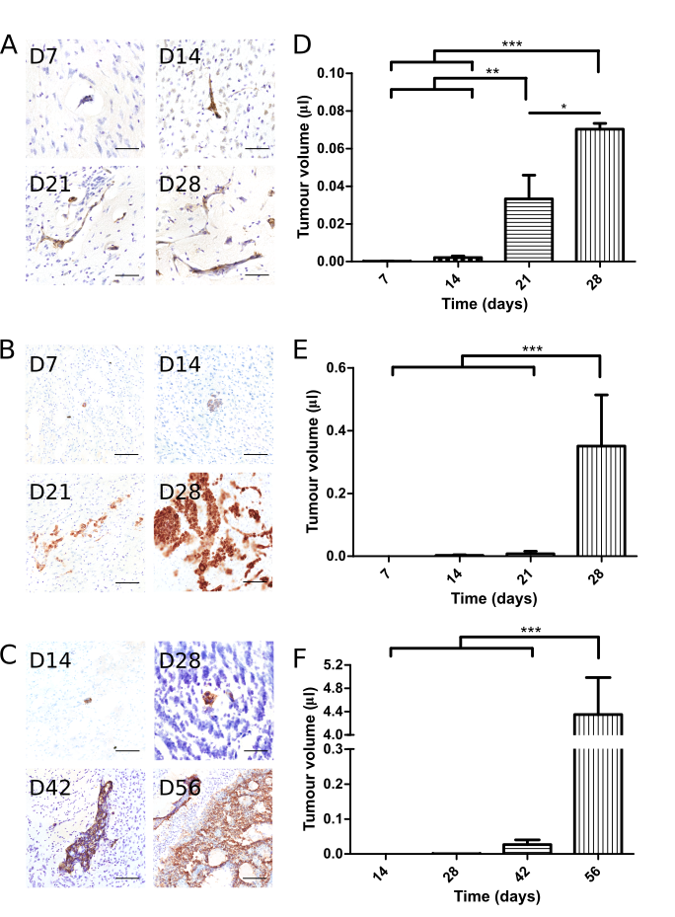

Fig 1. (A-C) Representative histological images demonstrating presence of metastatic tumours within the brain parenchyma for each model (brown colour denotes stained tumour cells); (A) MDA231Br-GFP, (B) H1_DL2 and (C) SEBTA-001; scale bar = 50μm. (D-F) Graphs showing increasing metastatic tumour burden in the brain measured over time following intracardiac injection of (D) MDA231Br-GFP (up to 28 days), (E) H1_DL2 (up to 28 days) and (F) SEBTA-001 cells (up to 42 days) (n = 3 per time-point; ***p<0.001, **p<0.01, *p<0.05).

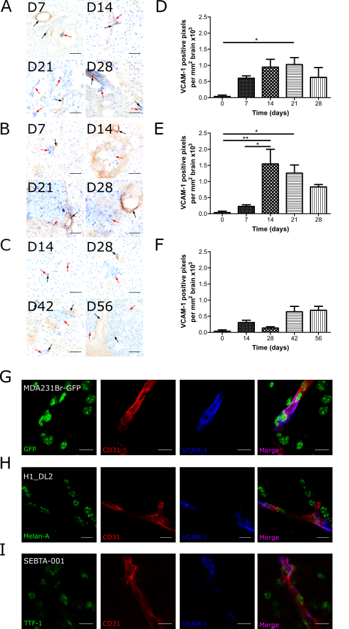
Fig 2. (A-C) Representative images of DAB-stained histological sections for VCAM-1 expression (brown colour) demonstrating upregulation on blood vessels (black arrow) in proximity to (A) MDA231Br-GFP, (B) H1_DL2 and (C) SEBTA-001 metastases (red arrows); scale bar = 50μm. (D-F) Graphs showing time course of VCAM-1 upregulation for (A) MDA231Br-GFP, (B) H1_DL2 and (C) SEBTA-001 metastases (n = 3 animals per time-point; *p<0.05, **p<0.01). Time point at 0 days denotes mean baseline VCAM-1 expression in brains of naïve animals (n = 3 animals). (G-I) Representative immunofluorescence images from mouse brain sections showing co-localisation of VCAM-1 expression (blue) with vascular endothelium (red) in close proximity to metastatic tumours (green) for all three models; (D) MDA231Br-GFP (day 21), (E) H1_DL2 (day 21) and (F) SEBTA-001 (day 42). Co-localisation is evident in merged images (purple); scale bar = 20μm.
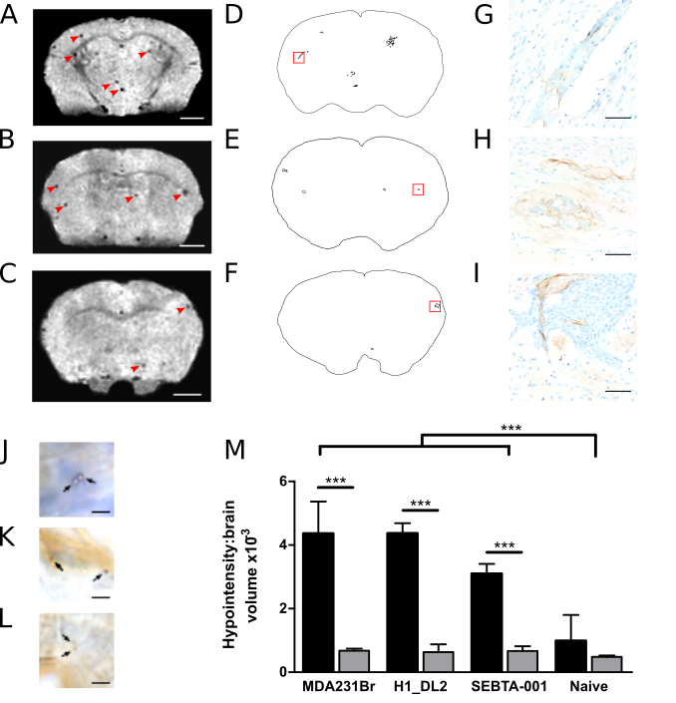
Fig 3. (A-C) Representative T₂*-weighted images from mouse brain bearing (A) MDA231Br-GFP, (B) H1_DL2 and (C) SEBTA-001 metastases, following i.v. injection of VCAM-MPIO; scale bar = 1.5mm. Red arrows highlight focal hypointensities, which are congruous with metastatic deposits evident on composite images of corresponding sequential histological sections (D-F). (G-I) Immunohistochemical detection of VCAM-1 positive vessels (brown) in close proximity to micrometastases highlighted in red boxes in D-F. Sections counterstained with cresyl violet; scale bar = 50μm. (J-L) Images from (J) MDA231Br-GFP, (K) H1_DL2 and (L) SEBTA-001 micrometastases showing VCAM-MPIO (black arrow) bound to VCAM-1 positive vessels (brown); scale bar = 2.5μm. (M) Graph showing volumes of hypointensities on T₂*-weighted images for all groups. Volumes of hypointensities were significantly greater for all three tumour groups injected with VCAM-MPIO than either tumour-bearing mice injected with non-specific IgG-MPIO or tumour-bearing naive mice injected with VCAM-MPIO; ***p<0.001).

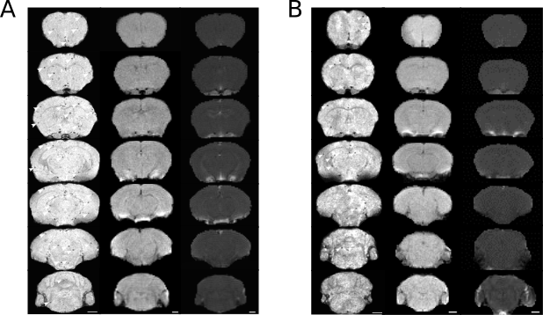

Fig 4. Corresponding images from a mouse brain bearing (A) MDA231Br-GFP and (B) H1_DL2 metastases for post-VCAM-MPIO T₂*-weighted MRI (left column), pre-gadolinium T₁-weighted MRI (middle column) and post-gadolinium T₁-weighted MRI (right column); scale bar = 1.5mm. Multiple focal hypointensities are visible (white arrows), despite lack of contrast enhancement on T₁-weighted MRI following i.v. gadolinium administration.

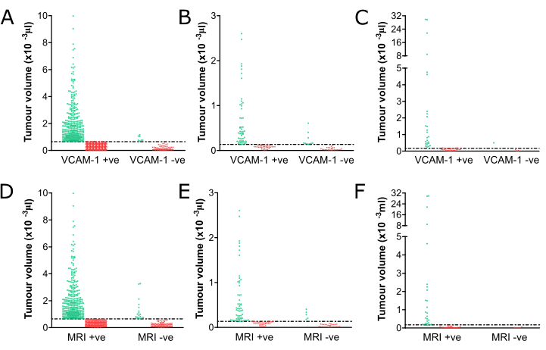

Fig 5. (A-C) Scatter plots showing individual VCAM-1 positive and negative tumours above (green ○) and below (red x) the median volume for (A) MDA231Br-GFP, (B) H1_DL2 and (C) SEBTA-001 metastases. (D-F) Corresponding plots indicating metastatic tumours that are hypointensity positive and negative, above (green ○) and below (red x) the median volume, on T₂*-weighted MRI following intravenous VCAM-MPIO injection. Dashed horizontal line denotes the median volume for each tumour type.

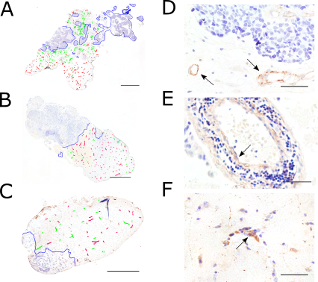

Fig 6. (A-C) Representative immunohistochemical images from human brain metastasis biopsies of (A) breast carcinoma, (B) lung adenocarcinoma and (C) melanoma stained for VCAM-1 (brown). Blue denotes tumour border, green indicates VCAM-1 positive vessels and red indicates VCAM-1 negative vessels. Scale bar = 1mm. (D-F) Higher magnification images demonstrating upregulation of VCAM-1 on vessels (brown) near to the tumour border of the corresponding tumours. Arrows indicate VCAM-1 positive vessels. Scale bar = 50μm.

